
 | Rocznik Ochrona Środowiska
 | Volume 28 | Year 2026 ISSN 2720-7501 | pp. 619-648
https://doi.org/10.54740/ros.2026.042
open access
 | Received: May 2026 Accepted: July 2026 Published: July 2026
Environmental Applications of Vetiver Grass: Phytoremediation and Nature-Based Solutions for Climate-Resilient Landscapes
Kannan Thakur¹, Niraj Singh Parihar¹, Hemant Sood², Parveen Berwal^{3*}
¹Department of Civil Engineering, Jaypee University of Information Technology, Waknaghat, Solan, India
²Department of Biotechnology and Bioinformatics, Jaypee University of Information Technology, Waknaghat, Solan, India
³Civil Engineering Department, Galgotias College of Engineering & Technology, Greater Noida, India https://orcid.org/0000-0003-2422-3391
*corresponding author’s e-mail: parveenberwal@gmail.com
Abstract: Vegetation is a strong resource for scalable, climate-resilient infrastructure in mainstream disaster mitigation, but its potential is largely unexplored. This study identifies vetiver grass as a distinctive, dual-purpose bioengineering solution that successfully integrates ecological restoration with geotechnical stability. The study illustrates vetiver's significant ability to stabilize susceptible slopes and remediate contaminated land concurrently. In terms of geotechnical stability, vetiver is a natural alternative to traditional hard engineering, helping protect against the growing threat of landslides, directly or indirectly caused by climate change. Its root system promotes stability due to its dense, deep roots and good tensile strength, thereby providing both mechanical support and hydrological control. The roots make the soil stick together better, increase the friction angle and shear strength, and allow the soil to withstand greater ductile deformation. Vetiver's extensive root system acts like a natural sponge, absorbing moisture through evapotranspiration. This action lowers pore water pressure and prevents saturation, which is the main cause of slope failure during rain. It also improves soil water retention and air entry suction. Vetiver is a great plant for cleaning up contaminated soil and water, and it has developed a remarkable self-regulating mechanism that allows it to thrive in and detoxify environments contaminated with heavy metals (like Pb, Cd, Zn, As, and Cu), high salinity, and xenobiotics.
Keywords: vetiver, geotechnical stability, tensile strength, shear strength, phyto-stabilization, genotoxicity, contamination, bioengineering
1. Introduction
Landslides rank among the most destructive natural hazards worldwide, resulting in 55,996 fatalities from 4,863 non-seismic incidents between 2004 and 2016, averaging roughly 4,300 deaths annually. Asia has equally been the most affected by these losses, especially in the mountainous areas where the majority of people live (Froude & Petley, 2018). South and Southeast Asia have been identified by the UNDRR (United Nations Office for Disaster Risk Reduction) and the WMO (World Meteorological Organization) as a global hotspot for landslides. Such areas can be defined by increases in events and the intensity of hazards resulting from climate change, unpredictable precipitation, and unplanned slope changes (UNDRR and WMO 2023). The magnitude of the issue is more pronounced at the state level. There were 316 landslide-related deaths alone in Uttarakhand in 2015–24, a figure that clearly underscores the need for more powerful hazard monitoring systems and more efficient mitigation protocols (The Times of India 2024). Figure 1 illustrates the distribution of landslides worldwide using a color-coded scale for each country. It is quite clear that South and East Asia, India and China in particular, have the greatest number of recorded events (Froude & Petley, 2018). Figure 2 shows only the number of landslides that occurred between 2004 and 2017, as shown in the time-series plot. This graph reveals a clearly defined seasonal trend in event occurrence, with sharp peaks every year that are presumably attributed to the monsoon or heavy rainfall seasons. The consistency of the annual peaks has been highlighted through a 25-day moving average.

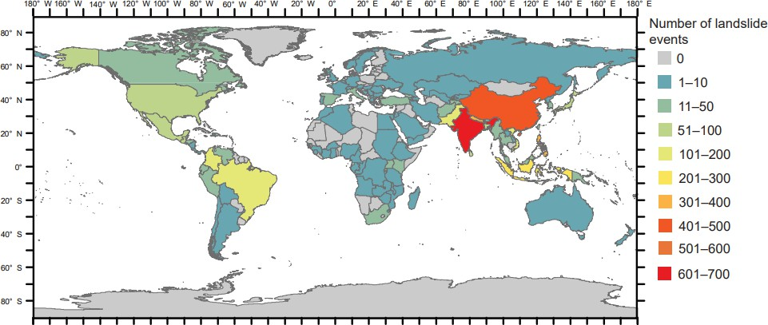
Fig. 1. Total events and non-seismic landslides from 2004 to 2016 (Froude & Petley, 2018)

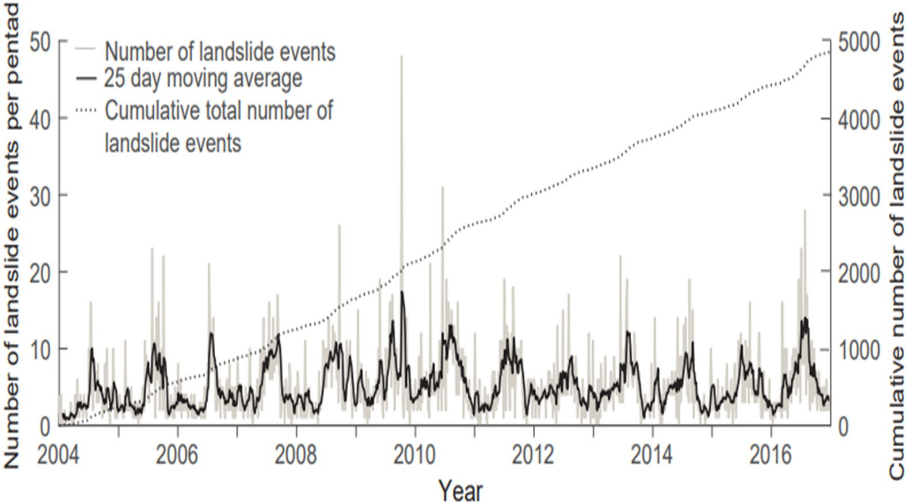
Fig. 2. Number of catastrophic landslides that were not triggered by seismic activity between 2004 and 2016 in countries (Froude & Petley, 2018)

The data show that the overall number of recorded landslides has been steadily increasing. This totalled almost 5,000 at the time the data were studied, and it shows a consistent increase in the reported events over 13 years (Froude & Petley, 2018). In this regard, recent research has developed comprehensive vulnerability indices and maps to assess the vulnerability of critical infrastructure in landslide-affected areas in India (The Times of India, 2024). The risk assessment was extensive and spatially explicit, combining satellite-based geospatial data with extensive ground-based observations. The findings indicate that in the national road network, railway lines, and buildings, about 9.13, 1.37, and 3.25 percent are in the very highly vulnerable category (Joshi et al., 2025). However, these dangers are not evenly distributed; they occur mostly in the northeastern states and in other hilly and mountainous regions of the country. In general, the study highlighted the need to plan strategically and proactively, as well as to invest specifically in sustainable infrastructure. To reduce the human and economic impacts of landslides and avoid future losses, there is a strong need to reinforce infrastructure systems in potentially dangerous areas (Joshi et al., 2025). Slope stabilization has been listed as a priority in the Landslide Risk Mitigation Scheme by the National Disaster Management Authority (NDMA, 2023). Nevertheless, national statistics on landslide-related casualties are not fully assembled. Slope vegetation, especially Vetiver grass, is also a nature-based intervention to reduce shallow slope failures and rainfall-induced landslides, and its application is increasingly spreading to high-risk terrains (Verma et al., 2025). The ability of vetiver grass to enhance geotechnical reinforcement together with ecological stability has made the plant an effective bioengineering species (Rinitha & Sreedharan, 2026). It can also grow in polluted and degraded soil, unlike most common grasses, and at the same time help stabilize slopes. The root system of the species is deep and high-tensile, thereby increasing shear strength and soil cohesion. This aspect enhances the efficacy of vetiver in minimizing shallow landslides caused by heavy rains and surface erosion in unstable soils. Landslides are a severe natural hazard and can cause widespread physical destruction, economic losses, and human casualties (Kalia, 2018; Guzzetti et al., 2008). Vetiver planting has also been integrated in slope protection schemes in high landslide-prone areas, such as the Himalayas, Southeast Asia, and steep or hilly slope drainage, where the addition of vegetation is expected to reduce the risk of failure, enhance surface and groundwater drainage, and increase macro-stability of the slope (Gariano & Guzzetti, 2016). Table 1 displays roads, railways, and buildings in India in categories of landslide risk, constructed through a geospatial analysis of a modified study of infrastructure exposure in 2025 (Joshi et al., 2025).

Table 1. Landslide Infrastructure Vulnerability Data – India (Joshi et al., 2025)
Infrastructure Type | Extreme Risk | High Risk | Moderate Risk | Low Risk | Very Low Risk | Total High + Extreme Risk
Roads | 9.13% | 6.02% | 15.4% | 36.6% | 32.9% | 15.15%
Railways | 1.37% | 1.94% | 3.11% | 5.15% | 88.43% | 3.31%
Buildings | 3.25% | 2.05% | 2.92% | 4.32% | 87.46% | 5.30%

Vetiver grass is a remarkable noninvasive perennial species that has been proven to be a unique bioengineering resource, effectively used as an environmentally friendly plant for environmental remediation, ecological restoration, and geotechnical stability (Chakraborty & Khan, 2024). Vetiver’s ability to survive in contaminated soil has been widely documented. Numerous studies have demonstrated its effectiveness in pollutant removal, including the uptake of heavy metals such as lead, cadmium, and zinc from contaminated soils (Chen et al., 2004). Controlled experiments have further confirmed their significant potential for arsenic absorption (Datta et al., 2011). In addition, soil amendments such as humic and fulvic acids have been shown to enhance vetiver’s capacity to extract contaminants from soil (Singh et al., 2007; Angin et al., 2008). An innovative partnership between vetiver and Achromobacter xylosoxidans was found to significantly outperform vetiver alone in removing aromatic pollutants (Ho et al., 2013), while review studies have emphasized that microbial associations facilitate stress tolerance and pollutant degradation (Chen et al., 2021). These findings collectively demonstrate that vetiver, in conjunction with microbial partners or chemical amendments, serves as a highly adaptable and effective phytoremediation system. Beyond water and soil remediation, vetiver has also demonstrated strong potential in the rehabilitation of mining-degraded lands (Wong, 2002). Its role in restoring metal-contaminated soils has been clearly observed (Sharma et al., 2024). Field-scale studies have reported the successful establishment of vetiver on lead- and zinc-rich mine tailings, where the plant not only survived under harsh conditions but also actively extracted metals from the waste material (Shu et al., 2002). Additionally, vetiver has demonstrated potential for remediation of soils contaminated with petroleum hydrocarbons, further bolstering its broad pollution tolerance. (Brandt et al., 2006). The current review aims to address these knowledge gaps by providing a comprehensive evaluation of the Vetiver System from engineering and environmental perspectives. This review critically discusses the biological characteristics and soil reinforcement mechanisms of vetiver. It systematically evaluates its influence on slope stability, erosion control, hydrological behaviour, ecological restoration, and climate resilience at international and national levels, using case studies from China, Vietnam, Thailand, Australia, South Africa, and Fiji, and its relevance to Indian afforestation, watershed, and railway infrastructure programmes. It also considers the environmental co-benefits of vetiver, such as sediment and nutrient runoff reduction, carbon sequestration, and phytoremediation potential, as well as key adoption challenges, including the lack of standardized design specifications and limited long-term field data. Based on this existing literature, this review identifies the integration of vetiver with geocell reinforcement as a promising future direction for sustainable slope stabilization. Furthermore, it highlights an experimental framework that could be adopted in future studies to evaluate the performance of hybrid vetiver–geocell systems under combined rainfall and seismic loading.

1.1. Engineering Applications
From a geotechnical perspective, vetiver's root system acts as a natural net that helps hold the soil together. Slope landslide susceptibility is a measure of the probability of collapse under specific geo-environmental conditions. In this context, scientists have quantified the direct effects of root density and tensile strength in improving slope stability in semi-arid regions (Mickovski & van Beek, 2009), highlighting the strong connection between the grass’ resistance to being uprooted and the overall shear strength of the soil (Mickovski et al., 2005). Recent engineering research has verified its role in contemporary slope stability practice and has confirmed that when vetiver is used with soil nails to protect slopes, it is an effective solution (Nghia et al., 2019; Maadi & Noorzad, 2024). Vetiver has proven to be an important tool in bioengineering, with outstanding potential for preventing landslides and remediating the environment. It has been proven that mature vetiver increases slope stability by 6.7% over 20 years through its positive impact on soil cohesion (+67%), with measurable root tensile strength of 27 MPa (Maadi & Noorzad, 2024; Islam & Badhon, 2020). The grass has dual functionality, with the roots reinforcing mechanical stability during long spells of rainfall and the water absorption resulting in beneficial matric suction during short spells of rainfall (Islam et al., 2013; Patil et al., 2022). Mulching the surface with vetiver results in a 68% reduction in surface runoff and an 82% reduction in soil loss, thus proving very effective in erosion control (Donjadee & Chinnarasri, 2012). However, engineers need to evaluate the effectiveness of this method, accounting for soil variation, slope angles, and rainfall duration, while steep slopes may destabilize due to deep roots, thereby creating preferential infiltration paths (Jotisankasa et al., 2020; Mahima et al., 2025). The roots also demonstrate phytostabilization capabilities for heavy metal-contaminated soils, making vetiver suitable for mine reclamation projects (Banerjee et al., 2016), while engineering models confirm optimal stability up to 33° slope angles, beyond which hybrid structural-biological solutions become necessary (Aziz et al., 2022; Kong et al., 2025). Beyond stabilization, vetiver's roots host diverse diazotrophic bacteria including Bradyrhizobium, Sphingomonas, and Klebsiella, which fix nitrogen and promote plant growth while enhancing essential oil production (Vollú et al., 2012). Successfully implemented in Thailand and other developing countries, vetiver-based soil bioengineering addresses UN Sustainable Development Goal 15 by providing cost-effective, environmentally friendly landslide protection (Leknoi et al., 2025). Figure 3 illustrates vetiver growth after three months in different soils.

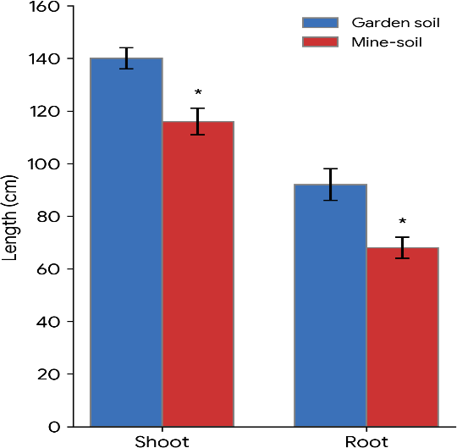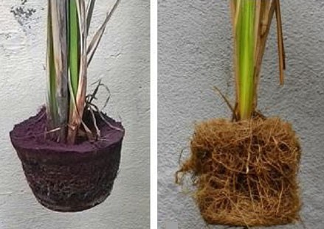
(a) (b)
Fig. 3. (a)Three-month shoot and root length of vetiver (P < 0.05); (b) soil-entangled roots versus thick root mesh following soil removal (Banerjee et al., 2016)
1.2. Adaptability and Phytostabilization
Vetiver grass is widely recognized for its engineering value in stabilizing slopes and controlling erosion, as well as for its robust biological characteristics, which enable it to thrive in challenging environmental conditions. To assess its efficacy as a sustainable bioengineering material, it is crucial to understand its morphology, phytochemistry, and ecological adaptations. The roots are strong, making it resistant to toxic heavy metals such as lead and cadmium, even at high concentrations (Danh et al., 2009). The adaptability of phytostabilization technologies offers transformative potential for managing heavy metal-contaminated environments. While hyperaccumulators like HEDTA-treated corn achieve remarkable shoot-Pb concentrations of 10,600 mg/kg for active phytoextraction (Huang & Cunningham, 1996), phytostabilization approaches prioritise long-term containment through vegetation establishment on metalliferous wastes. For effective implementation, specific ameliorative strategies are necessary for a particular site to improve nutrient levels and address substrate structural limitations through direct seeding, cover systems, and natural revegetation processes (Tordoff et al., 2000). Another technique for increasing effectiveness is strategic co-cultivation. Vetiver-cattail association exudaten 3.23 to 7.91 times higher amounts of root exudates in low-nutrient conditions, and oxalic acid is key to chelation of metals and soil remediation (Wu et al., 2012). Field results revealed that vetiver grass successfully established itself on Lead/Zinc mine tailings. Application of refuse compost significantly enhanced biomass growth due to improved soil conditions, and inoculation of AM (Arbuscular Mycorrhiza) fungal spores enhanced plant growth with the increase in the uptake of nutrients and decreased metal accumulation in plant roots, thus emphasizing its importance in phytostabilization of contaminated soils (Suganya et al., 2024). This adaptive mechanism demonstrates that biological strategies adopted at specific sites are equally important for ensuring the sustainability of plant-based remediation systems, not just for metal accumulation. Overall, studies comparing plant tolerances indicate that vetiver grass is equally tolerant of high levels of trace elements as other known metal-tolerant plant species (Kabata-Pendias, 2000).
2. Morphology & Root Architecture
Vetiver grass forms a distinctive and mainly vertical root structure, which normally reaches well below 3 meters deep and is a result of a much-branched rootstock in large, tufted clumps. This outstanding morphology reflects a wonderful environmental adaptation, including being a hydrophyte in natural humid habitats and coping with xerophytic habitats by investing energy in deep-rooted growth to endure. The vertical root system endures extreme conditions ranging from highly acidic (pH 3) to strongly alkaline (pH 11) soil environments and withstands elevated levels of mineral toxicity up to 550 ppm, allowing adjacent crops to thrive without compromising their yields (Maffei, 2002). Figure 4 shows phytoremediation, a process in which plants take up heavy metals from contaminated soil and sequester them in the shoots, enabling their safe removal.

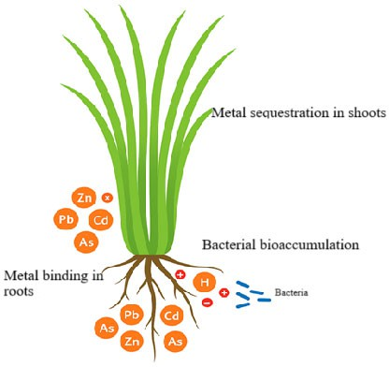
Fig. 4. Phytostabilization mechanism in vetiver grass

Vetiver grass roots are composed of numerous small rootlets that provide a large surface area to interact with contaminants in the soil. Under microscopic examination, well-developed epidermis and cortical cells, and, in some areas, aerenchyma tissue, were also present, indicating structural strength to penetrate into the soil and facilitate oxygen transport in saturated zones (Singh et al., 2007). A field experiment in a semi-arid region of Spain revealed that young Chrysopogon zizanioides plants developed dense, vertically oriented roots within the upper 20 to 30 cm of the soil profile, with fine roots exhibiting tensile strengths of up to 18 MPa. The root system enhanced the in-situ shear strength of the soil by 2.8 kPa (36%), and the factor of safety on slopes improved from 1.0 to 1.15. Uprooting tests yielded pull-out resistance ranging from 190 to 620 N, which was closely correlated with plant height and lateral root expansion, suggesting the species' potential for slope stabilization (Mickovski et al., 2005). The root system evaluation of the grass using multiple methods indicated that the greatest root concentration occurs in the shallow zone (0–0.50 m), indicative of a high level of biotechnical reinforcement potential. The results from the trench and volumetric ring method showed a high level of correlation, whereas the monolith method was less accurate due to a loss of fine roots, suggesting that methods are less accurate in dense root systems (Holanda et al., 2022). Various researchers have noted the unique strength properties of grass in stabilizing slopes, particularly its high tensile strength and significant positive resistance to sliding (shear) (Nilaweera & Hengchaovanich, 1996). Numerical analyses (computer modeling) also verify these results, confirming the effectiveness of roots in improving soil cohesion and water infiltration dynamics, thereby enhancing slope stability (Jotisankasa et al., 2020; Islam et al., 2020). Vetiver has been compared with other grasses and found to be more effective in terms of root depth and density, enabling the soil to be reinforced more consistently (Holanda et al., 2022). This root structure of vetiver makes the plant stand apart as an excellent bioengineering tool for erosion control.
2.1. Phytochemistry & Essential Oil Composition
Vetiver is prized for its distinct root chemistry as well as its structural characteristics. Research has shown that vetiver roots contain substances such as alcohols, ketones, and sesquiterpenes (Maffei, 2002). These compounds form the basis of vetiver essential oil (VEO), which has commercial applications and remedial capabilities against pesticides, heavy metals, and industrial waste, in addition to its medicinal use (Barcellos-Silva et al., 2025). Research shows that contamination with heavy metals can influence VEO yield and chemical composition, with notable changes observed when the plant is exposed to zinc (Zn) and lead (Pb) (Prasad et al., 2014). For instance, one study demonstrated that vetiver can endure and sequester a substantial lead concentration of 19,530 mg/kg in its roots while sustaining vigorous growth and producing up to 1.3% essential oil. Lead exposure also augmented the diversity of oil compounds (from 46.8 to 143) while maintaining the primary components, thereby reinforcing its dual utility for site remediation and commercial oil production (Rotkittikhun et al., 2010). A comprehensive review of VEO discusses its role in environmental remediation (against contaminants like heavy metals, herbicides, and radioactive materials) alongside its beneficial pharmacological properties (including antioxidant, anti-inflammatory, and organ-protective effects) (Barcellos-Silva et al., 2025). Collectively, these results indicate that vetiver’s phytochemistry extends its role beyond soil reinforcement, conferring ecological resilience and potential medicinal benefits. Figure 5 shows the chemical structures of five major phytoconstituents of vetiver essential oil (VEO), which have been known to contribute to its aroma, pharmacological, and insect repellent properties.

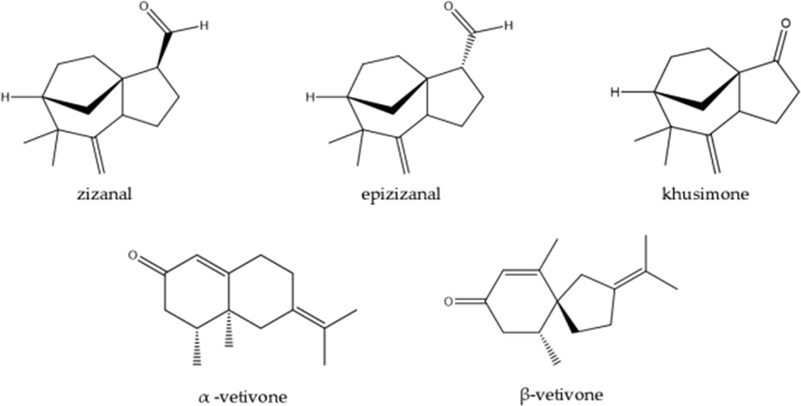
Fig. 5. Five insect-repellent vetiver oil phytoconstituents (Barcellos-Silva et al., 2025)
2.2. Ecological & Physiological Adaptations
The root system is the key feature of vetiver that is widely recognised as the wonder grass, mainly because of its unbelievable root systems that resemble the living tall steel nails in the sense that it grows straight down to 2-4 meters long, thus a master of soil stabilisation (Maadi & Noorzad, 2024; Islam & Badhon, 2020; Islam et al., 2013). It has a thick, deep root system, enabling it to endure harsh conditions such as droughts by tapping deep root moisture that is not available to other plants, as well as giving it mechanical support, which enhances the slope factor of safety by 6.7 percent over 20 years (Patil et al., 2022). The chemical durability of the plant is also quite impressive, as it shows adaptability to extreme pH gradients and other soil texture characteristics. Still, performance results vary depending on soil gradation and local conditions (Mahima et al., 2025). It has an advanced biological association that allows the control of heavy metal absorption: the arbuscular mycorrhizal fungi intelligently selectively promote heavy metal uptake in lightly contaminated soils and limit uptake in highly contaminated soils to prevent toxicity, which contributes to its phytoremediation potential (Banerjee et al., 2016; Wong et al., 2007). All these adaptations make vetiver a perfect, cost-effective bio-engineering agent for land reclamation and environmental protection worldwide. Table 2 presents a systematic review of the scientific rationale for Vetiver grass as a multifunctional agent in environmental restoration. The synthesis of the data from research studies.

Table 2. Multifunctional Applications for Vetiver Grass
Citation | Focus Area | Specific Contribution / Finding
(Chen et al., 2004) | Heavy Metals | Confirmed accumulation of Zn, Pb, and Cd without significant biomass loss.
(Chantachon et al., 2004) | Heavy Metals | Proof of Pb (Lead) phytoextraction in lab  and field simulations.
(Datta et al., 2011) | Heavy Metals | Greenhouse study showing high As (Arsenic) uptake retained in roots.
(Zhang et al., 2014; Aibibu et al., 2010) | Heavy Metals | Noted Cd (Cadmium) accumulation in roots/shoots; identified physiological changes.
(Abaga et al., 2014a; Abaga et al., 2014b) | Soil Cleanup | Demonstrated effectiveness in cleaning  agricultural soils in Burkina Faso.
(Zhuang & Hazelton, 2013) | Amendments | Fulvic acid and straw-water improved As  absorption from groundwater.
(Rotkittikhun et al., 2007) | Amendments | Pig manure and fertilizers increased Pb content.
(Chiu et al., 2005) | Amendments | As, Zn, and Cu uptake increased with chelating agents.
((Shu et al., 2002; Wu et al., 2010) | Mining | Growth on Pb/Zn mine tailings; Mycorrhizal fungi improved root absorption.
(Wong, 2002; Melato et al., 2016) | Mining | Restoration of mine soils; production  of metal-binding molecules in gold tailings.
(Brandt et al., 2006) | Hydrocarbons | Survival in petroleum-contaminated soils  (Venezuela) via microbial support.
(Donjadee & Chinnarasri, 2012;  Jotisankasa et al., 2020) | Hydrology | Mulch reduces erosion; computer models show limited slope infiltration.
(Aziz et al., 2022; Leknoi et al., 2025) | Engineering | Improved slope stability in tropics;  used for landslide mitigation in Thailand.
(Nghia et al., 2019) | Engineering | Success in combined "soil nailing"  and bio-reinforcement techniques.
(Vollú et al., 2012) | Ecology | Identified nitrogen-fixing bacterial communities in the rhizosphere.
(Mickovski & van Beek, 2009;  Maffei, 2002; Tessema et al., 2024) | Carbon | High belowground biomass enables long-term carbon sequestration in humus.
3. Engineering Applications in Soil
Slope stability is important to prevent disastrous landslides and safeguard infrastructure such as roads and buildings. It is important to ensure that gravity's downward pressure does not exceed the soil's strength. It is vital to ensure stability to prevent disastrous landslides caused by gravity and rain. Concrete is a common material in engineering, but Vetiver is a "bio-engineering" alternative to concrete for providing slope stability. Vetiver's massive roots are like rebar in concrete, providing stability to slopes. Vetiver is a high-strength alternative for preventing erosion and holding loose topsoil firmly in place.
3.1. Performance of Vetiver under Different Soil Conditions

Soil characteristics, including texture, structure, permeability, shear strength, and nutrient availability strongly influence the effectiveness of the Vetiver System. Although Chrysopogon zizanioides exhibits remarkable adaptability across a wide range of soil conditions, its root development and reinforcement mechanisms vary with soil physical and mechanical properties. Table 3 presents the performance of vetiver across different soil types and highlights the significance of each.

Table 3. Performance of vetiver under different soil types
Soil type | Characteristics | Response of vetiver | Engineering significance | References
Clay and silty clay | High cohesion, low permeability | Dense root development increases apparent cohesion and crack resistance | Improves shallow slope stability and reduces mass movement | Hengchaovanich & Nilaweera (1996); Truong, Van, & Pinners (2008)
Silt | Highly erodible, low cohesion | Reduces runoff velocity, traps sediments, enhances aggregation | Effective for erosion control and surface stabilization | Donjadee & Tingsanchali (2016)
Sand | High permeability, low cohesion | Deep root penetration and particle interlocking | Increases shear resistance and controls erosion | Truong, Van, & Pinners (2008)
Gravelly / rocky soils | Coarse texture, hard substrate, shallow rooting zones | Root penetration reduced to ~1 m (vs. 2–3 m in normal soils), but slope remained stable where an unvegetated control slope collapsed | Can substitute for or complement hard engineering on moderate-risk rocky slopes | Ke et al. (2003)
Degraded mine spoil | Poor fertility, disturbed structure, often metal-contaminated | High survival, rapid revegetation, tolerance to heavy metals and extreme pH | Supports ecological restoration and slope rehabilitation | Truong & Baker (1998)
3.2. Tensile and Shear strength relationships
Slope stabilization using vetiver grass incorporates vegetation to improve soil shear strength and slope safety, especially in sandy soils. Root reinforcement has been shown to enhance shear strength by 50 percent and the factor of safety by 20 percent. Although the results of using vetiver in clayey soils are scarce, it is reasonable to note that the plant can help minimize erosion and stabilize shallow terrain (Badhon et al., 2021a). Research demonstrates that vegetation, such as the vetiver grass, enhances slope stability by increasing the shear strength of the soil and root water uptake during dry and low-speed rainfalls, although its stabilizing ability declines under continuous rainfalls, especially on steep slopes and shallow-rooting soils (Mickovski & van Beek, 2009; Patil et al., 2022). Besides, it was recorded that vetiver grass can survive and support nutrient-deficient slopes, and its factor of safety was increased, resulting in a decrease of approximately 10 mm in crest deformation. Although it will not be as effective at angles steeper than 33deg, a mixture of vetiver and terracing is a much better approach to stability, providing a sustainable and cost-effective method to decrease shallow slope failures and landslides (Aziz et al., 2022). Figure 6 illustrates the mechanism by which Vetiver grass contributes to slope stability and landslide mitigation through soil bioengineering.

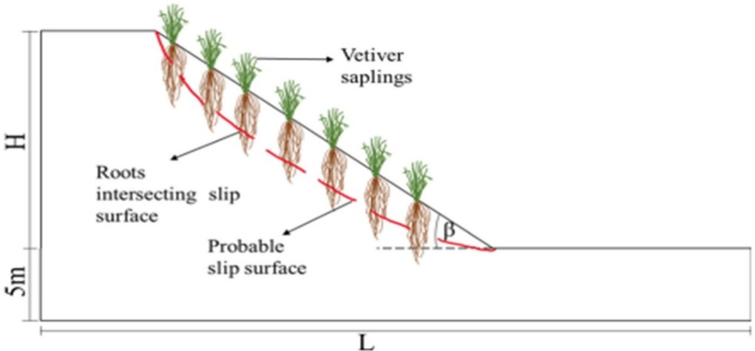
Fig. 6. Potential failure surface being penetrated by vetiver roots (Aziz et al., 2022)

Mathematical model 𝛥 𝑆 = 5.14 𝑡_{𝑅} predicts the supplementary shear strength contribution of vetiver roots in lean clay soils, indicating that the additional shear strength increases linearly with root tensile strength per unit area (Islam & Badhon, 2020; Badhon et al., 2021b). They demonstrated the inverse relationship between vetiver root diameter and ultimate tensile strength, showing that finer roots possess significantly higher strength, which is mathematically modelled by a power law function, and vetiver roots significantly increase soil shear strength (up to 30 kPa), a benefit reliably quantified by the linear relationship: 𝛥 𝑆 = 5.14 𝑡_{𝑅} (Figures 7 & 8). The tensile strength of vetiver roots is comparable to that of synthetic fibers, and it improves the stability of residual soils. (Nilaweera & Hengchaovanich, 1996). Figure 7 shows the variation of tensile strength of vetiver roots with root diameter.

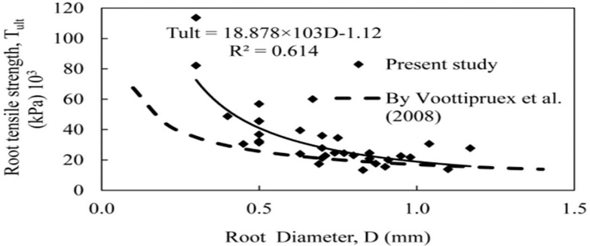
Fig. 7. Vetiver grass root tensile tests: ultimate strength (Islam and Badhon 2020)

The results indicate that thin (fine) roots are significantly more resistant to pulling forces than thick roots. The downward trend of the curve shows that as the root diameter increases, the tensile strength decreases. The experimental results also agree very well with those of Voottipruex et al. (2008). These results indicate that the numerous fine roots of vetiver play an important role in enhancing soil reinforcement, resistance to erosion, and slope stability. Figure 8(a) shows the stress-strain behavior of bare soil and vetiver root-reinforced soil specimens during direct shear testing. The shear strength of the reinforced specimens is consistently higher than that of bare soil during deformation, indicating that the addition of vetiver roots enhances the soil's resistance to shear deformation. The improvement is attributed to the mechanical reinforcement by the root network, which increases the inter-particle bonding and limits soil displacement during loading. Figure 8(b) shows the relationship between the additional shear strength and the root area ratio (RAR). The increase in shear strength is directly proportional to the root density with a strong positive linear correlation (R² = 0.8135). The results indicate that a higher root area ratio can improve slope stability and reduce the probability of shallow slope failure by enhancing root-soil interaction and tensile resistance, thereby providing better soil reinforcement.

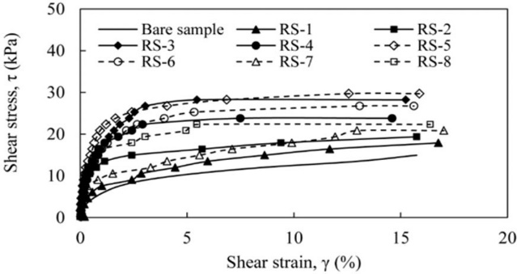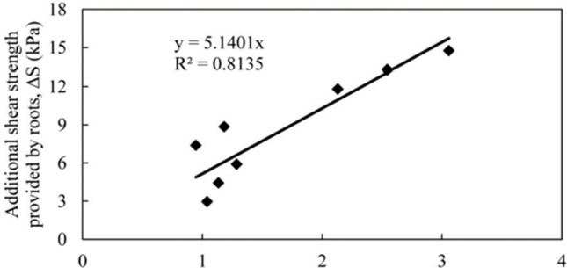
(a) (b)
Fig. 8. Vetiver root reinforcement analysis: (a) Shear stress versus shear strain curves for block specimens and (b) Root-added shear strength experimental relationship, ΔS and the mobilized tensile strength per unit area of soil, tR (Islam & Badhon 2020)

Direct shear testing and triaxial compression testing are two fundamental methodologies, both widely employed in geotechnical engineering to characterise the shear strength of soils. These testing methodologies are often employed interchangeably in research, despite the possibility of discrepancies in the results (Castellanos & Brandon, 2013). Rainfall and seepage are common causes of slope failures; however, vegetation can act as a natural barrier to such failures. A study carried out to evaluate the effectiveness of Vetiver grass (Vetiveria nemoralis A. Camus) indicated that the rapid growth of its roots within a year can considerably improve the shear strength of the soil. Direct shear and centrifuge tests showed that root bundles improve cohesion and friction and reduce slope deformations, thereby providing mechanical and hydrological benefits to slope stability (Eab et al., 2015). The gradual development of the vetiver root system over 6 months is shown in Figure 9(a). The root depth and root bundle radius increased over time, indicating an improvement in the potential to reinforce the soil. Figure 9(b) shows the increase in vetiver root depth over time. The almost linear trend in growth supports previous observations of rapid deep root development, which improve soil anchoring and slope stability.

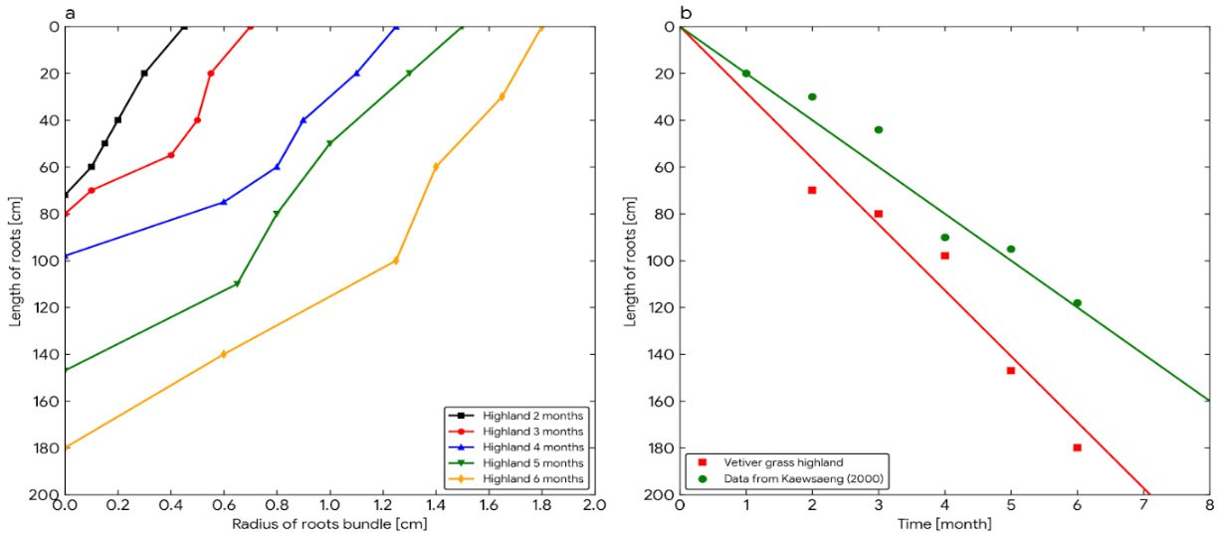
(a) (b)
Fig. 9. Average vetiver root data: (a) root length compared to bundle width; (b) speed of root growth (Eab et al., 2015)

Such intensive and extensive procedures have been essential for measuring the effect of grass on important soil strength measures, including the internal friction angle, cohesion, and total shear resistance, across numerous diverse settings (Rahardjo et al., 2014). One of the contributions was an exploration of silt-clay composite soils in Spain, where the study outlined the mechanism by which the plant's fine, root-bound soil clusters resist dilation under shear (Mickovski & van Beek, 2009). Other more extensive studies examined Vetiver-reinforced low-plasticity clay and silty sand in Bangladesh; it was found that establishing root biomass is more difficult, making it more difficult to achieve a clear failure plane (Islam et al., 2013). Another study that focused on sandy soil matrices in Malaysia reported that the efficiency of the root system remains even in granular media with high permeability (Ali et al., 2008). The experimental evidence required to test the effect of vetiver is provided by field-scale direct shear testing (as illustrated in Fig. 10(a)) to test the hypothesis. Taken together, these studies consistently demonstrate that vetiver root systems remarkably increase soil cohesion and the maximum shear stress limit. The enhancement that the plant provides to the internal friction angle, however, seems less pronounced in these direct shear tests, which could be because of the small volume of root material compared to the total amount of soil mass sheared. Figure 10(b) shows that the soil reinforced with Vetiver is significantly stronger in peak strength and less ductile (stretching and snapping), and thus the slope is less stubborn. On the contrary, the unreinforced soil (Figure 10(c)) is weaker and brittlely fails (it breaks easily). The greatest strength is always attained in the shallowest zone (0.15 m), which is the best supported by roots.
A field-scale direct shear test apparatus, a large-scale mechanism placed on the slope, was used to simulate a possible landslide failure. The vetiver roots are packed into a block of soil, where this machine exerts a measured amount of horizontal force using a Screw Jack. This enables us to directly test the soil's resistance, maximum shear stress, and cohesion on a particular failure plane. The findings are strong: the reinforced soil using vetiver was characterised by significantly higher peak shear stress than plain soil, indicating the root-stitching effect of the plant. Remarkably, this strengthening effect is not identical; it is most pronounced at the surface and decreases with depth (D'Souza et al., 2019). This is exactly the natural density of the roots, and it is ascertained that the reinforcement is concentrated where the roots are thickest. This is a significant performance difference, evident in the data curves. Experimental studies have shown that shear stress and the growing period of reinforcing vetiver grass are positively related, as shown in Figure 11 (Teerawattanasuk et al., 2014).

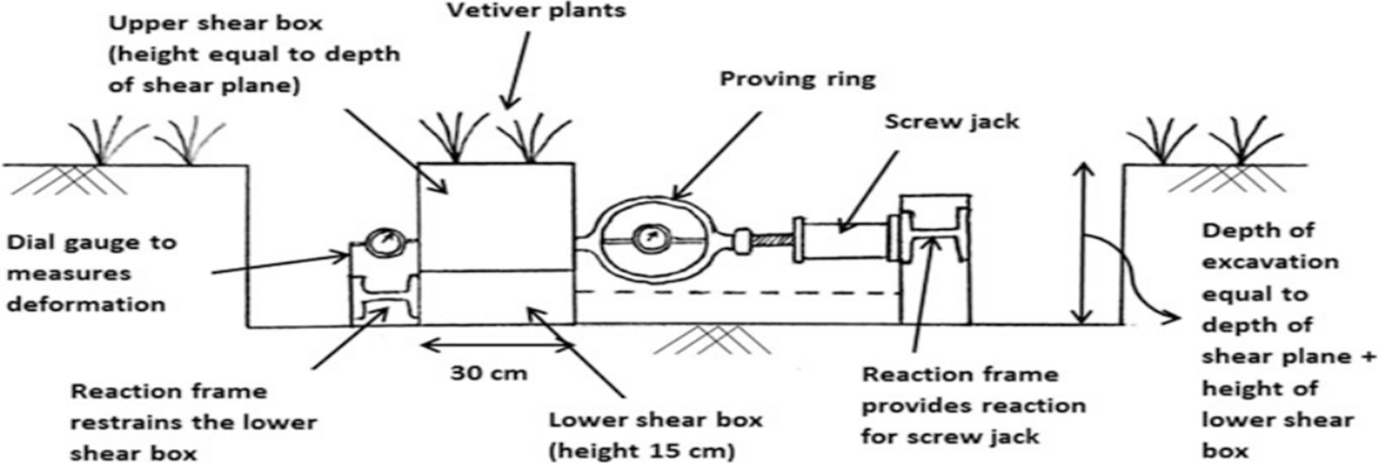
(a)
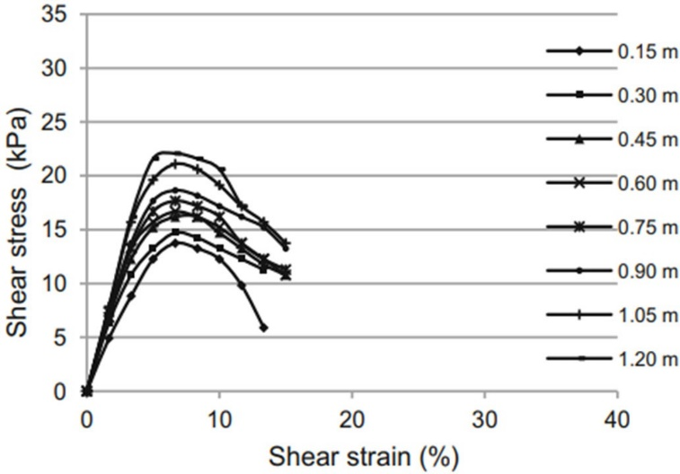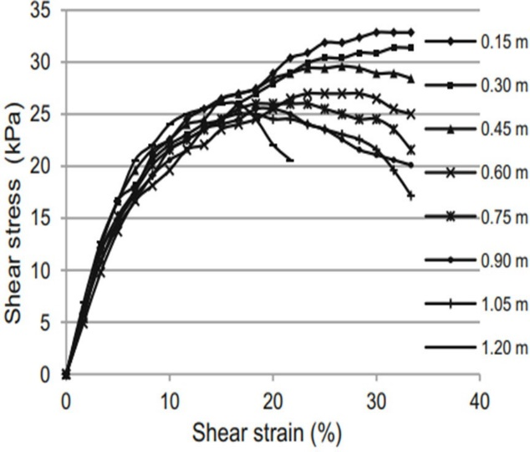
(b) (c)
Fig. 10. In situ direct shear test setup (a) and stress–strain responses (b & c) of non-rooted and one-year-old Vetiver-rooted soil (0.15 m spacing) at different depths (D’Souza et al., 2019)

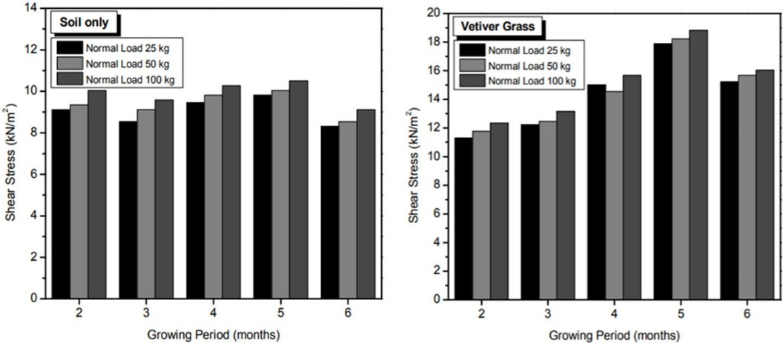
Fig. 11. Relationship between shear stress and growing period of vetiver grass reinforcement (Teerawattanasuk et al., 2014)

Root-reinforced specimens exhibited a greater tolerance to strain than unreinforced soil. This implied that soils reinforced with vetiver could exhibit increased deformation before failing. In addition, both the presence and lateral extension of roots had a significant positive impact on pull-out resistance, and root distribution and dispersion increased the force resistance (Mickovski et al., 2005). Although these results were obtained, there were still gaps in knowledge of the mechanics of vetiver root pull-out, especially regarding failure behaviour. Critical research must also involve a systematic investigation of vetiver pull-out performance under different soil conditions and the measurement of the influence of moisture content on the slippage mechanism at the root-soil interface.

3.3. Effect on Slope Failure Mechanisms
Water quantity or saturation in a soil system is determined by numerous factors, such as the length, intensity, and timing of rainfall, and the soil's natural capacity to allow water to pass through it (Yoshida et al., 1991). The main threat is that once soil reaches its maximum saturation, its strength declines significantly due to the so-called softening process, which ultimately leads to landslides. Infiltration of rainwater can cause problems even in unsaturated soil, despite being in the pre-saturation stage. It decreases the positive matric suction forces, the forces that hold soil particles together and, consequently, the forces that make the soil immobile to sliding (Rahardjo et al., 1995). Heavy rainfall is a significant hazard, as it may lead to water traps known as perched groundwater. This situation largely undermines the shear (sliding) resistance of soil (Lee et al., 2009). This problem is particularly detrimental in difficult soils, such as highly plastic clays; water can easily seep through pre-existing cracks and fractures. These fissures create flow-favorable channels, leading to extensive softening and sudden slope failure (Khan et al., 2017). Luckily, Vetiver grass (as well as such plants as Orange Jasmine) is a natural defence. It has been found that the two plants assisted in maintaining negative pore-water pressure (sustaining the same advantageous suction) in the slopes, even during rain, which is a critical factor in stability (Rahardjo et al., 2014). Sophisticated experimental methods, such as centrifuge modelling, offer valuable capabilities, as they enable investigators to examine physical slope models under conditions of stress that sufficiently replicate field conditions. This method is especially beneficial for landslide studies, since gravitational forces are the primary driving forces in slope instability processes (Taylor, 2001). It is highly evident through the models that the essential hydrological advantage of the grass, its capacity to handle water, is very well manifested. The Original Slope often accumulates destabilizing positive pore-water pressure (greater than 0 kPa) when it rains, which directly results in a loss of shear strength and consequent failure. Conversely, in sharp contrast, the Vetiver-Covered Slope is effective in maintaining negative pore-water pressure (also referred to as matric suction) throughout all depths. Figure 12(a) presents the variation of pore-water pressure at different depths in the original (untreated) slope. Large variations during rain reflect higher infiltration and pore-water pressure build-up, which may reduce slope stability. Figure 12(b) shows the changes in pore-water pressure in the vetiver-covered slope. Pore-water pressure fluctuations are smaller and more stable than those of the untreated slope, indicating that vetiver roots can improve soil drainage, which in turn contributes to improved slope stability (Rahardjo et al., 2014).

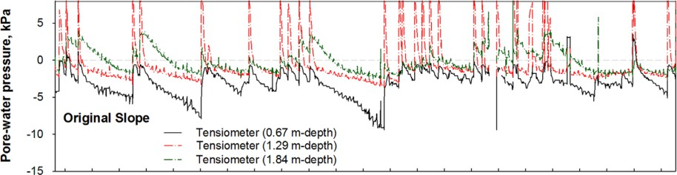
(a)

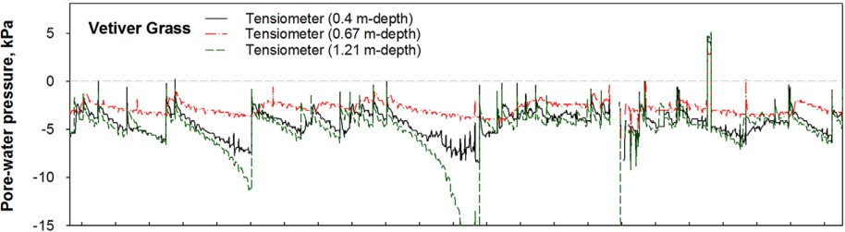
(b)
Fig. 12. Pore-water pressure at different depths for (a) original slope and (b) Vetiver-covered slope, showing the stabilizing influence of vetiver roots (Rahardjo et al., 2014)

Field monitoring in places such as Singapore provides strong support for this finding. Researchers found that Vetiver grass had great levels of reducing rainwater penetration into slopes. This decrease helped preserve matric suction, critical shear strength, and overall slope stability during rain (Rahardjo et al., 2014). Figure 13(a) indicates that although the two species differed in root systems, they were equally effective and thus have potential as useful green engineering solutions for slope stabilisation in tropical climates. Figure 13(b) The graphs employ the Mohr Circles, as well as the Mohr-Coulomb failure lines, to demonstrate the varying effects that different plant roots have on the strength of soil against landslides. The graph basically demonstrates that those roots, especially the Vetiver roots, would be similar to internal steel reinforcement bars in the soil, greatly enhancing the soil's shear strength, which it can withstand before a slope collapses. This makes the vegetated soil very stable and resistant to erosion and failure.

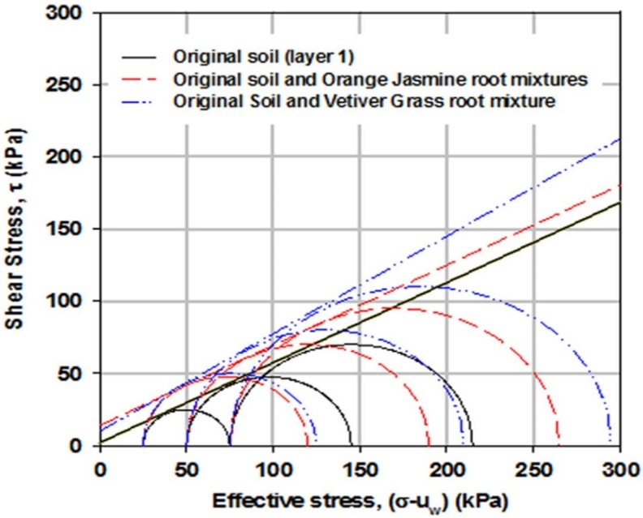
(a)
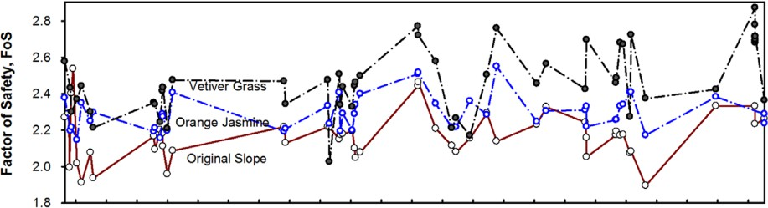
(b)
Fig. 13. (a) Variation in factor of safety and (b) Mohr-Coulomb failure envelopes (at zero matric suction) for original soil, Orange Jasmine-reinforced soil, and Vetiver-re (Rahardjo et al., 2014)
3.4. Hydraulic and Erosion Control
Soil permeability has a major effect on rainfall-induced landslides, as water infiltrates the ground through it. The processes of water content, matrix suction, pore water pressure, and overall stress in a slope are altered in different ways by rainfall of varying intensities (Liu et al., 2021). Increased permeability enhances water absorption and reduces surface runoff and erosion, and the most significant aspect of this in storms is saturated hydraulic conductivity (Scanlan & Hinz, 2010; Rahardjo et al., 2014). The effect of vetiver on soil permeability varies with soil type. Vetiver roots altered soil-water retention and permeability in clayey sand and low-plasticity silt differently. In silt, permeability initially increased due to root-induced cracking, but then declined with further increases in root density because of pore saturation. Roots primarily decreased lower-bound permeability in clayey sand but had insignificant effects in higher-suction soils (Jotisankasa & Sirirattanachat, 2017), whereas sandy soils tend to exhibit greater permeability with vetiver (Rajamanthri et al., 2021). Old Vetiver plants have a greater ability to retain water than young plants. Places with deeper roots can retain more water, especially on higher slopes. Other investigations indicate that steep slopes could enhance water retention, but this association requires further explanation. Figure 14(a) Time Series indicates that the vegetated slope (blue line) exhibits much higher soil suction (up to 550 kPa) and more variable values than the bare slope (0 kPa), and thus a stronger influence of transpiration on soil drying. The data in Figure 14(b) demonstrate that the range of water content under vegetation is broad and detailed, indicating the dynamic non-uniformity of root water uptake compared with simple model fits.

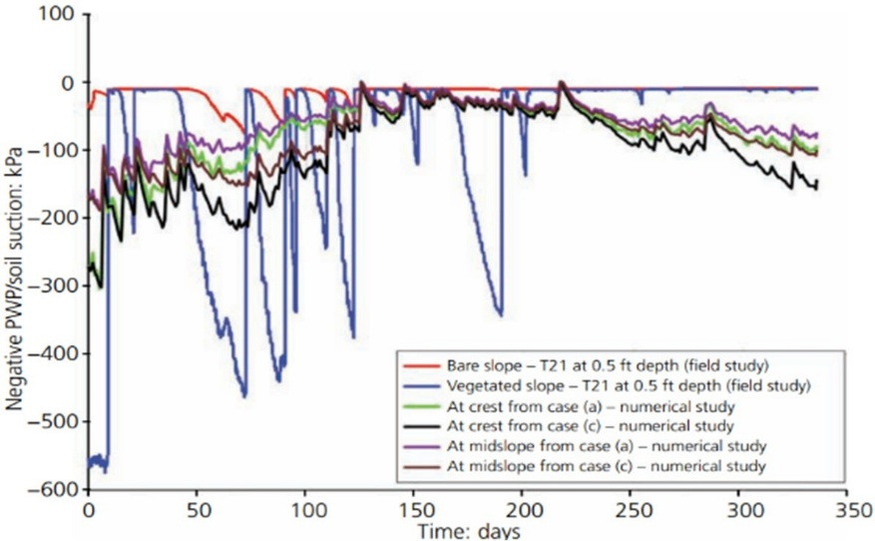
(a)
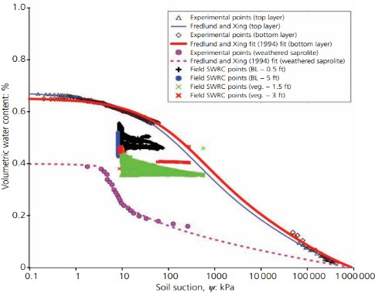
(b)
Fig. 14. Comparison of simulated and field-measured suction at shallow depths for vegetated and bare slopes, and field moisture–suction data against laboratory SWRC. BL = bare land (Patil et al., 2022)

The Guam study emphasizes the roles of vegetation in slope stability through root water uptake (RWU) and root reinforcement. The results indicate that RWU improves matric suction, thereby delaying failure during short, low-intensity rainfall events. But during prolonged rainfall, this advantage is lost. Mechanical root cohesion, in particular with the use of vetiver, becomes a more effective stabilising factor (Patil et al., 2022). Vetiver has also been shown to be useful in erosion control and hydrological control. One study found that mulching with vetiver grass reduces soil erosion by 33.6–82.4% and runoff by up to 68.5% (Donjadee & Chinnarasri, 2012). To supplement this, hydraulic assessments of hedges of vetiver grass showed that they had a strong ability to reduce overland flow and to trap sediment, and that effective spacing of hedges was necessary for successful erosion control in low-slope floodplains (Dalton et al., 1996). Other studies also reported similar findings, indicating that vetiver hedges reduced annual soil erosion by over 50% (Truong, 2001). Another study also emphasized the cost-effectiveness of vetiver, stating that it is an effective and inexpensive hedge against erosion (Greenfield, 1990). Vetiver grass increases water retention in MH and ML soils by 15% and 30%, respectively. Tests in soil columns also indicated that vetiver's performance was highly dependent on soil gradation, with silty and sandy soils giving different responses. High root density also promoted suction during transpiration, thereby increasing soil stability processes relevant to slope performance (Mahima et al., 2025). Figure 15 monitors the variation in Air Entry Value (AEV) and permeability of four soil types (MH, SM, SW, ML) with increasing plant age (0–120 days). As a rule, when the sprouting plant roots develop, the AEV of the soil rises, and its permeability falls, which indicates a change in the pore structure that impedes the entry of air and slows the flow of water.

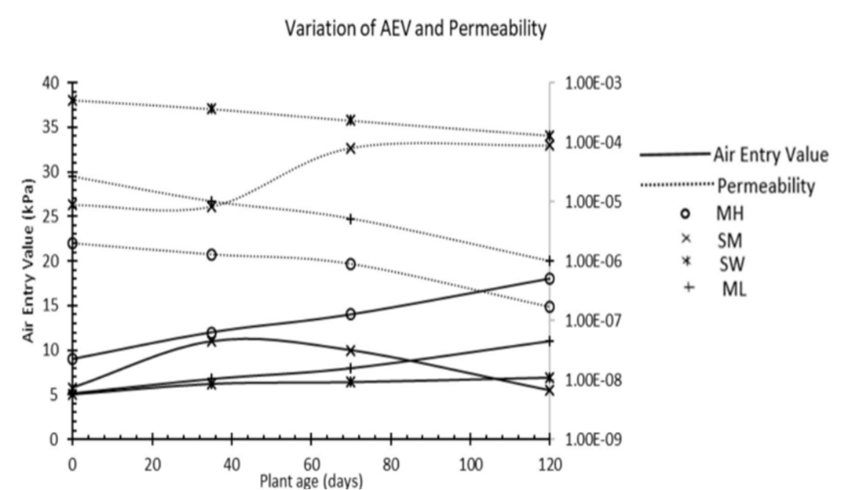
Fig. 15. The impact of root incorporation on soil permeability (Mahima et al., 2025)

The role of vetiver in water management goes deeper, aiding soil conservation at the catchment scale; one study found substantial sediment reduction in Thailand, directly associated with vetiver programs (Leknoi et al., 2025). The study has verified the dual use of the plant in the removal of pollutants, such as lead, in polluted areas and, at the same time, offers a very important benefit in soil stabilization (Chantachon et al., 2004; Rotkittikhun et al., 2007). Concerning such a complicated interaction between water and slope strength, literature in the field of numerical modelling has discovered that although in many cases the introduction of vetiver will raise the infiltration levels (and, as a result, reduce the size of destructive overland runoff), the increased infiltration rate may, under specific circumstances, cause a rise in pore water pressure in extremely steep slopes. This means that the total stability effect of vetiver varies greatly with the slope angle and soil conditions (Jotisankasa et al., 2020). Although this is complex, there is strong evidence of its stabilizing effect provided by other recent contributions. It has been found that Vetiver was effective in slowing the accumulation of pore water pressure during rainfall, thereby minimizing shallow slope failures across various soil types (Mahima et al., 2025). Similarly, numerical modeling showed that Vetiver reinforcement significantly reduced rainfall-induced instability on loess slopes (Kong et al., 2025). In addition, the simulated hill-slope reports indicated that Vetiver has the potential to reduce infiltration rates during intense rainfall, thereby reducing erosion rates and surface washouts (Islam et al., 2021). Vetiver offers a versatile, robust resource for landscape sustainability. Nonetheless, the secondary literature remains insufficient, and it would still be necessary to conduct extensive studies on different soils to gain a comprehensive understanding and maximize the diverse hydraulic properties of Vetiver across all slope stabilizations. Figure 16 compares the Factor of Safety (FOS) and the grade of the side slope for rooted (vegetated soil) and bare (unvegetated) slopes. Across all slope grades, the rooted slope always has a greater Factor of Safety than the bare slope, indicating that vegetation is important for slope stability and resistance to failure.

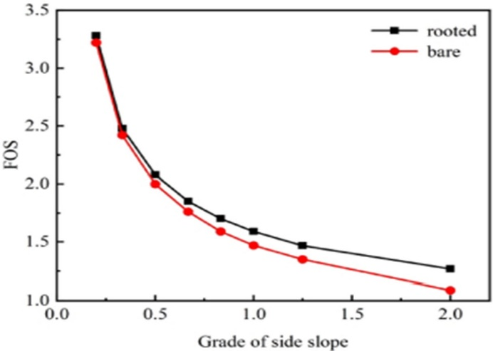
Fig. 16. Effect of slope grade on FoS (Kong et al., 2025)
3.5. Comparison with Conventional Bioengineering
The effects of landslides and floods extend well beyond the physical realm, negatively affecting livelihoods, markets, health, and education (Winter et al., 2016). Vetiver grass is a multi-purpose, nature-based solution that alleviates these threats while providing enormous economic and performance benefits compared to traditional hard engineering. Young Vetiver (with high root density and a vertically oriented root structure) showed significant reinforcement benefits, with in-situ soil shear strength increasing by an average of 36 percent and the slope Factor of Safety (FoS) increasing from sim 1.0 to 1.13 during short-term saturated conditions (Islam et al., 2013). When used in combination with mechanical measures, e.g., soil nails, its stabilizing performance can reach FoS values of 1.37 at roughly a 33 percent cost reduction (Nghia et al., 2019). The numerical modelling results validate the findings that show less displacement and pore water pressures in vegetated slopes than in bare ones (Islam et al., 2013; Lou et al., 2007). All in all, a system based on vetiver is cost-efficient, versatile, and more efficient over time, hence a competitive method in the long run for slope and erosion control (Leknoi et al., 2025; Dalton et al., 1996). Table 4 summarises the dual stabilising effects of vetiver grass on soil: mechanically, by greatly enhancing cohesion and shear stress mainly at the surface; and hydrologically, by maintaining negative pore water pressure (suction) and decreasing rainwater infiltration. These mechanisms render it a useful and cost-effective substitute for traditional slope stabilization methods.

Table 4. Summary of key findings on the influence of vetiver grass roots on soil
Aspect | Finding | Source/Reference
Soil Shear  Strength Testing | Direct shear and triaxial compression testing characterised soil shear strength parameters. Direct shear testing protocols consistently show that Vetiver root systems enhance soil cohesion and peak shear stress capacity, but the magnitude of friction angle improvement is less pronounced | (Badhon et al., 2021a; Badhon et al., 2021b; Rahardjo et al., 2014)
Stability  under rainfall | Vetiver grass cover maintains a high factor of safety (up to 2.26 after 24 h rainfall at 22.2 mm/h) compared with a bare slope that drops to 1.83, demonstrating quantitatively superior stability under extreme  rainfall. This improvement arises from increased total cohesion,  𝑐_{𝑡} = 𝑐′ + (𝑢_{𝑎} − 𝑢_{w})𝑡𝑎𝑛 𝜙_{𝑏}, as vetiver roots help preserve matric suction and limit rainfall-induced strength loss. | (Rahardjo et al., 2014)
Strain Tolerance | Root-reinforced soil exhibits enhanced strain tolerance capacity and  can accommodate significantly greater deformation magnitudes before failure compared to unreinforced soil. | (Islam et al., 2013)

Table 4. cont.
Aspect | Finding | Source/Reference
Hydrological/Pore Water Pressure  Effect | Vetiver grass measurably improves slope stability by maintaining factors of safety above 1.0 for 45° slopes under year-long rainfall, mainly through increased matric suction and added root cohesion.  Its deep roots enhance shear strength 𝜏 = 𝑐′ + 𝑐_{𝑟} + (𝜎 − 𝑢_{w})𝑡𝑎𝑛𝜙,  with root cohesion 𝑐_{𝑟} being the dominant stabilizing factor even during intense storms. | (Badhon et al., 2021b; Patil et al., 2022)
Effect  on Permeability | The effect varies by soil type: Low-plasticity clay initially improves then decreases; sandy clay remains largely unchanged; sandy soils  generally show increased permeability. | (Jotisankasa & Sirirattanachat, 2017; Rajamanthri et al., 2021)
Comparison  to Conventional Methods | Vetiver is presented as an economical alternative and a cost-effective "hedge against erosion" compared to conventional soil conservation and geosynthetics. It can also be successfully combined with mechanical methods, such as soil nails. | (Greenfield 1990; Maffei 2002; Kong et al., 2025; Mickovski et al., 2005)
Effect on soil  cohesion | As vetiver grass matures, its effect on slopes can be quantitatively  measured, increasing cohesion by 67% over 20 years and improving the FoS of a 45-degree slope by 6.7%. | (Maadi & Noorzad, 2024)
4. Phytoremediation and Environmental Services
Phytoremediation is a promising and innovative technique for the cleanup of contaminated soil, leveraging plants' inherent ability to perform phytovolatilization, phytostabilization, and phytoextraction of hazardous pollutants such as heavy metals (Ali et al., 2013). This technique is also a "green" technology that is economically feasible, significantly cheaper than conventional techniques (Marques et al., 2009; Mendez et al., 2007).
4.1. Heavy Metal Uptake and Soil Detoxification
Vetiver has consistently been found to be immensely effective in both extraction and stabilization of heavy metals in soils. It accumulates heavy metals such as lead (Pb), copper (Cu), zinc (Zn), and cadmium (Cd), maintaining a high biomass with consistently high metal concentrations in the roots (Chen et al., 2004). Greenhouse studies have confirmed that Vetiver accumulates a high amount of arsenic (As), both in shoots and roots, with a higher accumulation in the roots. Efficiency in removing As is also highest (10.6%) at a low level of soil As contamination (45 mg/kg). However, efficiency decreases as As contamination in the soil increases (Datta et al., 2011). Amendments to soil also increase efficiency in removing As from water. For instance, a high level of straw water increased As extraction from groundwater by 47.8%, reaching a maximum of 95.14 mg/kg dry weight in the roots (Zhuang & Hazelton, 2013). Amendments increase or reduce As extraction in different ways. For instance, it was established that pig manure had a significant impact on reducing Pb uptake in grass, making it suitable for phytostabilization rather than phytoextraction of Pb from contaminated sites, due to interactions between metals and organic matter (Rotkittikhun et al., 2007). Moreover, inoculating vetiver grass with arbuscular mycorrhizal fungi (AMF) showed significant results in plant growth and metal tolerance in Pb/Zn mine tailings, increasing dry matter yield by 8.1 to 13.8 percent (Wu et al., 2010). When vetiver grass is compared to other plants in re-establishing vegetation in mine tailings, it is evident that vetiver had the maximum biomass (2,111 g/m²) and 100 per cent cover in six months when organic matter was applied, compared to Paspalum notatum, Cynodon dactylon, and Imperata cylindrica. Figure 17. Biomass production of Vetiveria zizanioides, Paspalum notatum, Imperata cylindrica and Cynodon dactylon at different lead (Pb) concentrations, showing superior biomass production and heavy metal tolerance of vetiver (Shu et al., 2002).

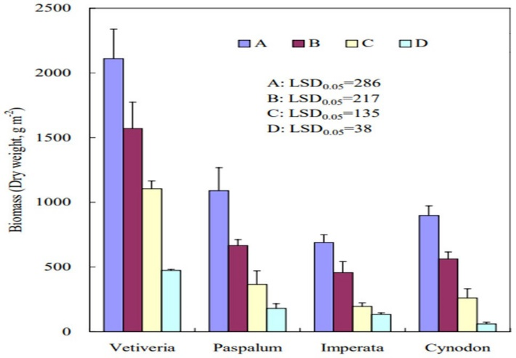
Fig. 17. Paspalum notatum, Imperata cylindrica, Cynodon dactylon, and Vetiveria zizanioides biomass (Shu et al., 2002)

The effectiveness of Vetiver in remediating polluted environments is well documented. Research has shown Vetiver’s high tolerance to pollutants, with the plant’s roots able to absorb up to 4,500 mg/kg of lead under laboratory conditions. Most importantly, the plant maintains a low lead concentration in the shoots, which is safe for use in phytostabilization (Chantachon et al., 2004). Similarly, in another study, after being subjected to Cadmium (Cd), the plant’s roots accumulated over 2,200 mg/kg of Cd. Although plant health parameters, such as chlorophyll content, were variable, plant survival was consistent (Aibibu et al., 2010). Field studies in Burkina Faso confirmed Vetiver’s high potential for remediating both Copper (Cu) and Cadmium (Cd) in soils. The plant accumulated up to 4,635mg/kg of Cu and 21.8mg/kg of Cd in local soils. These studies also indicated a better phytoextraction potential for Cd than for Cu (Abaga et al., 2014a). In a similar vein, it was also established that it significantly reduces pesticide residues, such as endosulfan, in cotton soil (Abaga et al., 2014b). Another plant considered a hyperaccumulator is vetiver. Studies have shown that it is possible to increase metal hyperaccumulation in vetiver using chelating agents. Specifically, it was established that EDTA is most efficient for Pb phytoextraction, and that chelating agents are also efficient for hyperaccumulating Cu and Zn (Chen et al., 2012). Although vetiver proved efficient at hyperaccumulating Pb and Zn, it was less successful at hyperaccumulating chromium and Cu, making it a strong tool for cleanup of Pb and Zn pollutants (Antiochia et al., 2007). Collectively, these investigations confirm its consistent ability to extract lead, cadmium, zinc, copper, and arsenic under various conditions, achieving uptake efficiencies generally ranging between 50% and 70% of the available metal load while maintaining high survival rates. The use of vetiver grass for phytoremediation, specifically the uptake and accumulation of different heavy metals from contaminated media, is summarized in Table 5.

Table 5. Effects of vetiver grass on heavy metal accumulation based on the data collected from different studies
Metal Tested | Experimental Setup | Outcomes and Effectiveness | Important Findings | Study
Lead | Field (3 months, sandy loam) + lab (hydroponic Pb(NO₃)₂ irrigation,  5–11 g/L) | Maximum roots: 4,545 mg/kg, maximum shoots: 775 mg/kg (V. zizanioides) Field: Maximum shoots:  573 mg/kg, roots: 2,843 kg/mg; additionally, roots are high, shoots are  moderate, and V. zizanioides is higher. | V. zizanioides tolerant to high Pb, V. nemoralis sensitive at  >7 g/L; roots accumulated  >80% Pb; field phytoextraction coeff. up to 32 | Chantachon  et al. (2004)
Lead | Pb treatments (100–10,000 mg/kg) were implemented in glasshouse pot trials on mine soil.  Pig manure (20%, 40%) and fertilizer (75, 150 mg/kg) were implemented as amendments. | Maximum shoot lead content: 425 mg/kg (V. zizanioides Songkhla), maximum root lead content: 5,950 mg/kg (V. zizanioides Kamphaeng Phet)  Extremely high root accumulation and little shoot transfer | Roots >90% Pb pig manure  Pb bioavailability fertilizer Identification of Pb availability-tolerant ecotypes | Rotkittikhun  et al. (2007)

Table 5. cont.
Metal Tested | Experimental Setup | Outcomes and Effectiveness | Important Findings | Study
Lead,  copper,  zinc,  cadmium | Leaching column tests using pots containing Pb-contaminated soil (500–5000 mg/kg) plus EDTA (0–5 mmol/kg) | 243 mg/kg of shoots, 2,280 mg/kg of roots, 132.8 mg/kg of Cu, 59.6 mg/kg of Zn, and 0.2 mg/kg of Cd are found in the plant. Low for Cd, moderate for Cu/Zn, and high for Pb in roots | EDTA enhanced Pb uptake and translocation; retained Pb in the root zone up to 98% Most metals were root-preferential | Chen  et al. (2004)
Arsenic | Five soil types; as at 45, 225, and 450 mg/kg; four months of growth; greenhouse pot study | Roots are more effective than shoots at getting rid of them (Millhopper, 45 mg/kg); shoots can get up to 600 mg/kg of As (Orelia soil, high As).  When As is high, moderate, or root-preferential, efficiency goes down. | Tolerable up to 225 mg/kg Uptake depends on soil chemistry, just like with minor symptoms Fe/Al-rich soils pick up | Datta  et al. (2011)
Arsenic | Glasshouse hydroponic "pot & pail" system; sandy soil plus groundwater (5.5 mg/L As); Fulvic acid and straw water (0.01%, 0.1%) are the additions. | Fulvic acid effects mixed; highest shoot As with straw water 0.1%; root As ≈ 47.8% with straw water 0.1% High shoot and root uptake with amendment; without moderate | Improved growth/uptake with straw water; Variable effect of fulvic acid complexation; Low-costamendment potential | Zhuang  & Hazelton (2013)
Cadmium | Hydroponic; 0, 1, 7.5, 15, 30 mg/L Cd for 15 days | Roots: 262.9-2,233 mg/kg DW Shoots: 27.9-92.8 mg/kg Maximum DW at 30 mg/L  Low for shoots, high for roots | Low Cd (1 mg/L) decreased biomass by 2.3%; 96% of the Cd was found in the roots; TF was less than 0.23; the amount  of Cd in the plants was close to the hyperaccumulator threshold (92.8 mg/kg vs. 100 mg/kg); they had a strong antioxidant defense. | Aibibu  et al. (2010)
Copper, Zinc,  Lead | Hydroponic & pot trials with EDTA, EDDS, citric acid (soil: 1000 mg/kg Cu, 8000 mg/kg Zn, 8000 mg/kg Pb) | Zn: >10,000 mg/kg shoots (all chelators); Pb: 1,126 mg/kg (EDTA); Cu: 936 mg/kg (EDDS).  Very high with chelator enhancement | Cu, Zn, and Pb are hyperaccumulators. EDTA is most toxic but best for Pb. Biodegradable chelators are less toxic. | Chen  et al. (2012)
Chromium, Copper, Lead, Zinc | Pot experiment | Zn: 1% shoots and roots; Pb: 0.4% shoots and 1% roots; Cr & Cu: <0.1% High to moderate (Pb, Zn) | Pb and Zn hyper-accumulators, with poor performance for Cr and Cu. | Antiochia  et al. (2007)

The graph also confirms the two major phytoremediation strategies that are discussed in the table above. One is phytostabilisation, and the other is chelation-assisted phytoextraction. From the graph, it is also clear that Vetiver is mainly involved in the phytoremediation of metals such as Lead (Pb) and Cadmium (Cd), which are concentrated in plant roots (high orange line). Moreover, it is clear that in phytoextraction, assisted by chelators such as EDTA, plants can hyperaccumulate metals, such as Zinc (Zn), in both their roots and shoots (high overlapping lines). The various points on a graph that describe a particular metal, such as Lead (Pb), also indicate how the experimental setup and additions discussed in the table above can significantly impact the plant's ability to accumulate metals (as shown in Figure 18).

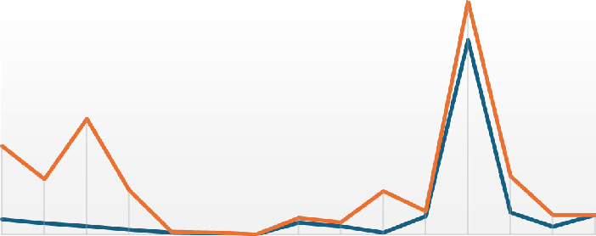
CONCENTRATION MG/KG
14000
12000
10000
8000
6000
4000
2000
0
Max Shoot Uptake (mg/kg DW)
Max Root Uptake (mg/kg DW)
Pb Pb Pb Pb Cu Zn Cd As As Cd Cu Zn Pb Pb Zn
METAL TESTED
Fig. 18. The accumulation of metals in the roots and shoots of Vetiver and related species, as reported in individual studies

4.2. Bioengineered Natural Systems
Plants are transforming civil engineering by being potent agents of environmental healing and reinforcement. This is an exemplary case of the versatility of vetiver grass. It can thrive under severe crude oil contamination in Venezuela (Brandt et al., 2006), improve the stability of embankment slopes in Bangladesh (Islam et al., 2013), and remove over 70% of the toxic compounds such as PBDEs, PCBs, and PAHs from e-waste sites while accumulating heavy metals (Ye et al., 2014; Chiu et al., 2006). Phytoremediation is becoming popular for solving contemporary environmental engineering challenges, considering its low cost of only 5% of conventional methods of cleanup (Ali et al., 2013). Urea enhances vetiver's effectiveness in decontaminating TNT explosive pollutants at old military sites (Melato et al., 2016). Meanwhile, strategic soil additives, such as composted manure, increase nutrient content and reduce bioavailable heavy metals in mine tailings (Chiu et al., 2006). Clay is another useful material for removing aluminium and manganese from polluted water; bentonite is also useful (Otunola et al., 2023). Aside from rehabilitating the environment, plants also provide mechanical stability. For instance, grass can hold up to 25.3 MN/m², while trees can hold up to 68 MN/m² (Coppin & Richards, 1990). Vetiver's root systems, which span three to four meters, can withstand temperatures ranging from -20°C to 60°C and have an efficiency of 86-90% in the removal of nitrogen and phosphorus (Srivastava et al., 2008). Different species focus on different types of pollution. For example, Thlaspi caerulescens is effective at removing cadmium and zinc from the surface, while maize and willows work in deeper layers of the soil (Keller et al., 2003). Vetiver stores metals in its roots, collecting up to 218 g/ha of cadmium (Chen et al., 2000). It has been very useful in southern Africa and tropical Asia for controlling erosion and stabilizing slopes (Erskine, 1992; Flathman & Lanza, 1998). Hyperaccumulator plants have amazing potential because they can take up more than 1,000 mg/kg of heavy metals, such as copper and nickel. Some species can even take up more than 10,000 mg/kg of zinc (Ali et al., 2013). Native metalliferous plants offer an inexpensive and unobtrusive way to clean up contamination, reducing it to levels that are safe under the law (Baker et al., 1994). Field studies show that stakeholders are more likely to adopt new practices when immediate benefits are evident rather than when long-term conservation gains are expected (Hellin & Haigh, 2002; Pandey et al., 2025; Leknoi et al., 2025). In this context, geotechnical, geosynthetics, and geoenvironmental engineering must move beyond cost and performance criteria to quantitatively integrate sustainability and resilience, using standardized and transparent assessment frameworks to support informed decision-making (Reddy & Janga, 2025).
5. Current Government Initiatives and Sustainable Practices
5.1. Government Initiatives in India
India has increasingly recognized nature-based solutions as an integral component of sustainable land management and ecosystem restoration. Several national programmes emphasize soil and water conservation, afforestation, watershed development, and climate-resilient infrastructure, providing opportunities to adopt bioengineering approaches such as the Vetiver System. Although most government programmes do not specifically mandate the use of vetiver grass, their objectives closely align with vegetation-based stabilization techniques for controlling erosion, restoring degraded landscapes, and enhancing slope stability.
The Green India Mission (GIM), under the National Action Plan on Climate Change (NAPCC), aims to restore landscapes through afforestation, ecological rehabilitation, and the augmentation of ecosystem services (Ministry of Environment, Forests and Climate Change (MoEFCC, 2017). These objectives promote the use of vegetation-based engineering measures for stabilization of degraded slopes and reduction of soil erosion. The National Afforestation Programme (NAP) also aims to restore degraded forests through participatory forest management, thereby improving soil conservation and watershed health (MoEFCC, 2019). The National Mission for Sustainable Agriculture (NMSA) also promotes climate-resilient agriculture by calling for soil and water conservation measures to curb land degradation, promote resource-use efficiency and stability (National Mission for Sustainable Agriculture, 2010). Similarly, the Watershed Development Component of Pradhan Mantri Krishi Sinchayee Yojana (WDC–PMKSY) initiatives integrates watershed management using tools such as runoff control, vegetative barriers and erosion control (Department of Land Resources), where vetiver hedgerows have exhibited significant potential due to their deep-root systems coupled with a high adaptability to changing climate zones (Sharma & Kumar, 2025; The Vetiver Network International). Bioengineering approaches beyond watershed management – Bioengineering techniques are increasingly being considered for transportation infrastructure. The advent of technical guidelines from authorities such as the Indian Roads Congress (IRC), along with practices adopted in highway and railway projects, has highlighted vegetation as a non-engineering control that can be used as a secondary tier for slope stabilization, particularly when combined with engineering structures. These hybrid methods, which reduce erosion and improve the long-term performance of slopes, are also a step toward eco-sustainable infrastructure development. As is well documented, the example of Indian Railways practice establishes this: As part of spilt function due to slope stabilisation, over 10 million vetiver slips were planted by Konkan Railway and no major disruption in traffic was ever reportedr post implementation (The Vetiver Network International, 2009), some manual guidelines for using vetiver based slope stabilization have been released by the Research Designs and Standards Organisation (RDSO) which has been implemented on the Lumding–Badarpur hill section of North East Frontier Railway (National Institute of Disaster Management, 2023). These hybrid methods serve to reduce erosion, enhance slope performance over longer periods, and support environmental sustainability in infrastructure design (Ghosh & Bhattacharya, 2018; Bracken & Truong, 1999; Sanguankaeo et al., 2003).
5.2. International Practices
Vetiver System has been a proven, cost-effective bioengineering technology for controlling erosion, stabilizing slopes, and promoting ecological restoration in more than 100 countries. Vetiver's versatility in low-climate and geologically diverse settings allows its application on land as diverse as tropical riverbanks and mountainous transport corridors.
Vetiver grass has been widely used across China for highway slope cut stabilization, mine spoil rehabilitation, and ecological restoration of degraded landscapes (Ke et al., 2003; Sanguankaeo et al., 2003). Research in the country indicates that due to vetiver's extensive root system, soil shear strength is dramatically enhanced, reducing surface runoff and sediment transport (Wang et al., 2020; Zhou et al., 2016). The Vetiver System has been one of the most successful large-scale implementations in Vietnam. Heavy rains have caused many landslides and heavy damage to infrastructure. Vetiver is now being used on highway embankments, riverbanks, and reservoir slopes as an economical alternative or complement to conventional engineering practices (Truong, 2004). Tropical climates have seen significant decreases in erosion and increased slope stability in field applications (Phan et al., 2025). In Thailand, vetiver has been promoted by the Royal Development Projects, where it has been widely used for watershed conservation, protection of agricultural land, and rehabilitation of degraded slopes. These initiatives have played a pivotal role in raising awareness and showcasing the long-term environmental and economic advantages of vegetation-driven engineering approaches (Chulalongkorn University, 2026). In Australia and South Africa, vetiver has been used mainly for mine rehabilitation and stabilization of waste dumps, tailings storage facilities, and highly erodible embankments (Vetiver Australia, 2025). The species has been particularly successful in these areas due to its ability to tolerate adverse environmental conditions and to develop dense root networks that stabilize loose soils (Mlalazi et al., 2025). Similarly, Fiji and some Pacific Island nations have employed vetiver to protect riverbanks, coastal embankments, and watersheds susceptible to heavy rainfall and tropical storms (Ocean & Climate Platform, 2021; The Commonwealth, 2022). The applications illustrate the adaptability of the Vetiver System to a range of climatic and geomorphic conditions, and highlight its role in building ecosystem resilience and reducing disaster risk. Table 6 summarizes the applications of vetiver grass across different countries.

Table 6. Representative international applications of the Vetiver System in slope stabilization, erosion control, mine rehabilitation, and ecological restoration
Country/Region | Major Applications | Key Outcomes | References
China | Highway cut slopes, mine spoil rehabilitation, ecological restoration of degraded lands | Improved soil shear strength, reduced surface runoff and sediment transport, enhanced vegetation establishment on steep slopes | Ke et al. (2003); Sanguankaeo et al. (2003); Wang et al. (2020); Zhou et al. (2016)
Vietnam | Highway embankments, riverbanks, reservoir slopes, landslide-prone areas | Reduced soil erosion, improved slope stability, cost-effective alternative to conventional engineering measures under high rainfall conditions | Truong et al. (2008);  Truong (2004); Phan et al. (2025)
Thailand | Watershed conservation,  agricultural land protection, degraded slope rehabilitation | Enhanced soil and water conservation, increased awareness of bioengineering approaches through Royal Development Projects | Sanguankaeo et al. (2003); Hengchaovanich & Nilaweera (1996); Truong et al. (2008)
Australia | Mine rehabilitation, waste dumps, tailings storage  facilities, road embankments | Stabilized disturbed mine lands, controlled erosion, improved revegetation under harsh environmental conditions | Vetiver Australia (2025); Mlalazi et al. (2025)
South Africa | Mine rehabilitation, sugarcane fields, erodible  embankments | Reduced gully erosion, stabilized loose soils, improved long-term land rehabilitation | Mlalazi et al. (2025)
Fiji and Pacific Islands | Riverbanks, coastal embankments, watershed management | Increased resilience against tropical storms, reduced riverbank erosion, improved ecosystem restoration | Ocean & Climate Platform (2021); The Commonwealth (2022)
5.3. Current Challenges
The Vetiver System has been effective, but several challenges limit its widespread adoption. One of the major constraints is the lack of accepted engineering design standards and specifications for plantation density, spacing, maintenance requirements, and integration with conventional stabilization measures. This means that project performance is often a matter of local experience rather than standard engineering practice. Another important challenge is ensuring the plants establish successfully during the initial growth period. Adequate irrigation, maintenance, and protection from grazing usually help develop a mature root system. Moreover, the efficiency of vetiver depends on local soil characteristics, climate conditions, rainfall intensity, and slope geometry, suggesting that site-specific design remains essential. Long-term field monitoring is also relatively scarce in comparison with conventional geotechnical stabilization methods. Further research is therefore needed to quantify long-term mechanical reinforcement, hydraulic behaviour and resilience under changing climatic conditions. Demonstration projects and technical guidelines to increase awareness among engineers, planners, and policymakers would further assist in the integration of vetiver into sustainable infrastructure development (Kim et al., 2022).
6. Environmental Footprint of Vetiver-Based Slope Stabilization
Vetiver-based bioengineering offers a significantly lower environmental footprint than conventional stabilization techniques that rely heavily on concrete, steel, and synthetic materials, while also providing multiple ecosystem services. Chrysopogon zizanioides' extensive root system is deep. It leads to soil reinforcement, increased infiltration, decreased surface runoff and sediment transport without the need for energy-intensive construction materials. Reductions in runoff volume of 35–90% and sediment concentration of 42–94% have been shown in field trials of vegetative buffer strips (Saleh et al., 2018; Hussein et al., 2007). In a field study on medicinal vetiver cropping in tropical regions, vetiver sequesters 15.24 Mg C/ha/year in shoot and root biomass, significantly more than lemongrass, palmarosa, or tree species measured in the same study (Singh et al., 2014). Thus, the use of vegetation-based stabilization as a primary or complementary solution can significantly reduce greenhouse gas emissions associated with material production and transportation.
In addition to mechanical stabilization, vetiver plays a role in carbon sequestration through its continuous biomass production and soil organic carbon accumulation. In glasshouse trials on Australian soils, vetiver produced large shoot and root biomass (67.7 and 52.5 Mg/ha dry biomass, respectively), and vetiver roots contributed much more to stable soil organic matter accumulation than shoots (Tessema et al., 2022). Its extensive root network improves soil structure, stimulates microbial activity, and increases organic matter content, leading to long-term soil fertility and ecosystem recovery. Vetiver’s characteristics make it particularly suitable for rehabilitating degraded landscapes, abandoned mines, and watersheds prone to erosion. Vetiver’s ecological benefits extend beyond soil conservation. Vetiver offers ecological benefits beyond soil conservation. Vegetated buffer strips, including those with vetiver, have been shown to reduce nitrate concentrations in runoff by 35–88% and phosphate concentrations by 28–95% (Hussein et al., 2007). Bioengineering with vetiver consumes less material, produces fewer greenhouse gases, and provides greater ecological benefits than conventional slope stabilization techniques such as retaining walls, soil nailing, and anchoring. However, its application is typically most useful for shallow slope failures and erosion control, while conventional engineering methods are better suited to deep-seated failures and high-risk infrastructure. Thus, hybrid methods combining vegetation reinforcement and structural reinforcement have emerged as promising approaches to achieve both engineering reliability and environmental sustainability. Recent studies indicate that integrated gray-green solutions might provide better long-term performance than either approach taken alone (Uzielli et al., 2025). Moreover, vetiver has shown high potential for phytoremediation by absorbing heavy metals and other contaminants, thereby improving the environmental quality of disturbed ecosystems. These multiple ecosystem services are consistent with the principles of nature-based solutions. One study based in Thailand that analyzes four community-level vetiver landslide-protection projects explicitly frames the practice as a pathway toward multiple UN Sustainable Development Goals, including SDG 15 (Life on Land), as well as SDG 1, SDG 2, SDG 11, and SDG 13 (Leknoi et al., 2025).
7. Future Research Directions and Proposed Hybrid Framework
The present review proposes a hybrid, nature-based slope stabilisation approach that combines the biological reinforcement of Vetiver grass roots with the mechanical confinement of geocell reinforcement. Although Vetiver has been widely recognised for its exceptional root strength and erosion-control potential, most existing studies have examined its performance in isolation and under limited loading conditions. In reality, slopes in mountainous regions, particularly in the Himalayas, are often exposed to multiple hazards acting together, where prolonged rainfall weakens the soil while seismic shaking triggers rapid deformation and failure. Despite this real-world scenario, the interaction of vegetation-based reinforcement under combined rainfall-seismic loading remains poorly understood. To address this critical gap, the proposed research adopts a laminar box-based experimental framework to simulate the deformation behaviour of vegetated slopes subjected to rainfall infiltration and dynamic shaking. The study aims to observe how root–soil interlocking and geocell confinement work together to reduce displacement, delay failure, and enhance the overall stability of the slope. By treating roots as active structural elements, the research moves beyond conventional vegetation studies, which often focus only on surface erosion or small-scale root tests. The novelty of this work lies in its fusion of engineering and ecology, offering a practical pathway toward low-carbon, self-reinforcing, and climate-resilient slope protection. Unlike traditional concrete retaining systems and HDPE-based geocells, the vetiver–geocell combination has the potential to restore natural soil structure, support vegetation growth, and reduce life-cycle maintenance costs, all while maintaining engineering reliability. This research is therefore innovative not only in its experimental methodology but also in its underlying philosophy: that living systems, when supported by smart geotechnical design, can create safer, more sustainable slopes. The anticipated outcomes may contribute to future design guidelines and promote wider adoption of bio-engineered, nature-based solutions for landslide mitigation. Figure 19 demonstrates the novel research approach by illustrating how the engineered geocell provides immediate mechanical reinforcement and prevents surface erosion. Simultaneously, the illustration shows the dense, deep Vetiver root system extending into the soil, acting as an active biological reinforcement that increases soil shear strength and prevents deep-seated movement.

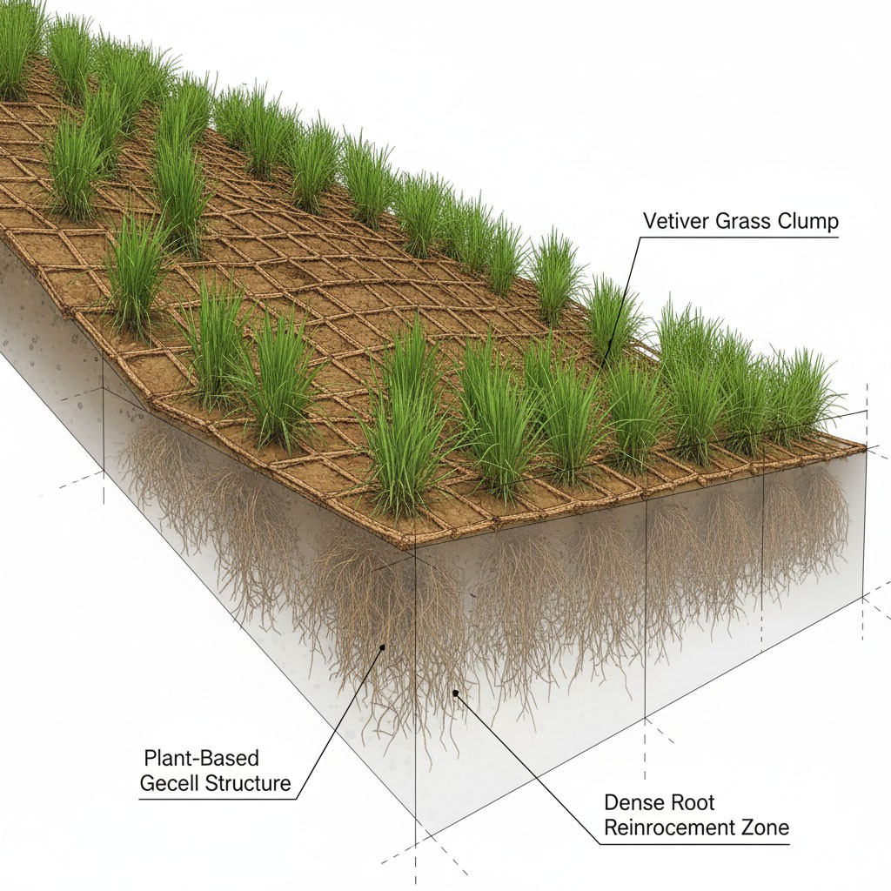
Fig. 19. Hybrid bio-engineered slope stabilisation system combining a geocell confinement matrix with vetiver grass planting
8. Discussion
Excessive precipitation, often intensified by climate change, is a major contributor to landslides. Soil bioengineering using plants is emerging as a permanent, nature-based approach to reducing slope failures, especially those triggered by heavy rainfall. Vetiver grass is a good alternative to traditional slope stabilization because it affects the slope both mechanically and hydrologically. Mechanically, its dense roots, which can reach up to 3 meters and possess an ultimate tensile strength of at least 17 MPa for finer specimens and, in some cases, the mean tensile strength of matured vetiver root was found to be 27 MPa. It increases soil cohesiveness, friction angle, and peak shear stress. Such reinforcement makes it flexible so that it may bend before breaking. Soil yielding is also an indication of a landslide. From a hydrological perspective, shear strength is typically reduced in saturated soils. However, with the extensive root system of vetiver, there is no soil saturation, as it is actively engaged in evapotranspiration. Such activity reduces pore-water pressure and increases beneficial matric suction, thereby improving soil shear strength. Adult vetiver plants have sufficient strength to reduce the depth of the slip surface on the slope during rain. Such activity is pronounced at the toe of the slope. Besides slope stability, vetiver has been recognized for its use in phytoremediation, an eco-friendly approach to controlling environmental degradation. Over the last two decades, the grass has been shown to possess an incredible self-regulatory mechanism, enabling it to survive and adapt to various environmental extremes, such as high temperatures, salinity, alkalinity, flooding, and metal poisoning. Vetiver has shown great promise for the remediation of sites with high levels of metals, such as lead (Pb) and cadmium (Cd), due to its rapid growth and biomass production. This includes remediation capacity for arsenic uptake in sandy soils, which can be achieved using straw water as an amendment. Moreover, vetiver grass has shown increased essential oil production in response to lead exposure, indicating it can be used as a multipurpose tool for cleaning up sites (such as removing Al and Mn from contaminated water) and is economically significant. Most importantly, vetiver grass has shown great promise in cleaning up and reducing the risks posed by coal fly ash (FA), including metals in the root system and genotoxicity, making it an ideal candidate for cleaning up FA dump sites. While promising, further research is needed to transition these controlled findings to full-scale applications under diverse field conditions.
9. Future Scope and Conclusion
Landslides are a major form of natural disaster worldwide, and Asia has recorded the highest number of landslide fatalities. South and Southeast Asia have been recognized as hotspots of landslide vulnerability owing to climate change, excessive rainfall, and uncontrolled slope alterations. Vetiver grass is an ecologically safe and effective solution to landslides and environmental degradation owing to its ability to withstand extremes of climate, pH level (3.3 to 9.5), salinity, flooding, and heavy metals. Its extensive root system enhances its ability to increase soil shear strength and cohesion, thus providing an effective solution to shallow landslides caused by excessive rainfall or erosion on unstable terrain. Vetiver plantations have been included in slope protection measures to decrease the probability of slope failure, improve drainage, increase soil shear strength by as much as 50 percent, increase slope factors of safety by 6 to 20 percent, and build slope strength over time. Vetiver grass, a dual-functioning plant, is used to mitigate soil degradation, erosion, landslides, and other climate-related hazards. Its ability to grow even on contaminated soils has been well documented, with research showing its use in cleaning up contaminated soils and re-establishing life on lands devastated by mining activities. At the same time, vetiver acts as a natural phytostabilizer and hyperaccumulator of heavy metals such as Pb and Zn, confining contaminants largely to its roots and preventing their spread. Nature-based solutions, particularly vetiver grass, have gained prominence as bioengineering interventions for shallow landslide control. Vetiver’s high tensile root system greatly enhances the shear strength and cohesion of soils and also regulates hydraulic flows.
In contrast, its high tolerance for degraded and contaminated soils makes it suitable for simultaneous slope stabilization and ecological remediation. All these properties make vetiver a multifunctional and living infrastructure for slope stabilization and resilience to climate change. Despite the extensive application of the Vetiver System in erosion control and slope stabilization, several research gaps remain that warrant further investigation. The grass has been used to rehabilitate highways and mine-slopes in China, mitigate landslides in Vietnam, conserve watersheds in Thailand, and restore mine-lands in Australia and South Africa. In the Indian context, initiatives such as the Green India Mission and the Watershed Development Component of PMKSY are closely aligned with the objectives of vegetation-based stabilization. Its efficacy has already been proven at scale by Indian Railways, which has planted over ten million vetiver slips. However, the lack of engineering design standards, especially regarding plantation density, spacing, and maintenance protocols, and the lack of long-term field monitoring data still restrict its wider engineering application. Hence, future research should be directed towards standardised design guidelines and the quantification of long-term mechanical and hydrological performance under field conditions. In this context, the present review proposes a hybrid vetiver–geocell system, evaluated under combined rainfall-seismic loading, as a novel contribution to filling this gap and advancing climate-resilient, bio-engineered slope stabilization solutions for landslide-prone mountainous terrain.
Statements and Declarations Clinical trial number
Not applicable.
Acknowledgement
The authors gratefully acknowledge Jaypee University of Information Technology, Himachal Pradesh, India, for providing the necessary facilities and institutional support for this study. This research did not receive any specific grant from funding agencies in the public, commercial, or not-for-profit sectors.
Data Availability
Data are already included in the manuscript file.
Ethical Approval
Not applicable.
Consent to Publish
All the authors consent to the publication of this manuscript.
References
Abaga, N.O.Z., Dousset, S., Mbengue, S., & Munier-Lamy, C. (2014). Is vetiver grass of interest for the remediation of Cu and Cd to protect market gardening soils in Burkina Faso? Chemosphere, 113, 42–47. https://doi.org/10.1016/j.chemosphere.2014.04.010
Abaga, N.O.Z., Dousset, S., Munier-Lamy, C., & Billet, D. (2014). Effectiveness of vetiver grass (Vetiveria zizanioides L. Nash) for phytoremediation of endosulfan in two cotton soils from Burkina Faso. International Journal of Phytoremediation, 16(1), 95–108. https://doi.org/10.1080/15226514.2012.759531
Aibibu, N., Liu, Y., Zeng, G., Wang, X., Chen, B., Song, H., & Xu, L. (2010). Cadmium accumulation in Vetiveria zizanioides and its effects on growth, physiological and biochemical characters. Bioresource Technology, 101(16), 6297–6303. https://doi.org/10.1016/j.biortech.2010.03.028
Ali, F., Ali, F.H., & Osman, N. (2008). Shear strength of a soil containing vegetation roots. Soils and Foundations, 48(4), 587–596. https://doi.org/10.3208/sandf.48.587
Ali, H., Khan, E., & Sajad, M.A. (2013). Phytoremediation of heavy metals—Concepts and applications. Chemosphere, 91(7), 869–881. https://doi.org/10.1016/j.chemosphere.2013.01.075
Angin, I., Turan, M., Ketterings, Q.M., et al. (2008). Humic acid addition enhances B and Pb phytoextraction by vetiver grass (Vetiveria zizanioides (L.) Nash). Water, Air, and Soil Pollution, 188, 335–343.
https://doi.org/10.1007/s11270-007-9548-0
Antiochia, R., Campanella, L., Ghezzi, P., et al. (2007). The use of vetiver for remediation of heavy metal soil contamination. Analytical and Bioanalytical Chemistry, 388, 947–956. https://doi.org/10.1007/s00216-007-1268-1
Asian Development Bank. (n.d.). Enhancing climate resilience of coastal communities sector project. https://www.adb.org/sites/default/files/linked-documents/58056-001-cca.pdf
Aziz, S., Islam, M. S., & Islam, M. S. (2022). Mechanical effect of vetiver grass root for stabilization of natural and terraced hill slope. Geotechnical and Geological Engineering. https://doi.org/10.1007/s10706-022-02092-y
Badhon, F. F., Islam, M. S., & Islam, A. (2021). Contribution of vetiver root on the improvement of slope stability. Indian Geotechnical Journal, 51(4), 829–840. https://doi.org/10.1007/s40098-021-00557-0
Badhon, F. F., Islam, M. S., Islam, M. A., et al. (2021). A simple approach for estimating contribution of vetiver roots in shear strength of a soil–root system. Innovative Infrastructure Solutions, 6, Article 96.
https://doi.org/10.1007/s41062-021-00469-1
Baker, A. J. M., McGrath, S. P., Sidoli, C. M. D., & Reeves, R. D. (1994). The possibility of in situ heavy metal decontamination of polluted soils using crops of metal-accumulating plants. Resources, Conservation and Recycling,
11(1–4), 41–49. https://doi.org/10.1016/0921-3449(94)90077-9
Banerjee, R., Goswami, P., Pathak, K., & Mukherjee, A. (2016). Vetiver grass: An environment clean-up tool for heavy metal contaminated iron ore mine-soil. Ecological Engineering, 90, 25–34. https://doi.org/10.1016/j.ecoleng.2016.01.027
Barcellos-Silva, I. G. C., dos Santos, F. K. F., Kharkwal, H., Chander, S., Kharkwal, A. C., Awasthi, R., Dhiman, N., Sharma, B., Kulkarni, G. T., & Larssen, H. (2025). Vetiver, Vetiveria zizanioides (L.) Nash: Biotechnology, biorefineries, and the production of volatile phytochemicals. Plants, 14(10), Article 1435. https://doi.org/10.3390/plants14101435
Bracken, N., & Truong, P. N. (2000). Application of Vetiver grass technology in the stabilization of road infrastructure in the wet tropical region of Australia. In Proceedings of the Second International Vetiver Conference (ICV-2). Thailand.
Brandt, R., Merkl, N., Schultze-Kraft, R., Infante, C., & Broll, G. (2006). Potential of vetiver (Vetiveria zizanioides (L.) Nash) for phytoremediation of petroleum hydrocarbon-contaminated soils in Venezuela. International Journal of Phytoremediation, 8(4), 273–284. https://doi.org/10.1080/15226510600992808
Castellanos, B.A., & Brandon, T.L. (2013). A comparison between the shear strength measured with direct shear and triaxial devices on undisturbed and remoulded soils. In Proceedings of the International Society for Soil Mechanics and Geotechnical Engineering (ISSMGE) (pp. 317–320). Paris, France.
https://www.cfms-sols.org/sites/default/files/Actes/317-320.pdf
Chakraborty, A., & Khan, S. (2024). Soil bioengineering using vetiver for climate-adaptive slope repair: A review. Natural Hazards Review, 25(3). https://doi.org/10.1061/NHREFO.NHENG-2014
Chantachon, S., Kruatrachue, M., Pokethitiyook, P., et al. (2004). Phytoextraction and accumulation of lead from contaminated soil by vetiver grass: Laboratory and simulated field study. Water, Air, and Soil Pollution, 154, 37–55 https://doi.org/10.1023/B:WATE.0000022926.05464.74
Chen, H. M., Zheng, C. R., Tu, C., & Shen, Z. G. (2000). Chemical methods and phytoremediation of soil contaminated with heavy metals. Chemosphere, 41(1–2), 229–234. https://doi.org/10.1016/S0045-6535(99)00415-4
Chen, K. F., Yeh, T. Y., & Lin, C. F. (2012). Phytoextraction of Cu, Zn, and Pb enhanced by chelators with vetiver (Vetiveria zizanioides): Hydroponic and pot experiments. Journal of Chemistry. https://doi.org/10.5402/2012/729693
Chen, X. W., Wong, J. T. F., Wang, J. J., & Wong, M. H. (2021). Vetiver grass–microbe interactions for soil remediation. Critical Reviews in Environmental Science and Technology, 51(9), 897–938. https://doi.org/10.1080/10643389.2020.1738193
Chen, Y., Shen, Z., & Li, X. (2004). The use of vetiver grass (Vetiveria zizanioides) in the phytoremediation of soils contaminated with heavy metals. Applied Geochemistry, 19(10), 1553–1565.
https://doi.org/10.1016/j.apgeochem.2004.02.003
Chiu, K.K., Ye, Z.H., & Wong, M.H. (2005). Enhanced uptake of As, Zn, and Cu by Vetiveria zizanioides and Zea mays using chelating agents. Chemosphere, 60(10), 1365–1375. https://doi.org/10.1016/j.chemosphere.2005.02.035
Chiu, K.K., Ye, Z.H., & Wong, M.H. (2006). Growth of Vetiveria zizanioides and Phragmites australis on Pb/Zn and Cu mine tailings amended with manure compost and sewage sludge: A greenhouse study. Bioresource Technology, 97(1), 158–170. https://doi.org/10.1016/j.biortech.2005.01.038
Chulalongkorn University. (2026, April 29). "Vetiver grass" innovation to handle global changes: Chula drafts master plan on using vetiver grass for soil and water conservation. https://www.chula.ac.th/en/news/137274/
Coppin, N.J., & Richards, I.G. (1990). Use of vegetation in civil engineering.
Available: https://www.ciria.org/CIRIA/ProductExcerpts/C708.aspx
D’Souza, D.N., Choudhary, A.K., Basak, P., & Shukla, S.K. (2019). Assessment of vetiver grass root reinforcement in strengthening the soil. In T. Thyagaraj (Ed.), Ground improvement techniques and geosynthetics (Lecture Notes in Civil Engineering, Vol. 14). Springer. https://doi.org/10.1007/978-981-13-0559-7_15
Dalton, P.A., Smith, R.J., & Truong, P.N.V. (1996). Vetiver grass hedges for erosion control on a cropped flood plain: Hedge hydraulics. Agricultural Water Management, 31(1–2), 91–104. https://doi.org/10.1016/0378-3774(95)01230-3
Danh, L.T., Truong, P., Mammucari, R., Tran, T., & Foster, N. (2009). Vetiver grass (Vetiveria zizanioides): A choice plant for phytoremediation of heavy metals and organic wastes. International Journal of Phytoremediation, 11(8), 664–691. https://doi.org/10.1080/15226510902787302
Datta, R., Quispe, M.A., & Sarkar, D. (2011). Greenhouse study on the phytoremediation potential of vetiver grass, Chrysopogon zizanioides L., in arsenic-contaminated soils. Bulletin of Environmental Contamination and Toxicology, 86(1), 124–128. https://doi.org/10.1007/s00128-010-0185-8
Department of Land Resources, Ministry of Rural Development, Government of India. Watershed Development Component of PMKSY. https://dolr.gov.in/wdcpmksy/
Donjadee, S., & Chinnarasri, C. (2012). Effects of rainfall intensity and slope gradient on the application of vetiver grass mulch in soil and water conservation. International Journal of Sediment Research, 27(2), 168–177. https://doi.org/10.1016/S1001-6279(12)60025-0
Donjadee, S., & Tingsanchali, T. (2016). Soil and water conservation on steep slopes by mulching using rice straw and vetiver grass clippings. Agriculture and Natural Resources, 50(1), 75–79.
https://doi.org/10.1016/j.anres.2015.03.001
Eab, K.H., Likitlersuang, S., & Takahashi, A. (2015). Laboratory and modelling investigation of root-reinforced system for slope stabilisation. Soils and Foundations, 55(5), 1270–1281. https://doi.org/10.1016/j.sandf.2015.09.025
Erskine, J.M. (1992, January). Vetiver grass: Its potential use in soil and moisture conservation in southern Africa. https://doi.org/10.10520/AJA00382353_9514
Flathman, P.E., & Lanza, G.R. (1998). Phytoremediation: Current views on an emerging green technology. Journal of Soil Contamination, 7(4), 415–432. https://doi.org/10.1080/10588339891334438
Froude, M.J., & Petley, D.N. (2018). Global fatal landslide occurrence from 2004 to 2016. Natural Hazards and Earth System Sciences, 18(8), 2161–2181. https://doi.org/10.5194/nhess-18-2161-2018
Gariano, S.L., & Guzzetti, F. (2016). Landslides in a changing climate. Earth-Science Reviews, 162, 227–252. https://doi.org/10.1016/j.earscirev.2016.08.011
Ghosh, C., & Bhattacharya, S. (2018). Landslides and erosion control measures by Vetiver system. In Disaster risk governance in India and cross cutting issues (pp. 387–413). Springer.
https://link.springer.com/chapter/10.1007/978-981-10-3310-0_19
Greenfield, J.C. (1990). Vetiver grass: The hedge against erosion. Available: https://documents1.worldbank.org/curated/en/759031468739235914/pdf/Vetiver-grass-the-hedge-against-erosion.pdf
Verma, M., Gupta, N., Goyal, R., Berwal, P., et al. (2025). Harnessing Agricultural Residues for Eco-Efficient Cement Substitution in Mortar: A Pathway to Low-Carbon and Sustainable Construction. Rocznik Ochrona Środowiska, 27. 388–401. https://doi.org/10.54740/ros.2025.032
Guzzetti, F., Peruccacci, S., Rossi, M., & Stark, C.P. (2008). The rainfall intensity–duration control of shallow landslides and debris flows: An update. Landslides, 5, 3–17. https://doi.org/10.1007/s10346-007-0112-1
Hellin, J., & Haigh, M. (2002). Better land husbandry in Honduras: Towards the new paradigm in conserving soil, water and productivity. Land Degradation & Development, 13(3), 233–250. https://doi.org/10.1002/ldr.501
Hengchaovanich, D., & Nilaweera, N.S. (1996). An assessment of strength properties of vetiver grass roots in relation to slope stabilization. In Proceedings of the First International Conference on Vetiver (pp. 153–158). Office of the Royal Development Projects Board.
Ho, Y.-N., Hsieh, J.-L., & Huang, C.-C. (2013). Construction of a plant–microbe phytoremediation system: Combination of vetiver grass with a functional endophytic bacterium, Achromobacter xylosoxidans F3B, for aromatic pollutants removal. Bioresource Technology, 145, 43–47. https://doi.org/10.1016/j.biortech.2013.02.051
Holanda, F.S.R., Santos, L.D.V., Pedrotti, A., et al. (2022). Evaluation of the root system of vetiver grass (Chrysopogon zizanioides L. Roberty) using different sampling methods. Environmental Systems Research, 11, Article 16. https://doi.org/10.1186/s40068-022-00262-8
Huang, J.W., & Cunningham, S.D. (1996). Lead phytoextraction: Species variation in lead uptake and translocation. New Phytologist, 134(1), 75–84. https://doi.org/10.1111/j.1469-8137.1996.tb01147.x
Hussein, J., Yu, B., Ghadiri, H., & Rose, C.W. (2007). Prediction of surface flow hydrology and sediment retention upslope of a vetiver buffer strip. Journal of Hydrology, 338(3–4), 261–272.
https://doi.org/10.1016/j.jhydrol.2007.02.038
Islam, M.A., Islam, M.S., & Elahi, T.E. (2020). Effectiveness of vetiver grass on stabilizing hill slopes: A numerical approach. In Geo-Congress 2020: Engineering, Monitoring, and Management of Geotechnical Infrastructure (Geotechnical Special Publication No. 316). ASCE. https://doi.org/10.1061/9780784482797.011
Islam, M.A., Islam, M.S., Chowdhury, M.E., et al. (2021). Influence of vetiver grass (Chrysopogon zizanioides) on infiltration and erosion control of hill slopes under simulated extreme rainfall condition in Bangladesh. Arabian Journal of Geosciences, 14, Article 119. https://doi.org/10.1007/s12517-020-06338-y
Islam, M.S., & Badhon, F.F. (2020). A mathematical model for shear strength prediction of vetiver rooted soil.
(pp. 96–105). https://doi.org/10.1061/9780784482797.010
Islam, M.S., Arifuzzaman, Shahin, H.M., & Nasrin, S. (2013). Effectiveness of vetiver root in embankment slope protection: Bangladesh perspective. Geotechnical Engineering, 136–148. https://doi.org/10.1179/1938636213Z.00000000023
Islam, M.S., Shahin, H.M., & Shahin, H.Md. (2013). Reinforcing effect of vetiver (Vetiveria zizanioides) root in geotechnical structures—Experiments and analyses. Geomechanics and Engineering, 5(4), 313–329. https://doi.org/10.12989/gae.2013.5.4.313
Joshi, R., Saharia, M., Ahmed, I.A., et al. (2025). Mapping infrastructure vulnerability to landslides in India using high-resolution geospatial data. Natural Hazards, 121, 11663–11693. https://doi.org/10.1007/s11069-025-07256-6
Jotisankasa, A., & Sirirattanachat, T. (2017). Effects of grass roots on soil-water retention curve and permeability function. Canadian Geotechnical Journal, 54(11), 1612–1622. https://doi.org/10.1139/cgj-2016-0281
Jotisankasa, A., Mairaing, W., & Tansamrit, S. (2014). Infiltration and stability of soil slope with vetiver grass subjected to rainfall from numerical modeling. In Unsaturated Soils: Research & Applications (1st ed., pp. 1–7). CRC Press. Available: THA_Infiltration.pdf
Kabata-Pendias, A. (2000). Trace elements in soils and plants (3rd ed.). CRC Press. https://doi.org/10.1201/9781420039900
Kalia, A.C. (2018). Classification of landslide activity on a regional scale using persistent scatterer interferometry at the Moselle Valley (Germany). Remote Sensing, 10(12), Article 1880. https://doi.org/10.3390/rs10121880
Ke, C., Feng, Z., Wu, X., & Tu, F. (2003). Design principles and engineering samples of applying vetiver eco-engineering technology for steep slope and riverbank stabilization. In Proceedings of the Third International Conference on Vetiver and Exhibition. Guangzhou, China.CHN_riverbank.pdf
Keller, C., Hammer, D., Kayser, A., et al. (2003). Root development and heavy metal phytoextraction efficiency: Comparison of different plant species in the field. Plant and Soil, 249, 67–81. https://doi.org/10.1023/A:1022590609042
Khan, M.S., Hossain, S., Ahmed, A., & Faysal, M. (2017). Investigation of a shallow slope failure on expansive clay in Texas. Engineering Geology, 219, 118–129. https://doi.org/10.1016/j.enggeo.2016.10.004
Kim, K., Riley, S., Fischer, E., & Khan, S. (2022). Greening roadway infrastructure with vetiver grass to support transportation resilience. CivilEng, 3(1), 147–164. https://doi.org/10.3390/civileng3010010
Kong, K., Deng, Z., Chen, F., Wang, Z., & Chen, Y. (2025). Numerical analysis of the effect of vegetation root reinforcement on the rainfall-induced instability of loess slopes. Scientific Reports. https://doi.org/10.1038/s41598-025-06400-3
Lee, L.M., Gofar, N., & Rahardjo, H. (2009). A simple model for preliminary evaluation of rainfall-induced slope instability. Engineering Geology, 108(3), 272–285. https://doi.org/10.1016/j.enggeo.2009.06.011
Leknoi, U., Yiengthaisong, A., & Likitlersuang, S. (2025). Promoting use of vetiver grass for landslide protection: A pathway to achieve Sustainable Development Goals in Thailand. Environmental Development, 54, Article 101155. https://doi.org/10.1016/j.envdev.2025.101155
Liu, Y., Deng, Z., & Wang, X. (2021). The effects of rainfall, soil type and slope on the processes and mechanisms of rainfall-induced shallow landslides. Applied Sciences, 11(24), Article 11652. https://doi.org/10.3390/app112411652
Lou, L.Q., Ye, Z., & Wong, M.H. (2007). Solubility and accumulation of metals in Chinese brake fern, vetiver and rostrate sesbania using chelating agents. International Journal of Phytoremediation, 9(4), 325–343. https://doi.org/10.1080/15226510701475778
Maadi, R., & Noorzad, A. (2024). Effect of root age on the slope stability using vetiver grass. Arabian Journal of Geosciences, 17, Article 217. https://doi.org/10.1007/s12517-024-12020-4
Maffei, M. (Ed.). (2002). Vetiveria: The genus Vetiveria (1st ed.). CRC Press. https://doi.org/10.4324/9780203218730
Mahima, D., Annie, R.J., Jayasree, P.K., Safa, T.T., & Balan, K. (2025). Impact of vetiver roots on hydrological behaviour of different soil types. Indian Geotechnical Journal. https://doi.org/10.1007/s40098-025-01246-y
Marques, A.P.G.C., Rangel, A.O.S.S., & Castro, P.M.L. (2009). Remediation of heavy metal contaminated soils: Phytoremediation as a potentially promising clean-up technology. Critical Reviews in Environmental.
Melato, F.A., Mokgalaka, N.S., & McCrindle, R.I. (2016). Adaptation and detoxification mechanisms of vetiver grass (Chrysopogon zizanioides) growing on gold mine tailings. International Journal of Phytoremediation, 18(5), 509–520. https://doi.org/10.1080/15226514.2015.1115963
Mendez, M.O., & Maier, R.M. (2008). Phytostabilization of mine tailings in arid and semiarid environments-An emerging remediation technology. Environmental Health Perspectives, 116(3), 278–283.
Mendez, M.O., Glenn, E.P., & Maier, R.M. (2007). Phytostabilization potential of quailbush for mine tailings: Growth, metal accumulation, and microbial community changes. Journal of Environmental Quality, 36(1), 245–253.
Mickovski, S.B., & van Beek, L.P.H. (2009). Root morphology and effects on soil reinforcement and slope stability of young vetiver (Vetiveria zizanioides) plants grown in semi-arid climate. Plant and Soil, 324(1), 43–56. https://doi.org/10.1007/s11104-009-0130-y
Mickovski, S.B., van Beek, L.P.H., & Salin, F. (2005). Uprooting resistance of vetiver grass (Vetiveria zizanioides). Plant and Soil, 278(1), 33–41. https://doi.org/10.1007/s11104-005-2379-0
Ministry of Environment, Forest and Climate Change, Government of India. (2019). National Afforestation Programme (NAP) guidelines. Press Information Bureau. https://www.pib.gov.in/Pressreleaseshare.aspx?PRID=1596332
Ministry of Environment, Forest and Climate Change, Government of India. (2017). National Mission for a Green India: Mission document (Revised). https://moef.gov.in/uploads/2017/08/Revised%20Mission%20Document.pdf
Mlalazi, N., Mbohwa, C., Ramuhaheli, S., & Chimwani, N. (2025). Towards circularity and sustainability: Phytoremediation approaches, legislative challenges, and bioenergy potential in South African mine tailings remediation. Processes, 13(11), 3400. https://doi.org/10.3390/pr13113400
National Disaster Management Authority. (2023). Annual report 2022–2023. Government of India. Available: https://ndma.gov.in/sites/default/files/PDF/Reports/Annual_Report_NDMA_2022-2023.pdf
National Institute of Disaster Management. (2023). Training report: Lumding–Badarpur hill section (22–24 August 2023). Government of India. https://nidm.gov.in/PDF/TrgReports/2023/August/Report_22-24August2023cg.pdf
National Mission for Sustainable Agriculture. (2010). Mission document (Approved in principle by the Prime Minister's Council on Climate Change, September 23, 2010). Department of Agriculture, Cooperation and Farmers Welfare, Government of India. National Mission for Sustainable Agriculture
Nghia, N.T., Lam, L.G., & Hino, T. (2019). Combining soil nail and vetiver grass in a slope protection project in Vietnam. Lowland Technology International, 21, 14–22. Available: View of Combining Soil Nail and Vetiver Grass In A Slope Protection Project In Vietnam
Nilaweera, N.S., & Hengchaovanich, D. (1996). Assessment of strength properties of vetiver grass roots in relation to slope stabilization. Available: https://www.vetiver.org/MAL_DITI_root_strength.pdf
Otunola, B.O., Aghoghovwia, M.P., Thwala, M., Gómez-Arias, A., Jordaan, R., Hernandez, J.C., & Ololade, O. (2023). Improving capacity for phytoremediation of vetiver grass and Indian mustard in heavy metal (Al and Mn) contaminated water through the application of clay minerals. Environmental Science and Pollution Research, 30, 53577–53588. Available: https://rdcu.be/fgBfW
Pandey, K., Kumar, S., Sekar, K.C., & Roy, C. (2025). Vetiver grass as a nature-based solution for soil and water conservation in the Garhwal Himalaya. Discover Sustainability, 6, Article 1148. https://doi.org/10.1007/s43621-025-02014-x
Patil, U., Shelton, A., Catahay, M., Kim, Y., & Congress, S. (2022). Role of vegetation in improving the stability of a tropical hill slope in Guam. Environmental Geotechnics, 9(8), 562–581. https://doi.org/10.1680/jenge.21.00064
Phan, T.T.T., Pham, T.Q., Vu, T., Nguyen, T.V., & Phan, T. (2025). The role of vetiver grass in soil erosion and slope stabilization in Vietnam: A review. In Proceedings of the International Conference on Bridge and Geotechnical Engineering (ICBBG 2025). https://doi.org/10.53243/ICBBG2025-124
Prasad, A., Chand, S., Kumar, S., Chattopadhyay, A., & Patra, D.D. (2014). Heavy metals affect yield, essential oil compound, and rhizosphere microflora of vetiver (Vetiveria zizanioides Linn. Nash) grass. Communications in Soil Science and Plant Analysis, 45(11), 1511–1522. https://doi.org/10.1080/00103624.2014.904334
Rahardjo, H., Lim, T.T., Chang, M.F., & Fredlund, D.G. (1995). Shear-strength characteristics of a residual soil. Canadian Geotechnical Journal, 32(1), 60–77. https://doi.org/10.1139/t95-005
Rahardjo, H., Satyanaga, A., Leong, E.C., Santoso, V.A., & Ng, Y.S. (2014). Performance of an instrumented slope covered with shrubs and deep-rooted grass. Soils and Foundations, 54(3), 417–425. https://doi.org/10.1016/j.sandf.2014.04.010
Rajamanthri, K., Jotisankasa, A., & Aramrak, S. (2021). Effects of Chrysopogon zizanioides root biomass and plant age on hydro-mechanical behavior of root-permeated soils. International Journal of Geosynthetics and Ground Engineering, 7, Article 36. https://doi.org/10.1007/s40891-021-00271-0
Reddy, K.R., & Janga, J.K. (2025). Sustainable geotechnical, geosynthetics, and geoenvironmental engineering solutions driven by quantitative assessments. Indian Geotechnical Journal. https://doi.org/10.1007/s40098-025-01442-w
Rinitha, R.P., & Sreedharan, V. (2026). Vetiver grass for sustainable slope stabilization: A GeoSlope-based study on laterite and sand-laterite embankments. Bulletin of Engineering Geology and the Environment, 85, Article 183. https://doi:10.1007/s10064-026-04837-y
Rotkittikhun, P., Chaiyarat, R., Kruatrachue, M., Pokethitiyook, P., & Baker, A.J.M. (2007). Growth and lead accumulation by the grasses Vetiveria zizanioides and Thysanolaena maxima in lead-contaminated soil amended with pig manure and fertilizer: A glasshouse study. Chemosphere, 66(1), 45–53.
https://doi.org/10.1016/j.chemosphere.2006.05.038
Rotkittikhun, P., Kruatrachue, M., Pokethitiyook, P., & Baker, A.J.M. (2010). Tolerance and accumulation of lead in Vetiveria zizanioides and its effect on oil production. Journal of Environmental Biology, 31, 329–334. Available: https://www.jeb.co.in/journal_issues/201005_may10/paper_18.pdf
Saleh, I., Kavian, A., Habibnezhad Roushan, M., & Jafarian, Z. (2018). The efficiency of vegetative buffer strips in runoff quality and quantity control. International Journal of Environmental Science and Technology, 15(4), 811–820. https://doi.org/10.1007/s13762-017-1411-2
Sanguankaeo, S., Chaisintarakul, S., & Veerapunth, E. (2003). The application of the Vetiver system in erosion control and stabilization for highways construction and maintenance in Thailand. In Proceedings of the Third International Conference on Vetiver and Exhibition. Guangzhou, China.THAI_highway_stab.pdf
Scanlan, C., & Hinz, C. (2010). Insights into the processes and effects of root-induced changes to soil hydraulic properties (pp. 41–44). Available: https://www.cabidigitallibrary.org/doi/pdf/10.5555/20113303343
Sharma, N., Saharia, M., & Ramana, G.V. (2024). High resolution landslide susceptibility mapping using ensemble machine learning and geospatial big data. CATENA, 235, Article 107653. https://doi.org/10.1016/j.catena.2023.107653
Sharma, P., & Kumar, A. (2025). Vetiver grass as a nature-based solution for soil and water conservation in the Garhwal Himalaya. Discover Sustainability. https://link.springer.com/article/10.1007/s43621-025-02014-x
Shu, W.S., Xia, H.P., Zhang, Z.Q., Lan, C.Y., & Wong, M.H. (2002). Use of vetiver and three other grasses for revegetation of Pb/Zn mine tailings: Field experiment. International Journal of Phytoremediation, 4(1), 47–57. https://doi.org/10.1080/15226510208500072
Singh, M., Guleria, N., Prakasa Rao, E.V.S. et al. Efficient C sequestration and benefits of medicinal vetiver cropping in tropical regions. Agron. Sustain. Dev. 34, 603–607 (2014). https://doi.org/10.1007/s13593-013-0184-3
Singh, S.K., Juwarkar, A.A., Kumar, S., et al. (2007). Effect of amendment on phytoextraction of arsenic by Vetiveria zizanioides from soil. International Journal of Environmental Science and Technology, 4, 339–344. https://doi.org/10.1007/BF03326291
Srivastava, J., Kayastha, S., Jamil, S., et al. (2008). Environmental perspectives of Vetiveria zizanioides (L.) Nash. Acta Physiologiae Plantarum, 30, 413–417. https://doi.org/10.1007/s11738-008-0137-7
Suganya, K., Bhavani, P., Anandham, R., Ramalakshmi, A., Sebastian, S.P., & Parameswari, E. (2024). Myco-assisted phytoextraction of heavy metals with vetiver grass: A green technology for cleaning tannery effluent contaminated sites. Environmental Monitoring and Assessment, 196(12), Article 1281. https://doi.org/10.1007/s10661-024-13414-3
Taylor, R.N. (1994). Geotechnical centrifuge technology. CRC Press. Available: https://www.taylorfrancis.com/books/edit/10.1201/9781482269321/geotechnical-centrifuge-technology-taylor
Teerawattanasuk, C., Maneecharoen, J., Bergado, D.T., Voottipruex, P., & Le, G.L. (2014). Root strength measurements of vetiver and ruzi grasses. Lowland Technology International, 16(2), 71–80. https://doi.org/10.14247/lti.16.2_71
Tessema, B., Baldock, J.A., Daniel, H., Kristiansen, P., Adimassu, Z., & Wilson, B.R. (2024). Soil carbon fractions under vetiver grass in Australia and Ethiopia relative to other land uses. Journal of Soil Science and Plant Nutrition. https://doi.org/10.1007/s42729-024-01933-4
Tessema, B., Wilson, B., Daniel, H., Kristiansen, P., & Baldock, J.A. (2022). Functional Links between Biomass Production and Decomposition of Vetiver (Chrysopogon zizanioides) Grass in Three Australian Soils. Plants, 11(6), 778. https://doi.org/10.3390/plants11060778
The Commonwealth. (2022, November 28). Blog: How Fiji is turning to nature to cope with climate change. https://thecommonwealth.org/news/blog-how-fiji-turning-nature-cope-climate-change
The Times of India. (2024, March). 316 killed in U’khand landslides since 2015; Pithoragarh worst hit. Available: https://timesofindia.indiatimes.com/city/dehradun/316-killed-in-ukhand-landslides-since-2015-pithoragarh-worst-hit/articleshow/122959121.cms
The Vetiver Network International. (2009, January). India: The Konkan Railway runs on time due to the Vetiver System!! [Blog post]. https://vetivernetinternational.blogspot.com/2009/01/this-11-year-old-railroad-located-in.html
The Vetiver Network International. (n.d.). Stiff grass hedgerows (barriers) and contour cultivation are key to watershed improvements. https://vetiver.org/stiff-grass-hedgerows-barriers-and-contour-cultivation-are-key-to-watershed-improvements/
Tordoff, G.M., Baker, A.J.M., & Willis, A.J. (2000). Current approaches to the revegetation and reclamation of metalliferous mine wastes. Chemosphere, 41(1), 219–228. https://doi.org/10.1016/S0045-6535(99)00414-2
Truong, P. (1999). Vetiver grass technology for mine rehabilitation. Office of the Royal Development Projects Board. https://vetiver.org/MineRehabilitation.pdf
Truong, P.N.V., & Pease, M.W.L. (2001). Vetiver hedgerow: A hedge for environmental protection and landscaping. In C. Barr & S. Petit (Eds.), Hedgerows of the world: Their ecological functions in different landscapes (pp. 309–318). International Association for Landscape Ecology (IALE).
Available: cabidigitallibrary.org/doi/full/10.5555/20023177886
Truong, P., & Baker, D.E. (1998). Vetiver grass system for environmental protection (Technical Bulletin No. 1998/1). Pacific Rim Vetiver Network, Office of the Royal Development Projects Board.
Truong, P., & Creighton, C. (1994). Report on the potential weed problem of vetiver grass and its effectiveness in soil erosion control in Fiji. Queensland Department of Primary Industries, Division of Land Management.
https://vetiver.org/FIJ_ER1994.pdf
Truong, P., & Loch, R. (2004, July). Vetiver system for erosion and sediment control. In Proceedings of the 13th International Soil Conservation Organisation Conference. Brisbane, Australia.
Truong, P., Van, T.T., & Pinners, E. (2008). Vetiver system applications: Technical reference manual (2nd ed.). The Vetiver Network International.
United Nations Office for Disaster Risk Reduction & World Meteorological Organization. (2023). Global status of multi-hazard early warning systems. Available: https://www.undrr.org/media/100358/download
Uzielli, M., Geppetti, A., Borselli, L., Renzi, S., & Preti, F. (2025). Comparative geotechnical analysis of slope stabilization through conventional, soil and water bioengineering, and combined solutions. Ecological Engineering, 212, 107487. https://doi.org/10.1016/j.ecoleng.2024.107487
Vetiver Australia. (2025, May 4). Rehabilitation with vetiver: Restoring degraded lands and ecosystems.
https://vetiver-australia.com/rehabilitation-with-vetiver/
Vollú, R.E., Blank, A.F., Seldin, L., et al. (2012). Molecular diversity of nitrogen-fixing bacteria associated with Chrysopogon zizanioides (L.) Roberty (vetiver), an essential oil producer plant. Plant and Soil, 356, 101–111. https://doi.org/10.1007/s11104-011-0801-3
Voottipruex, P., Bergado, D.T., Mairaeng, W., Chucheepsakul, S., & Modmoltin, C. (2008). Soil reinforcement with combination roots system: A case study of vetiver grass and Acacia Mangium Willd. Lowland technology international: the official journal of the International Association of Lowland Technology (IALT)/Institute of Lowland Technology, Saga University, 10(2), 56-67.
Wang, G., Huang, Y., Li, R., Chang, J., & Fu, J. (2020). Influence of vetiver root system on mechanical performance of expansive soil: Experimental studies. Advances in Civil Engineering, 2020, Article 2027172. https://doi.org/10.1155/2020/2027172
Winter, M.G., Shearer, B., Palmer, D., Peeling, D., Harmer, C., & Sharpe, J. (2016). The economic impact of landslides and floods on the road network. Procedia Engineering, 143, 1425–1434.
https://doi.org/10.1016/j.proeng.2016.06.168
Wong, M.H. (2003). Ecological restoration of mine degraded soils, with emphasis on metal contaminated soils. Chemosphere, 50(6), 775–780. https://doi.org/10.1016/S0045-6535(02)00232-1
Wu, F.Y., Chung, A.K.C., Tam, N.F.Y., & Wong, M.H. (2012). Root exudates of wetland plants influenced by nutrient status and types of plant cultivation. International Journal of Phytoremediation, 14(6), 543–553. https://doi.org/10.1080/15226514.2011.604691
Wu, S.C., Wong, C.C., Shu, W.S., Khan, A.G., & Wong, M.H. (2010). Mycorrhizo-remediation of lead/zinc mine tailings using vetiver: A field study. International Journal of Phytoremediation, 13(1), 61–74. https://doi.org/10.1080/15226511003671353
Ye, M., Sun, M., Wan, J., Fang, G., Li, H., Hu, F., Jiang, X., & Kengara, F.O. (2014). Evaluation of enhanced soil washing process with tea saponin in a peanut oil–water solvent system for the extraction of PBDEs/PCBs/PAHs and heavy metals from an electronic waste site followed by vetiver grass phytoremediation. Journal of Chemical Technology and Biotechnology. https://doi.org/10.1002/jctb.4512
Yoshida, Y., Kuwano, J., & Kuwano, R. (1991). Rain-induced slope failures caused by reduction in soil strength. Soils and Foundations, 31(4), 187–193. https://doi.org/10.3208/sandf1972.31.4_187
Zhang, X., Gao, B., Hong, X., & Xia, H. (2014). Effect of cadmium on growth, photosynthesis, mineral nutrition and metal accumulation of bana grass and vetiver grass. Ecotoxicology and Environmental Safety, 106, 102–108. https://doi.org/10.1016/j.ecoenv.2014.04.025
Zhou, C., Lu, Y.Z., & Huang, Y.H. (2016). Lateral limit expansion and direct shear test of vetiver grass reinforced expansive soil with different moisture content. Chinese Journal of Geotechnical Engineering, 38, 30–35.
Zhuang, Z., & Hazelton, P. (2013). An investigation of the efficiency of fulvic acid and straw water amendments for arsenic uptake from groundwater by Vetiveria zizanioides. Advanced Materials Research, 1233–1239. https://doi.org/10.4028/www.scientific.net/amr.864-867.1233

