
 | Rocznik Ochrona Środowiska
 | Volume 28 | Year 2026 ISSN 2720-7501 | pp. 601-618
 | https://doi.org/10.54740/ros.2026.041 open access
 | Received: May 2026 Accepted: July 2026 Published: July 2026
Renewable Penetration Energy on Cost-Optimal Dispatch of PV–Wind–BESS Microgrids: A Comparative Study for Urban India
Najma Nasreen Ansari¹, Sanjay Jain²
¹Research Scholar, Electrical Engineering, RKDF University, Bhopal, India
Department of Electrical Engineering, Anjuman College of Engineering, Nagpur, India
https://orcid.org/0009-0006-9740-5259
²Department of Electrical Engineering, RKDF University, Bhopal, India
*corresponding author's e-mail: nazmas@anjumanengg.edu.in
Abstract: This study presents an optimized operational framework for a grid-connected microgrid serving the Bhopal region, India, incorporating photovoltaic (PV) systems, wind generation, and a battery energy storage system (BESS). The primary objective was to minimize daily operational costs while ensuring reliable dispatch amidst fluctuating renewable availability. A comparative optimization approach utilizing Particle Swarm Optimization (PSO), Genetic Algorithm (GA), and Simulated Annealing (SA) is employed to ascertain the optimal power scheduling strategy. The methodology integrates real load and renewable generation profiles with operational constraints, facilitating a realistic assessment of microgrid flexibility. The results indicate that PSO achieved the lowest operational cost of ₹0.298 lakh/day, surpassing GA (₹0.2985 lakh/day) and SA (₹0.320 lakh/day). Additionally, PSO demonstrated the highest renewable penetration at 42%, followed by GA (40%) and SA (38%), highlighting its superior capability to leverage intermittent resources and coordinate BESS operations. The studied microgrid comprises a 1.5 MW PV system, a 1.0 MW wind turbine, and a 2 MWh battery energy storage system (BESS) designed to supply a representative urban load in Bhopal. These findings underscore the practical relevance of swarm intelligence methods in reducing reliance on grid imports and enhancing economic efficiency. The study contributes a validated optimization framework tailored to Indian microgrid conditions, where renewable variability and cost sensitivity are predominant factors. Future research may extend the model to include probabilistic forecasting, multi-day optimization horizons, and demand-response programs to further bolster system resilience.
Keywords: microgrid optimization, Particle Swarm Optimization (PSO), renewable energy integration,
Battery Energy Storage System (BESS), grid-connected microgrid
1. Introduction
A microgrid is a coordinated, integrated energy system that brings together numerous distributed energy sources and local loads to act as a single, manageable energy source. It can be connected to the main utility network and operate in grid-connected mode, or operate in islanded mode, independently supplying power during disturbances or outages, depending on operating conditions (Belrzaeg et al., 2023). Microgrids increase reliability and resilience by ensuring uninterrupted electricity supply in the event of utility grid failure (Belrzaeg et al., 2023; Bie & Bian, 2024; Zhou, Guo, & Youjie, 2017). The reserve margin is a term used in power system planning to denote the percentage of unutilized generation capacity that should be available to maintain system balance and serve critical loads during periods of high demand or supply limitations (Agupugo et al., 2024; Samir et al., 2025). Microgrids can play an important role in overall grid stability through their localized support to the grid, enhanced power quality, and reduced reliance on centralized infrastructure (Rajesh, 2024). Hybrid microgrids based on renewable energy are particularly useful because they integrate various clean energy technologies to improve efficiency and minimize carbon emissions. This type of system plays a direct role in decarbonization initiatives worldwide, such as the United Nations' vision of achieving net-zero emissions by 2050 (Ahmad & Alshatti, 2024; de Cerqueira Lima e Penalva Santos et al., 2022). Besides, microgrids can be a useful approach to addressing energy poverty, particularly in remote or isolated regions where extending the central grid is not only technically difficult but also economically infeasible (Rashwan et al., 2024).
The variability and intermittency of renewable energy sources are inherent characteristics that pose significant challenges for the management and operation of microgrids (Rajesh, 2024). To balance renewable generation, energy storage behavior, grid interaction, and load satisfaction, a careful balance among renewable generation, renewable energy storage, and renewable energy performance is essential to achieve stable, cost-effective performance (Ahmad & Alshatti, 2024). Therefore, identifying the optimal operating cost of a microgrid that accounts for grid import/export charges, battery charging and discharging cycles, and the use of renewable resources has become a crucial research topic (Queen et al., 2022). Optimization of power system operations is not a new pursuit; this has been developing over the decades, where classical mathematical programming has helped in its initial development, and its pace was also increased by the development of digital computation that has changed the face of numerical optimization (Agupugo et al., 2024; Belrzaeg et al., 2023; Khanna & Chanana, 2024). The use of advanced metaheuristic algorithms in contemporary microgrid studies has been employed to address the nonlinear interactions and high-complexity uncertainties. Among the proposed approaches are hybrid methods, such as the Series Salp Particle Swarm Optimization (SSPSO) method, to determine the Global Maximum Power Point (GMPP) in an independent photovoltaic (PV)-battery system, especially when experiencing partial shading (Hassan et al., 2023). In such situations, the photovoltaic properties exhibit several local optima, requiring strong optimization to achieve maximum power (Akram et al., 2022; Hassan et al., 2023). The significance of multi-energy microgrids, which combine electricity with hydrogen generation, thermal loads, and a variety of storage technologies, is also emphasized by recent studies (Rashwan et al., 2024). Proper component sizing is necessary for such systems to be economically feasible, as well as reliable and flexible in operation. Some studies have used a two-stage optimization model to simultaneously optimize energy management strategies and optimal sizing under economic, operational, and resource availability constraints. These strategies facilitate the overall shift to low-carbon industrial energy and promote the use of multi-energy microgrids as a means to achieve sustainable development (Hadi et al., 2025).
Over the last 20 years, studies of microgrids have grown significantly, driven by the rapid expansion of distributed renewable energy sources and the move towards low-carbon electricity systems worldwide. Very modern microgrids will be designed with photovoltaic (PV) arrays, wind energy conversion systems (WECS), battery energy storage systems (BESS), and complex control systems, which will support both grid-connected and islanded operation (Hadi et al., 2025; Zheng et al., 2014). Such systems are also critical, especially in areas like India, where voltage instability, overloaded transformers, and peak demand shortages are constant problems. The improvement of state-based power infrastructure in Madhya Pradesh, the activation of decentralized energy into the local grid, and therefore, the greater potential of hybrid microgrids in urban centres like Bhopal (Rathore et al., 2023). Another major problem with microgrid operation is the intermittent nature of renewable energy sources. Changes in solar radiation and wind velocity over time make generation difficult to forecast and decision-making regarding operation (Rathore et al., 2023; Vinothine et al., 2022). To overcome these issues, scholars have developed various optimization-based methods to control costs, reliability, the use of renewable energy, and grid interplay. The initial optimization methods used were based on classical mathematical programming, such as deterministic linear and nonlinear programming, dynamic programming, and mixed-integer programming (Hadi et al., 2025; Zheng et al., 2014). Foundational research by Carpentier (1962) developed the optimal power flow (OPF) paradigm, which was later improved by Wood and Wollenberg (1984) and, subsequently, by Frank and Rebennack (2016), focusing on reviewing current OPF approaches applied to distributed generation systems. As the complexity of the models and the use of nonlinear and nonconvex constraints increases, metaheuristic algorithms have taken a leading role (Naderi et al., n.d.; Pulluri, Basetti, Goud, & Kalyan, 2024). Particle Swarm Optimization (PSO) is one of the most used algorithms in the literature on microgrids, known to converge quickly and be easy to use (Kennedy and Eberhart, 1995). Many studies have used PSO in optimal microgrid sizing, power dispatch, and maximum power point tracking (MPPT) under extremely variable conditions (Pulluri et al., 2024). Researchers Calloquispe-Huallpa et al. (2023) used PSO in the optimal economic dispatch of hybrid microgrids (Calloquispe-Huallpa et al., 2023), and Chouhan et al. (2022) showed that PSO applies to distributed generation planning in Indian distribution networks (Chouhan, Ojha, & Swarnkar, 2022). Genetic algorithms (GAs) are effective tools for optimizing microgrid operations, particularly in multi-objective scenarios involving renewable energy integration and reliability enhancement. These algorithms are adept at navigating complex, multimodal search spaces, making them well-suited to addressing the diverse challenges of microgrid management. The application of GAs in this context involves optimizing multiple objectives, such as cost, emissions, and power quality, while accounting for the uncertainties inherent to renewable energy sources (Khan, Rukh, & Ullah, 2023; Oviedo-Carranza, Artal-Sevil, & Domínguez-Navarro, 2022). GA, however, can be very slow to converge to the same quality solution that PSO. The Simulated Annealing (SA) algorithm proposed by Kirkpatrick et al. (1983) has been used to solve several power system optimization tasks, such as the size of a renewable element and BESS scheduling (Vishwakarma & Dubey, 2012). The local minima entrapment is prevented by the probabilistic acceptance criterion of SA which makes it appropriate in the nonlinear applications of microgrids. Hybrid optimization methods have become prevalent in the recent years. In fact, the Series Salp-Particle Swarm Optimization (SSPSO) algorithm by may researchers showed good results in the process of optimization of global maximum power point (GMPP) of PV arrays in the case of partial shading, which is a frequent condition in urban systems. Also better versions of PSO, Grey Wolf Optimizers, and Salp-Swarm Hybrids have been used to micro-grid schedule and power balancing (Chouhan et al., 2022; Lyden, Galligan, & Haque, 2021; Naderi et al., n.d.; Pulluri et al., 2024).
Besides algorithm development, there have been significant advances in microgrid architecture. Multi-energy microgrids, a combination of electricity, hydrogen generation, thermal storage, and electric vehicle (EV) charging facilities, have been studied widely. A general modeling approach to multi-energy systems was proposed by Jia (Jia, Xu, Jin, & Wu, 2024). In contrast, recent works by Roy (Roy et al., 2021) have also emphasized the importance of jointly optimizing the energy and hydrogen subsystems. Multi-level and two-stage optimization methods that integrate long-term sizing with short-term operational planning have been shown to improve economic feasibility and system reliability (Lyden et al., 2021; Vishwakarma & Dubey, 2012). Hybrid renewable microgrids have been popular in the Indian context due to facilitating policies, including net-metering, faster deductions, the rooftop solar program under the Ministry of New and Renewable Energy (MNRE), and solar requirements by state governments. Chudasama & Kotwal, (2019), (Kumar & Venkatesan, (2023) and (Kirmani & Shadab, (2015) have demonstrated that microgrids are appropriate in the diverse climatic areas of India, including states with high solar potential, like Madhya Pradesh and Rajasthan, and coastal wind-dominated areas, including Gujarat and Tamil Nadu (Chudasama & Kotwal, 2019; Kirmani & Shadab, 2015; Kumar & Venkatesan, 2023). PV-wind-battery and other types of hybrid microgrids, when operated under grid-connected configurations, have been shown to minimize operating costs in several feasibility study areas. The literature still has significant gaps despite significant improvements. Numerous investigations address only one of the component-sizing or short-term operation-scheduling dimensions, without addressing both dimensions as a unit. Moreover, there is a lack of comparative analyses of various metaheuristic algorithms with the same databases, conditions, and metrics. Moreover, area-specific investigations, owing to the inclusion of local weather conditions, loading practices, and regulatory systems, especially in association with Indian cities, are relatively rare (Bouaouda & Sayouti, 2022; Chauhan & Chauhan, 2024; Kirmani & Shadab, 2015). These gaps highlight the need for an all-encompassing, India-specific analysis that considers the performance of optimization techniques, the peculiarities of renewable resources, storage behavior, and local grid policies simultaneously (Alshammari & Asumadu, 2020; Samir et al., 2025).
Despite substantial progress in renewable-based microgrid research, limited attention has been given to region-specific operational optimization that reflects the climatic variability, load diversity, and tariff structures of Indian urban environments such as Bhopal. Moreover, existing studies often evaluate a single optimization technique or focus solely on sizing rather than short-term operational scheduling under practical grid-connected constraints. To address these gaps, the present work develops a unified optimization and simulation framework for a PV–Wind–BESS microgrid tailored to the Bhopal region, incorporating high-resolution meteorological and demand profiles. The primary objective of this study is to minimize the microgrid's daily operational costs while ensuring reliable power balance, effective utilization of renewable resources, and adherence to technical constraints. A comparative analysis of Particle Swarm Optimization (PSO), Genetic Algorithm (GA), and Simulated Annealing (SA) is performed to identify the most efficient dispatch strategy under realistic operating conditions. The novelty of this work lies in (i) the integration of region-specific renewable and load datasets, (ii) the simultaneous evaluation of three widely used metaheuristic algorithms within an identical simulation environment, and (iii) the demonstration of cost and renewable-penetration improvements achievable through optimized dispatch in an Indian urban microgrid context.
2. Study Area
Bhopal, the capital city of Madhya Pradesh in central India, located at 23.25°N and 77.41°E, with an average elevation of about 500 meters, is selected as the study area for this research. Bhopal also has strong solar power potential, with an average Global Horizontal Irradiance (GHI) of 5.2 kWh/m²/day and 280–300 days of sunshine annually. April and May are the months with the greatest solar irradiation, with GPI levels reaching 7.0–7.2 kWh/m2/day, while the winter months have values of 4.2–4.8 kWh/m²/day. The National Institute of Wind Energy (NIWE) and the India Meteorological Department long-term datasets confirm that the city's high solar radiation makes it an ideal location for photovoltaic (PV) power generation, as well as for studying solar-dependent microgrid behaviour in realistic operating conditions. The wind energy resources in Bhopal are moderate and can supplement solar generation. The average wind speed is between 2.5 and 3.0 m/s at 10 m height throughout the year, with seasonal speeds up to 3.5–4.2 m/s during the monsoon months. Even though these speeds are not as high as those in coastal wind areas of India, they provide more renewable backup during seasons when the sun is weaker, especially on cloudy monsoon days, as well as in the late evening hours. Electrical load patterns in Bhopal reflect common urban consumption patterns (Ghosh et al., 2024). The evening peak is also high between 7.00 PM and 10.00 PM in residential areas due to lighting and cooling loads, while the daytime peak is between 9.00 AM and 6.00 PM in commercial and small industrial areas. To conduct this research, the microgrid is a mixed-use community with about 500 households, commercial units, and community service buildings. This cluster has a peak of about 2.5 MW, an average of almost 8.5 MWh per day, and an early morning base load of 150–180 kW. The cooling system's load profile is also affected by seasonal changes and shifts, particularly in higher demand during summer, which should be considered when optimizing (Ghosh et al., 2024).
Overall, Bhopal's combination of high solar irradiance, moderate but supportive wind conditions, mixed-use load characteristics, and strengthened state grid infrastructure provides an excellent real-world environment for evaluating hybrid renewable microgrid performance (Ghosh et al., 2024). These factors make the city highly suitable for studying the interplay among photovoltaic generation, wind support, battery storage, and grid interaction under a net-metering framework. As a result, Bhopal offers a representative and practically relevant setting for validating the optimization approaches employed in this research, namely Particle Swarm Optimization (PSO), Genetic Algorithm (GA), and Simulated Annealing (SA), for achieving cost-effective and reliable microgrid operation.
3. System Modeling
The proposed hybrid microgrid system consists of four major components: a photovoltaic (PV) generation unit, a wind energy conversion system (WECS), a battery energy storage system (BESS), and a bi-directional grid interface operating under a net-metering framework as shown in Figure 1.

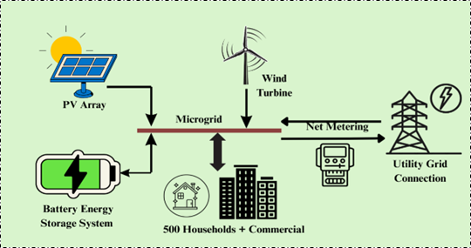
Fig. 1. PV–Wind–BESS based microgrid architecture with utility grid connection

The microgrid supplies a mixed residential-commercial load representative of the selected Bhopal study area and optimally dispatches it using the chosen optimization algorithms (PSO, GA, and SA). The load demand and renewable energy generation profiles used in this study were obtained from representative hourly datasets for the Bhopal region. Solar PV generation was derived from hourly solar irradiance data, while wind generation was estimated using hourly wind speed data. The electrical load profile was based on a representative urban demand pattern. All datasets were processed at an hourly resolution over a 24-hour scheduling horizon for the optimization analysis.
3.1. Photovoltaic (PV) System Modeling
The PV output is determined by incident solar irradiance and cell temperature. The model follows the standard efficiency-based formulation as shown in Equation 1 (Chouhan et al., 2022).
$P_{\text{PV}}(t)=η_{\text{PV}}A_{\text{PV}}G(t)\left[1-α\left(T_{c}(t)-25\right)\right]$ (1)
where $η_{\text{PV}}$: PV module efficiency, $A_{\text{PV}}$: Total PV array area, $G(t)$: Solar irradiance (kW/m²) $α$: Temperature coefficient, $T_{c}(t)$: Cell temperature (°C). High temperatures in Bhopal (up to 45°C) directly reduce module efficiency, necessitating thermal correction.
3.2. Wind Energy Conversion System (WECS) Model
Wind turbine output follows a manufacturer-defined power curve. The output is given by Equation 2.
$P_{\text{WT}}(t)=\left\{\begin{matrix}0, & V(t)<V_{\text{cut-in}} \\ P_{\text{rated}}\frac{V(t)-V_{\text{cut-in}}}{V_{\text{rated}}-V_{\text{cut-in}}}, & V_{\text{cut-in}}≤V(t)<V_{\text{rated}} \\ P_{\text{rated}}, & V_{\text{rated}}≤V(t)≤V_{\text{cut-off}} \\ 0, & V(t)>V_{\text{cut-off}}\end{matrix}\right.$ (2)
where: $V(t)$: Wind speed, $V_{\text{cut-in}}$, $V_{\text{rated}}$, $V_{\text{cut-off}}$: Turbine threshold speeds, $P_{\text{rated}}$: Rated turbine power

Wind speeds in Bhopal (2.5–4.2 m/s) are modest but complement solar generation particularly during monsoon months (Ghosh et al., 2024).
3.3. Battery Energy Storage System (BESS) Model
The battery supports peak shaving, renewable smoothing, and grid interaction. The state-of-charge (SOC) dynamic is modeled as expressed in Equation 3 (Queen et al., 2022).
$SOC(t+1)=SOC(t)+\left(\frac{η_{c} P_{c}(t)}{E_{\text{BESS}}}-\frac{P_{d}(t)}{η_{d} E_{\text{BESS}}}\right)Δt$ (3)
Subject to constraints:
$$SOC_{min}≤SOC(t)≤SOC_{max}$$
Charge/discharge limits:
$$0≤P_{c}\left(t\right)≤P_{c}^{max}$$
$$0≤P_{d}(t)≤P_{d}^{max}$$
where $P_{c}(t)$, $P_{d}(t)$: Charging/discharging power, $η_{c}$, $η_{d}$: Charging/discharging efficiency, $E_{\text{BESS}}$: Battery energy capacity.
3.4. Grid Interaction and Net-Metering Model
The microgrid exchanges power with the utility grid under a net-metering arrangement as shown in Equation 4 (Agupugo et al., 2024).
$P_{\text{grid}}(t)=P_{\text{load}}(t)-\left(P_{\text{PV}}(t)+P_{\text{WT}}(t)+P_{\text{BESS}}(t)\right)$ (4)
where: $P_{\text{grid}}(t)>0$: Grid import, $P_{\text{grid}}(t)<0$: Grid export (credited), Time-of-day tariffs of Madhya Pradesh are applied to compute import cost, while export tariffs are applied for credit settlement.
3.5. Load Modeling
The load profile reflects the consumption pattern of 500 households plus commercial units as shown in Equation 5.
$P_{\text{load}}(t)=P_{\text{base}}+P_{\text{res}}(t)+P_{\text{com}}(t)$ (5)
where: $P_{\text{res}}(t)$: Residential load component, $P_{\text{com}}(t)$: Commercial load component, Peak load ≈ 2.5 MW (evening hours), Daily energy consumption ≈ 8.5 MWh
3.6. Power Balance Constraint
At every time step, supply must equal demand, ensuring physically feasible operation during optimization, as expressed in Equation 6.
$P_{\text{PV}}(t)+P_{\text{WT}}(t)+P_{\text{BESS}}(t)+P_{\text{grid}}(t)=P_{\text{load}}\left(t\right)$ (6)
3.7. Cost Modelling
The total operational cost of the microgrid consists of grid import costs, export credit, BESS degradation costs, renewable curtailment penalties, and load shedding penalties. All components are expressed as shown in Equation 7 (Rashwan et al., 2024).
$C_{\text{total}}=\sum_{t=1}^{T}{\left[P_{\text{grid}}^{+}(t)λ_{\text{import}}(t)-P_{\text{grid}}^{-}(t)λ_{\text{export}}+β_{c}P_{c}(t)+β_{d}P_{d}(t)+γP_{\text{curt}}(t)+δP_{\text{LS}}(t)\right]}$ (7)
where, $P_{\text{grid}}^{+}(t)$represents the grid import power at time $t$, while $P_{\text{grid}}^{-}(t)$denotes the grid-export power delivered to the utility under the net-metering mechanism. The parameter $λ_{\text{import}}(t)$corresponds to the time-of-day (ToD) import tariff applied by the distribution company, whereas $λ_{\text{export}}$is the export compensation rate provided for surplus energy fed into the grid. Battery operation is modeled using the charging and discharging powers $P_{c}(t)$and $P_{d}(t)$, respectively, with $β_{c}$and $β_{d}$representing the associated degradation cost coefficients that penalize excessive cycling. Renewable energy curtailment at any time step is expressed through $P_{\text{curt}}(t)$, and its economic impact is controlled by the penalty factor $γ$. Any unserved or shed load is captured by $P_{\text{LS}}(t)$, with a high penalty coefficient $δ$ensuring that load shedding occurs only when unavoidable. The total cost is accumulated over the simulation horizon $T$, covering all time intervals considered in the operational scheduling.
The objective of the proposed microgrid optimization framework is to determine the optimal dispatch of photovoltaic (PV) generation, wind turbine output, battery charging/discharging, and grid power exchange such that the total operational cost of the hybrid system is minimized while ensuring reliable load supply and respecting all physical and operational constraints. The problem is formulated as a constrained nonlinear optimization problem, where decision variables include power flows from renewable sources, battery operations, and grid interactions at each time step as shown in Table 1.

Table 1. System parameters and component specifications of the proposed microgrid
Parameter | Value
PV Capacity | 1.5 MW
Wind Capacity | 1.0 MW
Battery Energy Capacity | 2 MWh
Battery Round-Trip Efficiency | 90%
SOC Operating Range | 20–90%
Grid Tariff | ₹6 – ₹9 per kWh

The selected component ratings were verified to meet the representative load profile of the examined urban microgrid and to provide sufficient renewable penetration and flexibility to operate the system. It was decided to design a 1.5 MW PV system to tap the high solar resource in Bhopal and meet most daytime demand. A 1.0 MW wind turbine can complement the PV generation during low-solar periods and seasonal variations. The 2 MWh BESS energy storage capacity is sufficient for short-term load balancing, smoothing the renewable energy supply, and peak shaving, subject to the desired SOC operating range. Such capacities can be used to ensure a proper generation-to-load ratio for the discussed 2.5 MW peak load and 8.5 MWh daily energy demand, enabling a valid comparison of the optimization algorithms' performance.
4. Optimization Algorithms (PSO, GA, and SA)
The operational scheduling problem modeled in this study is nonlinear, nonconvex, and time-coupled due to the intermittency of renewable generation and the dynamic nature of the battery energy storage system (BESS). To deal with this complexity effectively, three established metaheuristic optimization algorithms, Particle Swarm Optimization (PSO), Genetic Algorithm (GA), and Simulated Annealing (SA), are used as indicated in the flowchart shown in Figure 2. These algorithms have been selected because they are not gradient-based, but useful in the multi-dimensional search space, and exhibit excellent resistance to local minima (Zheng et al., 2014).
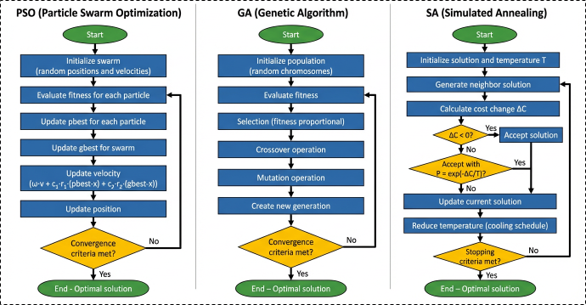
Fig. 2. Flowcharts of the PSO, GA, and SA optimization algorithms used for microgrid energy management
4.1. Particle Swarm Optimization (PSO)
Particle Swarm Optimization is an iterative population-based algorithm inspired by the collective behavior of birds flocking toward a destination. Each particle represents a candidate solution whose position and velocity evolve based on its own experience and the swarm's best-known solution. The velocity update of the $i$^{th} particle at iteration $k$is given by Equation 8 (Naderi et al., n.d.).
$v_{i}^{k+1}=ω v_{i}^{k}+c_{1}r_{1}\left(pbest_{i}-x_{i}^{k}\right)+c_{2}r_{2}\left(gbest-x_{i}^{k}\right)$ (8)
The updated velocity is then added to the current position given by Equation 9
$x_{i}^{k+1}=x_{i}^{k}+v_{i}^{k+1}$ (9)
In PSO, $x_{i}^{k}$and $v_{i}^{k}$denote the particle's position and velocity, while $pbest_{i}$and $gbest$represent its personal and global best positions. The coefficients $ω,c_{1},c_{2 }$govern inertia, self-learning, and collective learning. These updates continue iteratively, with constraints applied after each position update to ensure feasibility.
4.2. Genetic Algorithm (GA)
The Genetic Algorithm is an evolutionary optimization method inspired by natural selection and biological evolution. In GA, each candidate solution is encoded as a chromosome, and generations evolve through selection, crossover, and mutation. The probability of selecting a chromosome $i$based on its fitness is expressed as shown in Equation 11(Calloquispe-Huallpa et al., 2023)$.$
$P(i)=\frac{f_{i}}{\sum_{j=1}^{N}{f_{j}}}$ (10)
Crossover between parent solutions $A$and $B$generates an offspring using Equation 11
$\text{Offspring}=αA+(1-α)B$ (11)
Mutation introduces random variation given by Equation 12 as
$x_{i^{'}}=x_{i}+σ N(0,1)$ (12)
Where $f_{i}$determines selection probability, $α$controls crossover, and $σN(0,1)$defines mutation.

4.3. Simulated Annealing (SA)
Simulated Annealing is a single-solution probabilistic optimization method inspired by the thermodynamic annealing of metals. At each iteration, SA perturbs the current solution to generate a neighboring solution. If the new solution improves the objective function, it is accepted. If not, it may still be accepted with the probability expressed by Equation 13 (Lyden et al., 2021).
$P_{\text{accept}}=exp​\left(-\frac{ΔC}{T_{k}}\right)$ (13)
The temperature is gradually reduced according to Equation 14
$T_{k+1}=αT_{k}$ (14)
where the parameters $ΔC$, $T_{k}$, and $α$represent cost difference, temperature, and cooling coefficient, respectively.
5. Simulation Setup
A time-series simulation in MATLAB/Simulink was used to test the operational performance of the proposed hybrid microgrid over a 24-h horizon, with a 1-min time resolution (1440 intervals). It is such granularity that allows the variability of the solar irradiance, wind velocity, load demand, and battery state-of-charge (SOC) to be accurately modelled, and the behaviour of microgrids under climatic and consumption patterns reasonably representative of urban India. The hybrid microgrid was a combination of a photovoltaic (PV) array, a wind turbine, a lithium-ion battery energy storage system (BESS), and a grid interface under a controlled net-metering system (Vishwakarma & Dubey, 2012). These components serve a mixed-use load in Bhopal, Madhya Pradesh, comprising an estimated 500 households and commercial organisations, with a peak load of 2.5 MW and daily energy use of 8.5 MWh. The solar capacity (Average Global Horizontal Irradiance [GHI]) of ≈ 5.2 kWh/m²/day, with a higher amount of 7 kWh/m²/day in the summer seasons) and wind power (2.8–4.2 m/s annually) at the site were incorporated into the renewable production models. The renewable energy datasets were derived from representative solar irradiance and wind speed data for the Bhopal region obtained from publicly available meteorological records. At the same time, the load profile represents a typical urban mixed-use demand. The optimization was performed over a 24-hour scheduling horizon using hourly input datasets, which were subsequently processed in MATLAB/Simulink for microgrid operational analysis. At every simulation step, MATLAB loads irradiance, wind, and load data that are not accessible via time-series data. A temperature-dependent efficiency model was used to compute PV output, and a wind turbine power curve corrected for hub-height wind speed was used to compute wind generation. The SOC-based differential equation was used to model BESS dynamics, with charging/Discharging efficiencies, thermal/inverter loss, and battery degradation cost coefficients. The net-metering policy was used to determine grid power exchange, which is calculated using Time-of-Day (ToD) import tariffs and export credits. An operating-mode test was done by a power-balance test. The BESS would charge at the SOC and power-rate limit when renewable production was greater than demand; and would discharge until the bottom SOC limit was reached. When production was smaller, the deficit was made up by the grid. The grid import/export charges, BESS degradation, renewable curtailment, and load shedding were included in operational costs. These expenses were summed up within a 24-h period (Chouhan et al., 2022).
The simulation workflow is shown in Figure 3 and includes the decision-making steps taken every minute. The steps involved system initiation, calculation of renewable generation, power-balance analysis, BESS operation within SOC constraints, cost calculation, and reporting of Key Performance Indicators (KPIs). The flowchart below shows the simulation engine used by all the optimization algorithms. These optimization algorithms (PSO, GA, and SA) interact with this engine in the following way: schedules, minute-wise simulation, cost calculation, and loss-specific decision variables refinement until they come to a point of convergence (Akram et al., 2022; Hadi et al., 2025; Hassan et al., 2023; Vinothine et al., 2022; Zheng et al., 2014). All algorithms were run on the MATLAB platform to enable a level of comparative analysis; the results are shown in Table 2. Outputs varied, including PV and wind generation profiles, SOC, grid import/export, cost distributions, degree of renewable penetration, and convergence via PSO, GA, and SA.
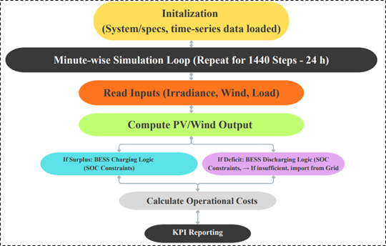
Fig. 3. Simulation workflow for microgrid energy management and cost evaluation

Table 2. Performance comparison of optimization algorithms for microgrid optimization
Algorithm | Parameter | Value
PSO | Swarm size | 30
PSO | Number of iterations | 100
GA | Population size | 50
GA | Mutation rate | 0.05
SA | Cooling factor | 0.95
6. Results and Discussion
6.1. Renewable Profiles & Load Behavior
This section presents the operational performance of the proposed hybrid renewable microgrid system designed for the Bhopal region of Madhya Pradesh, India. The results are obtained from the MATLAB-based simulation framework described in the previous sections, considering a 24-hour operational horizon with high temporal resolution. The analysis focuses on the interaction between photovoltaic generation, wind power output, load demand, and the battery energy storage system (BESS) under realistic climatic and consumption conditions typical of Bhopal. Due to the region's favorable renewable energy potential, particularly high solar irradiance and moderate wind availability, hybrid renewable integration is considered an effective strategy for improving energy reliability and sustainability in urban microgrid systems.
Figure 4 presents the hourly operational profiles of the key components of the hybrid microgrid system, including photovoltaic generation, load demand, wind power generation, and battery state of charge. These profiles represent the fundamental parameters that influence the microgrid's energy balance and optimal dispatch. The results provide insight into how renewable resources and energy storage interact dynamically to meet the electricity demand of the considered urban load cluster.
The photovoltaic generation profile illustrated in Figure 4(a) follows the typical diurnal solar irradiance pattern observed in central India. Photovoltaic power production begins to increase after sunrise at approximately 05:00 h, corresponding to the availability of solar radiation in the Bhopal region.
The generating power progressively increases with increasing solar power, and it peaks at about 500 kW around 10:00–11:00 h, when solar radiation is at its peak. The generation of photovoltaic power slowly decreases after this time due to a decrease in solar irradiance as it approaches sunset, and it becomes very low at night. This action confirms the high potential of solar energy in Bhopal, as well as the intermittency of photovoltaic energy, which requires a backup power source and a storage system to maintain a continuous power supply.
(a) | 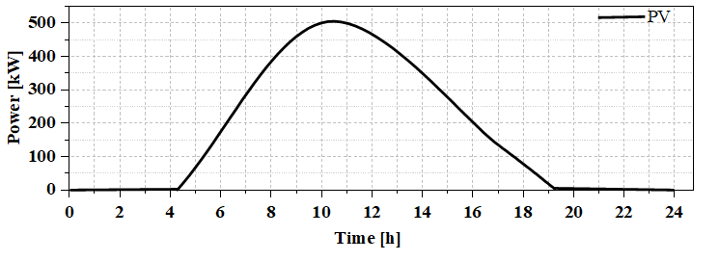
(b) | 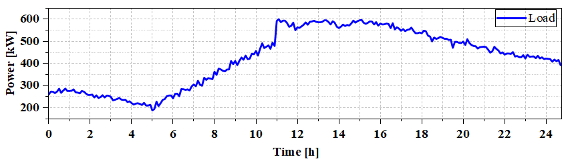
(c) | 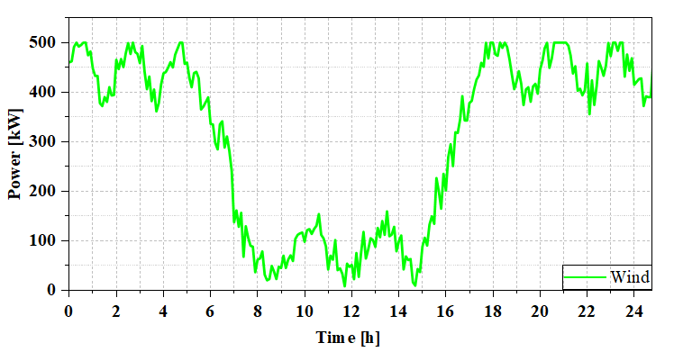
(d) | 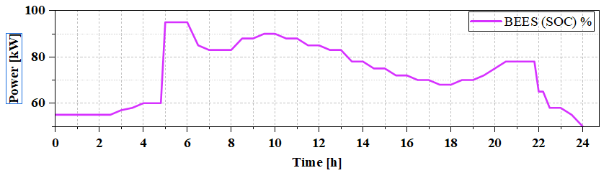
Fig. 4. (a) PV power generation (b) load demand profile (c) Wind speed profile and (d) operational dynamics of battery energy storage system

Figure 4(b) illustrates the hourly load demand profile, i.e., the electricity consumption profile of the urban microgrid system in the case study. The load demand starts at about 260–280 kW in the early mornings, reflecting the base residential demand during the night. There is a small decrease in load around 05:00 h, which is likely to represent decreased electricity consumption in the early mornings. The load demand rises gradually as the day starts and reaches a peak of almost 600 kW between 12:00 h and 15:00 h. The main cause of this peak demand is commercial, residential, and cooling needs, all of which are related to Bhopal's warm climatic conditions. The maximum occurs in the afternoon and steadily declines in the evening, reaching around 400 kW at night. The general load profile thus represents a normal mixed-use urban demand situation comprising residential, commercial, and service-sector electricity demand.
Figure 4(c) wind generation profile indicates the variable and stochastic nature of wind energy resources in the hybrid microgrid system. The output of wind power also changes significantly throughout the day; this depends heavily on changes in wind speed in the Bhopal region over time. The generation pattern suggests that wind energy generation is higher at nighttime and late evening hours, when the generation level was about 450–500 kW. On the other hand, wind generation decreases at noon and drops below 100 kW. This difference in wind supply highlights the complementary operation of wind and solar sources of energy. Although a photovoltaic system generates power during the daytime, wind generation supplements the power supply at night when the sun is not shining. Such complementary behavior benefits the stability of renewable energy supply and enhances the hybrid microgrid system's reliability.
Figure 4(d) illustrates the operational dynamics of the battery energy storage system and shows that the battery state-of-charge varies over the simulation period. At the onset of the simulation period, the battery SOC is set to about 55%, which represents the storage unit's initial working state. During the early morning hours, solar generation will rise, resulting in surplus renewable energy in the microgrid. This surplus energy is efficiently stored in the battery, leading to a rapid increase in SOC, reaching almost 95% between 05:00 h and 06:00 h. During this stage, the battery plays a crucial role in buffering excess renewable energy when generation is high. The stored energy is slowly used up as the day goes on, and the load demand starts to grow to maintain the system's energy balance. The battery discharges in the afternoon and evening, when renewable generation cannot meet demand. At the simulation horizon, the SOC is stabilized at around 50%, indicating balanced charging and discharging and the efficient operation of the energy storage system within the hybrid microgrid.
The overall analysis of Figure 4(a-d) shows that it is necessary to combine various renewable energy sources with battery storage to ensure the stable and consistent work of a microgrid. Photovoltaic generation is also a major contributor to power during the daytime because of Bhopal's strong solar potential. In contrast, wind energy is another contributor that augments generation at night and in the early morning hours. This battery energy storage system is significant in balancing the temporal variation between renewable generation and load demand, as it stores surplus energy and provides power when the load needs more energy than the renewable energy is available. This synchronized communication between renewable sources and energy storage will enable the microgrid to maintain operational stability and reduce reliance on grid electricity. Thus, the findings confirm that the hybrid structure of PV-Wind-BESS microgrids is, in fact, technically feasible for urban energy systems around Bhopal and can substantially increase the use of renewable energy without adversely affecting power supply.
6.2. Power Dispatch and Grid Interaction Analysis
Figure 5 presents the temporal power dispatch characteristics of the hybrid microgrid under the climatic and load conditions of Bhopal. The plotted profiles depict the instantaneous contributions of photovoltaic generation, wind output, battery charge–discharge activity, and grid interaction necessary to satisfy the real-time load demand. During the early morning hours (00:00–05:00 h), renewable availability remains low; photovoltaic generation is zero, and wind output fluctuates between 300 and –450 kW, indicating insufficient renewable contribution to meet the prevailing demand. Consequently, the system relies on grid import, as evidenced by the positive grid power values during this interval. As solar irradiance increases after sunrise, photovoltaic generation begins contributing significantly, reaching levels above 400 kW by mid-morning.

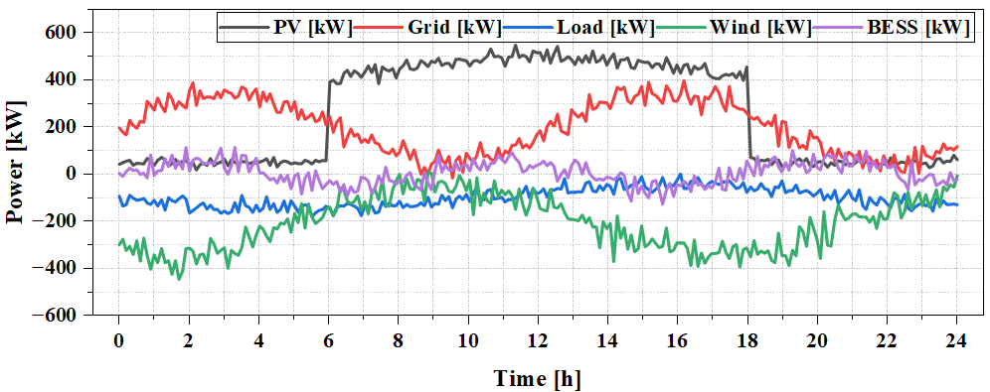
Fig. 5. Hourly power profiles of PV, wind, load demand, BESS operation, and grid power exchange in the microgrid
This increase in photovoltaic power production allows reducing grid reliance and starting to charge batteries, as the BESS's power values are positive in the morning. It is shown that there is a specific change in dispatch behavior between 10:00 h and 16:00 h, when the renewable availability, with solar energy prevailing, is adequate to meet a considerable portion of the demand. The maximum photovoltaic output occurs during this period, and wind power is supplementary because it is variable. The excess renewable energy at these times is channelled to the battery system to charge it, so the BESS can store energy and reduce grid imports. The system starts switching to a mixed supply approach as photovoltaic generation reduces towards the evening (after 16:00 h). The grid again does its fair share in meeting demand, as indicated by the rising grid power profile. The BESS is concurrently releasing stored energy to offset the deficit caused by reduced solar power and unpredictable wind energy. The dispatch pattern attests to the coordinated role of the three elements of the supply in the microgrid. Photovoltaic generation is the main source of power during the daytime; wind energy helps during non-solar periods, and the battery system helps bridge the gap between intermittent renewable sources and a constant demand. The grid is a stabilizing tool that serves as an additional source of power when renewable energy is scarce and to absorb system imbalances. According to the operational profile presented in Figure 5, the interaction among the renewable resources, BESS, and controlled grid exchange makes the microgrid self-sufficient in terms of energy balance throughout the entire diurnal cycle. It minimizes reliance on conventional grid electricity during peak periods of renewable energy availability.
6.3. Grid Import/Export Pattern
The grid import/export profile shown in Figure 6 provides useful information on the extent of grid reliance during the microgrid's 24-hour operation. The system will have poor renewable generation in the first hours (00:00–05:00 h), since photovoltaic generation will be zero and wind will be low, leading to steady grid importation of about 0.18–0.22 MW. As photovoltaic power increases with solar irradiance after sunrise, solar irradiance rises with it, and when solar irradiance is combined with moderate levels of wind power generation, the dependence on grid importation decreases. Between 06:00 and 09:00 h, the renewable supply is comparable to the load demand, and the short transition period between the net grid requirement is close to zero. Between 09:00 and 11:00 h, there is a small surplus of renewable generation over local load. This is indicated by negative grid values (-0.10 to -0.20 MW), which indicate short periods of possible export or inability to draw from the grid. These times also coincide with peak photovoltaic and wind generation, which improves solar-to-renewable penetration in the microgrid. The grid depends on the export phase, as the system is at peak load between 12:00 and 17:00 h, when demand exceeds 2 MW. Renewable generation cannot adequately meet the rising demand, despite robust solar generation. Therefore, the microgrid imports 0.5-1.45 MW, which is one of the highest periods of import during the day. This highlights the impacts of the midday commercial energy consumption pattern typical of Bhopal's urban load centers. The contribution from photovoltaic generation sharply declines after sunset, and the remaining contributors are wind and battery discharge.

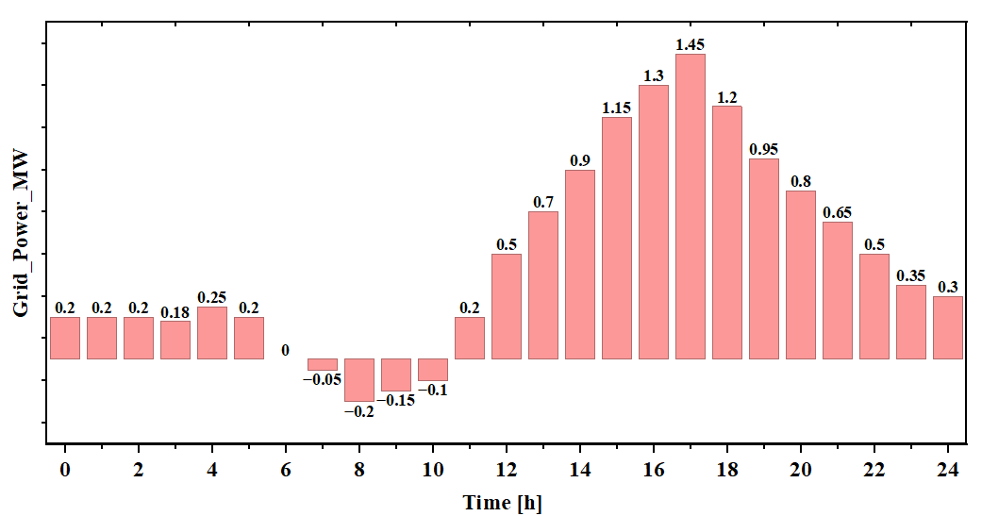
Fig. 6. Hourly grid power exchange of the microgrid under net metering operation

Even though wind production increases in the late evening, it is still insufficient to offset the decline in solar power. As a result, the grid import is moderate between 18:00–23:00 h and decreases slowly to 0.35 MW. This trend supports the hypothesis that the microgrid is more dependent on the grid in the evening, due to the concomitant drop in PV production and the rise in domestic power consumption. In general, the grid import/export profile shows that the hybrid PV-Wind-BESS architecture can substantially reduce grid reliance during a renewable surge but still requires additional power during extended high-demand events. The short export window shows that the system can support the distribution network during periods of renewable availability peaks. These findings reveal the importance of energy storage in further reducing grid dependence and illustrate how hybrid renewable microgrids can operate in the Bhopal region.
The optimization results are expected to vary with seasonal changes in solar irradiance and wind speed, as these directly influence renewable energy availability and battery utilization. Nevertheless, the proposed optimization framework remains applicable under different seasonal conditions by incorporating season-specific renewable resource and load profiles.
6.4. Optimization Convergence Analysis
The convergence patterns of the three optimization methods, including particle swarm optimization (PSO), genetic algorithm (GA), and simulated annealing (SA), have different search patterns and cost-reduction effectiveness in solving the operational scheduling of the hybrid microgrid system for day-to-day operation in the Bhopal case study are shown in Figure 7. The present value of the operational cost estimates at the initial iteration is ₹0.302 lakh/day, ₹0.334 lakh/day, and ₹0.347 lakh/day, representing the initial fitness values of the stochastic methods. The initial search phase (iterations 0–10) shows that GA is the most aggressive in cost reduction, reducing the cost from ₹0.334 lakh/day to around ₹0.309 lakh/day, a 7.5% reduction. This behavior is attributed to the exploration mechanism of GA, whereby crossover-mutation diversity enables the algorithm to quickly discard poor-quality initial solutions. On the other hand, the progression of PSO is steady and stable, as the cost decreases from ₹0.302 lakh/day to ₹0.299 lakh/day in iteration 12. The velocity-position update mechanism of PSO enables the swarm to gradually accumulate in high-quality regions of the search space, thereby preventing premature convergence. PSO finds a stabilizing minimum of about ₹0.2985 lakh/day after iteration 15, which is the lowest operational cost among the three algorithms. The convergence plateau also shows that PSO is well positioned to balance global and local search pressures, allowing the particles to fine-tune around the optimum without oscillations. Similarly, SA demonstrates the slowest convergence, reaching only ₹0.320 lakh/day after 25 iterations and stabilizing near ₹0.319–0.320 lakh/day for the remainder of the optimization. This outcome is anticipated, as the annealing schedule reduces the system "temperature" gradually, prioritizing global exploration over rapid convergence. While SA is robust against local minima, its convergence rate is inherently slower, and its final operational cost remains approximately 7.2% higher than that of PSO.
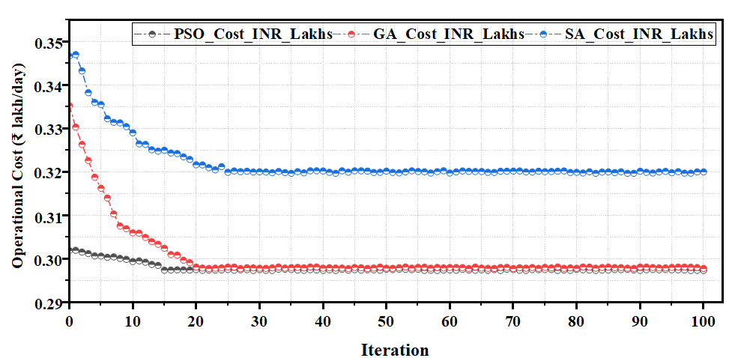
Fig. 7. Convergence behavior of PSO, GA, and SA algorithms for microgrid operational cost optimization

Table 3 presents a comparison that underscores PSO's superiority in addressing this specific microgrid dispatch problem. The marginal difference between GA and PSO upon convergence (~₹0.0003–0.0005 lakh/day) suggests that both algorithms can achieve near-optimal solutions. However, PSO reaches the optimum more swiftly and with smoother convergence, rendering it more suitable for real-time or iterative microgrid dispatch applications. Conversely, the slower decay curve of SA confirms its limited suitability for short-horizon operational scheduling, where rapid convergence is crucial. The overall convergence behavior substantiates the reliability of PSO-based cost minimization, demonstrating that integrating swarm intelligence and adaptive search dynamics is highly effective for mixed-integer, nonlinear microgrid optimization problems involving renewable variability, battery energy storage system scheduling, and grid interaction constraints.

Table 3. Comparative performance of PSO, GA, and SA algorithms for microgrid operational cost optimization
Algorithm | Initial Cost  (₹ lakh/day) | Final Cost  (₹ lakh/day) | Total  Improvement | Convergence Speed | Remarks
PSO | ~0.302 | 0.298–0.299 | 1.3% | Fast and stable | Best overall performance; lowest cost
GA | ~0.334 | 0.2988–0.2992 | 10.3% | Fast initially,  then stable | Near optimal; slightly higher than PSO
SA | ~0.347 | 0.319–0.320 | 8.0% | Slow | Highest cost; slowest convergence
6.5. Daily Load and Renewable Generation Profile
Figure 8 shows the 24-hour working environment of the Bhopal hybrid microgrid, reflecting the time-varying fluctuations in demand and renewable energy supply, which serve as the basis for the optimization framework. The load profile is recorded at a much higher rate, around 0.8 MW. It is gradually rising towards a peak of nearly 2.5 MW between 12:00 and 14:00 in the morning, driven by increased commercial and residential activity. PV power is zero at night, reaches a peak just after sunrise (1.2 MW around noon), and drops to zero at 18:00, following the irradiance pattern in the region. The production of wind power is more evenly spread across the day, with slight depressions at sunrise and slight increases in the middle of the day due to atmospheric mixing. The total renewable production is limited to about 1.8 MW between 10:00–14:00 and only
0.6–0.7 MW in the evening leading to a large disparity between renewable energy supply and the load. Such mismatch is the reason why coordinated operation of battery energy storage and the exchange of grid power is required, which is the primary motivation for the optimization model developed in this study.

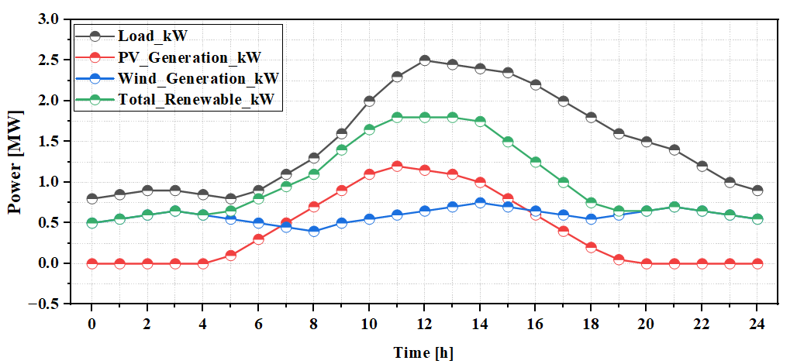
Fig. 8. Twenty-four-hour load demand, PV generation, wind generation, and total renewable power profile of the Bhopal hybrid microgrid

The variability illustrated in Figure 8 directly influences the optimization outcomes presented later in this study. The midday renewable surplus, coupled with a steep decline in PV output after 14:00, creates a critical requirement for BESS charging during surplus hours and BESS/grid support during evening deficits. This temporal imbalance shapes the operational constraints and cost structure encountered by the optimization algorithms (PSO, GA, and SA). The convergence trends shown in subsequent figures are therefore a direct consequence of these fluctuating resource conditions, as the optimization must continuously adjust dispatch schedules to minimize operational costs while maintaining supply-demand balance under highly time-dependent renewable inputs.
6.6. Cost Analysis
The comparison of costs, justified by the operational share shown in Figure 9, places the three optimization frameworks in a clear hierarchy of performance. The lowest operating cost is ₹0.298 lakh/day for PSO-based dispatch, with an operational share of 32.5% among all optimization methods. This high performance is directly connected to the swarm-coordinated exploration by PSO, which quickly moves it to the global minimum while preserving exploitation. It is worth noting that PSO has the highest renewable penetration of 42%, demonstrating its ability to optimally combine PV, wind, and BESS to limit grid power use and level cost peaks. The Genetic Algorithm (GA), with a daily price of ₹0.2985 lakh/day and a cost share of 32.6, is competent, although not as efficient as PSO. This minor variation, about 0.17% more expensive, can be explained by the very nature of GA, which adds some randomness through crossover and mutation and may temporarily send the search off track in potentially good areas. The GA has a renewable penetration of 40%, slightly lower than the PSO, indicating that it has a less accurate match between renewable availability and the battery energy storage system (BESS) dispatch strategy.

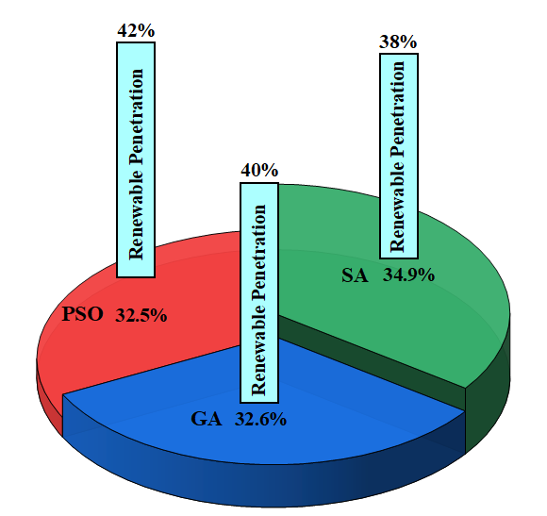
Fig. 9. Comparison of renewable energy penetration achieved using PSO, GA, and SA optimization methods

Simulated Annealing (SA) yields the least favourable outcome, with an operational cost of ₹0.320 lakh/day and a 34.9% cost share, representing a 7.38% increase relative to PSO. SA's single-solution search mechanism and temperature-driven perturbation process limit its ability to escape local minima in the microgrid's complex, time-dependent optimization landscape. This limitation also manifests in its lower renewable penetration of 38%, indicating reduced utilization of available clean energy and a heavier reliance on grid imports during high-load intervals. Overall, the operational share analysis combined with renewable penetration metrics clearly demonstrates that PSO simultaneously minimizes costs and maximizes renewable integration, validating its suitability as the preferred optimization engine for the Bhopal microgrid case study. GA provides moderately strong performance, whereas SA's slower convergence and reduced renewable utilization reinforce its relative inefficiency for high-resolution microgrid scheduling.

7. Conclusion
This study presents the development and evaluation of an optimized energy-management framework for a grid-connected microgrid in Bhopal, incorporating photovoltaic (PV), wind, and battery energy storage system (BESS) resources under realistic load and renewable conditions. The findings indicate that the proposed optimization approach effectively reduces operational costs while enhancing the utilization of renewable energy. Among the three algorithms assessed, particle swarm optimization (PSO) achieved the most cost-effective dispatch with a daily operational cost of ₹0.298 lakh/day, surpassing the genetic algorithm (GA) at ₹0.2985 lakh/day and simulated annealing (SA) at ₹0.320 lakh/day. The higher renewable penetration observed with PSO (42%) compared to GA (40%) and SA (38%) suggests that PSO more efficiently aligns storage charging and discharging cycles with renewable availability. The operational profiles further confirm stable load tracking, effective BESS support, and reduced reliance on grid imports during peak solar hours. This study contributes to microgrid scheduling research by providing a comparative assessment of widely used optimization algorithms within a unified test system and by quantifying their impact on operational costs and renewable penetration. Although developed for Bhopal, the proposed optimization framework can be readily adapted to other Indian cities by incorporating site-specific renewable resource profiles, load characteristics, and tariff structures, enabling its application under diverse climatic conditions. However, the analysis is limited to a single-day horizon, a fixed tariff structure, and deterministic renewable profiles. These assumptions constrain the generalizability of the results to systems with high uncertainty or dynamic pricing. Practical implementation of the proposed framework in real-world microgrids may encounter several challenges, including the availability of high-resolution meteorological and load data, communication delays among distributed energy resources, battery degradation over long-term operation, and uncertainties in renewable generation forecasts. Furthermore, successful deployment requires reliable energy management systems, advanced metering infrastructure, and compliance with local grid codes and net-metering regulations. Addressing these practical aspects is essential for the effective deployment of optimization-based microgrid energy management systems.

Data Availability Section: The datasets used and/or analysed during the work are available with the corresponding author on reasonable request.
Funding: No Funding is claimed
Competing interests: Not Applicable
Authors' contributions
N.N.A. Conceptualization, Formal analysis, Methodology, Supervision, Visualization, Writing – original draft, Writing – review & editing
S.J. Conceptualization, Formal analysis, Methodology, Supervision, Visualization, Writing – review & editing
Acknowledgements
The authors would like to thank the Department of Electrical Engineering, RKDF University, Bhopal, India, for conducting the research.
References
Agupugo, C.P., Kehinde, H.M., & Manuel, H.N.N. (2024). Optimization of microgrid operations using renewable energy sources. Engineering Science & Technology Journal, 5(7), 2379–2401. https://doi.org/10.51594/estj.v5i7.1360
Ahmad, F., & Alshatti, A.H. (2024). Design and Development of Hybrid Microgrid Control System for Renewable Energy Generation. International Journal of Advances in Scientific Research and Engineering, 10(04), 13–22. https://doi.org/10.31695/ijasre.2024.4.2
Akram, N., Khan, L., Agha, S., & Hafeez, K. (2022). Global Maximum Power Point Tracking of Partially Shaded PV System Using Advanced Optimization Techniques. Energies, 15(11), 4055. https://doi.org/10.3390/en15114055
Alshammari, N., & Asumadu, J. (2020). Comparative Analysis of Meta-Heuristic Algorithms for Optimal Sizing of Hybrid Renewable Energy System. Electro/Information Technology, 648–654. https://doi.org/10.1109/EIT48999.2020.9208343
Belrzaeg, M., Sif, M.A., Almabsout, E., & Benisheikh, U.A. (2023). Distributed generation for Microgrid technology. International Journal of Scientific Research Updates. Retrieved from https://doi.org/10.53430/ijsru.2023.6.1.0062
Bie, Z., & Bian, Y. (2024). Microgrids Resilience: Definition, Measures, and Algorithms, 197–218. https://doi.org/10.1002/9781119890881.ch10
Bouaouda, A., & Sayouti, Y. (2022). Hybrid Meta-Heuristic Algorithms for Optimal Sizing of Hybrid Renewable Energy System: A Review of the State-of-the-Art. Archives of Computational Methods in Engineering, 29(6), 4049–4083. https://doi.org/10.1007/s11831-022-09730-x
Calloquispe-Huallpa, R., Huaman-Rivera, A., Ordoñez-Benavides, A.F., Garcia-Garcia, Y.V, Andrade, F., Aponte-Bezares, E.E., & Irizarry-Rivera, A. (2023). A Comparison Between Genetic Algorithm and Particle Swarm Optimization for Economic Dispatch in a Microgrid. https://doi.org/10.1109/isgt-la56058.2023.10328280
Chauhan, S.K., & Chauhan, V.S. (2024). Meta-Heuristic Algorithms for Optimal Sizing of Hybrid Renewable Energy Systems. Advances in Systems Analysis, Software Engineering, and High Performance Computing Book Series,
184–200. https://doi.org/10.4018/979-8-3693-7842-7.ch010
Chouhan, J.B., Ojha, A., & Swarnkar, P. (2022). PSO-Based Distributed Generation Planning, 1–4. https://doi.org/10.1109/iSSSC56467.2022.10051441
Chudasama, P. P., & Kotwal, C. D. (2019). Feasibility Assessment of a Standalone Hybrid Rural Microgrid Using a Load Following Dispatched Strategy. International Journal of Scientific Research in Science, Engineering and Technology. https://doi.org/10.32628/ijsrset2182136
de Cerqueira Lima e Penalva Santos, D., Ihler, J.B., Soares, L.O., Alves, Y.A., Souza, C.G., & Boloy, R.A.M. (2022). Global Trends and Opportunities in Hybrid Microgrid Systems Using Renewable Energies. International Journal of Energy Economics and Policy, 12(4), 263–273. https://doi.org/10.32479/ijeep.13175
Ghosh, S., Nandanwar, S., & Pandey, G. (2024). Cost-Effective and Sustainable Microgrid System for Reliable Energy Supply in Remote and Rural Communities: A Case Study in Bhopal, Madhya Pradesh. 2024 IEEE 3rd International Conference on Electrical Power and Energy Systems (ICEPES), Bhopal, India, pp. 1–7. https://doi.org/10.1109/icepes60647.2024.10653587
Hadi, M., Elbouchikhi, E., Zhou, Z., & Saim, A. (2025). Optimal Sizing and Energy Management for Multi-Energy Microgrids Integrated with Combined Heat and Power Unit. 2025 International Conference on Control, Automation and Diagnosis (ICCAD), Barcelona, Spain, 2025, pp. 1–6. https://doi.org/10.1109/iccad64771.2025.11099312
Hassan, H., Habbi, H.M.D., & Abbood, A. (2023). Hybrid Metaheuristic Algorithms Mppt under Partial Shading Condition. The Journal of The University of Duhok, 26(2). 390–399. https://doi.org/10.26682/csjuod.2023.26.2.36
Jia, H., Xu, X., Jin, X., & Wu, J. (2024). Modeling of integrated energy systems, 7–35. https://doi.org/10.1049/pbpo149e_ch1
Khan, I.R., Rukh, G., & Ullah, M.F. (2023). A multi-objective strategy for cost-effective microgrid solutions based on renewable energy sources. International Conference on Applied Engineering and Natural Sciences, 1(1), 1057–1061. https://doi.org/10.59287/icaens.1128
Khanna, P., & Chanana, S. (2024). Optimizing the Energy and Operational Management of Microgrids, 1–6. https://doi.org/10.1109/sces61914.2024.10652565
Kirmani, S., & Shadab, M. (2015). Techno-Economic Feasibility Analysis of Hybrid Systems for Decentralized Power Generation in India. International Journal of Energy and Power Engineering, 4(2), 103. https://doi.org/10.11648/J.IJEPE.20150402.21
Kumar, T.S., & Venkatesan, T. (2023). A Techno-Economic Optimal Evaluation and Feasibility Analysis of Hybrid Microgrid Electrification for Smart Cities in Tamil Nadu. Electric Power Components and Systems. https://doi.org/10.1080/15325008.2023.2249883
Lyden, S., Galligan, H., & Haque, E. (2021). A Hybrid Simulated Annealing and Perturb and Observe Maximum Power Point Tracking Method. IEEE Systems Journal, 15(3), 4325–4333. https://doi.org/10.1109/JSYST.2020.3021379
Naderi, E., Narimani, H., Pourakbari-Kasmaei, M., Cerna, F.V, Marzband, M., & Lehtonen, M. (n.d.). State-of-the-Art of Optimal Active and Reactive Power Flow: A Comprehensive Review from Various Standpoints, 9(8), 1319. https://doi.org/10.3390/PR9081319
Oviedo-Carranza, S., Artal-Sevil, J.S., & Domínguez-Navarro, J.A. (2022). Optimal Operation of a Distributed Generation Microgrid based on the Multi-Objective Genetic Algorithms. Renewable Energy & Power Quality Journal, 20, 789–794. https://doi.org/10.24084/repqj20.436
Pulluri, H., Basetti, V., Goud, B.S., & Kalyan, C.N.S. (2024). Exploring Evolutionary Algorithms for Optimal Power Flow: A Comprehensive Review and Analysis. Electricity, 5(4), 712–733. https://doi.org/10.3390/electricity5040035
Queen, H.J., Jayakumar, J., & Deepika, T.J. (2022). Operating Cost Analysis of Microgrid Including Renewable Energy Sources and a Battery Under Dynamic Pricing, 291–302. https://doi.org/10.1007/978-981-16-4943-1_27
Rajesh, L.V. (2024). Energy management system of microgrid with renewable energy sources. Indian Scientific Journal Of Research In Engineering And Management, 08(05), 1–5. https://doi.org/10.55041/ijsrem35375
Rashwan, A., Faragalla, A.M., Abo-Zahhad, E.M., El-Dein, A.Z., Liu, Y., Chen, Y., & Abdelhameed, E.H. (2024). Techno-economic Optimization of Isolated Hybrid Microgrids for Remote Areas Electrification: Aswan city
as a Case Study. https://doi.org/10.1007/s40866-024-00200-w
Rathore, A.S., Kumar, A., & Patidar, N.P. (2023). Techno-Socio-Economic and sensitivity analysis of Standalone Micro-Grid located in Central India. International Journal of Ambient Energy, 44(1), 1490–1511. https://doi.org/10.1080/01430750.2023.2176922
Roy, A., Olivier, J.-C., Auger, F., Auvity, B., Schaeffer, E., Bourguet, S., … Perret, J. (2021). A combined optimization of the sizing and the energy management of an industrial multi-energy microgrid: Application to a harbour area. Energy Conversion and Management: X, 12, 100107. https://doi.org/10.1016/J.ECMX.2021.100107
Samir, A., Mostafa, M., Ashraf, A., & Hafez, A. (2025). Techno-Economic Assessment of Renewable Energy-Based Microgrids: A Case Study for Building in El Gouna, Egypt. Advanced Sciences and Technology Journal, 0(0), 0. https://doi.org/10.21608/astj.2025.387829.1061
Vinothine, S., Arachchige, L.N.W., Rajapakse, A., & Kaluthanthrige, R. (2022). Microgrid Energy Management and Methods for Managing Forecast Uncertainties. Energies, 15(22), 8525. https://doi.org/10.3390/en15228525
Vishwakarma, K.K., & Dubey, H.M. (2012). Simulated Annealing Based Optimization for Solving Large Scale Economic Load Dispatch Problems. International Journal of Engineering Research and Technology, 1(3). Retrieved from https://www.ijert.org/research/simulated-annealing-based-optimization-for-solving-large-scale-economic-load-dispatch-problems-IJERTV1IS3126.pdf
Zheng, X., Li, Q., Li, P., & Ding, D. (2014). Cooperative Optimal Control Strategy for Microgrid under Grid-Connected and Islanded Modes. International Journal of Photoenergy, 2014, 1–11. https://doi.org/10.1155/2014/361519
Zhou, X., Guo, T., & Youjie, M. (2017). An Overview on Operation and Control of Microgrid. DEStech Transactions on Engineering and Technology Research. https://doi.org/10.12783/DTETR/MCEE2016/6412

