
 | Rocznik Ochrona Środowiska
 | Volume 28 | Year 2026 ISSN 2720-7501 | pp. 575-586
 | https://doi.org/10.54740/ros.2026.039 open access
 | Received: January 2026 Accepted: June 2026 Published: July 2026
An Environmental Solution to Sand Overexploitation: Statistical Optimization of Quarry Sand in Concrete Production
Sujin George¹, Rafat Ali Vilayat Ali², Shahid Akhtar Sheikh³, Syed Aamir Hussain⁴,
Dhiraj Agrawal^{5*}, Nisha Thakur⁶, Abdullah Faiz Al Asmar⁷, Saiful Islam⁷
¹Civil Engineering Department, St. Vincent Pallotti College of Engineering and Technology, Nagpur, India
²Civil Engineering Department, Government Polytechnic Amravati Nagpur, India
³Department of Civil Engineering, MIET Bhandara Affiliated to RTMNU Nagpur University, Nagpur, India
⁴Department of Civil Engineering, Anjuman College of Engineering & Technology, Nagpur, India
⁵Department of Civil Engineering, Yeshwantrao Chavan College of Engineering, Nagpur, India
https://orcid.org/0000-0003-3283-5814
⁶Bajaj Institute of Technology, Wardha, India
⁷Civil Engineering Department, College of Engineering, King Khalid University, Abha, Saudi Arabia
*corresponding author's email: dgagrawal@ycce.edu
Abstract: This study aims to assess the use of quarry sand (QS) as a substitute for natural sand (NS) in concrete production, with a focus on sustainability impacts arising from NS overexploitation. It also aims to determine the optimal substitution levels of QS from local industries around Nagpur, India, which were tested per Indian standards. The study examines the mechanical performance of concrete in terms of strength and durability, using QS as a replacement for NS at replacement proportions up to 60% in 15% increments. This research demonstrates the possibility of replacing NS with QS up to 45% in concrete without losing its mechanical and durability properties, turning concrete into a more sustainable product with fewer harmful effects on the environment. The importance of finding solutions to mitigate the negative impacts of sand scarcity, such as the destruction of natural ecosystems and illegal sand extraction, was another crucial outcome of the study. This study builds on prior studies by aiming to clarify the use of QS without any accompanying cementitious materials added to the mix. The study uses Response Surface Methodology (RSM) to determine the optimal values of the input factors for the mixtures. Results from regression analysis showed R² values of 0.9374 for compressive strength and 0.9813 for workability, which reflect the credibility of the model. Optimization carried out throughout the process yielded 0.9289, indicating a moderate desirability level.
Keywords: quarry sand, natural sand, sustainable concrete, statistical optimization of concrete
1. Introduction
In a bid to address environmental challenges, the construction industry is always seeking technological innovations to supplement natural resources. The growing demand for construction has led to the depletion of natural sand (NS) worldwide. NS is an important part of concrete and mortar, and its use presents sustainability challenges. The excessive use of sand has negative environmental, social, and economic consequences. The global demand for sand has surged due to rapid urbanization and infrastructural growth. Between 1900 and 2010, the use of natural resources in construction increased significantly, with sand and gravel accounting for the largest share of these materials (Torres et al., 2017). Degradation of ecosystems, loss of biodiversity, and increasing pollution are only a few of the severe ecological issues caused by excessive sand mining from rivers and coastal areas (Martinent et al., 2022). Sand is often considered a common-pool resource, making it difficult to regulate its extraction and consumption. This has resulted in illegal sand mining and trade, exacerbating the scarcity issue (Torres et al., 2017, 2021). Addressing this issue requires developing new materials and eco-friendly strategies to mitigate the consequences of sand scarcity(Agrawal et al., 2023; Agrawal et al., 2024). The investigation into the properties of alternative sands as substitutes for natural sand in the construction sector is still developing, underscoring the need for further research to fully understand their performance and suitability across various construction applications(Boehme & Depoortere, 2019). This includes a comprehensive analysis of how these alternative sands compare to NS in terms of meeting the standards and specifications for road construction. There is a lack of extensive market research on the availability and economic viability of alternative sands derived from industrial residues, which presents a gap in understanding their potential impact on the construction industry and the feasibility of their widespread adoption as a replacement for natural sand (Bendixen et al, 2017; Mamaru, 2020; Sankh et al., 2014). One innovation is the substitution of NS with concrete sand or quarry sand (QS) (Mamaru, 2020). Several studies have been conducted to use QS as a fractional replacement for NS. Authors (Beniwal et al., 2024; Umar et al., 2025) revealed that the use of QS enhanced the mechanical properties of concrete. Another study on mortar (Guerbas et al., 2024) concluded that the incorporation of silica fume enhances the mechanical properties of concrete and that the use of QS and other industrial wastes can lead to a drop in workability. Tahir et al. (2024) conducted research on recycled aggregate and QS to produce sustainable concrete, and they found that the fractional replacement of NS with QS can be a viable solution, though with some limitations, including a drop in the durability and workability of altered concrete mixes. The mechanical properties of concrete were improved or provided the desired strength, with limitations on optimized substitution, a decline in durability and workability, and effects on gradation and water absorption(Deshan & Sampath, 2024; Jaradat, 2024; Lin, 2023; Yosri et al., 2024).
Several past research studies on QS have yielded no explicit outcomes for direct use without supplementary cementitious material, nor for its optimization in concrete. This research evaluates the capability of QS as a reasonable replacement for NS to reduce ecological damage while preserving the mechanical strength and durability of concrete.
One of the main highlights of this study is the extensive use of Response Surface Methodology (RSM) to optimize the input factors. Optimization in concrete using RSM is key for improving the mechanical properties and sustainability of concrete mixtures (Baba et al., 2023; Bora et al., 2023a, 2023b). RSM provides a systematic approach to modeling and analyzing the effects of various input variables on concrete properties, enabling the identification of optimal mix proportions that maximize performance while minimizing costs and environmental impact (Haque et al., 2024; Li et al., 2023). This methodology is particularly valuable in the construction industry, where demand for high-performance, eco-friendly materials is increasing. The following sections detail the importance of optimization in concrete using RSM, supported by examples from recent research (Bheel et al., 2024; Patil et al., 2024).
2. Materials and Methodology
2.1. Materials
The research is conducted to optimize the replacement levels of QS as a partial substitution of NS. The materials are procured from the local industries near Nagpur. The design mix is conducted in accordance with Indian standards (10262, 2019). Ordinary Portland cement (OPC) is used in this study and tested as per IS 269 (269, 2015). The angular crushed aggregates of 10 mm and 20 mm, with a specific gravity of 2.74, were mixed in the specified proportions and used in the study. They were tested before use in concrete in accordance with Indian standards (IS 383:2016; IS 2386 Part 1:1963; IS 2386 Part 3:1963; IS 2386 Part 4:963). Particle size distribution NS and QS is conducted to check the similarity in gradation of QS as compared to the NS of zone II according to IS 2386 (IS 2386- Part 1, 1963). The results are depicted in Fig. 1. The physical and chemical properties of NS and QS are verified before the partial substitution of QS in concrete, and the results obtained are demonstrated in Table 1 and Table 2.
NS is replaced using QS, up to 60% with increments of 15%. The quantity for 1 m³ of concrete for each mix is listed in Table 3.
2.2. Experimental Process
After mix design for each concrete mix, casting, curing, and testing are carried out in accordance with the relevant standards (C138/C138M-13, 2013; IS 516, 2021; IS 1199-3, 2018; IS 5816, 1999). The concrete is cured for 28 and 56 days, and then it is tested for its mechanical properties. Fresh concrete is tested for workability and density. Workability is verified using the slump value, compaction factor, Vee-Bee test, and Flow time test. The water absorption and acid attack tests are performed to assess the durability of modified concrete mixes according to specific standards (1881–122, 2011; ASTM C1898, 2020).
After determining the mechanical and durability properties, optimization is conducted to determine the maximum quantity of QS as a replacement for NS using Response Surface Methodology (RSM). The Central Composite Design (CCD) method of numerical analysis is selected for this study.

Table 1. Physical Properties of Natural Sand and Quarry Sand
Test Parameter | Natural Sand | Quarry Sand
Specific Gravity(gm/cc) | 2.54 | 2.796
Water Absorption in % | 1.00 | 2.456
Fineness modulus | 2.59 | 3.075

Table 2. Chemical Properties of Natural Sand and Quarry Sand
Chemical Components | Natural Sand | Quarry Sand
SiO₂ | 76.93 | 55.51
Al₂O₃ | 11.07 | 6.78
Fe₂O₃ | 2.28 | 6.79
CaO | 0.97 | 12.30
MgO | 0.24 | 5.89
K₂O | 4.47 | 0.06
Na₂O | 2.34 | 7.01

Fig. 1. Particle Size Distribution for NS and QS

Table 3. Quantity for Constituents of Concrete required in kg/m³
Mix ID | Cement | CA | NS | QS | Water
M0 | 565 | 1125 | 590 | 0 | 210
M1 | 565 | 1125 | 495 | 95 | 213
M2 | 565 | 1125 | 410 | 192 | 215
M3 | 565 | 1125 | 325 | 290 | 217
M4 | 565 | 1125 | 234 | 385 | 220
3. Results and Discussions
3.1. Properties of Fresh Concrete
The freshly cast concrete mixes are used to determine density according to ASTM (C138/C138M-13, 2013). The density of concrete increases with an increase in the amount of QS. As the specific gravity of QS is slightly higher than that of NS, this slight increase is observed in concrete mixes with QS. The density of fresh control concrete is 2470 kg/m³. The density for M4 mix is increased by 4.5%. The detailed results for the density variation are shown in Fig. 2.
The workability of all concrete mixes is evaluated using different methods, as QS has greater water absorption, which affects the water-cement ratio. The workability assessed in this study is without the use of any plasticizer or superplasticizer, as the actual effect can be observed. The workability of the control mix from the slump cone test is 130 mm, while the inclusion of QS in the concrete mix reduced it. The M4 mix showed a workability of 40 mm, with an almost 70% decline. Consequently, 23%, 38.5%, and 61.5% declines are noted for mixes M1, M2, and M3, respectively. A similar trend of decline in workability is observed in the compaction factor test, with the M4 compaction factor of 0.819 compared to 0.918 for the control mix. The flow test also showed results similar to those of the slump cone test and compaction factor test. The Vee Bee test showed that the time required increased from 8 seconds to 15 seconds after 60% fractional substitution of NS using QS. The results for all four tests are depicted in Fig. 3.

Fig. 2. Variation in Density of Fresh Concrete Mixes

Fig. 3. Variation in Workability of Concrete Mixes
3.2. Hardened Properties of Concrete
After the curing period is complete, the concrete mixes are tested for hardened concrete properties. The compressive, flexural, and split tensile strengths were determined at 28 days and 56 days of curing, respectively.
3.2.1. Compressive Strength
The compressive strength of the concrete mixes is measured by following IS standards (IS 516, 2021) and is depicted in Fig. 4. The cubes of size 150 mm are tested for each mix. The compressive strength was increasing up to 30% substitution of NS with QS. Beyond it, the required compressive strength is achieved even after replacing 45% of NS using QS. The compressive strength of the M4 mix is reduced by 16% and 14% at 28 and 56 days, respectively, relative to the control mix. The greatest increase in strength is observed for the M2 mix, with a 7% increase at 28 and 56 days. To achieve the desired strength according to the mix design, the fractional switch of NS using QS can be possible up to 45%.

Fig. 4. Variation in Compressive Strength for Concrete Mixes
3.2.2. Flexural Strength
Using IS 516 (IS 516, 2021), rectangular beams of size 100∙100∙500 mm were used to determine the flexural strength of each concrete mix. The beams were tested under two-point loading conditions. The results are shown in Fig. 5. The flexural strength increased by up to 45% substitution of NS, as mix M3 showed flexural strengths of 4.52 and 4.98 MPa at 28 and 56 days, respectively, compared with the control mix, which showed flexural strengths of 4.45 and 4.96 MPa. The highest flexural strength was obtained for mix M2, reaching 4.69 and 5.28 MPa (11% and 6.5% increase) after 28 and 56 days, respectively. The maximum decline is observed for mix M4 (15.9% and 13.9% compared to the control). As per IS 456 (IS 456:2000, 2000), the minimum tensile strength required for any concrete mix is 0.7 times the root of characteristic compressive strength, and ccording to this, mix M3 showed the required flexural strength; hence, it can be obtained using 45% QS as a fractional switch of NS.

Fig. 5. Variation in Flexural Strength for Concrete Mixes

3.2.3. Split Tensile Strength
Cylindrical specimens with a diameter of 150 mm and a diameter-to-height ratio of 1:2 were used to assess the split tensile strength of the concrete mixes as per IS standards (IS 516, 2021; IS 5816, 1999). The strength is computed for 28 and 56 days. The split tensile strengths for the control mix are 4.07 and 4.37 MPa. The maximum strength is obtained for mix M3 (4.46 and 4.94 MPa at 28 and 56 days, respectively), with an increase of 9.5% and 13% at 28 and 56 days, respectively, compared to the control mix. The obtained split tensile strength values are shown in Fig. 6.

Fig. 6. Variation in Split Tensile Strength for Concrete Mixes
3.3. Durability Properties of Concrete
After assessing the hardened properties, the concrete samples were tested for durability, as this determines the structure's lifespan and the effect of weathering on the concrete mixes. The water absorption of concrete mixes was determined according to the British standard (1881–122, 2011), and the acid attack test was performed according to ASTM (ASTM C1898, 2020). Water absorption increases linearly with increasing QS content. The water absorption for the control mix is 1.38%, while the inclusion of QS resulted in 2.36%, 2.82%, 3.69%, and 4.83% for M1, M2, M3, and M4, respectively. Water absorption increases as the gradation and surface texture of QS affect the void ratio in the concrete mix and because QS tends to absorb water. The increase in water absorption because of the incorporation of QS is due to the angularity of the QS particle and its gradation, which ultimately affects the packing density of the concrete. Mitigating techniques, such as optimized particle packing and the use of water-reducing admixture, can be incorporated to reduce water absorption. The acid attack resistance of all concrete mixes was tested by immersing concrete cubes in a 2% H₂SO₄ solution. The results show a decrease in compressive strength when comparing the immersed specimens with their 28-day compressive strength. The reduction in concrete compressive strength with increasing QS varies. The reduction ratio is lower than that of the control concrete for all other mixes. The mixes M0 and M4 showed almost identical decreases in compressive strength. The durability properties of all concrete mixes are displayed in Fig. 7. The decline in compressive strength after acid attack is noted as 25.3%, 20.07%, 19.81%, and 25.07% for M0, M1, M2, M3, and M4 mixes, respectively.
Based on the acid attack resistance performance, the long-term durability of the modified concrete can be improved by incorporating QS as a fractional substitution for NS.

Fig. 7. Variation in Durability Properties for Concrete Mixes
3.4. Optimization of QS Using Response Surface Methodology (RSM)
Analysis of Variance (ANOVA) statistics are applied to this study to check the optimized QS content prediction. The two-factor interaction model is fitted for this study, using the central composite design (CCD) method. The responses defined in this optimization process are compressive strength and workability, as compressive strength is the primary parameter for acceptance of any modified concrete mix, and workability results vary widely across the tests conducted in this study. The regression analysis showed R² values of 0.9374 for compressive strength and 0.9813 for workability, indicating the model's validity (Agrawal et al., 2024; Warade Khalid et al., 2023). Table 4 presents the detailed results of the QS optimization against NS.
Fig. 8 demonstrates the relation between predicted and actual values for compressive strength and workability. The desirability received from this optimization process is 0.9289 and is depicted in Fig. 9. The optimization process resulted in maximizing the use of QS with targeted compressive strength and maximum workability and is displayed as three-dimensional plots as shown in Fig. 10 and Fig. 11. The post-analysis confirmation obtained after numerical optimization suggested that 387.7 kg QS and 237.9 kg NS can be the optimized value for targeted compressive strength of 40 MPa and with maximum workability as 41 mm. The mechanical properties results also showed that 45% QS can be used as a substitute for NS. The validation of the post-analysis confirmation is shown using contours in Fig. 12.
Table 4. ANOVA for Compressive Strength and Workability
Source | Sum of Squares | df | Mean Square | F-value | p-value
Model for Compressive Strength
Model | 447.68 | 3 | 149.23 | 44.91 | < 0.0001 | significant
A-QS | 23.55 | 1 | 23.55 | 7.09 | 0.0260
B-NS | 15.01 | 1 | 15.01 | 4.52 | 0.0625
AB | 34.83 | 1 | 34.83 | 10.48 | 0.0102
Residual | 29.90 | 9 | 3.32
Cor Total | 477.58 | 12
Std. Dev. | 1.82 |  | R² | 0.9374
Mean | 39.80 |  | Adjusted R² | 0.9165
C.V. % | 4.58 |  | Predicted R² | 0.6723
 |  |  | Adeq Precision | 19.4047
Model for Workability
Model | 14425.54 | 3 | 4808.51 | 157.24 | < 0.0001 | significant
A-QS | 38.34 | 1 | 38.34 | 1.25 | 0.2918
B-NS | 1.16 | 1 | 1.16 | 0.0378 | 0.8502
AB | 651.66 | 1 | 651.66 | 21.31 | 0.0013
Residual | 275.23 | 9 | 30.58
Cor Total | 14700.77 | 12
Std. Dev. | 5.53 |  | R² | 0.9813
Mean | 65.69 |  | Adjusted R² | 0.9750
C.V. % | 8.42 |  | Predicted R² | 0.9441
 |  |  | Adeq Precision | 34.9314

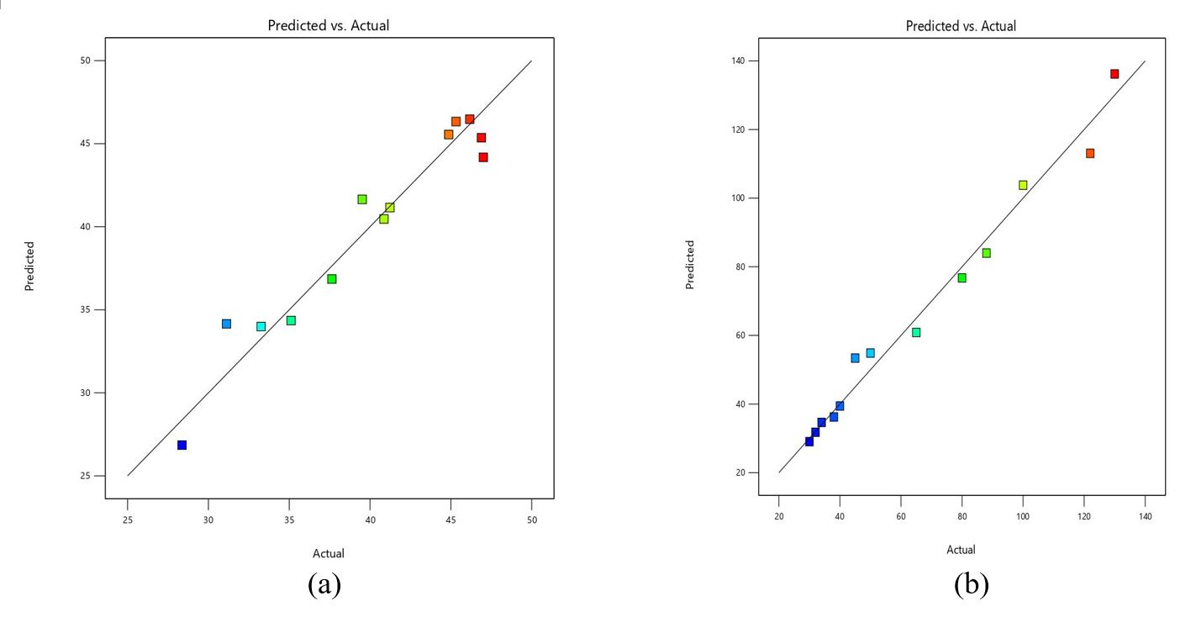
Fig. 8. Predicted Versus Actual Results for (a) Compressive Strength and (b) Workability
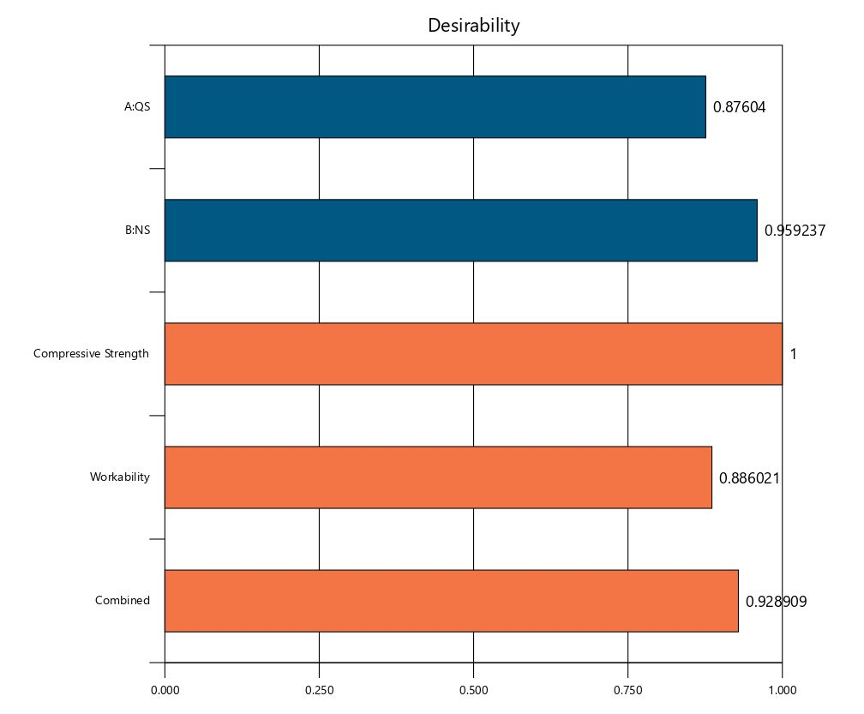
Fig. 9. Desirability for Compressive Strength and Workability

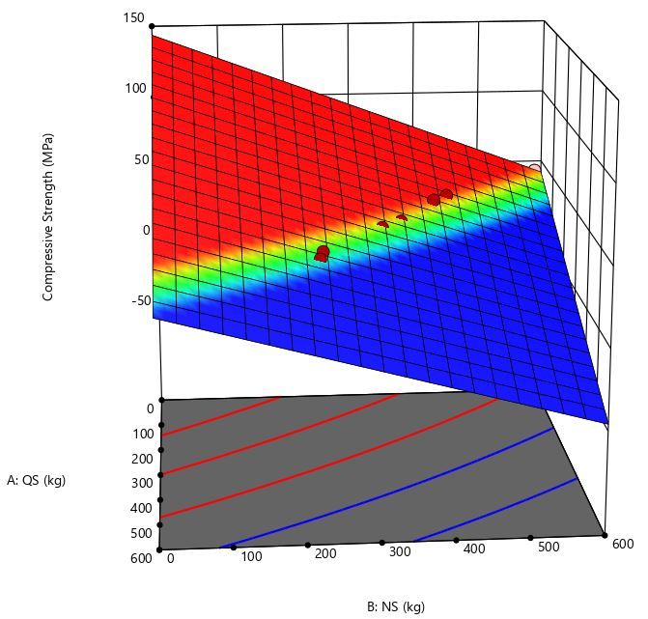  Fig. 10. Three-Dimensional Surface Plot for Compressive Strength | 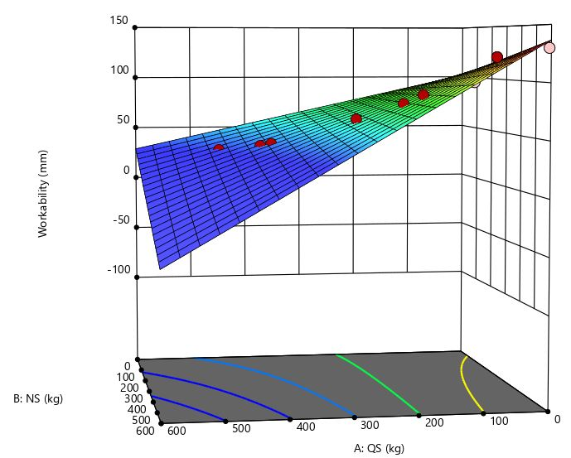  Fig. 11. Three-Dimensional Surface Plot for Workability

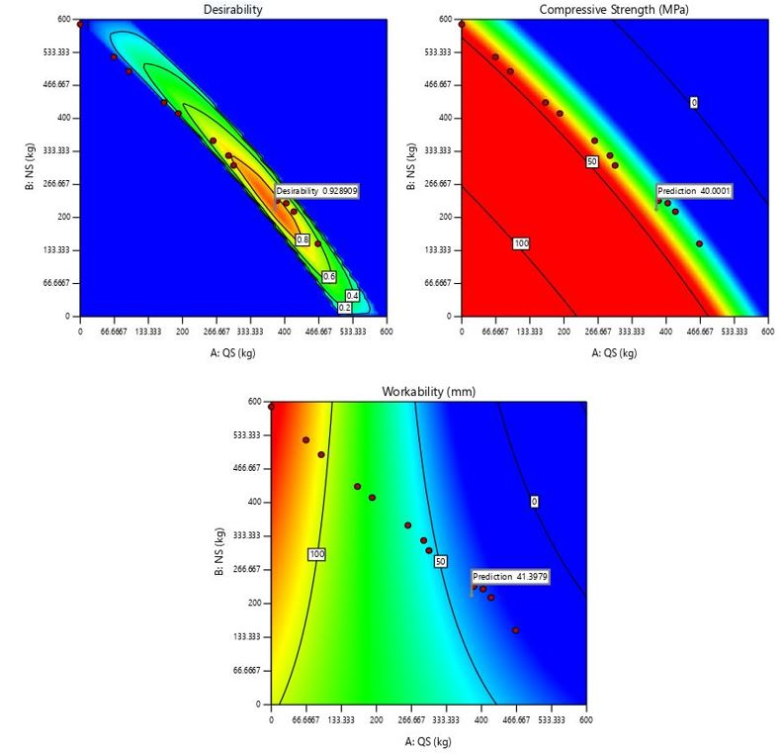
Fig. 12. Validation of Study for Compressive Strength and Workability
4. Conclusions
- A marginal increase in the density of fresh concrete is observed after the inclusion of QS in the concrete mix. This shows that the concrete's weight after the addition of QS is slightly higher.
- The four workability tests showed that the addition of QS reduced concrete workability by almost 70%, so it is recommended to use an appropriate superplasticizer along with QS to maintain concrete workability.
- The compressive strength of modified concrete mixes is enhanced with the incorporation of QS up to 30%, while the M3 mix showed a strength almost equal to the characteristic compressive strength assumed in the study. The results showed that the use of QS can be a viable solution for sustainable construction, as 45% substitution of NS can be achieved without compromising compressive strength.
- The flexural and split tensile strengths are found to increase with an increase in the amount of QS. From these results, it can be concluded that a 45% replacement of NS with QS is feasible.
- The inclusion of QS slightly increased the water absorption of concrete mixes, which can be controlled by using additives to make construction activities more sustainable. The acid attack resistance capacity is found to be better for the modified concrete mixes than the control mix.
- The optimization carried out using RSM showed that QS at 237.9 kg and NS at 387.7 kg can be used to prepare a sustainable concrete mix, confirming that 45% substitution of NS with QS is possible without compromising mechanical and durability properties.
Overall, the study concludes that QS can be considered an alternative to NS, with partial replacement up to 45%, as the mechanical characteristics of compressive and tensile strength are found to be enhanced. This represents significant environmental benefits, including reduced riverbed mining and ecosystem preservation, as well as the potential economic advantage of QS's lower cost compared to NS's fluctuating prices.
This study is performed without using any superplasticizer to examine the intrinsic effect of QS on concrete, which limits its direct field applicability; however, the actual results obtained for the effect of QS on concrete can pave the way for further research with superplasticizers. The research should also explore the use of QS, along with supplementary cementitious materials such as silica fume, ground granulated blast slag, etc. A life cycle assessment can be performed to quantify the environmental benefits of partially replacing NS with QS.
Acknowledgement
The authors extend their appreciation to the Deanship of Research and Graduate Studies at King Khalid University for funding this work through the Large Research Project under grant number RGP2/481/46.
References
Agrawal, D., Waghe, U., Ansari, K., Amran, M., Gamil, Y., Alluqmani, A.E., & Thakare, N. (2024). Optimization of eco-friendly concrete with recycled coarse aggregates and rubber particles as sustainable industrial byproducts for construction practices. Heliyon, 10(4), e25923–e25923. https://doi.org/10.1016/j.heliyon.2024.e25923
Agrawal, D., Waghe, U., Ansari, K., Dighade, R., Amran, M., Qader, D.N., & Fediuk, R. (2023). Experimental effect of pre-treatment of rubber fibers on mechanical properties of rubberized concrete. Journal of Materials Research and Technology, 23, 791–807. https://doi.org/10.1016/j.jmrt.2023.01.027
Agrawal, D., Waghe, U.P., Goel, M.D., & Bagde, A. (2024). Effect of Micro-silica and Crumb Rubber on Mechanical Properties of Concrete. In Engineering Access (Vol. 10).
Baba, A. S., Umar, A., Abubakar, A., & Adagba, T. (2023). Application of Response Surface Methodology in Predicting and optimizing the properties of Concrete containing Ground Scoria and Metakaolin blended Cement in Concrete. Journal of Civil Engineering Frontiers, 4(02), 19–26. https://doi.org/10.38094/jocef40269
Bendixen, M., Iversen, L., & Overeem, I. (2017). Greenland: Build an economy on sand. Science, 358(6365), 879. https://doi.org/10.1126/SCIENCE.AAR3388
Beniwal, A.S., Mathur, N., & Meena, R.V. (2024). Durability of Manufactured Sand (m-Sand) Concrete: A Review. Advances in Chemical and Materials Engineering Book Series, 157–166.
https://doi.org/10.4018/979-8-3693-5513-8.ch009
Bheel, N., Waqar, A., Radu, D., Benjeddou, O., Alwetaishi, M., & Almujibah, H. (2024). A comprehensive study on the impact of nano-silica and ground granulated blast furnace slag on high strength concrete characteristics: RSM modeling and optimization. Structures. https://doi.org/10.1016/j.istruc.2024.106160
Boehme, L., & Depoortere, A. (2019). Alternative Sands as Substitute for Natural Sand for the Construction Sector. IOP Conf. Ser.: Earth Environ. Sci. 290(1), 12007. https://doi.org/10.1088/1755-1315/290/1/012007
Bora, N., Daimary, N., Athparia, M., Loganathan, M.K., & Kataki, R. (2023a). Optimization of Biogenic Supplementary Cementitious Materials in Concrete prepared from East-Indian Lemon Grass (Cymbopogon flexuosus) and Poultry Litter using Response Surface Methodology. https://doi.org/10.21203/rs.3.rs-3314588/v1
Bora, N., Daimary, N., Athparia, M., Loganathan, M.K., & Kataki, R. (2023b). Optimization of Biogenic Supplementary Cementitious Materials in Concrete prepared from East-Indian Lemon Grass (Cymbopogon flexuosus) and Poultry Litter using Response Surface Methodology. https://doi.org/10.21203/rs.3.rs-3314588/v1
Deshan, K.A.M.M., & Sampath, K.H.S.M. (2024). Impact of particle morphology on the shear behavior of quarry dust / sea sand – concrete interface in geotechnical structures. 33–34. https://doi.org/10.31705/cers.2024.17
Guerbas, N., Amer, A.A.M., Adjoudj, M., & Ezziane, K. (2024). The impact of supplementary cementitious materials on the rheological and mechanical properties of mortars based on quarry waste sand. Studies in Engineering and Exact Sciences. https://doi.org/10.54021/seesv5n1-042
Haque, M., Ray, S., Mita, A. F., Mozumder, A., Karmaker, T., & Akter, S. (2024). Prediction and optimization of hardened properties of concrete prepared with granite dust and scrapped copper wire using response surface methodology. Heliyon. https://doi.org/10.1016/j.heliyon.2024.e24705
Jaradat, O. (2024). Experimental Study on the Sustainable Use of Quarry Sand in Sand Concrete Production. Brilliant Engineering, 5(3), 1–4. https://doi.org/10.36937/ben.2024.4924
Li, H.-F., Ma, X., & Zhang, G.-Z. (2023). Optimization of mortar self-healing performance-based on response surface methodology: A multifactor analysis of zeolites, crystalline admixtures, and water-to-binder ratio. Construction and Building Materials. https://doi.org/10.1016/j.conbuildmat.2023.134015
Lin, Y. (2023). Research on the effect of sand content on stress and durability of cement. 2608. https://doi.org/10.1088/1742-6596/2608/1/012007
Mamaru, D. (2020). Suitability of Crushed Manufactured Sand for Replacement of Natural River Sand to Produce C-25 Concrete. Journal of Civil and Environmental Engineering, 1–8. https://doi.org/10.37421/JCDE.2020.10.368
Martinent, J.-R., Lalau, Y., Dejean, G., & Minh, D.P. (2022). Valorisation of Local Residues, By-Products and Wastes into Ceramic Materials for Civil Engineer Application. Proceedings of the 2nd World Congress on Civil, Structural, and Environmental Engineering. https://doi.org/10.11159/icsect22.176
Patil, S., Bhaskar, R., & Xavier, J. R. (2024). Optimization of rheological and mechanical properties of sustainable lateritic self-compacting concrete containing sisal fiber using response surface methodology. Journal of Building Engineering. https://doi.org/10.1016/j.jobe.2024.108574
Sankh, A.C., Biradar, P.M., & Naghathan, S.J. (2014). Recent Trends in Replacement of Natural Sand With Different Alternatives. Retrieved from http://iosrjournals.org/iosr-jmce/papers/ICAET-2014/ce/volume-1/10.pdf
Tahir, S., Mhamed, A., Adem, A.M.A., & Karim, E. (2024). Effect of replacing natural sand by quarry waste sand in recycled aggregate concrete. European Journal of Environmental and Civil Engineering. https://doi.org/10.1080/19648189.2024.2314102
Torres, A., Brandt, J. S., Lear, K., & Liu, J. (2017). A looming tragedy of the sand commons. Science, 357(6355),
970–971. https://doi.org/10.1126/SCIENCE.AAO0503
Torres, A., Torres, A., Simoni, M.U., Keiding, J.K., Müller, D., zu Ermgassen, S.O.S.E., … Lambin, E.F. (2021). Sustainability of the global sand system in the Anthropocene. One Earth, 4(5), 639–650. https://doi.org/10.1016/J.ONEEAR.2021.04.011
Umar, M., Qian, H., Khan, M.N.A., Siddique, M.S., Almujibah, H., Elshekh, Ali. E.A., … Vatin, N. (2025). Strength and durability of concrete with bentonite clay and quarry dust. Frontiers in Materials, 11. https://doi.org/10.3389/fmats.2024.1458836
Warade Khalid; Bhaskar Kul; Zeba Naaz; Aamir Khan; Naddem Khan;Sasan Zahmatkesh; Mostafa Hajiaghaei-Keshteli;, H. A. (2023). Optimizing the grass bio methanation in lab scale reactor utilizing response surface methodology. Biofuels, 721–732. https://doi.org/10.1080/17597269.2023.2170034
Yosri, N.F.A.M., Jumahat, A., Hashim, U.R., Sidek, M.N.M., & Haris, N.A. (2024). Morphological Characteristics and Mechanical Properties of Quarry Dust Waste as Sand Replacement in Mortar. International Journal of Integrated Engineering, 16(1). https://doi.org/10.30880/ijie.2024.16.01.017
ASTM C1898. (2020). Standard Test Methods for Determining the Chemical Resistance of Concrete Products to Acid Attack. ASTM International, (Stage II), 9–10. https://doi.org/10.1520/D1898-20.1
C138/C138M-13, A. (2013). Standard Test Method for Density (Unit Weight), Yield, and Air Content (Gravimetric). ASTM International, i, 23–26. https://doi.org/10.1520/C0138
IS 269:2015. (2015). Ordinary Portland Cement Specification. IS 269-2015, New Delhi, India, Sixth Revi(December), 1–14.
IS 383:2016. (2016). Coarse and fine aggregate for concrete – Specification. Bureau of Indian Standards IS 383-2016, New Delhi, India, (January), 1–18.
BS 1881-122:2011. (2011). BSI Standards Publication Testing concrete Part 122 : Method for determination of water absorption. BSI Standards, 1–8.
IS 10262:2019 (2019). Concrete Mix Proportioning Guidelines. IS 10262-2019, New Delhi, India.
IS 456:2000. (2000). Plain and Reinforced Concrete - Code Of Practice. IS 456-2000, New Delhi, India, (July), 1–106.
IS 516. (2021). Hardened concrete - Methods of test. IS 516-2021, New Delhi, India, 54(August), 1–20. Retrieved from www.standardsbis.in
IS 1199-3. (2018). Fresh Concrete-Methods of Sampling, Testing and Analysis Part 3 Determination of Density of Fresh Concrete ( First Revision ). Retrieved from www.standardsbis.in
IS 2386- Part 1. (1963). Method of test for aggregate for concrete. Part I - Particle size and shape. BIS:2386- Part I, (Reaffirmed 2002)-(Reaffirmed 2002).
IS 2386 Part 3. (1963). Methods Of Test For Aggregates For Concrete Specific Gravity, Density, Voids, Absorption And Bulking. IS 2386 Part 3-2016, New Delhi, India, 2386 Part(October 1963), 1–19.
IS 2386 Part 4. (1963). Methods of test for Aggregates for Concrete,IS 2386 part 4 : Mechanical properties. IS 2386 Part 4 New Delhi, 1–37.
IS 5816. (1999). Specification for splitting tensile strength of concrete -Method of Test. IS 5816-1999, New Delhi, India, 1–8.

