
 | Rocznik Ochrona Środowiska
 | Volume 28 | Year 2026 ISSN 2720-7501 | pp. 559-574
 | https://doi.org/10.54740/ros.2026.038 open access
 | Received: June 2026 Accepted: July 2026 Published: July 2026
Reuse and Recycling of Greywater in Domestic Sector Using a Mini Treatment Plant Model with Bio-Lyte System
Elangovan G^{1*}, Balasundaram N², Ilangovan R³and Sivaraju S S⁴
¹Department of Civil Engineering, Karpagam Academy of Higher Education (Deemed to be University),
Coimbatore, Tamil Nadu, India
²Department of Civil Engineering, Karpagam Academy of Higher Education (Deemed to be University),
Coimbatore, Tamil Nadu, India
³Department of Civil Engineering, KPR College of Engineering and Technology, Coimbatore, Tamil Nadu, India
⁴Department of Electrical and Electronics Engineering, R V S College of Engineering and Technology,
Coimbatore, Tamil Nadu, India
*corresponding author's e-mail: elangovan.karpagam@outlook.com
Abstract: Greywater generated from household activities is an important source of wastewater from households that has to be treated before reuse or disposal. The present study deals with the development and evaluation of a compact four-chamber greywater treatment system under field conditions. The novelty of the proposed system lies in integrating Eco Bio Block (EBB), BioClean microbial culture, Nano-Nualgi solution, and hypochlorous acid (HOCl) disinfection within a compact four-chamber treatment unit designed for household-scale applications. The system provides a simple, low-energy, decentralized solution for greywater recycling, making it suitable for domestic non-potable reuse where space and operational requirements are limited. The system combines EBB, BioClean microbial culture, Nano-Nualgi solution, and HOCl for sequential biological and disinfection treatment. The performance of the system was evaluated based on key water quality parameters such as pH, total suspended solids (TSS), total dissolved solids (TDS), electrical conductivity (EC), biochemical oxygen demand (BOD₅), chemical oxygen demand (COD), total phosphorus, total nitrogen, and E. coli. As evidenced by the results, the quality of treated water improved significantly, with removal efficiencies varying by parameter and maximum reductions exceeding 95% for selected pollutants. After treatment, significant decreases were observed in TSS, BOD₅, COD, nutrients, and microbial load. Treated samples contained <1.8 MPN/100 mL, indicating effective treatment of E. coli. HOCl contributed to pathogen removal, while biological treatment processes reduced organic load. The study confirms that the proposed system can function as an efficient, decentralized greywater treatment system suitable for non-potable reuse applications.
Keywords: greywater treatment, Eco Bio Block (EBB), anolyte (HOCl) disinfection, Nano-Nualgi technology, sustainable urban water management
1. Introduction
Rapid urbanization has increased domestic water demand and wastewater generation, creating the need for effective and sustainable wastewater management in urban areas (Abbass et al., 2022). To address this challenge, Corporations, Municipalities, and Special Village Panchayats have been implementing Sewage Treatment Plants (STPs) and Fecal Sludge Treatment (FST) systems.
Recent studies have reported that improper disposal of domestic wastewater and anthropogenic activities can significantly degrade the quality of urban water bodies. Devaanand et al. (2023) emphasized that effective management of solid and liquid wastes is essential to reduce environmental pollution. In addition, Devaanand et al. (2025) demonstrated the importance of regular water quality assessment for protecting public health and ensuring sustainable water resource management. These findings further support the need for decentralized greywater treatment and reuse systems.
Wastewater is classified into two categories: blackwater and greywater. Blackwater originates from toilets and urinals. Greywater is generated in bathrooms, kitchens, and from floor-cleaning activities. During the 1960's and 1980's, a septic tank was used only for water closets and urinals, and this was called blackwater (Wu & Meng, 2023). Greywater is commonly used for gardening and agriculture. At that time, the use of chemicals in domestic areas was rare. But over the past three to four decades, a new practice has emerged in which both black and greywater are mixed and sent to septic tanks and soak pits (Pati, 2023).
Rapid urbanization has increased the pressure on drinking water resources, highlighting the need for sustainable water management and water reuse practices (Wichowsky & McNew-Birren, 2026; Seidel, 2026). In addition, climate change has led to more frequent floods and droughts over the past two decades. Cloudburst events in urban areas have further affected the performance of stormwater drainage systems (Sim & Kim, 2024). In many urban households, partially treated greywater is discharged into stormwater drains, reducing their drainage capacity and contributing to urban flooding. Several measures have therefore been proposed to divert and manage excess stormwater to mitigate flood impacts (Koyama & Yamada, 2020).
Sustainable Development Goal (SDG 6) emphasizes clean water, sanitation, and wastewater treatment. Reuse of treated greywater for non-potable applications such as urban gardening can reduce freshwater consumption and support sustainable urban water management. In this context, the present study was carried out in Wards 9 and 10 of Coimbatore Corporation.
Wastewater flowing through the canals in Ward Nos. 9 and 10, as well as the pond near Anboli Nagar, was analyzed to determine the characteristics of both raw and treated water. Based on these observations and results, the third objective of this study was to design and develop a mini-prototype model for greywater treatment that can be installed in individual households or locations with limited space.
Wastewater shall be classified into two categories. One is blackwater from toilets and urinals. It is mixed with night soil and water. The other one is greywater from the bathroom, floor wash, washing machine, and kitchen. This water is moderately polluted. At present, both waters are mixed and sent to Sewage Treatment Plants. If the greywater is separated, it shall be treated with moderate technology and used for urban and home gardening. This is also one of the objectives of this research, and a mini model tank is fabricated for implementation at the household level.
The specific objectives of the study are as follows:
- To assess the existing status and characteristics of household wastewater discharge, with particular emphasis on greywater.
- To identify an appropriate, efficient, and cost-effective treatment system for greywater treatment.
- To treat household greywater using a scientifically designed treatment process for improving its quality and potential reuse.
- To design and develop a mini greywater treatment model plant suitable for domestic households.
- To conduct pilot-scale trials of the developed system in selected households and analyse key water-quality parameters before and after treatment.

A field survey conducted in Wards 9 and 10 of Coimbatore Corporation indicated that greywater segregation is limited in most households. The findings suggest that household-level greywater treatment and reuse can support urban gardening, reduce wastewater discharge, and contribute to sustainable water management in urban areas. Despite the availability of several greywater treatment technologies, there remains a need for compact, low-cost, household-scale systems suitable for decentralized applications. Unlike conventional greywater treatment systems that often require larger installations or higher operational costs, the proposed system integrates biological treatment and disinfection within a compact four-chamber unit suitable for individual households. The study focuses on developing a practical, low-energy, decentralized treatment approach that enables greywater reuse for non-potable applications such as gardening and flushing, particularly in urban areas with limited space.
2. Related Works
Greywater Generation and Characteristics: Greywater is wastewater created from household activities, including bathing, washing clothes, washing dishes in the sink, and washing your hands after using the bathroom. In contrast, wastewater from toilets is blackwater. Typically, up to 80% of domestic wastewater originates from greywater. Because greywater typically has a lower level of contamination than blackwater, treatment methods exist for its reuse for purposes not requiring potable (drinkable) water. (Yanez, 2024; Qadir, 2025).
Greywater has different characteristics that result from the 1) types of household practices; 2) the detergents used; 3) the amount of water normally consumed. Greywater may contain organic materials, suspended solids, surfactants, oils, nutrients, and microorganisms from soaps, shampoos, and other household cleaning products. The concentration levels of the important parameters that contribute to the greywater's total contribution to environmental pollution, such as Biochemical Oxygen Demand (BOD), Chemical Oxygen Demand (COD), Total Suspended Solids (TSS), and turbidity, will differ based on the source of the greywater and the person's lifestyle (Awasthi, 2023).
Greywater may contain fewer pathogens than blackwater. However, untreated greywater can still pose environmental and human health hazards if dumped directly into the environment. Improperly disposed of greywater may lead to soil contamination, groundwater pollution, and/or a foul odour. Therefore, there must be treatment step(s) for greywater before reuse or discharge to the environment to ensure environmental safety and compliance with the water quality standards required by law (Bundeli & Sibali, 2025).
Importance of Greywater Reuse in Domestic Sector: The demand for fresh water is growing worldwide due to population growth, urbanization, and climate change. Water scarcity has emerged as a significant issue for many developing and semi-arid regions of the world. As a result, greywater reuse has become an essential means of addressing the global need to manage such resources sustainably by reducing the amount of fresh water used (Qadir et al., 2025). Using treated greywater for non-potable purposes (such as flushing toilets, landscaping, and cleaning) reduces residential potable water use, with some studies reporting decreases of 30%-50% in total water consumption when greywater reuse systems are implemented (Yánez et al., 2024). In addition to saving fresh water, greywater reuse systems also lessen the burden on centralized wastewater treatment plants and sewer systems. Greywater reuse systems offer greater flexibility by decentralizing treatment as close to the point of generation as possible, enabling lighter construction and lower operational costs (Al-Hamaiedeh et al., 2024).
Additionally, greywater reuse helps create a circular water economy by reducing wastewater discharge into natural water bodies, thereby enhancing the overall sustainability of urban water management systems. Many researchers are developing more efficient greywater treatment systems adaptable to residential installations (Santos et al., 2024).
Conventional Greywater Treatment Technologies: Greywater is purified through several treatment methods that use physical, chemical, and biological techniques. A conventional greywater treatment method involves screening (removal of larger materials), sedimentation (settlement of heavier materials), filtration, biological treatment, constructed wetland use, and membrane filtration (Awasthi et al., 2023). Sedimentation and filtration are typically used as primary treatment methods to remove larger particles (suspended solids) from greywater before secondary treatment processes. Sand filtration is an effective method of removing turbidity and larger suspended solids. Generally, sand is very easy to work with and has good turbidity-removing properties. On the other hand, filtering will not always remove dissolved organic matter and/or microorganisms from greywater (Santos et al., 2024). Unlike filtration, biological treatment systems, such as activated sludge processes and biofilters, rely on microorganisms to break down the organic pollutants found in wastewater. Although biological treatment typically produces lower BOD and COD levels than non-biological systems, it may require longer retention times and careful maintenance to achieve adequate operating efficiency (Al-Hamaiedeh et al., 2024). Research on constructed wetlands indicates that they can function as effective natural treatment systems for greywater. They use plants to treat greywater through biological processes, using microorganisms and/or soil media to filter out pollutants. Constructed wetlands are usually low-energy and low-tech systems that operate; however, they require large land areas and generally will not achieve sufficient pathogen removal without additional disinfection.
Advanced Oxidation Processes for Greywater Treatment: The usage of Advanced Oxidation Processes (AOP) in treating wastewater has gained large-scale attention among those looking to clean up complex organic wastes while simultaneously disinfecting microorganisms for their ability to degrade such waste through the generation of highly-reactive oxidizing species, such as hydroxyl radicals, which can potentially destroy organic contaminants associated with wastewater (Díaz & others, 2025). Among the various advanced oxidation technologies examined for treating greywater, ozonation has been one of the most popular methods. Being a primary oxidant with an oxidation potential greater than that of chlorine, ozone can readily oxidize organic materials, colour, destroy odours, and kill pathogenic microorganisms in water. Research has shown that ozonation can greatly reduce BOD, COD, turbidity and microbiological contamination in greywater. Furthermore, ozone naturally decomposes back into oxygen after destroying organic matter, leaving no harmful residual chemicals in the treated wastewater (Díaz & others, 2025). Due to its rapid reaction rate and high oxidative strength, ozone is particularly well-suited for small-scale residential greywater treatment systems. Ozonation, when used with filtration or other biological processes, can also provide significant improvements in greywater treatment performance and increased quality of water for reuse purposes (García-Morales & others)
Mini Treatment Plants for Domestic Greywater Recycling: Mini, or decentralized, greywater treatment plants have been attracting increasing interest recently because they offer sustainable waste management solutions for homes. They are small plants that treat greywater at the home site, using compact treatment units that employ multiple forms of treatment within their very small footprint. Many mini treatment plants use several treatment stages, including screening, sedimentation, filtration, biological treatment, and disinfection. These processes work together to effectively remove organic material, suspended solids, and microorganisms from greywater, allowing the reuse of treated water for non-potable purposes.
There has been increasing interest in using advanced processing technologies combined with small-scale treatment systems to improve greywater treatment. Hybrid systems that use both filtration and advanced oxidation processes, such as ozonation, have been shown to successfully produce treated water with improved quality and reduced pollutant levels. Even though a large number of technological developments have occurred in recent years regarding the treatment of greywater, many of these treatment systems still have a high cost and/or require significant effort to keep operating properly. Therefore, there is now an even greater need for the development of simple, inexpensive, and efficient mini-treatment systems suited for residential use. With this background, the current research is investigating the development of a mini greywater treatment plant incorporating.
Research Gap: Greywater reuse has gained popularity in response to rising water shortages and the increasing need for the sustainable use of our water resources. Numerous studies have investigated different treatments for greywater purification, including sand filtration, constructed wetlands, biological treatment systems, and membrane filtration. Each has differing levels of effectiveness in removing organics, suspended solids, and microbiological contaminants from domestic wastewater (Awasthi et al., 2023; Santos et al., 2024). Even though various types of greywater treatment technologies are available, the current greywater treatment systems are, in most cases, specifically designed for large-scale or centralized wastewater treatment systems or require large land areas and substantial operational costs. Constructed wetlands, for example, can effectively remove pollutants, but they require large areas and long hydraulic retention times to be effective; therefore, they cannot be accommodated in high-density residential areas. Membrane-based treatments achieve high removal efficiency and low turbidity, but they entail significant installation and maintenance costs, making them impractical for individual homes (Al-Hamaiedeh et al., 2024; Qadir et al., 2025).
Many different types of greywater treatment technologies have already been developed over the years. Many of them are complicated, expensive, and/or require a lot of space for installation, making them impractical for use in single-family residential homes. Most conventional treatment methods cannot remove certain organic contaminants and microorganisms in greywater; therefore, an additional disinfection step is usually required to obtain a safe, reusable product. Many recent studies are identifying the need for small-scale, affordable, and effective decentralized treatment systems capable of producing reusable water from greywater at the household level. Researchers have also found that combining advanced oxidation processes (AOPs), such as ozonation, in small-scale greywater treatment systems may enhance treatment performance by increasing the efficiency of contaminant/impurity removal, making the water safer for reuse. This study is focused on developing and evaluating a mini-greywater treatment plant with a Bio-Lyte treatment unit, with the intention of improving contaminant removal efficiency and enabling viable greywater reuse in residential applications.
3. Materials and Methods
3.1. Mini Model Fabrication for Greywater
Based on the analysis, it was decided to treat 500 liters of greywater at the source itself. Accordingly, a compact treatment unit was designed and finalized using AutoCAD. The overall dimensions of the unit are 1.80 m (length) × 0.45 m (width) × 0.45 m (height). The necessary inflow and intermediate flows between tanks 1, 2, and 3, and the final outlet level were fixed based on the gravity-flow assumption. Laser cutting was used to cut the sheet metal, which was then welded as per the plan.
Figure 1 illustrates the complete methodological framework adopted for the development, installation, and evaluation of the decentralized greywater treatment system. The workflow begins with field surveys and problem assessment, during which the greywater generation patterns and treatment needs in Ward Nos. 9 and 10 of Coimbatore Corporation are identified. Using this evaluation, the assessment seeks a compact treatment system suitable for household-level application. The process then moves on to the design and development of a four-chamber mini treatment plant with a mild-steel structure and a gravity-flow system. The pilot unit was installed and integrated with the existing greywater pipeline at the Anboli Nagar site after fabrication. The system configuration consists of a series of treatment units: primary settling, biological treatment with Eco Bio Block (EBB), secondary settling with disinfection, and final collection. The presence of various treatment additives, such as BioClean microbial culture, Nano-Nualgi to enhance oxygen levels, and oxidation agents (ozone and HOCl), will help enhance the degradation of pollutants and the removal of microbes. After installation of the system, there is a 15-day rest period during which the system achieves microbial stabilization and reaches steady state. Later, samples will be collected from various chambers, followed by laboratory assessment of vital physicochemical and microbiological parameters, including pH, TSS, TDS, EC, BOD₅, COD, total phosphorus, total nitrogen, and E. coli. Ultimately, the collected data are analyzed to assess treatment and system performance. The outcomes of this methodological sequence will be used to assess the suitability of the proposed system for decentralized greywater reuse applications. According to the layout plan, the unit is divided into four equal compartments, each measuring 0.45 m in length. Designed to perform processes sequentially, these compartments can effectively treat greywater in a small space.

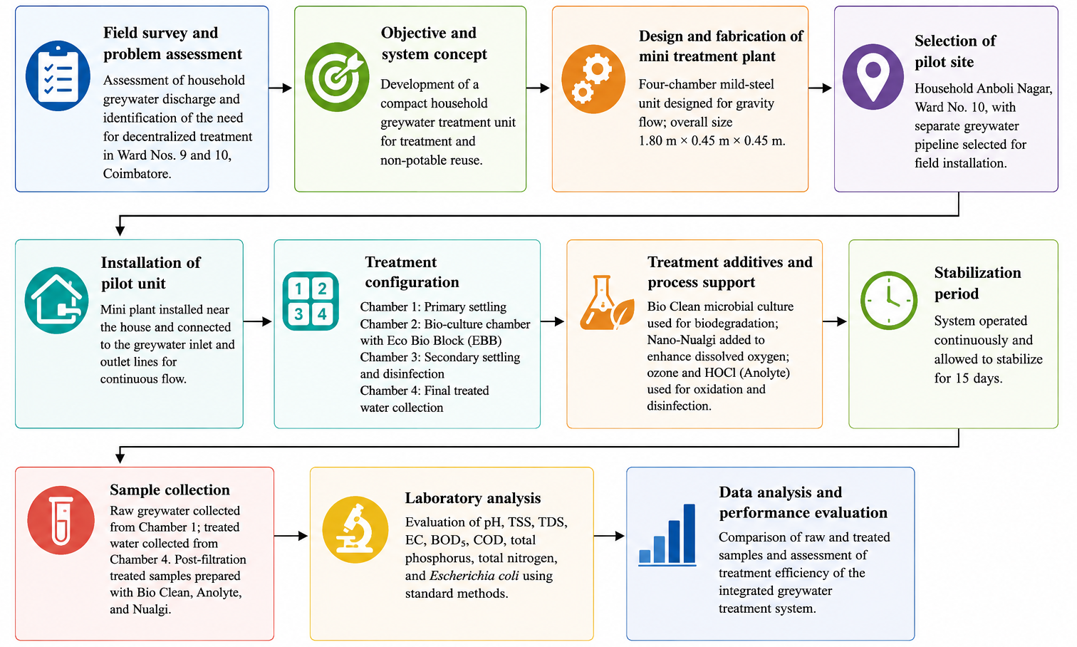
Fig. 1. Methodology Flowchart for Decentralized Greywater Treatment System Development and Evaluation

The treatment system plan and section are shown in Fig. 2. The system comprises a three-chamber serial configuration that ensures step-wise treatment of greywater. Tank 1 is the primary settling tank where suspended solids settle. Tank 2 is the bio-culture tank, used for biological treatment via EBB and microbial activity. Originally, Tank 3 was intended to operate as a secondary settling tank alongside a disinfection unit. Finally, Tank 4 serves as the final treated water collection tank, where fully processed greywater is stored before quality analysis or reuse.

Table 1. Reported configuration of the four-compartment field pilot
Compartment | Function in field record | Information available
Tank 1 | Primary settling | Initial collection and gravity settling of particulate matter.
Tank 2 | Biofilm chamber | EBB media was reported to be immersed; the record describes a 15-day stabilization period.
Tank 3 | Secondary  settling/disinfection | Collection of processed water; the original report states HOCl was used periodically but does not give dose or contact time.
Tank 4 | Final holding | Final treated-water collection before discharge or post-treatment sampling.

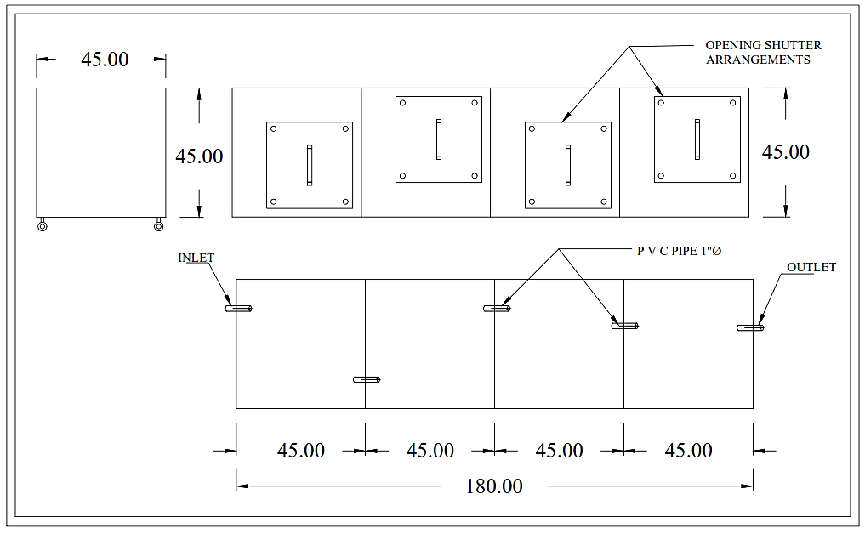
Fig. 2. Drawing – Plan and Section

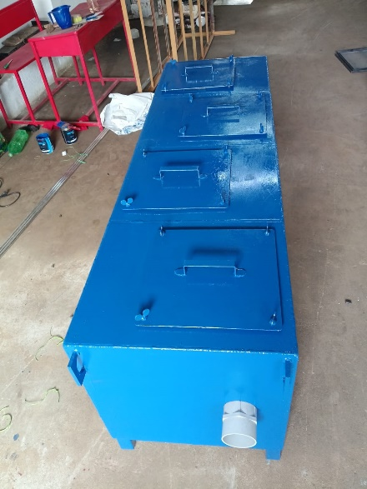 | 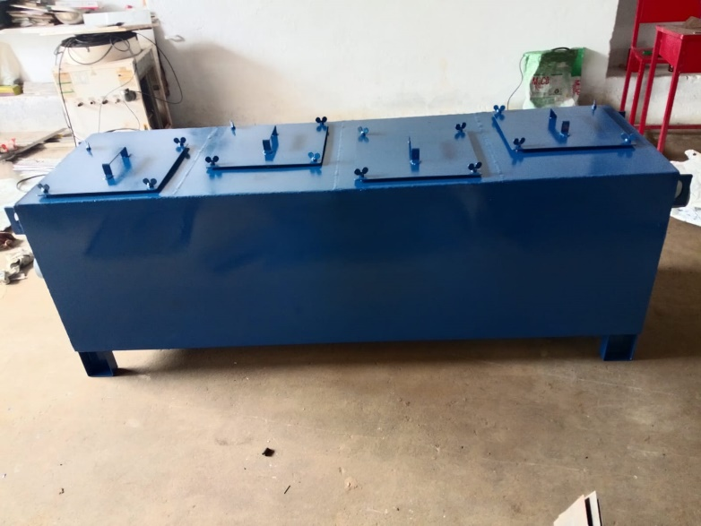
Fig. 3. Mini Model Unit for Pilot Project Study
3.2. Location for Greywater Treatment Plant
In wards no 9 and 10 of Coimbatore Corporation, intensive searches have been conducted, and one house has been found in ward no 10 near the Pond of Coimbatore Corporation. With the house owner's permission, a fabricated mini plant has been installed at this house, No. 14, Anboli Nagar, in ward no. 10. An existing separate greywater wastewater line is available at this house, as shown in Figure 4. The untreated grey wastewater is flowing through this pipeline. It is discharged into the stormwater canal, which leads to the Pond located in ward no. 9 of Coimbatore Corporation, as shown in the diagram. A small Park site is located adjacent to this house.

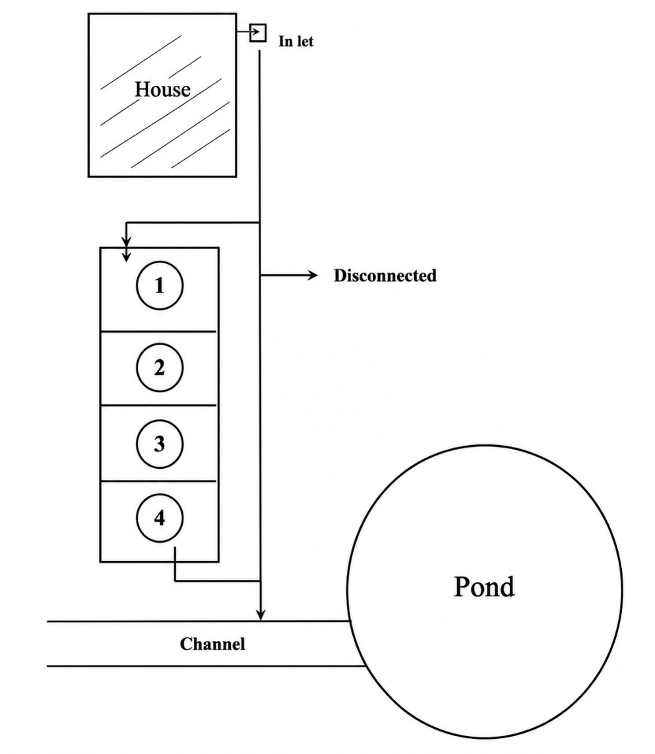
Fig. 4. Location of Site

With the house property owner's permission, the greywater pipeline is disconnected and diverted to the park area. The fabricated mini-treated plant is installed at the park site, and the greywater line is connected to it. Chamber 1 is the inlet entry. Chamber 1 will act as the primary settling tank, and the greywater will then go to Chamber 2, where the EBB block is immersed. EBB Block will help establish a beneficial bacterial population within two weeks. From Chamber 2, the water will flow to Chambers 3 and 4. Then, from the chamber, the grey wastewater will come out of the exit pipe and be reconnected to the main greywater pipeline. The flow is checked and verified; continuous inflow is found daily. So continuous outflow is also observed. Around 300 liters per day flow from the household. This was a baseline for designing a suitable device to treat the greywater flowing from the houses. The mini plant has been installed and verified to operate continuously. After 15 days of stabilization, the wastewater from the EBB and secondary settling tank chamber 4 has to be collected, filtered, and treated with the BioClean, Nualgi, and Anolyte System.
Hydraulic assumptions and residence time: Based on geometric volume and reported flow conditions, the theoretical hydraulic retention time (HRT) of the system was estimated to range from 17.5 h to 29.2 h, depending on daily flow rate variations. However, no tracer study or direct hydraulic residence time measurement was conducted. Therefore, HRT values reported in this study are theoretical estimates only and were not used for kinetic modeling or mechanistic interpretation (Budeli & Sibali, 2025; García-Morales et al., 2024).

Table 2. Evidence status of the treatment routes in the current field-pilot record
Route | Available treatment description | Critical evidence gap
Raw greywater | Chamber 1 influent | Baseline source water; no treatment.
BioClean route | Chamber 4 effluent, filtered,  then BioClean powder added | Dose, mixing time and contact time not recorded.
HOCl/Anolyte route | Chamber 4 effluent, filtered, then HOCl/Anolyte added | Free chlorine dose, residual and contact time not recorded.
Nano-Nualgi route | Chamber 4 effluent, filtered, then Nano-Nualgi added | Composition, dose, exposure time and mechanism not independently verified.
3.3. Materials and Treatment Process
The water samples collected were subjected to two treatment processes: EBB treatment, BioClean and Nualgi, and (Anolyte) HOCl treatment to evaluate their ability to remove impurities and improve the quality of the water. EBB and BioClean are microbial culture systems. The Nano Nualgi system helps increase dissolved oxygen levels. HOCl liquid is useful for eradicating pathogens in wastewater.
The treatment system was operated under gravity flow after a 15-day stabilization period to allow microbial growth on the EBB. EBB served as the biological support media for pollutant degradation, while BioClean microbial culture enhanced the breakdown of organic matter. Nano-Nualgi solution was added to improve dissolved oxygen availability and support biological activity. Finally, HOCl (Anolyte) was applied as the disinfection stage to reduce pathogenic microorganisms, and the treated greywater was then analyzed.
3.4. Eco Bio Block
During aeration, it is expected that beneficial bacteria will develop and degrade the biomass. But it is not happening due to the use of chemicals in houses. In 1998, the Ministry of Environment and Forests (MoEF) of India introduced a new concept called Bio Remediation. Beneficial microbes cultured in powder, liquid, or Solid Blocks shall be used in the aeration tank, so that the expected beneficial population can handle the pollution load. But when powder or liquid is used, the continuous maintenance cost shall increase due to the addition of microbial liquid or powder. So, in the same vein, if any solid blocks are available as a one-time investment, it will reduce running costs.

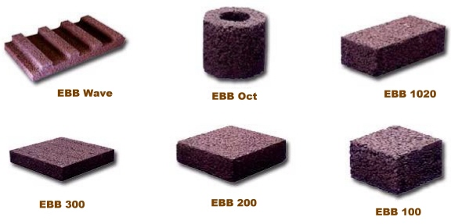
Fig. 5. Types of EBB blocks

During the search for society, the Japanese technology EBB helps with wastewater treatment when used in an aeration tank. Though this technology has been approved in the Government of India's manual, it is not used in any of the ASP, SBR, MBBR, or MBR technologies. The present study indicated that the EBB system showed promising treatment performance. The types of EBB are depicted in Figure 5.
The EBB Oct block was fixed in the ¾' PVC pipe in the aeration tank. Aeration is provided using mini fish tank aerators for 1 week, 24 hrs/day. After one week, the treated water is sent to the settling tank and into a 1-liter PVC bottle. In many STP projects, EBB has been used in the aeration tank. But after EBB, they go for settling tank, Sodium Hypochlorite, and Chlorination.
In the present study, an alternative treatment process was adopted after EBB. Ozonization is used in the settling tank, and the final step is dosing with HOCl liquid. HOCl liquid has a shelf life of around six months, so it will react with pollutants for up to six months.
3.5. BioClean Powder
The product BioClean Septic Plus powder was obtained from the market. It is a consortium of many beneficial bacteria. BioClean STP is a specialized microbial solution manufactured to enhance sewage treatment plants (STPs) by effectively breaking down organic pollutants, including COD, BOD, phosphorus, and nitrogen. Using natural, non-genetically modified bacteria reduces foul odors and minimizes sludge production, resulting in cleaner, reusable water for irrigation or flushing.
The system effectively reduces food waste and lowers the overall pollution load while preventing the generation of bad odour during treatment. It significantly reduces key wastewater parameters, such as BOD and COD, and improves effluent quality. Furthermore, it reduces fecal coliform counts, enabling safer water release. The process further reduces energy consumption and sludge generation, resulting in lower operating and disposal costs. Furthermore, the system is versatile and can be integrated with various treatment technologies, including the Activated Sludge Process (ASP), Moving Bed Biofilm Reactor (MBBR), Membrane Bioreactors, and decentralized sewage treatment plant (STP) systems.
3.6. Nano Nualgi System
Normally, the dissolved oxygen (DO) available in the greywater pipe is very low. Electrical aeration increases electricity consumption. But the Nano Nualgi liquid is a bio-aerator. Without electricity, the liquid improves the DO level in the wastewater chamber. The Nano Nualgi liquid contains nutrients like zinc, iron, manganese, and copper. When the liquid is sprayed into the wastewater, diatom algae develop, increasing dissolved oxygen levels. So, this is treated after the EBB block and filtered through sand and carbon.
3.7. Anolyte (Hypochlorous Acid, HOCl) System
Hypochlorous acid (HOCl) Treatment: Electrochemically activated HOCl, a powerful oxidizing agent, was added to the samples to facilitate microbial disinfection and chemical oxidation. HOCl is known to efficiently eliminate bacteria, viruses, and organic contaminants while lowering ammonia nitrogen levels. HOCl's oxidative action facilitates water purification by degrading complex contaminants into less toxic products. The HOCl liquid is made from the concept reactor. The brine solution is a dissolved solution of sodium chloride, water, and electricity. Two output liquids, Anolyte and Catholyte, shall be obtained. HOCl is used for disinfection, and Catholyte is used for agricultural activities.
3.8. Treatment Methodology
The complete unit was fabricated in a dedicated workshop from 3 mm-thick mild steel (MS) sheets. Each of the four chambers was provided with a top opening (0.30 m × 0.30 m), secured with flexible bolts and nuts to facilitate periodic inspection and maintenance. A mild-steel, fabricated mini model plant was installed in the Small Park area near Anboli Nagar house. This house has greywater separation. Bathroom, kitchen, and floor wash water is collected separately and sent to the nearby Storm Water Drain. With the Owner's permission, the outlet pipe is diverted and connected to the Mini Model Plant. From box no. 4, the outlet is again joined to the main pipe laid by the house owner. After passing through the four boxes, the treated water is again connected to the old pipeline as a bypass arrangement. While fixing the Mini plant, the EBB block is kept in box no. 2. After two weeks of the EBB block stabilization, the samples were collected from Chamber 1, 3 and 4.
After identifying a suitable residence in Ward No. 10, Anboli Nagar, near the pond, the installation site was finalized. The selected house accommodates three residents. The homeowner had already segregated toilet wastewater to a septic tank at the rear and directed greywater to a soak pit draining into the stormwater drain canal, obtaining the homeowner's consent. The model unit was installed to treat greywater at the household level. A pit measuring 2.00 m × 0.70 m × 1.20 m depth was excavated using earthmovers. A uniform layer of M-sand was placed on the pit base, and using the same earthmoving equipment, the fabricated unit was placed and aligned. Lastly, the greywater inlet from the house was connected to the inlet chamber of the model unit, and its treated outlet was connected to the existing drain pipe to ensure a steady flow through the treatment system.

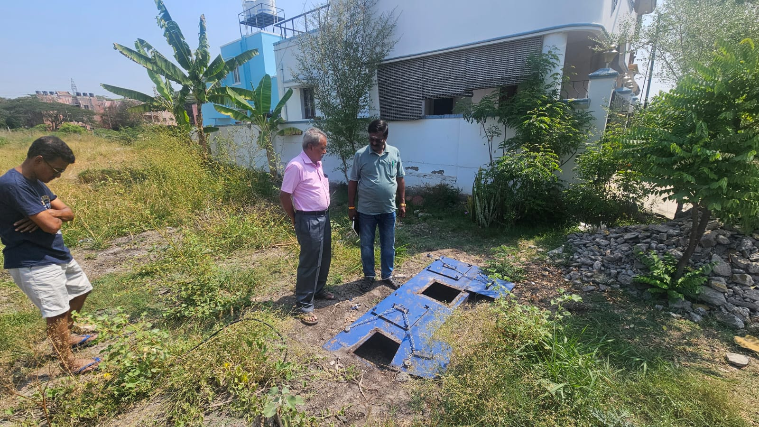
Fig. 6. Photograph shows the place of erected mini model plant

Samples were collected on 11th December 2025: Sample 1 - raw wastewater from Chamber 1; Sample 2 after the EBB treatment in Chamber 4, further collected, filtered, and treated with Anolyte liquid. The collection of Sample 3 from Chamber 4 was conducted after the EBB treatment. Then, it was filtered, and BioClean Powder was added. Sample 4 from Chamber 4, collected after EBB treatment, was filtered and treated with Nualgi liquid. All samples were appropriately preserved and dispatched to the laboratory in accordance with the timing and methodology.
Since the mini model unit was designed without an aeration system, Nano Nualgi liquid (5 mL) was introduced in Chambers 1 and 2. This helps increase dissolved oxygen levels biologically. A water sample in Chamber 4 was collected after a 15-day retention time for analysis. A sample was collected from the section treated with Nano Nualgi, and another from the section disinfected with 5 mL of HOCl solution. The samples were sent to an accredited laboratory for testing in accordance with standard procedures.
An investigation of the physicochemical and microbiological characteristics of the greywater was conducted to evaluate the pollution load and treatment efficiency of the developed system. The analysis was performed using standard analytical methods. Key physicochemical parameters, including pH, electrical conductivity (EC), total dissolved solids (TDS), total suspended solids (TSS), biochemical oxygen demand (BOD), chemical oxygen demand (COD), total phosphorus (TP), and total nitrogen (TN), were measured to assess water quality. In addition, microbiological analyses were carried out to determine the total bacterial load, faecal coliforms, faecal streptococci, and the presence of Escherichia coli (E. coli), as certain pathogenic microorganisms may survive conventional wastewater treatment processes and pose potential risks to human health and the environment. The combined evaluation of these physicochemical and microbiological parameters provides a comprehensive assessment of treatment performance and the safety of the treated greywater for potential reuse.
4. Results and Discussion
4.1. Influent Greywater Characteristics
The influent greywater characteristics represent a single measured baseline dataset obtained from the household source under real operating conditions. Because temporal sampling is absent, these values represent baseline descriptive conditions rather than statistically averaged influent behavior. These values indicate moderately high organic and microbial loading typical of domestic greywater streams, consistent with previously reported household-scale greywater characterization studies (Mohan et al., 2023; Mohan et al., 2024).

Table 3. Influent greywater characteristics (baseline observation)
Parameter | Influent (Single Observation)
pH | 7.41
TSS (mg/L) | 245
TDS (mg/L) | 1154
EC | 1804
COD (mg/L) | 350
BOD₅ (mg/L) | 110
Phosphorus (mg/L) | 12
Nitrogen (mg/L) | 45
E. coli (MPN/100 mL) | 140

4.2. Onsite Greywater Treatment
The greywater collected from bathrooms and kitchens was treated separately using the proposed mini treatment plant. Using the bio liquids and powders, the water was treated and tested using the EBB, Nano Nualgi, and HOCl (Bio Remediation) systems. A mini model machine was fabricated, and using the new Bio Engineering system, the EBB, Ozone, and HOCl liquid were used for the treatment. The treated wastewater quality was analyzed to evaluate the current characteristics of the greywater.
The following pH, EC, BOD, COD, phosphorus, nitrogen, and E. coli parameters were tested and analyzed. The results presented in this study are based on a single field sampling event conducted after system stabilization. The data provide preliminary evidence of the treatment performance of the proposed greywater treatment system. The test results indicated that the proposed Bio Remediation treatment system is working well. The land power cost and the sludge generation are reduced. The results are well within the permissible limits and highly encouraging.

Table 4. Physico-Chemical and Microbiological Characteristics of greywater at Different Treatment Stages
Sl. No | Test Parameter | Units | Raw greywater | After Filtration  (BioClean) | After Filtration  + Anolyte | After Filtration  + Nualgi
1 | pH | – | 7.41 | 7.40 | 7.39 | 7.24
2 | Total Suspended Solids (TSS) | mg/L | 245 | 48 | 26 | 7
3 | Total Dissolved Solids (TDS) | mg/L | 1154 | 1108 | 1080 | 1060
4 | Electrical Conductivity (EC) | µS/cm | 3125 | 1804 | 1731.25 | 1656.25
5 | Chemical Oxygen Demand (COD) | mg/L | 350 | 170 | 140 | 109
6 | Biochemical Oxygen Demand (BOD₅) | mg/L | 110 | 45 | 32 | 23
7 | Total Phosphorus (TP) | mg/L | 12 | 9 | 3 | 2
8 | Total Nitrogen (TN) | mg/L | 45 | 25 | 18 | 16
9 | Escherichia coli | MPN/100 mL | 140 | <1.8 | <1.8 | <1.8

This research provides an extensive analysis of greywater treatment using EBB, BioClean, Nano-Nualgi, and HOCl (Anolyte) under decentralized household conditions. The findings show that each of the three treatments results in significant reductions in important water quality pollutants, including TSS, TDS, COD, BOD, fecal coliforms, and nutrient load (nitrate, nitrite, phosphate, and ammoniacal nitrogen).
The Anolyte system consistently produced larger reductions, especially in pathogen removal and inorganic load destruction. The local greywater test results demonstrated the viability of such approaches in domestic, decentralized contexts and were an accessible means of sustainable urban water reuse. This research confirms the effectiveness of the proposed biological treatment and disinfection process for improving greywater quality at the household scale.
4.3. Removal Efficiency
Removal efficiencies were calculated using standard mass balance expressions for descriptive interpretation only.

Table 5. Descriptive removal efficiencies (single-event calculation)
Parameter | BioClean (%) | HOCl (%) | Nano-Nualgi (%)
TSS | 80.4 | 89.4 | 97.1
COD | 51.4 | 60.0 | 68.9
BOD₅ | 59.1 | 70.9 | 79.1
Phosphorus | 25.0 | 75.0 | 83.3
Nitrogen | 44.4 | 60.0 | 64.4

These values represent arithmetic reductions calculated from a single field-sampling event and should not be interpreted as statistically significant performance differences or definitive evidence of treatment superiority. The removal efficiencies shown in Figure 7 provide preliminary evidence of the proposed greywater treatment system's treatment performance. Further studies involving repeated sampling and statistical analysis are required to validate long-term performance and reliability.

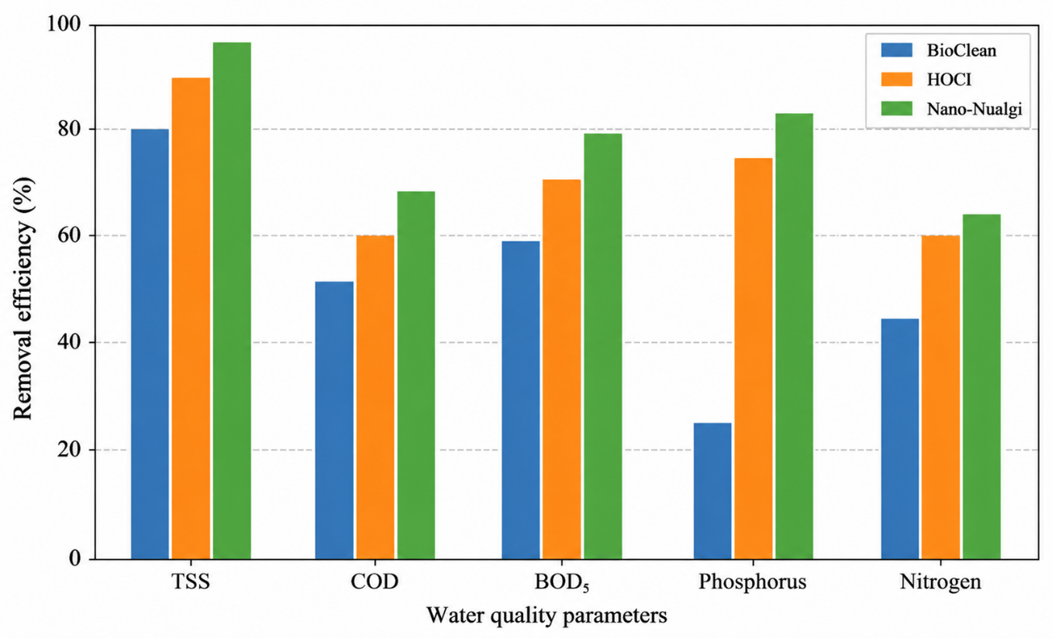
Fig. 7. Removal efficiencies of selected water-quality parameters based on a single field-sampling event
4.4. Discussion
Figures 8–12 present the removal efficiencies achieved for the investigated water-quality parameters. TSS showed the highest removal efficiency of 97.1%, whereas BOD₅, COD, total phosphorus, and total nitrogen also exhibited considerable reductions after treatment. These findings suggest that the proposed greywater treatment system can effectively improve effluent quality under the tested operating conditions. Nevertheless, since the evaluation was based on limited sampling, further monitoring over an extended period, together with statistical analysis, is necessary to confirm the system's consistency and long-term performance.
The combination of filtration and HOCl (Anolyte) disinfection significantly improved the physicochemical and microbiological quality of the treated greywater. Marked reductions were observed in organic pollutants and nutrients, while Escherichia coli (E. coli) concentrations were reduced to below the detection limit (<1.8 MPN/100 mL). This level of microbial reduction reflects the effectiveness of the oxidation process, in which HOCl damages microbial cell membranes and oxidizes cellular constituents, leading to efficient pathogen inactivation. The results indicate that the proposed treatment process can produce treated greywater of improved quality with potential for non-potable reuse.
The treatment performance observed in this study is comparable to that reported in recent studies on decentralized greywater treatment systems. Al-Hamaiedeh et al. (2024) reported effective removal of organic pollutants and improved water quality using an integrated household greywater treatment system. Similarly, Santos et al. (2024) highlighted the effectiveness of biological treatment processes for greywater reuse, while García-Morales et al. (2024) demonstrated that integrated treatment methods significantly improve greywater quality. The present findings are consistent with these studies and further demonstrate the applicability of the proposed compact household-scale treatment system for non-potable water reuse.

Fig. 8. pH and TSS

Fig. 9. TDS and EC

As shown in Figures 10–12, the declining trends in BOD and COD confirm the effective degradation of both biomaterial and non-biomaterial organic matter. Biological treatment together with HOCl disinfection contributed to the reduction of organic pollutants. Likewise, phosphorus and nitrogen concentrations were similarly reduced, indicating that nutrient removal was at least partially due to oxidation and adsorption.
Still, TDS and EC showed no comparable reduction efficiency, as revealed by the results. While there were some small declines across treatment stages, there was still no significant overall reduction. Due to their ionic nature and high solubility, these parameters cannot be removed by oxidation or basic filtration. Hence, units such as ion exchange, reverse osmosis, and other membrane-based filtration systems may be required to further reduce TDS and EC levels.

The pH remained stable throughout the treatment, indicating that the chemical equilibrium of water was not disturbed. Likewise, TSS improved after filtration; however, further optimization of the filtration unit is necessary. Findings indicate that improving media gradation, retention time, and fine filtration (microfiltration) in the existing sand filtration system could improve its effectiveness. Furthermore, the use of low-energy aeration systems, such as aerators used in fish tanks, would enhance oxygen transfer efficiency and biological degradation.
As the study shows, the combination of filtration and HOCl disinfection is a sound decentralized greywater treatment method. The suggested four-chamber system shows good prospects for household use, with the arrangement able to be continuous or vertical. With proper optimization and the installation of enhanced polishing units, it can be used to convert greywater into reusable, non-potable water. From a practical perspective, the proposed treatment system is suitable for household-level installation because of its compact design and simple operation. The treated greywater can be reused for non-potable purposes such as home gardening, landscape irrigation, and toilet flushing, thereby reducing freshwater consumption and wastewater discharge. The decentralized approach also makes the system suitable for urban areas where space and water resources are limited.

Fig. 10. BOD and COD

Fig. 11. Total phosphorus (TP) and total nitrogen (TN).

Fig. 12. Escherichia coli (E. coli)

To conclude, the results indicate that the combined treatment method is highly effective in reducing organic load and microbial contamination; however, for dissolved solids and filtration, the effectiveness needs to be enhanced for field application.
5. Conclusion
The pilot-scale greywater treatment system developed in this study successfully improved the quality of domestic greywater under actual household operating conditions. The treatment train, consisting of Eco Bio Block, BioClean microbial culture, Nano-Nualgi, and HOCl (Anolyte) disinfection, effectively reduced suspended solids, organic pollutants, nutrients, and microbial contamination. Among the evaluated parameters, total suspended solids exhibited the highest removal efficiency, while substantial reductions were also achieved for BOD₅, COD, total phosphorus, and total nitrogen. Escherichia coli was not detected in the treated effluent (<1.8 MPN/100 mL), indicating that the disinfection process was highly effective in controlling pathogenic microorganisms. Although dissolved solids and electrical conductivity showed comparatively smaller reductions, the overall treatment performance demonstrates that the developed system is suitable for improving greywater quality for non-potable reuse, including landscape irrigation and toilet flushing.
This work represents an initial field evaluation carried out at a single household using a limited number of samples. Consequently, the findings should be interpreted as preliminary evidence of system performance rather than long-term operational behaviour. Future investigations should evaluate the treatment system over extended periods and under varying household wastewater characteristics to verify its stability and reliability. Additional improvements, particularly through enhanced polishing processes for dissolved solids, may further increase the quality of the treated effluent and broaden its reuse applications. The results of this study provide a useful basis for developing compact, decentralized greywater treatment systems for residential communities.
References
Abbass, K., Qasim, M., Song, H., Murshed, M., Mahmood, H., & Younis, I. (2022). A review of the global climate change impacts, adaptation, and sustainable mitigation measures. Environmental Science and Pollution Research, 29, 42539–42559. https://doi.org/10.1007/s11356-022-19718-6
Al-Hamaiedeh, H., et al. (2024). Performance of an integrated household greywater treatment system for water optimization and reuse. Applied Water Science, 14, 242. https://doi.org/10.1007/s13201-024-02303-2
Awasthi, A., Gandhi, K., & Rayalu, S. (2023). Greywater treatment technologies: A comprehensive review. International Journal of Environmental Science and Technology, 21, 1053–1082. https://doi.org/10.1007/s13762-023-04940-7
Budeli, P., & Sibali, L. (2025). Greywater reuse: Contaminant profile, health implications, and sustainable solutions. International Journal of Environmental Research and Public Health, 22(5), 740.
Devaanand, A. D., Madhusudhanan, S., & Nallusamy, S. (2023). Assessment of solid and liquid waste inside the temple complex and tanks of Kumbakonam Town in India. SSRG International Journal of Civil Engineering, 10(6), 9–20. https://doi.org/10.14445/23488352/IJCE-V10I6P102
Devaanand, A. D., Madhusudhanan, S., Elango, M., Nallusamy, S., & Indrapriya, K. (2025). Water quality index of religious tanks in the temples of Kumbakonam, Thanjavur District. SSRG International Journal of Civil Engineering, 12(5), 76–86. https://doi.org/10.14445/23488352/IJCE-V12I5P107
Díaz, M.A., Blanco, D., Jaure, R.C., & Cunich, A.C. (2025). Ozonation for low-load greywater treatment: A review and experimental considerations for small-scale systems. Water, 17(8), 1195. https://doi.org/10.3390/w17081195
García-Morales, J.L., et al. (2024). Treatment of greywater coming from a food court using adsorption and advanced oxidation processes. Journal of Water Process Engineering, 64, 105653. https://doi.org/10.1016/j.jwpe.2024.105653
Koyama, N., & Yamada, T. (2020). A Proposed Simultaneous Calculation Method for Flood by River Water, Inland Flood, and Storm Surge at Tidal Rivers of Metropolitan Cities: A Case Study of Katabira River in Japan. Water, 12(6), 1769. https://doi.org/10.3390/w12061769
Mohan, S., Muralimohan, N., & Vidhya, K. (2023, October). Investigation of contamination level in Thirumanimutharu river and influence on groundwater at Salem Corporation. AIP Conference Proceedings, 2912(1), 020001. AIP Publishing LLC.
Mohan, S., Ragul, D., & Sudharson, N. (2024). Feasibility studies on deepening Pondicherry Port to accommodate larger vessels explored. E3S Web of Conferences, 529, 04020. EDP Sciences.
Pati, P. (2023). Stabilization Tank with Respect to Detention Time for Grey Water Treatment. International Journal for Research in Applied Science and Engineering Technology, https://doi.org/10.22214/ijraset.2023.51957
Qadir, M., et al. (2025). Greywater reuse for irrigation: A critical review of suitability, treatment, and risks. Science of the Total Environment, 975, 179272. https://doi.org/10.1016/j.scitotenv.2025.179272
Santos, J., Rodrigues, S., Gomes, A.M., & Rodrigues, K. (2024). A state-of-the-art review (2019–2023) on constructed wetlands for greywater treatment and reuse. Environmental Challenges, 16, 100973. https://doi.org/10.1016/j.envc.2024.100973
Seidel, C. (2026). Risk Reduction Opportunities in Drinking Water. Safe Drinking Water Act. 19–41.
https://doi.org/10.1007/978-3-032-10830-2_2
Sim, S.-B., & Kim, H.-J. (2024). The Impact of Storm Sewer Network Simplification and Rainfall Runoff Methods on Urban Flood Analysis. Water. 16(22), 3307. https://doi.org/10.3390/w16223307
Wichowsky, A., & McNew-Birren, J. (2026). Thirsty for Deliberation? Improving Public Engagement to Protect the Nation's Drinking Water. Safe Drinking Water Act. 153–173. https://doi.org/10.1007/978-3-032-10830-2_8
Wu, L., & Meng, Y. (2023). Water Requirement in North China from Grey Point Prediction and Grey Interval Prediction. Water. 15(8), 1453. https://doi.org/10.3390/w15081453
Yánez, D., Espinoza, L.C., Vargas, I., Romero, J., Aguirre, M.J., Arce, R., Quijada-Maldonado, E., & Abejón, R. (2024). Treated greywater as a novel water resource: The perspective of greywater treatment for reuse from a bibliometric analysis. Water Science and Technology, 90(11), 3076–3110. https://doi.org/10.2166/wst.2024.384

