
 | Rocznik Ochrona Środowiska
 | Volume 28 | Year 2026 ISSN 2720-7501 | pp. 547-558
 | https://doi.org/10.54740/ros.2026.037 open access
 | Received: June 2026 Accepted: June 2026 Published: July 2026
An Assessment of Water Reserve Changes in a Small Dam Reservoir:
The Case of the Przebędowo Reservoir
Mariusz Korytowski¹, Miłosz Nowak²
¹Department of Land Improvement, Environmental Development and Spatial Management,
Faculty of Environmental and Mechanical Engineering, Poznań University of Life Sciences
https://orcid.org/0000-0003-2084-3796
² Faculty of Environmental and Mechanical Engineering, Poznań University of Life Sciences
*corresponding author's email: mariusz.korytowski@up.poznan.pl
Abstract: This paper presents the results of a study conducted in the immediate watershed of the Przebędowo Reservoir. The analysed reservoir is located in the Wielkopolska (Greater Poland) Voivodeship and lies within the Surface Water Body (SWB) named Trojanka (Struga Goślińska) with the national code RW600010185969. The conducted research and analyses confirmed that, for small reservoirs with the dam operating in flow-through mode, water levels vary only slightly from the normal pool level (NPP). A regular pattern was also observed, often in dam reservoirs where inflows exceed outflows. It can be concluded that, in addition to evaporation from the water surface, the reservoir's partially fed nature significantly influenced this situation. Calculations of the correlations between changes in reservoir water storage and inflows and outflows revealed a relatively strong relationship. However, no direct correlations were found between increases in water storage in the reservoir in question and one of the factors of vertical water exchange, namely precipitation inflow into the reservoir.
Keywords: small-scale water retention, dammed reservoirs, changes in water levels
1. Introduction
Climate change exacerbates the effects of anthropogenic pressure on aquatic ecosystems. Recent climate reports indicate that if warming continues at the current rate, the global average air temperature will rise by 1.5°C, and then by 2°C, as early as between 2030 and 2052 (IPCC, 2018), significantly contributing to an increase in the intensity and duration of droughts (Zalewski et al., 2019; Grochowska et al., 2019). According to Wiatkowski et al. (2007), the seasonal and spatial variability of water resources, as well as the threats to human activities posed by cyclical extreme natural phenomena (floods and droughts), justify numerous measures to mitigate their negative effects. Currently, only 6.5% of rainfall is retained in over 4,000 anthropogenic reservoirs in Poland. However, the needs in the context of mitigating the aforementioned negative phenomena are twice as high (Marciniak, 2024). This often requires continuous monitoring of water-level changes in a reservoir, which directly determine its storage capacity. An analysis of water level changes in reservoirs, which allows for the characterization of a given object's effective retention capacity, along with studies on the factors determining horizontal water exchange (inflows and outflows from the reservoir), often form the basis for a comprehensive characterization of a given reservoir's operation, including in the context of assessing its water balance.
This study aimed to assess changes in water storage in a small reservoir, using the Przebędowo reservoir as a case study, during two hydrological years with varying precipitation levels. The study also sought to identify the relationship between changes in reservoir water storage and the factors influencing horizontal and vertical water exchange.
Although the studies conducted and the results obtained are of a local character (they concerned a single reservoir), they may have broader applications for similar studies of newly constructed facilities. To a large extent, they could help implement projects aimed at the optimal operation of new facilities, which, when subject to detailed monitoring—particularly hydrological and ecological—would contribute to improving Poland's water balance while significantly influencing the gradual increase in the national retention rate. According to Waligórski (2024), another significant factor in the context of conducting this type of research is the fact that the Water Shortage Mitigation Program (PPNW, also known as the Retention Development Program), approved for the years 2021–2027 with a perspective through 2030, the largest hydrotechnical investments in our country are scheduled for implementation between 2027 and 2030.

2. Materials and Methods
The Przebędowo Reservoir is located in the Greater Poland Voivodeship, approximately 25 km north of Poznań, in the municipality of Murowana Goślina (Fig. 1). The reservoir's primary purpose is to store water for agricultural use and to improve climatic conditions in its immediate watershed. The reservoir also serves as a flood and fire protection measure within the municipality. It is a typical small lowland dam reservoir, with the shallowest sections in the upstream part and the deepest near the dam.

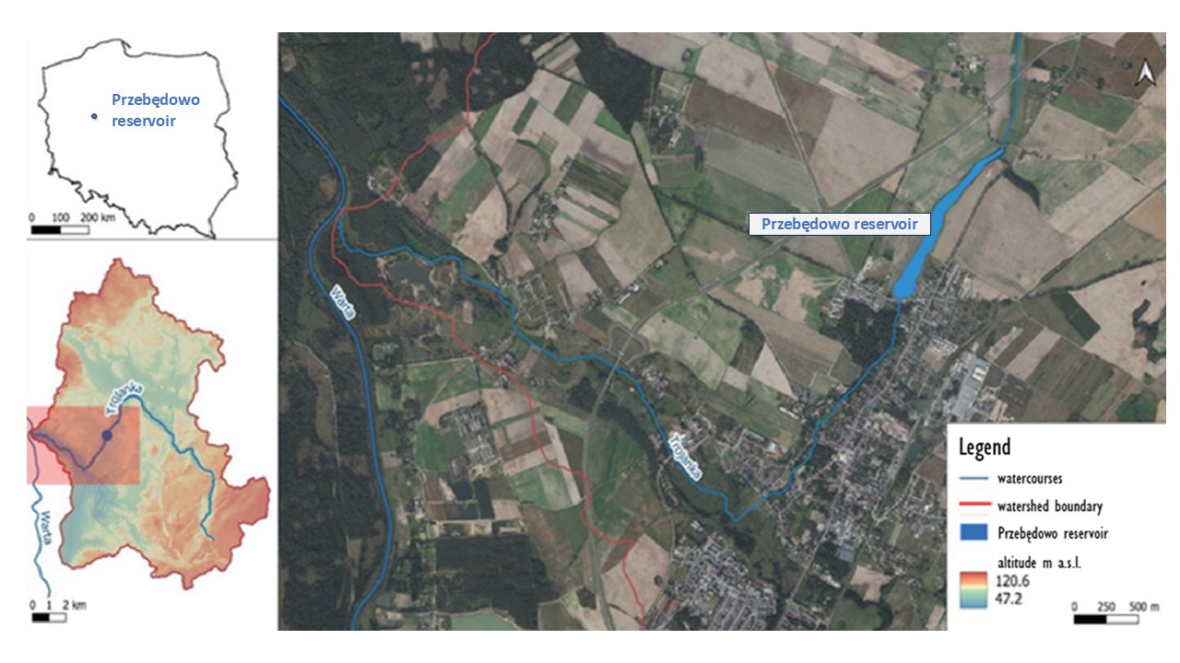
Fig. 1. Location of Przebędowo reservoir (source: Waligórski & Janicka, 2021)

According to the physical-geographical classification by Richling et al. (2021), the study area, characterized by a postglacial landscape, is located in the Wielkopolska Lake District in the region of the Poznań Gorge of the Warta River (315.54). In the studied watershed, covering approximately 100 km², forests predominate, whereas in the area adjacent to the reservoir, arable land composed of Quaternary (Pleistocene) fluvial sediments is present to a lesser extent. The area directly feeding the reservoir covers 1.31 km². An analysis of the layers covered by piezometers revealed a predominance of medium-grained sands extending to approximately 3 m in depth, with an average porosity of 36%, in which groundwater (phreatic) forms a continuous aquifer (Korytowski & Waligórski, 2017).
The analyzed reservoir (Fig. 2), which extends along a north-south axis over a 1.45 km stretch from the village of Przebędowo to the road to Trojanowo, was constructed in the Trojanka River valley (from km 6+915 to km 8+371 of its course), which serves as an accumulation route sloping toward the reservoir's banks, by the Wielkopolska Board of Land Reclamation and Water Facilities in Poznań and commissioned in November 2014. The reservoir is located within the Surface Water Body (JCWP) named Trojanka (Struga Goślińska) with the national code RW600010185969.
The weir structure (overflow-and-discharge type), or more specifically its inlet section (Fig. 3), consists of a reinforced concrete dock with 50 cm thick walls, equipped with two front spillways, each with a clear width of 2.25 m and a crest elevation of 72.45 m above sea level, and two side spillways, each with a clear width of 2.50 m and a crest elevation of 72.50 m above sea level. The earth-fill dam at the reservoir is Class IV, measuring 334 m in length and 3.30 m in height. The reservoir, which is 1,450 m long and has a maximum width of 120 m at a normal pool level (NPL) of 72.50 m above sea level, has an average depth of 0.94 m and a surface area of 12.03 ha (Table 1).

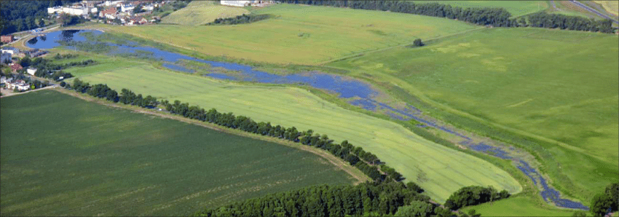
Fig. 2. Przebędowo reservoir – view from the northern side (source: Sojka et al., 2017)

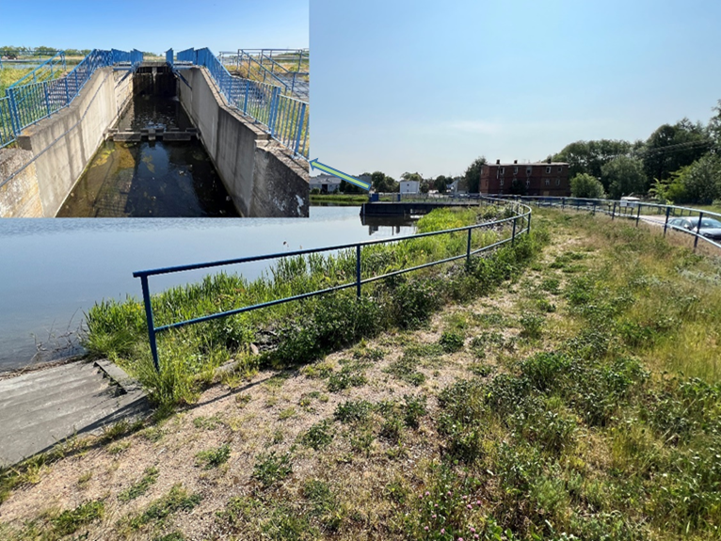
Fig. 3. Earthen head dam with overflow structure on Przebędowo reservoir

The shoreline length of the reservoir under analysis is 2,980 m, while its shoreline length per hectare is 248 m/ha, and the length-to-width ratio is 12. The flood reserve, which is the difference between the reservoir's capacity at maximum pool level (Max PP) and its capacity at normal pool level (NPP), amounts to 67,100 m³.

A biogeochemical barrier was constructed around the reservoir to protect against excessive inflow of biogenic compounds. The buffer zone consists of a transitional strip of grassland with trees and shrubs, with an average width of approximately 13 m.
Water levels in the Przebędowo reservoir were measured once every two weeks using a water gauge located on the weir at the reservoir's outflow (Fig. 4A). Additionally, water levels in the reservoir were continuously recorded using a hydrostatic probe, with the readings transmitted to a telemetry module installed on the spillway tower, and the data was then forwarded to the "Hydromonitor" program (Fig. 4B). This program is part of the Integrated Monitoring and Control System for Flood Protection Structures in the Wielkopolska Province, whose task is the continuous monitoring of the network of flood protection structures. This system enables the supervision of individual flood control facilities, i.e., pumping stations, retention reservoirs, stand-alone dam structures, and selected sections of levees, which are located several, a dozen, or even several dozen kilometers apart. It also shortens the response time of relevant services in emergencies when taking actions related, among other things, to so-called flood prevention.

Table 1. Basic morphometric parameters of Przebędowo reservoir
No. | Description | Unit | Quantity
1 | Area | ha | 12.03
2 | Length | m | 1450
3 | Maximum width | m | 120
4 | Average depth | m | 0,94
5 | Shore length | m | 2980
6 | Shore length (unfolded) | m/ha | 248
7 | Elongation ratio | - | 12
8 | Minimum impound level (Min. PP) | m a.s.l. | 71.50
9 | Normal pool level – NPP | m a.s.l. | 72.50
10 | Maximum pool level – MaxPP | m a.s.l. | 73.00
11 | Total capacity at NPP | m³ | 162 350
12 | Total capacity at MaxPP | m³ | 229 450
13 | Flood reserve between MaxPP and NPP | m³ | 67 100

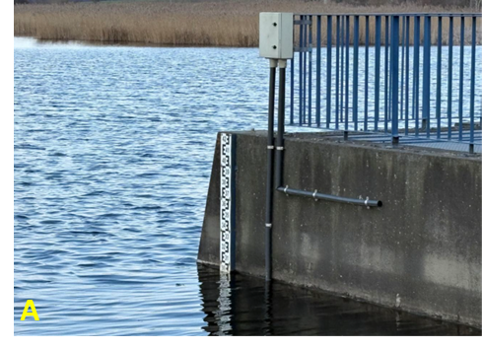 | 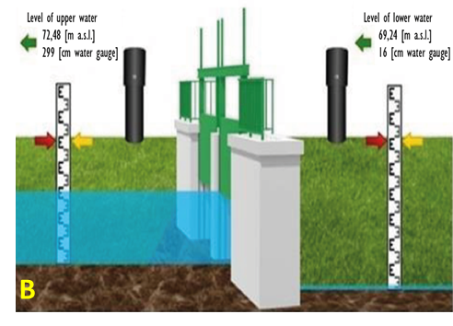
Fig. 4. Staff gauge with hydrostatic sonde situated at damming installation located at flow with reservoir (A), and a scheme of the spillway (B) on the Trojanka watercourse (PO054JZ – Przebędowo reservoir weir) in the "Hydromonitor" program (source: Waligórski, 2024)

In the reservoir's immediate catchment area, measurements are also taken regularly (once every two weeks), in part to assess the facility's impact on the groundwater in adjacent areas, groundwater levels in piezometers installed during the reservoir's construction (2014) as well as in additional ones drilled later (2016) for further detailed studies (Korytowski & Waligórski, 2017; Waligórski et al., 2019; Waligórski et al., 2020).
Meteorological conditions during the hydrological years in question (precipitation and air temperatures), compared to data from the 2000–2015 period, for the year 2021, were characterized based on measurement results obtained from the meteorological station of the Experimental and Educational Forest Arboretum in Zielonka, located approximately 8 km southeast of the reservoir in question. The station is situated in the central part of the Zielonka Forest at an elevation of 91.00 m above sea level, at 52°33ʹ00′′ north latitude and 17°06'33" east longitude (Grajewski, 2013).
The data for the 2024 hydrological year were obtained from IMGW-PIB studies titled: "Characteristics of selected climate elements in Poland for specific months of individual hydrological years."
The humidity characteristics for the analysed hydrological years were determined using the relative precipitation index (RPI) according to Kędziora (1995, as cited by Kaczorowska, 1962), with criteria listed in Table 2.
The thermal classification for the years was performed using the criteria proposed by Lorenc (2000). The inflows to the reservoir via the Trojanka stream and the outflows were determined from flow rate calculations based on water velocity measurements taken with a hydrometric current meter (Valeport FLAT Model 801 electromagnetic probe) once a month. Discharges were calculated based on calibration curves derived from field measurements.

Table 2. Moisture characteristics of the hydrological year. Source: Kędziora (1995)
Year type | % of normal precipitation
Extremely dry | Below 50
Very dry | 50–74
Dry | 75–89
Average | 90–110
Humid | 111–125
Very humid | 126–150
Extremely humid | Above 150

Reservoir inflow from precipitation and changes in reservoir water storage, due to the small amplitude of water level fluctuations, were calculated relative to the reservoir surface area at normal pool level (NPL).
Monthly changes in reservoir water storage were determined as the difference between water levels recorded at the beginning and end of each month during the analysed hydrological years.
The relationship between monthly changes in water storage in the Przebędowo reservoir and monthly inflow totals, as well as the relationship between changes in water storage and monthly precipitation inflow to the reservoir, were determined for months in which increases in water storage were observed during the years in question. In contrast, the relationship between monthly changes in water storage and monthly total outflows was determined for months with decreases in water storage.
The results of water level observations at the site in question were used with the permission of the Director of the State Water Management Authority (Wody Polskie); Regional Water Management Authority in Poznań.
3. Results and Discussion
In the existing climatological and hydrological literature, the Wielkopolska Lowlands are considered the areas with the most severe water shortages in Poland, compared to other physical-geographical regions. The regions with the lowest precipitation are the Gniezno Lake District, the Poznań Lake District, and part of Kujawy, where the long-term average annual precipitation does not exceed 550 mm (Woś, 1994). According to Okoński (2006), this situation is largely determined by the inadequate distribution of precipitation throughout the year and high evaporation rates. Additionally, the prevalence of cold fronts leads to frequent summer thunderstorms, accompanied by significant temperature fluctuations and increased wind speeds. The growing season is among the longest in Poland, beginning earliest in western Greater Poland—around March 28. In the South Greater Poland Lowland, the growing season lasts approximately 228 days; in the northernmost areas, it drops to 216 days (Program…2016).
The 2021 hydrological year, during which total precipitation amounted to 428 mm—76% of the normal amount—was a dry year in terms of moisture. During the winter half-year of that year, total precipitation was 35 mm below the long-term average, and the air temperature was 0.4°C below the average (Fig. 5). The summer half-year of the year in question was very dry, with total precipitation 96 mm below the long-term average and air temperature 0.2°C above the average.
The second hydrological year discussed in this study (2024), which saw total precipitation of 710 mm, 150 mm above the long-term average, and an air temperature 3.2°C above average, was a warm and very wet year. The winter half-year of that year was particularly humid and very warm, with total precipitation exceeding the long-term average by 121 mm and air temperatures up to 4.2°C above average. In contrast, during the summer half-year, total precipitation was 30 mm above average, with air temperatures 2.1°C above average.
An analysis of the average monthly water levels in the reservoir under study shows that in the month marking the start of the winter half-year of 2021 (November), the average water level was 299 cm (Fig. 6). Throughout the entire period of the analyzed half-year, water levels showed little variation and were close to the normal pool level (NPP) of 301 cm for the reservoir in question. The highest average monthly water level during this half-year, which, however, slightly exceeded the aforementioned value, was recorded in February and amounted to 304 cm, with total precipitation for that month at 37 mm. However, from the beginning of the summer half-year of the year in question, which was dry in terms of precipitation, a decline in water levels was observed in the reservoir in question. At the beginning of this half-year (May), the average monthly water level stood at 304 cm, and the lowest (267 cm) was recorded in August; this was also the lowest average monthly water level in the reservoir for the entire hydrological year under analysis. Precipitation totalling 40 mm in August raised the reservoir's water levels. The average monthly water level in September was 292 cm, and in the month ending the six-month period in question (October), it was 297 cm; however, both were below the normal range.
At the beginning of the winter half-year of the second year under study (2024), the average water level in the reservoir was 315 cm (Fig. 7). Precipitation totaling 170 mm, which occurred in November and December, caused water levels in the reservoir to rise, and in the latter month of the half-year in question, the maximum average water level (318 cm) was recorded; this was also the maximum average monthly water level for the entire hydrological year under analysis. By the end of the winter half-year, water levels in the reservoir were falling; however, it should be emphasized that they remained above the normal pool level (NPP) throughout this period. In the month concluding the half-year in question (April), the average water level was 309 cm. At the beginning of the summer half-year of the year in question, the average monthly water level was 298 cm. Precipitation totalling 190 mm in June and July raised reservoir water levels. The average monthly water levels in those months were 312 cm and 314 cm, respectively, while the highest average water level for the half-year, at 316 cm, was recorded in August. At the end of the analysed summer half-year, water levels were close to the level pool level (NPP), with the average monthly water level in the reservoir in question. According to Gierszewski (2018), reservoir operation has a significantly greater impact on water-level variability in dam reservoirs than natural factors. The number of phases of water-level rise and fall associated with filling and emptying the reservoir depends on the dam's water management practices. However, when a dam operates in a flow-through mode, as is the case with the Przebędowo reservoir, water levels fluctuate only slightly relative to the normal level of the NPP impoundment.
The results of the studies conducted during the analysed years, which indicated slight variability in water levels in the reservoir under study, were consistent with, among others, the studies by Szatten (2015) conducted between 1996 and 2012 on the Koronowskie Reservoir, which also found slight variability in water levels, with the average water level during the analyzed years being 7 cm below the normal water level. In contrast, the amplitude of water level fluctuations over the 16-year observation period was only 77 cm. As reported by Machowski and Rzętała (2020), water level fluctuations in reservoirs depend primarily on the functions they serve, their size, distribution, and inflow methods. Research conducted by these authors on the Łąka reservoir, located in the Silesian Voivodeship on the Pszczynka River, showed slightly greater water-level variability during the analysed period of 1987–2011; the reservoir's water levels usually exceeded 1 m, with an average of just over 121 cm. However, as reported by Wiatkowski et al. (2015), large dam reservoirs, whose operations are primarily linked to the energy sector, are often characterised by significant fluctuations in water levels. This author also emphasises that changes in water levels in such reservoirs can occur rapidly, several times a year. In studies conducted by Wojtuszewska (2007) on the Solina and Myczkowce reservoirs, the author also highlighted significant fluctuations in water levels. Under normal conditions, daily water level changes in the Solina reservoir did not exceed 0.5 m, annual changes ranged from 10 to 15 m, and maximum changes reached 20 m. In contrast, for the Myczkowce reservoir, much greater daily fluctuations were observed (up to approximately 3.5 m), a phenomenon caused by uneven daily water discharge from the Solina Hydroelectric Power Plant.

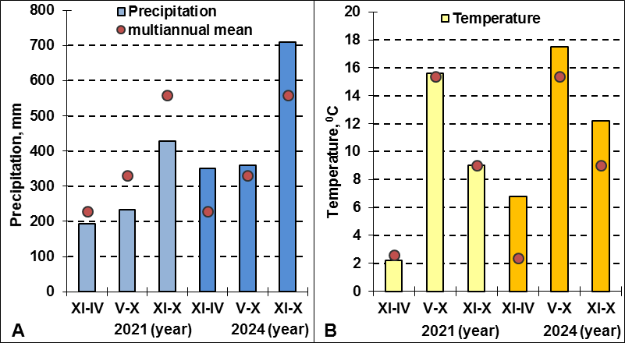
Fig. 5. Half-year and annual precipitation totals (A) and half-year and annual average air temperatures (B) for the hydrological years 2021 and 2024 and the 2000–2015 multiyear averages for these periods

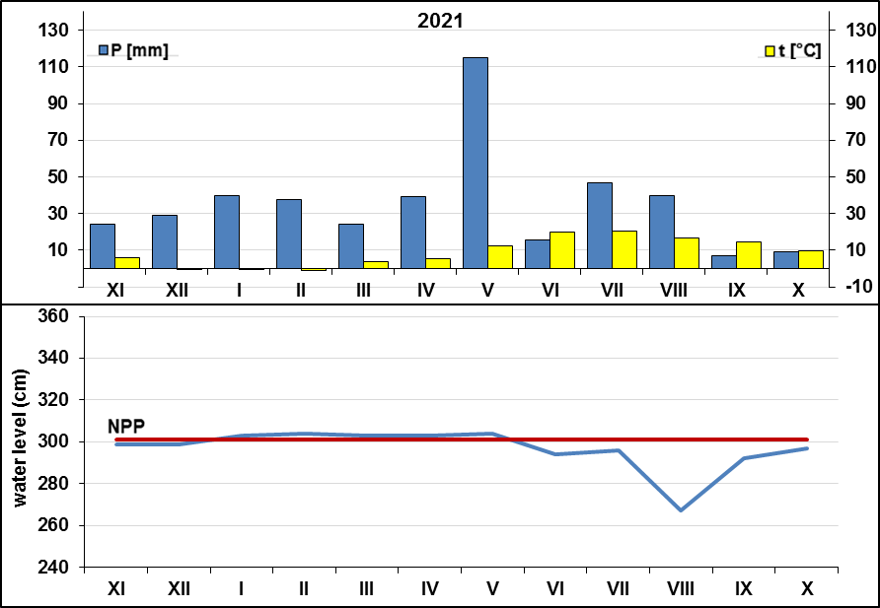
Fig. 6. Average monthly water levels (cm) in the Przebędowo reservoir, as well as levels corresponding to the minimum (Min. PP), normal (NPP), and maximum (Max PP) pool levels, plotted against average monthly precipitation totals (P) and average monthly air temperatures (t) for the 2021 hydrological year

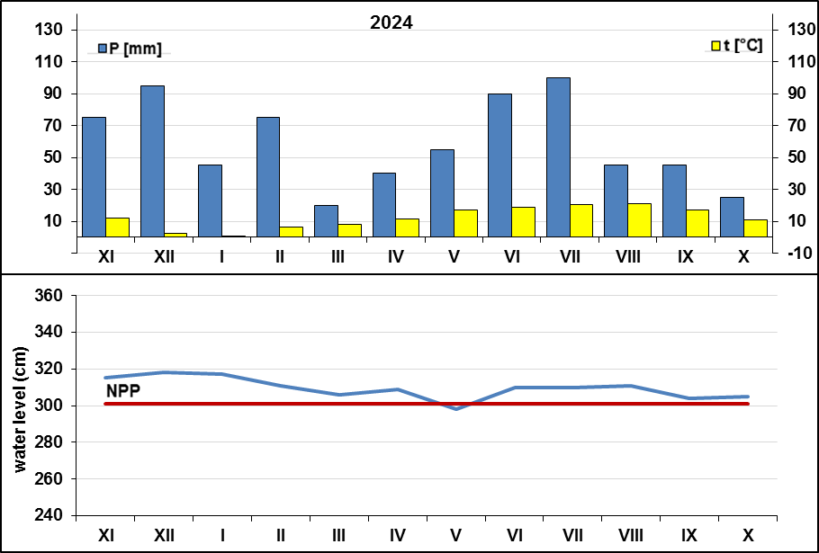
Fig. 7. Average monthly water levels (cm) in the Przebędowo reservoir, as well as levels corresponding to the minimum (Min. PP), normal (NPP), and maximum (Max PP) pool levels, plotted against average monthly precipitation totals (P) and average monthly air temperatures (t) for the 2024 hydrological year

In analyzing changes in water levels and storage in dam reservoirs, it is also crucial to consider the characteristics of horizontal water exchange factors (inflows and outflows), which often largely determine the usable storage capacity of a given facility. In the 2021 hydrological year, which was dry in terms of precipitation, the highest monthly inflow to the reservoir (1,240,725 m³) was recorded in May, with a total precipitation of 115 mm for that month, and the lowest inflow value, amounting to 161,564 m³, was recorded in August (Table 3). Over six months of the year, decreases in water storage were observed in the analysed reservoir, ranging from 1,203 m³ in November to 18,045 m³ in July. In the following six months of the year in question, increases in water reserves ranging from 2,406 m³ (January, February, October) to 6,015 m³ (August) occurred in the analyzed reservoir.

However, it should be noted that over the entire hydrological year in question, a decrease in water reserves of 7,218 m³ was observed in the reservoir. With regard to outflows from the reservoir, it was found, similarly to the case of inflows, that the highest and lowest values occurred in May and August and amounted to 886,513 m³ and 155,851 m³, respectively.
In the 2024 hydrological year, which was characterized by heavy rainfall, inflows into the reservoir in question were 10,721,141 m³ higher than those recorded in the first year under consideration. The highest monthly inflow to the reservoir, amounting to 2,677,677 m³, was recorded in December, while the lowest, at 1,073,334 m³, occurred in May. Throughout the entire year analyzed, water losses in the reservoir occurred in only three months, ranging from 3,609 m³ in January to 20,451 m³ in August. In contrast, in the remaining months—except for October, when no changes were observed—there were increases in water storage in the reservoir, ranging from 1,203 m³ in April to 6,015 m³ in December and September. Over the entire year in question, an increase in water storage in the reservoir of 8,421 m³ was recorded. The highest monthly outflow from the reservoir (1,695,555 m³) was recorded in December, and the lowest (766,582 m³) in May. It can be concluded that in the analysed hydrological year, water outflows from the reservoir in question were 632,940 m³ higher than in 2021.
Overall, during the hydrological years analyzed, water inflows to the reservoir exceeded outflows by an average of 5,039,525 m³, and in individual months of the analyzed years, they were higher by an average of 419,960 m³. The research results confirmed, among other things, the studies by Wiatkowski and Wiatkowska (2019) on the Turawa reservoir, located on the Mała Panew River, in which the authors also demonstrated, in the main, higher inflow values to the reservoir than outflows. Similar results were also obtained by Gierszewski (2018) in studies that included, among other things, the hydrological characteristics of the lower Vistula River during the operational period of the Włocławek reservoir. In the 1971–2015 period analysed by this author, the average annual flow measured at the inflow to the reservoir (Kępa Polska cross-section) was approximately 932 m³/s, while at the outflow (Włocławek cross-section) it was approximately 906 m³/s.
An important aspect of characterizing the factors that determine horizontal water exchange in a given reservoir, particularly in the context of tributaries, should also include monitoring bedload transport. The amount of material carried into the reservoir by tributaries—often over the course of several years of the structure's operation—determines its service life. This is an extremely important issue for future water management at the facility in question and at other reservoirs.

Table 3. Monthly sums of water inflows to the Przebędowo Reservoir, changes in water levels and storage, and monthly sums of outflows from the reservoir during the hydrological years 2021 and 2024
Period | Filling the reservoir with precipitation | The inflow to the reservoir | Water levels | Change in water levels | Change in water reserves | Outflow from  the reservoir
Period | (m³) | (m³) | (cm) | (cm) | (m³) | (m³)
2021
01 XI–30 XI | 2887 | 932939 | 300–299 | - 1 | - 1203 | 694812
01 XII–31 XII | 3489 | 975933 | 299–302 | + 3 | + 3609 | 725236
01 I–31 I | 4812 | 1171501 | 302–304 | + 2 | + 2406 | 845723
01 II–28 II | 4499 | 1106943 | 303–305 | + 2 | + 2406 | 793358
01 III–31 III | 2899 | 1198641 | 304–303 | - 1 | - 1203 | 862489
01 IV–30 IV | 4752 | 1129632 | 303–301 | - 2 | - 2406 | 816100
01 V–31 V | 13859 | 1240725 | 303–301 | - 2 | - 2406 | 886513
01 VI–30 VI | 1889 | 718517 | 301–298 | - 3 | - 3609 | 553777
01 VII–31 VII | 5654 | 836561 | 299–284 | - 15 | - 18045 | 635657
01 VIII–31 VIII | 4800 | 161564 | 282–287 | + 5 | + 6015 | 155851
01 IX–30 IX | 830 | 635120 | 292–296 | + 4 | + 4812 | 501251
01 X–31 X | 1119 | 854603 | 296–298 | + 2 | + 2406 | 648253
Total | 51488 | 10962679 | – | - 6 | - 7218 | 8119020

Table 3. cont.
Period | Filling the reservoir with precipitation | The inflow to the reservoir | Water levels | Change in water levels | Change in water reserves | Outflow from  the reservoir
Period | (m³) | (m³) | (cm) | (cm) | (m³) | (m³)
2024
01 XI–30 XI | 9022 | 2280593 | 313–317 | + 4 | + 4812 | 1474364
01 XII–31 XII | 11428 | 2677677 | 316–321 | + 5 | + 6015 | 1695555
01 I–31 I | 5413 | 2636582 | 320–317 | - 3 | - 3609 | 1672120
01 II–29 II | 9022 | 1733853 | 312–308 | - 4 | - 4812 | 1163599
01 III–31 III | 2406 | 1540995 | 304–311 | + 7 | + 8421 | 1056596
01 IV–30 IV | 4812 | 1700009 | 310–311 | + 1 | + 1203 | 1144567
01 V–31 V | 6616 | 1073334 | 309–312 | + 3 | + 3609 | 766582
01 VI–30 VI | 10827 | 1672812 | 312–314 | + 2 | + 2406 | 1132303
01 VII–31 VII | 12030 | 1746091 | 313–317 | + 4 | + 4812 | 1180323
01 VIII–31 VIII | 5413 | 2029148 | 318–301 | - 17 | - 20451 | 1330750
01 IX–30 IX | 5413 | 1271357 | 301–306 | + 5 | + 6015 | 895422
01 X–31 X | 3007 | 1321369 | 304–304 | + 0 | + 0 | 936247
Total | 85413 | 21683820 | – | 7 | + 8421 | 14448428

In the study by Babiński and Grześ (1995), the authors emphasised that the lower outflow from the reservoir relative to inflows is largely determined by evaporation losses. The operation of dam reservoirs also has a significant impact; as noted by Bajkiewicz-Grabowska (2007) and Michalak and Nowicki (2009), these reservoirs stabilize the groundwater table by increasing drainage from aquifers or raising the groundwater table in the river valley. According to these authors, a reservoir located within impermeable formations has a negligible impact on groundwater dynamics. In contrast, reservoirs with permeable formations, even partially, in the subsurface can influence groundwater dynamics over several dozen meters to several kilometres. Long-term studies have shown that such reservoirs initially tend to have a draining effect on the groundwater of adjacent areas. Still, the closer to the dam, the direction of water flow changes, and the water retained in the reservoir replenishes the groundwater (Głowski & Parzonka, 2007; Gurwin, 2010; Humnicki, 2010; Olszewska et al., 2012; Czekaj & Witkowski, 2014). Such processes, in addition to evaporation from the reservoir's surface, may—because of the reservoir's recharge function—result in lower outflows than inflows.
Calculations of the relationships between changes in water storage in the Przebędowo reservoir and inflows and outflows, conducted for the analysed hydrological years, revealed a relatively strong correlation. The calculated correlation coefficient for these variables was 0.7 (Fig. 8A), and this relationship was significant at the α = 0.01 level. According to Kala (2002), for phenomena analysed in the natural sciences, objective conclusions about strong relationships are sufficient at the α = 0.05 significance level. However, no direct link was found between increases in reservoir water storage and one of the factors of vertical water exchange, namely precipitation inflow into the reservoir (Fig. 8B). The research results obtained for the Przebędowo reservoir confirmed, among other things, the findings of Ptak et al. (2025) on 25 selected lakes in Poland, in which the authors emphasized that water level fluctuations—particularly in dam reservoirs—were determined primarily by local factors related to the use of the catchment area, without a clear dependence on elements such as precipitation. According to Rzętała (2008) and Moniewski (2015), atmospheric recharge (precipitation) of dam reservoirs accounts for several to over ten percent of the inflow to such structures. According to these authors, the share of precipitation in the total inflow to the lake basin is primarily a function of the reservoir's volume and the volume of surface runoff; furthermore, part of the precipitation reaching the exposed bottom zone is subsequently transported by surface runoff toward the open water body or, in the case of a compacted substrate, evaporates under conditions of strong solar radiation. It is also significant that in the littoral zone of some anthropogenic reservoirs, littoral vegetation is abundant, leading to additional interception and evapotranspiration of precipitation (at reduced water levels).

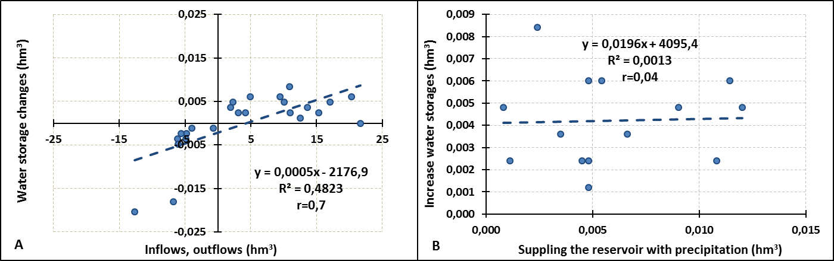
Fig. 8. Relationships between changes in water storage in the Przebędowo reservoir and inflows (+) and outflows (-) from the reservoir (A), as well as between increases in water storage in the reservoir and precipitation inflow to the reservoir (B), during the 2021 and 2024 hydrological years

Long-term studies of reservoir basin water balances have emphasised that horizontal water exchange factors, such as inflows and outflows from a given reservoir, have a decisive influence on their formation. In contrast, factors related to vertical exchange, such as precipitation and evaporation, played a marginal role in the balance equations (Rzętała, 2000; Fac-Beneda, 2013; Kropka & Jagliński, 2015; Wachowiak, 2015; Machowski & Rzętała, 2020).
4. Conclusions
- Studies and analyses conducted on the Przebędowo reservoir have confirmed that, for small reservoirs where the dam operates in flow-through mode, water levels fluctuate only slightly relative to the normal impoundment pool level. Both in the dry hydrological year of 2021 and in the wet year of 2024, the amplitude of water-level fluctuations was similar, at 23 cm and 20 cm, respectively.
- The calculations showed that during the first hydrological year analysed (2021), there was a decrease in water storage at the facility in question of 7,218 m³, and over the entire 2024 hydrological year, during which months with increases in water storage predominated, an increase of 8,421 m³ was observed.
- Based on the research, a pattern was observed, often in reservoir dams where inflows exceed outflows. During the analysed years, the difference between these volumes amounted to 5,039,525 m³, and in the individual months of the analysed years, inflows were on average 419,960 m³ higher. It can be concluded that, in addition to evaporation from the water surface, the reservoir's partially rechargeable nature (in the dam area) had a significant impact on this situation.
- Calculations of the relationships between changes in water storage in the Przebędowo Reservoir and inflows and outflows from the reservoir, conducted for the analyzed hydrological years, revealed a relatively strong correlation. The calculated correlation coefficient for these variables was 0.7, and this relationship was statistically significant at the α = 0.01 level. However, no direct relationship was found between increases in reservoir water storage and one of the factors of vertical water exchange, namely precipitation inflow into the reservoir.
- The studies conducted also confirmed that in dam reservoirs, increases or decreases in water storage are primarily determined by horizontal exchange factors such as inflows and outflows. In such facilities, these values are often determined by the hydrological conditions prevailing in the reservoir's watershed. In contrast, factors related to vertical water exchange—such as precipitation—have only a marginal direct impact on water levels and associated water storage.
References
Babiński Z., & Grześ M. (1995). Hydrological Monograph of the Włocławek Dam Reservoir. Proceedings of the Institute of Geology and Physical Geography, Polish Academy of Sciences, 30. (in Polish)
Bajkiewicz-Grabowska E. (2007). Lakes as links in the hydrographic network of young glacial areas and their role in shaping the outflow of a lake-drenched river. [in:] The Water Cycle in Natural and Human-Altered Environments. Published by UMCS, Lublin, p.: 39–46. (in Polish)
Czekaj J., & Witkowski A. (2014). Hydrodynamic modeling as a tool for assessing interactions in the aquatic environment in the vicinity of a reservoir, using the Goczałkowice Reservoir as an example. Jamorska, I. (ed.): Mathematical Models in Hydrogeology. Nicolaus Copernicus University Press, p.: 127–131, (in Polish)
Directive 2000/60/Ec of the European Parliament and of the Council of 23 October 2000 establishing a framework for Community action in the field of water policy. (in Polish)
Environmental Protection Program for the Wielkopolska Province for 2016–2020, pp. 170. (in Polish)
Fac-Beneda, J. (2013). Hydrological Characteristics of Lake Druzno. Natural History Monograph. Regional Directorate for Environmental Protection in Olsztyn. p.: 15–31. (in Polish)
Gierszewski, P. (2018). Hydromorphological Factors Affecting the Functioning of the Włocławek Reservoir Geoecosystem. Institute of Geography and Spatial Planning, Geographical Studies No. 268, pp.: 226. (in Polish)
Głowski, R., & Parzonka, W. (2007). Operation and Impact of the Brzeg Dolny Reservoir on the Oder River. Natural Sciences and Technology, 1(2), 1–12. (in Polish)
Grajewski, S. (2013): Thermal conditions in the Zielonka Forest from 1987 to 2008. Science, Nature, and Technology. 7(1), 1–12. (in Polish)
Grochowska, J., Płachta, A., Augustyniak, R, Tandyrak, R., Parszuto, K., Łopata, M., & Lorenc, J. (2019). The Impact of Meteorological Conditions on the Hydrological Regime of the Giłwa River in the Lake District. Monograph "The Functioning and Protection of Flowing Waters," 35–43. (in Polish)
Gurwin, J. (2010). Threats to groundwater in the environmental impact assessment of the planned renaturalization of the Turawa retention reservoir. Bulletin of the Polish Geological Institute, 440, 65–76. (in Polish)
Humnicki, W. (2010). Changes in hydrogeological conditions around dam reservoirs in the Pieniny Mountains. Pieniny – Dam – Changes — Monographs of the Pieniny Mountains, 2, 83–95. (in Polish)
IPCC, 2018: Global Warming of 1.5°C. An IPCC Special Report on the impacts of global warming of 1.5°C above pre-industrial levels and related global greenhouse gas emission pathways, in the context of strengthening the global response to the threat of climate change, sustainable development, and efforts to eradicate poverty [Masson-Delmotte, V., P. Zhai, H.-O. Pörtner, D. Roberts, J. Skea, P.R. Shukla, A. Pirani, W. Moufouma-Okia, C. Péan, R. Pidcock, S. Connors, J.B.R. Matthews, Y. Chen, X. Zhou, M.I. Gomis, E. Lonnoy, T. Maycock, M. Tignor, and T. Waterfield (eds.)]. Cambridge University Press, Cambridge, UK and New York, NY, USA, 616 pp., https://doi.org/10.1017/9781009157940.
Kala, R. (2002). Statistics for Natural Scientists. Published by the Agricultural University, Poznań, pp. 231. (in Polish)
Kędziora, A. (1995). Fundamentals of Agrometeorology. PWRiL Poznań, pp. 264. (in Polish)
Korytowski, M., & Waligórski, B. (2017). Assessment of water level fluctuations in the Przebędowo reservoir and groundwater levels in the immediately adjacent area during the first year of operation. Environmental Engineering, 18, 175–182, https://doi.org/10.12912/23920629/66996. (in Polish)
Kropka, J., & Jagliński, Ł. (2015). Water balance of the underground catchment area of the Kuźnica Warężyńska reservoir (Dąbrowa Basin). Mining Review, 12, 131–139. (in Polish)
Lorenc, H. (2000). Thermal and precipitation assessment of the climatic seasons in Poland and temporal-spatial trends. Research Project M-9, IMGW, Typescript. (in Polish)
Machowski, R., & Rzętała, M. (2020). Łąka Reservoir. Institute of Regional Research of the Silesian Library. Encyclopedia of the Silesian Voivodeship, 7, 1–13. (in Polish)
Machowski, R., & Rzętała, M. (2020). The Dziećkowice Reservoir. Institute of Regional Research of the Silesian Library. Encyclopedia of the Silesian Voivodeship, 7, 1–14. (in Polish)
Marciniak, A. (2024): Recreational value of anthropogenic water reservoirs in Poland. Conditions for the development of lake recreation, Vol. 1, ed. G. Borkowski and R. Tritt, Bogucki Scientific Publishing House, Poznań 2023, p:. 157–182. (in Polish)
Michalak, J., & Nowicki, Z. (2009). Determining changes in groundwater resources in areas of small retention reservoirs. Bulletin of the State Hydrological Service, pp. 109. (in Polish)
Michalec, B. (2014). An assessment of the applicability of the Brune method and its modifications for determining the debris retention capacity of small water bodies. Infrastructure and Ecology of Rural Areas. No. IV/2, Polish Academy of Sciences, Kraków Branch, p.: 1305–1316. (in Polish) http://dx.medra.org/10.14597/infraeco.2014.4.2.097
Michalec, B., Tarnawski, M., & Koniarz, T. (2013). Siltation as a factor limiting water resources in small retention reservoirs. Journal of Civil Engineering, Environment and Architecture, XXX(60(3/13), 129–142. (in Polish) https://doi.org/10.7862/rb.2013.43
Moniewski, P. (2015). The role of water reservoirs in shaping the physicochemical characteristics of river waters, using the Ciosenka River as an example. Prace i Studia Geograficzne, 58, 7–23. (in Polish)
Okoński, B. (2006). Water balance of a small forested watershed with potentially low retention capacity. Infrastructure and Ecology of Rural Areas, 3(1), 57–70. (in Polish)
Olszewska, B., Pływaczyk, L., & Łyczko, W. (2012). The impact of the impoundment of the Oder River by the Brzeg Dolny dam on flows in the Jeziorka stream during the years 1971–2010. Water-Environment-Rural Areas, 12(3)(39), 161–170. (in Polish)
Ptak, M., Szyga-Pluta, K, & Sojka, M. (2025). Long-term trends in water level fluctuations in lowland lakes in central Europe (Northern Poland). Scientific Reports, 15(1216). https://doi.org/10.1038/s41598-024-83286-7
Richling, A., Solon, J., Macias, A., Balon, J., Borzyszkowski, J., & Kistowski, M. (2021). Regional Physical Geography of Poland. Poznań: Bogucki Scientific Publishing House. (in Polish)
Rzętała, M. (2000). Water Balance and Dynamics of Changes in Selected Pollutants in the Dzierżno Duże Reservoir under Conditions of Strong Anthropogenic Pressure. Scientific Papers of the University of Silesia in Katowice No. 1913. University of Silesia Press, Katowice, pp 176. (in Polish)
Rzętała, M. (2008). The functioning of water reservoirs and the course of limnic processes under conditions of varied anthropogenic pressure, using the Upper Silesian region as an example. Scientific Papers of the University of Silesia in Katowice, University of Silesia Press, pp. 172. (in Polish)
Sojka, M., Korytowski, M., Jaskuła, J., & Waligórski, B. (2017). Assessment of the susceptibility to degradation of the Przebędowo retention reservoir. Ecological Engineering, 18, 118–125. https://doi.org/10.12912/23920629/76776
Szatten, D.A. (2015). Changes in water levels in the Koronowskie Reservoir between 1996 and 2012. Ecological Engineering, 44, 204–209. (in Polish) https://doi.org/10.12912/23920629/60047
Wachowiak, G. (2015). Water balance of the reservoir in the flooded final excavation of the decommissioned "Lubstów" open-pit mine, PAK Kopalnia Węgla Brunatnego Konin SA. Open-Pit Mining, 56, 68–79. (in Polish)
Waligórski, B. (2024). Assessment of the functioning of a dam reservoir during the first years of operation, using the Przebędowo facility as an example. Doctoral dissertation in the field of engineering and technical sciences, in the discipline of environmental engineering, mining, and energy. Poznań University of Life Sciences, Faculty of Environmental Engineering and Mechanical Engineering, pp. 141. (in Polish)
Waligórski, B., & Janicka, E. (2021). The Influence of the Przebędowo Reservoir on the Water Quality of the Trojanka River in the First Years of its Functioning. Rocznik Ochrona Środowiska, 23, 151–167. http://doi.org/10.54740/ros.2021.010
Waligórski, B., Korytowski, M., Stachowski, P., Otremba, K., & Kraczkowska, K. (2019). Assessment of the Impact of a Dammed Reservoir on Groundwater Levels in Adjacent Areas Based on the Przebędowo. Rocznik Ochrona Środowiska, 21, 767–788.
Waligórski, B., Korytowski, M., Zydroń, A., Liberacki, D., Fiedler, M., & Stasik, R. (2020). The water balance in a dammed reservoir – a case study of the Przebędowo reservoir. Rocznik Ochrona Środowiska, 22, 324–346.
Wiatkowski, M., Głowski, R., Kasperek, R., & Kościański, S. (2007). Assessment of the use of small-scale dam reservoirs in the Opole Province. Science, Nature, and Technology, 1(2), 1–9. (in Polish)
Wiatkowski, M., & Wiatkowska, B. (2019). Changes in the flow and quality of water in the dam reservoir of the Mała Panew catchment (South Poland) characterized by multidimensional data analysis. Archives of Environmental Protection, 45(1), 26–41. http://doi.org/10.24425/aep.2019.126339
Wiatkowski, M., Rosik-Dulewska, Cz. & Kasperek, R. (2015): Inflow to the Bukówka drinking water reservoir from the transboundary Bóbr River Basin. Rocznik Ochrona Środowiska, 17, 316–336.
Wojtuszewska, K. (2007). Dynamics of changes in the condition of surface and groundwater in the Solina-Myczkowce reservoir area. Mineral Resource Management, 23(3), 121–134. (in Polish)
Woś, A. (1994). The Climate of the Wielkopolska Lowlands. Adam Mickiewicz University Press, pp. 192. (in Polish)
Zalewski, M., Izydorczyk, K., Kiedrzyńska, E., Jarosiewicz, P., & Czerniawski, R. (2019). Ecohydrology for offsetting anthropogenic pressure and mitigating the effects of climate change in river ecosystems. Monograph "Functioning and Protection of Flowing Waters," p. 5–20. (in Polish)

