
 | Rocznik Ochrona Środowiska
 | Volume 28 | Year 2026 ISSN 2720-7501 | pp. 488-504
 | https://doi.org/10.54740/ros.2026.033 open access
 | Received: April 2026 Accepted: June 2026 Published: July 2026
GIS-based Morphodynamic Assessment and Engineering Stabilization
of the Bălăneasa River Basin (Romania)
Andreea-Maria Lupșan¹, Costin Mivu^{2*}, Alexandru Nedelea³, Laura Comănescu⁴,
Robert-Răzvan Dobre⁵, Andrei Laurențiu Ilie⁶
¹Faculty of Geography, University of Bucharest, Romania
https://orcid.org/0009-0008-1933-3581
²Faculty of Industrial Engineering and Robotics,
National University of Science and Technology Politehnica of Bucharest, Romania
https://orcid.org/0009-0006-0629-6246
³Faculty of Geography, University of Bucharest, Romania
https://orcid.org/0000-0002-6373-818X
⁴Faculty of Geography, University of Bucharest, Romania
https://orcid.org/0000-0001-9767-1190
⁵Faculty of Geography, University of Bucharest, Romanian Government – Ministry of Transport and Infrastructure
https://orcid.org/0000-0002-0590-1700
⁶Faculty of Geography, University of Bucharest, Romanian Government – Ministry of Transport and Infrastructure
https://orcid.org/0000-0002-0998-0020
*corresponding author's e-mail: costinmivu@yahoo.com
Abstract: The Bălăneasa River Basin, located in the Curvature Carpathians of Romania, is characterized by intense morphodynamic activity driven by lithological variability, tectonic influences, and high relief energy (Posea, 2005; Zăvoianu, 2006). This study proposes an integrated GIS–engineering framework based on morphometric analysis, DEM-derived modelling, historical cartographic comparison, and finite element modelling (FEM). Morphometric parameters were extracted using QGIS and GRASS GIS. Results indicate a decrease in channel length from 33 km to 32 km and a decrease in sinuosity from 1.1 to 1.03, reflecting channel adjustment under natural and anthropogenic constraints. Gabion-based systems proved to be the most suitable stabilization approach due to their flexibility, permeability, and adaptability to unstable substrates (Minea, 2011). Structural analysis confirms the mechanical reliability of a proposed gabion handling device under a 20 kN load. The approach provides a transferable framework for river management in small mountainous catchments.
Keywords: river morphodynamics, GIS, channel migration, gabions, FEM, Carpathians
1. Introduction
Mountainous river systems in the Curvature Carpathians are characterized by high morphodynamic sensitivity due to the interaction between tectonic structure, lithological variability, and active slope processes (Posea, 2005; Ielenicz, 1973), which control rapid channel adjustment and sediment redistribution (Zăvoianu, 2006). Although geomorphological studies in the Romanian Carpathians are numerous, most remain descriptive and lack integrated GIS-based and engineering-oriented approaches (Grecu, 1997). Globally, the integration of GIS-based geomorphometric analysis with spatial modeling has revolutionized the state of the art in assessing mountain river morphodynamics and channel evolution (Tarolli, 2014; Wohl, 2019). Within the broader Carpathian region, multi-national studies provide critical benchmarks for these processes, particularly in catchments facing similar high-energy dynamics and flysch lithologies. In the Polish Carpathians, extensive GIS and historical cartographic research on gravel-bed systems has documented severe channel narrowing, incision, and a dramatic shift in river patterns due to historic torrent-control structures (Gorczyca et al., 2020; Gołąb and Michno, 2024). Similarly, in the Slovak Carpathians, multi-temporal analyses of mountain streams have successfully mapped rapid post-flood bar dynamics and the morphodynamic degradation caused by artificial river training (Kidová et al., 2021).
While these regional Carpathian studies successfully leverage GIS environments for hazard mapping and morphodynamic classification, a significant scientific gap persists regarding the operational connection between geomorphological process-based assessments and practical engineering stabilization solutions. Most existing frameworks either remain strictly descriptive or evaluate ecological and structural responses in isolation. To address this limitation, this study introduces an innovative, transferable workflow that explicitly couples GIS-derived morphodynamic trends with finite element method (FEM) engineering design, bridging the gap between fluvial geomorphology and active structural management in highly constrained mountainous catchments.
In this context, the Bălăneasa River Basin is a small, high-energy catchment located in the central Curvature Carpathians, at the transition between the Buzău Mountains (Ivăneț Peak) and the Subcarpathian unit. It extends across several relief units, including the Ivăneț Peak area, the Blidișelu Hills, the Bălăneasa Depression, and the Dâlmei Hills. The basin has been mentioned in classical geomorphological works (Martonne, 1904; Posea et al., 1976) and regional syntheses of the Curvature Carpathians (Mihăilescu, 1963; Ielenicz, 1972; Ielenicz, 1973; Badea et al., 1977), but without detailed spatial or process-based analysis.
This study aims to integrate GIS-based geomorphological analysis with engineering approaches for channel characterization and stabilization of the Bălăneasa River Basin.

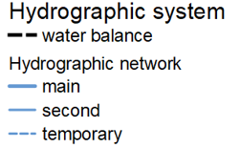
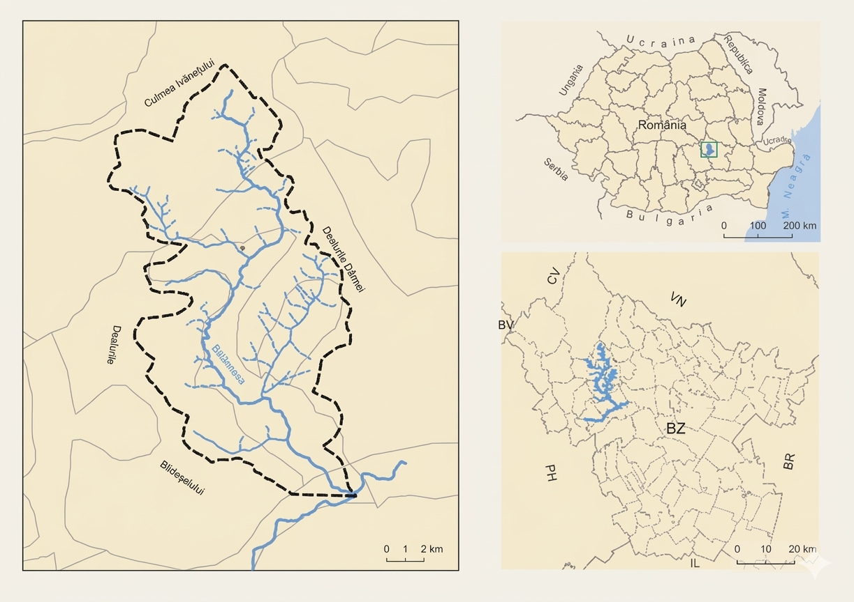
Fig. 1. Geographical position of the Bălăneasa Basin
1.1. Hypsometric Characteristics
The basin's altimetry is varied, ranging from 150 to 1191 m (Fig. 2). The analysis included the creation of six hypsometric intervals. The predominant areas are those between 450–620 m (26.5%) and 300–450 m (23.7%), corresponding to terraces favorable to human settlements (Brăești, Bozioru, Bălănești, Cozieni). The mountainous sector (>950 m) has steep slopes and pronounced linear erosion, with reception basins and ravines at the bottom, which explains the significant sedimentary input transported downstream.

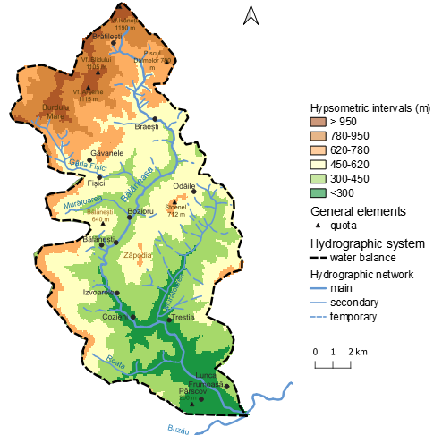
Fig. 2. Hypsometric characteristics – Bălăneasa Basin, Buzău County
In low-lying areas (<300 m, 11.9% of the surface), accumulations and flood risk prevail, favoring meandering. The stepped relief, with four leveling steps (one mountainous and three subcarpathian: Drăgăneasa, Pietraru, Zăpodia, Podul Leordișului), influences the flow direction and the dynamics of the riverbed, determining alternations of erosion, transport, and accumulation.
The third terrace appears punctually at 650 m, corresponding to the valley basin and the secondary interfluve. The subcarpathian slopes have amplitudes between 200–800 m, and the lands between 300–620 m are favorable for human settlements, corresponding to the second terrace, in the localities of Brăești, Bozioru, Bălănești and Cozieni.
1.2. Relief Units
The relief of the Bălăneasa Basin is controlled by tectonic structure and lithological heterogeneity, which govern slope morphology, channel gradients, and sediment connectivity. The vertical amplitude of the basin (~1000 m) reflects a stepped morphostructural system in which resistant formations alternate with friable sedimentary deposits, generating differential erosion and slope instability. This configuration governs slope morphology, channel gradients, and sediment connectivity. As documented in active alpine and alpine-Mediterranean orogenic belts, high tectonic uplift combined with friable substrates accelerates catchment-scale sediment delivery, directly conditioning downstream channel patterns (Bufe et al., 2021).
The upper mountainous sector, developed within the Curvature Carpathians (Ivăneț Peak area), is characterized by structurally controlled slopes, ridges, and erosion remnants formed on resistant lithologies. Active slope processes, including landslides and debris accumulation, contribute significantly to sediment supply toward downstream sectors.
The Subcarpathian transition zone is a structurally complex landscape characterized by alternating anticlines, synclines, and cuesta-type relief. This configuration induces frequent reversals of slope asymmetry and controls the spatial distribution of fluvial energy, favoring lateral erosion and channel migration.
Depression basins located at structural contacts (e.g., Brăești, Bozioru–Bălănești, Cozieni–Trestia) act as sediment accumulation zones and local base levels, influencing longitudinal profile adjustments of the river system.
Overall, the basin exhibits a multi-level geomorphological structure composed of mountainous, subcarpathian, and intramontane depression units, which together control fluvial incision, sediment transfer, and channel mobility.

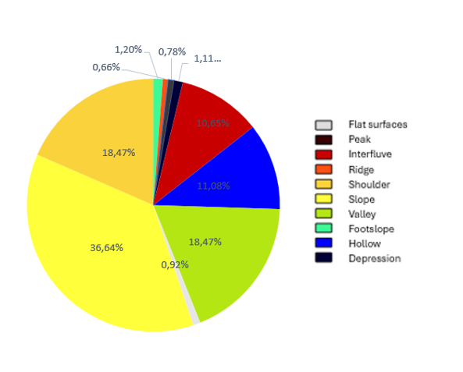
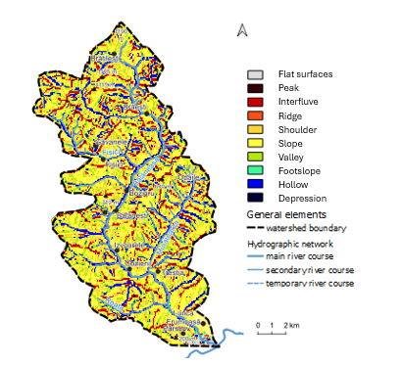
Fig. 3. Morphographic aspects of the relief – Bălăneasa Basin, Buzău County
1.3. Geology
The Bălăneasa Basin develops within the external flysch and foredeep domains of the Curvature Carpathians, "characterized by a complex alternation of sandstone, conglomerates, clays, and marls of Mio-Pliocene age" (Oncescu, 1959). This lithological variability strongly influences slope stability and fluvial dynamics.
Resistant lithologies (sandstones and conglomerates) favor relief persistence and structural ridges, while friable clay-marl sequences promote mass movements, slope failures, and enhanced sediment availability. The tectonic framework, defined by folds and faults (anticlines and synclines), further controls drainage orientation and channel confinement, altering fluvial supply-transport regimes (Hooke, 2019).
Neotectonic activity, combined with lithological contrasts, maintains high geomorphological activity, reflected in alternating erosional and depositional river sectors across the basin, directly conditioning the downstream distribution of structural hazards.

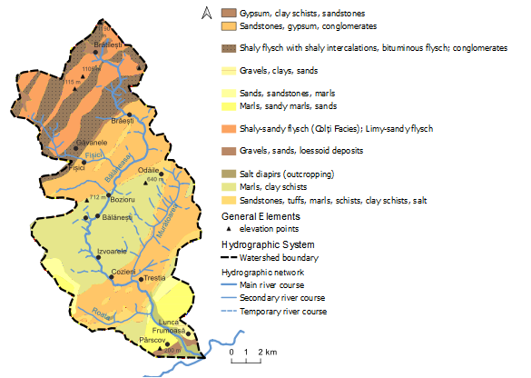
Fig. 4. Lithological structure – Bălăneasa Basin, Buzău County
1.4. Soil Types
Soil distribution in the basin is primarily controlled by altitude, lithology, and slope dynamics. Zonal soils (brown, cambic, luvic, and podzolic types) dominate mid-altitude areas and exhibit moderate erosion resistance, while azonal soils (alluvial soils, regosols, and colluvial deposits) are concentrated in valley bottoms and steep slopes.

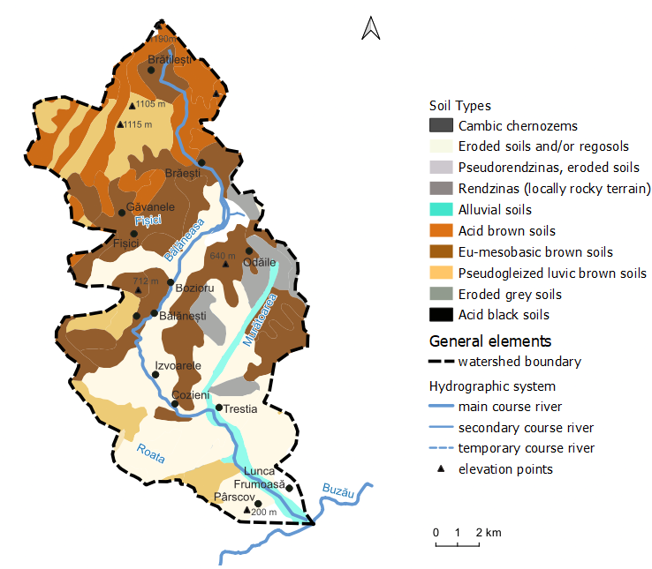
Fig. 5. Main soil types – Bălăneasa drainage basin, Buzău county
Steep slopes developed on weak or moderately developed soils are highly susceptible to mass movements, particularly when anthropogenic pressures reduce vegetation cover. In contrast, mid-altitude subcarpathian sectors (300–620 m) present relatively stable soil conditions and higher agricultural suitability.
This distribution justifies the application of technical-engineering solutions for "slope protection and river channel stabilization" (Minea, 2011).
1.5. Landuse
Land use in the Bălăneasa Basin reflects strong adaptation to geomorphological constraints. Forested areas (~4076 ha) dominate steeper slopes and play a key role in slope stabilization, runoff regulation, and erosion control.
Agricultural land, including pastures, hayfields, and orchards, is concentrated in depression areas and lower terraces where slope gradients are reduced and soil conditions are more favorable. Conversely, steeper slopes remain predominantly forested due to their high susceptibility to erosion.
This spatial organization of land use is strongly conditioned by relief, soil distribution, and hydrological processes, resulting in a landscape where anthropogenic activities and natural constraints are tightly coupled.

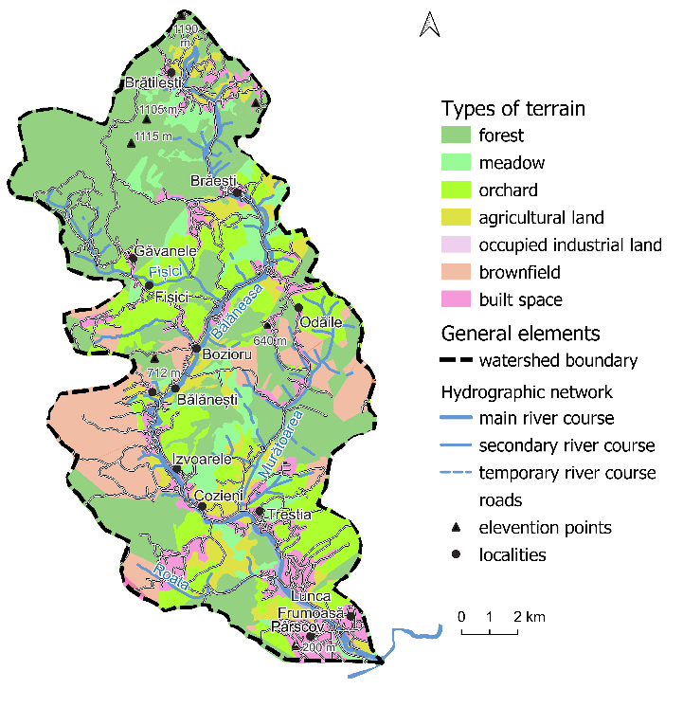
Fig. 6. Landuse – Bălăneasa basin, Buzău county
2. Data and Methods
2.1. Study Design
This study integrates geomorphological, GIS-based, hydrological, and engineering analyses to evaluate channel dynamics and to support riverbank stabilization strategies in the Bălăneasa River Basin. The methodological framework combines spatial morphometric analysis—where the channel gradient is quantified in per mille (‰), equivalent to meters per kilometer (m/km)—with numerical engineering modelling of a proposed gabion handling system. The overall methodological framework adopted in this study is summarized in Fig. 7, illustrating the integration of spatial geomorphological analysis with engineering modelling and FEA-based structural validation.

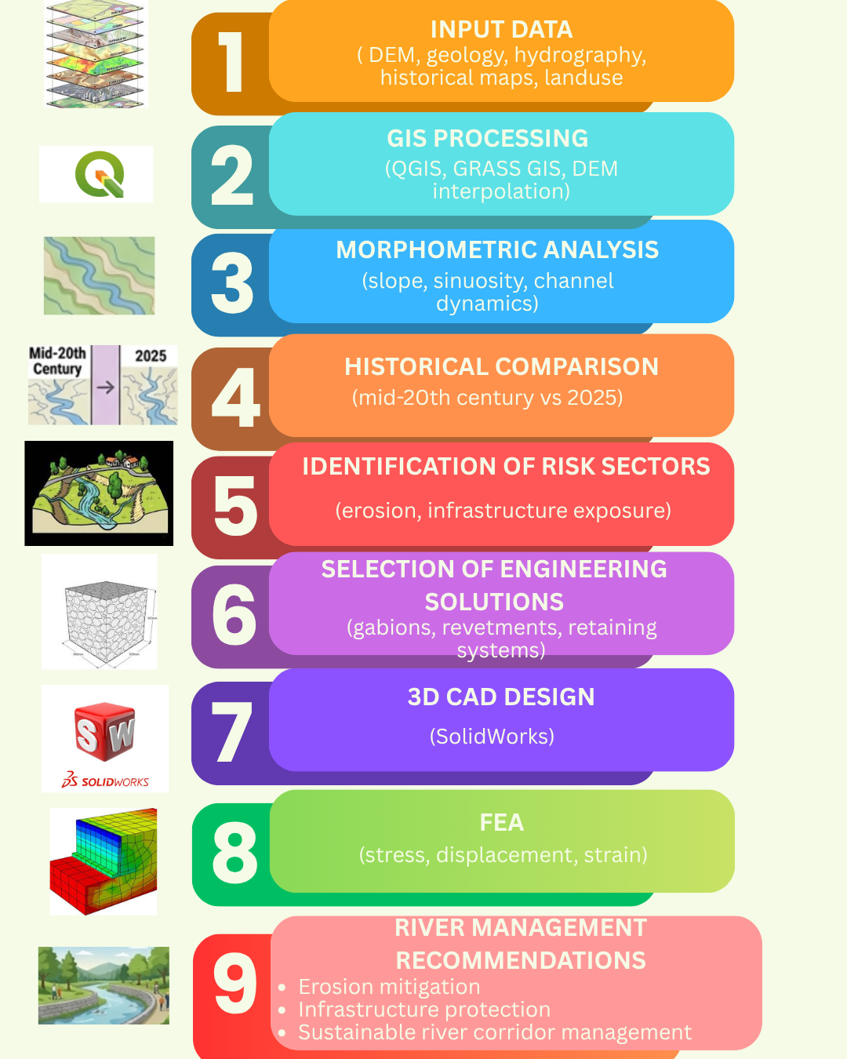
Fig. 7. Conceptual framework and multi-step operational workflow of the study

2.2. GIS processing and morphometric analysis
To complement the historical hydrographic data with continuous topographic metrics, a Digital Elevation Model (DEM) with a spatial resolution of 10 meters was generated from 1:25,000 topographic contour lines with a 5-meter contour interval. The elevation extraction utilized the Topo to Raster interpolation method, which is specifically optimized to preserve hydrological connectivity and prevent artificial sinks in river channels.
Potential uncertainties related to the inherent vertical accuracy limitations of contour-derived grids—which typically exhibit a vertical root-mean-square error (RMSEz) between 1.5 and 2.5 meters—were carefully factored into the morphometric analysis. These terrain model constraints include the potential smoothing of micro-topographic channel features and subtle underestimations of crest elevations below the 5-meter contour threshold. Consequently, the identified topographic variations are treated within these acceptable cartographic uncertainties, while simultaneously accounting for real morphodynamic adjustments along the channel.
Spatial analysis was performed using QGIS and GRASS GIS environments. The following tools were applied to the processed topographic data:
- r.slope.aspect – slope and exposure calculation,
- v.rast.stats – statistical extraction of raster values on vector layers,
- r.report – spatial distribution of terrain parameters.

Table 1. Data sets used
No. | Database (name) | Structure Type | Attributes | Data source
1 | Contour lines | vector | elevation | ANCPI Geoportal (1:25.000)
2 | Hydrography | vector | line | ANAR
3 | Landform unit boundaries | vector | polygon | ANCPI Geoportal (1:200.000)
4 | Geology | vector | polygon | Romanian Geological Institute  (1:50.000)
5 | Localities | vector | point | ANCPI Geoportal
6 | Roads | vector | line | ANCPI Geoportal (1:200.000)
7 | Hydrography | vector | line | INHGA
8 | Landuse | vector | polygon | ICPA
9 | DEM România | raster | – | Obtained from contour lines

2.3. Hydrographic and historical comparison
Historical hydrographic data were extracted exclusively from the Romanian Master Plan Sheets, which were produced between 1916 and 1959 at a spatial scale of 1:20.000. To minimize spatial distortions, these historical maps were georeferenced in QGIS using a second-order polynomial transformation based on distinct ground control points (GCPs), achieving a root-mean-square error (RMSE) of less than 12.5 meters. Potential uncertainties stemming from map generalization, paper shrinkage, georeferencing accuracy, and manual digitization procedures were meticulously evaluated.
To reduce operator-induced uncertainty, channel digitization was repeated independently and cross-checked against recent orthophotos and hydrographic layers. Estimated positional deviations remain below the spatial resolution threshold of the DEM and do not significantly affect basin-scale morphometric trends.
Consequently, during the interpretation of historical-to-present variations, it was acknowledged that the observed channel-length differences may derive both from genuine hydro-morphological adjustments (such as anthropogenically induced channel training or natural planform evolution) and from inherent cartographic errors or scale limitations.
2.4. Engineering modelling and design
Based on the geomorphological interpretation, areas prone to instability and erosion were identified, and appropriate river management measures were considered, including bank protection, torrent correction, and secondary channel regulation.
A gabion handling device was designed to support the implementation of stabilization works in steep and inaccessible sectors of the basin.
The design and 3D modelling of the device were carried out using SolidWorks Premium 2021. The software enabled geometric construction, assembly verification, and mechanical compatibility assessment of structural components.
2.5. Structural simulation (FEA)
Mechanical performance was evaluated using the finite element method (FEM) in the SolidWorks Simulation environment. The model was discretized using a finite element mesh, and boundary conditions were applied at the lifting attachment point. The applied load represents typical operational handling conditions for gabion elements in field stabilization works.
A representative load corresponding to a 2000 kg gabion (≈ 20.000 N) was applied at the gripping arms.
2.6. Data processing and interpretation
All spatial and numerical outputs were further processed and visualized using Microsoft Excel for graphical representation of morphometric parameters and temporal comparisons.
The integration of GIS-based analysis with field observations and engineering modelling provided a comprehensive framework for evaluating channel dynamics and supporting river management strategies in the Bălăneasa Basin.
3. Results

The following results summarize the morphometric characteristics, channel dynamics, infrastructure exposure, and engineering analyses conducted for the Bălăneasa River Basin.
3.1. Channel Dynamics of the Bălăneasa River
The morphometric and geometric characteristics of the Bălăneasa River channel were analyzed to quantify longitudinal dynamics and identify spatial variations in channel stability.
Key parameters include elevation at the upstream and downstream limits, channel slope, channel length (straight and sinuous), and sinuosity coefficient. Some of these parameters (elevation and straight-line distance) remain constant over time, while others (channel length and sinuosity) reflect channel dynamics and morphological adjustments.
At the upstream boundary, the river enters the study area at 770 m ASL., while the downstream limit is located at 168 m ASL., resulting in a total elevation difference of 602 m (Table 2).

Table 2. General Parameters in the Romanian Master Plan Sheets (mid-20th century)
No. | Analysis Item | Unit of Measurement | Value (Romanian Master Plan Sheets)
1 | Quota A | m (ASL) | 770
2 | Quota B | m (ASL) | 168
3 | Elevation difference | m | 602
4 | Straight-line length | m | 31000
5 | Sinuous length (Channel length) | m | 33000
6 | Sinuosity coefficient | n/a | 1.1
7 | River gradient (Slope) | ‰ | 18.24

The straight-line length of the river is 31 km, while the channel length in the reference dataset is 33 km, resulting in a sinuosity coefficient of 1.1. The mean channel slope is 18.24‰.

For the year 2025, the parameter values have not changed substantially compared to those in the Romanian Master Plan Sheets (mid-20th century), except for the sinuous length and, consequently, the sinuosity coefficient and slope, which are dependent on it (Zăvoianu, 2006). However, channel length decreases to 32 km, indicating a modification of channel geometry under constrained conditions. The decrease in sinuosity to 1.03 and the corresponding increase in mean channel slope to 18.81‰ reflect channel confinement and anthropogenic influence on river morphology. This systemic reduction in channel length and subsequent steepening is a classic morphodynamic response to river training and narrowing, where the concentration of stream power prevents natural energy dissipation through meandering (Surian et al., 2009).

Table 3. General Parameters in 2025
No. | Analysis Item | Unit of Measurement | Value (2025)
1 | Quota A | m (ASL) | 770
2 | Quota B | m (ASL) | 168
3 | Elevation difference | m | 602
4 | Straight-line length | m | 31000
5 | Sinuous length (Channel length) | m | 32000
6 | Sinuosity coefficient | n/a | 1.03
7 | River gradient (Slope) | ‰ | 18.81

These variations indicate a progressive channel simplification, associated with reduced lateral migration and channel adjustment tendency of the river course.
3.2. Meandering potential and spatial constraints
The spatial extent of meandering potential was delineated based on fixed anthropogenic constraints, including settlement boundaries and transport infrastructure (Fig. 8).
The total area available for lateral channel migration is approximately 28.5 km² and has remained constant throughout the analyzed period.
The meandering potential index, defined as the ratio of channel length to available migration area, decreases from 1.15 km/km² (historical dataset) to 1.12 km/km² in 2025 (Table 4), primarily due to a reduction in channel length.

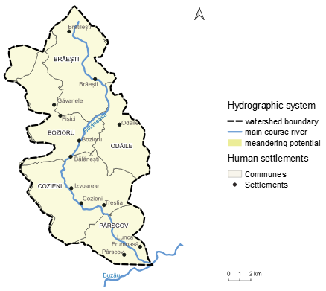
Fig. 8. Meandering potential of the Bălăneasa River

Table 4. Meandering Potential Index Analysis
Meandering Potential
Romanian Master Plan Sheets (mid-20th century) | River Length | 33
Romanian Master Plan Sheets (mid-20th century) | Polygon Area | 28.5
Romanian Master Plan Sheets (mid-20th century) | Potential Index | 1.15
2025 | River Length | 32
2025 | Polygon Area | 28.5
2025 | Potential Index | 1.12

This reduction reflects decreased active lateral migration and a tendency toward channel confinement across several sectors of the basin.
3.3. Infrastructure exposure and vulnerability
Based on spatial overlay analysis, infrastructure elements intersecting the meandering corridor were identified (Fig. 9).

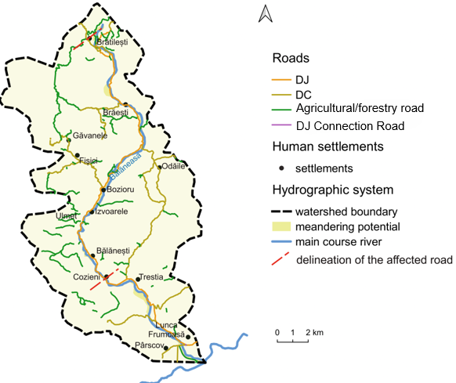
Fig. 9. Elements affected by the meandering potential of the Bălăneasa River

The main transport axis, DJ 203L (Cozieni–Bozioru–Brăești), follows the longitudinal valley and intersects multiple high-risk erosion zones characterized by narrow floodplains and active lateral erosion.
Secondary communal roads, including DC Bozioru–Ulmet (0.9 km) and DC Cătina–Valea Cătinei (0.6 km), together represent approximately 3.6 km of exposed infrastructure.
The most vulnerable administrative units are Brăești (0.15 km²), Bozioru (0.27 km²), Cozieni (0.32 km²), Cătina (0.18 km²), and Pârscov (0.21 km²), with a cumulative exposed area of approximately 1.13 km².
These results indicate a moderate to high level of infrastructure vulnerability, particularly in central and southern sectors of the basin.
3.4. Channel morphology and meander evolution
The spatial distribution of meanders in 2025 (Fig. 10) shows that channel curvature is primarily controlled by local slope conditions and valley confinement.

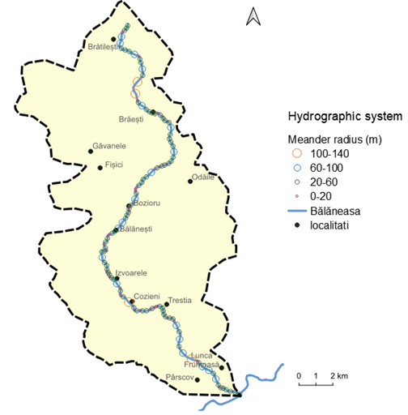
Fig. 10. Spatial distribution of meanders of the Bălăneasa River in 2025

In upper basin sectors, meander radii are generally <60 m, constrained by valley morphology and forested slopes. In contrast, the middle and lower reaches exhibit larger radii, typically 100–140 m, indicating partial channel adjustment and localized stabilization.
A comparative analysis of historical cartographic data (Fig. 11) shows that the river previously exhibited higher sinuosity and greater lateral mobility.
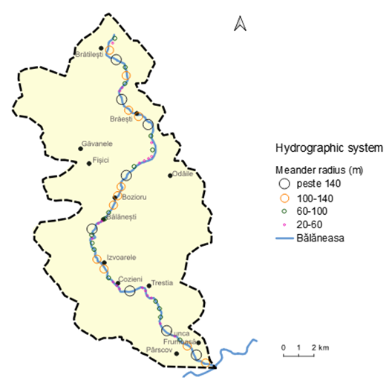
Fig. 11. Spatial distribution of meanders of the Bălăneasa River, according to the Romanian Master Plan Sheets
(mid-20th century)
At that stage, smaller meander radii and frequent channel shifts were characteristic of an active morphodynamic regime. Subsequent engineering interventions (bank stabilization, flow regulation, and local channel corrections) have contributed to reduced lateral migration and improved channel stability.
3.5. 3D Modeling of the Device (FEA)
The 3D model of the gabion clamping device was created in SolidWorks Premium 2021. The assembly was designed as a tong-type gripping mechanism intended for lifting and handling gabion units used in riverbank stabilization works.
The model integrates the main structural components, including the articulated gripping arms, claw elements, and the upper lifting attachment point (Fig. 12). The geometric configuration and joint positions were defined to ensure efficient load gripping and uniform mechanical stress distribution during operation.
The device was designed with an adjustable jaw opening ranging from 400 to 1100 mm, allowing compatibility with standard gabion dimensions and ensuring safe handling conditions under variable field requirements.

Table 5. Handling device subassemblies
No. | Assembly name | Quantity
1 | Upper lifting eye | 1
2 | Gripping arms | 2
3 | Claws | 2
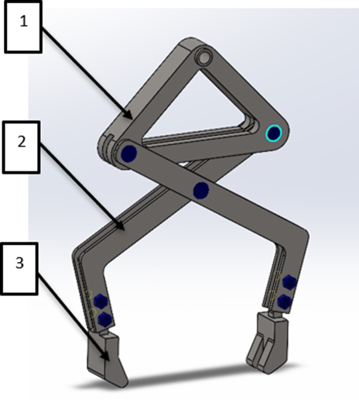
Fig. 12. 3D model of the proposed clamp-type gabion gripping device

The structural design incorporates a flexible articulated system intended to accommodate variable geomorphological conditions. The digital prototype is based on structural steel, selected for its high mechanical strength and resistance to environmental degradation. These material properties ensure reliable performance under repetitive handling operations and long-term exposure to mountainous outdoor conditions. (Callister & Rethwisch, 2018).
3.6. Structural Analysis Using the Finite Element Method (FEA)
The mechanical performance of the proposed clamping device was assessed using the finite element method (FEM) to evaluate stress distribution and displacement patterns under operational loading conditions.
The numerical simulation was conducted in the SOLIDWORKS Simulation environment, where the 3D model was discretized into a finite element mesh. Boundary conditions were applied at the upper lifting eye, representing the connection to the hoisting system, while the load was applied at the gripping claws to simulate gabion handling conditions (Fig. 13).
A representative load corresponding to a 2000 kg gabion (≈ 20 kN) was applied to the system.
The simulation results were obtained for equivalent (von Mises) stress, total displacement, and equivalent strain, as shown in Fig. 14.
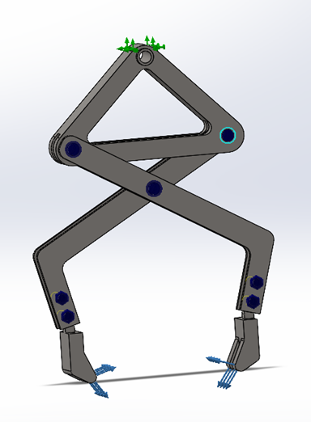
Fig. 13. Fixtures and load application points

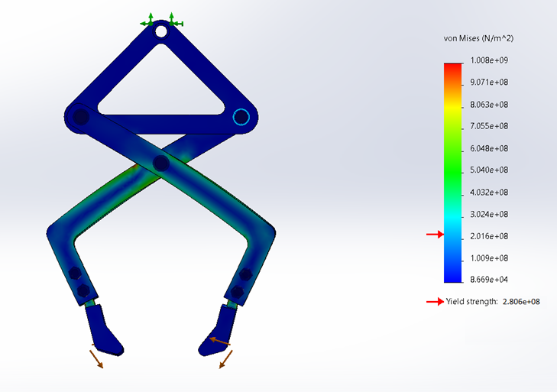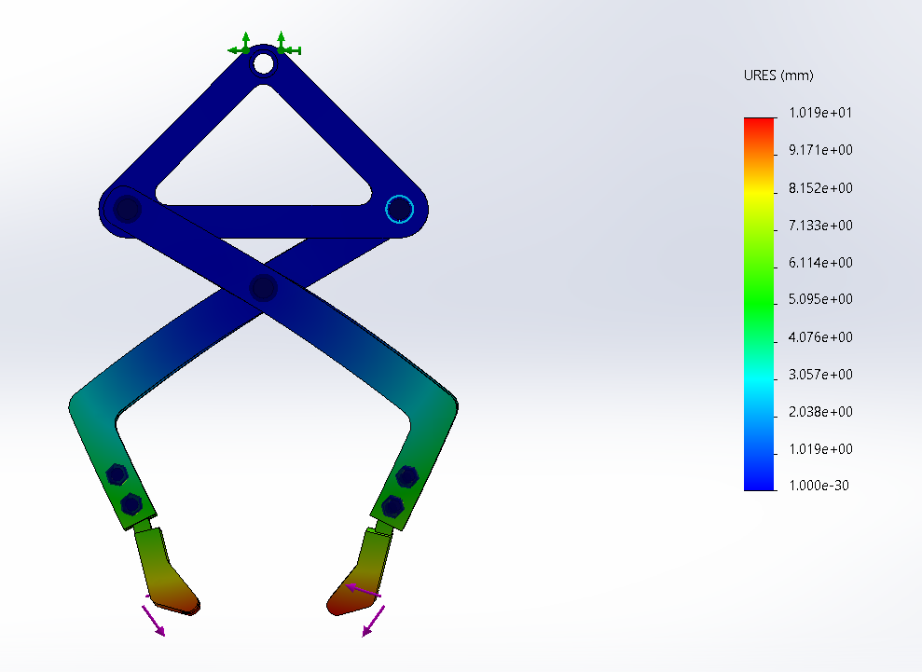
(b)
(a)
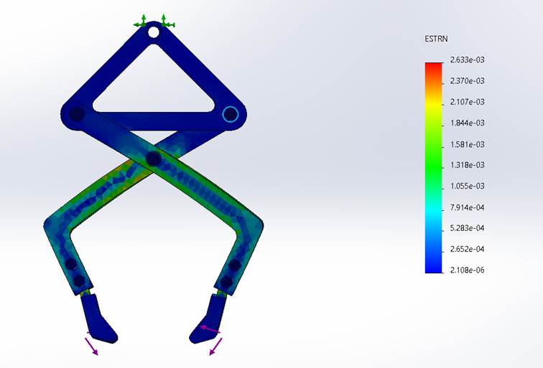
(c)
Fig. 14. FEA simulations of the clamp-type device. (a) Equivalent stress values according to the von Mises criterion, (b) Displacement values, (c) Equivalent strain values
4. Discussions
The results of the present study highlight a strong coupling between geomorphological controls and engineering applicability within the Bălăneasa River Basin. The observed morphodynamic patterns reflect the combined influence of lithology, relief energy, and channel gradient, which govern sediment transport processes and channel adjustment mechanisms. These interactions require an integrated interpretation that connects spatial analysis with practical stabilization strategies.
4.1. Technical and Engineering Measures for Riverbed Stabilization and Management
The Bălăneasa River Basin is characterized by a high degree of geomorphological sensitivity, as evidenced by alternating erosional and depositional sectors along its longitudinal profile. Lithological variability, particularly the presence of friable formations interbedded with more resistant strata, plays a decisive role in channel evolution and slope stability.
Steep gradients and structural relief contribute to increased stream power, which enhances lateral erosion in confined valleys and promotes sediment redistribution in downstream sectors. These conditions explain the observed tendency toward channel adjustment and localized instability, particularly in subcarpathian transition zones. Similar behaviours have been documented in other Carpathian catchments, where structural and lithological controls dominate fluvial dynamics (Posea, 2005; Zăvoianu, 2006).
4.2. Engineering interventions
To mitigate lateral erosion, channel migration, and bank instability, several engineering solutions were evaluated, each with distinct mechanical and hydraulic performance characteristics.
- Gabions
Gabions are flexible, permeable wire-mesh structures filled with rock material, used for bank protection and slope stabilization. Their deformable behavior allows them to adapt to differential settlements, making them suitable for clay-rich, unstable substrates typical of the Bălăneasa Basin. The use of local lithological materials (sandstones and conglomerates) reduces transport requirements and construction costs, while ensuring long-term structural stability with minimal maintenance demand. Despite their advantages, gabion systems may be affected over time by wire-mesh corrosion and abrasion caused by coarse bedload transport, particularly in high-energy mountain rivers.
- Stone revetments
Stone revetments dissipate flow energy effectively but require frost-resistant and mechanically durable lithologies. In the basin, the presence of friable formations (marls and clays) limits material availability, increasing dependency on external supply chains. Their performance is moderate to high but strongly site-dependent.
- Riprap
Riprap provides robust erosion protection in high-energy sectors; however, it requires stable foundation conditions and significant material volumes. Logistic constraints related to limited accessibility in forested and steep terrain increase implementation costs and reduce applicability in confined valley sectors.
- Retaining walls
Retaining walls offer high structural resistance but are rigid systems with limited adaptability to active fluvial environments. In the Bălăneasa Basin, their efficiency is constrained by slope instability and channel mobility. High construction and maintenance costs further limit their use to localized critical points.
- Flood spillways
Flood spillways are hydraulic control structures designed to manage peak discharges rather than stabilize banks. They are effective in specific sectors prone to rapid discharge increases (e.g., Pârscov, Cozieni), but serve only as complementary measures within integrated river management systems.

Considering the geomorphological and hydrological characteristics of the Bălăneasa Basin, including the alternation of erosional and depositional sectors, the presence of friable lithologies (clays and marls), variable slope gradients, and the pronounced mobility of the river channel evidenced by changes in sinuosity over the analyzed periods, gabion structures were identified as a suitable engineering solution for bank stabilization and energy dissipation. Based on this assessment, a gabion handling device was designed to support the implementation of such stabilization works. Consequently, recent global paradigms in river engineering shift toward hybrid eco-engineered frameworks; integrating classic gabion basements with vegetation-mat overlays or soft armoring systems yields immediate mechanical stability while fostering self-adjusting riparian ecosystems capable of absorbing extreme peak discharges (Loizeaux et al., 2024).

Table 6. Engineering solutions for the stabilization and management of the Bălăneasa riverbed
Type of Intervention | Technical Efficiency in the Bălăneasa Basin | Material & Execution Costs | Transport Requirements | Adaptability to Local Soils (Clays, Marls, Sandstones) | Durability & Maintenance | Conclusions for the Bălăneasa Area
Gabions | Very High  – Flexible, permeable structure; adapts well to erosion and settlement. | Moderate – Fill material can be sourced from local sandstones and conglomerates. | Low  – Requires minimal transport of fill material. | Very Good  – Performs well on unstable and variable soils. | High, with low maintenance requirements. | Represent a highly suitable solution under the studied conditions.
Stone Pitching | Good, but dependent on stone quality. | Moderate to High | Moderate  – Requires calibrated stone. | Moderate – Sensitive to friable soils. | Average | Effective for specific sites, but costs may rise without suitable stone.
Rockfill | High, but requires a stable foundation. | High – Large volume of material. | High  – Difficult transport in limited access areas. | Moderate | High, but difficult to maintain. | Suitable for specific points; not reco-mmended for large-scale use.
Retaining Walls | Very High in stable areas. | Very High  – Complex execution. | Moderate | Low on clayey and unstable soils. | High, but costly. | Inadequate  for mobile riverbeds;  useful only  for localized applications.
Flood Spillways | Effective only hydraulically for managing peak discharge. | Moderate | Moderate | N/A | High | Complementary solution, not for stabilization.

4.3. Design and finite element analysis of the device
These morphodynamic constraints directly justify the deployment of flexible gabion systems over rigid alternatives. However, transporting and positioning these units within the high-gradient, forested sectors of the Bălăneasa River is operationally unfeasible using standard municipal machinery.
The structural integrity demonstrated by the mechanical simulations addresses this execution bottleneck. Because the framework operates strictly within the elastic limit under peak operational stress, the device guarantees structural predictability during high-precision placement. Consequently, the engineering solution bridges the gap between geomorphic necessity and field logistics, allowing targeted bank stabilization without requiring destructive access-road clearance.
4.4. Analysis and interpretation of simulation results
Finite element analysis produced spatial distributions of stress, displacement, and strain, visualized through color-coded contour maps representing the numerical solution domain.
The simulation converged when residual errors reached 10⁻⁵, ensuring numerical stability and accuracy within the SOLIDWORKS Simulation environment. The resulting outputs allow identification of critical stress zones and validation of structural performance under representative loading conditions.
The stress distribution indicates low global stress levels, with localized concentrations in the central joint region. These values approach but do not exceed the material yield strength, confirming structural safety under operational loads.
Maximum displacements occur at the claw extremities, while the main structural joint remains stable, indicating adequate global stiffness. The results confirm the functional reliability of the design. Local reinforcement of high-stress regions may be considered to optimize long-term durability.
The numerical analysis of the gripping device indicates predominantly low equivalent stress levels across the structure, with localized stress concentrations in the central joint region of the arms. In these zones, stress values approach but do not exceed the material yield strength, confirming structural safety under the applied loading conditions.
Maximum displacements are recorded at the claw tips and in the lower arm sections, while the main articulation zone remains largely unaffected, suggesting adequate global stiffness of the system (Fig. 14).
Overall, the results confirm the functional integrity and mechanical reliability of the proposed design. The selected material and structural configuration ensure safe operation under working loads. For long-term performance optimization, targeted reinforcement of the lower arms and central connection area may be considered, provided that the controlled deformation behavior at the gripping extremities is preserved.
4.5. Limitations of the study
The findings of the present study are subject to several inherent limitations that should be considered when interpreting the overall results:
- Geomorphometric and Spatial Constraints: The analysis is inherently constrained by the spatial resolution and vertical accuracy of the available DEM. These factors may introduce minor uncertainties in the precise estimation of slope dynamics and channel parameters along the catchment.

Hydrological and Validation Gaps: The hydrological interpretation of the Bălăneasa River Basin is restricted by the absence of direct, permanent hydrometric observations along the studied sector. Consequently, continuous in-situ discharge, water level, and sediment transport measurements were unavailable for strict quantitative validation, preventing the direct calibration of the river's hydraulic behavior against field observations. To evaluate the broader regional context, hydrometric data from the nearest downstream gauging station—Măgura station on the Buzău River (Station ID 47, BZ)—were carefully analyzed (noting baseline variations such as the water level reaching 51.0 cm on April 20th relative to the 300, 350, and 400 cm defense thresholds). However, due to its location significantly downstream, these records were strictly used as a contextual reference and could not be integrated into the localized GIS workflow. To mitigate this, the hydrological framework relied on authoritative datasets, incorporating official boundaries and spatial sub-basin layers from the National Administration "Apele Române" (ANAR) and the National Institute of Hydrology and Water Management (INHGA) to ensure baseline technical validation.

Climatic Variability: While the basin exhibits a characteristic pluvio-nival hydrological behavior driven by seasonal rainfall and snowmelt, recent climatic fluctuations have induced localized anomalies. This is evidenced by data from the Romanian National Meteorological Administration (ANM), which showed monthly precipitation totals below 10 mm in January 2025, leading to temporary low-flow or near-dry conditions across several secondary tributaries that could not be fully quantified.

Structural and Engineering Simplifications: The structural assessment of the proposed gabion-handling device relies solely on finite-element simulations, without experimental or field-scale validation. Therefore, the structural results should be interpreted as indicative morphodynamic and engineering trends rather than fully deterministic outcomes.
5. Conclusions
The Bălăneasa River Basin exhibits strong geomorphological control over channel evolution, driven by lithological heterogeneity, slope variability, and active hydrological processes. These factors increase susceptibility to lateral erosion and channel migration, particularly in the Subcarpathian sectors.
The analysis suggests that flexible engineering systems, particularly gabion structures, represent the most suitable solution for stabilizing dynamic riverbanks due to their adaptability to settlement, permeability, and hydraulic efficiency.
The integration of GIS-based morphometric analysis with engineering design and finite element modelling enables a coherent framework for identifying high-risk sectors and implementing targeted stabilization measures. The proposed gabion handling device indicates adequate structural performance under simulated loading conditions and supports efficient field implementation.
Future river management strategies should prioritize continuous geomorphological monitoring and adaptive engineering interventions to ensure long-term stability and reduce erosion-related risks.
The approach is transferable to other small, mountainous catchments with similar morphodynamic behaviour, although future applications should incorporate local hydraulic calibration and site-specific lithological assessment.
Author Contributions
A.-M.L.: conceptualization, investigation, data curation, and GIS analysis.
C.M.: 3D modeling, methodology, validation, supervision, and writing—original draft preparation, review, and editing.
A.N., L.C., R.-R.D., and A.L.I.: manuscript review and final approval.
All authors have read and agreed to the published version of the manuscript.
Data Availability Statement
The data presented in this study are available from the corresponding author upon reasonable request.
Acknowledgments
During manuscript preparation, an AI-based language editing tool was used solely for grammar and language refinement. The authors reviewed and revised all content and take full responsibility for the scientific accuracy and integrity of the manuscript. The authors acknowledge A.N., L.C., R.R.D., and A.L.I. for their supervision, guidance, and constructive feedback throughout the development of this study.
Conflicts of Interest
The authors declare no conflicts of interest.
References
Badea, L., Dumitrescu, S., & Bălteanu, D. (1977). The Buzău Valley: A geomorphological study [Valea Buzăului: Studiu geomorfologic]. Bucharest, Romania: Editura Academiei Republicii Socialiste România.
Bufe, A., Cook, K.L., Sachse, D., Scherler, D., Turowski, J.M., & Hovius, N. (2021). Topographic, lithological and climatic controls on sediment transfer in an active orogen. Earth Surface Processes and Landforms, 46(12), 2465–2483. https://doi.org/10.1002/esp.5189
Callister, W.D., & Rethwisch, D.G. (2018). Materials science and engineering: An introduction (10th ed.). New York, NY: John Wiley & Sons.
Gołąb, A., & Michno, A. (2024). Key changes across valley floors in mountain areas affected by different levels of human impact: a case study of the Ochotnica river catchment in the Polish Carpathians. Journal of Mountain Science, 21(3), 850–866. https://doi.org/10.1007/s11629-023-8124-x
Gorczyca, E., Krzemień, K., & Jarzyna, K. (2020). The evolution of gravel-bed rivers during the post-regulation period in the Polish Carpathians. Water, 12(1), 254. https://doi.org/10.3390/w12010254
Grecu, F. (1997). Dynamics of minor riverbeds [Dinamica albiilor minore]. Bucharest, Romania: Editura Universității din București.
Hooke, J. (2019). Extreme processes and structural conditioning in gravel-bed rivers. Earth-Science Reviews, 192, 401–428. https://doi.org/10.1016/j.earscirev.2019.03.007
Ielenicz, M. (1972). The Buzău Hills: A geomorphological study [Dealurile Buzăului: Studiu geomorfologic] (Doctoral dissertation). University of Bucharest, Bucharest, Romania.
Ielenicz, M. (1973). The Buzău Subcarpathians — General geomorphological characterization [Subcarpații Buzăului — Caracterizare geomorfologică generală]. Analele Universității din București: Geografie [Annals of the University of Bucharest: Geography Series], 22, 45–53.
Kidová, A., Radecki-Pawlik, A., Rusnák, M., & Plesiński, K. (2021). Hydromorphological evaluation of the river training impact on a multi-thread river system (Belá River, Carpathians, Slovakia). Scientific Reports, 11(1), 6289. https://doi.org/10.1038/s41598-021-85805-2
Loizeaux, D., Hill, J., Patton, M., & Hoilman, J. (2024). Integrating engineered and nature-based solutions for riverbank stabilization. In Hazard Mitigation and Resilient Infrastructure (pp. 112–119). Routledge. https://doi.org/10.1201/9781003386889-21
Martonne, E. de. (1904). The border between mountain and plain in Romania: Lower Buzău and Călmățui. Annales de Géographie, 13(68), 133–143.
Mihăilescu, V. (1963). The South-Eastern Carpathians on the territory of the R.P.R.: A physical geography study [Carpații Sud-Estici de pe teritoriul R.P.R.: Studiu de geografie fizic]. Bucharest, Romania: Editura Științifică.
Minea, I.S. (2011). Hydrotechnical structures and their environmental impact [Amenajări hidrotehnice și impactul lor asupra mediului]. Iași, Romania: Editura Universității „Alexandru Ioan Cuza”.
Oncescu, N. (1959). Geology of the Romanian People's Republic [Geologia Republicii Populare Române]. Bucharest, Romania: Editura Tehnică.
Posea, G. (2005). Geomorphology of Romania: Relief, types, genesis, evolution, regionalization [Geomorfologia României: Relief, tipuri, geneză, evoluție, regionare]. Bucharest, Romania: Editura Fundației România de Mâine.
Posea, G., Popescu, N., & Ielenicz, M. (1976). The relief of Romania [Relieful României]. Bucharest, Romania: Editura Științifică și Enciclopedică.
Surian, N., Rinaldi, M., Pellegrini, L., Audisio, C., Maraga, F., Teruggi, L. B., ... & Ziliani, N. (2009). Channel adjustments in northern and central Italy over the past 150 years worldwide context. Geomorphology, 113(1–2), 13–24. https://doi.org/10.1016/j.geomorph.2009.02.011
Tarolli, P. (2014). High-resolution topography for understanding Earth surface processes: Opportunities and challenges. Geomorphology, 216, 295–312. https://doi.org/10.1016/j.geomorph.2014.03.008
Wohl, E. (2019). Forgotten rivers: The values and dynamics of mountain streams. Earth-Science Reviews, 196, 102881. https://doi.org/10.1016/j.earscirev.2019.06.002
Zăvoianu, I. (2006). Hydrology [Hidrologie] (4th ed.). Bucharest, Romania: Editura Fundației România de Mâine.

