
 | Rocznik Ochrona Środowiska
 | Volume 28 | Year 2026 ISSN 2720-7501 | pp. 478-487
 | https://doi.org/10.54740/ros.2026.032 open access
 | Received: July 2026 Accepted: July 2026 Published: July 2026
Sustainable Food Systems in Poland – Legal Aspects, Production and Food Safety
Maja Chamier-Gliszczyńska¹, Agnieszka Kurdyś-Kujawska²*
¹Faculty of Law and Administration, University of Gdańsk, Poland
https://orcid.org/0009-0003-2373-1535
²Faculty of Economic Sciences, Koszalin University of Technology, Poland
https://orcid.org/0000-0002-6024-2947
*corresponding author's e-mail: agnieszka.kurdys-kujawska@tu.koszalin.pl
Abstract: The aim of this article is to highlight the significance of sustainable food systems in Poland, particularly in production within the framework of agricultural retail trade, ensuring food safety and combating illegal food adulteration, which undermines consumer confidence and distorts fair competition. The article discusses the concept of sustainable food systems, as derived from both EU legislation and national law, taking into account the 'Farm to Fork' strategy and the principles of the European Green Deal. It presents the results of research into the structure of agricultural retail trade and the production of local food products. The essence of food safety, its legal basis and the importance of the actions taken by producers and control bodies in ensuring the appropriate quality of food products are also outlined. Particular attention was paid to the issue of illegal food labelling as a form of food fraud, highlighting its negative impact on consumer safety, fair competition and the proper functioning of the food market. The article also highlights the role of modern control methods, traceability systems and institutional cooperation in combating this phenomenon. The analysis carried out suggests that the effective transformation of food systems requires the comprehensive implementation of legal, organisational and technological solutions that will promote environmental protection, ensure food safety and increase market transparency.
Keywords: sustainable food systems, food safety, illegal food labelling, food law, food fraud
1. Introduction
Ensuring food safety and developing sustainable food systems are among the key challenges facing contemporary agricultural and food policy. Climate change, the ongoing globalisation of supply chains and growing consumer demands regarding the quality, origin and production methods of food make it essential to implement solutions that guarantee not only adequate food availability (healthy food), but also its safety, high quality and compliance with the principles of sustainable development. In this context, measures taken by both the European Union and the Member States – aimed at increasing transparency in the food market, promoting local food products and providing more effective protection for consumers against unfair practices by food producers and suppliers – take on particular significance.
As highlighted in strategic documents, food produced and supplied by local food producers is a key element of sustainable food systems. This concept stems from the 'Farm to Fork' strategy, on which the European Union largely bases the transformation of modern food systems. In this approach, farmers play a key role as local food producers who, as part of their farm retail activities (RHD), produce local food products. Farmers' retail trade is a supplementary activity carried out on a small scale, enabling farmers to produce food on farms and bring it to market. The process of bringing local food to market occurs within short food supply chains, where the number of intermediaries is kept to a minimum. In short, food supply chains involve the farmer supplying products directly to the end consumer; in specific cases, a single intermediary is permitted. It should be noted that, for this form of retail trade, separate regulations have been adopted within the Polish legal framework concerning the supervision by official food control authorities, and separate tax incentives have been introduced.
Another key aspect of food systems is combating food fraud, in particular the unlawful labelling of food products. Incorrect labelling can lead to infringements of consumer rights, distortions of the principles of fair competition, and a reduction in food safety standards and market confidence. Reducing the scale of this phenomenon requires effective legal regulations, an efficient supervisory system, and the use of modern methods of product traceability and monitoring throughout the food supply chain.
In light of the above, this study analyses a sustainable food system in terms of food production, food safety and the prevention of illegal food labelling. The aim of this article is to highlight the importance of sustainable food systems in Poland, focusing on production within the agricultural retail sector, ensuring food safety, and combating illegal food adulteration, which undermines consumer confidence and distorts fair competition. The article takes into account the applicable provisions of national and EU law, the relevant literature and current trends in the development of the European Union's food policy. The empirical research focuses on farmers engaged in additional activities, such as farm retail trade, and is based on reports from 21,518 farmers. The study covers farmers involved in farm retail trade at the national level and broken down by sixteen voivodeships.
2. Legal Regulations in the Areas of the Food System, Food Safety and Illegal Food Labelling
2.1. Food Systems in Poland and the European Union
A sustainable food system should be understood as a way of organising the production, processing, distribution and consumption of food that ensures food security and an adequate level of nutrition for the entire population, whilst preserving the economic, social and environmental conditions necessary to meet the needs of both present and future generations (HLPE, 2014). For many years, European Union policy documents have emphasised the need to build a food system that is sustainable, health-promoting, socially just and consistent with climate protection objectives (Leśkiewicz, 2020). However, it is essential to enhance the coherence and better integrate the objectives and instruments of food policy – covering, amongst other things, agriculture, environmental protection, public health, climate policy and the labour market – by basing them on the three pillars of sustainable development (European Economic and Social Committee, 2016).
In the light of current national regulations, the development of sustainable food systems remains consistent with the constitutional principle of sustainable development, as set out in Article 5 of the Constitution of the Republic of Poland (Konstytucja RP, 1997). Sustainable food systems have been incorporated into the objectives of the European Green Deal (European Parliament, 2020), which forms part of broader efforts to achieve the United Nations Sustainable Development Goals (United Nations General Assembly, 2015).
In May 2020, the 'Farm to Fork' strategy was adopted at European Union level to transform the food system towards one that is fairer, healthier and more environmentally friendly (European Commission, 2020). The 'Farm to Fork' strategy is geared towards developing a sustainable food system designed to ensure food security whilst protecting human health and the natural environment (Leśkiewicz, 2020).
Key priority areas include ensuring sustainable food production and food security, supporting sustainable practices in food processing, wholesale and retail trade, the hospitality sector and catering, as well as promoting sustainable food consumption and facilitating the transition to healthy and sustainable dietary patterns. Furthermore, the need to reduce food loss and waste and to combat food fraud throughout the supply chain was highlighted (Leśkiewicz, 2020). Taking into account the objectives of the Common Agricultural Policy set out in Article 39(1) of the Treaty on the Functioning of the European Union, it can be considered that the European Commission's strategy on sustainable food systems remains consistent with most of these objectives. Requirements relating to climate protection, on the other hand, are enshrined in separate provisions of the Treaty on the Functioning of the European Union, in regulations concerning climate policy, and in acts of international law (Górski, 2018). In the relevant literature, it is accepted that the concept of security within the meaning of Article 5 of the Constitution of the Republic of Poland should be interpreted broadly as a state that ensures a sense of stability, certainty, and the protection of these values (Bosek, 2016). This stems from the constitutional obligation of public authorities to pursue policies ensuring environmental security for both present and future generations (Article 74(1) of the Polish Constitution), as well as from the duty to protect the environment set out in Article 74(2) of the Polish Constitution (Bosek, 2016). The Polish legal system contains provisions of the Constitution of the Republic of Poland which enable the full realisation of the objectives of the future Common Agricultural Policy, which is geared towards environmental protection, as well as the principles of the 'Farm to Fork' strategy (Leśkiewicz, 2020).
2.2. Food Security
Ensuring public safety, particularly the protection of citizens' lives and health, is one of the state's fundamental tasks. In carrying out this task through its authorities, the state is responsible for establishing and maintaining an effective system for safeguarding public safety, which also encompasses issues of food security (Mróz, 2018). As part of the analyses carried out, it is important to present a definition of food safety in relation to the norms and regulations setting food safety standards (Żuchowska-Grzywacz, 2025).
Legislation on food safety covers, in particular, regulations concerning hygiene, quality standards, the rules for placing foodstuffs on the market, and the supervision of their production and distribution (Żuchowska-Grzywacz, 2025). Food is considered safe if it does not contain foreign or toxic chemical contaminants, pathogenic microorganisms or other physical contaminants, whilst at the same time having an adequate energy value and the right combination of nutrients in appropriate proportions (NIK, 2021). According to the definition of the Food and Agriculture Organisation of the United Nations (FAO), food safety means ensuring that food does not pose a risk to the consumer's health, provided it is prepared and consumed as intended (Żuchowska-Grzywacz, 2025).
Within the national legal framework, alongside EU regulations, the provisions of the Act on Food and Nutrition Safety apply. The provisions of this Act define food safety as the set of conditions that must be met, covering, amongst other things, the use of additives and flavourings, permissible levels of contaminants and pesticide residues, rules on food irradiation, organoleptic characteristics, and measures implemented at all stages of food production and distribution to protect human health and life (Act, 2006). Failure to meet any of the specified conditions means that a product cannot be deemed safe and, consequently, cannot be placed on the market, as it may pose a risk to consumers by adversely affecting their life or health (Żuchowska-Grzywacz, 2025). The Act does not provide a legal definition of the term' food safety', but merely sets out the conditions that must be met in this regard.
Consequently, the primary responsibility for ensuring food safety standards rests with producers. At the same time, to a certain extent, this also applies to consumers, who are expected to possess the necessary knowledge to make informed and safe choices (Żuchowska-Grzywacz, 2025). Ensuring food safety requires measures to prevent and eliminate hazards that may arise at various stages of the food chain, such as production, transport, or improper storage. This process also involves quality control of raw materials and ingredients used in food production, with particular emphasis on limiting the excessive use of synthetic additives (Żuchowska-Grzywacz, 2025). This analysis should take into account not only health aspects but also the economic consequences arising from unfair market practices, including food adulteration. The literature on the subject also emphasises that food safety encompasses risks associated with contamination, poisoning and food fraud, which can lead to significant negative consequences for both consumers and the functioning of the market (Kowalczyk, 2016).
2.3. Food Adulteration
Illegal food labelling is one of the key elements of the phenomenon referred to in the literature as 'food fraud', i.e. the deliberate misleading of consumers for the purpose of gaining an economic advantage. By definition, it encompasses situations in which the declared characteristics of a product – i.e. its composition, origin or method of production – do not correspond to reality, leading to a breach of the integrity of the food market and a loss of consumer trust (European Commission, 2018).
As indicated by the European Commission's Joint Research Centre (JRC), illegal practices in the area of food labelling include, amongst other things, false claims regarding geographical origin, product ingredients or production technologies. This phenomenon can take the form of both deliberate falsification of information and manipulation of the documentation accompanying the product, thereby making it difficult to detect irregularities in the supply chain (JRC, 2016). As a result, food systems require the development of control mechanisms and product traceability. In this context, the Knowledge Centre for Food Fraud and Quality (KCFFQ) plays a significant role by coordinating analytical and control activities in food fraud detection. The Centre collects data, conducts risk analyses, and assists Member States in identifying areas particularly vulnerable to illegal practices (European Commission, 2018).
It is noted that one of the main challenges is the lack of consistent and fully effective early-warning tools, as well as the limited availability of databases on product composition. The JRC's analysis on tools to combat food fraud indicates that the EU system is still evolving towards greater data integration and the use of predictive analytics. The need to develop early warning systems and to better utilise data on product composition and origin is also emphasised, as this is crucial for the effective detection of labelling irregularities (Ulberter, 2020).
The literature indicates that the problem of illegal food labelling is not marginal but systemic and cross-border, resulting from the globalisation of food supply chains (European Commission, 2018). Analyses of food crime in Poland indicate that these practices include, amongst other things, the sale of lower-quality products as premium products, incorrect labelling of ingredients, and false information regarding the origin of raw materials (Leciak & Daśko, 2019).
Of particular significance is also the practice of selling conventional food as organic, which is one of the most frequently identified forms of market fraud.
The literature indicates that modern food systems are under increasing pressure to simultaneously ensure high production efficiency and compliance with the requirements of sustainable development. As Budzinowski notes, agricultural and food law is evolving towards a systemic approach, in which food production issues are inextricably linked to environmental protection and consumer safety (Budzinowski, 2020). From the perspective of the European Union's food policy, the 'Farm to Fork' strategy (Farm to Fork), which aims to increase the transparency of food systems and reduce the risk of unfair market practices. This document highlights the need to build more transparent supply chains and to strengthen food quality control mechanisms (European Commission, 2020).
From the perspective of food law, Regulation (EU) No 1169/2011 is of significant importance, as it establishes the obligation to provide consumers with accurate information about a product's characteristics. However, the effectiveness of regulations depends not only on their content, but above all on law enforcement and on cooperation between the supervisory authorities of the Member States (Rouhonen, 2022).
In Poland, an additional issue is the labelling of food as GMO-free, which requires precise regulations to prevent consumers from being misled by ambiguous or purely marketing-oriented labels of this kind.
The literature emphasises that the lack of clear standards in this area can lead to interpretative abuses and unfair market practices (Kowalska & Kowalski, 2020). In Poland, supervision of correct food labelling is carried out by specialised administrative bodies, including the Agricultural and Food Quality Inspection Authority (Act, 2000) and the State Sanitary Inspection Authority (Act, 2006). Their activities include checking that labels comply with legal provisions and removing from the market products that do not conform to the manufacturer's declaration (Act, 2006). Where infringements are found, administrative sanctions may be imposed, including financial penalties and the withdrawal of the product from the market (Act, 2000). The importance of food quality control and labelling is also growing amid global food security challenges. The FAO points out that ensuring transparency in food systems is one of the key conditions for building stable, resilient systems capable of responding to food and environmental crises (FAO, 2024).
Public institutions, such as the National Institute of Hygiene (PZH-PIB), which conduct analytical and monitoring activities in food safety, also remain a vital component of the control system. Their activities include, amongst other things, health risk assessment and support for the food quality surveillance system, which, indirectly, help reduce the incidence of illegal labelling by increasing market transparency (PZH-PIB, 2020). The modern approach to combating food fraud also involves the use of analytical tools based on artificial intelligence and machine learning. As research on risk prediction in EU food systems indicates, analyzing large datasets enables the identification of irregularities and the prediction of potential breaches, thereby significantly enhancing the effectiveness of controls (Nogales et al., 2020). Incorrect food labelling poses a complex challenge to the food safety system in both the European Union and Poland. Effectively combating this phenomenon requires not only appropriate legal measures but also the use of modern analytical methods, close cooperation among relevant institutions, and the implementation of a coherent policy on food safety and quality.
3. A study of Sustainable Food Systems in Poland
3.1. Research Methodology
To examine sustainable food systems in Poland in the context of production within the framework of agricultural retail trade, ensuring food safety, and combating illegal food labelling, a study was conducted on food production by farmers within this framework. The study was carried out in three areas, namely:
- the identification of farm-to-consumer retail in Poland,
- analysis of the structure of food products produced within the framework of agricultural retail trade in Poland,
- food safety.

The research was carried out as part of the 'Envisioning an integrated quadruple helix and RRI framework for food system transformation and regional innovation ecosystem enhancement' (VISION4FOOD) project
– funded by the European Union.
3.2. Identification of Agricultural Retail Trade in Poland

Research in this area was based on data provided by the Chief Veterinary Inspectorate in Poland (GIW, 2026). According to data from the register of entities engaged in agricultural retail trade in Poland, 21,518 farmers are involved in this additional activity. Taking into account the structure of the sixteen voivodeships in Poland, the highest number of farmers engaged in agricultural retail trade is found in three voivodeships (Fig. 1), namely the Małopolskie Voivodeship (2,285 farmers), the Mazowieckie Voivodeship (2,213 farmers) and the Podkarpackie Voivodeship (2,018 farmers). In the next ten voivodeships, the number of farmers engaged in agricultural retail trade ranges from 1,023 in the Pomorskie Voivodeship to 1,646 in the Śląskie Voivodeship (Fig. 1). The lowest proportion of farmers engaged in agricultural retail trade is found in three provinces (Fig. 1): Podlaskie (797), Lubuskie (713) and Opolskie (503).
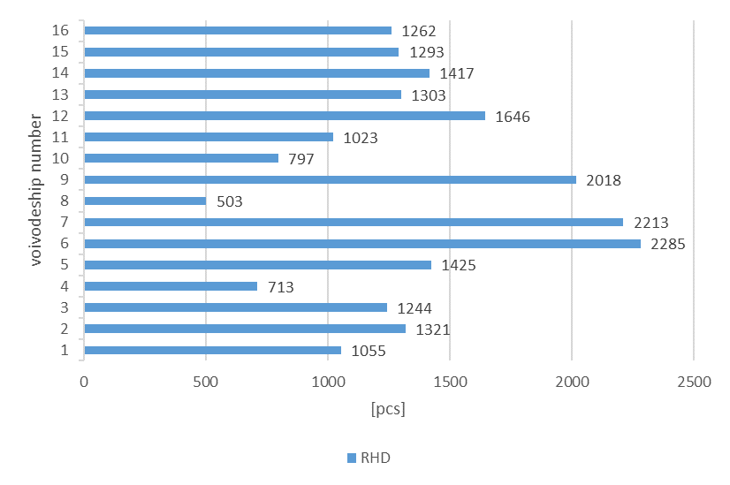
Fig. 1. Structure of farm retail trade (RHD) in Poland, broken down by voivodeship 1 – Dolnośląskie Voivodeship,
2 – Kujawsko-Pomorskie Voivodeship, 3 – Lubelskie Voivodeship, 4 – Lubuskie Voivodeship, 5 – Łódzkie Voivodeship, 6 – Małopolskie Voivodeship, 7 – Mazowieckie Voivodeship, 8 – Opolskie Voivodeship, 9 – Podkarpackie Voivodeship, 10 – Podlaskie Voivodeship, 11 – Pomorskie Voivodeship, 12 – Śląskie Voivodeship, 13 – Świętokrzyskie Voivodeship, 14 – Warmińsko-Mazurskie Voivodeship, 15 – Wielkopolskie Voivodeship, 16 – Zachodniopomorskie Voivodeship.
3.3. Structure of Local Food Products
In the study of a sustainable food system in Poland, a key element is the structure of food products produced within the agricultural retail sector and supplied via short food supply chains. For the study, six food products were identified as constituting a significant element of a sustainable food system, namely:
- local food product number 1 (lfp1); milk, cream, dairy products,
- local food product number 2 (lfp2); eggs,
- local food product number 3 (lfp3); ready meals (dishes) made from products of animal origin (meat dishes) and non-animal origin (non-meat dishes),
- local food product number 4 (lfp4); meat products,
- local food product number 5 (lfp5); bread, cakes, biscuits and confectionery,
- local food product number 6 (lfp6); bee products (honey, bee pollen, royal jelly).

Based on the research carried out, it can be concluded that bee products (honey, bee pollen, royal jelly) are the dominant products, with honey being the main one. In Poland, 16,419 farmers produce honey as a local product within the framework of agricultural retail trade (Fig. 2). Furthermore, 3,034 farmers produce eggs, 2,299 farmers produce ready-made meals (dishes) from products of animal origin (meat dishes) and non-animal origin (non-meat dishes), 1,517 farmers produce milk, cream and dairy products, 1,068 farmers produce meat products, and 786 farmers produce bread, cakes, biscuits and confectionery (Fig. 2).
As part of an analysis of local food systems, a study was conducted on food production across Poland's provinces. Taking honey as the dominant local food product, it should be noted that honey accounts for the largest share of local food production in three voivodeships (Fig. 3): in the Świętokrzyskie Voivodeship, the share stands at 87.80%, in the Podkarpackie Voivodeship, it stands at 86.67%, and in the Lubelskie Voivodeship, it stands at 84.16%. Honey also accounts for a significant share of local food production in the following voivodeships (Fig. 3): Mazowieckie (81.34%), Lubuskie (79.94%), Małopolskie (78.99%), Warmińsko-Mazurskie (78.83%), Opolskie (74.95%) and Kujawsko-Pomorskie (74.64%). In the remaining provinces, the share ranges from 72.50% (Zachodniopomorskie) to 65.88% (Pomorskie).

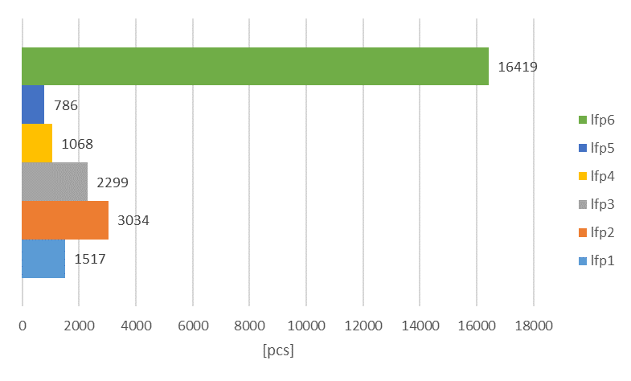
Fig. 2. Structure of products produced by farmers within the agricultural retail sector in Poland: lfp1 (local food product number 1) – milk, cream, dairy products; lfp2 (local food product number 2) – eggs; lfp3 (local food product number 3) – ready meals (dishes) made from products of animal origin (meat dishes) and non-animal origin (non-meat dishes), lfp4 (local food product number 4) – meat products, lfp5 (local food product number 5) – bread, cakes, biscuits and confectionery, lfp6 (local food product number 6) – bee products (honey, bee pollen, royal jelly)

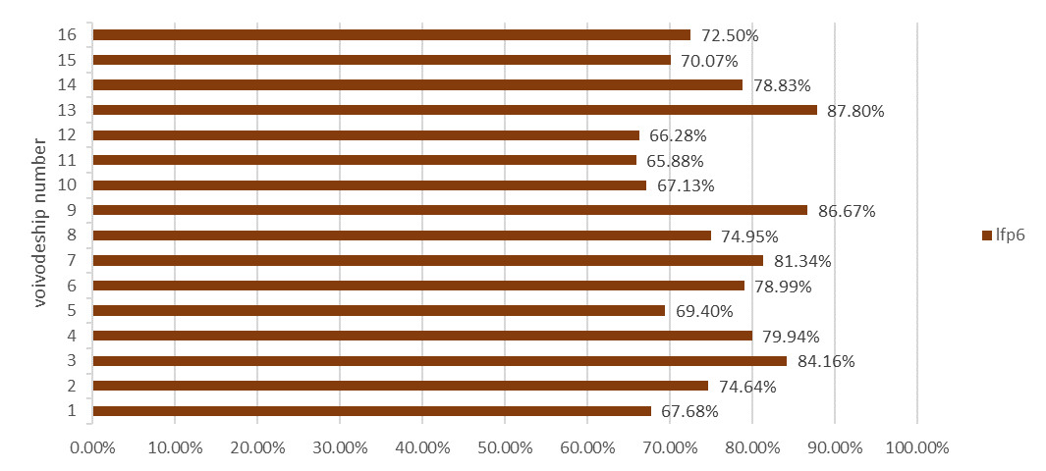
Fig. 3. Honey production (lfp6 – local food product number 6) within the agricultural retail trade, broken down by voivodeship: 1 – Dolnośląskie Voivodeship, 2 – Kujawsko-Pomorskie Voivodeship, 3 – Lubelskie Voivodeship,
4 – Lubuskie Voivodeship, 5 – Łódzkie Voivodeship, 6 – Małopolskie Voivodeship, 7 – Mazowieckie Voivodeship,
8 – Opolskie Voivodeship, 9 – Podkarpackie Voivodeship, 10 – Podlaskie Voivodeship, 11 – Pomorskie Voivodeship,
12 – Śląskie Voivodeship, 13 – Świętokrzyskie Voivodeship, 14 – Warmińsko-Mazurskie Voivodeship,
15 – Wielkopolskie Voivodeship, 16 – Zachodniopomorskie Voivodeship.

As regards the production of milk, cream, and dairy products (Fig. 4), the largest share is in the Śląskie Voivodeship (13.91%) and Dolnośląskie Voivodeship (10.90%). In the remaining provinces, the share of milk, cream and dairy products production is as follows (Fig. 4): Kujawsko-Pomorskie (4.69%), Lubelskie (2.73%), Lubuskie (7.29%), Łódzkie (7.37%), Małopolskie (8.23%), Mazowieckie (5.29%), Opolskie (8.15%), Podkarpackie (5.40%), Podlaskie (8.41%), Pomorskie (9.19%), Świętokrzyskie (2.84%), Warmińsko-Mazurskie (4.87%), Wielkopolskie (7.12%), Zachodniopomorskie (8.40%).
In the case of egg production (Fig. 4), the largest share of production is in the Śląskie Voivodeship (21.93%) and the Pomorskie Voivodeship (21.90%). In the other voivodeships, the share of egg production is (Fig. 4): Dolnośląskie (21.52%), Kujawsko-Pomorskie (17.41%), Lubelskie (8.28%), Lubuskie (13.60%), Łódzkie (15.37%), Małopolskie (9.06%), Mazowieckie (10.80%), Opolskie (14.51%), Podkarpackie (7.38%), Podlaskie (20.95%), Świętokrzyskie (6.06%), Warmińsko-Mazurskie (13.62%), Wielkopolskie (16.40%), Zachodniopomorskie (20.13%).
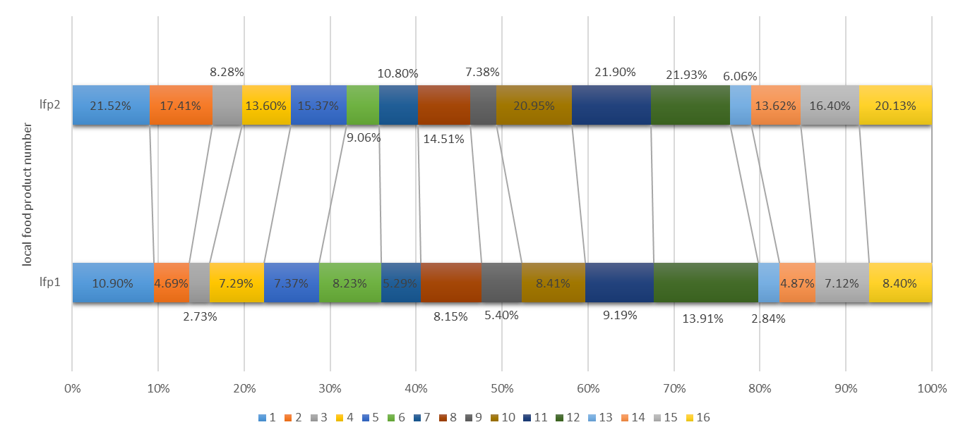
Fig. 4. Production of local food products within the agricultural retail trade in the given voivodeships: lfp1 – local food product number 1 (milk, cream, dairy products); lfp2 – local food product number 2 (eggs); voivodeship numbers:
1 – Dolnośląskie Voivodeship, 2 – Kujawsko-Pomorskie Voivodeship, 3 – Lubelskie Voivodeship, 4 – Lubuskie Voivodeship, 5 – Łódzkie Voivodeship, 6 – Małopolskie Voivodeship, 7 – Mazowieckie Voivodeship, 8 – Opolskie Voivodeship, 9 – Podkarpackie Voivodeship, 10 – Podlaskie Voivodeship, 11 – Pomorskie Voivodeship, 12 – Śląskie Voivodeship, 13 – Świętokrzyskie Voivodeship, 14 – Warmińsko-Mazurskie Voivodeship, 15 – Wielkopolskie Voivodeship, 16 – Zachodniopomorskie Voivodeship.

By contrast, in the case of ready-made meals made from animal and non-animal products (Fig. 5), the largest share of production is in the Dolnośląskie Voivodeship (25.69%) and the Opolskie Voivodeship (23.06%). In the remaining provinces, the share of ready-made meals made from animal and non-animal products in production is as follows (Fig. 5): Kujawsko-Pomorskie (9.16%), Lubelskie (6.51%), Lubuskie (18.79%), Łódzkie (12.63%), Małopolskie (4.86%), Mazowieckie (6.91%), Podkarpackie (5.80%), Podlaskie (12.55%), Pomorskie (12.32%), Śląskie (8.81%), Świętokrzyskie (8.06%), Warmińsko-Mazurskie (11.08%), Wielkopolskie (17.32%), Zachodniopomorskie (12.52%).
In the case of meat product production (Fig. 5), the largest share of production is in the Łódzkie Voivodeship (10.11%) and the Śląskie Voivodeship (8.57%). In the remaining voivodeships, the share of meat product production is (Fig. 5): Dolnośląskie (6.64%), Kujawsko-Pomorskie (3.71%), Lubelskie (1.61%), Lubuskie (4.21%), Małopolskie (4.55%), Mazowieckie (4.70%), Opolskie (3.78%), Podkarpackie (2.92%), Podlaskie (3.39%), Pomorskie (4.99%), Świętokrzyskie (3.53%), Warmińsko-Mazurskie (3.95%), Wielkopolskie (7.12%), Zachodniopomorskie (4.44%).
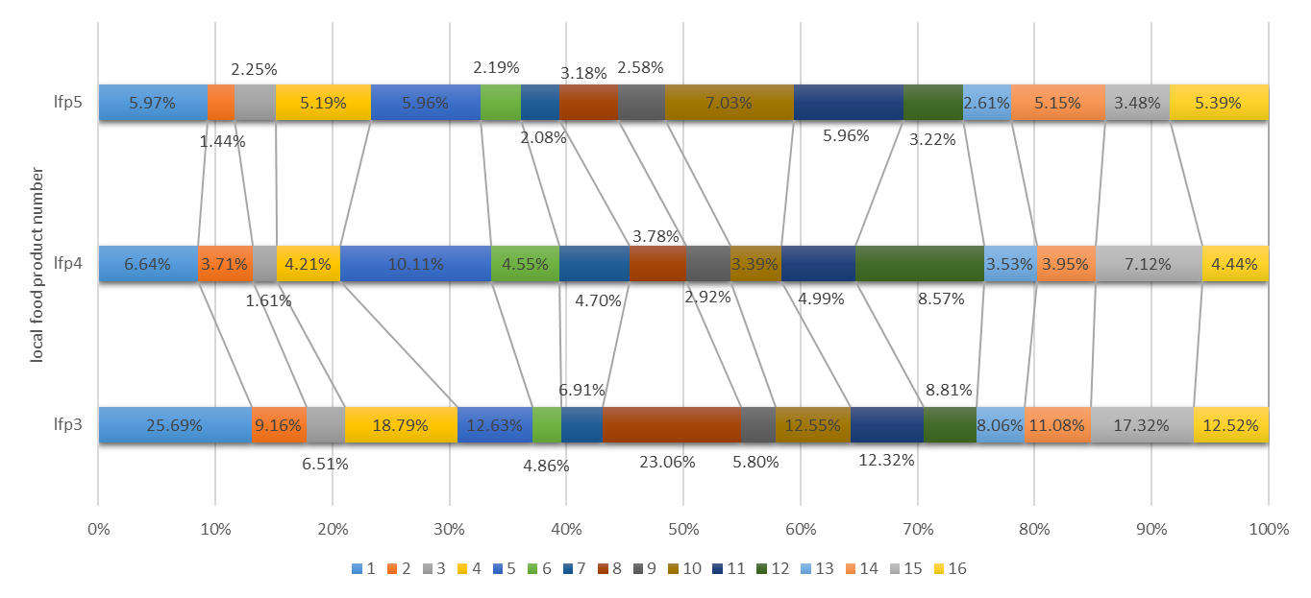
Fig. 5. Production of local food products within the agricultural retail trade in the given voivodeships: lfp3 – local food product number 3 (ready meals (dishes) made from products of animal origin (meat dishes) and non-animal origin (non-meat dishes)); lfp4 – local food product number 4 (meat products); lfp5 – local food product number 5 (bread, cakes, biscuits and confectionery); voivodeship numbers: 1 – Dolnośląskie Voivodeship, 2 – Kujawsko-Pomorskie Voivodeship, 3 – Lubelskie Voivodeship, 4 – Lubuskie Voivodeship, 5 – Łódzkie Voivodeship, 6 – Małopolskie Voivodeship, 7 – Mazowieckie Voivodeship, 8 – Opolskie Voivodeship, 9 – Podkarpackie Voivodeship,
10 – Podlaskie Voivodeship, 11 – Pomorskie Voivodeship, 12 – Śląskie Voivodeship, 13 – Świętokrzyskie Voivodeship,
14 – Warmińsko-Mazurskie Voivodeship, 15 – Wielkopolskie Voivodeship, 16 – Zachodniopomorskie Voivodeship.

In the case of the production of bread, cakes, biscuits and confectionery (Fig. 5), the largest share of production is in the Podlaskie Voivodeship (7.03%), Dolnośląskie Voivodeship (5.97%), Łódzkie Voivodeship (5.96%) and Pomorskie Voivodeship (5.96%). In the remaining voivodeships, the share of bread, cakes, biscuits and confectionery in production is as follows (Fig. 5): Kujawsko-Pomorskie (1.44%), Lubelskie (2.25%), Lubuskie (5.19%), Małopolskie (2.19%), Mazowieckie (2.08%), Opolskie (3.18%), Podkarpackie (2.58%), Śląskie (3.22%), Świętokrzyskie (2.61%), Warmińsko-Mazurskie (5.15%), Wielkopolskie (3.48%), Zachodniopomorskie (5.39%).
3.4. Food Safety
A worrying phenomenon that significantly affects food safety in food systems is food adulteration. This practice has become widespread, entailing numerous adverse health consequences for end consumers, whilst also generating negative economic consequences for local food producers (farmers), consumers, and state and local government bodies. It should be noted that misleading consumers regarding food – and in particular its composition, place and method of production – poses a real threat to the safety of individual food products, consumer health and honest food producers.
Research carried out based on data provided by the Agricultural and Food Products Quality Inspection Authority (IJHARS) shows that the food products most frequently adulterated include:
- meat, meat products, ready meals,
- olive oil,
- fruit and vegetables,
- honey and bee products,
- local food products (legally protected).

The IJHARS database records 2,893 confirmed (recorded) cases of food adulteration (IJHARS, 2026).
From the perspective of analysing and developing sustainable food systems, it is a cause for concern that the list of the most frequently adulterated foods includes meat products and ready meals, fruit and vegetables, honey and bee products, and legally protected local food products. This is because these food products form a fundamental part of sustainable food systems and are produced by local food producers (farmers) within the framework of agricultural retail trade.

4. Summary
The analysis carried out suggests that the development of sustainable food systems is one of the key priorities of contemporary agricultural and food policy, both in Poland and in the European Union. Implementing the objectives of the 'Farm to Fork' strategy and the European Green Deal requires ensuring food safety, environmental protection and a high level of consumer protection simultaneously. Achieving these objectives is only possible by maintaining a balance between the economic, social and environmental dimensions of food systems.
The illegal labelling of food products, which constitutes a form of food fraud, remains a significant threat to the proper functioning of the food market. Such practices lead to consumer misinformation, undermine trust in producers, and violate the principles of fair competition. Effectively curbing this phenomenon requires not only appropriate legal instruments and an efficiently functioning supervisory system, but also the use of modern analytical methods, the development of product traceability systems, and the strengthening of cooperation between national and EU institutions.
In summary, food safety and the reliability of information provided to consumers are the cornerstones of sustainable food systems. Their further development should be based on systematic improvements to food market supervision, raising awareness among supply chain participants, and developing effective mechanisms to prevent food fraud. These measures will help enhance consumer protection and strengthen the stability and credibility of the food market.
Acknowledgements
The present study was carried out within the framework of the 'Envisioning an integrated quadruple helix and RRI framework for food system transformation and regional innovation ecosystem enhancement'
(VISION4FOOD) project, funded by the European Union. Views and opinions expressed are, however, those of the authors only and do not necessarily reflect those of the European Union or the European Research Executive Agency. Neither the European Union nor the granting authority can be held responsible for them.
References
Bosek, L. (2016). Komentarz do art. 5. W: M. Safjan, L. Bosek (red.), Konstytucja RP. Tom I. Komentarz do art. 1-86. Warszawa: C.H. Beck. (in Polish)
Budzinowski, R. (2020). O potrzebie opracowania i koncepcji Systemu prawa rolnego. Przegląd Prawa Rolnego, 2(27), 11–24. https://doi.org/10.14746/ppr.2020.27.2.1
Górski, M. (2018). Konwencja klimatyczna. W: M. Górski (red.), Prawo ochrony środowiska (s. 290 i n.). Warszawa: Wolters Kluwer. (in Polish)
Kowalczyk, S. (2016). Bezpieczeństwo i jakość żywności, Wydawnictwo Naukowe PWN, Warszawa. (in Polish)
Kowalska, A. & Kowalski, J. (2020). Znakowanie żywności wolnej od GMO w polskim systemie prawa żywnościowego. Ruch Prawniczy, Ekonomiczny i Socjologiczny, 82(2), 213–228. https://doi.org/10.14746/rpeis.2020.82.2.15
Leciak, M. & Daśko, N. (2019). Food fraud: criminological perspective and limits of penal response in Poland. Ius Novum, 13(4), 17–34. https://doi.org/10.26399/iusnovum.v13.4.2019.41/m.leciak/n.dasko
Leśkiewicz K. (2020). Zrównoważone systemy żywnościowe w kontekście reformy Wspólnej Polityki Rolnej - aspekty prawne. Przegląd Prawa Rolnego, 2(27). 75–85. https://doi.org/10.14746/ppr.2020.27.2.4
Mróz, B. (2018). Rola i zadania organów administracji samorządowej w systemie bezpieczeństwa publicznego. Wyższa Szkoła Gospodarki Euroregionalnej w Józefowie. (in Polish)
Nogales, A., Diaz Moron, R. & Garcia-Tejedor, A.J. (2021). Food safety risk prediction with Deep Learning models using categorical embeddings on European Union RASFF data. Food Control, 134, 108697. https://doi.org/10.1016/j.foodcont.2021.108697
Rouhonen, J. (2022). A review of product safety regulations in the European Union. International Cybersecurity Law Review, 3(2), 345-366. https://doi.org/10.1365/s43439-022-00057-8
Ulberth, F. (2020). Tools to combat food fraud-A gap analysis. Food Chemistry, 330, 127044, https://doi.org/10.1016/j.foodchem.2020.127044
Żuchowska-Grzywacz, M. (2025). Rola administracji publicznej w zapewnianiu bezpieczeństwa żywności-wybrane aspekty prawne. Studia Prawnoustrojowe, 67, 445–457. https://doi.org/10.31648/sp.10413
Act (2000). Ustawa z dnia 21 grudnia 2000 r. o jakości handlowej artykułów rolno-spożywczych (2000).
Dz. U. 2023 poz. 1980. (in Polish)
Act (2006). Ustawa z dnia 25 sierpnia 2006 r. o bezpieczeństwie żywności i żywienia (2006).
Dz. U. 2020 poz. 2021 ze zm. (in Polish)
European Commission (2018). Knowledge Centre for Food Fraud and Quality. (access 03 June 2026). https://food.ec.europa.eu
European Commission (2020). A Farm to Fork Strategy for a fair, healthy and environmentally-friendly food system. Brussels: European Commission. (access 03 June 2026). https://eur-lex.europa.eu
European Commission (2020). Farm to Fork Strategy. Brussels. (access 03 June 2026). https://eur-lex.europa.eu
European Economic and Social Committee (2016). Opinion on more sustainable food systems (2016/C 303/08).
Official Journal of the European Union, C 303, 64–70. (access 03 June 2026). https://eur-lex.europa.eu
European Parliament (2020). Resolution of 15 January 2020 on the European Green Deal. (access 03 June 2026). https://www.europarl.europa.eu
FAO (2024). The State of Food and Agriculture 2024. Rome: FAO. (access 03 June 2026). https://www.fao.org
GIW (2026). Główny Inspektorat Weterynarii, wykaz podmiotów prowadzących rolniczy handel detaliczny w Polsce, https://www.wetgiw.gov.pl/nadzor-weterynaryjny/wykaz-zakladow-rejestrowanych. (access 05 June 2026).
HLPE (2014). Food losses and waste in the context of sustainable food systems. A report by The High Level Panel of Experts on Food Security and Nutrition June 2014. Rome. (access 03 June 2026). https://openknowledge.fao.org/handle/20.500.14283/i3901e
IJHARS (2026). Inspekcja Jakości Handlowej Artykułów Rolno-Spożywczych. Zafałszowane artykuły rolno-spożywcze, https://www.gov.pl/web/ijhars/zafalszowane-artykuly-rolno-spozywcze. (access 05 June 2026).
JCR (2016). Joint Reaserch Centre (JCR), Food authenticity and quality-detecting food fraud. European Commission, https://joint-research-centre.ec.europa.eu (access 03 June 2026).
Konstytucja RP (1997). Konstytucja Rzeczypospolitej Polskiej z dnia 2 kwietnia 1997 r. (1997). Dz. U. Nr 78, poz. 483.
NIK (2021). Najwyższa Izba Kontroli. System kontroli bezpieczeństwa żywności w Polsce-stan obecny pożądane kierunki zmian. Warszawa, https://www.nik.gov.pl (access 03 June 2026). (in Polish)
PZH-PIB (2020). Narodowy Instytut Zdrowia Publicznego (PZH-PIB). Materiały dotyczące bezpieczeństwa żywności, (access 03 June 2026). (in Polish) https://pzh.gov.pl
United Nations General Assembly (2015). Transforming our world: The 2030 Agenda for Sustainable Development (A/RES/70/1). (access 03 June 2026). https://undocs.org

