
 | Rocznik Ochrona Środowiska
 | Volume 28 | Year 2026 ISSN 2720-7501 | pp. 212-226
 | https://doi.org/10.54740/ros.2026.016 open access
 | Received: March 2026 Accepted: April 2026 Published: April 2026
Experimental Investigation of Odour Characteristics in Nitrogen Containing Aqueous Solutions
Eglė Marčiulaitienė¹, Dainius Paliulis^{2*}
¹Department of Environmental Protection and Water Engineering,
Vilnius Gediminas Technical University (Vilnius TECH), Lithuania
https://orcid.org/0000-0001-9397-9622
²Department of Environmental Protection and Water Engineering,
Vilnius Gediminas Technical University (Vilnius TECH), Lithuania
https://orcid.org/0000-0003-4353-3192
*corresponding author’s e-mail: dainius.paliulis@vilniustech.lt
Abstract: One of the key problems related to water pollution is the presence of odorous nitrogen compounds, especially ammonia, which often lacks a clearly defined odour threshold value. Odour intensity does not always correlate directly with gas concentration, and this complexity has encouraged broader scientific cooperation, such as the COST Action CA18225 “Taste and Odor in early diagnosis of source and drinking Water Problems” (2019–2023), which focuses on taste and odour issues in water. The work aimed to determine the dependencies between odour concentration and the temperature and concentration of an aqueous ammonia solution. A method was developed to measure odour concentration in water contaminated with ammonia at various levels. Results show that increasing solution temperature significantly raises odour concentration in the air: from 616 OUE/m³ at 20°C to 1052 OUE/m³ at 30°C and 1758 OUE/m³ at 40°C. The odour threshold also rises with temperature, doubling between 20°C and 30°C. Knowing odour emission flow enables modeling odour dispersion in ambient air.
Keywords: odour, nitrogen compounds, water, ammonia, temperature
1. Introduction
Fresh water is a limited resource essential for agriculture, industry, and human existence. Without a sufficient amount of high‑quality fresh water, sustainable economic development is difficult to imagine. As industrial production increases and new industries emerge, the consumption of fresh water resources continues to grow. Due to the water cycle, fresh water is renewed relatively quickly. If water were used at the rate of natural circulation, water resources would never be depleted. Still, in many countries, water is consumed at a much higher rate than it can be renewed (Bartram & Ballance et al., 1996). The smell of water depends on the impurities it contains. pH affects both the smell and taste of water (Adams et al., 2022). One of the major problems associated with drinking water and surface water pollution is the presence of nitrogen compounds. The concentration of nitrogen compounds (ammonia water) is an important indicator of water quality, as it can signal possible contamination by bacteria, sewage, animal feces, and other sources. Various nitrogen compounds (nitrites, nitrates, ammonium, etc.) may be dissolved in water (Schullehner et al., 2022). Ammonia is a colourless gas, easily soluble in water, with a characteristic pungent odour, and toxic to aquatic flora and fauna. In water, ammonia can exist in two forms: ammonium hydroxide (NH₄OH) and ammonium ions (NH₄⁺). The sources of ammonia in water include certain salts and nitrogen‑containing substances formed during the decomposition of proteins. Nitrogen compounds cause an unacceptable odour and taste in water intended for consumption, indicating that the water is unfit for drinking. The relationship between odour intensity and gas concentration may differ among chemical compounds. In many cases, high odour intensity indicates a high ammonia concentration, but a high gas concentration does not necessarily correspond to strong odour intensity. Odour emissions are among the most significant environmental problems investigated by scientists (Pawnuk et al., 2022; Wiśniewska et al., 2020; Piekarski et al., 2021). The detection threshold for ammonia varies under different conditions. Many chemical compounds have odour threshold values specified in hygiene standards or other documents, but ammonia is notable because it does not have a fixed odour threshold value. Literature sources report NH₃ odour detection thresholds ranging from 0.026 mg/m³ to 71.75 mg/m³. Even the Lithuanian hygiene standard HN 35:2007 does not provide an odour threshold value for ammonia. The permissible concentration of ammonium ions in drinking water according to Lithuanian hygiene standard HN 24:2023 is 0.50 mg/L (HN 24, 2023). The World Health Organization states that the odour threshold for rotten ammonia at alkaline pH is approximately 1.5 mg/L, while the taste threshold is 35 mg/L. The recommended ammonia concentration for drinking water is 0.5 mg/L in China (GB5749‑2006) and in the European Union (Zheng et al., 2012). Odour is not always a reliable warning indicator when health effects occur at concentrations below the odour threshold. However, ammonia is generally considered a chemical with good warning properties. Unpleasant odours and tastes can indicate water quality problems or pose potential risks to human health. Very strong odours can irritate the nose, throat, and eyes, and in individuals with asthma or other respiratory diseases, may trigger or worsen symptoms (Schiffman et al., 2000). The synergistic effect of hydrogen sulphide and ammonia can lead to rapid loss of smell, and prolonged exposure may result in inhalation poisoning (Mačiūnas et al., 2011). The rate of ammonia volatilisation is strongly influenced by acidity. NH₃ (gaseous ammonia) and NH₄⁺ (aqueous ammonium ion) are in equilibrium at approximately pH 9. Higher pH shifts more NH₄⁺ into the gaseous form, increasing volatility. Although ammonia volatilisation cannot be completely avoided, its release into the atmosphere can be reduced by controlling air supply, carbon‑to‑nitrogen ratio, pH, and by applying preventive measures such as adsorption, chemical transformation, and precipitation techniques (Zhang et al., 2008). Various methods can be used during the treatment of water and wastewater to remove odours, including ozonation, membrane filtration, adsorption, and catalysis (Rohani et al., 2021; Xue et al., 2018; Dos Santos & Daniel et al., 2020; Tabassum et al., 2019; Dey et al., 2021; Popova et al., 2023; Ruiz Bevia & Fernandes Torres et al., 2019; Dietrich & Burlingame et al., 2020; Kalweit et al., 2019). Over the past 50 years, progress in understanding taste and odour episodes has been closely linked to advances in sample preparation technologies and improvements in the sensitivity of separation, detection, and identification methods (Bruchet et al., 2019). Reliable and rapid odour detection methods are needed (Pochiraju et al., 2021). The most commonly used measurement system is the total odour number (TON), a method based on odour persistence after dilution. Other methods include flavour profile analysis and analytical measurement of chemical concentrations (Trojan, 2018). Drinking water with good aesthetic properties (e.g., pleasant taste and odour) is a major factor in global socio‑economic development. The deterioration of taste and odour quality, associated with the formation of various organic compounds, is a significant challenge for water suppliers today (Antonopoulou et al., 2020). Sensory and chemical analysis, risk assessment of contaminated water, and appropriate water treatment are key aspects of odour and taste control. However, experience in this field in Europe remains fragmented. The relevance of drinking water quality issues is demonstrated by the participation of European scientists in COST activities, such as CA18225 “Taste and Odor in Early Diagnosis of Source and Drinking Water Problems” (2019–2023), which significantly contributes to improving public health, protecting water resources, enhancing quality of life, promoting tap water use, increasing consumer awareness and involvement in water quality issues, and supporting the professional development of young researchers. These activities support the implementation of the EU Drinking Water Directive and strengthen European leadership in water quality science and technology. The work aimed to determine the dependencies between odour concentration and the temperature and concentration of an aqueous ammonia solution. Knowing the odour emission flow (Specific Odour Emission Rate, SOER) (OUE/m²/s) and the surface area of the odour-emitting object (e.g., a water body, m²), it is possible to calculate the total odour emission flow (OUE/s) from the source. With these parameters, odour dispersion in ambient air can be modelled.
2. Research Methodology
Aqueous solution odour testing using dynamic olfactometry
Water odour testing was carried out using dynamic olfactometry. Experimental odour studies were performed in the Vilnius TECH laboratory using an AC’SCENT® International dynamic olfactometer. Each odour assessor was provided with diluted sample air, and a forced‑choice method was applied. Odourless PET bags were used for olfactometric analysis and purged with odourless air before testing to eliminate background odours (Brattoli et al., 2011). Odour concentration measurements and analysis were conducted in a specially equipped odour‑free laboratory that meets strict operational requirements. The laboratory is equipped with a conditioning and ventilation system featuring specialised carbon filters. When the ventilation system is operating, the air in the room is exchanged four times per hour. Deionised water meeting the requirements of EN ISO 3696:1987 was used in the experimental studies. It was artificially contaminated with different concentrations of NH₄OH (25%). Aqueous solutions with varying NH₄OH concentrations were prepared to determine the relationship between pollutant concentration (NH₄OH) in water and odour intensity. The odour test results were analysed in accordance with the LST EN 13725:2004/AC:2006 standard. After completing the tests, geometric means of dilutions for all fourteen channels were calculated using the dynamic olfactometry method, followed by the calculation of geometric means of individual threshold estimates and the first retrospective check. Knowing the odour concentration, the surface area from which the odour sample is taken, and the air flow rate, the odour emission flow rate (OUE/m²/s) can be determined. The results of the odour emission flow rate calculations are presented in Table 1. For passive odour sources (e.g., non‑aerated liquid surfaces), the odour emission flow rate was calculated using the following equation:

𝑂𝐸𝑅=𝑆𝑂𝐸𝑅⋅𝐴_{𝑒𝑚} (1)
where:
OER – odour emission flow rate, OUE/s,
SOER – specific odour emission flow rate, OUE/m²/s,
Aₑₘ – surface area of the odour source (e.g., water or water body), m².

Knowing the specific odour emission flow rate (SOER) and the surface area of the odour‑emitting object, such as a water body, the total odour emission flow rate (OUE/s) can be calculated. These calculations are useful for estimating the amount of odour released into the environment and for preliminary assessment of potential odour dispersion patterns.
Total nitrogen analysis methodology
A Shimadzu TOC–VCSH total nitrogen analyser was used in the study. Since the water samples were contaminated with only one nitrogen compound (NH₄OH), the concentration of NH₄OH in the aqueous solution could be calculated from the measured total nitrogen (N_{b}) concentration.
Determination of odour threshold
Table 1. Determination of the odour threshold of the test sample water
The volume of the test sample (NH₄OH) was diluted to 200 mL | Dilution level, times (TON) | The amount of the test sample (NH₄OH) diluted to 200 mL | Dilution level, times (TON)
200 | 1.0 | 12.0 | 17
140 | 1.4 | 8.0 | 25
100 | 2.0 | 5.7 | 35
70 | 2.8 | 4.0 | 50
50 | 4.0 | 2.8 | 70
35 | 5.7 | 2.0 | 100
25 | 8.0 | 1.4 | 140
17 | 12.0 | 1.0 | 200

Calculated odour threshold:
TON = (A+B)/A (2)
here:
A – volume of the analysed sample with odour, mL,
B – volume of clean water without odour, mL.

Odour tests were performed at temperatures of 20, 30, 40, and 60°C. The odour threshold is determined when the first sample is perceived by smell, and the geometric mean between the dilution level of the detected sample and the dilution level of the preceding sample is calculated.
Ammonia vapor concentration test
Using a Shimadzu TOC–VCSV analyser, the total nitrogen (Nᵦ) concentration is measured, and this value is then converted into the concentration of ammonia water (NH₄OH) in the solution. Knowing the concentration of ammonia water in the solution and the volume of contaminated air that has passed through it, the concentration of ammonia vapor in the air (mg/m³) is calculated.
Determination of the odour threshold of water
Odour testing was performed using aqueous solutions at 20, 30, 40, and 60°C. To determine the odour threshold value, assessors began with an uncontaminated water sample and proceeded in order of decreasing dilution (increasing concentration). The odour threshold was identified as the dilution level at which the first sample was first perceived by smell, and the geometric mean was calculated using the dilution level of the detected sample and that of the preceding sample. The selected temperature range (20, 30, 40 and 60°C) covers both natural environmental conditions and temperatures that may occur in real systems. Temperature has a significant impact on ammonia volatility and, consequently, odour perception. This range allows us to assess how increasing temperature affects odor concentration and detection threshold.
The study used only p.a.grade reagents and Class A glass measuring vessels to ensure the highest measurement accuracy. All procedures followed relevant ISO standards, and each experiment was repeated three times to verify repeatability. The odour laboratory was equipped to the required specifications, and odour assessments were conducted by five trained assessors who met all qualification criteria. For statistical evaluation of relationships between different parameters, Pearson’s correlation coefficient was applied. Data processing was performed using Microsoft Excel 2021, which was used to calculate averages, standard deviations, and confidence intervals.
3. Results and Discussion
The results of odour detection at different temperatures of the analysed samples are presented in Table 2.

Table 2. Results of odour detection at different temperatures of the analysed sample
Solution temperature, °C | Contaminant amount in sample (odour detection), mL | Sample volume, mL | Dilution, times
20 °C | 4.0 | 200 | 50
30 °C | 2.0 | 200 | 100
40 °C | 1.4 | 200 | 143
60 °C | 1.0 | 200 | 200

Based on the results obtained, presented in Table 2, odour detection graphs were created to display the results (Fig. 1).
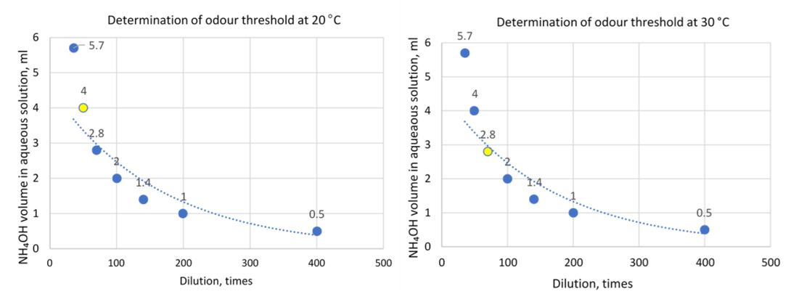
a) | b)
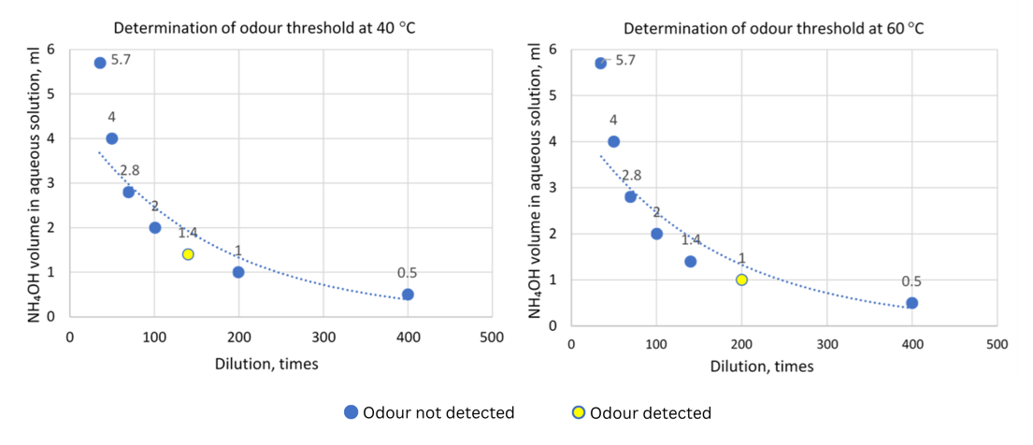
c) | d)
Fig. 1. Odour threshold: a) 20°C; b) 30°C; c) 40°C; d) 60°C
Fig. 1 shows that at a sample temperature of 20°C, the odour was first detected in a sample containing 4.0 mL of the aqueous solution (0.25% NH₄OH). This corresponded to a concentration of 0.005% ammonia water in the sample.
At a sample temperature of 30°C, the odour was first detected in a sample containing 2.0 mL of the aqueous solution (0.25% NH₄OH) (Fig. 1b). This corresponded to a concentration of 0.0025% ammonia water in the sample.
The graph in Fig. 1c shows that at a sample temperature of 40°C, the odour was first detected in a sample containing 1.4 mL of the aqueous solution (0.25% NH₄OH). This corresponded to a concentration of 0.00175% ammonia water in the sample.
At a sample temperature of 60°C, the odour was first detected in a sample containing 1.0 mL of the aqueous solution (0.25% NH₄OH) (Fig. 1d). This corresponded to a concentration of 0.0125% ammonia water in the sample.
Based on the odour detection results obtained at different sample temperatures, geometric means were calculated and are presented in Figs. 2a–2d. These values were used to determine the odour detection threshold for the ammonia‑contaminated water sample at each tested temperature.

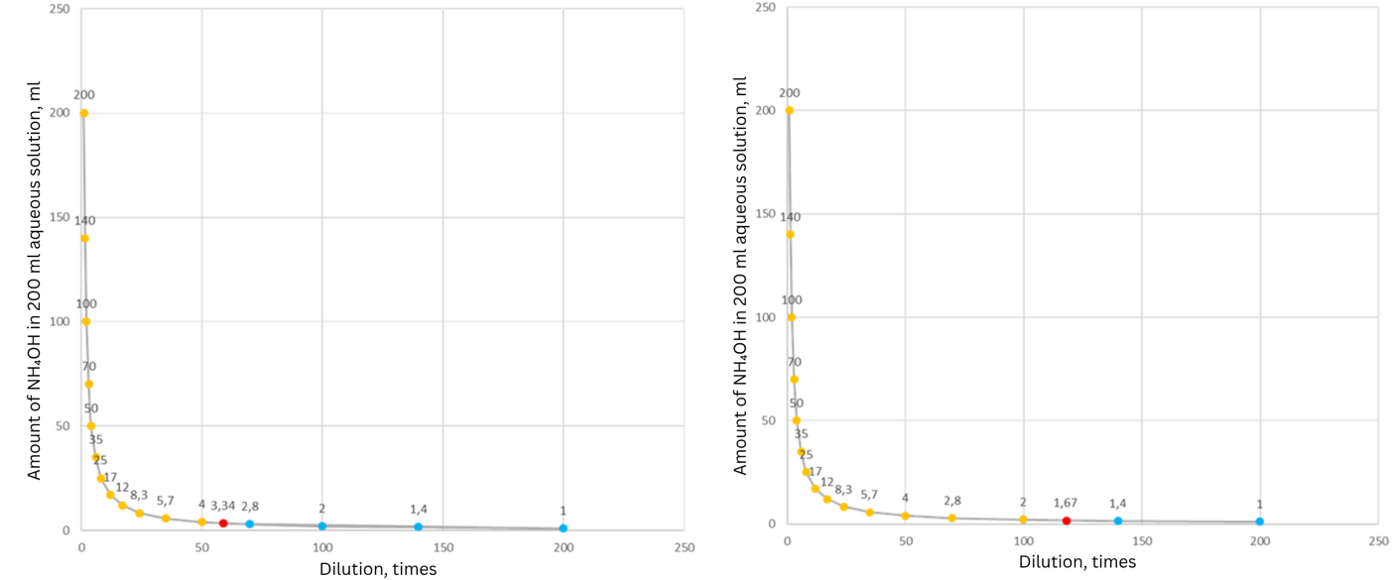
a) | b)
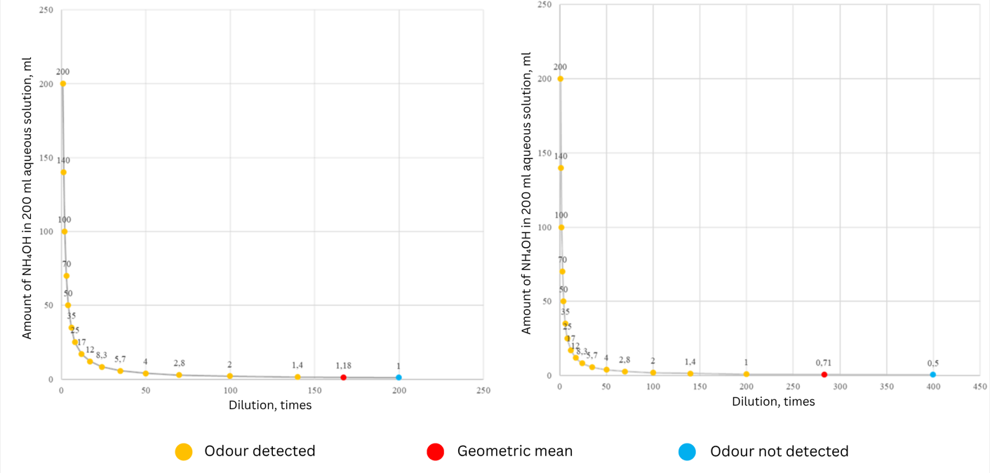
c) | d)
Fig. 2. Geometric mean of NH₄OH odour detection at different solution temperatures: a) 20°C, b) 30°C, c) 40°C, d) 60°C

Fig. 2a shows that at a sample temperature of 20°C, the odour could be preliminarily detected when the analysed sample contained 3.34 mL of the aqueous solution (0.25% NH₄OH). This corresponded to a concentration of 0.004175% ammonia water in the sample.
At a sample temperature of 30°C, the odour could be preliminarily detected when the analysed sample contained 1.67 mL of the aqueous solution (0.25% NH₄OH) (Fig. 2b). This corresponded to a concentration of 0.0020875% ammonia water in the sample.
From Fig. 2c, it can be seen that at a sample temperature of 40°C, the odour could be preliminarily detected when the analysed sample contained 1.18 mL of the aqueous solution (0.25% NH₄OH). This corresponded to a concentration of 0.001475% ammonia water in the sample.
At a sample temperature of 60°C, the odour could be preliminarily detected when the analysed sample contained 0.71 mL of the aqueous solution (0.25% NH₄OH) (Fig. 2d). This corresponded to a concentration of 0.0008875% ammonia water in the sample.
Based on the obtained experimental results, the odour threshold for the analysed samples at different temperatures was calculated by determining the geometric mean between the dilution level of the detected sample and that of the preceding sample. The resulting odour threshold values are presented in Fig. 3.

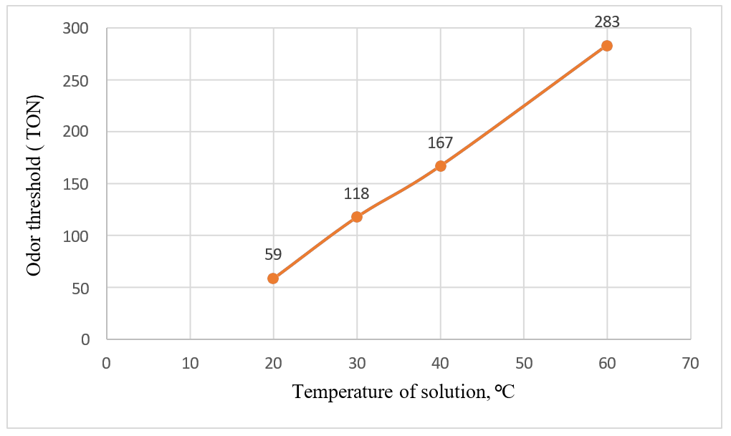

Fig. 3. Results of the odour threshold test at different temperatures of the analysed samples in the range of 20–60°C

Fig. 3 shows that the odour threshold detection limit varies depending on the temperature of the analysed water sample. When testing deionised water with different ammonia concentrations, the odour is detected earliest at 60°C (when the pollutant content in the sample is 1 mL, corresponding to 0.00125% ammonia concentration in water) due to the most intensive evaporation of ammonia from the aqueous solution.
As the temperature of the analysed water sample increases, the evaporation process intensifies. Higher solution temperatures accelerate ammonia volatilisation, resulting in the odour of the analysed sample being detected more quickly.
Determination of water odour by dynamic olfactometry
An aqueous solution emitting an ammonia odour was used for the experimental studies. The analysed odour sample was diluted and mixed with clean air in different ratios and then presented to the assessors, whose evaluations were recorded by the software.
Table 3 presents the results of the experimental studies performed using the dynamic olfactometry method at different sample temperatures.

Table 3. Results of determining the odour of water in air using the dynamic olfactometry method
Sample No. | Concentration of the test sample (NH₄OH), % | Temperature,  °C | Odour units, OUE/m³ | Odour emission flow rate (SOER), OUE/m²/s
1. | 0.25 | 20 | 616 | 0.116
2. | 0.025 | 20 | 217 | 0.123
3. | 0.0025 | 20 | 127 | 0.124
4. | 0.00025 | 20 | 112 | 0.206
5. | 0.25 | 30 | 1052 | 0.119
6. | 0.025 | 30 | 262 | 0.191
7. | 0.0025 | 30 | 194 | 0.110
8. | 0.00025 | 30 | 149 | 0.012
9. | 0.25 | 40 | 1758 | 0.120
10. | 0.025 | 40 | 262 | 0.125
11. | 0.0025 | 40 | 217 | 0.123
12. | 0.00025 | 40 | 195 | 0.142

Based on the experimental results, calculations of the odour emitted from the analysed samples (OUE/m3) were performed, and the results are presented in Fig. 4.
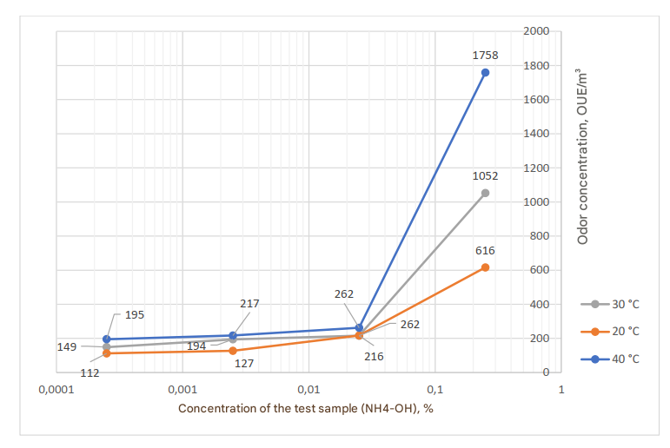
Fig. 4. Results of the dynamic olfactometry method for determining water odour

The results (Fig. 4) show that when the analysed water sample is exposed to higher temperatures, more odour units are released into the environment. When the temperature of the analysed sample increased by 10°C within the 20–50°C range, the odour emitted by solutions with higher ammonia concentrations increased by approximately 50 OUE/m³.
Determination of ammonia vapor concentration in air
After calculating the total nitrogen concentration in the analysed water sample and the volume of air that passed through it, the nitrogen concentration in the air was determined and converted to ammonia vapor concentration (mg/m³). The tests were performed at 20, 30, and 40°C, and the results are presented in Table 4.
Table 4. Summarised results of ammonia water (NH₄OH) concentration and ammonia (NH₃) concentration in air
Temperature, °C | Concentration of the test sample (NH₄OH), % | Concentration of the test  sample (NH₄OH) in water, mg/L | Concentration of ammonia  in air, mg/m³
20 | 0.25 | 276.96 | 18.029
20 | 0.025 | 58.82 | 3.829
20 | 0.0025 | 11.78 | 0.767
20 | 0.00025 | 3.25 | 0.211
30 | 0.25 | 451.34 | 30.425
30 | 0.025 | 92.04 | 6.205
30 | 0.0025 | 11.66 | 0.787
30 | 0.00025 | 3.58 | 0.242
40 | 0.25 | 508.63 | 35.387
40 | 0.025 | 92.39 | 6.428
40 | 0.0025 | 12.751 | 0.871
40 | 0.00025 | 3.803 | 0.265

Based on the experimental results presented in Table 4, comparative graphs (Fig. 5–7) were prepared to illustrate the relationships between the concentration of ammonia water (NH₄OH) and ammonia (NH₃) vapours in the air at different concentrations of the analysed ammonia‑containing samples. When comparing the study results with the Lithuanian hygiene standard HN 24:2023, it was determined that the lowest concentrations of the tested samples (NH₄OH) in water were 6.5 times higher than the permissible limit for drinking water (0.5 mg/L).
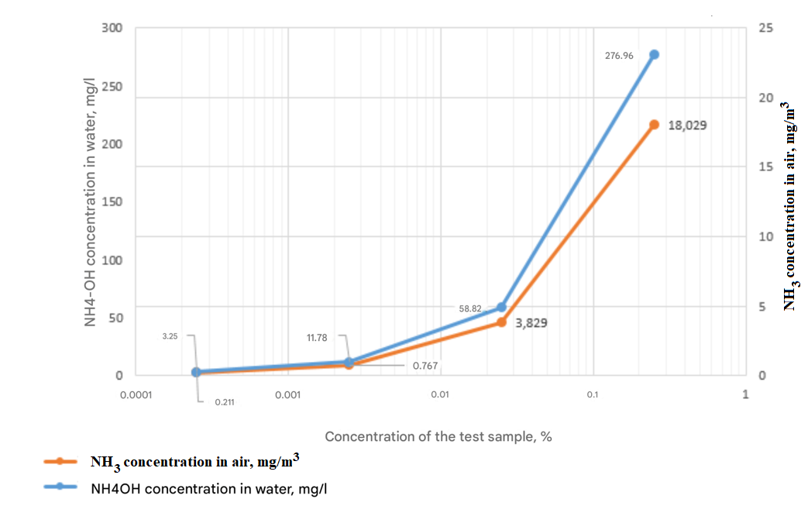
Fig. 5. Dependence of NH₄OH concentration in water and ammonia vapor concentration in air at 20°C

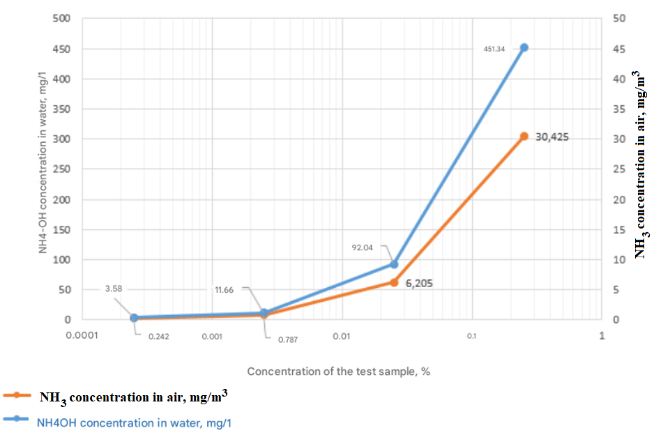
Fig. 6. Dependence of NH₄OH concentration in water and ammonia vapor concentration in air at 30°C

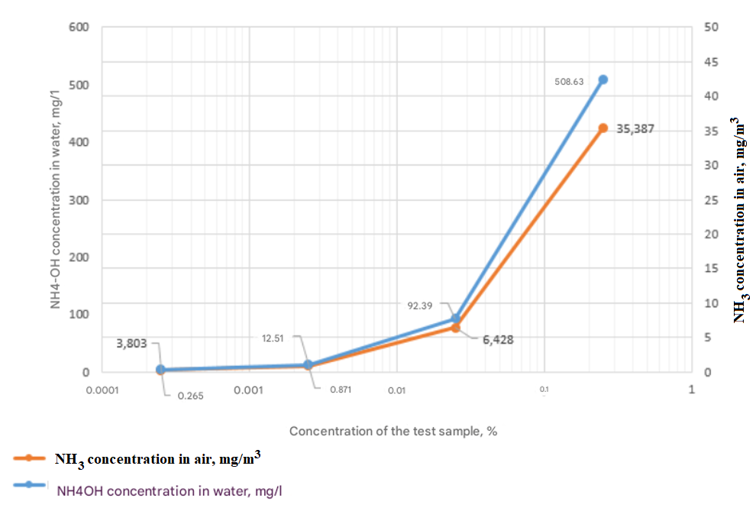
Fig. 7. Dependence of NH₄OH concentration in water and ammonia vapor concentration in air at 40°C

Fig. 5–7 show that, regardless of the sample temperature, the shapes of the variation curves for both the NH₄OH concentration in water and the NH₃ vapor concentration in air are very similar. This indicates that the increase in ammonia concentration in water is directly reflected in the amount of ammonia volatilising into the air, independent of temperature, although higher temperatures intensify the overall evaporation rate.
Correlation results of the analysed parameters
The experimental results were used to determine the relationships between several key parameters:
- solution temperature,
- odour threshold,
- ammonia vapor concentration in air,
- odour concentration in air,
- ammonia water concentration in the solution.

Tables 5–8 present the correlation coefficients for all analysed parameters at different ammonia concentrations in the water samples. The correlations are shown for solutions containing 0.25%, 0.025%, 0.0025%, and 0.00025% NH₄OH, respectively.

Table 5. Correlation between parameters when the analysed solution contains 0.25% ammonia water (NH₄OH)
 | Odour  threshold | Odour concentration in air, OUE/m³ | Substance concentration in solution (Nb), mg/L | NH₃ concentration  in air, mg/m³ | Temperature, °C
Odour threshold |  | 0.982 | 0.973 | 0.982 | 0.999
Odour concentration in air, OUE/m³ | 0.982 |  | 0.913 | 0.929 | 0.990
Substance concentration in solution (Nb), mg/L | 0.973 | 0.913 |  | 0.999 | 0.959
NH₃ concentration in air, mg/m³ | 0.982 | 0.929 | 0.999 |  | 0.970
Temperature, °C | 0.999 | 0.990 | 0.959 | 0.970

These correlation calculations showed how odour concentration depends on solution temperature, odour threshold, ammonia vapor concentration, ammonia water concentration in the solution, and odour concentration in air when using a 0.25% ammonia water (NH₄OH) solution. After calculating the Pearson correlation coefficients, all values were close to unity, indicating a very strong linear relationship (r ≥ 0.913).
The results of this study were compared with those of a 2018 investigation conducted by researchers at the Malaysian Sains University, which analysed correlations between water pH, chlorine content, odour threshold, and odour concentration in surface water bodies (Yusoff, 2019). Their study reported a high Pearson correlation coefficient (r = 0.833), indicating a strong relationship between odour threshold and odour concentration.
When comparing the findings of both studies, a similarly strong correlation was observed. In this work, isolating the dependence between odour concentration in air and odour threshold for a 0.25% ammonia water solution yielded a Pearson correlation coefficient of r = 0.982.

Table 6. Correlation between parameters when the analysed solution contains 0.025% ammonia water (NH₄OH)
 | Odour  threshold | Odour concentration in air, OUE/m³ | Substance concentration in solution (Nb), mg/L | NH₃ concentration  in air, mg/m³ | Temperature, °C
Odour threshold |  | 0.838 | 0.895 | 0.982 | 0.999
Odour concentration in air, OUE/m³ | 0.838 |  | 0.507 | 0.565 | 0.938
Substance concentration in solution (Nb), mg/L | 0.895 | 0.507 |  | 0.997 | 0.969
NH₃ concentration in air, mg/m³ | 0.982 | 0.565 | 0.997 |  | 0.977
Temperature, °C | 0.999 | 0.938 | 0.969 | 0.977

These correlation calculations showed how odour concentration depends on solution temperature, odour threshold, ammonia vapor concentration, ammonia water concentration in the solution, and odour concentration in air when using a 0.025% ammonia water (NH₄OH) solution. The Pearson correlation analysis revealed several distinct patterns in the strength of these relationships.
Strength of correlations at 0.025% NH₄OH
Two parameter pairs showed only moderate correlations:
NH₄OH concentration in solution (mg/L) vs. odour concentration in air (OUE/m³) — r = 0.507.
This moderate relationship may be influenced by the relatively high uncertainty of dynamic olfactometry measurements, where dilution‑related errors can reach ±40%, reducing the precision of odour concentration estimates.
NH₃ concentration in air (mg/m³) vs. odour concentration in air (OUE/m³) — r = 0.565.
This similarly moderate correlation is likely affected by the same methodological limitations of dynamic olfactometry, especially at low odour intensities.
Strong correlations among other parameters
All remaining Pearson correlation coefficients ranged from 0.838 to 0.999. indicating strong linear relationships between most of the analysed variables. These results show that, despite measurement uncertainties, the system behaves predictably across changes in temperature and concentration.
Comparison with international research
When isolating the relationship between odour concentration in air and odour threshold for the 0.025% NH₄OH solution, the Pearson correlation coefficient was r = 0.838. This value closely matches the correlation reported by researchers at the Malaysian Sains University in 2018 (r = 0.833) when analysing odour threshold and odour concentration in surface water bodies (Yusoff, 2019). The close agreement between the two studies suggests that odour threshold and odour concentration are consistently and strongly linked, that the relationship holds across different odour sources and environmental conditions, and that the methods used for odour threshold and odour concentration determination are mutually supportive and scientifically robust.

Table 7. Correlation between parameters, when the analysed solution contains 0.0025% ammonia water (NH₄OH)
 | Odour  threshold | Odour concentration in air, OUE/m³ | Substance concentration in solution (Nb), mg/L | NH₃ concentration  in air, mg/m³ | Temperature, °C
Odour threshold |  | 0.975 | 0.759 | 0.923 | 0.999
Odour concentration in air, OUE/m³ | 0.975 |  | 0.598 | 0.815 | 0.962
Substance concentration in solution (Nb), mg/L | 0.759 | 0.598 |  | 0.951 | 0.793
NH₃ concentration in air, mg/m³ | 0.923 | 0.815 | 0.951 |  | 0.942
Temperature, °C | 0.999 | 0.962 | 0.793 | 0.942

These correlation calculations showed how odour concentration depends on solution temperature, odour threshold, ammonia vapor concentration, ammonia water concentration in the solution, and odour concentration in air when using a 0.0025% ammonia water (NH₄OH) solution. The results reveal both moderate and strong linear relationships among the analysed parameters.
Correlation strength at 0.0025% NH₄OH A moderate correlation was found between:
NH₄OH concentration in solution (mg/L) and odour concentration in air (OUE/m³) — r = 0.598.
This moderate relationship is likely influenced by the relatively high uncertainty of dynamic olfactometry measurements, where dilution‑related errors can reach ±40%, reducing the precision of odour concentration estimates.
Strong correlations among remaining parameters
All other Pearson correlation coefficients ranged from 0.759 to 0.999. indicating strong linear dependencies between most of the analysed variables. These strong correlations show that even at very low ammonia concentrations, the relationships between temperature, odour threshold, ammonia volatilisation, and odour concentration remain consistent and predictable.
Comparison with international research
When isolating the relationship between odour concentration in air and odour threshold for the 0.0025% NH₄OH solution (dilution factor 10 000), the Pearson correlation coefficient was r = 0.975. This value closely aligns with the correlation reported by researchers at the Malaysian Sains University in 2018 (r = 0.833) when analysing odour threshold and odour concentration in surface water bodies (Yusoff, 2019).
The close agreement between the two studies suggests that:
Odour threshold and odour concentration are strongly and consistently linked; this relationship holds across different odour sources and concentration ranges. The methods used for odour threshold and odour concentration determination are mutually reinforcing and scientifically reliable.

Table 8. Correlation between parameters, when the analysed solution contains 0.00025% ammonia water (NH₄OH)
 | Odour  threshold | Odour  concentration  in air, OUE/m³ | Substance concentration in solution (Nb), mg/L | NH₃ concentration  in air, mg/m³ | Temperature, °C
Odour threshold |  | 0.993 | 0.998 | 0.999 | 0.999
Odour concentration in air, OUE/m³ | 0.993 |  | 0.984 | 0.989 | 0.998
Substance concentration in solution (Nb), mg/L | 0.998 | 0.984 |  | 0.984 | 0.993
NH₃ concentration in air, mg/m³ | 0.999 | 0.989 | 0.984 |  | 0.996
Temperature, °C | 0.999 | 0.998 | 0.993 | 0.996

The dependences of odour concentration on solution temperature, odour threshold, ammonia vapor concentration, ammonia water concentration in the solution, and odour concentration in air were determined using a 0.00025% ammonia water (NH₄OH) solution. After calculating the Pearson correlation coefficients, all obtained values were close to unity, indicating a very strong linear dependence (r ≥ 0.984).
By isolating the relationship between odour concentration in air and odour threshold for the 0.00025% ammonia water solution, a Pearson correlation coefficient of r = 0.993 was obtained. When compared with the correlation results reported by researchers at the Malaysian Sains University in 2018 (r = 0.833), the results can be considered closely aligned (Yusoff, 2019).
4. Conclusions
- A method was developed to determine the odour concentration (OUE/m³) emitted into the air by water contaminated with different concentrations of ammonia water. The dependence of odour concentration on solution temperature, odour threshold, ammonia vapour concentration, and ammonia water concentration in the solution was investigated.
- Using the dynamic olfactometry method, the odour concentration in air was determined at different temperatures of ammonia water. As the temperature of the aqueous solution increased, the odour concentration in air also increased: at 20°C the odour concentration was 616 OUE/m³; at 30°C it increased to 1052 OUE/m³; and at 40°C it reached 1758 OUE/m³.
- It was found that the Threshold Odour Number increases with increasing solution temperature: at 20°C, the odour threshold was 59 units; at 30°C, it increased to 118 units; and at 40°C and 60°C, it reached 167 and 283 units, respectively. Increasing the sample temperature from 20°C to 30°C doubled the odour threshold; increasing from 30°C to 40°C raised it by a factor of 1.4; and increasing from 40°C to 60°C raised it by a factor of 1.7.
- The dependence of odour concentration on solution temperature, odour threshold, ammonia vapor concentration, odour concentration in air, and ammonia water concentration in the solution was analysed. For samples containing 0.25% ammonia water (NH₄OH), the Pearson correlation coefficients were close to unity (r ≥ 0.913), indicating very strong linear relationships. For solutions with lower ammonia concentrations, the correlation coefficients ranged from moderate to strong (r = 0.598 to r ≥ 0.984).
- Knowing the odour emission flow (Specific Odour Emission Rate, SOER) (OUE/m²/s) and the surface area of the odour‑emitting object (e.g., a water body, m²), it is possible to calculate the total odour emission flow (OUE/s) from the source. With these parameters, odour dispersion in ambient air can be modelled.

References
Adams, H., Burlingame, G., Ikehata, K., Furatian, L., & Suffet, I.H. (2022). The effect of pH on taste and odor production and control of drinking water. AQUA—Water Infrastructure, Ecosystems and Society, 71(11), 1278–1290. https://doi.org/10.2166/aqua.2022.133
Antonopoulou, M., Ioannidis, N., Kaloudis, T., Triantis, T.M., & Hiskia, A. (2020). Kinetic and mechanistic investigation of water taste and odor compound 2‑isopropyl‑3‑methoxy‑pyrazine degradation using UV‑A/chlorine process. Science of the Total Environment, 732, 138404. https://doi.org/10.1016/j.scitotenv.2020.138404
Bartram, J., & Ballance, R. (1996). Water quality monitoring: A practical guide to the design and implementation of freshwater quality studies and monitoring programmes. CRC Press. https://doi.org/10.4324/9780203476796
Brattoli, M., De Gennaro, G., De Pinto, V., Demarinis Loiotile, A., Lovascio, S., & Penza, M. (2011). Odour detection methods: Olfactometry and chemical sensors. Sensors, 11(5), 5290–5322. https://doi.org/10.3390/s110505290
Bruchet, A. (2019). Chemical analytical techniques for taste and odour compounds. In T.F. Lin, S. Watson, A.M. Dietrich, & I.H. Suffet (Eds.), Taste and odour in source and drinking water (pp. 113–142). IWA Publishing. https://doi.org/10.2166/9781780406664
Dey, S., Haripavan, N., Basha, S.R., & Babu, G.V. (2021). Removal of ammonia and nitrates from contaminated water by using solid waste bio‑adsorbents. Current Research in Chemical Biology, 1, 100005. https://doi.org/10.1016/j.crchbi.2021.100005
Dietrich, A.M., & Burlingame, G.A. (2020). A review: The challenge, consensus, and confusion of describing odors and tastes in drinking water. Science of the Total Environment, 713, 135061.
https://doi.org/10.1016/j.jclepro.2019.01.261
Dos Santos, P.R., & Daniel, L.A. (2020). A review: Organic matter and ammonia removal by biological activated carbon filtration for water and wastewater treatment. International Journal of Environmental Science and Technology, 17(1), 591–606. https://doi.org/10.1007/s13762-019-02567-1
HN 24:2023. (2023). Geriamojo vandens saugos ir kokybės reikalavimai [Drinking water safety and quality requirements in Lithuanian]. Valstybės žinios, (Official Gazette) 79‑3606.
https://www.e-tar.lt/portal/lt/legalAct/604e9f00a1f811ed8df094f359a60216?csrt=10255604409864422327
Kalweit, C., Stottmeister, E., & Rapp, T. (2019). Contaminants migrating from cross‑linked polyethylene pipes and their effect on drinking water odour. Water Research, 161, 341–353. https://doi.org/10.1016/j.watres.2019.06.001
Mačiūnas, E., Bakasėnas, V., Karalienė, V., Maciūnienė, R., Ptašekas, J., & Juozulynas, A. (2011). Kvapai kaip gyvenimo kokybės ir visuomenės sveikatos rizikos veiksniai [Odors as quality of life and public health risk factors in Lithuanian]. Sveikatos mokslai (Health Sciences), 21(2), 37–42.
https://sm-hs.eu/wp-content/uploads/2019/02/18-89-1-PB.pdf
Pawnuk, M., Szulczyński, B., den Boer, E., & Sówka, I. (2022). Preliminary analysis of the state of municipal waste management technology in Poland along with the identification of waste treatment processes in terms of odor emissions. Archives of Environmental Protection, 48(3), 3–20. https://doi.org/10.24425/aep.2022.142685
Piekarski, J., Dąbrowski, T., Dąbrowski, J., & Ignatowicz, K. (2021). Preliminary studies on odor removal in the adsorption process on biochars produced from sewage sludge and beekeeping waste. Archives of Environmental Protection, 47(2), 20–28. https://doi.org/10.24425/aep.2021.137275
Pochiraju, S.S., Hoppe‑Jones, C., Adams, C., & Weinrich, L. (2021). Development and optimisation of analytical methods for the detection of 18 taste and odor compounds in drinking water utilities. Water Research X, 11, 100099. https://doi.org/10.1016/j.wroa.2021.100099
Popova, A., Rattanakom, R., Yu, Z.Q., Li, Z., Nakagawa, K., & Fujioka, T. (2023). Evaluating the potential of nanofiltration membranes for removing ammonium, nitrate, and nitrite in drinking water sources. Water Research, 244, 120484. https://doi.org/10.1016/j.watres.2023.120484
Rohani, R., Yusoff, I.I., Zaman, N.K., Ali, A.M., Rusli, N.A.B., Tajau, R., & Basiron, S.A. (2021). Ammonia removal from raw water by using adsorptive membrane filtration process. Separation and Purification Technology, 270, 118757. https://doi.org/10.1016/j.seppur.2021.118757
Ruiz Beviá, F., & Fernández Torres, M.J. (2019). Effective catalytic removal of nitrates from drinking water: An unresolved problem? Journal of Cleaner Production, 217, 398–408. https://doi.org/10.1016/j.jclepro.2019.01.261
Schiffman, S.S., Walker, J.M., Dalton, P., Loring, T.S., Raymer, J.H., Shusterman, D., & Williams, C.M. (2000). Potential health effects of odor from animal operations, wastewater treatment, and recycling of bioproducts. Journal of Agromedicine, 7(1), 7–81. https://doi.org/10.1300/J096v07n01_02
Schullehner, J., Stayner, L., & Hansen, B. (2017). Nitrate, nitrite, and ammonium variability in drinking water distribution systems. International Journal of Environmental Research and Public Health, 14(3), 276. https://doi.org/10.3390/ijerph14030276
Tabassum, S. (2019). A combined treatment method of novel mass bio system and ion exchange for the removal of ammonia nitrogen from micro‑polluted water bodies. Chemical Engineering Journal, 378, 122217. https://doi.org/10.1016/j.cej.2019.122217
Trojanuv. (2018). Taste and odor compounds in drinking water. https://www.resources.trojanuv.com/taste-and-odor
Wiśniewska, M., Kulig, A., & Lelicińska‑Serafin, K. (2020). Olfactometric testing as a method for assessing odour nuisance of biogas plants processing municipal waste. Archives of Environmental Protection, 46(3), 60–68. https://doi.org/10.24425/aep.2020.134536
Xue, R., Donovan, A., Zhang, H., Ma, Y., Adams, C., Yang, J., Hua, B., Inniss, E., Eichholz, T., & Shi, H. (2018). Simultaneous removal of ammonia and N‑nitrosamine precursors from high‑ammonia water by zeolite and powdered activated carbon. Journal of Environmental Sciences, 64, 82–91. https://doi.org/10.1016/j.jes.2017.02.010
Yusoff, S. (2019). Measurement of odour on source of drinking water using threshold odour number and modified olfactometry. International Journal of Integrated Engineering, 11(1), 147–157. https://doi.org/10.30880/ijie.2019.11.01.016
Zhang, W. (2008). Preventive control of ammonia and odor emissions during the active phase of poultry manure composting (p. 241). https://doi.org/10.14288/1.0058524
Zheng, B., Fu, Q., Zhao, X., Wang, L., & Liu, C. (2012). Ammonia pollution characteristics of centralised drinking water sources in China. Journal of Environmental Sciences, 24(10), 1739–1743.
https://doi.org/10.1016/S1001-0742(11)61011-5

