
 | Rocznik Ochrona Środowiska
 | Volume 28 | Year 2026 ISSN 2720-7501 | pp. 196-211
 | https://doi.org/10.54740/ros.2026.015 open access
 | Received: December 2025 Accepted: April 2026 Published: April 2026
Integrating the National Transport Model into High-Speed Rail Planning and Development Processes in Romania
Ioana-Alexandra Mirea^{1*}, Cosmin Păunescu², Alexandru Giurea³, Răzvan Cristian Muntean⁴, Robert Răzvan Dobre⁵, Alexandru Nedelea⁶
¹Faculty of Geography, University of Bucharest
https://orcid.org/0000-0002-1648-7832
²Faculty of Geography, University of Bucharest, Romanian Government – Ministry of Transport and Infrastructure https://orcid.org/0000-0001-9769-8756
³Faculty of Geography, University of Bucharest, Romanian Government – Ministry of Transport and Infrastructure https://orcid.org/0000-0002-6267-2967
⁴Faculty of Geography, University of Bucharest
https://orcid.org/0009-0000-6114-695X
⁵Faculty of Geography, University of Bucharest, Romanian Government – Ministry of Transport and Infrastructure https://orcid.org/0000-0002-0590-1700
⁶Faculty of Geography, University of Bucharest
https://orcid.org/0000-0002-6373-818X
*corresponding author's e-mail: ioana.alexandra-mirea@geo.unibuc.ro
Abstract: This paper examines the need for high-speed rail (HSR) in Romania by analyzing its economic, social, and environmental benefits. HSR has become an important part of modern transportation in Europe, and its introduction in Romania would not only improve domestic travel but also strengthen the country's connection to the wider European transport network. A well-developed HSR system would enhance cross-border mobility, support trade, attract investment, and contribute to a more efficient and sustainable transport system. To identify the best route alternatives, this study uses the National Transport Model, applying different scenarios based on traffic flows and demographic factors. The analysis also considers the natural terrain to ensure that proposed routes follow the most suitable geographical conditions. Beyond the clear advantage of reducing travel times between major cities, HSR could play a key role in regional development by reducing economic differences and encouraging more balanced growth across Romania. By aligning with European transport policies, the development of high-speed rail in Romania would be a major step toward modernizing infrastructure and improving the country's role in Europe's transport network. The objective of this study is to integrate Romania's National Transport Model with a land suitability analysis to identify the most suitable high-speed rail corridors and to evaluate their transport demand potential.
Keywords: high-speed rail, transport, geography, urban development, transport modelling
1. Introduction
The development of a high-speed rail (HSR) network in Romania presents an ambitious opportunity to reshape national transport infrastructure while aligning with European and global sustainability goals. Such a transformative project requires comprehensive planning that integrates multimodal transport systems, addresses ecological impacts, and incorporates modern urban planning principles. By examining current multimodal transport frameworks and the challenges of high-speed rail, we can explore how HSR could be integrated into Romania's existing transport models. The advantages of a city's location are less about the physical distance between places and more about how well it is connected to networks (Dupuy, 1995). From this viewpoint, two key factors are particularly important for large intermediate cities at the national level: first, the degree to which HSR enhances their connections to major metropolises; and second, the ability of HSR to attract inter-metropolitan travelers who previously did not pass through these cities (Ureña et al., 2009).
Therefore, the main objective of this research is to develop an integrated methodological framework combining the National Transport Model with land suitability analysis to identify, compare, and evaluate optimal high-speed rail route alternatives in Romania.
Recent advancements in multimodal transport highlight the importance of seamlessly integrating various transportation modes, offering greater efficiency, convenience, and reduced environmental impact. The concept of Mobility as a Service (MaaS) is pivotal here, emphasizing the unification of public transport services through digital platforms to enhance accessibility and optimize travel choices (Ejdys et al., 2024).
Mobility as a Service (MaaS) is rapidly reshaping travel behavior by integrating various transport modes, enabling easier access through sharing-economy concepts. To manage this evolving system, a holistic transport network model is required. This paper introduces a MaaS-based activity travel pattern (ATP) generator that facilitates ridesharing by enabling drivers and passengers to share their activity schedules. The model extends MaaS beyond just an intermodal trip planner, incorporating factors such as activity choices, time, and mode transitions. It also integrates dynamic ridesharing with MaaS, bridging gaps between ATP planning and rideshare models, and demonstrates how MaaS can improve ridesharing system performance. Integrating MaaS with digital ticketing and HSR platforms enhances the usability and convenience of high-speed rail services by providing seamless multimodal travel options for users (Najmi et al., 2020).
Recent studies emphasize the importance of integrating national-scale transport models with infrastructure planning tools to support evidence-based decision-making. The work of Dyczkowska et al. (2023) demonstrates how computational modeling and scenario-based simulations can enhance the evaluation of large transport projects, providing methodological insights relevant to the Romanian context.
However, introducing HSR is not without its challenges. One significant issue is the environmental impact of new rail infrastructure, including habitat fragmentation and wildlife collisions, as evidenced in other regions (Iwiński et al., 2019).
In Romania, careful ecological assessments will be necessary to mitigate these impacts while maintaining efficient HSR routes. Strategies such as constructing wildlife passages and integrating eco-friendly rail designs have proven effective in mitigating these concerns (Iwiński et al., 2019). Furthermore, urban and spatial planning must account for the acoustic and infrastructural effects of HSR. Studies from other countries underscore the importance of noise management strategies and careful land-use planning near railway corridors to balance development with environmental and societal concerns. For Romania, incorporating such practices could ensure that HSR not only enhances mobility but also supports sustainable urban development and preserves the quality of life for nearby communities (Podawca & Staniszewski, 2019). By embedding HSR development within a multimodal, ecologically conscious transport model, Romania can create a cohesive, forward-looking transport infrastructure that meets both local and international demands. This article examines these critical factors in detail and proposes a framework for integrating HSR into Romania's national transport model.
High-speed rail (HSR) significantly impacts cities by fostering economic growth through improved connectivity, attracting businesses, and boosting tourism. It stimulates local economies by expanding labor-market access, boosting productivity, and encouraging investment. HSR also drives urban regeneration, increases property values, and promotes compact, transit-oriented growth. It reshapes urban hierarchies by strengthening secondary cities and reducing congestion in major ones. Socially, HSR improves mobility, making commuting easier and enhancing access to education, healthcare, and cultural amenities. Environmentally, it offers a sustainable alternative to car and air travel, reducing emissions and congestion.
Moreover, HSR influences the spatial distribution of economic activity by decentralizing growth from megacities to smaller urban areas, fostering a more balanced pattern of regional development. This spatial redistribution can stimulate growth in less developed regions, reducing regional disparities and enhancing overall economic resilience. However, implementing HSR also presents challenges. The high costs of infrastructure development and maintenance can be a financial burden for cities and governments. Additionally, there is a risk of socio-economic disparities between connected and unconnected areas, potentially widening the gap between urban centers and peripheral regions. If not well integrated with local transport systems, HSR could contribute to urban sprawl, undermining the benefits of compact city planning (Garmendia et al., 2012).
1.1. Study Area
The study area is Romania, located in Southeastern Europe. With a population of approximately 19 million (National Institute of Statistics, 2025), Romania is one of the largest countries in Central and Eastern Europe, boasting a diverse infrastructure and a rapidly growing economy. Over the past three decades (1992–2021), Romania's administrative structure has undergone significant changes, reflected in the growth of settlements across various categories, such as cities, towns, urbanized localities, and communes. This evolution underscores a shift toward improving urban mobility and accessibility, emphasizing the need for greater connectivity to transport infrastructure to support this growth. The expansion and reorganization of settlements reflect the growing demand for efficient and accessible urban transport networks to accommodate the changing dynamics of population distribution (Zotic & Alexandru, 2024). In terms of transportation, Romania has an extensive railway network covering approximately 10,628 kilometers of lines (CFR S.A, 2020), connecting cities and regions across the country (Fig. 1).
However, Romania's railway infrastructure faces numerous challenges, including aging and underfunding, which have led to suboptimal performance in terms of speed and efficiency. In recent years, discussions about implementing high-speed rail in Romania have gained increasing traction, against the backdrop of the need to modernize and improve railway transportation in the country. A high-speed rail network could provide a fast and sustainable alternative to road and air transport, reducing travel time between major cities and promoting regional development (CFR S.A, 2020).
The complementarity between Romania's high-speed rail (HSR) development and Hungary's ambitious HSR expansion plans holds significant strategic importance for enhancing regional connectivity and economic integration. By aligning with Hungary's projects, Romania could gain seamless access to Western Europe, fostering greater mobility, economic growth, and cross-border collaboration. This synergy would not only strengthen Romania's position within the Trans-European Transport Network (TEN-T) but also enhance its role as a bridge between Eastern and Western Europe.
Hungary's HSR initiatives are designed as part of the TEN-T framework and aim to connect Budapest with neighboring countries via several strategic corridors. One of the key projects involves a new high-speed line linking Budapest to Austria (Vienna) via Győr, with branches extending towards Slovakia and Czechia, connecting cities like Bratislava and Brno. Another crucial corridor connects Budapest to Croatia (Zagreb) and continues towards Ljubljana and Venice, enhancing mobility within the region. Additionally, Hungary is developing an HSR route to Serbia (Belgrade), which is part of a larger corridor linking to the Greek HSR network through Sofia or Skopje. Importantly, Hungary also envisions direct high-speed rail connectivity to Romania, facilitating efficient travel to Bucharest and Constanța on the Black Sea coast.
By integrating Romania's HSR network with these expanding Hungarian corridors, Romania would gain direct access to a comprehensive European high-speed rail system. This would significantly reduce travel times to major European cities such as Vienna and Bratislava, while also boosting economic cooperation, tourism, and trade between Eastern and Western Europe. Moreover, this enhanced connectivity would attract investments, stimulate regional development, and support the growth of urban centers along the HSR routes.
The strategic alignment of Romania's HSR plans with Hungary's network not only complements regional transport infrastructure but also reinforces the TEN-T framework's goals by promoting sustainable, high-speed mobility across Europe. By leveraging this opportunity, Romania can maximize the benefits of HSR, ensuring its long-term economic growth and international competitiveness (Rail Target, 2025).
This study introduces a novel approach to high-speed rail (HSR) planning in Romania by integrating the National Transport Model with land favorability analysis, marking the first time this methodology has been applied in the country. This innovative perspective provides a deeper understanding of how terrain influences route selection and overall transport efficiency, an area previously unexplored in Romanian transport planning. The findings highlight the strategic importance of the Constanța - București - Brașov - Sibiu - Cluj Napoca - Oradea corridor as the most suitable option for meeting national population distribution and passenger traffic demands. This proposed route aligns with the Romanian Ministry of Transport and Infrastructure's plans for a future feasibility study within the Investment Program for the Development of the Transport Infrastructure between 2021 and 2030.
More importantly, the implementation of high-speed rail (HSR) is not just about improving transport efficiency—it has far-reaching economic implications. By enhancing connectivity between regions, HSR can stimulate economic growth, increase access to labor markets, and create new business opportunities. As such, the introduction of HSR plays a critical role in driving broader economic transformation and fostering long-term, sustainable development (Vickerman, 2018).
Looking at the broader European context, valuable insights can be gained by examining successful HSR implementations in other countries. One of the most relevant examples is Spain, which stands as a model of best practices for high-speed rail development. Spain's extensive HSR network has not only revolutionized domestic travel but also delivered significant economic and tourism benefits. Moreover, it has effectively contributed to a modal shift, encouraging travelers to choose rail transport over air travel for medium-distance routes. Analyzing Spain's experience can provide valuable lessons for Romania, highlighting the potential advantages of HSR in boosting economic growth, enhancing tourism, and promoting more sustainable mobility choices.
According to the International Union of Railways (UIC), Spain has the second-largest high-speed rail (HSR) network in the world, following only China, and ranks first when considering network length relative to population size (International Union of Railways, 2025). It stands as the undisputed leader in Europe, with HSR being the cornerstone of the country's transportation development. Spain serves as an excellent case study for examining the impact of two recent transportation innovations on tourism: high-speed rail as a technological innovation and the low-cost airline model as a managerial innovation. While the focus is often on HSR's technological advancements, it is also important to consider air traffic in the analysis to gain a more comprehensive understanding of HSR's overall impact on tourism outcomes (Albalate & Fageda, 2016).
Before the introduction of the high-speed rail (HSR) system, most trips between Madrid and Barcelona, around 4.8 million in 2007, were made by air, with this route being the busiest air corridor in Europe. However, the completion of HSR between the two cities had a significant impact, as high-speed trains quickly became a viable alternative, especially for business travelers, offering comparable frequency and comfort. As a result, HSR captured nearly half of the market share on the Madrid-Barcelona route, forcing Iberia to reduce its capacity and operate smaller aircraft while maintaining flight frequency. Despite this success, the 625 km (388 mi) between the two cities is at the upper limit of what is considered competitive for HSR. Yet, it still demonstrated the system's ability to shift travel patterns from air to rail (Pagliara et al., 2012).

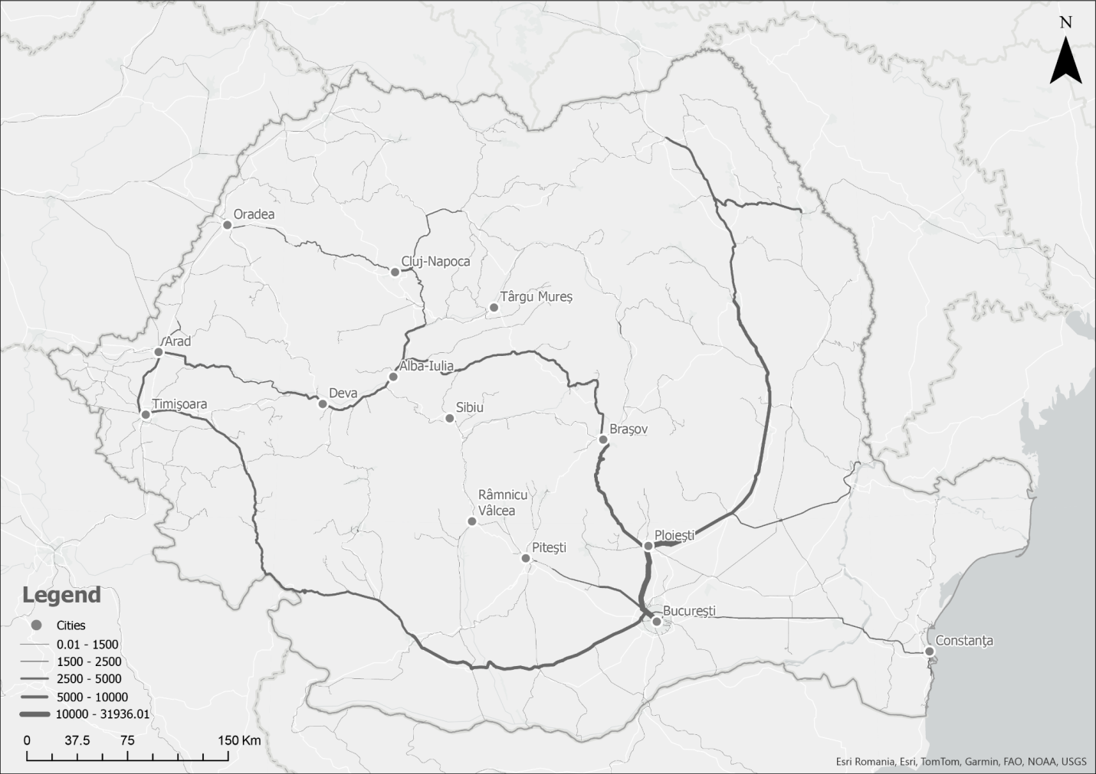
Fig. 1. Study area
2. Methods
The methodology presented in this article aims to integrate the National Transport Model into the planning and development processes for high-speed rail projects through a structured approach that encompasses two main components. The first component focuses on a multi-criteria analysis to generate a national land-favorability map to identify optimal routes and locations for high-speed rail infrastructure. The second component involves using the National Transport Model to conduct traffic modeling, providing a detailed perspective on transport demand, passenger flow distribution, and the impact on the existing network.
By combining these two methodological directions – multi-criteria analysis and traffic modeling – the study delivers an integrated approach that supports evidence-based decision-making in the planning and development stages of high-speed rail infrastructure. This methodological framework enables both a technical assessment of land potential and a simulation of operational impacts and transport demand, thus establishing a robust foundation for the sustainable and strategic development of transport projects.

2.1. Planning and Development Processes Using the Land Favorability Map
To identify favorable and restrictive areas for infrastructure construction, a multi-criteria analysis was developed and applied to aggregate natural and anthropogenic factors. Geographic Information Systems (GIS) were used for the multi-criteria analysis, utilizing both vector and raster data. The main output of the multi-criteria analysis conducted in the GIS tools is the land favorability map for high-speed rail infrastructure development (Fig. 2). This map serves as a valuable tool for identifying both restrictive and favorable areas (Păunescu et al., 2021).

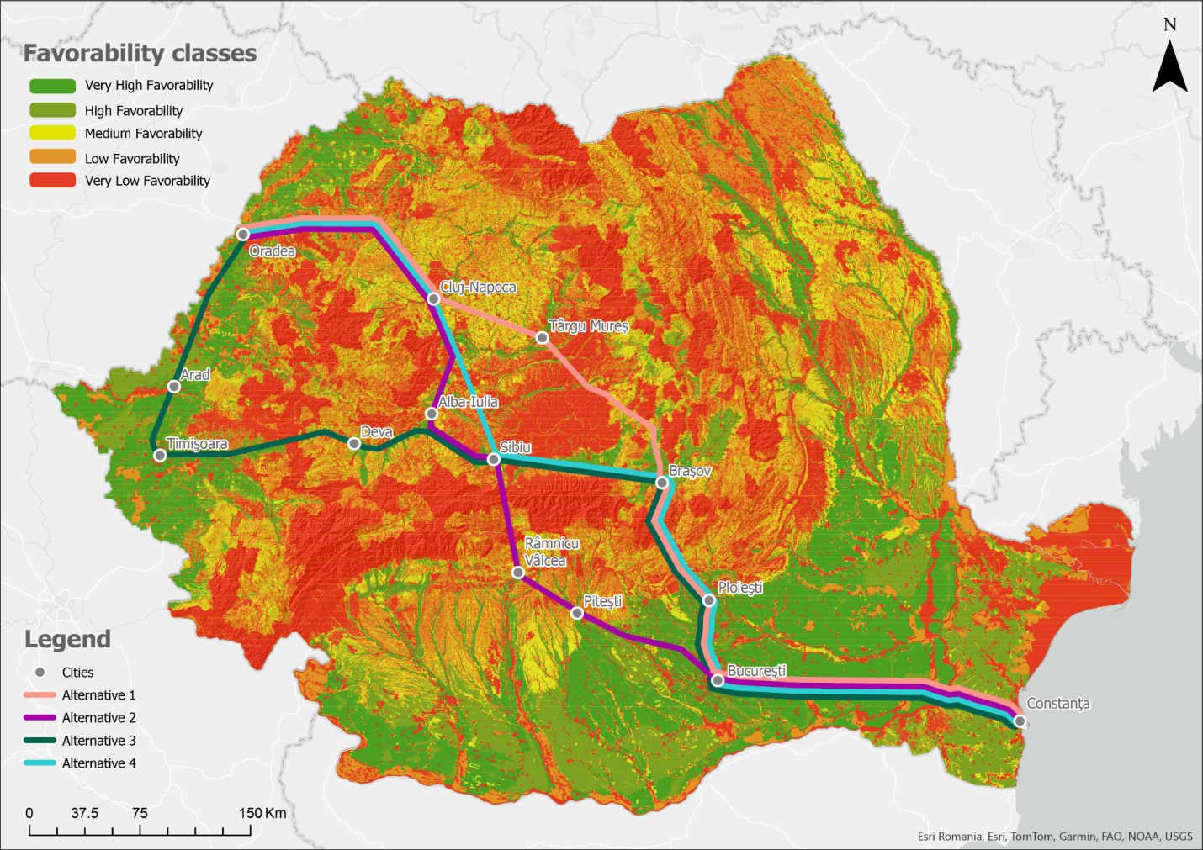
Fig. 2. Land favorability map correlated with the four proposed routes

The distribution and density of railway networks are closely linked to oro-hydrographic conditions. Mountain passes and valley corridors provide favorable routes for trans-Carpathian railway connections, while narrow valleys with steep slopes present natural constraints. Key geomorphological factors, including geological structure, slope inclination, terrain fragmentation, and relief energy, play a crucial role in railway design, operation, and management. The land's surface configuration and ongoing geomorphological processes (such as riverbed and slope dynamics) necessitate adaptations to essential infrastructure to ensure the safety and efficiency of railway transport (Dobre, 2009).
Planning future transportation routes must consider environmental factors and the necessary long-term infrastructure measures to protect and preserve natural ecosystems, even if the financial costs are substantial. Building ecoducts in areas where habitats are disrupted can provide a valuable solution, enabling wildlife to migrate safely across highways. This strategy has already been implemented by highway developers in other mountainous regions of Europe to support environmental conservation (Dobre, 2009).
The land suitability analysis plays a critical role in the initial phases of large-scale infrastructure projects, such as high-speed rail network planning. Land suitability analysis offers a robust framework for evaluating potential high-speed rail routes by systematically integrating multiple criteria that influence construction feasibility. The methodology illustrated in the diagram demonstrates how various datasets are merged to create a comprehensive suitability map. The process relies on several components:

Digital Elevation Models (DEM) and topographic maps to understand terrain elevation and gradients.
- Geological maps are used to assess soil stability, rock formations, and potential geological hazards.
- Flood zone maps to identify areas at risk of flooding, which are critical for ensuring rail network resilience.
- Land use maps and protected area maps (SCI, SPA, Natura 2000) to consider restrictions related to conservation and urban development.
- Field calibration with GPS to enhance accuracy and validate data on the ground.

The resulting suitability map categorizes land into classes ranging from very high favorability (green) to very low favorability (red). This classification provides a preliminary understanding of which regions are most appropriate for infrastructure development, serving as a powerful filter for future analyses. The integration of land suitability analysis with passenger traffic projections forms the basis for comprehensive cost-benefit assessments. By identifying which segments of each route align with favorable terrain, planners can estimate construction costs more accurately and prioritize investments accordingly. Furthermore, the suitability map enables comparison of multiple alternatives within a unified framework, simplifying decision-making and ensuring technical feasibility aligns with economic viability.
The generated map illustrates the favorability levels of existing transportation infrastructure based on land use, quantified by the degree of restriction imposed by grouped element classes. The analysis indicates high favorability in low-altitude and depression areas, whereas high-altitude regions exhibit lower suitability. This map will serve as a fundamental component in the final land suitability assessment for transportation infrastructure development (Purcăreață, 2015). The classification of favorability levels was established using expert judgment-based evaluations (Fig. 3).

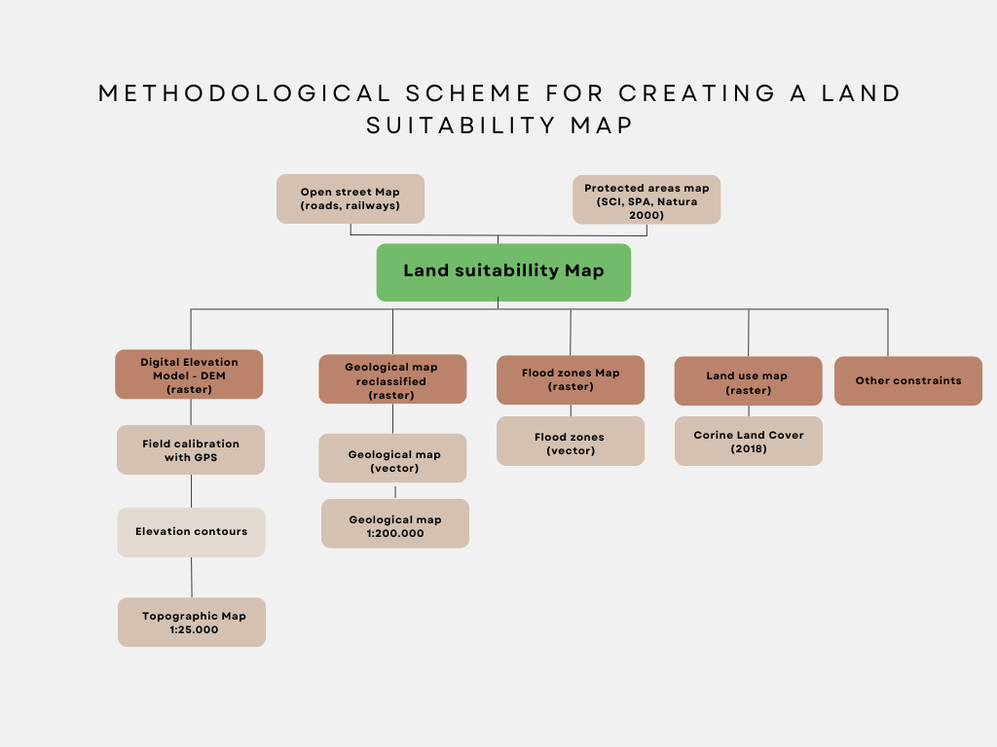
Fig. 3. Methodological flow for Land Suitability Map

2.2. Integrating National Transport Model
The transition of national transport policies from purely strategic investments to an investment and transport infrastructure management approach focused on efficiency, the environment, safety, and equitable regional development has led to the need for the development of powerful and complex analysis tools (Lundqvist & Mattsson, 2002).
The increase in interregional and international travel needs also requires forecasting tools that go beyond the urban or regional level. Thus, the framework for the large-scale implementation of national transport models, aligned at the European level, was created. A national transport model is a mathematical representation of passenger, freight, and vehicle traffic within a transport system. The primary role of a transport model is to create various analytical scenarios and generate insights resulting from societal changes. These include changes in transport policies, infrastructure, and services that affect the movement of people and goods, both at the national level and in relation to external regions. Despite national differences in infrastructure types or policies, transport models across European countries share common features, such as similar input data and adisaggregated, nested/tree-structured logit (Lundqvist & Mattsson, 2002).
Romania's National Transport Model was completed and put into operation in 2011 by the Ministry of Transport. The structure of the national transport model is based on a 4SM framework (four-step model). This type of model was first employed in the early 1950s in Chicago (McNally, 2000), further developed by Manheim in 1979, and subsequently by Florian and his team at the University of Montreal between 1979 and 1988 (Boyce & Huw, 2015).
The University of Montreal team conducted tests on Winnipeg's road and bus network, confirming that sophisticated modeling was essential for detailed simulation results. Their work contributed to the development of the first generation of the EMME software, which was later used to create Romania's National Transport Model and adopted in several countries in Europe, North America, and Australia (Florian, 1978).
The four-step transport modeling approach has evolved to include all transport modes (road, rail, maritime, air) and their multimodal nature. Unlike earlier models that focused on just one or two modes, this advancement enables comprehensive scenario simulations and policy testing. For example, Italy was the first to apply transport modeling to the railway sector, using the SAMS Decision Support System to evaluate benefits and make informed national-level investment decisions to optimize transport solutions (Lundqvist & Mattsson, 2002).
This aligns with recent advances in transport modeling, where national-scale simulation frameworks are increasingly used to assess infrastructure scenarios and optimize investment decisions (Dyczkowska et al., 2023).
Romania's National Transport Model, developed using the EMME 4 software platform, analyzes the movement of people and goods across various networks (road, rail, maritime, air) both within Romania and with external regions. The model evaluates the impact of policy changes, infrastructure developments, and new services on travel behavior and demand. It encompasses 1,169 internal zones, 140 external zones, 21,777 nodes, and 52,827 segments, addressing 18 transport modes, including passenger and freight transport.
The data entered into the National Transport Model is analyzed using specialized tools, generating traffic and environmental indicators. These outputs are then incorporated into a cost-benefit analysis process, using established methodologies. A key result of this analysis is the internal rate of return (IRR), which measures an investment's profitability and serves as an indicator of efficiency and quality for infrastructure projects.
To assess the economic efficiency of the high-speed rail connection between Constanța and Oradea, the latest version of Romania's National Transport Model was used. New railway routes, including major connections like Constanța-Bucharest-Oradea, were encoded into the model (Figs. 4 & 5). Detailed route information, such as train types, travel times, and station dwell times, was specified. The model includes 8 trains per day (4 in each direction) and supports policy evaluations for transport infrastructure planning through 2030.

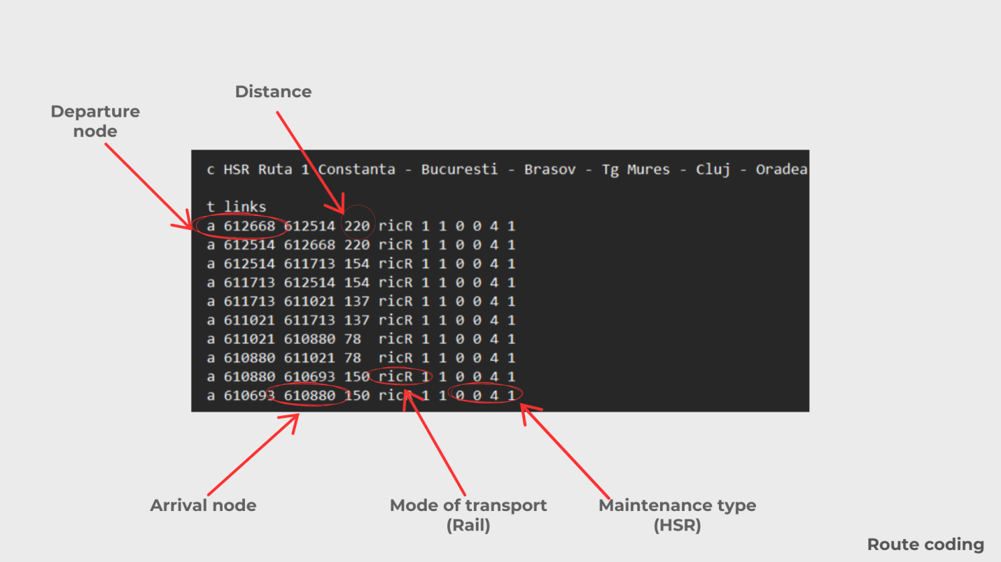
Fig. 4. Route coding

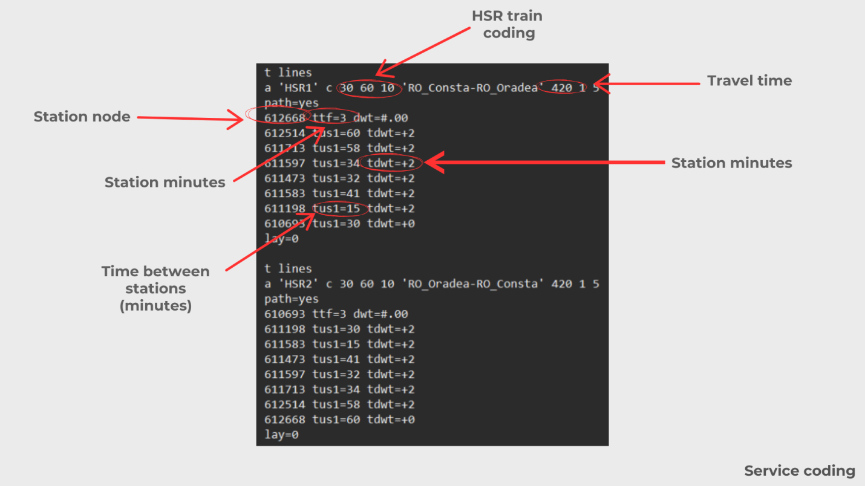
Fig. 5. Service coding
3. Results and Discussions
Romania's geographic position makes it a key transit point for rail transport between Western and Central Europe and Asia (the Middle East). Rail transport is vital to the Romanian economy, supporting trade and the exchange of raw materials. The country's transport network is connected to the European rail system, serving both passenger and freight needs. The Trans-European Transport Network (TEN-T) comprises all transport modes and is divided into a core and a comprehensive network. The core network features the EU's most important strategic and economic nodes, while the comprehensive network ensures connectivity across EU regions and supports multimodal transport services.
Modernizing the Trans-European railway infrastructure aims to improve service quality and increase train speeds on key routes. A modern, high-performance infrastructure is crucial for achieving sustainable economic growth, job creation, and improved interconnectivity within the EU's transport, telecommunications, and energy sectors, promoting the free movement of people, goods, and services (Dobre, 2016).
After encoding within the National Transport Model, the entire multimodal model was run for the Do All Scenario 2040 to analyze changes in traffic behaviors for the railway transport mode. Thus, four runs were performed, one for each scenario (Fig. 6).

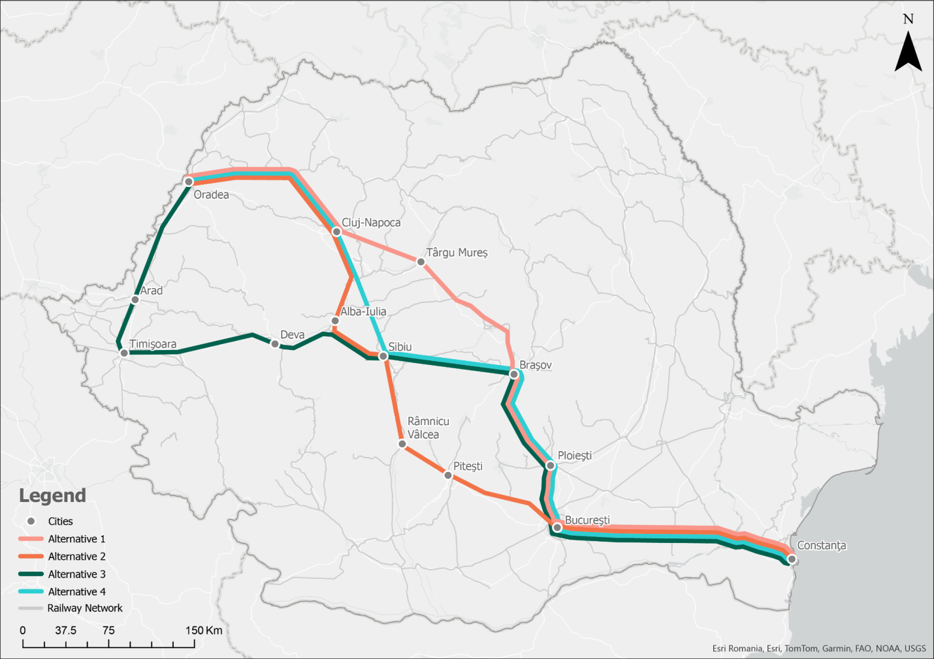
Fig. 6. Proposed alternatives

The Connecting Europe Facility (CEF) offers substantial funding for infrastructure projects that enhance connectivity within the EU, particularly in transport. For Romania, CEF provides a critical opportunity to modernize its rail infrastructure and align with high-speed networks in Western Europe. This includes upgrading rail lines to accommodate high-speed trains, improving cross-border connectivity, and enhancing interoperability with European standards. CEF funds could also support environmentally sustainable projects, such as electrification and energy efficiency, contributing to the EU's green transition goals. By securing CEF funding, Romania can enhance its transport links to Western Europe, improve regional development, and stimulate job creation while promoting the EU's broader objectives of a more integrated and sustainable transport network (European Commission, 2025).
On the other hand, there is the option of choosing an alternative that maximizes connectivity, even if it requires a larger investment. This approach would prioritize long-term economic growth, regional development, and the enhancement of Romania's position within Europe's broader transport network. Although this choice would entail higher upfront costs, it could lead to a more integrated and competitive infrastructure, ultimately driving greater economic opportunities, attracting business investments, and supporting urban and regional development across the country. Thus, the decision is a balancing act between immediate financial constraints and the long-term strategic vision for Romania's economic and infrastructural growth.
The National Company of Railway Infrastructure (CFR S.A.) is currently implementing several railway rehabilitation projects on key sections of major corridors, such as the Pan-European Corridor IV and the Orient/East-Mediterranean Corridor. These initiatives play a critical role in advancing Romania's rail transport infrastructure and facilitating a shift from polluting road transport to environmentally friendly rail. These projects are funded by non-reimbursable European grants that support the country's transition to a more sustainable and efficient transport network (CFR S.A., 2025).
The four alternatives for Romania's high-speed rail (HSR) network appear to be analyzed from the perspectives of traffic flows and network feasibility (Fig. 7). The choice of an alternative depends largely on Romania's economic priorities and development goals. On one hand, there may be a preference for a solution that is both accessible and efficient, focusing on minimizing costs while providing a practical transport option for the country. Such a solution could prioritize short-term economic benefits, ensuring the investment stays within budget while still improving connectivity to key regions.

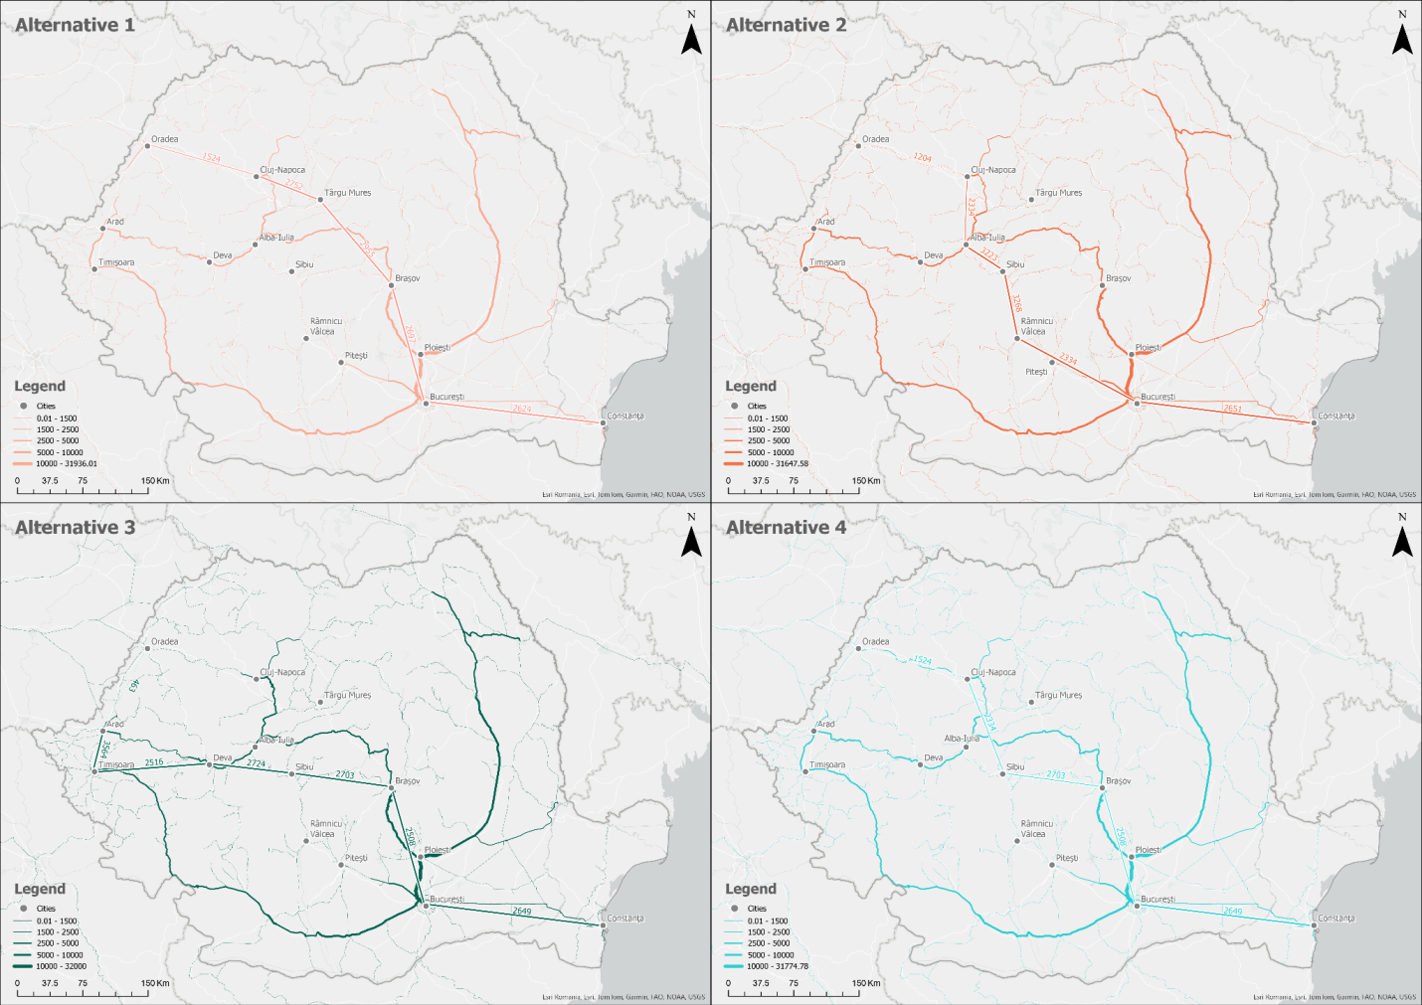
Fig. 7. Proposed alternatives

Thus, the first route for which the coding was carried out follows the Constanța-Oradea on the route: Constanța - Bucharest - Brașov - Târgu Mureș - Cluj Napoca - Oradea. The chosen route serves a total of 2.9 million inhabitants, to which is added the population from the metropolitan areas of the chosen centers that would have access to high-speed train services (Tab. 1).

Table 1. Average daily passengers for Alternative 1: Constanța - București - Brașov - Târgu Mureș - Cluj Napoca - Oradea
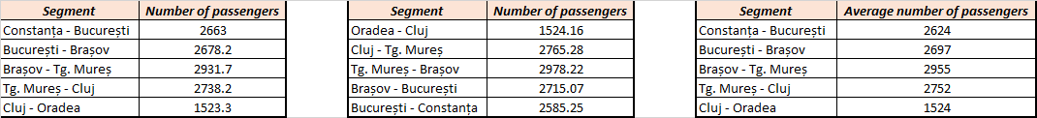

The highest transit is recorded on the sectors between Brașov-Târgu Mureș (2,955 passengers) and Târgu Mureș-Cluj (2,752 passengers). This indicates a higher demand for rail transport in the central region of the country, particularly between these cities.

Least congested segment: The Cluj-Oradea route has the lowest average daily passenger count (1,524 passengers/day). This could either indicate lower travel demand between these cities or weaker connectivity compared to the other segments. Bucharest, as the main urban center, has moderate passenger flow on the Constanța-Bucharest (2,624 passengers) and Bucharest-Brașov (2,697 passengers) segments. This reflects the capital's importance as a transport hub, while also showing that the northern and central regions (Brașov, Târgu Mureș, Cluj) generate even higher traffic.
Therefore, the central segments of the proposed route are the most popular, indicating a greater demand for high-speed rail transport in this area. This suggests the need for additional investments in transport infrastructure to meet the high passenger demand in these regions. It is also important to note that rail transport is currently not possible, as there is no infrastructure to serve this area.
The second route analyzed follows the path Constanța - Bucharest - Râmnicu Vâlcea - Sibiu - Alba Iulia
- Cluj Napoca - Oradea. This route serves a total population of 2.8 million people, along with the population from the metropolitan areas of the selected centers, who would also have access to high-speed rail services (Tab. 2).

Table 2. Average daily passengers for Alternative 2: Constanța - București - Râmnicu Vâlcea - Sibiu - Alba Iulia - Cluj Napoca - Oradea
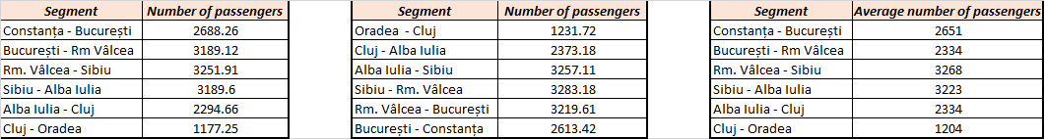

Segment with the most passengers: The Râmnicu Vâlcea-Sibiu route records the highest passenger volume, with 3,268 travelers per day. This indicates a high demand for high-speed transport on this route, suggesting potential economic or tourist significance between these two cities.
Segment with the fewest passengers: The Cluj-Oradea route has the fewest passengers (1,204 per day). This suggests either low demand for transport between these cities or a less favorable alternative for travelers than other transportation options.
Balanced flow in central and southern regions: The routes Constanța-Bucharest, Bucharest-Râmnicu Vâlcea, and Alba Iulia-Cluj show similar values, around 2,330-2,650 passengers per day, suggesting moderate and consistent passenger flow in these regions. Bucharest and Cluj remain important transport hubs, but the highest demand appears to be concentrated on the Râmnicu Vâlcea-Sibiu and Sibiu-Alba Iulia segments.
High importance in the central area: Segments in the central region of Romania (between Sibiu and Alba Iulia) are in high demand, indicating a high passenger flow in this area, similar to the first table analyzed.
Therefore, the central and southern regions appear to have significant demand for high-speed transport, with a peak on the Râmnicu Vâlcea-Sibiu route. The lower flow on the Cluj-Oradea route suggests either low demand or the need for improvements to attract more passengers.
The third route analyzed follows the path Constanța - Bucharest - Brașov - Sibiu - Deva - Timișoara - Arad - Oradea. The chosen route serves a total of 3 million inhabitants, plus the population from the metropolitan areas of the selected centers that would have access to high-speed train services (Tab. 3).

Table 3. Average daily passengers for Alternative 3: Constanța - București - Brașov - Sibiu - Deva - Timișoara
- Arad - Oradea
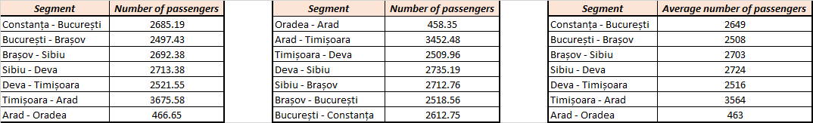

Segment with the most passengers: the Timișoara-Arad route has the highest average daily passenger count, with 3,564 travelers. This indicates extremely high demand in this segment, likely due to the geographical proximity and strong economic or commercial ties between the two cities in western Romania. Implementing a high-speed transport system connecting these urban centers would significantly boost local economies and expand the potential workforce pool.
Segment with the fewest passengers: the Arad-Oradea segment is the least used, with only 463 passengers per day, suggesting very low demand for high-speed transport on this route. This discrepancy could be influenced by factors such as distance, population density, and the availability of alternative transportation.
Central and southern segments: Routes in the central and southern areas (Constanța-Bucharest, Bucharest-Brașov, Brașov-Sibiu, Sibiu-Deva) have consistent passenger volumes, averaging 2,500 to 2,700 passengers per day. This reflects stable, consistent demand for high-speed transport in these regions, indicating frequently used routes connecting important urban and economic centers.
Therefore, the Timișoara-Arad segment is the most heavily used, underscoring its strategic importance in the proposed high-speed transport network. In contrast, the Arad-Oradea route requires further analysis, either to enhance its attractiveness or to reconsider infrastructure plans in this area. The other segments show steady, sustained passenger flow, confirming the need for a high-speed connection between them.
The fourth route analyzed follows the path Constanța - Bucharest - Brașov - Sibiu - Cluj Napoca - Oradea. This route serves a total of 3 million residents, in addition to the population in the metropolitan areas of the selected centers that would have access to high-speed train services (Tab. 4).

Table 4. Average daily passengers for Alternative 4: Constanța - București - Brașov - Sibiu - Cluj Napoca - Oradea
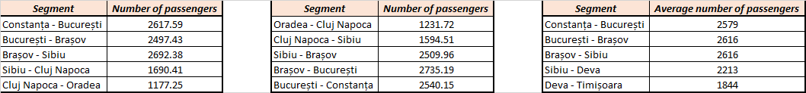

Segment with the most passengers: the Brașov-Bucharest route records the highest passenger volume, with 2735.19 travelers per day. This indicates a high demand for high-speed rail transport on this segment, likely due to the economic and tourist significance of both cities, as well as the direct connection to the capital. Implementing a high-speed transport system would significantly improve mobility and stimulate economic development in the region.
Segment with the fewest passengers: the Cluj Napoca-Oradea route is the least utilized segment, with only 1177.25 passengers per day, suggesting lower demand for high-speed transport between these cities. The population density could influence this, as could the relatively short distance between the cities or the availability of more attractive alternative transportation options.
Balanced flow in central and southern regions: the routes between Constanța-Bucharest, Bucharest-Brașov, and Brașov-Sibiu show a consistent passenger flow, ranging from 2500 to 2700 travelers per day. This reflects steady demand for high-speed rail transport in these areas, highlighting the importance of connecting major urban and economic centers in Romania.
Therefore, the Brașov-Bucharest segment demonstrates the highest demand, confirming the need for high-speed infrastructure to meet the population's mobility needs. Conversely, the Cluj Napoca-Oradea route requires further analysis to determine whether improvements are needed to enhance its attractiveness or whether investment plans in this area should be reconsidered. The segments in the central and southern regions exhibit consistent, sustained passenger flow, underscoring the need to invest in high-speed rail to strengthen economic and social ties between these urban centers.
Economic benefits would also be substantial. By shortening travel times, HSR would make various regions of Romania more attractive to both domestic and international investors. This improved connectivity would foster regional economic integration, bringing closer collaboration between historic regions such as Muntenia, Transylvania, and Dobrogea. Moreover, tourism would experience a boost as travel becomes faster, easier, and more comfortable for both domestic and international visitors. This research identifies several critical factors that must be considered during the planning process, including the city's current accessibility and its geographic location relative to major population centers. These elements should be addressed during the planning phase to ensure the optimal positive impact on spatial equity (Monzón et al., 2013).
From an environmental perspective, HSR presents a sustainable alternative to road and air transport. By shifting more passengers to rail, greenhouse gas emissions could be significantly reduced, contributing to Romania's transition toward greener, more sustainable mobility solutions. Additionally, HSR would alleviate congestion on national roads and improve overall traffic safety, enhancing the quality of life for millions of people.
The implementation of a High-Speed Rail (HSR) system in Romania, operating at speeds of 200 km/h, would reduce travel times between the country's main cities. A detailed comparison of current travel times with those achievable with HSR reveals significant improvements, highlighting the transformative potential of such infrastructure. For example, the travel time from Constanța to Bucharest would drop from 127 minutes to just 60 minutes, a reduction of 52.8%. Similarly, the journey between Bucharest and Brașov would be cut by 60.4%, from 146 minutes to only 57.8 minutes. Longer routes, such as Sibiu to Cluj and Cluj to Oradea, would see reductions of over 80%, decreasing from 245 minutes to 42.6 minutes and from 169 minutes to 50 minutes, respectively. These changes demonstrate that HSR would make long distances feel significantly shorter, connecting cities in ways previously unimaginable.
The reduction in travel times brings numerous opportunities, particularly for daily commuting. For instance, it would become entirely feasible for someone living in Brașov to work in Bucharest and return home the same day, as the trip would take less than one hour. Similarly, cities like Sibiu and Oradea would become attractive residential alternatives for professionals working in larger economic hubs like Cluj or Bucharest, thanks to improved accessibility (Table 5 & Fig. 8).
$\% time reduced=\frac{Present time-Time with HSR}{Present time}$* 100
Table 5. The time between stations at present vs. the time between stations after the implementation of HSR
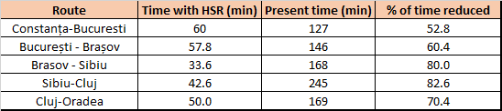
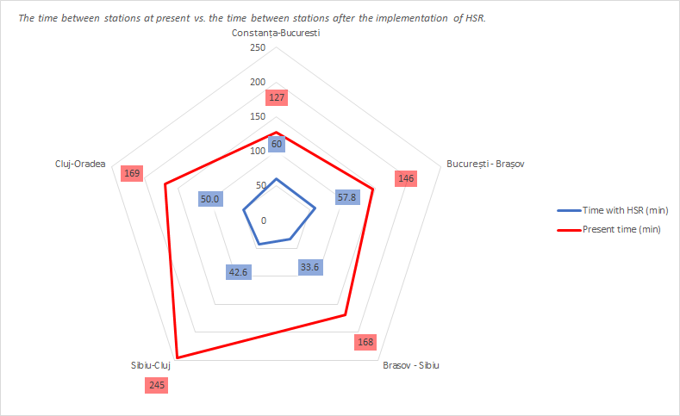
Fig. 8. The time between stations at present vs. the time between stations after the implementation of HSR

To better visualize the need for high-speed rail investment, a map was created that overlays the four proposed alternatives with population data from Romania's administrative territorial units. This approach helps identify areas with the highest population density, highlighting key regions where high-speed rail could have the greatest impact. The map illustrates the four proposed high-speed rail alternatives overlaid on population density data for Romania, highlighting the importance and necessity of investment based on the main population catchment areas along the routes.
The routes are strategically designed to connect major urban centers, including Constanța, Bucharest, Brașov, Sibiu, Cluj-Napoca, Timișoara, and Oradea, which are some of the most densely populated areas in the country. By intersecting regions with high population densities, these alternatives aim to maximize passenger usage and economic impact. This correlation between population hubs and rail connectivity underscores the need for high-speed rail infrastructure to effectively serve large communities, stimulate regional development, and enhance mobility. Moreover, the map clearly shows that the central and southern regions of Romania are particularly densely populated. Routes passing through Brașov, Sibiu, and Râmnicu Vâlcea would cater to substantial passenger demand, supporting economic interactions and social integration within these vital economic corridors. Similarly, linking Bucharest to other major cities not only connects the capital with economic powerhouses but also ensures accessibility to international transport routes via Constanța, the principal maritime gateway.
The population distribution also shows lower density in the northwest along the Cluj-Oradea segment, reflected in lower predicted passenger numbers. This emphasizes the need for a balanced approach to infrastructure planning, directing high investment toward segments with higher demand while optimizing costs on routes with lower usage. Overall, this visual representation effectively demonstrates the need to align high-speed rail development with population catchment areas. It justifies the strategic choice of corridors that promise to maximize social, economic, and mobility benefits, ensuring a sustainable and impactful transport investment.

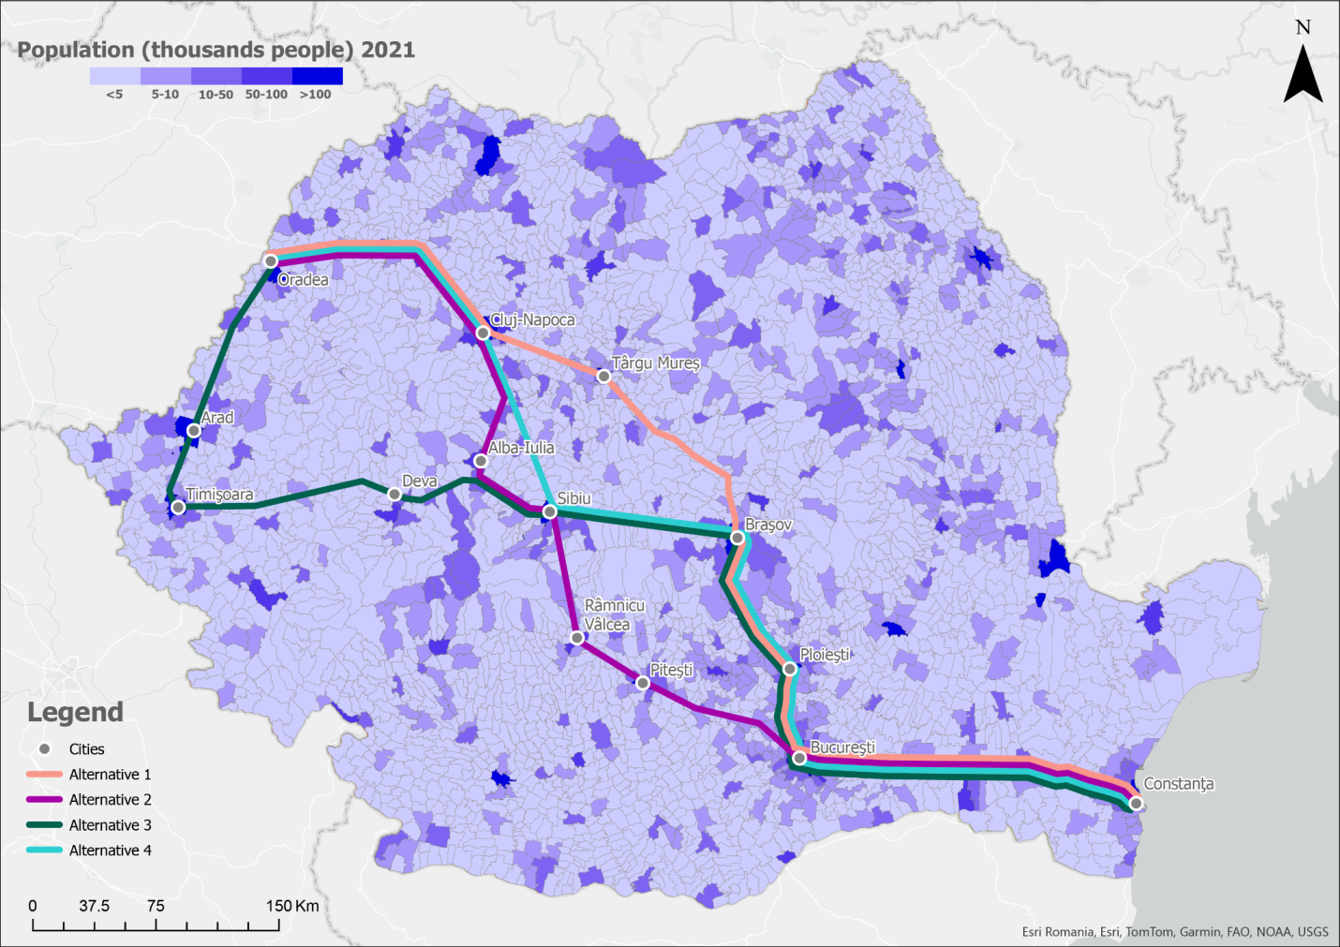
Fig. 9. The proposed alternatives correlated with Romania's population
The introduction of high-speed rail brings about a significant shift in demand patterns across different modes of transport, to the point where it's accurate to distinguish between a transport market before and after HSR's arrival. As a result, it can be confidently predicted that rail will become the dominant mode of transport on the Madrid-Barcelona route, surpassing air travel's market share (Coto-Millán et al., 2007).
The significance of this study lies not only in its methodological contributions but also in its potential to guide informed decision-making for sustainable infrastructure development. Nevertheless, this research represents only an initial step, as a more comprehensive analysis is required to account for additional economic factors, conduct cost-benefit evaluations, and compare with other countries. Future research will expand on this foundation, incorporating detailed economic analyses and cost comparisons to enhance the viability and sustainability of the proposed HSR route. As the study evolves, it holds the potential to become a valuable tool for policymakers and relevant institutions, supporting strategic transport planning in Romania.
The analysis of the four proposed high-speed rail alternatives in Romania considers both land suitability and estimated passenger traffic. The favorability map indicates that the most suitable areas for infrastructure development are in the southern and western plains, while the least suitable areas, highlighted in red, are in the Carpathian Mountains, where construction would be complex and costly.
The first alternative connects Constanța to Oradea via Bucharest, Brașov, Târgu Mureș, and Cluj-Napoca. This route offers strong connections between major cities but faces significant challenges in crossing mountainous terrain, particularly between Brașov and Târgu Mureș. Despite the technical difficulties, traffic is expected to be high due to the economic importance of linking Bucharest and Cluj-Napoca.
The second alternative avoids some of the harshest terrain by passing through Râmnicu Vâlcea, Sibiu, and Alba Iulia. Although this route is more accessible, it is longer, which may reduce passenger attractiveness. Traffic potential is moderate but less promising compared to other alternatives.
The third alternative, which passes through Deva, Timișoara, and Arad, targets high traffic by connecting major western cities. While most of the route passes through favorable terrain, the Sibiu-Deva section poses technical challenges. However, its connection to Western Europe presents a strong economic opportunity.
The fourth alternative, included in the national transport infrastructure strategy, links Constanța, Bucharest, Brașov, Sibiu, Cluj-Napoca, and Oradea. This route has strong institutional support and high estimated traffic, making it a viable option despite the difficult terrain between Sibiu and Cluj-Napoca.
All things considered, Alternative 4 is the most feasible option due to its strategic prioritization and strong urban connectivity. Alternative 3 is also promising due to its economic potential and connectivity with Western Europe. The other two alternatives are less attractive, mainly due to unfavorable terrain and lower traffic potential.
4. Conclusions
This study demonstrates the importance of integrating the National Transport Model into the high-speed rail (HSR) planning and development process, with a particular focus on land suitability analysis in Romania. By evaluating four alternative HSR routes using the national transport model, the research provides valuable insights into optimizing route selection and enhancing strategic transport planning. The findings highlight the utility of employing a national transport model to support evidence-based decision-making, ensuring that infrastructure investments are both effective and sustainable. Additionally, this study introduces a novel approach that combines land suitability analysis with transport modeling, an approach that has not been extensively explored in Romania.
The analysis of the four alternatives shows that Alternative 4 provides the highest passenger potential on key segments such as Bucharest–Brașov (2735 passengers/day), while Alternative 3 demonstrates exceptional demand in the western region, particularly between Timișoara and Arad (3564 passengers/day). The land-favorability map confirms that the southern and western lowlands offer the most suitable terrain, whereas the Carpathian crossings remain the main technical constraint. Travel time reductions of over 50–80% between major cities further support the strategic relevance of HSR development.
However, some limitations were encountered, notably the reliance on the 2015 version of the national transport database, which may not fully reflect current traffic patterns and socio-economic conditions. Furthermore, the scarcity of prior studies on HSR integration in Romania posed challenges in benchmarking and comparative analysis. Despite these limitations, this research lays the groundwork for future studies and provides a methodological framework adaptable to other regions, ultimately advancing HSR planning and development.
Acknowledgement
This study was conducted with the support of the Ministry of Transport and Infrastructure of Romania, through the General Directorate for European Transport Programs and the specialized Office responsible for managing the National Transport Model at the national level in Romania. Their invaluable assistance and expertise have greatly contributed to the successful completion of this research.
References
Albalate, D. & Fageda, X. (2016). High Speed Rail and Tourism: Empirical Evidence from Spain. Transportation Research Part A, 85, 174–185. https://doi.org/10.1016/j.tra.2016.01.009
Boyce, D., & Huw, W. (2015). Forecasting urban travel: Past, present and future. Edward Elgar Publishing, 672. https://doi.org/10.1177/0265813516655644
CFR S.A. (2020). Railway infrastructure development strategy 2021–2025. Bucharest: CFR S.A.
CFR S.A. (2025). Situation of railway infrastructure projects financed from non-reimbursable external funds. Retrieved from https://cfr.ro: https://cfr.ro/monitorizare-proiecte-fonduri-ue/
Coto-Millán, P., Inglada, V., & Rey, B. (2007). Effects of network economies in high-speed rail: the Spanish case. The Annals of Regional Science, 41, 911–925.
Dobre, R. (2009). Suitability of the terrain for communication and transport roads in the Prahova corridor (Mountain and Subcarpathian sectors). Bucharest: Editura Universitară.
Dobre, R. (2016). The dynamic relationship between relief and transport infrastructure. Bucharest: Editura Etnologică.
Dupuy, G. (1995). L'urbanisme des réseaux: théories et méthodes. Annales de géographie.
Dyczkowska, J., Olkiewicz, M., Chamier-Gliszczynski, N., & Królikowski, T. (2023). Mobility-as-a-Service (MaaS) as a solution platform for the city and the region: case study. Procedia Computer Science, 225, 4092–4100. https://doi.org/10.1016/j.procs.2023.10.405
Ejdys, S., Dzik, R., Kowal, B., Dudzicz., M., Piasecki, A., Górka, W., Nowak, E., Markowska, E., & Witkowski, D. (2024). The Essence of Multimodal Travel and Key Standards for Data Exchange in Public Transport. Rocznik Ochrona Środowiska, 26, 691–699. https://doi.org/10.54740/ros.2024.060
Europeean Comission. (2025). European Comission. Retrieved from Connecting Europe Facility (CEF): https://cinea.ec.europa.eu/programmes/connecting-europe-facility/transport-infrastructure_en
Florian, M. (1978). Letter to the Editor–Rejoinder: A Traffic Equilibrium Model of Travel by Car and Public Transit Modes. Transportation Science. 12(2), 176–176.
Garmendia, M., Ribalaygua, C., Ureña, J.M. (2012). High speed rail: implication for cities. Cities, 29(2), S26-S31. https://doi.org/10.1016/j.cities.2012.06.005
International Union of Railways. (2025). International union of railways. Retrieved from International union of railways: https://uic.org/
Iwiński, M., Zydroń, A., Kayzer, D., & Dąbrowski, J. (2019). Environmental Protection in the Aspect of Preventing Collisions with Wild Boar, Roe Deer, Red Deer Based on Selected Railway Lines in Wielkopolska. Rocznik Ochrona Środowiska, 21, 1061–1075.
Lundqvist, L., & Mattsson, L.G. (2002). National Transport Models: Recent Developments and Prospects. Springer Science & Business Media.
Monzón, A., Ortega, E. & López, E. (2013). Efficiency and Spatial Equity Impacts of High-Speed Rail Extensions in Urban Areas. Cities, 30, 18–30.
Najmi, A., Rashidi, T.H., & Liu, W. (2020). Ridesharing in the era of Mobility as a Service (MaaS): An Activity-based Approach with Multimodality and Intermodality. arXiv preprint arXiv:2002.11712. https://doi.org/10.48550/arXiv.2002.11712
National Statistical Institute. (2025). Retrieved from https://insse.ro/cms/
Pagliara, F., Vassallo, J.M., & Román, C. (2012). High-Speed Rail Versus Air Transportation. Case Study of Madrid–Barcelona, Spain. Transportation Research Record Journal of the Transportation Research Board, 2289, 10–17.
Păunescu, C., Dobre, R., Comănescu, L., Drăghici, T., & Nedelea, A. (2021). GIS as a Support Tool for Sensitivity and Decision-Making Analysis for Transport Infrastructure Development. Rocznik Ochrona Środowiska, 23, 23–41. https://doi.org/10.54740/ros.2021.002
Podawca, K., & Staniszewski, R. (2019). Impact of Changes of the Permissible Railway Noise Levels on Possibilities of Spatial Management in Urban Areas. Rocznik Ochrona Środowiska, 21, 1378–1392.
Purcăreață, G. (2015). Land suitability for transport infrastructure in Țara Bârsei. Buchares: Editura Universitară.
Rail Target (2025). Retrieved from Rail Target: https://www.railtarget.eu/
Ureña, J.M., Menerault, P., & Garmendia, M. (2009). The high-speed rail challenge for big intermediate cities: A national, regional and local perspective. Cities. 26(5), 266–279. https://doi.org/10.1016/j.cities.2009.07.001
Vickerman, R. (2018). Can high-speed rail have a transformative effect on the economy? Transport Policy, 62, 31–37.
Zotic, V., & Alexandru, D.E. (2024). Settlement Population Size in Romania. Dynamics and Reranking. Journal of Settlements and Spatial Planning, 15(2), 155–173. https://doi.org/10.24193/JSSP.2024.2.07

