
 | Rocznik Ochrona Środowiska
 | Volume 28 | Year 2026 ISSN 2720-7501 | pp. 165-180
 | https://doi.org/10.54740/ros.2026.013 open access
 | Received: March 2026 Accepted: April 2026 Published: April 2026
Features of Assessing Efficiency in the Context of Implementing Environmental Protection Measures by Types of Economic Activity
Olha Khaietska¹, Antonina Broyaka², Andrii Sakhno³, Оlena Holovnia⁴, Svitlana Dotsiuk⁵,
Illia Chikov^{6*}, Iryna Nedobor⁷
¹Department of Economics and Entrepreneurship, Vinnytsia National Agrarian University, Vinnytsia, Ukraine
https://orcid.org/0000-0002-0262-1455
²Department of Agricultural Economics, Kansas State University, Manhattan, Kansas, US
https://orcid.org/0000-0001-5700-297X
³Department of Economics and Entrepreneurship, Vinnytsia National Agrarian University, Vinnytsia, Ukraine
https://orcid.org/0000-0002-6135-2371
⁴Department of Business and Service Areas, Vinnytsia National Agrarian University, Vinnytsia, Ukraine
https://orcid.org/0000-0002-8396-4846
⁵Department of Economics and Entrepreneurship, Vinnytsia National Agrarian University, Vinnytsia, Ukraine
https://orcid.org/0000-0002-4021-8018
⁶Department of Computer Science and Digital Economy, Vinnytsia National Agrarian University, Vinnytsia, Ukraine
https://orcid.org/0000-0002-2128-5506
⁷Director of the Department of Public Diplomacy and International Affairs,
Community Organization "Living in the Hour of War", Kiev, Ukraine
https://orcid.org/0009-0004-7780-6296
*corresponding author's e-mail: ilya95chikov@gmail.com
Abstract: The purpose of the study is to provide a theoretical and methodological justification for approaches to assessing the environmental and economic efficiency of various types of economic activity based on comparing costs for environmental protection measures (waste management and soil and water protection) with the actual volume of environmental services provided. The study is based on the application of the Data Envelopment Analysis (DEA) method as a nonparametric assessment tool. A graphical method was used to construct lines of technical efficiency and inefficiency, and the boundary lines. The analytical tools were supplemented by the calculation of coverage coefficients, as well as the author's development of two complementary indices: the index of the need to increase the volume of services (INIVS) and the imbalance coefficient (IF), based on which a matrix of the spatial distribution of industries was constructed. The study was conducted based on statistical data from Ukraine for 2023. A deep asymmetry of environmental and economic efficiency was revealed in the context of types of economic activity. It is proven that the agricultural sector (agriculture, forestry, and fisheries) and the extractive industry are in a state of critical inefficiency: the volume of their environmental protection costs exceeds the volume of implemented environmental services by a factor of 1,000. Instead, the processing industry, electricity supply, and water supply serve as benchmarks for efficiency. It has been established that the low efficiency of the agricultural sector is due not so much to a lack of funding as to a critically low level of actual implementation of environmental services in response to the costs incurred. The paper first proposes a complex matrix model for classifying types of economic activity by the level of environmental and economic efficiency and the nature of structural imbalance (INIVS × IF). The method for analyzing the operating environment is specifically adapted for assessing environmental costs (where the production factors are the costs of waste management and soil/water protection, and the result is the volume of environmental services). The proposed approach forms a universal toolkit for strategic management of environmental activities at the macro and meso levels. The distribution matrix allows state bodies and top management to identify "bottlenecks", justify targeted mechanisms for transferring positive experience from reference industries to problem ones, and also optimize the distribution of investments in the green economy (in particular, in the field of rational land use).
Keywords: sustainable economic development, land use, agricultural sector of the economy, ecological and economic efficiency, types of economic activity
1. Introduction
The issues of sustainable development, the implementation of innovative environmental strategies, and the assessment of the effectiveness of environmental protection measures are the subject of in-depth research in modern scientific literature. An analysis of recent publications allows us to identify several key areas in which scientific thought in this area is developing: 1) strategies for ecological modernization and the development of a green economy – a significant contribution to the study of environmental security mechanisms was made by Vrabcová and Urbancová (2023). In particular, their work highlights the need to develop breakthrough, innovative strategies for ecologically sustainable development (Vrabcová & Urbancová, 2023; Dankevych et al., 2021) and substantiates the need to implement public-private partnership models for financing ecological modernization projects (Kaletnik & Lutkovska, 2021). In parallel, based on European experience, investigate the processes of modernization of the agro-industrial complex through the prism of the introduction of «green» technologies, which is a necessary condition for the industry's adaptation to global environmental challenges (Tucci & Battisti, 2020; Chowdhury et al., 2022); 2) waste management, water protection and bioenergy development – a separate block of research is devoted to the issues of rational use of waste and wastewater as a component of the circular economy. The potential for biogas and biomethane production from waste to achieve climate neutrality is detailed in the work (Zhang et al., 2022). In the context of achieving the Sustainable Development Goals in Ukraine, the important role of bioenergy utilization of wastewater (in particular by food industry enterprises) is substantiated in the work (Havrysh & Nitsenko, 2016; Chandra et al., 2018; Malode et al., 2021; Bezdushna et al., 2023; Materynska et al., 2025; Nagaj et al., 2025). These studies demonstrate applied mechanisms for transforming environmental problems (waste, water pollution) into economic benefits (energy); 3) investment and innovation support for the agricultural sector in the context of environmental changes - a significant body of literature focuses on the problems of financing and development of agriculture. The impact of climate change on the investment attractiveness of agricultural enterprises is thoroughly studied in the work by Adams et al. (1998). The search for investment attraction strategies to support the economic recovery of the agricultural sector and rural areas is a focus of the work (Klius & Syvochka, 2023; Pokataiev et al., 2023). Factors that activate investment activity are identified in the article (Lyalina & Chavykina, 2020; Brockova et al., 2021) using correlation-regression analysis. At the same time, the need to modernize state support instruments for small farms is substantiated by the authors of the work (Honcharuk & Tokarchuk, 2024; Perevozova et al., 2022a). Digitalization (precision farming technologies, field monitoring) is recognized as an important growth driver that contributes to both cost optimization and increased environmental friendliness of production, as confirmed by recent research (Gorobets et al., 2021; Balanovska et al., 2021).
Despite the depth of developments in the areas of «green» modernization, bioenergy, and investment incentives, there is fragmentation in the scientific discourse in assessing the ultimate effectiveness of environmental investments. The analyzed studies mainly focus on specific technological solutions (waste processing, precision agriculture) or on the investment attractiveness of a particular agricultural sector. However, the issue of cross-sectoral comparison of efficiency remains out of focus: how exactly do direct financial costs for environmental measures (waste management, soil and water protection) correlate with the actual volume of generated environmental services in the context of radically different types of economic activity (agriculture compared to industry or the service sector).
While this study places a specific emphasis on these sectors due to their direct and massive physical impact on land use, it should be noted that the assessment context is broader. Other types of economic activity (such as manufacturing or services) are also integrated into the overall matrix through their indirect footprint, specifically evaluated through the lens of return water purification and waste management dynamics.
To address the identified gap, the paper proposes applying a nonparametric method to analyze the operating environment. In contrast to existing methods, which mainly focus on absolute financial indicators or macro-level environmental footprints, the proposed approach uses the DEA method to directly link specific industry costs to the actual volume of environmental services delivered. This enables identification of structural imbalances at the sectoral level, a new contribution to the methodology for assessing environmental and economic efficiency.
2. Methods
The assessment of efficiency in the context of environmental protection measures by type of economic activity is based on the effective indicator of the volume of implemented environmental protection services and two-factor indicators: costs of waste management and costs of protection and rehabilitation of soil, groundwater, and surface waters. The feasibility of the study is related to the importance of greening for business entities by type of economic activity, taking into account the role of land use for the agricultural sector of the economy and other industries. The dynamics of the sown areas of agricultural crops, current costs for the purification of return waters, waste management, protection and rehabilitation of soil, groundwater and surface waters, waste from enterprises and households are taken into account.
Using the method of analysis of the operating environment, models were built for all positions by type of economic activity, which made it possible to identify technical efficiency, technical inefficiency, and the marginal structure regarding the volume of implemented environmental services in the system of costs for waste management and costs for the protection and rehabilitation of soil, groundwater, and surface waters.
The application of the DEA method in this study is structured into three consecutive stages: 1) the selection of relevant input variables (costs for environmental protection) and output variables (volume of implemented services); 2) the construction of the operational environment boundaries (efficiency frontiers) based on empirical data; and 3) the calculation of relative efficiency scores for different economic sectors. The graphical models presented in this study are designed to visually reflect these efficiency frontiers, where the distance of a specific sector's position from the optimal curve indicates its level of structural imbalance.
The basis of the method of analyzing the operating environment is the graphical method and the coefficient method. Based on the graphical method, a boundary line was constructed, which allowed substantiation of approaches to determining technical efficiency, technical inefficiency, and the ability to manage both the volume of implemented environmental services and the corresponding costs. The coefficient method is based on calculating the coverage coefficients of the volume of implemented environmental services for the volume of waste management costs and the coverage coefficients of the volume of implemented environmental services for the volume of costs for protection and rehabilitation of soil, groundwater, and surface waters, which allows to assess the positions of types of economic activity in the operating environment.
In terms of practical application for strategic management, the proposed methodological tools can be used to: 1) allocate state environmental subsidies more effectively by directing them to sectors with high structural imbalances; 2) allow corporate managers to benchmark their environmental costs against industry efficiency frontiers; and 3) adjust state environmental policy by shifting focus from simply increasing environmental expenditures to maximizing the actual volume of provided eco-services.
3. Results
Economic activity aims to provide society with high-quality products by developing efficient production (Sira & Pukala, 2020). In conditions of increased competition, achieving quality indicators in the production process is ensured through the implementation of environmental protection services, as greening results from optimizing costs for environmental restoration (Zamula et al., 2020; Manikandan et al., 2022; Mykhailenko et al., 2023).
Thus, ecological and economic efficiency is an effective indicator of achieving greening of production through an increase in the volume of environmental services, taking into account the costs of their implementation (Kaletnik et al., 2025). For Ukraine, achieving ecological and economic efficiency is relevant across all sectors of the national economy; therefore, we propose an analysis in the context of all types of economic activity (Long, 2019).
At the same time, it is necessary to take into account the peculiarities of each industry, including the volume of resources used, the level of harmfulness during processing, waste generation, technological development, etc. In agricultural production, approaches to achieving ecological and economic efficiency are based on agricultural development, particularly land use (Kristoffersen et al., 2021; Zos-Kior et al., 2021; Perevozova et al., 2022b). The importance of costs for the protection and rehabilitation of soil, groundwater, and surface waters is also recognized in the extractive industry and in the development of quarries (Bokusheva & Čechura, 2017; Ostapchuk et al., 2021). It should be noted that the costs for these measures are also provided for other types of economic activity, which allows us to discuss the efficiency of resource use.
Fig. 1 shows the dynamics of the sown areas of agricultural crops for 2020–2024 (State Statistics Service of Ukraine, 2024). Due to difficulties conducting research in areas near hostilities, data for 2024 are not available. As a result of Russia's full-scale invasion of Ukraine in 2022, the sown areas decreased in 2022 compared to 2021 by 18.11%, and in 2023 compared to 2022 by 2.55%.
As a result, this loss of crop areas has significantly affected the implementation of environmental services for agriculture, forestry, and fisheries.
To improve land use, expenditures are made to restore the environment for soil use, water treatment, and waste management. Fig. 2 shows the dynamics of current expenditures for return water treatment, waste management, protection and rehabilitation of soil, groundwater, and surface water during 2020–2024.
Based on the above dynamics, it can be concluded that during the studied period, the least expenditure was directed to the protection and rehabilitation of soil, groundwater, and surface waters. Compared to 2020, in 2024, the expenditure on the protection and rehabilitation of soil, groundwater, and surface waters decreased by 16.37%.

Fig. 1. Dynamics of sown areas of agricultural crops, thousand hectares
Source: formed by the authors using (State Statistics Service of Ukraine, 2024)

Fig. 2. Dynamics of current costs for return water treatment, waste management, protection and rehabilitation of soil, groundwater, and surface waters
Source: formed by the authors using (State Statistics Service of Ukraine, 2024)

A sufficiently significant factor influencing the efficiency of the national economy is waste, since it is always a source of technogenic problems and diseases of the population (Khezrimotlagh et al., 2019; Sirant et al., 2025). Fig. 3 shows the dynamics of waste by enterprise and household economic activity type, based on the 2024 results.
Thus, the largest share of waste falls on the extractive industry and quarry development, making this industry the least attractive for ensuring environmental protection.

Fig. 3. Dynamics of waste by types of economic activity of enterprises and households; 1 – Agriculture, forestry and fisheries; 2 – Mining and quarrying; 3 – Processing industry; 4 – Supply of electricity, gas, steam and conditioned air;
5 – Water supply; sewerage, waste management; 6 – Construction; 7 – Other types of economic activity; 8 – Households
Source: formed by the authors using (State Statistics Service of Ukraine, 2024)

Table 1 presents indicators for assessing environmental and economic efficiency, by volume of environmental protection services provided by economic activity type, for 2023. Due to the lack of reliable 2024 data for some indicators, we propose using 2023 data, especially given the significance of this period, which will allow us to characterize all economic and environmental processes objectively.
Since there is no data on the costs of protecting and rehabilitating soil, groundwater, and surface waters, temporary accommodation and catering (I), and the volume of environmental services provided in information, telecommunications (J), and art, sports, entertainment, and recreation (R), we will not use these types of economic activity in further research.
The largest volume of implemented environmental services is observed in the results of activities in water supply, sewage, waste management (E) – 15603987.9 thousand UAH. The least implemented environmental services in the field of education (P) – 36.1 thousand UAH. Compared to other types of economic activity, implementation in agriculture, forestry, and fisheries (A) – 555.9 thousand UAH is also insignificant.
In terms of waste disposal costs, the largest volume is characterized by water supply, sewage, waste management (E) – 5631248.8 thousand UAH, and mining and quarrying (B) – 3765537.3 thousand UAH. The smallest volume (60.5 thousand UAH) is financial and insurance activities (K).
In terms of costs for the protection and rehabilitation of soil, groundwater, and surface waters, the largest volumes are characterized by activities in the mining industry and quarry development (B) – 799731.9 thousand UAH- and agriculture, forestry, and fisheries (A) – 680744.7 thousand UAH.
For further study of ecological and economic efficiency, we will use the method of analysis of the operating environment, the main principles of which were implemented by Farrell (1957) to assess the efficiency of natural monopolies. This method allows us to determine the reasonableness of the price for the services of natural monopolies.
The method of analyzing the operating environment is a nonparametric limit method based on calculating the coefficients of technical efficiency and resource use (factors of production), which allows multiplying the invested resources by the achieved result (Fenyves et al., 2015). Farrell used labor costs and the cost of capital as production (factor) indicators, and the volume of products sold as an effective indicator.
At the same time, the method of analyzing the operating environment is used to evaluate economic activity in competitive areas of the national economy, in particular, the functioning of agricultural enterprises, tourism, investments, innovative development, implementation of environmental protection measures, etc. (Fenyves et al., 2015; Parmacli et al., 2019; Khezrimotlagh et al., 2019; Andriushchenko et al., 2025; Zaremba et al., 2025).

Table 1. Indicators for assessing environmental and economic efficiency by the volume of environmental protection services provided
Code | Type of economic activity | Waste  management, thousand UAH | Protection and rehabilitation of soil, groundwater, and surface waters,  thousand UAH | Volume of implemented environmental protection services, thousand UAH
А | Agriculture, forestry  and fishing | 15057.4 | 680744.7 | 555.9
B | Mining and quarrying | 3765537.3 | 799731.9 | 3301.5
C | Manufacturing | 622223.6 | 39861.5 | 166264.5
D | Electricity, gas, steam  and air conditioning supply | 305180.3 | 45637.7 | 241674.6
E | Water supply; sewage,  waste management | 5631248.8 | 65543.6 | 15603987.9
F | Construction | 129815.2 | 121.6 | 100389.6
G | Wholesale and retail trade;  repair of motor vehicles and motorcycles | 30102.7 | 1236.8 | 3092.5
H | Transport, warehousing, postal, and courier activities | 287180.5 | 80350.2 | 137256.1
I | Temporary accommodation and catering | 821.9 | – | 467.9
J | Information and telecommunications | 16.4 | 218.5 | –
K | Financial and insurance  activities | 60.5 | 3516.4 | 29104.1
L | Real estate activities | 35991.5 | 11980.9 | 62803.9
M | Professional, scientific,  and technical activities | 2780.9 | 197.0 | 9809.3
N | Administrative and support service activities | 379877.7 | 91.0 | 416128.1
O | Public administration  and defense; compulsory  social insurance | 91202.7 | 4436.2 | 2224.4
P | Education | 1683.7 | 4.1 | 36.1
Q | Health and social assistance | 7908.3 | 102.8 | 958.5
R | Arts, sports, entertainment, and recreation | 2059.1 | 12.3 | –
S | Other service activities | 1294.1 | 15.0 | 2948.3
Source: formed by the authors using (State Statistics Service of Ukraine, 2023)

In our study, we propose to use the following factor indicators: $Х_{1}$ – waste management costs; $Х_{2}$ – costs for protection and rehabilitation of soil, groundwater, and surface water. Performance indicator: $Y$ – volume of environmental protection services provided.
In the context of this study, environmental and economic efficiency is defined as the achievement of an optimal balance between the economic component (minimizing the financial costs of environmental protection measures) and the environmental component (maximizing the physical volume of environmental services, such as waste neutralization or land rehabilitation). A structural imbalance occurs when the growth of the economic component (costs) significantly outpaces the actual environmental outcomes.
The results of calculating the coefficients of coverage by the volume of implemented environmental protection services, of the volume of waste management costs $\left(\frac{Х_{1}}{Y}\right)$ and the coefficients of coverage by the volume of implemented environmental protection services, of the volume of costs for protection and rehabilitation of soil, groundwater, and surface waters $\left(\frac{Х_{2}}{Y}\right)$ are given in Table 2.

Table 2. Coverage ratios of the volume of environmental protection services sold to the volume of waste management costs $\left(\frac{Х_{1}}{Y}\right)$ and coverage ratios of the volume of environmental protection services sold to the volume of costs for protection and rehabilitation of soil, groundwater, and surface water $\left(\frac{Х_{2}}{Y}\right)$
Code | Type of economic activity | $$\frac{Х_{1}}{Y}$$ | $$\frac{Х_{2}}{Y}$$
А | Agriculture, forestry, and fishing | 27.09 | 1224.58
В | Mining and quarrying | 1140.55 | 242.23
O | Public administration and defense | 41.00 | 1.99
P | Education | 46.64 | 0.11
G | Wholesale and retail trade | 9.73 | 0.40
Q | Health care and social assistance | 8.25 | 0.11
H | Transport, warehousing | 2.09 | 0.58
F | Construction | 1.29 | 0.001
D | Electricity, gas, and steam supply | 1.26 | 0.19
C | Manufacturing | 3.74 | 0.24
N | Administrative and support services | 0.91 | 0.0002
S | Provision of other types of services | 0.44 | 0.005
L | Real estate operations | 0.57 | 0.19
M | Professional, scientific, and technical activities | 0.28 | 0.02
E | Water supply, sewage, waste management | 0.36 | 0.004
K | Financial and insurance activities | 0.002 | 0.12
I | Temporary accommodation and catering | 1.76 | –
J | Information and telecommunications | – | –
R | Arts, sports, and entertainment | – | –
Source: formed by the authors using (State Statistics Service of Ukraine, 2023)

The coverage coefficients of the volume of environmental services sold to the volume of waste management costs $\left(\frac{Х_{1}}{Y}\right)$ have a fairly significant interval from 0.28 (Professional, scientific and technical activities) to 1140.55 (Extractive industry and quarry development). Similarly, the coverage coefficients of the volume of environmental services sold to the volume of costs for protection and rehabilitation of soil, groundwater and surface waters – from 0.0002 (Administrative and support service activities) to 1224.58 (Agriculture, forestry and fisheries).
If the coverage ratio is greater than 1 $(\frac{Х_{1}}{Y}>1; \frac{Х_{2}}{Y}>1)$, then the amount of expenditure is greater than the amount of environmental services provided. Conversely, if the coverage ratio is less than 1 ($0<\frac{Х_{1}}{Y}<1; 0<\frac{Х_{2}}{Y}<1$), then the amount of environmental services provided is greater than the amount of expenditure.
Thus, the inequality in the coefficients of coverage of the volume of environmental services provided by the volume of waste management costs ($0<\frac{Х_{1}}{Y}<1$) is fulfilled only for the following types of economic activity: water supply; sewage, waste management; financial and insurance activities; real estate transactions; professional, scientific and technical activities; activities in the field of administrative and support services; provision of other types of services.
Inequality in terms of coverage ratios by the volume of implemented environmental services and the volume of expenditures on protection and rehabilitation of soil, groundwater, and surface waters ($\frac{Х_{2}}{Y}>1$) is observed for the following types of economic activity: agriculture, forestry and fisheries; mining and quarrying; public administration and defense; mandatory social insurance.
$$\frac{Х_{1}}{Y};\frac{Х_{2}}{Y}$$
To complement the operational environment analysis method, we propose two complementary indices: the index of necessary service increase ($INIVS$), which quantifies the distance of each sector to the efficiency condition, and the imbalance coefficient ($IF$), which characterizes the structural configuration of inefficiency through the ratio of the dominant and secondary coverage coefficients. This combination transforms the abstract coordinates of positions into a clear classification scheme, where each sector receives a double characteristic: how far it is from efficiency, and in which direction the main problem is localized (Zos-Kior et al., 2016; Chikov et al., 2023; Su & Fu, 2022; Marwan & Soleman, 2025).
The calculation formula for any economic activity will have the following form:
$$INIVS=max(\frac{X_{1i}}{Y_{i}},\frac{X_{2i}}{Y_{i}})$$
where: $X_{1i}$ – waste management costs of the sector $i$; $X_{2i}$ – costs for protection and rehabilitation of soil, groundwater, and surface waters of the sector $i$; $Y_{i}$ – volume of environmental protection services provided by the sector $i$; $\frac{X_{1i}}{Y_{i}},\frac{X_{2i}}{Y_{i}}$ – coverage ratios.
To interpret the index, we propose the following system of conditions (Table 3):

Table 3. System of conditions for interpreting the $INIVS$
Value of INIVS | Economic content | Efficiency condition
$${INIVS}_{i}≤1$$ | The industry is efficient: volume of services $≥$ costs | Achieved
$${INIVS}_{i}>1$$ | Need to increase the volume of services by $INIVS_{i}$ times | Not achieved
$${INIVS}_{i}>∞$$ | Critical inefficiency (virtually zero service volume) | Systemic crisis
Source: developed by the authors

Imbalance coefficient ($IF$) quantifies whether the problem of environmental and economic inefficiency is concentrated (one critical area) or diffuse (even distribution of problems across areas).
For any economic activity $i$, where both coverage ratios are positive $IF=\frac{INIVS}{min(\frac{X_{1i}}{Y_{i}},\frac{X_{2i}}{Y_{i}})}$.
Here $IF ≈ 1$ – balanced inefficiency: both areas (waste management and soil protection) have the same degree of problem → a comprehensive approach is needed; $IF > 10$ – concentrated inefficiency: one direction is a «bottleneck» → the strategy should focus on it; $IF → ∞$ – extreme imbalance: one of the coefficients approaches zero → the problem is localized in one direction with an almost ideal state of the other.
So, let's apply these indicators to the economic sectors based on the data in Table 4.

Table 4. Efficiency indices by type of economic activity
Code | Type of economic activity | $${INIVS}_{i}$$ | $${IF}_{i}$$ | Dominant coefficient
А | Agriculture, forestry, and fishing | 1224.58 | 45.20 | $\frac{Х_{2}}{Y}$ (soil protection)
В | Mining and quarrying | 1140.55 | 4.71 | $\frac{Х_{1}}{Y}$ (waste management)
O | Public administration and defense | 41.00 | 20.60 | $\frac{Х_{1}}{Y}$ (waste management)
P | Education | 46.64 | 424.00 | $\frac{Х_{1}}{Y}$ (waste management)
G | Wholesale and retail trade | 9.73 | 24.33 | $\frac{Х_{1}}{Y}$ (waste management)
Q | Health care and social assistance | 8.25 | 75.00 | $\frac{Х_{1}}{Y}$ (waste management)
H | Transport, warehousing | 2.09 | 3.60 | $\frac{Х_{1}}{Y}$ (waste management)
F | Construction | 1.29 | 1290.00 | $\frac{Х_{1}}{Y}$ (waste management)
D | Electricity, gas, and steam supply | 1.26 | 6.63 | $\frac{Х_{1}}{Y}$ (waste management)
C | Manufacturing | 3.74 | 15.58 | $\frac{Х_{1}}{Y}$ (waste management)
N | Administrative and support services | 0.91 | 4550.00 | $\frac{Х_{1}}{Y}$ (waste management)

Table 4. cont.
Code | Type of economic activity | $${INIVS}_{i}$$ | $${IF}_{i}$$ | Dominant coefficient
S | Provision of other types of services | 0.44 | 88.00 | $\frac{Х_{1}}{Y}$ (waste management)
L | Real estate operations | 0.57 | 3.00 | $\frac{Х_{1}}{Y}$ (waste management)
M | Professional, scientific, and technical activities | 0.28 | 14.00 | $\frac{Х_{1}}{Y}$ (waste management)
E | Water supply, sewage, waste management | 0.36 | 90.00 | $\frac{Х_{1}}{Y}$ (waste management)
K | Financial and insurance activities | 0.12 | 60.00 | $\frac{Х_{2}}{Y}$ (soil protection)
I | Temporary accommodation and catering | 1.76 | – | $\frac{Х_{1}}{Y}$ (waste management)
J | Information and telecommunications | – |  | No data
R | Arts, sports, and entertainment | – |  | No data
Source: formed by the authors using (State Statistics Service of Ukraine, 2023)

The analysis of the ${INIVS}_{i}$ allows classifying industries by the degree of inefficiency: Level 0 (effective): $INIVS_{i}≤1$ – sectors E, K, L, M, N, S; Level 1 (moderate): $1 < {INIVS}_{i} ≤ 10$ – sectors C, D, F, G, H, Q; Level 2 (high): $10 < {INIVS}_{i}≤ 100$ – sectors O, P; Level 3 (critical): $INIVS_{i}> 100$ – sectors A (1224.58), B (1140.55).
The matrix $INIVS_{i}× IF_{i}$ in the $2×2$ format, built on this basis, creates a universal tool for strategic management of environmental activities. It allows not only to differentiate industries by the level and type of inefficiency, but also to substantiate targeted mechanisms for transferring experience from reference industries to those that require optimization (Table 5).

Table 5. Matrix of distribution of economic sectors by $INIVS$ and $IF$
Indicators | $${IF}_{i}$$
$${INIVS}_{i}$$ | Level | Low level | High level
$${INIVS}_{i}$$ | High level | В (4.71). H (3.60) | А (45.20). O (20.60). P (424.00).  G (24.33). Q (75.00)
$${INIVS}_{i}$$ | Low level | C (15.58). D (6.63). L (3.00) | E (90.00). F (1290.00). K (60.00).  M (14.00). N (4550.00). S (88.00)
Source: based on Table 2

Within the framework of the matrix approach to assessing the efficiency and structural balance of the system, it is advisable to distinguish four quadrants, each of which reflects the specifics of the combination of the level of efficiency and the nature of the problem structure.
The first quadrant is characterized by critical inefficiency under balanced problem conditions. This means that the imbalances are distributed between two directions of development or functioning, without the obvious dominance of either. In such a situation, a comprehensive approach to improving the system is advisable, with measures prioritized according to the value of the dominant influence coefficient.
The second quadrant reflects critical inefficiency under the conditions of a concentrated problem. Inefficiency is localized in one direction, acting as a «bottleneck» for the system. In this case, the maximum effect is achieved through targeted intervention in the problem segment, allowing you to increase overall performance quickly.
The achieved efficiency and balanced structure characterize the third quadrant. This state indicates the optimal distribution of resources and harmonious development of both directions. The main management task is to support existing practices, systematize them, and use them as a reference model for other structures or divisions.

The fourth quadrant reflects the achieved efficiency under conditions of a concentrated structure. One of the directions functions optimally, while the other remains relatively weak. In this situation, it is advisable to scale successful experience and management decisions from the effective segment to industries or directions in crisis.
Thus, the proposed classification allows you to logically structure management decisions based on the nature of efficiency and the distribution of problems, forming the basis for a differentiated strategy for the system's development.
The scale effect, using the method of analysis of the operating environment, allows for determining environmental and economic efficiency based on the values of the coefficients in the context of comparing types of economic activity.
Fig. 4 shows six types of economic activity, and the technical efficiency line consists of the positions: L (Real estate operations), D (Electricity, gas, steam, and air conditioning supply), and Q (Health care and social assistance). Thus, the positions of these types of economic activity can be considered a reference in relation to others, since their efficiency coefficient is 1 $\left(R_{eff}=1\right)$.
For items of other types of economic activity, the coefficient of technical efficiency is calculated using the following ratio (using the example of wholesale and retail trade, repair of motor vehicles and motorcycles – G): $R_{eff}=\frac{{ОG}_{1}}{ОG}$, where $G_{1}$ – projection of position G onto the line L-D-Q. Technical efficiency coefficients are within the limits: $0<R_{eff}<1$.

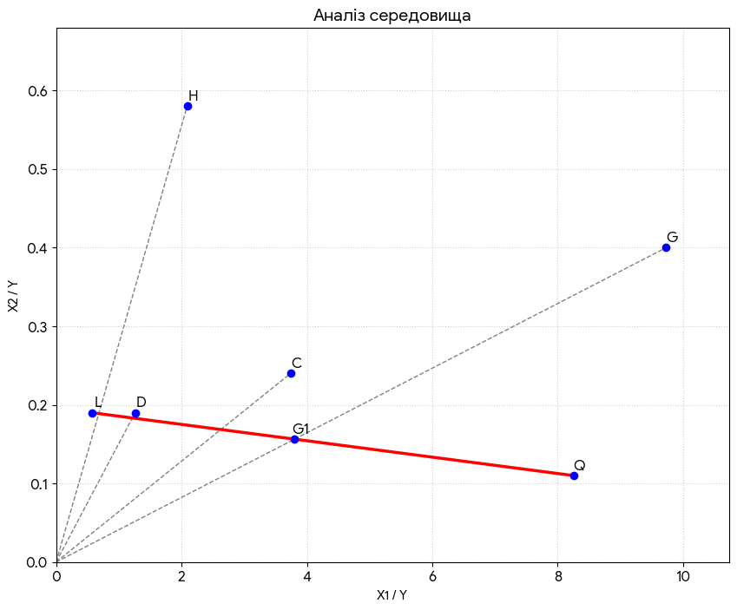
Fig. 4. Assessment of environmental and economic efficiency by types of economic activity according to the indicators of 2023 within the values of: $0.57<\frac{X_{1}}{Y}<9.73$ and $0.11<\frac{X_{2}}{Y}<0.58$
Source: based on Table 2

Based on the above figure, we can conclude that the greatest ecological and economic efficiency compared to enterprises of other types of activity is the activity of processing industry enterprises, since position C is as close as possible to the line of technical efficiency. The functioning of enterprises of other types of activity (positions H and G) is less efficient – their positions are at a significant distance from the line of technical efficiency.
Although this figure illustrates the general conceptual direction of increasing efficiency, it translates directly into applied metrics. Within this operational environment, every point on these directional rays is defined by specific coordinates $(x, y)$, where $x$ represents the required financial input and $y$ reflects the expected volume of environmental services. By determining these coordinates, the model provides stakeholders with precise, quantifiable targets, transforming theoretical efficiency trajectories into actionable management parameters for investment allocation.
Thus, increasing the environmental and economic efficiency of enterprises in these types of economic activity is possible if all positions move towards the origin (Parmacli et al., 2019; Kotykova et al., 2020). This means that there is sufficient expenditure on waste management and on the protection and rehabilitation of soil, groundwater, and surface waters for both types of economic activity; therefore, increasing the volume of environmental services provided is a real measure to increase efficiency by the results of 2023.
Fig. 5 shows four types of economic activity, and the line of technical inefficiency consists of the positions: M (Professional, scientific and technical activities) and F (Construction).

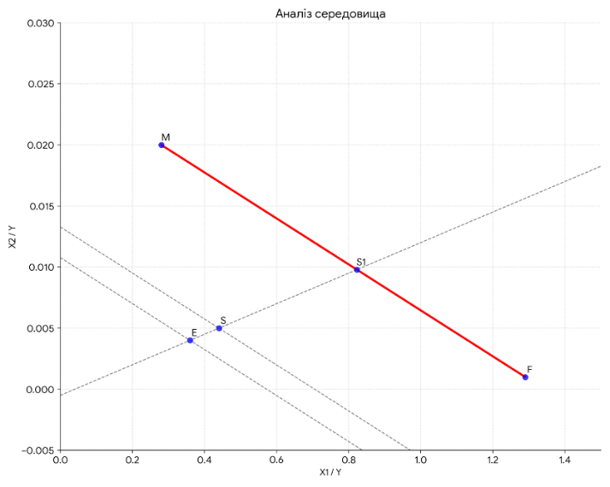
Fig. 5. Assessment of environmental and economic efficiency by types of economic activity according to the indicators of 2023 within the values of: $0.28<\frac{X_{1}}{Y}<1.29$ and $0.001<\frac{X_{2}}{Y}<0.02$
Source: based on Table 2

Water supply, sewage, waste management (E), and other services (S) are efficient, since these economic activity positions are much closer to the origin of the coordinates than positions M and F. It should be noted that the efficiency of position E (Water supply; sewage, waste management) is greater than the efficiency of position S (Provision of other services).
Thus, to increase environmental and economic efficiency, business entities engaged in construction (F) and professional, scientific, and technical activities (M), having achieved the maximum in the implementation of environmental protection services (line of positions M-F), must reduce waste management costs and costs for the protection and rehabilitation of soil, groundwater, and surface waters (initially to the level of the conditional line passing through position S, and in the future to the level of the conditional line passing through position E in the direction to the origin).
Fig. 6 shows two types of economic activity, and the marginal line consists of the positions: O (Public administration and defense; compulsory social insurance) and P (Education). In this case, we use the term «marginal line» in contrast to previous cases, when a line of technical efficiency and a line of technical inefficiency were constructed.
The boundary line is not related to the efficiency characteristic, since it allows evaluating only two positions that determine the trend in the implementation of environmental services, namely, costs for the protection and rehabilitation of soil, groundwater, and surface water, and costs for waste management.
Segments 0-O and 0-P allow us to construct triangle 0OP, the area of which characterizes the potential for increasing the volume of implemented environmental services. Direction 0-0¹ shows the most optimal option for increasing environmental and economic efficiency, where the volume of products sold, as it approaches zero, increasingly exceeds the volume of all expenses in the areas of public administration and defense, compulsory social insurance, and education.

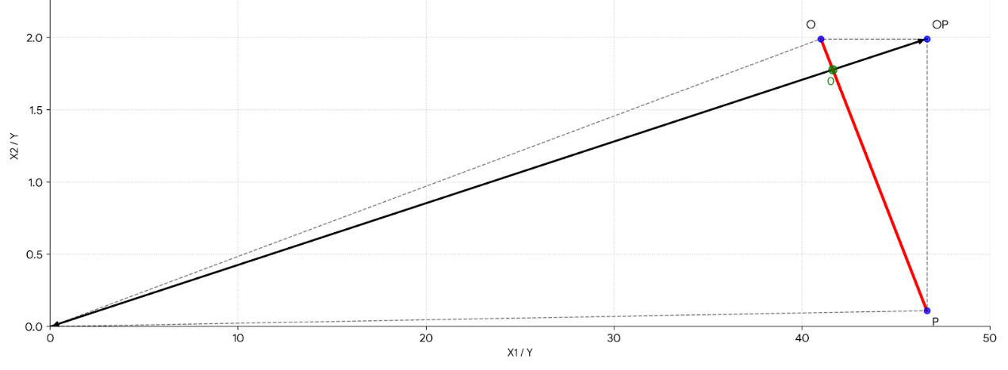
Fig. 6. Assessment of environmental and economic efficiency by types of economic activity according to the indicators of 2023 within the values of: $41<\frac{X_{1}}{Y}<46.64$ and $0.11<\frac{X_{2}}{Y}<1.99$
Source: based on Table 2

The triangle O-OP-P is formed by the intersection of the lines O-OP (parallel to the abscissa axis) and OP-P (parallel to the ordinate axis). Its area characterizes the increase in costs (direction 0¹-OP), and the position of OP represents the maximum amount of costs for waste management and for the protection and rehabilitation of soil, groundwater, and surface waters.
Fig. 7 also shows two types of economic activity, with the boundary line defined by the positions K (Financial and insurance activities) and N (Administrative and support service activities).

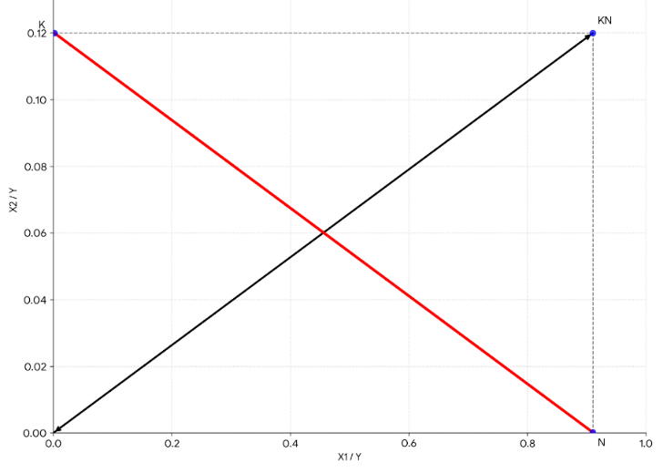
Fig. 7. Assessment of environmental and economic efficiency by types of economic activity according to the indicators of 2023 within the values of: $0.002<\frac{X_{1}}{Y}<0.91$ and $0.0002<\frac{X_{2}}{Y}<0.12$
Source: based on Table 2

Unlike Fig. 6, in Fig. 7, the positions of the types of economic activity are characterized by all coverage coefficients being less than unity. Therefore, they are as close as possible to the abscissa and ordinate axes. For all other evaluation parameters, the ecological and economic efficiency is determined as in the previous case. It should be noted that in 2023, activities in the field of administrative and auxiliary services provided one of the largest volumes of implemented environmental services compared to other types of economic activity, which is second only to activities in the field of water supply, sewage, and waste management.
Another example of constructing a boundary line is shown in Fig. 8, which consists of the following positions: A (Agriculture, forestry, and fisheries) – B (Mining and quarrying) (Zaremba et al., 2025).
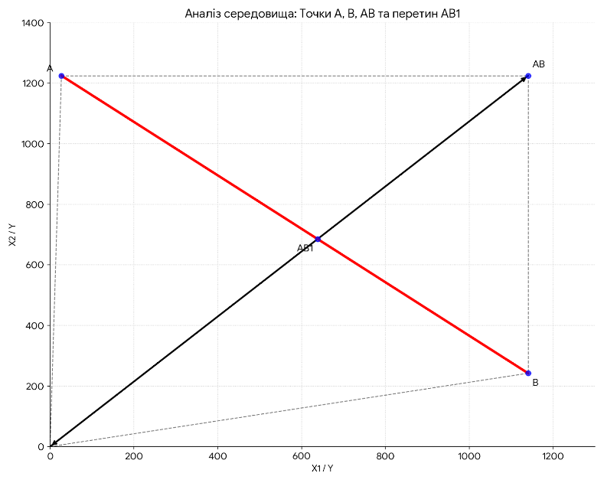
Fig. 8. Assessment of environmental and economic efficiency by types of economic activity according to the indicators of 2023 within the values of: $27.09<\frac{X_{1}}{Y}<1140.6$ and $242.23<\frac{X_{2}}{Y}<1224.6$
Source: based on Table 2

The assessment of ecological and economic efficiency (Fig. 8) is, on the one hand, similar to other assessments (Fig. 6 and Fig. 7); on the other hand, in this case, for the above types of economic activity, industries directly related to land use are analyzed. In terms of costs for the protection and rehabilitation of soil, groundwater, and surface waters, and for activities in agriculture, forestry, and fisheries, as well as in the extractive industry and quarry development, these are the undisputed leaders compared to other types of economic activity. In terms of the volume of environmental services provided, both types of economic activity are among those with rather low indicators.
As a result (Fig. 8), coverage ratios are measured not only in tenfold or hundredfold excesses, but also in thousandfold excesses of waste management costs and costs for protection and rehabilitation of soil, groundwater, and surface waters over the volume of environmental services provided. Thus, it can be concluded that the motivation of enterprises in agriculture, forestry, fisheries, and mining and quarry development is the A0B triangle, within which ecological and economic efficiency is achieved.
It is important to clarify that, while the options presented in Figures 6, 7, and 8 model theoretical boundary conditions, they also have direct applied significance. These matrices form a diagnostic framework that maps the entire spectrum of possible operational states. By establishing these theoretical boundaries, we create a benchmarking tool that allows state regulators and corporate managers to position real economic sectors within this space, identify their specific structural imbalances relative to the extremes, and model strategic scenarios for their optimization.
The most optimal option for ensuring ecological and economic efficiency is the direction AB₁-0. It should also be noted that agriculture, forestry, fisheries and mining and quarry development are types of economic activity that spend huge resources on the production of products and the formation of the economic potential of the state, however, the low level of implemented environmental protection services reflects the real state of both economic opportunities (lack of competitive products based on indicators of compliance with the greening criteria) and environmental support (significant costs for waste management and for the protection and rehabilitation of soil, groundwater and surface waters do not guarantee the implementation of the appropriate volume of implemented environmental protection services).
4. Discussion
Our study demonstrates the critical inefficiency of environmental protection spending relative to manufacturing and energy, opening a new perspective on the macro-level assessment of green modernization. This is fully consistent with the study's results (Guo et al., 2021), which confirm the crucial role of green innovation and environmental investment in ensuring high environmental quality.

The study's findings on the critical inefficiency of the agricultural sector in soil protection and rehabilitation align with caveats regarding rational land use in the scientific discourse. While previous scientific studies have mainly focused on local ecological and economic problems of fertilizer application in crop production (Shweta et al., 2021), management of environmental parameters based on soil fertility restoration indices (Kucher & Hrechko, 2021), or on assessing the effectiveness of individual technologies, such as straw harvesting for soil conservation (Halko et al., 2023), our study raises this issue to a macro-comparative level. It mathematically proves that despite the introduction of individual technologies, agriculture as a type of economic activity in general lags significantly behind industrial efficiency standards in terms of transforming costs into real environmental services.
In addition, identifying the processing industry and the water and waste management sectors as a "benchmark" makes a significant contribution to understanding the circular economy. The processing industry demonstrates that the high costs of managing municipal and industrial solid waste, the volumes and types of which are largely shaped by socio-economic factors (Kala et al., 2020), can be effectively transformed into a large volume of services sold. We argue that the agricultural sector should adopt this benchmark model. In particular, this is possible by developing waste-free production to achieve energy autonomy for agricultural enterprises (Deže et al., 2023). Thus, agribusiness will be able to transform waste management from a cost center to a generated environmental service, significantly improving its position on the DEA frontier.
Finally, when discussing the strategic implications of the indices we constructed (INIVS and IF), it is important to emphasize their macroeconomic significance. Overcoming deep ecological and economic imbalances is a necessary condition for ensuring proper economic security in the context of the realization of national interests in the information economy (Volyk et al., 2023). In the future, the indices and matrix model proposed in our study can serve as a fundamental basis for developing new digital management tools, ensuring transparent and effective environmental monitoring of enterprises' activities across all sectors of the national economy.
5. Conclusions
Based on the justification of the features of assessing the effectiveness in the context of carrying out environmental protection measures by type of economic activity, it can be concluded that there is a lack of sufficient volume of implemented environmental protection services for such types of economic activity as agriculture, forestry, fisheries, and mining and quarrying. At the same time, these types of economic activity lead in terms of the volume of expenses for the protection and rehabilitation of soil, groundwater, and surface waters, and for mining and quarrying in terms of waste management. Thus, in Ukraine, the problem of achieving environmental and economic efficiency in land-use development in the agricultural sector can be solved not through cost optimization, but by increasing the volume of environmental protection services implemented. Examples include activities related to the processing industry, the supply of electricity, gas, steam, and conditioned air, as well as water supply, sewage, and waste management. These types of economic activity have, on the one hand, significantly lower costs for the protection and rehabilitation of soil, groundwater, and surface water, and, on the other hand, much higher costs for waste management than agriculture, forestry, and fisheries. At the same time, types of economic activity such as the processing industry, the supply of electricity, gas, steam, and conditioned air, as well as water supply; sewage; waste management, have a significantly higher volume of environmental services implemented than in agriculture, forestry, fisheries, and extractive industries and quarrying. Even if by types of economic activity such as processing industry, supply of electricity, gas, steam and conditioned air, as well as water supply; sewage, waste management, the volume of expenses exceeds the volume of environmental services provided (from 1 to 4), then in the operating environment they are among those that are a benchmark of efficiency or come close to it compared to other types of economic activity.
References
Adams, R., Hurd, B., Lenhart, S., & Leary, N. (1998). Effects of global climate change on agriculture: an interpretative review. Inter-Rese, 11, 19–30. https://doi.org/10.3354/cr011019
Andriushchenko, K., Liezina, A., Slavkova, A., Logvinov, P., Lavruk, V., Petrukha, S., & Storozhenko, A. (2025). The Impact of Energy-Efficient Technologies on the Development of the Agricultural Industry. Journal of Environmental & Earth Sciences, 7(1), 423–437. https://doi.org/10.30564/jees.v7i1.7635
Balanovska, T., Mykhailichenko М., Holik, V., Dramaretska, К., & Troian, A. (2021). Development management of agricultural enterprises. Financial and Credit Activity: Problems of Theory and Practice, 3(38), 134–143. https://doi.org/10.18371/fcaptp.v3i38.237434
Bezdushna, Y., Prodanchuk, M., Zhuk, V., & Popko, E. (2023). Rationale of Management Principles of Providing Sustainable Development of Rural Territorial Communities. International Journal of Information Technology Project Management (IJITPM), 14(1), 1–11. https://doi.org/10.4018/IJITPM.323209
Bokusheva, R., & Čechura, L. (2017). Evaluating dynamics, sources and drivers of productivity growth at the farm level. OECD Food, Agriculture and Fisheries Papers, 106, OECD Publishing, Paris, https://doi.org/10.1787/5f2d0601-en
Brockova, K., Rossokha, V., Chaban, V., Zos-Kior, M., Hnatenko, I., & Rubezhanska, V. (2021). Economic mechanism of optimizing the innovation investment program of the development of agro-industrial production. Management Theory and Studies for Rural Business and Infrastructure Development, 43(1), 129–135. https://doi.org/10.15544/mts.2021.11
Chandra, R., Castillo-Zacarias, C., Delgado, P., & Parra, R. (2018). A biorefinery approach for dairy wastewater treatment and product recovery towards establishing a biorefinery complexity index. Journal of Cleaner Production, 183, 1184–1196. https://doi.org/10.1016/j.jclepro.2018.02.124
Chikov, I., Khaietska, O., Okhota, Yu., Titov, D., Prygotsky, V., & Nitsenko, V. (2023). Modeling of the synthetic indicator of competitiveness of agricultural enterprises: a methodological approach to the use of neural network tools. Financial and Credit Activity: Problems of Theory and Practice, 5(52), 222–242. https://doi.org/10.55643/fcaptp.5.52.2023.4149
Chowdhury, S., Rahman, M., Zayed, N.M., Rajibul Hasan, K.B.M., & Nitsenko, V. (2022). The impact of financial development on accelerating the environmental degradation in Bangladesh. Naukovyi Visnyk Natsionalnoho Hirnychoho Universytetu, 2, 102–107. https://doi.org/10.33271/nvngu/2022-2/102
Dankevych, A., Sosnovska, O., Dobrianska, N., Nikolenko, L., Mazur, Yu., & Ingram K. (2021). Ecological and economic management of innovation activity of enterprises. Naukovyi Visnyk Natsionalnoho Hirnychoho Universytetu, 5,
112–118. https://doi.org/10.33271/nvngu/2021-5/118
Deže, J., Sudarić, T., & Tolić, S. (2023). Social Innovations for the Achievement of Competitive Agriculture and the Sustainable Development of Peripheral Rural Areas. Economies, 11(8), 209. https://doi.org/10.3390/economies11080209
Farrell, M.J. (1957). The Measurement of Productive Efficiency. Journal of Royal Statistical Society. Series A, CXX, Part 3, 253–290.
Fenyves, V., Tarnóczi, T., & Zsidó, K. (2015). Financial Performance Evaluation of Agricultural Enterprises with DEA Method. Procedia Economics and Finance, 32, 423–431. https://doi.org/10.1016/S2212-5671(15)01413-6
Gorobets, N.M., Khomyakova, D.O., & Starikovska, D.O. (2021). Prospects for the use of digital technologies in the activities of agricultural enterprises. Effective economy, 1. https://doi.org/10.32702/2307-2105-2021.1.90
Guo, J., Zhou, Y., Ali, S., Shahzad, U., & Cui, L. (2021). Exploring the Role of Green Innovation and Investment in Energy for Environmental Quality: An Empirical Appraisal from Provincial Data of China. Journal of Environmental Management, 292, 112779. https://doi.org/10.1016/j.jenvman.2021.112779
Halko, S., Vershkov, O., Horák, J., Lezhenkin, O., Boltianska, L., Kucher, A., Suprun, O., Miroshnyk, O., & Nitsenko, V. (2023). Efficiency of Combed Straw Harvesting Technology Involving Straw Decomposition in the Soil. Agriculture, 13, 655. https://doi.org/10.3390/agriculture13030655
Havrysh, V.I., & Nitsenko, V.S. (2016). Current state of world alternative motor fuels market. Actual problems of economics, 7(181), 41-52.
Honcharuk, І., & Tokarchuk, D. (2024). Review of the European experience of AIC development and the role of green technologies in the modernisation of this process. Baltic Journal of Economic Studies, 10(5), 155-165. https://doi.org/10.30525/2256-0742/2024-10-5-155-165
Kala, K., Bolia, N.B., & Sushil. (2020). Effects of socio-economic factors on quantity and type of municipal solid waste. Management of Environmental Quality, 31(4), 877-894. https://doi.org/10.1108/MEQ-11-2019-0244
Kaletnik, G., & Lutkovska, S. (2021). Implementation of Public-Private Partnership Models in the Field of Ecological Modernization of the Environmental Safety System. European Journal of Sustainable Development, 10(1), 81–89. https://doi.org/10.14207/ejsd.2021.v10n1p81
Kaletnik, G., Sakhno, A., Pryshliak, N., Lutkovska, S., & Kolomiiets, T. (2025). Economic evaluation of environmental protection activities in the context of sustainable development: the experience of Ukraine. Polityka Energetyczna – Energy Policy Journal, 28(3), 217–236. https://doi.org/10.33223/epj/207022
Khezrimotlagh, D., Zhub, J., Cookd, W.D., & Tolooe, M. (2019). Data envelopment analysis and big data. European Journal of Operational Research, 274(3), 1047–1054. https://doi.org/10.1016/j.ejor.2018.10.044
Klius, Y., & Syvochka, V. (2023). Ensuring the competitiveness of regional enterprises on an innovative basis. Visnik of the Volodymyr Dahl East Ukrainian National University, 2(278), 50–55.
https://doi.org/10.33216/1998-7927-2023-278-2-50-55
Kotykova, O., Babych, M., & Pohorielova, O. (2020). Impact of economic affordability of food on the level of food consumption by Ukrainian households. Intellectual Economics, 14(1), 76-88. https://doi.org/10.13165/IE-20-14-1-05
Kristoffersen, E., Mikalef, P., Blomsma, F., & Li, J.Y. (2021). The effects of business analytics capability on circular economy implementation, resource orchestration capability, and firm performance. International Journal of Production Economics, 239, 108205. https://doi.org/10.1016/j.ijpe.2021.108205
Kucher, A., & Hrechko, A. (2021). Assessment and analysis of regional features of resource-saving land use for sustainable management. Scientific Papers. Management, Economic Engineering in Agriculture and Rural Development, 21(1), 431–441. https://managementjournal.usamv.ro/pdf/vol.21_1/Art49.pdf
Long, X. (2019). Scientific and technological innovation related to real economic growth. China Political Economy, 2(1), 108–122. https://doi.org/10.1108/CPE-04-2019-0012
Lyalina, N.S., & Chavykina, O.V. (2020). Analysis of investment activity in the agriculture of Ukraine and determination of directions for its activation. Black Sea Economic Studies, 52(2), 23–28. https://doi.org/10.32843/bses.52-26
Malode, S.J., Prabhu, K.K., Mascarenhas, R.J., Shetti, N.P., & Aminabhavi, T.M. (2021). Recent advances and viability in biofuel production. Energy Conversion and Management, X, 10, 100070. https://doi.org/10.1016/j.ecmx.2020.100070
Manikandan, S., Subbaiya, R., Biruntha, M., Yedhu Krishnan, R., Muthusamy, G., & Karmegam, N. (2022). Recent development patterns, utilization and prospective of biofuel production: Emerging nanotechnological intervention for environmental sustainability – A review. Fuel, 314. https://doi.org/10.1016/j.fuel.2021.122757
Marwan, M., & Soleman, M.M. (2025). Analysis of role antecedent variables on innovative work behavior and the impact on business performance of micro and small enterprises. Intellectual Economics, 19(1), 210–233. https://doi.org/10.13165/IE-25-19-1-09
Materynska, O., Klymchuk, O., Kronivets, T., Romanchuk, L., & Burlaka, N. (2025). Sustainable development management: basic principles and tools of influence. Naukovyi Visnyk Natsionalnoho Hirnychoho Universytetu, 4, 217–226. https://doi.org/10.33271/nvngu/2025-4/217
Mykhailenko, V., Safranov, T., & Adobovska, M. (2023). Biological wastewater treatment plants as sources of environmental pollution by persistent organic pollutants (on the example of Odesa industrial-and-urban agglomeration). Visnyk of V. N. Karazin Kharkiv National University, Series "Geology. Geography. Ecology", 58, 350–359. https://doi.org/10.26565/2410-7360-2023-58-26
Nagaj, R., Vasilev, J., & Žuromskaitė-Nagaj, B. (2025). Hierarchical modelling of sustainable energy consumption profiles for developed and developing countries. Intellectual Economics, 19(1), 234–259.
https://doi.org/10.13165/IE-25-19-1-10
Ostapchuk, T., Orlova, K., Biriuchenko, S., Dankevych, A., & Marchuk, G. (2021). Defuzzification in the process of managerial estimating the value of agricultural lands. Agricultural and Resource Economics: International Scientific E-Journal, 7(4), 62-81. https://doi.org/10.51599/are.2021.07.04.04
Parmacli, D., Soroka, L., & Bakhchivanji, L. (2019). Methodical bases of graduation of indicators of efficiency of realized production in agriculture. Agricultural and Resource Economics: International Scientific E-Journal, 5(1), 107–121. https://doi.org/10.51599/are.2019.05.01.07
Perevozova, I., Mykhailyshyn, L., Morozova, O., Gordeyeva, Ye., Liubar, R., & Shapoval, O. (2022a). Financial and economic support of the functioning of enterprises of the material sphere of production: a practical dimension. Financial and Credit Activity Problems of Theory and Practice, 2(43), 71–77. https://doi.org/10.55643/fcaptp.2.43.2022.3680
Perevozova, I., Prodius, Y., Selinnyi, M., Lobza, A., & Pikulina, N. (2022b). Improving the efficiency of land use in the agricultural sector of Ukraine. IOP Conference Series: Earth and Environmental Science, 949, 012044. https://doi.org/10.1088/1755-1315/949/1/012044
Pokataiev, P., Liezina, N., Andriushchenko, A., & Petukhova, H. (2023). The role of biotechnology in the development of the bioeconomy. Acta Innovations, 46, 18–33. https://doi.org/10.32933/ActaInnovations.46.2
Sira, E., & Pukala, R. (2020). Management of agriculture innovations: Role in Economic Development. Marketing and Management of Innovations, 2, 154–166. http://doi.org/10.21272/mmi.2020.2-11
Sirant, M., Sheptytska, L., Remenyak, O., Zakharchyn, N., & Tsebenko, S. (2025). Legal aspects of environmental rights guarantees in the conditions of martial state in Ukraine. Naukovyi Visnyk Natsionalnoho Hirnychoho Universytetu, 3, 147–155. https://doi.org/10.33271/nvngu/2025-3/147
State Statistics Service of Ukraine (2024). http://www.ukrstat.gov.ua
Su, X., & Fu, W. (2022). Impact of multiple performance feedback and regional institutional development on enterprises' exploratory innovation. Frontiers in Psychology, 13, 982211. https://doi.org/10.3389/fpsyg.2022.982211
Tucci, F., & Battisti, A. (2020). Green Economy for Sustainable and Adaptive Architectures and Cities: Objectives, Guidelines, Measures, Actions. IOP Conference Series: Earth and Environmental Science, 503, 012022. https://doi.org/10.1088/1755-1315/503/1/012022
Volyk, S., Kukhar, O., & Bril, M. (2023). Management of the agricultural enterprises' competitiveness in the context of food security. Baltic Journal of Economic Studies, 9(4), 88–95. https://doi.org/10.30525/2256-0742/2023-9-4-88-95
Vrabcová, P., & Urbancová, H. (2023). Sustainable innovation in agriculture: Building a strategic management system to ensure competitiveness and business sustainability. Agricultural Economics – Czech, 69(1), 1–12. https://doi.org/10.17221/321/2022-AGRICECON
Zamula, І., Prodanchuk, M., Kovalchuk, T., Kolesnikova, O., & Myhalkiv, A. (2020). Indicators of ecological condition of natural resources in integrated reporting of the enterprise. Naukovyi Visnyk Natsionalnoho Hirnychoho Universytet, 6, 180-187. https://doi.org/10.33271/nvngu/2020-6/180
Zaremba, O., Sakhno, A., Chesnik, N., Nitsenko, V., Chikov, I., Zakharova, T., & Boltovska, L. (2025). Capital Investments in Sustainable Development of Land Resources of Ukrainian Agrarian and Industrial Complex Enterprises: Assessment, Modeling, Optimization. Rocznik Ochrona Środowiska, 27, 722-737. https://doi.org/10.54740/ros.2025.058
Zhang, L., Xu, M., Chen, H., Li, Y., & Chen, S. (2022). Globalization, Green Economy and Environmental Challenges: State of the Art Review for Practical Implications. Frontiers in Environmental Science, 1(10), 1–9. https://doi.org/10.3389/fenvs.2022.870271
Zos-Kior, M., Kuksa, I., Ilyin, V., & Chaikina, A. (2016). Land management prospects. Economic Annals-XXI, 9–10, 243–246. https://doi.org/10.21003/ea.V161-10
Zos-Kior, M., Shkurupii, O., Fedirets, O., Shulzhenko, I., & Rubezhanska, V. (2021). Modeling of the investment program formation process of ecological management of the agrarian cluster. European Journal of Sustainable Development, 10(1), 571–583. https://doi.org/10.14207/ejsd.2021.v10n1p57

