
 | Rocznik Ochrona Środowiska
 | Volume 28 | Year 2026 ISSN 2720-7501 | pp. 153-164
 | https://doi.org/10.54740/ros.2026.012 open access
 | Received: September 2025 Accepted: March 2026 Published: April 2026
Groundwater Quality and Mineralization Processes in the Béchar Region, Algeria: A Hydrochemical and Statistical Approach
Salih Lachache^{1*}, Abdelouahab Amroune², Bendjillali Redha Ilyes³, Amina Lachache⁴,
Bendelhoum Mohammed Sofiane⁵, Ali Abderrazak Tadjeddine⁶
¹LSETER Laboratory, Technology Institute, Nour Bachir University Center, El-Bayadh, Algeria
https://orcid.org/0000-0003-2890-8822
²Department of Agricultural Sciences, University Mohamed BOUDIAF, M'sila, Algeria
https://orcid.org/0000-0002-9850-6258
³LSETER Laboratory, Technology Institute, Nour Bachir University Center, El-Bayadh, Algeria
https://orcid.org/0000-0003-2465-8192
⁴Institute of Sciences, Department of Biology, University Center of Tipaza, Tipaza, Algeria
https://orcid.org/0000-0003-4563-005X
⁵LSETER Laboratory, Technology Institute, Nour Bachir University Center, El-Bayadh, Algeria
https://orcid.org/0000-0002-9789-8712
⁶LSETER Laboratory, Technology Institute, Nour Bachir University Center, El-Bayadh, Algeria
https://orcid.org/0000-0003-0926-3440
*corresponding author's e-mail: s.lachache@cu-elbayadh.dz
Abstract: Groundwater mineralization in arid regions like Béchar, Algeria, poses a major challenge for sustainable water management, as groundwater is the sole source. Intensive use, harsh climate, and rising demand from agriculture, industry, and households are driving progressive salinization and threatening water quality. To address this, an integrated approach combining hydrochemical analyses, graphical methods, and multivariate statistics was applied to identify the mechanisms shaping groundwater composition in the Béchar-Kénadsa basin. Results reveal three main water types: calcium bicarbonate (Ca - HCO₃, 35%), linked to limestone interactions; magnesium-potassium-sulfate (Mg - K - SO₄ - Cl, 40%), influenced by evaporitic deposits and agriculture; and sodium chloride (Na - Cl, 25%), tied to saline intrusions. Gibbs diagrams show that evaporation dominates 60% of samples, while 30% are controlled by water-rock interaction. Salinization is mainly caused by dissolution of Upper Cretaceous formations, with elevated sodium, chloride, and sulfate concentrations from the basin center to its outlet, further reinforced by ion exchange with clay. These findings emphasize the urgent need to protect recharge zones and regulate exploitation to preserve groundwater quality and ensure its long-term sustainability.
Keywords: hydrogeochemical processes, groundwater salinization, evaporite dissolution, water–rock interaction, multivariate statistical analysis, Béchar-Kénadsa basin
1. Introduction
It has long been believed that water is an endless and renewable resource. However, the current climate and the growing demand driven by population expansion and socioeconomic development are causing many countries to confront the loss of their water sources. Under the influence of an arid Saharan climate and in the absence of surface water mobilization infrastructure, the water supply of the Béchar region relies primarily on the exploitation of groundwater resources from its multilayer aquifer system (Milano et al., 2013; Hosni et al., 2024). These resources are in increasing demand to meet the growing water demand. However, its overexploitation, combined with high mineralization levels, leads to both quantitative and qualitative alterations that could gradually render the reserves unexploitable (Yihdego & Khalil, 2017; Mebarki et al., 2024). Efficient and sustainable management of water resources requires an in-depth analysis of their availability, quality, and spatiotemporal variability.
The physicochemical characteristics of groundwater serve as key indicators for determining the origin of aquifer mineralization and the source and extent of pollution. This approach has attracted the interest of many researchers (Liu et al., 2018; Shi et al., 2018; Wang et al., 2020) to develop statistical approaches to identify various water-rock interaction mechanisms, quantify their contributions to the chemical composition of groundwater, and create precise models for accurately determining water sources.

Several studies have analyzed the groundwater quality in the Béchar region, Algeria, using various methodologies and parameters. For instance, (Mebarki et al., 2024) investigated the variations in water quality parameters of groundwater in the Béchar region, identifying the borehole and the consumer: a 26% decrease in total hardness, 27% in calcium, and 57% in sodium, while conductivity drops by 3% and phosphate increases by 150%. Another study by Belkendila et al. (2018) found high salinity and a dominance of Mg-Cl-SO₄ and Mg-Ca-Cl-SO₄ water types, influenced by precipitation and water-rock interaction. Only a small portion of the water is potable, and most is unsuitable for irrigation due to high salinity and sodium content. Additionally, Lachache et al. (2018) highlight high water mineralization caused by the dissolution of evaporate formations, infiltration of runoff water, and ion exchange processes. Analyses reveal a chemical evolution of the water from northeast to southwest, with high concentrations of sodium, chloride, and sulfate. Furthermore, this study shows that the drinking water supply in the Béchar region is inadequate, with shortages and low pressure forcing residents to buy water (Kendouci et al., 2019; Seddiki & Cherif, 2021). A survey reveals that 74% of citizens are dissatisfied. Recommendations include better resource management and wastewater recycling. Moreover, a comprehensive groundwater quality assessment of the Turonian aquifer in Béchar is required. It reveals water ranging from fresh to brackish, with 50% of samples failing to meet WHO standards. This study demonstrated that the physicochemical analysis included measurements of pH, electrical conductivity, and major dissolved ions (Mokaddem et al., 2018). Results indicate non-compliance with drinking water standards for some samples, requiring treatment. These research findings underscore the critical need to implement sustainable management strategies and establish a systematic, high-frequency monitoring framework for groundwater resources in the region. Such measures are essential to safeguarding the long-term availability, quality, and resilience of water supplies, thereby ensuring their reliability for domestic consumption and agricultural irrigation. This study's objective is to do a thorough evaluation of the water quality across the Béchar region. Using more than 20 samples, we employed both graphical tests and multivariate statistical analysis to conduct chemical analyses. Characterizing water quality and determining the sources of mineralization and other affecting variables were our goals. Furthermore, to supplement the statistical methods, Geographic Information System (GIS) tools are included to provide a crucial spatial component. GIS improved our capacity to recognize and interpret patterns, correlation, and trends in groundwater quality data by fusing statistical techniques with spatial analysis, providing a more comprehensive understanding of the underlying processes. This study highlights the necessity of sustainable management and systematic monitoring of groundwater resources in the region to safeguard a reliable, safe water supply for domestic, agricultural, and industrial uses.
2. Study Area
The Béchar region is located at the foot of the southern slope of the Pre-Saharan Atlas. It is situated between the coordinates: Latitude 30° N and 32° N, Longitude -2° W and -1° E, putting it in a climatic transition zone between the Saharan Atlas in its western region and the Tellien Atlas in its northern region (Figure 1). The region's climate is predominantly arid, characterized by mild, wet winters and hot, dry summers. Precipitation is irregular, occurring from October to March, with an annual average of 106 mm (Rabah et al., 2012). The average temperature varies from 9 to 35°C. Groundwater quality and recharge are strongly impacted by these climatic patterns and the local terrain, which also affect water penetration and discharge (Oubadi et al., 2020; Sadat et al., 2020). The extensive multilayer aquifer system in the Béchar region is a vital water source for the area's household and agricultural needs (Lachache et al., 2023). The complex climate, varied terrain, and aquifer system underscore the region's need for sustainable water management. Given issues such as desertification, climate change, and urbanization, the region of Béchar highlights the need to preserve groundwater recharge rates and safeguard water quality for long-term use in drinking, agriculture, and ecosystem support.

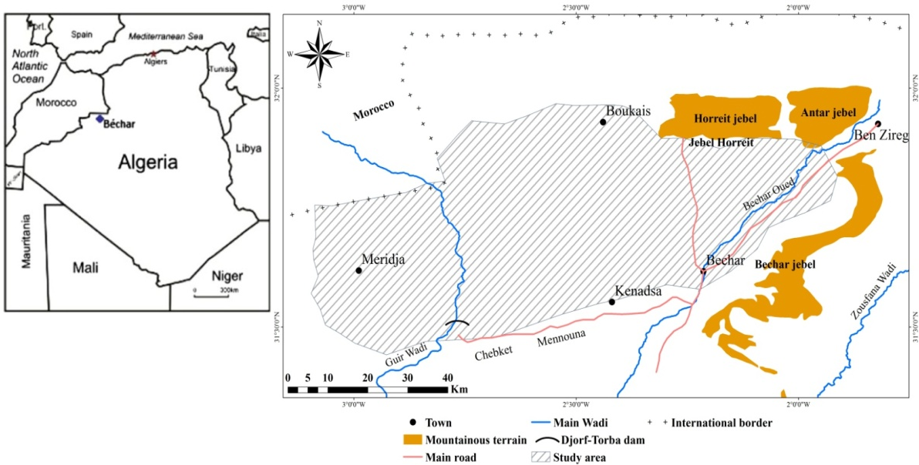
Fig. 1. Locality and geography of the study area (Lachache et al., 2018)
3. Geological and Hydrogeological Setting
The hydrogeological and geological settings of the Béchar area show a dynamic, intricate past shaped by geological processes and events. They have proven that the Béchar region's geological formations span a broad spectrum of terrains, from the Precambrian to the Quaternary (Figure 2) (Perrodon, 1922; Deleau, 1951; Delépine, 1951; Roche, 1973; Loboziak & Nedjari, 1987; Kabour et al., 2011; Kabour et al., 2012; Madani et al., 2025). It consists of a succession of thick limestone beds, followed by stratified limestone. This assemblage is prominently evident in the topography, forming distinct cliffs visible along the Béchar–Kénadsa–DjorfTorba dam road. There are several aquifers and various formations at ground level (Benaradj et al., 2012). The oldest outcrop, whose volcanic rocks prevail (basalt, andesite, dolerite, and rhyolite), is located north of the research region, namely at the level of the town of Boukais (Byramjee & Meindre, 1956; Mebarki et al., 2012), and northeast of the Ben Zireg anticline, where Cambro-Ordovician and Gothlandian deposits are found. At the base of the Koudiat El Haïdoura (Grouz), at the level of Talzaza, the Maïder El Mehadjib, to Soltane El Betoum, and to Ben Zireg, the Devonian is more numerous outcrops (Menchikoff, 1936; Perrodon, 1957). The most widely distributed and well-researched outcrop in our zone is that of the Carboniferous plains (Deleau, 1951; Pareyn, 1961). They form the foundation of the town of Béchar and are the main relief areas in the area (Djebel Antar, Djebel Horreït, Djebel Béchar, and Chabket Mennouna). Conglomerates and polygenic breccias of Permo-Triassic age, followed by Jurassic-era clay-limestone and gypsum lagoon deposits, reflect the sequential orogenesis at Chebket Fendi (Mekkaoui, 2000). The majority of the Cretaceous lands are cuesta formations, such as the DjorfTorba dam, Bezazil El Kelba, and Ras Smar. These are sandstone-clay soils with gypsum, transitioning into marls and massive limestones. The Upper Cretaceous is characterized by evaporitic clays containing halite and gypsum. These folded terrace series are succeeded by a tabular sequence of Tertiary-Quaternary age, with its lower units composed of sandy marls of continental origin and lacustrine limestone beds, likely dating to the early Eocene.

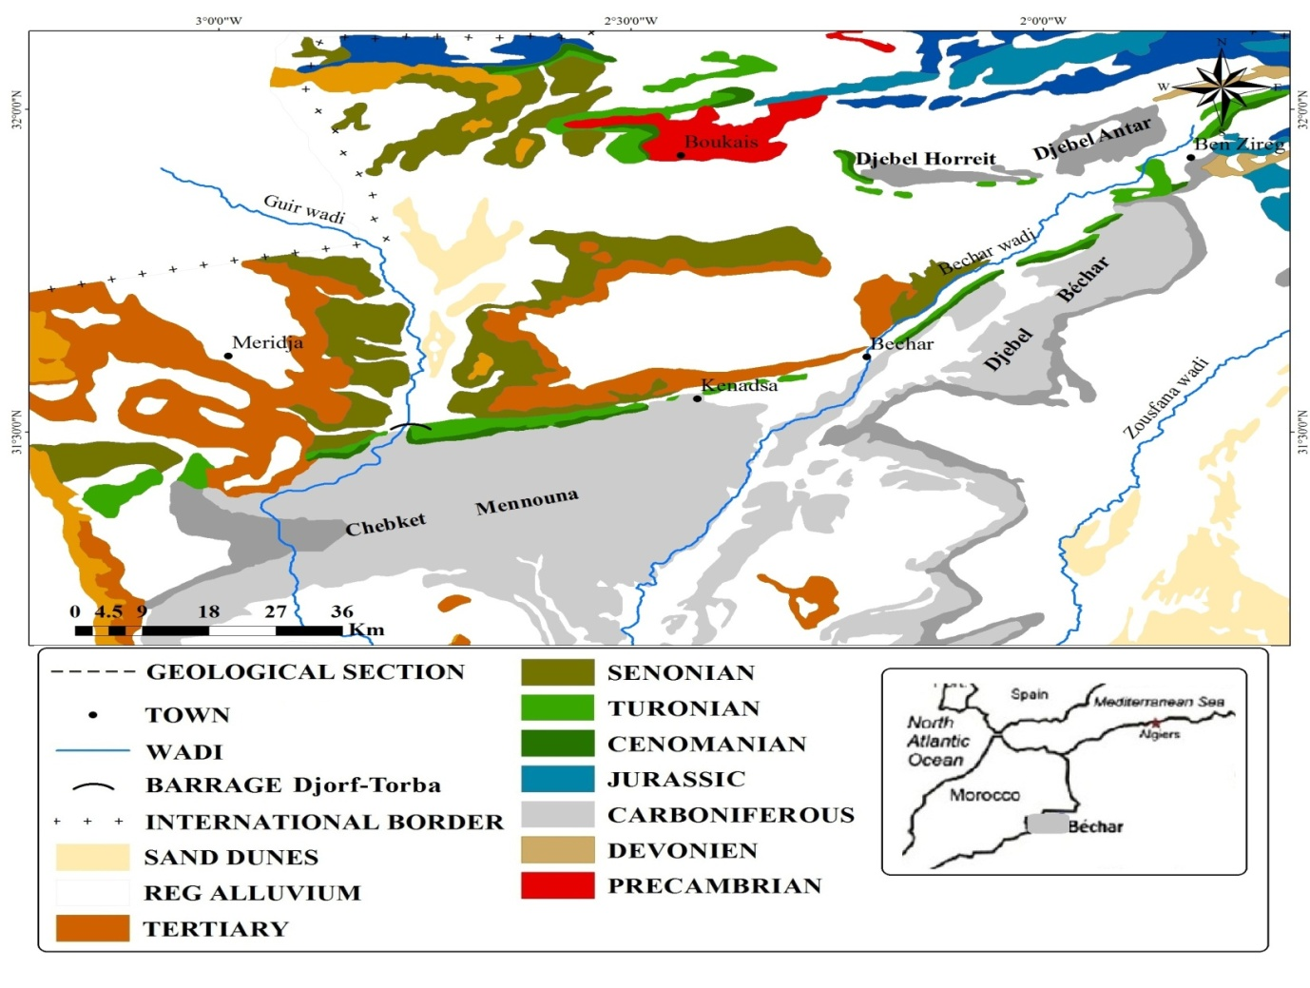
Fig. 2. Geological map of the study area (Lachache et al., 2018)
4. Materials and Methods
4.1. Sampling and Analysis
More than twenty groundwater samples were collected from the Water Resources Directorate of the Wilaya of Béchar. The concentrations of eight major ion types (Na⁺, K⁺, Ca²⁺, Mg²⁺, HCO₃⁻, Cl⁻, SO₄²⁻, NO₃⁻). Certified hydrogeologists from the National Water Resources Agency collected, preserved, and transported all samples while following stringent quality assurance and control (QA/QC) protocols. As required by state regulations, chemical tests were conducted exclusively at this Agency's fully accredited laboratories, which are the only organizations authorized to do groundwater quality assessments in agricultural areas.
After all ion concentration measurements were finished, the ionic balance was calculated using Equation 1 to confirm the AE (analytical errors).
$BI \left(\%\right)=\frac{\left[∑Cations-∑Anions\right]()}{[∑Cations+∑Anions])}x100$ (1)
where:
- positively charged ions, such as calcium, magnesium, sodium, and potassium, are examples of cations, which are measured in milliequivalents per liter (meq/L) and add to the total positive charge in water;
- negatively charged ions such as bicarbonate, carbonate, chloride, sulfate, and nitrate are examples of anions, which are likewise measured in milliequivalents per liter (meq/L) and balance the overall ionic charge in the water sample.

In high-quality analytical data, an acceptable ionic balance usually falls within ±5%. Errors in sampling, analysis, or computation may be indicated if the balance falls outside this range (Nordstrom et al., 1989).
4.2. Analytical Graphics
The Hierarchical Ascending Classification (HAC), Piper, Box plots, Gibb diagrams are essential hydrogeological methods for determining the origin and evolution of groundwater (Amroune et al., 2017; Arroyo-Figueroa et al., 2024). Transforming complex data into a tree structure called a dendrogram makes it easier to classify water samples with similar chemical characteristics. The main objectives are to identify homogeneous water families, clarify the similarities and variations between samples, simplify hydrochemical data, and identify common mineralization sources or processes. The procedure follows specific methodological steps: data normalization, calculation of sample distances, hierarchical clustering, and graphical display.CAH offers independence from the variable count, rapid processing of many variables, and clear visualization of correlations between samples. Understanding the origins and evolution of groundwater is made easier by the dendrogram's interpretation, which assumes that each branch represents a sample group and that the link height indicates the degree of similarity (Bastianoni et al., 2021; Agidi et al., 2022; Djalal et al., 2022).
4.3. Hierarchical Ascending Classification (HAC)
Hierarchical Ascending Classification (HAC) is a clustering technique that begins by treating each sample as a separate cluster and then progressively merges the most similar clusters using a chosen distance metric (e.g., Euclidean distance). This iterative process continues until all samples are grouped into one cluster, producing a dendrogram that visually represents the nested relationships and similarities among the data. In hydrogeochemical studies, HAC is instrumental in identifying homogeneous water groups and revealing underlying geochemical processes or common contamination sources.
4.4. Piper Diagram
The primary chemical components and various groundwater facies are depicted in the Piper diagram, developed by Piper in 1944. Time-spaced analyses or analyses of samples collected from different sites make it possible to visualize the evolution of water as it moves from one facies to another. This diagram proves invaluable in representing diverse analysis groups. It consists of two triangles and a diamond. The two triangles: one for cations and the other for anions, are first filled, followed by the diamond. The values used are expressed in % meq/l.
4.5. Box Plots
Box plots are statistical tools that visually summarize data distribution, highlighting the median, interquartile range, and outliers. They are crucial in hydrogeochemical studies for assessing groundwater quality by identifying variations in ion concentrations, mineral saturation indices, and potential contamination sources. In the Béchar region study, box plots were used to illustrate the variability in saturation indices for key aquifer minerals, aiding understanding of water-chemistry evolution and geochemical processes.
4.6. Gibbs Diagram
Since its creation by Gibbs (1970), the Gibbs diagram has been a crucial tool for clarifying the geochemical processes behind groundwater mineralization. Numerous studies have extensively used this picture to clarify the factors influencing groundwater chemistry (Marandi & Shand, 2018; Sunkari et al., 2020). Three basic elements form the basis of the Gibbs diagram: evaporation, precipitation, and water-rock interaction. These factors are crucial for determining the process of groundwater mineralization.
Gibbs' formulations are crucial for analyzing the diagram:
- Gibbs I is defined as Cl⁻ / (Cl⁻ + HCO₃⁻),
- Gibbs II is defined as (Na⁺ + K⁺) / (Na⁺ + K⁺ + Ca²⁺) expressed in meq/l.

Researchers can infer the dominant geochemical processes in a particular study region by examining the locations of water samples on the Gibbs diagram. This method helps uncover the main mechanisms controlling the chemical development of groundwater by providing crucial insights into the complex interactions among various chemical components.
4.7. Statistical Analyses
The study of groundwater has significantly advanced from traditional graphical methods to more sophisticated multivariate statistical approaches (Piper, 1944; Stiff, 1951; Schoeller, 1962). These statistical techniques provide more precise and thorough information on the chemical makeup of groundwater. Correlation analysis helps assess the relationship between variables, identify elements with similar origins, and uncover shared control mechanisms. Using the correlation matrix and varimax rotation, Principal Component Analysis (PCA) streamlines and categorizes data, highlighting the most crucial variables and tracing the origins of the elements (Granato et al., 2018; Hasan et al., 2021).

5. Results
5.1. Graphical Analytic
5.1.1. Cluster Analysis
The application of cluster analysis to the sampled water data reveals three distinct classes (Figure 3).
- Group one (G1): Characterized by the presence of Calcium Ca²⁺ and Bicarbonate HCO₃⁻.
- Group two (G2): Includes ions Mg²⁺, K⁺, SO₄²⁻, NO₃⁻ that are associated with saline and evaporitic deposits.
- Group three (G3): Dominated by Na²⁺ and Cl⁻, primarily linked to evaporitic and saline formations.

Additionally, this study enabled the water sample locations to be divided into three distinct groups.

Fig. 3. Hierarchical Ascending Classification (HAC) of Physico-Chemical Parameters of Sampled Water
5.2. Piper Diagram
The Piper diagram analysis of groundwater in the Béchar region reveals significant variations in water composition, influenced by climatic, geological, and anthropogenic factors (Figure 4). The study classifies water into three main groups: 35% of samples are dominated by calcium and bicarbonate (Ca - HCO₃⁻), indicating interactions with limestone formations; 40% show high levels of magnesium, potassium, sulfate, and nitrate (Mg - SO₄ - Cl), suggesting evaporation effects and possible agricultural contamination; while 25% are characterized by sodium and chloride (Na - Cl), reflecting saline water intrusion. Overall, 60% of the samples exhibit high evaporation effects, leading to increased salinity, and 20% indicate potential nitrate contamination from human activities.

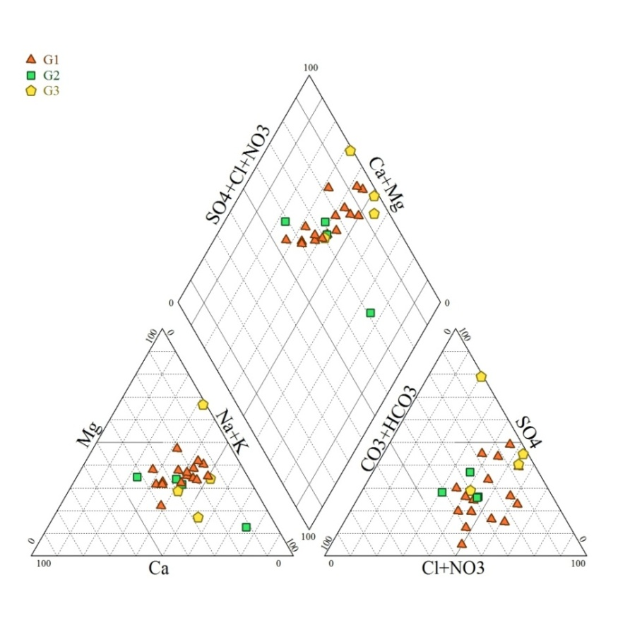
Fig. 4. Piper diagram of groundwater of Béchar region (Lachache et al., 2018)
5.3. Box Plots
Box plots were used to analyze the variability of key hydrochemical parameters in groundwater samples from the Béchar region (Figure 5). This statistical tool provided insights into the distributions, medians, and potential outliers of major ions, including Ca²⁺, Mg²⁺, Na⁺, K⁺, Cl⁻, SO₄²⁻, HCO₃⁻, and NO₃⁻.
The results indicate significant variations in water composition:
- Calcium (Ca²⁺) and Magnesium (Mg²⁺): High variability, reflecting water-rock interactions, particularly with carbonate formations.
- Sodium (Na⁺) and Chloride (Cl⁻): Elevated concentrations in some samples, suggesting evaporative effects and potential saline intrusion.
- Sulfate (SO₄²⁻) and Nitrate (NO₃⁻): Outliers were observed, indicating localized contamination, likely resulting from agricultural activities and industrial sources.

The box plots highlight the heterogeneity of groundwater chemistry in the region, emphasizing the need for continuous monitoring and sustainable management strategies to mitigate salinization and contamination risks.

Fig. 5. Box plots illustrating the variation of the saturation index (IS) of certain minerals of aquifer formations (Lachache et al., 2018)
5.4. Gibbs Diagram
The analysis of the Gibbs diagram facilitated the dominant mechanisms controlling groundwater mineralization in the Béchar region (Figure 6). This diagram establishes the relationship between water chemistry and three major processes: water-rock interaction, evaporation, and precipitation influence.
The results indicate that:
- 60% of the samples fall within the evaporation-dominance zone, with high Na⁺ and Cl⁻ concentrations characteristic of arid environments with intense evapotranspiration.
- 30% of the samples indicate water-rock interaction, with Ca²⁺ and HCO₃⁻ dominant, suggesting carbonate dissolution and ion exchange.
- 10% of the samples indicate precipitation's influence; however, this effect remains limited due to the region's arid climate.

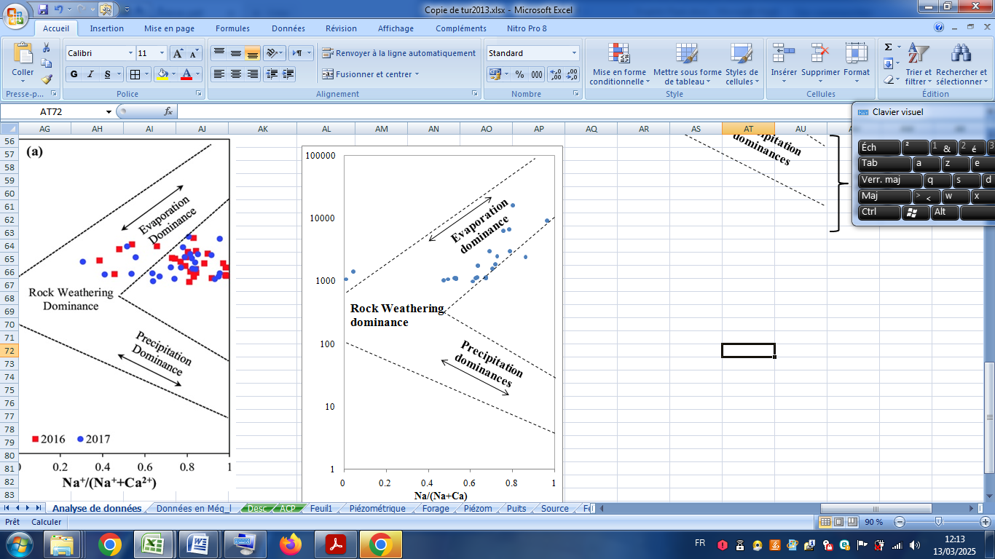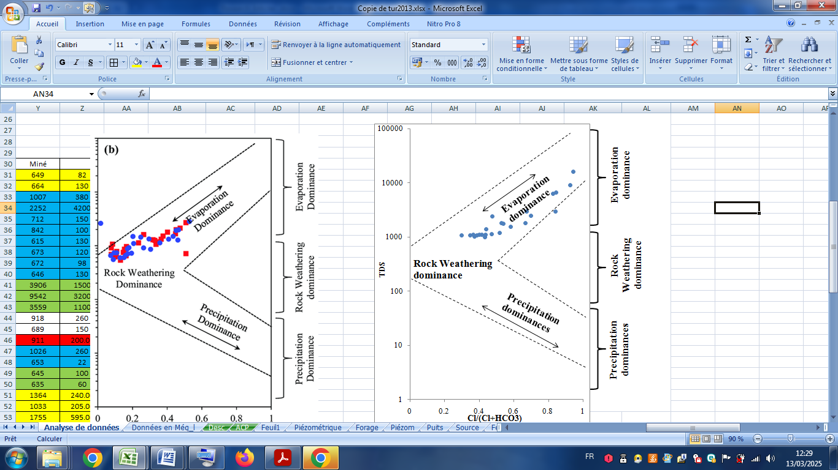
Fig. 6. Gibbs diagram showing the mechanism that is most involved in chemical control of groundwater
5.5. Statistical Analysis
A statistical study (PCA) was performed on 10 variables of over 20 individuals (Table 1) representing the regional aquifer. Analysis of the factorial plane (F1 / F2) indicates that more than 75% of the total variance is expressed. Strong negative correlation is observed between pH and EC, as well as between the electrical conductivity and HCO₃⁻, that is to say any increase of one, implies a decrease in the other and the opposite (Table 1), and a strong correlation between pH and HCO₃⁻, these elements are responsible for the acquisition of mineralization of the groundwater in the aquifer. Concomitantly, the pH is placed in opposition to the EC and the HCO₃⁻ ion on the F1 axis, with a total variance of 29.09%. This can be explained by the fact that the waters have a high electrical conductivity due to the effect of the Upper Cretaceous formations. A strong correlation (0.51 < R < 0.93) was observed between the ions Mg²⁺, Na⁺, Cl⁻, SO₄²⁻, and Ca²⁺. These elements are represented on the same axis of F1, with a total variance of more than 46%. This axis is responsible for the acquisition of the evaporite origin (Halite, gypsum, and dolomite) of the groundwater of this aquifer. Associated with the geological origin by the dissolution of the evaporite formations and the dolomitic limestone. The factor F3 of (PCA) determined by the chemical elements of K⁺ and NO₃⁻ shows that the superficial infiltration of water comes originally from the degradation of organic material (Fertilizers).

Table 1. Correlation matrix of the different parameters of groundwater quality. Values in bold indicating correlation coefficients ((Pearson (n)) (Lachache et al., 2018)
 | pH | EC | Ca²⁺ | Mg²⁺ | Na⁺ | K⁺ | Cl⁻ | SO₄²⁻ | HCO₃⁻ | NO₃⁻
pH | 1
EC | -0.953 | 1
Ca²⁺ | 0.285 | -0.225 | 1
Mg²⁺ | -0.365 | 0.447 | 0.628 | 1
Na⁺ | -0.048 | 0.113 | 0.912 | 0.863 | 1
K⁺ | 0.014 | 0.008 | -0.064 | -0.005 | -0.144 | 1
Cl⁻ | 0.006 | 0.066 | 0.935 | 0.840 | 0.990 | -0.061 | 1
SO₄²⁻ | -0.468 | 0.539 | 0.510 | 0.985 | 0.783 | 0.047 | 0.750 | 1
HCO₃⁻ | 0.810 | -0.811 | 0.128 | -0.337 | -0.191 | 0.311 | -0.116 | -0.396 | 1
NO₃⁻ | 0.206 | -0.051 | 0.201 | 0.285 | 0.238 | -0.356 | 0.225 | 0.218 | 0.026 | 1
Note: EC: Electrical conductivity of water
6. Discussion
This study, conducted in Algeria's Béchar region, provides important new insights into the processes of groundwater mineralization, which are crucial for managing water resources sustainably in dry areas. Particularly in regions like Béchar that rely significantly on groundwater, maintaining the quality of the resource and ensuring sustainable resource management requires an understanding of the mechanisms governing groundwater mineralization. The results show that geological formations and human activity have a substantial impact on groundwater quality, resulting in different hydrochemical groups with different degrees of mineralization. This study enhances our understanding of local hydrogeological processes and provides insightful comparisons with comparable circumstances in other dry locations worldwide. Comparing the groundwater mineralization patterns in El-Bayadh and Naama with those in Béchar reveals several similarities. Similar geological formations that affect groundwater chemistry can be found in both areas. El Bayadh, for example, has significant levels of mineralization due to the preponderance of gypsum and limestone rocks. Similarly, Béchar's groundwater is influenced by saline deposits and evaporation, resulting in elevated salinity (Derdour et al., 2023). Due to comparable climatic conditions and human demands, excessive salinity in Tunisia, especially in the Chott Djerad area, compromises groundwater quality (Kraiem et al., 2014). Comparing the Béchar region with other dry areas, including the Central Valley in California, USA, and the Atacama Desert in Chile, is one way to examine human influences on groundwater quality (Herrera et al., 2018). The Central Valley of California has experienced severe salinization and groundwater depletion due to extensive agricultural activities (Burow et al., 2013). Due to fertilizer application and soil salt leaching, which can pollute aquifers, the dependence on irrigation has raised mineralization levels. This scenario is similar to the difficulties in Béchar, where over extraction and agricultural needs have raised saline levels and raised worries about the quality of the water. This is similar to the situation in Béchar, where excessive salt levels endanger groundwater's suitability for home and agricultural uses.
The strength of this study lies in its comprehensive approach, utilizing a robust dataset of over 20 groundwater samples analyzed using multivariate statistical methods (Figure 7). This methodological rigor enhances the reliability of the findings and establishes a benchmark for future research in similar contexts. The innovation of this research stems from its detailed contextual analysis, which emphasizes the dynamic interaction between natural geological processes and anthropogenic activities. This study makes a substantial contribution to the existing corpus of information on groundwater management in dry areas. In addition to offering a framework for further research to lessen the effects of human activity and climate change on essential water supplies, it emphasizes the significance of sustainable behaviors. In light of mounting environmental pressures, the results serve as a reminder that efficient management techniques are crucial to maintaining groundwater quality and guaranteeing its availability for future generations. The results of the Cluster Analysis, along with the various types of water identified, are presented in Figure 7, which succinctly summarizes the study's findings. This image provides a comprehensive picture of the hydrogeochemical processes and changes in groundwater quality across the research region by illustrating the distribution of the different water groups, including recharge zones, areas of reverse ion exchange, and halite formations.

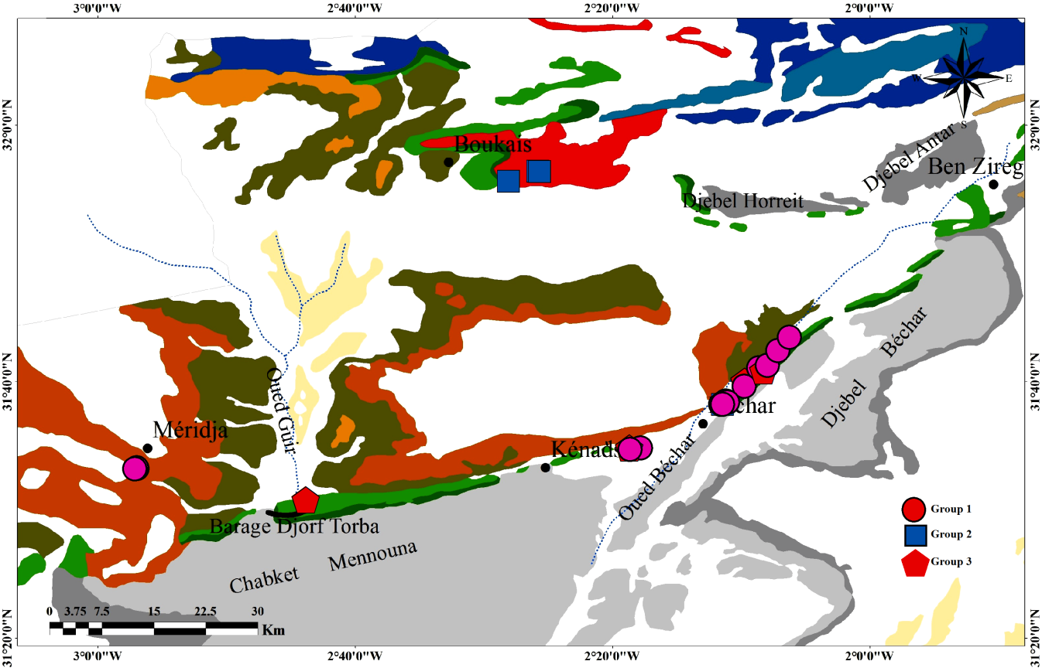
Fig. 7. Overview of Groundwater Hydrogeochemistry in the study area
7. Conclusion
The study on groundwater quality in the Béchar region highlights significant challenges in managing water resources in arid environments. Given the region's heavy reliance on groundwater, understanding the mechanisms governing its mineralization is essential to sustainable water resource management. The findings indicate that groundwater quality is strongly influenced by geological formations and human activities, resulting in distinct hydrochemical groups with varying degrees of mineralization.
The research identified three main hydrochemical groups: (i) calcium-bicarbonate (Ca - HCO₃) waters, reflecting interactions with limestone formations; (ii) magnesium, potassium, sulfate, and nitrate-dominant waters (Mg - SO₄ - Cl), associated with evaporitic deposits and potential agricultural contamination; and (iii) highly saline sodium-chloride water (Na - Cl), influenced by saline water intrusion and evaporitic formations. The analysis showed that 60% of samples exhibited high evaporation effects, contributing to salinity, while 20% indicated potential nitrate contamination from human activities.
The primary objective of this study is twofold: to assess water quality and to contribute to protecting an ecosystem critical to environmental sustainability and human well-being. However, this research encountered several significant limitations. Data collection was hindered by geopolitical constraints, particularly in the border area, which restricted access to certain critical zones, resulting in incomplete datasets. Additionally, local farmers showed notable reluctance to allow access to their farms for sampling. These challenges may limit the comprehensiveness and applicability of the findings to the broader Béchar region. Nevertheless, this research represents a valuable tool for policymakers involved in water resource management. The insights gained can inform strategies to promote sustainable groundwater management and develop tailored protection measures to address the specific challenges faced by the study area. Future studies should aim to overcome current data-collection challenges by adopting innovative approaches, such as remote sensing or community engagement initiatives that foster local cooperation. Furthermore, integrating advanced techniques, such as isotopic analysis, could facilitate a more comprehensive assessment. Longitudinal studies are also recommended to monitor the evolution of environmental conditions in response to both anthropogenic activities and environmental pressures.

References
Agidi, B., Akakuru, C., Aigbadon, O., Schoeneich, K., & Esomonu, I. (2022). Correction to: Water quality index, hydrogeochemical facies and pollution index of groundwater around Middle Benue Trough, Nigeria. International Journal of Energy and Water Resources, 8(2), 449. https://doi.org/10.1007/s42108-022-00190-4
Amroune, A., Boudoukha, A., Boumazbeur, A., Benaabidate, L., & Guastaldi, E. (2017). Groundwater geochemistry and environmental isotopes of the Hodna area, Southeastern Algeria. Desalination and Water Treatment, 73(2), 225–236. https://doi.org/10.5004/dwt.2017.20642
Arroyo-Figueroa, C., Chalá, C., Gutiérrez-Ribon, G., & Quiñones-Bolaños, E. (2024). A Framework to Evaluate Groundwater Quality and the Relationship between Rock Weathering and Groundwater Hydrogeochemistry in the Tropical Zone: A Case Study of Coastal Aquifer Arroyo Grande, in the Caribbean Region of Colombia. Water, 16(12), 1650. https://doi.org/10.3390/w16121650
Bastianoni, A., Guastaldi, E., Barabgli, A., Bernardinetti, S., Zirulia, A., Brancae, M., & Colonna, T. (2021). Multivariate Analysis Applied to Aquifer Hydrogeochemical Evaluation: A Case Study in the Coastal Significant Subterranean Water Body between "Cecina River and San Vincenzo", Tuscany (Italy). Applied Sciences, 11(16), 7595. https://doi.org/10.3390/app11167595
Belkendila, A., Habia, M., & Morslib, B., (2018). Evaluation of the physico-chemical quality of groundwater in arid areas: case study (watershed of the Oued Bechar) in Bechar- Kénadsa Region. Desalination and Water Treatment, 107(6), 136–146.
Benaradj, A., Boucherit, H., Bouzza, M., Baghdadi, D., & Aibout, F. (2012). Geological Features of the Saharan Atlas in Oran (Béchar). 2nd International Colloquium on Sahara Geology – Mineral, Hydrocarbon, and Water Resources, Ouargla, Algeria.
Burow, K.R., Jurgens, B.C., Belitz, K., & Dubrovsky, N. (2013). Assessment of regional change in nitrate concentrations in groundwater in the Central Valley, California, USA, 1950s–2000s. Environmental earth sciences, 69(8), 2609–2621. https://doi.org/10.1007/s12665-012-2082-4
Byramjee, R., & Meindre, M. (1956). The Guettara Manganese Deposit. Manganese Symposium. 20th International Geological Congress, University of Mexico, Mexico.
Deleau, P. (1951). Les bassins Houillers du Sud Oranais dans la région de Colomb-Béchar-Abadla (Coalfields of South Oran in the region of Colomb-Bechar-Abadla). Série 2 Strat N°20, Bulletin de service de la carte géologique de l’Algérie, France, 294p. (in French)
Delépine, G. (1951). Studies of the Devonian and Carboniferous of Western Europe and North Africa. Proceedings of the Geologists' Association, 62(2), 140–166. https://doi.org/10.1016/S0016-7878(51)80005-1
Derdour, A., Abdo, H.G., Almohamad, H., Alodah, A., Al Dughairi, A.A., Ghoneim, S.S., & Ali, E. (2023). Prediction of groundwater quality index using classification techniques in arid environments. Sustainability, 15(12), 9687. https://doi.org/10.3390/su15129687
Djalal AB., Abdelhak M., & Lachache S. (2022). Physical-chemical characterisation of the urban wastewater – case study of the Boumerdes region, North – Algeria. Journal of water and land development, 54(VII-IX), 243–250.
Granato, D., Santos, J.S., Escher, G.B., Ferreira, B.L., & Maggio, R.M. (2018). Use of principal component analysis (PCA) and hierarchical cluster analysis (HCA) for multivariate association between bioactive compounds and functional properties in foods: A critical erspective. Trends in Food Science & Technology, 72(83–90). https://doi.org/10.1016/j.tifs.2017.12.006
Hasan, B.M.S., & Abdulazeez, A.M. (2021). A review of principal component analysis algorithm for dimensionality reduction. Journal of Soft Computing and Data Mining, 2(1), 20–30.
Herrera, C., Gamboa, C., Custodio, E., & Jordan, T. (2018). Groundwater origin and recharge in the hyperarid Cordillera de la Costa, Atacama Desert, northern Chile. Science of the Total Environment, 624(114–132).
Hosni A., Derdour A., Nouri T., Moussaoui T., Zahi F., & Reghais A. (2024). Cultivating sustainability: A multi-assessment of groundwater quality and irrigation suitability in the arid agricultural district of Dzira (Ksour Mountains, Algeria). Environmental Monitoring and Assessment, 196(10), 886.
Kabour A., Heni A., Chebbah L., & Sadek Y. (2012). Wastewater Discharge Impact on Groundwater Quality of Béchar City, Southwestern Algeria: An Anthropogenic Activities Mapping Approach. Procedia Engineering, 33(10), 242–247.
Kabour, A., Hani, A., Mekkaoui, A., & Chebbah L. (2011). Evaluation and Management of Water Resources in an Arid Zone: The Case of Béchar City (Southwest Algeria). LARHYSS Journal, 9(2), 7–19.
Kendouci M., Bendida A., Mebarki S., & Kharroubi B. (2019). Study of the management efficiency of the drinking water supply in arid areas: case of Bechar city (southwest of Algeria). Applied Water Science, 11(102), 1–12.
Kraiem, Z., Zouari, K., Chkir, N., & Agoune, A. (2014). Geochemical characteristics of arid shallow aquifers in Chott Djerid, south-western Tunisia. Journal of Hydro-environment research, 8(4), 460–473.
Lachache, S., Derdour, A., Maazouzi, I., & Amroune, A. (2023). Statistical approach of groundwater quality assessment at Naama region, southwest Algeria. LARHYSS Journal, 55(55), 125–144.
Lachache, S., Nabou, M., Merzougui, T., & Amroune, A. (2018). Hydrochemistry and origin of principal major elements in the groundwater of the Béchar–Kénadsa basin in arid zone, Southwest of Algeria. Journal of water and land development, 36(I-III), 77–87.
Liu, Q., Sun, Y., Xu, Z., & Xu, G. (2018). Application of the comprehensive identification model in analyzing the source of water inrush. Arabian Journal of Geosciences, 11(5), 1–10.
Loboziak, S., & Nedjari, A. (1987). Palynologie des formations houillères du bassin de Béchar-Abadla (SW oranais, Algérie). Journal of African Earth Sciences, 6(2), 133–140.
Madani, B., & Bernard, L., (2025). Systematics and taphonomy of Pliocene Gastropoda (Mollusca) from the Dahra Mountains, NW Algeria. Annales de Paléontologie, 111(1), 102–122.
Marandi, A., & Shand, P. (2018). Groundwater chemistry and the Gibbs Diagram. Applied Geochemistry, 97, 209–212. https://doi.org/10.1016/j.apgeochem.2018.07.009
Mebarki, S., Kendouci, M., & Bendida A. (2024). Monitoring the spatial evolution of groundwater quality during its diversion in the drinking water supply network in arid areas, case of Bechar city (Algeria Sahara). Applied Water Science, 14(118), 1–18.
Mebarki, S., Kendouci, M., & Bendida, A. (2024). Monitoring the spatial evolution of groundwater quality during its diversion in the drinking water supply network in arid areas, case of Bechar city (Algeria Sahara). Applied Water Science, 114(14), 118–138.
Mekkaoui, A. (2000). Margin of the Atlas Trough–Saharan Platform During the Lower and Middle Jurassic (Southern Grouz, Charef-Fendi), Southwestern Algeria. University of Oran, Algeria. (in Algeria)
Menchikoff, N. (1936). Geological Studies on the Algerian-Moroccan Southern Borderlands. Journal of Physical Geography and Dynamic Geology, 2(1), 131–149.
Milano, M., Ruelland, D., Fernandez, S., Dezetter, A., Fabre, J., & Servat, E. (2013). Current state of Mediterranean water resources and future trends under climatic and anthropogenic changes. Hydrological Sciences Journal, 58(3), 498–518.
Mokaddem, I., Belhachemi, M., Merzougui, T., & Lachache, S. (2018). Hydrochemical assessment and groundwater pollution parameters in arid zone: Case of the Turonian aquifer in Béchar region, southwestern Algeria. Journal of water and land development, 39(X-XII), 109–117.
Nordstrom, D.K., Ball, J.W., Donahoe, R.J., & Whittemore, D. (1989). Groundwater chemistry and water-rock interactions at Stripa. Geochimica et Cosmochimica Acta, 53(8), 1727–1740.
Oubadi, M., Hamou, A., Faci., M., & Farhi, Y. (2020). Impacts of Heatwaves on Environmental Constraints in the Béchar Region. Algerian Journal of Arid Regions, 14(1), 80–101.
Perrodon, A. (1922). Geological Study of the Neogene Sublittoral Basins of Western Algeria. Geological Map Service of Algeria. (in Algeria)
Perrodon, A. (1957). Geological Study of the Neogene Sublittoral Basins of Western Algeria, University of Lorraine, France. (in French)
Piper, A.M. (1944). A graphic procedure in the geochemical interpretation of water-analyses. . Eos, Transactions American Geophysical Union, 25(6), 914–928.
Rabah, M., Zitouni, F., & Messaoudi, K. (2012). Climate Change and Water Availability: A Case Study on the Evolution of Aquifer Levels in the Béchar Region, Algeria. Journal d’Hydrologie Africaine, 3(1), 34–48.
Roche, M.A. (1973). Hydrogeology of the high Saoura (Sahara Occidental North), CNRS, France. (in French)
Mebarki S. (2012). Hydrogeological Characteristics of the Jurassic Aquifer in the Mougheul Plain (Northern Ksour, Béchar), University of Béchar, Algeria. (in Algeria)
Sadat, S., Mansou, H., Mekkaoui, A., & Merzougui, T. (2020). Identification and evolution of the Turonian aquifer case study: Cretaceous basin of Béchar, southwestern Algeria. Journal of water and land development, 46(VII-IX), 190–199.
Schoeller, H. (1962). Les eaux souterraines: hydrologie dynamique et chimique, recherche, exploitation et évaluation des ressources, France. (in French)
Seddiki, S., & Cherif, El. (2021). Modeling of water demand management in an arid area: case of Bechar city. Applied Water Science, 11(87), 1–10.
Shi, S., Xie., X., Bu, L., Li, L., & Zhou., Z. (2018). Hazard-based evaluation model of water inrush isaster sources in karst tunnels and its engineering application. Environmental earth sciences, 77(09), 1–13.
Stiff, Jr.A. (1951). The interpretation of chemical water analysis by means of patterns. Journal of petroleum technology, 3(10), 13–15.
Sunkari, E.D., Abu, M., Zango, M.S., & Wani, A.M.L. (2020). Hydrogeochemical characterization and assessment of groundwater quality in the Kwahu-Bombouaka Group of the Voltaian Supergroup, Ghana. Journal of African Earth Sciences, 169, 103899.
Wang, Y., Shi, L., Wang, M., & Liu, T. (2020). Hydrochemical analysis and discrimination of mine water source of the Jiaojia gold mine area. China. Environmental earth sciences, 79(10), 1–14.
Yihdego, Y., & Khalil, A. (2017). Economic and environmental management of water resources: perspective of groundwater. Global journal Human-Social Science, 6(2), 45–51.

