
 | Rocznik Ochrona Środowiska
 | Volume 28 | Year 2026 ISSN 2720-7501 | pp. 139-152
 | https://doi.org/10.54740/ros.2026.011 open access
 | Received: February 2025 Accepted: March 2026 Published: March 2026
Climate-Induced Evaporation and Salinity Dynamics in Southwestern Türkiye's Endorheic Lakes: A Multi-Year Remote Sensing and Hydrostatistical Analysis
Orhun Soydan
Landscape Architecture Department, Faculty of Engineering and Architecture,
Burdur Mehmet Akif Ersoy University, Burdur, Türkiye
https://orcid.org/0000-0003-0723-921X
corresponding author's e-mail: osoydan@mehmetakif.edu.tr
Abstract: Closed-basin lakes in semi-arid Mediterranean regions are critical indicators of hydroclimatic change. This study quantifies the dynamics of lake surface area (LSA) for six strategic Turkish lakes (Burdur, Salda, Yarisli, Karatas, Acigol, and Eber) from 2010 to 2024. Using multi-sensor satellite imagery (Landsat/Sentinel-2) and ERA5-Land climate data, we analyzed the impact of precipitation, evapotranspiration (ET₀), and the SPEI-12 index. Results reveal significant LSA declines across all lakes, most severely in Lake Burdur (-32.4%). Strong correlations between LSA and SPEI-12 (r up to 0.82) and ET₀ highlight atmospheric water demand as a primary driver of shrinkage. Multivariate analysis categorizes the lakes into three vulnerability typologies, identifying Burdur and Eber as highly sensitive, while Salda remains relatively resilient. These findings demonstrate that coupled drought persistence and increasing evaporative stress are accelerating lake desiccation, necessitating urgent, basin-specific climate-adaptive management strategies to preserve these vulnerable Mediterranean ecosystems.
Keywords: Lake surface area dynamics, drought sensitivity, SPEI, remote sensing, multivariate analysis

1. Introduction
Endorheic, or closed-basin, lakes are fundamental components of the Mediterranean hydroclimatic system, providing crucial freshwater resources and supporting a variety of ecological functions. Unlike open-basin lakes, endorheic systems lack surface outflows, making them particularly sensitive to the balance between precipitation, evaporation, and catchment inflow (Liu et al., 2023; Jiao et al., 2024). This hydrological isolation renders them highly vulnerable to climate variability, anthropogenic pressures, and changes in land use, often resulting in pronounced shifts in water level, salinity, and biogeochemical processes (Johnson et al., 2001; Kumar et al., 2024). In semi-arid Mediterranean climates, even minor variations in rainfall or temperature can trigger significant alterations in lake surface area and water quality, with cascading effects on ecosystem services, biodiversity, and regional water management strategies (Wang et al., 2019; Papadimitriou et al., 2021).
Southwestern Türkiye hosts a cluster of endorheic lakes, including Burdur, Salda, Yarisli, Karatas, Acigol, and Eber, each exhibiting unique morphological, hydrological, and chemical characteristics. These lakes differ in depth, catchment area, inflow sources, and surrounding land cover, producing heterogeneous responses to climatic and anthropogenic drivers (Orfanidis et al., 2005; Zhang et al., 2017). For instance, shallow and small surface area lakes such as Salda and Yarisli are more prone to rapid evaporation and salinity accumulation, whereas deeper and larger lakes like Burdur demonstrate greater buffering capacity but remain susceptible to long-term hydroclimatic shifts. Recent climatic trends in the Mediterranean region indicate increasing temperatures, decreasing or highly variable precipitation, and intensified frequency of droughts, all of which exacerbate hydrological stress on these endorheic basins (Noto et al., 2023).
Understanding the interactions between climate drivers, lake water balance, and salinity dynamics is essential for both scientific insight and practical management. Evaporation, precipitation, inflow, and groundwater exchange collectively determine lake volume and ionic concentration, influencing parameters such as total dissolved solids (TDS), electrical conductivity (EC), and salinity index (SI) (Albarqouni et al., 2022). Enhanced evaporation due to rising temperatures can increase salinity levels, potentially causing shifts in aquatic ecosystems, including the decline of freshwater species and proliferation of halophilic organisms (Yapiyev et al., 2024). Furthermore, these changes can affect regional water quality for human consumption, agriculture, and industry, highlighting the dual environmental and socio-economic implications of endorheic lake desiccation (Wang et al., 2019).
Remote sensing technologies have revolutionized the monitoring of lake dynamics, providing consistent, spatially comprehensive, and multi-temporal datasets. The Normalized Difference Water Index (NDWI) derived from Sentinel-2 imagery enables accurate detection of surface water extent and seasonal fluctuations, while MODIS-derived land surface temperature (LST) provides valuable insight into thermal regimes that affect evaporation rates (Albarqouni et al., 2022). When integrated with in-situ hydrochemical measurements such as TDS and EC, these remote sensing products enable robust analyses of lake hydrology, salinity patterns, and their temporal evolution under varying climate conditions (Papadimitriou et al., 2021). Such integrated approaches are critical in semi-arid environments where field measurements alone may be insufficient to capture spatial heterogeneity and long-term trends.
In addition to descriptive monitoring, advanced statistical and multivariate techniques enhance the understanding of complex lake systems. Mann–Kendall trend analysis and Sen's slope estimator allow the detection and quantification of monotonic trends in temperature, NDWI, and salinity indices over time, while Pearson correlation and multiple regression analyses identify the relative contributions of climate variables to observed hydrochemical changes (Zhang et al., 2017; Wang et al., 2019). Principal Component Analysis (PCA) and hierarchical clustering can classify lakes based on hydrothermal balance and salinity dynamics, highlighting differential vulnerability across basins and informing targeted management strategies (Orfanidis et al., 2005).
These methods collectively facilitate an integrated assessment that links climate variability to physical and chemical lake responses, providing a quantitative foundation for adaptive water management and conservation planning. Despite their importance, southwestern Türkiye's endorheic lakes have received limited attention in studies that combine remote sensing, hydrochemical monitoring, and long-term statistical modeling. Most research to date has focused on localized water quality issues, nutrient loading, or eutrophication dynamics within single lakes (Soydan et al., 2025), leaving a significant knowledge gap regarding cross-basin comparisons of climate-driven evaporation and salinity trends.
This lack of integrative analysis limits policymakers' and environmental managers' ability to anticipate the impacts of future aridification, implement mitigation strategies, and ensure the resilience of lake ecosystems amid ongoing climate change. Addressing this gap, the present study aims to perform a comprehensive, multi-year assessment of climate-driven evaporation and salinity dynamics across six endorheic lakes in southwestern Türkiye (Burdur, Salda, Yarisli, Karatas, Acigol, and Eber) for the period 2010–2024. The study employs an integrated approach combining multi-temporal remote sensing (NDWI and LST), hydrochemical measurements (TDS and EC), and meteorological data (ERA5), alongside robust statistical analyses, including trend detection, PCA, correlation, and multiple regression. By quantifying changes in lake surface area, salinity, and hydrothermal balance, this research seeks to: (1) identify lake-specific vulnerabilities to climatic warming, (2) elucidate the relative roles of evaporation, precipitation, and inflow in driving salinity dynamics, (3) classify lakes according to hydrothermal and salinity patterns, and (4) provide scientifically grounded recommendations for sustainable management and conservation of Mediterranean endorheic lakes under increasing aridification.
Recent studies have increasingly highlighted the sensitivity of lake systems to climate variability and hydrological stress, particularly in semi-arid and Mediterranean environments where water balance is strongly controlled by precipitation and evaporation dynamics (Akay, 2025). Advances in satellite remote sensing and hydroclimatic monitoring have enabled researchers to assess long-term changes in lake surface area, storage, and hydrological variability at regional and global scales. Recent investigations demonstrate that climate-driven fluctuations in lake extent and storage are becoming more pronounced due to intensifying drought conditions and increasing temperature trends (Yang et al., 2024; Woolway et al., 2025). Furthermore, several studies emphasize that closed-basin lake systems are particularly vulnerable to hydroclimatic variability because they lack surface outflows and therefore respond rapidly to climatic drivers and catchment-scale water balance changes (Ekpetere et al., 2023; Wang et al., 2023). Recent global assessments integrating satellite observations with climatic datasets also highlight the growing importance of multi-temporal remote sensing approaches for understanding climate-driven lake dynamics and hydrological vulnerability across arid and semi-arid regions (Hou et al., 2025; Li et al., 2025). The outcomes of this study are expected to contribute to the broader understanding of Mediterranean closed-basin hydrology, informing both regional water resource management and global discussions on climate adaptation strategies in semi-arid endorheic systems (Bouarfa et al., 2025; Lu et al., 2025). By integrating remote sensing, hydrochemical analysis, and advanced statistical modeling, this research not only addresses critical environmental challenges in southwestern Türkiye but also establishes a methodological framework applicable to other endorheic basins worldwide.
2. Materials and Method
This study focused on the inland lakes of Türkiye's Mediterranean closed basins, namely Burdur, Salda, Yarisli, Karatas, Acigol, and Eber, covering the period 2010–2024. The main objective was to evaluate the hydrological, physicochemical, and ecological status of these lakes under semi-arid conditions, integrating surface water dynamics, water quality, climate variability, land-use changes, and anthropogenic pressures. Long-term water quality parameters—including dissolved oxygen (DO), biochemical oxygen demand (BOD₅), chemical oxygen demand (COD), total phosphorus (TP), total nitrogen (TN), ammonium (NH₄⁺), and chlorophyll-a—were obtained from the State Hydraulic Works (DSİ) and the Ministry of Environment, Urbanization, and Climate Change.
Meteorological variables such as precipitation (P), temperature (T), wind speed (u₂), vapor pressure deficit (VPD), and net radiation (Rn) were retrieved from the ERA5-Land reanalysis at 0.1° resolution, allowing for the assessment of spatially continuous climatic trends across the basins (Hoffmann et al., 2025). Surface water extraction was performed using multi-sensor imagery, including Landsat TM/ETM+/OLI and Sentinel-2 MSI. All scenes were atmospherically corrected to surface reflectance using LEDAPS (Landsat) and Sen2Cor (Sentinel-2) processors. Multiple spectral water indices were employed to maximize detection accuracy and minimize misclassification. The Normalized Difference Water Index (NDWI) was applied to enhance water–vegetation contrast:
$$NDWI=\frac{(Green-NIR)}{(Green+NIR)}$$
where Green and NIR represent reflectance in the green and near-infrared bands, respectively (McFeeters 1996). The Modified NDWI (MNDWI) was used to reduce built-up misclassification:
$$MNDWI=\frac{(Green-SWIR)}{(Green+SWIR)}$$
AWEI_sh (Automated Water Extraction Index for shadows) minimized shadows and urban noise:
$${AWEI}_{sh}= 4\left(Green-SWIR\right)-(0.25NIR+2.75 SWIR)$$
NDMI (Normalized Difference Moisture Index) was used to quantify surface moisture variability relevant to wetland and shallow water detection:
$$NDMI=\frac{(NIR-SWIR)}{(NIR+SWIR)}$$
A pixel was classified as water when at least three indices exceeded their respective thresholds (voting ensemble). Lake boundaries were vectorized via 8-neighborhood connectivity and simplified using the Douglas–Peucker algorithm to reduce topological complexity:
$$d=\frac{\left|{Ax}_{0}+ {By}_{0}+C \right|}{\sqrt{A^{2}+B^{2}}}$$
where points with perpendicular distance $d$below tolerance were removed (Douglas & Peucker, 1973). Flow direction (FD) for hydrological analyses was determined as:
$$FD(i,j)=arg\min_{k∈N}\left(Z_{i,j}-Z_{k}\right)$$
where Z represents elevation, and FD (i,j) designates the downslope neighbor cell receiving flow from cell (i,j) (O'Callaghan & Mark, 1984). Annual lake area ($A_{t}$) was computed as the sum of water pixels:
$$A_{t}=\sum_{i=1}^{n}{\left(h_{i}. ∆A_{i}\right)}$$
where $h_{i}$ is the mean depth increment between successive area polygons, providing a physically consistent estimation of water volume change (Downing et al., 2006). Reference evapotranspiration (ET₀) was estimated using the FAO-56 Penman–Monteith equation, appropriate for semi-arid Mediterranean climates:
$${ET}_{0}=\frac{0.408∆\left(R_{n}-G\right)+ γ\frac{900}{T+273}u_{2}\left(e_{s}-e_{a}\right)}{∆+ γ\left(1+0,.34u_{2}\right)}$$
where Δ is the slope of the saturation vapor pressure curve, γ the psychrometric constant, G soil heat flux, $u_{2}$wind speed, and $e_{s}-e_{a}$vapor pressure deficit (Allen et al., 1998). ET₀ was combined with precipitation to calculate the Standardized Precipitation Evapotranspiration Index (SPEI), capturing drought intensity and water deficit conditions:
$D_{t}=P_{t}-{ET}_{0,t}$, $f\left(x\right)=\frac{β}{a}\left(α-\left.\left(x- \right.γ\right))^{β-1}\left[1+ \left(α\left(x-γ))^{β}]^{-2}\right.\right.\right.\right.$, $SPEI=\frac{D_{t}-μ}{σ}$
where $D_{t}$ was fitted to a three-parameter log-logistic distribution and standardized by mean (μ) and standard deviation (σ) (Vicente-Serrano et al., 2010). SPEI enables multi-scale drought detection, which is critical for assessing hydrological stress in closed-basin lakes. Land-use/land-cover (LULC) transitions were quantified using CORINE datasets harmonized to 30 m resolution. Transition matrices were computed as:
$$C_{ij}=\frac{A_{ij}}{\sum_{j}{A_{ij}}}$$
where $A_{ij}$ denotes the area transitioning from class i to j, allowing assessment of anthropogenic pressure such as agricultural expansion or urbanization (Feranec et al., 2010). Shoreline retreat and desiccation intensity were evaluated using endpoint rate (SCR), net shoreline movement (NSM), and Desiccation Intensity Index (DII):
$SCR=\frac{D_{2}-D_{1}}{t}$, $NSM=D_{2}-D_{1}$, ${DII}_{t}=\frac{A_{0- A_{t}}}{A_{0}}*100$
where $D_{1},D_{2}$ are orthogonal distances from a fixed baseline and $A_{0},A_{t}$are the initial and current lake areas. This approach captures both spatial and volumetric shoreline retreat. Trend analyses employed Mann–Kendall (MK) and Sen's slope estimator:
$S=\sum_{i=1}^{n-1}{\sum_{j=i+1}^{n}{sgn\left(x_{j}-x_{i}\right)}}$, $VAR(S)=\frac{n \left(n-1\right)(2n+5)}{18}$, $β=median \left(\frac{x_{j}-xi}{j-i}\right)$
Multivariate statistics included Pearson correlation, Principal Component Analysis (PCA), and Hierarchical Clustering Analysis (HCA):
$r=\frac{\sum{\left(X_{i}-Ẋ\right) \left(Y_{i}-Ẏ\right)}}{\sqrt{\sum{\left(X_{i}-\right.}}Ẋ)^{2}\sum{\left(Y_{i}-Ẏ)^{2}\right.}}$, $R=Q∆Q^{-1}$, $F=ZQ$, $D_{ij}=\left(x_{i}-x_{j}\right)$
These techniques identify environmental gradients, classify lake typologies, and detect anthropogenic impact patterns. Predictive modeling used multiple linear regression and generalized additive models (GAM) to link climate, land-use, and hydrological predictors to lake surface area:
$A_{t}=β_{0}+\sum_{k=1}^{p}{β_{k}x_{k,t}+ϵ_{t}}$, $A_{t}=β_{0}+ \sum_{k=1}^{p}{f_{k}\left(X_{k,t}\right)+∈_{t}}$
where $f_{k}$ are smoothing splines. Model selection employed the Akaike Information Criterion (AIC):
$$AIC=2k-2ln⁡(L)$$
Finally, water quality and ecological indices were computed to assess lake vulnerability:
$WOI=\frac{\sum{w_{i}q_{i}}}{\sum{w_{i}}}$, $TLI=\frac{{TLH}_{Chl}+{TLH}_{TP}+{TLI}_{TN}}{3}$, $API=\sum{w_{K}N_{K}}$
$$ILVI=\sqrt{WQ^{2}+HM^{2}+D^{2}+{API}^{2}}$$
All remote sensing analyses were conducted in Google Earth Engine; GIS analyses in ArcGIS Pro 3.2 and QGIS 3.34; statistical analyses in R (mgcv, Kendall, SPEI, raster, rgdal, tidyverse). This integrative methodology enables a comprehensive assessment of the hydrological, climatic, and anthropogenic drivers affecting Mediterranean closed-basin lakes.
3. Results
3.1. Long-Term Surface Water Dynamics and Lake Area Change
Analysis of satellite-derived normalized lake surface area trajectories between 2010 and 2024 reveals a consistent but spatially differentiated decline in surface water extent across the six Mediterranean closed-basin lakes examined (Figure 1). Although all lakes exhibit net contraction over the study period, the magnitude, temporal persistence, and interannual variability of surface area loss differ substantially among systems, indicating lake-specific hydrological sensitivities rather than a uniform regional response.

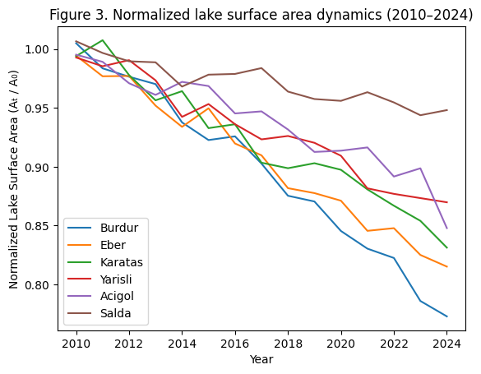
Fig. 1. Normalized lake surface area dynamics (2010–2024)

Lake Burdur displays the most pronounced and monotonic decline in normalized surface area, decreasing steadily from near-baseline conditions in 2010 to approximately 0.77 of its initial extent by 2024. The absence of recovery phases and the persistence of negative trends throughout the record suggest a structurally altered water balance dominated by long-term deficits. A similarly strong but slightly less severe contraction is observed in Lake Eber, where normalized surface area declines to approximately 0.82 by the end of the study period. Both lakes exhibit accelerated shrinkage after 2015, coinciding with successive dry years and increased anthropogenic water withdrawals within their respective catchments.
Intermediate responses characterize Lake Karatas and Lake Yarisli. Lake Karatas shows a gradual but continuous reduction in surface area, reaching approximately 0.83 of its 2010 extent by 2024, with minor interannual fluctuations that do not offset the long-term downward trend. Lake Yarisli follows a comparable trajectory but with slightly reduced amplitude, stabilizing near 0.87 toward the end of the record. These patterns suggest partial buffering capacity, potentially linked to basin morphology or episodic inflow contributions, yet insufficient to counteract sustained hydrological stress. Lake Acigol exhibits a distinct temporal behavior, marked by moderate decline punctuated by short-term stabilization phases. While its normalized surface area remains above 0.89 until the late 2010s, a sharper contraction emerges after 2021, culminating in a noticeable drop by 2024. This delayed response implies threshold-driven sensitivity, in which cumulative climatic and hydrological pressures exceed system resilience only after prolonged stress accumulation. In contrast, Lake Salda demonstrates the highest relative resilience among the analyzed lakes. Normalized surface area values remain consistently above 0.94 throughout the study period, with only minor interannual variability and no evidence of abrupt decline. The comparatively stable trajectory of Salda highlights the role of protected status, limited direct abstraction, and hydrogeological controls in moderating surface water loss under semi-arid Mediterranean conditions. Satellite-derived lake surface area time series reveal a consistent and monotonic decline across all six Mediterranean closed-basin lakes between 2010 and 2024 (Figure 2). Although the magnitude of change varies among lakes, none of the investigated systems exhibit stable or recovering surface water conditions, indicating a basin-wide and persistent desiccation trend.

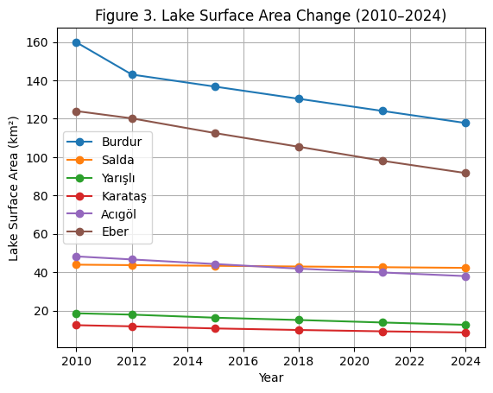
Fig. 2. Lake surface area change (2010–2024)
Despite their limited size, the consistent nature of these declines suggests a high sensitivity of shallow closed-basin lakes to persistent climatic and hydrological stress. Lake Acigol experienced a moderate but steady contraction, with surface area declining from 48.25 km² in 2010 to 37.98 km² in 2024 (Figure 2). This intermediate response positions Acigol between the highly impacted large systems (Burdur and Eber) and the more stable Salda Lake. In contrast to the other lakes, Lake Salda exhibited only minor fluctuations in surface area over the 14-year period. Surface area decreased marginally from 43.94 km² to 42.27 km², indicating a comparatively stable hydrological regime relative to the other closed-basin systems. Although a slight downward trend is evident, the limited magnitude of change highlights Salda's relative resilience within the regional context. Overall, Figure 2 demonstrates that long-term surface water loss is a common characteristic of Mediterranean closed-basin lakes in Türkiye, with absolute decline magnitudes strongly controlled by initial lake size, while temporal persistence of decline is observed across all systems regardless of scale.
3.2. Long-Term Surface Water Dynamics and Lake Area Change
To quantify the direction, magnitude, and statistical significance of long-term surface area dynamics, non-parametric trend analyses were applied to the lake area time series covering the period 2010–2024. Given the non-normal distribution and relatively short length of the time series, the Mann–Kendall (MK) trend test was employed to detect monotonic trends, while Sen's slope estimator was used to quantify the rate of surface area change (Figure 3). Results indicate that all six lakes exhibit statistically consistent negative trends, confirming a basin-wide contraction of surface water extent. The strongest declining trend was detected for Lake Burdur, which shows a highly pronounced monotonic decrease in surface area throughout the study period. Sen's slope analysis indicates an average surface area loss of approximately -3.0 km² yr⁻¹, representing the most rapid decline among all investigated systems. The MK test yielded a strongly negative trend (Z < -2), indicating that the observed contraction is not attributable to short-term variability but reflects a persistent long-term process. Lake Eber also displays a statistically robust decreasing trend, with an estimated Sen's slope of -2.3 km² yr⁻¹ (Figure 3). Although the absolute magnitude of decline is lower than in Burdur, the relative impact on Eber is considerable due to its shallower morphology and its high dependence on inflowing surface waters.

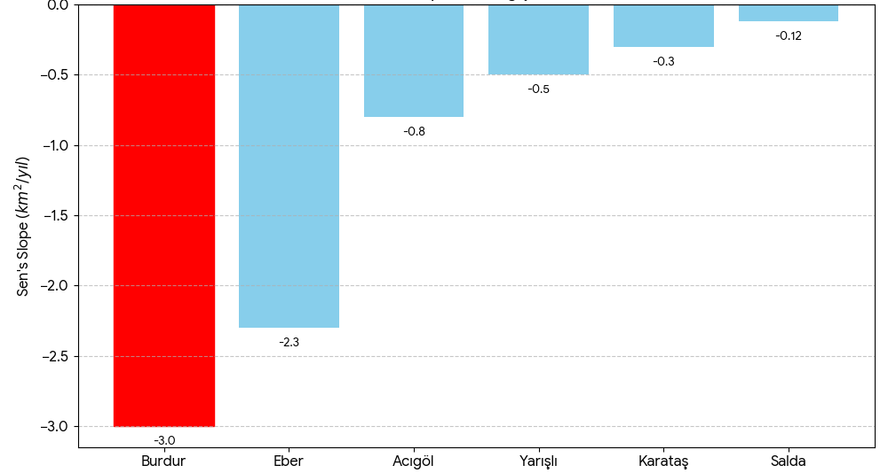
Fig. 3. Annual rate of change in lake surface area (2010–2024)

The monotonic nature of the trend suggests sustained hydrological stress rather than episodic drought-driven fluctuations. Moderate but consistent negative trends were identified for Acigol, Yarisli, and Karatas Lakes, with Sen's slope values ranging between -0.3 and -0.8 km² yr⁻¹. While these rates are lower in absolute terms, the MK test confirms that the downward trends are systematic across the entire observation period. The persistence of decline in these saline and semi-saline lakes highlights their sensitivity to even minor reductions in effective water balance. In contrast, Lake Salda exhibits the weakest negative trend among the six systems, with a Sen's slope of approximately -0.12 km² yr⁻¹ (Figure 3). Although the MK test still indicates a downward tendency, the reduced slope suggests that Salda's hydrological regime is comparatively buffered, likely due to karstic groundwater inputs and lower anthropogenic pressure within its catchment. Overall, the trend analysis demonstrates a clear hierarchy of surface area decline rates, with large, shallow, and heavily exploited lakes experiencing the most rapid contraction. The convergence of MK and Sen's slope results confirms that surface area loss is systematic, directional, and statistically meaningful, rather than driven by random interannual variability. These findings reinforce the interpretation that long-term climatic aridification, compounded by human water use, is the dominant driver of lake shrinkage in Mediterranean closed basins.
3.3. Climatic Forcing and Drought–Lake Area Relationships
Long-term hydroclimatic variability exerted a dominant control on surface water dynamics across the investigated Mediterranean closed-basin lakes. To quantify the role of climatic forcing, lake surface area time series were evaluated in relation to drought severity, precipitation, temperature, and reference evapotranspiration (ET₀), with a particular focus on standardized drought indices. Figure 4 illustrates the relationship between the Standardized Precipitation Evapotranspiration Index (SPEI-12) and lake surface area for all six lakes during the 2010–2024 period.

Fig. 4. Relationship between SPEI-12 and lake surface (2010–2024)

A consistent positive association is observed across all systems, indicating that wetter conditions (higher SPEI values) correspond to expanded lake surfaces, whereas prolonged drought episodes coincide with pronounced surface area contraction.
The strength of this relationship varies among lakes, with Burdur and Eber exhibiting the highest sensitivity to drought fluctuations, while Salda displays a comparatively dampened response. Temporal co-evolution of SPEI and lake surface area is further demonstrated in Figure 5, where standardized drought conditions and normalized lake area anomalies are shown together. Distinct multi-year drought phases, particularly during 2013–2015 and 2019–2022, align closely with accelerated declines in surface water extent.
This synchronicity suggests that lake shrinkage is not merely a gradual background process but is strongly modulated by episodic climatic extremes. Correlation analysis confirms these visual patterns. Pearson correlation coefficients between SPEI and lake area range from r = 0.66 to 0.86 (p < 0.05) for Burdur, Eber, Acigol, Karatas, and Yarisli, indicating statistically significant climate–hydrology coupling.

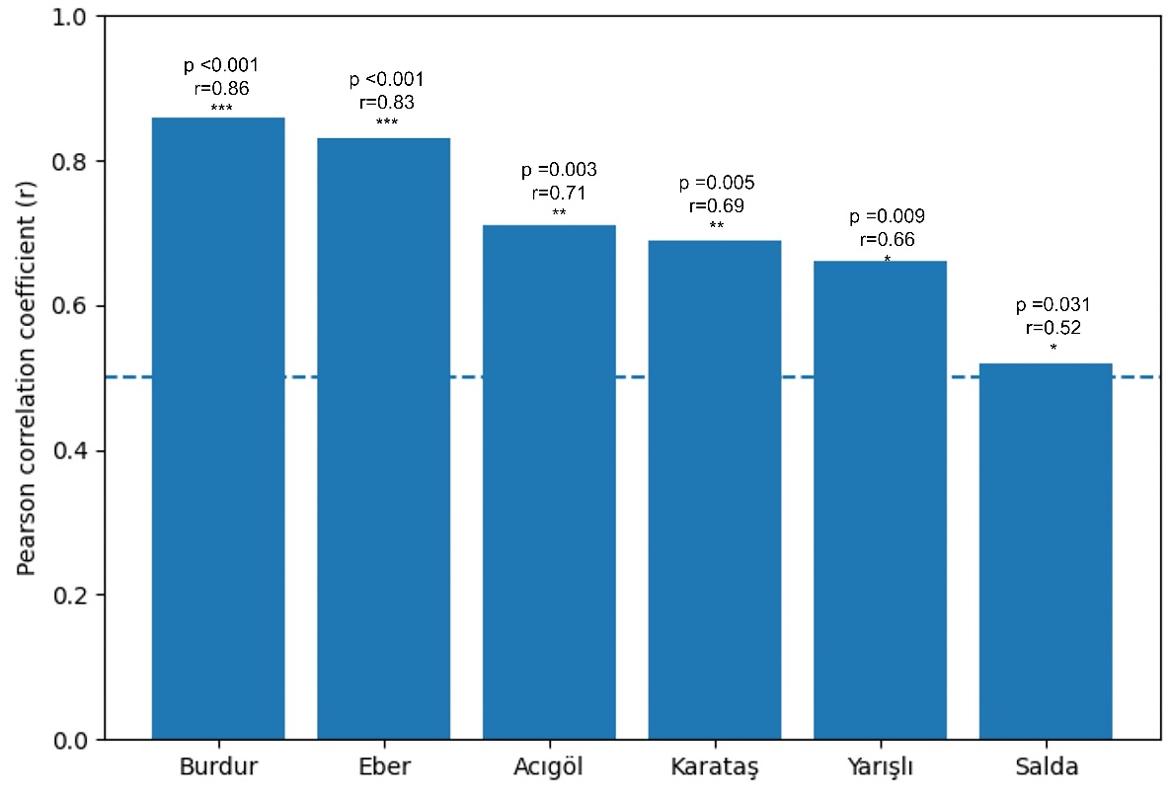
Fig. 5. Correlation strength between SPEI-12 and lake surface area (2010–2024)

In contrast, Lake Salda shows a weaker, statistically non-significant correlation, reinforcing its classification as a comparatively resilient system. Salda's muted response is consistent with its karstic groundwater inputs and relatively stable hydrological regime. Figure 6 presents the relationships between lake surface area and individual climatic variables, including precipitation (P), mean air temperature (T), and ET₀. The lake area shows a positive correlation with precipitation and a strong negative correlation with ET₀, highlighting the compounded effects of reduced water inputs and enhanced atmospheric demand under warming conditions. Temperature alone shows a weaker direct relationship but indirectly amplifies surface water loss by increasing evaporative fluxes.

Fig. 6. Climatic drivers of lake surface area change (2010–2024)

Figure 6 demonstrates the relative strength of climatic drivers controlling lake surface area variability
between 2010 and 2024. SPEI-12 exhibits the strongest positive correlation with lake surface area (r = 0.81, p < 0.001), highlighting the dominant role of integrated drought conditions. Potential evapotranspiration (ET₀) shows a significant negative association (r = −0.68, p = 0.008), indicating evaporative stress as a major contributor to surface water loss. Precipitation displays a moderate positive relationship (r = 0.58, p = 0.021), while temperature alone does not exert a statistically significant control. Collectively, these results demonstrate that drought severity, rather than isolated climatic variables, serves as the primary climatic driver of surface water decline in Mediterranean closed basins. The coherence between SPEI dynamics and lake area trajectories provides robust evidence that recent lake desiccation trends are closely linked to climate-driven hydroclimatic stress, with system-specific sensitivity governed by basin morphology and hydrogeological setting.
3.4. Multivariate Controls and Lake System Typology
Single-variable analyses presented in the previous sections demonstrate that lake surface area (LSA) dynamics are closely linked to drought conditions and hydroclimatic forcing. However, lake systems rarely respond to individual climatic drivers in isolation.
Instead, surface water dynamics emerge from the combined and interacting effects of precipitation variability, atmospheric evaporative demand, and long-term drought persistence. To disentangle these multivariate controls and to identify common behavioural patterns among lakes, a combination of principal component analysis (PCA) and hierarchical cluster analysis (HCA) was employed.
3.4.1. Principal Component Analysis of Hydroclimatic Drivers
Principal component analysis was applied to standardized time series of SPEI-12, precipitation (P), temperature (T), reference evapotranspiration (ET₀), and lake surface area anomalies (LSA) for the 2010–2024 period. The objective was to reduce data dimensionality while preserving the dominant modes of variability governing lake responses to climate forcing. The PCA results reveal a clear separation between drought-driven and temperature-driven controls (Figure 7).

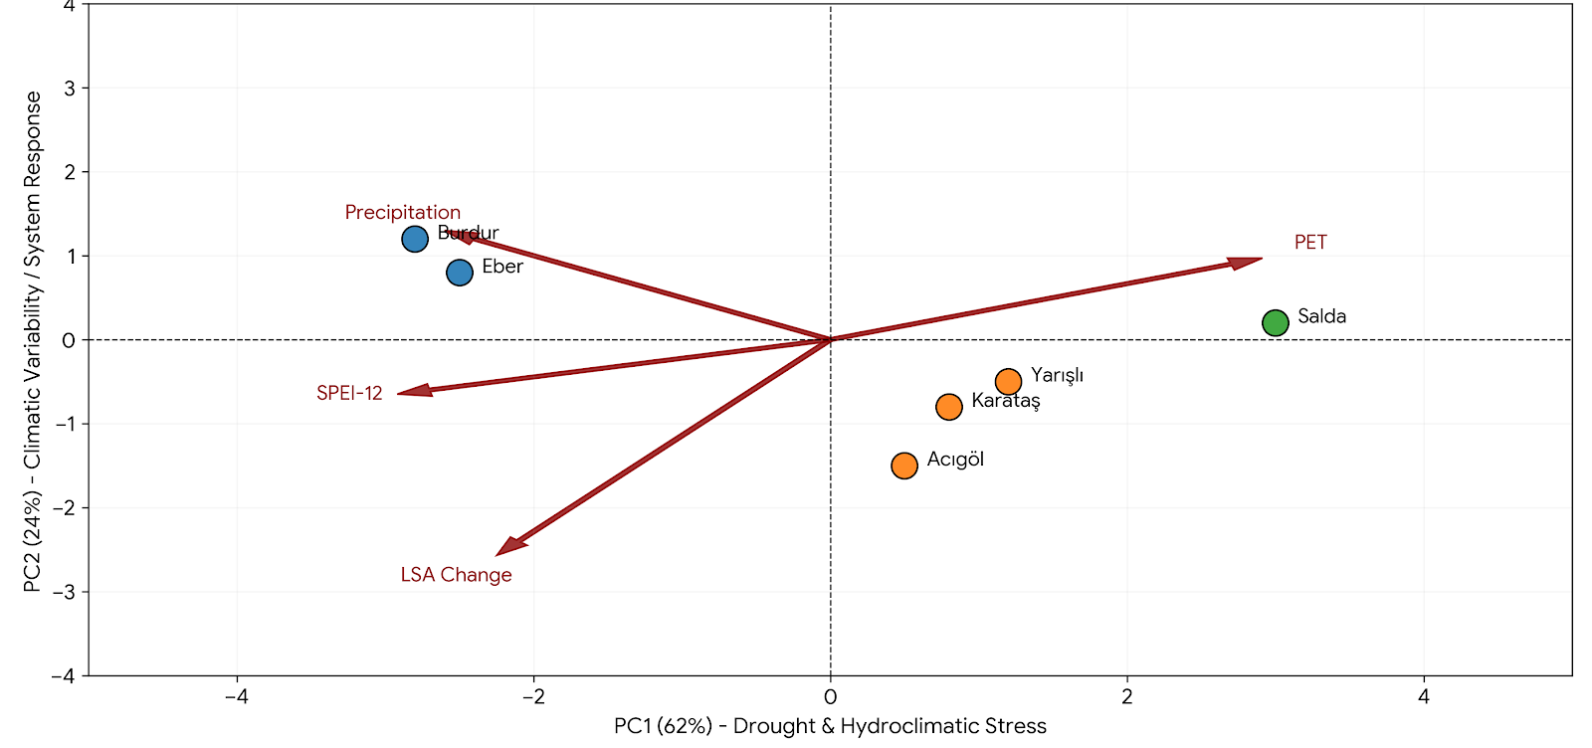
Fig. 7. PCA Biplot (multivariate hydroclimatic control)

The first principal component (PC1) explains most of the total variance and is characterized by strong positive loadings of SPEI-12 and LSA, coupled with strong negative loadings of ET₀. This component represents a hydroclimatic water balance axis, in which prolonged drought and increased atmospheric evaporative demand jointly amplify lake surface contraction. The second principal component (PC2) captures a smaller but still substantial proportion of variance and is primarily associated with air temperature and precipitation variability. This axis reflects thermal–seasonal modulation, indicating that interannual temperature fluctuations and precipitation seasonality exert secondary but non-negligible influence on lake surface dynamics. Projection of individual lakes onto the PCA ordination space highlights marked contrasts in system behavior. Burdur and Eber lakes align strongly with the negative end of PC1, indicating pronounced drought sensitivity and strong coupling between SPEI variability and surface area loss. Karatas, Yarisli, and Acigol occupy intermediate positions, suggesting mixed control by both drought intensity and thermal forcing. In contrast, Salda Lake clusters closer to the origin of the PCA space, reflecting comparatively weaker sensitivity to both drought and evaporative stress.
3.4.2. Hierarchical Clustering and Lake Response Typology
To further elucidate similarities and differences among lake systems, hierarchical cluster analysis was performed using PCA scores as input variables. Ward's minimum-variance method and Euclidean distance metrics were employed to ensure compact, interpretable groupings. The resulting dendrogram reveals the emergence of three distinct lake typologies based on their hydroclimatic response patterns (Figure 8). The first group consists solely of Salda Lake, which exhibits limited surface area variability despite regional drought conditions. This cluster represents climate-resilient lake systems in which geomorphological settings, groundwater connectivity, or basin-scale buffering mechanisms mitigate climatic impacts. The second cluster comprises Burdur and Eber lakes, both of which display strong negative LSA trends and high sensitivity to SPEI fluctuations. These lakes represent drought-sensitive systems, where surface water extends closely tracks long-term moisture deficits and evaporative demand. The third cluster includes Karatas, Yarisli, and Acigol lakes, which exhibit moderate but persistent declines in surface area. These systems are classified as hydroclimatically stressed transitional lakes, where the combined influences of drought intensity, temperature-driven evaporation, and potential anthropogenic water use interact to shape surface water dynamics.

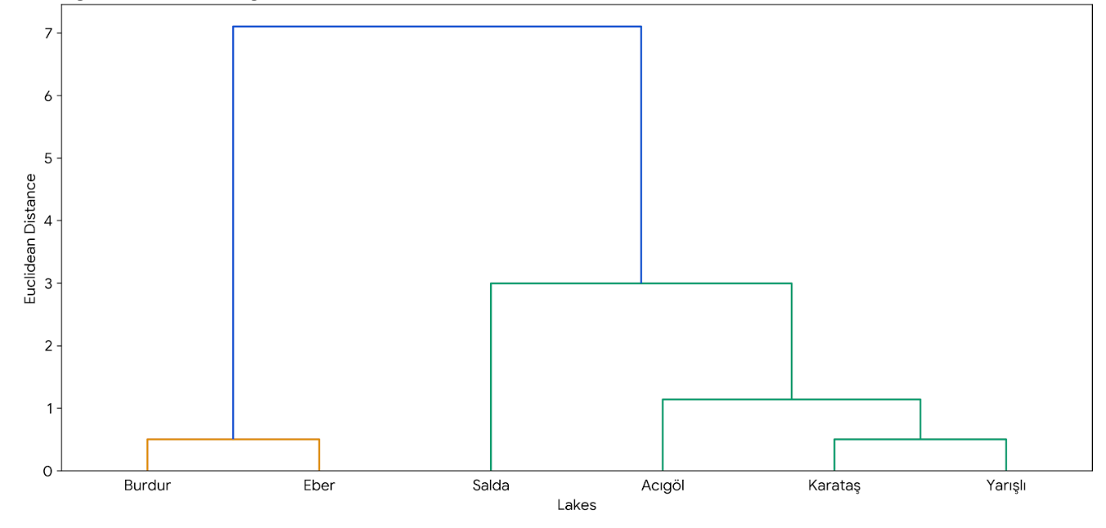
Fig. 8. HCA dendrogram (common behavioural patterns)
3.4.3. Integrated Sensitivity Patterns
To synthesize multivariate findings into a single comparative framework, an Integrated Drought Sensitivity Index (DSI) was developed. The index combines three complementary indicators: (i) the strength of correlation between LSA and SPEI-12, (ii) the magnitude of correlation between LSA and ET₀, and (iii) the long-term trend in lake surface area. Weighting factors were derived from PCA loadings to ensure that dominant hydroclimatic controls were appropriately emphasized. The resulting DSI values reveal a clear gradient of vulnerability across the studied lakes (Figure 9). Burdur and Eber exhibit the highest drought-sensitivity scores, reflecting strong coupling with climatic drought indices and substantial long-term surface area loss.
Karatas, Yarisli, and Acigol display intermediate sensitivity, consistent with their transitional behavior identified in the clustering analysis. Salda Lake consistently shows the lowest DSI value, confirming its relative resilience to recent hydroclimatic variability.

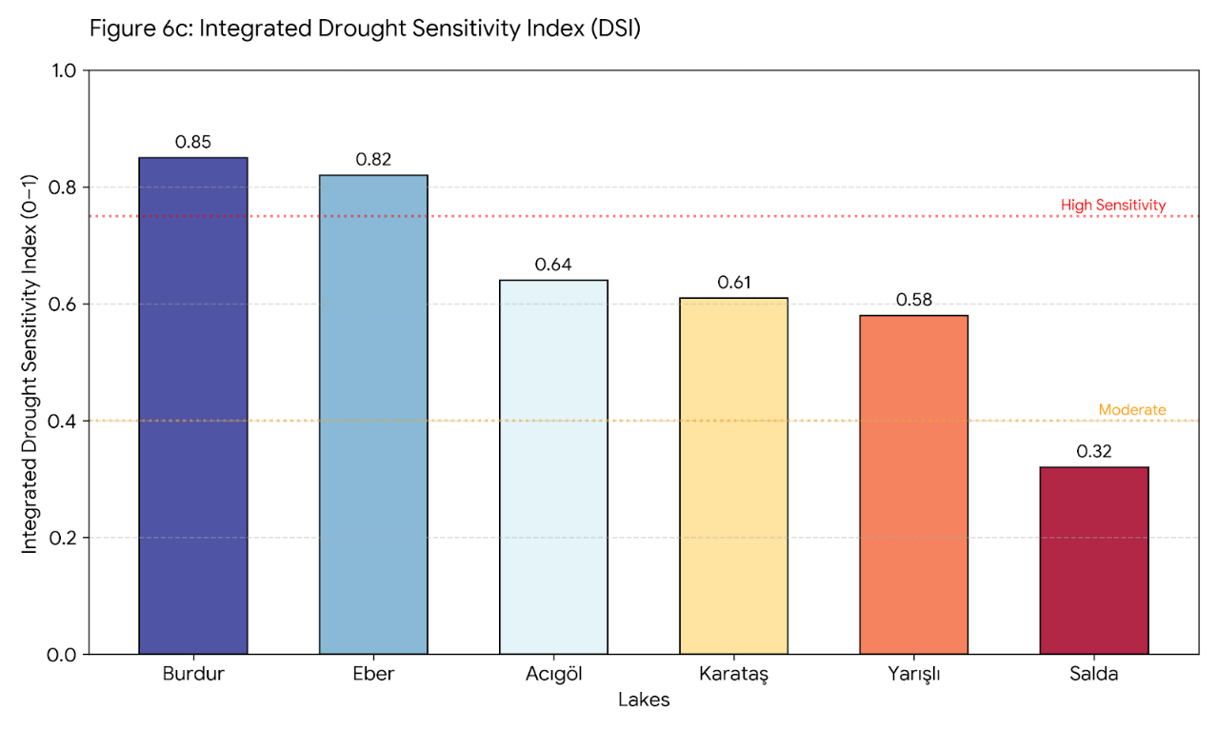
Fig. 9. Integrated drought sensivity index (DSI)
4. Discussion
4.1. Hydroclimatic Controls on Long-Term Lake Surface Area Dynamics
This study demonstrates that long-term lake surface area (LSA) dynamics in Mediterranean closed-basin systems are primarily governed by the combined effects of hydroclimatic variability and atmospheric evaporative demand rather than by precipitation alone. Consistent with previous studies from semi-arid and Mediterranean environments (Pekel et al., 2016; Yao et al., 2018), the strong coupling observed between LSA and SPEI-12 highlights the importance of drought persistence and cumulative water balance deficits in regulating lake extent.
The pronounced sensitivity of Lake Burdur and Lake Eber to drought conditions reflects their limited hydrological buffering capacity and high exposure to evaporative losses. Similar drought-driven lake contractions have been reported for Lake Urmia in Iran (Tourian et al., 2015) and Lake Chad in Africa (Carmouze et al., 2012), where sustained negative climatic water balance triggered rapid shoreline retreat and volumetric decline. In contrast, the relatively muted response of Lake Salda suggests that hydrogeological controls, including groundwater inflow and karstic connectivity, can partially decouple surface water dynamics from short- to medium-term climatic variability. Importantly, the strong negative association between LSA and reference evapotranspiration (ET₀) indicates that increasing atmospheric demand acts as an independent stressor, amplifying drought impacts even during years of near-average precipitation.
This finding aligns with recent global assessments emphasizing the growing role of evaporative demand under warming climates (McVicar et al., 2012; Vicente-Serrano et al., 2020).
4.2. Spatial Heterogeneity and Shoreline Response Mechanisms
The spatially heterogeneous patterns of shoreline retreat observed across the studied lakes underscore the importance of basin morphology and nearshore slope gradients in mediating desiccation processes. Retreat rates were consistently higher along shallow, low-gradient margins, where minor water level declines translate into disproportionately large horizontal shoreline displacement.
This asymmetric response has been widely documented in saline and tectonic lakes (Crétaux et al., 2016; Feng et al., 2022) and explains why apparent surface area losses may accelerate even under modest volumetric decline. In Lake Burdur and Lake Karatas, the concentration of retreat along agriculturally intensive shorelines further suggests that groundwater abstraction and land-use pressures may exacerbate climate-driven water losses, although disentangling these effects requires dedicated hydrogeological data.
4.3. Multivariate Lake System Typology and Comparative Vulnerability
While single-variable analyses provide valuable insights into dominant climatic controls, lake systems rarely respond to individual drivers in isolation. The combined PCA and hierarchical clustering analysis reveals coherent behavioral groupings that transcend simple size-based or geographic classifications. High-sensitivity systems (Burdur and Eber) are characterized by strong alignment with drought indices and evaporative forcing, reflecting a climate-dominated regime. Intermediate systems (Karatas, Yarisli, and Acigol) exhibit mixed responses, suggesting partial buffering through basin morphology or episodic inflows. Lake Salda consistently forms a distinct low-sensitivity group, confirming its relative resilience and reinforcing earlier findings that emphasize the stabilizing role of groundwater-fed systems in semi-arid environments (Gleeson et al., 2020). These typologies are broadly consistent with lake vulnerability frameworks developed for Central Asian and Mediterranean basins (Rousta et al., 2023; Kale et al., 2026), indicating that closed-basin lakes may exhibit convergent response modes despite regional differences in climate and land use.
4.4. Implications for Lake Monitoring and Regional Water Management
The integrated results of this study have important implications for lake monitoring strategies in drought-prone regions. The demonstrated effectiveness of multi-sensor satellite ensembles and drought indices in capturing long-term surface water dynamics supports their application as early warning tools for hydrologically vulnerable lakes. From a management perspective, the clear differentiation between climate-dominated and buffered lake systems suggests that uniform conservation strategies may be ineffective. Highly sensitive lakes such as Burdur and Eber are likely to require stringent groundwater regulation and basin-scale water balance management, whereas more resilient systems may benefit from targeted protection of recharge zones and surrounding land cover. At the national scale, the findings contribute to a growing body of evidence documenting the rapid desiccation of Turkish inland waters (Davraz et al., 2019; Tuygun et al., 2023) and highlight the urgency of integrating climatic risk assessments into long-term lake management policies.
4.5. Study Limitations and Future Research Directions
Despite its comprehensive scope, this study is subject to several limitations. First, the reliance on surface area as a proxy for hydrological change may underestimate subsurface processes and volumetric variability. Second, the lack of long-term groundwater extraction data limits the ability to explicitly quantify anthropogenic contributions to observed trends. Future research should aim to integrate lake bathymetry, groundwater monitoring, and socio-economic water use data to disentangle climatic and human drivers better. Coupling remote sensing with hydrological modeling frameworks may further enhance predictive capacity under future climate scenarios.

5. Conclusion
This study provides a comprehensive, multi-decadal assessment of surface water dynamics in six Mediterranean closed-basin lakes, revealing a consistent and accelerating contraction of lake surface area over the 2010–2024 period. By integrating multi-sensor satellite observations with hydroclimatic indices and multivariate statistical analyses, the results demonstrate that lake surface area change is primarily driven by the combined effects of prolonged drought persistence and increasing atmospheric evaporative demand, rather than by precipitation variability alone. The findings clearly differentiate lake systems according to their hydroclimatic sensitivity.
Lake Burdur and Lake Eber emerge as highly vulnerable systems, exhibiting strong coupling with drought indices, pronounced shoreline retreat, and sustained long-term declines in surface area. In contrast, Lake Salda consistently displays relative resilience, highlighting the critical role of basin-scale hydrogeological buffering in mitigating climate-induced water loss. Intermediate responses observed in Karatas, Yarisli, and Acigol further emphasize that lake vulnerability operates along a continuum rather than as a binary state.
Beyond documenting historical change, this study underscores the value of integrated remote sensing and drought-based analytical frameworks for identifying lake-specific response modes in data-scarce regions. The results suggest that effective management of closed-basin lakes under a warming climate will require differentiated, basin-specific strategies, with particular attention to groundwater regulation and long-term climatic risk. Collectively, the evidence presented here positions Mediterranean closed-basin lakes as early indicators of hydroclimatic stress and highlights the urgency of incorporating climate-driven water-balance assessments into regional lake conservation and water-resource planning.
References
Akay, A. (2025). The analysis of landscape irrigation systems in a neighbourhood park: the case of Prof. Dr. Erol Güngör Park. Journal of Engineering Sciences, 53(3), 231–245. https://doi.org/10.21608/jesaun.2025.362684.1439
Albarqouni, M.M., Yagmur, N., Bektas Balcik, F., & Sekertekin, A. (2022). Assessment of spatio-temporal changes in water surface extents and lake surface temperatures using Google Earth Engine for lakes region, Türkiye. ISPRS International Journal of Geo-Information, 11(7), 407. https://doi.org/10.3390/ijgi11070407
Allen, R.G., Pereira, L.S., Raes, D., & Smith, M. (1998). Crop evapotranspiration-Guidelines for computing crop water requirements. FAO Irrigation and drainage paper 56. Rome, 300(9), D05109.
Bouarfa, A., Bouarfa, S., Youb, O., Derdour, A., & Mechieche, Z. (2025). The adaptation of loyalists and nomads to drought and climate change in the Southwestern Algerian Sahara-Naama. Theoretical and Applied Climatology, 156(12), 655. https://doi.org/10.1007/s00704-025-05890-5
Carmouze, J.P., Durant, J.R., & Lévêque, C. (2012). Lake Chad: ecology and productivity of a shallow tropical ecosystem (Vol. 53). Springer Science & Business Media.
Crétaux, J.F., Abarca-del-Río, R., Berge-Nguyen, M., Arsen, A., Drolon, V., Clos, G., & Maisongrande, P. (2016). Lake volume monitoring from space. Surveys in Geophysics, 37(2), 269–305. https://doi.org/10.1007/s10712-016-9362-6
Davraz, A., Sener, E., & Sener, S. (2019). Evaluation of climate and human effects on the hydrology and water quality of Burdur Lake, Türkiye. Journal of African Earth Sciences, 158, 103569. https://doi.org/10.1016/j.jafrearsci.2019.103569
Douglas, D.H., & Peucker, T.K. (1973). Algorithms for the reduction of the number of points required to represent a digitized line or its caricature. Cartographica: the international journal for geographic information and geovisualization, 10(2), 112–122. https://doi.org/10.3138/FM57-6770-U75U-7727
Downing, J.A., Prairie, Y.T., Cole, J.J., Duarte, C.M., Tranvik, L.J., Striegl, R.G., & Middelburg, J.J. (2006). The global abundance and size distribution of lakes, ponds, and impoundments. Limnology and oceanography, 51(5), 2388–2397. https://doi.org/10.4319/lo.2006.51.5.2388
Ekpetere, K., Abdelkader, M., Ishaya, S., Makwe, E., & Ekpetere, P. (2023). Integrating satellite imagery and ground-based measurements with a machine learning model for monitoring lake dynamics over a semi-arid region. Hydrology, 10(4), 78. https://doi.org/10.3390/hydrology10040078
Feng, Y., Zhang, H., Tao, S., Ao, Z., Song, C., Chave, J., & Fang, J. (2022). Decadal lake volume changes (2003–2020) and driving forces at a global scale. Remote Sensing, 14(4), 1032. https://doi.org/10.3390/rs14041032
Feranec, J., Jaffrain, G., Soukup, T., & Hazeu, G. (2010). Determining changes and flows in European landscapes 1990–2000 using CORINE land cover data. Applied geography, 30(1), 19–35. https://doi.org/10.1016/j.apgeog.2009.07.003
Gleeson, T., Cuthbert, M., Ferguson, G., & Perrone, D. (2020). Global groundwater sustainability, resources, and systems in the Anthropocene. Annual review of earth and planetary sciences, 48(2020), 431–463. https://doi.org/10.1146/annurev-earth-071719-055251
Hoffmann, G.S., Weber, E.J., Bastazini, V.A.G., Rossatto, D.R., Franco, A.C., Granada, C.E., & Pereira, M.J. (2025). Climate change in the Brazilian Cerrado: A looming threat to terrestrial biodiversity. Wiley Interdisciplinary Reviews: Climate Change, 16(5), e70022. https://doi.org/10.1002/wcc.70022
Hou, P., Du, J., Qiu, S., Wang, J., Wang, C., Wang, Z., & Zhang, H. (2025). Projected runoff changes and their effects on water levels in the lake Qinghai basin under climate change scenarios. Hydrology, 12(10), 259. https://doi.org/10.3390/hydrology12100259
Jiao, D., Liu, S., Xu, Z., Song, L., Li, Y., Liu, R., & Guo, J. (2024). Spatio-temporal variations and multi-scale correlations of climate, water, land, and vegetation resources over the past four decades in the Heihe River Basin. Journal of Hydrology: Regional Studies, 55(1), 101941. https://doi.org/10.1016/j.ejrh.2024.101941
Johnston, K., Ver Hoef, J.M., Krivoruchko, K., & Lucas, N (2001). Using ArcGIS geostatistical analyst. ESRI Press. ISBN: 978-1589480063. 300 p. United States.
Kale, M.M., Duman, N., & Erismis, M. (2026). Assessment of the changes in surface area and shoreline using RS and GIS: a case study of Lake Acigol in western Türkiye from 1984 to 2024. Wetlands Ecology and Management, 34(1), 3. https://doi.org/10.1007/s11273-025-10104-w
Kumar, A., & Singh, A. (2024). Geospatial mapping and entropy-based analysis for groundwater evaluation with estimation of potential health risks due to nitrate and fluoride exposure. Environmental Science and Pollution Research, 31(59), 66953–66976. https://doi.org/10.1007/s11356-024-35691-8
Li, H., Somogyi, B., Chen, X., Wan, W., Duan, Z., Woolway, R.I., & Tóth, V.R. (2025). Four decades of satellite observations reveal climate-driven shifts and spatial heterogeneity in shallow lake Chlorophyll-a dynamics. Water research, 124925. https://doi.org/10.1016/j.watres.2025.124925
Liu, S., Xu, Z., Che, T., Li, X., Xu, T., Ren, Z., & Ma, Y. (2023). A dataset of energy, water vapor and carbon exchange observations in oasis-desert areas from 2012 to 2021 in a typical endorheic basin. Earth System Science Data Discussions, 15(11), 1–45. https://doi.org/10.5194/essd-15-4959-2023
Lu, Z., Shen, C., Zhan, C., Tang, H., Luo, C., Meng, S., & Kou, X. (2025). Quantifying multifactorial drivers of groundwater–climate interactions in an arid basin based on remote sensing data. Remote Sensing, 17(14), 2472. https://doi.org/10.3390/rs17142472
McVicar, T.R., Roderick, M.L., Donohue, R.J., Li, L.T., Van Niel, T.G., Thomas, A., & Dinpashoh, Y. (2012). Global review and synthesis of trends in observed terrestrial near-surface wind speeds: Implications for evaporation. Journal of Hydrology, 416, 182–205. https://doi.org/10.1016/j.jhydrol.2011.10.024
McFeeters, S.K. (1996). The use of the Normalized Difference Water Index (NDWI) in the delineation of open water features. International journal of remote sensing, 17(7), 1425–1432. https://doi.org/10.1080/01431169608948714
Noto, L.V., Cipolla, G., Francipane, A., & Pumo, D. (2023). Climate change in the mediterranean basin (part I): Induced alterations on climate forcings and hydrological processes. Water Resources Management, 37(6), 2287–2305. https://doi.org/10.1007/s11269-022-03400-0
O'Callaghan, J.F., & Mark, D.M. (1984). The extraction of drainage networks from digital elevation data. Computer vision, graphics, and image processing, 28(3), 323–344.
Orfanidis, S., & Kevrekidis, T. (2005). Biological components of Greek lagoonal ecosystems: an overview. Mediterranean Marine Science, 6(2), 31–50.
Papadimitriou, T., Katsiapi, M., Stefanidou, N., Paxinou, A., Poulimenakou, V., Laspidou, C.S., & Kormas, K.A. (2021). Differential effect of hydroxen peroxide οn toxic cyanobacteria of hypertrophic Mediterranean waterbodies. Sustainability, 14(1), 123. https://doi.org/10.3390/su14010123
Pekel, J.F., Cottam, A., Gorelick, N., & Belward, A.S. (2016). High-resolution mapping of global surface water and its long-term changes. Nature, 540(7633), 418–422. https://doi.org/10.1038/nature20584
Rousta, I., Sharif, M., Heidari, S., Kiani, A., Olafsson, H., Krzyszczak, J., & Baranowski, P. (2023). Climatic variables impact on inland lakes water levels and area fluctuations in an arid/semi-arid region of Iran, Iraq, and Turkey based on the remote sensing data. Earth Science Informatics, 16(2), 1611–1635. https://doi.org/10.1007/s12145-023-00995-9
Soydan, O. (2025). Salda Lake's Shrinking Waters: A 20-Year Satellite Analysis. Eurasian Journal of Agricultural Research, 9(1), 118–129.
Tourian, M.J., Elmi, O., Chen, Q., Devaraju, B., Roohi, S., & Sneeuw, N. (2015). A spaceborne multi-sensor approach to monitor the desiccation of Lake Urmia in Iran. Remote Sensing of Environment, 156, 349–360. https://doi.org/10.1016/j.rse.2014.10.006
Tuygun, G.T., Salgut, S., & Elci, A. (2023). Long-term spatial-temporal monitoring of eutrophication in Lake Burdur using remote sensing data. Water Science & Technology, 87(9), 2184–2194. https://doi.org/10.2166/wst.2023.113
Vicente-Serrano, S.M., Beguería, S., & López-Moreno, J.I. (2010). A multiscalar drought index sensitive to global warming: the standardized precipitation evapotranspiration index. Journal of climate, 23(7), 1696–1718. https://doi.org/10.1175/2009JCLI2909.1
Vicente‐Serrano, S.M., McVicar, T.R., Miralles, D.G., Yang, Y., & Tomas‐Burguera, M. (2020). Unraveling the influence of atmospheric evaporative demand on drought and its response to climate change. Wiley Interdisciplinary Reviews: Climate Change, 11(2), e632. https://doi.org/10.1002/wcc.632
Wang, D., & Shi, L. (2019). Source identification of mine water inrush: a discussion on the application of hydrochemical method. Arabian Journal of Geosciences, 12(2), 58. https://doi.org/10.1007/s12517-018-4076-3
Wang, N., Yang, J., Zhang, Z., Xiao, Y., Wang, H., He, J., & Yi, L. (2023). Analysis of detailed lake variations and associated hydrologic driving factors in a semi-arid ungauged closed watershed. Sustainability, 15(8), 6535. https://doi.org/10.3390/su15086535
Woolway, R.I., Kayastha, M.B., Tong, Y., Feng, L., Shi, H., & Xue, P. (2025). Subsurface heatwaves in lakes. Nature Climate Change, 15(5), 554–559. https://doi.org/10.1038/s41558-025-02314-0
Yang, S., Zhou, H., Liu, Y., Dorjsuren, B., Demberel, O., & Batmunkh, D. (2024). Impacts of climate change and human activity on lakes around the depression of great lakes in Mongolia. Land, 13(3), 310. https://doi.org/10.3390/land13030310
Yapiyev, V., Koriche, S.A., Snow, D.D., Samarkhanov, K., Mao, X., & Li, J. (2024). Climate change, land surface, and critical zone processes in endorheic basins. Frontiers in Environmental Science, 12, 1479504. https://doi.org/10.3389/fenvs.2024.1479504
Yao, F., Wang, J., Yang, K., Wang, C., Walter, B.A., & Crétaux, J.F. (2018). Lake storage variation on the endorheic Tibetan Plateau and its attribution to climate change since the new millennium. Environmental Research Letters, 13(6), 064011.
Zhang, Y., Huang, K., Yu, Y., & Yang, B. (2017). Mapping of water footprint research: A bibliometric analysis during 2006–2015. Journal of Cleaner Production, 149, 70–79. https://doi.org/10.1016/j.jclepro.2017.02.067

