
 | Rocznik Ochrona Środowiska
 | Volume 28 | Year 2026 ISSN 2720-7501 | pp. 122-127
 | https://doi.org/10.54740/ros.2026.009 open access
 | Received: February 2026 Accepted: March 2026 Published: March 2026
Analysis of a Wood-and-Metal Geodesic Dome in Extreme North Conditions
Makhmud Abu-Khasan¹, Alexander Shkarovskiy², Shirali Mamedov³, Alina Maklerova⁴,
Lali Kuprava⁵, Anton Kovalevskiy⁶, Rustam Sayganov⁷*
¹Emperor Alexander I Saint Petersburg State Transport University, Russia
https://orcid.org/0000-0002-6782-2514
²Koszalin University of Technology, Poland
https://orcid.org/0000-0002-2381-6534
³Saint Petersburg State University of Architecture and Civil Engineering, Russia
https://orcid.org/0000-0003-0366-1085
⁴Saint Petersburg "GradProekt" Association
https://orcid.org/0009-0008-1086-2487
⁵Emperor Alexander I Saint Petersburg State Transport University, Russia
https://orcid.org/0000-0003-3906-168X
⁶Saint Petersburg State University of Architecture and Civil Engineering, Russia
https://orcid.org/0000-0002-6663-4706
⁷Saint Petersburg State University of Architecture and Civil Engineering, Russia
https://orcid.org/0009-0004-5921-9848
*corresponding author's e-mail: saigrustam@gmail.com
Abstract: This article examines geodesic domes in the far north using different materials (wood and steel) to determine the most effective material based on cost. The main thesis of the article is that, depending on the material selected for the frame of a geodesic dome, using the SCAD calculation and graphic complex, it is possible to determine the necessary sections to ensure the bearing capacity for the first and second groups of limit states, which in turn will allow comparing structures based on their cost criteria. The article draws attention to possible ways to optimize the cost of building geodesic domes in the far north. The SCAD calculation and graphical complex of geodesic domes with a grating frequency of 8 V, made of different materials (wood and steel) under the same operating conditions, to find the optimal design based on the cost criterion.
Keywords: geodesic domes, conditions of the far north, SCAD, stress-strain state, research, cost, strength according to the first and second groups of limit states
1. Introduction
At present, the technology of constructing geodetic systems is effectively used in the construction of residential buildings, hotels, exhibition complexes, botanical gardens, swimming pools, cafes, restaurants, pavilions, sports complexes, planetariums, production and storage facilities, and protective shells for buildings (Abu-Khasan, Egorov & Kuprava, 2018). The construction of such buildings is usually caused by the need for large areas and volumes of air (Zhivotov & Tilinin, 2020). This design has significant strength, and the economic benefit from its use increases with an increase in the size of the dome (Abu-Khasan & Egorov, 2018). Construction in the conditions of the North is a difficult job (Veselov, Egorov & Abu-Khasan, 2019). Geodesic domes were widely developed in the second half of the 20th century and remain one of the best solutions for covering large-span buildings of various types (Abu-Khasan, Rozantseva & Kuprava, 2018). Nowadays, thanks to the development of calculation programs and the growth of computer power, geodesic domes have received a second wind. The Arctic zone is characterized by extreme climatic conditions: negative average annual temperatures, polar nights, strong winds, and snowstorms (Temnev et al., 2020). The building structure must be free of temperature bridges through which heat can escape instantly from the premises. One of the solutions to the above problems in housing construction is a geodesic dome, which has several advantages (Egorov et al., 2018):
1) the dome is the most effective form of building under wind and snow loads, which has been proven during tornadoes and hurricanes,
2) the dome has the largest volume with the smallest surface area,
3) minimal material consumption, labor intensity, and construction time of the dome.

The following materials can be used for the frame of a geodesic dome (Sycheva, Abu-Hasan & Chernakov, 2016):
- wood (universal in use),
- metal (usually used for tents, decorative and fully glazed domes, plasterboard profiles can also be used for a small dome),
- plastic (can be used for small domes and spheres with relatively low loads),
- composite materials.

In the work, the authors examine metal and wooden domes, perform calculations, and conduct a comparative analysis.
Computer modeling is a very powerful tool in the hands of researchers; with a real digital model, the results of calculations correlate with the natural outcomes of experiments (Egorov, Abu-Khasan & Kuprava, 2018). In this work, the calculation and computing complex SCAD was used.
2. Progress of Work
The most efficient geodesic dome with a frequency of 8 V was considered as the calculation model.
Figure 1 shows a general view of a geodesic dome.
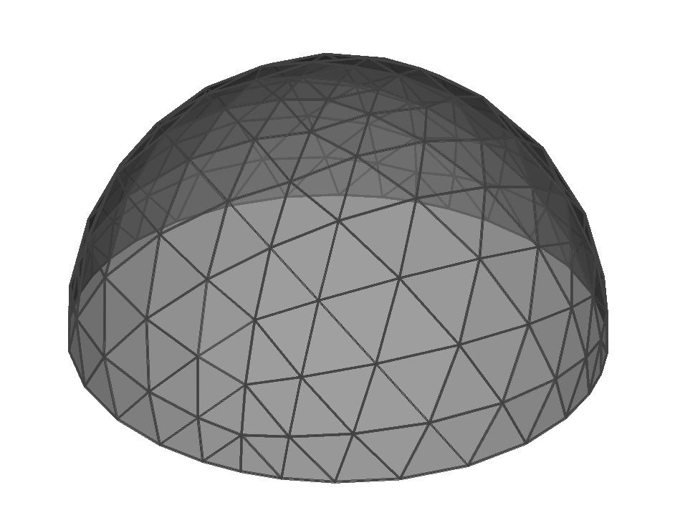
Fig. 1. General view of a geodesic dome with a frequency of 8 V

Dome characteristics:
Number of elements – 400 pcs.
Number of nodes – 145 pcs.
The diameter of the dome is 18 m.
The height of the dome boom is 9 m.
We will assume the dome fastening is rigid along the contour; we will implement this using the "connections in nodes" tool (Solovieva et al., 2017a).
Let us consider the operation of the dome in the conditions of the city of Yakutsk, Rissua (II – snow region, I – wind region, according to Russian climate norms).
The calculated value of snow load is 70 kg/m².
The calculated value of wind load is 32.2 kg/m².
Let's estimate the cost of geodesic domes with a frequency of 8V made of wood and steel in the conditions of the city of Yakutsk:
1 ton of steel – 80,000 RUR (approx. $1010);
1 ton of glued timber – 50,000 RUR (approx. $630).
When designing domes, it is necessary to account for temperature and force effects (Alpatov et al., 2016). Enclosing structures of buildings in the Far North are subject to temperature fluctuations driven by daily and seasonal changes, one-sided solar radiation, air humidity, wind speed, etc. (Svatovskaya et al., 2007).
The article, which is part of the dissertation research, examines the stress-strain state of the elements of a mesh geodesic dome under the influence of temperature and climate, snow, wind, its own weight, and the weight of the coating (Kondrat'eva et al., 2025). Deadweight loads are automatically set in SCAD. Figures 2–5 show the load application diagrams for steel and timber domes.
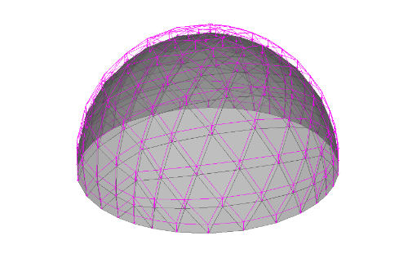
Fig. 2. Scheme of application of load from own weight

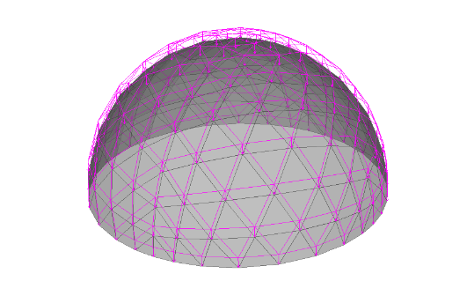
Fig. 3. Scheme of application of snow load to the entire dome

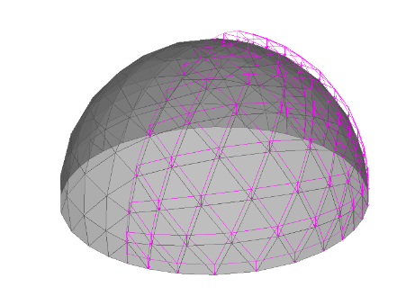
Fig. 4. Snow load application diagram for ½ dome

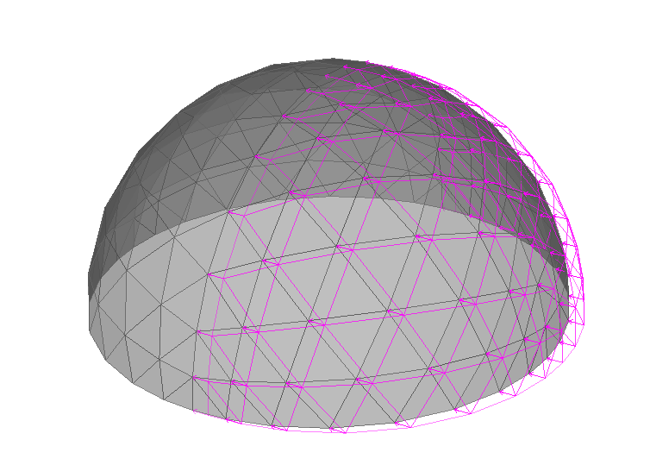
Fig. 5. Wind load application diagram. For the calculation we create 2 loading combinations: 1 – Own weight + snow + wind; 2 – Own weight + snow (½ dome) + wind.
We will perform a static calculation, determine the coefficients of use of the sections of the geodesic dome, the weight required to ensure the bearing capacity for the first and second groups of limit states, and the cost of the necessary material for the frame of the dome made of glued timber (Starchukov et al., 2017; Klimenko, 2020).
To determine the strength characteristics of the section, namely the fulfillment of the conditions for the first and second groups of limit states (calculation for strength and stability), we will determine the utilization factors for wooden beams in the geodesic dome (Komokhov, Maslennikova & Abu-Khasan, 2003). Figure 6 shows the utilization factors for the static calculation of a geodesic dome with wooden sections (glued timber) measuring 80 x 80 mm.

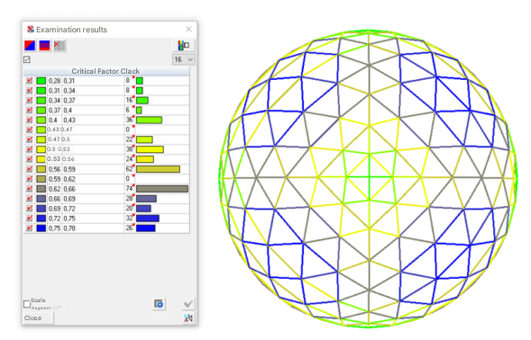
Fig. 6. Utilization factors for calculating a wooden geodesic dome

As a result, the two most critical factors were identified:
Flexibility of the element in the XOY plane with the utilization factor K_{max} = 0.78, and the flexibility of the element in the XOZ plane with the utilization factor K_{max} = 0.78.
The total weight of glued timber to ensure the bearing capacity for the first and second groups of limit states is 3.77 tons.
Based on the calculation of 50,000 RUR (approx. $630) per 1 ton of glued timber, the cost of the material is:
50,000 x 3.77 = 188,500 RUR (approx. $2400).
We will perform a static calculation, determine the coefficients of use of the sections of the geodesic dome, the weight required, ensuring the bearing capacity for the first and second groups of limit states, and the cost of the necessary material for the dome frame made of steel (Solovieva et al., 2017b).
To determine the strength characteristics of the section, namely the fulfillment of the condition for the first and second groups of limit states (calculation for strength and stability), we will determine the utilization factors of wooden beams of the geodesic dome. Figure 7 shows the utilization factors in the static calculation of a geodesic dome with steel sections measuring 50 x 50 x 3 mm.
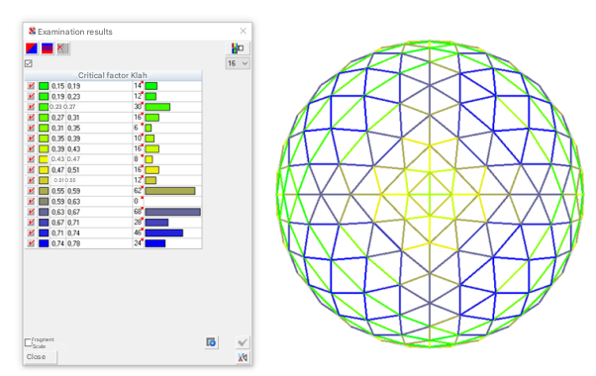
Fig. 7. Utilization factors for calculating a metal geodesic dome

As a result, the two most critical factors were identified:
Ultimate flexibility out of plane with utilization factor K_{max} = 0.78 and ultimate flexibility in the plane with utilization factor K_{max} = 0.63.
The total weight of steel to ensure the bearing capacity for the first and second groups of limit states is 3.73 tons.
Based on the calculation of 80,000 RUR (approx. $1010) per 1 ton of steel, the cost of the material is:
80,000 x 3.73 = 298,400 RUR (approx. $3800).
3. Conclusions
As part of the study, domes with a frequency of 8 V in the conditions of the city of Yakutsk (Far North, Russia) made of glued timber and steel pipes were examined.
An estimated cost of the geodesic dome lattice frame was also made, based on the calculation results, the following can be concluded: using glued wood as a lattice material in the conditions of the Far North (Yakutsk) is more economically feasible, so for the construction of a dome made of glued wood, the cost of the lattice will be 188,500 RUR (approx. $2400), and for the construction of the same dome made of steel – 298,400 RUR (approx. $3800), which is 37% more expensive.
References
Abu-Khasan, M., Egorov, V., & Kuprava, L. (2018). Connections of wooden structures based on composite materials. Bulletin of construction equipment, 12(1012), 46-47. (in Russian)
Abu-Khasan, M., & Egorov, V. (2018). Constructions from wood-frame trusses. Collection of works of the XII St. Petersburg Congress: Professional education, science and innovation in the 21st century. St. Petersburg, 2018, 9-10. (in Russian)
Abu-Khasan, M., Rozantseva, N., & Kuprava, L. (2018). Innovative technology for installation of prefabricated energy-efficient roofs of large-span railway depots. Bulletin of construction equipment, 2(1002), 48-51. (in Russian)
Alpatov, V. et al. (2016). Computer modeling and numerical studies of nodal connections of structural structures. Urban development and architecture, 6(4), 19-22. (in Russian)
Egorov, V. et al. (2018). Load-bearing wood-metal structures of roof trusses of large-span railway depots. Bulletin of construction equipment, 8(1008), 37-38. (in Russian)
Egorov, V., Abu-Khasan, M., & Kuprava, L. (2018). New design solution for cornice units in the form of reinforced concrete inserts for three-hinged glued timber frames from rectilinear elements. Bulletin of construction equipment, 9(1009), 28-29. (in Russian)
Klimenko, M. (2020). Prospects for the use of geodesic domes in the Arctic. Trends in the Development of Science and Education, 61(7), 54-58.
Komokhov, P., Maslennikova, L., & Abu-Khasan M. (2003). Control of strength of ceramic materials by forming a contact zone between clay matrix and leaner. Construction materials, 12, 44-45. (in Russian)
Kondrat'eva, O. et al. (2025). Physico-mechanical properties and radiation tolerance of magnesium-indium ferrite synthesized by the polymer-nitrate method. Nanosystems: Physics, Chemistry, Mathematics, 16(6), 829-836.
Solovieva, V. et al. (2017). Innovative efficient concrete with reduced energy consumption for prefabricated structures. Proceedings of the IV international scientific and practical Internet conference: Innovative technologies in construction and geoecology. St. Petersburg, 2017, 17-20. (in Russian)
Solovieva, V. et al. (2017). Innovative high-strength concrete for high-voltage lines. Proceedings of the IV international scientific and practical Internet conference: Innovative technologies in construction and geoecology. St. Petersburg, 2017, 21-25. (in Russian)
Starchukov, D. et al. (2017). Increasing the durability of heavy concrete due to an insulated anti-corrosion barrier. Bulletin of construction equipment, 7(995), 58-61. (in Russian)
Svatovskaya, L. et al. (2007). Clay phosphate material. Patent for invention RU 2359937 C1, 27.06.2009. Application No. 2007147167/03 dated 18.12.2007.
Sycheva, A., Abu-Hasan, M., & Chernakov, V. (2016). Evaluation of energy absorption capacity of materials. Proceedings of the III international scientific and practical Internet conference: Innovative technologies in construction and geoecology. St. Petersburg, 2016, 50-53.
Temnev, V. et al. (2020). The mesh of shells of a bionic type to be operated in extreme habitats. IOP Conference Series: Materials Science and Engineering, 753, 022023. https://doi.org/10.1088/1757-899X/753/2/022023
Veselov, V., Egorov, V., & Abu-Khasan, M. (2019). Innovative designs of wooden beams in the conditions of the Far North. Bulletin of construction equipment, 3(1015), 16-19. (in Russian)
Zhivotov, D., & Tilinin, Yu. (2020). Technology of construction of a wooden geodesic dome taking into account the results of the experiment. Actual problems of military scientific research, S10(11), 27-36. (in Russian)

