
 | Rocznik Ochrona Środowiska
 | Volume 27 | Year 2025 ISSN 2720-7501 | pp. 816-824
 | https://doi.org/10.54740/ros.2025.065 open access
 | Received: November 2025 Accepted: December 2025 Published: December 2025
Metrological Assessment of Three German-type Light Falling Weight Deflectometers for Evaluating the Load-bearing Capacity of a Forest Road with a Crushed-stone Surface
Sylwester M. Grajewski
Department of Forest Engineering, Faculty of Forestry and Wood Technology,
Poznań University of Life Sciences, Poland
https://orcid.org/0000-0002-3425-1460
corresponding author's e-mail: sylwester.grajewski@up.poznan.pl
Abstract: Rational forest management requires an efficient road infrastructure that provides safe access to forest stands and supports non-productive functions. The technical condition and bearing capacity of forest roads are crucial for timber harvesting logistics and emergency response, as confirmed by numerous studies. With increasing demand for fast and reliable quality assessment methods, lightweight falling weight deflectometers (LFWDs) are an important complement to static plate load tests. However, structural differences between devices highlight the need for objective metrological evaluation. The aim of this study was to analyse the consistency and usefulness of three German LFWDs in assessing the bearing capacity of crushed-stone forest roads. Two diagnostic parameters were evaluated: the dynamic deformation modulus (E_{vd}) and the deformation rate index (s/v). The results revealed statistically significant differences between the devices, affecting both mean values and measurement variability. The ZFG 3000 GPS (10 and 15 kg) exhibited the highest measurement consistency, whereas the HMP LFG 4 and especially the Terratest 4000 Stream produced more variable E_{vd} and s/v values. Parametric and non-parametric analyses confirmed the lack of metrological equivalence between the devices (p < 0.001). The findings indicate that interpreting LFWD data requires the use of homogeneous device types and further standardisation of measurement procedures, while combined analysis of E_{vd} and s/v can support a comprehensive assessment of forest road bearing capacity.
Keywords: forestry engineering, forest road, LFWD, LWD, PFWD, dynamic deformation modulus, E_{vd},
Kruskal-Wallis test, Tukey's HSD
1. Introduction
Rational forest management requires an appropriate road infrastructure (Trzciński 2011, Bitir et al. 2021), which provides access to forest stands, supports the productive potential of forests, and facilitates non-productive functions such as tourism and recreation (Gumus et al. 2008, Santiago & Loomis 2009, Termansen et al. 2013, Keramati et al. 2020). The condition and density of forest roads also affect the effectiveness of forest protection and the capacity to respond to natural disasters (Grajewski 2019, Laschi et al. 2019, Thompson et al. 2021). An optimal road network reduces management costs, shortens timber transport routes, and lowers the environmental impact of transport (Hrůza 2003, Sakai 2017, Keramati et al. 2020). Forest roads are classified as Low Volume Roads (LVR), typically single-lane roads with gravel, crushed stone, or natural surfaces, whose bearing capacity shows high seasonal variability (Coghlan 2000).
In Poland, the main forest administrator is the State Forests-National Forest Holding (SF-NFH), which manages approximately 77% of the country's 9.242 million hectares of forested area (Raport… 2020). The forest road network managed by SF-NFH comprises about 104 thousand kilometres, with an average density of 14.5 m·ha⁻¹, of which 47% are unpaved and less than 4% have bituminous or concrete surfaces (Grajewski 2022a). Road structures are mainly constructed from natural aggregates, increasingly supplemented with recycled materials and geosynthetics. Sections subjected to intensive use are built using bituminous or concrete technologies, while more cost-effective alternatives include prefabricated slabs and surface treatments with asphalt emulsions on aggregate pavements (Grajewski 2022b).
Despite substantial investment, which reached 42.24 billion PLN between 2010 and 2021, modernisation needs remain high, particularly as the technical condition of more than 17% of roads has been assessed as poor (Grajewski 2022a). In this context, the demand for fast, economical, and reliable methods of evaluating geotechnical parameters continues to grow.
The key geotechnical parameters in the design and maintenance of roads are bearing capacity and compaction (Grajewski 2019). In Poland, the standard method for their evaluation remains the static plate load test (PLT). This test is considered the reference method; however, it has numerous limitations, including high time consumption, the need for a heavy counterweight, frequent substantial interference with traffic, and limited mobility of the equipment (Krawczyk et al. 2015, Mackiewicz & Krawczyk 2015, Wyroślak & Ossowski 2016, Grajewski 2019).
Light falling weight deflectometers (LFWD) are increasingly used as practical tools for the rapid assessment of subgrade deformation under dynamic loading. Based on the recorded deflection and settlement rate, the parameters s/v and E_{vd} are calculated according to Equation (1):
E_{vd} = 1.5·r·σ/s (1)
where:
E_{vd} – dynamic deformation modulus,
r – plate radius,
σ – mean stress applied under the loading plate,
s – mean settlement of the loading plate.

The s/v index is commonly regarded as a measure of compaction quality (Sulewska 2012), and typical acceptance criteria require s/v < 3.5 ms (Zorn 2014).
Compared with the PLT method, LFWD testing offers several advantages: (1) the device is compact and does not require a reaction load; (2) measurement is performed in a very short time; (3) results are available immediately after the test and are automatically recorded, minimising the risk of human error; (4) the procedure can be conducted under almost all field conditions, including narrow or deep excavations where PLT testing is unfeasible; (5) the ability to carry out a large number of measurements facilitates both comprehensive quality control and robust statistical analysis.
Relative to PLT, LFWD devices are fast, highly mobile, do not require a reaction system, and allow for the execution of numerous tests. The method has strong scientific support (e.g., Livneh & Goldberg 2001, Sulewska 2004, 2012, Alshibli et al. 2005, Fleming et al. 2007, Mooney & Miller 2009, Kaakkurivaara et al. 2015) and demonstrates meaningful correlations with FWD, DCP, CBR, and PLT measurements (Steinert et al. 2005, Nazzal et al. 2007, Kongkitkul et al. 2014, Kamal et al. 2018). However, commercially available LFWD devices differ in several design aspects, including sensor type, impact energy, and plate parameters, raising the question of their metrological equivalence (Table 1).

Table 1. Basic parameters of selected light falling weight deflectometers (LFWDs)
Description/  devices | Zorn | Keros | Dynatest | Prima | Loadman | ELE | TFT | CSM
Plate type | Solid | Annulus | Annulus | Annulus | Solid | Solid | Annulus | Solid
Plate diameter [mm] | 100, 150, 200, 300 | 150, 200, 300 | 100, 150, 200, 300 | 100, 200, 300 | 110, 130, 200, 300 | 300 | 200, 300 | 200, 300
Plate thickness [mm] | 45, 28, 20 | 20 | 20 | 20 | Not  reported | Not  reported | Not  reported | Not  reported
Plate mass [kg] | 15ª | Not  reported | Not  reported | 12ª | 6ª | Not  reported | Variable | 6.8, 8.3
Drop mass [kg] | 10, 15 | 10, 15, 20 | 10, 15, 20 | 10, 15, 20 | 10 | 10 | 10, 15, 20 | 10
Drop height [mm] | 720 | Variable | Variable | Variable | 800 | Variable | Variable | Variable
Buffer type | Steel springs | Rubber (conical) | Rubber (flat) | Rubber (conical) | Rubber | Not  reported | Rubber | Urethane
Force display | No | Yes | Yes | Yes | Yes | Not  reported | Yes | Yes
Transducer type | Accelerometer | Geophone | Geophone | Geophone | Accelerometer | Geophone | Geophone | Geophone
Transducer location | Plate | Ground | Ground | Ground | Plate | Plate | Ground | Plate
Impulse time [ms] | 18 ±2 | 15-30 | 15-30 | 15-20 | 25-30 | Not reported | 15-25 | 15-25
Max load [kN] | 7.07 | 15.0^{b} | 15.0^{b} | 15.0^{b} | 20^{b} | 10^{b} | 15^{b} | 8.8^{b}
Plate rigidity | Uniform | Rigid/  flexible | Rigid/  flexible | User  defined | Rigid/  flexible | User  defined | User  defined | User  defined
ª – may vary based on plate thickness, ^{b} – may vary based on drop height.
Source: Duddu & Chennarapu (2022)

The aim of the study was to assess the consistency and metrological suitability of three German-type light falling weight deflectometers (LFWDs) in evaluating the bearing capacity of a crushed-stone forest road pavement in the field. For this project, the following research questions were formulated:
- What is the scope and nature of the variability in the dynamic deformation modulus (E_{vd}) and the s/v index obtained using three German-type LFWDs during field tests on a crushed-stone forest road surface?
- Do the analysed LFWDs demonstrate a level of repeatability sufficient to consider them metrologically equivalent in assessing the bearing capacity of a crushed-stone forest road?
- To what extent does the use of a heavier falling mass influence the quality and reliability of the determined geotechnical parameters (E_{vd}, s/v) compared with the results obtained using the standard load?
2. Materials and Methods
2.1. Object of research
The field investigations were conducted on forest road No. 10, which serves as a fire access route in the Oborniki Forest District, within the Mycin and Rożnowo forest ranges (Figs. 1-2). The surveyed section is situated in forest compartments 774b, 774c, 754h, 775a, and 755j (52.703325N, 16.826298E – 52.702627N, 16.820324E).

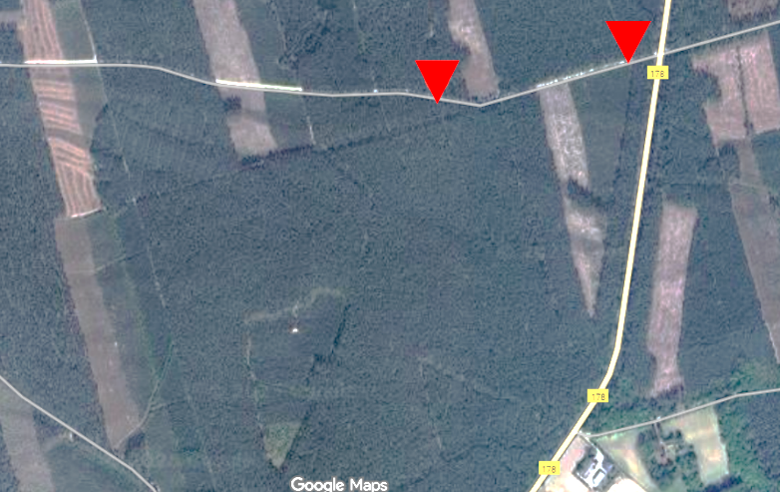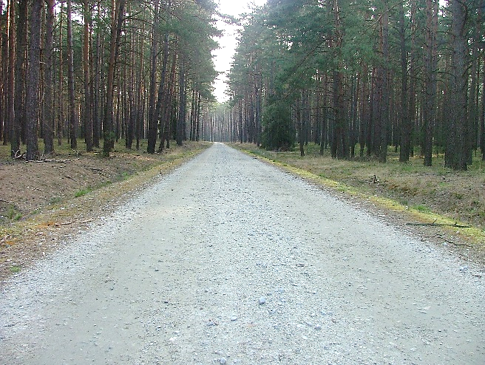
Fig. 1. Location of the test road section near Voivodeship Road No. 178 | Fig. 2. View of the test road section with a crushed-stone surface (photo: S. M. Grajewski)

The pavement structure comprises a 0/31.5 mm crushed-stone surface layer (0-5 cm) placed on a base course of 0/63.0 mm crushed aggregate (5-25 cm), underlain by a subgrade of uniform fine/medium sand (FSa/MSa) with a coefficient of uniformity C_{U} < 3.0 and a sand equivalent SE > 35 (25-250 cm). No groundwater was detected within the 250 cm soil profile (Grajewski 2019).
2.2. Light falling weight deflectometers
Tests were conducted using the following devices: ZFG 3000 GPS (with 10 kg and 15 kg drop weights), HMP LFG 4, and Terratest 4000 Stream. All devices held valid calibration certificates.
- The ZFG 3000 GPS lightweight falling weight deflectometer, manufactured by Zorn Instruments GmbH & Co., Stendal, Germany, consists of a 20 mm thick, 300 mm diameter plate weighing 15 kg. The 10 kg drop weight generates an impact force of 7.070 kN with a tolerance of ±1%, while the 15 kg drop weight produces an impact force of 10.605 kN ±1%. The impact duration is 17.0 ms for the lighter drop weight and 13.0 ms for the heavier one, each with an accuracy of ±1.5 ms. The impact is generated by a 10 kg or 15 kg weight operating with a steel spring mechanism. The device measures settlements in the range 0.3-5.0 mm with an accuracy of ±0.02 mm and E_{vd} values of 15-70 MN·m⁻² for the 10 kg drop weight and 70-105 MN·m⁻² for the 15 kg drop weight.
- The HMP LFG 4 lightweight falling weight deflectometer, manufactured by HMP Magdeburger Prüfgerätebau GmbH, Magdeburg, Germany, consists of a 20 mm thick, 300 mm diameter steel plate weighing 15 kg. The device generates an impact force of 7.070 kN with a tolerance of ±1%. The impact duration is 17.0 ms with an accuracy of ±1.5 ms. The impact is produced by a 10 kg drop weight working with a set of 17 disc springs. The device measures settlements in the range 0.1-2.0 mm with an accuracy of ±0.02 mm and E_{vd} values of 15-70 MN·m⁻² (with a non-standard upper measurement limit of 225 MN·m⁻²).
- The Terratest 4000 Stream, manufactured by Terratest GmbH, Löwenberger Land, Germany, consists of a 20 mm thick, 300 mm diameter steel plate weighing 15 kg. The device generates an impact force of 7.070 kN with a tolerance of ±1%. The impact duration is 17.0 ms with an accuracy of ±1.5 ms. The impact is produced by a 10 kg drop weight working with a set of 17 disc springs. The device measures settlements in the range 0.1-2.0 mm with an accuracy of ±0.02 mm and E_{vd} values of 15-70 MN·m⁻² (with a non-standard upper measurement limit of 225 MN·m⁻²).
2.3. Field testing
Measurements were taken in both wheel tracks according to the procedures recommended by the manufacturers and the guidelines of the Road and Bridge Research Institute in Warsaw (Szpikowski et al. 2005) (Fig. 3). The parameters E_{vd} and s/v were recorded.

1
2
3
4
≥1
≥1
≥1
1
2
3
4
≥1
≥1
≥1
~20 m
4
3
2
1

Fig. 3. Schematic layout of LFWD measurements: 1 – ZFG 3000 GPS with 10 kg falling weight, 2 – Terratest 4000 Stream, 3 – HMP LFG 4, 4 – ZFG 3000 GPS with 15 kg falling weight
2.4. Data analysis
All analyses were conducted using the Statistica 14 software environment (TIBCO Software Inc., San Ramon, CA, United States). The raw data underwent preliminary filtering, during which outliers and extreme values – classified as measurement errors – were removed, followed by statistical analyses (Shapiro-Wilk, Tukey HSD, Levene, Kruskal-Wallis). The choice of statistical procedure depended on whether the assumptions of normality and homogeneity of variance were met.
Outliers and extreme values were identified according to the classical Tukey rules, implemented in Statistica 14, using the automated outlier-detection procedures available in the boxplot module, separately for each measurement dataset. All threshold values and the classification of observations were based on quartiles calculated by Statistica 14 for the respective data subsets. Outliers were defined as observations that satisfied condition (2):
x < Q₁ – 1.5 ⋅ IQR or x > Q₃ + 1.5 ⋅ IQR (2)
Observations satisfying condition (3) were classified as extreme values:
x < Q₁ – 3.0 ⋅ IQR or x > Q₃ + 3.0 ⋅ IQR (3)
where:
IQR = Q₃ – Q₁.

Observations identified as outliers or extreme values were considered to be affected by measurement error and were excluded from further statistical analyses.
3. Results
Analysis of the dynamic deformation modulus (E_{vd}) measurements revealed apparent differences between the tested light falling weight deflectometers (LFWDs). The E_{vd} values obtained using the ZFG 3000 GPS 10 kg fell within a relatively narrow range and showed the lowest variability (CV = 11.2%), indicating the highest measurement repeatability (Table 2, Fig. 4). In contrast, the HMP LFG 4 recorded a much wider spread of values and the highest coefficient of variation (CV = 23.7%), indicating the greatest dispersion among all devices. The Terratest 4000 Stream produced E_{vd} values with moderate variability (CV = 17.6%), positioned between the results from the ZFG 10 kg and the HMP. The ZFG 3000 GPS 15 kg was characterised by the highest E_{vd} median, the broadest overall range, and moderate variability (CV = 20.6%). Among the analysed LFWDs, the ZFG 3000 GPS 15 kg captured the highest apparent subgrade stiffness, whereas the most consistent E_{vd} measurements were obtained using the ZFG 3000 GPS 10 kg. However, the dataset from the ZFG 3000 GPS 10 kg required the removal of the largest number of outliers.
The s/v index also showed notable differences among the devices (Table 2, Fig. 5). The highest measurement uniformity was observed for the ZFG 3000 GPS 10 kg and ZFG 3000 GPS 15 kg (CV = 6.4% for both), with relatively narrow value ranges (2.08-2.71 ms and 2.03-2.63 ms, respectively). The HMP LFG 4 exhibited the lowest s/v variability among all devices (CV = 5.2%). However, its value distribution displayed a different internal structure compared with the other plates, particularly when contrasted with the Terratest 4000 Stream, which demonstrated the highest coefficient of variation for s/v (6.9%) and the widest spread of values (1.83-2.37 ms). The s/v results therefore indicate that the closest similarity occurs between the ZFG 10 kg and ZFG 15 kg models, whereas the greatest divergence is observed between the HMP and the Terratest.

Table 2. Basic descriptive statistics for datasets obtained using different light falling weight deflectometers (LFWD) for the bearing-capacity parameters (E_{vd}, s/v) of the crushed-stone forest road pavement
Cecha | Typ LFWD | n | N | x_{min} | x_{max} | M | $$\overline{x}$$ | SD | SE | CV
E_{vd} | ZFG 3000 GPS 10 kg | 41 | 31 | 56.53 | 94.54 | 76.53 | 74.97 | 8.41 | 1.51 | 11.2
E_{vd} | HMP LFG 4 | 41 | 41 | 49.23 | 148.03 | 77.85 | 82.77 | 19.65 | 3.07 | 23.7
E_{vd} | Terratest 4000 Stream | 41 | 40 | 53.10 | 119.70 | 76.95 | 80.10 | 14.10 | 2.23 | 17.6
E_{vd} | ZFG 3000 GPS 15 kg | 39 | 39 | 57.69 | 139.46 | 96.15 | 94.79 | 19.53 | 3.13 | 20.6
s/v | ZFG 3000 GPS 10 kg | 41 | 40 | 2.076 | 2.712 | 2.268 | 2.294 | 0.15 | 0.02 | 6.4
s/v | HMP LFG 4 | 41 | 39 | 1.881 | 2.297 | 2.023 | 2.042 | 0.11 | 0.02 | 5.2
s/v | Terratest 4000 Stream | 41 | 39 | 1.829 | 2.372 | 2.056 | 2.067 | 0.14 | 0.02 | 6.9
s/v | ZFG 3000 GPS 15 kg | 39 | 37 | 2.033 | 2.634 | 2.212 | 2.235 | 0.14 | 0.02 | 6.4
Explanatory notes: n – initial sample size, N – sample size after removal of extreme and outlying values, x_{min} – minimum value, x_{max} – maximum value; M – median, x̄ – mean value, SD – standard deviation, SE – standard error, CV – coefficient of variation

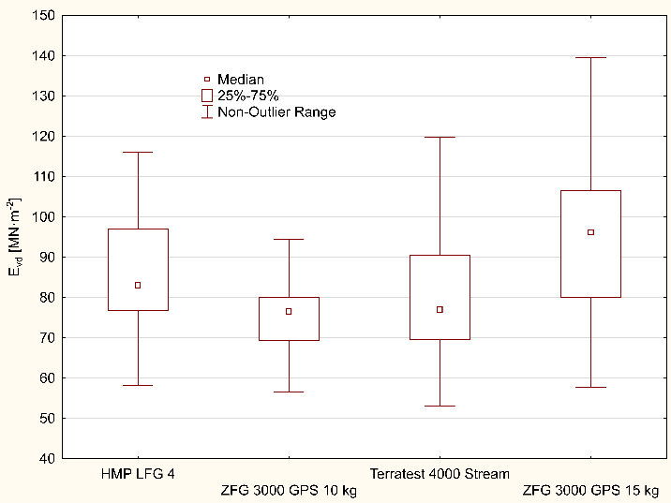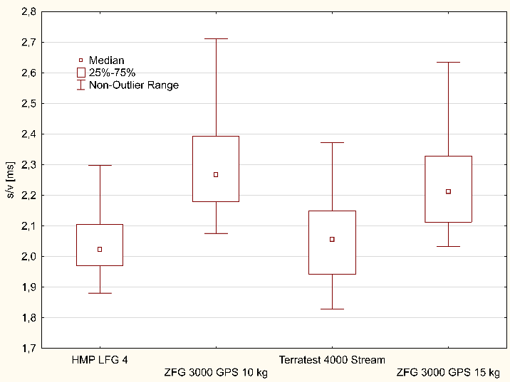
Fig. 4. Statistical characteristics of the dynamic deformation modulus (E_{vd}) values obtained using the tested lightweight falling weight deflectometers (LFWDs) | Fig. 5. Statistical characteristics of the s/v index values obtained using the tested lightweight falling weight deflectometers (LFWDs)

The statistical analyses confirmed the presence of clear differences between devices. Tukey's HSD test for E_{vd} revealed significant differences between ZFG 10 kg and HMP, between ZFG 15 kg and ZFG 10 kg, and between ZFG 15 kg and the Terratest, indicating that discrepancies between these device pairs are not incidental (Table 3). The Kruskal-Wallis test for s/v demonstrated significant differences across all key device pairs, particularly between ZFG 10 kg and HMP, and between ZFG 15 kg and the Terratest, confirming the distinct nature of the recorded dynamic responses (Table 4).
The ZFG 3000 GPS 10 kg proved to be the device with the highest stability and lowest variability in E_{vd} measurements, while the ZFG 3000 GPS 15 kg achieved the highest deformation modulus values and similarly uniform s/v results. The HMP LFG 4 displayed the most significant variability in E_{vd} but the lowest variability in s/v, resulting in an internally contrasting performance profile. The Terratest 4000 Stream occupied an intermediate position between the ZFG and HMP devices in terms of E_{vd}, but for s/v it exhibited the highest variability and the broadest range of values. The greatest similarity between devices was observed for the ZFG 10 kg and ZFG 15 kg models, whereas the most pronounced differences occurred between the HMP LFG 4 and the Terratest 4000 Stream. Overall, the results clearly show that all devices recorded distinct and statistically significant subgrade responses, which must be considered when comparing their outputs and interpreting field measurements.

Table 3. Results of the parametric Tukey HSD test for unequal sample sizes evaluating the significance of differences between dynamic deformation modulus (E_{vd}) values obtained using various lightweight falling weight deflectometers (MSE = 318.28, df = 158)
LFWD | HMP LFG 4 | ZFG 3000 GPS 10 kg | Terratest 4000 Stream | ZFG 3000 GPS 15 kg
HMP LFG 4 | – | 0.0230 | 0.3051 | 0.0569
ZFG 3000 GPS 10 kg | 0.0230 | – | 0.5522 | 0.0000
Terratest 4000 Stream | 0.3051 | 0.5522 | – | 0.0001
ZFG 3000 GPS 15 kg | 0.0569 | 0.0000 | 0.0001 | –

Table 4. Results of the non-parametric Kruskal-Wallis test evaluating the significance of differences between s/v values obtained using various lightweight falling weight deflectometers (H(3) = 66.36535, N = 155, p = 0.0000)
LFWD | HMP LFG 4 | ZFG 3000 GPS 10 kg | Terratest 4000 Stream | ZFG 3000 GPS 15 kg
HMP LFG 4 | – | 0.0000 | 1.0000 | 0.0000
ZFG 3000 GPS 10 kg | 0.0000 | – | 0.0000 | 0.9895
Terratest 4000 Stream | 1.0000 | 0.0000 | – | 0.0001
ZFG 3000 GPS 15 kg | 0.0000 | 0.9895 | 0.0001 | –
4. Discussion
The variability of measurement results obtained using light falling weight deflectometers (LFWD) is widely reported in the literature. Fleming et al. (2007) demonstrated that construction-related differences – including sensor type, signal acquisition method, and plate geometry – can lead to substantial discrepancies in recorded deflections and calculated E_{vd} values. The results presented in this study are consistent with these findings, as the ZFG 3000 GPS, HMP LFG 4, and Terratest 4000 Stream devices produced datasets with clearly distinct statistical structures for both E_{vd} and s/v, despite uniform field conditions.
Further confirmation of the naturally high variability of E_{vd} measurements is provided by Trzciński (2022), who, while examining eight road sections with diverse structural configurations, recorded wide ranges of E_{vd} values in the left and right wheel paths, particularly on sand-gravel pavements placed over wooden substructures. The author did not remove extreme values, allowing the full amplitude of field variability to be captured, and the resulting ranges were comparable to or even wider than those observed in the present study, despite more uniform testing conditions. These findings highlight that the variability of recorded E_{vd} results from both the properties of the tested medium and the operational characteristics of the LFWD device itself.
Regarding impulse loading energy, the findings of Duddu and Chennarapu (2022) are also confirmed in the present study. The higher impulse energy of the ZFG 3000 GPS 15 kg resulted in higher mean and median E_{vd} values compared with the 10 kg variant. However, similar to the observations of Trzciński (2022), the increase in E_{vd} level did not reduce the amplitude of the results, indicating that impulse energy influences the magnitude of the modulus rather than the stability of the measurements.
The lack of standardisation among manufacturers is identified as a major source of systematic equipment bias (Shin et al. 2024). The results of the present study fully confirm this: despite measurements being taken at the same field locations, the devices recorded structurally different distributions of both E_{vd} and s/v. Particularly strong contrasts were noted between the HMP LFG 4 and Terratest 4000 Stream, which exhibited the highest and intermediate variability for E_{vd}, respectively, whereas for s/v the relationship was reversed – the HMP showed the lowest variability and the Terratest the highest. This inverse pattern of signal stability confirms significant construction-related differences and distinct characteristics of the recorded load-deflection response. In this context, the results of Trzciński (2022) provide essential comparative background, showing that wide spreads in E_{vd} may arise from both structural heterogeneity of road layers and, as demonstrated in the present study, from constructional differences between LFWD devices.

The results obtained are also partially consistent with the observations of Grasmick et al. (2015), who indicated that the signal acquisition method and sensor type affect the shape of the deflection-time curve. In the present study, the Terratest 4000 Stream recorded more variable waveforms with local fluctuations, which resulted in the highest spread of s/v parameters. At the same time, it was shown that even devices manufactured by the same company – the ZFG 3000 GPS 10 kg and 15 kg – produce systematically different E_{vd} values despite identical subgrade conditions, which had not been clearly documented previously.
Absolute differences in E_{vd} values may appear small from a practical perspective; however, their significance increases when E_{vd} is used to predict primary (E_{v1}) and secondary (E_{v2}) deformation moduli obtained from static plate load tests (PLT). Regardless of the complexity of applied regression models, even minor differences in E_{vd} may intensify discrepancies in computed results, leading to substantial differences in bearing capacity assessment (Grajewski 2022a, 2023, Pawłowski et al. 2024). Similarly, seemingly minor variations in s/v – though within the compaction quality limits specified by manufacturers (e.g., < 3.5 ms according to Zorn 2014) – may distort the estimation of E_{v1} and E_{v2} and lead to misinterpretations (Sulewska & Bartnik 2017).
The results of the study clearly confirm that LFWD devices differing in construction, drop weight mass, and signal acquisition method produce statistically different ground responses, even under identical field conditions. The data indicate that the greatest similarity in recorded characteristics was between the ZFG 10 kg and ZFG 15 kg devices, while the largest differences were observed between the HMP LFG 4 and the Terratest, for both E_{vd} and s/v. These findings are consistent with previous literature and extend it in several areas, particularly regarding the influence of constructional differences between devices from the same manufacturer. At the same time, they challenge the commonly assumed complete interchangeability of LFWD devices of different types and brands, emphasising the need to use homogeneous equipment in comparative studies and field analyses.
5. Conclusion
The tested German-type light falling weight deflectometers (LFWDs) exhibited substantial variation in the values of the dynamic deformation modulus (E_{vd}) and the s/v index. These differences affected both the mean levels and measurement variability, indicating a strong influence of device construction and technical parameters on the recorded mechanical-dynamic response of the crushed-stone forest road surface. The distinct nature of the recorded data was evident even under identical field conditions, confirming the lack of full comparability between the LFWD designs.
Statistical analyses (unequal N Tukey HSD, Kruskal-Wallis test) showed that the examined devices did not produce interchangeable results. Significant differences were found between the distributions of E_{vd} and s/v, indicating that the tested LFWDs cannot be considered metrically equivalent without prior calibration or standardisation of measurement procedures. Consequently, direct comparison of results from different LFWD units may lead to erroneous diagnostic conclusions. The divergence in statistical characteristics between devices, particularly between the HMP LFG 4 and the Terratest 4000 Stream, further emphasises the need for caution when interpreting results obtained using different plates. This is especially important when E_{vd} or s/v values are used as input data for regression models or bearing-capacity assessment procedures.
The use of a heavier falling weight increased the consistency and reliability of the results, especially for the dynamic deformation modulus (E_{vd}). The higher impact energy enhanced the sensitivity of the measurement to the structural properties of the crushed-stone layer, while reducing the influence of local effects and lowering the relative variability of the results. However, the findings showed that a heavier weight does not automatically ensure lower variability for all parameters, particularly s/v, which indicates a more complex relationship between impulse energy and the stability of the recorded signal. This implies that the selection of weight mass should be adjusted not only to the stiffness of the subgrade but also to the intended interpretative use of LFWD parameters.
The results highlight the need for further standardisation of LFWD measurement procedures and the development of device-specific correction coefficients, particularly for inter-device comparisons or the use of results for design purposes. Future research should include analyses of long-term repeatability, the influence of complex multilayer systems, and calibration methods enabling harmonisation of results between different plate types. It also appears justified to develop recommendations for selecting LFWD devices for field testing depending on subgrade stiffness and the expected ranges of E_{vd} and s/v values. Additionally, consideration should be given to establishing an expanded, unified national standard for LFWD testing, which could significantly improve result comparability and facilitate its interpretation in engineering practice.

Funding
The publication was financed by the Polish Minister of Science and Higher Education as part of the Strategy of the Poznan University of Life Sciences for 2024-2026 in the field of improving scientific research and development work in priority research areas.

Acknowledgements
I would like to thank Eng. Tomasz Bzdyra for his valuable assistance with research logistics and field data collection. Special thanks are also extended to two units of the State Forests – National Forest Holding: Oborniki Forest District and Jawor Forest District, as well as to Merazet Inc. in Poznań for selflessly providing the testing equipment.
Reference
Alshibli, K. A., Abu-Farsakh, M., & Seyman, E. (2005). Laboratory evaluation of the geogauge and light falling weight deflectometer as construction control tools. Journal of Materials in Civil Engineering, 17(5), 560-569. https://doi.org/10.1061/(ASCE)0899-1561(2005)17:5(560)
Bitir, I., Musat, E. C., Lunguleasa, A., & Ciobanu, V. D. (2021). Monitoring the transport on the Ciobănuș forest road within the Bacău Forestry Department. Recent Journal, 1(63), 10-16. https://doi.org/10.31926/RECENT.2021.63.010
Coghlan, G. T. (2000). Opportunities for low-volume roads. Transportation in the Millennium: state of art and future directions. Transportation Research Board, National Research Council, TR News, 205, 1-7.
Duddu, S. R., & Chennarapu, H. (2022). Quality control of compaction with lightweight deflectometer (LWD) device: a state-of-art. International Journal of Geo-Engineering, 13, Article 1. https://doi.org/10.1186/s40703-021-00171-2
Fleming, P. R., Frost, M. W., & Lambert, J. P. (2007). Review of the lightweight deflectometer for routine in situ assessment of pavement material stiffness. Transportation Research Record, Soil Mechanics, 2004(1), 80-87. https://doi.org/10.3141/2004-09
Grajewski, S. M. (2019). Functionality of forest fire roads in view of requirements of modern fire engines and pumper trucks and currently used forest firefighting tactics and technologies. Poznań University of Life Sciences Publishing House, Poznań, Poland. (in Polish)
Grajewski, S. M. (2022a). Prediction of primary deformation modulus based on bearing capacity: a case on forest road with a light falling weight deflectometer Zorn ZFG 3000 GPS. Forests, 13, 1874. https://doi.org/10.3390/f13111874
Grajewski, S. M. (2022b). Forest road engineering in Poland: current status and development perspectives. Sylwan, 166(2), 123-140. https://doi.org/10.26202/sylwan.2022006
Grajewski, S. M. (2023). Evaluation of the light falling weight deflectometer for in situ measurement of the secondary deformation modulus of various forest road pavements. Croatian Journal of Forest Engineering, 44(2), 313-326. https://doi.org/10.5552/crojfe.2023.2125
Grasmick, J. G., Mooney, M. A., Senseney, C. T., Surdahl, R. W., & Voth, M. (2015). Comparison of multiple sensor deflection data from lightweight and falling weight deflectometer tests on layered soil. Geotechnical Testing Journal, 38(6), 851-863. https://doi.org/10.1520/GTJ20140172
Gumus, S., Acar, H. H., & Toksoy, D. (2008). Functional forest road network planning by consideration of environmental impact assessment for wood harvesting. Environmental Monitoring and Assessment, 142, 109-116. https://doi.org/10.1007/s10661-007-9912-y
Hrůza, P. (2003). Optimization of forest road network under principles of functionally integrated forest management. Journal of Forest Science, 49(9), 439-443. https://doi.org/10.17221/4717−JFS
Kaakkurivaara, T., Vuorimies, N., Kolisoja, P., & Uusitalo, J. (2015). Applicability of portable tools in assessing the bearing capacity of forest roads. Silva Fennica, 49(2), article id 1239. https://doi.org/10.14214/sf.1239
Kamal, M., Arshid, M., Sha, M., & Khan, E. (2018). Relationship between dynamic deformation modulus (E_{vd}) and CBR for common and granular materials. Technical Journal, 23(1), 9-14. https://tj.uettaxila.edu.pk/index.php/technical-journal/article/view/532
Keramati, A., Lu, P., Sobhani, A., & Esmaeili, S. A. H. (2020). Impact of forest road maintenance policies on log transportation cost, routing, and carbon-emission trade-offs: Oregon case study. Journal of Transportation Engineering, Part A: Systems, 146(5), 04020028. https://doi.org/10.1061/JTEPBS.0000335
Kongkitkul, W., Saisawang, T., Thitithavoranan, P., Kaewluan, P., & Posribink, T. (2014). Correlations between the surface stiffness evaluated by lightweight deflectometer and degree of compaction. Tunneling and Underground Construction, GSP 242, 65-75. https://doi.org/10.1061/9780784413449.007
Krawczyk, B., Mackiewicz, P., & Szydło, A. (2015). Influence analysis of counterweight type used in static plate test on identified parameters of pavement courses and subgrade. Roads and Bridges, 14(2), 143-157. https://doi.org/10.7409/rabdim.015.010
Laschi, A., Foderi, S., Fabiano, F., Neri, F., Cambi, M., Mariotti, B., & Marchi, E. (2019). Forest road planning, construction and maintenance to improve forest fire fighting: a review. Croatian Journal of Forest Engineering, 40(1), 207-219.
Livneh, M., & Goldberg, Y. (2001). Quality assessment during road formation and foundation construction: use of falling-weight deflectometer and light drop weight. Journal of Transportation Research Board, 1755(1), 69-77. https://doi.org/10.3141/1755-08
Mackiewicz, P., & Krawczyk, B. (2015). Influence of loading time on subgrade parameters derived from VSS static plate test. Roads and Bridges, 14(1), 19-29. https://doi.org/10.7409/rabdim.015.002
Mooney, M. A., & Miller, P. K. (2009). Analysis of lightweight deflectometer test based on in situ stress and strain response. Journal of Geotechnical and Geoenvironmental Engineering, 135, 199-208.
https://doi.org/10.1061/(ASCE)1090-0241(2009)135:2(199)
Nazzal, M. D., Abu-Farsakh, M. Y., Alshibli, K., & Mohammad, L. (2007). Evaluating the light falling weight deflectometer device for in situ measurement of elastic modulus of pavement layers. Transportation Research Record: Journal of the Transportation Research Board, 2016, 13-22. https://doi.org/10.3141/2016-02
Pawłowski, M., Grajewski, S. M., & Węgliński, S. (2024). Reloading modulus estimation based on static and dynamic plate load tests carried out on unpaved forest roads. Advances in Science and Technology Research Journal, 18(4), 250-264. https://doi.org/10.12913/22998624/189403
Raport… (2020). Raport o stanie lasów w Polsce 2019. General Directorate of State Forests National Forest Holding, Warsaw, Poland. Available from https://www.lasy.gov.pl/pl/informacje/publikacje/informacje-statystyczne-i-raporty/raport-o-stanie-lasow [accessed: 06.08.2021]. (in Polish)
Sakai, H. (2017). Challenges in road construction and timber harvesting in Japan. Croatian Journal of Forest Engineering, 38(2), 187-195.
Santiago, L. E., & Loomis, J. (2009). Recreation benefits of natural area characteristics at the El Yunque National Forest. Journal of Environmental Planning and Management, 52(4), 535-547. https://doi.org/10.1080/09640560902868439
Shin, B., Tiwari, N., Becker, P. J., & Bobet, A. (2024). Improved light weight deflectometer test (LWD) and analysis. Joint Transportation Research Program Publication No. FHWA/IN/JTRP-2024/35. West Lafayette, IN, Purdue University. https://doi.org/10.5703/1288284317813
Steinert, B. C., Humphrey, D. N., & Kestler, M. A. (2005). Portable falling weight deflectometer study. Report No. NETCR52. Department of Civil and Environmental Engineering, University of Maine, Maine, USA.
Sulewska, M. J. (2004). The application of the modern method of embankment compaction control. Journal of Civil Engineering and Management, 10 (Suppl 1), 45-50.
Sulewska, M. J. (2012) The control of soil compaction degree by means of LFWD. The Baltic Journal of Road and Bridge Engineering, 7(1), 36-41. https://doi.org/10.3846/bjrbe.2012.05
Sulewska, M. J., & Bartnik, G. (2017). Application of the light falling weight deflectometer (LFWD) to test aggregate layers on geosynthetic base. Procedia Engineering, 189, 221-226. http://dx.doi.org/10.1016/j.proeng.2017.05.035
Szpikowski, M., Dreger, M., Przygoda, M., Dróżdż, R., Dąbrowski, M., Tokarczyk, T., Har, M., Mitrut, M., & Żuławnik, P. (2005). Badanie i ustalenie zależności korelacyjnych dla oceny stanu zagęszczenia i nośności gruntów niespoistych płytą dynamiczną. IBDiM, Laboratorium Geotechniki, Warszawa, Poland. (in Polish)
Termansen, M., McClean, C. J., & Jensen, F. S. (2013). Modelling and mapping spatial heterogeneity in forest recreation services. Ecological Economics, 92, 48-57. https://doi.org/10.1016/j.ecolecon.2013.05.001
Thompson, M. P., Gannon, B. M., & Caggiano, M. D. (2021). Forest roads and operational wildfire response planning. Forests, 12, 110. https://doi.org/10.3390/f12020110
Trzciński, G. (2011). Analysis of technical parameters of forest roads in terms on timber haulage by high-tonnage vehicles. Warsaw University of Life Sciences Publishing House, Warsaw, Poland. (in Polish)
Trzciński, G. (2022). Bearing capacity of forest roads on poor-bearing road subgrades following six years of use. Forests, 13(11), 1888. https://doi.org/10.3390/f13111888
Wyroślak, M., & Ossowski, R. (2016). Evaluation of deformation moduli in controlled soil embankment based on VSS plate and LFWD plate. Acta Scientarum Polonorum Architectura, 15(3), 111-118. (in Polish)
Zorn (2014). User manual for the light weight deflectometer ZFG 3000 GPS in accordance with the German technical test requirements for soil and rocks in road construction TP BF – StB Part B 8.3. Merazet, Poznań, Poland. (in Polish)

