
 | Rocznik Ochrona Środowiska
 | Volume 27 | Year 2025 ISSN 2720-7501 | pp. 705-721
 | https://doi.org/10.54740/ros.2025.057 open access
 | Received: October 2025 Accepted: November 2025 Published: November 2025
Testing the Temperature Fields and Power of a Flat Radiator Covered
With and Without a Curtain
Magdalena Orłowska^{1*}, Paweł Szałański², Wojciech Cepiński³
¹Faculty of Civil Engineering Environmental and Geodetic Science, Koszalin University of Technology, Poland
https://orcid.org/0000-0002-2072-1791
²Department of Air Conditioning, Heating, Gas Engineering and Air Protection, Faculty of Environmental Engineering, Wroclaw University of Science and Technology, Poland
https://orcid.org/0000-0001-9263-3486
³Department of Air Conditioning, Heating, Gas Engineering and Air Protection, Faculty of Environmental Engineering, Wroclaw University of Science and Technology, Poland
https://orcid.org/0000-0003-4294-0431
*corresponding author's e-mail: magdalena.orlowska@tu.koszalin.pl
Abstract: The article presents the results of experimental studies on a flat plate radiator. The influence of curtains made of materials of different structures and permeabilities on the temperature fields in the space around the radiator and the heating power of the radiator was checked. Temperature studies concern the gap between the front panel of the radiator and the hung material. The heating power was calculated for the individual variants tested (with or without a cover). The highest heating power was shown to be achieved by the radiator without a cover, which was 319.8 W. The radiator with guipure cover had 319.3 W, while the lowest power was achieved by the radiator with cotton curtain, which was 277.0 W. Based on the experiment conducted, screening factors were given. They were established in relation to the curtains tested and their effect on the heat power of the radiator.
Keywords: temperature, radiator, curtain, material, shielding factor, heating power
1. Introduction
For many years, radiators have been an integral part of the equipment of buildings in temperate and colder climates (Kennard et al. 2022). The purpose of their use is to maintain the desired air temperature in rooms. The principle of operation of a radiator is to transfer heat from a liquid water medium to the interior of the room through a partition made, depending on the type of radiator, e.g., of steel, aluminum, or copper.
A whole range of different radiators is available on the market. Starting with popular plate heat exchangers, through aluminum, cast iron, ladder, convector, channel, etc., exchangers. You can also choose the type and color of the radiator. The aesthetics is one of the most critical aspects in choosing these devices. However, much more important than aesthetics is ensuring appropriate heating power in heated rooms. Currently, the most popular type of radiator in residential and office buildings is a plate radiator (https://www.globalgrowthinsights.com/market-reports/steel-radiator-market-106676).
The most common way to mount such radiators is to hang them on hooks on the wall. Due to the most significant temperature difference, they are most often mounted under windows. However, in modern construction, they appear more and more often on interior walls because windows are display cases that reach all the way to the floor. Popular interior furnishings include decorative elements in the form of curtains and drapes. In addition to their decorative function, curtains affect the acoustics of rooms. The noise is bothersome. Some sound waves are therefore absorbed and reflected depending on the porosity and structure of the material. In addition, curtains shade rooms, so their function is diverse. They can have different lengths, for example, they hang on a rail or curtain rod at the ceiling and reach all the way to the floor, or they can end above the windowsill. Their structure may be different. They can be delicate, airy, thin, perforated guipure curtains and shading, covering, thicker, more compact, cotton curtains. Fabric curtains are often installed near windows and radiators and are often covered by them. Radiator covers reduce their heating power and affect the temperature distribution in their surroundings (Kołodziejczyk & Płuciennik 2001, Brady et al. 2016, Menéndez-Díaz et al. 2014).
Fabric curtains, depending on their method of installation relative to radiators and the type of material they are made of, can have a similar effect on radiators. However, such an effect is not sufficiently described in the literature. Therefore, this article presents the results of research that illustrate the effect of curtains made of different materials on the operation of radiators.

1.1. Free Convection
In the case of a plate radiator, the theory of heat transfer can be applied to a flat plate. Figure 1 shows the distribution of temperature and air velocity during laminar free convection on the surface of a flat, vertical plate. The case concerns a Newtonian fluid.

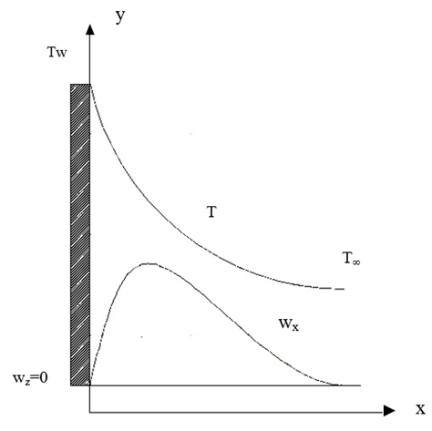
Fig. 1. Diagram of shaping temperature and air velocity fields along the vertical plate (Wiśniewski & Wiśniewski 2017), T_{w} – wall temperature, T – temperature at distance from wall, T∞ – ambient temperature at distance from wall, w_{z} = 0 velocity on wall, wx – velocity at distance from wall

In Figure 1, it is clear that the temperature T decreases with increasing distance from the plate to a certain point and remains at the level T∞, while the velocity wx increases up to a certain point, reaches a maximum, and decreases.
1.2. The studies of radiator design
Studies of radiator design elements and their operating conditions are a developing, up-to-date, and constantly discussed topic in the literature. However, the influence of curtain fabric shielding on the distribution of air parameters in the surroundings of the plate radiator has not been described.
Research related to radiators includes changes to radiator design, the influence of the environment on heat flow, experimental studies using specially prepared test stands, and numerical CFD analysis. Typically, in addition to a more precise understanding of the mechanisms that influence heat transfer, results with practical applications are crucial. Reducing heat losses, improving heat transfer conditions, and reducing radiator production costs are just some of the examples.
In the work (Boháč et al. 2023), the authors studied rings for distributing the medium inside the plate for the panel radiators. This element plays an important role in the distribution of water in the upper chamber of the radiator. The influence of the shape of the holes placed radially in this ring on the water flow was examined. A CFD analysis was performed. A unique prototype of the ring was created. It turned out that the trapezoidal shape is the most advantageous. The solution was patented. With this configuration, the radiator plate had the most uniform temperature distribution along its length, so the water was evenly distributed without changing the cross-section of the radiator distribution chamber.
In the work (Gelis & Akyurek 2021), the authors focused on the study of the influence of different types of panel radiators (pc-11, pccp-22, and pccpcp-33) on the heat transfer coefficient and the generated entropy. The temperature of the working medium was analyzed: 40°C, 50°C, 60°C, flow rate: 2.5 dm³/min; 5.0 dm³/min; 7.5 dm³/min. A mathematical model was developed. The model was verified by experimental tests. Optimal parameters with a reduced number of panels, low temperature, and high flow were obtained.
In the following article (Sevilgen & Kilic 2011), the authors decided to perform a numerical analysis of a room in which a mannequin was sitting in an armchair. The room was heated by a double-plate radiator. It was assumed that a mannequin of the shape and size of a human had a surface with a constant temperature. The values of the average room temperature, air humidity, radiator temperature, and heat transfer coefficient for the window and the external wall of the room were changed. The dependencies of the body heat loss indicators, the PMV values, and the total heat loss coefficients in the room were shown. It was shown that energy consumption can be reduced and thermal comfort improved at the same time by appropriate insulation of external walls and windows.
In the work (Calisir & Baskaya 2021), numerical studies were carried out on the influence of the geometric dimensions of the convectors on the efficiency of panel radiators. An attempt was also made to perform an experiment on a single convector placed on a wall with a constant temperature. The influence of the following parameters was taken into account: convector height, sheet thickness, trapezoid height, distance between opposite convectors, width of convector ends, vertical position of the convector, and cut-off coefficient. The results obtained showed that heat transfer increases with an increase in the thickness and height of the convector, but the amount of material, the sheet, also increases. With an increase in trapezoid height, heat transfer increases, but above a specific value, it decreases. Heat transfer increases with the distance of the opposite convectors and becomes almost constant above a particular value. The results are helpful in designing radiators, with high efficiency and low material input – sheet.
In the article (Beck et al. 2004), an attempt was made to increase the efficiency of a double heat radiator by placing one or two sheets of high emissivity between its internal surfaces. In the case of conventional radiators, the surface is increased by fins. Unfortunately, dust collects on the fins, which reduces their thermal power. In addition, material is needed to make the fins, which increases their production cost. The conclusions of this work indicate an increase in the thermal power of the heat exchanger and that the sheets operate effectively. They release heat by radiation and then transfer it to the environment by convection. Due to this action, surface release heat is increased. This method is an alternative to the production of radiators. The cost of production is reduced, and cleaning is easier than in the case of fins. According to the authors of the work, the thermal power of finned radiators can also be increased by moving the fins relative to each other to better use the radiation effect.
In the work (Bayram & Koç 2023), the thermal power of the radiator was increased without increasing the supply temperature or changing the size of the radiator to a larger one. Fans were installed under the radiator. Heat was transferred by forced convection. The thermal power has increased. The tests were performed experimentally under various conditions with respect to the temperature of the supply and the speed of the fan. The influence of fan heaters on the air temperature in the room was also examined. A greater effect was observed under conditions of lower supply temperature. The total thermal power of the radiator was higher, but the efficiency of natural convection and radiation decreased.
This paper (Shahsavar & Arici 2021) deals with multi-criteria optimization for a hybrid integrated photovoltaic/thermal (BIPVT) building system that has a sensible rotary heat exchanger (SRHX) for heating and cooling purposes. The BIPVT system applies to two cases: the use of a glass cover and a variant without a cover. A system with a glass cover shows more heat gain and less electricity generation. The differences in the two considered cases are given as 7 MWh for the total energy produced and 378 kWh for the difference in total exergy.
The article (Calisir et al. 2021) examined different sizes of the convector and air flow over the radiator. The flows took into account the direction of air flow, the influence of the adjacent wall, and the velocity profiles were checked. PIV measurements and CFD numerical simulations were performed. Higher velocity values were recorded at the water inlet. The thermal comfort conditions were maintained. As a result of the research, it was found that it is possible to save on the material from which convectors are made, which has a significant impact on the cost of their production.
In Myhren & Holmberg's (2011) work, researchers focused on longitudinal fins on a non-traditional ventilation radiator. CFD simulations of heat transfer and its flow mechanism were performed, along with analytical calculations that verified the CFD analysis. The power of the radiator was calculated. They found that heat transfer could be improved by slightly changing the geometry of the fins, "reducing the distance between the fins and cutting the central section of the fin array". This significantly increased the thermal efficiency of the entire radiator, lowering the temperature of the water and saving energy.
In the work (Shati et al. 2011), the study examined the heating power of a radiator and heat transfer from the wall behind the radiator. The structure of the wall was found to influence the thermal effect. A rough wall with a high emissivity coefficient produced better results compared to a smooth, glossy wall. Heat transfer was 26% higher. The resulting air velocities were also higher for the rough wall. Roughness increases the surface area and intensity of convective heat flux in the gap between the wall and the radiator.
The author of (Robinson 2016) studied the convection and radiation from panel radiators. He assessed the efficiency of the heating system and the energy losses through the wall behind the radiator. The losses were estimated to be around 5%. Reflector panels were used. The system's efficiency improved, while the radiator's thermal output decreased. The wall's construction and its U-value are essential factors. Radiation shielding was also used: with reflective surfaces on both sides, and another method with a high-emissivity surface facing the radiator and a low-emissivity surface facing the wall. The last method proved to be the most effective, increasing heat transfer to the room and reducing heat losses.
The authors of (Harris 1995) conducted experimental studies in a climatic chamber. They examined the effect of a metal foil placed behind radiators and under a suspended floor on heat loss. The foil proved to be a good solution. It was estimated that when the foil was used on the walls, the energy consumption in the room decreased by 6%, and heat losses through the wall behind the radiator fell below 30%. Heat losses from a wooden floor with foil under its surface decreased by 48%.
Some heat flow solutions employ numerical analyses, which provide significant support in predicting behavior. They often shorten the time required for lengthy experimental studies. Examples of similar work include (Defraeye et al. 2012, Cao et al. 2020, Singh & Gohil 2019).
Other examples of research related to convective heat transfer include (Sadri et al. 2018, Lin et al. 2020, Lei et al. 2017). Solutions are sought that could increase the heat transfer intensity in a non-mechanical way.
1.3. Radiator covers
An important topic that is still relevant and developed in the literature is the influence of radiator covers on their heating power and temperatures in their surroundings.
In Poland, the standards for the design of radiators are specified, among others, by the INSTAL Central Research and Development Center for Installation Technology (Kołodziejczyk & Płuciennik 2001).
The influence of the radiator covers on their power is illustrated in Figure 2. It should be mentioned that when calculating the thermal efficiency of a radiator, in addition to the calculated demand for thermal power of the room, various factors should also be taken into account, which affect the increase or decrease of the necessary heating surface of the radiator. These are the so-called correction factors. They include, for example, factors: taking into account the use of a thermostatic valve, the location of the radiator, the method of connection to the installation, the influence of the casing (Figure 2), the influence of the cooling of the water in the pipes (Kołodziejczyk & Płuciennik 2001, Koczyk 2005). According to (Kołodziejczyk & Płuciennik 2001), assuming there is no thermostatic valve, the radiator is located on an external wall above the floor, for nominal heating medium temperatures and for the nominal method of connecting the radiator, and in the absence of other heat emitters in the room, the design heat output of the radiator ($\dot{Q_{D}}$), which is the basis for its sizing, is determined as follows:
$\dot{Q_{D}}={\dot{Q}}_{room}∙β_{cov}$ (1)
where:
${\dot{Q}}_{room}$ – heat load of the room,
$β_{cov}$ – radiator shielding factor.

In the work (Brady 2016), the authors investigated the effect of covers on heat exchange in a panel radiator in three variants: a magnetic cover placed on the front panel of the radiator, the same cover with a shelf above the radiator, and a decorative wooden cover not adjacent to the radiator (the radiator covered on all sides, inlets at the floor and outlets in the upper part, openwork front cover plate). Based on heat exchange equations and measurements of the surface temperatures of the radiator and housings, and air parameters, the radiator power was determined. With a magnetic cover with a shelf above the radiator, the thermal power of the radiator was 314.85 W, with only the magnetic cover 267.67 W, and with a wooden housing 190.43 W.
Further research related to radiators consisted of the analysis of a radiator covered with a stoneware plate (Menéndez-Díaz et al. 2014). The correctness of the statement that the stoneware coating retains heat longer after the radiator is turned off was checked. Experimental studies and numerical CFD analyses were carried out. In the experimental studies, thermovision and thermocouples were used to examine temperatures. The results for the stoneware radiator were compared with the results obtained under the same conditions for an aluminum radiator. The stoneware radiator temperature was shown to be slightly higher during radiator cooling, but the temperature difference was less than 2°C and had a tendency to decrease; it disappeared after 50 minutes from the start of cooling.
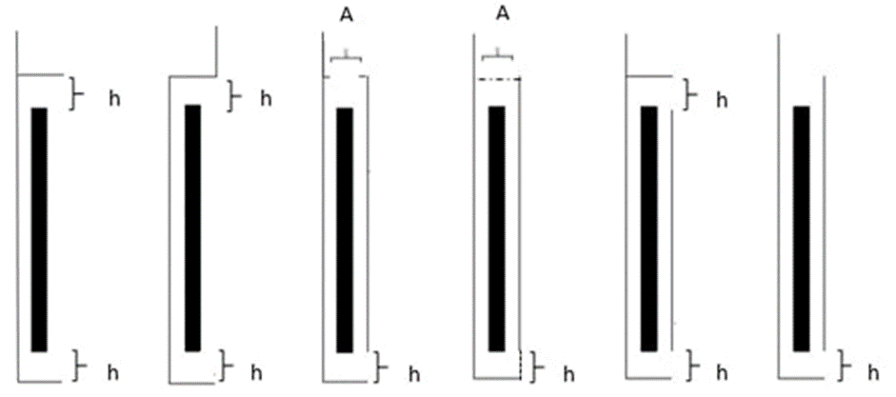
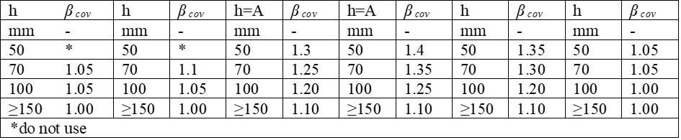
Fig. 2. Radiator shielding factor βcov taking into account the influence of covering the radiator or placing it in a recess (Kołodziejczyk & Płuciennik 2001)

The authors of the articles were involved in research on free convection associated with vertical plates (Tanda et al. 2000, Hosseini & Taherian 2004, Martynenko et al. 1984). The results of the work (Tanda et al. 2000) allowed the acquisition of valuable indications of the natural convection thermal cooling system. A vertical isothermal plate was placed inside a cabinet. The number of ventilation holes, the distance between the plate and the cabinet, and the temperature difference between the plate and the surrounding were varied. The authors of (Hosseini & Taherian 2004) studied heat transfer via convection from a vertical plate to air and other gases. The experiment involved various atmospheric pressures and vertical plates with varying emissivity. The contributions of convection and radiation, as well as emissivity, were determined as a function of pressure. The authors of (Martynenko et al. 1984) also investigated convection in a vertical finite plate. The Navier-Stokes equations were considered within the scope of the chosen topic. The leading and trailing edges, as well as the boundary layer, were investigated. The results were supported by experimental studies of velocity profiles, temperature, and heat transfer coefficients.
1.4. Research gap
Today, interior design plays a significant role. Often, with a focus mainly on aesthetic and architectural considerations, this is done without careful thought, which can result in poorer heat exchange and, consequently, reduced heat efficiency of the radiator. Designers decide on various decorative and architectural elements without fully considering their impact on air circulation and thermal conditions in the room. Information on radiator installation recommendations does not specify shielding factors for screens with different transparency levels, and this type of data is missing in the design guidelines and literature.
The temperature parameters of heating systems have decreased significantly in recent years as a result of the frequent use of condensing boilers and the more widespread use of heat pumps. Radiator supply temperatures in the range of 35°C to 55°C are now more common than the traditional 70°C to 90°C. To achieve the same heating power at a lower temperature, a larger heat exchange surface is required. Therefore, currently installed radiators are larger, have more plates and fins, and are therefore more challenging to integrate aesthetically into interior design. There is a lack of research on the impact of radiator covers operating at lower parameters.
Based on the literature review conducted, it was found that the topic of testing various structural elements and operating parameters of radiators is current and is constantly discussed in the literature (Kołodziejczyk & Płuciennik 2001, Brady et al. 2016, Menendez-Diaz et al. 2014, Rout et al. 2012, Simionescu & Balan 2016, Sevilgen & Kilic 2011, Hu et al. 2020, Calisir et al. 2021, Zhang et al. 2019, Wang et al. 2011, Sertkaya & Sari 2021). Numerous studies focus on the efficiency of exchangers in ideal conditions, i.e., without the possibility of the influence of the surroundings or disturbing factors. A special topic discussed in the literature is the influence of solid radiator covers on their operation (Kołodziejczyk & Płuciennik 2001, Brady et al. 2016, Menéndez-Díaz et al. 2014). Covers serve more than just a decorative purpose. They must also be safe (especially in preschools, nurseries, and hospitals). However, the influence of curtains, the expected influence of which may be similar to the influence of solid covers, is not sufficiently described in the literature. It can be hypothesized that, similar to solid covers, there is a risk of reducing the power of radiators by shielding them with material curtains. Knowledge of this influence will allow for the correct design of radiators. Therefore, it was decided to discuss this topic in this article. Due to the commonness of such solutions, all such information is helpful. The article presents tests of panel water radiators during their operation in various conditions, taking into account various curtains made of a material with a selected structure.
1.5. Novelty and purpose of the paper
The novelty of this paper is the results of experimental studies of the effect of curtain covers on air temperature near the radiator and its heating power, performed with two different types of materials: cotton-curtain, a smoother, solid, and stiffer material, and guipure curtain, softer and perforated. Moreover, the paper attempts to prove the hypothesis that curtains can decrease the heating power of the radiator and that the shielding factor of the curtain depends on the type of material from which it is made.
The paper presents the following results.
- temperature measurements at the front panel of the radiator without a cover,
- temperature measurements at the front panel of the radiator covered in the gap between the front panel of the radiator and the cotton and guipure curtain hung next to it,
- power of the radiator without a cover and covered with a cotton and guipure curtain determined on the basis of measurements of the flow and cooling of the heating medium.

This information explores the current state of knowledge and confirms the effect of curtains on the power of the panel radiator and the temperature distribution in its proximity.
In installation and engineering practice, permanent elements of covers, such as casings with perforated plates or horizontal shelves – window sills, are usually taken into account, ignoring the influence of decorative elements such as curtains. Based on the presented research results, recommendations can be developed regarding the installation of curtains in the context of reducing the risk of uncontrolled reduction of radiator power.
2. Materials and Methods
2.1. Experimental setup
The experimental research was carried out using a research stand located at the Faculty of Civil Engineering, Environmental, and Geodetic Sciences of the Koszalin University of Technology. Figure 3a shows a diagram of the research stand. The stand is part of the equipment of the Department of Building Networks and Installations. Figure 3b shows a photograph of the stand with a radiator covered with a cotton curtain, and Figure 3c shows a radiator without a curtain.
The test installation (Figure 3) consists of:
- (1) a Galmet 100 dm³ capacity water heater,
- (2) a heat source in the form of a 2 kW ME 2000 spiral electric heater equipped with a power regulator (3), mounted inside a water-filled capacity water heater (1) and heating the water in it,
- (4) a tested panel radiator with a flat and smooth front panel without ribs, Purmo Plan Ventil Compact M type, FCVM 22, with dimensions: height 30 cm, width 100 cm, thickness 10 cm, whose power given by the manufacturer, in the water supply and return parameters and the air temperature in the room of 55/45/20°C is 482 W and at 75/65/20°C is 937 W (Sevilgen & Kilic 2011) – a radiator without a thermostatic valve and thermostatic head,
- (5) an electronic circulation pump type EPO 25/4-7/180, with a flow range of 0.4-3.3 m³/h and a maximum lifting height of 6.9 mH₂O, pumping heated water from the storage heater (1) through the piping to the tested radiator (4),
- (6) a balancing valve that allows the flow generated by the pump to be throttled to the required value,
- (7) safety devices in the form of: AFRISO MS central heating safety valve with an opening pressure of 2 bar, connections: Rp½"x Rp¾", maximum installation power according to UDT: 52 kW, maximum installation power according to TUV: 50 kW protecting against pressure increase above the permissible limit and a Reflex Refix DE diaphragm expansion vessel with a capacity of 12 l, with a membrane operating temperature range of -10/70°C and a pressure range of 4/10 bar, taking over water volume fluctuations caused by thermal expansion,
- (8) structure for mounting a fabric curtain (9).
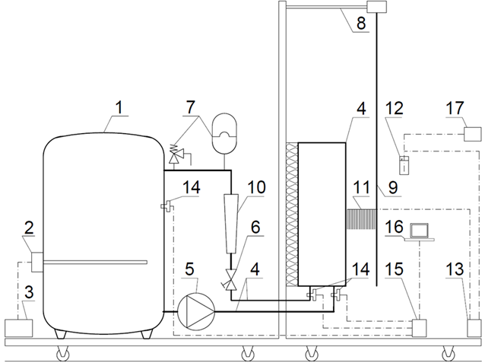
a)
c)
b)
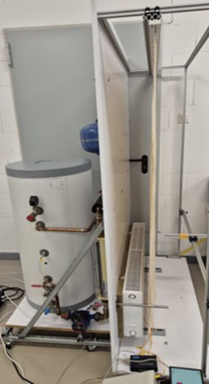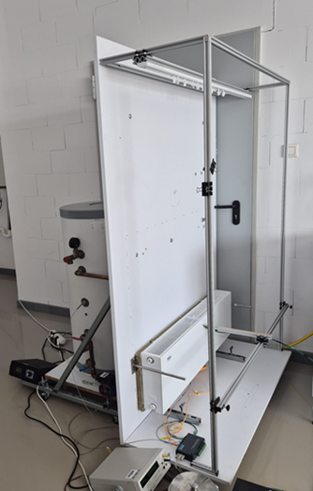
Fig. 3. Experimental setup: (a) diagram, (b) with a radiator and hung cotton material, (c) with a radiator without a curtain (visible insulation on the back of the radiator plate)

The research station is mobile and was placed in a 3.46 m high room equipped with heating, air conditioning, and ventilation systems. In the station, the radiator is mounted on a plate that imitates a wall without a window, 10 cm above the plate that imitates the floor in the station (Figure 3).
Since the geometric layout of the radiator is symmetrical, its rear side was eliminated from the measurements by completely insulating it with mineral wool between the rear wall of the radiator and the plate on which the radiator was mounted. In this way, the influence of heat exchange from the rear surface of the radiator's rear plate was eliminated.
The following measuring equipment was used on the test stand (Figure 3):
- (10) Brooks GT1000 rotameter to measure the volume flow of heating water flowing through the radiator,
- (11) a set of 20 calibrated T190 type K (Ni-Cr-Ni) thermocouples, with a reference temperature in a thermos (12) containing a water-ice mixture, placed 1 mm apart, connected in the form of a comb in a way that allows simultaneous measurement of the air temperature near the radiator at 20 points at the same height,
- (13) PMP-410 digital switch with 45 inputs (20 used) for the set of thermocouples (11),
- (14) a set of 3 calibrated thermocouples to measure the temperature at the supply and return of the radiator and the water in the buffer – connected to a USB module (15) connected to a computer (16),
- (17) Gwinstek laboratory multimeter GDM-8245.
2.2. Scope and conditions of the tests
During the tests, the following measurements were taken:
- temperature of heating water in the storage heater using a sensor (14),
- temperature at the supply and return of the heating medium of the radiator using sensors (14),
- volumetric flow of heating water flowing through the radiator using a rotameter (10),
- air temperature at the front surface of the radiator front panel, in the central part of the radiator, using a set of thermocouples (11) and a digital switch (13), at three fixed heights:
- lower edge of the radiator,
- middle of the radiator,
- upper edge of the radiator,

The air temperature on the front surface of the radiator front panel was measured every 1 mm, at a distance of 1 mm to 20 mm from the front surface of the unshielded radiator front panel, in the case of a shielded radiator, at the same points but in the gap (approximately 2 cm wide) between the curtain and the front surface of the shielded radiator front panel.
All measurement series were carried out with the air temperature in the room maintained at a constant level of 20°C. Several measurement series were performed. The repeatability of the results for the individual series allowed us to conclude that there were no significant errors. The two most popular types of curtains were used for the tests. The experimental tests were carried out for three variants:
- variant A – no radiator cover,
- variant B – radiator covered with a material in the form of an openwork guipure curtain (Figure 4) with dimensions of 155 x 100 cm,
- variant C – radiator covered with 100% cotton material with a weight of 125-130 g/m² (Figure 5) with dimensions of 155 x 100 cm.

In variants B and C, the material was hung on a rail, 2 cm from the radiator front panel, at a height of 165 cm, 10 cm from the base, which is an imitation of the floor.
The guipure curtain – a lightweight, semi-sheer fabric with lace-like structure (estimated transparency
~70-80%) – has an openwork structure with holes through which air can flow (Figure 4). However, the cotton curtain is made of a thicker and more densely woven material (estimated transparency ~20-30%) – much less breathable and transparent, hindering the free flow of air (Figure 5).

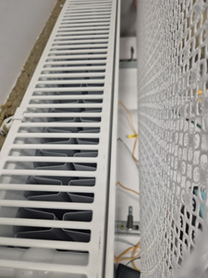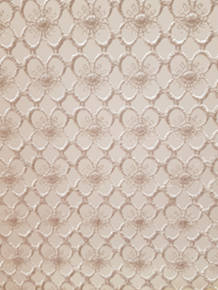
- b)
Fig. 4. Experimental setup with guipure openwork curtain-type material: a) slot between radiator and curtain; (b) zoom of the material

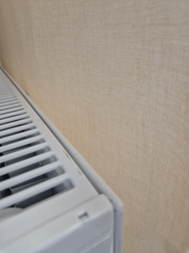
- b)
Fig. 5. Experimental setup with cotton material curtain: slot between radiator and curtain; (b) zoom of the curtain

2.3. Heating capacity and shielding factor of the radiator
The radiator used for the tests has a symmetrical structure. In the modeled station system, heat exchange was considered and focused only on the front side of the exchanger plate. A gap was created there, where the measurements were taken. The rear wall of the radiator was insulated Fig. 3 b, c.
Measured heating capacity of the radiator from dependence:
$\dot{Q_{m}}=\dot{V_{w}}∙ρ_{w}∙c_{w}∙\left(T_{su,m}- T_{r,m}\right)$ (2)
where:
$\dot{V_{w}}$ – measured volume flow of water in the exchanger, m³/s
$ρ_{w}$ – density of the water, kg/m³
$c_{w}$ – specific heat of water, kJ/kgK
$T_{su,m}$ – measured temperature of the radiator supply water, °C
$T_{r,m}$ – measured temperature of the radiator return water, °C

The shielding factor based on the measurements performed was calculated as follows:
$β_{cov}^{m}= \frac{{\dot{Q}}_{m,no }}{{\dot{Q}}_{m, cur}}$ (3)
where:
${\dot{Q}}_{m,no }$ – measured heating power of the radiator without a curtain, W
${\dot{Q}}_{m,cur }$ – measured heating power of the radiator with a curtain, W
3. Results of Experimental Research
3.1. Temperature in the radiator front panel
The results of temperature measurements at the radiator panel not covered with a curtain (variant A), covered with a guipure curtain (variant B), and covered with a cotton curtain (variant C) are presented in Figures 6 to 11. Figures 6, 8, and 10 show the results of air temperature measurements at different heights of the radiator depending on the distance from the front panel for variants A, B, and C, respectively. Figures 7, 9, and 11 show the results of temperature measurements at different distances from the radiator front panel depending on the height of the radiator.
Figure 12 shows the average temperature values measured at a distance of 1 to 20 mm at various heights of the radiator for the individual radiator cover variants A, B, and C.

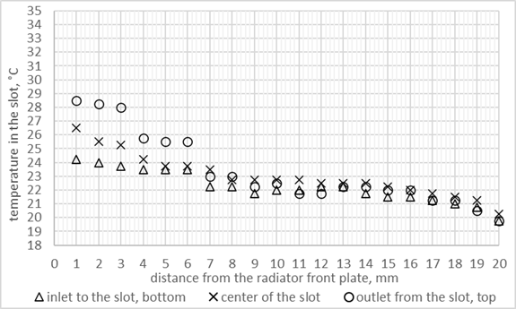
Fig. 6. Horizontal temperature distribution close to the front plate of the radiator without a curtain

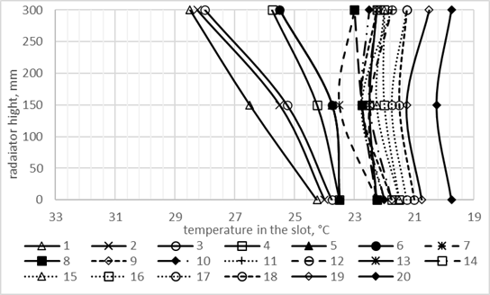
Fig. 7. Vertical temperature distribution close to the front plate of the radiator without a curtain

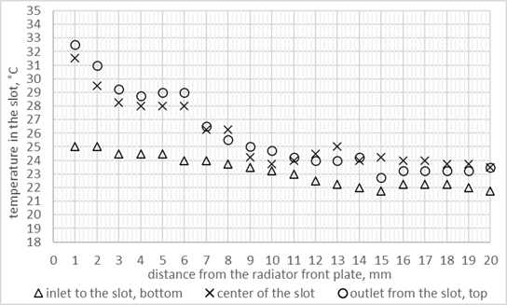
Fig. 8. Horizontal temperature distributions in the slot for the radiator with guipure curtain (2 cm wide slot)

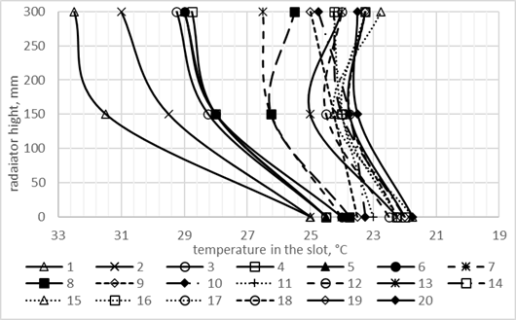
Fig. 9. Vertical temperature distributions in the slot for the radiator with guipure curtain (2 cm wide slot)

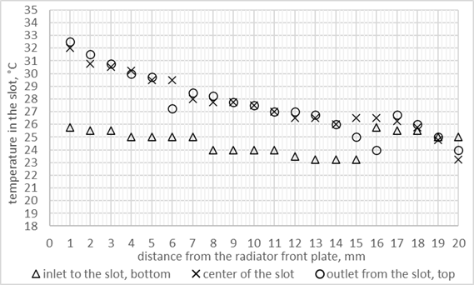
Fig. 10. Horizontal temperature distributions in the slot for the radiator with a cotton curtain (2 cm wide slot)

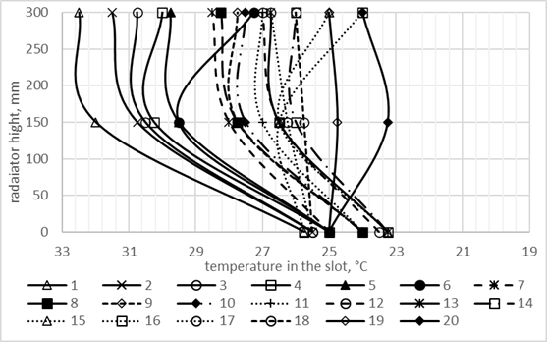
Fig. 11. Vertical temperature distributions in the slot for the radiator with a cotton curtain (2 cm wide slot)

The analysis of horizontal temperature distributions in variant A with the bare radiator (Figure 6) shows a horizontal decrease in temperature between the closest point to the radiator and the closest point to the curtain:
- from 24.3°C to 19.8°C (23.5°C at 5 mm) at the bottom of the radiator – a difference of 4.5°C (0.8°C at 5 mm),
- from 26.5°C to 20.3°C (23.8°C at 5 mm) in the center of the radiator – a difference of 6.3°C (2.8°C at 5 mm),
- from 28.5°C to 19.8°C (25.5°C at 5 mm) at the top of the radiator – a difference of 8.8°C (3.0°C at 5 mm).

In variant B with the guipure curtain (Figure 8), the horizontal temperature decrease between the closest point to the radiator and the closest point to the curtain:
- from 25.0°C to 21.8°C (24.5°C at 5 mm) at the bottom of the radiator – a difference of 3.3°C (0.5°C at 5 mm),
- from 31.5°C to 23.5°C (28.0°C at 5 mm) in the center of the radiator – a difference of 8.0°C (3.5°C at 5 mm),
- from 32.5°C to 23.5°C (29.0°C at 5 mm) at the top of the radiator – a difference of 9.0°C (3.5°C at 5 mm), the lowest value of 22.8°C was observed at a distance of 15 mm from the radiator. In variant C with the cotton curtain (Figure 10), the horizontal temperature decrease between the closest point to the radiator and the closest point to the curtain:
- from 25.8°C to 25.0°C (25.0°C at 5 mm) at the bottom of the radiator – a difference of 0.8°C (0.8°C at 5 mm), the lowest value of 23.2°C was observed at a distance of 13 and 14 mm from the radiator.
- from 32.0°C to 23.3°C (29.5°C at 5 mm) in the center of the radiator – a difference of 8.8°C (2.5°C at 5 mm),
- from 32.5°C to 24.0°C (29.8°C at 5 mm) at the top of the radiator – a difference of 8.5°C (2.8°C at 5 mm).

The analysis of vertical temperature distributions in variant A with the bare radiator (Figure 7) shows changes in temperature with the height of the radiator as follows:
- in close proximity to the front panel (1-3 mm) – the highest vertical increase from 24.3°C at the bottom to 28.5°C at the top of the radiator – a difference of 4.3°C,
- at 12 mm from the front panel, the highest vertical decrease from 22.3°C at the bottom to 21.8°C at the top of the radiator – a difference of -0.5°C.

In variant B, the guipure curtain (Figure 9) shows changes in temperature with radiator height as follows:
- at 1 mm from the front panel – the highest vertical increase from 25.0°C at the bottom to 32.5°C at the top of the radiator – a difference of 7.5°C,
- at 15-18 mm from the front panel – the lowest vertical increase from 21.8-22.3°C at the bottom to 22.8-23.3°C at the top of the radiator – a difference of 1.0°C; however, the highest temperature was recorded halfway up the radiator.

In variant C, the cotton curtain (Figure 11) shows changes in temperature with radiator height as follows:
- at 1 mm from the front panel – the highest vertical increase from 25.8°C at the bottom to 32.5°C at the top of the radiator – a difference of 6.8°C,
- at 16 mm from the front panel – the highest vertical decrease from 25.8°C at the bottom to 24.0°C at the top of the radiator – a difference of -1.8°C; however, the highest temperature was recorded halfway up the radiator.

Figures 8-11 show local disturbances in the monotonicity of the temperature distribution occurring closer to the curtain. This may mean the thermal impact of the curtain itself.
Figure 12 shows the average temperature values measured at distances from 1 to 20 mm at different heights of the radiator for each of the radiator cover variants A, B, and C.
The lowest average temperature of 22.9°C was observed in variant A with a bare radiator (22.2°C at the bottom, 23.0°C in the center, and 23.4°C at the top of the radiator). The medium was in variant B with a guipure curtain with an average of 24.9°C (23.2°C at the bottom, 25.7°C in the center, and 25.9°C at the top of the radiator). The highest average temperature was in variant C with a cotton curtain with an average of 26.6°C (24.6°C at the bottom, 27.6°C in the center, and 27.6°C at the top of the radiator).

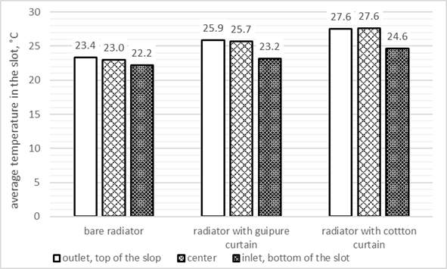
Fig. 12. Average measured temperature at different heights at a distance of 1 to 20 mm from the heater plate

The lowest temperature gradient between average temperatures at the bottom and the top of the radiator was observed in variant A (1.2°C), medium in variant B (2.7°C), and the highest in variant C (3°C).
3.2. Radiator power
Figure 13 presents a comparison of the radiator power determined on the basis of the measured values in the individual covering variants A, B, and C. As can be seen, the heating power determined on the basis of measurements for the uncovered radiator (variant A) is the highest, 319.8 W; it is slightly lower for the radiator covered with guipure material (variant B), 319.3 W, and significantly lower for the radiator covered with cotton material (variant C), 277.0 W. The ratio of the power of the radiator covered with guipure material (variant B) and cotton material (variant C) in relation to the power of the uncovered radiator (variant A) is 0.999
(𝛽_{𝑐𝑜𝑣,𝑚} = 1.00) and 0.866 (𝛽_{𝑐𝑜𝑣,𝑚} = 1.15), respectively.

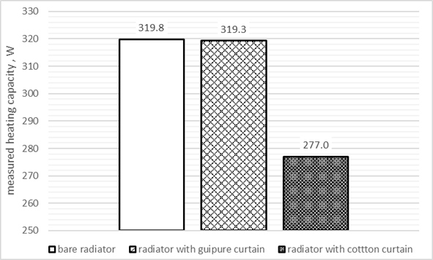
Fig. 13. Heating capacity of the radiator calculated based on the measured supply, return temperatures, and measured flow of the heating water

The water temperatures at the supply and return of the radiator and the water flow rate are shown in Table 1.

Table 1. Water temperature and flow values in the experiment
 | A | B | C
 | bare radiator | radiator with  guipure curtain | radiator with  cotton curtain
T_{su,m} – measured supply water temperature, °C | 51.47 | 51.49 | 51.50
T_{r,m} – measured return water temperature, °C | 44.52 | 44.55 | 45.48
V_{w} – measured volume flow of water, [l/h] | 40.00
4. Discussion
The results obtained indicate that the presence of a curtain significantly affects the temperature distribution close to the radiator, resulting in a change in the conditions of heat exchange. In the case of a bare radiator (variant A), a clearly developed convective flow was observed, based on a relatively uniform temperature distribution and low vertical and horizontal thermal gradients compared to variants with curtains. It shows the temperature distribution of natural convection without any obstacles that limit the flow of surrounding air to the boundary layer of the radiator front panel. The pattern of temperature change is consistent with the theoretical pattern of natural convection presented in (Wiśniewski & Wiśniewski 2017) and Figure 1.
The introduction of a curtain causes deformation of this pattern. The results obtained indicate that the presence of a curtain affects the temperature distribution in the gap between the radiator and the cover, resulting in a change in the conditions of heat exchange. Adding a fabric cover, regardless of the type of material, causes an increase in average temperatures in the gap, especially in the upper parts of the radiator. This phenomenon indicates a restriction of free air flow and, consequently, a weakening of natural convection in this area. At the same time, an analysis of vertical temperature gradients shows that the temperature differences between the bottom and top of the radiator increase in the presence of a cover, which may indicate disturbances in air flow. When comparing variants B and C, the differences resulting from the physical properties of the materials used are significant. The structure of the guipure curtain, with its relatively open-knit, allows partial air flow and enables convection to develop to a certain extent. In the case of a cotton curtain, characterized by a compact structure and lower air permeability, this effect is much stronger. This results in more pronounced disturbances in convective heat transport and greater differences in temperature distributions. The openwork curtain (variant B) introduces a faster (than for bare radiator – variant A) initial temperature drop on the close distance from the front plate and greater fluctuations in the entire gap. This is probably due to the disruption of the completely free inflow/outflow of air from/to the room by the curtain material and its mixing with the air in the gap. The cotton curtain (variant C) results in a more uniform temperature gradient and introduces fluctuations near the curtain. This is the effect of separating the gap from the rest of the room with a less airy/transparent cotton curtain.
The observed changes suggest that material screens are a physical barrier, modifying heat exchange conditions and introducing additional resistance to air movement. In practice, this means that the presence of a curtain can reduce the effectiveness of natural convection around the radiator, as well as diminish radiative heat transfer, thereby affecting its ability to efficiently transfer heat to the room. In addition, the spatial variation in temperature distributions in the gap between radiator and curtain indicates that local micro-airflow conditions are strongly dependent on the geometry of the system and the properties of the covering material used. This means that even small changes in the structure or location of the curtain can lead to significant differences in the heat exchange mechanisms.
The above observations are confirmed by the results of measurements and calculations of the heating power of the radiator for particular variants. The introduction of curtains reduces the radiator heating power (Figure 13), which, considering the curtains as a form of radiator housing, is consistent with the literature (Kołodziejczyk & Płuciennik 2001, Bayram & Koç 2023, Shahsavar & Arici 2021). In the case of a curtain made of guipure material, openwork with large openings and constituting a slight resistance to air flow, the reduction in the heating power of the uncovered radiator analyzed is 0.1%. In the case of cotton material, which is much less perforated, the reduction is much more significant and equals 13.4%. Therefore, the shielding factors 𝛽_{𝑐𝑜𝑣,𝑚} would be 1.00 and 1.15, respectively. The result for the cotton curtain differs significantly from the values of the correction factors given in (Kołodziejczyk & Płuciennik 2001), (Figure 2). According to this source, the power of a radiator shielded by a fixed shield placed in front of the front panel (the distance of the radiator from the shield or the material from which the shield was made were not specified), starting 10 cm above the floor (as in this study), with a height similar to the height of the radiator, the shielding factor is 1.0. This difference may be influenced by the use of insulation between the rear wall of the radiator and the panel imitating the wall of the building, the variable distance of the radiator from the curtain/casing, and the variable height of the curtain/casing above the radiator. The second reason for this difference can be the temperature parameters of the radiator supply. The shielding factors presented in (Kołodziejczyk & Płuciennik 2001) were determined at a time when traditional, higher temperatures were used in heating systems than in this research (characteristic of today's times).
5. Conclusions and Summary
Based on the conducted research, the hypothesis (sections 1.3 and 1.4) can be confirmed, and the following conclusions can be drawn.
1) The use of curtains by a radiator affects heat exchange in a heated room. A curtain by a radiator constitutes a physical barrier between the radiator and the room. Its presence causes a change in the share of individual components in the heat exchange mechanism. Compared to an uncovered radiator, there is a limitation of heat exchange through the curtain. Compared to an uncovered radiator, there is a limitation of both methods of heat exchange by the radiator through radiation and convection. There is also an additional resistance to heat conduction; the more significant, the less airy/transparent the curtain. The intensity of convection and radiation through the curtain depends on the size and density of the curtain holes, whereas the intensity of heat conduction depends on the type and thickness of the material from which it is made. Each of these factors may be different for a curtain with different airiness and translucency.
2) The use of curtains can noticeably affect the heating power of the radiator. The more solid and airtight/opaque the curtain, the higher the temperature behind the curtain at the radiator and the lower the temperature difference between the heating medium in the radiator and the temperature of the air flowing by the radiator, and consequently the lower the intensity of heat exchange between these media, resulting in lower heating power of the radiator.
3) The introduction of material (poorly heat-conducting) radiator shielding resulting from the desire to improve aesthetics can cause a disruption in the radiator's heat transfer to the room, and thus affect the heating efficiency. The type of cover has a significant impact on the thermal environment around the radiator (temperature distribution in its surroundings), and the degree of its airiness/transparency on the possible decrease in the radiator's power and its heating efficiency.

It should be noted that the presented test results have limitations related to the properties of the curtain material, e.g., translucency, distance of the heating plate from the curtain, dimensions of the radiator and curtains, the method of installation, and the distances of the radiator from other partitions, i.e., walls, floors, and the parameters of the radiator power supply.
In the future, the scope of research can be extended to include the influence of other covers (different materials and including draperies), methods of their attachment to the radiator, as well as for radiators of other types and dimensions, operating with other heating medium parameters, also, in terms of optimizing the method of installing curtains depending on the type of material, type and size of the radiator, and the type of temperature parameters of the radiator supply.
References
Bayram, H., & Koç, N. (2023). Experimental investigation of the effects of add-on fan radiators on heat output and indoor air temperature. Case Studies in Thermal Engineering, 50, 103432. https://doi.org/10.1016/j.csite.2023.103432
Beck, S. M. B., Grinsted, S. C., Blakey, S. G., & Worden, K. (2004). A novel design for panel radiators. Applied Thermal Engineering, 24(8-9), 1291-1300.
Boháč, J., Legner, T., Bašta, J., & Barták, M. (2023). Uniform temperature field in panel radiators using modified spacer rings. Applied Thermal Engineering, 232, 121019.
Brady, L., Abdellatif, M., Cullen, J., Maddocks, J., & Al-Shamma'a, A. (2016). An investigation into the effect of decorative covers on the heat output from LPHW radiators. Energy and Buildings, 133, 414-422.
Calisir, T., Yazar, H.O., & Baskaya, S. (2021). Evaluation of Flow Field Over Panel Radiators to Investigate the Effect of Different Convector Geometries. J. of Building Engineering, 33, 1-18.
Cao, M., Zong, C., Wang, X., Teng, G., Zhuang, Y., & Lei, K. (2020). Numerical simulations of airflow and convective heat transfer of a sow. Biosyst. Engin., 200, 23-39.
Defraeye, T., Herremans, E., Verboven, P., Carmeliet, J., & Nicolai, B. (2012). Convective heat and mass exchange at surfaces of horticultural products: A microscale CFD modelling approach. Agricul. and Forest Meteorology, 162-163,
71-78.
Gelis, K., & Akyurek, E. F. (2021). Entropy generation of different panel radiator types: Design of experiments using response surface methodology (RSM). Journal of Building Engineering, 41, 102369.
Harris, D. (1995). Use of metallic foils as radiation barriers to reduce heat losses from buildings. Applied Energy, 52(4), 331-339. https://doi.org/10.1016/0306-2619(95)00018-6
Hosseini, R., & Taherian, H. (2004). Natural convection heat transfer from a vertical plate to air at very low pressure. Transactions of the Canadian Society for Mechanical Engineering, 2004. https://doi.org/10.1139/tcsme-2004-002
Hu, C., Sun, M., Xie, Z., Yang, L., Song, Y., Tang, D., & Zhao, J. (2020). Numerical simulation on the forced convection heat transfer of porous medium for turbine engine heat exchanger applications. Applied Ther. Engin., 180, 1-12.
Kennard, H., Oreszczyn, T., Mistry, M., & Hamilton, I. (2022). Population-weighted degree-days: The global shift between heating and cooling. Energy and Buildings, 271, 112315. https://doi.org/10.1016/j.enbild.2022.112315
Koczyk, H. (2005). Ogrzewnictwo praktyczne, Projektowanie, montaż, eksploatacja, Systherm Serwis. (in Polish)
Kołodziejczyk, W., & Płuciennik, M. (2001). Wymagania Techniczne COBRTI Instal. Zeszyt 2, Warszawa, 78. (in Polish)
Lei, X., Zhang, Q., Zhang, J., & Li, H. (2017). Experimental and numerical investigation of convective heat transfer of supercritical carbon dioxide at low mass fluxes. Applied Sciences, 7, 1-18.
Lin, H., & Cheng, J. H. (2020). A study of the simulation and analysis of the flow field of natural convection for a container house. Sustainability, 12, 1-28.
Martynenko, O., & Berezovsky, A. (1984). Sokovishin Yu., Laminar free convection from a vertical plate. International Journal of Heat and Mass Transfer, 27(6), 869-881. https://doi.org/10.1016/0017-9310(84)90008-5
Menéndez-Díaz, A., Ordóñez-Galán, C., & Benito Bouza-Rodríguez, J. (2014). Fernández-Calleja J. J., Thermal analysis of a stoneware panel covering radiators. Applied Energy, 131, 248-256.
Myhren, J., & Holmberg, S. (2011). Improving the thermal performance of ventilation radiators – The role of internal convection fins. International Journal of Thermal Sciences, 50(2), 115-123.
https://doi.org/10.1016/j.ijthermalsci.2010.10.011
Robinson, A. (2016). A thermal model for energy loss through walls behind radiators. Energy and Buildings, 127(1),
370-381. https://doi.org/10.1016/j.enbuild.2016.05.086
Rout, S. K., Thatoi, D. N., Acharya, A. K., & Mishra, D. P. (2012). CFD Supported Performance Estimation of an Internally Finned Tube Heat Exchanger Under Mixed Convection Flow. Procedia Engin., 38, 585-597.
Sadri, R., Mallah, A. R., Hosseini, M., Ahmadi, G., Kazi, S. N., Dabbagh, A., Yeong, C. H., Ahmad, R., & Yaakup, N. A. (2018). CFD modeling of turbulent convection heat transfer of nanofluids containing green functionalized graphene nanoplatelets flowing in a horizontal tube: Comparison with experimental data. J. of Molecular Liquids, 269, 152-159.
Sertkaya, A., & Sari, S. (2021), Experimental Investigation of Heat Transfer Depending on Inclination Angle of Unfinned, Axial Finned and Radial Finned Heat Exchangers. Int. J. of Heat and Mass Transf., 165, 1-12.
Sevilgen, G., & Kilic, M. (2011). Numerical analysis of air flow, heat transfer, moisture transport and thermal comfort in a room heated by two-panel radiators. En. and Buildings, 43, 137-146.
Shahsavar, A., & Arici, M. (2021). Effect of glass cover on the energy and exergy performance of a combined system including a building integrated photovoltaic/thermal system and a sensible rotary heat exchanger. International Journal of Energy, 46(4), 5050-5066. https://doi.org/10.1002/er.7499
Shati, A., Blakey, S., & Beck, S. (2011). The effect of surface roughness and emissivity on radiator output. Energy and Buildings, 43, 400-406. https://doi.org/10.1016/j.enbuild.2010.10.002
Simionescu, S. M., & Balan, C. (2016). CFD study on convective heat exchange between impinging gas jets and solid surfaces. Energy Procedia, 85, 481-488.
Singh, R.J., & Gohil, T. B. (2019). Numerical study of MHD mixed convection flow over a diamond-shaped obstacle using OpenFOAM. Int. J. of Thermal Sciences, 146, 1-18.
Tanda, G., Misale, M., & Devia, F. (2000). Experimental heat transfer from a vertical plate within a naturally ventilated cabinet. Heat and Mass Transfer, 36, 511-516. https://doi.org/10.1007/PL00005889
Wang, L., Wu, K., Yu, Y. B., Sun, D. M., Huang, Z. Y., & Gu, P. F. (2011). Study on LED array heat radiator improvement under natural Convection. J. of Optoelectr. Laser, 22, 338-342.
Wiśniewski, S., & Wiśniewski, T. (2017). Wymiana Ciepła, 6th ed.; WNT, Warszawa, Poland, 268. (in Polish)
Zhang, P., Li, J. A., Wang, D. A., & Liu, J. B. (2019). Study on Heat Transfer Characteristics of Serrated Fins of Plate-Fin Heat Sink. Proceedings of 2019 IEEE 3rd International Electrical and Energy Conference, Beijing, China,
7-9.9.2019.
https://www.globalgrowthinsights.com/market-reports/steel-radiator-market-106676, Available online: URL (accessed on 12.11.2025)

