|  |  |  |  |
| --- | --- | --- | --- |
|  |  | | |
| **Rocznik Ochrona Środowiska** | | |
| Volume 27 | Year 2025 ISSN 2720-7501 | pp. 361-372 |
|  | https://doi.org/10.54740/ros.2025.029 open access | | |
|  | Received: April 2025 Accepted: May 2025 Published: June 2025 | | |

Assessment of the Suitability of Dehydrogenase Activity as a Biomarker in the Plant Rhizosphere Soil and Lichen Thalli for Trace Element Pollution Around a Zinc Smelter   
– A Preliminary Research

Kaja Skubała1, Jakub Styburski2, Karolina Chowaniec3*

1Institute of Botany, Faculty of Biology, Jagiellonian University, Kraków, Poland   
<https://orcid.org/0000-0003-2241-1081>

2Institute of Botany, Faculty of Biology, Jagiellonian University, Kraków, Poland

Doctoral School of Exact and Natural Sciences, Jagiellonian University in Kraków, Poland   
https://orcid.org/0009-0005-4169-0399

3Institute of Botany, Faculty of Biology, Jagiellonian University, Kraków, Poland   
https://orcid.org/0000-0001-7532-856X

*corresponding author's e-mail: karolina.chowaniec@uj.edu.pl

**Abstract:** In recent years, the application of biomarker-based approaches in field studies of contaminated environments has gained attraction, as biomarkers offer a sensitive method for early detection of toxicological impacts. Dehydrogenase activity (DHA) is a good environmental indicator of stress in lichens, while a decrease in its activity in soil may be associated with increased levels of pollutants in the substrate. The objective of this study was to evaluate the impact of distance to the zinc smelter on dehydrogenase activity in the epigeic lichen *Cladonia rei* Schaer. and in the rhizosphere soil of grass *Calamagrostis epigejos* L. Roth. We also aimed to evaluate the performance of DHA in lichens and rhizosphere soil in the context of validating this biomarker for soil monitoring. Samples of *C. rei* and rhizosphere soil were collected from sites designated on the transect between 300 to 4100 m east of the "Miasteczko Śląskie" zinc smelter. We found reduced DHA levels in rhizosphere soil near the smelter; however, there was no clear trend of DHA increase with distance from the smelter. This phenomenon may be explained by the specificity of the rhizosphere microhabitat and interactions between microorganisms and plants. Our results also showed that DHA in *C. rei* is highly sensitive to soil contamination by trace element. Consequently, measurement of DHA in this species could indicate elevated trace element concentrations in the soil. This biomarker in lichens may serve as a warning signal for high soil pollution, particularly when smelting activities are conducted near agricultural areas.

**Keywords:** *Cladonia rei*, dehydrogenase activity, biomonitoring, rhizosphere soil, *Calamagrostis epigejos*

1. Introduction

Trace elements contamination in soil represents a significant environmental challenge on a global scale. According to the European Environmental Agency, mercury, arsenic, lead, and cadmium are among the metals with the highest toxicity in the environment (EEA 2023). Trace elements rank among the most challenging pollutants due to their widespread presence, persistent toxicity, and ability to bioaccumulate within the food chain (Kabata-Pendias & Mukherjee 2007, Mishra et al. 2019, Singh et al. 2024). Metal smelting is a significant anthropogenic contributor to contamination worldwide and is considered the primary cause of toxic trace element accumulation in soils (Nriagu 1996). Trace elements released during the smelting of non-ferrous metals typically accumulate initially in the surrounding soils (Dudka & Adriano 1997), and upon entering the soil, they primarily affect the biological properties of soil, such as the diversity and abundance of microbial communities and the activity of enzymes present in the soil (Wang et al. 2007). While soil serves as a primary sink for trace elements introduced into the environment, the mobility of trace metals facilitates their transfer to other environmental compartments, including water, air and plants. In the last century, the development of the smelting industry in Europe led to a significant increase of trace element concentrations in the environment. Consequently, many organisms are still exposed to an excess of trace elements in their habitats today.

Biomonitoring is an increasingly used method for assessing the influence of external factors on ecosystems, aiding in the differentiation between impacted and unaffected sites (Markert et al. 2003, Girotti et al. 2020). Reactions to pollution observed across different levels of biological organization, from individual enzymes to cells, organs, organisms and populations, and entire ecosystems, are extensively employed in environmental monitoring studies, as pollution inherently poses a threat to living organisms. Organisms integrate exposure to environmental pollutants and exhibit responses that are predictable, and their responses could be observed and measured at various levels (Bickham et al. 2000). A pollution biomarker is characterized as a change in a biological response at the molecular, cellular, or physiological levels of an organism, directly associated with exposure to toxic environmental chemicals (Lionetto et al. 2019). Biomarkers offer a sensitive early indicator of toxicological effects that may later manifest at the population and ecosystem levels (Hook et al. 2014). Biomarkers, therefore, possess the capacity to identify underlying causes and can serve as early warning signals of damage to the ecosystem. The use of biomarkers can aid in decision-making processes across various environmental management activities, including habitat conservation, monitoring programs for affected areas, or the implementation of remediation procedures (Lionetto et al. 2019). Due to these reasons, novel biological methods for soil monitoring, such as assessing biochemical and cellular responses to pollutants (e.g., biomarkers), are crucial for evaluating soil quality.

Lichens are symbiotic organisms formed through an association between a fungus and photoautotroph, which is usually a green alga and/or cyanobacterium. They are ectohydric organisms, particularly sensitive to various environmental pollutants due to their physiological nature, characterized by a lack of cuticle and roots, which leads to the absorption of both nutrients and toxic substances across the entire surface of the thallus (Nimis & Purvis 2002). Numerous studies have demonstrated the negative impact of trace elements on the physiology and biochemistry of lichens. The negative effects include oxidative stress, a decrease in ergosterol and glutathione content, impairment of cell membrane integrity, and degradation of chlorophyll (e.g., Bačkor & Dzubaj 2004, Rola et al. 2022). Therefore, lichens are often used as biomonitors and bioindicators of environmental pollution (e.g. Kiszka 1990, Kłos 2007, Kłos 2009, Traczewska 2011, Matwiejuk 2014).

Bačkor and Fahselt (2005) highlighted that dehydrogenase activity (DHA) serves as a very good environmental indicator of stress in lichens. Although the lichen thallus consists of two main symbiotic partners, the fungal partner represents the majority of the thallus in most lichen species (Hale 1983), so DHA is mainly an indicator of the physiological state and viability of the fungus. Bačkor and Fahselt (2005) developed a quick and cost-effective quantitative method to assess the physiological state of lichens by evaluating their capacity to reduce 2,3,5-triphenyltetrazolium chloride (TTC) to triphenyl formazan (TPF). The formation of the red-colored product TPF was considered an indicator of dehydrogenase activity. The study by Bačkor and Fahselt (2005) confirmed that low pH, copper stress, UV radiation, and heat stress significantly reduced the lichen's ability to produce formazan under laboratory conditions, indicating physiological damage resulting from exposure to these factors. The authors also pointed out that such an approach could also be used for monitoring the effects of several stress factors that occur in the environment on lichens collected directly in the field (Bačkor & Fahselt 2005). In subsequent years, numerous studies were conducted in which DHA in lichens was analyzed under laboratory conditions after exposure to wood distillate (Fačkovcová et al. 2020), herbicides (Vannini et al. 2015), fungicides (Rola et al. 2023), and excess nitrogen (Munzi et al. 2017). Nevertheless, there is a conspicuous lack of research on lichens growing in situ.

Soil dehydrogenase is a key member of the oxidoreductase class of enzymes (Gu et al. 2009) and constitutes an intracellular enzyme that is only present in active cells (Nannipieri et al. 1990). Dehydrogenase activity indicates overall microbial activity, which is proportional to the biomass of the microorganisms present in soil (Quilchano & Marañonm 2002) or in other ecosystem components, e.g., biological soil crusts (Chowaniec et al. 2024). Measuring dehydrogenase activity in soil provides insights into its biological characteristics, as it reflects the abundance and metabolic activity of microorganisms (Gu et al. 2009). Although many other enzymes are also present in soil (e.g., hydrolase, ligase), dehydrogenase is the most crucial since it cannot be accumulated extracellularly in the soil (Wolińska & Stępniewska 2012), but it occurs intracellularly in all living cells (Moeskops et al. 2010). DHA is a crucial indicator of toxicity in polluted soils, as toxic trace elements directly affect enzyme activity by decreasing intracellular water potential (Santos et al. 2011, Araujo et al. 2015). Nevertheless, DHA is also modulated by various soil parameters, such as pH, granulometric composition, organic matter within the soil, and the availability of nutrients (Nannipieri et al. 1978, Dick 2011, Liang et al. 2014), as well as the interactions of these soil parameters with trace elements.

The meta-analysis, based on 143 observational studies, also confirmed a significant decrease in DHA in soil in response to trace element pollution, and this decrease clearly corresponds to an increase in total and available element content in soil (Aponte et al. 2022). The rhizosphere soil surrounding plant roots is the most active part of the soil, exhibiting higher microbial abundance and enzymatic activity compared to bare soil (Bahadur et al. 2017, Verma et al. 2017). With regard to toxic trace element pollution, Kandziora-Ciupa et al. (2021) noted a more pronounced impact of trace elements on soil enzyme activity in the analyzed soil samples from the rhizosphere of *Vaccinum myrtillus* than in the non-rhizosphere soil samples. Thus, it could be assumed that the rhizosphere soil is particularly sensitive to toxic trace element stress.

The research was conducted near the zinc smelter in Miasteczko Śląskie, Poland. The facility underwent expansion during its initial phase, from 1961 to 1972. Between 1972 and 1990, the production of zinc and lead increased significantly, accompanied by a rise in SO₂ and toxic trace element emissions, which had a severe impact on the environment. By the 1980s, the smelter had gained notoriety as one of Europe's largest polluters. Environmental improvements began in the 1990s with the adoption of eco-friendly technologies that markedly reduced atmospheric emissions (Bojanowski 2008). Despite this progress, soil samples collected in 2018 revealed that toxic trace element concentrations in the surface layer were significantly higher than levels measured at the same locations 20 years earlier (Kicińska 2019). Today, the smelter operates as part of the ZGH Bolesław Group, owned by the joint-stock company Stalprodukt S.A., and continues to produce zinc and lead. In 2022, its total output included approximately 75,000 tons of zinc and 16,000 tons of lead (Ministry of Justice 2023).

The purpose of this study was to test the effect of distance from the point polluter – the zinc smelter "Miasteczko Śląskie" on dehydrogenase activity in the epigeic lichen *Cladonia rei* and in the rhizosphere soil of the grass *Calamagrostis epigejos*. We also aimed to evaluate dehydrogenase activity in lichens and rhizosphere soil collected from sites contaminated with trace elements, providing a preliminary assessment of the usefulness of this biomarker in soil monitoring.

2. Materials and Methods

2.1. Study area

The research was conducted near the zinc smelter in Miasteczko Śląskie, located in the Silesia-Cracow Upland (southern Poland; Fig. 1; Fig. S1). The metallurgical activities in this region revolve around the extraction and processing of zinc and lead ores. Construction of the "Miasteczko Śląskie" zinc smelter in Upper Silesia (50°30'09.6"N; 18°55'34.6"E) began in the early 1960s.

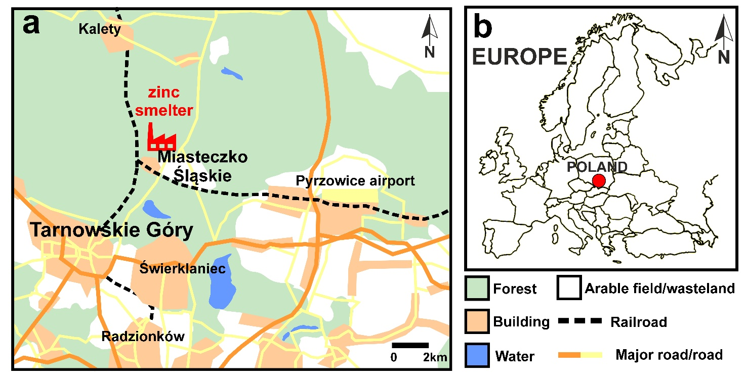

**Fig. 1.** Location of the study area and "Miasteczko Śląskie" zinc smelter

**2.2. Sampling**

2.2.1. Sampling design

The sampling was conducted in the autumn of 2023. The transect was located east of the emitter following the direction of the prevailing winds and extended from 300 to 4100 m (Fig. 2). Six sampling sites were designated on the transect at 300 m, 550 m, 1000 m, 1500 m, 2600 m and 4100 m away from the smelter.

2.2.2. Method of collection

Each sampling site constituted open, sunny place with an area of 2×2 m. Each sampling site was divided into a grid of 100 equal squares, each measuring 20×20 cm. To ensure random sampling, 15 squares were randomly selected for the collection of *Cladonia rei* (n = 15) and rhizosphere soil samples (n = 15). Identification of plant and lichen species was established using a stereomicroscope and identification keys (Rutkowski 2008, Smith et al. 2009). Rhizosphere soil was collected by uprooting *Calamagrostis epigejos* plants with a trowel and gathering the soil surrounding the roots. Lichen thalli were transported to the laboratory in paper envelopes and then carefully cleaned of soil particles and other visible contaminants attached to their surface. After that, the lichen samples were air-dried, and then they were placed in a freezer at -30°C for two days until the analyses were conducted. The soil samples were placed in a portable freezer and transported to a laboratory, where they were processed immediately.

*2.2.3. Characteristics of studied material*

The choice of lichen and grass species for rhizosphere soil sampling was determined by the fact that these species occur abundantly in the study area. *Cladonia rei* (Fig. S2) is an epigeic lichen regarded as a pioneer colonizer of bare soil, particularly in disturbed and human-affected habitats (Paus 1997, Osyczka & Rola 2013, Rola et al. 2014). This species is well adapted to grow on substrates that are extremely polluted with toxic trace elements (Rola & Osyczka 2018). *Calamagrostis epigejos* is a tall perennial grass native to the Euro-Asian region, which readily grows in anthropogenic and man-made habitats (Rebele & Lehmann 2001). The species has a large ecological amplitude and a high tolerance to abiotic stress factors. It has a range of adaptation mechanisms to cope with stressful habitat conditions and is well adapted to grow in polluted habitats, demonstrating its potential for phytoremediation (Ranđelović et al. 2020).

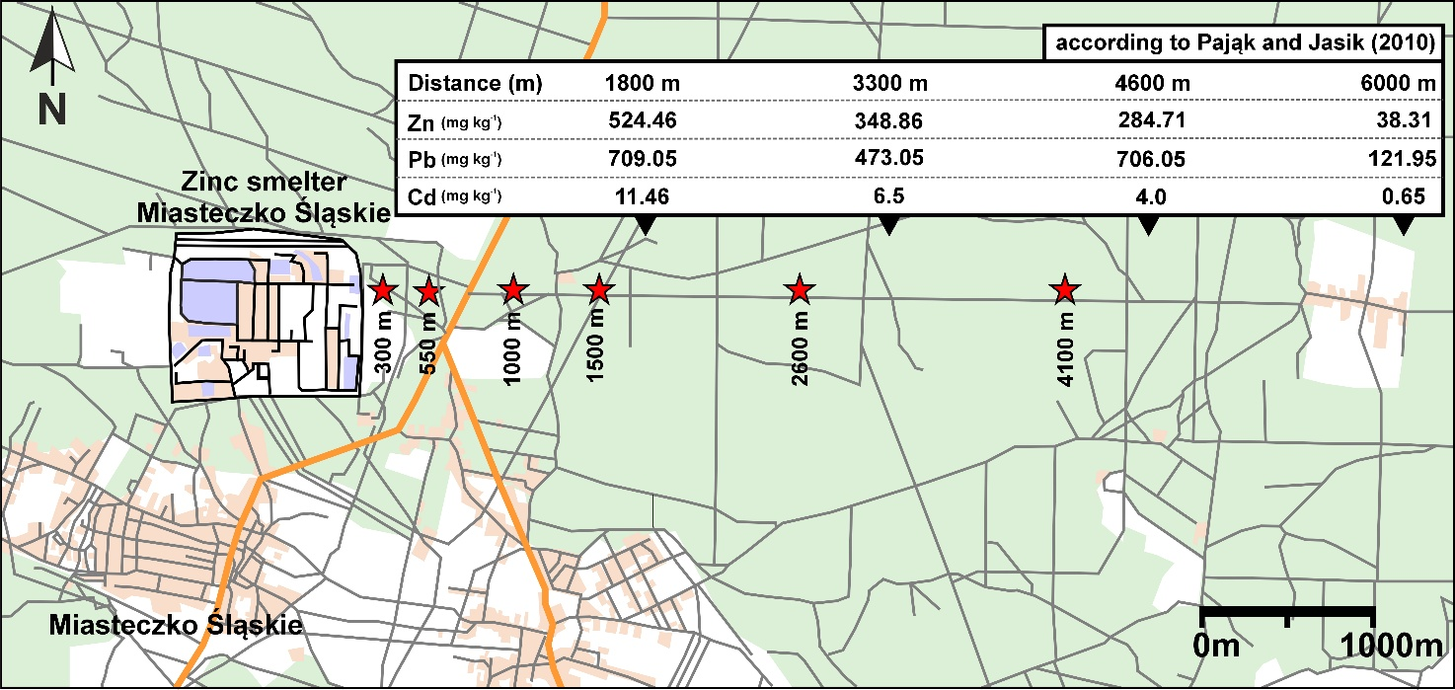

**Fig. 2.** Location of sampling plots in the vicinity of the "Miasteczko Śląskie" zinc smelter. The concentrations of zinc, lead, and cadmium in topsoil (0-20 cm) were provided according to Pająk and Jasik (2010). Red stars refer to sampling points in the present study.

2.3. Dehydrogenase activity in lichen thalli

Dehydrogenase activity in lichen samples was determined by measuring the reduction of 2,3,5-triphenyl tetrazolium chloride (TTC) to triphenyl formazan (TPF), a red compound indicative of mitochondrial respiratory chain activity (Bačkor & Fahselt 2005, Ruf & Brunner 2003). *C. rei* samples (approximately 40 mg each, 3-4 podetia = secondary thallus) were incubated in darkness for 20 hours at 25°C in a solution containing 2 ml of 0.6% TTC (Sigma-Aldrich) and 0.005% Triton X-100 (Sigma-Aldrich) prepared in 50 mM sodium phosphate buffer (pH 6.8). After incubation, the solutions were discarded, and the lichens were rinsed with distilled water to eliminate any residual Triton X. The samples were then dried on filter membranes. To extract water-insoluble formazan, the samples were treated with 4 ml of 96% ethanol (Sigma-Aldrich) at 65°C in a water bath (JWE 357, Elpin-Plus, Poland) for 1 hour. The tubes were centrifuged at 4000 × g for 10 minutes (MIKRO 200, Hettich, Germany), and the absorbance of the supernatant was measured at 485 nm using a UV–Vis spectrophotometer (Shimadzu UV-1900i, Shimadzu Corporation, Japan). Results were expressed as absorbance units per dry weight of the thalli. Fifteen samples were analyzed for each sampling site.

2.4. Dehydrogenase activity in soil

Dehydrogenase activity (DHA) was assessed following the method of Casida et al. (1964), with slight modifications. Approximately 1.5 g of rhizosphere soil from each sample was placed in test tubes and mixed with 2 ml of 3% TTC (Sigma-Aldrich) prepared in 50 mM sodium phosphate buffer (pH 6.8). The test tubes were wrapped in aluminum foil and incubated in the dark at 25°C for 24 hours. After incubation, the samples were vortexed and centrifuged (MIKRO 200, Hettich, Germany) at 3000 × g for 10 minutes, and the supernatant was discarded. Methanol (Sigma-Aldrich) was used to extract the TPF produced. First, 2 ml of methanol was added to each tube, followed by incubation at 65°C in a water bath (JWE 357, Elpin-Plus, Poland) for 30 minutes. This step was repeated, resulting in a total of 4 ml of methanol used for extraction. The samples were centrifuged again, and the absorbance of the supernatant was measured at 485 nm using a UV–Vis spectrophotometer (Shimadzu UV-1900i, Shimadzu Corporation, Japan). TPF concentration was determined using a calibration curve created according to standard procedures. Results were expressed as micrograms of formazan per gram of dry rhizosphere soil. A total of fifteen samples from each sampling site were analyzed.

2.5. pH measurements

The pH in H2O (1:5; v:v) was measured in each rhizosphere soil sample using Seven Go Duo SG23-FK5 (Mettler Toledo, Switzerland) following ISO 10390 (2021).

2.6. Statistical analysis

Differences in dehydrogenase activity (DHA) in *C. rei* thalli from various sampling sites were assessed using one-way ANOVA (p < 0.05), followed by Tukey's HSD post-hoc test. Normality was evaluated using the Kolmogorov-Smirnov test, and variance homogeneity was assessed with the Brown-Forsythe test. Similarly, DHA in rhizosphere soil samples and soil pH were analyzed. All analyses were conducted using STATISTICA 13 (TIBCO Software Inc., USA).

3. Results

3.1. Dehydrogenase activity in lichens

Regarding DHA in *C. rei*, statistically significant differences between lichens collected at particular distances from the zinc smelter were recorded (Fig. 2). The lowest DHA was recorded in samples collected closest to the smelter (300 m), and they differed significantly from samples collected from further distances. A higher DHA was observed at the second distance (550 m) and significantly differed from the first distance (300 m) and the last two distances (2600 m and 4100 m). The highest DHA levels were observed at the last four sites located at 1000 m, 1500 m, 2600 m, and 4100 m from the smelter, and there were no significant differences between them (Fig. 3).

**Fig. 3.** Dehydrogenase activity demonstrated as absorbance at 485 nm on g DW of lichen thallus measured in *Cladonia rei* gathered from specific sampling locations (square = mean, box = SE, whisker = 95% confidence interval). The result of one-way ANOVA with Tukey's HSD post-hoc test is provided; the different letters indicate statistically significant differences (p < 0.05).

3.2. Dehydrogenase activity in rhizosphere soil

Dehydrogenase activity in rhizosphere soil samples collected around roots of *C. epigeios* differed significantly between different distances from the zinc smelter (Fig. 4). The soil samples collected closest to the smelter (300 m) had the lowest DHA and differed significantly from samples collected at further distances. The highest values of DHA were measured at the remaining sites (550 m, 1000 m, 1500 m, 2600 m, 4100 m), which did not differ significantly from each other (Fig. 4). Moreover, significant correlation between DHA in rhizosphere soil and lichen thalli was observed (R = 0.82, p < 0.05).

**Fig. 4.** Dehydrogenase activity demonstrated as triphenylformazan (TPF) concentration (µg g-1 DW 24h-1) determined in rhizosphere soil samples gathered from specific sampling locations (square = mean, box = SE, whisker = 95% confidence interval). The results of the one-way ANOVA with Tukey's HSD post-hoc test are presented, with different letters denoting statistically significant differences (p < 0.05).

3.3. Soil pH

Soil pH differed between the analysed distances from the smelter and ranged from moderately acidic to slightly alkaline (around 7.5). The lowest pH level was recorded at 1500 m, while the highest was at 4100 m. (Fig. 5).

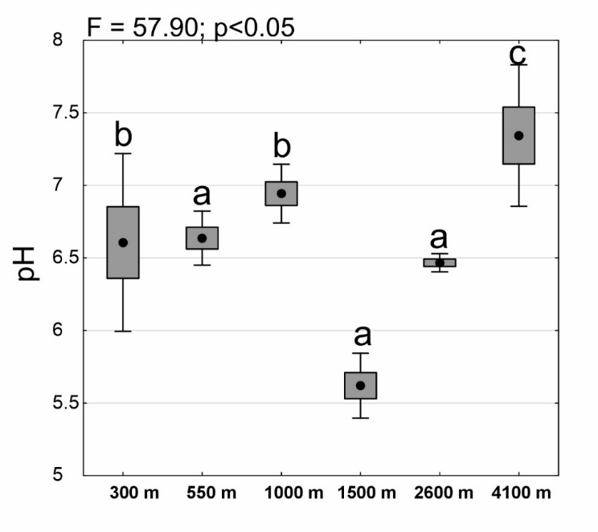

**Fig. 5.** The pH level of rhizosphere soils collected at particular sampling sites (circle = mean, box = SE, whisker = 95% confidence interval). The results of the one-way ANOVA with Tukey's HSD post-hoc test are presented, with different letters denoting statistically significant differences (p < 0.05).

4. Discussion

Many studies conducted in areas adjacent to the "Miasteczko Śląskie" zinc smelter have reported decreasing concentrations of trace elements in soils with increasing distance from the smelter (see, e.g., Olszowska 1997, Pająk & Jasik 2011, Azarbad et al. 2013). Our study revealed that DHA in the rhizosphere soil of *C. epigejos* was considerably lower near the smelter compared to further distances, which is consistent with findings reported by Olszowska (1997) and Nadgórska-Socha et al. (2013), who studied the impact of trace elements on enzymatic activity in bulk soils collected at varying distances from the "Miasteczko Śląskie" zinc smelter. Many previous studies have reported significant inhibition of enzyme activity by trace elements (e.g., Effron et al. 2004, Pliveira & Pampulha 2006, Wang et al. 2008, Zhao et al. 2020). Therefore, it has been suggested that evaluating soil enzyme activity may be one of the most cost-effective and straightforward methods for assessing soil pollution (Hinojosa et al. 2004, Khan et al. 2007). This is crucial, as rapid and reliable methods are needed to evaluate the effects of combined environmental pollutants. However, the impact of trace elements on soil enzyme activity is a complex phenomenon. Different enzymes can respond significantly different to the same element, and a single enzyme may exhibit variable reactions to different trace elements (He et al. 2003, Li et al. 2009). Dehydrogenase, a crucial enzyme in living cells, reflects overall microbial activity in the soil and correlates with the abundance and metabolic activity of microorganisms (Quilchano & Marañon 2002). DHA proved sensitive to trace element pollution, as dehydrogenases are primarily endoenzymes whose activity directly depends on microbial metabolism. Elevated trace element concentrations within microbial cells cause protein denaturation, reducing their activity (Liang et al. 2014). Most researchers have demonstrated a decrease in dehydrogenase activity in soil with increasing element concentrations (e.g., Liang et al. 2014), which is directly attributed to the destructive effect of toxic elements on the enzymes (Pan & Yu 2011). Although we found reduced DHA near the smelter, no clear trend of an increase in DHA with distance from the smelter could be observed. This phenomenon may be explained by the unique microhabitat of the rhizosphere and the interactions between microorganisms and the plant within it. The rhizosphere soil surrounding plant roots is the most active part of the soil, with a higher microbial abundance compared to bulk soil (Bahadur et al. 2017, Verna et al. 2017), which has a clear impact on plant growth and productivity (Hillel et al. 2005). Plant roots can secrete a variety of secondary metabolites, known as root exudates. Some of them act as chelating or detoxifying agents (Bais et al. 2004, Brahmaprakash et al. 2017, Vives et al. 2020). Soil microorganisms in the rhizosphere can also produce chelating compounds (Ortúzar et al. 2020, Joshi et al. 2023), which bind metal cations and contribute to the immobilization of trace elements. All of these can protect both microbes and plants from the uptake of trace elements and their toxic effects (Gupta & Diwan 2017). In addition, plants growing in polluted soils under stressful conditions can develop a specialized rhizobiome (Muehe et al. 2015) that helps transform trace elements into less toxic forms and alters their availability (Tirry et al. 2018). Finally, the toxic impact of trace elements on microorganisms may be mitigated in soils high in organic carbon, as humic acids can chelate toxic elements (Perelomov et al. 2021, Terekhova et al. 2021). Consequently, the greater abundance of *C. epigejos* observed in areas far from the smelter, along with a specific rhizobiome, may be responsible for alleviating the harmful effects of metals on microorganisms in rhizosphere soil, implying the observed greater dehydrogenase activity, regardless of the distance from the smelter. Soil dehydrogenases are intracellular enzymes whose activity is dependent on pH. Soil pH may affect their activity by changing the ionic form of active sites and by altering the affinity of the substrate to the enzyme (Wolińska & Stępniewska 2012). The optimal pH for dehydrogenase activity is typically neutral to slightly acidic (pH 6.0-7.5) (Wolińska & Stępniewska 2012). At low pH, increased solubility of toxic trace elements can additionally reduce enzymatic activity. However, in our study, we did not observe a clear trend in relation to the changes in soil pH with distance from the smelter, and all sampling sites were characterized by a pH level optimal for dehydrogenase activity.

Cryptogams are widely used in biomonitoring of environmental pollution. Several biomarkers of lichens have already been utilized for biomonitoring trace element pollution, including membrane lipid peroxidation and cell membrane integrity (Cuny et al. 2002, Cuny et al. 2004, Osyczka & Rola 2019, Osyczka et al. 2023). Nevertheless, cryptogams are still more commonly used in biomonitoring by measuring the concentrations of trace elements accumulated in lichens and mosses, which readily reflect the levels of these elements in the environment. To date, two biomonitoring studies on mosses have been conducted in the vicinity of the "Miasteczko Śląskie" smelter. One of them concerned active biomonitoring and indicated that *Pleurozium schreberi* moss is a significant source of information on environmental pollution, including trace elements (Kaczmarek et al. 2017). The second study examined trace elements concentrations in soil and *P*. *schreberii*, with the highest concentrations observed closest to the smelter (Pająk & Jasik 2011). A colorimetric method based on the reduction of 2,3,5-triphenyl tetrazolium chloride (TTC) to triphenyl formazan (TPF) also provides a precise assessment of dehydrogenase activity in lichens. Regarding DHA, several studies have so far analyzed the impact of pollution on this parameter in lichens. Certain laboratory experiments have shown a decrease in DHA after exposure of lichens to trace elements. For example, Bačkor and Fahselt (2005) revealed a decrease in DHA after exposure of *Flavoparmelia caperata* and *Cetraria arenaria* to copper and Pisani et al. (2011) showed a negative effect of arsenic on *Xanthoria parietina*. Field studies have also shown a decrease in DHA in lichens transplanted to industrial areas for a certain period (Corapi et al. 2014, Paoli et al. 2015). We observed an increase in DHA in *C*. *rei* with distance from the zinc smelter, which suggests that the level of this enzyme may act as a biomarker of trace element levels in the environment. Unlike short-term laboratory experiments or transplantation studies, our research investigates the long-term effects of toxic trace elements exposure on lichens in their natural habitat, providing a more ecologically realistic assessment of physiological responses under chronic environmental stress.

5. Conclusions

Our findings indicated that DHA in the lichen *C. rei* corresponds well with trace element pollution in the soil surrounding the zinc smelter. Therefore, the measurement of DHA in this species could indicate increased trace element concentrations in the soil. Anthropogenic activities, especially metallurgy, can significantly pollute the soil in the vicinity of the emitter. This biomarker in lichens can serve as a warning signal for high soil pollution with trace elements, particularly when smelting activities are conducted near agricultural areas. However, further studies are needed to measure more up-to-date trace element concentrations to confirm the utility of this biomarker on a large scale.

*The research has been supported by the Institute of Botany at the Jagiellonian University,   
project no. N18/DBS/000002.*

References

Aponte, H., Meli, P., Butler, B., Paolini, J., Matus, F., Merino, C., Cornejo, P., & Kuzyakov, Y. (2020). Meta-analysis of heavy metal effects on soil enzyme activities. *Science of the Total Environment*, *737*, 139744. <https://doi.org/10.1016/j.scitotenv.2020.139744>

Araujo, A. S. F., Miranda, A. R. L., Oliveira, M. L. J., Santos, V. M., Nunes, L. A. P. L. & Melo, W. J. (2015). Soil microbial properties after 5 years of consecutive amendment with composted tannery sludge. *Environmental Monitoring and Assessment*, *187*, 4153. <https://doi.org/10.1007/s10661-014-4153-3>

Azarbad, H., Niklinska, M., Gestel, C., van Straalen, N. M., Röling, W., & Laskowski, R. (2013). Microbial community structure and functioning along metal pollution gradients. *Environmental Toxicology and Chemistry*, *32*, 1992-2002. <https://doi.org/10.1002/etc.2269>

Bačkor, M., & Dzubaj, A.J. (2004). Short-term and chronic effects of copper, zinc and mercury on the chlorophyll content of four lichen photobionts and related alga. *Hattori Botanical Laboratory*, *95*, 271-283. <https://doi.org/10.18968/jhbl.95.0_271>

Bačkor, M., & Fahselt, D. (2005). Tetrazolium reduction as an indicator of environmental stress in lichens and isolated bionts. *Environmental and Experimental Botany*, *53*(2), 125-133. <https://doi.org/10.1016/j.envexpbot.2004.03.007>

Bahadur, I., Maurya, B. R., Meena, V. S., Saha, M., Kumar, A., & Aeron, A. (2017). Mineral release dynamics of tricalcium phosphate and waste muscovite by mineral-solubilizing rhizobacteria isolated from Indo-Gangetic Plain of India. *Geomicrobiology Journal*, *34*(5), 454-466. <https://doi.org/10.1080/01490451.2016.1219431>

Bais, H. P., Park, S. W., Weir, T. L., Callaway, R. M., & Vivanco, J. M. (2004). How plants communicate using the underground information superhighway? *Trends in Plant Science*, *9*(1), 26-32. <https://doi.org/10.1016/j.tplants.2003.11.008>

Bickham, J., Sandhu, S., Hebert, P., Chikhi, L., & Athwal, R. (2000). Effects of chemical contaminants on genetic diversity in natural populations: Implications for biomonitoring and ecotoxicology. *Mutation Research*, *463*(1), 33-51. <https://doi.org/10.1016/S1383-5742(00)00004-1>

Bojanowski, S. (2008). *Zinc Smelter „Miasteczko Śląskie” Inc. Yesterday and Today.* Miasteczko Śląskie: Zinc Smelter „Miasteczko Śląskie”. (in Polish)

Brahmaprakash, G. P., Sahu, P. K., Lavanya, G., Nair, S. S., Gangaraddi, V. K., & Gupta, A. (2017). Microbial functions of the rhizosphere. In: D. Singh, H. Singh, R. Prabha (eds.), *Plant-Microbe Interactions in Agro-Ecological Perspectives* (p. 177-210). Singapore: Springer. <https://doi.org/10.1007/978-981-10-6593-1_9>

Casida, L. E. Jr, Klein, D. A., & Santaro, R. (1964). Soil dehydrogenase activity. *Soil Science*, *98*(6), 371-383. <https://doi.org/10.1097/00010694-196412000-00004>

Chowaniec, K., Styburski, J., Kozioł, S., Pisańska, Z., & Skubała, K. (2024). Dune blowouts as microbial hotspots and the changes of overall microbial activity and photosynthetic biomass along with succession of biological soil crusts. *Microbial Ecology*, *87*(1), 22. <https://doi.org/10.1007/s00248-023-02333-4>

Corapi, A., Gallo, L., Nicolardi, V., Lucadamo, L., & Loppi, S. (2014). Temporal trends of element concentrations and ecophysiological parameters in the lichen Pseudevernia furfuracea transplanted in and around an industrial area of S. Italy. *Environmental Monitoring and Assessment*, *186*(5), 3149-3164.   
<https://doi.org/10.1007/s10661-013-3607-3>

Cuny, D., Pignata, M. L., Kranner, I., & Beckett, R. (2002). Biomarkers of pollution-induced oxidative stress and membrane damage in lichens. In: P. L. Nimis, C. Scheidegger, P. A. Wolseley (eds.), *Monitoring with Lichens – Monitoring Lichens* (p. 97-110). Dordrecht: Springer. <https://doi.org/10.1007/978-94-017-4313-4_9>

Cuny, D., van Haluwyn, C., Shirali, P., Zerimech, F., Jerome, L., & Haguenoer, J. M. (2004). Cellular impact of metal trace elements in terricolous lichen Diploschistes muscorum (Scop.) R. Sant.: Identification of oxidative stress biomarkers. *Water, Air, and Soil Pollution*, *152*(1-4), 55-69. <https://doi.org/10.1023/B:WATE.0000015332.94219.ff>

Dick, W. A. (2011). Development of a soil enzyme reaction assay. In: R. P. Dick (ed.), *Methods of Soil Enzymology*   
(p. 71-84). Madison, Wisconsin, USA: SSSA Book Series 9.

Dudka, S., & Adriano, D. C. (1997). Environmental impacts of metal ore mining and processing: A review. *Journal of Environmental Quality*, *26*(3), 590-602. <https://doi.org/10.2134/jeq1997.00472425002600030003x>

Effron, D., de la Horra, A. M., Defrieri, R. L., Fontanive, V., & Palma, P. M. (2004). Effect of cadmium, copper, and lead on different enzyme activities in a native forest soil. *Communications in Soil Science and Plant Analysis*, *35*(9-10), 1309-1321. <https://doi.org/10.1081/CSS-120037548>

European Environmental Agency (EEA). (n.d.). Heavy metal emissions in Europe. Retrieved from: <https://www.eea.europa.eu/ims/heavy-metal-emissions-in-europe> (10.10.2023).

Fačkovcová, Z., Vannini, A., Monaci, F., Grattacaso, M., Paoli, L., & Loppi, S. (2020). Effects of wood distillate (pyroligneous acid) on sensitive bioindicators (lichen and moss). *Ecotoxicology and Environmental Safety*, *204*, 111117. <https://doi.org/10.1016/j.ecoenv.2020.111117>

Girotti, S., Ghini, S., Ferri, E., Bolelli, L., Colombo, R., Serra, G., Porrini, C., & Sangiorgi, S. (2020). Bioindicators and biomonitoring: Honeybees and hive products as pollution impact assessment tools for the Mediterranean area. *Euro-Mediterranean Journal for Environmental Integration*, *5*, 62. <https://doi.org/10.1007/s41207-020-00204-9>

Gu, Y., Wang, P., & Kong, C. H. (2009). Urease, invertase, dehydrogenase, and polyphenoloxidase activities in paddy soil influenced by allelopathic rice variety. *European Journal of Soil Biology*, *45*(5-6), 436-441. <https://doi.org/10.1016/j.ejsobi.2009.06.003>

Gupta, P., & Diwan, B. (2017). Bacterial exopolysaccharide-mediated heavy metal removal: A review on biosynthesis, mechanism, and remediation strategies. *Biotechnology Reports*, *13*, 58-71. <https://doi.org/10.1016/j.btre.2016.12.006>

Hale, M.E. (1983). *The Biology of Lichens, third ed*. London: Edward Arnold.

He, Z. L., Yang, X. E., Baligar, V. C., & Calvert, D. V. (2003). Microbiological and biochemical indexing systems for assessing acid soil quality. *Advances in Agronomy*, *78*, 89-138. <https://doi.org/10.1016/S0065-2113(02)78003-6>

Hillel, D., Hatfield, J. L., Powlson, D. S., Rosenzweig, C., Scow, K. M., & Singer, M. J. (2005). *Encyclopedia of Soils in the Environment 4 vols*. Amsterdam: Elsevier Academic Press.

Hinojosa, M. B., Carreira, J. A., & Garcia-Ruiz, R. (2004). Microbiological rates and enzyme activities as indicators of functionality in soils affected by the Aznalcóllar toxic spill. *Soil Biology and Biochemistry*, *36*, 1637. <https://doi.org/10.1016/j.soilbio.2004.07.006>

Hook, S. E., Gallagher, E. P., & Batley, G. E. (2014). The role of biomarkers in the assessment of aquatic ecosystem health. *Integrated Environmental Assessment and Management*, *10*(3), 327-341. <https://doi.org/10.1002/ieam.1530>

Joshi, S., Gangola, S., Bhandari, G., Bhandari, N.S, Nainwal, D., Rani, A., Malik, S., & Slama, P. (2023). Rhizospheric bacteria: the key to sustainable heavy metal detoxification strategies. *Frontiers in Microbiology*, *14*, 1229828. <https://doi.org/10.3389/fmicb.2023.1229828>

Kabata-Pendias, A., & Mukherjee, A. B. (2007). *Trace Elements from Soil to Human*. Berlin: Springer-Verlag.

Kaczmarek, K., Świsłowski, P., & Rajfur, M. (2017). The active biomonitoring using mosses as bioindicators near Miasteczko Śląskie. *Proceedings of* ECOpole, *11*, 507-516. <https://doi.org/10.2429/proc.2017.11(2)055>

Kandziora-Ciupa, M., Nadgórska-Socha, A., & Barczyk, G. (2021). The influence of trace elements on biological soil quality assessments in the Vaccinium myrtillus L. rhizosphere under different field conditions. *Ecotoxicology*, *30*(2), 292-310. <https://doi.org/10.1007/s10646-021-02345-1>

Khan, S., Cao, Q., Hesham, A. E., Xia, Y., & He, J. Z. (2007). Soil enzymatic activities and microbial community structure with different application rates of Cd and Pb. *Journal of Environmental Sciences*, *19*, 834. <https://doi.org/10.1016/S1001-0742(07)60139-9>

Kicińska, A. (2019). Environmental risk related to presence and mobility of As, Cd and Tl in soils in the vicinity of a metallurgical plant – Long-term observations. *Chemosphere*, *236*, 124308.   
<https://doi.org/10.1016/j.chemosphere.2019.07.039>

Kiszka, J. (1990). Licheno-indication of the area of the Cracow voivodeship. *Studia Ośrodka Dokumentacji Fizjograficznej*, *18*, 201-212. (in Polish)

Kłos, A. (2007). Lichens – bioindicator and biomonitor of environment pollution. *Chemistry, Didactics, Ecology, Metrology*, *12*(1-2), 61-77. (in Polish)

Kłos, A. (2009*). Lichens in environmental biomonitoring*. Opole: Opole Univeristy. (in Polish)

Li, Y. T., Rouland, C., Benedetti, M., Li, F. B., Pando, A., Lavelle, P., & Dai, J. (2009). Microbial biomass, enzyme, and mineralization activity in relation to soil organic C, N and P turnover influenced by acid metal stress. *Soil Biology and Biochemistry*, *41*, 969-977. <https://doi.org/10.1016/j.soilbio.2009.01.021>

Liang, Q., Gao, R., Xi, B., Zhang, Y., & Zhang, H. (2014). Long-term effects of irrigation using water from the river receiving treated industrial wastewater on soil organic carbon fractions and enzyme activities. *Agricultural Water Management*, *135*, 100-108. <https://doi.org/10.1016/j.agwat.2014.01.003>

Lionetto, M., Caricato, R., & Giordano, M. (2019). Pollution biomarkers in environmental and human biomonitoring. *The Open Biomarker Journal*, *9*, 1-9. <https://doi.org/10.2174/1875318301909010001>

Matwiejuk, A. (2014). Monitoring środowiska z wykorzystaniem porostów (Monitoring of environment with the use of lichens). *Ekonomia i Środowisko* (*Economics and Environment*), *2*, 271-287.

Markert, B. A., Breure, A. M., & Zechmeister, H. G. (2003). Definitions, strategies and principles for bioindication/biomonitoring of the environment. In: B. A. Markert, A. M. Breure, H. G. Zechmeister (eds.), *Bioindicators and Biomonitors* (p. 3-39). Amsterdam: Elsevier.

Ministry of Justice, Court and Economic Monitor (2023). Huta Cynku Miasteczko Śląskie S.A., Sprawozdanie zarządu z działalności spółki Huta cynku “Miasteczko Śląskie” Spółka Akcyjna w roku obrotowym 2022. Miasteczko Śląskie. Retrieved from: [https://wyszukiwarka-msig.ms.gov.pl](https://wyszukiwarka-msig.ms.gov.pl/) (accessed: 1.12.2023) (in Polish)

Mishra, S., Bharagava, R. N., More, N., Yadav, A., Zainith, S., Mani, S., & Chowdhary, P. (2019). Heavy metal contamination: An alarming threat to environment and human health. In: R. Sobti, N. Arora, R. Kothari (eds.), *Environmental Biotechnology: For Sustainable Future*. Singapore: Springer. <https://doi.org/10.1007/978-981-10-7284-0_5>

Moeskops, B., Buchan, D., Sleutel, S., Herawaty, L., Husen, E., Saraswati, R., Setyorini, D., & De Neve, S. (2010). Soil microbial communities and activities under intensive organic and conventional vegetable farming in West Java, Indonesia. *Applied Soil Ecology*, *45*, 112-120. <https://doi.org/10.1016/j.apsoil.2010.03.005>

Muehe, E. M., Weigold, P., Adaktylou, I. J., Planer-Friedrich, B., Kraem, U., Kappler, A., & Behrens, S. (2015). Rhizosphere microbial community composition affects cadmium and zinc uptake by the metal-hyperaccumulating plant Arabidopsis halleri. *Applied and Environmental Microbiology*, *81*, 2173-2181.   
<https://doi.org/10.1128/AEM.03359-14>

Munzi, S., Sheppard, L. J., Leith, I. D., Cruz, C., Branquinho, C., Bini, L., Gagliardi, A., Cai, G., & Parrotta, L. (2017). The cost of surviving nitrogen excess: energy and protein demand in the lichen Cladonia portentosa as revealed by proteomic analysis. *Planta*, *245*, 819-833. <https://doi.org/10.1007/s00425-017-2647-2>

Nadgórska-Socha, A., Kandziora-Ciupa, M., Ciepał, R., Musialik, D., & Barczyk, G. (2013). The activity of selected soil enzymes, and soil contamination with zinc, cadmium and lead in the vicinity of the zinc smelter "Miasteczko Śląskie". *Ecological Chemistry and Engineering A*, *20*, 123-131. <https://doi.org/10.2428/ecea.2013.20(01)014>

Nannipieri, P., Ceccanti, B., Cervelli, S., & Sequi, P. (1978). Stability and kinetic properties of humus-urease complexes. *Soil Biology and Biochemistry*, *10*, 143-147. <https://doi.org/10.1016/0038-0717(78)90085-8>

Nannipieri, P., Grego, S., & Ceccanti, B. (1990). Ecological significance of the biological activity in soil. In: J. M. Bollag, G. Stotzky (eds.), *Soil Biochemistry*, *6*, 293-355. New York: Marcel Dekker.

Nimis P. L., & Purvis O. W. (2002). Monitoring lichens as indicators of pollution. In: P. L. Nimis, C. Scheidegger, P. A. Wolseley (eds.), *Monitoring with Lichens – Monitoring Lichens* (p. 7-10). Dordrecht: Kluwer Academic Publisher.

Nriagu, J. O. (1996). A history of global metal pollution. *Science*, *272*, 223. <https://doi.org/10.1126/science.272.5259.223>

Oliveira, A., & Pampulha, M. E. (2006). Effects of long-term heavy metal contamination on soil microbial characteristics. *Journal of Bioscience and Bioengineering*, *102*, 157-161. <https://doi.org/10.1263/jbb.102.157>

Olszowska, G. (1997). Enzymatic activity of forest soils in the area affected by emissions from the zinc and lead smelter "Miasteczko Śląskie". *Prace Instytutu Badawczego Leśnictwa*, *834*, 107-130.

Ortúzar, M., Trujillo, M. E., Román-Ponce, B., & Carro, L. (2020). Micromonospora metallophores: A plant growth promotion trait useful for bacterial-assisted phytoremediation? *Science of the Total Environment*, *739*, 139850. <https://doi.org/10.1016/j.scitotenv.2020.139850>

Osyczka, P., & Rola, K. (2013). Cladonia lichens as the most effective and essential pioneers in strongly contaminated slag dumps. *Central European Journal of Biolog*y, *8*, 876-887. <https://doi.org/10.2478/s11535-013-0210-0>

Osyczka, P., & Rola, K. (2019). Integrity of lichen cell membranes as an indicator of heavy-metal pollution levels in soil. *Ecotoxicology and Environmental Safety*, *174*, 26-34. <https://doi.org/10.1016/j.ecoenv.2019.02.054>

Osyczka, P., Chowaniec, K., & Skubała, K. (2023). Membrane lipid peroxidation in lichens determined by the TBARS assay as a suitable biomarker for the prediction of elevated levels of potentially toxic trace elements in soil. *Ecological Indicators*, *146*, 109910. <https://doi.org/10.1016/j.ecolind.2023.109910>

Pająk, M., & Jasik, M. (2011). Heavy metal (Zn, Pb, Cd) concentration in soil and moss (Pleurozium schreberii) in the Brynica District, southern Poland. *iForest - Biogeosciences and Forestry*, *4*, 176-180. <https://doi.org/10.3832/ifor0581-004>

Pan, J., & Yu, L. (2011). Effects of Cd or/and Pb on soil enzyme activities and microbial community structure. *Ecological Engineering*, *37*, 1889-1894. <https://doi.org/10.1016/j.ecoleng.2011.07.002>

Paoli, L., Guttová, A., Grassi, A., Lackovičová, A., Senko, D., Sorbo, S., Basile, A., & Loppi, S. (2015). Ecophysiological and ultrastructural effects of dust pollution in lichens exposed around a cement plant (SW Slovakia). *Environmental Science and Pollution Research*, *22*, 15891-15902. <https://doi.org/10.1007/s11356-015-4807-x>

Paus, S. M. (1997). Die Erdflechtenvegetation nordwestdeutschlands und einiger Randgebiete. *Bibliotheca Lichenologica*, *66*, 1-222.

Perelomov, L., Sarkar, B., & Pinsky, D. et al. (2021). Trace elements adsorption by natural and chemically modified humic acids. *Environmental Geochemistry and Health*, *43*, 127-138. <https://doi.org/10.1007/s10653-020-00686-0>

Pisani, T., Munzi, S., Paoli, L., Bačkor, M., & Loppi, S. (2011). Physiological effects of arsenic in the lichen Xanthoria parietina (L.) Th. Fr. *Chemosphere*, *82*, 963-969. <https://doi.org/10.1016/j.chemosphere.2010.10.079>

Quilchano, C., & Marañon, T. (2002). Dehydrogenase activity in Mediterranean forest soils. *Biology and Fertility of Soils*, *35*, 102-107. <https://doi.org/10.1007/s00374-002-0446-8>

Ranđelović, D., Jakovljević, K., & Jovanović, S. (2020). The application of Calamagrostis epigejos (L.) Roth. in phytoremediation technologies. In: M. LaFleur (ed.), *Phytoremediation Potential of Perennial Grasses* (p. 259-282). Amsterdam: Elsevier.

Rebele, F., & Lehmann, C. (2001). Biological flora of Central Europe: Calamagrostis epigejos (L.) Roth. *Flora*, *196*,   
325-344. <https://doi.org/10.1016/S0367-2530(17)30069-5>

Rola, K., & Osyczka, P. (2018). Cryptogamic communities as a useful bioindication tool for estimating the degree of soil pollution with trace elements. *Ecological Indicators*, *88*, 454-464. <https://doi.org/10.1016/j.ecolind.2018.01.013>

Rola, K., Latkowska, E., Ogar, W., & Osyczka, P. (2022). Towards understanding the effect of trace elements on mycobiont physiological condition in a widespread metal-tolerant lichen Cladonia rei. *Chemosphere*, *308*, 136365. <https://doi.org/10.1016/j.chemosphere.2022.136365>

Rola, K., Majewska, E., & Chowaniec, K. (2023). Interaction effect of fungicide and chitosan on non-target lichenized fungi. *Chemosphere*, *316*, 137772. <https://doi.org/10.1016/j.chemosphere.2023.137772>

Rola, K., Osyczka, P., & Nobis, M. (2014). Cryptogamic communities dominated by the lichen Cladonia rei – a case study of Polish post-smelting dumps in a worldwide context. *Herzogia*, *27*, 121-135. <https://doi.org/10.13158/heia.27.1.2014.121>

Ruf, M., & Brunner, I. (2003). Vitality of tree fine roots: reevaluation of the tetrazolium test. *Tree Physiology*, *23*,   
257-263. <https://doi.org/10.1093/treephys/23.4.257>

Rutkowski, L. (2008). Key to the identification of vascular plants of lowland Poland. Warsaw: Polish Scientific Publishers PWN. (in Polish)

Santos, J. A., Nunes, L. A. P. L., Melo, W. J., & Araújo, A. S. F. (2011). Tannery sludge compost amendment rates on soil microbial biomass of two different soils. *European Journal of Soil Biology*, *47*, 146-151. <https://doi.org/10.1016/j.ejsobi.2011.01.002>

Singh, P. K., Kumar, U., Kumar, I., Dwivedi, A., Singh, P., Mishra, S., Seth, C. S., & Sharma, R. K. (2024). Critical review on toxic contaminants in surface water ecosystem: sources, monitoring, and its impact on human health. *Environmental Science and Pollution Research*, *31*, 56428-56462. <https://doi.org/10.1007/s11356-024-34932-0>

Smith, C. W., Aptroot, A., Coppins, B. J., Fletcher, A., Gilbert, O. L., James, P. W., & Wolseley, P. A. (2009). *Lichens of Great Britain and Ireland*. London: The British Lichen Society.

Terekhova, V. A., Fedoseeva, E. V., Kiryushina, A. P., & Barra Caracciolo, A. (2021). Effect of an equal dose of polymetallic pollution on the microbiological characteristics of two soils with different organic carbon contents. *Water, Air, and Soil Pollution*, *232*, 292. <https://doi.org/10.1007/s11270-021-05174-4>

Tirry, N., Tahri Joutey, N., Sayel, H., Kouchou, A., Bahafid, W., Asri, M., & El Ghachtouli, N. (2018). Screening of plant growth-promoting traits in trace elements resistant bacteria: Prospects in phytoremediation. *Journal of Genetic Engineering and Biotechnology*, *16*, 613-619. <https://doi.org/10.1016/j.jgeb.2018.06.004>

Traczewska, T. M. (2011). *Biological methods for assessing environmental contamination*. Wrocław: Oficyna Wydawnicza Politechniki Wrocławskiej. (in Polish)

Vannini, A., Guarnieri, M., Bačkor, M., Bilová, I., & Loppi, S. (2015). Uptake and toxicity of glyphosate in the lichen Xanthoria parietina (L.) Th. Fr. *Ecotoxicology and Environmental Safety*, *122*, 193-197. <https://doi.org/10.1016/j.ecoenv.2015.07.030>

Verma, R., Maurya, B. R., Meena, V. S., Dotaniya, M. L., Deewan, P., & Jajoria, M. (2017). Enhancing production potential of cabbage and improves soil fertility status of Indo-Gangetic Plain through application of bio-organics and mineral fertilizer. *International Journal of Current Microbiology and Applied Sciences*, *6*, 301-309. <https://doi.org/10.20546/ijcmas.2017.603.033>

Vives-Peris, V., de Ollas, C., & Gómez-Cadenas, A. et al. (2020). Root exudates: from plant to rhizosphere and beyond. *Plant Cell Reports*, *39*, 3-17. <https://doi.org/10.1007/s00299-019-02447-5>

Wang, Y., Li, Q., Shi, J., Lin, Q., Chen, X., Wu, W., & Chen, Y. (2008). Assessment of microbial activity and bacterial community composition in the rhizosphere of a copper accumulator and a nonaccumulator. *Soil Biology and Biochemistry*, *40*, 1167-1177. <https://doi.org/10.1016/j.soilbio.2007.12.010>

Wang, Y. P., Shi, J. Y., Wang, H., Lin, Q., Chen, X. C., & Chen, Y. X. (2007). The influence of soil trace elements pollution on soil microbial biomass, enzyme activity, and community composition near a copper smelter. *Ecotoxicology and Environmental Safety*, *67*, 75-81. <https://doi.org/10.1016/j.ecoenv.2006.03.007>

Wolińska, A., & Stępniewska, Z. (2012). Dehydrogenase activity in the soil environment. In: R. A. Canuto (ed.), *Dehydrogenases* (p. 183-210). London: IntechOpen.

Zhao, X., Sun, Y., Huang, J., Wang, H., & Tang, D. (2020). Effects of soil heavy metal pollution on microbial activities and community diversity in different land use types in mining areas. *Environmental Science and Pollution Research*, *27*, 20215-20226. <https://doi.org/10.1007/s11356-020-08538-1>

Mishra, S., Bharagava, R. N., More, N., Yadav, A., Zainith, S., Mani, S., & Chowdhary, P. (2019). Heavy metal contamination: An alarming threat to environment and human health. In: R. Sobti, N. Arora, R. Kothari (eds.), *Environmental Biotechnology: For Sustainable Future*. Singapore: Springer. <https://doi.org/10.1007/978-981-10-7284-0_5>

Zhao, X., Sun, Y., Huang, J., Wang, H., & Tang, D. (2020). Effects of soil heavy metal pollution on microbial activities and community diversity in different land use types in mining areas. *Environmental Science and Pollution Research*, *27*, 20215-20226. <https://doi.org/10.1007/s11356-020-08538-1>

Supplementary material

**Fig. S1.** The area surrounding the "Miasteczko Śląskie" zinc smelter on the eastern side

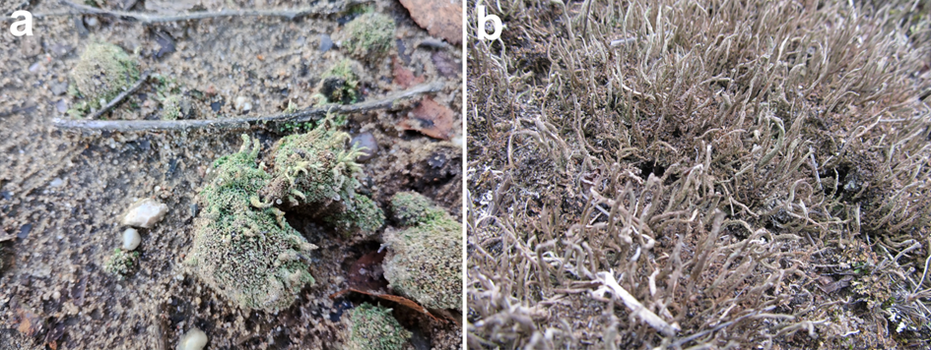

**Fig. S2.** Exemplary photos presenting *Cladonia rei* from sampling sites designated on the transect at 300 m and 1500 m away from the "Miasteczko Śląskie" zinc smelter