|  |  |  |  |
| --- | --- | --- | --- |
|  |  | | |
| **Rocznik Ochrona Środowiska** | | |
| Volume 27 | Year 2025 ISSN 2720-7501 | pp. 269-291 |
|  | https://doi.org/10.54740/ros.2025.022 open access | | |
|  | Received: January 2025 Accepted: May 2025 Published: May 2025 | | |

Performance Evaluation of LGWP-Series Refrigerants as a Substitute   
for HFC-134a Air Conditioning System: A Sustainable Approach

Albela H. Pundkar1, Sharad S. Chaudhari1, Khalid Ansari2*, Sandip Khedkar1,   
Charuta Waghmare2, Dhiraj Agrawal2, Prajakta Waghe3, M. Ramkumar Raja4, Saiful Islam5

1Mechanical Engineering Department, Yeshwantrao Chavan College of Engineering, Nagpur, India

2Civil Engineering Department, Yeshwantrao Chavan College of Engineering, Nagpur, India

3Department of Chemistry, Yeshwantrao Chavan College of Engineering, Nagpur, India

4Department of Electrical Engineering, College of Engineering, King Khalid University, Abha, Saudi Arabia

5Civil Engineering Department, College of Engineering, King Khalid University, Abha, Saudi Arabia

*corresponding author's e-mail: ksansari@ycce.edu

**Abstract:** This research aimed to investigate the impact on performance and environmental factors of newly developed blended refrigerants XP10-Opteon and Solstice® N13 from the olefins group. With a focus on mobile air conditioning (AC) systems, the necessity to replace high global warming potential (HGWP) R134a (1400) refrigerant has become prominent over the past decades. It was crucial to find a more suitable refrigerant with low global warming potential (LGWP), such as HFO-blend R513a (573) or R450a (547), especially for industrial or commercial applications within the medium temperature range of 25°C to -10°C. This particular research entailed utilizing HFC-HFO blend refrigerants for automotive air conditioning applications. The experimental setup employed a 0.50HP hermetic reciprocating compressor and a copper tube-type condenser. The temperature range for testing was maintained between 30°C and 60°C. A more pronounced reduction of 14-24.6% in electricity usage because of less power consumption enhanced the value of COP. The results revealed noteworthy findings in comparison to R134a; the average coefficient of performance (COP) for R513a exhibited almost the same performance coefficient with a little bit reduction factor of approximately 13%, whereas R450a showed results better than R134a with 8% enhancement at the same operating conditions. Additionally, the mass flow rate for R513a increased by 14-16%. Most importantly, R513a showed a substantial global warming potential (GWP) reduction by approximately 56-57% compared to the conventional refrigerant R134a.

**Keywords:** LGWP/HGWP, cooling capacity, MAC, COP, Wc

1. Introduction

In recent years, global concerns regarding environmental sustainability have led to a paradigm shift in refrigerants used in air conditioning and refrigeration systems. The phase-out of hydro-chlorofluorocarbons (HCFCs) and hydrofluorocarbons (HFCs) due to their high global warming potential (GWP) has spurred the search for more environmentally friendly alternatives. The European Union (EU) implemented regulations (MAC Directive) that required transitioning from high-GWP refrigerants like R134a in mobile air conditioning systems to lower-GWP alternatives. The European F-Gas Regulation 2019 imposed strict limitations on high-GWP refrigerants across almost all applications. This spurred more significant interest in natural refrigerants and low-GWP synthetic options. Since 2020, researchers and manufacturers focused on developing and adopting L-GWP substitutes for HFCs. Natural refrigerants like propane (R290) and iso-butane (R600a) also gained traction in domestic refrigeration with small air conditioning systems.

Tada et al. (2016) studied refrigerant choice depending on the type of cooling application, GWP, ODP, energy efficiency, cost, and availability. As more companies commit to reducing their carbon footprint, adopting sustainable cooling technologies that use eco-friendly refrigerants is essential. This shift toward more environmentally friendly manufacturing will provide a brighter and cleaner future.

The current research paper delves into the assessment of utilizing HFO-HFC series refrigerants as substitutes for the widely used R134a refrigerant, focusing on their substantial benefits. The investigation explores these substitutes' thermodynamic properties and compatibility and aims to quantify the potential enhancement in performance and environmental impact. By studying the transition from R134a to HFO-HFC blends, this research contributes to the growing body of knowledge that seeks to align cooling technology with the imperative of sustainable and energy-efficient solutions. In the ever-evolving landscape of refrigerants, the quest for environmentally friendly, energy-efficient, and safe alternatives has driven research and innovation across various sectors. Diverse applications such as domestic air conditioning (DAC), mobile air conditioning (MAC), industrial air conditioning (IAC), and beyond have been under scrutiny to identify optimal refrigerants that balance performance with minimal environmental impact. Daviran et al. (2027) and Devecioğlu & Oruc (2017) recently unveiled the eco-friendly refrigerants series, notably the Hydrofluroolefins (HFO) compounds – R1234yf, R1234ze, and R1233zd. These compounds exhibit a shallow global warming potential (GWP), approaching negligible levels, marking a substantial departure from their predecessors. HFO blends with hydro-fluorocarbons (HFCs), including R513a, R450a, R515a, and R515b, have emerged as viable candidates for numerous applications. These blends harmonize the energy efficiency of HFOs with the proven performance of HFCs, presenting a comprehensive solution to the refrigerant problem. The automotive industry, responsible for a significant share of greenhouse gas emissions, found respite in the form of HFO-HFC blend refrigerants (Daviran 2017, Devecioğlu & Oruc 2017). These blends were poised to revolutionize the mobile air conditioning (MAC) sector, addressing the need for improved efficiency without compromising safety. Meanwhile, applications such as chillers and heat pumps, pivotal in commercial and industrial domains, stood to benefit from the advancements in HFO refrigerants. These refrigerants offered the flexibility to retrofit existing systems and seamlessly integrate into new installations, fostering a transition towards sustainable cooling solutions. Achaichia (2018) studies some alternatives to R134a refrigerants.

Based on the above comparison in Table 1, R717 (Ammonia) was the most eco-friendly regarding GWP and ODP. However, the safety concerns and flammability might cause difficulties in its application. On the other hand, R744 (carbon dioxide) was an excellent and highly energy-efficient alternative, but its high operating pressure demands specialized components that may affect its application. R32 and R1234yf have a much lower GWP than R134a and are easier to adopt commercially, while R290 offers cost advantages. R744 (carbon dioxide) is non-toxic and non-flammable, with zero ODP and low GWP. It was an effective refrigerant for low-temperature applications (<-40°C) and an excellent alternative for supermarket refrigeration systems. R717 (Ammonia) had zero ODP and GWP and the lowest operating cost of all other refrigerants. It was a suitable refrigerant for high-temperature (>-50°C) applications. Its excellent thermodynamic properties made it an energy-efficient alternative. R290 (Propane) was a hydrocarbon that had zero ODP and low (< 3) GWP. It could be used in domestic refrigeration systems and small cooling applications. It was highly efficient and cost-effective. R1234yf (Tetrafluoropropene) had a GWP of four and zero ODP, which made it an excellent alternative for automobile air conditioning systems. It was also suitable for all other cooling and conditioning applications, but again, the refrigerant cost was very high, approximately 10 times more than R134a. Considering the comparative properties of substitute refrigerants, R744 (Carbon dioxide), R717 (Ammonia), R290 (Propane), R32 (Di-fluoro-methane), and R1234yf (2, 3, 3, 3 Tetra-fluoro-propene) were eco-friendly alternatives to R134a.

**Table 1.** Eco-friendly refrigerant and comparative properties of all substitutes to R134a (Achaichia 2018)

|  |  |  |  |  |  |
| --- | --- | --- | --- | --- | --- |
| Refrigerant | GWP | ODP | Energy Efficiency | Cost | Availability |
| R744 (Carbon Dioxide) | 1 | 0 | High | Low | High |
| R717 (Ammonia) | 0 | 0 | High | Low | High |
| R290 (Propane) | 3 | 0 | Moderate | Low | Moderate |
| R32 (Difluoromethane) | 675 | 0 | High | High | Moderate |
| R1234yf (Tetra-fluoro-propene) | 4 | 0 | High | High | Moderate |

This research explored the diverse landscape of refrigerants tailored for specific applications, from Domestic Air Conditioning to Industrial Air Conditioning. By evaluating the efficacy of HFO and HFO-HFC blend refrigerants in various contexts, this study sought to unravel the optimal combinations that harmonized performance, energy efficiency, and environmental preservation. Through this exploration, we aimed to contribute to the collective pursuit of a cooler, greener future. The following section summarises the details of substitute refrigerants for current HFCs and HCFC refrigerants. Due to the intricate balance of thermal, mechanical, and chemical properties, arriving at a singular "one-size-fits-all" solution became challenging. As a result, a systematic categorization was necessitated, segregating refrigerants based on their appropriateness for distinct operating conditions within various application equipment setups. Moreover, the eventual selection of the optimal refrigerant was also contingent on the specific geographical context in which the equipment would operate.

(Direk & Mert 2018, Makhnatch et al. 2019) provide details of refrigerants flammability and toxicity levels. With a maximum burning velocity of ≤ 0.1 m/s, A2L or B2L group's refrigerants have lower flammability.

The subsequent Table 2 offers a comprehensive breakdown, classifying refrigerants according to their compatibility across diverse applications (Alawi et al. 2015).

**Table 2.** Refrigerant Details Substitute of HFCs-HGWP-R134a (Daviran 2017, Morales-Fuentes et al. 2021)

|  |  |  |  |  |  |
| --- | --- | --- | --- | --- | --- |
| Category  of Refrigerant | Name of Item | AHRAE  (Safety Group) | GWP | Applications | Compatible  Compressor Oil |
| Pure-Natural  Refrigerant | R-290  R-600  R-744  R-717 | A3  A3  A1  B2L | 3  1  1 | Condensing Unit,  Industrial RA&C,  Chillers, HPs,  Domestic RF | POE/PAG/PAO |
| HFCs with LGWP | R32 | A2L | 675 | Heat pump, Chiller,  VFR-Variable Flow Rf. | New  (PVE and POE) |
| HFOs-Hydrofluroolefins | R1234yf  R1234Ze  R1233zd | A2L  A2L  A1 | 4.0  7.0  4.5 | Split, MAC, VRF Chillers | POE-A,  POE-B, POE-C |
| HFC-HFO  mixture | R450a  R452B  R454B  R455A  R513A | A1  A2L  A2L  A2L  A1 | 605  698  466  148  631 | Heat Pump, Chiller,  VRF system,  MAC-Bus/car  Ac system | Pentaerythritol  Esters (PEC5) and POE |

**Table 3.** The Toxicity and Flammability of Refrigerants (Aljubury & Mohammed 2019, Aljubury et al. 2015)

|  |  |  |
| --- | --- | --- |
|  | Eco-Friendly Refrigerants | Traditional Refrigerants |
| Toxicity | Low to moderate toxicity, non-flammable | High toxicity, flammable |
| Flammability | Non-flammable | Highly flammable |

From Table 3 above, it's clear that mobile air conditioning HFOs and their blends with LGWP and HGWP refrigerant of HFCs series get the best results regarding positive environmental impact. The current research highlights the effect of (LGWP-HFOs-HGWP-HFC) Blends R450 and R513 versus pure R134a for automobile air conditioning systems. Therefore, let's compare these refrigerants' thermodynamic properties and safety classifications.

**Table 4.** Refrigerants and Lubricant Thermodynamics properties and safety classification   
(Sieres & Santos 2018, Aprea et al. 2018, Al-Sayyab et al. 2022)

|  |
| --- |
| **R134a**: |
| HFC (Hydrofluorocarbon) Pure Safety Group – A1 (Low toxicity; Low flammability) Boiling Point Temp @ 1 atm (-26.5°C) Critical Point Temperature – 101.01°C Dew Point Temperature @ 1 bar – No glide-Zero Glide GWP Value @ 100-year – (1300-1400) |
| **R450A**: |
| HFC Blend (blend HFC-HFO:R134a + R1234ze) Safety Group – A1 (Less toxicity ; No flammability) Boiling Point Temp @ 1 atm (-24.5°C) Critical Point Temperature – (105.9°C) Dew Temperature @ 1 bar – (0.8K) GWP Value @100-year – (547) |
| **R513A**: |
| HFC Blend (blend HFC-HFO:R134a+R1234ze) Safety Group – A1 (Less toxicity, No flammability) Boiling Point Value @ 1 atm – (-29.02°C) Critical Temperature (98°C) Bubble-Dew @ 1 bar(absolute) – (0.8 K) GWP (@100-year) – (573-674) |

**Table 4.** cont.

|  |
| --- |
| **POE 68 Lubricating oil – Polyol Ester** |
| Refrigerant Suitability: R134a, R404A, R407C, R513A, R450A  ISO VG 68  Kinematic Viscosity @ 40°C (cSt) 67  Kinematic Viscosity @ 100°C (cSt ) 8.7  Viscosity Index 101  Pour Point (°C) -36  Flash Point (°C) 260  Density @ 15°C (g/cm³) 0.995 |

By comparing these refrigerants based on safety group, BPT, DPT, and GWP information, we can say that all three refrigerants had the same safety classification group of A1, indicating they were non-flammable and non-toxic. Boiling Temperature of R513A had the lowest boiling temperature, followed by R450A and R134a. Critical Temperature of R450A had the highest critical temperature again, followed by R134a and R513A, respectively. Bubble-dew point temperatures of R513A and R450A had similar bubble-dew ranges, with a small glide of 0.8K, whereas R134a didn't have a glide at 1 bar (absolute) pressure. R450A and R513A had significantly lower Global Warming Potentials (GWPs) than R134a, indicating their harmless environmental impact over a 100-year timescale (Schultz & Kujak 2013, Li 2021).

When considering these refrigerants for various applications, it was essential to consider their thermodynamic and physical properties, environmental impact, system compatibility, and any regulatory requirements. The choice of refrigerant should have been made based on a thorough evaluation of these factors in the specific context of the application. Sadaghiani et al. (2022) studied the blends R1234yf and R32 using Hartmann Bomb analogs for the measurement of Pure natural refrigerant NH3 – Ammonia, and above blends at 24°C atmospheric temperature with Equivalence ratio (φ) was 0.9, 1.33, 1.27 for of R717, R32, and R1234yf respectively to get the value of least ignition energy (LIV) and burning laminar velocity (BLV). LIV values were 84 and 74 mm/s for R717 and R32, respectively. Adding HFO-R1234yf (5%) decreased the value of LIV by 10.99% and BLV by 29.99% over LIV. Redhwan et al. (2019) performed a test to improve automobile AC performance using SiO2 and Al2O3 nanoparticles (0.07, 0.3, and 1%), with PAG oil for lubrication, and reported considerable COP raising with 0.3 and 1% of NP addition.

Vaghela, in 2017, did a comparative study on mobile air conditioning using R290, R410a, R1234yf, R1234ze, R152a, and R134a. From the results, it proved that R1234yf could be a direct drop-in replacement to HFCs-R134a due to being nearer to 4-LGWP with approximately similar thermodynamically and thermophysical properties as that of R134a-HFCs with all the equipment components for the old system (Vaghela 2017, Mohamed et al. 2017).

Daviran et al. (2017) also performed a simulation study for MAC using 2, 3, 3, 3-sTetrafluoropropene (HFO-1234yf) as a substitute for old-R134a. An experiment was conducted to determine the constant cooling capacity and constant volume flow rate of refrigerant conditions. Results showed that using HFO-R1234yf there was a negative impact on HTC(hc) by 18 to 22% as compared to Tetrafluoroethane-R134a with drop-in pressure value for condensing unit and evaporator unit ~ 24% and ~20%, respectively. Similarly, the value of COP also gets deduced by 1.5-5.0% for R1234yf for constant evaporator capacity and COP nearer to 18-19% more for R1234yf for constant volume flow rate condition. Mohan Raj et al. compared the performance of a small capacity refrigeration system with HFC-HFO blends-R430a with pure R134a as it has better thermophysical properties than the HFC refrigerant. R430 shows near to 3% more outlet compressor temperature and hence 6 to 11% lower work of compression required and 11 to 19% more COP compared to the value of R134a. With this R430 A significantly lowers the TEGWI for LPG-liquefied petroleum gas, Diesel, and Gasoline vehicles by about 46%, 33%, and 34%, respectively.

Schultz & Kujak (2013) investigated the performance of HFO Blends R-445A Mixture of R-1234ze:   
R-134a: R-744 with a fraction of mass (0.85:0.09:0.06) as a trial substitute to R134a in a mobile or bus air conditioning system. It was reported that as compared to HFC-R134a, R-445A has a lower COP and cooling capacity. The cooling capacity and performance of the coefficient were improved by 5.5% and 12% by reducing the mass fraction of CO2-R744. In another work, the maximum exergy destructions for the refrigerants were observed in the compressor, and the least exergy destruction was observed in the evaporator. The energy destruction in the system working with R450A was found to be less by 15-28% with 10-13% more exergy efficiency-(EE) compared to R134a refrigerants (Transient evaluation of a city bus air conditioning system with   
R-445A as drop-in from the molecules to the system – October 2015).

From the comprehensive review of existing literature and the detailed properties Table 4 provided, it became evident that composite mixtures offered discernible advantages. These advantages primarily encompass enhanced thermodynamic, thermo physical, and chemical properties while minimizing their environmental footprint (Belman-Flores et al. 2023). The compatibility challenges of HFO and HFC refrigerants with mineral oil were resolved using POE oil for blending. Assessing blends, including Tetrafluoroethane HFC and fourth-gen HFOs, showcased significant performance enhancements, notably addressing previous miscibility issues via strategic POE oil incorporation (Li 2021). Aljubury predominant refrigerant used in most automotive air conditioning systems was R134a. However, due to environmental concerns and regulatory changes, there was an increasing need to explore alternative refrigerants to replace the hydrofluorocarbon (HFC) R134a. This demand arises from the desire to mitigate the environmental impact associated with HFCs. The vehicle's cooling system was specifically engineered to maintain a comfortable and cool interior, especially when faced with high external temperatures. This was particularly significant in places like Iraq, where the hot climate and extended summer periods demanded prolonged operation of these systems. In such conditions, the vehicle cabin's temperature could rise to as high as 70°C (Li et al. 2019, Lopis et al. 2017, Makhnatch et al. 2019, Makhnatch 2017).

Wang (2014) has highlighted a significant difference in the efficiency of a reversible air-conditioning/heat pump system when transitioning from R134a to R1234yf as the refrigerant. The review encompassed various experimental investigations, revealing that the decline in Energy Efficiency Ratio (EER) ranged from 0% to 27%, depending on specific operational conditions. It was noted that R1234yf's lower thermal conductivity in the liquid state could lead to compromised heat transfer performance, particularly within the condense (Mohanraj & Abraham 2022). The study further observed that the volumetric efficiency of the R1234yf system was marginally inferior to that of R134a, attributed to the higher frictional resistance of R1234yf. Regarding evaporator heat transfer performance, R1234yf exhibited almost comparable performance to R134a. A similar comparison was conducted by Li et al. (2019) in an oil-free variable capacity refrigeration system (VCRS)   
at a condenser temperature of 40°C. Their findings indicated a 20% reduction in EER for the VCRS utilizing R1234yf compared to R134a.

Additionally, Li et al. revealed that R1234yf incurred a higher pressure drop across the evaporator due to increased wall friction. Considering the unit exergy cost of domestic refrigerators using R1234yf and R134a, the findings showed that R134a outperforms R1234yf across various operating conditions. In this current research paper, the central focus revolves around investigating the impact of Pure R134a and its specific blend (R513a) when utilized with POE lubricating oil. This research marks a significant stride forward in comprehending the dynamic interplay between refrigerants and lubricants, shedding light on how these blends perform in practical applications. Table 5 summarises the comparative studies of various researchers regarding modern-era refrigerants.

Table 5 compiles (EU) European Commission reports, experimental findings, and reviewed research studies conducted by researchers from the last two decades (2009 to 2024). These studies primarily focus on environment-friendly refrigerants in the context of diverse operational conditions. The results consistently indicate that these refrigerants can serve as effective drop-in substitutes for conventional working fluids, with varying degrees of impact on performance characteristics. Despite that, the refrigerant volume has become quite important in an International agreement that aims to reduce the production and consumption of hydrofluorocarbons (HFCs). Also, the modification of cooling systems was strenuous and expensive. In such a situation, the most reasonable way is to find ways to use efficient alternative refrigerants without or less modifications to existing systems. For this reason, unlike other studies, this study presents the refrigerant volume flow per unit of energy performance parameters when R513A, R450A were tested instead of R134a. This study's novelty is that it considers both the GWP and the refrigerant amount together and the correlation of the energetic performance parameters with the refrigerant-specific volume flow rate during the adaptation process to the Kigali Amendment. The aim is to contribute to this transition process for researchers who do not have the opportunity to test performance parameters related to refrigerant discharge temperature and pressure by considering psychometric analysis. Additionally, this study is an extended version of the paper presented at the 2nd International Conference and Exposition on Advances in Mechanical Engineering (ICAME-2022_COEP) (Pundkar & Chaudhari 2022, Chaudhari et al. 2024).

**Table 5.** Review of literature in tabular format for ecofriendly and new era refrigerants

|  |  |  |  |
| --- | --- | --- | --- |
| Author | Applications | Refrigerants/Working Medium | Final Concluding remarks with detailed working conditions |
| (Alawi et al. 2015) | All RAC system | R134a  Mineral Oil  TiO2 NP | The mixture of nanoparticles as a lubricant, containing 0.1% mass fraction of TiO2 nanoparticles, resulted in a remarkable 26.1% energy savings compared to the HFC134a and POE oil system. |
| (Makhnatch et al. 2019) | Small capacity VCRS for HAT environments. | R134a  R513a | In TEWI analysis of a small refrigeration unit, R450A demonstrates CO2 equivalent emission savings compared to other conditions. However, when considering CC variation, the R513A system meets the lowest TEWI per unit of delivered CC. |
| (Nair 2020) | MAC | HFC,HFO,HC | Reviewed and concluded future refrigerant and their performance characteristic. |
| (Sánchez et al. 2017) | General refrigeration system | R290, R600a R134a R152a R1234yf R1234ze(E) | Under similar working conditions using a hermetically sealed compressor, it was concluded that all new refrigerants could be used as direct drop-in without any special modification in the current system. |
| (I Vinoth Kanna. 2019, Velders et al. 2015) | All AC System – Review | All Ecofriendly  Refrigerant taken  into account | A review was carried out to study the compatibility of refrigeration system components to ensure their optimal performance when using these alternative refrigerants and concluded future refrigerant for replacement of HFC and equivalent with good ODP and GWP impact. |
| (Aprea et al. 2018) | Air Conditioning System | Pure HFO;  Blend;  R134a | Tests were conducted on the freezer with R134a and HFO blends refrigerant and found both achieve the same temperature level with about 17% lessen the GWP compared to conventional Refrigerant. |
| (Siricharoenpanich  et al. 2019) | Air conditioning system | R134a | A conventional air conditioning system and new designed AC system with the cooling water loop with the concentric helically coiled tube heat exchanger were installed between the compressor unit and condenser unit with R134a tested, resulting in a 31% increase in COP value. |
| (Chauhan et al. 2019) | Ice plant test rig | TiO2 –POE-R134a | The R134a/Nano lubricant (POE-TiO2) blend (0.1%, 0.2%, and 0.3%) of TiO2 volume concentration operated efficiently and safely, with a 15.8% reduction in compressor power consumption and a 29.1% increase in COP at a 0.2% TiO2 nanoparticle concentration. |

**Table 5.** cont.

|  |  |  |  |
| --- | --- | --- | --- |
| Author | Applications | Refrigerants/Working Medium | Final Concluding remarks with detailed working conditions |
| (Ahmed & Khan 2021) | Air Conditioner | Cu and Al2O3 Nanofluid | The test was performed with 3 volume fractions of 1%, 2%, and 5% with water as the base fluid. Results showed that using a 5% volume fraction, Al2O nanofluid improved the COP by up to 22.1%, while copper nanofluid showed an even more substantial enhancement of 29.4%. |
| (Pereira et al. 2019) | Two-phase mechanically pumped loop  (TMPL R system | R1234yf and R134a | Research work has used R1234yf and R134a with Evaporator sizes from 0.1 to 1, mass flux levels – of 300 kg∙s-1m-2 and 400 kg∙s-1m-2, and Tsat – 25°C and 30°C. Better results were obtained with mean absolute errors of 12% and 13%. |
| (Sieres & Santos 2018) | Mini VCR system | R1234yf and R134a | Test performed @ 2 compressor supply frequencies  (40 Hz /60 Hz) and varying evaporation temperatures  (-5°C to +5°C), while maintaining condenser temperatures at 45°C, 50°C, and 55°C. R1234yf appeared a suitable replacement for R134a as a refrigerant, providing similar cooling performance but slightly lower energy efficiency (EER). |
| (Bellman-Flores  et al. 2023) | Domestic refrigeration  system | R1234yf and R134a | A computational model was developed to work out the thermodynamic parameters. Results have proven that irreversibility tendencies are mainly concentrated in the compressor; this is the case for R1234yf and R134a. |
| (Lopis et al. 2017) | Commercial direct expansion refrigeration system | XP10, R134a | The tests were performed at three water dissipation temperatures (23.3, 32.8, and 43.6°C).Results showed the increments in energy consumption between-1.6 to +1.2% for R-513A and from+1.3 to +6.8% for R-450A, +1.3 to +6.8% for R-450A |

2. Testing and Thermodynamic Analysis

2.1. Safety Precautions taken before and during operation

Before starting with experimental work, employing blend refrigerants, specific precautions were crucial to prevent potential compressor damage. Although steady-state performance is important, system energy usage and lifespan are greatly impacted by the transient behavior at start-up. Regular start-ups can result in increased tear and wear and hence, decreased system efficiency, especially while operating intermittently. It is crucial to characterize these unstable situations to improve system design and control. In actuality, refrigeration and air conditioning – RAC systems would never function in steady-state conditions. Therefore, to describe those transition stages, it was essential to understand system behavior in brief during the start-up phases. Significant deviations from steady-state conditions during the start-up phase of a refrigeration system can lead to refrigerant migration, thermal stresses, and performance loss. Understanding these transient events is crucial to ensure reliable and efficient functioning. Transient circumstances significantly impact system performance, especially in real-world applications like refrigeration systems. Examining system behavior during start-up helps understand response time, stability, energy consumption trends, and control system enhancements. Transient analysis helps identify thermal delays or initial inefficiencies, while final measurements were performed under steady-state conditions to ensure accuracy and reproducibility. Maintaining an optimal operational environment involves maintaining a superheat range of 8k to 10k. This precaution helps mitigate the risk of liquid refrigerant migration into the compressor, especially during standby periods, for which the use of a heater in the crankcase was advised.

Furthermore, it was imperative to utilize electronic leak detectors (ELD) designed exclusively for R513a. Employing an ELD machine was essential for efficient leak detection. A refrigerant cylinder for the refrigerant recovery unit (RRU) was vital to facilitate the process. Additionally, provisions for lubricant changeover, if required, should also be made to ensure a seamless retrofitting procedure.

2.2. Schematic Diagram of Experimental Setup

The experimental setup consists of an evaporator capacity of 6 kW, compressor-reciprocating hermetic sealed driven by a rated speed 1500 rpm with thermostat arrangement of cut-off range from 5°C to 15°C and POE 68 Lubricating oil – Polyol Ester, forced convection air cooling condenser size 13" x 11", Ammeter/Voltmeter 0-30A/220 V respectively. The actual experimental setup is shown in Fig. 1 and Fig. 3. Thermal heat resistance of capacity 1500 W was used. Rotameter -6.0 to 68 LPH was used to measure the volume flow rate of the working medium. For more details about the experimental setup, all the specifications for each setup component and accuracy/precision/uncertainty analysis of the measuring device were done in the following section, and a summary of it is mentioned below in Table 6 and Table 7.

Standard uncertainty analysis can be done based on a Type A and Type B. In the current work, Type B's evaluation approach was utilized to assess the uncertainty related to each measuring device employed in the air conditioning test rig. The expression where 𝑎 was used to calculate the standard uncertainty for each device, assuming a uniform distribution (Saadoon & Aljubury 2019, Enang et al. 2018).

$U=±t*√\frac{\sum{(xi-}{\overline{x}}^{)2}}{n(n-1)}$**.** (1)

Where an is the corresponding measuring device's accuracy limit (or least count) and U is the standard uncertainty. Thermocouples, wattmeters, hygrometers, and pressure gauges are among the tools utilized in the setup. Table 7 provides a summary of each device's uncertainty values. By using a coverage factor 𝑘 = 2, which corresponds to a 95% confidence level, the enlarged uncertainty was computed:

$U=\frac{Accuracy or least count}{\sqrt{3}}$. (2)

The root-sum-square (RSS) approach was used to assess the combined standard uncertainty for computed performance metrics like cooling capacity, coefficient of performance (COP), and heat rejection rate:

${\left(\frac{U_{Q}}{Q}\right)}^{2}= {\left(\frac{U_{m}}{m}\right)}^{2}+ {\left(\frac{U_{cp}}{Cp}\right)}^{2}+{\left(\frac{U_{△t}}{△t}\right)}^{2}$. (3)

Where Q stands for the derived quantity (such as cooling capacity), and x1, x2... xn i.e. m, Cp, and t are the individual measured parameters that contribute to Q. Expanded uncertaintywas calculated using:

$U ex. =k*U$. (4)

Where k ≈ 2 for 95% confidence. Expanded uncertainty with a 95% confidence level was obtained by applying a coverage factor of 𝑘 ≈ 2.

**Table 6.** Components with specifications for air conditioning test rig

|  |  |  |
| --- | --- | --- |
| Components | QTY | Specifications |
| Compressor | 1 | Reciprocating Compressor Single phase, 0.5-5.0 HP, Bitzer, and Semi Hermetically sealed, Fixed Speed. |
| Evaporator | 1 | Copper Tube Inner Diameter – 8 mm, L – 380 mm, number of pipes – 36. Fin Material – Aluminum, 3 mm – space between two fins Fin Thickness – 1.2-2 mm (15 fins/inch). The working temperature will be 0°C to 25°C |
| Condenser | 1 | The condenser is the forced air-cooled type Tube diameter 8 mm, a length – 380 mm, a number of copper tubes – 24; Fin Thickness – 3 mm – The condensing temperature will be from 30°C to 60°C |
| TXV  (Expansion Valve) | 1 | Honeywell – 0.52 to 23.4 kW Temperature Range – 140°C,  Maximum Working Pressure – 45 bar |
| Anemometer | 1 | 190x72x37 mm, Op.Temp (0-50°C) Photo contact type/Lurton Electronic, 2.5 to 99,999 rpm/±(0.05+1digit) |

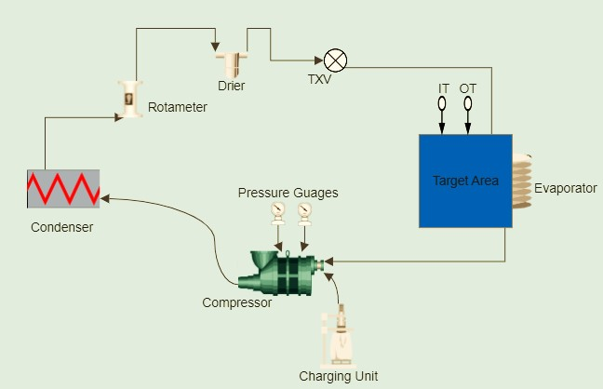

**Fig. 1.** Schematic of Experimental Setup (@flycarpet)

**Table 7.** Accuracy/Precision/Uncertainty of Measuring Device (Nawaz et al. 2017)

|  |  |  |  |  |
| --- | --- | --- | --- | --- |
| Measuring device | Parameter  measured | Accuracy/Least Count | Standard  uncertainty | Expanded  uncertainty |
| Thermocouple (K-type) | Temperature (°C) | ± 0.5°C | ± 0.29°C | ±0.58°C |
| Pressure Gauge | Pressure(bar) | ±1 psig | ± 0.058 bar | ±0.116 bar |
| Hygrometer | Relative Humidity (%) | ±0.5% error | ±1.15% RH | ±2.3% RH |
| Dimmer/Wattmeter | Electric Power | ±1.5% error | ± 5.77 W | ±11.54 W |

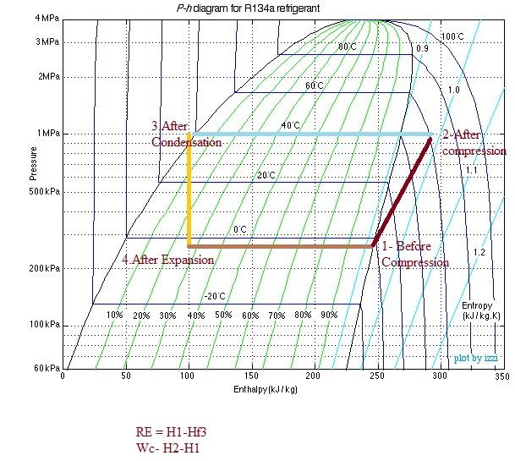

**Fig. 2.** p-h plot of VCR Cycle – R134a refrigerant

The thermodynamic process occurs in the air conditioning system Fig. 3 and Fig. 4.

Process 1-2: Isentropic Compression Process 2-3: Isobaric Condensation

Process 3-4: Isenthalpic Expansion Process 4-1: Isobaric Evaporation

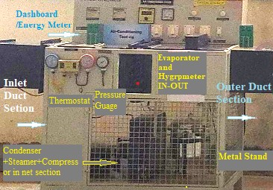

**Fig. 3.** Actual Experimental Setup

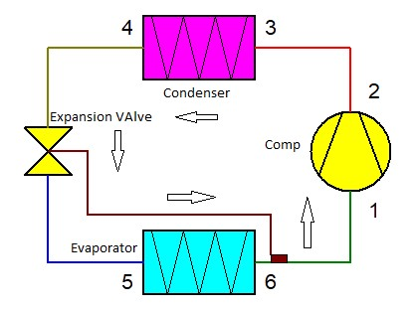

(a)

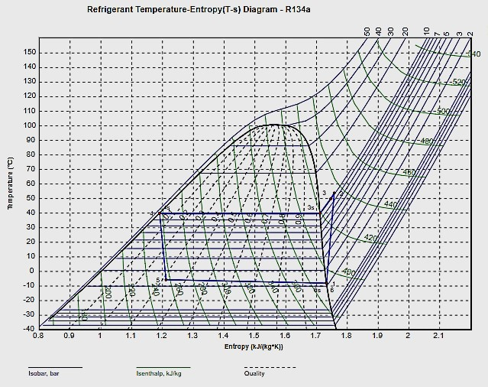

(b)

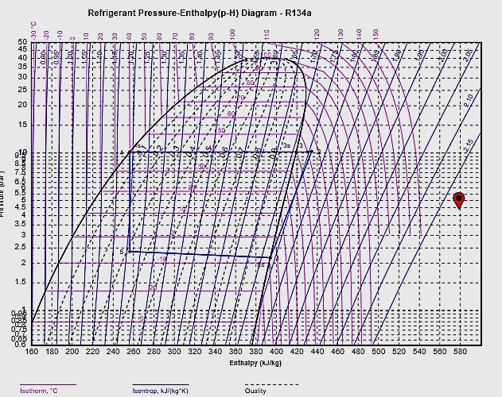

(c)

**Fig. 4. (a, b, c)** Processes 1-2, 2-3, 3-4, and 4-1: Compression, Condensation, Expansion, and Evaporation for Single Stage VCR cycle @ Fly carpet

2.3. Experimental Evaluation

The measurement equipment was placed accordingly to conduct a thermodynamic analysis of the experimental setup, and the required measurement states were determined. Pressure and temperature measurements were noted at each state to facilitate the thermodynamic analysis of the air conditioning circuit. A vapor compression refrigeration system designed to meet cooling requirements underwent tests under ambient conditions of 25-32°C at atmospheric pressure. The compressor is utilized to compress the refrigerant's low pressure and low temperature from the evaporator to high pressure with rising temperature. After the compression process, the refrigerant is released into a condenser where the condensation handle requires heat rejection to the environment. The refrigerant can be condensed at climatic temperature by expanding lower temperature over the climatic conditions. After the condensation, the refrigerant condensate will stream into the TXV. When the pressure drops, the refrigerant vapor expands. The evaporator coil absorbs energy from the duct tube, and a cooling effect is observed when the heat is extracted. The cycle is completed when the refrigerant returns to the suction line of the compressor after the evaporation process. The main refrigerants in the refrigerator are R-134a, and proposed replacements R450a and R513a have been used for comparative study. The experiment encompassed the evaporator and condenser with airflow conditions. The system parameters, including refrigerant pressures, temperatures, and compressor meter readings, were recorded at 10-minute intervals as the dynamic cooling process progressed from 25°C to -10°C at the evaporator's outlet. The baseline readings commenced with pure HFC-R134a. Key analysis factors included refrigerant flow rate (kg/sec), refrigerant type, evaporator load, and selection of system components based on MSDS specifications.

The experimental setup aimed for evaporation and condensation saturation temperatures typical of air-source heat pumps. R134a was utilized, with a consistent compressor speed of 1500 RPM for all test sets. Two load conditions (50% and full load 100%) were applied. Three heaters of 500W each capacity were installed in the evaporator section. Experimental conditions were mentioned in tabulated form Table-8. Starting with putting 'ON" the condenser fan and running it for 2-4 minutes, followed by the start of the blower with the suction fully open condition. Further, switching 'ON' the compressor so the refrigeration cycle may produce a conditioning effect. The air velocity in the duct was measured using a light anemometer. Note down the following observations @superheat were maintained at 8K for HFC-HFO readings. This superheat is kept constant throughout all the tests. The setup is also designed to achieve a 5°C subcooling for R134a at the condenser outlet, which is kept constant throughout the tests. The measurement range and uncertainties of the measurement devices are also consistent with similar studies in the literature (Kanna & Subramani 2018). Table 6 shows the technical information of all the measurement devices used in the experiments. The experimental condition is summarized in the following Table 8.

**Table 8.** Experimental Condition

|  |  |  |
| --- | --- | --- |
| Sr. No. | Particulars | Condition |
| 1 | Compressor RPM | 1500 constant |
| 2 | Atmospheric condition | 25-32°C |
| 3 | Degree of sub cooling | 5°C |
| 4 | Degree of Superheat | 8-10K |
| 5 | LOAD Range | 50% to 100% (1500 W Full Load condition) |
| 6 | Time Interval between two readings | 10-12 minutes |

2.4. Mathematical Analysis treatment

Values of enthalpies were calculated at corresponding pressure and temperature conditions using p-h and   
t-s plot. The following calculations were performed from the properties table of each refrigerant (Pundkar & Chaudhari 2022).

COPth = (Enthalpy of the Vapor Refrigerant at Evaporator Inlet Temperature - Sensible Heat at Condenser Outlet Temperature) / (Enthalpy of the Vapor Refrigerant at Condenser Inlet Temperature – Enthalpy of the Vapor Refrigerant at Evaporator Inlet Temperature)

In equation form:

$COP= \frac{(h1-hf3)}{(h2-h1)}$, (5)

where:

h1 – Enthalpy of the vapor refrigerant at the evaporator inlet temperature (T1),

h2 – Enthalpy of the vapor refrigerant at the condenser inlet temperature (T2),

hf3 – Enthalpy of the liquid refrigerant at the condenser outlet temperature (T3).

Refrigerating Effect which is equivalent to Heat absorbed by the evaporator section-load in (kW).

$Refrigerating Effect RE=ṁ*\left(h1-h4\right).$ (6)

After finding the enthalpies value at suction and discharge of the compressor i.e., at Ts and Td, respective enthalpies will be h1 and h2.

The compressor work required was calculated by

$Work of compresion consumption=ṁ*(h2-h1)$ (7)

Therefore system performance Coefficient:

$COP(Coefficient of Performance)=\frac{ṁ*(h1-h4) }{ṁ*(h2-h1)}$*.* (8)

Coefficient of Performance (Actual COP) = Refrigeration Effect / Energy consumed by Compressor (Hashimoto et al. 2019). Note – (Using the Density of refrigerant at the condenser outlet, referring to the R-134a, R513A, and R450 A properties chart for density at the condenser outlet temperature).

3. Result and Discussion

3.1. Analysis of Pressure Variations

After initiating the system by switching on the power and supplying input to the heater through the dimmer control, the refrigeration system was allowed to stabilize for approximately 5-6 minutes before measurements were recorded. The corresponding thermodynamic parameters were observed regularly to evaluate the system's performance under increasing heat input. The base readings for R134a refrigerant are presented in Table 9, showing variations in suction and discharge pressures with time and input power. As observed in Table 9, both suction pressure (P1) and discharge pressure (P2) increased progressively with time and corresponding heater input. The increase in pressure correlates directly with the heat input, indicating a rise in refrigerant flow and thermal load on the system. This behavior is typical in vapor compression systems, where greater thermal input increases refrigerant enthalpy and pressure after compression.

Locate inlet and outlet conditions on a psychometric chart and study the cooling and dehumidification process for the current set of readings.

3.2. Psychrometric Analysis and Cooling–Dehumidification Process

Using the observed dry bulb and wet bulb temperatures, the air properties at the inlet and outlet were determined from the psychrometric chart. The key parameters such as humidity ratio-specific humidity) (X), enthalpy (H), relative humidity (RH), and air density (ρ) are summarized in Table 10. A significant decrease in dry bulb temperature and humidity ratio was noted from the inlet to the outlet, indicating effective cooling and dehumidification. The enthalpy drop from 78.9 kJ/kg to 43.9 kJ/kg in the first set and 75.82 to 50.07 kJ/kg in the second signifies a substantial heat removal process. Correspondingly, the relative humidity increases at the outlet, indicating that while air becomes cooler, its moisture-holding capacity also reduces.

**Table 9.** Base Readings for Observations – R134a

|  |  |  |  |  |  |  |
| --- | --- | --- | --- | --- | --- | --- |
| Sr. No. | Input to Heater Watt = V ∙ I | Time  (Min) | P1  (PSI) | P2  (PSI) | P1  (kg/cm2) | P2  (kg/cm2) |
| 1 | 1472.0 | 5 | 28 | 146 | 1.9 | 10.2 |
| 2 | 1419.8 | 10 | 31 | 209 | 2.1 | 14.6 |
| 3 | 1473.7 | 15 | 37 | 259 | 2.6 | 18.2 |
| 4 | 1396.9 | 20 | 42 | 261 | 3.0 | 18.3 |
| 5 | 1448.4 | 25 | 48 | 269 | 3.3 | 18.9 |

|  |  |  |  |  |  |  |  |
| --- | --- | --- | --- | --- | --- | --- | --- |
| Process | Action | ΔT (°C) | ΔX (g/kg) | ΔX (l/h) | ΔH (kJ/kg) | Power ΔH (kW) | Power ΔT (kW-T) |
| 0-1 | Cool | -18 | -6.3 | -73.6 | -34.5 | -112.4 | -60.8 |

All processes are calculated with 10000 m3/hr and actual densities.

**Table 10.** Results from Base readings for observation R134a

|  |  |  |  |  |  |  |  |  |
| --- | --- | --- | --- | --- | --- | --- | --- | --- |
| Points | Tdb  (°C) | Twb  (°C) | Tdew  (°C) | X  (kg/kg) | H  (kJ/kg) | RH  (%) | ρ  (kg/m³) | Pv  (Pa) |
| 1 | 35.0 | 25.6 | 22.30 | 0.017 | 78.90 | 47.9 | 1.134 | 2697 |
| 2 | 17.8 | 15.7 | 14.90 | 0.010 | 43.90 | 87.5 | 1.209 | 1696 |
| 1 | 38.0 | 25.0 | 20.78 | 0.015 | 75.82 | 45.0 | 1.133 | 2452 |
| 2 | 24.0 | 17.8 | 14.35 | 0.010 | 50.07 | 56.0 | 1.180 | 1633 |

Therefore; Actual COP Calculations

Volume flow rate of air = 0.0911 m3/s

Mass flow rate of air in kg/sec = Density * Volume flow rate of air = 0.0991168

Refrigerating effect = ṁ a*(h1-h2) = 3.469088 kW

Tonnage capacity = 0.986377026 TR

Compressor Work = Energy meter reading / Time in hour = 2.31

Actual COP = RE/WC = 3.469/2.31 = 1.501

Fortheoretical COP calculations from readings of P1 and P2 in bar, with the help of p-h chart plotting condenser pressure and evaporator line, placed all temperature points as discharge temperature after compressor @point 1, after condensation @ point 2, after expansion @ point3 and after evaporation @ point4 as shown in the following diagram. Noted in Table 11 are all enthalpies values such as h1, h2, and h3 = hf3 = h4. Calculation of theoretical COP was performed using the above mathematical data formulae (Zhai & Zhao 2019, Pundkar & Chaudhari 2022).

**Table 11.** Process calculation result (for one set of readings as per above plots p-h and t-s)

|  |  |  |  |  |  |  |
| --- | --- | --- | --- | --- | --- | --- |
| States | P (bar) | t (°C) | h (kJ/kg) | s (kJ/(kg∙K)) | v (m3/kg) | x (-) |
| 1 | 1.996 | -8.00 | 394.400 | 1.7403 | 0.10113 | 0.311 |
| 2 | 10.266 | 56.71 | 437.500 | 1.7668 | 0.02194 |
| 3 | 10.166 | 52.71 | 433.400 | 1.7550 | 0.02170 |
| 3s | 10.166 | 40.00 | 419.420 | 1.7111 | 0.01997 |
| 4s | 10.156 | 39.96 | 256.354 | 1.1903 | 0.00087 |
| 4 | 10.156 | 37.96 | 253.371 | 1.1807 | 0.00087 |
| 5 | 2.206 | -7.57 | 253.371 | 1.2017 | 0.02879 |
| 6s | 2.006 | -10.00 | 392.665 | 1.7333 | 0.09959 |
| 6 | 2.006 | -10.00 | 392.665 | 1.7333 | 0.09959 |

From the chart pressure enthalpy plot, t-s temperature entropy plot, refrigerant property table, and calculations following process calculations results shown in Table 12 were obtained for performance parameters like WC and COP were calculated and discussed in the next section in detail.

The base readings in Table 9 for refrigerant R134a demonstrate variations in pressure (P1 and P2), heater input power, and time. Multiple factors influence these variations, including system dynamics, measurement uncertainty, and operational conditions. Fig. 4 (a,b,c) diagrams for the thermodynamic cycle of test base readings R134a. (a) Temperature-Entropy (c) Log (Pressure)-Enthalpy. Similarly, readings were taken for another refrigerant, and calculations for actual COP, theoretical COP with the psychometric chart, and p-h t-s plot were calculated. From the energy meter, the initial and final reading of compressor work consumption was calculated. Further results analysis is performed using graphical representation.

**Table 12.** Test Results

|  |  |  |  |  |  |
| --- | --- | --- | --- | --- | --- |
| CC-R134a (kW) | CC-R513A (kW) | CC-R450a (kW) | Pc-R134a  (kW) | Pc-R513a  (kW) | Pc-R450a  (kW) |
| 2.557 | 2.409 | 2.608 | 0.954 | 1.125 | 1.039 |
| 2.294 | 2.276 | 2.339 | 1.032 | 1.217 | 1.124 |
| 2.145 | 2.045 | 2.187 | 1.143 | 1.348 | 1.245 |

Based on the observed experimental data, it was evident that R134a exhibits the highest compressor discharge temperature among all refrigerants. In contrast, HFO blends low – Global Warming Potential (GWP) alternatives showed slightly lesser discharge temperatures. Fig. 5 and Fig. 6 for discharge temperature and pressure reading with the time over the value noted down showed a range of minimum and maximum recorded discharge temperatures for R134A, R513A, and R450A (47.43°C; 46.43°C; 47.09°C); (87.5°C; 84.9°C; 85.9°C) respectively. Graphs plotted showed some points that appeared far apart due to uncertainties, even if slight changes in observed values may appear substantial. Discharge pressure (P2) rises as heating power and time progress, reflecting the anticipated rise in refrigerant pressure due to heat addition. When the system load changes (e.g., due to variations in heater input), there is a temporary overshoot or undershoot before achieving equilibrium. System behavior was also one of the causes of slight variable observations, such as the heater input power varying slightly (e.g., 1419.8 Wm, 1472 W, 1473.7 W), influencing the refrigerant pressure readings (P1 and P2) and subsequently affecting the system's thermal energy performance. However, compressor cycling, unsteady state at start-up, and refrigerant type change might cause the non-linear behavior indicated by oscillations in values like P1 (1.9-2.6 kg/cm2) and P2 (10.2-18.2 kg/cm2). The K-type thermocouple has a ±0.5°C accuracy, affecting the interpretation of enthalpy calculations and cooling capacity. The pressure gauge has a ±1 psi accuracy (~0.058 bar), affecting discharge pressure readings and compressor work calculations. The electric power measurement has a ±1.5% error, affecting heater power input and system performance evaluation. These uncertainties can cause significant differences in plotted graphs. Apart from that, the measurement intervals were intended to capture key changes in system performance. However, some spots may appear far apart due to sensor limitations and ambient conditions.

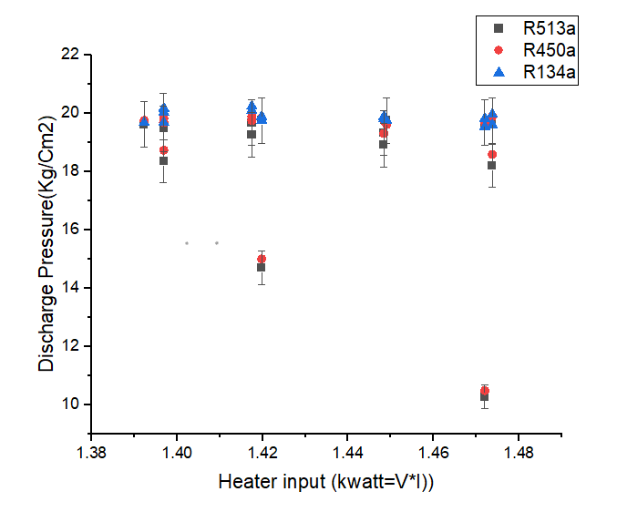

**Fig. 5.** Discharge pressure vs. heater input

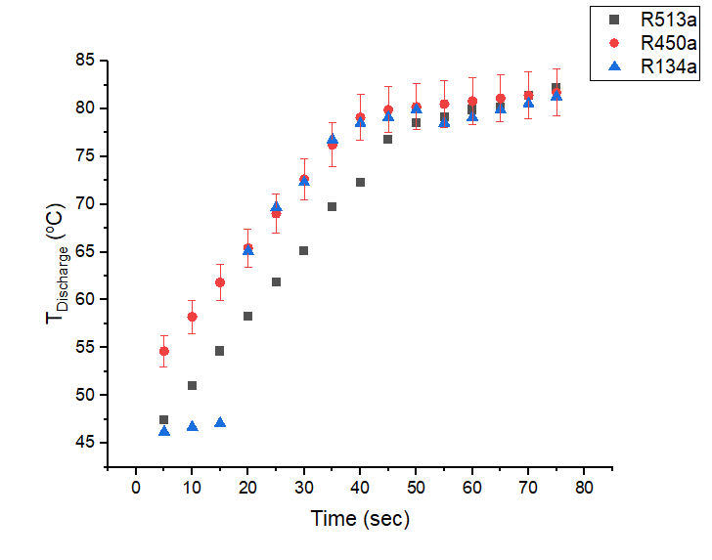

**Fig. 6.** Discharge temperature vs. time

This variation in discharge temperatures among the refrigerants has significant implications for system operation. Utilizing lower GWP alternatives such as R450A and R513A offers the advantage of reduced discharge temperatures compared to R134a under equivalent operating conditions. Consequently, employing these alternatives allows for an expansion of the system's operational range. The alternative refrigerants' lower discharge temperatures (td) facilitate this extended operational range, enhancing the system's overall performance and reliability over the broader range of operating conditions.

The discharge temperature of a compressor plays a pivotal role in determining the efficiency (ᶯ) of an air conditioning system, as indicated by its Coefficient of Performance (COP). When the discharge temperature rises (↑), there is a corresponding decline in the COP. This outcome stems from the fact that an elevated discharge temperature signifies greater energy input required by the compressor. Consequently, the overall efficiency of the system diminishes. Fig. 6 clearly shows the effect of discharge temperature over the value of cooling capacity.

The refrigerant R134a, R513a, and R450a cooling capacity values were 2.4654, 2.1098, and 2.51407, respectively. Maximum cooling capacity values for the respective refrigerant were 2.557, 2.409 and 2.6081 whereas power consumption values obtained were 1.12 kW, 1.3216 kW, and 1.2208 kW, respectively. Results from the calculations and graphical representation showed a 4.6% reduction in CC for R513a, whereas for R450a, 8% increasing cooling capacity value. Fig. 7 (a-b) indicates the specific volume effect over the range of COP and Pc. This clearly illustrates the vapor displacement characteristics of a compressor, which depend on the specific volume of the refrigerant vapor and the overall refrigeration capacity.

In this context, a lower specific volume is generally preferable; notably, refrigerant R513A exhibits a lower specific vapor volume than R134a. This implies that R513A has a higher vapor density, which subsequently translates to a higher mass flow rate.

At reduced cooling capacity(CC), fluctuation in specific volume(Vs) is moderate, but with rising cooling capacity(CC), the specific volume(Vs) rises more sharply. The relation is affected by the type of working refrigerant, system pressure, and evaporator operating conditions. Refrigerant characteristics, pressure drop, heat transfer efficiency, and superheating/subcooling can cause non-uniform fluctuation. Specific volume and compressor power consumption are inversely proportional, and a rise in specific volume causes more compressor effort per unit of refrigerant, but a reduction in mass flow rate leads to a net reduction in power consumption. Non-uniform fluctuation can be caused by compressor size, speed, refrigerant flow rate, compression ratio, and efficiency.

In other words, R513A can accommodate more vapors within a given volume due to its higher vapor density, necessitating a higher mass flow rate to achieve the desired refrigeration capacity. This distinction in vapor density contributes to the differences in compressor behavior and system performance when using R513A compared to R134a. From the results and graphical representation, Fig. 9 for all refrigerants used for the experimental shows approximately 48-49% reduction value in COP actual than COP theoretical.

A reduction in the actual Coefficient of Performance (COP) compared to the theoretical COP for various refrigerants in an experimental setup can be indicative of several factors affecting the system's performance such as The efficiency of the heat exchangers in the system, refrigerant Properties, refrigeration systems are subject to non-ideal behavior, such as pressure drops, heat losses, and internal losses, Oversizing or under sizing components can lead to inefficiencies., refrigerant Leakage, etc. To address the issue of a lower actual COP compared to the theoretical COP, it is planned to analyze the current experimental setup to conduct further experiments and adjust system components, controls, and operating conditions, which will be expected to improve COP with overall system efficiency.

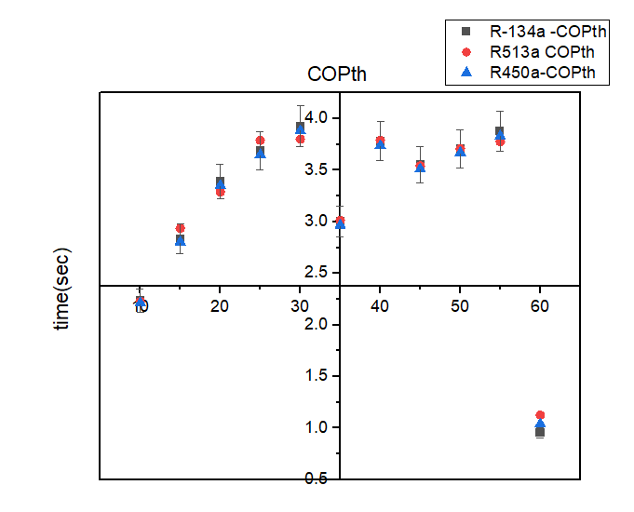

(a)

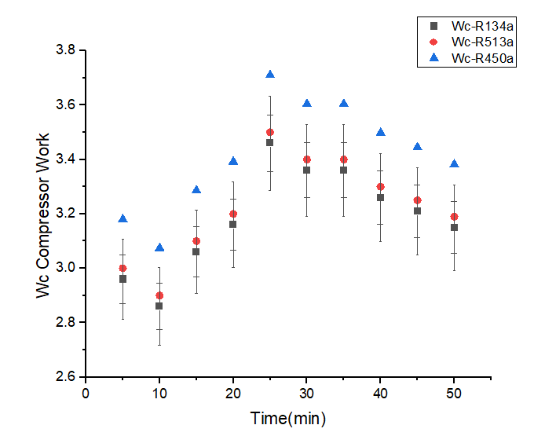

(b)

**Fig. 7.** **(a, b)** Comparative study of variation in COP and WC of all 3-refrigerant-R134a, R513a, R450a

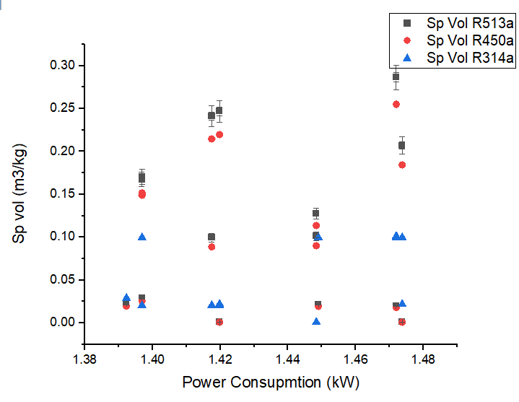

(a)

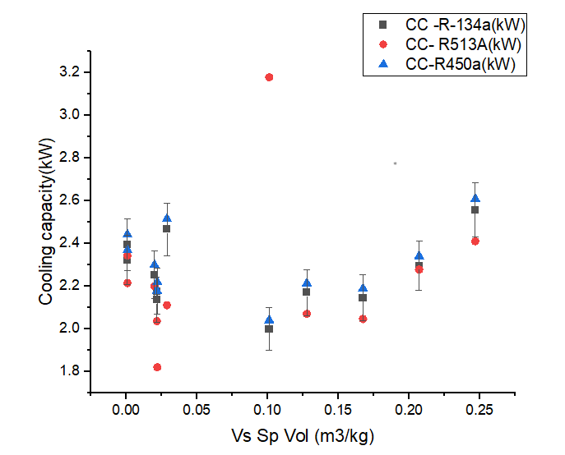

(b)

**Fig. 8. (a, b)** Specific volume and Power Consumption (WC) and Cooling Capacity (CC)

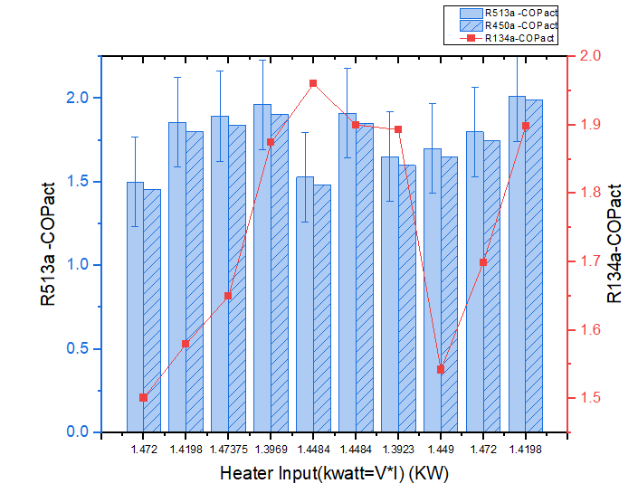

*Actual from DBT-WBT psychometric plot calculation

**Fig. 9.** Input heater vs. COP Actual

3.3. Validation of the experimental results and comparison of results with previous work

Firstly, the results of the experiments were verified by checking the ideal and actual P-h and T-s diagrams obtained from the VCRS with R134a in this study, such as similar studies in the literature (Redhwan et al. 2019) compared with the current work and others studied R450A and R513A as alternatives to R134a in small air conditioners compare results based on pressure ratio of energy cooling systems. The results showed that R513A has a COP 12% lower than R134a under similar conditions. Almost all results showed that R513A has a worse energy efficiency (EER) than R134a at similar cooling capacity. Meanwhile, current research work highlighted the effect of discharge temperature, specific volume flow rate, heating load, etc., on performance parameters like cooling capacity, COP, and Wc with the use of a TXV arrangement to enhance ecological benefits.

4. Conclusions

In the current study, R513A and R450A instead of R134a as alternative refrigerants in a mechanical VCRS medium temperature system were experimentally examined using energetic approaches based on the Kigali Amendment. The assessments were performed approximately at the same chilling medium temperatures. The required refrigerant's specific volume flow rate per unit energy performance considered and studied parameters like (power input, cooling capacity, COP value, and Wc) with the criteria restricting the use of fluorinated greenhouse gases after the Kigali regulations. From the results and discussion, it is clear that the value of COP for R513A is only 13% less and R450 about 8% more than that of pure R134a at various operating conditions despite the mass flow rate (m) for R513a being increased by 14-16%. At the same time, the work of compression value got more for R-450A, whereas, for R450A, it is very much similar to R134a with a 0.6 to 4% reduction percentage. Apart from the thermal performance parameters, Solstice® N13-R-450A and azeotropic blend OpteonTM_XP10-R513A are designed to serve as a replacement for R-134a in various applications in refrigeration applications across different sectors like domestic refrigeration, commercial refrigeration, and industrial refrigeration, chillers. Therefore, from the results, we can conclude that R513A, R450A HFO blends series refrigerant can perform very close to that of R134a with less GWP effect about R450A-56.92% and R513A-56.8% and can be used as a direct drop-in solution for the existing with potential modification or retrofitting AAC system with TXV arrangement to enhance the ecological benefits.

5. Future Scope

For the substitute refrigerant, more research needs to be done for increased cooling capacity and COP of the system, as currently, the COP and WC will be nearer to the same as that of the HFC refrigerant. One should find the easiest way to charge and recover phenomenon for the HFOs blends refrigerant. The use of HFO blends can increase the cost of performance; therefore, there is scope to find a solution to use eco-friendly with economical system design, especially for compressors with small and medium capacity applications.

6. Social and Industrial Relevance

For industrial applications, supermarket refrigeration, and chiller systems where maintaining low-temperature and medium-temperature environments is mandatory, HFO-OpteonTM XP-10 can be used as a drop in arrangement. As environmental awareness among consumers continues to grow, using low-GWP refrigerants can be considered a socially responsible choice by corresponding business holders because it will surely enhance their company's reputation and appeal to environmentally conscious consumers.

|  |  |  |  |
| --- | --- | --- | --- |
| **Nomenctature and Abbrevations** | | | |
| MAC | Mobile Air Conditioning | CC | Cooling Capacity (kW) |
| DAC | Domestic Air Conditioning | X | Dryness Fraction |
| IAC | Industrial Air Conditioning | ṁ a | Mass of air to be cooled (kg/s) |
| COP | Coefficient of Performance | NF | No flammable |
| H-GWP | High Global Warming Potential | HF | High Flammable |
| L-GWP | Low Global Warming Potential | LF | Low Flammable |
| HC | Hydrocarbon | A1 | No Toxicity |
| ṁ | Refrigerant mass ﬂow rate (kg/s) | A2 | Low toxic |
| HAT | High Ambient Temperature | A3 | Low Toxic |
| SC | Sub-cooling | B1 | Toxic |
| SUP | Superheating | B2 | High Toxic |
| HFC | Hydrofluorocarbon | B3 | High Toxic |
| HFO | Hydrofluroolefins | A2L | Low Toxic |
| ODP | Ozone Depletion Potential | B2L | High Toxic |
| POE | Polyolester | NF | No flammable |
| PAO | Polyalphaolefin | HF | High Flammable |
| DBT/Tdb | Dry Bulb Temperature (°C) | **Subscript** | |
| WBT/Twb | Wet Bulb Temperature (°C) | 1234yf | 1234yf |
| T | Temperature (°C) | 134a | 134a |
| P | Pressure (Psi or Bar) | 513A | 513A |
| h | Enthalpy (J/kg or kJ/kg) | 450A | 450A |
| RE | Refrigeration Effect (kJ/kg) | 1,2,3,4 | 1,2,3,4 |
| RH | Relative Humidity (%) |  |  |
| ρ | Air Density |  |  |
| Pv | Vapor Pressure |  |  |
| DPT | Dew Point Temperature |  |  |
| BPT | Boiling Point Temperature |  |  |

**ACKNOWLEDEGMENT:** THE AUTHORS EXTEND THEIR APPRECIATION TO THE DEANSHIP OF RESEARCH AND GRADUATE STUDIES AT KING KHALID UNIVERSITY FOR FUNDING THIS WORK THROUGH RESEARCH PROJECT UNDER GRANT NUMBER (RGP2/183/45).

**FUNDING:** THE AUTHOR(S) DISCLOSED RECEIPT OF THE FOLLOWING FINANCIAL SUPPORT FOR THE RESEARCH, AUTHORSHIP ARTICLE: THIS RESEARCH WAS FUNDED BY THE DEANSHIP OF RESEARCH AND GRADUATE STUDIES AT KING KHALID UNIVERSITY, GRANT NUMBER RGP2/183/45.

Reference

Achaichia, N. (2018). *HFO-1234yf, a refrigerant of choice in mobile air conditioning*. 1st IIR International Conference on the Application of HFO Refrigerants, Birmingham, United Kingdom, September 2-5. http://dx.doi.org/10.18462/iir.hfo.2018.1144

Ahmed, F., & Khan, W. A. (2021). Efficiency enhancement of an air-conditioner utilizing nanofluids: An experimental study. *Energy Reports*, *7*, 575-583. https://doi.org/10.1016/j.egyr.2021.01.023

Alawi, O. A., Sidik, N. A. C., & Kherbeet, A. S. (2015). Nano refrigerant effect in heat transfer performance and energy consumption reduction: A review. *International Communications in Heat and Mass Transfer*, *69*, 76-83.

Aljubury, I., & Mohammed, M. (2019). Heat transfer analysis of conventional round tube and micro channel condensers in automotive air conditioning systems. *Journal of Engineering*, *25*(2), 38-56.

Aljubury, I., Farhan, A., & Mussa, M. (2015). Experimental study of interior temperature distribution inside a parked automobile cabin. *Journal of Engineering*, *21*(3), 1-10.

Al-Sayyab A.K.S., Navarro-Esbri, J., Barragan-Cervera, A., Kim, S., & Mota-Babiloni, A. (2022). Comprehensive experimental evaluation of R1234yf-based low GWP working fluids for refrigeration and heat pumps. *Energy Conversion and Management*, *258*. https://doi.org/10.1016/j.enconman.2022.115378

Aprea, C., Greco, A., & Maiorino, A. (2018). HFOs and their binary mixtures with HFC-134a working as drop-in refrigerant in a household refrigerator: Energy analysis and environmental impact assessment. *Applied Thermal Engineering*, *141*, 226-233.

Belman-Flores, J. M., Heredia-Aricapa, Y., Garcia-Pabon, J. J., Perez-Garcia, V., & Perez-Reguera, C. G. (2023). Drop-in replacement of R134a in a household refrigerator with low-GWP refrigerants R513A, R516A, and R1234ze(E). *Energies (Basel)*, *16*(8). https://doi.org/10.3390/en16083422

Chaudhari, S. S., Pundkar, A. H., Giri, J., Sathish, T., Daryapurkar, A. S., Chadge, R., Parthiban, A. (2024). Optimizing air conditioning efficiency: Utilizing nano-oxides ZnO, CuO, and TiO2 with traditional and alternative refrigerants in medium temperature range cooling systems. *Interactions*, *245*(1), 108.   
https://doi.org/10.1007/s10751-024-01931-z

Daviran, S., Kasaeian, A., Golzari, S., Mahian, O., Nasirivatan, S., & Wongwises, S. (2017). Comparative study on the performance of HFO-1234yf and HFC-134a as an alternative in automotive air conditioning systems. *Applied Thermal Engineering*, *110*, 1091-1100.

Devecioğlu, A. G., & Oruc, V. (2017). An analysis on the comparison of low GWP refrigerants to alternatively use in mobile air conditioning systems. *Thermal Science and Engineering Progress*, *1*, 1-5.

Direk, M., & Mert, M. S. (2018). Exergetic investigation of an R1234yf automobile air conditioning system with an internal heat exchanger. *International Journal of Thermodynamics*, *21*, 103-109.

Enang, S. A., Ega, T. B., & Mutaufiq, M. (2018). Investigation on the improvement of car air conditioning system performance using an ejector. The 3rd Annual Applied Science and Engineering Conference (AASEC 2018), Bandung, Indonesia. *EDP Sciences*, *197*.

Hashimoto, M., Otsuka, T., Fukushima, M., Okamoto, H., Hayamizu, H., Ueno, K., & Akasaka, R. (2019). Development of New Low-GWP Refrigerants–Refrigerant Mixtures Including HFO-1123. *Science and Technology for the Built Environment*, *25*(6), 776-783. https://doi.org/10.1080/23744731.2019.1603779

Kanna, V., & Subramani, K. (2018). Study of future refrigerants for vapor compression refrigeration systems. Innovative Design, Analysis and Development Practices in Aerospace and Automotive Engineering (I-DAD 2018), Lecture Notes.

Li, G. (2021). Performance evaluation of low global warming potential working fluids as R134a alternatives for two-stage centrifugal chiller applications*. Korean Journal of Chemical Engineering,* *38*, 1-10.

Li, Z., Liang, K., & Jiang, H. (2019). Experimental study of R1234yf as a drop-in replacement for R134a in an oil-free refrigeration system. *Applied Thermal Engineering*, *153*, 646-654.

Lopis, R., Sánchez, D., Cabello, R., Catalán-Gil, J., & Nebot-Andrés, L. (2017). Experimental analysis of R-450A and   
R-513A as replacements of R-134a and R-507A in a medium-temperature commercial refrigeration system. *International Journal of Refrigeration*, *84*, 52-66.

Makhnatch, P. (2017). Experimental assessment of R134a and its lower GWP alternative R513A. *International Journal of Refrigeration*, *74*, 682-688.

Makhnatch, P., Mota-Babiloni, A. López-Belchí A., & Khodabandeh, R. (2019). R450A and R513A as lower GWP mixtures for high ambient temperature countries: Experimental comparison with R134a. *Energy*, *166*, 223-235.

Mohamed, B., Alshatewi, M., & Omar, H. (2017). Developments of vapor-compression systems for vehicle air-conditioning: A review. *Advances in Mechanical Engineering*, *9*(8), 1-15.

Mohanraj, M. & Abraham, A. (2022). Environment-friendly refrigerant options for automobile air conditioners: A review. Journal of *Thermal Analysis and Calorimetry*, *147*, 47-72. http://dx.doi.org/10.1007/s10973-020-10286-w

Morales-Fuentes, A., Ramirez-Hernandez, H. G., Mendez-Diaz, S., Martinez, S., Sanchez-Cruz, F. A., Silva-Romero, J. C., & Garcia-Lara, H. D. (2021). Experimental study on the operating characteristics of a display refrigerator phasing out R134a to R1234yf. *International Journal of Refrigeration*, *130*, 317-329.

Nair, V. (2020). HFO refrigerants: A review of its present status and future prospects. *International Journal of Refrigeration. International Journal of Refrigeration*, *70*, 123-135. http://dx.doi.org/10.1016/j.ijrefrig.2020.10.039

Nawaz, K., Shen, B., Elatar, A., Baxter, V., & Abdelaziz, O. (2017). R-1234yf and R-1234ze(E) as Low-GWP Refrigerants for Residential Heat Pump Water Heaters. *International Journal of Refrigeration*, *82*, 348-365. https://doi.org/10.1016/j.ijrefrig.2017.06.031

Pereira, L., Humia, G., Khosravic, A., Revellin, R., Bonjour, J., Machado, L., Garcia Pabon, J. J. (2019). A study on the fluid refrigerant charge in a two-phase mechanically pumped loop system using R134a and R1234yf, *Applied Thermal Engineering*, *158*, Article 113727.

Pundkar, A. H., & Chaudhari, S. S. (2022). Performance parameters enhancement with application of nanotechnology to MTR refrigeration system. *Materials Today Proceedings*, *72*(3), 890-895. http://dx.doi.org/10.1016/j.matpr.2022.09.087

Rajput, S. P. S. (2019). Performance investigation of an ice plant working with R134a. *Journal of the Brazilian Society of Mechanical Sciences and Engineering*, *41*(163), 1-10.

Redhwan, A. A. M., Azmi, W. A., Sharif, M. Z., Mamat, R. Samykano, M. & Najafi, G. (2019). Performance improvement in a mobile air conditioning system using Al₂O₃/PAG nano lubricant. *Journal of Thermal Analysis and Calorimetry*, *135*, 1299-1310.

Sadaghiani, M. S., Siahvashi, A., Norris, B. W. E., Al Ghafri, S. Z. S., Arami-Niya, A., & May, E. F. (2022). Prediction of solid formation conditions in mixed refrigerants with iso-pentane and methane at high pressures and cryogenic temperatures. *Energy*, *250*, 123789. https://doi.org/10.1016/j.energy.2022.123789

Saadoon, Y. G. & Aljubury I. (2019). Experimental analysis of a mobile air conditioning system using R513a as an alternative refrigerant to R134a. *Journal of Mechanics of Continua and Mathematical Sciences*, *14*(6), 450-469. https://doi.org/10.26782/jmcms.2019.12.00031

Schultz, K. & Kujak S. (2013). *System Drop-In Tests of R134a Alternative Refrigerants (ARM-42a, N-13a, N-13b,   
R-1234ze(E), and OpteonTMXP10) in a 230-RT Water-Cooled Water Chiller*. Air-Conditioning, Heating, and Refrigeration Institute (AHRI). Low-GWP Alternative Refrigerants Evaluation Program (Low-GWP AREP) TEST REPORT #7. https://www.ahrinet.org/system/files/2023-06/AHRI%20Low-GWP%20AREP-Rpt-007.pdf

Sieres, J., & Santos, J. M. (2018). Experimental analysis of R1234yf as a drop-in replacement for R134a in a small power refrigeration system, *International Journal of Refrigeration*, *91*, 230-238.

Siricharoenpanich, A., Wiriyasart, S., Prurapark, R., Naphon, P. (2019). Effect of cooling water loop on the thermal performance of an air-conditioning system. *Case Studies in Thermal Engineering*, *15*, 100518.

Tada, A., Okido, T., Sakamoto, K. (2016*). Development of polyolester refrigeration oils for HFO refrigerants*. 16th International Refrigeration and Air Conditioning Conference at Purdue, Paper 1732, 2399(1-7).

United Nations Environment Programme. (2016). Twenty-eighth meeting of the parties to the Montreal Protocol on substances that deplete the ozone layer, Decision XXVIII/Further Amendment Montreal Protocol, 1-9.

Vaghela, J. K. (2017). Comparative Evaluation of an Automobile Air – Conditioning System Using R134a and Its Alternative Refrigerants. *Energy Procedia*, *109*, 153-160. https://doi.org/10.1016/j.egypro.2017.03.083

Velders, G. J. M., Fahey, D. W., Daniel, J. S., Andersen, S. O., & McFarland, M. (2015). Future atmospheric abundances and climate forcing's from scenarios of global and regional hydrofluorocarbons (HFC) emissions. *Atmospheric Environment*, *123*, 200-209.

Wang, Chi-Chuan. (2014). System performance of R-1234yf refrigerant in air-conditioning and heat pump system – An overview of current status. *Applied Thermal Engineering*, *73*(2), 1412-1420.   
https://doi.org/10.1016/j.applthermaleng.2014.08.012

Zhai, R., & Zhao, Y. (2019). Effect of environmental conditions on the flammability limits of two isomers of tetrafluoropropene. *Combustion and Flame*, *207*, 295-301.