|  |  |  |  |
| --- | --- | --- | --- |
|  |  | | |
| **Rocznik Ochrona Środowiska** | | |
| Volume 27 | Year 2025 ISSN 2720-7501 | pp. 240-252 |
|  | https://doi.org/10.54740/ros.2025.020 open access | | |
|  | Received: January 2025 Accepted: April 2025 Published: April 2025 | | |

Spatial Evaluation by GIS Mapping and Trend Analysis of Urban Wastewater Amounts in Central Anatolia Region of Turkiye

Yigitcan Ballı1, M. Cuneyt Bagdatlı2*

1Graduated from MSc Programme of Nevsehir Hacı Bektas Veli University,   
Graduate School of Natural and Applied Sciences, Nevsehir, Turkiye   
https://orcid.org/0000-0002-3329-1698

2Department of City and Regional Planning, Faculty of Architecture,   
Nigde Omer Halisdemir University, Nigde, Turkiye  
https://orcid.org/0000-0003-0276-4437

corresponding author's e-mail: [cuneytbagdatli@gmail.com](mailto:cuneytbagdatli@gmail.com)

**Abstract:** The wastewater amounts of 13 provinces included in the Central Anatolia Region in Turkiye between 2002 and 2018 were spatially analyzed in the Geography Information Systems (GIS) environment within the scope of this study. Wastewater amounts were spatially evaluated and modeled for each year with the help of the IDW interpolation method. Moreover, the change in wastewater amounts over the years was analyzed using Mann-Kendall, Sperman's Rho, and Sen's Trend Slope Tests. The analyses indicated that while the total amount of wastewater in the Central Anatolia Region was 466279 thousand m3/year in 2002, this amount increased by 31% in 2018 and reached 611275 thousand m3/year. On the other hand, while the amount of treated wastewater was 238779 thousand m3/year in 2002, this rate increased by 123% to 534456 thousand m3/year in 2018. The trend analyses indicated that there was a significant increasing trend in the amounts of treated wastewater in Eskişehir, Çankırı, Kırşehir, Konya, Karaman, Kayseri, Yozgat and Sivas provinces yearly. The change in the total amount of wastewater over the years was analyzed, and it was observed that there was a significant tendency to increase over time in the provinces of Eskişehir, Konya, Karaman, Kayseri, and Sivas.

**Keywords:** wastewater, GIS mapping, spatial evaluation, trend analysis, Turkiye

1. Introduction

Improved living standards accompany the rapidly increasing population around the world. Accordingly, the amount of water consumption also increases. While the amount of water used per capita increases with the increasing population, some of the water used turns into domestic wastewater, and some turns into industrial wastewater. When domestic and industrial wastewater is discharged without treatment, it causes environmental pollution. Damages caused by environmental effects have a negative impact on aquatic creatures, soil, air quality, and human health.

Wastewater production has increased both in the world and in Turkiye for reasons such as population growth, development of technology, and increase in living standards. Uncontrolled discharge of this wastewater into nature causes environmental problems. The presence of health-threatening factors (bacteria, viruses, parasites, and worm eggs) in domestic wastewater is an issue that should be taken seriously. Even in well-treated wastewater, some disease-causing pathogens may remain, and after the wastewater is treated, it must be subjected to a disinfection process to remove disease-causing pathogens (Samsunlu 2008). Studies have shown that water use worldwide has doubled in the last 40 years (Zeyrek 1996).

Water, the main source of life, is constantly polluted as it is used in different areas of daily life, and as a consequence, it becomes wastewater. It is important in which area the water is used in wastewater treatment, and it aims to regain the partially lost biological, physical and chemical properties when it turns into wastewater. In addition, the treatment processes applied to prevent wastewater from harming the environment in which it is released can be defined as wastewater treatment (Sekaran et al. 2007).

Water pollution can disrupt natural balances, affect aquatic ecosystems, and gradually reduce or destroy the assimilation capacity of all waters in nature. Water pollution can disrupt natural balances, affect aquatic ecosystems, and gradually reduce or destroy the assimilation capacity of all waters in nature (Anonymous, 2007). After lakes, rivers, and other water resources are polluted, improving the conditions and purifying them is possible at very costly expense. Hence, minimizing the amount of wastewater and waste concentration is necessary. For this reason, wastewater treatment should be carried out using technology that will prevent pollution from its source. Wastewater treatment must be carried out using technically and economically suitable methods (Anonymous 2004, Ergüven et al. 2021).

Domestic wastewater is mostly wastewater originating from residential areas, domestic activities (laundry, bathroom, toilet, kitchen, house cleaning, etc.), and service departments such as hotels, schools, workplaces, and hospitals where the daily life activities of the society are located (Açıktepe 2016, Kucuk et al. 2021). Domestic wastewater is polluting and should not be released into the water network without treatment. The wastewater treatment process can be done according to the characterization of the wastewater and the characteristics of the receiving environment (Sekaran et al. 2007).

Another area of water use is the removal of industrial waste and human waste. These wastes must be removed from areas where people live and rendered harmless. While local government institutions in urban areas meet this requirement with sewage systems, wet and dry pits can be used in rural areas. However, this waste is mixed directly with the sea, rivers, or even lakes in some regions. In such regions with limited infrastructure, groundwater and surface water are easily polluted. In this case, water, which is indispensable for life, may become a medium or carrier that poses a danger to health (Güler & Çobanoğlu 1994, Bayhan et al. 2017).

Within the scope of this study, the amount of wastewater discharged from the network in the Central Anatolia Region of Turkiye between 2002 and 2018 was spatially analyzed, and an evaluation was made. The obtained data were transferred to the GIS environment, and distribution maps and models regarding the wastewater amounts of the provinces in the Central Anatolia Region were created. In addition, the temporal change in the wastewater amounts of 13 provinces in the Central Anatolia Region between 2002 and 2018 was also revealed by trend analysis.

2. Materials and Methods

2.1. Study Area

The current research material consists of data on the amount of wastewater discharged from the network in the provinces of the Central Anatolia Region of Turkiye between 2002 and 2018. The region's location subject to the research is shown on the map in Figure 1.

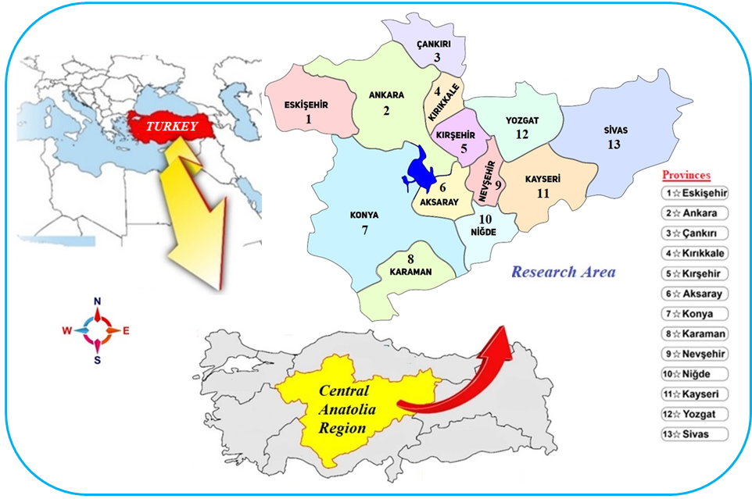

**Fig. 1.** Study area

The Central Anatolia Region, the study area, is one of the 7 geographical regions of Turkiye. Central Anatolia Region consists of 13 provinces. One of these provinces, Ankara, is the capital of Turkiye and the second largest city in Turkiye. The population of Ankara province is 5 million 782 thousand 285 people. The total population of the Central Anatolia Region, which is the subject of the research, is 13 million 566 thousand 792 people (TUIK 2023).

2.2. Spatial Analysis and GIS-Based Mapping

Within the scope of the study, the Arc GIS 10.3.1 program, one of the Geography Information Systems (GIS) software, was used to evaluate the wastewater amounts (ESRI 2010) spatially.

Wastewater amounts in the examined provinces were spatially analyzed and modeled using the IDW interpolation method in the GIS environment. The IDW method performs analysis because nearby points have more weight than distant points on the surface to be analyzed (Şen 2007). Predicted values are a function of near and far points, and as the distance increases, the importance and impact on the cell to be predicted decreases. The provinces' wastewater amount data were modeled using the IDW interpolation method and the following equation (Burrough & Mcdonnell 1998).

$Z_{0}=\frac{\sum_{i=1}^{N}{{Zi.di}^{-n}}}{\sum_{i=1}^{N}{{di}^{-n}}}$ (1)

where:

Z0 – The estimation value of variable z in point I,

zi – The sample value in point I,

di – The distance of the sample point to the estimated point,

N – The coefficient that determines weight based on a distance,

n – The total number of predictions for each validation case.

IDW interpolation method is faster, easier to calculate, and simpler to interpret than other interpolation methods. This method gives very good results for dense models. In this study, the IDW interpolation method is preferred over other interpolation methods (Lu & Wang 2008, Garnero & Godone 2013).

2.3. Trend Analysis

The study determined changes in the amount of treated, untreated, and total wastewater over the years through trend analysis. Mann-Kendall and Sperman's Rho Test and Sen's Trend Slope method were applied to water quality data at a 95% confidence level (Kendall 1975, Mann 1945, Sen 1968). The current study used the Mann-Kendall test called "Trend Analysis for Windows", Spearman's Rho test, Mann-Kendall Rank Correlation test and a software developed by Sen to calculate the Trend Slope method (Gümüş 2006).

Although the Mann-Kendall Test is a widely used method, it is a non-parametric test (Karakuş 2017). In the Mann-Kendal statistical test, the data does not require any special distribution. Data show less sensitivity to sudden breaks (Yu et al. 1993). Mann-Kendall test statistical was calculated using the equations given below (Karakuş 2017).

$S=\sum_{İ=1}^{n-1}{\sum_{J=i+1}^{n}{sgn(x_{j}-x_{i})}}$ (2)

where n is the number of data points, 𝑥j, and 𝑥i; Data values in time series j and i (j > i) are 𝑠𝑔𝑛 (𝑥𝑗 − 𝑥𝑖); it is a sign function and is expressed as follows (Karakuş 2017).

+1, xj-xi > 0

0, xj-xi = 0

-1, xj-xi < 0

sgn (xj-xi) = (3)

Variance:

$Var \left(S\right)= \frac{n\left(n-1\right)\left(2n+5\right)-\sum_{İ=1}^{m}{t_{i}\left(t_{i}-1\right)\left(2t_{i}+5\right)}}{18}$ (4)

where:

n – number of data points,   
m – number of connected groups,   
𝑡𝑖 – number of bonds within I (Karakuş 2017).

Whether the Mann-Kendall test, whose variance is determined, is significant or not is determined by calculating the standard normal variable *Z* with the following equation and comparing it with the critical *Z* value (Büyükyıldız & Berktay 2004):

$Z_{s}=\left\{\begin{aligned}\frac{S-1}{\sqrt{Var \left(S\right)}}, S>0 \\ 0, S =0 \\ \frac{S+1}{\sqrt{Var \left(S\right)}}, S<0\end{aligned}\right.$ (5)

As a result of the tests, if the trend has a positive correlation level, it can be considered. Still, if it has a negative correlation, the trend's importance may not be considered (Kumar et al. 2009). Sperarman's Rho Test is compared with the Mann-Kendall test (Karakuş 2017). While the H0 hypothesis means no trend, the H1 hypothesis determines the increasing or decreasing direction of the trend (Yue et al. 2002). This test statistic is given in the equation below (Karakuş 2017).

$R_{sp}=1-\frac{6\sum_{i=1}^{n}{{(Di-i)}^{2}}}{n(n^{2}-1)}$ (6)

$Z_{Sp}=R_{sp}\sqrt{\frac{n-2}{1-{Rsp}^{2}}}$ (7)

where:

Di – sequence number of i observations,   
n – total length of time series data,   
i – observation order of data,   
Zsp – (𝑛-2) degrees of freedom.

Positive values of 𝑍𝑠𝑝 indicate an increasing trend in the hydrological time series, while negative values indicate a decreasing trend (Karakuş 2017, Büyükyıldız & Berktay 2004).

Spearman's rank correlation coefficient measures how strong the coefficient is between variables in data analysis. The Mann-Kendall test is widely used in such studies to determine and evaluate the significance of a trend in a data set (Esterby 1993, Samsudin et al. 2017).

3. Results and Discussion

3.1. Spatial Evaluation and Modeling of Wastewater Amounts

Treated, untreated, and total wastewater amount data of 13 provinces in the Central Anatolia Region of Turkiye were analyzed spatially using the IDW interpolation method with the help of Arc GIS 10.3.1 software in the GIS environment. The spatial analysis results of the total wastewater amount in the Central Anatolia Region in 2002 are presented in Figure 2.

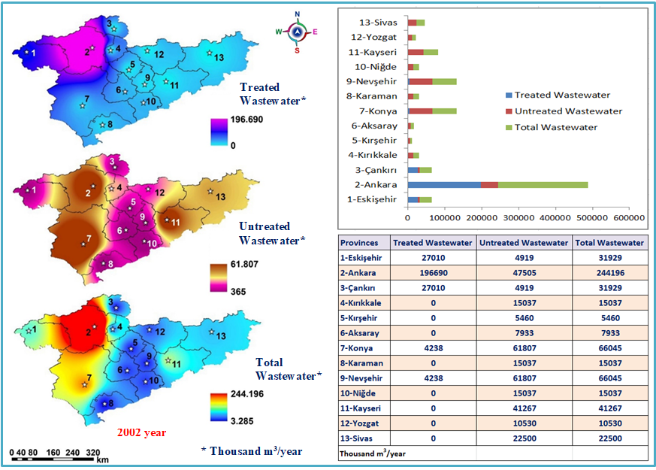

**Fig. 2.** Spatial Modeling of wastewater amount for the 2002 year

Due to the high population in Ankara, the amount of wastewater is high, and Ankara is the province with the highest amount of treated wastewater. The amount of treated wastewater throughout the Central Anatolia Region varied between 0-196,690 thousand m3/year. It has been determined that the amount of treated wastewater is higher in Ankara and its neighboring provinces than in other provinces. The amount of treated wastewater showed a low distribution in the provinces around Ankara, depending on the population, compared to Ankara. In 2002, 196,690 thousand m3/year of wastewater was treated in Ankara, the capital of Turkiye. The amount of untreated wastewater was examined and it was seen that it varied between 365-61,807 thousand m3/year. It was determined that Ankara, Kayseri, Konya, and Sivas provinces had a high distribution regarding untreated wastewater potential. Wastewater treatment was not carried out in Kırıkkale, Kırşehir, Aksaray, Karaman, Niğde, Kayseri, Yozgat and Sivas provinces in 2002. The total amount of wastewater varies between 3,285 and 244,196 thousand m3/year. The total amount of wastewater was more densely distributed in the provinces in the north and northwest of the Central Anatolia Region. The total wastewater amount of the provinces in the Central Anatolia Region is 466,279 thousand m3/year. The rate of wastewater treated in 2002 was only 52.6%. The spatial distribution of wastewater amounts in the Central Anatolia Region in 2004 is given in Figure 3.

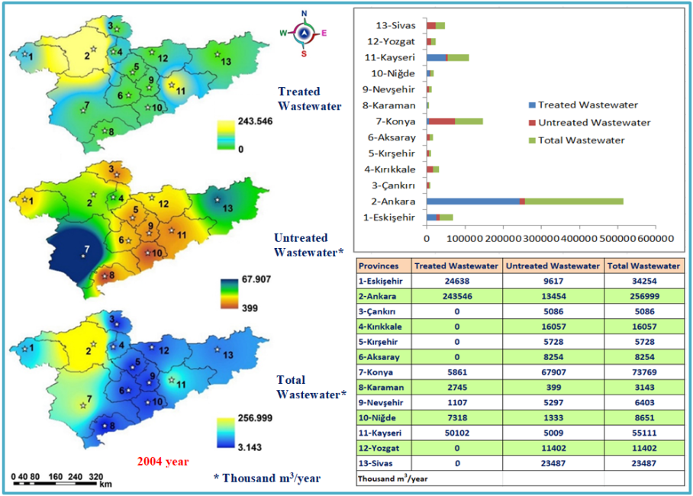

**Fig. 3.** Spatial Modeling of wastewater amount for the 2004 year

The amount of treated wastewater in the Central Anatolia Region varied between 0 and 243,546 thousand m3/year. The amount of treated wastewater was higher in Ankara, Kayseri, and Eskişehir provinces. It was concluded that the amount of treated wastewater in the provinces of Sivas, Çankırı, Yozgat, Kırıkkale, Karaman, Nevşehir, Niğde, Kırşehir, Aksaray and Konya was less dense. The provinces where wastewater was not treated in 2004 were Aksaray, Kırıkkale, Kırşehir, Sivas, Çankırı and Yozgat.

It has been observed that the amount of untreated wastewater varies between 399-67,907 thousand m3/year. The amount of untreated wastewater was higher in Konya and Ankara provinces. Total wastewater amounts in the Central Anatolia Region in 2004 varied between 3,143 and 256,999 thousand m3/year. In the provinces in the northern and southern regions of the Central Anatolia Region, the density of the total amount of wastewater showed a decreasing distribution depending on the population. The highest amount of untreated wastewater in 2004 was in Konya with 67,907 thousand m3/year.

The provinces with the highest total amount of wastewater were Ankara, Konya, Kayseri, and Eskişehir, respectively. The highest amount of treated wastewater in 2004 was in Ankara, the capital of Turkiye, with 243,546 thousand m3/year. Kayseri was the second province with the highest amount of treated wastewater, with 50,102 thousand m3 / year. In 2004, 65.9% of the total wastewater amount of the provinces in the region could be treated. The spatial distribution modeling of wastewater amounts in the Central Anatolia Region in 2006 is shown in Figure 4.

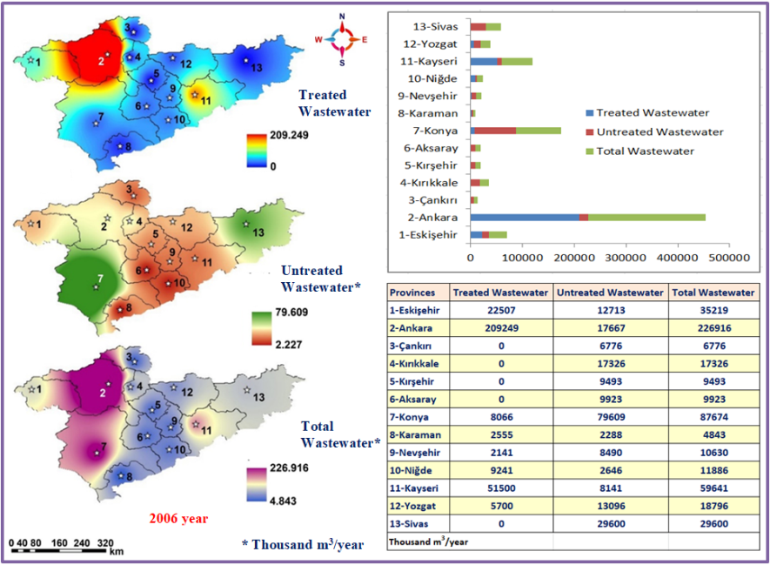

**Fig. 4.** Spatial Modeling of wastewater amount for the 2006 year

The amount of treated wastewater in the Central Anatolia Region in 2006 varied between 0-209,249 thousand m3/year. The amount was less in the provinces located in the south, north, and northwest of the region. It was observed that the density of treated wastewater was higher in Ankara, Eskişehir, and Kayseri provinces.

The amount of untreated wastewater varied between 2,227 and 79,609 thousand m3/year. In 2006, it was observed that the amount of untreated wastewater in the region was at high levels in Sivas, Ankara, and Eskişehir provinces.

Total wastewater amounts varied between 4,843 and 226,916 thousand m3/year. The provinces with the highest total wastewater amounts are Ankara, Eskişehir, Kayseri, and Konya. This amount was found to be lower in the provinces located in the north and south of the Central Anatolia Region compared to Ankara, Eskişehir, Kayseri, and Konya.

The total amount of wastewater was observed at the highest level in 2006, with 226,916 thousand m3/year, in Ankara, which has a high population. It is seen that the lowest total wastewater amount is in Çankırı province, with 6,776 thousand m3/year. The total wastewater amount of the provinces in the Central Anatolia Region is 528,722 thousand m3/year, and only 61.6% of this wastewater amount could be treated in 2006. The spatial distribution modeling of wastewater amounts in the Central Anatolia Region in 2008 is given in Figure 5.

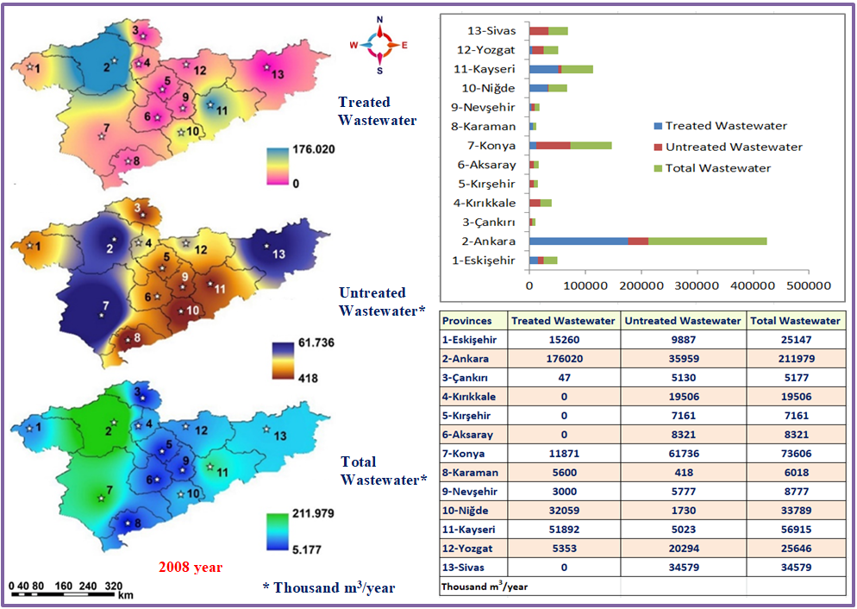

**Fig. 5.** Spatial Modeling of wastewater amount for the 2008 year

In the Central Anatolia Region, subjecting to the research, the amount of treated wastewater in 2008 varied between 0 and 176,020 thousand m3/year. It was determined that the amount of treated wastewater was highest in Ankara, Kayseri, and Yozgat provinces. In terms of the amount of treated wastewater, it was observed that wastewater was not treated in Aksaray, Kırıkkale, Kırşehir, and Sivas provinces in 2008. It is seen that the highest amount of treated wastewater in the region is in Ankara, with 176,020 thousand m3/year. It was observed that the amount of untreated wastewater in the research area varied between 418 and 61,736 thousand m3/year. In 2008, it was found that the amount of untreated wastewater was high, especially in Ankara, Konya, and Sivas provinces. It was determined that the provinces where the amount of untreated wastewater was distributed were Aksaray, Konya, Kırıkkale, Kırşehir, Nevşehir, Sivas and Yozgat. Total wastewater varies between 5,177 and 211,979 thousand m3/year in terms of quantity. It was determined that the spatial density of the total amount of wastewater was high in the northwest, west, and east provinces of the Central Anatolia Region. It is observed that the density is low in the provinces located in the north and south of the Central Anatolia region. The provinces with the lowest total wastewater amounts in 2008 are Çankırı with 5177 thousand m3/year, Karaman with 6.018 thousand m3/year, and Kırşehir with 7.161 thousand m3/year. The provinces with the highest total wastewater amounts are Ankara with 211979 thousand m3/year, Konya with 73606 thousand m3/year, and Kayseri with 56915 thousand m3/year. Spatial distribution modeling of the amount of wastewater in 2010 is given in Figure 6.

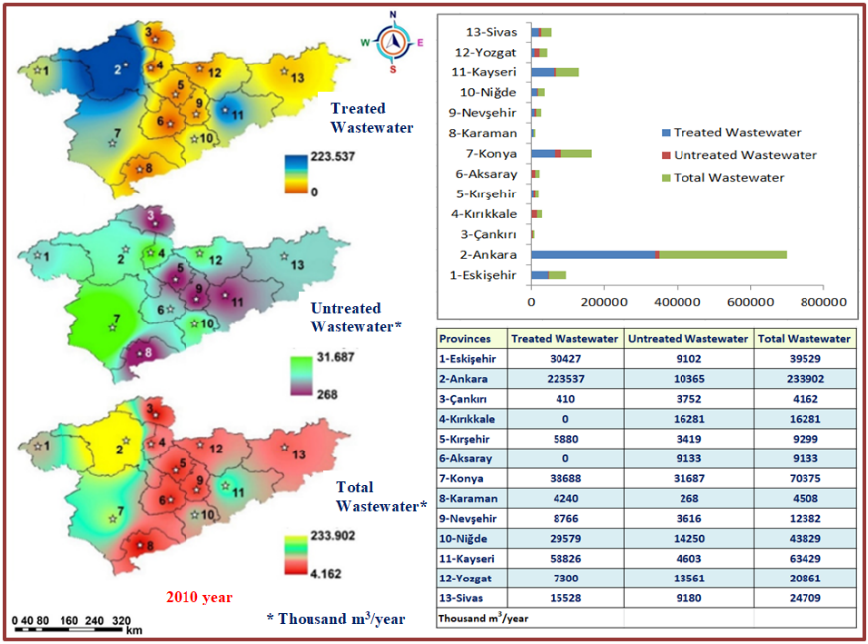

**Fig. 6.** Spatial Modeling of wastewater amount for the 2010 year

The spatial analysis results of the 2010 data of the Central Anatolia Region were examined, and it was seen that the amount of treated wastewater varied between 0 and 223,537 thousand m3/year. The spatial distribution of treated wastewater amounts in the Ankara, Eskişehir, Konya, and Kayseri provinces showed higher density than others.

The amount of untreated wastewater in the region varied between 268-31687 thousand m3/year. It has been observed that the amount of untreated wastewater is above the average in the provinces of Eskişehir, Ankara, Konya, Kırıkkale, Aksaray, Yozgat, Niğde and Sivas. The province with the lowest amount of untreated wastewater is Karaman with 268 thousand m3/year. The province with the highest amount of untreated wastewater is Kırıkkale, with 16,281 thousand m3/year.

The total amount of wastewater is distributed below the average in the provinces located in the north, south, and southwest of the region. Total wastewater amounts in the Central Anatolia Region in 2010 varied between 4,162 and 233,902 thousand m3/year. The highest amount of total wastewater is in Ankara province, with 233,902 thousand m3/year. The lowest total wastewater amount was Çankırı province, with 4,162 thousand m3/year. In 2012, the spatial distribution of wastewater amounts in the Central Anatolia Region was analyzed, modeled, and presented in Figure 7.

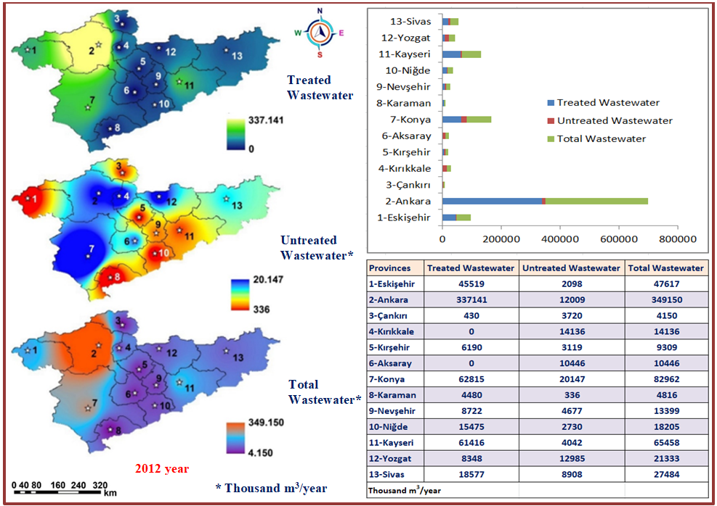

**Fig. 7.** Spatial Modeling of wastewater amount for the 2012 year

The 2012 data in the Central Anatolia Region was subjected to spatial analysis, and it was observed that the amount of treated wastewater varied between 0 and 337,141 thousand m3/year. The amount of treated wastewater showed a dense spatial distribution in Ankara, Eskişehir, Konya, and Kayseri provinces. The provinces in the region were examined, and it was seen that the water was not purified in the Aksaray and Kırıkkale provinces in 2012. In 2012, it was observed that Ankara, the capital of Turkiye, was the province with the highest wastewater treatment, with 337,141 thousand m3/year. The amount of untreated wastewater in the region varied between 336 and 20,147 thousand m3/year. It has been observed that Ankara, Konya, Kırıkkale, Yozgat, Aksaray, and Yozgat provinces have a figure above the average in terms of the amount of untreated wastewater. It was concluded that the untreated wastewater density was at lower levels in Eskişehir, Çankırı, Kırşehir, Nevşehir, Niğde, Karaman, and Kayseri provinces.

It was determined that the total amount of wastewater in the research area varied between 4,150 and 349,150 thousand m3/year. It was determined that the total amount of wastewater in the northern, northwestern, and western provinces of the Central Anatolia Region was higher than that in the eastern, southeastern, and southern provinces. The total amount of wastewater was measured at the lowest levels in Çankırı province, with 4,150 thousand m3/year, and in Karaman province, with 4,816 thousand m3/year. The total wastewater amount of the provinces in the region is calculated as 668,465 thousand m3/year. In 2012, only 85.1% of this total amount of wastewater could be treated. Spatial distribution models of treated, untreated, and total wastewater amounts in the Central Anatolia Region in 2014 are given in Figure 8.

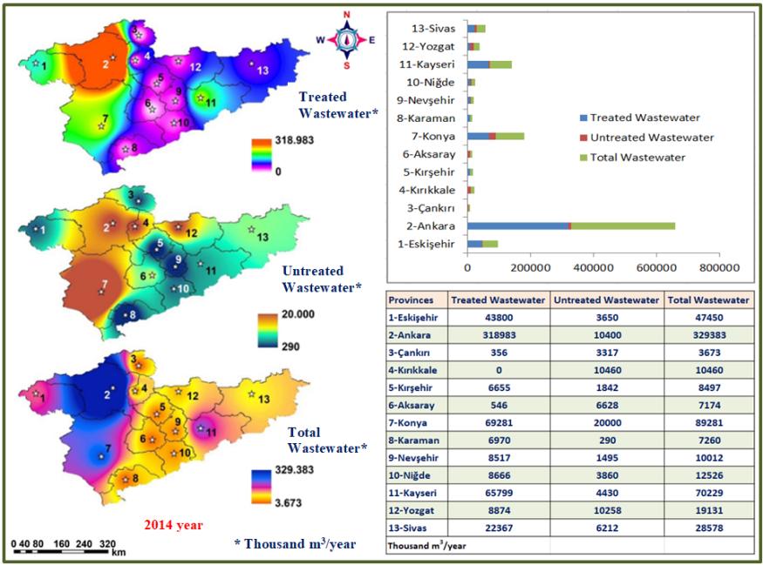

**Fig. 8.** Spatial Modeling of wastewater amount for the 2014 year

The amount of treated wastewater in the Central Anatolia Region in 2014 varied between 0-318,983 thousand m3/year. In the central parts of the region, this amount was below average. Kayseri, Eskişehir, Ankara, and Konya provinces were among the provinces with the highest amounts of treated wastewater.   
As a result of examining the amount of wastewater treated in 2014, it was observed that wastewater was not treated only in Kırıkkale province. It has been observed that the amount of untreated wastewater in the research area varies between 290-20,000 thousand m3/year. It has been observed that the amount of untreated wastewater is concentrated in Ankara, Konya, Kırıkkale, and Yozgat provinces. The provinces with the highest amount of untreated wastewater were Konya with 20,000 thousand m3/year, Kırıkkale with 10,460 thousand m3/year, and Ankara with 10,400 thousand m3/year. Total wastewater amounts in the Central Anatolia region varied between 3,673 and 329,383 thousand m3/year. Total wastewater amounts show a dense spatial distribution in the region's northwestern, western and southwestern provinces. The total wastewater amount of the provinces in the Central Anatolia Region is calculated as 643,654 thousand m3/year. In 2014, only 87.1% of this amount could be purified. Spatial distribution models of wastewater amount in the Central Anatolia Region in 2016 are given in Figure 9.

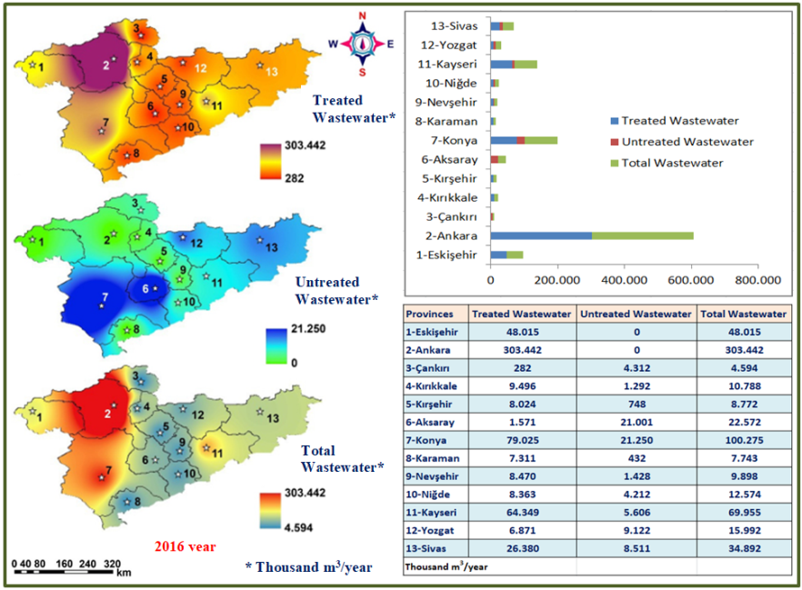

**Fig. 9.** Spatial Modeling of wastewater amount for the 2016 year

The spatial analysis results of the 2016 data of the Central Anatolia Region, subjecting of the research, were examined. It was observed that the amount of treated wastewater varied between 282 and 303,442 thousand m3/year. It has been observed that Ankara and Konya provinces have a denser spatial distribution compared to other provinces in terms of treated wastewater amounts. In 2016, efforts were made to treat wastewater amounts in all provinces in the Central Anatolia Region. There were no provinces that did not treat any wastewater in 2016.

The amount of untreated wastewater varied between 0-21,250 thousand m3/year. It has been observed that the amount of untreated wastewater, especially in the Aksaray and Konya provinces, is at higher levels than others.

Total wastewater in the research area varied between 4,574 and 303,442 thousand m3/year, depending on the population density of the provinces. It was observed that the total wastewater amounts were at higher levels, especially in the provinces of Ankara, Konya, and Kayseri. Depending on the population ratio, the provinces with the highest amount of treated wastewater are Ankara, with 303,442 thousand m3/year, Konya, with 100,275 thousand m3/year; and Kayseri, with 69,955 thousand m3/year. In 2016, the total wastewater amount of the provinces in the Central Anatolia Region was 649,512 thousand m3/year; only 88.0% of this amount could be treated. Spatial distribution models of treated, untreated, and total wastewater amounts in the Central Anatolia Region for 2018 are given in Figure 10.

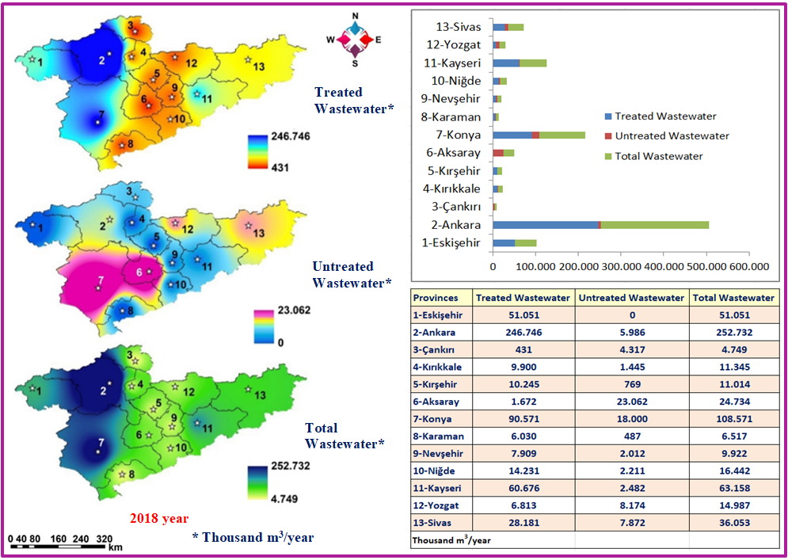

**Fig. 10.** Spatial Modeling of wastewater amount for the 2018 year

The amount of wastewater treated within the Central Anatolia Region in 2018 varied between 431 and 246,746 thousand m3/year. The provinces with the highest amount of treated wastewater were Ankara, Konya, and Kayseri. The proportional distribution of the treated wastewater amounts in the region's provinces was examined. It has been observed that 100% of the wastewater was treated in Eskişehir, 6.8% was treated in Aksaray, 97.6% was treated in Ankara, 87.2% was treated in Kırıkkale, 92.5% was treated in Karaman, 96.1% was treated in Kayseri, 96.1% was treated in Konya, 83.4% was treated in Kırşehir, 93.0% was treated in Kırşehir, 79.7% was treated in Nevşehir, 86.6% was treated in Niğde, 78.2% was treated in Sivas, 9.1% was treated in Çankırı and was treated 45.5% in Yozgat. The amount of untreated wastewater varied between   
0-23,062 thousand m3/year. It has been observed that the amount of untreated wastewater has a dense spatial distribution in Konya and Aksaray provinces.

Total wastewater amounts in the research area varied between 4,749 and 252,732 thousand m3/year. It has been observed that total wastewater amounts have a dense distribution in the northwestern, western, and southwestern provinces of the Central Anatolia Region and in the province of Kayseri. It has been determined that this density is at lower levels in the region's northern, southern, and eastern provinces than in Ankara, Konya, and Kayseri provinces. The total wastewater amount of the provinces in the Central Anatolia Region is 611,275 thousand m3/year; only 87.4% of this amount has been treated.

3.2. Trend Analysis of Wastewater Amounts in 2002-2018 periods

The treated and untreated wastewater amounts of 13 provinces in the Central Anatolia Region between 2002 and 2018 were subjected to trend analysis. Mann-Kendall, Spearman's Rho and Sen's trend slope method tests were applied to the data in this context. The results obtained were presented statistically in terms of yearly trends. The trend analysis results regarding the wastewater amounts of the provinces of the Central Anatolia Region are summarized and presented in Table 1.

**Table 1.** Trend Analysis of Average Wastewater Amounts (2002-2018)

|  |  |  |  |  |  |  |  |  |  |  |
| --- | --- | --- | --- | --- | --- | --- | --- | --- | --- | --- |
| **Provinces** | | **Treated**  **Waste**  **water**  **Amount**  **\*** | **Unreated**  **Waste**  **water**  **Amount**  **\*** | **Total Waste**  **water**  **Amount**  **\*** | **Treated Wastewater** | | **Unreated Wastewater** | | **Total Wastewater** | |
| **Test Statisticals** | | | | | |
| **MK** | **SR** | **MK** | **SR** | **MK** | **SR** |
| **1** | **Eskişehir** | **308227** | **51986** | **360211** | **+** | **+** | **-** | **-** | **+** | **+** |
| **2** | **Ankara** | **2255354** | **153345** | **2408699** | **n** | **n** | **-** | **-** | **-** | **-** |
| **3** | **Çankırı** | **1956** | **41263** | **43220** | **+** | **+** | **n** | **n** | **-** | **-** |
| **4** | **Kırıkkale** | **19396** | **111540** | **130936** | **+** | **n** | **n** | **-** | **-** | **-** |
| **5** | **Kırşehir** | **36994** | **37739** | **74733** | **+** | **+** | **-** | **-** | **-** | **-** |
| **6** | **Aksaray** | **3789** | **104701** | **108490** | **n** | **n** | **+** | **+** | **+** | **-** |
| **7** | **Konya** | **370416** | **382143** | **752558** | **+** | **+** | **-** | **-** | **+** | **+** |
| **8** | **Karaman** | **42851** | **5283** | **48133** | **+** | **+** | **n** | **n** | **+** | **+** |
| **9** | **Nevşehir** | **49618** | **37096** | **86712** | **n** | **n** | **n** | **-** | **-** | **-** |
| **10** | **Niğde** | **131867** | **33992** | **165857** | **n** | **n** | **n** | **n** | **-** | **-** |
| **11** | **Kayseri** | **464560** | **80603** | **545163** | **+** | **+** | **-** | **n** | **+** | **+** |
| **12** | **Yozgat** | **49259** | **109422** | **158678** | **+** | **+** | **n** | **n** | **-** | **-** |
| **13** | **Sivas** | **111033** | **150849** | **261882** | **+** | **+** | **-** | **-** | **+** | **+** |
|  | **Max.** | **2255354** | **382143** | **2408699** | **n : No Trend**  **-**  **: Downward Tren**  **+ : Increasing Trend**  **\* : Thousand m3/year** | | | | | |
| **Min.** | **1956** | **5283** | **43220** |
| **Avrg.** | **295793,8** | **99997,1** | **395790,2** |
| **SD** | **607963,3** | **96856,1** | **640712,7** |
| MK: Mann – Kendall Test Statistical SR: Spermans's Rho Test Statistical | | | | | | | | | | |

The average amount of treated and untreated wastewater in the provinces of the Central Anatolia Region between 2002 and 20018 was subjected to trend analysis. The temporal change in wastewater amounts over 17 years was revealed by trend analysis. Trend analysis results have indicated that the amount of treated wastewater had an increasing trend in Eskişehir, Çankırı, Kırşehir, Konya, Karaman, Kayseri, Yozgat and Sivas provinces according to both test statistics. This indicates that there has been a positive trend towards the treatment of wastewater in the provinces over the years.

In terms of the amount of untreated wastewater, it has been observed that there is an increasing trend only in Aksaray province. An increasing trend in the amount of untreated wastewater is not acceptable. It seems extremely important to take precautions to purify untreated wastewater, especially in Aksaray province. When the temporal change of the total wastewater amount in the provinces of the Central Anatolia Region was examined, it was concluded that there was an increasing trend in both test statistics in the provinces of Eskişehir, Konya, Karaman, Kayseri, and Sivas.

There are many studies in the literature where wastewater amounts are evaluated by spatially analyzing them. In addition, it is possible to come across many studies that evaluate wastewater data with trend analysis. Mann Kendall and Sperman's Rho tests and Sen's Trend Slope method are among the most commonly used methods in studies to determine the change of wastewater amounts over the years. In these studies, wastewater amounts were analyzed spatially in the GIS environment, and distribution maps and models of wastewater amounts were created. In addition, the change in the amounts of treated and untreated wastewater between 2002 and 2018 on a provincial basis in 13 provinces in the Central Anatolia Region was tried to be revealed through trend analysis. Similar studies on these issues in the literature are summarized and presented in Table 2.

**Table 2.** Current studies on the evaluation of wastewater quantities regarding GIS modeling and Trend analysis

|  |  |  |  |
| --- | --- | --- | --- |
| Recent Studies | Research Area | Aim | Analysis |
| (Sakti et al. 2023) | Bandung province in Indonesia | Spatial network analysis | GIS analysis |
| (Zolfaghary et al. 2021) | Golestan province, Iran | Use of GIS  in wastewater evaluation | GIS evaluation |
| (Hama et al. 2019) | Sulaimania, Iraq | Spatial evaluation | Spatial analysis by GIS |
| (Shamsı 2013) | General Applications | GIS Applications  for Water and Wastewater | Spatial Evaluation |
| (Muttaqin 2020) | Cimahi City in Indonesia | Examination of wastewater | Trend Analysis |
| (Eccles et al. 2020) | The Logan-Albert estuary in southeast Queensland, Australia | The Quality  of wastewater discharges | Trend Analysis  with Mann-Kendall Test |
| (Wilopo et al. 2021) | Yogyakarta-Sleman Groundwater Basin, Indonesia | Impacts of urban wastewater ant etc. on groundwater level fluctuation | Trend Analysis |
| (Fathi & El-Rawy 2018) | Greater Cairo, Egypt | Evaluation of groundwater resources near wastewater treatment plants | GIS-based analysis |
| (Mancuso et al. 2022) | Northern Italy | Potential for treated wastewater reuse | Assessment  with GIS mapping |
| (Tomperi et al. 2018) | The largest wastewater treatment plant in Finland | wastewater treatment process | Evaluation  by trend analysis |

4. Conclusion

With rapid population growth and the development of technology and industry worldwide, water consumption is also increasing linearly. With the increase in water consumption and environmental pollution, spring waters and groundwater, as well as streams, lakes, and coastal and sea waters where wastewater is discharged or indirectly mixed, are decreasing.

The amount of water used per person increases with the increasing population. Some water used turns into domestic wastewater, and some into industrial wastewater. Discharging domestic and industrial wastewater without treatment causes environmental pollution. Damages caused by environmental effects have a negative impact on aquatic creatures, soil, air quality, and human health.

In the current study, the wastewater amounts of 13 cities in the Central Anatolia Region, one of the 7 regions of Turkiye, were evaluated and modeled spatially yearly in the Geography Information Systems (GIS) environment. In addition, the change in the total wastewater amounts of the provinces in the research region between 2002 and 2018 was determined by trend analysis. Analyzing the amount of wastewater in cities and evaluating the change amounts are extremely important processes. While conducting such research, making spatial evaluations with geographic information systems is extremely important for planning. In addition, determining the changes in wastewater amounts over the years will inevitably contribute to effective wastewater management.

In conclusion, through the current study, research has been conducted to evaluate the wastewater amounts for the provinces of the Central Anatolia Region yearly. The study's results will contribute to planning wastewater treatment capacities in the provinces for future projections with the increasing population. In addition, the results will guide the decision-making processes of local governments regarding increasing wastewater treatment capacities. It is thought that this study will lead to similar research and make significant contributions.

*This study is quoted from a part of the MSc thesis of Yigitcan Ballı titled "Spatial Analysis of the Amounts of Wastewater Discharged from the Network in the Central Anatolia Region by Years and with the Help of Geographical Information Systems (GIS)", Nevsehir Hacı Bektas Veli Univesity, Graduate School   
of Natural and Applied Sciences.*

References

Açıktepe, D. (2016). *Atıksuların Geri Kazanımı*. Ondokuz Mayıs Üniversitesi, Fen Bilimleri Enstitüsü, Yüksek Lisans Tezi, Samsun, Türkiye. (in Turkish)

Anonymous (2007). *Türkiye’nin Çevre Sorunları*. Türkiye Çevre Vakfı Yayını, Yayın No: 131, Ankara, Türkiye. (in Turkish)

Anonymous (2004). *Su Kirliliği Kontrolü Yönetmeliği*. Sayı:25687, Resmî Gazete 31 Aralık sayısı, Türkiye. (in Turkish)

Bayhan, H., Erguven, G. O., Akkoyunlu, A., & Kanat G. (2017). The Assessment of Water Qualıty in Omerlı Dam Reservoir, Istanbul, Turkiye. *Fresenius Environmental Bulletin*, *26*(1a/2017), 977-988.

Burrough, P. A., & Mcdonnell, R. A. (1998). *Creating continuous surfaces from point data*. [In:] Burrough, P. A., Goodchild, M. F., McDonnell, R. A., Switzer, P., Worboys, M. (Eds.), Principles of Geographic Information Systems. Oxford University Press, Oxford, UK.

Büyükyildiz, M., & Berktay A. (2004). Trend Analysis of Rainfall in Sakarya Basin Using Non-Parametric Tests. *Selcuk University Journal of Engineering, Science and Technology*, *19*(2), 23-38.

Eccles, R., Zhang, H., Hamilton, D., & Maxwell, P. (2020). Trends in water quality in a subtropical Australian river-estuary system: Responses to damming, climate variability and wastewater discharges. [*Journal of Environmental Management*](https://www.sciencedirect.com/journal/journal-of-environmental-management), 269, 110796. https://[10.1016/j.jenvman.2020.110796](https://doi.org/10.1016/j.jenvman.2020.110796)

Ergüven, G. Ö., Yıldırım, N., & Çilek, A. (2021). Removal of Chemical Oxygen Demand, Total Organic Carbon and Color from Textile Industry Wastewater by Using Phanerochaete chrysosporium (ME446). *J. Anatolian Env. and Anim. Sciences*, *6*(2), 211-216.

Esterby S. R. (1993). Trend analysis methods for environmental data. *Environmetrics*, *4*(4), 459-481.

ESRI (2010). Arc GIS 10.3.1 software, ESRI, Environmental System Research Institute, Redland, CA, USA.

Fathi, H., & El-Rawy, M. (2018). [GIS-based evaluation of water quality index for groundwater resources nearbywastewatertreatment plants, Egypt](https://www.researchgate.net/profile/Mustafa-El-Rawy/publication/326304698_GIS-BASED_EVALUATION_OF_WATER_QUALITY_INDEX_FOR_GROUNDWATER_RESOURCES_NEARBY_WASTEWATER_TREATMENT_PLANTS_EGYPT/links/5df08647299bf10bc351bf1a/GIS-BASED-EVALUATION-OF-WATER-QUALITY-INDEX-FOR-GROUNDWATER-RESOURCES-NEARBY-WASTEWATER-TREATMENT-PLANTS-EGYPT.pdf), 2018. *Poll Res.* *37*(1), 105-116.

Garnero, G., & Godone, D. (2013). *Comparisons Between Different Interpolation Techniques*. The International Archives of the Photogrammetry, Remote Sensing and Spatial Information Sciences, XL-5/W3, he Role of Geomatics in Hydrogeological Risk, 27-28 February, Padua, Italy. https://[10.5194/isprsarchives-XL-5-W3-139-2013](https://doi.org/10.5194/isprsarchives-XL-5-W3-139-2013)

Güler, Ç., & Çobanoğlu, Z. (1994). Su kirliliği, Çevre Sağlığı Temel Kaynak Dizisi 12. (in Turkish)

Gümüş V. (2006). *Fırat Havzası Akımlarının Trend Analizi İle Değerlendirilmesi*. Harran Üniversitesi Fen Bilimleri Enstitüsü İnşaat Mühendisliği Anabilim Dalı Yüksek Lisans Tezi, 2006, Şanlıurfa, Türkiye. (in Turkish)

Hama, A. R., Al-Suhuli, R. H., & Ghafour, Z. J. (2019). A multi-criteria GIS model for suitability analysis of locations of decentralized wastewater treatment units: case study in Sulaimania, Iraq. *Heliyon*, *5*(3), e01355. https://[10.1016/j.heliyon.2019.e01355](https://doi.org/10.1016/j.heliyon.2019.e01355)

Karakuş, C. B. (2017). Trend Analysis Methods for Hydro-Meteorological Parameters. *International Journal of Scientific and Technological Research*, *3*(2), 22-32.

Kendall, M. G. (1975). Rank Correlation Methods. Charles Griffin, p.135, London.

Kucuk, E., Pilevneli, T., Erguven, G. O., Aslan, S., Olgun, E. Ö., Canlı, O., Unlu, K., Dilek, F. B., Ipek, U., Avaz, G., & Yetıs, U. (2021). Occurrence of micropollutants in the Yesilirmak River Basin, Turkiye. *Environmental Science and Pollution Research*, *28*, 24830-24846. https://[10.1007/s11356-021-13013-6](https://doi.org/10.1007/s11356-021-13013-6)

Kumar, R., Singh, S., Randhawa, S. S., Singh, K. K., & Rana, J. C. (2009). Temperature Trend Analysis in The Glacier Region of Naradu Valley, Himachal Himalaya, India. *C. R. Geoscience*, *346*, 213-222.

Lu, G. Y., & Wang, D. W. (2008). An adaptive inverse-distance weighting spatial interpolation techniqu. [*Computers & Geo-sciences*](Computers%20& Geo-sciences), *34*(9), 1044-1055. https://[10.1016/j.cageo.2007.07.010](https://doi.org/10.1016/j.cageo.2007.07.010)

Mann, H. B. (1945). Non-parametric Tests Against Trend. *Econometrica,* *13*, 245-259.

Mancuso, G., Parlato, M. C. M., Lavrnı´C S., Toscano, A., & Valenti, F. (2022). GIS-based assessment of the potential for treated wastewater reuse in agricultural irrigation: a case study in Northern Italy. *Sustainability*, *14*, 9364. https://[10.3390/su14159364](https://doi.org/10.3390/su14159364)

Muttaqin, H. F. (2020). Trend Analysis and Data Modeling of Domestıc Wastewater Quality as Preparation Towards Smart Environment Platform Development. *Palarch's Journal of Archaeology of Egypt / Egyptology*, *17*(10), 1954-1963.

Samsunlu, A. (2008). *Çevre Mühendisliği Kimyası*. Birsen Yayınevi, 6. Baskı, p. 396, İstanbul, Türkiye. (in Turkish)

Zeyrek, Y. (1996). *Su Kirliliği ve Ülkemizde Su Kirliliği Kontrol Yönetmeliği'nin Uygulanışı*. Trakya'da Sanayileşme ve Çevre Sempozyumu Bildiriler Kitabı, Çorlu, M.M.O. Yayın 1996, p. 183, 548-552. (in Turkish)

Samsudin, M. S., Khalit, S. I., Juahir, H., Nasır, M. F. M., Kamarudin, M. K. A. K., & Lananan, F. (2017). Application of Mann-Kendall in Analyzing Water Quality Data Trend at Perlis River, Malaysia. *International Journal on Advanced Science Engineering Information Tevhnology*, *7*(1), 78-85.

Sakti, A. D., Mahdani, J. S., Santoso, C., Ihsan, K. T. N., Nastiti, A., Shabrina, Z., Safira, M., Rohma, F., Yulianto, F., & Virtriana, R. (2023). Optimizing city-level centralized wastewater management system using machine learning and spatial network analysis. *Environmental Technology & Innovation*, *32*, 103360. https://[10.1016/j.eti.2023.103360](https://doi.org/10.1016/j.eti.2023.103360)

Sekaran, G., Ramani, K., Kumar, A. G., Ravindran, B., Kennedy, L. J., & Gnanamani, A. (2007). Oxidative destabilization of dissolved organics and E. coli in domestic wastewater through immobilized cell reactor system. *Journal of Environmental Management*, *84*(2), 123-133.

Şen, A. (2007). Elektrik alan şiddetlerinin ölçümü ve Coğrafi Bilgi Sistemi ortamında yapay sinir ağlar ıile analizi, Yıldız Teknik Üniversitesi Fen Bilimleri Enstitüsü, Yüksek Lisans Tezi, 2007, İstanbul, Türkiye. (in Turkish)

Sen, P. K. (1968). Estimates of the regression coefficient based on Kendall's Tau. *Journal of the American Statistical Association*, *63*(324), 1379-1389.

Shamsi, U. M. (2013). *GIS Applications for Water, Wastewater and Stormwater Systems*. eBook ISBN: 9780429120428, 2013, CRC Press. https://doi.org/[10.1201/9781420039252](https://doi.org/10.1201/9781420039252)

Tomperi, J., Juuso, E., Kuokkanen, A., & Eiviskä, K. (2018). Monitoring a municipal wastewater treatment process using a trend analysis. *Environmental Technology*, *39*(24), 3193-3202. https://doi.org/[10.1080/09593330.2017.1375026](https://doi.org/10.1080/09593330.2017.1375026)

TUIK (2023). *Turkiye's Central Anatolia region population statistics*. Turkish Statistical Institute, Turkiye

Wilopo, W., Putra, D. P. E., & Hendrayana, H. (2021). Impacts of precipitation, land use Change and urban wastewater on groundwater level fluctuation in the Yogyakarta – Sleman Groundwater Basin, Indonesia. *Environmental Monitoring Assessment*, *193*, 76. https://doi.org/[10.1007/s10661-021-08863-z](https://doi.org/10.1007/s10661-021-08863-z)

Yu, Y. S., Zou, S., & Whittemore, D. (1993). Non-Parametric Trend Analysis of Water Quality Data of Rivers in Kansas. *Journal of Hydrology*, *150*, 61-80.

Yue, S., Pilon, P., & Cavadias, G. (2002). Power of The Mann-Kendall and Spearman's Rho Tests for Detecting Monotonic Trends in Hydrological Series. *Journal of Hydrology*, *259*(1-4). 254-27.

Zolfaghary, P., Zakerinia, M., & Kazemi, H. (2021). A model for the use of urban treated wastewaterin agriculture using multiple criteria decision making (MCDM) and geographic information system (GIS). [*Agricultural Water Management*](https://www.sciencedirect.com/journal/agricultural-water-management), *243*, 106490. https://doi.org/[10.1016/j.agwat.2020.106490](https://doi.org/10.1016/j.agwat.2020.106490)