|  |  |  |  |
| --- | --- | --- | --- |
|  |  | | |
| **Rocznik Ochrona Środowiska** | | |
| Volume 27 | Year 2025 ISSN 2720-7501 | pp. 229-239 |
|  | https://doi.org/10.54740/ros.2025.019 open access | | |
|  | Received: March 2025 Accepted: April 2025 Published: April 2025 | | |

GIS-Based Mapping and Spatial Modeling of Drinking Water Quality   
in The Capital City of Turkiye

Oguzhan Arslan1, M. Cuneyt Bagdatlı2*

1Graduated from MSc Programme of Nevsehir Hacı Bektas Veli University,   
Graduate School of Natural and Applied Sciences, Nevsehir, Turkiye

2Department of City and Regional Planning, Faculty of Architecture,   
Nigde Omer Halisdemir University, Nigde, Turkiye  
https://orcid.org/0000-0003-0276-4437

corresponding author's e-mail: [cuneytbagdatli@gmail.com](mailto:cuneytbagdatli@gmail.com)

**Abstract:** This study spatially evaluated certain drinking water quality parameters concerning the 2018-2020 period in Ankara, the capital of Turkiye, using Geography Information Systems (GIS) and the IDW (Inverse Distance Weighted) interpolation method. The study examined drinking water samples taken weekly by Ankara Water and Sewerage Administration (ASKİ). Electrical conductivity (EC), turbidity, residual chlorine (Cl), sulfate (SO4-2), iron (Fe), and aluminum (Al) values were analyzed in drinking water samples. In addition, changes in drinking water quality parameters were evaluated over the years using Mann-Kendall and Sperman's Rho tests. The study indicated the following general average value ranges for Ankara province EC: 28.3-134.9 mS/m, turbidity: 0.23-0.71 NTU, residual Cl: 0.38-0.74 mg/l, SO4-2: 12.33-178.10 mg/l, Fe: 4.4-45.4 µg/l and Al: 9.2-85.6 µg /l. In the trend analysis results, it was seen that there was an increasing change in the examined parameters. As a result of the research, it was seen that the water quality of Ankara province was close to the allowed values.

**Keywords:** drinking water quality, spatial modeling, GIS Mapping, capital city, Turkiye

1. Introduction

Water is indispensable for all living things to survive. Water has a significant impact on the ecosystem. It is important to use water resources consciously and correctly. Water is necessary for every being. Without water, it will be impossible for all living things on Earth to escape the negative effects. Today, this problem is already being experienced in some continents. This is especially evident in Africa. The quality characteristics of the resources people find as drinking and utility water on this continent are not fully known.

The earth is largely covered with a layer of water. However, it cannot be said that the earth has a rich water resource. Because the amount of water on Earth that is of drinkable quality, especially for human life, corresponds to only 0.74% of the Earth's surface (Akın & Akın 2007).

One of the most important vital substances on Earth is water. If there were no water, there would be no life on Earth. Approximately 20% of people living in the world have access to quality, drinkable and clean water. Clean water resources are becoming increasingly polluted due to environmental pollution problems that occur with increasing population density and industrialization (Ali et al. 2022).

The same is true for Turkiye. Agriculture constitutes a large part of Turkiye's economy. Water is of great importance in agricultural activities. Therefore, Turkiye's water potential is of great importance. Turkiye's total rainfall amount is 450 billion m3. Annual surface potential water flow is 186 billion m3. The amount of usable surface water is 94 billion m3. Turkiye's total usable water amount is 112 billion m3. According to 2020 data, the annual amount of water per person in Turkiye is 1346 m3. Therefore, Turkiye is among the countries experiencing water stress. The average annual rainfall in Turkiye is below the world average. The average annual rainfall is 574 mm/year. In Turkiye, 44 billion m3 of water is used annually as irrigation water and 13 billion m3 of water is used as drinking, domestic and industrial water (Anonymous 2021).

The population is increasing rapidly both around the world and in Turkiye. Various problems also arise due to this rapid increase. In particular, the increase in consumption needs causes an increase in production. All sectors will be negatively affected by the scarcity and absence of water. As a result, global water crises will arise. Water resources need to be protected to prevent global water crises. It is important for local governments to create water crisis action plans to protect water resources and correctly manage existing water resources. In particular, taking advantage of the opportunities of developing technology will effectively create and monitor plans.

Geography Information Systems (GIS) plays an active role in monitoring water crises and the status of existing water resources. GIS enables various analyses by collecting location and space-related data into a database (Fitzpatrick & Maguire 2001). GIS integrates data from different information sources, where collected data, graphics, and quality information are used simultaneously, and the results can be displayed with a map (Başayigit et al. 2008). With the topographic maps used as a base in GIS, current and future predictions of water resources can be made, and protection or necessary precautions can be taken (Bağdatlı et al. 2014).

In this current study, certain water quality parameters in drinking water were spatially evaluated and modeled in Ankara, the capital of Turkiye, during the 2018-2020 period. Water quality data was obtained from the Ankara Water and Sewerage Administration. The data were spatially modeled using IDW (Inverse Distance Weighted) interpolation methods in the Arc GIS 10.3.1 software environment, which is a Geography Information systems program. In addition, trend analyses were performed on 120 water samples collected weekly between 2018 and 2020. Changes in some drinking water quality parameters over the years have been revealed through trend analysis.

2. Materials and Methods

2.1. Study area

This research was conducted in Ankara, the capital of Turkiye, located in the Central Anatolia Region. The location and water sampling locations of Ankara province, which is the subject of the research, are shown in Figure 1.

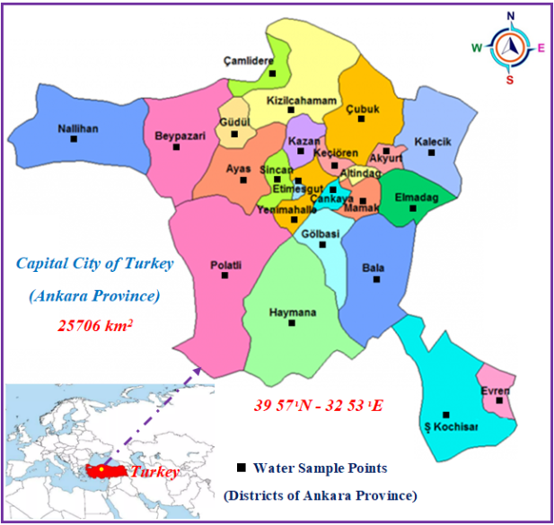

**Fig. 1.** Study area

Ankara province is located in the Central Anatolia Region of Turkiye. Ankara has an area of 26,897 km². Ankara province is between latitude 39.57 N and longitude 32.53 E (Anonymous 2023a). There are 25 districts, 1 metropolitan municipality, 25 district municipalities, and 1432 neighborhoods in Ankara (Anonymous 2023b). Population distribution affects life in every sense and to a significant extent. Consumption and other needs increase with population growth. Nowadays, the need for water is increasing daily in many countries. In addition, population is an important parameter in determining the capacity and need to create a drinking water treatment and distribution network. According to 2020 data from Ankara province, its population is 5,782,285 people (TÜİK 2022). Kızılırmak and Sakarya rivers, two of the largest rivers in Turkiye, pass through Ankara province. Kızılırmak River passes through the east of Ankara province, and Sakarya River passes through the west and is used as irrigation water. In the south of Ankara province, there is Salt Lake, the second-largest lake in Turkiye. 9 drinking water treatment plants supply water to Ankara.

2.2. Water Samples

Water samples collected weekly by Ankara Water and Sewerage Administration (ASKİ) and covering 2018, 2019, and 2020 were used as research material. In laboratories, analyses were carried out following drinking water criteria for water samples collected from 25 different districts of Ankara province (ASKİ 2021).

Conductivity (EC), turbidity, residual chlorine, aluminum, iron, and sulfate in drinking water samples collected weekly by ASKİ are determined by classical and general instrumentation analyses. Turbidity was measured by using a turbidimeter device (Hach Lange 2100AN). Conductivity measurement was made with an EC meter (Hach Large brand HQ40D model). Residual chlorine was measured with ready-made test kits to measure free chlorine in water (DRXD-002 device) (Tanas 2016).

Aluminum and iron were analyzed using the ICP-MS device (Shimadzu 2030 series). The sulfate parameter was determined using ion chromatography (940 Professional IC Vario) (Zeydanlı 2013).

2.3. Permissible Limit Values of Some Quality Parameters in Drinking Water

Water resources on earth have different characteristics. While some waters are described as fresh, some are salty. Since water has different properties, choosing water with the appropriate properties for its intended use is necessary. Physical, chemical, and biological parameters are valid for determining these properties. Parameters have limit values for the intended use of water.

Some scientific organizations determine these limit values. In Turkiye, permissible limit values for water to be used for human consumption are evaluated within the scope of TS 266 standards (TS 2005). In the world, there are limit values determined by the World Health Organization (WHO 2017), the US Environmental Protection Agency (EPA 2016), and the European Union (EU 2020). As a result of this study, the values obtained from water samples were interpreted by considering these limit values. The limit values allowed for drinking water in Turkey and the world are summarized in Table 1.

**Table 1.** Some permissible limit values in drinking water (TS 2005, WHO 2017, EPA 2016, EU 2020).

|  |  |  |  |  |
| --- | --- | --- | --- | --- |
| Parameters | TS 266 | WHO | EPA | EU |
| Turbidity (NTU) | 1 | 5 | 1 | 1 |
| Chloride (mg/l) | 250 | 250 | 250 | 250 |
| Fe (µg/l) | 200 | 300 | 300 | 200 |
| Al (µg/l) | 200 | 100 | 200 | 200 |
| SO4 (mg/l) | 250 | 500 | 250 | 250 |
| TS 266: Turkish Drinking Water Quality Standard, WHO: World Health Organization, EPA: US Environmental Protection Agency, EU: European Union. | | | | |

2.4. Spatial Modeling by GIS-based Mapping

Various drinking water quality parameters of Ankara province were evaluated spatially in a GIS environment using Arc GIS 10.3.1 software (ESRI 2010). IDW interpolation method was used to evaluate spatial analysis. The IDW (Inverse Distance Weighted) method performs analysis on the basis that the nearby points have more weight than the distant points on the surface to be analyzed (Şen 2007). The estimated values are a function of the near and far points, and as the distance increases, the importance and impact on the cell to be estimated decreases. Water quality parameters were modeled using the IDW interpolation method with the help of Arc GIS software using the following equation (Burrough & Mcdonnell 1998).

$Z_{0}=\frac{\sum_{i=1}^{N}{{Zi.di}^{-n}}}{\sum_{i=1}^{N}{{di}^{-n}}}$ (1)

where:

Z0 – the estimation value of variable z in point I,   
zi – the sample value,   
di – the distance of the sample point to the estimated point,   
N – the coefficient that determines weight based on distance,   
N – the total number of predictions for each validation case.

2.5. Trend Analysis

The change in drinking water quality parameters over the years was evaluated by trend analysis in the current study. Mann-Kendall and Sperman's Rho Test and Sen's Trend Slope method were applied to water quality data at a 95% confidence level (Mann 1945, Kendall 1975, Sen 1968). Mann-Kendall test was applied using the following equation:

$S=\sum_{İ=1}^{n-1}{\sum_{J=i+1}^{n}{sgn(x_{j}-x_{i})}}$ (2)

where:

S – Mann-Kendall test statistical,

n – number of data points,   
𝑥𝑖 and 𝑥𝑗 – data values in time series i and j (j > i),   
sgn (xj-xi) – mark function (Karakuş 2017). It is expressed below:

+1, xj-xi > 0

0, xj-xi = 0

-1, xj-xi < 0

sgn (xj-xi) = (3)

Whether the Mann-Kendall test, whose variance is determined, is significant or not is determined by calculating the standard normal variable Z with the following equation and comparing it with the critical Z value.

$Var \left(s\right)=\frac{n\left(n-1\right)\left(2n+5\right)-\sum_{İ=1}^{m}{t_{i}\left(t_{i}-1\right)\left(2t_{i}+5\right)}}{18}$ (4)

where:

Var(s) – variance,   
n – number of data points,   
m – number of connected groups,   
𝑡𝑖 – number of bonds within i.

$Z_{s}=\left\{\begin{aligned}\frac{S-1}{\sqrt{Var \left(S\right)}}, S>0 \\ 0, S=0 \\ \frac{S+1}{\sqrt{Var \left(S\right)}}, S<0\end{aligned} \right.$ (5)

Sperarman's Rho Test is used in comparison with the Mann-Kendall test. This test statistic is given in the equations below.

$R_{sp}=1\frac{6\sum_{i=1}^{n}{{(Di-i)}^{2}}}{n(n^{2}-1)}$ (6)

$Z_{Sp}=R_{sp}\sqrt{\frac{n-2}{1-{Rsp}^{2}}}$ (7)

where:

Di – sequence number of i observations,   
n – total length of time series data,   
i – observation order of data,   
Zsp – (𝑛-2) degrees of freedom.

Positive values of 𝑍𝑠𝑝 indicate an increasing trend in the hydrological time series, while negative values indicate a decreasing trend (Karakuş 2017, Büyükyıldız & Berktay 2004).

Water quality parameter values were subjected to the training method test developed by Sen. This test was used to determine the slope and magnitude of the trend (Sen 1968). This non-parametric method, with its structure that is not affected by large data errors or outliers, is applied to calculate the linear trend size, that is, the change in unit time, in the time series of the data (Yu et al. 1993). "Trend Analysis for Windows" software was used to evaluate drinking water quality parameters determined in water samples with trend analysis depending on time. This program applies the Mann-Kendall test, Spearman's Rho test, Mann-Kendall Rank Correlation test, and Sen's Trend Slope method to the data and performs analysis. The results are presented as graphics and text (Gümüş 2006).

3. Results and Discussions

3.1. Spatial Modeling and Trend Analysis of the Electrical Conductivity (EC) Values in Drinking Water

EC values determined in the drinking water of Ankara province between 2018 and 2020 were analyzed spatially. Spatial distribution models of EC values in drinking water of Ankara province are presented in Figure 2.

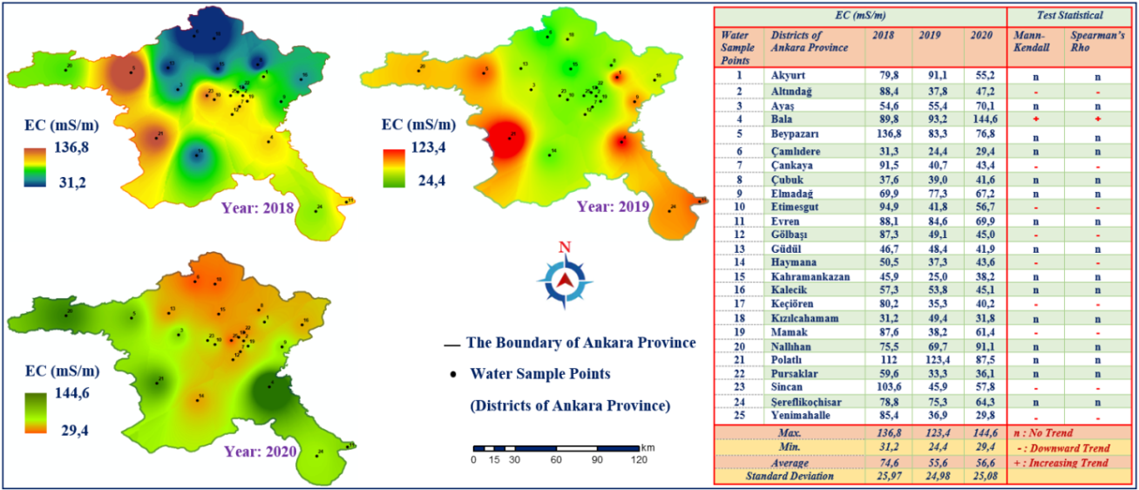

**Fig. 2.** Spatial Modeling and Trend Analysis of the Electrical Conductivity (EC) Values

The EC term is the numerical expression of water's ability to conduct electricity, and the permissible limit value (drinking water) according to the TS 266 standard in Turkey is 250 mS/m at 25°C (TS 2005). EC values in the drinking water of Ankara province and 25 districts in 2018 were examined. According to this analysis, it was determined that the highest EC value was 136.8 mS/m, concentrated in Beypazarı and Polatlı districts, and the lowest value was 31.2 mS/m, concentrated in Çamlıdere and Kızılcahamam districts.

According to the EC values of 2020, the highest EC value was determined in Bala and Nallıhan districts with 144.6 mS/m, and the lowest value was determined in Çamlıdere and Kızılcahamam districts with 29.4 mS/m. It has been observed that the drinking water of Ankara province complies with the TS 266 standard in terms of EC.

Trend analysis was applied to the average EC values of 25 districts of Ankara province in 2018-2020. The results showed that there was a significant trend in 10 districts. According to Mann-Kendall and Sperman's Rho tests, it was concluded that there was a decreasing trend in Altındağ, Çankaya, Etimesgut, Gölbaşı, Haymana, Keçiören, Mamak, Sincan and Yenimahalle districts, and an increasing trend in Bala district. No significant increase or decrease in EC values was found in other districts.

3.2. Spatial Modeling and Trend Analysis of Turbidity Values in Drinking Water

Spatial distributions of turbidity values of drinking water in Ankara province for 2018-2020 are presented in Figure 3.

In the analyses carried out in drinking water in Ankara in 2018, it was determined that the highest turbidity value was 1.02 NTU, concentrated in Beypazarı district and its surroundings, and the lowest value was 0.36 NTU, concentrated in Kızılcahamam, Nallıhan, and Polatlı districts. In drinking water analyses for 2019, the highest turbidity value was seen in Altındağ, Çamlıdere, Elmadağ, Kahramankazan and Şereflikoçhisar districts with 0.57 NTU.

The lowest value was seen in Beypazarı and Güdül districts, with 0.17. In 2020, the highest turbidity value in drinking water was seen in Çamlıdere and Elmadağ districts with 0.50 NTU. The lowest turbidity value was seen in Güdül and Nallıhan districts with 0.15 NTU. Turbidity is a measure of light transmittance in water. According to TS 266, EPA, and EU standards, the permissible limit value in drinking water is 1 NTU (TS 2005, EPA 2016, EU 2020). Based on these outcomes, the drinking water in Ankara was found to be of drinkable quality in terms of turbidity.

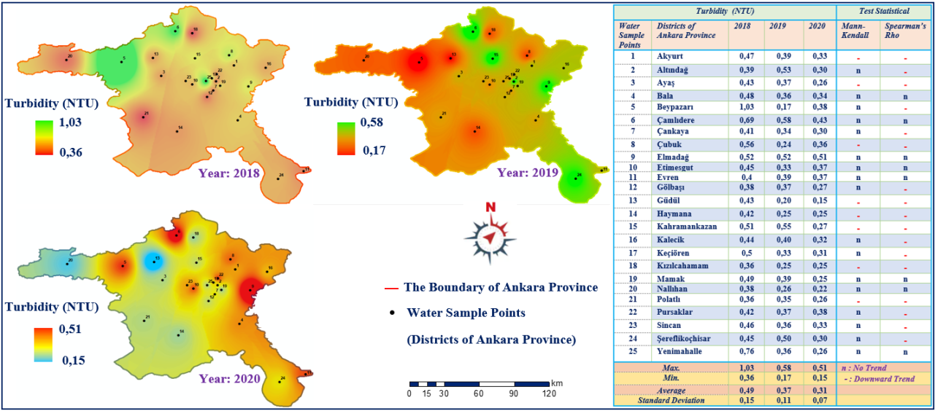

**Fig. 3.** Spatial Modeling and Trend Analysis of Turbidity Values

The results obtained from the trend analysis indicate that there is a trend in 17 districts. According to Sperman's Rho Test, it was determined that there was a decreasing trend in Altındağ, Beypazarı, Çankaya, Gölbaşı, Kalecik, Keçiören, Pursaklar, Sincan, and Şereflikoçhisar districts. Still, there was no trend according to the Mann-Kendall test. According to Mann-Kendall and Sperman's Rho tests, it was determined that there was a decreasing trend in Akyurt, Ayaş, Çubuk, Güdül, Haymana, Kahramankazan, Kızılcahamam and Polatlı districts according to both test results. No trend was observed in other districts.

3.3. Spatial Modeling and Trend Analysis of Residual Chlorine (Cl) Amounts in Drinking Water

A spatial analysis of the residual Cl values in the drinking water of Ankara province was carried out in the 2018-2020 period. Spatial models of residual Cl values according to years are presented in Figure 4.

**,**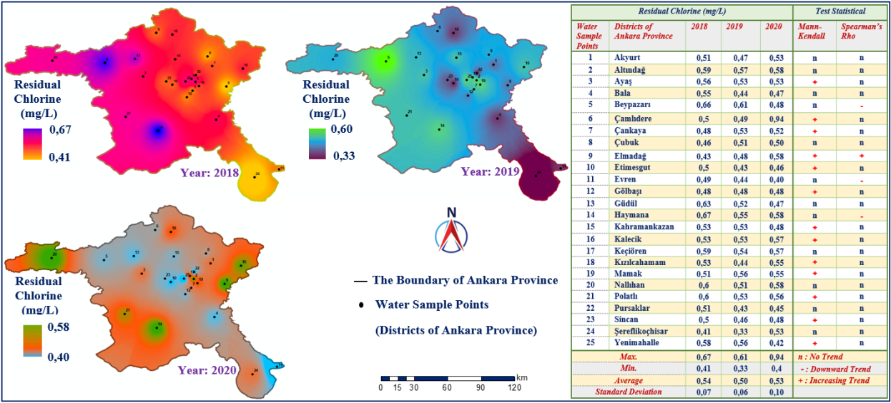

**Fig. 4.** Spatial Modeling and Trend Analysis of Residual Chlorine (Cl) Amounts

The highest residual Cl values in the drinking water of Ankara province in 2018 were seen in Beypazarı and Haymana districts with 0.66 mg/l. The lowest residual Cl value was in Elmadağ and Şereflikoçhisar districts with 0.41 mg/l. The highest residual Cl value in drinking water for 2019 was seen in Beypazarı district with 0.60 mg/l. The lowest value was in Şereflikoçhisar district and its surroundings, with 0.33 mg/l. In 2020, the highest residual Cl value in drinking water was seen in Elmadağ, Haymana, Kalecik, and Nallıhan districts with 0.58 mg/l. The lowest residual Cl value was seen in the Evren district with 0.40 mg/l. The highest allowable residual Cl amount in drinking water is 250 mg/l according to TS 266, WHO, EPA, and EU standards (TS 2005, WHO 2017, EPA 2016, EU 2020). In this regard, Ankara province's drinking water has been deemed suitable for chlorine concentration.

Trend analyses were conducted, and a trend was found in 16 districts. According to the Mann-Kendall test, there is an increasing trend in Ayaş, Çankaya, Çamlıdere, Etimesgut, Gölbaşı, Kahramankazan, Kalecik, Kızılcahamam, Mamak, Polatlı, Sincan and Yenimahalle districts. According to Spearman's Rho test, there is a decreasing trend in the Beypazarı, Evren, and Haymana districts. According to both test results, an increasing trend was found in Elmadağ district.

3.4. Spatial Modeling and Trend Analysis of Sulphate (SO4-2) Amounts in Drinking Water

Sulfate values in drinking water for the 2018-2020 period were subjected to spatial analysis and modeled using the IDW interpolation method. Spatial models of sulphate amounts in drinking water of Ankara province for 2018, 2019, and 2020 are presented in Figure 5.

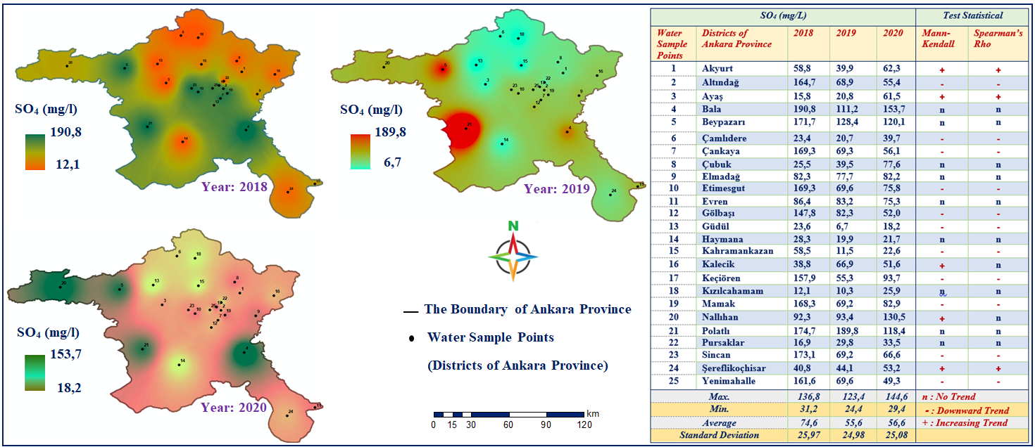

**Fig. 5.** Spatial Modeling and Trend Analysis of Sulphate (SO4) Amounts

The highest value of sulfate amount in drinking water of Ankara province in 2018 was seen in Bala, Beypazarı, Çankaya, Etimesgut, Gölbaşı, Polatlı, Sincan and Yenimahalle districts with 190.8 mg/l. The lowest sulfate value of 12.1 mg/l was seen in Ayaş, Çamlıdere, Güdül, Haymana, and Kızılcahamam districts. Concerning 2019, the highest sulfate concentration in drinking water in Ankara was seen in Beypazarı and Polatlı districts, with 189.8 mg/l. The lowest amount of sulfate was determined in Ayaş, Çamlıdere, Güdül, Haymana, Kahramankazan and Kızılcahamam districts with 6.7 mg/l. The highest sulfate concentration in drinking water of Ankara province for 2020 was seen in the Bala, Beypazarı, Nallıhan, and Polatlı districts with 153.7 mg/l. The lowest amount of sulfate was seen in Çamlıdere, Güdül, Haymana, Kahramankazan, and Kızılcahamam districts with 18.2 mg/l. According to TS 266, EPA and EU standards, the allowable limit value for sulfate in drinking water is 250 mg/l (TS 2005, EPA 2016, EU 2020).

Regarding sulfate concentration, it is below the permissible limit values of Ankara drinking water. The drinking water of Ankara province has been deemed suitable for sulphate concentration.

Trend analyses were made in sulfate values, and a trend was found in 17 districts. In Mann-Kendall and Spearman's Rho test, a decreasing trend was detected in Altındağ, Çamlıdere, Çankaya, Etimesgut, Gölbaşı, Güdül, Kahramankazan, Keçiören, Mamak, Sincan, Şereflikoçhisar Yenimahalle districts. It was determined that there was an increasing trend in the Akyurt, Ayaş, and Şereflikoçhisar districts. It was determined that there was an increasing trend in the Kalecik and Nallıhan districts only according to the Mann-Kendall test. No trend results were found in other districts.

3.5. Spatial Modeling and Trend Analysis of Iron (Fe) Amounts in Drinking Water

Spatial modeling of iron concentration values in drinking water is presented in Figure 6.

In Ankara province, the highest Fe concentration values in drinking water in 2018 were 70.0 µg/l, concentrated in Ayaş, Çankaya, Etimesgut, Gölbaşı and Sincan districts. The lowest Fe amount was seen in Beypazarı, Bala, Elmadağ, Güdül, Kızılcahamam, Nallıhan, and Şereflikoçhisar districts with 4.2 µg/l. For 2019, the highest Fe amount was seen in Ayaş, Çamlıdere, Etimesgut, Kahramankazan, and Şereflikoçhisar districts with 37.8 µg/l. The lowest Fe concentration was determined in the Bala, Güdül, Haymana, Kızılcahamam, and Nallıhan districts with 4.0 µg/l.

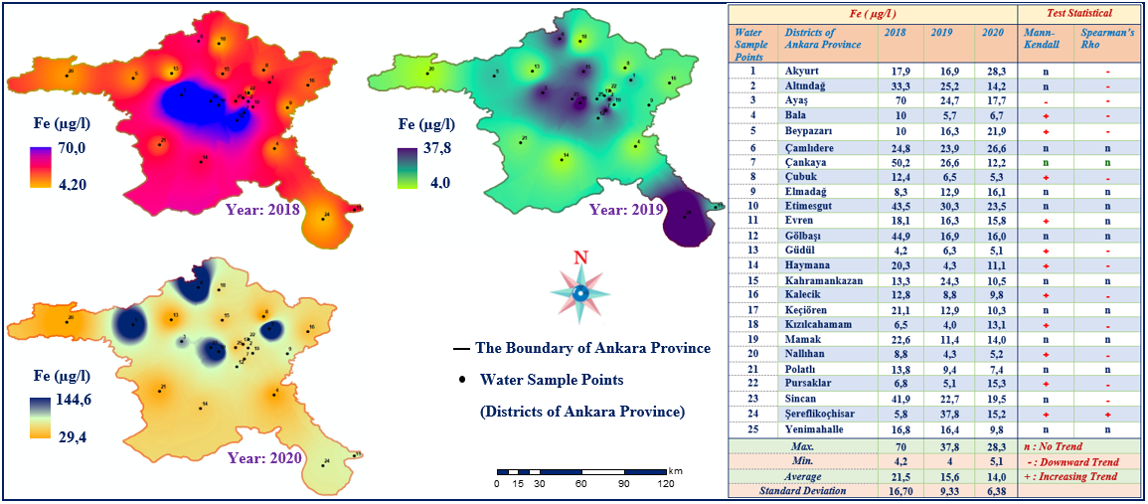

**Fig. 6.** Spatial Modeling and Trend Analysis of Iron (Fe) Amounts

The distribution of Fe concentrations in drinking water in 2020 was examined. The highest Fe amount was concentrated in the Akyurt, Beypazarı, Çamlıdere, Etimesgut, and Sincan districts, with 28.3 µg/l. The lowest Fe amount was seen in Bala, Çubuk, Güdül and Nallıhan districts with 5.1 µg/l. According to TS 266 and EU standards, the allowable Fe concentration in drinking water is 200 µg/l (TS 2005, EU 2020). In this regard, drinking water in Ankara was deemed suitable for Fe concentration.

A trend analysis was conducted in sulfate values for the 2018-2020 period in 25 districts of Ankara. The trend was found in 15 districts. Mann-Kendall test was conducted, and it was determined that there was an increasing trend in Bala, Beypazarı, Çubuk, Evren, Güdül, Haymana, Kalecik, Kızılcahamam, Nallıhan and Pursaklar districts. According to SpearmanRho's test, it was determined that there was a decreasing trend in Akyurt, Altındağ, Bala, Beypazarı, Çubuk, Güdül, Haymana, Kalecik, Kızılcahamam, Nallıhan, Pursaklar and Sincan districts. According to both test results, it was determined that there was a decreasing trend in Ayaş district and an increasing trend in Şereflikoçhisar district. No trend was found in other districts.

3.6. Spatial Modeling and Trend Analysis of Aluminum (Al) Amounts in Drinking Water

The spatial distribution of aluminum amounts in the drinking water of Ankara province between 2018 and 2022 is presented in Figure 7.

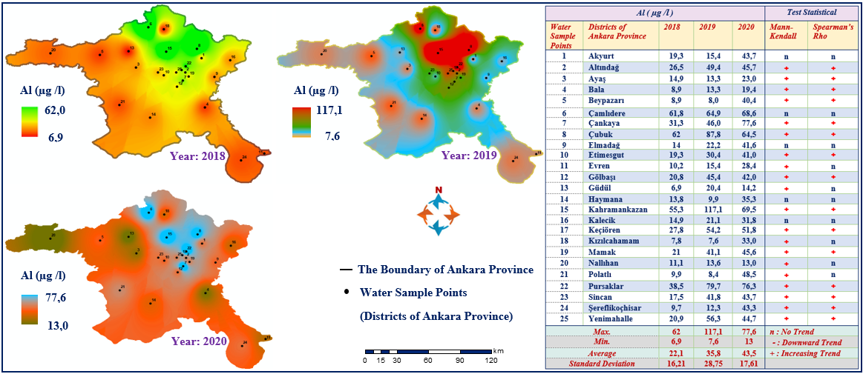

**Fig. 7.** Spatial Modeling and Trend Analysis of Aluminum (Al) Amounts

In 2018, the highest amount of Al in drinking water in Ankara was seen in the Çamlıdere, Çubuk, and Kahramankazan districts, with 62.0 µg/l. The lowest amount of Al was seen in the Güdül district, with 6.9 µg/l. In 2019, the highest Al value was seen in Çamlıdere, Çubuk, Kahramankazan, and Pursaklar districts with 117.0 µg/l. The lowest Al concentration was seen in Beypazarı, Haymana, and Polatlı districts with 7.6 µg/l. In 2020, the highest Al value was seen in Çamlıdere, Çubuk, Kahramankazan, and Pursaklar districts with 77 µg/l. The lowest amount of Al was determined in Ayaş, Bala, Nallıhan, and Güdül districts with 13.0 µg/l. According to TS 266, EPA, and EU standards, the maximum allowable Al concentration in drinking water is 200 µg/l (TS 2005, EPA 2016, EU 2020).

As a result of the trend analysis made with Al values in 2018-2020 of 25 districts of Ankara province, a trend was found in 20 districts. According to the Mann-Kendall test, an increasing trend was found in the Evren, Güdül, Kızılcahamam, Nallıhan, and Polatlı districts. Both test results showed that there was an increasing trend in Altındağ, Ayaş, Bala, Beypazarı, Çankaya, Çubuk, Etimesgut, Gölbaşı, Kahramankazan, Keçiören, Mamak, Pursaklar, Sincan, Şereflikoçhisar and Yenimahalle districts. No significant trend results were found in other districts.

Many studies in the literature show that drinking water quality should be evaluated spatially with GIS. For example, a study was conducted to determine and monitor drinking water quality in southern Ethiopia. This study carried out some drinking water quality parameters and heavy metal analyses. The results obtained were evaluated spatially with the help of IDW interpolation techniques using Arc GIS, one of the Geography Information Systems programs, and distribution maps were produced (Bojago et al. 2023).

A study was conducted in the Jammu and Kashmir regions of India, and a GIS-based assessment of drinking water quality was carried out. Water samples were collected from 32 different regions in the research mentioned above. 11 parameters were examined in the drinking water samples taken, and spatial distribution maps were produced (Hemraj & Kumar 2022).

In a thesis study conducted to determine drinking water quality in Giresun province of Turkiye, water samples were taken from 5 different locations. Dissolved oxygen, temperature, pH, salinity, conductivity, biological oxygen demand, alkalinity, and hardness values were examined in the water samples taken.

As a result of the study, it was seen that the drinking water content of Giresun province was among the allowed limit values (Aydın 2020). There are many recent studies in the literature on evaluating water quality spatially using GIS-based mapping and trend analysis (Table 2).

**Table 2.** Some recent studies on spatial modeling and trend analysis of water quality

|  |  |  |  |
| --- | --- | --- | --- |
| Recent Studies | Research Area | Aim | Analysis |
| (Laaraj et al. 2023) | In the northern part of Morocco's  Fès-Taza region | Spatial Analysis of water quality | GIS-based Mapping with Kriging interpolation |
| (Al Yousıf & Chabuk 2023) | Al-Abbasiyah River of Iraq | Spatial Analysis of water quality | GIS-based Mapping, IDW and Kriging interpolations |
| (Ram et al. 2021) | South-western district of Uttar Pradesh, India | Spatial Analysis of water quality | GIS-based Mapping, IDW interpolation |
| (Naddeo 2023) | Salerno of Napoli in Italy | Trend analysis of water quality | Trend Analysis with Mann-Kendall |
| (Alilou et al. 2022) | South-west Australia | Trend analysis of water quality | Trend Analysis with Mann-Kendall |
| (Gao et al. 2023) | Xiaoqing River, China | Trend analysis of water quality | Trend Analysis with Mann-Kendall |

4. Conclusions

It is vital for human health that the water supplied for drinking water and released into the distribution network is high quality and healthy. Epidemic disease in the drinking water treatment process or distribution network in a settlement can affect all people in the region and cause serious health problems. To prevent these negative incidents, water quality parameters and regional monitoring of these quality parameters are necessary. Therefore, monitoring drinking water quality parameters from the source to the distribution network is important.

Evaluating water quality parameters alone is not sufficient to monitor the current situation. It may be important for determining water quality, but it is ineffective in determining the current status and distribution. It is important to perform spatial analyses with statistical and geographical programs to determine the current situation and take precautions against future incidents with advanced technology. GIS enables spatial analysis by storing data in a digital environment.

Within the scope of the current study, spatial analysis of drinking water quality parameters of Ankara province was carried out using Arc GIS 10.3.1 software, and the results were presented as map output. Spatial analyses were carried out by integrating water quality parameters with GIS. It is important to obtain clear results from the distribution maps created from these analyses to monitor the current situation and share the results obtained strikingly and effectively. Drinking water quality parameters can be evaluated with spatial analyses created in GIS. In addition, many factors such as climate, agriculture, and population change can be analyzed to reveal clear results and factors.

Ankara province, which is important due to its strategic location, is in the Central Anatolia region and the capital of Turkey. Due to regional geography, the drought rate is high. With the increasing temperature due to drought, decreases in water resources are inevitable. Dams provide the majority of raw water resources for drinking water in Ankara. The water occupancy rate in dams is important for the world and Turkey. The same importance applies to Ankara. In some districts of Ankara, groundwater is used as a drinking water source.

Nowadays, the amount of water used for drinking is decreasing, and the importance of water resources is increasing. Unfortunately, the opportunity to access quality water resources to obtain drinking water is decreasing. Evaluation using GIS or different statistical analyses will provide more necessary information for today and the future. As a result of all these processes, it will be important for local governments to use GIS more widely and actively to control the existing water potential and monitor drinking water quality parameter results. This will save time, especially in determining the measures that can be taken against current and future changes or dangers.

*This study is quoted from a part of the MSc thesis of Oğuzhan ARSLAN titled "Modeling of Drinking   
Water Quality Parameters in Ankara Province with Geography Information Systems (GIS) by Using Different Interpolation Methods", Nevsehir Hacı Bektas Veli Univesity, Graduate School of Natural   
and Applied Sciences.*

References

Akın, M., & Akın, G. (2007). Suyun önemi, Türkiye’de su potansiyeli, su havzaları ve su kirliliği. *Ankara Üniversitesi Dil ve Tarih-Coğrafya Fakültesi Dergisi*, *47*(2), 105-118 (in Turkish)

Ali, S., Farooq F. H., Abbas G., Hussain Z., Anwar M. S., Ahmad R. I., Naz F., Hussain M., Nawaz H., Shaukat M., Shaukat H., Sindhu M. W., & Sindhu M. A. (2022). Clean Drinking Water And Future Prospective. *Pakistan Journal of Science*, *74*(1), 28-39.

ASKİ (2021). İçme suyu kalitesi parametreleri, Ankara Su ve Kanalizasyon İdaresi Genel Müdürlüğü, <https://www.aski.gov.tr/TR/SuAnalizSonuclari.aspx> (in Turkish)

Al Yousıf, M. A., & Chabuk A. (2023). Assessment of the Al-Abbasiyah River (Iraq) Water Quality for Drinking Purposes Using the Water Quality Index and GIS Software. *Journal of Ecological Engineering*, *24*(8), 157-174. https://doi.org/[10.12911/22998993/166396](https://doi.org/10.12911/22998993/166396)

Aydın, M. (2020). Giresun İli İçme Suyu Kalitesi, Giresun Üniversitesi, Fen Bilimleri Enstitüsü, Yüksek Lisans Tezi. (in Turkish)

Alilou, H., Oldham, C., Mcfarlane, D., & Hipsey, M. R. (2022). A structured framework to interpret hydro-climatic and water quality trends in Mediterranean climate zones.[*Journal of Hydrology*](https://www.sciencedirect.com/journal/journal-of-hydrology), [*614*(A](https://www.sciencedirect.com/journal/journal-of-hydrology/vol/614/part/PA)), 128512. https://doi.org/[10.1016/j.jhydrol.2022.128512](https://doi.org/10.1016/j.jhydrol.2022.128512)

Anonymous (2021). Toprak Su Kaynakları, Devlet Su İşleri Genel Müdürlüğü. (in Turkish)

Anonymous (2023a). Genel coğrafya ve yeryüzü şekilleri, Ankara Valiliği. (in Turkish)

Anonymous (2023b). Nüfus ve idari durum, Ankara Valiliği. (in Turkish)

Başayiğit, L., Şenol, H., & Müjdeci, M. (2008). Isparta İli Meyve Yetiştirme Potansiyeli Yüksek Alanların Bazı Toprak Özelliklerinin Coğrafi Bilgi Sistemleri ile Haritalanması. *Süleyman Demirel Üniversitesi Ziraat Fakültesi Dergisi.*, *3*(2), 1-10. (in Turkish)

Bağdatli, M. C., İstanbulluoğlu, A., & Bayar, N. A. (2014). Toprak ve su kaynakları potansiyelinin Coğrafi Bilgi Sistemleri (CBS) yardımıyla belirlenmesi: Tekirdağ-Çerkezköy ilçesi uygulaması. *Afyon Kocatepe Üniversitesi, Fen ve Mühendislik Dergisi*, *14*, 17-25. (in Turkish)

Burrough, P. A., & Mcdonnell, R. A. (1998). *Creating continuous surfaces from point data*. [In:] Burrough, P. A., Goodchild, M.F., McDonnell, R.A., Switzer, P., Worboys, M. (Eds.), Principles of Geographic Information Systems., Oxford University Press, Oxford, UK.

Büyükyildiz, M., & Berktay, A. (2004). Parametrik Olmayan Testler Kullanılarak Sakarya Havzası Yağışlarının Trend Analizi. *J. Fac. Eng. Arch. Selcuk Uni.*, *19*(2), 23-38. (in Turkish)

Bojago, E., Tyagi, I., Ahamad, F., & Chandniha, S. K. (2023). GIS based spatial-temporal distribution of water quality parameters and heavymetals in drinking water: Ecological and health modelling. *Physics and Chemistry of the Earth*, *130*, 103399. https://doi.org/[10.1016/j.pce.2023.103399](https://doi.org/10.1016/j.pce.2023.103399)

EPA (2016). National primary drinking water regulations related info, US. Environmental Protection Agency (EPA) <https://www.epa.gov/sites/production/files/201606/documents/npwdr_complete_table.pdf>

EU (2020). Directive (EU) 2020/2184 of the European Parliament and of the Council of 16 December 2020 on the quality of water intended for human consumption. *Off. J. Eur. Union.*, *435*, 1-62.

ESRI (2010). Arc GIS 10.3.1 software, ESRI, Environmental System Research Institute, Redland, CA, USA.

Fitzpatrick, C., & Maguire, D. J. (2001). GIS in Schools: Infrastructure, Methodology and Role, CRC Press.

Gao, Z., Chen, J., Wang, G., Ren, S., Fang, L., Yinglan, A., & Wang, Q. (2023). A novel multivariate time series prediction of crucial water quality parameters with Long Short-Term Memory (LSTM) networks. [*Journal of Contaminant Hydrology*](https://www.sciencedirect.com/journal/journal-of-contaminant-hydrology), *259*, 104262. https://doi.org/[10.1016/j.jconhyd.2023.104262](https://doi.org/10.1016/j.jconhyd.2023.104262)

Gümüş, V. (2006). Fırat havzası akımlarının trend analizi ile değerlendirilmesi, Harran Üniversitesi Fen Bilimleri Enstitüsü Yüksek Lisans Tezi, Şanlıurfa. (in Turkish)

Hemraj, & Kumar M. (2022). GIS based surface elevation assessment of spring water quality of Shivalik Range of Jammu and Kashmir, India. [*Groundwater for Sustainable Development*](https://www.sciencedirect.com/journal/groundwater-for-sustainable-development), *19*, 100851. https://doi.org/[10.1016/j.gsd.2022.100851](https://doi.org/10.1016/j.gsd.2022.100851)

Karakuş, C.B. (2017). Trend Analysis Methods for Hydro-Meteorological Parameters. *International Journal of Scientific and Technological Research*, *3*(2), 22-32.

Kendall, M. G. (1975). Rank Correlation Methods. Charles Griffin, London, 135.

Laaraj, M., Benaabıdate, L., Mesnage, V., & Lahmıdı, I. (2023). Assessment and modeling of surface water quality for drinking and irrigation purposes using water quality indices and GIS techniques in the Inaouene watershed, Morocco. *Modeling Earth Systems and Environment*, *10*, 2349-2374. https://doi.org/[10.1007/s40808-023-01904-1](https://doi.org/10.1007/s40808-023-01904-1)

Mann, H. B. (1945). Non-parametric Tests Against Trend. *Econometrica*, *13*, 245-259.

Naddeo, V., Zarra, T., Pervez, M. N., Papamıchael, I., Zorpas, A. A., Lı, C. W., Klontza, E., Lekkas, D. F., & Belgıorno, V. (2023). A comparative analysis of ecological status assessment in river water quality under the European Water Framework Directive. *Case Studies in Chemical and Environmental Engineering*, *8*, 100477. https://doi.org/[10.1016/j.cscee.2023.100477](https://doi.org/10.1016/j.cscee.2023.100477)

Ram, A., Tıwarı, S. K., Pandey, H. K., Chaurasıa, A. K., Sıngh, S., & Sıngh, Y. V. (2021). Groundwater quality assessment using water quality index (WQI) under GIS framework. *Applied Water Science*, *11*(46), 1-20. https://doi.org/[10.1007/s13201-021-01376-7](https://doi.org/10.1007/s13201-021-01376-7)

Sen, P. K. (1968). Estimates of the Regression Coefficient Based on Kendall's Tau. *J. Am. Stat. Assoc.*, *63*, 1379-1389, https://doi.org/10.1080/01621459.1968.10480934

Şen, A. (2007). *Elektrik alan şiddetlerinin ölçümü ve Coğrafi Bilgi Sistemi ortamında yapay sinir ağları ile analizi*. Yıldız Teknik Üniversitesi Fen Bilimleri Enstitüsü, Yüksek Lisans Tezi, 2007, İstanbul. (in Turkish)

Tanas, E. N. (2016). *Sakarya ili içme suyu şebekesinin su kalitesinin araştırılması*. Sakarya Üniversitesi Fen Bilimleri Enstitüsü Yüksek Lisans Tezi, Sakarya, Türkiye. (in Turkish)

TS (2005). Water intended for human consumption. [In:] Standards for Drinking Waters, TS266, Turkish Standards Institute, Turkiye.

TÜİK (2022). Ankara ili Nüfus Verileri. Türkiye İstatistik Kurumu (TÜİK), (in Turkish)

WHO (2017). Guidelines for Drinking-water Quality. World Health Organization (WHO).   
<https://www.who.int/publications/i/item/9789241549950>

Yu, Y. S., Zou, S., & Whittemore, D. (1993). Non-parametric trend analysis of water quality data of rivers in Kansas. *Journal of Hydrology*, *150*(1), 61-80. https://doi.org/[10.1016/0022-1694(93)90156-4](https://doi.org/10.1016/0022-1694(93)90156-4)

Zeydanlı, D. (2013). *İyon kromatografi kondüktivite dedektörü ile orotik asidürili hasta idrarında orotik asit tayini*. İstanbul Üniversitesi Fen Bilimleri Enstitüsü, Yüksek Lisans Tezi. (in Turkish)