
 | Rocznik Ochrona Środowiska
 | Volume 27 | Year 2025 ISSN 2720-7501 | pp. 110-120
 | https://doi.org/10.54740/ros.2025.010 open access
 | Received: February 2025 Accepted: February 2025 Published: March 2025
Parametric Analysis of Heat Flows Through Building Envelope Considering Orientation, Massiveness, and Intermittent Heating Modes
Valerii Deshko¹, Inna Bilous², Nadia Buyak³, Hanna Hetmanchuk^{4*},
Maksym Hurieiev⁵, Tatjana Odineca⁶
¹Educational and Research Institute of Nuclear and Heat Power Engineering,
National Technical University of Ukraine "Igor Sikorsky Kyiv Polytechnic Institute", Ukraine
Institute of Engineering Thermophysics of NAS of Ukraine, Ukraine
https://orcid.org/0000-0002-8218-3933
²Educational and Research Institute of Nuclear and Heat Power Engineering,
National Technical University of Ukraine "Igor Sikorsky Kyiv Polytechnic Institute", Ukraine
https://orcid.org/0000-0002-6640-103X
³Educational and Research Institute of Nuclear and Heat Power Engineering,
National Technical University of Ukraine "Igor Sikorsky Kyiv Polytechnic Institute", Ukraine
https://orcid.org/0000-0003-0597-6945
⁴Educational and Research Institute of Nuclear and Heat Power Engineering,
National Technical University of Ukraine "Igor Sikorsky Kyiv Polytechnic Institute", Ukraine
https://orcid.org/0000-0003-1655-8642
⁵Educational and Research Institute of Nuclear and Heat Power Engineering,
National Technical University of Ukraine "Igor Sikorsky Kyiv Polytechnic Institute", Ukraine
https://orcid.org/0000-0003-0420-3609
⁶Institute of Heat, Gas, and Water Technology, Riga Technical University, Latvija
https://orcid.org/0000-0002-7533-3139
*corresponding author e-mail: hetmanchuk.anna@gmail.com
Abstract: The study's objective is to conduct a parametric analysis of the components of the building's heat balance, and a parametric analysis of heat flows in buildings with different thermal and physical properties. To this end, a non-stationary multi-zone energy model of a multi-story building was developed, which was then utilized to ascertain the components of the energy balance of a pilot room under various temperature control regimes of the heating system, the massiveness of internal and exterior walls, the insulation of the exterior wall, and contingent on the purpose of the room. Two distinct types of building premises are distinguished: residential and commercial. The analysis revealed that representative rooms oriented towards the north exhibited a 34.8% higher energy consumption for heating needs when compared to rooms oriented towards the south for walls comprising a single brick and a 38.3% higher energy consumption for walls composed of three bricks. Implementing intermittent heating modes has been shown to reduce heat energy consumption by 13.8% and 14.6% for a one-brick exterior wall and 18.2% and 19.9% for a three-brick exterior wall, respectively, for residential and public buildings. The impact of altering the massiveness of internal walls on overall energy consumption is negligible. In contrast, the insulation of exterior walls and replacing windows with more energy-efficient ones exhibit a greater potential for reducing energy consumption in a building. A south-facing model with a constant heating mode in January demonstrated a 39.2% reduction in energy consumption for heating compared to a model lacking exterior wall insulation. Implementing additional intermittent heating modes can achieve energy savings of up to 22.3% for south-facing rooms and up to 21.4% for north-facing rooms. The findings of this study offer valuable insights into the regulation of heating modes in buildings with distinct characteristics in terms of exterior and internal wall composition.
Keywords: building energy modeling, energy balances, massivity, heating system operation mode, building,
heating system
1. Introduction
Energy saving is one of the most important tasks of our time. Rising energy prices and the need to reduce greenhouse gas emissions require the search for new ways to improve the energy efficiency of buildings. Energy savings, which can be achieved through accurate energy design of buildings, are very relevant for new buildings and renovations (Hafez et al. 2023, Leccese et al. 2024, Belaïd & Massié 2023).
The construction sector accounts for about 40% of final energy consumption and 36% of greenhouse gas emissions in Europe (Asdrubali et al. 2020). This is because buildings require energy for heating, cooling, lighting, and other energy-consuming processes throughout their life cycle, and the total operating energy consumption reaches 60% (Buyak et al. 2023).
One of the most important factors affecting the energy efficiency of buildings is heat flow through the exterior envelope, which is one of the main sources of heat loss in buildings (Leccese et al. 2018). The main factors affecting heat loss through exterior walls are the orientation of the exterior walls, the massiveness of the exterior walls, thermal insulation, and the mode of operation of the heating system.
Study notes (Habibi 2024) that building orientation is one of the main factors affecting building efficiency. After all, heat loss through the building envelope is significantly influenced by climatic parameters. In addition to the ambient temperature, the heat loss of buildings largely depends on the direction and strength of the wind (Ding et al. 2024) and the intensity of solar radiation. The amount of solar heat gain into the room affects the process of thermal convection, which in turn affects the energy demand for heating and the level of thermal comfort of the occupants. A study (Deka & Szlęk 2022) substantiates the feasibility of using thermal energy storage from solar radiation and its release following the needs of buildings.
Since climatic parameters affect the thermal performance of buildings and the amount of energy consumption of buildings, it is important to develop effective strategies for regulating and adapting heating systems (Dodoo & Gustavsson 2016, Hea & Huang 2024).
Paper (Buyak et al. 2022) presents the results of studies that include forecasting conditions based on solar heat gain in the building zone on the example of a typical 5-story residential building in Kyiv. According to the article, using a heat load schedule that considers solar heat gain can reduce energy consumption for heating by 37% for the North-South window orientation and 28% for the East-West window orientation.
The researchers also conducted an experimental comparison of the impact of solar heat gain on energy consumption between two equivalent rooms with different orientations for Chinese conditions (Hajji et al. 2022). The results show that solar heat gain in south-facing rooms can save up to 8.5% of thermal energy.
The results of a study of the impact of solar heat gain on unheated sunny and cloudy winter days on the thermal environment in passive houses (Zhao et al. 2020) shows that a house with weaker thermal insulation but more solar heat gain has better performance than a house with a stronger building envelope but less solar heat gain. Two independent passive houses in cold regions of China were chosen as the objects of the study, which had almost the same geographical location, building shape, and floor plans. This indicates that in a passive house system, solar heat gain is of great importance and has a competitive status with the thermal insulation characteristics of the building envelope.
Massive exterior walls characterize buildings in Central and Eastern Europe (which includes Ukraine). According to the national standard of Ukraine, "Thermal insulation and energy efficiency of buildings" (DBN V.2.6-31:2021), the requirements for the minimum permissible value of the reduced heat transfer resistance for exterior wall envelope structures for the conditions of the city of Kyiv are 4.00 m²·K/W. It is possible to achieve the appropriate U-value for exterior walls by using new materials with better heat transfer resistance and increasing the thickness of exterior walls during construction. However, thicker walls are also more expensive and difficult to construct.
Also, according to the national standard (DBN V.2.6-31:2021) in new construction, it is allowed to reduce the reduced heat transfer resistance to 80%, provided that other indicators of energy efficiency of buildings, including the specific energy consumption of the building for heating and cooling, are met. The minimum permissible requirements for the energy efficiency of buildings are becoming higher over time. Therefore, their fulfillment requires not only the implementation of measures to reduce the transmission component of building heat loss but also the consideration of the possibility of regulating the heating system with a decrease in the temperature on the premises of the building during the day or at night, depending on the purpose of the building, as this will reduce the overall energy consumption of the heating system.
Particular attention is paid to the study and implementation of intermittent heating modes, as this method is one of the low-cost and energy-efficient measures to improve the energy efficiency of buildings. Researchers (Buyak et al. 2021) found that the implementation of intermittent heating modes in typical Ukrainian buildings can achieve heat energy savings of about 16-25%, depending on the orientation, the depth of the dip in the indoor air temperature graph, and the thermal properties of the envelope. This study also supported an increase in the range of fluctuations in the load on the heating system for the southern orientation due to additional solar heat gain in the room area. Another study (Deshko et al. 2020) has shown that implementing intermittent heating modes leads to a reduction in heat consumption of up to 13% over the entire heating period. For the winter period, the savings are 8-10%, and for the off-season, they are up to 25%.
The study of heat flows through exterior walls using the EnergyPlus software allows for dynamic energy modeling, considering hourly climate data and intermittent heating schedules. The results of such modeling can show changes in the ratio of components of the energy balance of premises and their impact on the heating schedule.
In general, the results of studies (Buyak et al. 2021, Deshko et al. 2020, Deshko et al. 2024, Zhao et al. 2020) have shown that all the factors considered have a significant impact on heat flows through exterior walls, and the results of a comprehensive study will allow the developing of strategies to reduce heat loss and energy consumption in buildings.
2. Methodology
This study permits the evaluation of the impact of various factors on heat flows through the outer walls of buildings. This can be employed to enhance the energy efficiency of buildings by optimizing the characteristics of exterior envelope structures and the operation mode of the heating system, which is of particular relevance in the context of implementing buildings with close to zero energy consumption.
This study aims to conduct a parametric analysis of the factors influencing heat flows through the exterior and interior walls of buildings under the influence of changes in the massiveness of interior and exterior walls, the level of thermal protection, and operating conditions.
Following the goal as mentioned above, the following tasks were successfully completed:
1. Create an energy-dynamic 3D model of the building.
2. Study of the effect of the massiveness of interior and exterior walls and the level of thermal protection on the building's energy consumption for heating and heat flows.
3. Investigation of the influence of building envelope orientation on energy consumption and heat flows.
4. Investigation of the influence of intermittent temperature regimes of heating of building premises on energy consumption and heat flows between zones.

This study conducts a parametric analysis focusing solely on the impact of orientation, thickness, and thermal properties of massive building envelope components on heat flow.
The dynamic energy model of the building was created using the DesignBuilder software, a graphical environment based on the EnergyPlus platform. The energy model of the building is based on the principle of building grid models. The energy balance is compiled for each individual zone. It considers ventilation, transmission losses, flows between adjacent rooms, structure heat accumulation, interior heat gain from lighting, equipment, people, and solar heat gain. The model allows you to consider the equipment operation schedules, lighting, presence of people, changes in the indoor air temperature schedule, ventilation system operation, etc.
The model considers engineering systems for heating, cooling, ventilation, hot water, lighting, etc. Significant attention is paid to calculating energy consumption for heating needs, which account for the lion's share of costs. The building's heat supply system consists of heat transfer, distribution, and generation subsystems, which are considered in the model. The load on the heating system is calculated based on the instantaneous energy balances of the building zone. The calculation time interval in the building energy model is 15 minutes. The climate data uses hourly climate data from a typical year from the International Weather for Energy Calculation (IWEC) file.
Dynamic simulation models of a room were created based on the EnergyPlus software product to study the energy performance of a building. A residential building of a typical construction located in Kyiv was chosen as the object of study.
The following factors were taken into account when modeling heat flows through exterior walls:
- geographical location of the building,
- climatic conditions,
- characteristics of building materials,
- massiveness of exterior walls,
- orientation of exterior walls,
- mode of operation of the heating system.

An important element of the heat load calculation is considering exterior climate changes, including ambient temperature and solar heat gain. The study used hourly climatic data for a typical year from the International Weather file for Energy Calculations (IWEC) weather file for Kyiv, Ukraine, which is directly used by the EnergyPlus software product.
The object of study is an existing 12-story residential building built in 1993 in Kyiv (Ukraine). The building has 175 apartments with a total of 431 living rooms. The premises of the lower floors are used for office/commercial purposes.
The walls of the building are self-supporting and made of hollow ceramic bricks. The windows are vinyl with triple glazing. The interior floors are made of 220 mm thick reinforced concrete slabs, plastered on one side, and equipped with sound insulation and flooring. The roof of the building is flat. The interior walls are made of 255 mm thick brickwork (one brick), plastered on both sides.
The building utilizes a water radiator heating system with overhead distribution, which is a standard Eastern European system. Hot water is supplied from the central heating network. In the basement of the building, there is a heating station where the temperature and pressure of the heat carrier are reduced using an elevator before it is supplied to the heating devices. Radiators in each room transfer heat to the premises by convection and radiation.
Fig. 1 shows the energy dynamic 3D model of the building under study and a plan of the middle section of a typical floor. The building model was created in the Design-Builder software environment, which considers the building geometry, characteristics of building materials, building orientation, regional climate data, heating and ventilation system, and building user behavior. This allows for accurate calculations of the building's heat balances and heat flows throughout the year.

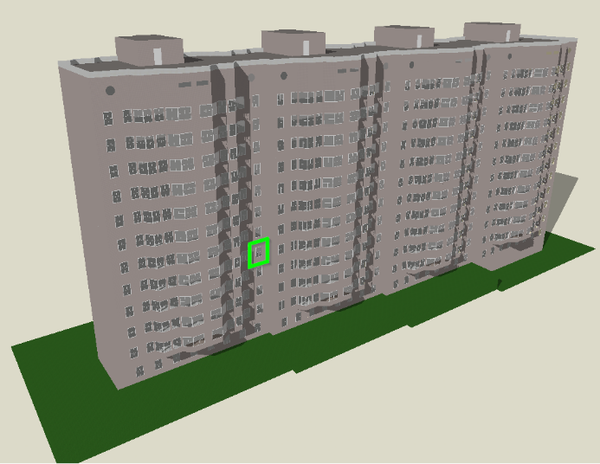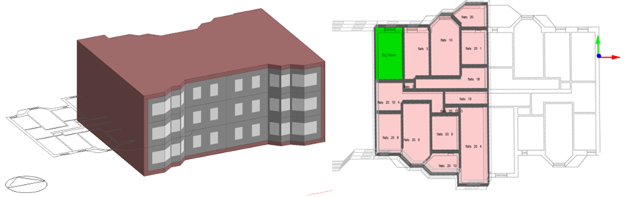
Fig. 1. 3D model and floor plan of the building under study in the Design-Builder software environment

To conduct a more detailed analysis of the above parameters, the study was carried out using the example of a room with options for residential and commercial use. We selected a representative living room in one of the central apartments and the adjacent premises. The area of the room under study is 14.82 m². The area of the outer wall (excluding the window) is 6.82 m². The window area (including the frame) is 1.5 m². The room under study is bordered by two adjacent living rooms, a private corridor, and a restroom.
An explanation of the model names and a schematic representation of the variability is shown in Fig. 2.
During the simulation, the temperature drop was 2℃. For residential premises, when residents are usually not at home, the temperature drop was up to 18℃ between 8:00 and 18:00. Lowering the temperature at night is advisable in commercial premises. Therefore, in the representative commercial building, we considered lowering the temperature on weekends and at night from 22:00 to 8:00 to 18℃.

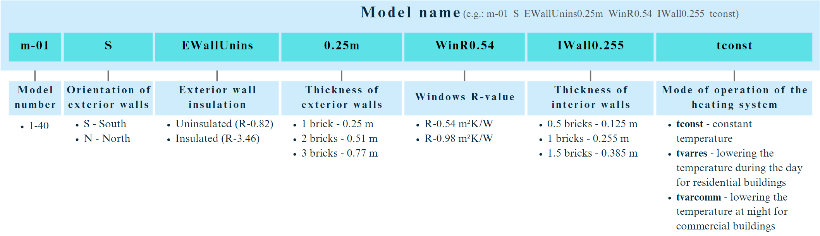
Fig. 2. Model variants and their names

For the thermally modernized thermal envelope variation, the wall was insulated with a 0.1 m thick layer of mineral wool, and the windows were replaced with low-e double-glazed windows with two layers of selective coating (4i-12air-4-12air-4i).
3. Result and Discussion
The modeling results allow us to estimate the impact of various factors on heat flows through exterior walls. Fig. 3, 4, and 5 show how the orientation of the exterior building envelope, wall thickness, and possible modes of indoor temperature reduction can affect heat energy consumption.
Fig. 3 shows the heat energy consumption during the year for different modeling variations, where the variables are the room's orientation, the exterior walls' massiveness, and the heating modes, and the massiveness of the interior walls does not change. It is 255 mm (one brick).

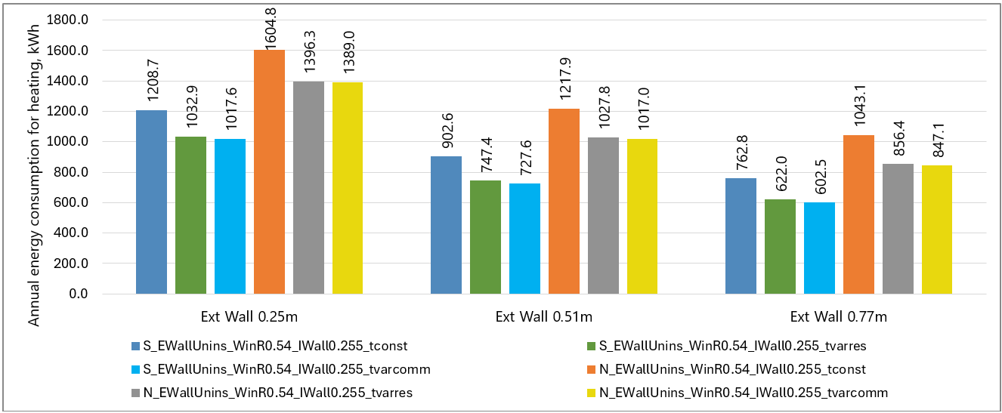
Fig. 3. The annual heat energy consumption at a constant internal wall thickness of 0.255 m

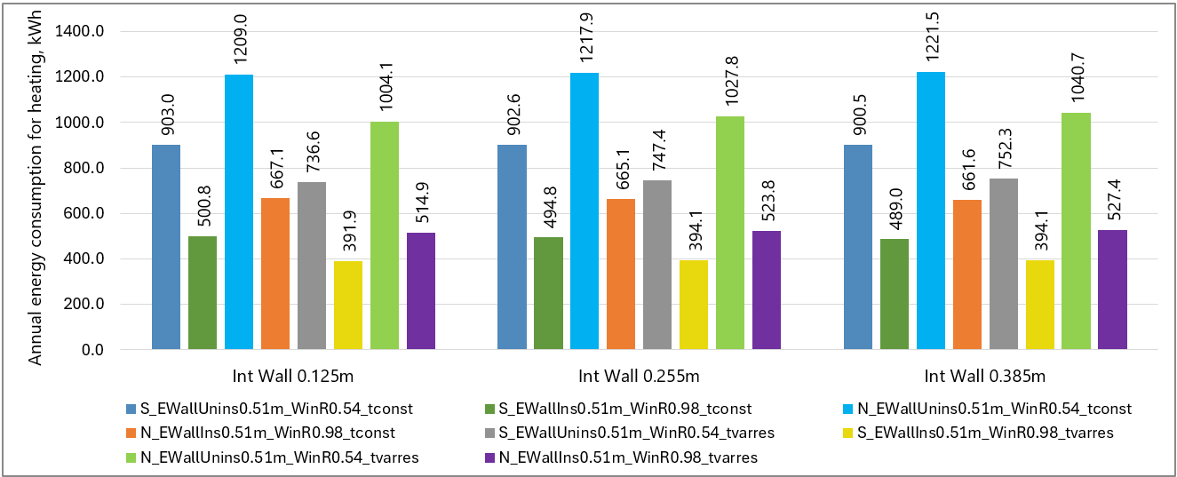
Fig. 4. The annual heat energy consumption at a constant exterior wall thickness is 0.51 m

From the analysis of this series of simulations, it follows that increasing the massiveness of the exterior walls is more effective for rooms with a northern orientation. According to the modeling results, if the exterior wall thickness is doubled (from one brick to two), there is a significant decrease in the average annual load on the heating system and heat energy savings for the northern orientation – 24.1% for the southern orientation – 25.3%. For comparison, a change in the thickness of the outer wall of 3 bricks compared to 1 brick leads to annual heat energy savings of 35.0% for the northern orientation and 36.9% for the southern orientation under constant heating conditions. This pattern is maintained with variable heating modes.
A room with a North (N) orientation has a higher annual energy consumption of 22.63% compared to a room with a South (S) orientation for walls with a massiveness of one brick. In comparison, a threefold increase in wall thickness will lead to a difference in consumption between S and N room orientations of 25.64%.
Fig. 4 shows the heat energy consumption over a year for different simulation variations, where the variables are room orientation, massiveness of interior walls, and heating modes. The thickness of the exterior walls in this series of simulations does not change, and it is 510 mm (two bricks).
The analysis of this series of simulations shows that increasing the massiveness of interior walls has a negligible impact on annual heat energy consumption. The maximum deviation of the corresponding indicators between the models in which the interior walls differed only in massiveness does not exceed 3.65%.
Higher efficiency of increasing the massiveness of interior walls is observed for the southern orientation of the building, where potential savings can reach 2.35%.
At the same time, under conditions of intermittent heating, the positive impact of the increased massiveness of the interior walls decreases, especially for the northern orientation, where an increase in heat consumption of up to 3.65% was recorded, which is explained by a decrease in the intensity of the heat flow from neighboring rooms.
When implementing thermo-modernization measures, heat energy savings of 1-2% are observed with greater massing in all studied variants. This is due to the interaction between the thermal inertia of structures and reduced heat loss through the building envelope. Massive interior walls, with significant thermal inertia, can accumulate heat more efficiently and release it more slowly. Combined with insulation, this leads to a smoother distribution of heat flows and reduced peak loads on the heating system.
Fig. 5 shows the graphs for January (a) and March (b), which demonstrate the dependence of heat consumption on changes in temperature, room orientation, massiveness of interior walls, and the presence of insulation. The thickness of the exterior walls in this series of simulations does not change, and it is 510 mm (two bricks).

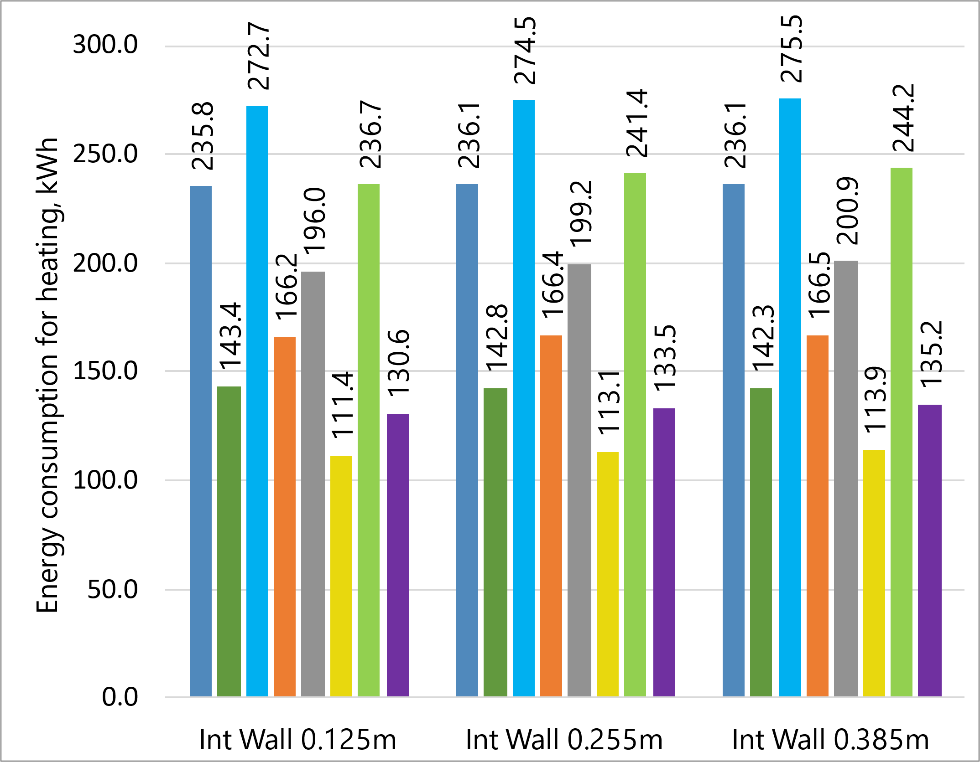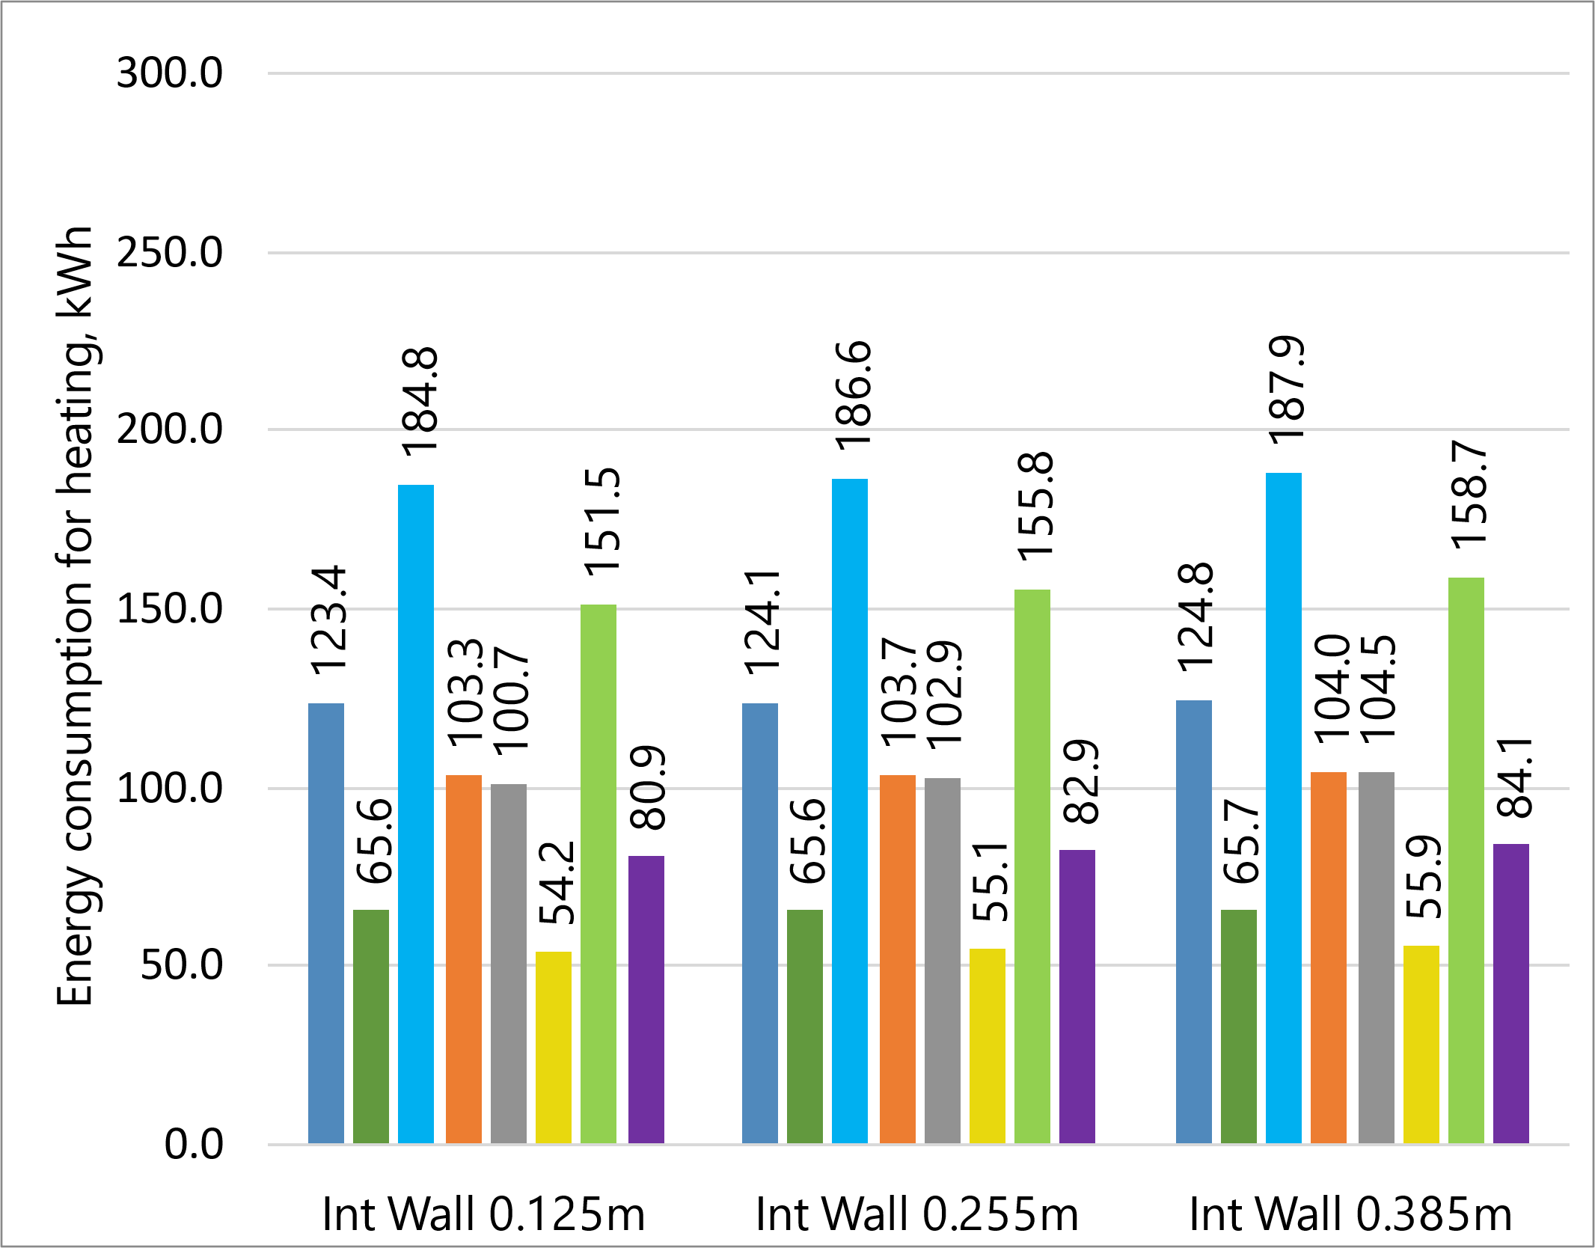
a. b.
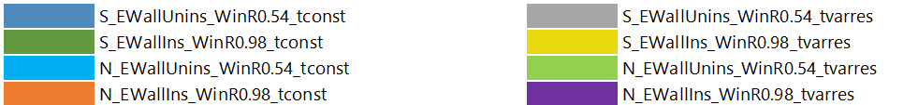
Fig. 5. The annual heat energy consumption at a constant internal wall thickness of 0.255 m

Fig. 5 shows that energy consumption is higher in winter and decreases in transitional seasons. Changing the mass of the interior walls does not significantly affect the overall energy consumption while insulating the exterior walls and replacing windows with more energy-efficient ones has a greater potential to reduce the energy consumption of the building. For example, a model with a south-facing room with insulated exterior walls and replaced windows, 125 mm interior wall thickness, and constant heating mode in January consumes 39.2% less energy for heating compared to a similar model without exterior wall insulation. The difference in heating energy consumption for similar models with a northern orientation of the premises is 39.1%. Introducing intermittent heating modes can save up to 22.3% more for south-facing rooms and up to 21.4% for north-facing rooms.
Fig. 6 shows the study results of the effect of the orientation and thickness of the exterior walls on the load on the heating system in a constant heating mode (constant indoor air temperature tconst is maintained) for February.
It is worth noting that the difference in the load on the heating system between exterior walls with different orientations and massiveness increases in absolute terms and decreases in relative terms with a decrease in outdoor air temperature and solar activity. Notably, February exhibited the high levels of solar activity and the greatest temperature fluctuations. For example, on February 25, the maximum average daily temperature for the month was 4.6°C, while the heat consumption of a room with a southern orientation was 4 429 Wh (1 brick) and 2 466 Wh (3 bricks). For the room with a northern orientation, the same figures were 7 020 Wh (1 brick) and 4 560 Wh (3 bricks).

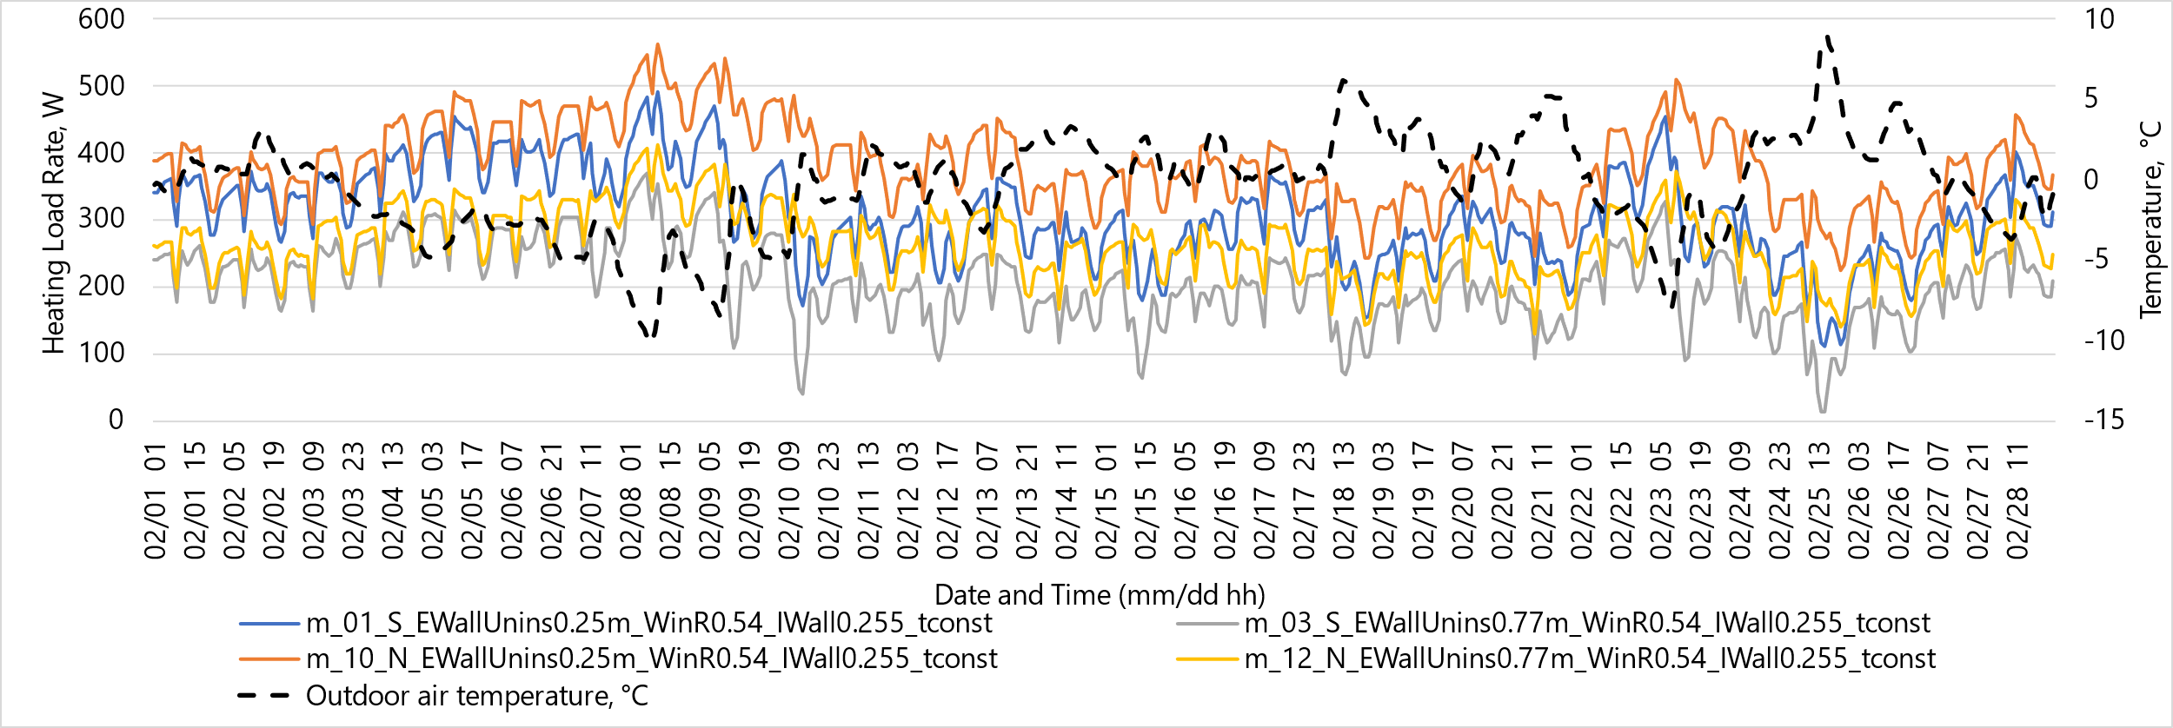
Fig. 6. The load on the heating system depending on different design options, orientation, and outdoor air temperature

On February 8, the minimum average daily temperature for the month was -8°C. At this temperature, the consumption increased to 10 058 Wh (1 brick) and 7 214 Wh (3 bricks) for the south orientation and 12 026 Wh (1 brick) and 8 579 Wh (3 bricks) for the north orientation of the room, respectively.
Fig. 7 shows the study results of the effect of the orientation and thermal modernization of exterior walls on the load on the heating system at a constant heating mode (tconst) for January.

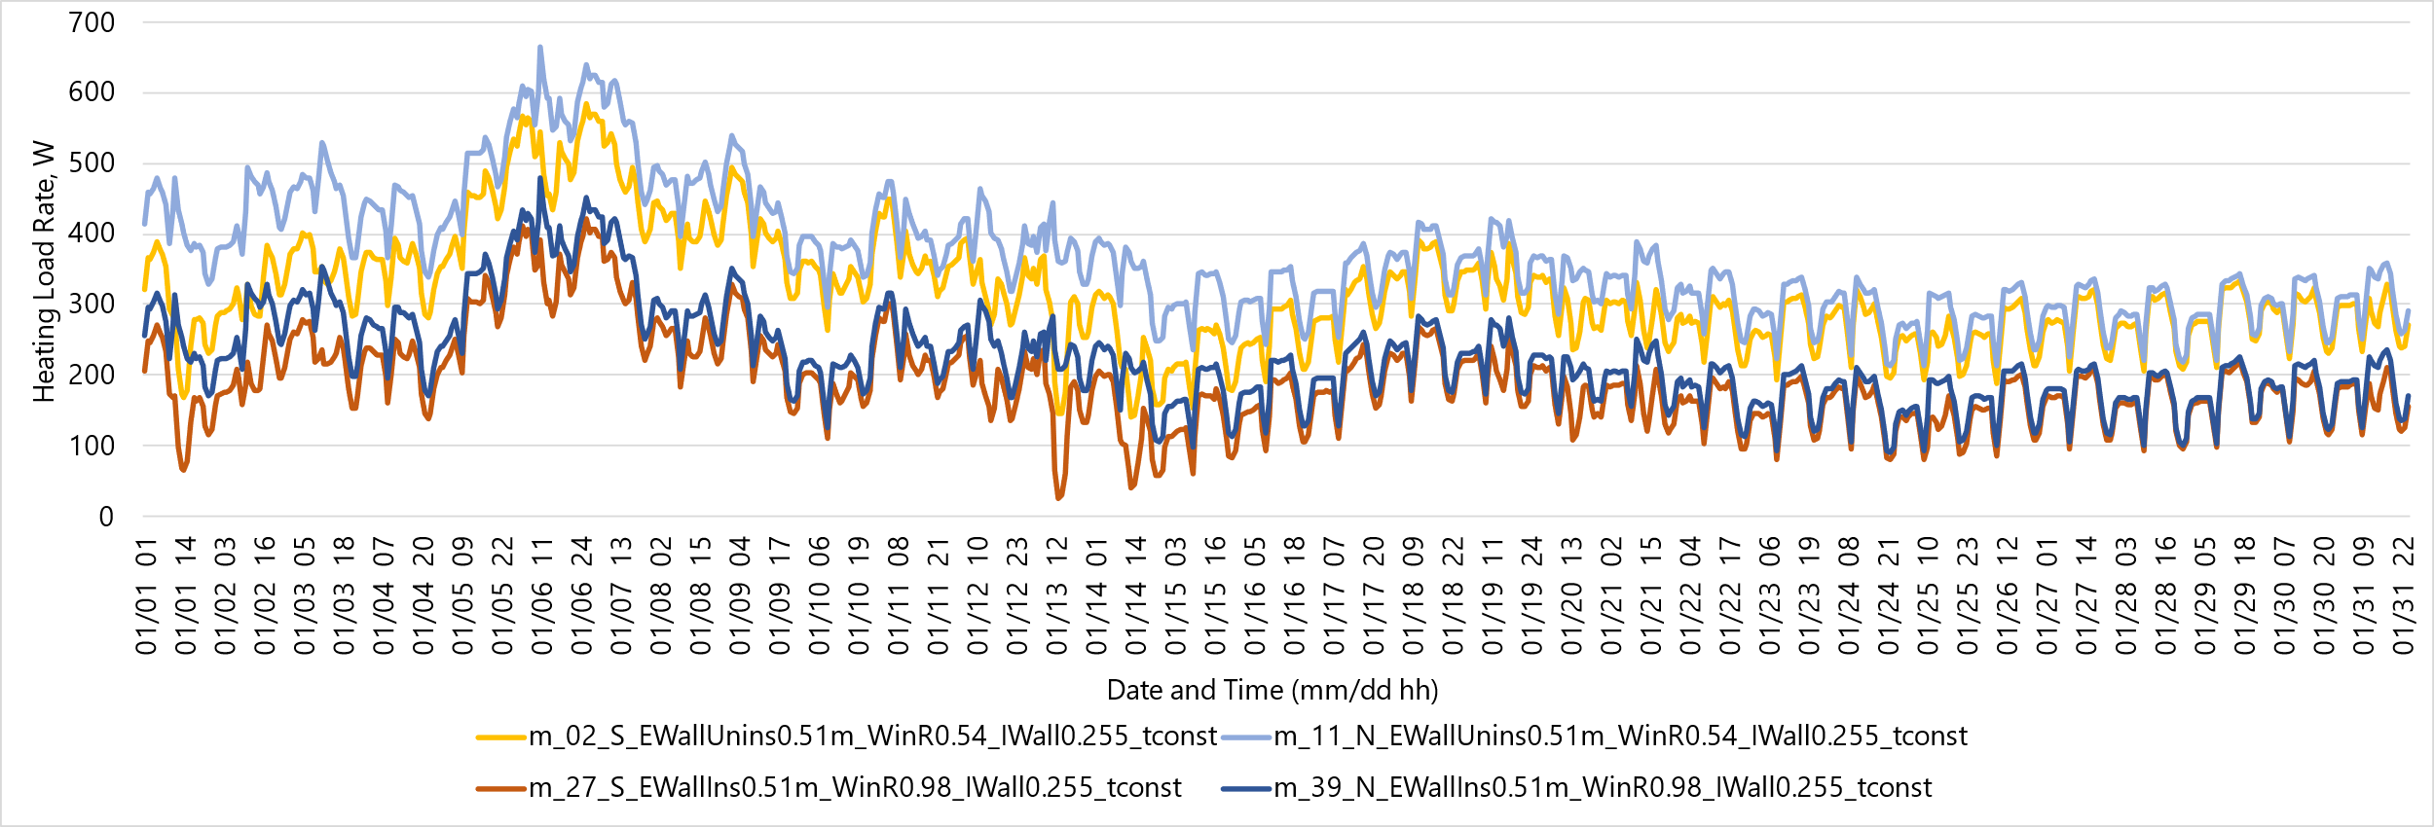
Fig. 7. The load on the heating system depending on different design options, orientation, and outdoor air temperature

Fig. 7 shows that the thermal modernization measures of the building envelope significantly impact the load on the heating system. Accordingly, when the exterior walls are insulated from R = 0.82 m²·K/W to R = 3.46 m²·K/W and the windows are replaced from R = 0.54 m²·K/W to R = 0.98 m²·K/W, the hourly average load on the heating system per month will decrease by 39.5% for south-facing rooms and by 39.4% for north-facing rooms under constant heating conditions.
Figures 9 and 8 show the results of modeling the load on the heating system for the N and S orientations, respectively, depending on different options for controlling the heating system and the outside air temperature for February.

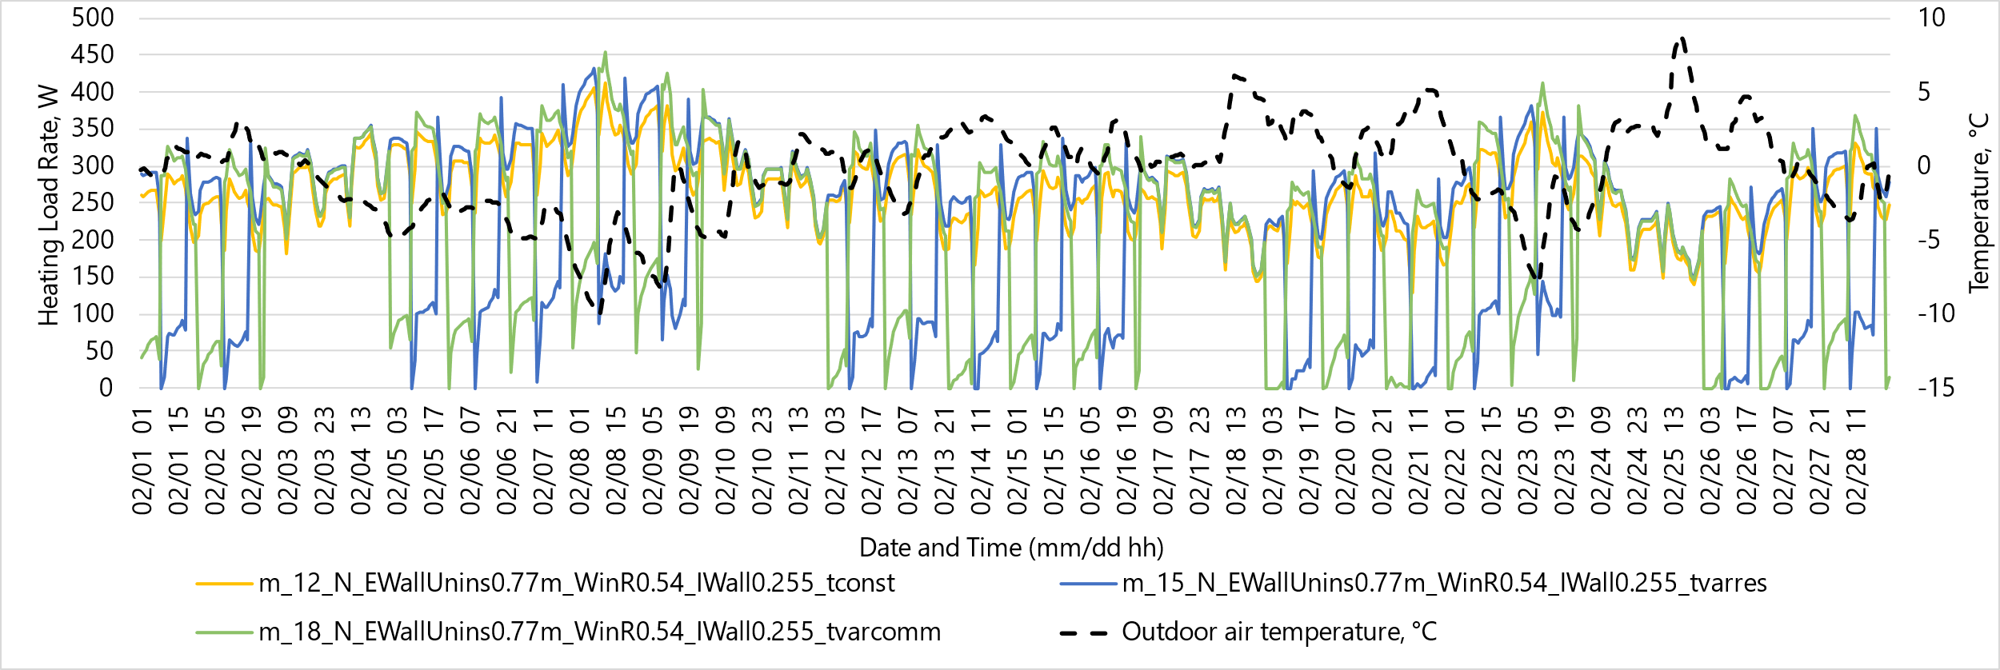
Fig. 8. The load on the heating system for the N orientation, depending on different options for regulating the heating system and the outside air temperature

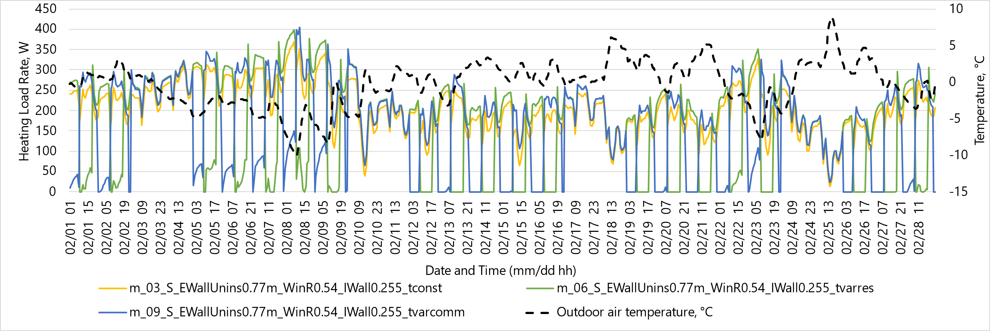
Fig. 9. The load on the heating system for the S orientation depending on different options for regulating the heating system and the outside air temperature

The use of temperature reduction modes explains the sawtooth-shaped spikes in the graphs of Figures 8 and 9. For residential premises, the temperature decrease occurred during the day, when there was solar heat gain and a higher ambient temperature compared to the night period. For commercial premises, the temperature drop occurred at night and on weekends. For the southern orientation, there is a greater range of fluctuations in the magnitude of the load on the heating system, which is associated with greater solar heat gain in the room zone (Fig. 9).
In the second half of February, the outside temperature fluctuated between -8°C and +8.9°C, and there was also greater solar heat gain, so on some days, there was no load on the heating system (Fig. 9).
The annual heat energy savings due to the use of temperature reduction modes in residential and commercial premises compared to the constant heating mode in these premises are shown in Table 1. The modeling was carried out taking into account different thicknesses of exterior walls.

Table 1. Annual heat energy savings due to the use of temperature reduction modes
Masonry thickness |  | 0.25 m | 0.51 m | 0.77 m
Thermal conductivity resistance, (m²·K)/W |  | 0.503 | 0.824 | 1.145
South | Residential | -14.5% | -17.2% | -18.5%
 | Commercial | -15.8% | -19.4% | -21.0%
North | Residential | -13.0% | -15.6% | -17.9%
 | Commercial | -13.4% | -16.5% | -18.8%

The data in Table 1 shows that as the massiveness of the exterior walls increases, the percentage of savings due to the use of intermittent heating modes also increases. At the same time, for commercial premises, the percentage of savings is higher due to lower temperatures during off hours. Annual heat energy savings in north-facing commercial buildings are higher than in residential buildings with the same orientation due to lower temperatures at night.
Fig. 10 shows the results of modeling the load on the heating system for the southern orientation when implementing a variable heating schedule with different masses of interior walls for January.

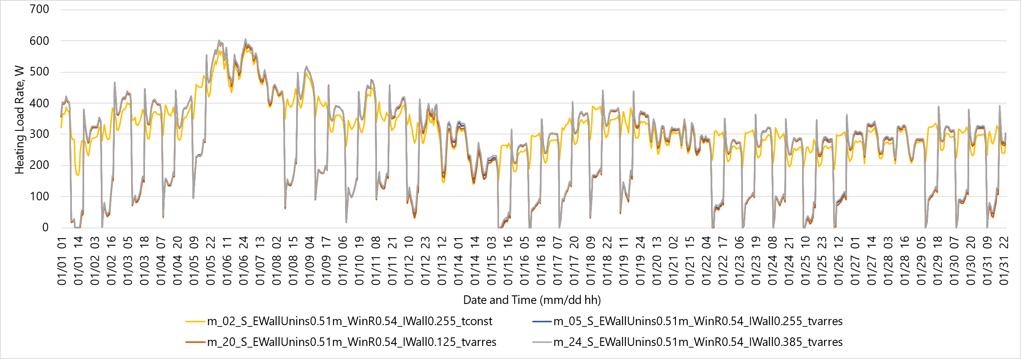
Fig. 10. The load on the heating system depending on different design options, orientation, and outdoor air temperature

The analysis of the data in Fig. 10 shows that the massiveness of the interior walls has a negligible effect on the change in the load on the heating system. The difference in the load on the heating system per hour averaged for January between models with 125 mm and 255 mm interior walls is 1.6% (4.3 W), and with an increase in massiveness to 385 mm, this difference will be 2.5% (6.5 W). However, with the introduction of intermittent heating modes, there are temporary peaks in the load schedule after periods of temperature drop. At the same time, these peaks are higher for rooms with more massive interior walls. Similar peaks are also observed during periods of reduced solar activity.
Fig. 11 shows the monthly heat balances of the studied living room for the northern and southern orientations for the variants with insulated and non-insulated exterior walls for January with constant and variable heating modes. This figure also shows the dependence of heat flows through the exterior walls on such factors as the orientation of the premises to the cardinal points and the thermal conductivity of the exterior walls.
When intermittent heating schedules are introduced, the model shown in Fig. 11(a) is 15.6% more efficient in terms of heating compared to the model shown in Fig. 11(c), which is also clearly demonstrated in the corresponding figures. It is also noticeable that intermittent heating modes reduce heat flows through interior walls and ceilings to adjacent rooms.
When walls are insulated, and new energy-saving windows are installed (Fig. 11(b)), heat losses through exterior walls are significantly reduced – 74.7% and windows – 39.3%, compared to the model in Fig. 11(а). However, due to the lower transmittance of the new windows, solar heat gain is also reduced. Insulation of exterior walls and replacing windows with new ones cause a slight decrease in heat flows through interior walls and ceilings to adjacent rooms.
The use of thermal modernization and the introduction of intermittent heating modes in the complex (Fig. 11(d)) will reduce the total load on the heating system compared to an uninsulated building with a constant heating mode (Fig. 11(a)) in January by 52.1%, and in the off-season months of March and October by 55.6% and 90.6%, respectively.
Due to solar heat gain during the day in a room with a southern orientation, the temperature increases, energy accumulates in the walls, and heat flows through the interior walls and ceilings to adjacent rooms increase. In rooms oriented to the north, there is less heat gain from the sun, and during periods of lower temperatures, the amount of heat flow from the room through the interior walls and ceilings to adjacent rooms increases. Heat losses due to infiltration are the same for all cases and amount to 162-167 kWh.
The data also make it possible to trace the change in the ratio between the heat balance components, for example, in the daytime, depending on fluctuations in outdoor air temperature, solar heat gain, wall thickness, and characteristics.

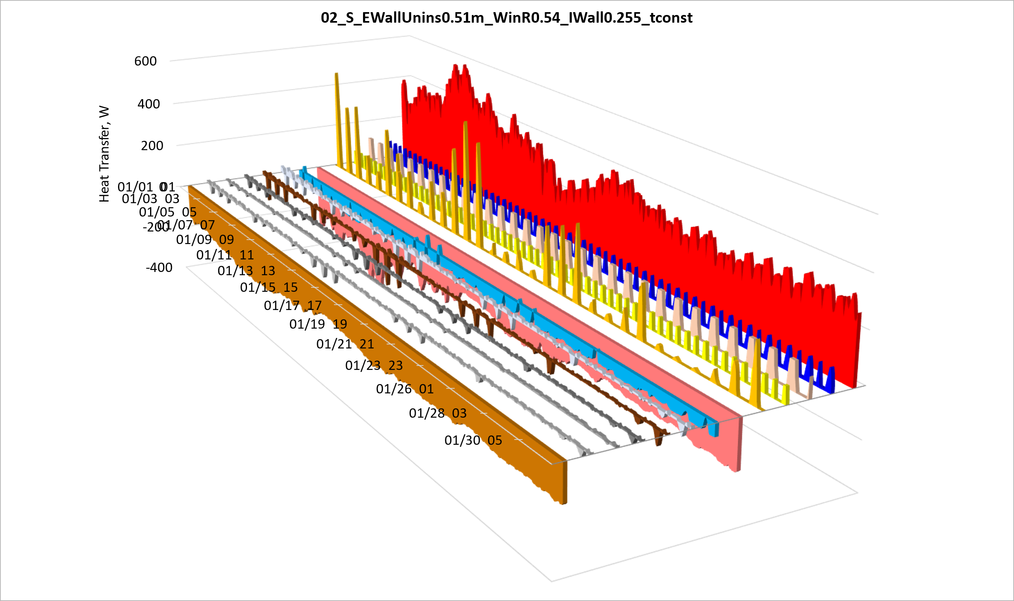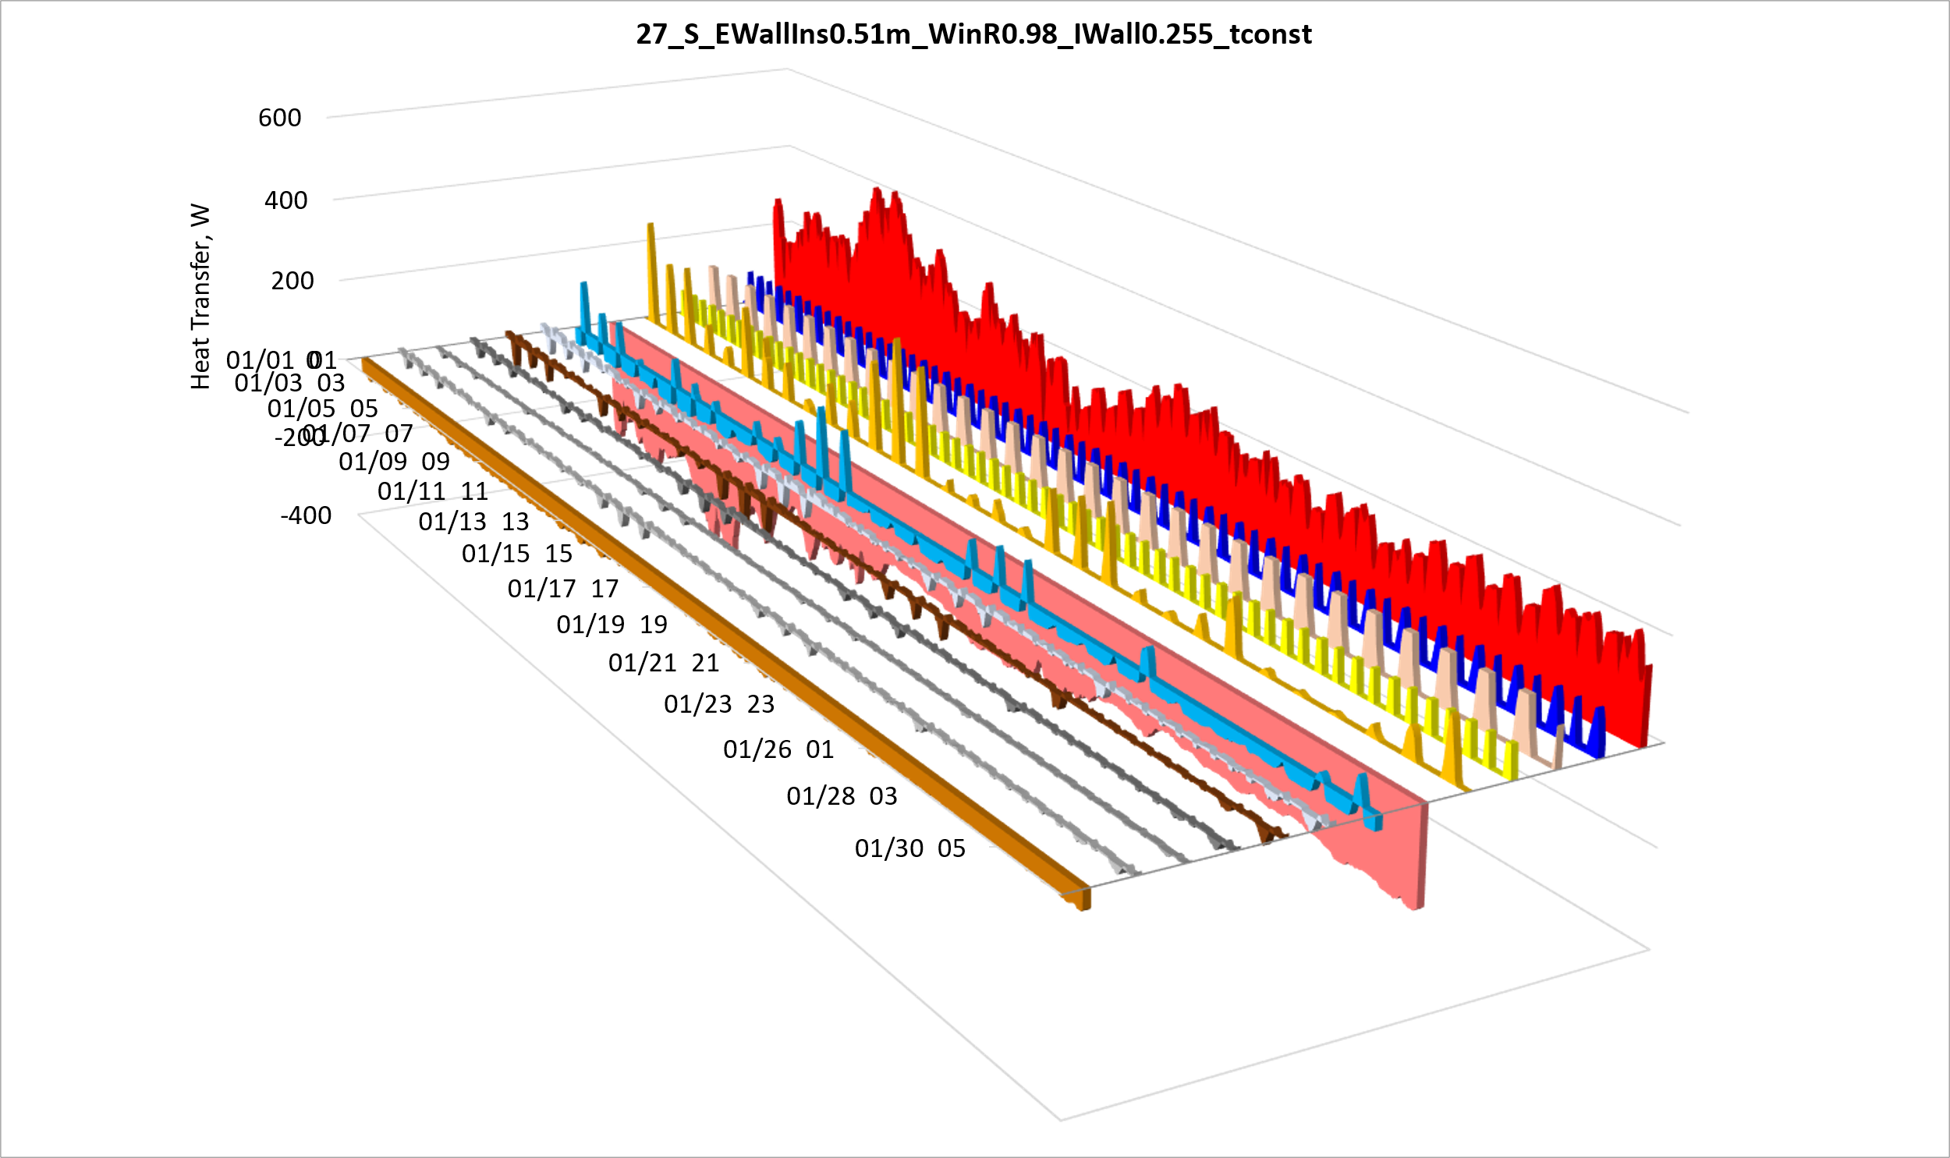
а. b.
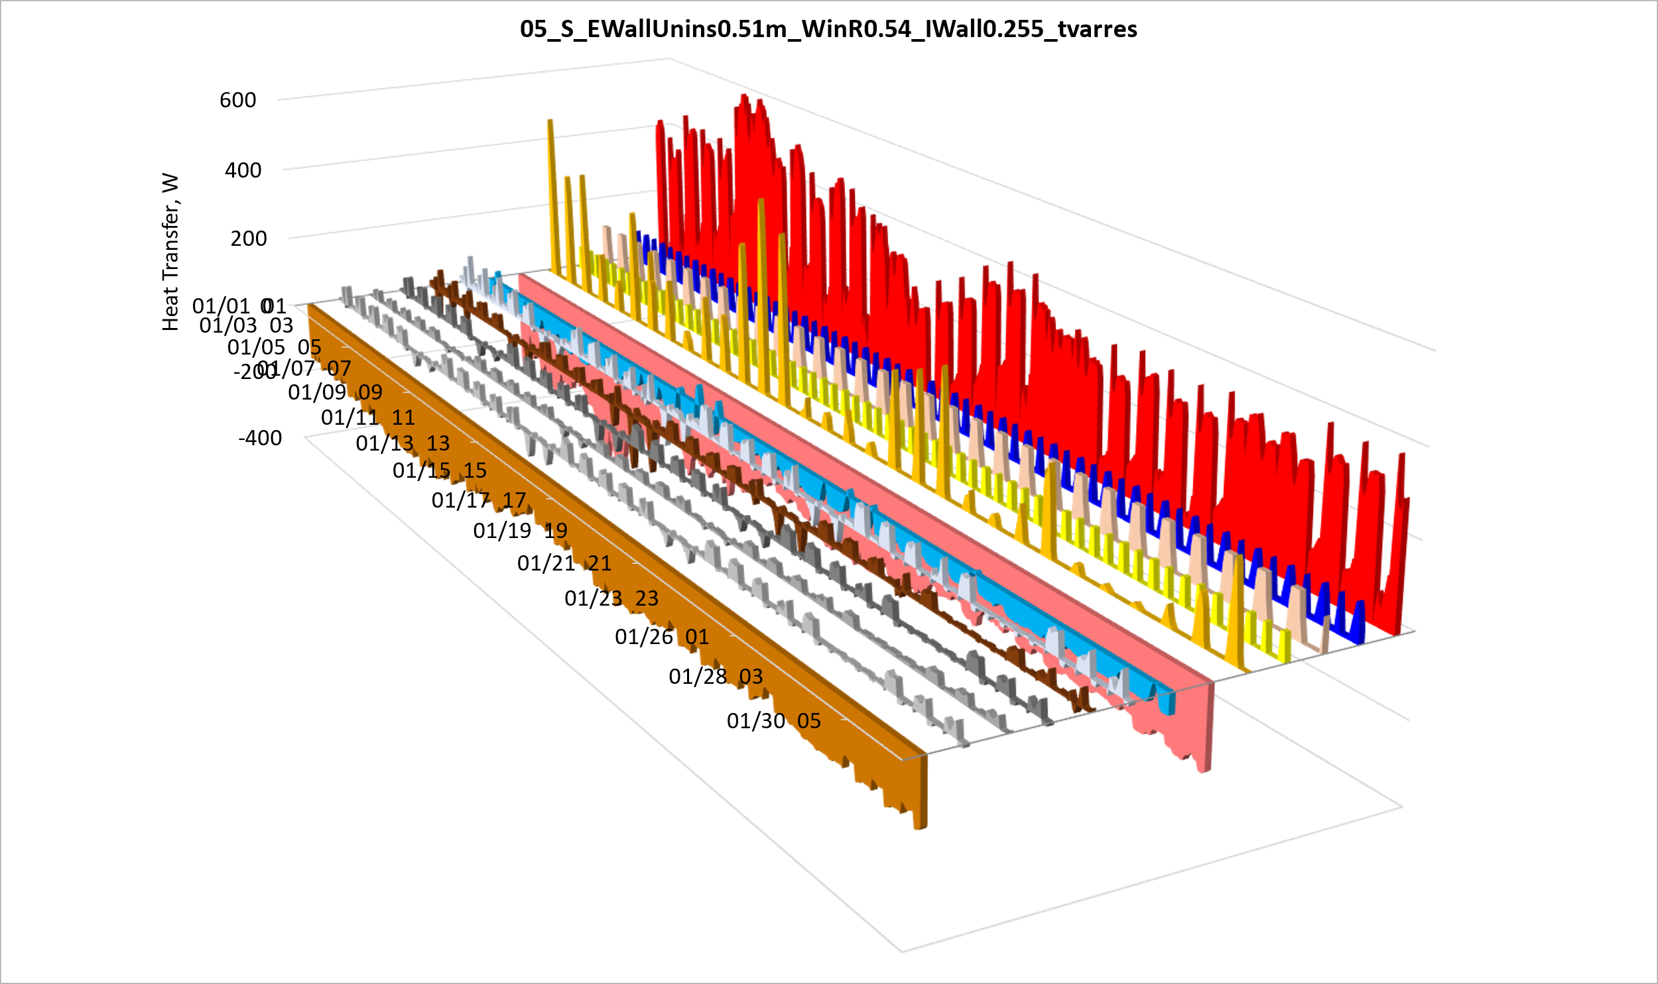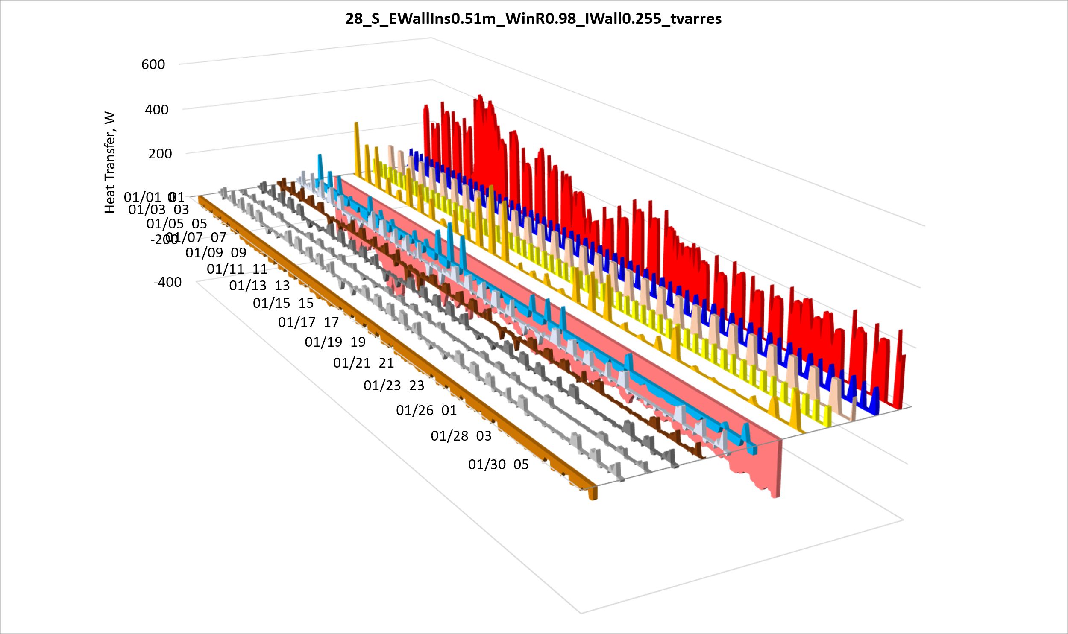
c. d.
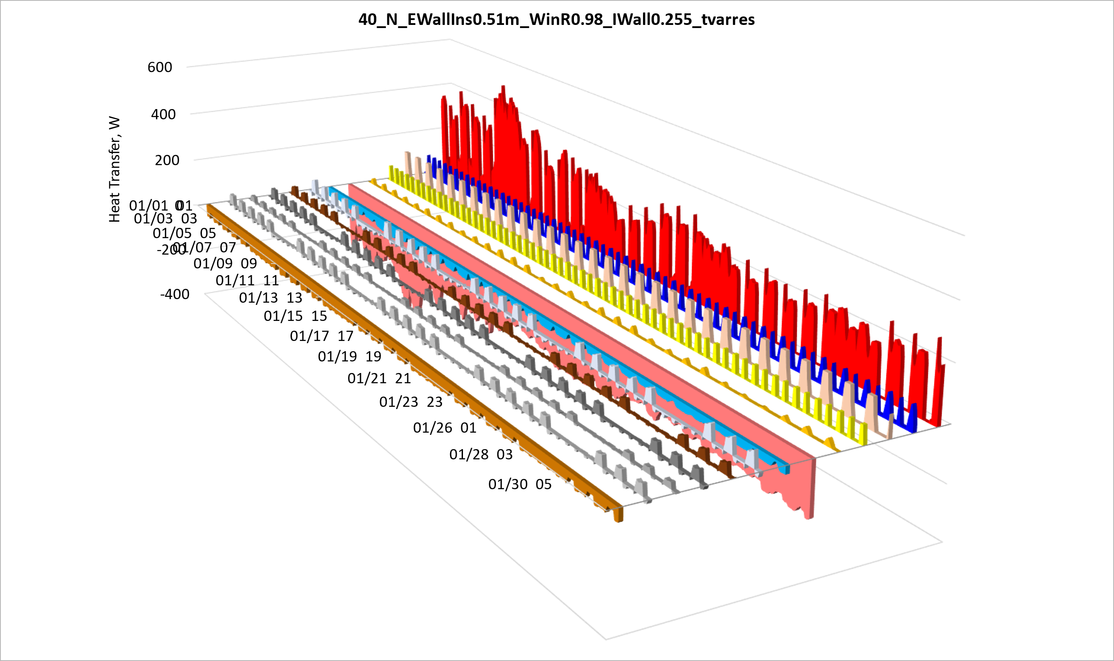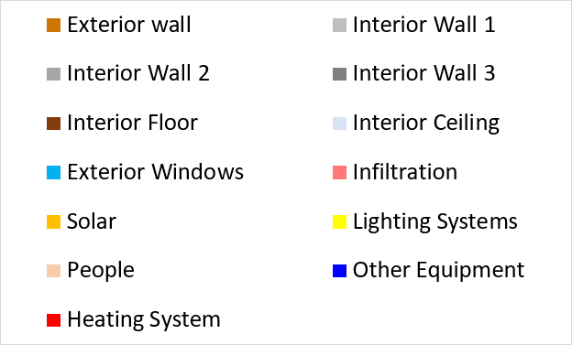
e.
Fig. 11. Heat balance of the room under study for the climatic conditions of January:
a) southern orientation, uninsulated, at a constant temperature
b) southern orientation, insulated, at a constant temperature
c) southern orientation, uninsulated, at variable temperature
d) southern orientation, insulated, at variable temperature
e) north orientation, insulated, at variable temperature
4. Conclusions
This comprehensive research provides a systematic and quantitative analysis of thermal dynamics in residential and commercial buildings, offering critical insights into factors influencing heat flows through exterior and interior walls. The study's primary contribution lies in its sophisticated parametric investigation utilizing advanced dynamic energy simulation techniques, specifically employing EnergyPlus software for precise thermal performance modeling.
Key scientific findings demonstrate substantial energy conservation potential through thermal envelope optimization. Specifically, increasing exterior wall thickness and thermal resistance can achieve up to 40.1% annual heating energy savings.
Comprehensive thermal modernization, encompassing wall insulation and fenestration replacement, can reduce heating system load by nearly 40-50%.
The role of heat flows to interior heaters in balancing the heating level while maintaining the specified indoor air temperature regimes is determined.
Implementing intermittent heating modes allows for an additional 15-23% energy consumption reduction, depending on other characteristics.
The methodological value of the research resides in developing a precision approach to parametric thermal dynamics modeling, incorporating hourly climatic data and comprehensive interactions between architectural, structural, and operational factors.
The obtained results hold significant implications for architectural design, energy-efficient building modernization and retrofit, and the development of adaptive thermal management systems, namely to become the basis for tuning controllers using building artificial intelligence/neural networks, which will allow for a more accurate and detailed representation of heat transfer characteristics inside the building.
References
Asdrubali, F., Venanzi, D., Evangelisti, L., Guattari, C., Grazieschi, G., Matteucci, P., & Roncone, M. (2020). An Evaluation of the Environmental Payback Times and Economic Convenience in an Energy Requalification of a School. Buildings, 11(1), 12. https://doi.org/10.3390/buildings11010012
Belaïd, F., & Massié, C. (2023). Driving forward a low-carbon built environment: The impact of energy con-text and environmental concerns on building renovation. Energy Economics, 124. https://doi.org/10.1016/j.eneco.2023.106865
Buyak, N., Deshko, V., & Bilous, I. (2021). Сhanging Energy and Exergy Comfort Level after School Thermomodernization. Rocznik Ochrona Srodowiska, 23, 458-469. https://doi.org/10.54740/ros.2021.031
Buyak, N., Deshko, V., Bilous, I., Biriukov, D. & Voloshchuk, V. (2024). Applying dynamic energy and exergy analysis to a building envelope. Int. J. Exergy, 43(2). 93-107. https://doi.org/10.1504/IJEX.2024.136928
Buyak, N., Deshko, V., Bilous, I., Pavlenko, A., Sapunov, A., & Biriukov, D. (2023). Dynamic interdependence of comfortable thermal conditions and energy efficiency increase in a nursery school building for heating and cooling period. Energy, 283. https://doi.org/10.1016/j.energy.2023.129076
Deka, P., & Szlęk, A. (2022). Thermal energy storage in buildings: Opportunities and challenges. (2023). Archives of Thermodynamics. 43(4), 21-61. https://doi.org/10.24425/ather.2022.144405
Deshko, V., Bilous I., Boiko, T., Shevchenko, O., Borodinecs, A., & Zemitis, J. (2024). Energy performance of higher education institutions buildings operating during quarantine restrictions and/or martial law in Ukraine. Latvian Journal of Physics and Technical Sciences, 2, 44-65. https://doi.org/10.2478/lpts-2024-0012
Deshko, V., Bilous, I., Buyak, N. & Shevchenko, O. (2020). The Impact of Energy-Efficient Heating Modes on Human Body Exergy Consumption in Public Buildings. 2020 IEEE 7th International Conference on Energy Smart Systems (ESS), 201-205. https://doi.org/10.2478/lpts-2024-0012
Ding, K., Kaiser Calautit, J., & Jimenez-Bescos, C. (2024). Significance of external wind conditions on the convective heat transfer coefficients (CHTC) and energy performance in multi-zone high rise buildings. Energy and Buildings, 320. https://doi.org/10.1016/j.enbuild.2024.114570
Dodoo, A., & Gustavsson, L. (2016). Energy use and overheating risk of Swedish multistorey residential buildings under different climate scenarios. Energy, 97, 534-548. https://doi.org/10.1016/j.energy.2015.12.086
Habibi, S. (2024). The effect of building orientation on energy efficiency. Clean Technologies and Envi-ronmental Policy, 26(4), 1315-1330. https://doi.org/10.1007/s10098-024-02796-0
Hafez, F. S., Sa’di, B., Safa-Gamal, M., Taufiq-Yap, Y. H., Alrifaey, M., Seyedmahmoudian, M., Stojcevski, A., Horan, B., & Mekhilef, S. (2023). Energy Efficiency in Sustainable Buildings: A Systematic Review with Taxonomy, Challenges, Motivations, Methodological Aspects, Recommendations, and Pathways for Future Research. Energy Strategy Reviews, 45. https://doi.org/10.1016/j.esr.2022.101013
Hajji, A., Lahlou, Y., & Abbou, A. (2022). Impact of Solar Gain on Energy Consumption and Thermal Comfort. [In:] S. Bennani, Y. Lakhrissi, G. Khaissidi, A. Mansouri, & Y. Khamlichi (Eds.). WITS, 745, 723-733. Springer Singapore. https://doi.org/10.1007/978-981-33-6893-4_66
Hea, W., & Huang, H. (2024). Research on optimization of the heating system in buildings in cold regions by energy-saving control. Archives of Thermodynamics, 129-135. https://doi.org/10.24425/ather.2024.150445
Leccese, F., Salvadori, G., & Bisegna, F. (2024). Thermal resilience of buildings: The role of partition walls and slabs in the optimization of the building external envelope. Applied Thermal Engineering, 257. https://doi.org/10.1016/j.applthermaleng.2024.124084
Leccese, F., Salvadori, G., Asdrubali, F., & Gori, P. (2018). Passive thermal behaviour of buildings: Per-formance of external multilayered walls and influence of internal walls. Applied Energy, 225, 1078-1089. https://doi.org/10.1016/j.apenergy.2018.05.090
Zhao, E., Zhao, L., & Zhou, Z. (2020). The signifi-cance for solar heat gain on the indoor thermal environment of passive houses in cold areas in China. Energy Efficiency, 13(6), 1047-1062.
https://doi.org/10.1007/s12053-020-09858-4
DBN V.2.6-31:2021. Thermal insulation and energy efficiency of buildings. Replaces DBN V.2.6-31:2016; effective from 2022-09-01. Official edition. Kyiv, 2021. 23 p.
DesignBuilder. (n.d.). [Computer software]. Design-Builder Software Ltd. https://designbuilder.co.uk/software/product-overview
EnergyPlus Energy Simulation Software. (n.d.). [Computer software]. https://energyplus.net/downloads
International Weather for Energy Calculations. (n.d.). [Dataset]. https://climate.onebuilding.org/WMO_Region_6_Europe/UKR_Ukraine/index.html#IDKC_Kiev_City-

