|  |  |  |  |
| --- | --- | --- | --- |
|  |  | | |
| **Rocznik Ochrona Środowiska** | | |
| Volume 27 | Year 2025 ISSN 2720-7501 | pp. 96-109 |
|  | https://doi.org/10.54740/ros.2025.009 open access | | |
|  | Received: September 2024 Accepted: February 2025 Published: February 2025 | | |

Optimizing Stabilizer Mixes for Solidification of Heavy Metal-Laden Sludge from Electroplating Industry Wastewater: A Comprehensive Study on Operational Parameters and Microstructural Analysis

Pushpa Lumina1, Megha Kulkarni2, Mohammad Amir Khan3*, Majed Alsubih4, Saiful Islam4, Ahmed M. Abdulhadi5, Vaishali Mendhe6

1REVA University, Bangalore, Karnataka, India

2Nitte Meenakshi Institute of Technology, Bangalore,   
Affiliated to Visvesvaraya Technological University, Belagavi, Karnataka, India

3Department of Civil Engineering, Galgotias College of Engineering, Greater Noida, Uttar Pradesh, India

4Civil Engineering Department, College of Engineering, King Khalid University, Abha, Saudi Arabia

5Al-Safwa University College, Kerbala, Iraq

6Department of Civil Engineering, Yeshwantrao Chavan College of Engineering, Nagpur, India

*corresponding author's e-mail: [amirmdamu@gmail.com](mailto:amirmdamu@gmail.com)

**Abstract:** This study focuses on optimizing stabilizer mixes for the solidification and stabilization (S/S) of heavy metal-laden sludge from the electroplating industry, with a dual objective: meeting secure landfill disposal standards and understanding the underlying S/S mechanisms. The research investigates the impact of operational parameters such as stabilizer dosage, curing time, and material composition on solidification efficiency using samples from an electroplating effluent treatment plant. Advanced analytical techniques, including Scanning Electron Microscopy (SEM) and X-ray Diffractometry (XRD), were employed to examine the microstructural changes in the stabilized matrices. The findings highlight the effectiveness of cement-based stabilizers and waste-derived pozzolanic materials, such as waterworks sludge and electroplating slurry, in achieving high unconfined compressive strength (UCS) and immobilizing heavy metals. The study also identifies sinter as a promising binder that transforms waste into durable, structurally sound products, offering a sustainable approach to waste management.

**Keywords:** solidification, stabilization, electroplating industry, heavy metal-laden sludge, operational parameters, secure landfills, microstructural study

Highlights

* **Enhanced Solidification**: Sinter-stabilized mixes achieve compressive strengths up to 18 times the minimum criteria for secure landfill disposal.
* **Waste Utilization**: Innovative use of waterworks and electroplating sludge as binding agents reduces disposal costs and landfill waste.
* **Mechanistic Insights**: SEM and XRD analyses reveal crystalline "spinal formation" encapsulating heavy metals, ensuring effective stabilization.
* **Superior Binder Performance**: Sinter "S" outperforms conventional binders like fly ash and lime in reducing heavy metal concentrations.

1. Introduction

Concrete, a component in the construction industry, is susceptible to forms of damage over time. One of the problems is the formation of cracks, which significantly reduce its strength. To address this challenge, researchers have explored the concept of self-healing materials that can repair themselves and minimize damage (Taheri & Clark 2021). Over the years, attention has focused on self-healing mortar, an incredible substance that can repair fractures and imperfections without external help (Tesfamariam et al. 2022). This study aims to optimize the combination of fly ash, oxides, and bacterial agents to develop an environmentally friendly self-healing mortar (Nguyen et al. 2019).

The basic concept of self-healing materials incorporates healing agents or processes into the material's structure (Sun et al. 2021). This study investigates the mechanism of induced calcium carbonate precipitation (MICP), which has shown potential in the field of self-healing mortar (Chen et al. 2021). Bacterial agents, those from the genera Bacillus or Sporosarcina, play a role in the production of calcium carbonate, a mineral that effectively repairs cracks and increases the durability of mortar (Khed et al. 2022). Combining fly ash, a by-product of coal combustion, with the properties and properties of graphene oxide, known for its strength and impermeability, significantly improves the mortar's ability to chemically repair itself (Nasser et al. 2022).

Based on previous studies investigating microbial activity in aquifers and the influence of microbes in areas affected by landfill leachate, understanding bacterial function is essential for developing materials with self-healing capabilities (Wydro et al. 2022). The complex interplay between microbiological mechanisms highlights the importance of precise control of bacterial agents to promote effective mortar crack healing, particularly in environments affected by landfill leachate (Chen et al. 2021).

This research deals with the urgent issue of hazardous waste, which seriously threatens the environment and public health. Various sources, such as industrial processes, medical facilities, laboratories, and residential areas, can produce hazardous waste. There is a chance that these wastes can contaminate the soil, water, and air, endangering both humans and wildlife (LaGrega et al. 2010). To meet these potential risks, strict guidelines and procedures have been implemented to govern the safe handling, storage, transportation, and disposal of hazardous waste. One of the key pretreatment techniques for hazardous waste management is stabilization. This project aims to develop innovative solutions for hazardous waste management by reducing its toxicity and reactivity. A critical step in this effort is the solidification process, which converts hazardous waste into a more manageable state. This is achieved by incorporating specific materials that facilitate waste handling and disposal. The basis of this process is the sintering technique, which uses high temperatures to dry the sludge and create a stabilizing material called "Sinter". This paper focuses on the key role sintering plays in the stabilization process and aims to identify alternative binders and optimize stabilizer mixtures for effective solidification of sludges with high heavy metal content. The ultimate goal of this project is to provide practical recommendations for the proper disposal of hazardous waste. In addition, to better understand the solidification/stabilization (S/S) process, microstructural analysis involves the use of X-ray diffraction (XRD) and scanning electron microscopy (SEM) (Xu et al. 2009). The main goal of this project is to revolutionize landfill leachate research. By fine-tuning the ratios of fly ash, graphene oxide, and microbiological agents, we aim to produce a self-healing mortar that is sustainable and durable. Through the integration of microbial activity and redox processes, the aim is to promote progress in developing environmentally friendly building materials. For a quick reference to current literature, refer to Table 1.

**Table 1.** Recent literature

|  |  |  |  |  |
| --- | --- | --- | --- | --- |
| Reference | Title | Objective | Methodology | Key Findings |
| (Changjutturas et al. 2019) | "Solidification and Stabilisation of Metal Plating Sludge with Fly Ash Geopolymers"  Changjutturas, Kosawat et al. (2019) | Investigate stabilization of metal plating sludge with fly ash geopolymers. | Synthesis of geopolymers from fly ash, PS-FA mixtures, and liquid alkaline activator. | Increasing PS content reduces porosity, forms N-A-S-H and C-A-S-H gels, meets EPA requirements, proposes waste management approach. |
| (Omar et al. 2023) | "Optimization of the Self-Healing Efficiency of Bacterial Concrete"  Omar, O. et al. (2023) | Evaluate and optimize bacterial concrete self-healing with mineral precursors. | Phases involving impregnation, mechanical testing, wet/dry cycles, and SEM/EDS analysis. | Utilizes bacterial agents, investigates novel sodium lactate precursor, validates results through SEM/EDS, addresses literature gap. |
| (Khed et al. 2022) | "Optimization of Graphene Oxide Incorporated in Fly Ash-Based Self-Compacting Concrete"  Khed, Veerendrakumar C. et al. (2002) | Investigate the effects of graphene oxide on SCC properties. | Uses Response Surface Methodology tests various combinations of fly ash, GO, and other variables. | GO negatively affects fresh properties, enhances mechanical strengths, optimal fly ash content determined, improved heat resistance, multi-objective optimization for optimal SCC performance. |

**Table 1.** cont.

|  |  |  |  |  |
| --- | --- | --- | --- | --- |
| (Stefanovska & Fidanchevski 2023) | "Effect of Fly Ash and Crystalline Admixture on the Self-Healing Efficiency of Mortars"  Stefanovska, I., & Fidanchevski, E. (2023) | Study the impact of FA and CA on the self-healing efficiency of mortars. | Crack formation, aging, testing mechanical properties, microscopic investigation, and healing efficiency evaluation. | FA and CA influence strength, promote self-healing, microscopic analysis shows CaCO3 precipitation, healing efficiency increases over time. |
| (Luan et al. 2023) | "Uncovering the Mechanism of the Role of Fly Ash in the Self-Healing Ability of Mortar with Different Curing Ages"  Luan, Congqi et al. (2023) | Investigate self-healing of mortar with varying fly ash contents at different curing ages. | Material analysis, sample preparation, crack induction, observation techniques, and self-healing product characterization. | Fly ash impacts crack closure, time-dependent influence on self-healing, calcium carbonate precipitation dominates self-healing mechanism. |
| (Chen et al. 2021, Luan et al. 2023) | "Bacterial Self-Healing Agent in Low-Carbon Concrete: Impact on Embodied Carbon and  Mechanical Properties"  Medeiros, J. M. P., & Di Sarno, L. (2022) | Examine bacterial self-healing agent in low-carbon concrete. | Preparation and testing of concrete mixes, analysis of embodied carbon, assessment of mechanical properties. | GGBS reduces embodied carbon, self-healing agent further reduces embodied carbon, lowers mechanical properties initially, but matches control by 28 days, concerns about GGBS sustainability |
| (Abdurrahman & Putra 2022) | "Analysis of Self-Healing Concrete Parameters Using Taguchi Method and Regression Modeling"  Abdurrahman, D., & Putra, H. (2022) | Analyze parameters influencing self-healing properties of concrete. | Taguchi method, analysis of variance, modeling, validation through direct testing. | Optimal variations determined for bacterial concentration, bacterial type, application method, and curing time, modeling results supported by literature. |
| (Askar et al. 2023) | "Self-healing abilities of cement mortars containing microorganisms produced in the process of sewage sludge treatment".  Askar, Muath Abu et al. (2023) | Investigate sewage water as self-healing agent in concrete. | Sewage water collection, sample preparation, exposure and testing, evaluation of self-healing. | Sewage water induces crack healing without compromising properties, specific sewage water enhances compressive strength, stereomicroscopic analysis confirms self-healing ability. |

Novelty of the Present Research

Introduction of Sinter as a Novel Binder: The study uniquely identifies sinter, derived from waste materials, as a highly effective stabilizer for solidifying and stabilizing heavy metal-laden sludge. This binder performs better than conventional materials like lime and fly ash in terms of compressive strength and metal immobilization.

Utilization of Industrial Waste for Sustainable Stabilization: For the first time, waterworks sludge and electroplating slurry are employed as pozzolanic binding agents, showcasing their potential to reduce landfill dependency while offering a sustainable waste management solution.

Mechanistic Insights through Advanced Analytical Tools: The application of Scanning Electron Microscopy (SEM) and X-ray Diffractometry (XRD) provides novel insights into the microstructural changes during the stabilization process, specifically the formation of crystalline "spinal structures" responsible for immobilizing heavy metals.

Circular Economy Approach: The research integrates industrial waste into sintered products, reducing disposal costs and creating opportunities for secondary applications in construction and road materials, promoting resource efficiency and sustainability.

High-Strength Solidified Products: The research demonstrates the ability to achieve compressive strengths up to 18 times the minimum requirements for secure landfill disposal, significantly exceeding existing benchmarks in stabilization technology.

This combination of novel binder introduction, sustainable waste utilization, advanced mechanistic studies, and alignment with circular economy principles establishes the present research as a pioneering contribution to industrial waste management practices.

2. Materials and Methodology

2.1. Materials

OPC and Fly Ash (Binders)

The cement was obtained from the Birla Cement Company. Class F fly ash was obtained from the Prism RMC plant. The cement used was OPC 43 grade, which adheres to the Indian Standard IS 8112.

Chemical analysis for cement and fly ash was also performed, and its results are tabulated as shown in Table 2.

**Table 2.** Physical and chemical composition of OPC and fly ash

|  |  |  |  |  |  |  |  |  |  |
| --- | --- | --- | --- | --- | --- | --- | --- | --- | --- |
| Material | Chemical properties % | | | | | | | | Physical properties |
| CaO | SiO2 | Al2O3 | Fe2O3 | MgO | Na2O | SO3 | Loss  in ignition | Specific gravity (g/cm3) |
| OPC | 63.2 | 21.08 | 5.74 | 3.13 | 4.32 | 0.18 | 2.06 | 1.91 | 3.15 |
| Fly ash | 4.08 | 59.94 | 20.87 | 4.67 | 1.55 | 0.62 | 0.35 | 4.34 | 2.2 |

Lime

Lime of AR grade was purchased from Chemical Stores. Write down the chemical and physical properties as shown above.

ETP Sludge

The PEENYA Industrial Estate in Bangalore provided the zinc-containing ETP sludge. The moisture content, volatile solids, Zn, Cd, Co, Cu, Cr, Fe, Pb, Mn, and Ni were all determined by characterizing the zinc sludge (ETP sludge). The sludge was dried in a muffle furnace at 400°C for 2 hours. To achieve a homogenized sample with particles smaller than 1 mm, it was crushed to remove any large stones and then sieved. Visual examination showed that the ETP sludge had a deep brown hue, a powdery texture, and a semi-solid physical condition. Using the Pyconometer Method, the specific gravity of the sludge was calculated, and the result was 2.67. This parameter gives information on the sludge's density, affecting its behavior throughout different processes like settling and separation.

Upon using a pH meter, it was discovered that the sludge had a pH of 8.25. The pH of the sludge plays a crucial role in determining its chemical makeup and how it interacts during the treatment process. In fact, the sludge appears to have slightly alkaline properties, as evidenced by its reading of 8.25 on the pH scale. Further investigation was then conducted to measure the levels of heavy metals present in the sludge samples. The concentrations were quantified using parts per million (ppm) for metals such as Cu, Cr, Fe, Mn, Ni, Pb, Zn, and Co. The results in Table 3 indicate significant amounts of these heavy metals in the raw sludge from the ETP.

**Table 3.** Heavy metal concentration in a sludge sample

|  |  |  |  |  |  |  |  |  |  |
| --- | --- | --- | --- | --- | --- | --- | --- | --- | --- |
| Sno. | Sample | Heavy Metal Concentration (ppm) | | | | | | | |
| Cu | Cr | Fe | Mn | Ni | Pb | Zn | Co |
| 1 | Raw ETP Sludge | 197.94 | 1.68 | 64.72 | 506.73 | 3.46 | 15.53 | 6613.9 | BDL |
| 5 | SLF Disposal Limits | 10 | 0.5 | – | – | 3 | 2 | 10 | – |

The Cu, Cr, Fe, Ni, Pb, and Zn levels found in the electroplating sludge far exceed the allowable limits for sludge disposal (as stated in the SLF Disposal Limits). This raises significant concerns about the impact of this sludge on the environment and whether it meets regulatory requirements. Lead (Pb) and zinc (Zn) are particularly prevalent among the heavy metals present and greatly exceed disposal limits. Effective management and treatment measures must be implemented to deal with these high concentrations properly. Only through these measures can we ensure that proper disposal methods follow environmental regulations and that ecosystems are safeguarded against potential pollution.

2.2. Methods

We carefully examined 5 kilogram samples of electroplating sludge in our experimental setup and carefully studied their physical and chemical properties. Our in-depth analysis focused on key stabilizers such as fly ash, lime, cement, and additives. To evaluate the effectiveness of these agents in preventing the leaching of hazardous components, we performed leaching resistance experiments with varying amounts of each. Our study emphasized the determination of heavy metal levels and carefully investigated the characterization of stabilization agents and stabilized samples.

To achieve optimal stabilization of electroplating sludge, the study team carefully tested and analyzed various operational factors, including stabilizer dosage, combinations, ratios, and curing time (3 and 7 days). Their goal was to identify the most effective approach to stabilizing the material. The team also performed a critical TCLP (Toxicity Characteristic Leaching Procedure) analysis to determine the suitability of the stabilized material for disposal. This method evaluates the possibility of hazardous elements leaching from the material and provides valuable insights into its environmental impact and compliance with disposal regulations. The results of these assessments help to clarify the stabilization process and guide the use of stabilized material in real-world applications, particularly when it comes to landfilling. Thus, the research is a thorough attempt to test and improve the electroplating sludge stabilization process, emphasizing regulatory compliance and environmental safety.

2.2.1. Mix Design

Optimization of Stabilization Agents: Mixing, Preparation of Samples and Tests

The study evaluated the effectiveness of stabilizing agents, particularly in comparison to traditional binders such as fly ash, cement, and lime, individually and in combination. These binding agents' concentrations varied in electroplating effluent treatment plant (ETP) sludge samples, which were used in the experimental analysis. The study investigated the effect of various operational factors on mobilization efficiency, such as stabilizer combination, dose level and curing time. The amounts and combinations of stabilizing agents used for ETP sludge are shown in Table 4, which also includes a complete breakdown of the amounts used in each combination.

The additives-to-cement ratio in the table indicates the particular ratio of additives (lime and fly ash) to cement in each row. For example, a ratio of 20:80 means that 10 grams of additives (lime and fly ash) are combined with 40 grams of cement. The subcategories with the labels a, b, and c describe the differences in the combinations. For instance, the additives-to-cement ratio in the first set (1a, 1b, 1c) stays at 20:80, but the fly ash and lime proportions are changed, either with both present, only fly ash or only lime.

The amounts of fly ash, cement, lime, and ETP sludge are detailed for every combination, making the experimental setup easy to comprehend. For example, 50 grams of ETP sludge, 10 grams of fly ash, 10 grams of lime, and 40 grams of cement are combined in the first combination (1a). Similar modifications are made to the following combinations, enabling a methodical investigation of the effects of various stabilizer compositions on the ETP sludge's stabilization efficiency.

**Table 4.** Composition of bacterial cement mortar

|  |  |  |  |  |  |
| --- | --- | --- | --- | --- | --- |
| Slno. | Additives: Cement Ratio | Quantity (g) | | | |
| ETP Sludge | Additives+Cement | | |
| Additives | | Cement |
| Fly Ash | Lime |  |
| 1a | 20:80 | 50 | 5 | 5 |  |
| ie. 10g: 40g |  | 10/2=5 | 10/2=5 | 40 |
| 1b | 20:80 | 50 | 0 | 10 |  |
| ie. 10g: 40g |  | 0 | 10/2=5 | 40 |
| 1c | 20:80 | 50 | 10 | 0 |  |
| ie. 10g: 40g |  | 10/2=5 | 0 | 40 |
| 2a | 30:70 | 50 | 7.5 | 7.5 |  |

The unconfined compressive strength of cylindrical specimens measuring 25 mm by 75 mm was measured experimentally. The leachability investigations were interpreted by later TCLP heavy metal analyses.

2.2.2. Tests

Unconfined compressive strength

One hundred grams of soil contaminated with metals were used in the experiment, along with premeasured amounts of cement and solidification additives such as fly ash, lime, and sinter "S." Distilled water was added to the mixture to aid in mixing and producing a homogenous mixture. The purpose of this composite combination was to harden and stabilize the soil that contained metals so that it could be used for further investigation.

The produced mixes were poured into 2.5 cm diameter by 7.5 cm length PVC molds, as shown in Figure 1, to speed up the curing and hardening process. The mixes were contained in these molds for the first twenty-four hours of the hardening process. After this first stage, the samples were left to cure for three to seven days. A controlled environment with a temperature of 23°C and a relative humidity of 95% was used for the curing process. The purpose of this controlled environment was to mimic real conditions and to track the stabilization and solidification of the matrix over time.

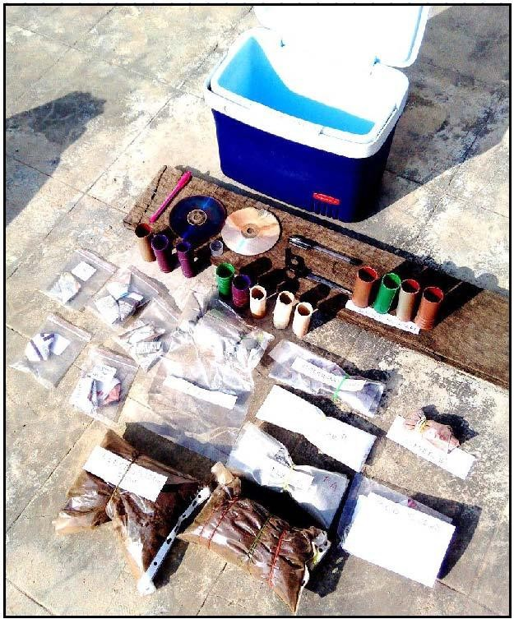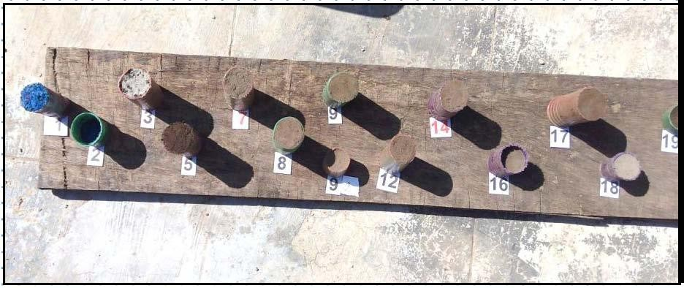

**Fig. 1.** Specimen investigated in the study

After being subjected to the designated curing time, the samples were tested for unconfined compressive strength (UCS) with a universal testing machine. This method, commonly used to evaluate the mechanical durability of materials against axial forces, is known as the UCS test. Numerous measurements were conducted on each frozen or solid matrix formulation to ensure accurate and reliable results. In unconfined compressive strength testing, axial pressure is applied to cylindrical matrix specimens until they reach failure while simultaneously measuring force and deformation using a universal testing machine. Unconfined compressive strength, a critical property indicating a material's ability to withstand compressive stress, was then calculated using this information.

The purpose of the research was to evaluate how the mechanical strength of the stabilized/solidified matrix changed over time by performing these tests at different curing times. This information is needed to understand the long-term effectiveness of stabilization and reinforcement processes in converting metal-laden soils into durable and structurally stable materials.

TCLP heavy metal analysis

Figure 2 shows the detailed examination procedure for samples containing metals. Evaluation of leachate characteristics and metal concentrations requires careful attention. The first step involved mixing 2000 ml of acetic acid solution with 100 g of sample in plastic bottles. The mixture was then stirred for 18 h, then filtered using a 0.6 to 0.8 mm Millipore filter. The pH of the filtered leachate was then determined. The filtered leachate was then acidified to a pH of 2 using nitric acid to enable detection of metal concentrations by inductively coupled plasma optical emission spectroscopy (ICP-OES). To analyze the leachate from the Toxicity Characteristic Leaching Procedure (TCLP), the researchers used the hot plate digestion method (HPDM) and the microwave digester method. In HPDM, a 100 ml volume of leachate is carefully heated with nitric acid until it is reduced to 10 ml, with additional nitric acid added as needed. This meticulous process occurred in a fume cabinet, with the steam escaping safely under the watch glass. After filtration of the digested material, the remaining residue was rinsed through the filter to provide the 100 ml volume required for subsequent ICP-OES heavy metal analysis. The project involves the microwave digester method, which is a sophisticated and faster alternative due to the time-consuming nature of HPDM. In this method, samples were digested using microwaves, gradually increasing the power to 400 W over 40 minutes. After cooling, the solution is diluted with 100 ml of water for analysis. The microwave digester method proved efficient and was subsequently used for further analysis.

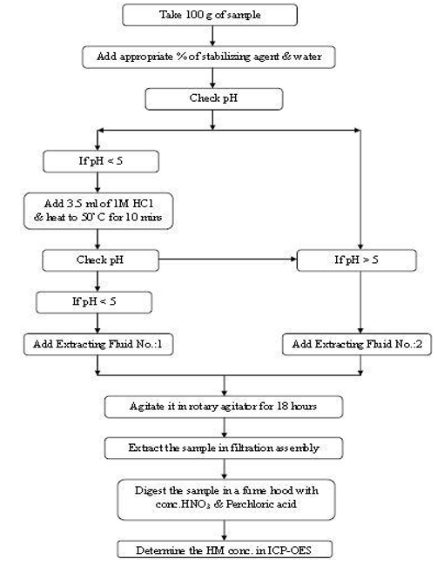

**Fig. 2.** TCLP Process

The TCLP Rotary Agitator and Filtration Assembly were among the study's apparatuses. When it came to thoroughly mixing and extracting TCLP samples, the TCLP Rotary Agitator, running at 220 V/50 Hz, followed USEPA regulations. Two-liter or ZHE 90-mm extraction bottles might be placed in the agitator. The USEPA found that the TCLP Filtration Assembly, which is intended for absolute filtration and the separation of solids from liquids, is appropriate for use with TCLP. It had an inner holder coated with PTFE to shield against heavy metal contamination, a simple sample insertion process, and quick disassembly for cleaning. During the filtering process, 0.6-0.8 mm GF filter paper was used, and pressure settings were adjusted from 10 to 50 psi.

All things considered, the thorough approach guaranteed accurate leachate and metal concentration analysis, combining traditional and cutting-edge methods to improve efficiency and accuracy in determining the toxicity properties of the investigated materials.

3. Results and Discussion

Unconfined compressive strength

Unconfined compressive strength studies across several batches and sample compositions provide important information on how additive ratios, doses, and stabilizer compositions affect how well the stabilization process works. Figure 3 shows a significant increase in compressive strength in Group 1 Sample 1a from day 70 to 87 on the third and seventh days. This indicates that the significant increase in power over time can be attributed to the combination of stabilizer and ratio 1a. On the other hand, samples 1b and 1c show contrasting patterns, with sample 1b decreasing and sample 1c increasing. This shows that the exact ratio and composition of stabilizers significantly affect the change in compressive strength over time.

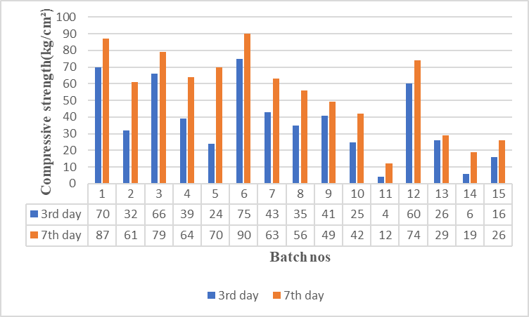

**Fig. 3.** Graph of Compressive Strength of 15 ETP Sludge Samples After the 3rd and 7th Days of Curing

Each batch and sample shows variation in compressive strength. For example, between days 3 and 7, there was a significant increase in sample 2c from batch 2, jumping from 39 to 90. In addition, sample 4b from the top 4 showed a significant increase from 4 to 12. However, even in the same group, there are cases of strong decline, as shown in example 4a group 4. This variation in the composition of the stabilizer and its effect can vary from batch to batch. In most groups and samples, compressive strength was significantly increased from the third to the seventh day of treatment. This suggests that the stabilization process increases the strength of the material over time. The two groups with the greatest gains were group 2, sample 2c, and sample 3, both of which significantly increased strength during the long curing period.

Some samples, for example, sample 4b from group 4, have very low compressive strength values, indicating potential difficulties during the stabilization procedure of this particular composition. This emphasizes the need for further optimization to overcome deficiencies in relation to specific stabilizers and combinations.

The results of batch 5 are inconsistent; whereas some samples (5b) see a decline in compressive strength throughout the 7 days, others (5a and 5c) show improvements. Because of this heterogeneity, it's possible that Batch 5 may need more research to comprehend and fully improve the stabilizer compositions.

The findings highlight the importance of monitoring compressive strength throughout a prolonged curing time. The data collected on the seventh day offers a more thorough comprehension of the stabilization process's long-term efficacy, exposing patterns that would not be noticeable after just three days of healing.

TCLP heavy metal analysis

Cu concentrations

The amounts of copper (Cu) in leachates from different mix design batches of ETP (Effluent Treatment Plant) sludge samples are detailed in the results, as shown in Figure 4. A certain additive-to-cement ratio distinguishes each mix design batch. These quantities, expressed in parts per million (ppm), are important markers of the leachability of the heavy metal copper. The regulation standard for copper disposal in SLFs (secure landfills) is 10 parts per million. A relationship may be observed between the copper concentrations in leachate and the ratio of cement to additive. As the number of additives to cement increases, there is a discernible increase in copper concentrations throughout batches with varying ratios (20:80, 30:70, 40:60, 50:50, and 60:40). This pattern indicates that the selection of the additive-to-cement ratio has a significant influence on the leachability of copper from the stabilized material.

Copper concentrations in leachate from several mix design batches, including 1a, 1b, 1c, 2a, 2b, 2c, 3a, 3b, 3c, 4a, 4b, 4c, and 5a, are less than the SLF disposal limit of 10 ppm. This indicates that these parties meet the legal requirements for safe landfill disposal regarding copper availability. Copper concentrations from mixed design batches 5b and 5c exceeded the SLF emission limit. This may require improvement or other stabilization strategies for this composition, raising the question of how the specific admixture-cement ratio controls the availability of copper.

The design of a mixture of liver with copper grades 1a, 1b, 1c, 2a, 2b, 2c, 3a, 3b, 3c, and 4a in the scope of the SLF elimination rule can be considered very effective in stabilizing the availability of copper. This batch is a valuable reference point for determining the optimum ratio of admixtures to cement. However, further improvements are required for batches such as 5b and 5c that exceed the SLF emission limit. This may include finding alternative stabilizers or adjusting cement and mix ratios to reduce copper availability and ensure compliance with statutory standards.

Zn concentration

Figure 5 shows a clear pattern showing the relationship between the increase in the amount of zinc and the increase in the amount of cement additives. This means that the amount of zinc that can be extracted from the stabilized material depends on the admixture ratio to cement.

Based on our research, it can be concluded that the zinc levels emitted from all mixed design batches (1a-4a) are within the SLF emission limit of 10 ppm, indicating compliance with legal standards for the safe disposal of zinc in landfills. However, the concentration of zinc released from batches 4b and 5a was slightly higher than the emission limit, raising concerns about the effect of this particular admixture-cement ratio in controlling zinc leaching. Consequently, this composition may require further research and potential modification or alternative stabilization methods.

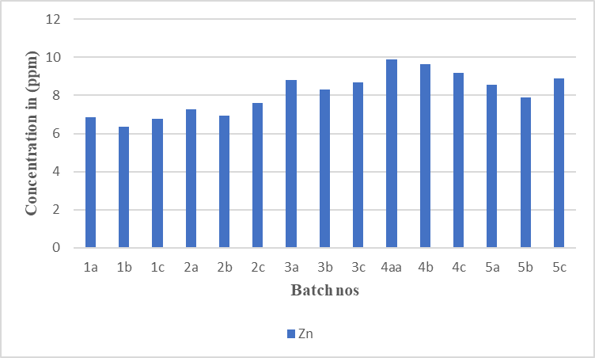

**Fig. 5.** Zn concentrations in the leachates obtained from the Stabilized ETP Mix Batches

To optimize the availability of zinc, it is useful to analyze groups of mixed design groups. This includes 1a, 1b, 1c, 2a, 2b, 2c, 3a, 3b, 3c, and 4a, as they are all below the threshold of SLF elimination. This selected batch can be an effective indicator to determine the ideal amount of admixtures used with cement. However, further optimization may be required for batches such as 4b and 5a that exceed the SLF emission limit. This may include finding alternative stabilizers or adjusting cement and mix ratios to reduce zinc availability and meet legal requirements.

Ni concentrations

The mix design batches denoted as 1a, 1b, 1c, 2a, 2b, 2c, 3a, 3b, 3c, 4a, 4b, 4c, 5a, 5b, and 5c show differing nickel amounts in leachate, which correlate to varied ratios of additive to cement. Figure 6 illustrates a clear pattern showing that increased quantities of nickel in leachate are generally correlated with increasing the quantity of additions to cement. This implies that the amount of nickel that can be extracted from the stabilized material depends greatly on the addition ratio to cement. Figure 7 shows the SEM image and micrograph of raw Zinc sludge sample-Sample A.

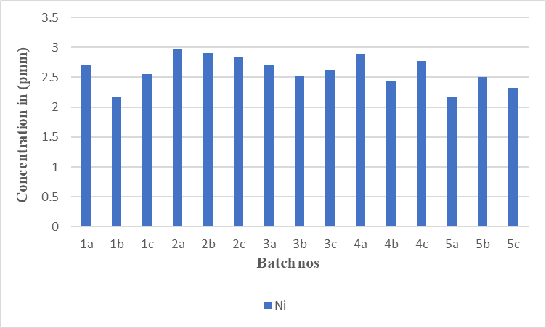

**Fig. 6.** Ni concentrations in the leachates obtained from the Stabilized ETP Mix Batches

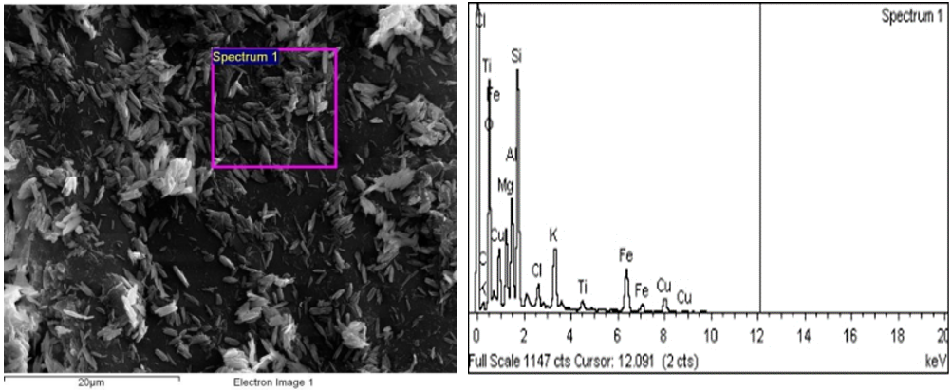

**Fig. 7.** SEM image and micrograph of raw Zinc sludge sample-Sample A

The nickel concentrations in the leachate of mix design batches 1a, 1b, 1c, 2a, 2b, 2c, 3a, 3b, 3c, 4a, 4b, 4c, 5a, 5b, and 5c are less than the 3 ppm SLF disposal limit. This shows that these batches satisfy the legal requirements for the safe disposal of nickel in landfills. Nickel concentrations in leachate in none of the mix design batches surpass the SLF disposal limit. Regarding nickel leachability, all batches show good stability as they are all within the allowable limit.

All mix design batches consistently comply with SLF disposal limitations, indicating that the stabilization method successfully limits the leachability of nickel. This shows how well the selected stabilizer combinations and their corresponding ratios performed overall. It is implied that the existing stabilizer combinations and their ratios are efficient for stabilizing nickel because there are no concentrations of nickel over the SLF disposal limit. Optimizing these combinations or looking into different stabilizers for possible increases in efficacy or cost-effectiveness might be the main topics of future research.

The results of the TLCP study provide significant new information on the stabilization of hazardous waste, especially regarding the impact of fly ash and lime mixes and the cement-to-additives ratio. One of the important findings is that mixes with high lime content are more successful in stabilization in different scenarios when the cement-admixture ratio is maintained. This means that lime is important to increase stability and can help reduce the amount of harmful compounds in waste products.

The pozzolanic reaction plays an important role in stabilizing fly ash and lime mixtures. This reaction during curing leads to the production of compounds that significantly strengthen and stabilize the material. What is surprising is that this reaction can be repeated during the curing process, indicating a continuous improvement in the material's structural integrity and overall performance.

The extra size of the fly ash particles allows them to effectively fill the voids in the matrix, resulting in a denser and more stable structure. This reduces the risk of leakage of hazardous materials and improves the environment's safety from stable waste. In addition, the study highlighted the importance of the complex hydration process in the structural development of cement-based solid waste materials. An important factor in increasing the product's density during this hydration process is the formation of dicalcium silicates, tricalcium aluminate and ferrite. The increased structural integrity is associated with increased density, indicating that the hydration process supports the stability and strength of the stabilized waste material.

Microstructure Analysis

SEM and EDAX

A deeper understanding of these transformations can be gained through analytical techniques, such as FESEM and EDX. Energy Dispersive X-ray Spectroscopy assessed the elemental makeup of two specimens (Sample A and B) (Figures 7 and 8). Sample A, which originally consisted of raw PCB sludge, and Sample B, which underwent treatment, displayed clear variations in composition. The elements carbon, magnesium, silicon, titanium, iron, aluminum, copper, and gold were all present in Sample A. However, after processing with cement and additives, Sample B showed a notable increase in carbon content (27.17%) compared to its initial state (1.77% carbon). Only the sludge treated with cement contained calcium, most likely due to the calcium carbonate in the cement. On the other hand, the treated sludge lacked components like gold (Au), potassium (K), and magnesium (Mg), whereas titanium (Ti), iron (Fe), aluminum (Al), copper (Cu), and silicon (Si) were present in reduced quantities.

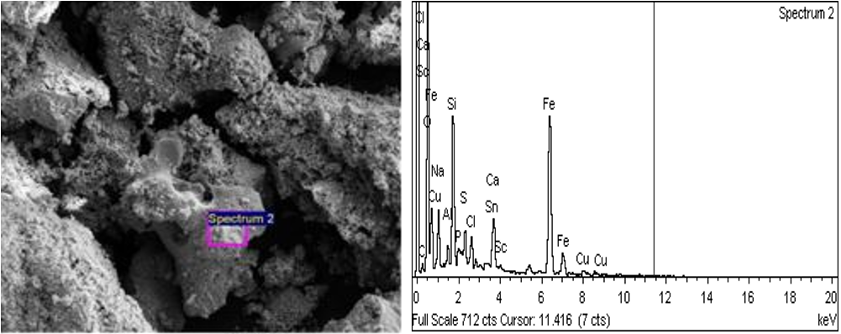

**Fig. 8.** SEM and micrograph of sinter sample-Sample-B

Additional microscopic analysis using Field Emission Scanning Electron Microscopy (FESEM) revealed clear distinctions between the unstabilized raw zinc sludge and the stabilized sludge treated with cement and chemicals. Chip fragments were seen sporadically throughout the raw sludge, suggesting an unstable and uneven structure. On the other hand, the stabilized sludge showed a homogenous mixture devoid of stray chip fragments, indicating successful stabilization and enhanced structural integrity.

Metals were incorporated into the sintered product when the metal-laden sludge was sintered with waterworks sludge for four hours at 1000°C, as shown by scanning electron microscopy (SEM). Fine-grained, strongly aggregated platy-like particles were seen in the SEM pictures. The aggregate size reached many tens of micrometers, although individual particle sizes were around 1-2 microns or less. This finding emphasizes how well the heavy metals were incorporated into the sintered matrix, demonstrating how the sintering process successfully transformed and stabilized the metal-laden sludge.

In conclusion, using EDX and FESEM analysis techniques provides valuable insight into the compositional and structural changes that occur during the processing and stabilization of metallurgical sludge. The results show that using water plant waste for sintering is an effective way to incorporate heavy metals into the final product while also highlighting the important role of cement and additives in changing the elemental makeup and improving the stable structural properties of the sludge.

FTIR

Incorporating specific chemical bonds within a molecule, Fourier transform infrared spectroscopy (FTIR) offers a formidable analytic approach capable of both quantitatively and qualitatively examining organic and inorganic substances. By producing an infrared absorption spectrum, FTIR creates a one-of-a-kind chemical signature for the sample, allowing for efficient screening and scanning of its various components. As a particularly effective means of detecting functional groups and elucidating information on covalent bonding, this method proves invaluable for gaining insight into a particular material.

Our investigation involved performing FTIR analysis on various materials, including cement, sinter "S," raw ETP sludge, stabilized ETP sludge, raw PCB sludge, and stabilized PCB sludge (Figure 9). The analysis revealed that, in general, there was no significant change in the peaks. This suggests that the stabilization process may involve only a few molecular changes. Compared to the raw sample, there was no significant change in the FTIR spectrum of the stabilized sample.

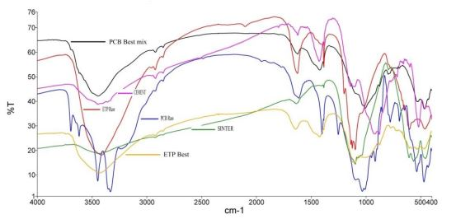

**Fig. 9.** FTIR of cement, sinter "S", raw ETP sludge, stabilized ETP sludge, raw PCB sludge, and stabilized PCB sludge samples

The molecular structure of the solidified/stabilized (S/S) sample was not significantly affected by the addition of metal clay, as evidenced by the absence of significant changes in the FTIR spectrum. This shows that the chemical composition and bonding properties remain unchanged before and after stabilization. The stability of this molecular structure may be related to the effectiveness of the stabilization method used, which failed to cause visible changes.

Conclusion

This research successfully demonstrates the potential of innovative stabilizer mixes for the effective solidification and stabilization of heavy metal-laden sludge, with the following key outcomes:

* **Meeting Disposal Standards**: Sinter-stabilized mixes consistently surpassed secure landfill criteria, achieving compressive strengths up to 18 times the minimum requirements.
* **Optimized Binder Composition**: Mixes with higher proportions of sinter and fly ash significantly improved solidification and stabilization efficiency, showcasing their versatility as sustainable materials.
* **Mechanistic Insights**: Microstructural analyses (SEM and XRD) revealed that the formation of crystalline structures, particularly "spinal formation," plays a crucial role in encapsulating and immobilizing heavy metals.
* **Sustainable Utilization of Waste**: Integrating waterworks and electroplating sludge as pozzolanic materials reduces landfill dependency and disposal costs, aligning with circular economy principles.
* **Future Research Directions**: Further exploration of sludge-to-additive ratios, pH variations, and temperature impacts on stabilization processes is recommended, alongside studies on reusing stabilized waste in construction materials.

These findings underscore the importance of collaborative efforts between academia and industry to apply and continuously improve sustainable waste management technologies successfully.

Looking ahead, the study suggests various avenues for further research. Exploring additional sludge-to-additive ratios, varying sample pH, and investigating the impact of temperature on stabilization processes are recommended. Additionally, studies on the secondary use of stabilized waste for construction or road materials could contribute to sustainable waste management practices and further enhance the environmental and economic benefits of the technology. The collaboration between academic research scientists and environmental engineers with industrial experience is crucial for successfully implementing and continuously improving these technologies in real-world applications.

Statements and Declarations

**Conflict of Interest Statement**

The authors declare no conflicts of interest.

**Acknowledgment**

The authors extend their appreciation to the Deanship of Research and Graduate Studies at King Khalid University for funding this work through Large Research Project under grant number RGP2/324/45.

References

Abdurrahman, D., & Putra, H. (2022). *Optimization of Self-Healing Concrete Parameters using Experimental Design Taguchi Method*. IOP Conference Series: Earth and Environmental Science.   
https://doi.org/10.1088/1755-1315/1117/1/012009

Askar, M. A., Zdeb, T., Chwastowski, J., & Ferrara, L. (2023). *Self-healing abilities of cement mortars containing microorganisms produced in the process of sewage sludge treatment*. MATEC Web of Conferences. https://doi.org/10.1051/matecconf/202337802003

Changjutturas, K., Hoy, M., Rashid, A. S. A., Horpibulsuk, S., & Arulrajah, A. (2019). Solidification and stabilisation of metal plating sludge with fly ash geopolymers. *Environmental Geotechnics*, *10*(1), 66-75. https://doi.org/10.1680/jenge.19.00050

Chen, B., Sun, W., Sun, X., Cui, C., Lai, J., Wang, Y., & Feng, J. (2021). Crack sealing evaluation of self-healing mortar with Sporosarcina pasteurii: Influence of bacterial concentration and air-entraining agent. *Process Biochemistry*, *107*, 100-111. https://doi.org/10.1016/j.procbio.2021.05.001

Khed, V. C., Pesaralanka, V., Adamu, M., Ibrahim, Y. E., Azab, M., Reddy, M., Hakamy, A., & Deifalla, A. F. (2022). Optimization of graphene oxide incorporated in fly ash-based self-compacting concrete. *Buildings*, *12*(11), 2002. https://doi.org/10.3390/buildings12112002

LaGrega, M. D., Buckingham, P. L., & Evans, J. C. (2010). *Hazardous waste management*. Waveland Press. Available: www.intechopen.com

Luan, C., Yuan, L., Wang, J., & Zhou, Z. (2023). Uncovering the Mechanism of the Role of Fly Ash in the Self-Healing Ability of Mortar with Different Curing Ages. *Materials*, *16*(9), 3453. https://doi.org/10.3390/ma16093453

Nasser, A. A., Sorour, N. M., Saafan, M. A., & Abbas, R. N. (2022). Microbially-Induced-Calcite-Precipitation (MICP): A biotechnological approach to enhance the durability of concrete using Bacillus pasteurii and Bacillus sphaericus. *Heliyon*, *8*(7). https://doi.org/10.1016/j.heliyon. 2022.e09879

Nguyen, T. H., Ghorbel, E., Fares, H., & Cousture, A. (2019). Bacterial self-healing of concrete and durability assessment. *Cement and Concrete Composites*, *104*, 103340.   
https://www.sciencedirect.com/science/article/pii/S0958946519302781

Omar, O., Mousa, M. R., Hassan, M., Hungria, R., Gavilanes, A., Arce, G., Milla, J., & Rupnow, T. (2023). Optimization of the self-healing efficiency of bacterial concrete using impregnation of three different precursors into lightweight aggregate. *Transportation Research Record*, *2677*(3), 1611-1624.   
https://repository.lsu.edu/gradschool_theses/5782

Stefanovska, I., & Fidanchevski, E. (2023). *Self-healing of cement mortars based on fly ash and crystalline admixture*. MATEC Web of Conferences. https://doi.org/10.1051/matecconf/202337802018

Sun, X., Chen, J., Lu, S., Liu, M., Chen, S., Nan, Y., Wang, Y., & Feng, J. (2021). Ureolytic MICP-based self-healing mortar under artificial seawater incubation. *Sustainability*, *13*(9), 4834. https://doi.org/10.3390/su13094834

Taheri, S., & Clark, S. M. (2021). Preparation of self-healing additives for concrete via miniemulsion polymerization: formulation and production challenges. *International Journal of Concrete Structures and Materials*, *15*(1), 8. https://doi.org/10.1186/s40069-020-00449-2

Tesfamariam, B. B., Seyoum, R., Andoshe, D. M., Terfasa, T. T., Ahmed, G. M. S., Badruddin, I. A., & Khaleed, H. (2022). Investigation of self-healing mortars with and without bagasse ash at pre-and post-crack times. *Materials*, *15*(5), 1650. https://doi.org/10.3390/ma15051650

Wydro, U., Wołejko, E., Sokołowska, G., Leszczyński, J., & Jabłońska-Trypuć, A. (2022). Investigating landfill leachate influence on soil microbial biodiversity and its cytotoxicity. *Water*, *14*(22), 3634. https://doi.org/10.3390/w14223634

Xu, G., Zou, J., & Li, G. (2009). Stabilization/solidification of heavy metals in sludge ceramsite and leachability affected by oxide substances. *Environmental science & technology*, *43*(15), 5902-5907. https://doi.org/10.1021/es900139k