|  |  |  |  |
| --- | --- | --- | --- |
|  |  | | |
| **Rocznik Ochrona Środowiska** | | |
| Volume 27 | Year 2025 ISSN 2720-7501 | pp. 53-69 |
|  | https://doi.org/10.54740/ros.2025.006 open access | | |
|  | Received: January 2025 Accepted: February 2025 Published: February 2025 | | |

Live Clean, Make Green! Green Management Practices and their Role in Achieving Sustainable Development in Hotels: Barriers and Drivers

Arej Alhemimah1, Abdulrahman Eidhah Al Shamlan2, Humoud Mohamed Jaber3, Meshael Batarfi4, Mohamed A.Abdel Fatah5*, Mohamed Hussein6, Hashim Elshafie7, Aliaa Korshem8

1King Abdulaziz University, Jeddah, Saudi Arabia   
https://orcid.org/0000-0002-4522-8645

2Department of Human Resources, College of Business Administration, Northern Border University, Arar, Saudi Arabia  
https://orcid.org/0009-0005-8176-2422

3Tourism Department, College of Tourism and Hospitality, King Khalid University, Saudi Arabia  
https://orcid.org/0009-0000-6341-4962

4University of Business and Technology, Jeddah, Saudi Arabia   
https://orcid.org/0000-0002-2150-094X

5Human Resources Department, Al-Alson Higher Institute for Tourism, Hotels and Computer, Cairo, Egypt   
https://orcid.org/0009-0009-8444-5261

6Hotel Management Department, Badr Higher Institute of Tourism and Hotels, Cairo, Egypt  
https://orcid.org/0009-0007-8288-6851

7Department of Computer Engineering, College of Computer Science, King Khalid University, Abha, Saudi Arabia  
https://orcid.org/0000-0002-5111-3764

8Business Administration Department, Higher Institute of Administrative Sciences, Belbies, Al Sharqia, Egypt  
https://orcid.org/0009-0006-6979-447X

*corresponding author's e-mail: mohamed1974.abdelhamed@gmail.com

**Abstract:** This study aims to analyze the internal and external factors that facilitate or hinder the adoption of environmental management techniques in Saudi hotels and to assess the impact of these practices, technologies, and environmental management systems on advancing environmental protection and sustainability. Global economic, cultural, and technical developments are accelerating, making managing environmental deterioration and overuse of natural resources more difficult. The study also looks at how environmental management systems and technology may affect environmental conservation in the future. Data from 408 full-time employees of five-star hotels were analyzed using (PLS-SEM) to assess the effect of technologies on environmental protection initiatives. The results show that using technology integration promotes sustainability and catalyzes ecological conservation, with quantifiable benefits including cost savings and improved environmental outcomes. These programs have reduced pollution significantly, encouraged environmentally friendly economic practices, and lessened the depletion of natural resources over the past ten years. This study emphasizes technology's important role in advancing environmental sustainability. It offers a fresh viewpoint on how businesses may leverage digital advances to strengthen green activities and contribute to an environmentally friendly future.

**Keywords:** Green revolutions, environmental sustainability, environmental conservation

1. Introduction

In recent years, Saudi Arabia has made considerable progress in advancing environmentally sustainable hospitality practices and environmental protection along with its overarching objectives of cultivating a green economy and endorsing environmental protection efforts (Abdou et al. 2022). Green hotels, which use environmentally sustainable practices such as utilizing biodegradable materials and offering energy-efficient lodgings, are gaining popularity as consumers and investors acknowledge the significance of sustainability (Albert 2020). Despite the increasing interest in eco-friendly hotels, the business continues encountering numerous obstacles, such as excessive resource consumption, environmental deterioration and demands from diverse stakeholders to enhance sustainability standards and environmental protection (Robinot & Giannelloni 2010).

The primary objective of this study is to analyze the internal and external factors that facilitate or hinder the adoption of environmental management techniques in Saudi hotels and to assess the impact of these practices, technologies, and environmental management systems on advancing environmental sustainability and environmental protection. Hotels progressively use sustainable practices to promote operational efficiency (Boyacı et al. 2022), manage costs, bolster reputation, and gain competitive advantage (Deraman et al. 2017). Moreover, consumers have demonstrated an increasing readiness to pay a premium for accommodations at eco-friendly hotels, even accepting slight inconveniences to endorse sustainable practices (Han & Kim 2010). This study pioneers the examination of the internal and external determinants influencing environmental investments in the Saudi hospitality sector, contrasting with previous studies that predominantly concentrated on green hotels in other locations (Cembruch-Nowakowski 2020).

Environmental management practices (EMP) motivate businesses to conserve energy and water, minimize solid waste, decrease operational costs, and safeguard the environment (Teng et al. 2013). With the escalation of global environmental concerns, implementing sustainable business strategies has become imperative across multiple industries. The hotel sector is under growing pressure to fulfill environmental obligations, as it can no longer disregard its influence on natural resources and ecosystems (Chan et al. 2018). Nonetheless, a substantial research gap persists, especially concerning the obstacles hindering the extensive implementation of sustainable hotel policies (Deraman et al. 2017). The disparity is particularly evident in areas like Saudi Arabia, where no extensive research has investigated the specific difficulties confronting the hotel sector in this context.

This study also investigates the comprehensive effects of green investments, technologies, and environmental management systems on the three dimensions of sustainability—environmental, economic, and social performance. By examining these interrelated factors, the study offers pragmatic insights for hotel executives and investors aiming to improve their business's economic and social outcomes while minimizing their environmental impact (Boyacı et al. 2022). The study introduces a novel paradigm emphasizing environmental, economic, and social performance results influenced by internal and external factors in green investment decisions (Abdou et al. 2020). This approach can provide a basis for future research in tourism and hospitality, especially in developing nations such as Saudi Arabia, where sustainable practices are yet nascent.

In light of these challenges, investigating the drivers and obstacles to sustainable practices, technologies, and environmental management systems in Saudi hotels is essential. This study seeks to address the literature gap by examining the determinants of environmental management techniques and their effects on the sustainability performance of hotels in Saudi Arabia. This approach offers a thorough insight into the potential contributions of the Saudi hospitality sector to global environmental conservation initiatives. The precise aims of the study are:

* To examine the internal and external drivers and barriers impacting the adoption of environmental conservation practices, technologies, and environmental management systems in eco-friendly hotels in Saudi Arabia.
* To identify the most significant drivers and barriers that affect the implementation of green practices.
* To assess how green investments, technologies, and environmental management systems influence the environmental, economic, and social performance of hotels.

This study offers significant insights for researchers and practitioners, establishing a basis for future investigations into environmental investments, technologies, and environmental management systems in the hospitality industry, especially in areas where sustainable practices are emerging. This research enhances the existing knowledge of environmental conservation and sustainable management strategies within the Saudi hotel industry.

2. Literature Review

2.1. Investment in environmental technologies

Three unique and complete forms of environmental technologies can be identified based on the literature on operations strategy and environmental management: pollution prevention, pollution control, and management systems. This classification, which was used in this study and was first put forth by Klassen and Whybark (1999), is in line with new developments in the measurement of different environmental technologies (Berwal et al. 2024, Jones & Klassen 2001). It is important to remember that environmental technologies include many elements, such as equipment, design, and operating procedures, all of which work to reduce or neutralize the negative effects of products or services on the environment (Klassen & Whybark 1999).

Moreover, the kind of investment – whether in management systems, pollution control, or prevention – operates separately from the total amount of money invested in environmental technologies. It represents allocating capital among several technology possibilities (Klassen & Vachon 2003).

Technological integration, through strategic activities involving knowledge transfer and sharing, facilitates identifying and evaluating a broader range of options to address specific environmental challenges (Bonifant et al. 1995). These options can enhance other dimensions of service performance, such as quality and delivery, and encourage additional investment in projects related to environmental sustainability. Moreover, such integration can help mitigate resistance to change often associated with structural modifications in production processes or products.

2.2. Technologies and environmental protection initiatives

Incorporating technologies and environmental management systems into hotel operations is crucial for mitigating environmental effects and establishing hotels as frontrunners in sustainable tourism. These technologies allow hotels to satisfy increasing consumer demands for sustainable practices while ensuring enduring economic and social advantages (Masiero & Qiu 2018). The hospitality industry's evolution will hinge on technology and Environmental Management Systems (EMS) to advance environmental conservation and prioritize sustainability within corporate strategies (Jones et al. 2016, Zhang et al. 2020). Multiple prior studies have demonstrated that environmental management enhances the competitiveness of vacation destinations. Sustainable tourism served as the foundational impetus for the emergence of ecologically friendly hotels (Chou 2014). Abdou (2022) defines EMP as examining all organizational and technological efforts to mitigate the environmental effects of an organization's operations. Businesses are more aware of ecologically sustainable practices due to the established statutory framework for corporate environmental policies and heightened public attention (Misevičiūtė et al. 2024, DiPietro et al. 2013). Unlike the manufacturing industry, the hospitality sector does not significantly harm the environment, yet its various activities consume substantial amounts of water, power, and non-reusable materials for everyday operations (Chan et al. 2014). As per Boyacı et al. (2022), tourism adversely impacts the environment through resource depletion, pollution, soil erosion, ecosystem damage, heightened pressure on endangered species, and increased vulnerability to forest fires.

Although eco-friendly hotel practices have been greatly aided by sustainable tourism, environmental management systems (EMS) and technologies have a greater influence on how environmental conservation will develop in the hospitality industry. With these technologies, hotels may operate more sustainably while still providing for the needs of their customers. They also assist in minimizing water and energy usage, enhance waste management, and monitor environmental consequences more effectively. By offering an organized method for handling environmental goals, EMS ensures that green policies are successfully applied in various operational contexts (Silva et al. 2020, Chou 2014). Hotels may track their environmental performance in real-time, detect inefficiencies, and lessen their ecological impact by incorporating cutting-edge technology like smart energy systems and IoT-enabled monitoring (Boyacı et al. 2022). By demonstrating their dedication to eco-friendly operations, these technologies support sustainability and increase hotels' competitiveness (Yaw 2002).

Sustainable tourism practices offer various profitable benefits, despite the hotel and tourism sectors' denials that they don't comprehend sustainability (Mowforth & Munt 2015). Aiming to lessen the environmental harm their hotels cause, the hospitality industry in developed countries has realized the need for environmental protection. It has started incorporating EMP into its daily operations (Goeldner & Ritchie 2006). For example, Fairmont, Ramada, Marriott, and Sheraton introduced environmentally conscious programs focusing on reducing energy and water consumption (Goeldner & Ritchie 2006).

Technologies transforming hotel resource management include automatic climate control, water recycling systems, and energy-efficient lighting (Bohdanowicz et al. 2011). These innovations have also helped hotels save money and protect the environment. By standardizing these procedures, EMS assists lodging facilities in coordinating their operational objectives with international sustainability frameworks like the Sustainable Development Goals (SDGs) (United Nations 2015). In places like Saudi Arabia, where green hospitality practices are still in their infancy, these systems are extremely helpful, and implementing technology can hasten the shift to a more sustainable future (Abdou et al. 2022). Additionally, EMS makes it easier for hotels to comply with environmental laws, assisting them in meeting national and international requirements for environmentally responsible operations (Tsai et al. 2016).

For several reasons, hotels voluntarily develop and implement green policies. According to Deraman et al. (2017), hotels can establish a pleasant impression and obtain a competitive advantage by implementing ecologically friendly methods. This enhances their green image. Using green practices is one approach to improve the quality of travel-related products and attract new clients, according to Aguilo et al. (2005). Customers are willing to pay extra to stay at a hotel with a good reputation and an eco-friendly policy. Additionally, customers are willing to tolerate little inconveniences to participate in environmentally friendly behaviours because they act ecologically responsibly (Han & Kim 2010).

2.3. Antecedents and challenges in environmental protection initiatives

Levy and Dilwali (2000) identified various barriers that impede the widespread adoption of environmental management practices, such as limited access to capital, insufficient understanding of new technologies, lack of effective policies, and difficulties in measuring ecological benefits. Chan (2008) identified insufficient behaviors and skills as further barriers. The absence of resources, ambiguity surrounding certification and verification processes, unclear outcomes, and the expenses related to implementation and maintenance were identified as factors diminishing hotel managers' motivation to participate in sustainable initiatives. Yusof and Jamaludin (2014) identified several key barriers to adopting green practices, including the lack of dedicated personnel, essential supplies, ownership and support from top management, customer backing, and engagement with environmentally conscious suppliers.

All businesses, especially in the hospitality sector, are obligated to reduce adverse environmental effects. Nonetheless, the successful execution of green initiatives is hindered by several challenges, especially resistance to change (Watson 2006). The growing acknowledgment of climate change has increased consumer awareness regarding ecological issues. Companies recognise a developing market characterized by increasingly environmentally conscious consumers who favor products from firms committed to environmental preservation (Boyacı et al. 2023, Stachowski 2021). Prior studies indicate that companies implementing measures to mitigate their environmental footprint frequently aim to improve their reputation as a secondary competitive strategy (Kasim et al. 2014). Chan (2008) identified that consumers' pre-existing positive perceptions are the main factor influencing the implementation of environmental practices. Lee et al. (2015) observed that customer willingness to pay a premium for environmentally friendly accommodations significantly influences hotels' adoption of green practices. The local community's influence may impact hotels' decisions to adopt environmentally friendly practices (Chang et al. 2014). Despite these incentives, significant barriers continue to hinder the effective integration of environmental management practices (Basok 2021). This study seeks to identify the barriers to implementing sustainable practices in Saudi hotels from the industry's perspective. The findings offer recommendations to assist Saudi hotel management in addressing these barriers and effectively implementing environmentally sustainable practices.

3. Hypotheses Development

3.1. Technology support

Due to its ability to speed up the gathering, storing, and sharing of information, technology assistance is essential to the development of new methods and expertise (Kraus et al. 2019). Advanced technology incorporates novel procedures and methods (Gold et al. 2001), which can remove obstacles to departmental interaction inside a company (Medina-Molina et al. 2019). Businesses with access to technology will create innovative green products and innovative sustainable procedures. Environmentally demanding businesses rely heavily on technology assistance as a key component that may reduce manufacturing expenses (Song et al. 2019). According to Song et al. (2019), technology assistance offers the instruments required to efficiently convert resources into ecological outcomes and green innovation in product effectiveness. So, the study suggested that H1: Technological support positively impacts EMP.

3.2. Laws and Regulations

According to Carraro et al. (2013), governments and authoritative agencies are seen to be the primary regulatory agencies that influence businesses to adopt environmentally friendly measures. Official environmental rules and support from the government for environmentally conscious activities that go above and beyond compliance motivate businesses to engage in environmental efforts, which leads to improved environmental sustainability Winter and May (2001). According to Delmas and Toffels (2004), political and regulatory pressures lead corporations to engage in EMP activities. The most evident parties that impact a company's implementation of EMP are regulations (Rivera et al. 2009). Government laws and rules are seen as external variables that may impact how receptive businesses are to adopting sustainable methods, according to Kasim and Ismail (2012). While some firms are inherently environmentally conscientious, most are under pressure from national, regional, and/or worldwide laws and regulations (Watson & Emery 2004). Good governance is essential for effectively applying environmental laws; those regulations must be tailored to the specific sovereign nation (Bramwell 2011).

Government laws and regulations pertaining to environmental management are coercive tools used to force firms to adopt environmentally friendly processes (Yusof, Jamaludin 2014). According to Kasim and Ismail (2012), the government currently lacks laws and regulations to motivate and control businesses to adopt green practices. One type of coercive mechanism that applies pressure (impositions) to companies or provides incentives for them to follow procedures is the regulation (Scott 2004). According to Eltayeb (2010), regulation is the formal means by which authorities and regulatory organizations encourage corporate entities to engage in green conduct. These methods include regulations, norms, processes, and reward systems. EMP is implemented with great influence from regulations (Darnall et al. 2008, Delmas & Toffel 2008). Still, little is known about the circumstances in which these diverse justifications seek to justify the companies' adoption of activities beyond compliance with the law (Delmas & Toffel 2008). In light of this, the study stated thatH2: There is a significant relationship between regulation/government and EMP.

3.3. Top management

According to Stone et al. (2004), management has a pivotal role in establishing a climate for adopting EMP, one of the most significant motivations stated in the literature about shifting business views concerning environmentalism. Leaders' dedication and work culture facilitate the implementation of green initiatives (Kasim 2009). According to Pham et al. (2019), the increasing environmental concerns drive the use of environmental management in commerce. According to Claver-Cortés et al. (2015), corporations may improve their market share by adopting EMP, which has significant strategic implications. A significant obstacle to the company's efforts to incorporate EMP might be senior management's callous, uncaring dedication that does not view the environment as a core priority (Post & Altman 1994). Workers may become more aware of the environment through ecological training, which gives them the green information and skills they need (Pham et al. 2019). Consequently, the study developed an additional hypothesis: H3: There is a significant relationship between top management and EMP.

3.4. Employee awareness

Employers, producers, and consumers who are not environmentally conscious may find it challenging to adopt EMP. Despite their environmental concern, some guests are unwilling to pay more for accommodations in green hotels (Wan et al. 2017, Yusof & Jamaludin 2014). Furthermore, some consumers doubt the caliber of alternatives (Tzschentke et al. 2008). Management significantly impacts hotels' EMP because they view ecological problems as advantages or dangers and decide on the most effective program of action to address them strategically (Wan et al. 2017). According to Deraman et al. (2017), certain workers are particularly unable to participate in procedures that might threaten the standard of service. According to Kasim and Ismail (2012), it might be hard to modify the working habits of workers. Accordingly, the study formulated the following: H4: There is a significant relationship between employees' awareness and EMP.

3.5. Attitude towards change

Le et al. (2006) describe innovations as ideas, behaviors, or concepts thought to be novel by potential adopters. This definition of attitude toward change is similar to that of innovations. Hurley and Hult (1998) propose that rather than emphasizing learning (growth in understanding and perceptions), theories of business performance should concentrate on attitude toward change (adoption of novel concepts, services, or procedures). Thus, the study suggested that H5: There is a significant relationship between attitude towards change and EMP.

3.6. Resources

Since EMP is a relatively new topic in the tourism sector, it could take some time to train staff members to be skilled practitioners and environmental specialists (Yusof & Jamaludin 2014). Many hotels lack qualified staff members who may assess staff members' success in implementing EMP (Chan 2020). In light of this, the following hypothesis will be stated H6: There is a significant relationship between Resources and EM

3.7. Costs

Although environmentally friendly items and machinery are typically costly, implementing EMP requires monetary investments to accomplish sustainable development over time. For instance, in comparison with a standard chiller, a saving energy chiller costs more (Yusof & Jamaludin 2014). A significant sum of money is also needed for ecological inspection and certification costs, besides the expense of the ecological items and machinery (Deraman et al. 2017).) So, the study suggested that H7: There is a significant relationship between cost and environmental management practices

3.8. Competition pressure

The company sector must address environmental issues in the volatile world market to retain clients and stay competitive (Chavan 2005). Creativity that might benefit a business can be sparked by initiatives to use EMS. Such technology offsets can reduce manufacturing costs (Porter & van der Linde 1995). According to empirical research, competition raises the possibility that innovations will be adopted (Sigala 2006). It is an incentive for companies to be creative. Competition raises the demand for and rate of implementation of innovations while also creating environmental problems. If they observed a higher degree of competition, management would feel more pressure to use green initiatives to get a competitive advantage.

Businesses may produce environmentally friendly products through green developments, increasing their profitability and enhancing their brand. Additionally, businesses that are leaders in green technology stand to gain from "first-mover advantages." To put it briefly, a business's competitive edge increases with the amount of money it invests in creating green innovation (Chen et al. 2006). So, the study suggested that H8: There is a significant relationship between competition pressure and EMP.

**Fig. 1.** Study framework

4. Methods

4.1. Data collection and sample

This research looked at all four- and five-star EMP hotels that have committed substantially to implementing eco-friendly measures (Abdou et al. 2020). (403) hotels in Saudi Arabia are certified eco-friendly, according to data on green and sustainable lodgings that was released on the ETIC lodging establishments web page. The Saudi Tourist Development Authority and the Saudi Ministry of Environment awarded the "Green Star Hotel Initiative-GSHI" accreditation under the Global Tourism Sustainability Criteria (GSTC).

A Saudi hotel seeking to become GSHI certified must meet 151 environmental requirements encompassing all aspects of hotel operations, including EMP (13 criteria); education and guidance (3); water 22; energy 27; waste 13; guest information (12); food and beverage and kitchen (14); housekeeping (20); garden and beach area (14); and both indoor and outside appearance (13). The hotel must meet a minimum of 15, 90, or 120 requirements to receive 5 or 4 stars. An online survey was created and sent via e-mail to every hotel to accomplish the research goals. One survey was sent to senior management, such as a hotel manager or the executive responsible for environmental operations (i.e., environmental director).

An online Google questionnaire was used to conduct the survey. A greeting and information about the goal of the study were given. The voluntary nature of study involvement was made clear to participants. They were asked to evaluate the correct response on a scale of 1 to 5. They were asked to submit the survey when they had finished it. Only 408 of the 490 issued surveys were suitable for analysis, which represented a response rate of 83.2%

4.2. Survey instrument development

An online survey was used to gather data for this work to address the study goals. A pilot test with ten participants was conducted on the tool to improve the survey's reliability. The survey form employed the Likert scale method, which asks participants to select from an established set of answers to demonstrate whether they agree or disagree with a proposition or how important the issue is to them. This allows researchers to determine whether the proposition has a positive or negative pattern (Veal 2017). The four-point (ordinal) scale that was used to quantify the points is as follows: (1) strongly agree, (2) agree, (3) disagree, and (4) strongly disagree. A neutral point was excluded to avoid responders becoming ambiguous (Dane 1990).

4.3. Reliability and validity test

A pre-test of the pilot test was carried out, and its Cronbach alpha coefficient of 0.934 indicated that it had high internal consistency. This number may be regarded as satisfactory (Sekaran 2005) and dependable (Pallant 2005) as it is more than 0.7. A pilot test was conducted with the intention of pre-testing the following: survey wording, survey organization, survey arrangement, participant familiarization, field setup, answer rate estimation, interview duration estimation, and test analytic techniques (Veal 2017). Five hotels received a survey to gauge its validity and reliability and determine whether the pilot test's objectives were achieved.

5. Results

5.1. Descriptions of participants

**Table 1.** Respondents' profiles

|  |  |  |  |
| --- | --- | --- | --- |
| Items | | Frequency | Percent |
| Gender | Male | 350 | 85.8 |
| Female | 58 | 14.2 |
| Age | Less than 30 years | 191 | 46.8 |
| 30-40 years | 160 | 39 |
| More than 40 years | 57 | 14 |
| Educational level | Master degree | 34 | 8.3 |
| Bachelor degree | 322 | 78.9 |
| High school | 52 | 12.7 |
| Years of experience | Less than 5 year | 146 | 35.8 |
| Between 5 to 10 year | 207 | 49 |
| More than 10 year | 55 | 13.5 |
| Job level | Managers | 108 | 26.5 |
| Operative workers | 300 | 73.5 |
| Total | | 408 | 100 |

Out of 408 participants in the current study, there were 350 (85.8%) males and 58 (14.2%) women. Also, 191 (46.8%) participants were fewer than 30 years old, 160 (39.2%) were between the ages of 35 and less than 45, and 57 (14%) were 45 years old or more. In addition, 52 (12.7%) held a high school or high institute certificate, 322 (78.9%) held a bachelor's degree, and 34 (8.3%) held a master's or PhD degree. Moreover, 146 (35.8%) are less than 2 years of work experience, 207 (31.4%) had 5:10 years, 55 (13.5%) had more than 10 years, and finally, 108(26.5%) of them were managers, the majority 300 (73.5%) are operative workers.

Figure 3 stated that the majority strongly disagreed that there is a limited range of technological competencies in environmental practices. They disagreed that there is a lack of environmental practices and technological capabilities in the hotel industry. Most also disagree that there is a lack of new technology, materials, and processes to support environmental practices. In addition, many disagreed that there is a lack of additional infrastructure requirements to support environmental practices*.* Figure 4 states that although most people know the current environmental laws, they do not feel they are limiting them. However, this is most likely connected to how they addressed the next point, which is that the Environment Act's rules and regulations are not being enforced, impacting how they operate. They also thought the federal and local governments didn't care about them*.*

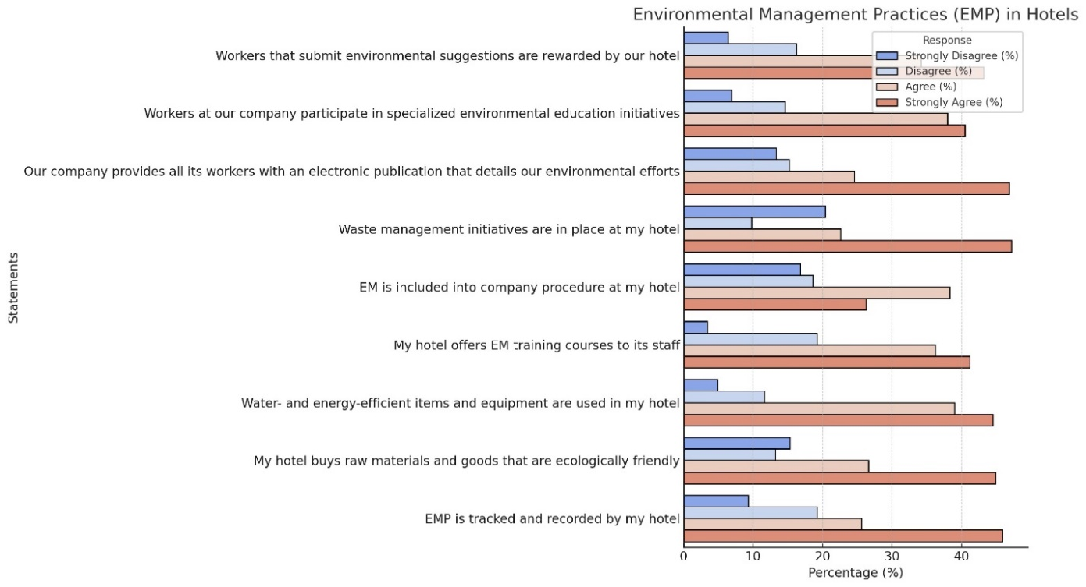

**Fig. 2.** Agreement level for hotel EMP

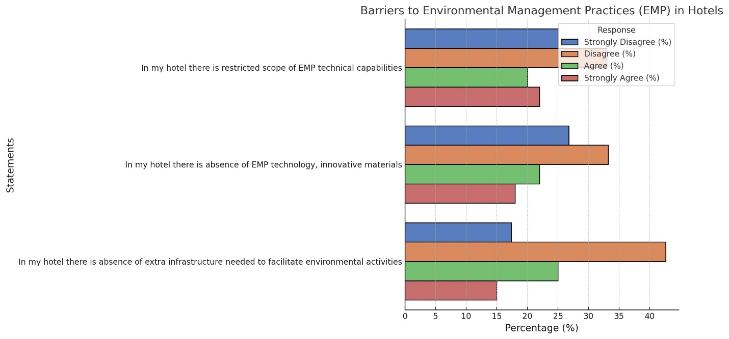

**Fig. 3.** Agreement level for technology support

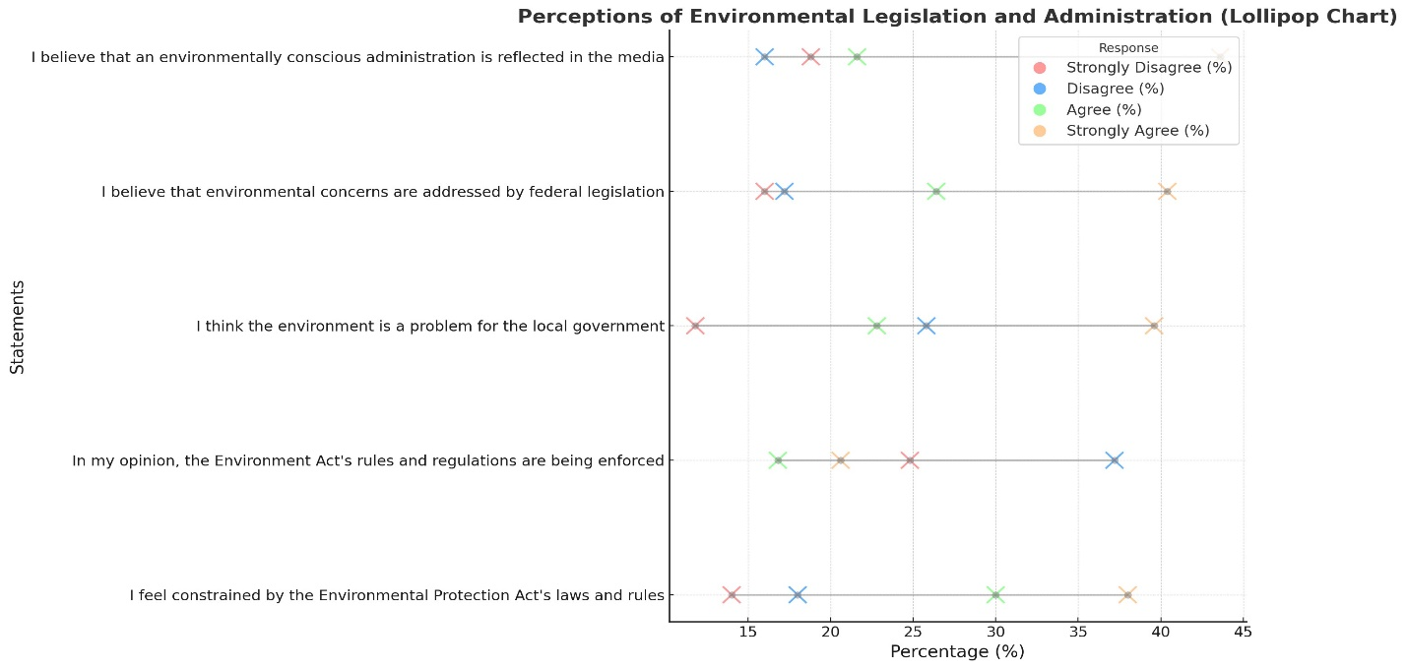

**Fig. 4.** Agreement level for laws and regulations

Figure 5 states that most respondents assert they know and care about environmental concerns. They believe that protecting the environment has a significant impact on their lives. Additionally, most people think they are knowledgeable about ecological issues, know a local program already in place, and would consider implementing EMS at their location. However, most would also consider making sustainable activities a top priority in their corporate policy.

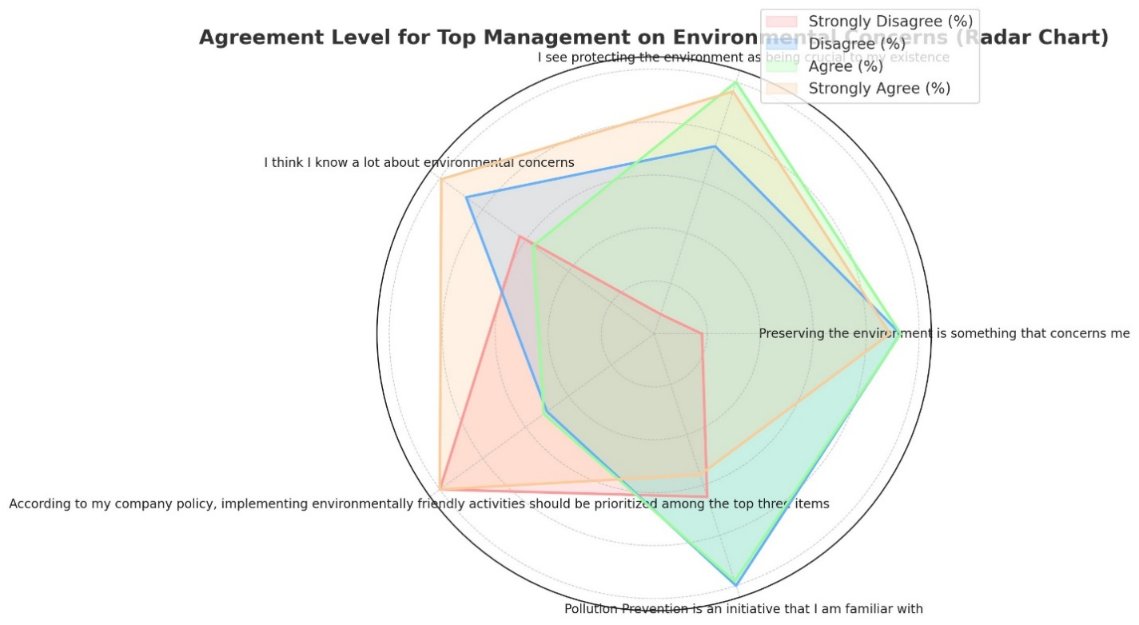

**Fig. 5.** Agreement level for top management

Based on Figure 6, it was agreed upon by slightly more than half of the hotel managers polled that their training does not include environmental awareness. They did, however, plan to do so later. Currently, 46.1% include these awareness campaigns. Given that this is a respectable amount, there is a significant chance that more hotel managers will eventually incorporate awareness of the environment into their training programs. Many hotel executives would give incentives to staff members who suggest green practices that might improve these initiatives inside the organization.

**Fig. 6.** Agreement level for employee awareness

As per Figure 7, most respondents agreed that their business readily accepts technological developments based on research findings. They also decided that trying new things that don't succeed will cost their company. Most also felt that innovation is discouraged and seen as too hazardous in their company.

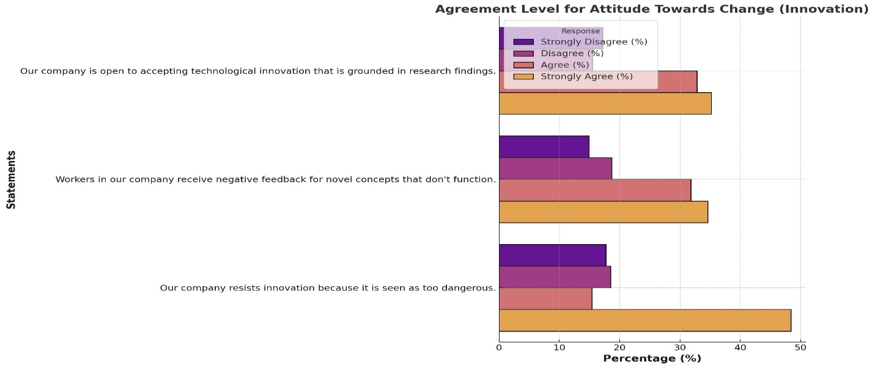

**Fig. 7.** Agreement level for attitude towards change (innovation)

Figure 8's results showed that most people did not agree that there aren't enough green specialists. They disapproved of the claim that there aren't enough workers to conduct EMP. Most of them disagree with "lack of knowledge and skill" as well. Furthermore, a sizable portion of them refuted the claim that there is a shortage of instruments for improving EMP.

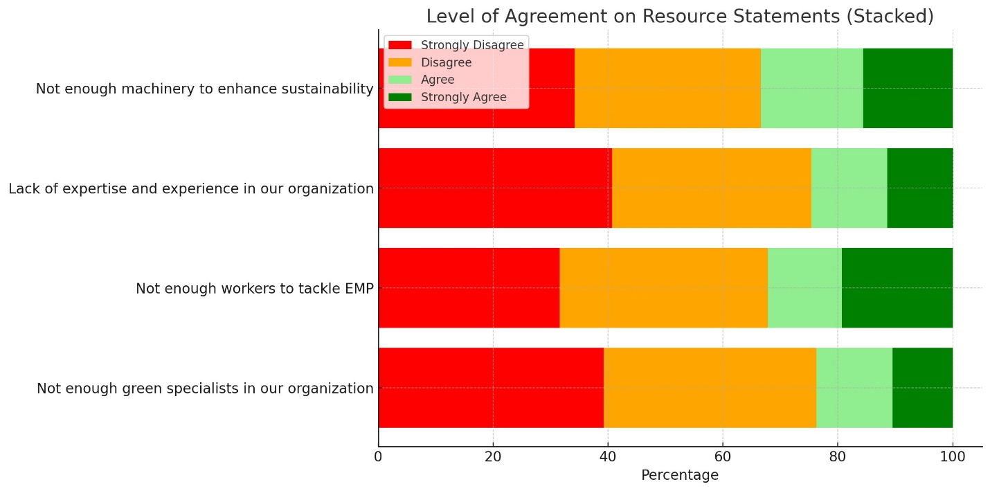

**Fig. 8.** Level of agreement on resource statements

According to Figure 9, there seems to be considerable opposition to the concept of investing money to have an EMS in place. Additionally, if respondents thought the expense of EMS would be excessive, they would reject its deployment. Additionally, nearly half of the respondents did not think EMS implementation would be profitable. Furthermore, they didn't appear to care that there may be consequences. In addition, they expressed some interest in allocating funds for advertising to promote the hotel if they choose to use eco-friendly procedures*.*

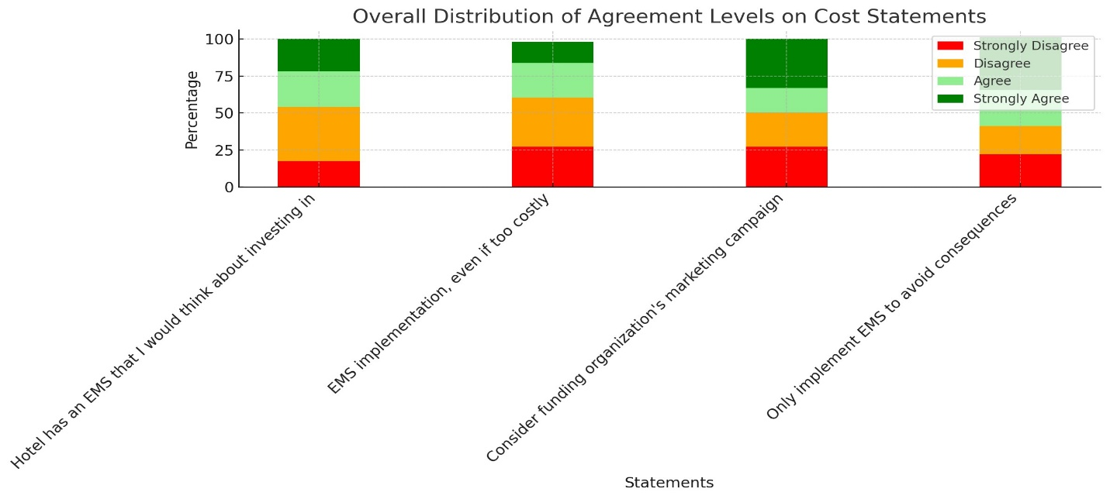

**Fig. 9.** Agreement level for cost statements

The results of Figure 10 stated that most of them firmly believed that having a green hotel would offer them an advantage over rivals. They both agreed that the hotel sector needs green innovators. Most of them were also persuaded that the hotel's income would rise due to its green status. Furthermore, a sizable portion of them concurred that the hotel business benefits from EMP.

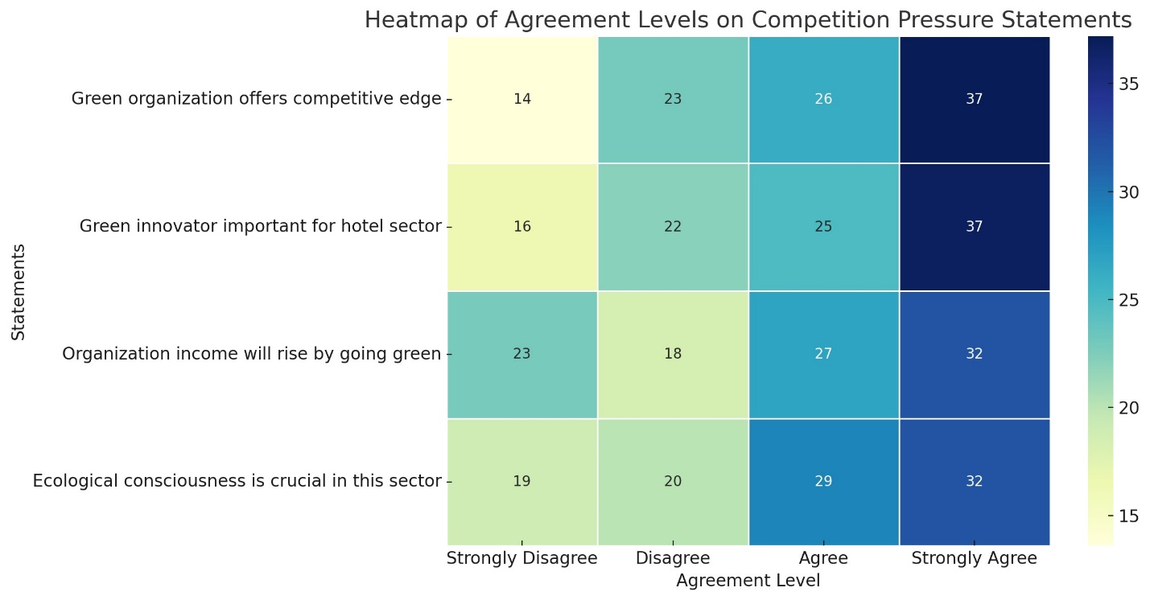

**Fig. 10.** Agreement level for competition pressure

Table 10 displays the outcomes of eight hypotheses evaluating the influence of different factors on Environmental Management Practices (EMP). All hypotheses are validated, demonstrating that technological   
support, legal frameworks, executive leadership, employee awareness, receptiveness to change, resource availability, cost factors, and competitive pressure positively affect EMP. Although several associations lacked statistical significance, the results underscore that these characteristics are essential for implementing EMP in organizations.

**Table 2.** Hypotheses test

|  |  |  |  |  |
| --- | --- | --- | --- | --- |
| H | Hypothesis | B | P- values | Decision |
| H1 | Technology Support > EMP | 0.233 | 0.622 | Supported |
| H2 | Laws and Regulations > EMP | 0.231 | 0.133 | Supported |
| H3 | Top management > EMP | 0.221 | 0.221 | Supported |
| H4 | Employee awareness > EMP | 0.235 | 0.232 | Supported |
| H5 | Attitude towards change > EMP | 0.431 | 0.333 | Supported |
| H6 | Resources > EMP | 0.241 | 0.158 | Supported |
| H7 | Costs > EMP | 0.397 | 0.152 | Supported |
| H8 | Competition pressure > EMP | 0.286 | 0.163 | Supported |

6. Discussion and Conclusion

In industrialized nations like Europe, hoteliers are becoming more conscious of environmental preservation and understanding that doing so protects their industry (Bohdanowicz et al. 2011). Accordingly, the study's conclusions demonstrate that stakeholders and the law pressure hoteliers – at least those in the study context – to adopt EMP. On the other hand, it seems that some hoteliers had adopted eco-friendly procedures and their participants showed an awareness of these benefits and chose to carry on with traditional operations leadership despite the availability of internet and literature-based examples of successful Environmental savings from better handling of resources. Additionally, trade associations within the industry and the government may exert stress or offer support to promote or facilitate the adoption of environmentally friendly practices within the hotel business. Even if hoteliers were open to the idea of putting eco-friendly techniques into action, numerous elements, such as strictly enforced and antiquated ecological laws and rules, a strong green supply chain, intense trade stress, and a high level of sustainability consciousness among the populace, all motivate people to participate in an EMS.

According to the study's findings, it can be easier to develop a framework for independently owned upmarket hotels and possibly adapt it to other hotel industry segments if one has a clear grasp of the processes, important drivers, and obstacles to implementing environmentally friendly practices. Because of this, we investigate what motivates and hinders becoming environmentally conscious. The main objective of the current research was to investigate the drivers and barriers of environmental management practices in Saudi hotels. The study reported a significant positive relationship between technological support and environmental management practices, as it has been determined that businesses must adopt novel innovations to implement new EMP successfully. Businesses can genuinely promote the adoption of EMP by utilizing new technologies, new cooperation techniques, or new information (Roig-Tierno et al. 2018). The study also reported a significant positive relationship between laws, regulations, and EMP. Green practices are partly implemented by government rules and laws (Wan et al. 2017). Thus, to impose green practices in hotels, the government should show loyalty, create procedures, and take decisive action (Asadi et al. 2020).

Furthermore, governments consistently push the service sector to become more environmentally conscious and to raise knowledge of efficient resource use (Al-Aomar & Hussain 2017). The government can provide more suitable programs and rewards to motivate hotels to adopt more EMP. Moreover, there is a considerable positive association between EMP and top management. According to Wan et al. (2017), management issues are a significant obstacle to adopting EMP. Green practices at hotels can be implemented more methodically by creating a formal EMP (Okumus et al. 2019). As a result, EMS implementation in hotels greatly aids in removing these obstacles associated with the unpredictable nature of environmental management. Offering green practice training has been shown to significantly increase workers' voluntary environmental actions (Pinzone et al. 2016).

Furthermore, there is a better chance of improving workers' attitudes toward the environment in hotels and in their daily lives the more greener practice training is implemented (Tuckova, & Jabbour 2019). Therefore, hotel management ought to give their staff more green education opportunities. The current study also found a strong relationship between cost and EMP. Green practice implementation and upkeep are expensive endeavors. Certain green facilities need to be installed using a wide range of sophisticated machinery. ISO green standards will require hotels to match their green policies, increasing their costs. Thus, a distinct eco-fund might be assigned to every EMP, for example, rainwater collection for a water conservation program or the purchase of energy-efficient tools (Wan et al. 2017).

In other words, the findings showed a negative correlation between employee awareness and EMP (r= -0.421, p< 0.005). It is clear from our research that vendors, staff, and consumers don't know much about sustainability. According to Han (2020), Alonso-Almeida et al. (2016), and Han et al. (2018), hotel managers have a responsibility to assist guests in appreciating the significance of green practices. One of the main obstacles to implementing green practices in hotels is the staff's low environmental knowledge level. Encouraging workers to evaluate their environmental performance and providing environmentally friendly education are also important. Assigning environmental tasks to staff members is another successful strategy for encouraging them to engage in the hotel's green initiatives (Pham et al. 2019). Likewise, Lee's (2008) findings support our results, indicating that worker competencies were positively associated with their readiness to engage in green activities.

The study demonstrated that certain hoteliers were open to adopting eco-friendly procedures to cut expenses, such as energy prices. Nevertheless, hoteliers who started implementing eco-friendly methods to save money might alter their performance beliefs; therefore, this perspective might not be sufficient to demonstrate EMP (Harris & Crane 2002). It is crucial to integrate the interests of the public and private sectors by recognizing their respective moral, social, and legal obligations. Radzi (2024) has argued that individuals can only become firmly committed to implementing EMP when ethical considerations are made evident.

Nonetheless, this survey's findings suggest that hoteliers are fundamentally businesspeople with a natural concentration on income, expenses, and profits. This is not surprising and supports the perspective expressed by Hamzah (2024) that many managers believe that adopting environmentally friendly methods will undermine their ability to make profits, keep market share, control expenses, and create efficient production. That's why many small business owners are reluctant to make the initial investments, even in the face of published data showing cost benefits from using EMP.

Businesses that possess greater capital and the ability to adapt are better equipped to cover the costs of environmental and general company development (Hamzah 2024). Furthermore, even though restaurateurs thought that adopting EMP might be advantageous in the long run, they were uncertain about whether their investment would yield the anticipated outcomes because the hotel industry is seen as being so fiercely competitive and highly unpredictable that it is impossible to rule out the possibility of their business closing completely. Thus, incentivizing small firms to take EMP responsibility is necessary.

According to Schubert et al. (2010), hoteliers can gain a competitive advantage by being ecologically conscientious. However, most participants in this study think that becoming green can help them make a lasting impression. In Saudi Arabia, hoteliers think that being green will make them stand out from the competition, similar to the US, where they can obtain significant competitive advantages by differentiating themselves from other businesses by exhibiting a strong interest in EMP and actively participating in eco-friendly operations (Schubert et al. 2010). There are benefits to being an environmentally conscious innovator in their area. Despite being seen as profitable, becoming green has very little impact on the industry. This indicates that as long as stakeholders, particularly customers and potential customers, are pressuring hoteliers to project an eco-friendly image, implementing sustainable practices to reach environmental conservation in this industry will remain crucial.

*This Project was funded by the Deanship of Scientific Research (DSR) at King Abdulaziz University, Jeddah, under grant no. (GPIP:841-246-2024). The authors, therefore, acknowledge with thanks DSR for technical and financial support.*

References

Abdou, D. S., Halim, Y. T., & El-Deeb, M. S. (2020). The Egyptian hospitality sector as a case study in post-COVID-19: searching for greening and sustainable recovery strategies. *International Journal of Green Economics*, *17*(4), 330-360.

Abdou, H. A., Ellelly, N. N., Elamer, A. A., Hussainey, K., & Yazdifar, H. (2022). Corporate governance and earnings management nexus: Evidence from the UK and Egypt using neural networks. *International Journal of Finance & Economics*, *26*(4), 6281-6311.

Al-Aomar, R., & Hussain, M. (2017). An assessment of green practices in a hotel supply chain: A study of UAE hotels. *Journal of Hospitality and Tourism Management*, *32*, 71-81.

Albert, L., & Ferguson, I. (2021, May). *The COVID-19 Pandemic: An exploration of environmental implications*. (In:) Canadian Society of Civil Engineering Annual Conference (pp. 265-276). Singapore: Springer Nature Singapore.

Alonso-Almeida, M. D. M., Rocafort, A., & Borrajo, F. (2016). Shedding light on eco-innovation in tourism: A critical analysis. *Sustainability*, *8*(12), 1262.‏

Angelidou, M., Psaltoglou, A., Komninos, N., Kakderi, C., Tsarchopoulos, P., & Panori, A. (2018). Enhancing sustainable urban development through smart city applications. *Journal of science and technology policy management*, *9*(2), 146-169.

Asadi, S., Pourhashemi, S. O., Nilashi, M., Abdullah, R., Samad, S., Yadegaridehkordi, E., ... & Razali, N. S. (2020). Investigating influence of green innovation on sustainability performance: A case on Malaysian hotel industry. *Journal of cleaner production*, *258*, 120860.‏

Balicka, A. (2015). *Ecological Controlling in the Company*. Wrocław: Publishing House of the Wrocław University of Economics. (in Polish) http://dx.doi.org/10.15611/pn.2015.399.01

Basok, B., Bazeev, E., Pavlenko, A., & Kurayeva, I. (2021). Municipal Heat Energy of Ukraine – Adaptation to Global Warming. *Rocznik Ochrona Środowiska*, *23*, 552-568. <https://doi.org/10.54740/ros.2021.039>

Berwal, P., Gupta, N., Kumar, R., Sherif, E., & Kumar, A. (2024). Environmental Conservation by Using Recycled Aggregates: Enhancing Sustainability in Road Construction. *Rocznik Ochrona Środowiska, 26*, 510-524. https://doi.org/10.54740/ros.2024.047

Bohdanowicz, P., Zientara, P., & Novotna, E. (2011). International hotel chains and environmental protection: an analysis of Hilton's we care! programme (Europe, 2006-2008). *Journal of Sustainable Tourism*, *19*(7), 797-816.

Bonifant, B. C., Arnold, M. B., & Long, F. J. (1995). Gaining competitive advantage through environmental investments. *Business Horizons*, *38*(4), 37-48.

Boyacı, S., Başpınar, A., Atilgan, A., & Rolbiecki, R. (2023). Determination of the Vertical Distribution Pattern of Indoor Climate Parameters in the Greenhouse Heated in the Winter Period. *Rocznik Ochrona Środowiska*, *25*, 105-115. <https://doi.org/10.54740/ros.2023.011>

Bramwell, B., & Lane, B. (2011). Critical research on the governance of tourism and sustainability. *Journal of Sustainable Tourism*, *19*(4-5), 411-421.‏

Brown, K. (2020). Tied for Warmest Year on Record, NASA Analysis Shows. NASA Available: http://www.nasa.gov/press-release/2020-tied-for-warmestyear-on-record-nasa-analysis-shows. (Accessed 23 January 2021).

Carraro, C., Katsoulacos, Y., & Xepapadeas, A. (Eds.). (2013). Environmental policy and market structure (Vol. 4). Springer Science & Business Media.

‏Cembruch-Nowakowski, M. (2020). Labels and Certificates for Green Hotels. *Rocznik Ochrona Środowiska*, *22*.

‏Chan, E. S. W. (2008). Barriers to EMS in the hotel industry. *International Journal of Hospitality Management*, *27*(2), 187-196.

Chan, E. S. W., Okumus, F., & Chan, W. (2018). Barriers to Environmental Technology Adoption in Hotels. *Journal of Hospitality & Tourism Research*, *42*(5), 829-852. <https://doi.org/10.1177/1096348015614959>

Chan, E. S., Hon, A. H., Chan, W., & Okumus, F. (2014). What drives emsloyees' intentions to implement green practices in hotels? The role of knowledge, awareness, concern and ecological behaviour. *International Journal of Hospitality Management*, *40*, 20-28.‏

Chang, L. H., Tsai, C. H., & Yeh, S. S. (2014). *Evaluation of green hotel guests' behavioral intention*. In Advances in hospitality and leisure (pp. 75-89). Emerald Group Publishing Limited.

‏Chavan, M. (2005). An appraisal of environment management systems: A competitive advantage for small businesses. *Management of Environmental Quality: An International Journal*, *16*(5), 444-463.‏

Chen, Y. S., Lai, S. B., & Wen, C. T. (2006). The influence of green innovation performance on corporate advantage in Taiwan. *Journal of business ethics*, *67*, 331-339.‏

Chou, C. J. (2014). Hotels' environmental policies and employee personal environmental beliefs: Interactions and outcomes. *Tourism management*, *40*, 436-446.

Claver-Cortés, E., Molina-Azorin, J. F., Pereira-Moliner, J., & López-Gamero, M. D. (2007). Environmental strategies and their impact on hotel performance. *Journal of sustainable tourism*, *15*(6), 663-679.

Corvellec, H., Stowell, A. F., & Johansson, N. (2022). Critiques of the circular economy. *Journal of industrial ecology*, *26*(2), 421-432.

Dane, F.C. (1990). Research methods (1st ed.). Belmont, CA: Brooks/Cole Publishing.

Darnall, N., Jolley, G. J., & Handfield, R. (2008). Environmental management systems and green supply chain management: complements for sustainability?. *Business strategy and the environment*, *17*(1), 30-45.‏

Delmas, M. A., & Toffel, M. W. (2008). Organizational responses to environmental demands: Opening the black box. *Strategic management journal*, *29*(10), 1027-1055.

‏DiPietro, R. B., Gregory, S., & Jackson, A. (2013). Going green in quick-service restaurants: Customer perceptions and intentions. *International Journal of Hospitality & Tourism Administration*, *14*(2), 139-156.‏

Deraman, F. D., Noralisa Ismail, N. I., Ahmad Izzat, M. A., & Mohamad Izzuan, A. M. (2017). Green practices in hotel industry: factors influencing the implementation ‏from <http://www.dinegreen.com/sources>

Eltayeb, T. K., & Zailani, S. (2010). Investigation on the drivers of green purchasing towards environmental sustainability in the Malaysian manufacturing sector. *International Journal of Procurement Management*, *3*(3), 316-337.‏

Erdogan, N., & Baris, E. (2007). Environmental protection programs and conservation practices of hotels in Ankara, Turkey. *Tourism Management*, *28*(2), 604-614. [https://doi.org/10.1016/j.tourman.2006.07.003](https://doi.org/10.1016/j.%20tourman.2006.07.003)

ETIC hotels. Sustainable and Eco-Hotels in Saudi Arabia. Available online: (accessed on 15 June 2022). <https://etichotels.com/hotels?src=countries&regid=6&conid=116&cityid=0&fromdt=na&todt=na&adlts=2&chlds=0>

Goeldner, C.R., & Ritchie, J.R.B. (2006). *Tourism: Principles, practices, philosophies.* 10th ed., New Jersey: Hoboken.

Gajdzik, B., Wolniak, R, Nagaj, R., Grebski, W., Romanyshyn, T. (2023). Barriers to renewable energy source (RES) installations as determinants of energy consumption in EU countries. *Energies*, *16*(21), 7364, 1-32. http://doi.org/10.3390/en16217364.

Gold AH, Malhotra A, Segars AH (2001) Knowledge management: an organizational capabilities perspective. *J Manag Inf Syst* *18*(1), 185-214.

Hamzah, H., Wahab, S. N., Othman, N., & Ferguson, G. (2024). Greening the hospitality industry: examining institutional influences and perceived benefits of EMS in Malaysian SME hotels. *Journal of Hospitality and Tourism Insights.*‏

Han, H. (2020). Theory of green purchase behavior (TGPB): A new theory for sustainable consumption of green hotel and green restaurant products. *Business Strategy and the Environment*, *29*(6), 2815-2828.‏

Han, H., & Kim, Y. (2010). An investigation of green hotel customers' decision formation: Developing an extended model of the theory of planned behavior. *International Journal of Hospitality Management*, *29*(4), 659-668. https://doi.org/10.1016/j.ijhm.2010.01.001

Han, H., Lee, J. S., Trang, H. L. T., & Kim, W. (2018). Water conservation and waste reduction management for increasing guest loyalty and green hotel practices. *International Journal of Hospitality Management*, *75*, 58-66.‏

Hao, Y., Li, X., & Murshed, M. (2023). Role of environmental regulation and renewable energy technology innovation in carbon neutrality: A sustainable investigation from China. *Energy Strategy Reviews*, *48*, 101114.

Harris, L. C., & Crane, A. (2002). The greening of organizational culture: Management views on the depth, degree and diffusion of change. *Journal of organizational change management*, *15*(3), 214-234.‏

Hurley, R. F., & Hult, G. T. M. (1998). Innovation, market orientation, and organizational learning: an integration and emsirical examination. *Journal of marketing*, *62*(3), 42-54.‏

Ivosevic, B., Han, Y. G., Cho, Y., & Kwon, O. (2015). The use of conservation drones in ecology and wildlife research. *Journal of Ecology and Environment*, *38*(1), 113-118.

Jones, A. L.,Klassen, T. P., , Cook, D. J., Jadad, A. R., Tugwell, P., & Moher, M. (2001). *Assessing the Quality of Reports of Randomised Trials Included in Meta-Analyses: Attitudes, Practice, Evidence and Guides*. (In:) The Advanced Handbook of Methods in Evidence Based Healthcare (pp. 409-425). SAGE Publications Ltd.

Jones, P., Hillier, D., & Comfort, D. (2016). Sustainability in the hospitality industry: Some personal reflections on corporate challenges and research agendas. *International Journal of Contemporary Hospitality Management*, *28*(1), 36-67.

Kasim, A. (2009). Managerial attitudes towards environmental management among small and medium hotels in Kuala Lumpur. *Journal of Sustainable Tourism*, *17*(6), 709-725.

Kasim, A., & Ismail, A. (2012). Environmentally friendly practices among restaurants: Drivers and barriers to change. *Journal of Sustainable Tourism*, *20*(4), 551-570.

Kasim, A., Gursoy, D., Okumus, F., & Wong, A. (2014). The importance of water management in hotels: A framework for sustainability through innovation. *Journal of Sustainable Tourism*, *22*(7), 1090-1107.

Klassen, R. D., & Vachon, S. (2003). Collaboration and evaluation in the supply chain: The impact on plant‐level environmental investment. *Production and operations Management*, *12*(3), 336-352.

Klassen, R. D., & Whybark, D. C. (1999). Environmental management in operations: the selection of environmental technologies. *Decision sciences*, *30*(3), 601-631.

‏Kraus, S., Roig-Tierno, N., & Bouncken, R. B. (2019). Digital innovation and venturing: an introduction into the digitalization of entrepreneurship. *RMS* *13*(3), 519-528

Kuziemska, B., Grużewska, A., Wysokiński, A., Pakuła, K., & Pieniak-Lendzion, K. (2021). Environmental Awareness and Knowledge of Municipal Waste Management Among Inhabitants of Eastern Mazovia. *Rocznik Ochrona Środowiska*, *23*, 356-368. <https://doi.org/10.54740/ros.2021.024>

Le, Y., Hollenhorst, S., Harris, C., McLaughlin, W., & Shook, S. (2006). Environmental management: A study of Vietnamese hotels. *Annals of Tourism Research*, *33*(2), 545-567.

Lee, K. (2008). Opportunities for green marketing: young consumers. *Marketing intelligence & planning*, *26*(6), 573-586.‏

Lee, V. H., Ooi, K. B., Chong, A. Y. L., & Lin, B. (2015). A structural analysis of greening the supplier, environmental performance and competitive advantage. *Production Planning & Control*, *26*(2), 116-130.‏

Lee, Y. C., Wang, Y. C., Chien, C. H., Wu, C. H., Lu, S. C., Tsai, S. B., & Dong, W. (2015). Applying revised gap analysis model in measuring hotel service quality. *SpringerPlus*, *5*, 1-14.

Levy, J. I., & Dilwali, K. M. (2000). Economic incentives for sustainable resourceconsumption at a large university: Past performance and future considerations.International Journal of Sustainability in Higher Education, 1(3), 252–266.Market Structure Vol. 4 Springer Science and Business Media.

Marek, S., & Białasiewicz M. (red.). (2008). *Podstawy nauki o organizacji*. *Przedsiębiorstwo jako organizacja gospodarcza*. Warszawa: PWE, 17-18. (in Polish)

Masiero, L., & Qiu, R. T. (2018). Modeling reference experience in destination choice. *Annals of Tourism Research*, *72*, 58-74.

Matejun, M., & Nowicki, M. (2013). *Organizacja w otoczeniu – od analizy otoczenia do dynamicznej lokalizacji.* [w:] Adamik A. (red.), Nauka o organizacji. Ujęcie dynamiczne. Warszawa: Oficyna a Wolters Kluwer Business, 152-221. (in Polish)

Medina-Molina, C., Rey-Moreno, M., Felício, J. A., & Romano Paguillo, I. (2019). Participation in crowdfunding among users of collaborative platforms: the role of innovativeness and social capital. *Review of Managerial Science*, *13*, 529-543.

Michalak, A., & Wolniak, R. (2023). The innovativeness of the country and the renewables and non-renewables in the energy mix on the example of European Union. *Journal of Open Innovation: Technology, Market, and Complexity*, *9*(2), 100061, 1-16. https://doi.org/10.1016/j.joitmc.2023.100061

Misevičiūtė, V., Rogoža, A., & Tučkus, R. (2024). Optimizing Energy Efficiency and Environmental Sustainability in Gas Distribution Station: A Comprehensive Analysis and Technological Solutions. *Rocznik Ochrona Środowiska*, *26*, 251-263. https://doi.org/10.54740/ros.2024.025

Mois, G., Folea, S., & Sanislav, T. (2017). Analysis of three IoT-based wireless sensors for environmental monitoring. IEEE *Transactions on Instrumentation and Measurement*, *66*(8), 2056-2064.

Mowforth, M., & Munt, I. (2015). *Tourism and sustainability: Development, globalisation and new tourism in the third world*. Routledge.

Ogiemwonyi, O., Alam, M. N., Hago, I. E., Azizan, N. A., Hashim, F., & Hossain, M. S. (2023). Green innovation behaviour: Impact of industry 4.0 and open innovation. *Heliyon*, *9*(6).

Okumus, F., Köseoglu, M. A., Chan, E., Hon, A., & Avci, U. (2019). How do hotel emsloyees' environmental attitudes and intentions to implement green practices relate to their ecological behavior?. *Journal of Hospitality and Tourism Management*, *39*, 193-200.‏

Olkiewicz, M. (2023). Changes in the Natural Surroundings are a Determinant of the Implementation of the Environmental Management System. *Rocznik Ochrona Środowiska*, *25*, 357-366. https://doi.org/10.54740/ros.2023.036

Olkiewicz, M., & Wolniak, R. (2020). Responsible pro-environmental management in an organization: A case study. *Rocznik Ochrona Środowiska*, *22*.

Pacana, A., Siwiec, D. (2022). Model to Predict Quality of Photovoltaic Panels Considering Customers' Expectations. *Energies*, *15*(3), 1101, https://doi.org/10.3390/en15031101

Pallant, J. F., & Bailey, C. M. (2005). Assessment of the structure of the Hospital Anxiety and Depression Scale in musculoskeletal patients. *Health and quality of life outcomes*, *3*, 1-9.

Parker, C., Redmond, J., & Simpson, M. (2009). A review of interventions to encourage SMEs to make environmental improvements. *Environment and Planning, C: Government and Policy*, *27*, 279-301.

Pham, N. T., Tučková, Z., & Jabbour, C. J. C. (2019). Greening the hospitality industry: How do green human resource management practices influence organizational citizenship behavior in hotels? A mixed-methods study. *Tourism management*, *72*, 386-399.‏

Pinzone, M., Guerci, M., Lettieri, E., & Redman, T. (2016). Progressing in the change journey towards sustainability in healthcare: the role of 'Green'HRM. *Journal of Cleaner Production*, *122*, 201-211.‏

Piontek, W. (2019). Depopulation in the Concept of Sustainable Development. *Rocznik Ochrona Środowiska*, *21*.

Porter, M., & Van der Linde, C. (1995). Green and competitive: ending the stalemate. The Dynamics of the eco-efficient economy: environmental regulation and competitive advantage, *33*, 120-134.‏

Post, J. E., & Altman, B. W. (2017). *Managing the environmental change process: barriers and opportunities 1*.   
(In:) Managing green teams (pp. 84-101). Routledge.

Quoreshi, A. M. (2008). The use of mycorrhizal biotechnology in restoration of disturbed ecosystem. Mycorrhizae: sustainable agriculture and forestry, 303-320.

Radzi, N. E. M., A-Jalil, E. E., Mahmod, M., & Salleh, E. S. A. (2024). WEEE Behaviour from Households: A qualitative approach. *Environment-Behaviour Proceedings Journal*, *9*(SI22), 175-182.

Reshetnikova, O., Dyczkowska, J., Olkiewicz, M., Paszkowska, D. (2021). Promoting Pro-ecological Behavior with Logistics Operators in Poland and Ukraine. *Rocznik Ochrona Środowiska*, *23*, 642-654. https://doi.org/10.54740/ros.2021.045

Revell A, Blackburn R. (2007). The business case for sustainability? An examination of small firms in the UK" s construction and restaurant sectors. *Business Strategy and the Environment*, *16*, 404-420.

Rivera-Jaimes, J. A., Postigo, C., Melgoza-Alemán, R. M., Aceña, J., Barceló, D., & de Alda, M. L. (2018). Study of pharmaceuticals in surface and wastewater from Cuernavaca, Morelos, Mexico: occurrence and environmental risk assessment. *Science of the Total Environment*, *613*, 1263-1274.‏

Robinot, E., & Giannelloni, J. L. (2010). Do hotels' "green" attributes contribute to customer satisfaction?. *Journal of Services Marketing*, *24*(2), 157-169.‏

Rodríguez-Antón, J. M., del Mar Alonso-Almeida, M., Celemín, M. S., & Rubio, L. (2012). Use of different sustainability management systems in the hospitality industry. The case of Spanish hotels. *Journal of Cleaner Production*, *22*(1), 76-84.‏

Roig-Tierno, N., Kraus, S., Cruz, S. (2018). The relation between coopetition and innovation/entrepreneurship. *RMS* *12*(2), 379-383.

Rudewicz, J. (2016). Zmiany kierunków użytkowania gruntów ze szczególnym uwzględnieniem terenów przemysłowych w wielkich miastach Polski i ich otoczeniu w latach 2005 i 2009-2014. *Prace Komisji Geografii Przemysłu Polskiego Towarzystwa Geograficznego*, *30*(2), 122-141. (in Polish)

Schubert, F., Kandampully, J., Solnet, D., & Kralj, A. (2010). Exploring consumer perceptions of green restaurants in the US. *Tourism and Hospitality Research*, *10*(4), 286-300.

Scott, D., McBoyle, G., & Schwartzentruber, M. (2004). Climate change and the distribution of climatic resources for tourism in North America. *Climate research*, *27*(2), 105-117.

‏Sekaran, U. (2005). Research methods for business: A skill building approach (4th ed.). Singapore: John Wiley & Sons.

Sepehri, A., Sarrafzadeh, M. H., & Avateffazeli, M. (2020). Interaction between Chlorella vulgaris and nitrifying-enriched activated sludge in the treatment of wastewater with low C/N ratio. *Journal of Cleaner Production*, *247*, 119164.

Shafi, U., Mumtaz, R., García-Nieto, J., Hassan, S. A., Zaidi, S. A. R., & Iqbal, N. (2019). Precision agriculture techniques and practices: From considerations to applications. *Sensors*, *19*(17), 3796.

Sigala, M. (2006). *New media and technologies: trends and management issues for cultural tourism*. In: International Cultural Tourism (pp. 167-180). Routledge.‏

Silva, C., Magano, J., Moskalenko, A., Nogueira, T., Dinis, M. A. P., & Pedrosa e Sousa, H. F. (2020). Sustainable management systems standards (SMSS): Structures, roles, and practices in corporate sustainability. *Sustainability*, *12*(15), 5892.

Siti-Nabiha, A. K., Wahid, A. N., & Ariffin, K. S. (2010). The drivers and the outcomes of environmental management practices in the hotel industry: A proposed framework. *Journal of Hospitality and Tourism*, *17*(1).

Song, W., Wang, G. Z., & Ma, X. (2019). Environmental innovation practices and green product innovation performance: a perspective from organizational climate. *Sustain Dev* 2019, 1-11.

Stachowski, P. (2021). Assessment of the Water Needs of Fruit Plants in the Perspective of Climate Change. *Rocznik Ochrona Środowiska*, *23*, 434-445. <https://doi.org/10.54740/ros.2021.029>

Stone, G., Joseph, M., & Blodgett, J. (2004). Toward the creation of an eco‐oriented corporate culture: a proposed model of internal and external antecedents leading to industrial firm eco‐orientation. *Journal of Business & Industrial Marketing*, *19*(1), 68-84.‏

Sunny, J., Undralla, N., & Pillai, V. M. (2020). Supply chain transparency through blockchain-based traceability: An overview with demonstration. *Computers & Industrial Engineering*, *150*, 106895.

Taylor, N., Barker, K., & Simpson, M. (2003). Achieving sustainable business, a study of perceptions of environmental best practice by SMEs in South Yorkshire. *Environment and Planning C: Government and Policy*, *21*, 89-105.

Teng, Yi-Man & S., Wu & Liu, Hsiao-Hui. (2013). Integrating Altruism and the Theory of Planned Behavior to Predict Patronage Intention of a Green Hotel. *Journal of Hospitality & Tourism Research*, *39*. https://doi.org/10.1177/1096348012471383

Tomaszewski, K., & Sekściński, A. (2020). Odnawialne źródła energii w Polsce – perspektywa lokalna i regionalna. *Rynek Energii*, *149*(4), 10-19. (in Polish).

Tsai, H., Liu, H., & Wu, J. (2016). Performance assessment of Hong Kong hotels. *Journal of China Tourism Research*, *13*(2), 123-140.

Tzschentke, N. A., Kirk, D., & Lynch, P. A. (2008). Going green: Decisional factors in small hospitality operations. *International Journal of Hospitality Management*, *27*(1), 126-133.‏

Wach, K. (2010). Analiza otoczenia przedsiębiorstwa w szkołach i koncepcjach zarządzania. *Zeszyty Naukowe Uniwersytetu Ekonomicznego w Krakowie*, *812*, 134-135. (in Polish)

Wan, Y. K. P., Chan, S. H. J., & Huang, H. L. W. (2017). Environmental awareness, initiatives and performance in the hotel industry of Macau. *Tourism Review*, *72*(1), 87-103.

Watson, M. (2006). Protecting the environment: the role of environmental management systems. *The journal of the Royal Society for the Promotion of Health*, *126*(6), 280-284.‏

Watson, M., & Emery, A. R. (2004). Environmental management and auditing systems: The reality of environmental self‐regulation. *Managerial Auditing Journal*, *19*(7), 916-928.

Winter, S. C., & May, P. J. (2001). Motivation for compliance with environmental regulations. *Journal of Policy Analysis and Management: The Journal of the Association for Public Policy Analysis and Management*, *20*(4), 675-698.‏

Wyszomirski, A., & Olkiewicz, M. (2020). Environmental corporate social responsibility as a tool for creating the future of environmental protection. *Rocznik Ochrona Środowiska*, *22*, 1145-1161.

Yang, C. C. (2022). Explainable artificial intelligence for predictive modeling in healthcare. *Journal of healthcare informatics research*, *6*(2), 228-239.

Yaw Jr, F. (2002). Cleaner technologies for sustainable tourism: Caribbean case studies. *Journal of Cleaner Production*, *13*(2), 117-134.

Yusof, Z. B., & Jamaludin, M. (2014). Barriers of Malaysian green hotels and resorts. *Procedia-Social and Behavioral Sciences*, *153*, 501-509.

Zhang, D., Tu, J., Zhou, L., & Yu, Z. (2020). Higher tourism specialization, better hotel industry efficiency? *International journal of hospitality management*, *87*, 102509.