|  |  |  |  |
| --- | --- | --- | --- |
|  |  | | |
| **Rocznik Ochrona Środowiska** | | |
| Volume 27 | Year 2025 ISSN 2720-7501 | pp. 19-24 |
|  | https://doi.org/10.54740/ros.2025.003 open access | | |
|  | Received: January 2025 Accepted: February 2025 Published: February 2025 | | |

Change in the Chemical Composition and Strength of Wood that has been Used   
for a Long Time Under Water

Alexander Chernykh1, Alexander Shkarovskiy2, Ivan Kudryavtsev3, Pavel Koval4, Shirali Mamedov5*

1Saint Petersburg State University of Architecture and Civil Engineering, Russia   
<https://orcid.org/0000-0001-9805-1428>

2Koszalin University of Technology, Poland,  
Saint Petersburg State University of Architecture and Civil Engineering, Russia   
<https://orcid.org/0000-0002-2381-6534>

3Saint Petersburg State University of Architecture and Civil Engineering, Russia   
https://orcid.org/0009-0009-9695-2172

4Saint Petersburg State University of Architecture and Civil Engineering, Russia<https://orcid.org/0000-0003-1911-5169>

5Saint Petersburg State University of Architecture and Civil Engineering, Russiahttps://orcid.org/0000-0003-0366-1085

*corresponding author's e-mail: mamedov_am@bk.ru

**Abstract:** The article shows the importance of analyzing old wood strength properties in restoration and monitoring the structure's condition. The issue of the characteristics of wooden structures destruction in the salty water of the Gulf of Finland is discussed. In particular, wood's physical and mechanical properties are analyzed during the long-term operation in water. The result of testing of small standard samples for different types of stress states is shown. Changes in the chemical composition of wood are identified. The change in the chemical composition of the material affecting its strength properties is described on the example of Fort Kronschlot crib foundation. It has been established that the process of diffusion, amplified by alternating wave loads, led to the washing of extractive substances, a decrease in potassium, and a lack of calcium in the cell walls of tracheids. The results of this research work may be useful in assessing the residual life of long-term wooden structures underwater and in predicting the restoration time for these structures more accurately.

**Keywords:** mechanical properties of wood, long-term durability, chemical composition of wood, water-soluble extractive substances

**1. Introduction**

Cribs, piles, and other types of wooden structures have been built in large numbers since ancient times as underwater footings for constructions from other materials (Fatkullina & Voznyak 2022, Chernykh et al. 2020). The crib foundations were suitable when the solid soil of the footing did not allow the driving of piles or, conversely, in the case of very weak soil (hay, peat). The crib on the weak soil is carried out with a bottom preventing seepage; in solid and rocky soils, such type of bottom is not available.

In hydraulic engineering structures, the crib's height should be as low as possible so that the bottom is permanently underwater to prevent its rotting. The height of the crib foundations is determined according to the position of the lowest water level.

The low cost, sufficient strength, environmental friendliness, and durability of underwater wooden structures put wood first among the other materials used in this construction field (Kagan 1958, Ishimaru et al. 2001).

However, one of the most serious problems of wood is its reduced strength due to the effects of different environmental conditions (such as very wet environment, bioactive environment, and others). Based on centuries-old experience in exploiting wooden marine hydraulic structures, it has been established that wood will be preserved indefinitely under water if there are no woodworms in the sea.

However, several studies have shown that wood is sometimes less well stored in seawater than in freshwater (Kazantseva 2021). Thus, in the work (Bykovskiy 1953), there are examples of a reduction in the strength of wood when exposed to seawater for a long time. It should be noted that the reduction of wood strength was also found when it has been kept in river water for a long time (Mudrov 1949).

This issue is particularly relevant in preserving ancient structures that have become a part of our historical heritage and have been exposed to the aquatic environment for a long time. In the process of studying this problem, we will understand the influence of the environment on the structure and properties of wood in detail, as well as lay the foundation for the study of issues about its preservation and restoration.

Great historical experience in constructing and exploiting wooden structures, including architectural monuments, has also been accumulated in Poland (Adamczyk 2021, Gloger 1907, Kotwica 2006).

Nowadays, structures, the foundations of which include wooden cribs, are often cultural heritage monuments, and preservation is a major task. (Shashkin et al. 2021-1, Korolkov et al. 2020). A typical example of the structure erected on the crib foundation is the historical Fort Kronschlot, located in the Neva Bay of the Gulf of Finland; its restoration is currently being done (Shashkin et al. 2021-2).

The paper gives the results of a study of pine logs put in the crib of the foundation in 1824. Special attention is paid to the chemical changes in the wood composition during its long stay under the water when there was an aggressive environmental impact on the material. Leaching of wood salts, decomposition (or hydrolysis) of cellulose, and dissolution of structural elements occur, which also appear in the form of deterioration of its mechanical properties.

**2. Materials and Methods**

The diameter of the logs crib studied was 26 cm, length 1.5 m (Fig. 1). The material examination revealed that the log's central part (core) was light-colored and undamaged. The peripheral part (sapwood) had a bright dark grey color (Fig. 2). The outside part of the sapwood was full of radial cracks (fig. 3) at a depth of 0.5 to 2 cm. The area of the damaged part was 15 to 20% of the total cross-sectional area of the sample. The annual layers were 0.4 to 5.1 mm wide. The wood density was 370 kg/m3.

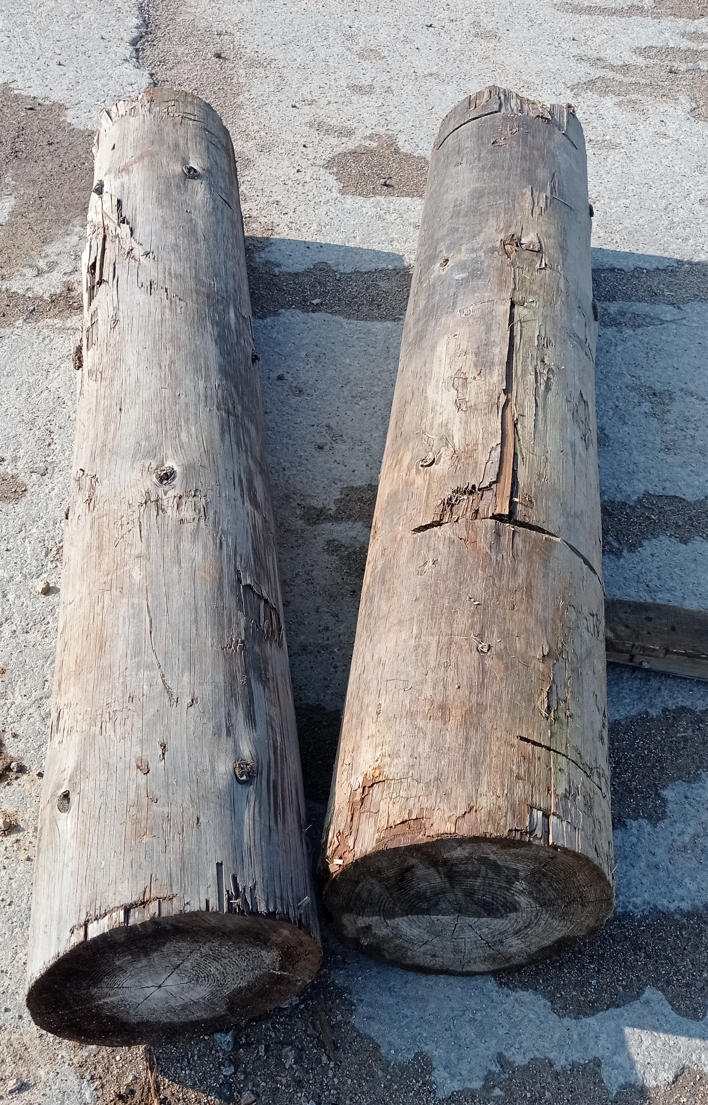

**Fig. 1.** Logs of the studied crib foundation

Due to the high number of defects in the form of dark grey cracks, the wood was not used to determine the physical and mechanical properties of the material being studied, which was consistent with the accepted research practice (Shkarovskiy et al. 2022, Glukhikh & Akopian 2017). Only the chemical properties of this part of the log were determined.

Extensive testing was done to determine the influence of the Gulf of Finland on wood's strength and chemical composition.

For testing 10 samples were prepared for each type of stress state according to the following standards (State Standards, GOST) of the Russian Federation: compression along (GOST 16483.10-73*) and across the fibers (GOST 16483.11-72*), chipping along the fibers (GOST 16483.5-73*), tension (GOST 16483.23-73*) and bending (GOST 16483.9-73*). The research was carried out on an Instron 5966 universal machine at Saint Petersburg State University of Architecture and Civil Engineering (SPbSUACE/ SPbGASU) testing center in a certified sector for mechanical tests of building structures. The speed of load application was 4 mm/min. The humidity of samples before tests was determined by weight and was 20%.

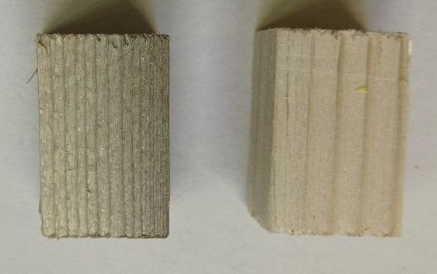

**Fig. 2.** Samples of light and dark grey wood of the studied log

A chemical analysis was also carried out (Azarov et al. 1999) for the log's light and dark grey wood to analyze the changes in the physical and mechanical properties of the material.

This research was conducted at the Department of Cellulose and Paper Production of Saint Petersburg State Forest Technical University (SPbFTU). Also, for the detection of the various chemical elements in the studied material, X-ray fluorescence spectroscopy was done on a spectrometer of the brand Bruker Jaguar (Mukhamedova & Pashkova 2018).

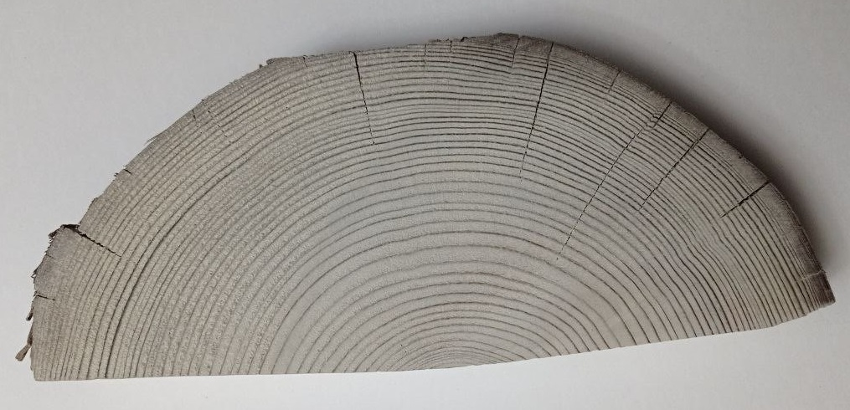

**Fig. 3.** Cracks of the peripheral part of the studied log

3. Results and Discussion

Table 1 shows the test results of the stained pine used in the Gulf of Finland for 200 years in a crib foundation with a standard humidity of 12%. The same values are given in standard pine samples from B.P. Kohlev (Ugolev 1998) for comparison.

The results of the stained pine chemical analysis from the peripheral (dark-colored) and central (light) parts of the studied log are presented in Table 2. For comparison, the parameters of a standard pine sample are given.

The results of the stained pine chemical analysis from the peripheral (dark-colored) and central (light) parts of the studied log are presented in Table 2. For comparison, the parameters of a standard pine sample are given.

The data presented in Table 1 showed that the strength properties of the stained pine were lower than those in the standard samples from the reference literature. The maximum reduction can be seen in the modulus of elasticity.

**Тable 1.** Comparison of the temporary strength values by types of stress state of samples

|  |  |  |  |
| --- | --- | --- | --- |
| Item No. | Name of the stress parameter | Temporary strength  of the studied pine tree crib, MPa | Temporary strength  of the standard pine, MPa |
| 1 | Compression along the fibers | 18.56 | 48.5 |
| 2 | Cross-fiber compression | 1.67 | 5.1 |
| 3 | Chipping along the fibers | 3.62 | 6.5 |
| 4 | Tension along the fibers | 55.97 | 100 |
| 5 | Bending | 70.36 | 86 |
| 6 | Modulus of elasticity | 1581.83 | 10000 |

**Table 2.** Comparison of chemical analysis results

|  |  |  |  |  |
| --- | --- | --- | --- | --- |
| Item No. | Name of the parameter | Light part  of the pine crib | Dark-coloured part of the pine crib | Standard pine |
| 1 | Ash content, % | 0.181 | 0.341 | 0.16 |
| 2 | Cellulose, % | 58.176 | 58.572 | 50.6 |
| 3 | Lignin, % | 29.517 | 30.133 | 27.5 |
| 4 | Amount of soluble substances  in hot water, % | 0.265 | 0.101 | 2.6 |
| 5 | Amount of soluble substances  in acetone, % | 0.878 | 0.566 | 19.14 |

**Table 3.** Comparison of the content of chemical elements in wood

|  |  |  |  |  |
| --- | --- | --- | --- | --- |
| № | Name | Concentration, % | | |
| Light part  of the studied pine crib | Dark-coloured part  of the studied pine | Standard pine |
| 1 | Hafnium (Hf) | 0.1455 | 0.1493 | – |
| 2 | Stibium (Sb) | 0.6276 | 0.6569 | – |
| 3 | Calcium (Ca) | 0.3950 | 0.2222 | 0.208 |
| 4 | Sodium (Na) | 0.1547 | 0.1262 | 0.016 |
| 5 | Ferrum (Fe) | 0.3189 | 1.053 | 0.038 |
| 6 | Bismuth (Bi) | 0.1167 | – | – |
| 7 | Plumbum (Pb) | 0.1134 | – | – |
| 8 | Cadmium (Cd) | 0.0371 | 0.1520 | – |
| 9 | Chlorine (Cl) | 0.0114 | 0.2530 | – |
| 10 | Marganese (Mn) | – | – | 0.030 |
| 11 | Potassium (K) | – | – | 0.472 |
| 12 | Sulfur (S) | – | – | 0.087 |
| 13 | Phosphorus (Р) | – | – | 0.127 |
| 14 | Silicon (Si) | – | – | 0.055 |
| 15 | Manganese (Mg) | – | – | 0.123 |
| 16 | Aluminium (Al) | – | – | 0.041 |
| 17 | Nitrogen (N) | – | – | 2.090 |

This value has decreased 6 times as wood softens in water and loses its hardness. This phenomenon can also be explained by the fact that extractive water-soluble substances in the samples studied are few (Table. 2).

Extractive substances can be found not only in cell cavities but also permeate the walls of wood cells, thus making them more flexible (Tsepaev 2003, Shniewind 1966). After being in the water for a long time, they have been washed out, and the wood has become more fragile.

* Compression across the fibers decreased by 3 times,
* Compression along the fibers by 2.6 times,
* Chipping and tension along the fibers decreased by 1.8 times,
* Bending by 1.2 times.

In the material that has been used in water for a long time, the adhesion strength of early and latewood also decreases due to faster destruction of the walls of earlywood because of their slight thickness, especially under compression (Ishimiaru et al. 1996).

A slight decrease in chipping strength along the grain (compared to other indicators) can be explained by the destruction in the radial plane, where the contact area of early and latewood was smaller (Miyoshi et al. 2020).

The increased ash content of the material significantly affects the strength properties (Azarov et al. 1999). A significant value of this parameter demonstrates the increased amount of minerals in wood.

Considering that the waters washing Fort Kronschlot were considerably polluted due to human labor activity (Zaytseva 2019), many uncharacteristic chemical elements were found in wood during the research. This factor explains the presence of heavy metals in the material (see Tables 1 and 2). In dark grey wood, the concentration of metals is higher, except for calcium, which indicates the significant destruction of wood cells.

Based on the data presented in Tables 1, 2, 3, we can conclude that the main factors that led to a decrease in the strength properties of wood are the following:

* the absence of potassium and reduced calcium, the main chemical elements that affect the wood's cells,
* the reduction of extractive substances concentration,
* increase in the ash content, especially in the peripheral part of the log,
* the impact of the sediment, especially sand, is caused by the waves of water-borne effects that, at small depths, are typical for a crib foundation capturing the sand and moving it onto the crib.

4. Conclusions

The chemical composition and strength properties of the wood of a crib foundation that has been in seawater for a long time are subject to significant changes. These changes are caused by both chemical and biochemical processes as well as diffusion processes. The diffusion speed increases significantly under the influence of alternating loads caused by the constant movement of waves.

The outer (dark grey) wood has a high ash content, which leads to increased fragility of the wood and may indicate a high content of minerals derived from water, while the inner (light part) has an ash content that is not different from the known data.

In turn, wave action dynamics are characterized by significant variability in both force load and spatial distribution. At shallow depths (crib foundations are at a depth of 3...5 m), the wave reaches the bottom, captures sand, and moves it to the foundation cribs. Sand has an abrasive effect on the structure, contributing to its destruction.

The results will allow us to predict the possibility of further exploitation of the crib foundations without expensive research available only in specialized laboratories or to justify the need for their restoration.

*The work was carried out within the framework of the research topic No. 22C24 with the financial support   
of a grant of St. Petersburg State University of Architecture and Civil Engineering.*

References

Adamczyk, R. (2021). *Wooden structures. Part 1.* Koszalin: Koszalin University of Technology. (in Polish)

Azarov, V., Burov, A., Obolenskaya, A. (1999). *Chemistry of wood and synthetic polymers.* St. Petersburg: St. Petersburg LTA. (in Russian)

Bykovsky, V. (1953). *Influence of seawater salts on physical and mechanical properties of wood. RDI of Construction. Research. Wooden structures.* State publishing house of literature on construction and architecture. (in Russian)

Chernykh, A., Korolkov, D., Nizhegorodtsev, D., Kazakevich, T., Mamedov, Sh. (2020). Estimating the residual operating life of wooden structures in high humidity conditions. *Architecture and Engineering,* *5*(1), 10-19. https://doi.org/10.23968/2500-0055-2020-5-1-10-19

Fatkullina, A., Wozniak, E. (2022) Timber foundation in the first third of the 18th century in Saint-Petersburg. *Archi-Teographic seasons in SPbGASU. Collection of materials of the XII Regional Creative Forum with international participation.* Saint Petersburg: St.Petersburg State University of Architecture and Civil Engineering, 57-58.   
(in Russian)

Gloger, Z. (1907). Wooden architecture and wooden products in old Poland. *Vol. 1 and 2.* Warsaw: Druk. W. Łazarskiego. (in Polish)

Glukhikh, V., Akopian A. (2017). Prevention of round timber lateral cracking in wooden house construction. *Architecture and Engineering*, *2*(3), 3-10. https://doi.org/[10.23968/2500-0055-2017-2-3-3-10](http://dx.doi.org/10.23968/2500-0055-2017-2-3-3-10)

Ishimaru, Y., Yamada, Y., Iida, I., Urakami, H. (1996). Dynamic viscoelastiy properties of wood in various stages of swelling. *Mokuzai Gakkaishi*, *42*, 205-257 (in Japanese)

Ishimaru, Y., Arai, K., Mizutani, M., Oshima, K., Iida, I. (2001). Physical and mechanical properties of wood after moisture conditioning. *J. Wood Sci.*, *47*, 185-191. https://doi.org/10.1007/BF01171220

Kagan, M. (1958). Physical and mechanical properties of the wooden piles being long in the water of the Caspian Sea. Vol.: V. Bolshakov, M. Kagan (ed.). *Bulletin of IISS Studies on wooden structures. Collection of works №13.* Moscow: Gosstroyizdat, 223. (in Russian)

Kazantseva, T. (2021). Physical and mechanical properties of wood from the Sayano-Shushensky water reserve. *Conference papers «Current problems and prospects of the development of the forest industry complex*», 123-128.   
(in Russian)

Korolkov, D. et al. (2020). Method for Determining the Residual Resource of Building Structures by the Terms of Their Operation. *Proceedings of EECE 2019 : Energy, Environmental and Construction Engineering,* St. Petersburg, November 19-20, 2019. Springer, 389-402.

Kotwica, J. (2006). *Wooden structures in traditional construction.* Warsaw: Arkady. (in Polish)

Miyoshi, Y. et al. (2020). Dynamic viscoelastic properties of wood and acetylated wood in nonequilibrium states swollen by water or organic liquids. *J. Wood Sci.*, *66*(6). https://doi.org/10.1186/s10086-020-1856-7

Moudrov, G. (1949). Properties of wood for hydraulic structures. Bulletin of construction techniques, 3. (in Russian)

Mukhamedova, M., Pashkova G. (2018). Application of full-spectrum X-ray analysis to determine the elemental composition of environmental objects. *Current problems of the ethno-ecological and ethnocultural traditions of the peoples of Sayano-Altai. Proceedings of the 5th international scientific-practical conference for young scientists, graduate students and students, Kyzyl*, 156-158. (in Russian)

Shashkin, A., Stupak, N., Hisamov, R. (2021). Fort "Emperor Peter I" of the Kronstadt fortress: history of construction and modern technical condition. *Geotechnics*, *13*(1), 20-39. (in Russian)

Shashkin, A., Ulitski, V., Voloboy, S. (2021). Fort "Kronschlot" – history and modernity*. Geotechnics*, *13*(3), 32-50.   
(in Russian)

Shkarovskiy, A. et al. (2022). Use of Eco-friendly Protective Compounds to Increase Crack Resistance of Timber Structures. *Rocznik Ochrona Srodowiska*, *24*, 74-82.

Shniewind, A. (1966). On the influence of moisture content changes on the creep of beech wood perpendicular to the grain including the effects of temperature and temperature changes. *Holz Roh Werkstoff*, *24*, 87-98.

Tsepaev, V. (2003). Evaluation of the modulus of elasticity of wooden structures. *Residential construction*, *2*, 11-13.   
(in Russian)

Ugolev, B. (1998). Problems of wood science and scientific basis of forest technology. *Forest Bulletin*, *1*, 21-28.   
(in Russian)

Zaytseva, A. (2019). Some issues of the application of the water code in relation to pollution of the Gulf of Finland by sewage and bilge waters. *Ocean management*, *1*(4), 22-25. (in Russian)