|  |  |  |  |
| --- | --- | --- | --- |
|  |  | | |
| **Rocznik Ochrona Środowiska** | | |
| Volume 26 | Year 2024 ISSN 2720-7501 | pp. 716-727 |
|  | https://doi.org/10.54740/ros.2024.063 open access | | |
|  | Received: November 2024 Accepted: November 2024 Published: December 2024 | | |

Analysis of Ammonia Emissions from Thermal Sludge Treatment Plants

Maciej Dobrzański1, Robert Cichowicz2*

1Faculty of Civil Engineering, Architecture and Environmental Engineering,   
Lodz University of Technology, Poland  
https://orcid.org/0000-0002-7112-0857

2Faculty of Civil Engineering, Architecture and Environmental Engineering,   
Lodz University of Technology, Poland  
https://orcid.org/0000-0003-3233-2838

*corresponding author's e-mail: [robert.cichowiczi@p.lodz.pl](mailto:robert.cichowiczi@p.lodz.pl)

**Abstract:** The article presents an analysis of the spatial dispersion of ammonia in the troposphere, emitted from the thermal treatment of sludge from the sewage treatment plant in Łódź. The study aimed to assess the impact of the emitter on the air quality in the nearby single-family housing estate. The results of field measurements of ammonia concentration were compared with computer simulations based on data measured at the emitter. Mobile measuring equipment mounted on a transport platform and an unmanned aerial vehicle was used to conduct field measurements, which were then subjected to analytical processing in ArcGis Pro software. Computer simulation of ammonia dispersion from two 25 m high chimneys was conducted in the OPA03 program. Both field measurements and simulation data showed a negligible impact of the emitter on the ammonia concentration in the air. This is primarily due to the low concentration of emitted ammonia at the chimney outlet and the emitter's location relative to the buildings, considering the dominant wind directions. Field studies have shown that the emission of ammonia in the analyzed area may be to a greater extent caused by the sewage collection station from sewage disposal vehicles and the composting plant, which are located close to the analyzed emitter and the residential area.

**Keywords:** ammonia, air pollution, mobile measurements, computer simulation, spatial analysis

1. Introduction

Ammonia gas NH3 is the most abundant alkaline gas in the atmosphere (Behera et al. 2013). The largest source of anthropogenic NH3 emissions, according to the European Environment Agency report (EEA report 2022) is agriculture (94% of emissions), while in Poland, this value reaches 97% (KOBiZE report 2020), including animal husbandry and the use of NH3-based fertilizers (Yang et al. 2023, Mielcarek-Bocheńska et al. 2019). Other sources of NH3 include industrial processes and vehicle emissions. One example of industrial ammonia emissions into the atmosphere may be sewage treatment plants (Cichowicz & Stelągowski 2019, Zhang et al. 2017). The first source of ammonia emissions in sewage treatment plants may be sludge, which, after the dewatering process, contains ammonium nitrogen compounds and ammonia gas (Valach et al. 2023). The second main source may be the selective noncatalytic reduction NOX technological system (Wielgosiński et al. 2016). The SNCR method consists of injecting 25% ammonia water into the upper part of the fluidized bed furnace to reduce the NOX concentration in the exhaust gases. The dosage of ammonia water translates into the occurrence of gaseous ammonia in the exhaust gases and, together with them, the emission of NH3 into the atmosphere. Industrial ammonia emission is particularly important due to the high point concentrations that can occur, thus worsening the comfort of work and threatening the health and life of employees (Van Damme et al. 2018). Ammonia emissions can also cause odour nuisance to nearby residential buildings (Piccardo et al. 2022, Szyłak-Szydłowski et al. 2024). Ammonia in atmospheric air at a concentration of about 3.5 mg/m3 (3500 µg/m3) is noticeable, and at a concentration 10 times higher, it causes discomfort. At a concentration above 280 mg/m3, it causes throat irritation, above 1200 mg/m3, it causes coughing, and concentrations above 1700 mg/m3 can be life-threatening. Long-term exposure to high concentrations of ammonia leads to chronic lung diseases. According to the law regulation (RMŚ 2010), the reference value for ammonia in the air is 400 µg/m3 (average for one hour) and 50 µg/m3 (average for a calendar year). Taking into account the content of Polish legal acts (RMŚ 2012, RMKiŚ 2020, RMK 2020), ammonia is not included in the group of substances subject to the need for continuous monitoring of concentration in atmospheric air. However, it is subject to limitations following the regulation (RMRPiPS 2018) in the work environment to the value of the highest permissible concentration of 14 mg/m3 and the highest allowable momentary concentration of 28 mg/m3.

Recent studies indicate that NH3 emissions have increased globally over the past few decades (Behera et al. 2013). According to the 2022 EEA Air Quality Report in Europe, gaseous pollutant emissions are decreasing year-on-year. Still, ammonia emissions have decreased only 8% over 15 years, the least of all gaseous pollutants analyzed. This is a problem because NH3 plays a significant role in forming particulate matter in the atmosphere (Gong et al. 2013), contributing to atmospheric nitrogen deposition in sensitive ecosystems. Thus, NH3 emissions negatively impact environmental and public health, as well as climate change (Wang et al. 2015).

The spread of gaseous pollutants in the atmosphere is a complex phenomenon (Watson et al. 1988, Aloyan & Arutyunyan 2000). The decisive factors in this respect are the wind direction and speed, the emitter's height, and the terrain's roughness (Kim et al. 2015). As shown in publications (Cichowicz & Wielgosiński 2015, Cichowicz & Dobrzański 2022), in urbanized areas, the phenomenon of accumulation of gaseous pollutants between buildings in lee zones and a decrease in concentration in the "airing" zones very often occurs. Due to the complexity of the phenomenon, computer numerical methods represented by programs such as OPA03 (Łatuszyńska 2013), Aeromod (Abu-Allaban & Abu-Qdais 2011), ENVI-ment and Austral2000 (Paas 2016) are currently used to analyze the spread of pollutants in the atmosphere. Computer programs enable the simulation of pollutant dispersion and, thus, assessment of the emitter's environmental impact.

For these reasons, it is important to clearly understand the sources, deposition, and atmospheric behaviour of NH3. This paper presents a comprehensive analysis of the dispersion of ammonia emitted from a thermal sludge treatment plant based on field measurements using unmanned sampling and transfer technology and computer modelling of the contamination spread based on emitter measurement data.

2. Methodology

2.1. Analyzed objects

The main subject of the analysis was the spread of air pollution emitted by 2 chimneys of a sewage sludge thermal treatment plant SSTT (Fig. 1: L1 and L2.). Each chimney has a height of 25 m and an internal diameter of 0.7 m. The emission source is the combustion reaction at a temperature above 750°C, which is the basic process in sewage sludge thermal treatment utilization. The flue gases produced by the SSTT are subjected to the following processes: cooling energy recovery from flue gases, dedusting separation of solid fractions in cyclones, and chemical treatment removal of acidic substances and mercury using calcium carbonate and activated carbon. The SSTT plant consists of 2 technological lines, each equipped with a fluidized bed furnace using the "Pyrofluid" technology from Veolia Water Technologies with a capacity of approximately 4 MW. SSTT processes approximately 236 m3/d of stabilized dewatered sludge. Approximately 220 Mg of sludge is thermally processed per day.

**Fig. 1.** Location of the analyzed emitter, where L1, L2 are chimneys emitting air pollutants (source of background map: ArcGIS Pro)

Table 1 summarizes the most important data collected from the emitter at the outlet of the L1 and L2 stacks. The L2 emitter operates on average about 20 h longer per month than the L1 emitter, which results in 60% higher average NH3 emissions. The differences between the emitters were considered in the numerical analysis methodology.

**Table 1.** Emission data, exhaust gas temperatures and velocities measured at emitters L1 and L2

|  |  |  |  |  |  |  |  |  |
| --- | --- | --- | --- | --- | --- | --- | --- | --- |
| Parameter | Q-NH3 | | Exhaust gas velocity | | Furnace operating time | | Exhaust gas temp. | |
| Unit | kg/h | | m/s | | h/month | | °C | |
| Emitter no. | L1 | L2 | L1 | L2 | L1 | L2 | L1 | L2 |
| Mean | 0.0510 | 0.0838 | 16.0 | 18.6 | 632.5 | 656.0 | 163.4 | 156.3 |
| Min | 0.0000 | 0.0199 | 15.4 | 14.7 | 173.0 | 333.0 | 159.9 | 148.0 |
| Max | 0.1570 | 0.4312 | 16.8 | 28.9 | 727.0 | 721.0 | 166.0 | 162.6 |

The actual, direct monitoring of air quality near the emitter was carried out in an area of 52 ha (Fig. 2), demarcated from the east by the S14 expressway, from the south by the southern border of the single-family housing area, from the west by the north-south direction of Biwakowa Street, and the north by the entrance to the S14 expressway. The analysis covered the areas of single-family housing, Euro catchment, dye house, garden plant nursery, car, bicycle and pedestrian communication routes. The indicated area (at a distance of 1100 m from the SSTT emitter) was selected due to its location behind the analyzed chimney of the sewage sludge incineration plant in relation to the prevailing wind directions in this area. The selected area was particularly important regarding the possibility of direct odour nuisance or negative impact of the analyzed emitters on the health and life of residents of nearby housing estates.

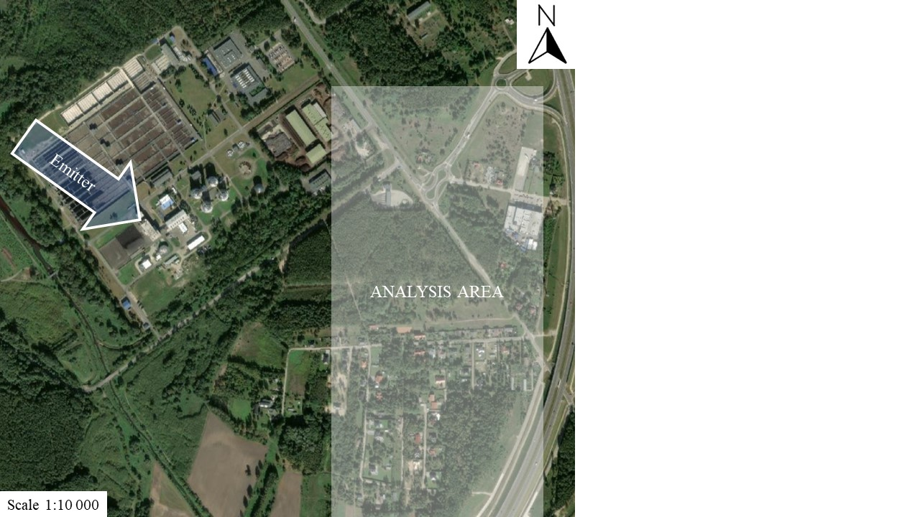

**Fig. 2.** Map of the air quality analysis area (source of background map: ArcGIS Pro)

2.2. Methodology of analysis

The presented studies on the impact of NH3 emissions on air quality can be divided into two parts, which were compared with each other. The first part concerns computer numerical simulation of NH3 dispersion emitted from chimneys based on data collected at the chimney outlet, carried out in the OPA03 program ver. 5.42 by Eko-Soft (Eko-soft company). The second part of the research consisted of actual air quality control in the area most exposed to air pollution with NH3 emitted by emitters L1 and L2. It was performed using mobile measuring equipment. Then, the results collected in this way were presented graphically using the ArcGIS Pro program.

Simulations in the OPA03 program are based on the calculation methodology described in the Regulation of the Minister of the Environment of 26 January 2010 on reference values (hourly average 400 µg/m3 and annual average 50 µg/m3) for certain substances (RMŚ 2010). The input data for modelling in OPA03 came from monitoring pollutant emissions and the velocity and temperature of exhaust gases at the outlet of chimneys from 2022. In the analysis, following the regulation (RMŚ 2010), the background level of ammonia pollution in the air was assumed at 10% of the reference value averaged for the year. Since the concentration of NH3 is not monitored by the Environmental Protection Inspectorate (RMKiŚ 2020 ), it is not possible to determine a real reference value for this pollutant for the analysis area. Therefore, the reference value for ammonia was assumed following the regulation (RMŚ 2010) of 50 µg/m3 (average for the year), and therefore the background level of pollution used in the analysis was 5 µg/m3. This value will be a reference for the emitter's impact on air quality. The analysis was carried out considering meteorological data from the Lodz-Lublinek measuring station. The simulation in the OPA03 program was carried out divided into 12 time periods due to large disproportions in ammonia emissions from two emitters (Table 2). In addition, an analysis was carried out for a hypothetical situation of the occurrence of maximum emission of emitters L1 and L2 from 2022 in the same month, to check the extreme from the available data. The results of the OPA03 analyses are presented in spatial graphs of the maximum hourly and average annual ammonia concentration at a height of 2 m above ground level. The adopted height of 2 m was intended to compare computer results with field measurements performed at the same height. In addition, this is the height of direct impact on people staying and living near the emitter and is following legal measurement recommendations stating the need to measure at a height of 1.5 to 4 m above the ground (OMKiŚ 2024). The concentration of 0.02 µg/m3 (less than 0.04% of the reference value) was assumed as the minimum presented in the graphics.

Field measurements of NH3 concentration verified the results of the computer simulation. Field measurements of NH3 concentration were performed using measurement and sampling equipment installed on an unmanned aerial vehicle (UAV) (Fig. 3A) and a transport platform (TP) (Fig. 3B). The use of a UAV allowed for measurements to be made at heights ranging from 15 to 50 m above the ground surface. The TP was used for measurements at a height of approximately 2 m above ground level. The UAV with TP was equipped with a metal oxide semiconductor (MOS) NH3 sensor (10 ppb to 300 ppm). The MOS sensors were validated against measurements made using a VEGA-GC microchromatograph gas chromatograph equipped with a thermal conductivity detector (TCD), a minimum concentration of 500 ppb (0.005 ppm).

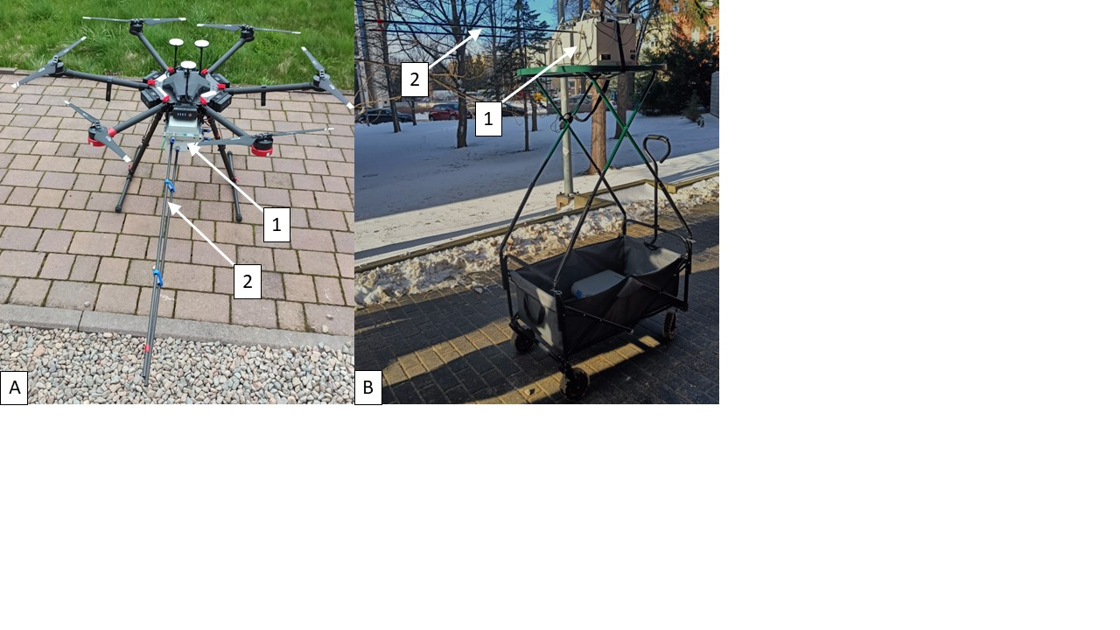

**Fig. 3.** Measuring apparatus: A – unmanned aerial vehicle (UAV), B – transport platform (TP) with 1 – measuring equipment, 2 – sampling probe

The results of field measurements of NH3 concentration were developed based on numerical analyses of pollutant dispersion and were performed using ArcGIS Pro 3.2 (Esri company). The pollutant concentration distribution was interpolated using the Empirical Bayesian Kriging 3D method. The Kriging method was chosen over other interpolation methods, such as Inverse Distance Weighting (Maleika 2020) or Triangulated Irregular Network (Pawlowicz 2019) methods because it has the advantage of treating the observed variable as a random variable. The weight coefficients are estimated by minimizing the sum of squared deviations for regression and using spatial autocorrelation (semivariogram). This improves the quality of spatial prediction (Song et al. 2018). The results were transformed into a 3D spatial image using the Voxel method to graphically display the actual measurement data (Butler 2020).

3. Results

The first step towards computer numerical simulation of NH3 contamination dispersion in the OPA03 program according to the Regulation of the Minister of Environment methodology of 26 January 2010 was to determine the aerodynamic roughness coefficient of the terrain z0. Within the range of 50x the emitter height (25 m), i.e. within 1.25 km from the analyzed emitter, five types of land cover were selected in the analyzed area according to the recommendations of the regulation (RMŚ 2010). In the western directions, from the emitter north to south, forest areas, copses and thickets, as well as meadows and fields, predominate. In the eastern direction from the emitter, apart from the previously mentioned ones, there are also low-rise residential and industrial development areas (Fig. 4).

**Fig. 4.** Analysis of the aerodynamic terrain roughness coefficient

Based on the division of the area, the surface Fc and the unit coefficient z0c were determined for each land cover type (Table 2). Finally, the aerodynamic coefficient of terrain roughness z0 was calculated following the regulation (RMŚ 2010) as 0.72.

**Table 2.** Determination of the aerodynamic terrain roughness coefficient z0

|  |  |  |  |
| --- | --- | --- | --- |
| Land cover type: | z0c | Fc [m2] | z0c*Fc |
| Water | 0.00008 | 61131 | 4.9 |
| Meadows, pastures | 0.02 | 2054006 | 41080.1 |
| Orchards, thickets, groves | 0.4 | 553158 | 221263.2 |
| Forest | 2 | 1428306 | 2856612.0 |
| Low-rise buildings | 0.5 | 809649 | 404824.5 |
| Sum: | | 4906250 | 3523784.7 |
| **z0** | **0.72** |  | |

The next stage of computer analysis in OPA03 was the presentation of the spatial distribution of NH3 concentrations. Figure 5 shows the range of impact of emitters L1 and L2 on the SSTT area and surroundings within a range of 1 km in terms of emission of the maximum one-hour NH3 concentration. The maximum one-hour concentration refers to the situation of the extremely unfavourable impact of the emitter on the environment, in which the spread of pollution occurs following the laws of atmospheric physics, without taking into account the influence of wind on the dilution of concentration and the direction of pollution movement. The highest hourly concentration of 4 µg/m3 (1% of the reference value) occurs within a radius of approx. 200 m from the emitters, i.e. almost entirely within the SSTT area. The further from the emitter, the lower the concentration. Outside the sewage treatment plant boundaries, the concentration decreases to 3.0-3.5 µg/m3. At a distance of 700 m from the emitters, the concentration is lower than 2.0 µg/m3 (Fig. 5).

**Fig. 5.** Maximum hourly NH3 concentration in the analysis area at a height of 2 m

The observed rapid reduction of NH3 concentration in the vicinity of the emitter results from its height (only about 15 m above the surrounding obstacles: trees and buildings) and the high roughness of the terrain. This translates into a reduction in the spread of pollution.

The second parameter analyzed in the computer simulation was the dispersion of NH3 in relation to the emitted average annual concentration. The result of the spatial distribution of the average annual concentration (Fig. 6) is influenced by the dominant wind direction and speed in the analyzed area (according to data from the nearest meteorological station Lodz-Lublinek). In the analysis area, winds blowing from the south-west dominate, which causes the precipitation of emitted NH3 to predominate in the north-east direction. The highest average annual concentrations ranging from 0.06 to 0.09 µg/m3 (constituting only 0.13-0.20% of the reference value) occurred primarily within the boundaries of the sewage treatment plant. The area of impact of emitters L1 and L2 can be limited to a radius of 1.0 km, in the north-east direction from the emitter, where forest areas predominate. The analysis shows that residential areas are not affected by the emitter in most cases.

**Fig. 6.** Average annual NH3 concentration in the analysis area at a height of 2 m

Significant differences in NH3 emissions between emitters L1 and L2 necessitated the simulation in a hypothetical scenario. In the hypothetical scenario, it was assumed that maximum emissions from both emitters would occur simultaneously. This means that a maximum NH3 emission of 0.15701 kg/h from emitter L1 in June 2022 and a maximum NH3 emission of 0.43116 kg/h from emitter L2 in December 2022 were taken into the simulation. This allowed us to verify the extreme case of two emitters operating.

**Fig. 7.** Hypothetical variant. Maximum hourly NH3 concentration in the analysis area at a height of 2 m

In the hypothetical variant (Fig. 7), the value of the maximum one-hour concentration increased compared to the actual analysis (Fig. 5) by 56% to the value of 6.547 µg/m3, while the average annual concentration increased by 39% to the value of 0.093 µg/m3. Despite the increase in emissions by more than 3 times, the highest maximum concentration (Fig. 7) at a height of 2 m increased from 1% to 1.62% of the permissible value. The impact of emitters L1 and L2 within a radius of 1.5 km increased from 2 to 3.5 µg/m3.

The hypothetical variant adopted also caused a change in the average annual concentration in the spatial distribution (Fig. 8). The highest concentrations at the SSTT plant increased by about 30% to a range from 0.08 to 0.13 µg/m3 compared to the analysis of actual data. Outside the adopted sewage treatment plant boundaries, the concentration was about 0.03 µg/m3.

**Fig. 8.** Hypothetical variant. Average annual NH3 concentration in the analysis area at a height of 2 m

The hypothetical variant slightly changed the simulation of the average annual ammonia dispersion. The highest concentration is only 0.28% of the permissible value and concerns a small area on the premises of the treatment plant. The emitter's impact area can be limited to a radius of 800 m, in the north-eastern direction from the emitter. The residential area is again mostly not affected.

The computer simulation results were verified by field measurements of NH3 concentration in the vicinity of residential buildings most exposed to the potential negative effects of air pollution. Three scenarios relating to the dominant wind directions were selected from the measurements performed. The first scenario shows the 3D dispersion of NH3 concentration with a south-westerly wind (Fig. 9).

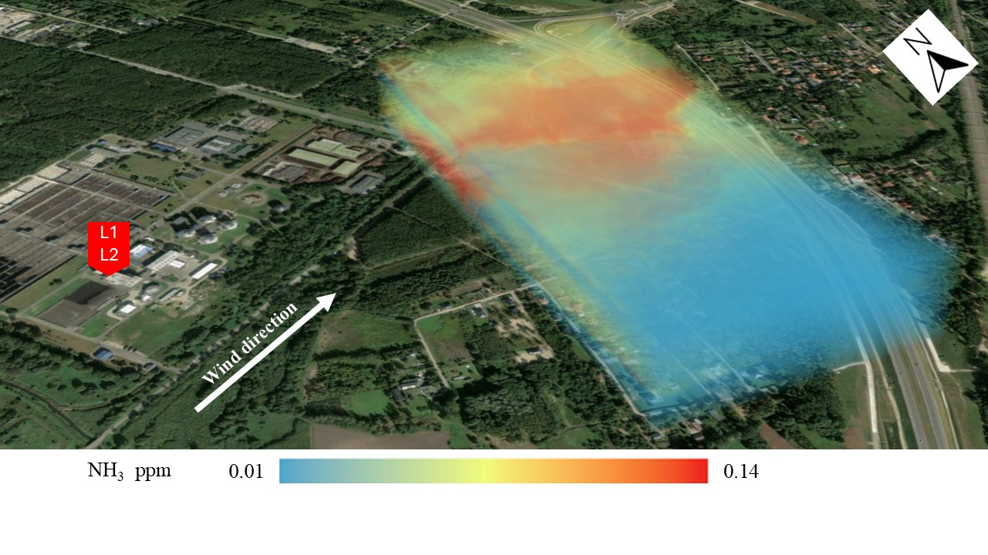

**Fig. 9.** Spatial dispersion of NH3 concentration in the analysis area in the scenario I

The highest measured concentration (Fig. 9) was about 0.1 ppm and did not exceed the detection threshold of 5 ppm. Over the residential area, the concentration was below 0.6 ppm. After converting the units, the highest concentration was about 100.8 µg/m3, which did not exceed the permissible momentary concentration level of 400 µg/m3. 3D dispersion of NH3 concentration in the troposphere with the most common wind direction confirmed the negligible impact of SSTT on the residential area. The highest concentration occurred near the sewage catchment area from sewage tankers and moved in the direction of the wind.

The second scenario (Fig. 10) shows the 3D dispersion of NH3 concentration in the troposphere with the wind direction directly on the line between the emitter and the analysis area. In this case, the impact of the emitter on the residential area should be the greatest. The highest measured concentration was about 0.12 ppm and again did not exceed the permissible limits. It also did not exceed the level that allows humans to sense NH3 in the air. The highest concentration was recorded in the north-eastern part of the analysis area. It can be observed that the spread of NH3 pollution begins inside the analyzed area. This proves the existence of another source of NH3 emissions, which was most likely the sewage discharge station from sewage tankers. Over the residential area, the concentration did not exceed 0.05 ppm.

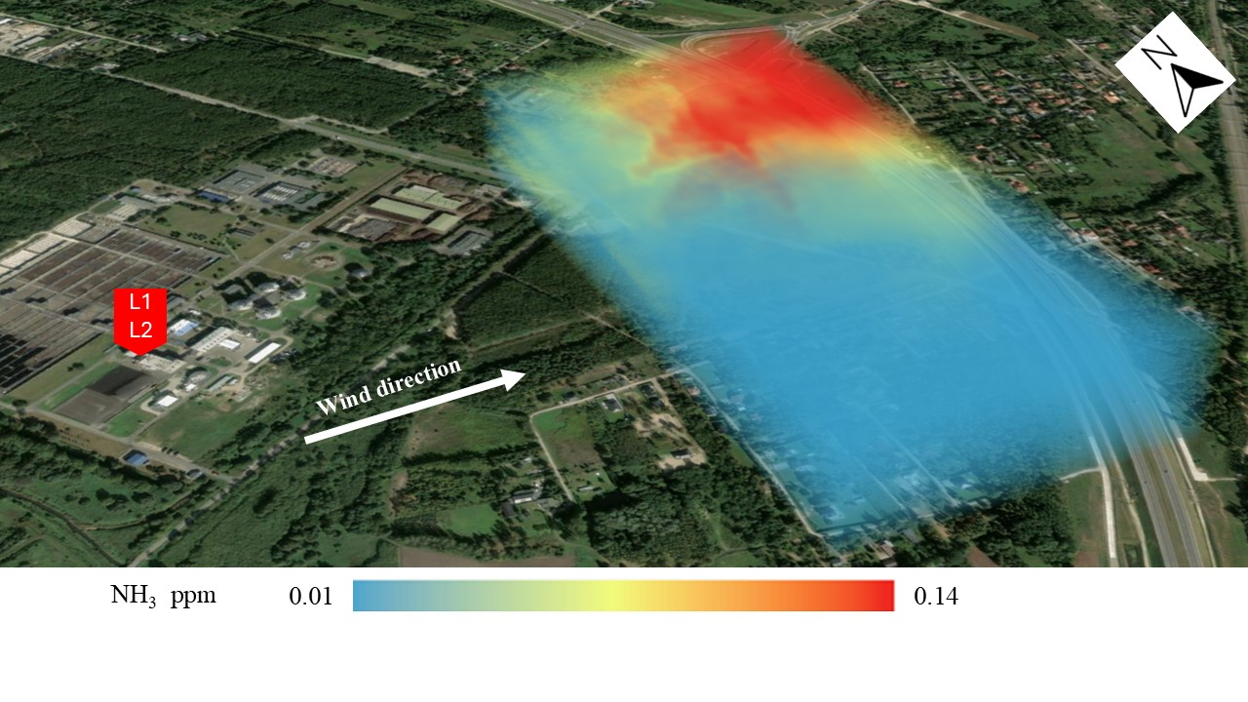

**Fig. 10.** Spatial dispersion of NH3 concentration in the analysis area in scenario II

The last scenario III, represents the situation of wind blowing from the emitter directly towards the residential area (Fig. 11). The highest concentrations of NH3 0.12 ppm were recorded at the location of the sewage catchment station and not in the direction of the impact of the analyzed emitter L1 and L2. The wind blowing from the location of the maximum NH3 concentrations towards the residential area causes the pollution to spread over the area where people live, reaching concentrations from 0.08 to 0.1 ppm. In scenario III, the concentration over the residential area was almost twice as high as in scenarios I and II. This proves the negative impact on air quality caused by NH3 emissions from the sewage catchment station. After passing the area of trees, the pollution fell and locally accumulated in the residential area.

**Fig. 11.** Spatial dispersion of NH3 concentration in the analysis area in scenario III

4. Conclusions

The computer analysis of the NH3 dispersion simulation showed a small impact of the L1 and L2 emitters on the air quality. In the case of the maximum 1-hour concentration, the impact of the emitters was only 1% of the reference value, and in the case of the average annual NH3 concentration, it was only 0.2%. In the hypothetical variant, the impact of the emitters on the air quality increased to 1.62% and 0.28% of the reference value, respectively. Assuming the area of the sewage treatment plant and SSTT as the working environment, the concentrations calculated in the computer simulation did not exceed the permissible values following national law regulations (RMRPiPS 2018). The maximum calculated concentration (6.5 µg/m3) and measured concentration (0.14 ppm ≈ 98 µg/m3) at the level of 2 m do not exceed the threshold of human detection (3500 µg/m3) and, therefore, should not constitute an odour nuisance. Field studies confirmed the negligible impact of SSTT on the NH3 concentration in the air, showing increased emission of the pollutant from the sewage collection station in the close vicinity of SSTT. Field measurements have shown the positive impact of green and wooded areas on protecting residential areas from the spread of ammonia in the troposphere.

The presented research results prove the necessity of conducting bimodal analyses containing computer simulations and real-field measurements. This approach ensures the obtaining of reliable data, drawing reliable conclusions, and, as the presented results show, determining the presence of another emitter of air pollution. The presented methodology can be used anywhere in the world for a comprehensive assessment of the impact of emitters on the environment and the health and life of residents.

Statements and Declarations

**Author Contributions**

Conceptualization, R.C. and M.D.; methodology, R.C., M.D.; software, M.D., R.C.; writing—original draft, M.D., review and editing, R.C. All authors have read and agreed to the published version of the manuscript.

**Funding**

This study was conducted as part of the research project entitled “Spatial analysis of air pollution changes in the Lodz agglomeration (in Polish: Analiza przestrzenna zmian stanu zanieczyszczenia powietrza w aglomeracji łódzkiej)”, which was co-financed approx. 80% by the Provincial Fund for Environmental Protection and Water Management in Łódź (in Polish: Wojewódzki Fundusz Ochrony Środowiska i Gospodarki Wodnej w Łodzi).

**Institutional Review Board Statement**

Not applicable

**Informed Consent Statement**

Not applicable

**Data Availability Statement**

Data available on request

**Conflicts of Interest**

The authors declare no conflict of interest.

References

Abu-Allaban, M., Abu-Qdais, H. (2011). Impact assessment of ambient air quality by cement industry: A case study in jordan. *Aerosol Air Qual. Res.*, *11*, 802-810. https://doi.org/10.4209/aaqr.2011.07.0090

Aloyan, A.E., Arutyunyan, V.O. (2000). Global transport of gaseous pollutants in the atmosphere and aerosol particle formation through kinetic processes. NUCLEATION AND ATMOSPHERIC AEROSOLS 2000: 15th International Conference. *AIP Conference Proceedings*, *534*, 843-846. https://doi.org/10.1063/1.1361991

Behera, S.N., Sharma, M., Aneja, V.P., Balasubramanian, R. (2013). Ammonia in the atmosphere: a review on emission sources, atmospheric chemistry and deposition on terrestrial bodies. *Environ Sci Pollut Res Int.*, *20*(11), 8092-8131. https://doi.org/10.1007/s11356-013-2051-9

Butler, K. (2020). *The Science of Where: A voxel visualization of smoke plume rise and dispersion*. ArcGIS Blog. 3D Visualization & Analytics. ArcGIS Pro. Nov 23, 2020. Available Online: <https://www.esri.com/arcgis-blog/products/arcgis-pro/3d-gis/the-science-of-where-a-voxel-visualization-of-smoke-plume-rise-and-dispersion/>   
(accessed on 12.07.2024).

Cichowicz, R., Dobrzański, M. (2022). 3D spatial dispersion of particulate matter and gaseous pollutants on a university campus in the center of an urban agglomeration. *Energy*, *259*, 125009.   
https://doi.org/10.1016/j.energy.2022.125009

Cichowicz, R., Stelęgowski, A. (2018). Effect of thermal sludge processing on selected components of air quality in the vicinity of a wastewater treatment plant. *Chemical Papers*, *73*(4), 843-849.   
<https://doi.org/10.1007/s11696-018-0636-y>

Cichowicz, R., Wielgosiński, G. (2015). Effect of meteorological conditions and building location on CO2 concentration in the university campus. *ECOL CHEM ENG S.*, *22*(4), 513-525. https://doi.org/10.1515/eces-2015-0030

Eko-Soft company from Poland. Calculation Software for Pollutant Concentration Analysis.   
Available Online: http://www.eko-soft.com.pl/sysopa.htm (accessed on 12.07.2024).

Esri company. ArcGIS Pro software supporting data visualization, advanced analysis. Available Online: https://www.esri.com/pl-pl/arcgis/products/arcgis-pro (accessed on 12.07.2024).

Gong, L., Lewicki, R., et al. (2013). Role of atmospheric ammonia in particulate matter formation in Houston during summertime. *Atmospheric Environment*, *77*, 893-900. <https://doi.org/10.1016/j.atmosenv.2013.04.079>

Kim, K.H., Lee, S.B., Woo, D., Bae, G.N. (2015). Influence of wind direction and speed on the transport of particle-bound PAHs in a roadway environment. *Atmospheric Pollution Research*, *6*(6), 1024-1034. <https://doi.org/10.1016/j.apr.2015.05.007>

Łatuszyńska, M., Strulak-Wójcikiewicz, R. (2013). A model for assessing the environmental impact of transport. *Oper. Res. Decis.*, *2*, 67-80, https://doi.org/10.5277/ord130206

Maleika, W. (2020). Inverse distance weighting method optimization in the process of digital terrain model creation based on data collected from a multibeam echosounder. *Appl Geomat*, *12*, 397-407.   
<https://doi.org/10.1007/s12518-020-00307-6>

Mielcarek-Bocheńska, P., Rzeźnik, W. (2019). Ammonia emission from livestock production in Poland and its regional diversity, in the years 2005-2017. *Archives of Environmental Protection*, *45*(4), 114-121. https://doi.org/10.24425/aep.2019.130247

Obwieszczenie Ministra Klimatu i Środowiska z dnia 12 kwietnia 2021 r. w sprawie ogłoszenia jednolitego tekstu rozporządzenia Ministra Środowiska w sprawie poziomów niektórych substancji w powietrzu   
(Dz.U. 2021 r. poz. 845). Available Online: <https://isap.sejm.gov.pl/isap.nsf/DocDetails.xsp?id=WDU20210000845> (accessed on 12.07.2024)

Obwieszczenie Ministra Klimatu i Środowiska z dnia 6 maja 2024 r. w sprawie ogłoszenia jednolitego tekstu rozporządzenia Ministra Klimatu i Środowiska w sprawie dokonywania oceny poziomów substancji w powietrzu   
(Dz.U. 2024 poz. 870). Available Online: <https://isap.sejm.gov.pl/isap.nsf/DocDetails.xsp?id=WDU20240000870> (accessed on 15.07.2024)

Paas, B., Schneider, C. (2016). A comparison of model performance between ENVI-met and Austal2000 for particulate matter. *Atmospheric. Environ*., *145*, 392-404, https://doi.org/10.1016/j.atmosenv.2016.09.031

Pawlowicz, A.J. Application of the Triangulated Irregular Network (TIN) Method in the Creation of Models of Historical Buildings. *IOP Conf. Ser.: Mater. Sci. Eng.*, *603*, 052069. https://doi.org/10.1088/1757-899X/603/5/052069

Piccardo, M.T., Geretto, M., Pulliero, A., Izzotti, A. (2022). Odor emissions: A public health concern for health risk perception. *Environ Res.*, *204*(Pt B), 112121. https://doi.org/10.1016/j.envres.2021.112121. Epub 2021 Sep 24. PMID: 34571035.

Report EEA, Air quality in Europe 2022. Available Online: <https://www.eea.europa.eu/publications/air-quality-in-europe-2022/sources-and-emissions-of-air> (accessed on 12.07.2024)

Report KOBIZE, Krajowy bilans emisji SO2, NOx, CO, NH3, NMLZO, pyłów, metali ciężkich i TZO za lata 1990-2020. Warszawa 2022. Available Online: <https://www.kobize.pl/uploads/materialy/materialy_do_pobrania/krajowa_inwentaryzacja_emisji/Bilans_emisji_za_2020.pdf> (accessed on 12.07.2024)

Rozporządzenie Ministra Klimatu i Środowiska z dnia 11 grudnia 2020 r. w sprawie dokonywania oceny poziomów substancji w powietrzu (Dz.U. 2020 r. poz. 2279). Available Online: <https://isap.sejm.gov.pl/isap.nsf/DocDetails.xsp?id=WDU20200002279> (accessed on 12.07.2024)

Rozporządzenie Ministra Klimatu z dnia 24 września 2020 r. w sprawie standardów emisyjnych dla niektórych rodzajów instalacji, źródeł spalania paliw oraz urządzeń spalania lub współspalania odpadów (Dz.U. 2020 poz. 1860). Available Online: <https://isap.sejm.gov.pl/isap.nsf/DocDetails.xsp?id=WDU20200001860&SessionID=09C25DC54979F9D80EC807E5A52BD1368BABD350> (accessed on 12.07.2024)

Rozporządzenie Ministra Rodziny, Pracy i Polityki Społecznej z dnia 12 czerwca 2018 r. w sprawie najwyższych dopuszczalnych stężeń i natężeń czynników szkodliwych dla zdrowia w środowisku pracy (Dz.U. 2018 r. poz. 1286). Available Online: <https://isap.sejm.gov.pl/isap.nsf/DocDetails.xsp?id=WDU20180001286>   
(accessed on 12.07.2024)

Rozporządzenie Ministra Środowiska z dnia 24 sierpnia 2012 r. w sprawie poziomów niektórych substancji w powietrzu (Dz.U. 2012 r. poz. 1031). Available Online: <https://isap.sejm.gov.pl/isap.nsf/DocDetails.xsp?id=WDU20120001031> (accessed on 12.07.2024)

Rozporządzenie Ministra Środowiska z dnia 26 stycznia 2010 r. w sprawie wartości odniesienia dla niektórych substancji w powietrzu (Dz.U. 2010 r. Nr 16, poz. 87). Available Online: <https://isap.sejm.gov.pl/isap.nsf/DocDetails.xsp?id=wdu20100160087> (accessed on 12.07.2024)

Song, W., Jia, H., Li, Z., Tang, D. (2018). Using geographical semivariogram method to quantify the difference between NO2 and PM2.5 spatial distribution characteristics in urban areas. *Science of The Total Environment*, *631-632*,   
688-694. <https://doi.org/10.1016/j.scitotenv.2018.03.040>

Szyłak-Szydłowski, M., Kos, W. (2024). Application of Sensory Methods to Evaluate the Effectiveness of Solutions to Reduce the Exposure to Odour Nuisance and Ammonia Emissions from the Compost Heaps. Sensors, *24*(13), 4200. <https://doi.org/10.3390/s24134200>

Valach, A.C., Häni, C., Bühler, M., Mohn, J., Schrade, S., Kupper, T. (2023). Ammonia emissions from a dairy housing and wastewater treatment plant quantified with an inverse dispersion method accounting for deposition loss.   
*J Air Waste Manag Assoc.*, *73*(12), 930-950. https://doi.org/10.1080/10962247.2023.2271426

Van Damme, M., Clarisse, L., Whitburn, S. et al. (2018). Industrial and agricultural ammonia point sources exposed. *Nature*, 564, 99-103. <https://doi.org/10.1038/s41586-018-0747-1>

Wang, S., Nan, J., Shi, C. et al. (2015). Atmospheric ammonia and its impacts on regional air quality over the megacity of Shanghai, China. *Sci Rep*, *5*, 15842. https://doi.org/10.1038/srep15842

Watson, A.Y., Bates, R.R., Kennedy, D. (1988). *Air Pollution, the Automobile, and Public Health*. Washington (DC): National Academies Press (US); Atmospheric Transport and Dispersion of Air Pollutants Associated with Vehicular Emissions. Available from: <https://www.ncbi.nlm.nih.gov/books/NBK218142/>

Wielgosiński, G., Cichowicz, R., Wiśniewski, J. (2016). Ammonia emission from sewage sludge incineration process. *ECOL CHEM ENG S.*, *23*(4), 665-675. https://doi.org/10.1515/eces-2016-0047

Yang, Y., Liu, L., Liu, P., Ding, J., Xu, H., Liu, S. (2023). Improved global agricultural crop- and animal-specific ammonia emissions during 1961-2018. *Agriculture, Ecosystems & Environment*, *344*, 108289. <https://doi.org/10.1016/j.agee.2022.108289>

Zhang, C., Geng, X., Wang, H., Zhou, L., Wang, B. (2017). Emission factor for atmospheric ammonia from a typical municipal wastewater treatment plant in South China. *Environmental Pollution.*, *220*, 963-970. https://doi.org/10.1016/J.ENVPOL.2016.10.082