|  |  |  |  |
| --- | --- | --- | --- |
|  |  | | |
| **Rocznik Ochrona Środowiska** | | |
| Volume 26 | Year 2024 ISSN 2720-7501 | pp. 707-715 |
|  | https://doi.org/10.54740/ros.2024.062 open access | | |
|  | Received: December 2024 Accepted: December 2024 Published: December 2024 | | |

Sustainable Aviation Fuels as the Path to Carbon Neutrality in Air Transport

Rafał Szyc1, Radim Lenort2*

1Faculty of Management, Department of Logistics,   
University of Business and Administration in Gdynia, Poland   
<https://orcid.org/0000-0001-6797-60572>

2Škoda Auto University, Mladá Boleslav, Czech Republic   
https://orcid.org/[0000-0001-6194-5364](https://orcid.org/0000-0001-6194-5364)

*corresponding author's e-mail: radim.lenort@savs.cz

**Abstract:** This paper delves into the evolving landscape of the aviation industry, focusing on Sustainable Aviation Fuels (SAF) as a potential solution to mitigate the environmental impact of air transport. With the aviation sector playing a pivotal role in global connectivity, its growth is shadowed by significant environmental challenges, notably high levels of carbon dioxide emissions and other greenhouse gases. Traditional aviation fuels, largely based on petroleum, are the primary contributors to these emissions, presenting a clear imperative for alternative solutions. This study explores the viability and environmental benefits of SAFs, produced from diverse renewable sources such as biomass, agricultural waste, and solar energy, which can seamlessly integrate into existing aviation infrastructure. The research highlights the technical, economic, and regulatory challenges in transitioning to SAFs while emphasizing their potential to significantly reduce carbon emissions without necessitating major modifications to aircraft technologies. The paper provides a comprehensive analysis of current technologies, production methods, and the market viability of SAFs, including their economic implications in the context of fluctuating oil prices and the industry's drive towards carbon neutrality. By examining the lifecycle emissions and sustainability of various SAFs, this paper contributes to the ongoing discourse on reducing the aviation sector's carbon footprint and enhancing its sustainability profile.

**Keywords:** aviation, sustainable aviation fuels, environmental impact, economic viability,   
technological advancements, carbon neutrality, air transport

1. Introduction

Aviation plays a crucial role in the global economy, enabling the rapid transport of people and goods over long distances. Due to the continuous growth of the world population and the globalization of the economy, significant development of this sector is predicted in the coming decades. However, the dynamic development of aviation carries serious environmental challenges, primarily related to the high level of carbon dioxide (CO2) emissions and other greenhouse gases.

Traditional aviation fuels, the main energy source for aircraft, significantly contribute to global warming. Alternative propulsion methods, such as electric engines or fuel cells, are currently unable to meet the energy needs of large aircraft, mainly due to the insufficient energy density of most available alternative energy sources, primarily batteries and hydrogen. In this context, Sustainable Aviation Fuels (SAF) emerge as a promising alternative that can reduce dependence on conventional fossil fuels, thereby also reducing the external costs of air transport, mainly net carbon dioxide emissions and climate change costs. SAFs are fuels that can be produced from various renewable sources, such as biomass, agricultural waste, synthetic gases, and electric energy from renewable sources, and solar energy. Their key advantage is the ability to be used in the existing aviation infrastructure without costly modifications to engines or aircraft fuel systems. This scientific article aims to examine thoroughly the potential of SAFs as a sustainable energy source for the aviation industry, analyzing their environmental benefits, technological and economic challenges, and future development prospects.

This article aims to present the current state of knowledge about various types of SAFs and their impact on the environment, including the issue of net emissions, and to review research and initiatives aimed at commercializing and broadly implementing these fuels in the global aviation sector.

2. Technical Foundations and Production Technologies

Aviation, alongside maritime transport and long-distance freight in road transport, is considered one of the sectors where full decarbonization will be extremely difficult. This is influenced by several key factors such as the global nature of civil aviation and the associated need for technology standardization, the high implementation costs of new technologies, and safety considerations. However, one of the greatest obstacles in developing emission-free or low-emission propulsion systems is the energy density of alternative energy sources compared to conventional aviation fuel. Aviation fuels, products made from petroleum, have been the primary energy source in civil aviation for decades. Jet-A1 and Jet A (in the USA only) are the most popular of these products. These fuels have a high energy density, which means they can deliver relatively a lot of energy in relation to their volume and mass. This property is crucial for aircraft, where weight and space are significant constraints. Fossil fuels, such as diesel, jet fuel, and gasoline, exhibit high energy density both per unit mass and per unit volume, making them highly efficient energy carriers for transport applications. Hydrogen, despite having the highest energy density by mass (120 MJ/kg) in its liquid form, is characterized by significantly lower energy density per unit volume (8 MJ/l), presenting challenges in terms of storage and transportation. In the case of compressed hydrogen at 300 and 700 bar, the energy density by volume is even lower than fossil fuels. Alternative fuels, such as methanol, ethanol, ammonia, and methane in liquid or compressed states, offer a trade-off between energy density by mass and volume; however, their adoption requires further research into optimizing storage and utilization processes. Lithium-ion batteries, while providing energy for highly efficient electric motors, exhibit the lowest energy efficiency in terms of both mass (0.9 MJ/kg) and volume (2.5 MJ/l), limiting their potential application in the most energy-intensive transportation modes, such as freight transport and aviation. For example, a lithium-ion battery capable of storing an amount of energy equivalent to that of a passenger aircraft's fuel tank would be significantly larger and heavier than the aircraft itself. Conversely, while hydrogen provides three times more energy per unit mass than kerosene, it requires three times the volume to store. The energy density by volume and mass of selected energy sources available for use in aviation is shown in Fig. 1 (Davies et al. 2018).

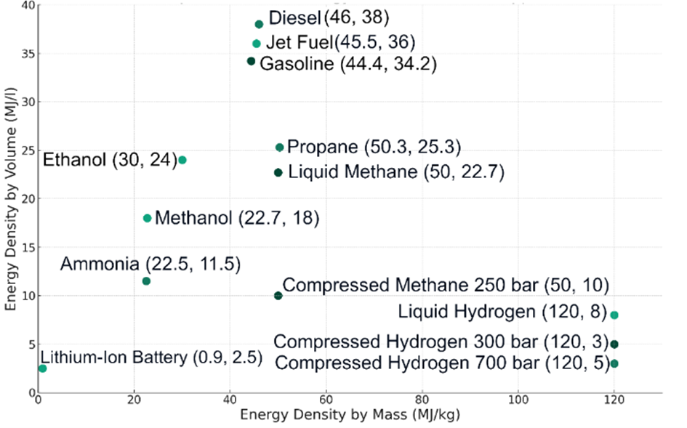

**Fig. 1.** Energy Density of Selected Fuels and Energy Sources by Mass and Volume (source: own work based on Seynor et al. 2003, Goldman et al. 2018, Rodrigue 2024)

Due to the serious limitations related to the aforementioned energy density of fuels and energy sources, research and development efforts in aviation aimed at moving away from fossil fuels are being conducted in multiple directions, with expected outcomes ranging from the reduction of CO2 emissions to achieving a zero or even negative balance. Some of the most important innovative solutions that meet these conditions include:

* SAF – biofuel,
* SAF – electrofuel,
* Liquid methane,
* Hydrogen,
* Ammonia,
* Hybrid drives,
* Electric drives (Alternative Fuels 2024).

There are two types of SAF; in both, hydrocarbon fuel is produced by carbon and hydrogen synthesis. In the case of biofuels, carbon is sourced from plants and organic matter, while in electrofuels, this element comes from the breakdown of carbon dioxide molecules, which is typically captured from non-biogenic sources, most often through Direct Air Capture (DAC) (Fig. 2).

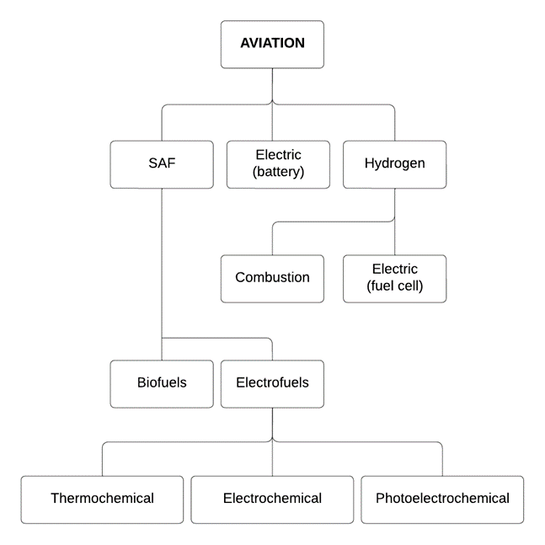

**Fig. 2.** Alternative Aviation Fuels and Energy Pathways (source: own work based on Douglas et al. 2022)

From a short-term perspective, sustainable aviation fuel (SAF) appears to be the easiest solution to implement. SAFs have almost identical physicochemical properties as conventional jet fuel and can be safely mixed with it in various proportions. SAFs are 'Drop-In' fuels, which means they can use the same distribution infrastructure as conventional fuels, but most importantly, they do not require adjustments to engines or airframe designs for their use. SAFs must simultaneously meet specific sustainability criteria, such as:

* Reduction of carbon dioxide emissions throughout the life cycle.
* Limited requirements for fresh water.
* No conflict with the necessary food production, which often occurs in the production of first-generation biofuels conflict.
* No deforestation.

Suitable raw materials for the production of SAF include:

* Corn kernels.
* Oilseeds.
* Marine algae.
* Other fats, oils, and greases.
* Agricultural waste.
* Forest biomass.
* Sawmill waste.
* Municipal sewage.
* Manure.
* Sewage sludge.
* Energy crop cultivations.

There are many methods for producing SAF, but 95% of current global production is created using the HEFA (Hydrotreated Esters and Fatty Acids) method, in which raw materials, mainly plant or animal oils and fats, are cleaned and then subjected to hydrolysis. This process involves adding hydrogen-rich gas at high temperatures and pressure in the presence of a catalyst, which leads to the breakdown of triglycerides in the oils and fats into smaller hydrocarbons. These are then fractionated, i.e., separated into different components, of which those suitable for aviation fuel are isolated and can be directly mixed with conventional jet fuel.

In the medium-term perspective, it seems that to meet the global demand for sustainable aviation fuels, other sources of raw materials and, consequently, different processing methods will be needed. One such technology is synthetic SAF, which refers to aviation fuel produced using synthetic processes, not refining as in the HEFA technology. Like refined fuels, synthetic fuels can directly replace conventional jet fuels, meeting the same physicochemical requirements. Therefore, they can be considered drop-in fuels, meaning they can be used in existing aircraft engines without the need for modifications, and moreover, they can be mixed with conventional jet fuel.

The most well-known technologies for the production of synthetic SAF include:

* Fischer-Tropsch Synthesis (FT).
* Alcohol-to-Jet (AtJ).
* Synthesized Iso-Paraffins (SIP).
* Power-to-Liquid (PtL).
* Solar Fuels.

Fischer-Tropsch Synthesis converts syngas, a mixture of carbon monoxide and hydrogen derived from biomass, municipal waste, or even coal, into liquid hydrocarbons. The FT process is versatile in terms of feedstock but requires complex gasification and synthesis stages. The resulting synthetic paraffinic kerosene can be blended with conventional jet fuel and used in existing aircraft engines (Maurer et al. 2023).

Alcohol-to-Jet technologies convert alcohols such as ethanol or butanol, which can be produced biologically or synthetically, into jet fuel. This involves alcohol dehydration to create olefins, which are then oligomerized and hydrogenated to produce jet fuel range hydrocarbons. AtJ fuels must address the challenge of removing oxygen from the alcohol structure, which typically requires substantial energy input.

Synthesized Iso-Paraffins involve the fermentation of sugars to produce iso-butene, which is then oligomerized and hydrogenated to produce renewable jet fuel. SIP processes are less common but hold promise due to their potential for high yields and the use of renewable biogenic carbon sources.

Emerging technologies involve capturing CO2 directly from the atmosphere and combining it with hydrogen produced via water electrolysis using renewable energy. This method, known as Power-to-Liquid, synthesizes jet fuel from these basic components. While technically feasible, the scalability of Direct Air Capture (DAC) combined with the energy-intensive nature of hydrogen production presents significant challenges. Moreover, the substantial demand for electricity required for this process poses additional challenges, especially in countries like Poland, where electricity is primarily generated from fossil fuels (Maćkowiak et al. 2023). This reliance on coal and other non-renewable energy sources complicates the transition to greener technologies and could offset the environmental benefits of such innovative processes.

A potential solution to the high energy demand in the production of synthetic SAF is the use of solar fuel. This production method harnesses solar energy, carbon dioxide (CO2), and water (H2O). Solar radiation is concentrated using a mirror system, which directs the focused energy to a thermal receiver. In the receiver, the solar energy is absorbed and used to heat a transfer medium, such as steam, which circulates in a closed-loop system to deliver thermal energy to a reactor. Inside the reactor, operating at high temperatures (approximately 1,000°C), the thermochemical decomposition of water and carbon dioxide takes place in the presence of a catalyst, resulting in the production of synthesis gas (syngas), a mixture of hydrogen (H2) and carbon monoxide (CO). Syngas serves as a crucial intermediate for subsequent chemical processes, such as Fischer-Tropsch synthesis, to produce hydrocarbon-based fuels. The final fuel product is stored in tanks as sustainable aviation fuel but can also be converted into gasoline or diesel. Additionally, excess heat captured from the concentrated solar energy by the mirrors is stored, enabling the reactor to operate continuously, even on cloudy days or at night. This approach has the potential to address the issue of high electricity consumption in SAF production methods that depend on electrolysis and Direct Air Capture (DAC) (Fig. 3) (Balla et al. 2023, Kim et al. 2012, Wang et al. 2018).

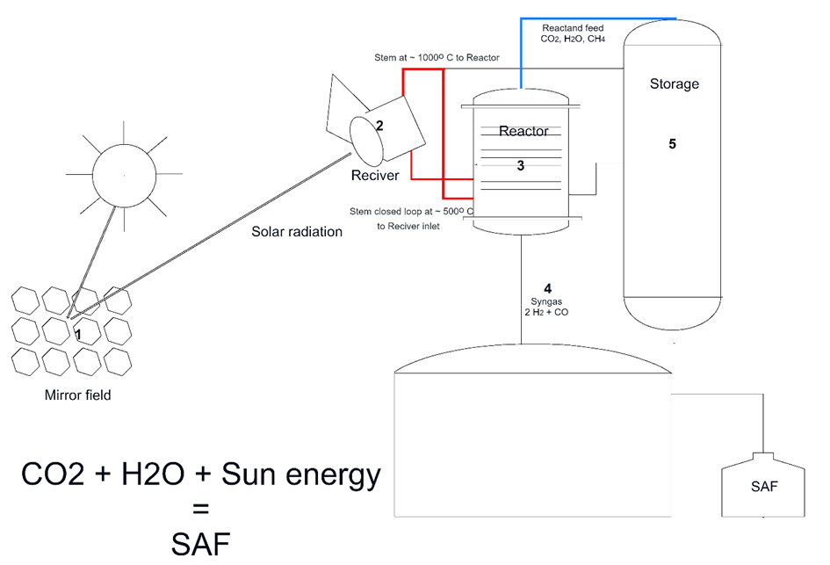

**Fig. 3.** General Diagram of Solar Fuel Production (source: own work based on Kim et al. 2012)

3. Economic Implications and Market Viability

The aviation industry's dependence on fossil fuels exposes it to significant business risks, such as those resulting from fluctuating oil prices, particularly noticeable after the Russian Federation's military aggression against Ukraine. Sustainable Aviation Fuel (SAF) represents a real alternative to conventional aviation fuel because its production is not dependent on the oil producers' oligopoly, which allows for greater diversification of supply sources and may reduce the risk of sudden changes in fuel prices for airlines. The raw materials for producing SAF can be cultivated or collected in many countries worldwide, potentially shortening the supply chains needed for production (Dyczkowska et al. 2024, Kłodawski et al. 2024).

Estimating how much SAF can be produced from the wastes available globally is difficult. Still, taking the USA as an example, it is estimated that the annual dry biomass resources needed to produce SAF amount to about 1 billion tons. This could suffice to produce from 189 billion to 194 billion litres of low-carbon biofuels, which in turn is sufficient to meet the annual demand for aviation fuel in that country (What SAF 2024, US Department 2024).

One of the world's first plants producing SAF synthetically on an industrial scale is the Ineratec facility in Emsland, Germany. This company plans to build a plant in Industriepark Höchst in Frankfurt, where, after synthesizing carbon dioxide from biogas plants, exhaust gases or atmospheric air with green hydrogen, it intends to produce about 4.6 million litres of SAF annually from 2026, which is 40 times more than currently. Such an amount would represent about 4% of Germany's annual demand for aviation fuel. The main barrier in the development of this technology lies in the fact that both synthesis and the production of green hydrogen require the use of a very large amount of electrical energy, which is why such fuel is called electrofuel (Power-to-Liquid) or sometimes e-fuel (Walter 2022).

In September 2022, the Swiss company Synhelion began constructing the world's first industrial-scale solar fuel production plant in Jülich near Cologne. This technology was developed at the local research centre, tested in Spain, and will soon be commercialized. According to Synhelion representatives, this technology's efficiency depends on highly sunny locations. By 2025, the company plans to introduce 1.25 million litres of solar fuel to the market, and by 2030, 875 million litres, which currently corresponds to half of the demand for aviation fuel in Switzerland. The world's first industrial-scale solar fuel factory, owned by the Swiss company Synhelion and located in Jülich, Germany, is shown in Fig. 4 (Synhelion 2024).

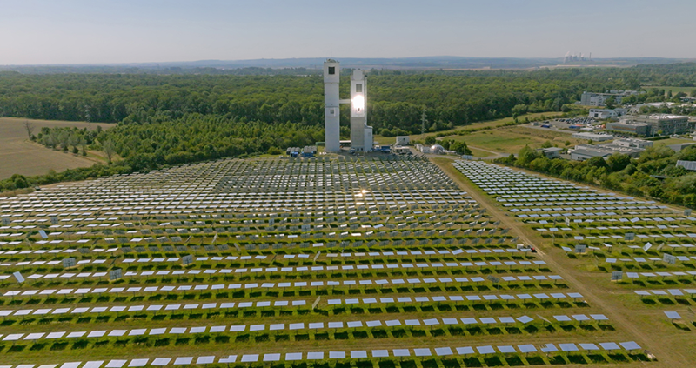

**Fig. 4.** One of the World's First Industrial-Scale Solar Fuel Factories, Owned by the Swiss Company Synhelion, Located in Jülich, Germany

In 2022, the global production of SAF fuel amounted to 0.24 Mt, constituting only 0.1% of the total jet engine fuel. Nevertheless, the production of SAF increased fivefold from 2019 to 2022, indicating a high demand for this fuel. In 2022, airlines purchased the entire globally available quantity of SAF, despite the still significant price difference compared to conventional fuel. The estimated average price of SAF in 2022 was approximately USD 2.40 per litre, though there were significant differences between regions. This is about two and a half times more than the price of conventional JET-A1 and JET-A fuels (IATA International Air 2023).

4. Environmental Impact and Sustainability Considerations

Since the beginning of the 21st century, significant changes have been observed in civil aviation, primarily aimed at the sustainable development of this transport sector. These changes are mainly related to environmental, economic, and safety concerns. A symbol of these changes was the retirement in 2003 of the only supersonic aircraft then in operation, the Concorde, as well as the end of production after 52 years of the four-engine Boeing 747 and the world's largest passenger aircraft, the Airbus A380, mainly due to their high energy consumption and consequently high emissions (Szyc 2024).

According to research findings, aviation accounts for about 2-3% of global carbon dioxide emissions (Glantz 2020). Due to additional emissions of sulfur dioxide and nitrogen oxides mixed with water vapor, forming a condensation cloud in the upper troposphere, aviation's impact on climate change is significantly higher. It corresponds to two to three times the CO2 equivalent (Falk 2021).

The demand for transportation services is expected to increase in the coming decades, driven by the anticipated growth of the global population and its income. In its report on technological prospects in the energy sector, the International Energy Agency (IEA) predicts that the global demand for transportation services, measured in passenger-kilometers (pkm), will double, and the demand for civil aviation services, both in passenger and cargo transport, will triple by 2070 (Glantz 2020).

The primary advantage of Sustainable Aviation Fuels (SAF) over traditional fossil fuels is the reduction of CO₂ emissions throughout their life cycle. The amount of carbon dioxide plants absorb during biomass growth is comparable to the amount of CO₂ released during fuel combustion in aircraft engines. This implies that SAF can be considered practically carbon-neutral when considering the full life cycle. It is important to note, however, that emissions are also generated during the production process of SAF, such as from the use of agricultural machinery, transportation of raw materials, production (Lenort et al. 2019), recycling (Chamier-Gliszczynski & Krzyzynski 2005) and fuel refining. Nevertheless, despite these factors, using SAF can reduce total carbon dioxide emissions by up to 80% compared to fossil fuels. Additionally, SAF contains lower levels of other pollutants, such as sulfur, which significantly reduces emissions of sulfur dioxide and particulate matter relative to conventional fuels. The circulation of carbon dioxide in the atmosphere using SAF is shown in Fig. 5.

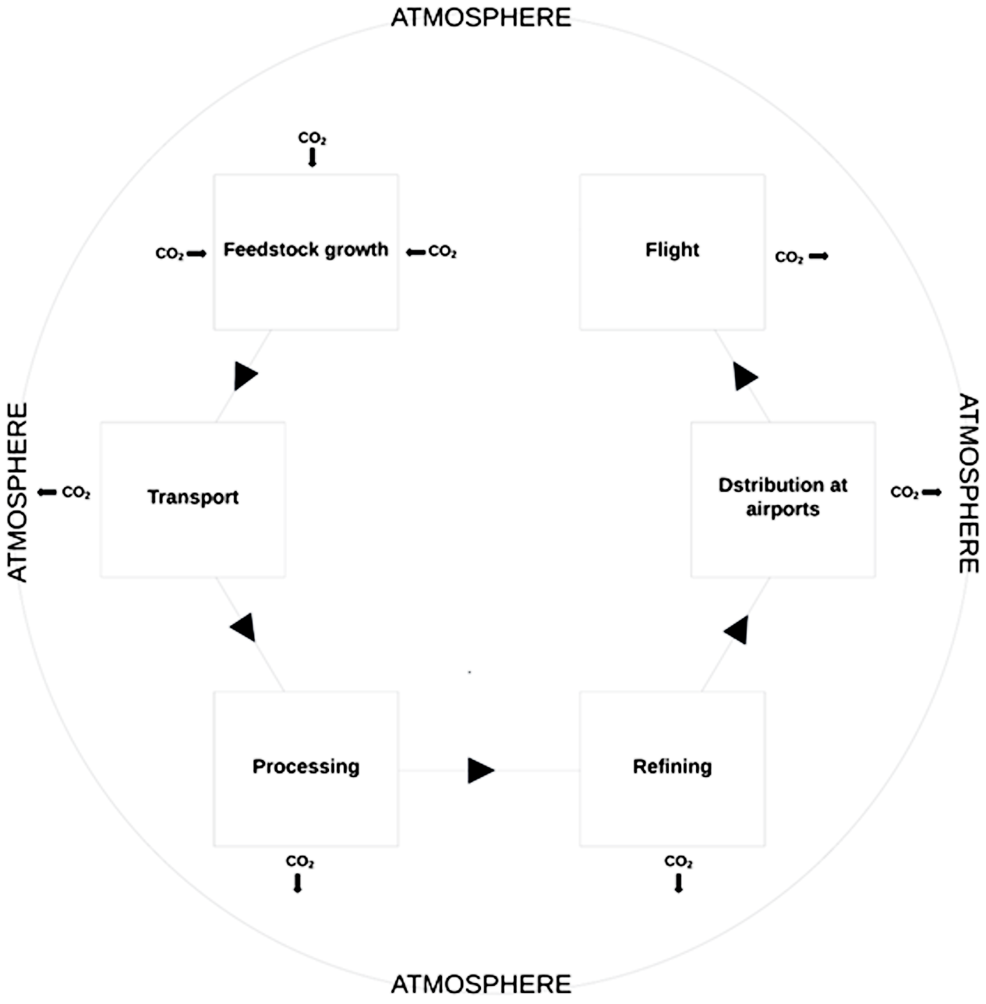

**Fig. 5.** Closed Carbon Dioxide Cycle in the Atmosphere Using SAF (source: own work based on Szyc 2024, IATA 2021)

Achieving net-zero carbon emissions in aviation by 2050 is a goal adopted by many organizations and countries as part of global efforts to reduce the impact of air transport on climate change. The International Civil Aviation Organization (ICAO) and the International Air Transport Association (IATA) are two leading industry organizations that promote goals related to reducing carbon dioxide emissions and achieving net-zero emissions in aviation by 2050. This declaration has been supported by many airlines worldwide. It is assumed that this ambitious goal will be achieved through a combination of new technologies, 65% of which will be based on SAF fuels. Additionally, the contribution of other technologies includes electric and hydrogen propulsion systems – 13%, improving infrastructure functionality and increasing the efficiency of aviation operations – 3%, offsets and carbon capture – 19%.

5. Summary and Discussion

The exploration of Sustainable Aviation Fuels in this paper underscores their potential to significantly mitigate the environmental impact of the aviation sector, an important contributor to global carbon emissions. The comprehensive analysis presented herein reflects the multifaceted nature of transitioning towards sustainable aviation, encompassing technical innovations, economic implications, and environmental considerations.

The development of SAF has showcased promising technological advancements. Adapting existing infrastructures to accommodate SAF without significant modifications is a pivotal achievement. However, the reliance on advanced technologies such as HEFA, Fischer-Tropsch synthesis, and Power-to-Liquid processes presents challenges, primarily due to the high energy requirements and the need for extensive R&D to optimize these technologies for broader application.

Economically, the production of SAF is currently more costly than conventional jet fuels, primarily due to the expenses associated with raw material sourcing and processing. SAF's price is approximately two and a half times higher than that of conventional fuels, which highlights the need for economic strategies to reduce costs, such as governmental subsidies, carbon pricing, or technological advancements that enhance yield and efficiency. Reducing the price difference between conventional fuel and SAF could also be aided by greater internalization of external costs in civil aviation.

Environmentally, SAFs offer a substantial reduction in CO2 emissions, contributing to the aviation industry's goals of achieving carbon neutrality. The lifecycle analysis of SAF production, from raw material sourcing through to fuel combustion, indicates a potential reduction of up to 80% in carbon emissions compared to fossil fuels. This aligns with global targets for reducing the impact of climate change and highlights the critical role of SAF in achieving these objectives.

Looking forward, the scale-up of SAF production will require an integrated approach involving policy support, industry collaboration, and continued innovation. The potential for global expansion in SAF usage offers a pathway towards significant reductions in aviation's carbon footprint, but this will necessitate further advances in crop yields, synthetic biology, and chemical processing to make SAF a mainstream solution across the globe. Another problem is the need to supply a large amount of electrical energy from renewable sources required (Chamier-Gliszczynski et al. 2024) to produce synthetic SAF based on synthesis and electrolysis processes.

Effective policy frameworks and international cooperation will be essential in standardizing regulations and encouraging the adoption of SAF. Initiatives like those led by ICAO and IATA, which aim for net-zero emissions by 2050, underscore the need for a unified global approach to addressing aviation emissions.

In conclusion, while significant hurdles remain, the promise of SAF as a cornerstone technology in decarbonizing aviation is undeniable. The ongoing research, pilot projects, and policy developments are encouraging signs that aviation can transition to a more sustainable future, albeit with concerted global efforts, technological breakthroughs, and robust economic incentives.

References

Ballal, V. et al. (2023). Climate change impacts of e-fuels for aviation in Europe under present-day conditions and future policy scenarios. *Fuel*, 338, 2-8.

Chamier-Gliszczynski, N., Krzyzynski, T. (2005). *On modelling three-stage system of receipt and automotive recycling*. *REWAS'04*, Global Symposium on Recycling, Waste Treatment and Clean Technology. 2005, 2813-2814, Madrid, Spain, 26-29 September 2004, Conference Paper, ISBN: 8495520060.

Chamier-Gliszczynski, N., Dyczkowska, J., Woźniak, W., Olkiewicz, M., Stryjski, R. (2024). The Determinant of Time in the Logistical Process of Wind Farm Planning. *Energies*, *17*(6), 1293. https://doi.org/10.3390/en17061293

Davies, S.J. et al. (2018). Net-Zero Emissions Energy Systems. *Science*, *360*, 6396.   
https://www.science.org/doi/10.1126/science.aas9793

Douglas, C., James, B. (2022). The state of: electrofuels for aviation. *World Fund*, 5-7.

Dyczkowska, J., Chamier-Gliszczynski, N., Woźniak, W., Stryjski, R. (2024). Management of the Fuel Supply Chain and Energy Security in Poland. *Energies*, *17*(22), 5555. https://doi.org/10.3390/en17225555

Falk, M.T., Hagsten, E. (2021). Determinants of CO2 emissions generated by air travel vary across reasons for the trip. *Environ Sci Pollut Res Int.*, 22969-22980.

Glantz, P. Noone, K. (2020). *Aviation, climate, and the "high altitude" effect (2020)*. Bolin Centre for Climate Research, Stockholms Universitet, 2-3.

Główka, M. (2024). Sustainable aviation fuel – Comprehensive study on highly selective isomerization route towards HEFA based bioadditives. *Renewable Energy*, *220*, 1-3.

Goldmann, A., Sauter, W., Oettinger, M., Kluge, T., Schröder, U., Seume, J.R., Friedrichs, J., Dinkelacker, F. (2018). Study on Electrofuels in Aviation. *Energies*, *11*, 3-7.

Kim, J., Miller, J.A., Johnson, T., Stechel, E., Maravelias, C.T. (2012). Fuel Production from CO2 Using Solar-Thermal Energy: System Level Analysis. *Energy and Environmental Science*, *5*(9), 8417-8429.

Kłodawski, M., Jachimowski, R., Chamier-Gliszczyński, N. (2024). Analysis of the Overhead Crane Energy Consumption Using Different Container Loading Strategies in Urban Logistics Hubs. *Energies*, *17*(5), 985. https://doi.org/10.3390/en17050985

Lenort, R., Baran, J., Wysokinski, M., Golasa, P., Bienkowska-Golasa, W., Golonko, M., Chamier-Gliszczynski, N. (2019). Economic and Environmental Efficiency of the Chemical Industry in Europe in 2010-2016. *Rocznik Ochrona Srodowiska*, *21*(2), 1393-1404.

Maćkowiak, A., Kostrzewski, M., Bugała, A., Chamier-Gliszczyński, N., Bugała, D., Jajczyk, J., Woźniak, W., Dombek, G., Nowak, K. (2023). Investigation into the Flow of Gas-Solids during Dry Dust Collectors Exploitation, as Applied in Domestic Energy Facilities – Numerical Analyses. *Eksploatacja i Niezawodnosc*, *25*(4), 174095, https://doi.org/10.17531/ein/174095

Meurer, A., Jochem, P., Kern, J. (2023). Implications and trade-offs of a targeted small-scale production of sustainable aviation fuel based on Fischer–Tropsch synthesis. *Sustainable Energy & Fuels*. 752-753.

Rodrigue, J.P. (2024). *The Geography of Transport Systems*. 6th ed. New York Routledge: 2006-2007.

Saynor, B., Bauen, A., Matthew, L. (2003). *The potential for renewable energy sources in aviation*. Imperial College Centre for Energy Policy and Technology: 35-44.

Szyc, R. (2024). *Innovations in Air Transport*. In: Wojewódzka-Król, K. Innovations in Transport. Warsaw, PWN. (in Polish). https://doi.org/10.53271/2023.178

Voß, S., Bube, S., Kaltschmitt, M. (2023). Aviation fuel production pathways from lignocellulosic biomass via alcohol intermediates – A technical analysis. *Fuel Communications*, *17*, 2-3.

Walter, J. (2022). *SAF Aviation Fuel: The dream of Emission-Free flying*. DW, https://www.dw.com/pl/zr%C3%B3wnowa%C5%BCone-paliwo-lotnicze-saf-marzenie-o-bezemisyjnym-lataniu/a-63345791 (21.03.2024) (in Polish).

Wang, L., Xia, M., Wang, H., Huang, K., Qian, C., Maravelias, C.T., Ozin, G.A. (2018). Greening Ammonia: Toward the Solar Ammonia Refinery. *Joule*, *2*, 1055-1074.

Zoller, S. (2022). A solar tower fuel plant for the thermochemical production of kerosene from H2O and CO2. *Joule*, *6*(7), 1605-1607.

*Alternative Fuels Used for Aviation*. European Alternative Fuels Observatory. (access: 19.04.2024).   
https://alternative-fuels-observatory.ec.europa.eu/transport-mode/aviation/alternative-fuels-for-aviation

International Air Transport Association (IATA) (2021). *SAF – Sustainability Considerations, Sustainable Aviation Fuels, IATA*, 2-3. (access: 26.03.2024).   
https://www.iata.org/contentassets/d13875e9ed784f75bac90f000760e998/saf-and-sustainability.pdf

International Air Transport Association (IATA) (2021). *Resolution on the industry's commitment to reach net zero carbon emissions by 2050*. (access: 20.04.2024). https://www.iata.org/en/pressroom/2021-releases/2021-10-04-03/

International Air Transport Association (IATA). *Sustainable aviation fuel output increases, but volumes still low*. (2023). (access: 26.04.2024). https://www.iata.org/en/iata-repository/publications/economic-reports/sustainable-aviation-fuel-output-increases-but-volumes-still-low/

Synhelion company, https://synhelion.com/technology [access: 20.03.2024].

US Department of Energy, Bioenergy Technologies Office. *Sustainable Aviation Fuels*. (access: 10.04.2024).  
https://www.energy.gov/eere/bioenergy/sustainable-aviation-fuels

What Is SAF?, IATA, (access: 10.04.2024).  
https://www.iata.org/contentassets/d13875e9ed784f75bac90f000760e998/saf-what-is-saf.pdf