|  |  |  |  |
| --- | --- | --- | --- |
|  |  | | |
| **Rocznik Ochrona Środowiska** | | |
| Volume 26 | Year 2024 ISSN 2720-7501 | pp. 616-628 |
|  | https://doi.org/10.54740/ros.2024.054 open access | | |
|  | Received: November 2024 Accepted: November 2024 Published: December 2024 | | |

The Influence of Deep Drawing Parameters on Stresses and Strains in Drawing Tools   
in the Context of their Durability and Process Load

Paweł Kałduński

Faculty of Mechanical Engineering, Koszalin University of Technology, Poland   
https://orcid.org/0000-0003-1020-5184

corresponding author's e-mail: pawel.kaldunski@tu.koszalin.pl

**Abstract:** This publication presents the influence of selected parameters in the deep drawing process on the energy consumption of the entire process. It was analysed how die clearance and the radius of the rounded working edge of the die affect drawing force and work. Modifying these parameters does not directly affect the geometry of the finished stamped product. In addition, it was analysed how modifying the clearance and the radius of the rounding of the working edge of the die affects the magnitudes of stresses and strains in the tools, i.e. the punch and the die. The study was carried out numerically using Ansys Ls-Dyna software. An elastic-plastic model with isotropic hardening was used to model the tools without considering strain rate. This approach makes it possible to assess how a given process will affect the abrasive wear of the working surfaces of the die and punches when the yield stress in the tool material is exceeded. A significant increase in tool life was observed through a reduction in plastic deformation when using clearances greater than the thickness of the sheet metal. Using a larger die edge rounding radius also positively affected tool life, maximum drawing force, and total work.

**Keywords:** deep drawing, clearance, numerical analysis, deformable tools, energy consumption, tool wear

1. Introduction

Drawing processes belong to the metal forming processes and are, therefore, non-labelling processes. In contrast to subtractive manufacturing, such as turning, milling or grinding, there are fewer possibilities for improving productivity, reducing manufacturing time and minimising energy input (Bohdal et al. 2014, Bohdal et al. 2013). In drawing processes, however, it is possible to reduce the energy input by reducing the maximum force and the drawing work (Kałduński et al. 2016). This particularly involves ensuring ideal process conditions. Among the most important is the minimisation of friction on the die working surface, which reduces the drawing force, and the maximisation of friction on the punch surface, which protects the drawpiece from bottom breakage. Tool durability is also among the important things, leaving aside the energy gain in terms of less work and force resulting from the optimum selection of these parameters (Roizard et al. 2009). Materials other than tool steel, such as ceramic materials, can be used to improve durability (Kataoka et al. 2004). In other cases, innovative die designs are used, considering the die's deformation to ensure the ideal shape of the finished product (Choi et al. 2013, Del Pozo et al. 2008, Iorio et al. 2016). Such modified tools are particularly important when drawing non-standard components such as welded components, where deformable pressers are used (Brusilová et al. 2017). Standard dies and punches can also deform elastically during the drawing process (Lingbeek et al. 2007) and this is a normal phenomenon. Most numerical analyses of drawing processes ignore tool deformability. If deformability is already considered, elastic models are most often used (Keum et al. 2005, Neto et al. 2016, Takamura et al. 2004). The use of models that take into account yield stress and isotropic material strengthening will allow the assessment of whether the process conditions are chosen optimally and do not cause plastic deformation. Plastic deformation reduces tool life by causing greater surface fatigue wear. In addition, the dimensional accuracy of the tools, i.e. their tool life, deteriorates.

This article presents the influence of the roundness of the working edge as well as the size of the die clearance on the process conditions. The course of force from die displacement was numerically determined, and the amount of work required to shape a good quality product was calculated. Using elastic-plastic models with isotropic hardening made it possible to measure and evaluate how process conditions affect stresses and strains in tools. This is new, as the tool models described in the literature only consider stresses and strains in the elastic range. Considering plastic models with isotropic hardening allows plastic deformation in tools to be monitored and can also be used to perform fatigue analyses.

2. Model and Conditions of the Drawing Process

Numerical analyses were developed in Ansys/Ls-Dyna using the explicit method. A bilinear material model with linear elastic characteristics and linear plasticity was used for both the workpiece and tools. The yield strength for the tool steel was assumed to be 1200 MPa. The process was treated as isothermal and quasistatic, i.e. it was assumed that the strain and stress values are not affected by the strain rate. A typical DC01 stamping sheet was used as the drawing material. Its characterisation was developed based on a tensile flat three-stage test specimen on a tensile testing machine. Different friction conditions were determined for die-sheet and punch-sheet contact. The friction coefficients of the sheet against the die were defined as: 0.1 static friction coefficient and 0.01 dynamic friction coefficient. The sheet's friction coefficients against the punch were determined as: 0.2 static friction coefficient and 0.1 dynamic friction coefficient. Numerical tests were carried out for the following constant conditions for all cases:

D0 = 70 mm – diameter of disc,

g0 = 2 mm – disc thickness,

dd = 40 mm – die diameter,

rp = 4 mm – roundness of the punch.

Three different die working edge roundings were assumed: 12 mm, 16 mm and 18 mm. For each radius, simulations were carried out with 4 different clearances: 2 mm, 2.5 mm, 2.7 mm, 3 mm, which, with a fixed die diameter dm = 40 mm, required the use of punches with diameters, successively: dp = 36 mm, 35 mm, 34.6 mm and 34 mm. According to recommendations from the literature (Marciniak 2002), the clearance should be no less than 2.65 mm:

$g_{max}=g_{0}∙{\left(D_{0}/d\right)}^{b}$, (1)

where:

gmax – maximum sheet thickness at the edge, mm,

g0 – initial sheet thickness, mm,

D0 – initial diameter of drawing disc, mm,

d – outside diameter of finished drawpiece, mm,

b0 – exponent of normal anisotropy (isotropic sheet 0.5).

Figure 1 shows a 3D model of the freeform drawing process in cross-section. On the other hand, Figure 2 shows the process of forming a drawpiece without a flange. The initial stage (Fig. 2a) and the final stage (Fig. 2b).

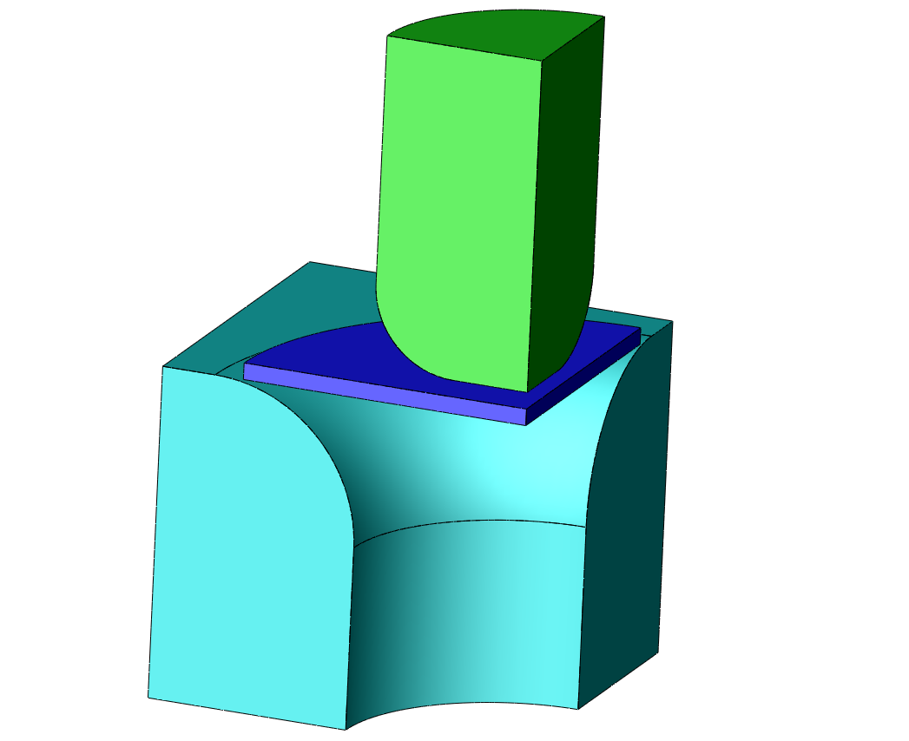

Drawing die

Punch

Disc

**Fig. 1.** Three-dimensional model of the drawing process in cross-section

a) b)

 

dp

dd

rp

rd

**Fig. 2.** Forming a drawpiece without a flange initial stage (a) and final stage (b)

3. Results of Numerical Calculations

3.1. Calculation of drawing force and total work

The maximum drawing force alone can determine whether the drawing process is proceeding correctly. According to the literature (Marciniak 2002), the calculated estimated drawing forces should not exceed 90 kN. It can be observed in Figure 3 that the maximum drawing force for a die clearance of 2 mm and a 12 mm curved die used is more than 170 kN. Similar results of maximum forces can be observed regardless of the die working radius used, where all forces exceed 170 kN (Fig. 4). Such high drawing forces are probably caused by the difficult formation of the drawpiece flange in the gap between the punch and die. Using a larger radius for the working edge of the die in such a case will not improve the situation but may make it worse. Because the outer edge of the drawpiece is formed at a later time, the thickening of the flange enters the die later and results in an even higher maximum force value. When drawing with larger clearances, the drawing forces are below 80 kN and increasing the die radius from 12 mm to 16 mm or 18 mm further decreases the maximum drawing force. In general, in drawing or redrawing processes, the aim should be to minimise force to minimise wear on the working surfaces of the tools. At more than twice the recommended force, the abrasive wear of the tools increases, impacting their service life.

**Fig. 3.** Drawing force for 2 mm die clearance and 12 mm radius die

**Fig. 4.** Maximum drawing force for 4 die clearances and 3 die radiuses

The total work was determined from the force-displacement diagrams of the punch using the trapezoidal method of linearising individual measurement points. There are 1500 measurement points for each case. The large maximum drawing force values recorded translate directly into the total drawing work required to form the finished product (Fig. 5). Assuming that the path of product formation during punch penetration is similar for different die radiuses, the total drawing work is mainly dependent on the drawing force. For the applied die clearance of 2 mm, which is the thickness of the initial sheet, the drawing work averages 3500 J. This is almost twice as much as for the larger clearances of 2.5 mm to 3 mm. The total work for the larger clearances, for 3 different die radiuses, is between 1600 J and 1800 J. Increasing the clearance further, or increasing the die radius, will not decrease force or work but may degrade the quality of the formed drawpiece. Similar results in the context of die radius analysis were obtained in (Kalduński et al. 2016).

**Fig. 5.** Total drawing work for 4 die clearances and 3 die radiuses

3.2. Calculation stress and strain in drawing tools for clearance 2 mm

It was assumed that the material goes into a plastic state at stresses exceeding 1200 MPa and a strain equal to 0.003. Maximum stress and strain values were read from individual nodes from across the whole object. This means that the maximum stress located pointwise at individual nodes was determined as a numerical error and did not determine the permanent deformation of the tool. This is rather related to the definition of the finite element mesh and its density.

Figure 6 shows the process phase for an applied clearance of 2 mm and a die radius of curvature of 16 mm, for which maximum stresses were observed in both the punch and the die.

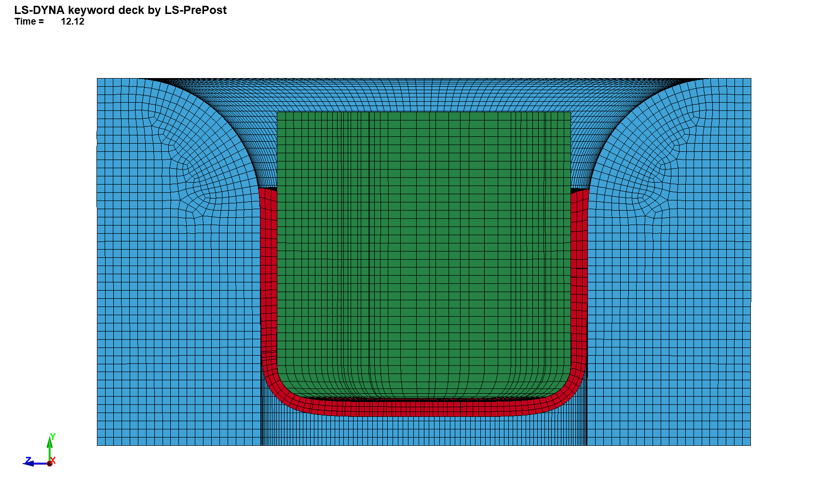

**Fig. 6.** Drawing process phase for maximum tool stresses

The maximum stress in the punch at this stage of the process is at the limit of the plastic phase and is 1199 MPa (Fig. 7b). The stress concentration occurs in the contact area between the drawpiece flange and its cylindrical surface. Such high values are directly caused by insufficient clearance concerning the increase in thickness of the drawpiece sheet in the flange area. In the cross-sectional view, it can be observed that the compressive stresses are localised to the punch axis but do not exceed 900 MPa (Fig. 7a).

a) b)

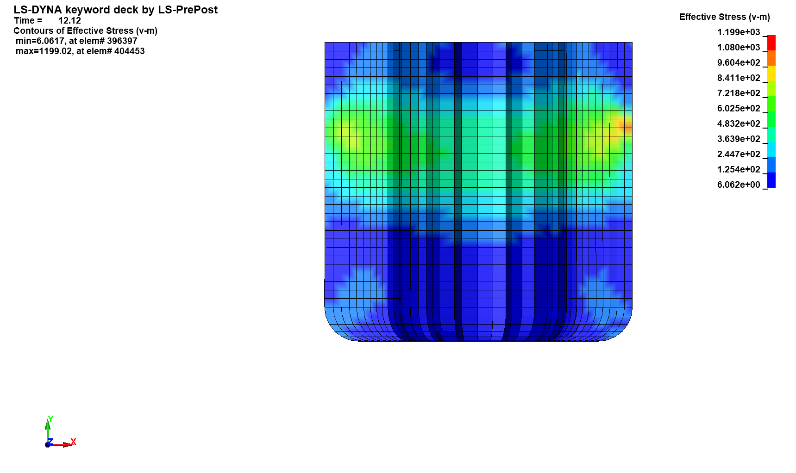 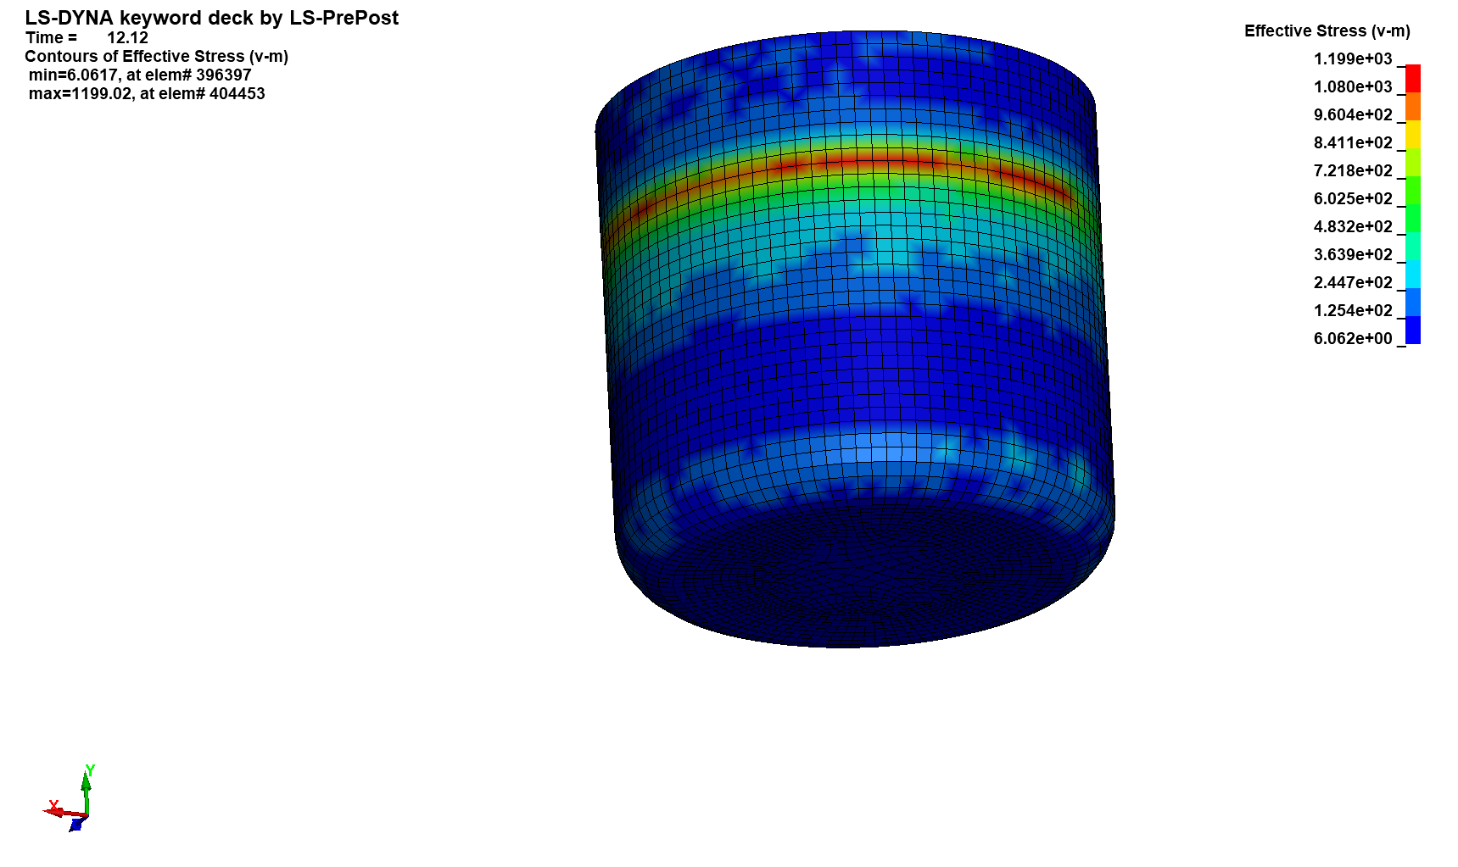

**Fig. 7.** Reduced stress distribution in the punch, in cross-section (a) and on the cylindrical surface (b)

Similarly, the stresses on the die surface propagate at this stage of the process (Fig. 8). In this case, however, they exceed the yield stress and are approximately 1300 MPa. They are also localised below the surface.

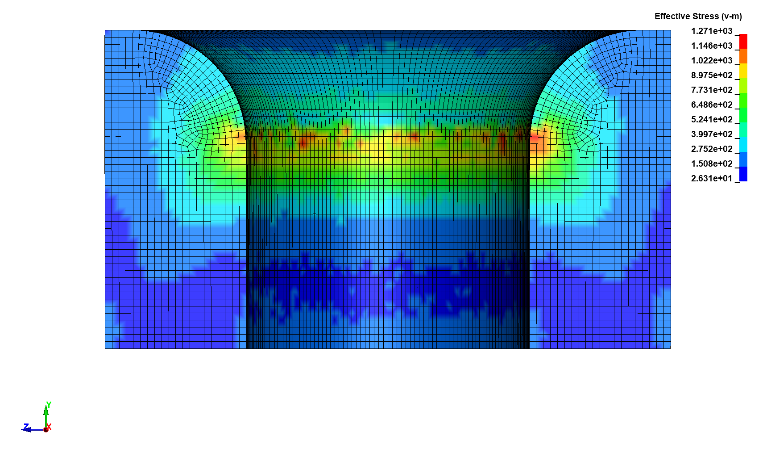

**Fig. 8.** Reduced stress distribution in the die

As the yield stress is exceeded, plastic deformations of up to 0.02 occur on the surface and under the working surface of the die (Fig. 9). Assuming that plastic deformation occurs at deformations of the order of 0.003, it can be concluded that these are significant permanent strains. Permanent deformations of 0.02 can affect the dimensional accuracy of the die and accelerate the wear of its working surface. In addition, the fatigue strength of the die surface will be significantly lower than if only elastic deformation occurs.

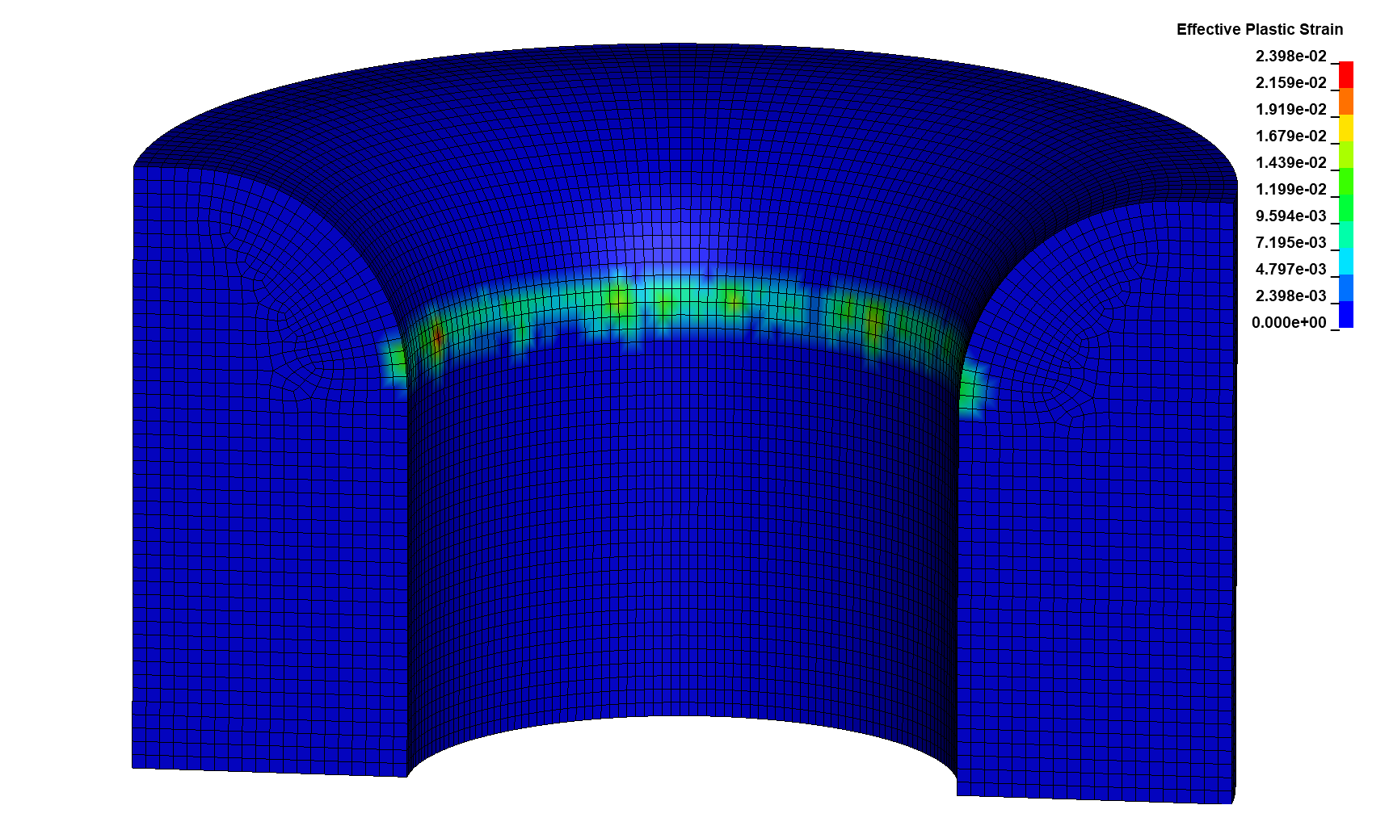

**Fig. 9.** Strain distribution in the die

3.3. Calculation stress and strain in drawing tools for clearance 2.5 mm

Figure 10 shows the process phase for an applied clearance of 2.5 mm and a die radius of curvature of 16 mm, for which maximum stresses were recorded in both the punch and the die. In this case, there is no overstretching of the edge of the drawpiece flange, as was the case with the 2 mm clearance (Fig. 6). The clearance used is slightly smaller than recommended in the literature for the given process conditions.

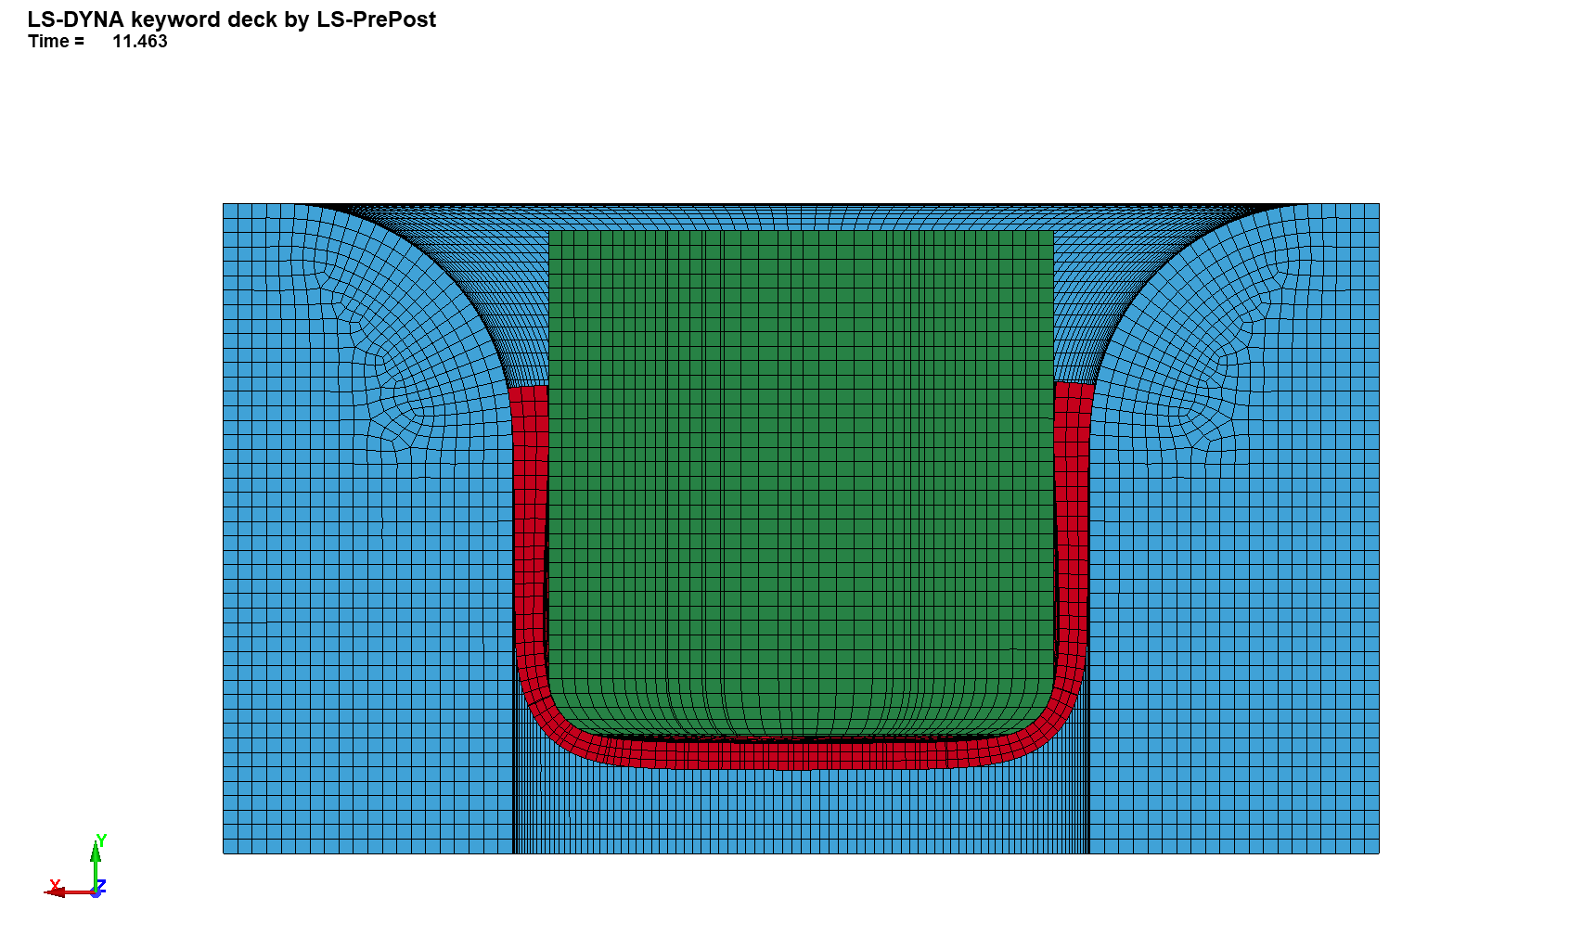

**Fig. 10.** Drawing process phase for maximum tool stresses.

Figure 11b shows the localisation and distribution of the maximum stresses on the surface of the punch and in its interior (Fig. 11a). The stresses oscillate around the mid-point of the yield stress, with a maximum of 631 MPa. They are mainly located on the outer surface of the punch and do not extend to its axis. Although the stresses are half as much as for the case with 2 mm clearance, the process stage at which they occurred indicates that too little clearance is still adopted, and the drawpiece flange is compressed between the working surfaces of the punch and die.

a) b)

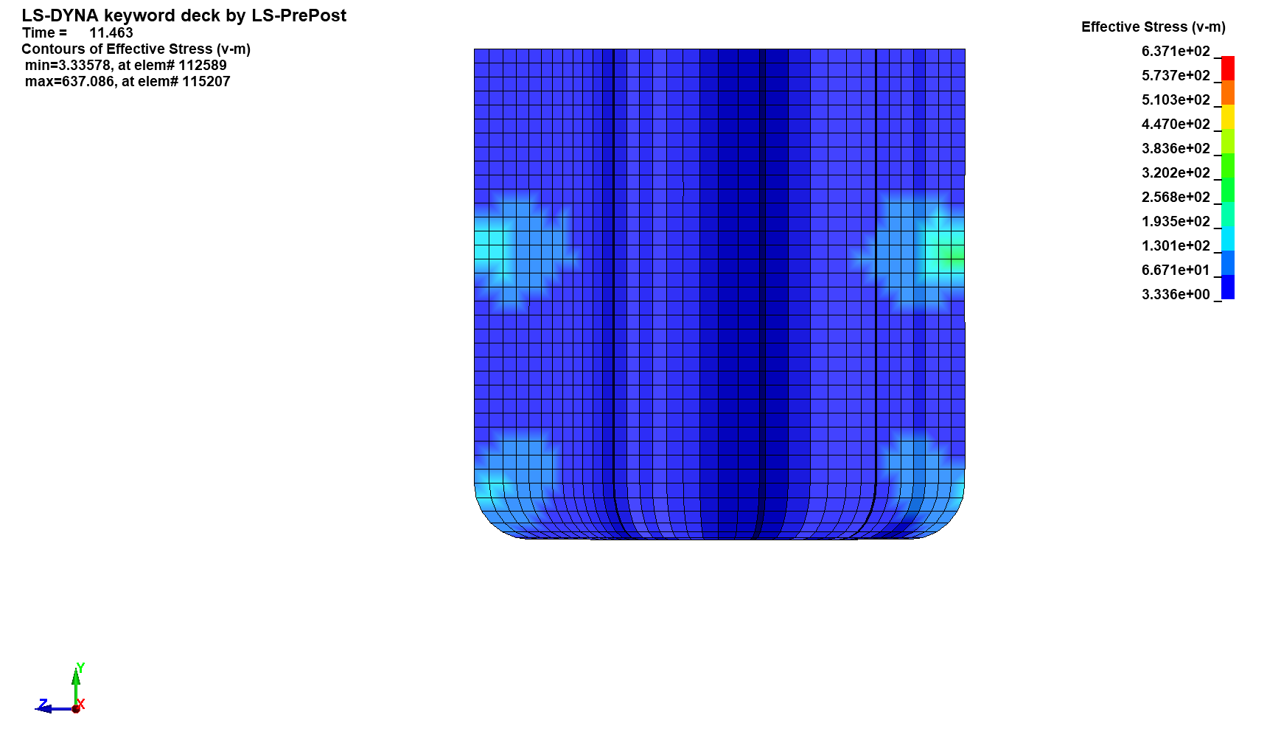 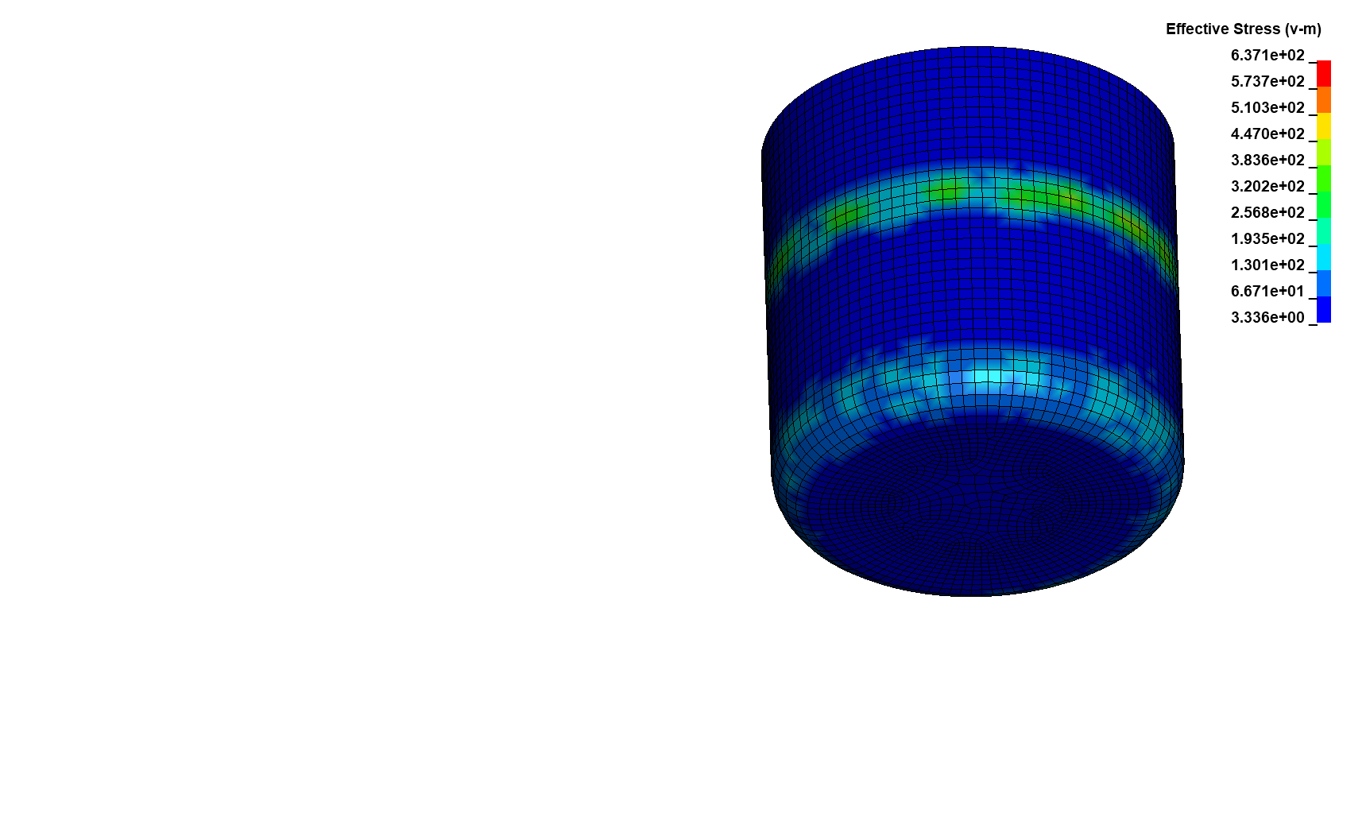

**Fig. 11.** Reduced stress distribution in the punch, in section (a) and on the cylindrical surface (b)

Significant pressure on the working surface also occurs in the die. Locally, the stresses reach the yield point (Fig. 12), but to a lesser extent than for a clearance of 2 mm. The distribution of these stresses is more concentrated around the die's surface area and minimally overlaps below the surface. Stresses oscillating around the yield point result in permanent localised strain at several points in the die (Fig. 13). Serial deep drawing ofproducts for such process conditions will result in an increase in these strains and increased local wear of the die surface in this area. The dimensional accuracy of the die will also deteriorate, causing the nominal dimensions of the die to increase.

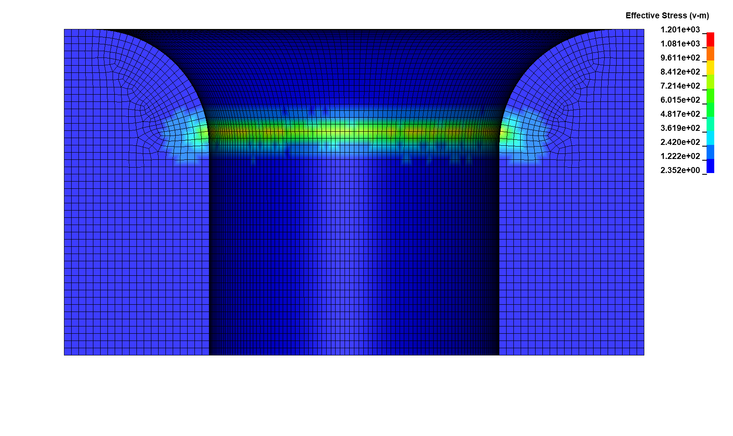

**Fig. 12.** Reduced stress distribution in the die

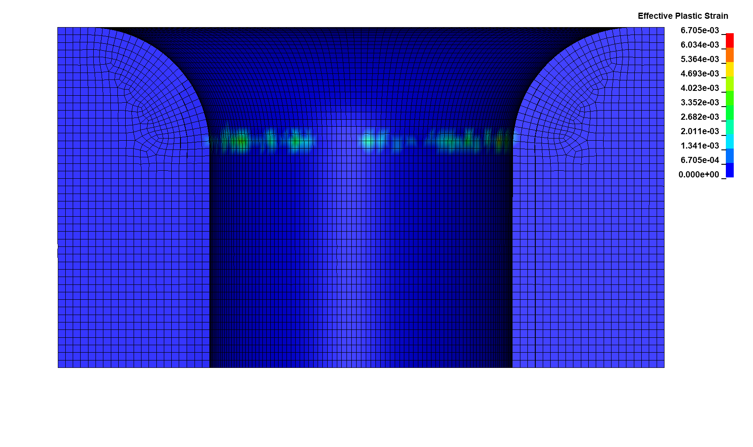

**Fig. 13.** Strain distribution in the die

3.4. Calculation stress and strain in drawing tools for clearance 2.7 mm

Figure 14a shows the process phase for an applied clearance of 2.7 mm and a die radius of curvature of 16 mm, where the maximum stresses in the punch were observed. On the other hand, maximum stresses in the die occur at the final stage of the drawing process (Fig. 14b). The different phases of the process in which the tools are subjected to maximum stress mean that the clearance applied is greater than the maximum drawpiece flange thickness achieved. This means that in the final stage of the drawing process, there is no compression of the top edge of the drawpiece between the punch and the die, which negatively affects tool life. The maximum punch stress for such an early stage of the process means that the maximum drawing force has been reached at this point in the process, which decreases as the drawpiece flange moves deeper into the die.

In this case, the maximum stresses in the punch occur at the rounded edge and do not exceed, even pointwise, 500 MPa (Fig. 15). The punch's rounded working edge is generally the punch's most stressed area during drawing or redrawing. However, this is not abrasive wear, as with high friction, there is no slippage in this area. It is worn through excessive surface pressure.

The reduced stresses for the final stage of extrusion flange forming, as shown in Figure 14b, do not exceed the yield stress in the die (Fig. 16). The average values are at 700 MPa. These values allow us to conclude that the conditions of the drawing process are chosen correctly and the working surface of the die is not exposed to plastic deformation, which was not observed in this case.

a) b)

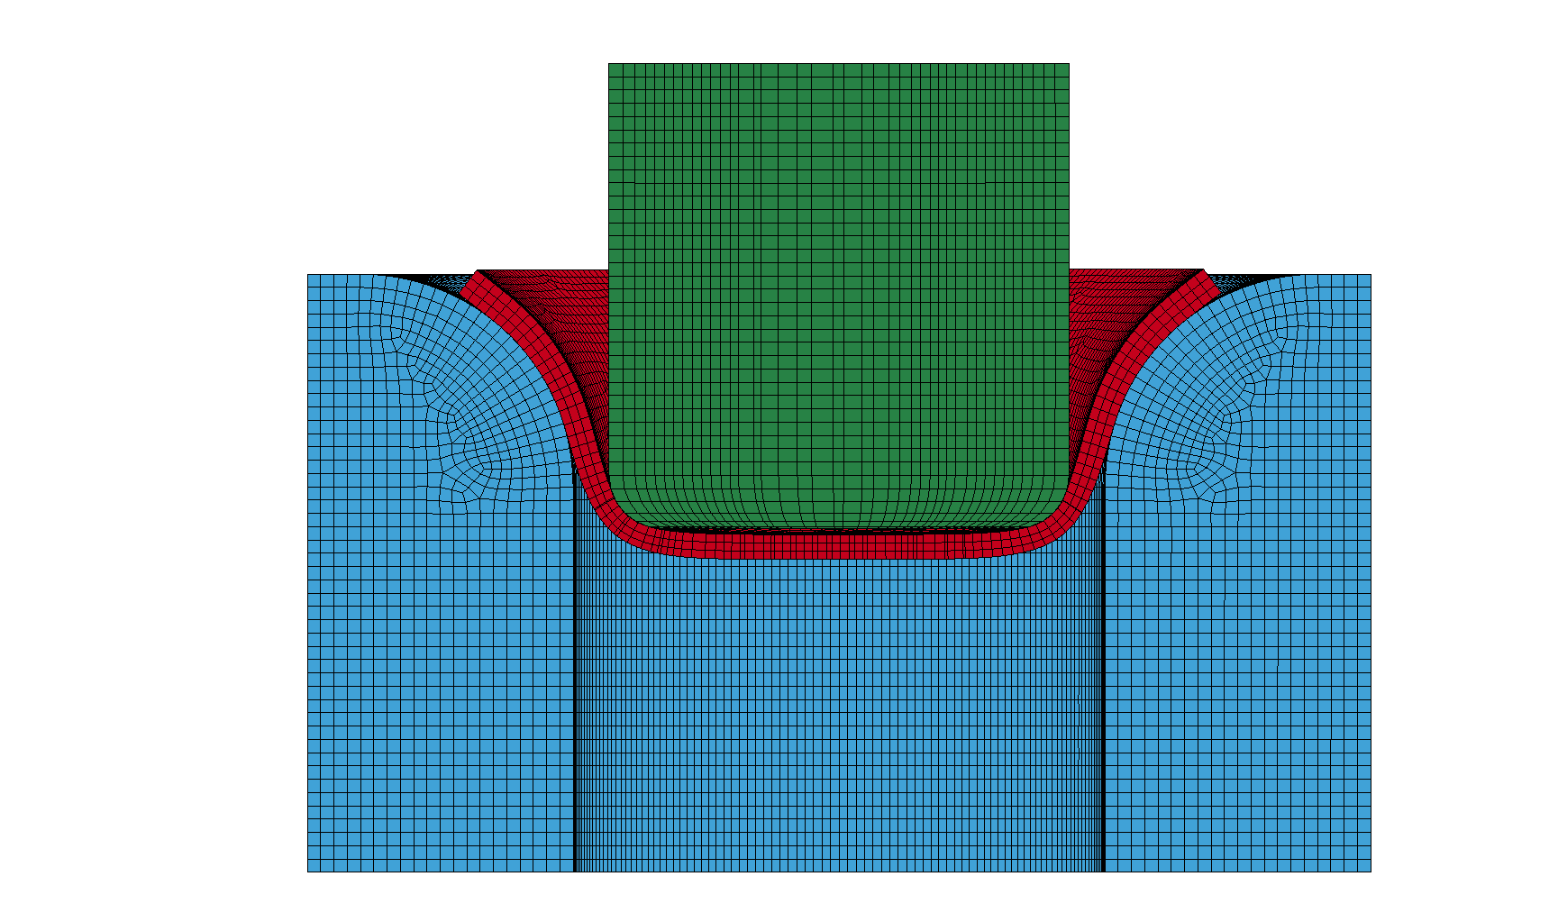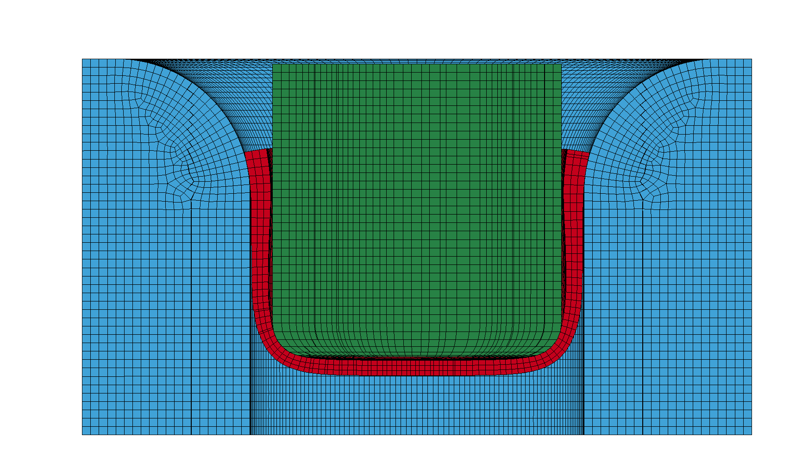

**Fig. 14.** Phase of the drawing process for maximum stresses in the punch (a) and in the die (b)

a) b)

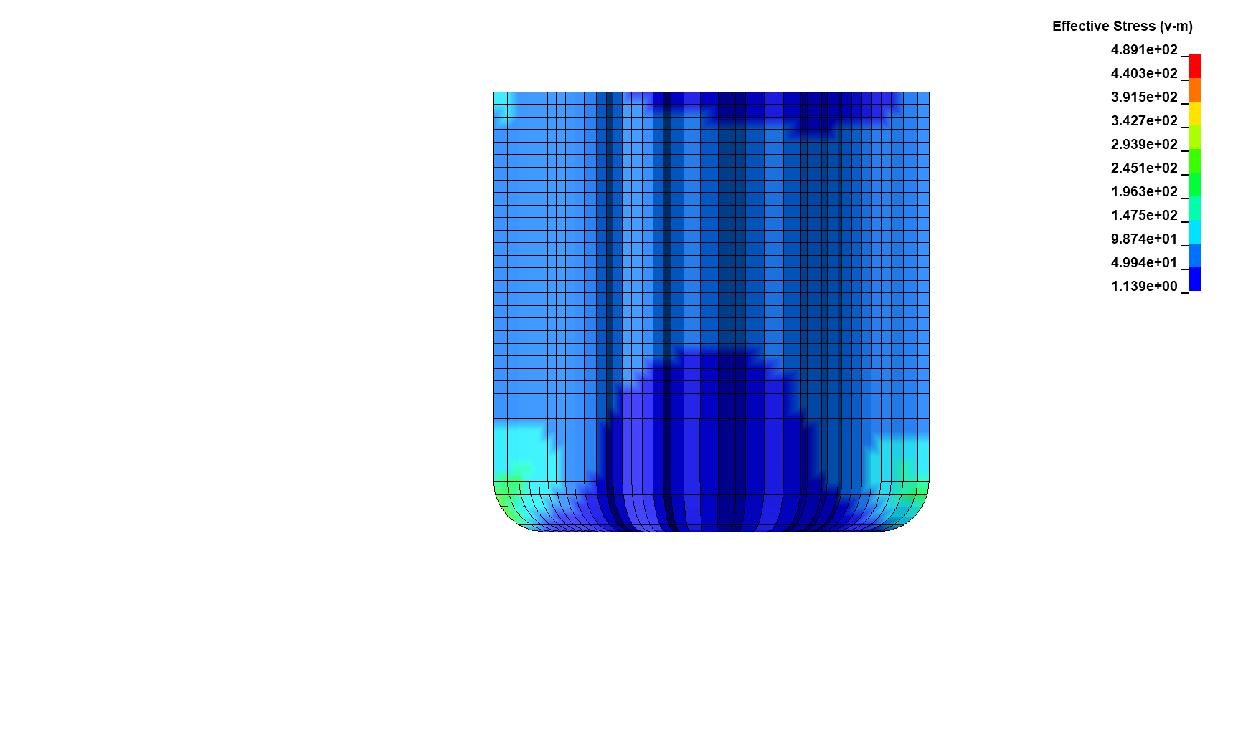 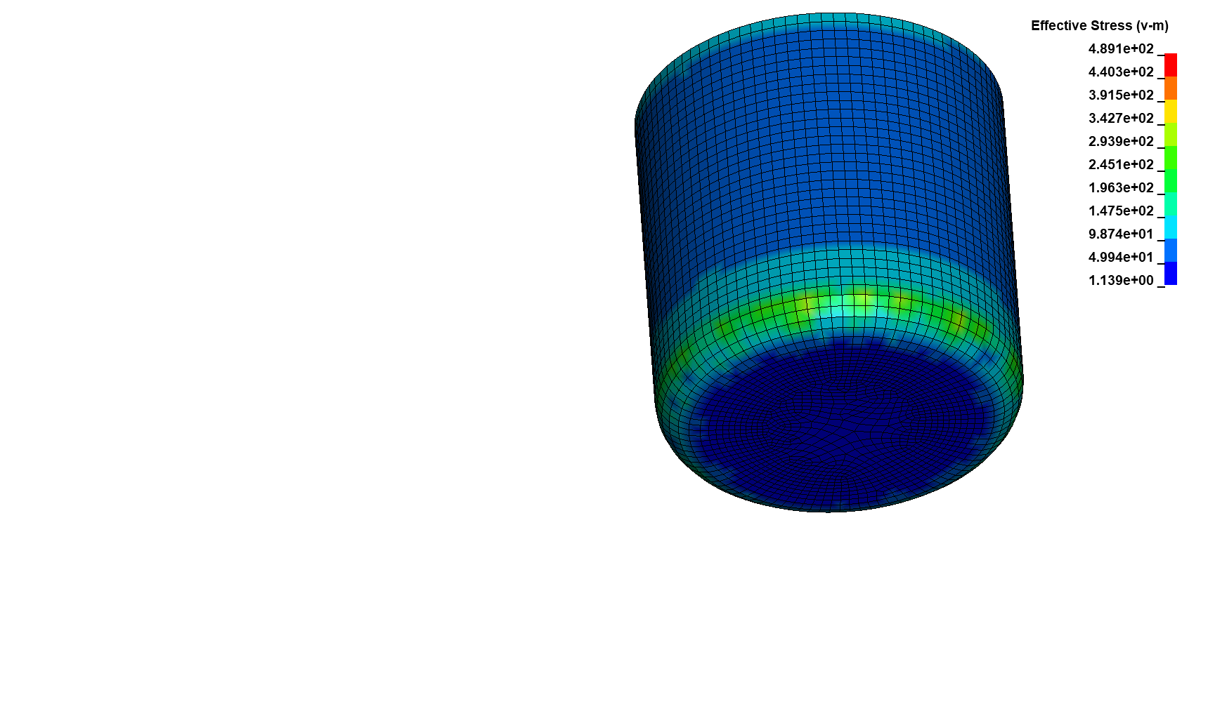

**Fig. 15.** Reduced stress distribution in the punch, in section (a) and on the cylindrical surface (b)

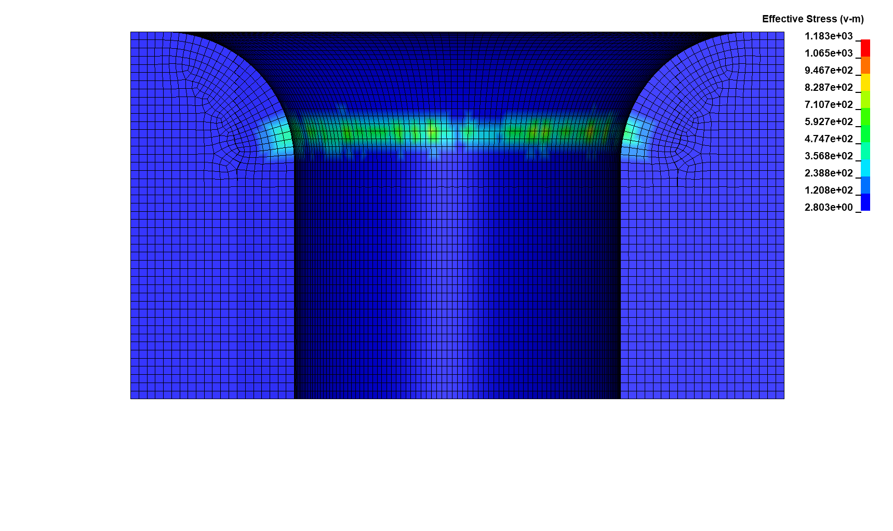

**Fig. 16.** Reduced stress distribution in the die

3.4. Calculation stress and strain in drawing tools for clarence 3 mm

Figure 17a shows the process stage for an applied clearance of 3 mm and a die radius of curvature of 16 mm, where the maximum stresses in the punch were observed. On the other hand, maximum stresses in the die occur at the final stage of the drawing process (Fig. 17b), similar to the 2.7 mm clearance used. As can be observed in Figure 17b, the selected clearance is too large in relation to the thickness of the sheet metal, as there is a gap between the punch's side surface and the product's inner surface. This is a disadvantageous phenomenon but mainly reflected in the quality of the drawn product, which will not obtain vertical cylindrical walls. The sides of the drawpiece will have a sigmoidal outline sloping upwards towards the punch. Excessive clearance can also result in greater stretching of the drawpiece sides, as the product is only in contact with the punch in the bottom area and at the rounded edge of the punch.

a) b)

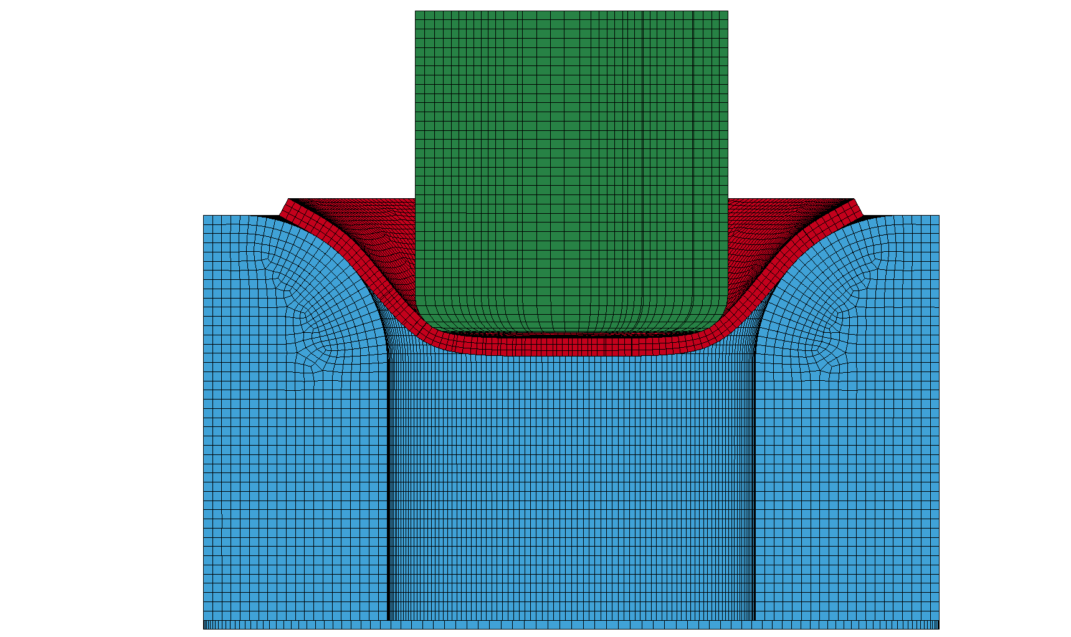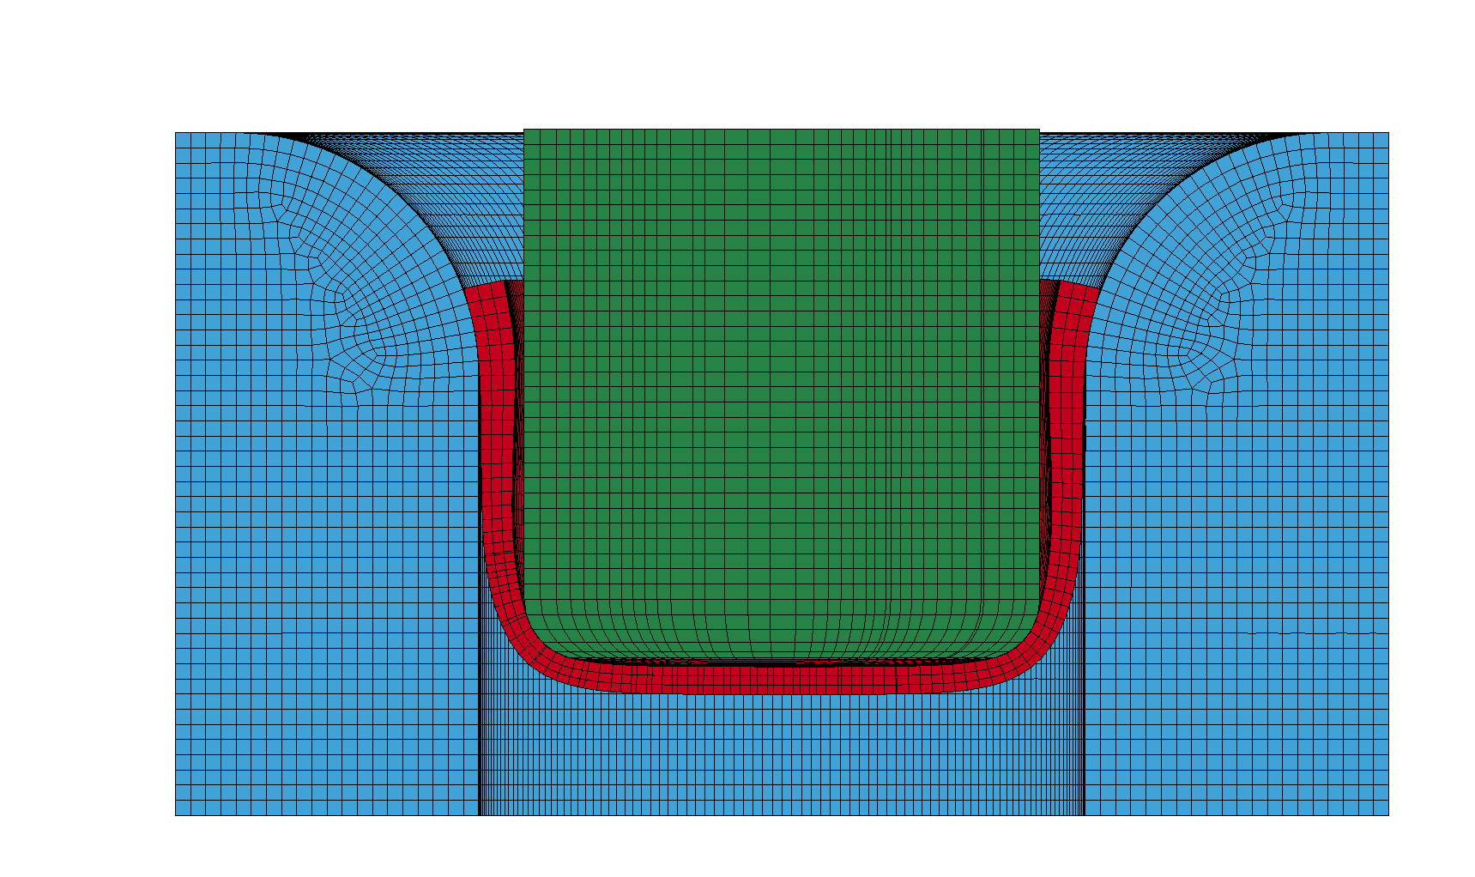

**Fig. 17.** Phase of the drawing process for maximum stresses in the punch (a) and in the die (b)

The maximum stresses in the punch occur, as for the 2.7 mm clearance, at the rounded edge and do not exceed 450 MPa (Fig. 18b). Stresses are mainly localised closer to the face of the punch due to the larger die clearance. Increasing the clearance further will no longer decrease stresses in the punch area but can only result in them being localised to the frontal face. Below the surface of the punch, the value of the maximum stresses is lower and does not exceed 300 MPa (Fig. 18a). In the punch core, the reduced stresses do not exceed 100 MPa.

a) b)

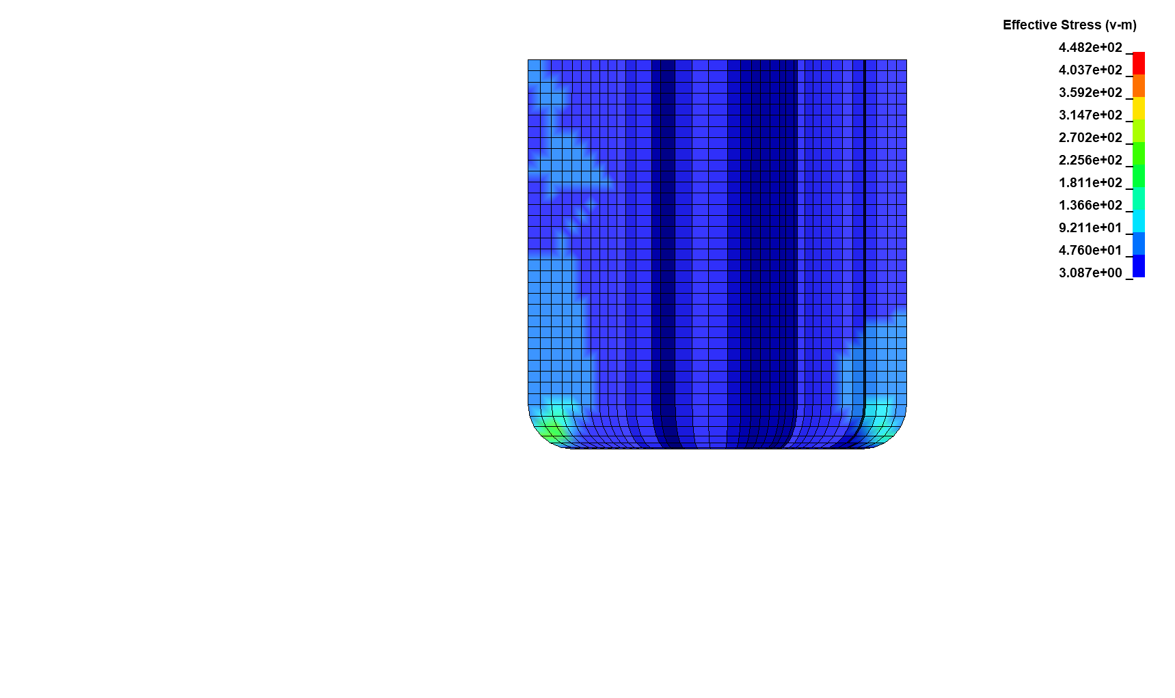 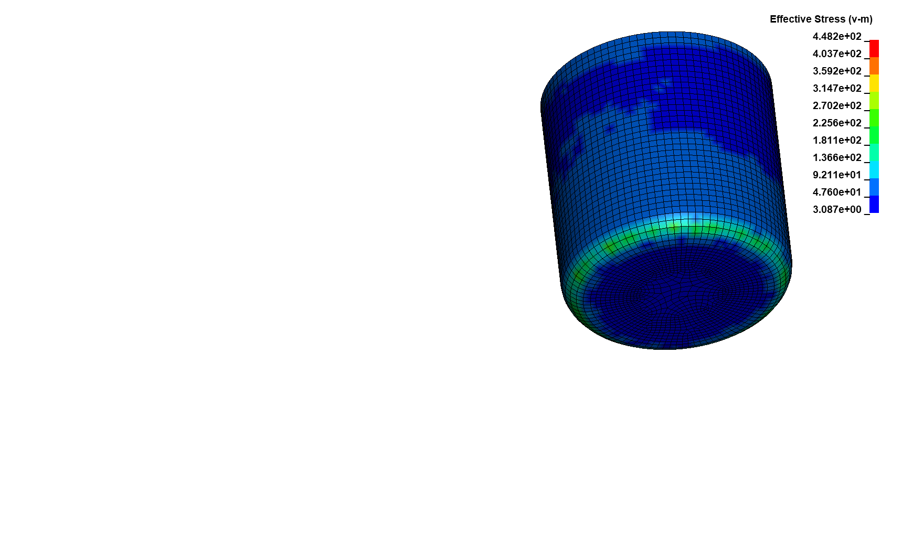

**Fig. 18.** Reduced stress distribution in the punch, in section (a) and on the cylindrical surface (b)

As with the 2.7 mm die clearance, for a clearance size of 3 mm, the yield strength of the die is not exceeded. The reduced stresses for the final stage of drawpiece flange formation max out at 1100 MPa, but these are nodal values, which can be read as a point numerical error (Fig. 19). The average stress values oscillate around 600 MPa. As in the other cases, they are located in the lower curvature region of the die working surface. This area is most often exposed to excessive contact pressure, and using too little clearance exposes the die to damage. It is also particularly important that the working surface of the die is well lubricated, allowing the product to be moved in depth with minimum friction, which at least partially limits the increase in stress in this area. Because the sticking of the drawpiece in the die, due to the increase in frictional forces, will cause a further increase in stress and strain in both the die and the punch.

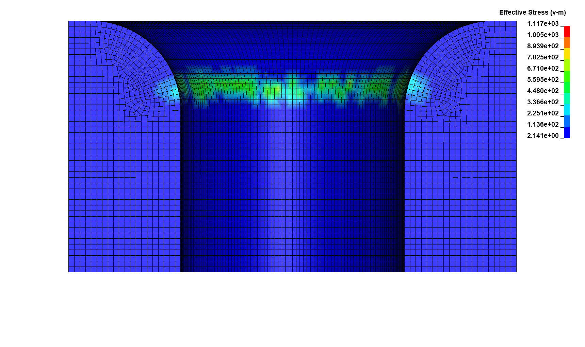

**Fig. 19.** Reduced stress distribution in the die

3.5. Results summary

Comparing all the results, it can be seen that, in the case of punch stress, the greatest difference is between a die clearance of 2 mm and 2.5 mm (Fig. 20a). By increasing the clearance above the nominal sheet thickness, a decrease in stress by half is observed. A further increase in the clearance size results in a further slight decrease in stress values of around 100 MPa when the clearance increases to 2.7 mm and a further 50 MPa when the clearance increases to 3 mm. The phenomenon is observed for all 3 dies with different rounding radiuses of the working surface. There are slight differences in stress values between the different dies, which can be considered insignificant.

In the case of die stress, on the other hand, the differences between the applied clearances have a near linear characteristic (Fig. 20b). A gradual decrease in stress in the die can be observed as the clearance increases. Also, increasing the size of the die radius results in a slight linear decrease in stress. Most significantly, from a die clearance size of 2.7 mm, the stresses are below the tool's accepted yield strength of 1200 MPa.

a) b)

**Fig. 20.** Maximum stresses in the punch (a) and in the die (b)

In the case of the punch, no plastic strain was observed for any of the die clearances used, and the 3 different die radiuses used. In the case of the die, the characteristics of the dependence of the magnitude of the strain on the applied clearance are non-linear (Fig. 21a). Significant amounts of plastic strain were observed for a clearance of 2 mm and a die radius of curvature of 12 mm. The strain for this case reaches 0.055. Increasing the die's curvature radius from 12 mm to 16 mm with the same clearance resulted in a decrease in plastic strain to 0.025. The use of a die clearance of 2.5 mm resulted in a further decrease in strain magnitude to 0.0085 for a die with a radius of 12 mm and 0.005 for a die with a radius of 18 mm (Fig. 21b). Only the applied clearance of 2.7 mm for all 3 die types resulted in strains not exceeding the yield point specified at 0.003 strain values. Increasing the clearance to a magnitude of 3 mm no longer had any measurable benefit in terms of a decrease in the magnitude of strains, which were already at elastic rather than plastic levels.

a) b)

**Fig. 21.** Maximum strains in the die for all cases (a) and for clearances greater than 2 mm (b)

4. Summary and Conclusions

From the numerical analyses carried out in Ansys Ls-Dyna, it is clear that the amount of die clearance is crucial to the life and wear of the drawing tools, punch and die. This is a more important parameter than selecting the die's curvature radius. It has been numerically proven that using a clearance size of 2 mm, which is the size of the initial sheet thickness, will result in very high drawing forces. They will be extremely detrimental to both the product and the tools. Due to the 2 times higher drawing forces achieved, compared to the higher die clearances of 2.5 mm, 2.7 mm and 3 mm used, a significantly higher energy input will also be required to form the product. This occurs under the assumption that the punch travel distance is similar for all cases and that changes in die rounding radius do not significantly affect the required displacement. The use of larger rounding radiuses, on the other hand, reduces the drawing force. On average, this is 10% less between the largest die radius of 18 mm and 12 mm, assuming a clearance greater than the initial thickness of the sheet.

There was also a significant effect of the amount of die clearance on the amount of stress in both the punch and the die. With an initial sheet thickness of 2 mm, the clearance used caused stresses in the punch close to the yield point. In the case of the die, the yield strength was noted to be exceeded for clearance sizes of 2 mm and 2.5 mm, which also resulted in the appearance of plastic strains on the working surface.

For proper shaping of the product and for reliable and long-lasting tool life, a clearance of 2.7 mm is recommended. This is the optimum clearance for the selected drawing conditions. Increasing it to a value of 3 mm will worsen the quality and dimensional accuracy of the product and will not bring tangible benefits in terms of increased tool life. It is also recommended to use larger die radiuses, 16 mm and 18 mm, which results in better moulding of the drawpiece and also generates less stress in the tools.

From the point of view of environmental protection, further research on plastic forming processes is important. Particularly concerning the modification of tool geometry, allowing for the minimisation of wear and increased durability. This is important in the case of forming products from atypical metals, which are not easily subject to plastic forming. In such conditions, optimal friction conditions are also very important.

References

Bohdal, Ł., Kułakowska, A., Patyk, R. (2014). Analysis of slitting of aluminum body panels in the aspect of scrap reduction. *Annual Set The Environment Protection*, *16*, 105-114.   
https://ros.edu.pl/images/roczniki/2014/pp_2014_01_06.pdf

Bohdal, Ł., Walczak, P. (2013). Eco-modeling of metal sheet cutting with disc shears. *Annual Set The Environment Protection*, *15*, 863-872. https://ros.edu.pl/images/roczniki/2013/pp_2013_058.pdf

Brusilová, A., Schrek, A., Švec, P. et al. (2017). Deep-Drawing Process Simulation for Tailor-Welded Blanks with an Elastic Blankholder. *Strength of Materials*, *49*, 586-593. https://doi.org/10.1007/s11223-017-9902-4

Choi, K.Y., Lee, M.G. & Kim, H.Y. (2013). Sheet metal forming simulation considering die deformation. *International Journal of Automoive Technology*, *14*, 935-940. https://doi.org/10.1007/s12239-013-0103-2

Del Pozo, D., López de Lacalle, L.N., López, J.M. et al. (2008). Prediction of press/die deformation for an accurate manufacturing of drawing dies. *International Journal of Advanced Manufacturing Technology*, *37*, 649-656. https://doi.org/10.1007/s00170-007-1012-1

Iorio, L., Pagani, L., Strano, M., and Monno, M. (2016). Design of deformable tools for sheet metal forming. *Journal of Manufacturing Science and Engineering*, *138*(9): 094701 (10 pages). https://doi.org/10.1115/1.4034006

Kałduński, P., Bohdal, Ł., Chodór, J., Kułakowska, A., Patyk, R. (2016). Determination of energy expenditure in the drawing process in the aspect of environment protection. *Annual Set The Environment Protection*, *18*, 171-187. https://ros.edu.pl/images/roczniki/2016/010_ROS_V18_R2016.pdf

Kataoka, S., Murakawa, M., Aizawa, T., Ike, H. (2004). Tribology of dry deep-drawing of various metal sheets with use of ceramics tools. *Surface and Coatings Technology*, *177-178*, 582-590.   
https://doi.org/10.1016/S0257-8972(03)00930-7

Keum, Y.T., Ahn, I.H., Lee, I.K., Song, M.H., Kwon, S.O., Park, J.S. (2005). Simulation of stamping process of automotive panel considering die deformation. *AIP Conference Proceedings*, *778 A*, 90-95. https://doi.org/10.1063/1.2011199

Lingbeek, R.A., Meinders, T. (2007). Towards efficient modelling of macro and micro tool deformations in sheet metal forming. *AIP Conference Proceedings*, *908*, 723-728. https://doi.org/10.1063/1.2740896

Marciniak, Z. (2002), *Construction of dies.* Warszawa: Technical Center A. Marciniak. (in Polish)

Neto, D.M., Coër, J., Oliveira, M.C., Alves, J.L., Manach, P.Y., Menezes, L.F. (2016). Numerical analysis on the elastic deformation of the tools in sheet metal forming processes. *International Journal of Solids and Structures*, *100-101*, 270-285. https://doi.org/10.1016/j.ijsolstr.2016.08.023

Roizard, X., Pothier, J.M., Hihn, J.Y., Monteil, G. (2009). Experimental device for tribological measurement aspects in deep drawing process. *Journal of Materials Processing Technology*, *209*, 1220-1230. https://doi.org/10.1016/j.jmatprotec.2008.03.023

Takamura, M., Ohura, K., Sunaga, H., Kuwabara, T., Makinouchi, A., Teodosiu, C. (2004). Sheet Forming Simulation Using a Static FEM Program and Considering the Elastic Deformation of Tools. *AIP Conference Proceedings*, *712*(1), 940-945. https://doi.org/10.1063/1.1766648