
 | Rocznik Ochrona Środowiska
 | Volume 26 | Year 2024 ISSN 2720-7501 | pp. 558-567
 | https://doi.org/10.54740/ros.2024.050 open access
 | Received: September 2024 Accepted: November 2024 Published: November 2024
Green Innovations in Foundry Production Processes of Automobile Castings
Josef Bradáč^{1*}, Martin Folta², Jiří Machuta³, Jiří Slabý⁴, Michal Beneš⁵
¹Department of Mechanical and Electrical Engineering, Škoda Auto University, Czech Republic
https://orcid.org/0000-0003-4075-3616
²Department of Production, Logistics and Quality Management, Škoda Auto University, Czech Republic
https://orcid.org/0000-0002-4508-5760
³Škoda Auto a.s., Czech Republic
https://orcid.org/0009-0005-6149-5611
⁴Škoda Auto a.s., Czech Republic
https://orcid.org/0009-0006-3432-6211
⁵Škoda Auto a.s., Czech Republic
https://orcid.org/0009-0003-1103-0707
*corresponding author's e-mail: josef.bradac@savs.cz
Abstract: The paper deals with individual possibilities for energy savings and the use of chemicals in the production of automotive components. Specifically, it focuses on operating an aluminium foundry where shape-complex castings such as engine blocks and gear and clutch housings are produced using high-pressure die-casting technology. Regarding the production process, foundry operations are characterized by high energy consumption and high wastewater production. On the other hand, there is also a great potential for introducing various innovations and seeking savings. This paper aims to present selected innovative solutions throughout the foundry operation and assess their benefits in energy consumption savings, reduced wastewater production, and chemicals usage. The impact of the presented savings is financial in terms of the production of components and environmental in terms of CO₂ production.
Keywords: foundry, innovations, energy savings, environmental impact
1. Introduction
Nowadays, there is an increasing interest in environmental protection and a general effort to reduce the production of harmful substances related to all areas of human activities. This is also valid for the industrial sector (Lenort et al. 2019, Gabrylewicz et al. 2021) and industrial production in general. New trends such as green production (Saetta & Caldarelli 2020) and city and related green logistics (Sharma et al. 2023, Chamier-Gliszczynski 2012) are being applied here. There is also pressure to minimize and recover waste and build a waste management system (Espuny et al. 2022, Ignatowicz et al. 2021). It is also important to apply a comprehensive approach, i.e. monitoring and assessing all activities throughout the product life cycle LCA (Bajdur et al. 2023, Chamier-Gliszczynski & Krzyzynski 2005). Modern industrial production (Sąsiadek et al. 2023) with high demands on productivity and efficiency is now highly focused on finding savings on the energy resource side. Achieving energy savings in all types of energy (Kuczynski et al. 2021) is an essential prerequisite for meeting the requirements for efficient and environmentally friendly industrial production (Orłowska 2022, Jenek, et al. 2022). The next trend is the digitization of processes and Industry 4.0 (Ghadge et al. 2022, Menti et al. 2023, Kostrzewski et al. 2020). Digitization brings numerous opportunities to increase process efficiency (Szajna et al. 2021). Thanks to the large amount of production data in digital form, it is possible to monitor certain trends or evaluate the level of positive impact of the innovations introduced to increase efficiency and, in turn, reduce the environmental impact.
The automotive industry is a complex and specific industry characterized by very dynamic development, great innovative potential, and innovation performance (Mir et al. 2022, Nawrocki et al. 2018). There is also high level of standardization and increased demand for the quality of the resulting products (Sumasto et al. 2023). Car manufacturing is complex and involves many specific production technologies and processes. The aim is to design, manufacture, and deliver the final product to customers in the shortest possible time and at minimum cost, while maintaining the required quality. This would be impossible without constant focus on innovation and optimization of all production processes and related logistics processes (Scharf et al. 2022, Staniuk et al. 2022). This applies, in particular, to production areas with high energy and fuel consumption, such as foundries. Therefore, in the metallurgical sector in general, there is a high potential for various savings and cuts of production costs and process optimization (Obzina et al. 2021). In the case of the automotive industry, foundry plants mainly produce parts of combustion engines and gearboxes. The basic materials to produce castings are aluminium alloys, which show favourable mechanical properties such as low weight and corrosion resistance. High-pressure die casting is a technology that enables high productivity and is suitable for producing complex thin-walled castings. However, the correct setting and control of process parameters are necessary to achieve the desired properties (Ťavodová et al. 2022). This also involves applying systems to monitor the process parameters of individual production machines and using this data in digital form. Similarly, it is possible to monitor and subsequently identify losses occurring in the entire process and the consumption of process fluids. The better we identify areas with high levels of waste heat, the more efficiently we can reduce the level of heat losses (Samtleben et al. 2021). This also requires an optimal location of the production equipment and an efficient material flow through the foundry (Scharf et al. 2021). The following part of the present article is focused on green innovations in the foundry production process of automobile castings. The article aims to present selected innovations in Škoda Auto foundry aimed at reducing the consumption of energy and operating substances and thus lowering the foundry operation environmental impact.
2. Aluminium Foundry Production
The foundry at Škoda Auto is an important plant with a long history. Over time, in addition to its own plants in the Czech Republic, it has also been supplying its products to other Škoda Group production facilities in Europe and overseas. The main products produced by the foundry are combustion engine blocks, gearboxes, and clutch housings. These parts range in weight from 5 to 25 kg. The foundry's operating facilities include 4 aluminium melting furnaces, 13 casting machines to produce engine blocks, and 7 machines to produce clutch and gearbox housings, with clamping force ranging from 1800 to 3500 t. The operating section also includes annealing continuous furnaces and blasting and machining equipment. The annual production is substantial at around 2 million parts produced, most of which are internal combustion engine blocks. The high production volume is matched by high energy consumption, as this is one of the most energy-intensive operations from a technological point of view, during which solid material in the form of bundles is transformed into the final product by melting and casting, as shown in Fig. 1. The actual production starts with the melting of the aluminium alloy at 750°C in gas melting furnaces. The molten metal is then distributed using transport pans to the individual casting machines equipped with electric holding furnaces, where the metal temperature is maintained at 650°C. Metal is then dosed into a casting chamber with a volume corresponding to the weight of the future casting. The steel moulds, which give the part's final shape, are subjected to extreme thermal stress and operate in a cyclical mode. The mould cooling system must be set up correctly to compensate for this loading. To remove the manufactured part correctly from the mould, it is also necessary to treat the surface of the mould with a separating agent before starting the next production cycle. These operation steps must be well-optimized to make the most efficient use of the cooling medium and the heat supply. The manufactured product is then removed from the mould and cooled in a water bath, and the engine blocks are subsequently marked with a unique DMC code. The metallurgical plant also provides subsequent operations such as surface blasting, stabilization annealing, removal of process spikes from the casting mould, and rough machining.

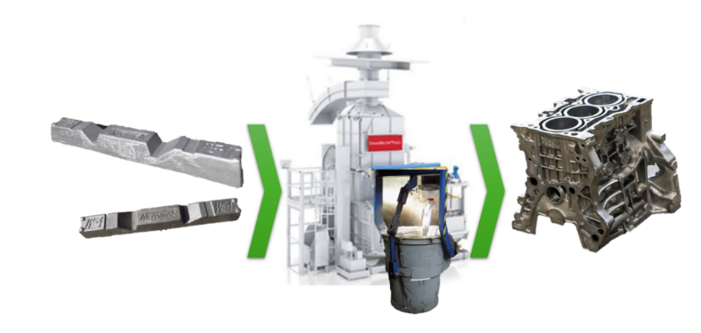
Fig. 1. The procedure of cylinder block production, from molten metal to final product

The foundry uses natural gas, electricity, and compressed air produced by the in-house producer Ško-Energo. For the above-mentioned technological reasons, there is also a high consumption of industrial water. An example of the annual consumption of each type of energy and the total annual costs is shown in Table 1. These are high values with a great potential for savings. To define the savings potential, it is first necessary to monitor the consumption of individual energy sources, see the overview of monthly natural gas consumption in the Power BI in Fig. 2. By monitoring the consumption in digital form; it is also possible to assess the benefits of implementing innovative solutions and measure their impact. For this reason, a lot of attention has recently been paid to digitalisation and data monitoring in foundry operations. In addition, particularly in the last decade, major sustainability and environmental measures have been implemented.

Table 1. Annual energy consumption in foundry operation by energy type
Types of energy | Consumption in 2023
Natural gas | 3,000,000 m³
Electricity | 23,000 MWh
Compressed air | 24,000,000 Nm³
Heat | 2,700 MWh
Industrial water | 14,000 m³

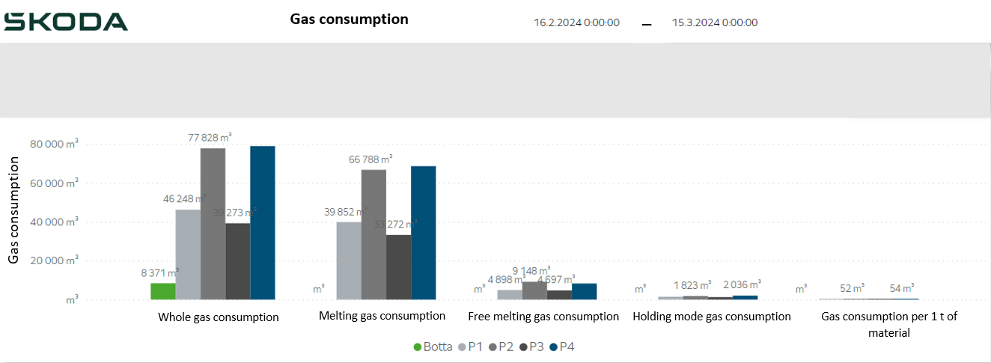
Fig. 2. Power BI report of gas consumption in individual melting devices for a selected period

Several solutions have been implemented to optimise the production process and reduce energy consumption at all levels, some of which will be presented in the following section of this article. Apart from the solutions to reduce the consumption of standard energies, associated areas are mentioned, such as measures to reduce the consumption of chemicals used to treat the moulds of casting machines (corrosion inhibitors, NaOH, dispersants, salt). The chemicals needed for technological reasons impact the stability and quality of production.
3. Solutions to Reduce Energy Consumption in Foundry Operations
It follows from the previous section that the energy costs of running a foundry are high. Savings must be found in the whole production flow, i.e., from the material melting, production by casting machines, and heat treatment to the total amount of energy required to operate a production hall.
3.1. Solutions to reduce natural gas consumption needed for melting
Melting is the first stage of the production process. The foundry uses natural gas-fired furnaces for melting. The internal melting space of the furnace is subject to considerable cyclic thermal stress, which is also influenced by molten metal. After a period, the inner part of the furnace, called the lining (see Fig. 3), is eroded, losing its conformity and integrity, generally leading to heat loss. Heat leakage prolongs the period it takes to reach the melting temperature of the metal and causes higher consumption of natural gas.
The annual savings on natural gas consumption after the renovation of a furnace lining are 584 m³/year, which is equivalent to 100 thousand euros per year, calculated based on the higher 2022 prices per MWh. The proportional reduction in CO₂ production is also an important aspect. This has another benefit: shorter time needed to achieve the melting temperature and the possibility of increasing production efficiency. This innovation brings required savings and shows the need to monitor and control the furnace linings. Subsequently, it allows for proper planning of repair works before critical wear occurs and natural gas consumption increases.
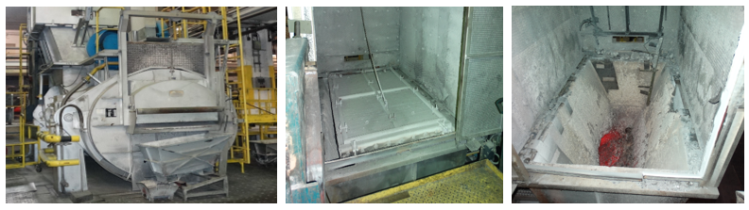
Fig. 3. Melting furnace with an example of an inner lining of the melting space
3.2. Solutions to reduce electric energy consumption
From the point of view of electricity savings, partially implemented savings projects covering individual areas of the foundry's operation, from the casting workplace through the subsequent heat treatment of castings to the lighting of production halls and spaces, will be presented.
3.2.1. Reduction of electric energy consumption in casting workplaces
The casting workplace consists of several devices which consume a considerable amount of electric energy. The different devices used in the casting workplace can be seen in Fig. 4. The reduction of electricity consumption leads to cost savings and mitigation of the environmental impact due to the decrease in electricity generation and lower CO₂ production.
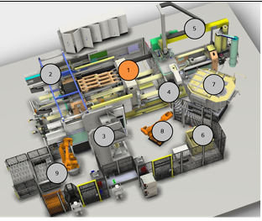
Fig. 4. Schematic view of individual devices in the casting workplace: (1 – high pressure casting machine, 2 – machine extraction, 3 – cutting press, 4 – data matrix code punch, 5 – foundry mould treatment manipulator, 6 – cooling bath, 7 – holding furnace, 8 – handling robot, 9 – robotic, automatic palletizing)

The first solution to reduce power consumption was applied to the casting machine. More specifically, this was an installation of frequency converters in the hydraulic circuit. It enabled to control the operation of a hydraulic pump used to generate the necessary pressure. The situation before and after introducing the frequency converter in the hydraulic circuit of a casting machine is shown in Fig. 5. This solution reduced hourly power consumption in the working mode by 54 kW and in the waiting mode by 10 kW. Table 2 shows an annual calculation of savings.
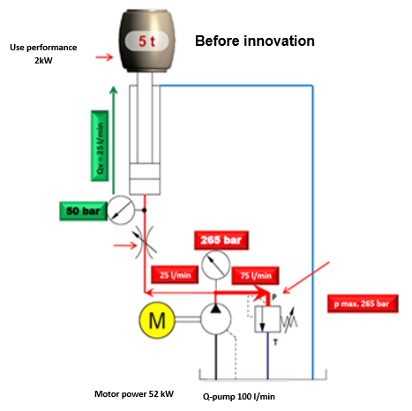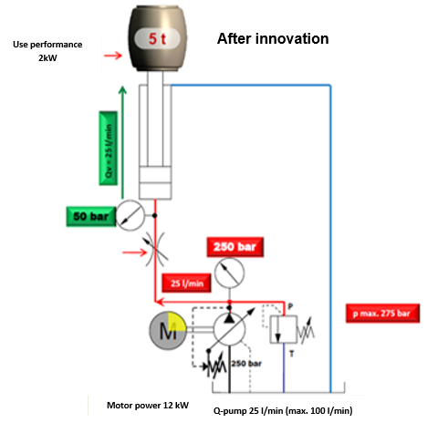
Fig. 5. Control status of the casting machine hydraulic circuit before and after applying the frequency converter

Table 2. An annual overview of electricity savings before and after applying the hydraulic control solution
Device mode | hrs/year | Savings kW/hr | Savings kWh/year
Working mode | 4333 | 54 | 233982
Standby mode | 2387 | 10 | 23870
Total savings |  |  | 257852

The second solution that led to energy savings in the casting workplace was installing a more efficiently controlled extraction system. When the mould is opened, more extraction power is needed, but when the mould is closed, there is no longer a need to extract at such a high power. In the original version, the extraction system was set at the same value during the whole cycle time. The new version decreases power consumption after the mould is closed. In addition, the device is not running in standby mode and does not consume electricity, see Fig. 6 and Table 3.

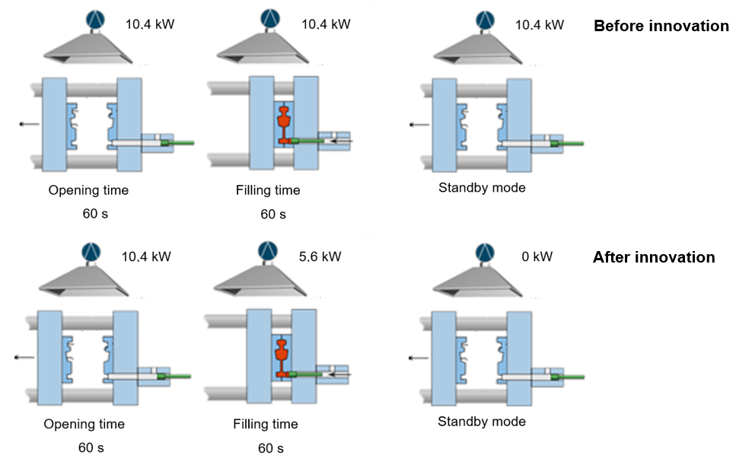
Fig. 6. Comparison of energy consumption of an extraction system, before (top) and after (bottom)

Table 3. Annual overview of electricity savings before and after the application of the innovative extraction solution
 | Mode | hrs/year | Consumption kW/hr | Energy consumption kWh/year
Before innovation | Working | 4333 | 10,4 | 45063,2
 | Standby | 2387 | 10,4 | 24824,8
 | Total |  |  | 69888
After innovation | Working | 4333 | 8 | 34664
 | Standby | 2387 | 0 | 0
 | Total |  |  | 34664
Total savings |  |  |  | 35224

The third solution at the casting workplace concerns the cutting press. After removing the cast from the casting mould, the cast still contains the sprue system and castings, which must first be removed on the cutting press. Again, the machine's function and power consumption in the different working cycles have been optimised. A new control system was installed to reduce consumption both in operating and standby modes. Fig. 7 shows a graphical representation of the cutting press's original and new control systems. The quantification of the amount of savings after upgrading the workstation of the cutting press is shown in Table 4.

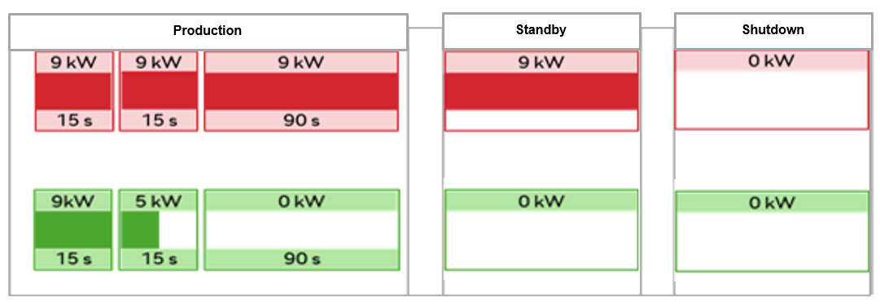
Fig. 7. Graphical representation of the innovation concerning savings of the cutting press, before (red), after application of the innovation (green)

Table 4. Annual overview of electricity savings before and after the application of the innovative cutting press control
 | Mode | hrs/year | Consumption kW/hr | Energy consumption kWh/year
Before innovation | Working | 4333 | 9 | 38997
 | Standby | 2387 | 9 | 21483
 | Total |  |  | 60480
After innovation | Working | 4333 | 2,71 | 11742
 | Standby | 2387 | 0 | 0
 | Total |  |  | 11742

It is clear from the graphical representation and the data in the table that the power consumption has been reduced and that the new cutting press works more efficiently. In operating mode, the electricity saving is more than two-thirds; in standby mode, the system does not consume any electricity. This is matched by significant electricity savings at the trimming station, contributing to the required savings at the entire casting station.
3.2.2. Reducing electricity consumption by using waste heat
Following the production of castings as internal combustion engine blocks at the casting workstations, the engine blocks are moved on pallets in the production flow to large continuous annealing furnaces where heat treatment is carried out. The aim is to achieve the final products' high quality and dimensional stability, satisfying the high requirements for internal combustion engine blocks. Until five years ago, the standard annealing temperature was 250°C. Following the optimisation of the process, a lower temperature of 210°C was set, which positively affected power consumption. In addition, tests have shown that even if the annealing temperature has decreased, there is no negative effect on the quality of castings. Apart from the annealing temperature reduction, an innovative solution using waste heat from the annealing furnaces to heat the main hall was applied, as shown in Fig. 8. This solution allowed to reduce the consumption of electricity during the heating season, needed to heat the main hall using installed heating elements powered by electricity. As a result, it was possible to reduce the number of electric heating elements in the main hall and to achieve winter electricity savings of 691,000 kWh/year.
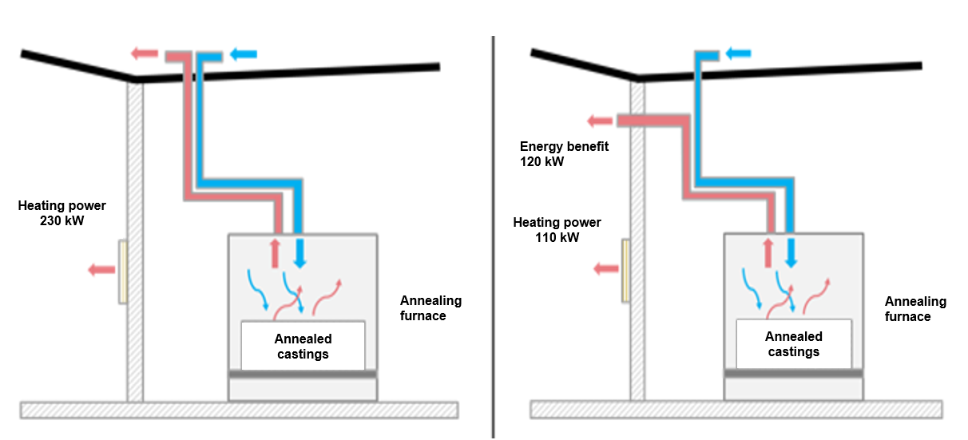
Fig. 8. Situation before and after the implementation of waste heat recovery system from annealing furnaces
3.2.3. Reducing electricity consumption by replacing the lighting system
A comprehensive approach is important to achieve the desired goal of reducing electricity consumption. For this reason, the focus was not only on the actual production part, where there is the highest consumption and, therefore, the highest savings potential but also on areas not directly related to the production power part, such as lighting in the production facilities. The lighting in the halls is on 24 hours a day. Firstly, the condition and efficiency of the existing light sources were assessed, and a new solution was proposed based on the acquisition of more efficient light sources. Initially, conventional large 400 W lamps were used to light the halls, which were replaced by fluorescent and LED lighting, see Fig. 9. The specific amount of electricity savings for 2022 is 2680 MWh.

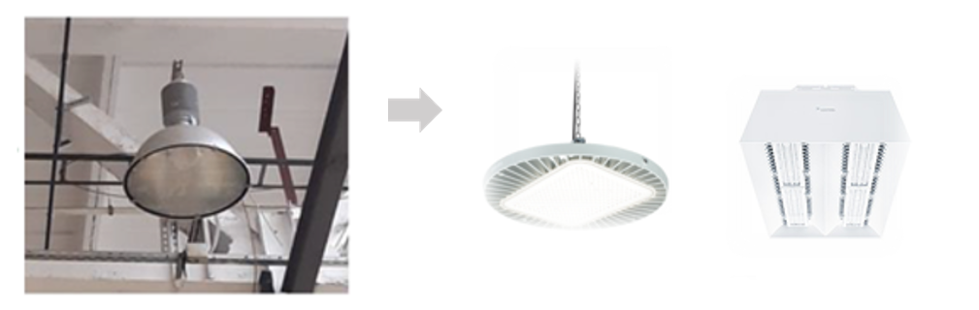
Fig. 9. Transition from the old type of lighting on the left to the modern type of LED lamps on the right

4. Solutions to Reduce Water and Chemicals Consumption
The basic part of the casting machine is a die-casting mould made of durable steel. A separating agent must be applied before each cycle to prevent dirt and cast metal from adhering to the inner parts of the mould. This is usually a water-based product. With this treatment method, it is difficult to determine the correct ratio of water to the amount of separator used so that, on the one hand, the melt does not stick to the inner part of the mould, and, on the other hand, water does not remain in the mould cavity, which subsequently causes higher porosity of castings. Furthermore, the disadvantage of using a conventional separating agent is the high consumption of industrial water.
4.1. Reducing the consumption of water used for cooling
In connection with the technology of conventional mould treatment, there is also a problem with the stability and contamination of those substances in mixing equipment, e.g., when bacteria are commonly formed in water. Due to the increasing quality requirements for die castings, there is now an effort to replace this most common but ecologically less suitable method of mould face treatment by new methods. These innovative methods include micro spraying, which uses only a hundred percent cutting (separating) agent concentrate. Applying the new treatment method leads to an increase in the quality of castings, shortens the casting cycle of the machine, and reduces the ecological burden. This micro-lubrication technology has never been applied to engine block castings before, while an engine block is one of the most complex castings when this method is used.
The technology enables zero industrial water consumption and a reduction of up to a quarter of the separator consumption, which has important environmental benefits, especially regarding reduced wastewater production. This innovative technology also positively reduces the casting cycle time and, therefore, saves energy per cast piece. However, micro-lubrication technology is generally more complex, mainly due to the need for an optimal setting for mould tempering channels. It is, therefore, necessary to cool these circuits much more intensively. Adjusting the technological parameters of the entire process is also more exigent. The technology is more suitable for casting thin-walled castings and can achieve certain advantages compared to conventional mould treatment. These advantages are: reduction of casting cycle time, the extension of the casting machine lifetime, reduction of piston speed during filling by 15-30%, an increase of the foundry productivity by 20-30%, reduction of air consumption by 50-80%, energy saving of the mould – the mould is not heated, only cooled, reduction in the number of mismatched parts and increase of the quality of castings, reduction of the internal porosity and improvement of the surface quality of castings. The real savings are as follows: from the original 6 l of water with 100 ml of release agent per cycle in conventional mould treatment, it is now possible to use only 25 ml of release agent with no additional water added per casting cycle.
The production of castings on die-casting machines located at casting workplaces generally results in high water consumption. The water consumption is particularly high when the moulds are being cooled, which is an important part of the technological process, enabling a higher production speed while maintaining the required quality. The aim is rapid but uniform cooling, allowing shorter production cycles. For these reasons, we use innovative tempering devices that precisely adjust and regulate water flow and temperature in individual channels. At the same time, a continuous intensive or pulsed, i.e., intermittent cooling mode can be set for specific circuits. All flow and temperature parameters are currently downloaded from the machines and stored in a data lake. Thus, it is possible to work with the data for quality control purposes or optimize the casting process.
4.2. Reducing chemical consumption by optimizing demineralised water
Demineralised water containing chemical additives such as corrosion inhibitors, NaOH, dispersants, and salts is used to cool the moulds. After removing the mould, each casting is transferred to a cooling bath. It is necessary to monitor water consumption daily to identify possible leaks and losses in the system to achieve low industrial water consumption. The PowerBI reports are used for this purpose. This allows certain trends to be monitored and faults and losses in the system to be identified in time and corrected quickly. For water analysis and the precise dosing of chemical products for the cooling water, the 3D Trasar online device is used. This device continuously takes water samples, analyses them, and then operates 3 automatic pumps, which, according to the results, dose the necessary chemical products (Fig. 10).
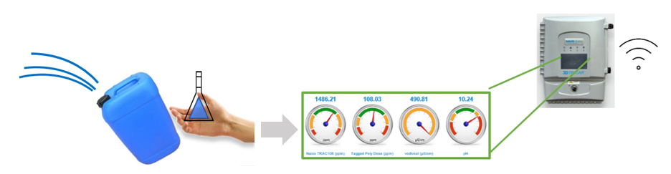
Fig. 10. Transition from manual water sampling and manual laboratory analysis to the use of the 3D Trasar online equipment for precise analysis and dosing of chemical products to be used in the cooling water
5. Conclusion
In the automotive industry, in general, there is an increasing emphasis on higher efficiency and lower environmental impact. This applies to vehicles, where the aim is to achieve maximum driving efficiency with minimum emissions, and to their production, where the aim is to make maximum use of recyclable materials and work with efficient energy sources with minimum environmental impact. Similar requirements are set for heavy plants with high energy consumption of various types, such as foundries, where the technology and nature of the production process make it less straightforward to concretize these visions. This is because these are specialized plants handling high-temperature molten metal, which is not only energy-intensive but also problematic from a safety and environmental point of view. However, given the wide range of energies used, saving energy is also possible. To implement an effective innovation, it is first necessary to correctly identify the potential and evaluate its benefits. It is also necessary to assess the financial aspect, i.e., the acquisition costs and any downtime in implementing the innovation.
The present article shows individual solutions that bring plants closer to the desired targets regarding energy consumption savings and the associated CO₂ production. However, they represent only individual steps toward a more sustainable and environmentally friendly production of components. Nowadays an important driver of innovation in manufacturing is the digitisation of data and the possibilities for data evaluation and visualisation. This makes it possible to monitor the entire production process and its individual sub-components more frequently and accurately, thus minimising losses at all levels.
The Škoda Auto foundry clearly recommends using 100% micro-spraying of moulds to increase the quality of manufactured products. Daily monitoring and elimination or at least daily reduction of all potential leakages of all process substances are recommended to reduce the overall consumption of water and all process substances. This has a substantial environmental aspect and does not necessarily require an increased initial investment.

This paper was made with partial support from internal grant agency project IGA/2024/01
Application of innovative trends in the automotive sector.
References
Bajdur, W., Zielińska, A., Gronba-Chyła, A. (2023). Product Life Cycle Assessment (LCA) as a Tool for Environmental Management. Rocznik Ochrona Środowiska, 25(1), 389-398.
Chamier-Gliszczynski, N., Krzyzynski, T. (2005). On modelling three-stage system of receipt and automotive recycling. REWAS'04, Global Symposium on Recycling, Waste Treatment and Clean Technology 2005, 2813-2814, Madrid, Spain, 26-29 September 2004, Conference Paper, ISBN: 8495520060.
Chamier-Gliszczyński, N. (2012). Modeling system mobility in urban areas. Congress Proceedings, CLC 2012: Carpathian Logistics Congress, 501-508, 111467.
Espuny, M., Costa, A.C.F., Reis, J.S.M., Barbosa, L.C.F.M, Snatos, R.C.G., Oliveira, O.J. (2022). Identification of the Elements and Systematisation of the Pillars of Solid Waste Management. Quality Innovation Prosperity, 26(2), 147-169.
Gabrylewicz, I., Lenort, R., Wędrychowski, M., Krupa, P., Woźniak, W. (2021). Environmental Loads Resulting from Manufacturing Technology. Rocznik Ochrona Srodowiska, 23, 613-628. https://doi.org/0.54740/ros.2021.043
Ghadge, A., Mogale, D.G., Bourlakis, M., Maiyar, L.M., Moradlou, H. (2022). Link between Industry 4.0 and green supply chain management: Evidence from the automotive industry. Computers & Industrial Engineering, 169(1), 1-14.
Ignatowicz, K., Piekarski, J., Kogut, P. (2021). Influence of selected substrate dosage on the process of biogas installation start‐up in real conditions. Energies, 14(18), 5948. https://doi.org/10.3390/en14185948
Jenek, M., Ociepa, M., Woźniak, W., Vilmová, Š., Švecová, E. (2022). Rocznik Ochrona Srodowiska, 24, 360-370. https://doi.org/10.54740/ros.2022.025
Kostrzewski, M., Chamier-Gliszczynski, N., Królikowski, T. (2020). Selected reflections on formal modeling in Industry 4.0. Procedia Computer Science, 176, 3293-3300. https://doi.org/10.1016/j.procs.2020.09.118
Kuczynski, W., Kaminski, K., Znaczko, P., Chamier-Gliszczynski, N., Piatkowski, P. (2021). Features and Thermal Efficiency of Flat-Plate Solar Collectors. Energies, 14(2), 261. https://doi.org/10.3390/en14020261
Lenort, R., Baran, J., Wysokinski, M., Golasa, P., Bienkowska-Golasa, W., Golonko, M., Chamier-Gliszczynski, N. (2019). Economic and Environmental Efficiency of the Chemical Industry in Europe in 2010-2016. Rocznik Ochrona Srodowiska, 21(2), 1393-1404.
Menti, F., Romero, D., Jacobsen, P. (2023). A technology assessment and implementation model for evaluating socio-cultural and technical factors for the successful deployment of Logistics 4.0 technologies. Technological Forecasting and Social Change, 190(1), 1-17.
Mir, M., Llach, J., Casadesus, M. (2022). Degree of Standardization and Innovation Capability Dimensions as Driving Forces for Innovation Performance. Quality Innovation Prosperity, 26(2), 1-20.
Nawrocki, W., Stryjski, R., Woźniak, W., Jakubowski, J. (2018). Improving the quality of manufacturing processes in Toyota motor manufacturing, Poland. Proceedings of the 31st International Business Information Management Association Conference, IBIMA 2018: Innovation Management and Education Excellence through Vision 2020, 143853, 5931-5945.
Obzina T., Merta V., Folta M., Bradáč J., Beňo J., Novohradsaká N., Gawronová M., Kroupová I., Lichý P., Radkovský F., Janovská K., Vasková I., Drobíková K., Nguyenová I. Technological and Quality Aspects of the Use of Innovative Inorganic Binders in the Production of Castings. Metals, 11(11), 1-13.
Orłowska, M. (2022). Saving Energy – a Smart, Ecological and Necessary Trend. Rocznik Ochrona Środowiska, 24(1), 472-480.
Saetta, S., Caldarelli, V. (2020). Lean production as a tool for green production: the green foundry case study. Procedia Manufacturing, 42(1), 498-502.
Samtleben, S., Schleich, CH., Chenk, M. (2021). Identifying energy flexible manufacturing layouts in a light metal foundry. Procedia CIRP, 104(1), 1589-1594.
Sąsiadek, M., Niedziela, M., Woźniak, W., Jachowicz, T., Mikušová, N. (2023). A New Effective Algorithm for Mechanical Assembly Sequence Planning. Advances in Science and Technology Research Journal, 17(5), 56-67. https://doi.org/10.12913/22998624/171271
Sharma, M., Luthra, S., Joshi, S., Kumar, A., Akshat, J. (2023). Green logistics driven circular practices adoption in industry 4.0 Era: A moderating effect of institution pressure and supply chain flexibility. Journal of Cleaner Production, 383(1), 1-12.
Scharf, S., Sander, B., Kujath, M., Richter, H., Riedel, E, Stein, N., Felde, J.T. (2022). Sustainability potentials of an innovative technology and plant system in non-ferrous foundries. Procedia CIRP, 105(1), 758-763.
Scharf, S., Sander, B., Kujath, M., Richter, H., Riedel, E., Stein, N., Felde, J.T. (2021). Foundry 4.0: An innovative technology for sustainable and flexible process design in foundries. Procedia CIRP, 98(1), 73-78.
Staniuk, W., Staniuk, M., Chamier-Gliszczynski, N., Jacyna, M., Klodawski, M. (2022). Decision-Making under the Risk, Uncertainty and COVID-19 Pandemic Conditions Applying the PL9A Method of Logistics Planning-Case Study. Energies, 15(2), 639. https://doi.org/10.3390/en15020639
Sumasto, M., Arliananda, AImansuri, F., Aisyah, S., Purwojatmiko, B.H., (2023). Enhancing Automotive Part Quality in SMEs through DMAIC Implementation: A Case Study in Indonesian Automotive Manufacturing. Quality Innovation Prosperity, 27(3), 57-74.
Szajna, A., Kostrzewski, M., Ciebiera, K., Stryjski, R., Woźniak W. (2021). Application of the deep CNN-based method in industrial system for wire marking identification. Energies, 14(12), 3659. https://doi.org/10.3390/en14123659
Ťavodová, M., Vargová, M., Stančeková, D., Hajdúch, A., Mrázik, J. (2022). Evaluation of the Influence of Process Parameters on the Mechanical Properties of Castings during High Pressure Die Casting. Manufacturing Technology, 22(6), 764-770.

