|  |  |  |  |
| --- | --- | --- | --- |
|  |  | | |
| **Rocznik Ochrona Środowiska** | | |
| Volume 26 | Year 2024 ISSN 2720-7501 | pp. 510-524 |
|  | https://doi.org/10.54740/ros.2024.047 open access | | |
|  | Received: September 2024 Accepted: October 2024 Published: November 2024 | | |

Environmental Conservation by Using Recycled Aggregates: Enhancing Sustainability   
in Road Construction

Parveen Berwal1*, Nakul Gupta2, Ravi Kumar3, El-Sayed M. Sherif4, Ashish Kumar5

1Department of Civil Engineering, Galgotias College of Engineering & Technology, Greater Noida, India  
https://orcid.org/0000-0003-2422-3391

2NICMAR Institute of Construction Management and Research, NICMAR, Delhi-NCR, Bahadurgarh, India   
https://orcid.org/0000-0001-9525-8482

3Department of Civil Engineering, GLA University, Mathura, India  
https://orcid.org/0000-0001-6047-9840

4Mechanical Engineering Department, College of Engineering, King Saud University, Riyadh, Saudi Arabia   
https://orcid.org/0000-0003-2080-8552

5Division of Research and Development, Lovely Professional University, Phagwara, India  
https://orcid.org/0000-0002-5351-8685

**\***corresponding author's e-mail: parveenberwal@gmail.com

**Abstract:** Every day, construction and demolition waste is generated worldwide. As the road business and traffic grow, construction materials have evolved to include more unorthodox features. Road construction and maintenance rely significantly on quarried aggregates, resulting in high resource extraction demands. There is a trend toward employing secondary (recycled) materials rather than primary (virgin) ones to address this. This transformation requires the use of a variety of secondary and tertiary components, including waste byproducts. Numerous studies have been conducted to study and analyze the suitability and practical application of recycled materials in the field. Some recycled materials have better qualities than others, proving satisfactory performance in real-world circumstances. However, concerns about their incorporation persist, based on laboratory research and field observations. These concerns emphasize the necessity for more in-depth research to address potential difficulties. It is claimed that using recycled and tertiary materials in road construction can greatly help to save natural resources. This study predicts the attributes of selected materials, such as gradation, water absorption, maximum dry density, impact value, flakiness, and elongation, to establish their appropriateness for the production of Granular Sub-base (GSB) and Wet Mix Macadam (WMM).

**Keywords:** traffic, recycled aggregate, fresh aggregate, demolition waste, construction waste

1. Introduction

Road infrastructure is critical to economic growth because it allows people and goods to travel freely, connects industry, and promotes trade. It also acts as a critical last-mile link to other types of transportation, including railways and airlines. A strong and well-connected road network is critical to a country's prosperity. Road building requires various materials, the principal components of which are multiple grades of aggregates and binding materials (Acosta Alvarez et al. 2019, Afshar et al. 2017, Al-Bayati et al. 2018). Aggregates make up a significant percentage of the pavement structure and serve the primary purpose of transferring wheel loads to the subgrade. In this load transmission process, aggregates must withstand stresses caused by wheel loads on the pavement and surface course and resist wear from traffic's abrasive effects. As a result, highway engineers place a high value on aggregate qualities, which are classified according to size, shape, texture, and gradation (Arabani & Azarhoosh 2012, Arabani et al. 2013, Balaguera et al. 2018, Bassani & Tefa 2018).

Various pavement mixes, such as bituminous macadam, thick bituminous macadam, semi-dense bituminous macadam, and bituminous concrete, require different gradations, as stated by organizations such as A.S.T.M, B.S.I, I.S.I, and IRC. Despite the importance of aggregates, recycling methods, particularly the use of recovered aggregates, are uncommon in India and other developing countries (Galan et al. 2019).

Given the increasing need for aggregates due to fast infrastructure development, there is an urgent need to investigate alternatives to reduce dependency on fresh aggregates (Gedik 2020, Giri et al. 2021). The current study focuses on recycling aggregates acquired from destroyed roadways as a sustainable replacement material in road construction.

This study encourages the use of recycled aggregates, which minimizes dependency on natural resources and reduces construction scrap and carbon emissions. This study is being used to improve the performance of recycled aggregates so that they fulfill the sustainability and strength criteria necessary for road construction. Furthermore, this study might offer a broader view of the environmental and economic benefits of using recycled materials in road construction. This study adds significant value to civil and sustainability engineering techniques in infrastructure construction by combining the use of sustainable materials, environmental impact assessment, and practical application methodologies.

2. Importance of Research Topic

The current study analyzed the appropriateness of using recycled materials in road construction. This study intends to improve road development cost-effectiveness while mitigating environmental degradation by minimizing mining activities and pollutants.

The building and maintaining roads and highways require significant amounts of aggregate, with millions of tonnes being used. Recognizing the scarcity of fresh aggregate, the current study investigates the feasibility of substituting a portion of fresh aggregate with recycled aggregate. Road building is a financially challenging activity in which material costs account for more than 60% of total construction expenses, with the aggregate cost component accounting for about 30% (Boora et al. 2023, Gómez-Soberón 2002, Gopalam et al. 2020). Financial savings can be realized throughout the project by using recycled aggregate instead of fresh aggregate in road building.

To fully realize the benefits of recycled aggregates, assessing their applicability in various pavement components is critical. The purpose of this study is to assess the economic benefits of using recycled aggregate in Granular Sub Base (GSB) and Wet Mix Macadam (WMM) road construction projects (Garg et al. 2023, Gul & Guler 2014, Habibi et al. 2021).

3. Recycling as an Option

The shortage of aggregates in the infrastructure sector, as predicted in the ninth five-year plan, makes meeting road development targets difficult, particularly given the demand for millions of coarse aggregates as sub-base material (Hou et al. 2014, Ismail & Ramli 2013). Recycling aggregates can be an effective alternative to bridge the demand-supply gap.

Recognizing the critical significance of recycled building materials and technology in urban infrastructure development, the Technology Information Forecasting and Assessment Council (TIFAC) launched a techno-market survey on "Utilization of Waste from the Construction Industry. This survey sought to assess existing knowledge in the Indian construction industry about the possible recycling of construction and demolition (C&D) wastes, with a particular emphasis on the housing/building sector and road construction (Berwal et al. 2022, Jayasuriya et al. 2021, Jin et al. 2017).

The study results revealed a significant impediment to implementing waste recycling methods in the construction industry: a lack of knowledge about recycling techniques. A significant 70% of respondents stated this as the top reason for not recycling, while another 30% acknowledged being completely unaware of recycling options (Congress 2001, Khanna & Justo 2010, Rao & Deulkar 2019).

4. Poor Acceptability of Recycled Material

Adopting recycled materials confronts challenges in India due to a negative view of recycling efforts. Current customer criteria prevent the use of waste-recycled products. The costs associated with disposing of building waste in landfills directly influence recycling operations (Mhlongo et al. 2014). The cheap costs involved with dumping in India also impede recycling efforts. Introducing taxes for sanitary landfill use may encourage builders and property owners to shift garbage into recycling activities (Giri et al. 2020, McGarrah 2007, Mills-Beale & You 2010).

5. Absence of Appropriate Technology

There are few commercially feasible technologies for recycling construction and demolition waste. The hot recycling technology for bituminous material is almost non-existent in India, stressing the importance of research and development in this area (Mahendra et al. 2018). Based on the research findings, it is advised that the hot in-situ approach be investigated for practicality. Alternatively, the financial viability of foreign equipment developed for the hot in-situ process could be investigated. Educational and scientific institutions are critical to promoting these initiatives. Once the suitable technology has been established, the difficulty of obtaining a sufficient supply of high-quality feedstock becomes critical (Li et al. 2009, Puskás et al. 2014). Figure 1 depicts a schematic illustration of the circulation of construction materials, from their raw state to final usage and disposal.

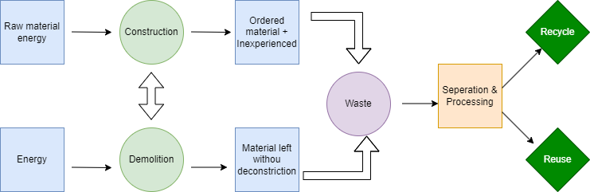

**Fig. 1.** Circulation of construction materials from raw state to end-use and disposal

6. Objective of the Study

The study intends to meet its goals by getting recycled material from S.H-7 (Shahabad-Ladwa) and new aggregate from the Yamunanagar quarry. A series of tests are conducted to determine the material's fitness for road construction following the Indian Roads Congress (IRC) criteria. The study's primary purpose is to assess the suitability of recycled material for use in road construction projects. The primary aims of the study include:

1. Obtaining the appropriate study materials.
2. Investigating the selected materials' qualities, such as gradation, water absorption, maximum dry density, impact value, flakiness, and elongation, to establish their appropriateness for Granular Sub Base (GSB) and Wet Mix Macadam (WMM) construction.
3. Create a Job Mix Formula for Granular Sub Base (GSB).

7. Historical Background

The usage of recycled materials in construction dates back many years. (Wilmot & Vorobieff 1997) stated that recycled aggregates have been a vital part of Australia's road business for the past century. Over the last five years, there has been substantial improvement in the use of recycled materials in the construction and rehabilitation of municipal roadways. C&D's recycling industry data repository indicated that stones from earlier roads were recycled to restore their famous road network even in ancient periods, such as Rome. Europe's recycling sector has been well-established since the end of World War II.

(Hanson 1986) emphasized the global research effort on recycled aggregates, primarily focused on evaluating their strength attributes and determining their viability as a replacement for fresh materials in road construction. According to (Tavakoli et al. 2018), recycled aggregate can have equivalent compressive strength to fresh material. (Limbachiya et al. 2000) discovered that the recovered aggregate had lower relative density and water absorption than the fresh aggregate. (Sagoe-Crentsil et al. 2002) contended that the differences between fresh recycled aggregate and natural aggregate characteristics were rather minor when compared to laboratory-crushed recycled aggregate mixtures.

(Mistri et al. 2020) found that using more recycled aggregate resulted in a modest increase in compressive strength. However, they concluded that recycled aggregate's qualities and attributes remain inferior to new aggregate. Tavakoli (1996) discovered several parameters that influence the loss of compressive strength in the recycled aggregate, including inorganic contaminants, the coarse-to-fine aggregate ratio, and the aggregate top size. Several approaches have been developed to improve the strength of recycled aggregate. According to the results, the recycled material had construction and durability comparable to fresh aggregate. The work done by Bassam A. Tayeh et al. (2020) shows that reusing recycled aggregate (RA) to create HPC can add to the decrease in waste delivered every year. In addition, reuse would help to decrease worldwide CO2 emissions. Using RA as fine and coarse aggregates with high replacement ratios is possible. Ebenezer O. Fanijo et al. (2023) proposed regarding sustainability gain, RCA pavement is more environmentally and socially friendly than NA pavement; such sustainability benefits are especially significant for reducing health hazards, waste generation, and the pressure on landfill sites. Transport distance played an essential role in the sustainability of RCA materials over NA. Overlong delivery distances of secondary RCA materials could be detrimental due to increased fuel consumption and gas emissions. For natural depletion and waste generation reduction, replacing NA with RCA is a technical strategy to improve the sustainability of pavement construction.

8. Comparison of Recycled Aggregate and Fresh Aggregate

(1) Texture. Regarding texture, the recovered aggregate has elongated particles stuck to the bitumen, as opposed to the fresh aggregate's smooth, angular, and compact form, as seen in Figure 2. The angular and elongated particles and the bitumen component require less water to produce usable aggregate than the smoother, more rounded compact aggregate (Chen et al. 2011). The presence of angular aggregate tends to increase void content, while bigger sizes of well-graded aggregate help to reduce void content.

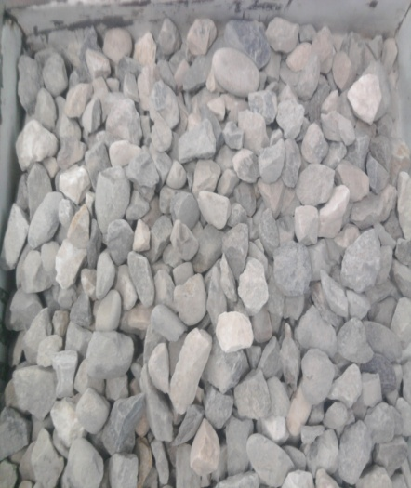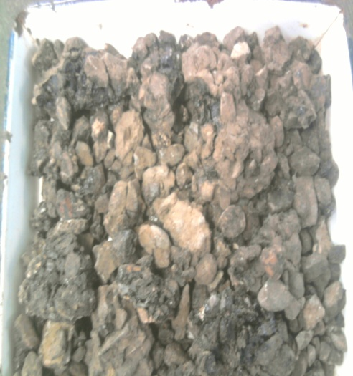

**Fig. 2.** Fresh aggregate and Recycled aggregate

(2) Quality. The quality of recycled aggregate and new material is not the same. The physical and chemical properties of the source sites dictate the quality of fresh aggregate, whereas contamination from waste sources influences the quality of recovered aggregate (Bester et al. 2017, El Haggar 2010, Yang et al. 2017). The declaration also underlines how natural resources provide diverse products with a larger market reach. In contrast, recycled material has a limited product mix, which may limit its market potential.

(3) Location. Fresh aggregate comes from a wide range of rock sources, and fresh aggregate processing plants are resource-dependent, typically located at mining sites outside of city limits. On the other hand, recycled aggregates are made from waste generated by buildings and roads, and the recycling process is typically carried out in cities.

8.1. Flow diagram

9. Test Conducted

A series of tests as per IRC guidelines is carried out to assess the marital suitability for road construction. The various tests conducted are the elongation test, specific gravity test, impact test, CBR test, water absorption test, procter test, bitumen extraction test, and permeability test. The test is shown in Figure 3 a-h.

## C:\Users\ponu\Documents\Photo0177.jpgC:\Users\ponu\Documents\Photo0184.jpgC:\Users\ponu\Documents\Photo0165.jpgC:\Users\ponu\Documents\Photo0167.jpg

**Fig. 3.** a) Elongation b) Specific gravity c) Impact d) CBR

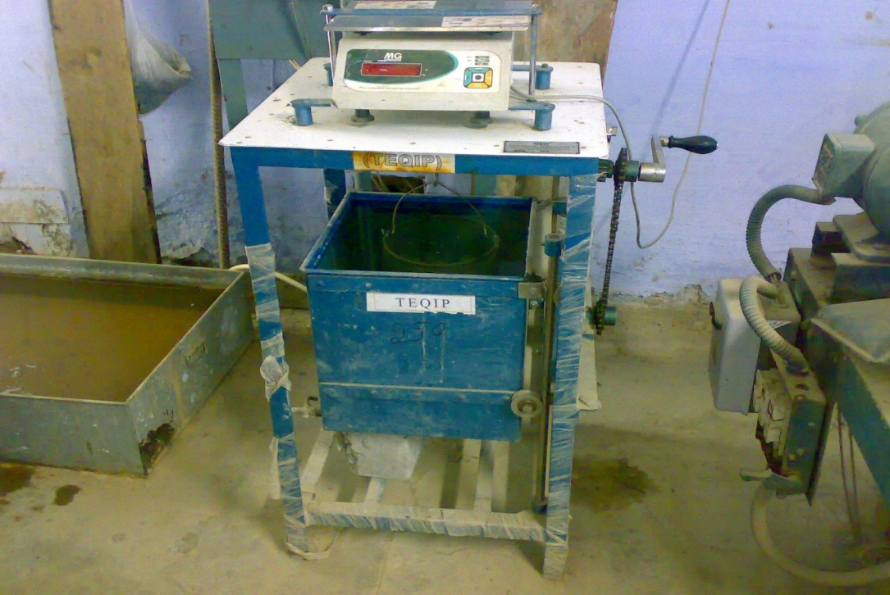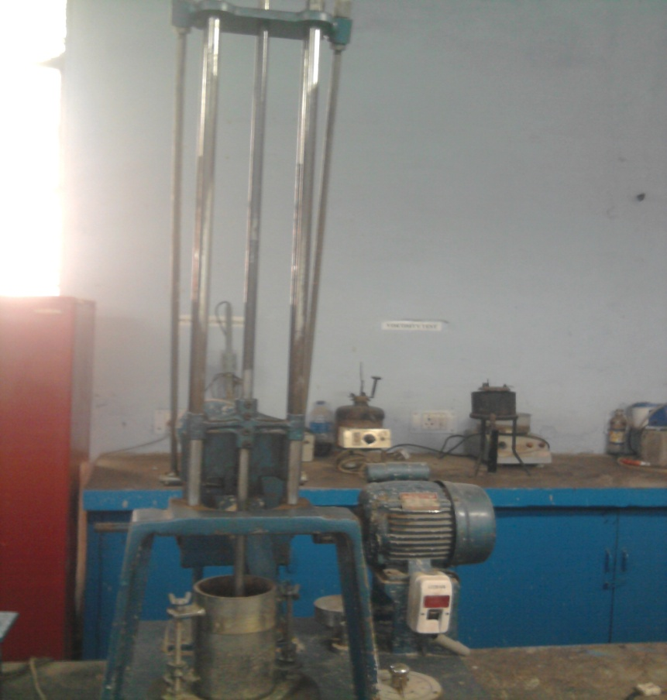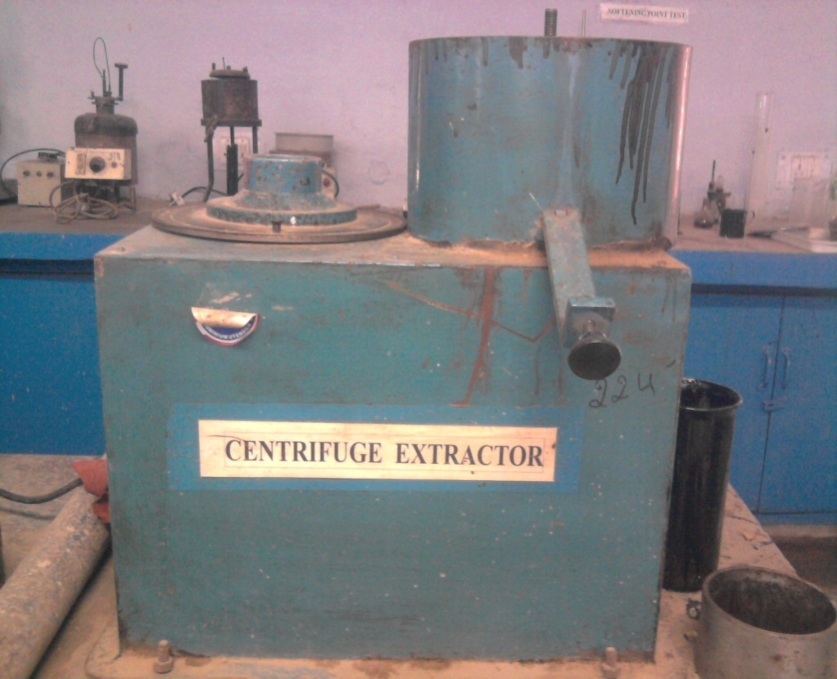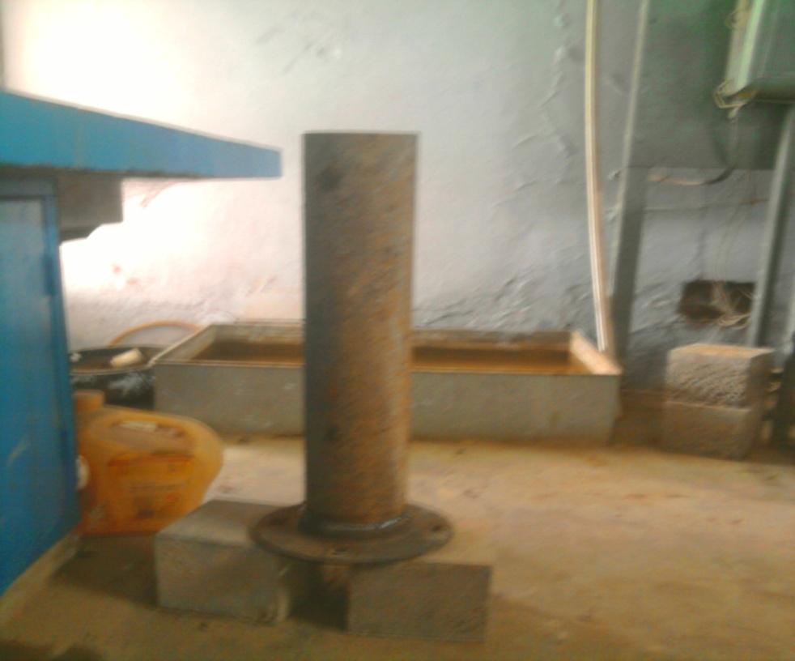

**Fig. 3.** e) Water absorption f) Procter test g) Bitumen extraction h) Permeability test

10. Results and Discussion

A series of tests are performed in the laboratory to assess the various qualities of the material chosen for this investigation. All tests adhere to IRC rules, IS codes, and MORTH recommendations. The acquired values are compared to the MORTH requirements.

Aggregate impact test

The overall impact value is expressed as a percentage of fine particles generated relative to the total weight of the sample. If we label the original weight of the oven-dried sample as (A) grams and the weight of the fraction that passes through the 2.36 mm IS sieve as (B) grams. Aggregate impact value = (B/A)·100. The fresh and recycled aggregate results are shown in Table 1 and expressed in graphical form in Figure 4.

**Table 1.** Result of aggregate impact value test on fresh and recycled aggregate

|  |  |  |
| --- | --- | --- |
| Type of Material | Fresh aggregate | Recycled aggregate |
| Weight of collar | 1259.5 kg | 1259.5 kg |
| Weight of material | 328 g | 345 g |
| Weight of material passing through the IS 2.36 mm sieve | 48.60 g | 42.30 g |
| Impact value | 14.81% | 12.26% |

**Fig. 4.** Aggregate impact value on fresh and recycled aggregate

Water absorption test

This test helps to determine the water absorption value of coarse aggregates as per IS: 2386 (Part III) – 1963. Water absorption = [(A - B)/B] · 100%. The fresh and recycled aggregate results are shown in Table 2 and expressed in graphical form in Figure 5.

**Table 2.** Result of water absorption test of fresh and recycled aggregate

|  |  |  |
| --- | --- | --- |
| Type of Material | Fresh aggregate | Recycled aggregate |
| Weight of sample (before immersed in water) | 2 kg | 2 kg |
| Weight of sample (after immersed in water) | 0.710 kg | 1.203 kg |
| Weight of sample (after drying "A") | 2.055 kg | 2.085 kg |
| Weight of sample (after oven "B") | 1.996 kg | 1.988 kg |
| Water absorption amount | 0.475% | 1% |

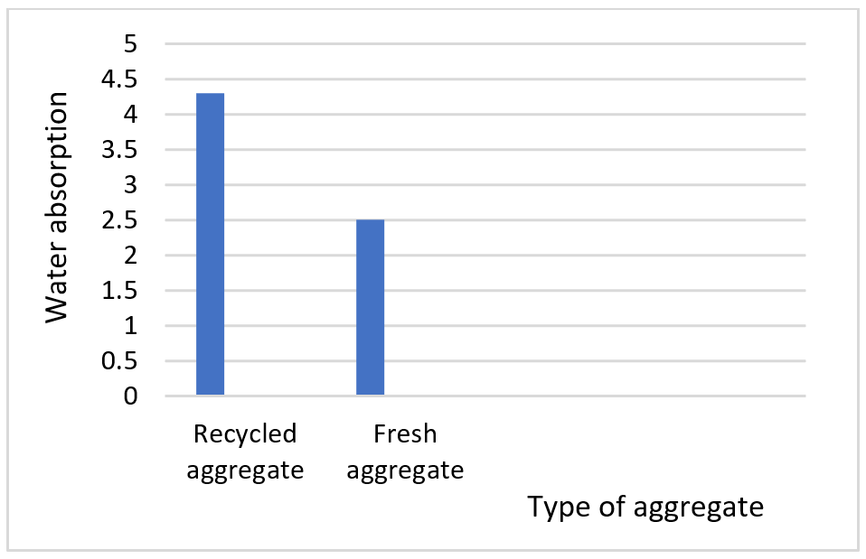

**Fig. 5.** Water absorption test of recycled and fresh aggregate

Bitumen extraction test

This test, conducted following ASTM 2172, is designed to assess bitumen content. Begin by getting a 1000 g sample, then start the centrifugal extractor, allowing it to rotate slowly before progressively increasing the speed until the solvent stops flowing through the outlet. Introduce the sample (marked as weight 'A') into the centrifugal extractor and fill it with 200 cc of benzene. The results for the recycled aggregate are shown in Table 3. Bitumen content = [(A - B)/B] · 100%.

****Result****

**Table 3. Result of bitumen content test in recycled aggregate**

|  |  |
| --- | --- |
| Weight of sample (before test) | 1000 g |
| Weight of sample (after test) | 990 g |
| Bitumen content | (10/1000) 100 = 1% |

Specific gravity test

The specific gravity of fine and coarse aggregate is determined following IS: 2386 (Part 3), using a pycnometer bottle and a wire basket with a buoyancy balance. The results for the fresh and recycled aggregate for the specific gravity are shown in Table 4.

**Table 4.** The specific gravity of different grades of aggregate

|  |  |
| --- | --- |
| Type of Material | Value for Specific Gravity |
| Recycled aggregate (20 mm) | 2.53 |
| Fresh aggregate (20 mm ) | 2.72 |
| Fresh aggregate (40 mm) | 2.62 |
| Fresh aggregate (10 mm) | 2.65 |
| Stone dust | 2.60 |

Elongation index test

The flaking and elongation indices are determined during the form test for coarse aggregates. The elongation index is calculated using the following formula: Elongation index = (weight of the aggregate with the maximum dimension larger than 1.8 times the average dimension of the sample / total weight) × 100. This computation is performed using a length gauge. The test uses fresh and recycled aggregates with a particle size of 20 mm. Elongation index = 15% for fresh aggregate and 12.5% for recycled aggregate

10.1. Job mix formula

10.1.1. Mix design of GSB

Mix design of GSB with diverse categories of resources is organized by analytical techniques and accessible in Tables 5 and 6. The result is also shown in graphical form in Figure 6 and Figure 7.

**Table 5.** Mix design of GSB with recycled aggregate

|  |  |  |  |  |  |
| --- | --- | --- | --- | --- | --- |
| Sieve size (mm) | Percent by weight passing the sieve | | | | |
| Aggregate designation | | MORTH specified grading (table 400.2, grading 3) | | Observed grading of Granular mix (proportion 33:67: A:B) |
| 20 mm A | Stone dust B | Range | Mean |
| 26.5 | 100.0 | 100.0 | 100 | 100.0 | 100.0 |
| 4.75 | 8.7 | 99.2 | 25-45 | 35.0 | 33.4 |
| 0.075 | 0.2 | 7.6 | < 10 | 5.0 | 2.6 |

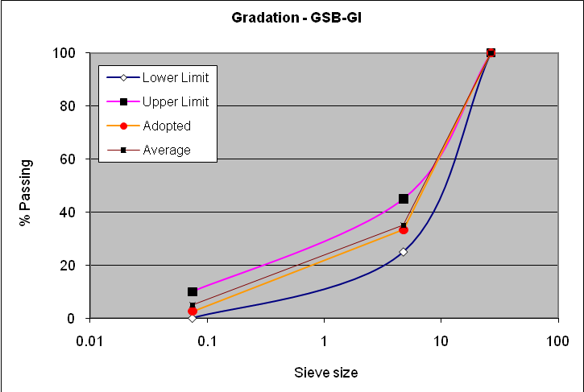

**Fig. 6.** Grading of mix with recycled aggregate

**Table 6.** Mix design of GSB with fresh aggregate

|  |  |  |  |  |  |
| --- | --- | --- | --- | --- | --- |
| Sieve size (mm) | Percent by weight passing the sieve | | | | |
| Aggregate designation | | MORTH specified grading (table 400.2, grading 3) | | Observed grading of Granular mix (proportion 35:65: A:B) |
| 20 mm A | Stone dust B | Range | Mean |
| 26.5 | 100.0 | 100.0 | 100 | 100.0 | 100.0 |
| 4.75 | 0.0 | 99.2 | 25-45 | 35.0 | 34.7 |
| 0.075 | 0.0 | 7.6 | < 10 | 5.0 | 2.7 |

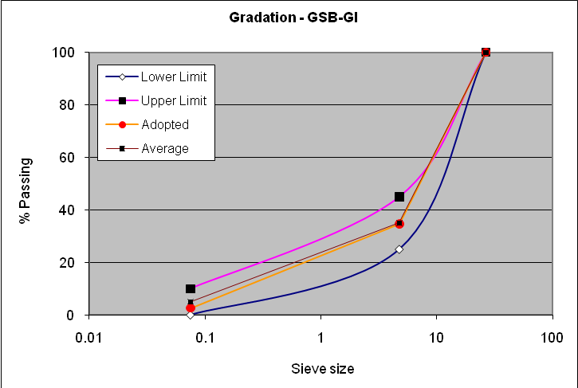

**Fig. 7.** Grading of mix with fresh aggregate

10.1.2. Maximum dry density and optimum moisture content of GSB mix

Standard Procter compaction test determines the optimum moisture content and maximum dry density as per IS: 2720(part-8)-1987(6) for different materials. The fresh and recycled aggregate results for MDD and OMC are shown in Figures 8 and 9.

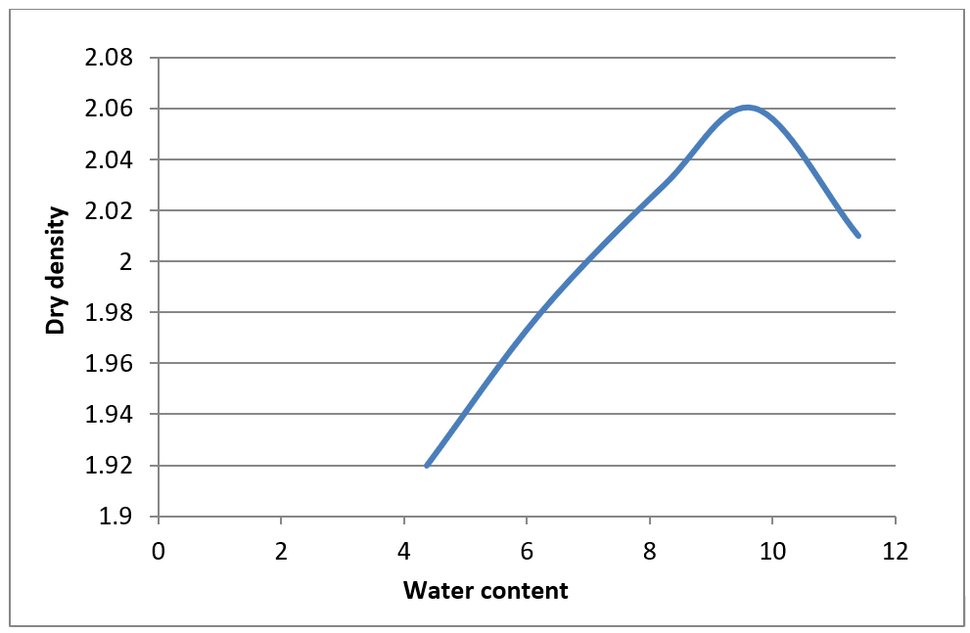

**Fig. 8.** MDD and OMC for GSB (fresh aggregate)

**Fig. 9.** MDD and OMC for GSB (recycled aggregate)

10.1.3. California bearing ratio (CBR)

The CBR test is performed on the GSB mix using the maximum dry density determined by the Proctor compaction test. This indicates the material's resistance to penetration by a conventional seal at controlled density and humidity levels. The CBR value is heavily impacted by the state of the material being tested. The test can be performed on recast specimens using static or dynamic procedures, according to the guidelines given in IS: 2720 (part-16)-1987(10). Results of the CBR test on GSB using fresh and recycled aggregate are presented in Table 7 and in graphical form in Figure 10 and Figure 11.

**Table 7.** Standard loads for CBR test

|  |  |
| --- | --- |
| Penetration depth | Standard load |
| 2.5 mm | 1370 kg |
| 5.0 mm | 2055 kg |

**Fig. 10.** CBR curve for GSB for fresh aggregate

**Fig. 11.** CBR curve for GSB for recycled aggregate

Similar to the above curve, obtaining a curve with an initial rising concavity is possible, suggesting the need for rectification. In such circumstances, the rectified origin is obtained by drawing a tangent from the curve's steepest point. The strain values for penetration values of 2.5 mm and 5.0 mm from the rectified origin are then recorded.

10.1.4. The permeability test

The amount of water collected in the graduated vessel during the constant head permeability test is small and difficult to precisely quantify for lower permeability materials. In such circumstances, the variable head patency test is applied. The permeability coefficient is calculated at 27°C using IS: 2720 (Part 17). The result for the permeability is shown in Table 8. The WMM layer comprises aggregates held together by stone ash and water. Road pavements are exposed to rainfall and surface water; thus, it is critical to keep excess water from collecting within the layer. Adequate permeability helps water to drain effectively, lowering the risk of floods, which can damage pavement over time. If the permeability of the WMM layer is too low, water will remain trapped within the road layer, resulting in frost formation in cold places or excessive pressure in rainy situations. This can result in structural flaws like fractures and surface deformations.

**Table 8.** GSB (with fresh and recycled aggregate)

|  |  |  |  |
| --- | --- | --- | --- |
| Fresh aggregate | | Recycled aggregate | |
| Depth of flow | Reading (in minute) | Depth of flow | Reading (in minute) |
| 1st 5 cm | 24 minute | 1st 5 cm | 31 minute |
| 2nd 5cm | 15 minute | 2nd 5 cm | 21 minute |

10.2. Job mix formula for Wet Mix Macadam (WMM)

10.2.1. Mix design of WMM

Mix design of WMM with different types of selected materials is prepared using analytical method. The result for the job mix formula for WMM is shown in Table 9 and Table 10 and shown in graphical form in Figures 12 and 13.

**Table 9.** Mix design of WMM with recycled aggregate

|  |  |  |  |  |  |  |  |
| --- | --- | --- | --- | --- | --- | --- | --- |
| Sieve size (mm) | Percent by weight passing the sieve | | | | | | |
| Aggregate designation | | | | MORTH specified grading (table 400.2, grading 3) | | Observed grading of Granular mix (proportion 16:29:15:40:  A:B:C:D) |
| 40 mm | 20 mm | 10 mm | Stone dust | Range | Mean |
| 53.00 | 100.0 | 100.0 | 100.0 | 100.0 | 100 | 100.0 | 100.0 |
| 45.00 | 90.3 | 100.0 | 100.0 | 100.0 | 95-100 | 97.5 | 96.2 |
| 22.40 | 46.2 | 100.0 | 100.0 | 100.0 | 60-80 | 70.0 | 74.6 |
| 11.20 | 0.0 | 24.7 | 87.5 | 100.0 | 40-60 | 50.0 | 46.0 |
| 4.75 | 0.0 | 2.2 | 4.0 | 99.5 | 25-40 | 32.5 | 28.9 |
| 2.36 | 0.0 | 0.6 | 0.2 | 95.0 | 15-30 | 22.5 | 26.7 |
| 600.0 micron | 0.0 | 0.3 | 0.0 | 60.2 | 8-22 | 15.0 | 16.9 |
| 75.00 micron | 0.0 | 0.2 | 0.0 | 12.7 | 0-8 | 4.0 | 3.6 |

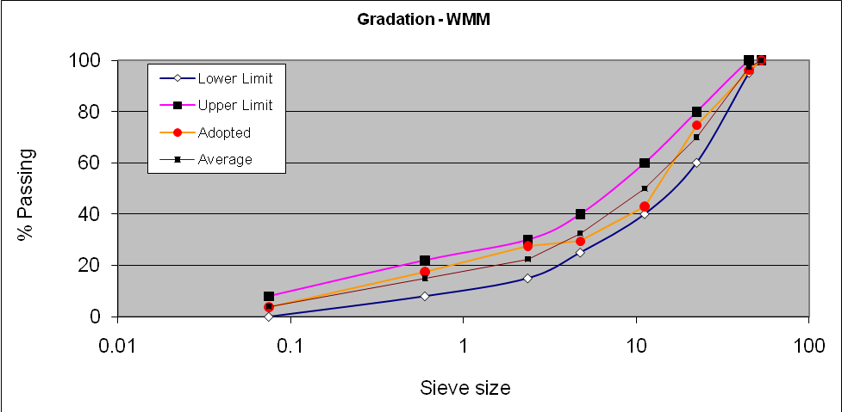

**Fig. 12.** Grade mix with recycled aggregate

**Table 10.** Mix design of WMM with fresh aggregate

|  |  |  |  |  |  |  |  |
| --- | --- | --- | --- | --- | --- | --- | --- |
| Sieve size (mm) | Percent by weight passing the sieve | | | | | | |
| Aggregate designation | | | | MORTH specified grading (table 400.2, grading 3) | | Observed grading of Granular mix (proportion 15:28:17:40:  A:B:C:D) |
| 40 mm | 20 mm | 10 mm | Stone dust | Range | Mean |
| 53.00 | 100.0 | 100.0 | 100.0 | 100.0 | 100 | 100.0 | 100.0 |
| 45.00 | 90.3 | 100.0 | 100.0 | 100.0 | 95-100 | 97.5 | 96.2 |
| 22.40 | 46.2 | 100.0 | 100.0 | 100.0 | 60-80 | 70.0 | 74.6 |
| 11.20 | 0.0 | 5.0 | 87.5 | 100.0 | 40-60 | 50.0 | 43.0 |
| 4.75 | 0.0 | 0.1 | 4.0 | 99.5 | 25-40 | 32.5 | 29.5 |
| 2.36 | 0.0 | 0.0 | 0.2 | 95.0 | 15-30 | 22.5 | 27.6 |
| 600.0 micron | 0.0 | 0.0 | 0.0 | 60.2 | 8-22 | 15.0 | 17.5 |
| 75.00 micron | 0.0 | 0.07 | 0.0 | 12.7 | 0-8 | 4.0 | 3.0 |

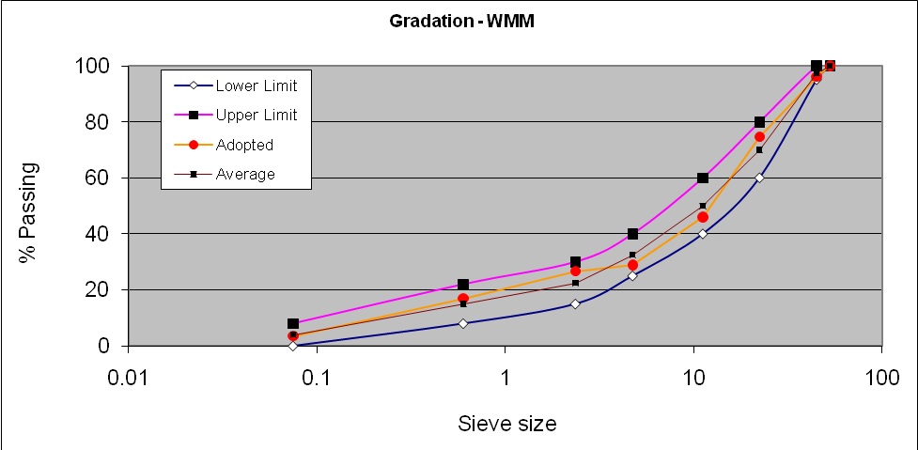

**Fig. 13.** Grade mix with fresh aggregate

10.2.2. Procter test

The MDD for WMM using the selected materials is 2.07 gm/cc for recycled aggregate and 2.09 gm/cc for new aggregate. The result for the procter test is shown in Figure 14 and Figure 15.

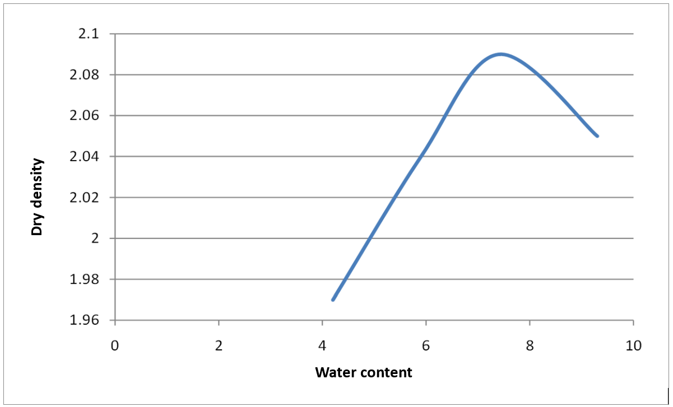

**Fig. 14.** MDD and OMC for WMM (fresh aggregate)

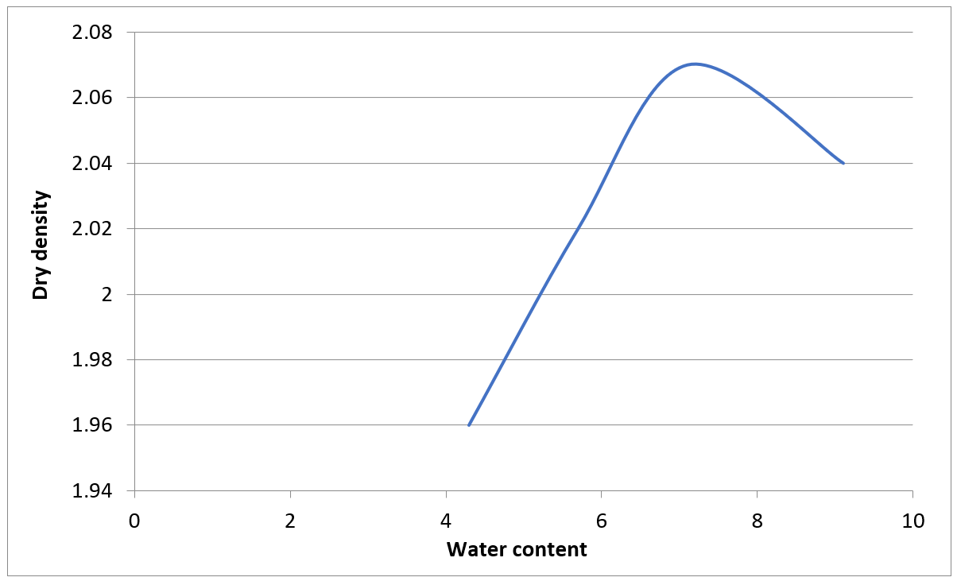

**Fig. 15.** MDD and OMC for WMM (recycled aggregate)

10.2.3. Permeability test

The permeability results show that in the case of WBM and WMM, the recycled aggregate has higher permeability than the fresh aggregate. The result of the permeability test is shown in Table 11.

**Table 11.** WMM (with fresh and recycled aggregate)

|  |  |  |  |
| --- | --- | --- | --- |
| Fresh aggregate | | Recycled aggregate | |
| Depth of flow | Reading (in minute) | Depth of flow | Reading (in minute) |
| 1st 5 cm | 6 minute | 1st 5 cm | 7 minute |
| 2nd 5 cm | 3 minute | 2nd 5 cm | 3 minute |

11. Conclusions

The study titled "Reuse of Road Material in Construction" sought to assess the viability of recycled material in road building using MORTH criteria. The key findings are as follows:

1. Test results for GSB made from recycled aggregates and stone dust meet MORTH categorization requirements. GSB's maximum dry density (MDD) is 2.06 g/cc with fresh aggregate and 2.04 g/cc with recycled aggregate. The CBR value for GSB with specified materials varies from 35% to 46%.
2. WMM granule combinations meet the MORTH grading standards. The MDD for WMM using the selected materials is 2.07 gm/cc for recycled aggregate and 2.09 gm/cc for new aggregate.
3. Using recycled aggregates in GSB and WMM for road construction increases profitability and minimizes mining pollution.
4. GSB and WMM have maximum dry densities of 2.04 g/cc and 2.07 g/cc, respectively, making them appropriate for subgrade construction.
5. The specific gravity of recycled aggregate, fresh aggregate, and stone dust ranges from 2.50 to 2.72.
6. The impact value test shows that recycled aggregate strength is comparable to fresh aggregate, with impact values of 14.81% and 12.26%, respectively.
7. The recycled aggregate has a higher water absorption capacity (1.0%) than the fresh aggregate (0.48%).
8. Bitumen content in recycled aggregate is 1%.
9. Recycling aggregate from demolition operations can help reduce expenses for transporting debris to landfills and disposal.
10. The permeability results show that in the case of WBM and WMM, the recycled aggregate has higher permeability than the fresh aggregate.

Both fresh and recycled aggregates were tested for obligatory features such as aggregate impact value and water absorption, which are required for road building. These qualities are within the allowed limits for both recycled and new aggregates. Using 20 mm recycled aggregate passes the grading standards for GSB and WMM. GSB mixes, including fresh and recycled aggregate, meet CBR requirements and the basic criteria for using recycled material in GSB and WMM mixes.

**Acknowledgement**  
Researchers Supporting Project number (RSP2024R33), King Saud University, Riyadh, Saudi Arabia

References

Acosta Alvarez, D., Alonso Aenlle, A., Tenza-Abril, A. J., Ivorra, S. (2019). Influence of partial coarse fraction substitution of natural aggregate by recycled concrete aggregate in hot asphalt mixtures. *Sustainability*, *12*(1), 250.

Afshar, T., Disfani, M. M., Arulrajah, A., Narsilio, G. A., Emam, S. (2017). Impact of particle shape on breakage of recycled construction and demolition aggregates. *Powder technology*, *308*, 1-12.

Al-Bayati, H. K. A., Tighe, S. L., Achebe, J. (2018). Influence of recycled concrete aggregate on volumetric properties of hot mix asphalt. *Resources, Conservation and Recycling*, *130*, 200-214.

Arabani, M., Azarhoosh, A. (2012). The effect of recycled concrete aggregate and steel slag on the dynamic properties of asphalt mixtures. *Construction and Building Materials*, *35*, 1-7.

Arabani, M., Moghadas Nejad, F., Azarhoosh, A. (2013). Laboratory evaluation of recycled waste concrete into asphalt mixtures. *International Journal of Pavement Engineering*, *14*(6), 531-539.

Balaguera, A., Carvajal, G. I., Albertí, J., Fullana-i-Palmer, P. (2018). Life cycle assessment of road construction alternative materials: A literature review. *Resources, Conservation and Recycling*, *132*, 37-48.

Bassam, A., Tayeh, Doha, M., Al, Saffar, Rayed, Alyousef. (2020). The Utilization of Recycled Aggregate in High Performance Concrete: A Review. *Journal of Materials Research and Technology, 9*(4), 8469-8481, https://doi.org/10.1016/j.jmrt.2020.05.126

Bassani, M., Tefa, L. (2018). Compaction and freeze-thaw degradation assessment of recycled aggregates from unseparated construction and demolition waste. *Construction and Building Materials*, *160*, 180-195.

Berwal, P., Goel, R., Garg, R., Kumar, A. (2022). Comparative Study of Micro-Silica-Based Concrete Using IS and DOE Methods. In *Recent Advances in Structural Engineering and Construction Management: Select Proceedings of ICSMC 2021* (pp. 821-829). Springer.

Bester, J., Kruger, D., Miller, B. (2017). South African construction and demolition waste procedure and its sourced material effects on concrete. MATEC Web of conferences,

Boora, A., Rani, K., Suthar, M., Rana, R., Berwal, P., Al Asmari, A. F. S., Amir khan, M., Islam, S. (2023). Slag and bagasse ash: potential binders for sustainable rigid pavement. *ACS omega*, *8*(36), 32867-32876.

Chen, M.-z., Lin, J.-t., Wu, S.-p., Liu, C.-h. (2011). Utilization of recycled brick powder as alternative filler in asphalt mixture. *Construction and Building Materials*, *25*(4), 1532-1536.

Congress, I.R. (2001). Guidelines for the design of flexible pavements. *Indian code of practice, IRC*, *37*.

El Haggar, S. (2010). *Sustainable industrial design and waste management: cradle-to-cradle for sustainable development*. Academic Press.

Ebenezer, O., Fanijo, John, Temitope, Kolawole, Adewumi, John, Babafemi, Jian, Liu. (2023). A comprehensive review on the use of recycled concrete aggregate for pavement construction: Properties, performance, and sustainability. *Cleaner Materials, 9*, 100199, https://doi.org/10.1016/j.clema.2023.100199

Galan, J.J., Silva, L.M., Pérez, I., Pasandín, A.R. (2019). Mechanical behavior of hot-mix asphalt made with recycled concrete aggregates from construction and demolition waste: A design of experiments approach. *Sustainability*, *11*(13), 3730.

Garg, R., Garg, R., Eddy, N.O., Khan, M.A., Khan, A.H., Alomayri, T., Berwal, P. (2023). Mechanical strength and durability analysis of mortars prepared with fly ash and nano-metakaolin. *Case Studies in Construction Materials*, *18*, e01796.

Gedik, A. (2020). A review on the evaluation of the potential utilization of construction and demolition waste in hot mix asphalt pavements. *Resources, Conservation and Recycling*, *161*, 104956.

Giri, J.P., Panda, M., Sahoo, U.C. (2020). Use of waste polyethylene for modification of bituminous paving mixes containing recycled concrete aggregates. *Road Materials and Pavement Design*, *21*(2), 289-309.

Giri, J.P., Panda, M., Sahoo, U.C. (2021). Development and evaluation of some bituminous mixes containing RCA. *Journal of Testing and Evaluation*, *49*(4), 2579-2596.

Gómez-Soberón, J.M. (2002). Porosity of recycled concrete with substitution of recycled concrete aggregate: An experimental study. *Cement and concrete research*, *32*(8), 1301-1311.

Gopalam, J., Giri, J.P., Panda, M. (2020). Effect of filler on bituminous base layer containing recycled concrete aggregates. *International Journal of Transportation Science and Technology*, *9*(3), 239-248.

Gul, W.A., Guler, M. (2014). Rutting susceptibility of asphalt concrete with recycled concrete aggregate using revised Marshall procedure. *Construction and Building Materials*, *55*, 341-349.

Habibi, A., Ramezanianpour, A.M., Mahdikhani, M., Bamshad, O. (2021). RSM-based evaluation of mechanical and durability properties of recycled aggregate concrete containing GGBFS and silica fume. *Construction and Building Materials*, *270*, 121431.

Hanson, T. (1986). *Assertionsträning ger självförtroende och handlingskraft*. Larson.

Hou, Y., Ji, X., Su, X., Zhang, W., Liu, L. (2014). Laboratory investigations of activated recycled concrete aggregate for asphalt treated base. *Construction and Building Materials*, *65*, 535-542.

Ismail, S., Ramli, M. (2013). Engineering properties of treated recycled concrete aggregate (RCA) for structural applications. *Construction and Building Materials*, *44*, 464-476.

Jayasuriya, A., Shibata, E.S., Chen, T., Adams, M.P. (2021). Development and statistical database analysis of hardened concrete properties made with recycled concrete aggregates. *Resources, Conservation and Recycling*, *164*, 105121.

Jin, R., Li, B., Zhou, T., Wanatowski, D., Piroozfar, P. (2017). An empirical study of perceptions towards construction and demolition waste recycling and reuse in China. *Resources, Conservation and Recycling*, *126*, 86-98.

Khanna, S., Justo, C. (2010). Highway Engineering', Nem Chand and Bros. publishers, Roorkee (UP) Lindsay R. *Peat (1982), Practical Guide to DBMS selection', Walter de Grawyter, New York*.

Li, J., Xiao, H., Zhou, Y. (2009). Influence of coating recycled aggregate surface with pozzolanic powder on properties of recycled aggregate concrete. *Construction and Building Materials*, *23*(3), 1287-1291.

Limbachiya, M., Leelawat, T., Dhir, R. (2000). Use of recycled concrete aggregate in high-strength concrete. *Materials and structures*, *33*, 574-580.

Mahendra, S., Puneeth, H., Rohith, M. (2018). Characterization of construction and demolition waste aggregates for rigid pavement construction. *Indian Highways*, *46*(7).

McGarrah, E.J. (2007). *Evaluation of current practices of reclaimed asphalt pavement/virgin aggregate as base course material*.

Mhlongo, S., Abiola, O., Ndambuki, J., Kupolati, W. (2014). Use of recycled asphalt materials for sustainable construction and rehabilitation of roads. Proceedings of the International Conference on Biological, Civil and Environmental Engineering (BCEE-2014), Dubai, United Arab Emirates,

Mills-Beale, J., You, Z. (2010). The mechanical properties of asphalt mixtures with recycled concrete aggregates. *Construction and Building Materials*, *24*(3), 230-235.

Mistri, A., Bhattacharyya, S.K., Dhami, N., Mukherjee, A., Barai, S.V. (2020). A review on different treatment methods for enhancing the properties of recycled aggregates for sustainable construction materials. *Construction and Building Materials*, *233*, 117894.

Puskás, A., Corbu, O., Szilágyi, H., Moga, L. (2014). Construction waste disposal practices: The recycling and recovery of waste. *WIT Transactions on Ecology and the Environment*, *191*, 1313-1321.

Rao, P. A., Deulkar, V. (2019). Utilization of Reclaimed Asphalt Pavement and Ceramic Waste in Pavement Construction.

Sagoe-Crentsil, K., Brown, T., Taylor, A. (2002). Durability and performance characteristics of recycled aggregate concrete. 9th International Conference on Durability of Materials and Components, Brisbane, Australia,

Tavakoli, D., Hashempour, M., Heidari, A. (2018). Use of waste materials in concrete: A review. *Pertanika J. Sci. Technol*, *26*(2), 499-522.

Wilmot, T., Vorobieff, G. (1997). Is road recycling a good community policy. Ninth National Local Government Engineering Conference,

Yang, H., Xia, J., Thompson, J.R., Flower, R.J. (2017). Urban construction and demolition waste and landfill failure in Shenzhen, China. *Waste management*, *63*, 393-396.