|  |  |  |  |
| --- | --- | --- | --- |
|  |  | | |
| **Rocznik Ochrona Środowiska** | | |
| Volume 26 | Year 2024 ISSN 2720-7501 | pp. 335-355 |
|  | https://doi.org/10.54740/ros.2024.033 open access | | |
|  | Received: December 2023 Accepted: August 2024 Published: August 2024 | | |

Investigating the Effect of Changes of the Roughness Coefficient on the Results of Model Calculations in One-dimensional Hydraulic Models

Aleksandra Czajkowska

Faculty of Mining, Safety Engineering and Industrial Automation,   
Silesian University of Technology, Gliwice, Poland  
https://orcid.org/0000-0002-5732-8563

corresponding author`s e-mail: aleksandra.czajkowska@polsl.pl

**Abstract:** One of the key elements in describing the flow of floodwaters is to determine the resistance created by friction acting along the surface wetted by water and created by objects directly washed by water. Flow resistance (roughness) influences flow velocity, water level, and, consequently, the river's capacity (Aberle 2020). This paper analyses the effect of the manner of defining roughness coefficients in one-dimensional models on the stability of these models and the results of model calculations. Three methods of defining the transverse variation of roughness coefficient in cross sections were used in the model calculations: Distributed, High/Low Flow Zones and Uniform. The greatest model stability, the highest flow rate values and the lowest water table ordinates were obtained when Distributed was selected. This has a major impact on determining the extent of flood hazard zones.

**Keywords:** roughness coefficient, one-dimensional modelling, MIKE 11, discharge, water level

**1. Introduction**

The flow of water in open channels occurs due to the force of gravity setting the water in motion, which is balanced by frictional forces. Natural river channels are characterised by varying bed and slope structure and, thus, by varying surface roughness. Flow resistance (roughness) varies along the river's course and within its cross-section, i.e., along the length of the wetted perimeter. In river channels, flow resistance is affected by numerous and diverse factors. The major ones include the roughness of the channel material, the degree of irregularity of the cross-section, the variability of the cross-section along the length of the river, obstacles present in the channel, vegetation and the spatial configuration of the channel (meandering).



The number of publications on flow resistance in open channels demonstrates the importance of this topic, as the issue of properly defining roughness affects many calculation procedures in various contexts (Dawson & Fisher 2003, Morvan et al. 2008, Simmons & Richardson 1963, Yen 1991, Yen 2002).

Researchers who studied flow resistance issues related to the occurrence of various bedforms and riverbed sediment transport included Aberle & Smart (2003), Carling et al. (1992), Hey (1988), Knighton (1998), Parker & Peterson (1980). Arcement & Schneider (1989), Horn & Richards (2007), Philips & Tadayon (2007) also covered the influence of vegetation in their discussion of factors that determine the resistance to motion in river channels. On the other hand, Goździk (2006) and Strupczewski (1989) considered the cross-section's dimensions and shape to be one of the more significant factors influencing flow resistance.

A fundamental issue in many scientific studies or practical applications in the field of environmental hydraulics is the adoption of a specific way of describing the roughness of a given channel.

Previous experience and research on flow resistance in river channels have shown that the most effective way of understanding and assessing these phenomena is through field surveys, which portray the actual state of the river channel (Bezzola et al. 2004, Słowik-Opoka & Brożek 2015, Smart et al. 2002, Żelazo 1992). Accurate determination of the roughness of natural watercourse channels is not always straightforward due to its random nature, i.e. the spatial variability of river channels. Field observations and measurements are usually expensive and often difficult to carry out. In the case of transient motion, where hydraulic parameters such as discharge, depth and average velocity change over time, roughness studies are difficult to carry out, but their results are nonetheless important, especially when considering flow resistance in rivers during floods (Morvan et al. 2008).

As an alternative to the costly and time-consuming field surveys, tabulated values of roughness coefficients quoted in textbooks resulting from many years of experimentation and reflection by the authors are used (Chow 1959, French 1986, Streeter & Wylie 1979) and empirical formulas.

The most common coefficient used to quantify roughness is the Manning coefficient *n* (1).

$n=\frac{1}{v}∙I^{\frac{1}{2}}∙R^{\frac{2}{3}} \left[m^{- \frac{1}{3}}s\right]$ (1)

where:

v – mean flow velocity of water in the channel (m/s),

I – hydraulic gradient (-),

R – hydraulic radius (m).

The roughness coefficient, according to Manning, depends on the shape and material of the channel. A comprehensive assessment of roughness under complex flow conditions based on the Manning coefficient was proposed by (Cowan 1956). In the method he developed, the roughness coefficient that characterises the total resistance in a river channel is presented as the sum of partial coefficients, which include the roughness coefficient of the channel material and corrections due to the degree of irregularity of the banks and bed, changes in the size and shape of cross-sections along the length of the river, the intensity of vegetation, the degree of obstruction in the bed, the presence of obstacles in the bed and the degree of river meandering (2).

n = no + (n1 + n2 + n3 + n4) · n5 (2)

where:

n0 – roughness coefficient of the channel material,

n1-n4 – corrections to the n0 values resulting from the complex nature of the cross-section and the topography of the channel and vegetation,

n5 – degree of river meandering.

The formula proposed by Cowan (1956) allows a comprehensive estimation of Manning's n-values for natural channels based on a description of their various features. Arcement & Schneider (1989) documented and extended this formula to flood plains.

Manning's coefficient of roughness *n* is often used as a parameter for model calibration. This means it is manually adjusted so that the simulated water levels and flow rates are equal to the measured values (Aberle 2020). The success of this approach (trial and error method) depends on the experience of the model builder and his/her expertise in the area being modelled. However, it is noteworthy that the way calibration is carried out depends on the application domain of the numerical model. For a model used for flood forecasting, a calibration method based on comparing simulated values with measured records of flood occurrences is not the most appropriate (Vidal et al. 2007).

The values from Manning's formula are related to other commonly used roughness coefficients, such as *C* by Cheza or Strickler's *kst* resistance coefficient (Kubrak & Nachlik 2003). A comparison of the Manning, Cheza and Strickler formulas shows that:

$C=\frac{1}{n}∙R^{\frac{1}{6}}$ (3)

and

$k_{st}=\frac{1}{n}$ (4)

Regardless of the resistance factor applied, it should always be borne in mind that the resistance values are usually strongly dependent on the depth and, therefore, on the flow rate (Dawson & Fisher 2003, Knight et al. 1989, Simmons & Richardson 1963, Wallis & Knight 1984).

In one-dimensional models for flood forecasting, determining the roughness in each defined cross-section of the watercourse and specifying how the values of this parameter will be distributed along the length of the cross-section are key elements of the simulation calculations.

The purpose of this study was to determine the effect of how roughness coefficients are defined in one-dimensional models on their stability and the results of model calculations. DHI's MIKE 11 software package has several options for defining flow resistance (MIKE 11… 2017). When 'Uniform' is selected, a single flow resistance value will be assigned for the entire cross-section. The 'High/Low flow zones' option allows different roughness values to be adopted in the riverbed and on the right and left flood plains, while the 'Distributed' option allows different values to be adopted for each set of x and z data in the table of points forming the cross-section. The flow resistance can be characterised by different coefficients, depending on the calculation method adopted, e.g. Manning coefficient *n* [m-1/3/s], Chezy coefficient *C* [m1/2/s] or Darcy-Weisbach coefficient (*k*). The Manning roughness coefficient *n* or its inverse, the *M* number, is most commonly used to characterise flow resistance in open channels.

**2. Area of Research**

Modelling studies were carried out on rivers belonging to the Upper Odra Water Region in Poland. Under Polish law, a water region is a part of a river basin district defined based on hydrographic criteria for the purpose of water resources management (Act of 20 July 2017…). The Upper Odra Water Region, with an area of 3,830 km2, is located in the south-eastern part of the Opolskie Voivodeship (11.5% of the area of the voivodeship) and the south-western part of the Silesian Voivodeship (22.3% of the area of the voivodeship) (Figure 1). According to Kondracki's physico-geographical division (Kondracki 2009), the Upper Odra Water Region comprises the following macro-regions: Eastern Sudetes and the Silesian Lowlands to the west, the Silesian Uplands to the east, and the Ostrava Basin, the West Beskid Foothills and the Western Beskids to the south.

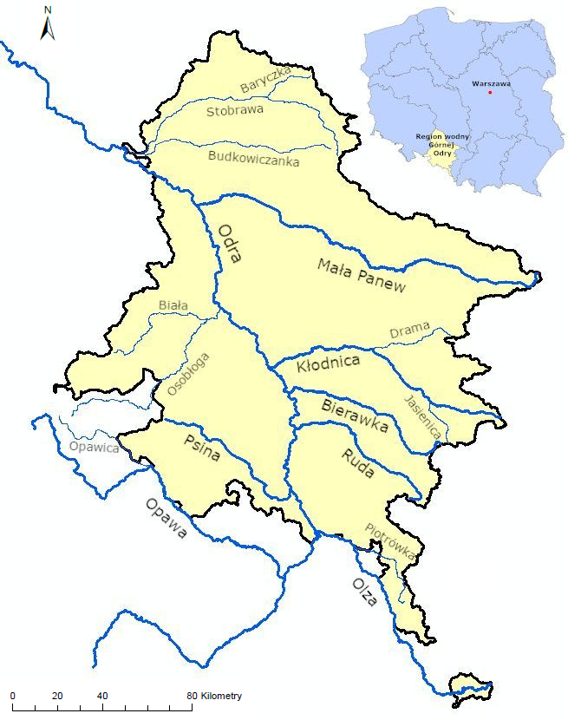

river courses

boundary of The Upper Odra Water Region



**Fig. 1.** The Upper Odra Water Region

The main watercourse in the Upper Odra Water Region is the section of the Odra River starting from the point where the Odra enters Poland north of the village of Chałupki, up to the town of Koźle together with the catchment area of the Kłodnica River. This section is 67 km long, and the overall length of the hydrographic network of the upper Odra catchment area is approximately 2,125 km. The major right-bank tributaries include Olza (22.9 km), Ruda (53.3 km), Bierawka (57.6 km) and Kłodnica (80 km). The most significant left-hand tributary is Psina (52.6 km) (Hobot 2010). In accordance with the division into water bodies, 91 surface water bodies (SWBs) were identified in the Upper Odra Water Region, which were then aggregated into 13 integrated water bodies (ISWBs).

More than 59% of the area of the water region in question is agricultural land. Forests cover almost 940 square kilometres, representing 24.5 per cent of the area of the Upper Odra Water Region. A large area of approximately 575 km2 (15% of the water region's area) is affected by anthropogenic changes. The highest industry concentration is in the Upper Silesian Industrial District (GOP), dominated by the mining, smelting, transportation, power generation, machine-building and chemical industries. In the southwest, the GOP is adjacent to the Rybnik Coal District, where hard coal mining and processing prevail. The remaining land, approximately 1.5%, comprises water bodies (Hobot 2010).

In the Upper Odra Water Region, areas with impaired natural water retention include built-up and urbanised areas, among them cities: Katowice, Zabrze, Ruda Śląska, Gliwice, Rybnik, Żory, Wodzisław Śląski, Racibórz, Kędzierzyn-Koźle and Jastrzębie-Zdrój, where the majority of the ground surface is covered with asphalt or concrete. In these areas, rainwater infiltration is impeded, increasing surface runoff. The increase in surface retention is also the effect of mining activities, primarily coal mining, the impact of which is manifested over a large area of the water region in question, including the Upper Silesian Coal Basin (GZW). The GZW is the only area in the country where human impact has led to such a significant transformation of the natural environment, including the underground hydrosphere (Szczepański & Różkowski 2007). Under the influence of mining activities, including the dewatering of existing workings and the flooding of decommissioned mining areas, changes in the groundwater table are observed. The effects of mine drainage are complex. The lowering of the groundwater table leads to soil drying, while subsidence of the land surface as a result of mining activities leads to the creation of drainless flood plains, deformation of watercourse channels, the formation of counter falls that interfere with gravitational water runoff conditions and increase waterlogging and flood hazard.

**3. Materials and Methods**

Research on the roughness coefficient was carried out using one-dimensional hydraulic models of selected rivers of the Upper Odra Water Region, i.e., Baryczka, Biała, Budkowiczanka, Drama, Jasienica, Opawica, Piotrówka (Fig. 1) (Hydraulic models … 2021). The models were developed according to the "Methodology for the development of flood hazard maps and flood risk maps for the 2nd planning cycle", as part of the task "Preparation of new flood hazard maps for rivers or river sections indicated in the Preliminary Flood Risk Assessment (WORP) (Methodology… 2020) for the 2nd planning cycle". Hydraulic modelling was carried out using DHI's MIKE software (MIKE 11… 2017). The one-dimensional (1D) models were based on the full one-dimensional Saint-Venant equations – the mass conservation and energy conservation equations. The solution of Saint-Venant's mathematical equations follows an implicit finite difference scheme developed by Abbott and Ionescu (Popescu 2012). Calculations were performed under the assumption of transient motion.

Building the models started with the schematisation of the river network. The rivers were inserted into the models using previously prepared vector layers. Watercourses were vectorised after verifying their course with the Hydrographic Partition Map of Poland on a scale of 1:10,000. The modelled river sections were assigned a mileage, adopting the topological node with the recipient as kilometre 0+000.

Based on the landform analysis, flood plains were delineated as distinct flood flow paths. Their route was determined based on a numerical terrain model. In particular, sections where the flood flow is clearly separated by flood embankments or dikes and sections where the floodplain flow path should be shortened compared to the channel flow path (highly meandering sections) were considered. For separated flood plains, link channels were defined.

The models were based on cross-sections of the watercourses measured geodetically in the channel part and in the valley part, which were determined based on a digital terrain model (DTM). To represent the valley correctly, the models were supplemented with additional cross-sections, interpolated in the channel part and the valley part generated from the DTM, similarly to the basic cross-sections. Additional cross-sections were created using the MIKE procedure and in a GIS environment. The cross-sections were split into the channel zone and the left and right floodplain zones. These zones were delineated using the so-called markers, which, when assigned to a particular point in the cross-section, marked the boundary of a particular zone. The model used the following markers: 4, 5 – channel edge markers 1, 3 – markers marking the end of the flood plain and 2 – lowest point of the cross-section. An example cross-section is shown in Fig. 2. All cross-sections were analysed for hydraulic capacity. In numerous cases, significant local depressions on flood plains that distorted the cross-sectional capacity and retention of the river valley were removed.

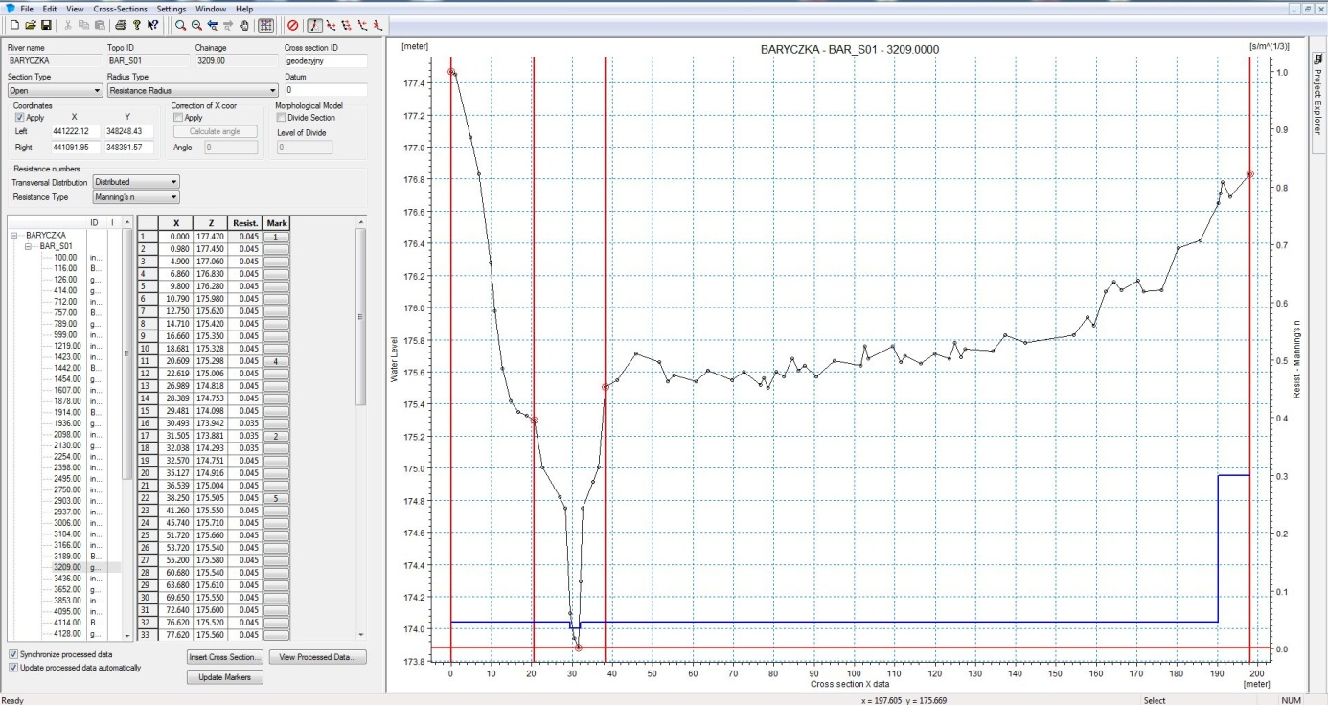

|  |
| --- |
| localization of markers  values of the coefficient of roughness along the cross-section |

**Fig. 2.** Example of a cross-section

Objects significantly affecting flood flow conditions were incorporated into the model. A method was used to map bridges by using two related hydraulic elements to describe the flow of water over the bridge and inside its structure (across its span). In MIKE 11, the 'structures – culverts/weirs' module is in the NWK11 river network file. An example of a bridge implementation in the form of a culvert and weir combination is shown in Figures 3 and 4.

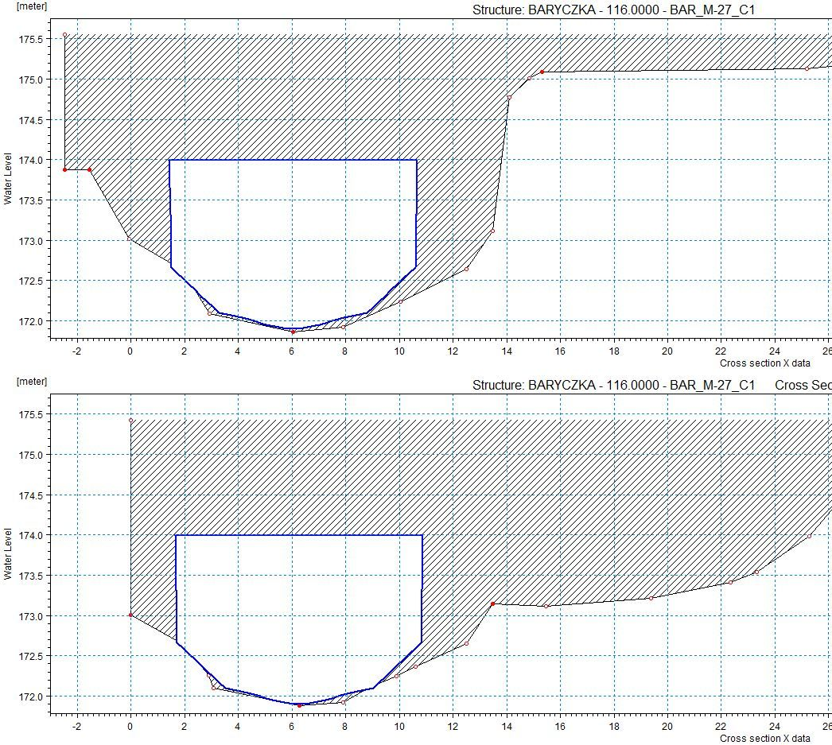

**Fig. 3.** Hydro structure – part representing the flow under the bridge (culvert)

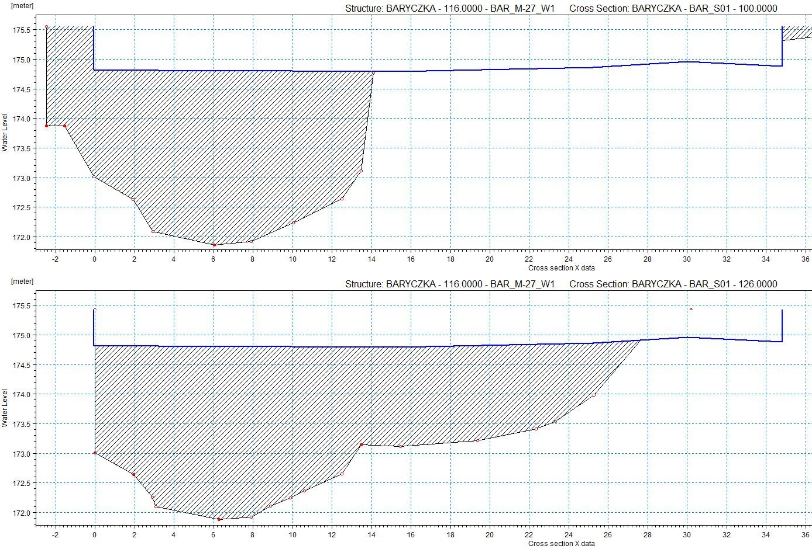

**Fig. 4.** Hydro structure – part representing the flow over the bridge (weir)

The other method used was a module dedicated to bridges, using methods that simultaneously simulate free flow (i.e. when the water table is below the underside of the bridge structure) as well as under pressure (water table between the underside of the bridge structure and the carriageway level), and under conditions of flow above the structure (water table above the carriageway level) – the 'Energy Equation' method.

Uncontrolled hydrotechnical objects, such as transverse barriers and water barrages, were represented in the models by a weir (module "structures – weirs").

Upper, lower and internal boundary conditions were employed in the hydraulic models. The upper boundary conditions were defined in terms of discharge hydrographs. According to the calculation scenario adopted, these were hypothetical flood waves culminating in flows with a probability of occurrence of p = 0.2%. The hydrographs of the water level for the receiving waters or the elevations of the receiving water table at the mouth of the modelled river were used for the lower boundary conditions. The internal boundary conditions were adopted as distributed flows (Qr) considering the increase in catchment size and concentrated inflows (Qs) for the watercourses not included in the modelling.

The models were calibrated by comparing the observed hydrographs (from historically raised water) with the calculated hydrographs (derived from the model). The models were then verified similarly, using a historical raised water other than that used in the calibration. It was impossible to carry out calibration and model verification for uncontrolled watercourses due to the lack of historical flood wave hydrograph data.

A fundamental issue was the determination of the roughness coefficients in each cross-section. Roughness coefficients in one-dimensional modelling reflect the resistance to flow due to a specific land cover with a specific geometric representation of the modelled reality. In the model calculations carried out, three methods were applied to define the transversal variation of the roughness coefficient in the cross-sections:

* method of variable roughness coefficient in cross-section (*Distributed*),
* mean roughness coefficient method with division into main channel and flood plain (*High/Low flow zones*),
* method of the mean roughness coefficient over the entire cross-section (*Uniform*) (MIKE 11… 2017).

In the *Distributed* option, the initial roughness coefficients were assigned to individual measurement points in the cross sections. Land use layers derived from the 1:10000 scale Topographic Objects Database were used to determine roughness coefficients for the flood plains. The isolated land cover forms were assigned codes along with the initial values of Manning's roughness coefficients n. The values of the roughness coefficients were adopted according to the Methodology for developing Flood Hazard Maps and Flood Risk Maps in the 2nd planning cycle (2020). Surveying measurements were used to determine cover codes in the main channel. For the channel section, the roughness coefficient *n* values ranged from 0.032 (sand) to 0.1 (channel with overwater vegetation, i.e. emergent vegetation, reeds), and for the flood plains, from 0.025 (concrete, asphalt) to 0.3 (large buildings, multi-family housing, blocks of flats).

In the second method used to specify roughness coefficients – High/Low flow zones – in the models analysed, flow conditions were analysed in each cross-section, and 3 flow zones (main riverbed, right and left flood plain) were identified and then assigned averaged roughness coefficient values for the section. The values of the roughness coefficients for each flow zone were determined as a weighted average of the different land uses and their corresponding initial roughness coefficient values (Methodology... 2020).

In the Uniform option, roughness coefficients were determined by assigning one flow resistance value to each entire cross-section, which was determined as a weighted average of the values assigned to each land cover code in the cross-section.

Different methods of defining roughness coefficients while keeping the other parameters of the models unchanged were intended to determine the impact of the flow resistance sizing method on the modelling results and the stability of the models.

**4. Results**

As a result of the model calculations obtained information on the maximum water level in the calculated cross-sections, water depths and maximum discharge at the model calculation points. The calculations were carried out for a flood scenario assuming a low probability of flooding once in 500 years (0.2%). Figures 5-11 show the variability of discharges along analysed rivers, while Figures 12-18 show the hydrographs of the maximum discharges at the model calculation points, marking each point with a different colour.

The Baryczka is a right-bank tributary of the Stobrawa River, and its total length is 15.7 km. The model of the Baryczka River was based on 41 cross-sections and covered a river section 6.739 km long. There were 9 geodetically measured bridges along the modelled section of the river. Roughness coefficients defined based on land use forms took values between 0.025 and 0.3 s/m1/3 (Methodology... 2020). The variability of discharge along the modelled river section for the different options for defining roughness coefficients is shown in Figure 5. The highest discharge values in the Baryczka mouth section of 12.725 m3/s were observed in the model developed using the *Distributed* option, while the lowest values of 8.473 m3/s were observed when using the *Uniform* option. Considering the discharge hydrographs at the Baryczka model calculation points, the largest oscillations were observed in the model using the Uniform option (Figure 12). The largest differences between the minimum and maximum flow rates occurred here at km 1.914 (28.428 m3/s) and km 2.115 (29.780 m3/s).

The Biała River is located in the catchment area of the Osobłoga River being its left tributary. Its total length is ca. 37.2 km. A one-dimensional river hydraulic model was created for a section 35.6 km long. A total of 385 cross-sections and 14 bridges and 1 uncontrolled hydrotechnical object were included in the model. Due to the complex flood flow conditions, flood plains were delineated for 16 sections and 148 link channels were defined. Analysis of the land use forms in each cross-section allowed the assignment of roughness coefficients, which adopted values ranging from 0.025 to 0.3 s/m1/3 (Methodology... 2020). The magnitude of the discharge in the Biała River ranged from 1.95 m3/s at the model's initial cross-section to 53.765 m3/s (*Distributed*), 54.937 m3/s (*High/Low flow zones*) and 56.247 m3/s (*Uniform*) at the mouth (Figure 6). In the section of the watercourse from its start to around km 15.000, the flow rate curves are regular and similar for each option tested. The rest of the river shows marked fluctuations in discharge (Figure 6). This is related to the flow conditions of the floodwaters, which are separated by dikes and flood embankments, and also to the creation of flood plains in the model along this section of the river, together with link channels. The water flow rates of the *Uniform* option are generally lower than those obtained with the other models. This is reflected in the water levels, the highest elevations observed in the model developed with the *Uniform* option. Regarding computational stability, the largest flow oscillations were observed in the model where roughness coefficients were introduced into the model using the *Uniform* method (Figure 13).

Budkowiczanka River is a left-bank tributary of the Stobrawa River with a length of 56.657 km. A total of 136 geodetically measured channel cross-sections and 231 interpolated cross-sections were used for modelling. After analysing the river valley's water retention capacity and shape, the flood plains and the links between them, which occur along almost the entire length of the river, were delineated. Objects significantly affecting flood flow conditions were incorporated into the model. A total of 39 bridges and 19 hydro structures were included in the model. The complex water flow conditions are reflected in the discharge curves (Figure 7). The flow rate varies from 0.43 m3/s at km 56.656 in each model, regardless of the option used to define roughness coefficients, to 47.004 m3/s in the *Distributed* option model, 44.362 m3/s in the *Uniform* option model and 35.659 m3/s in the *High/Low flow zones* model at the mouth. The lowest discharge values along the river are observed in the model, where the values of roughness coefficients were taken as averages over the entire cross-section. At the same time, the curve showing the variation in discharge for this option is the most 'jagged' (Figure 7). This translates into water levels generally higher in the Uniform model than in the Distributed model (up to 0.88 m) and the High/Low flow zones model (up to 0.78 m). The model with the *Uniform* option is the least stable; large flow oscillations are observed in many sections (Figure 14).

The 25.792 km long Drama River is located in the catchment area of the Kłodnica River being its right-bank tributary. A one-dimensional model of the River Drama was based on 78 geodetically measured cross-sections and 103 interpolated cross-sections. Flood plains on the right and left banks of the river (8 sections in total) and link channels (36 channels) were also included in the model. There are 33 bridges and 2 geodetically measured hydro objects along the modelled section of the river. The curves showing the discharge along the river have a similar pattern for all the roughness definition options used. At the created links to the flood plains, clear decreases in flow rates are visible in the model (Figure 8). The differences in flows only become substantially apparent in the mouth section of the Drama River, where the models with the *High/Low flow zones* and *Uniform* option applied to see an increase in discharge to 85.916 m3/s and 85.084 m3/s respectively, while in the model with the *Distributed* option, the discharge decreases to 53.575 m3/s (Figure 8). At the same time, minor flow oscillations become apparent in this model, which are not present in the models with *High/Low flow zones* and *Uniform* options (Figure 15). Higher water levels are observed in the model with the *Uniform* option; in the mouth section, a maximum of 1.06 m compared to the level in the *Distributed* model and by 1.79 m compared to the level in the *High/Low flow zones* model.

The Jasienica River is located in the catchment area of the Kłodnica River being its left tributary. Its total length is 16.1 km. A total of 145 cross-sections and 12 bridges were included in the model. One flood plain and 13 link channels were also defined. The Jasienica is a small watercourse with balanced flows, varying from 1.564 m3/s at the source to approximately 33 m3/s at the mouth, regardless of the option used to define roughness coefficients (Figure 9). The short valley cross-sections and the small variability of land cover forms within them mean no large differences in modelling results are observed with the roughness coefficient input options. The models are stable and show no oscillation of discharge (Figure 16).

The Opawica River, which is 35.68 km long, is a left-bank tributary of the Opawa River. The mouth section of the Opawica is located in the Czech Republic. The one-dimensional model covered the river section from km 4.129 to km 10.921. 22 geodetic cross-sections and 14 interpolated cross-sections were included in the model, flood plains were delineated for 5 sections, and 21 link channels were defined. There are 2 bridges and 1 uncontrolled hydro object on the modelled section of the river. Discharges on the modelled river section vary from 94.67 m3/s to 178.175 m3/s in the *Uniform* option, 178.725 m3/s in the *High/Low flow zones* option and 178.904 m3/s in the *Distributed* option (Figure 10). The discharge in the model developed with the *Distributed* option is, on average, 0.27 m3/s (6.42 m3/s maximum) higher than the discharge in the model with the *High/Low flow zones* option and on average by 1.17 m3/s (13.5 m3/s maximum) higher than the discharge in the model with the *Uniform* option. The highest water levels are observed in the model with the *Uniform* option; on average, they are higher by 0.3 m compared to the level in the *Distributed* model and by 0.19 m compared to the level in the *High/Low flow zones* model. At the same time, the model with the *Uniform* option was, in contrast to the others, the least stable (Figure 17).

The Piotrówka River is a right-bank tributary of the Olza River with a length of 39.031 km. The one-dimensional model of this river was based on 193 cross-sections. Flood plains were delineated for 32 sections, and 180 link channels were defined. Objects significantly affecting flood flow conditions in the form of 7 bridges and 3 hydro structures were included in the model. The complex flood flow conditions and the presence of numerous sections of flood plains in the model result in a high variability of discharge along the river. The highest discharge variability occurs in the model with the *Uniform* roughness coefficient definition option (Figure 11). The flow curves in the models with the other two options are similar to each other. The highest flow rates are observed in the *Distributed* model, ranging from 8.28 m3/s to 124.43 m3/s (average 59.25 m3/s), while the lowest is observed in the *Uniform* model, ranging from 8.28 m3/s to 109.84 m3/s (average 49.92 m3/s). The water level reaches the highest elevations in the *Uniform* model, which are, on average, 0.33 m higher than the level in the *Distributed* model and 0.25 m higher than in the *High/Low flow zones* model. In addition, the model with the *Uniform* option shows large discharge oscillations at several cross-sections (Figure 18).

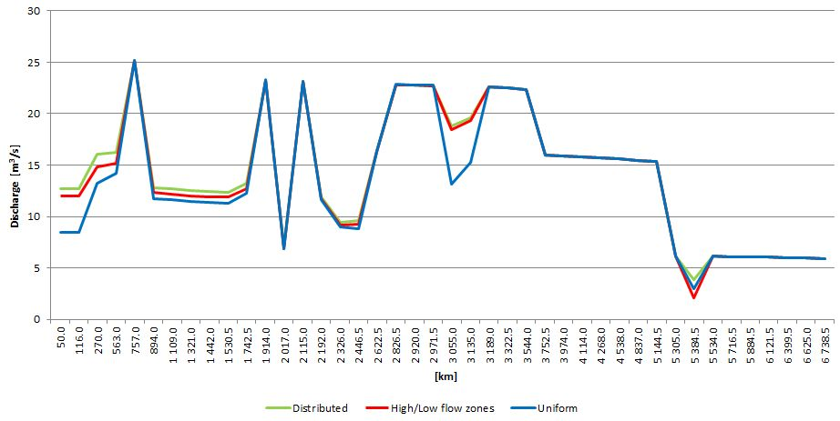

**Fig. 5.** Maximum discharge variability along the Baryczka River

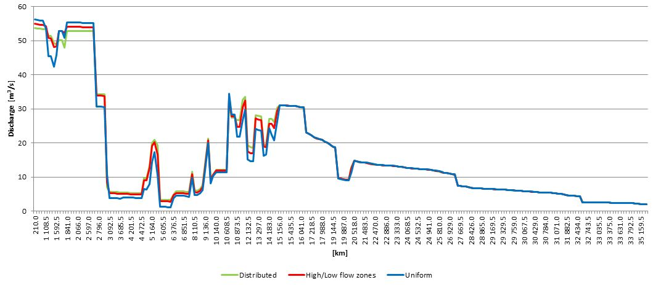

**Fig. 6.** Maximum discharge variability along the Biała River

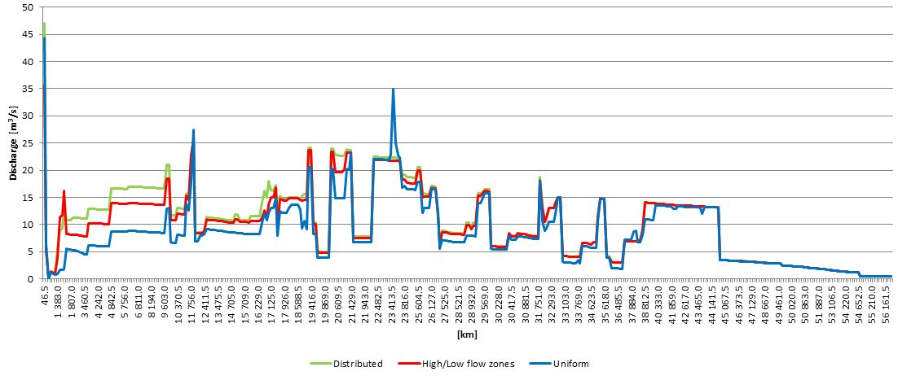

**Fig. 7.** Maximum discharge variability along the Budkowiczanka River

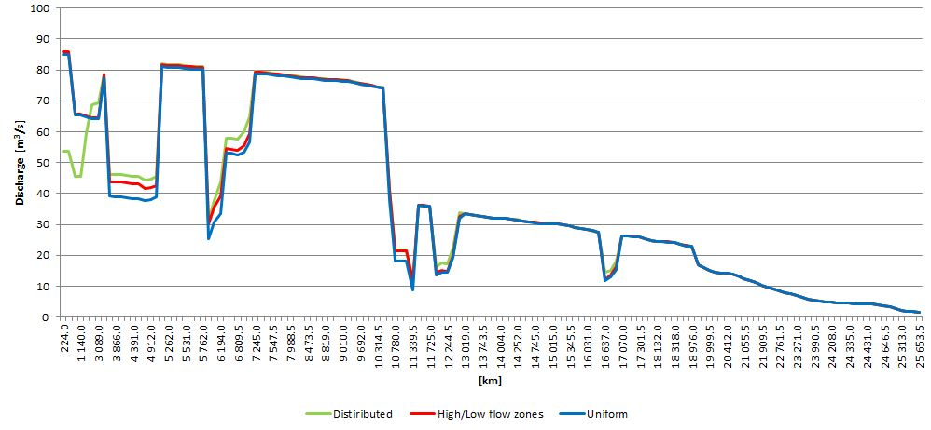

**Fig. 8.** Maximum discharge variability along the Drama River

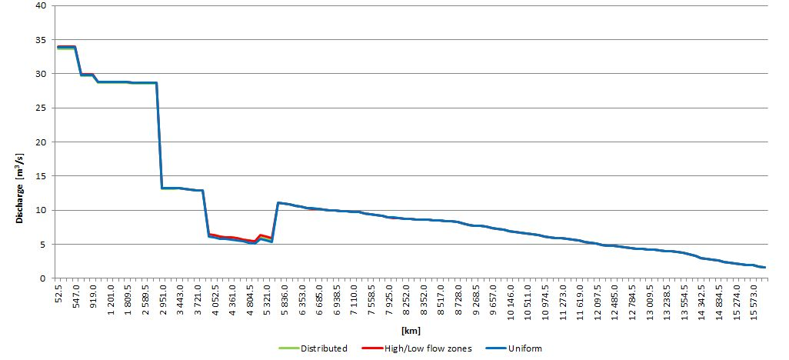

**Fig. 9.** Maximum discharge variability along the Jasienica River

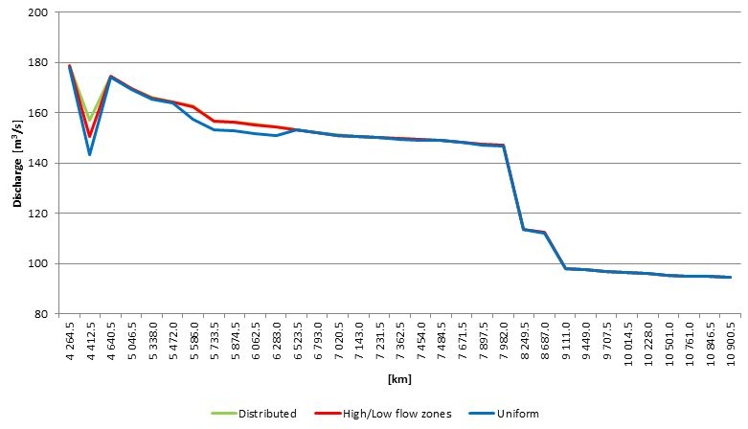

**Fig. 10.** Maximum discharge variability along the Opawica River

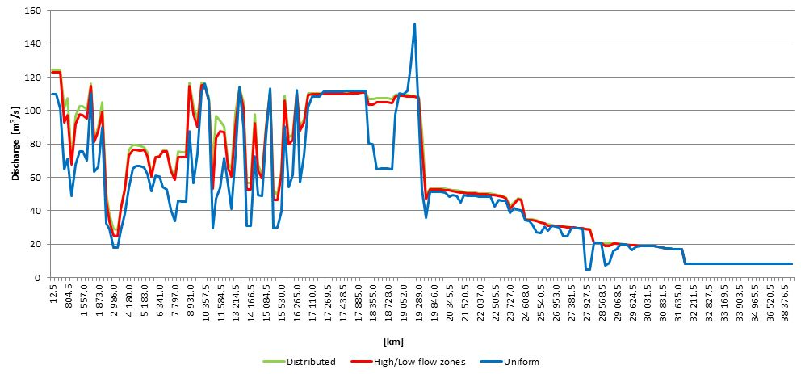

**Fig. 11.** Maximum discharge variability along the Piotrówka River

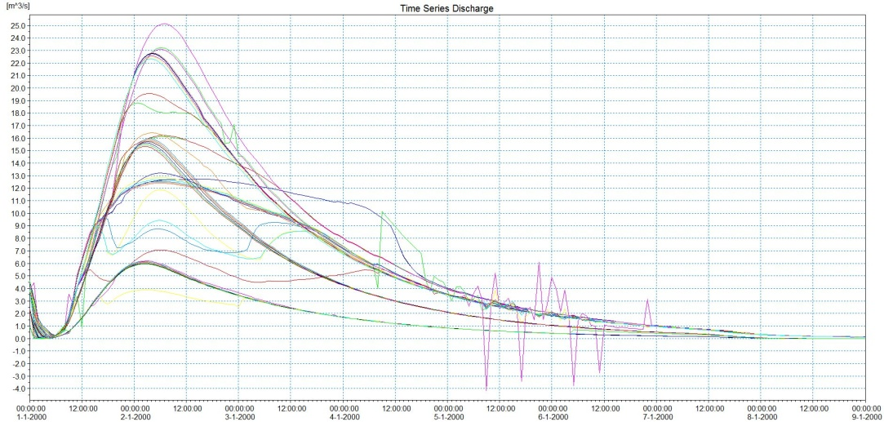

a)

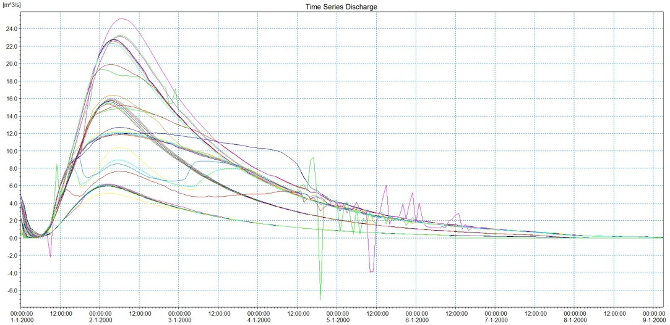

b)

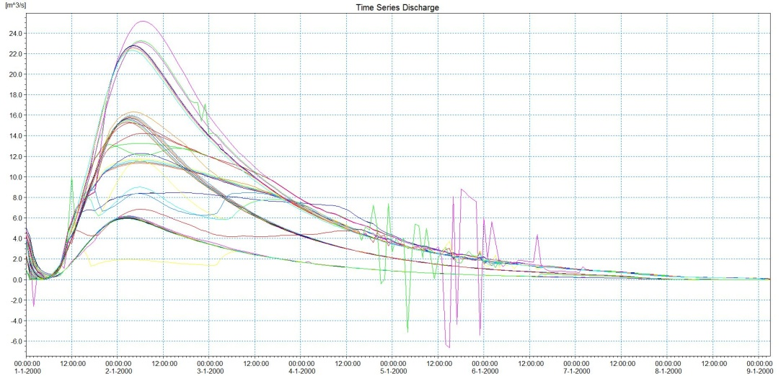

c)

**Fig. 12.** Discharge hydrographs for the Baryczka River model calculation points (discharge hydrographs at individual calculation points are colour-coded);   
a) *Distributed* option, b) *High/Low flow zones* option, c) *Uniform* option

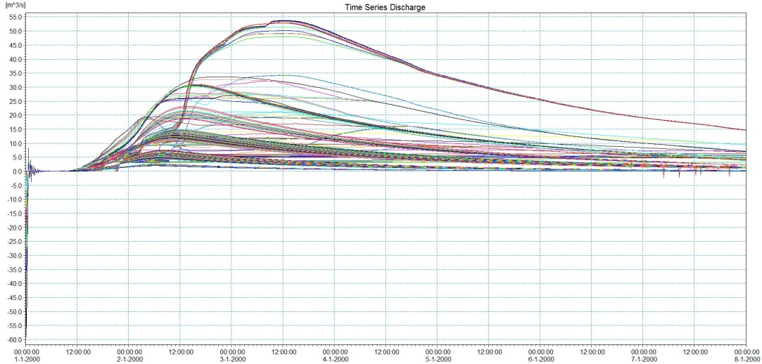

a)

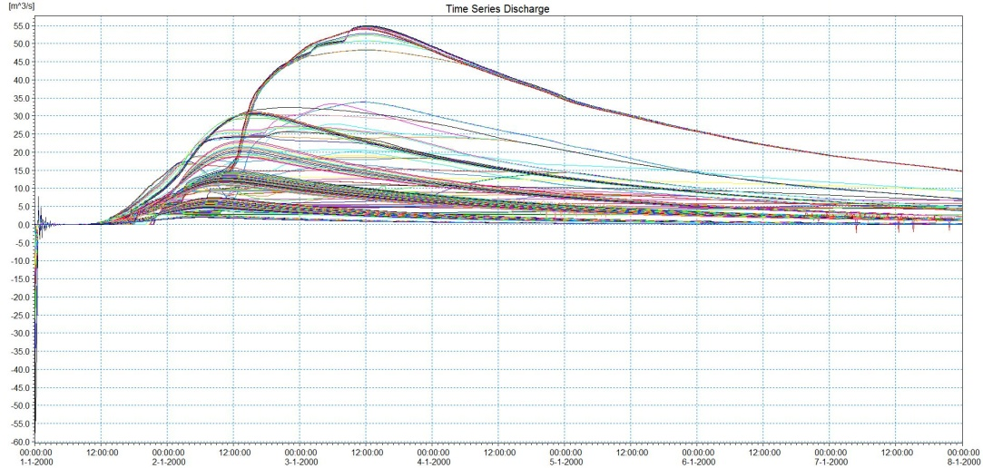

b)

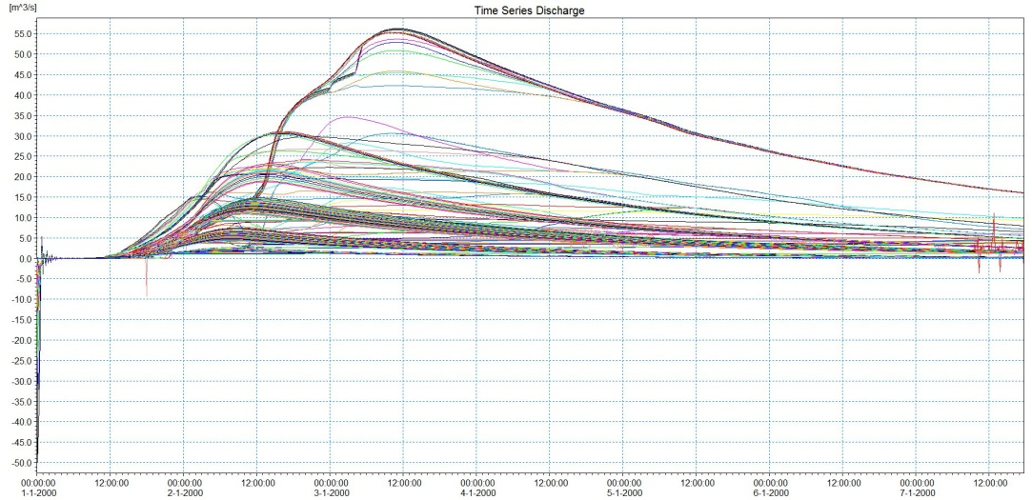

c)

**Fig. 13.** Discharge hydrographs for the Biała River model calculation points;   
a) *Distributed* option, b) *High/Low flow zones* option, c) *Uniform* option

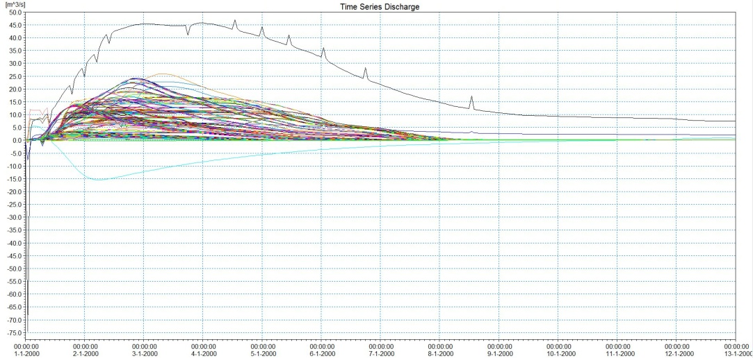

a)

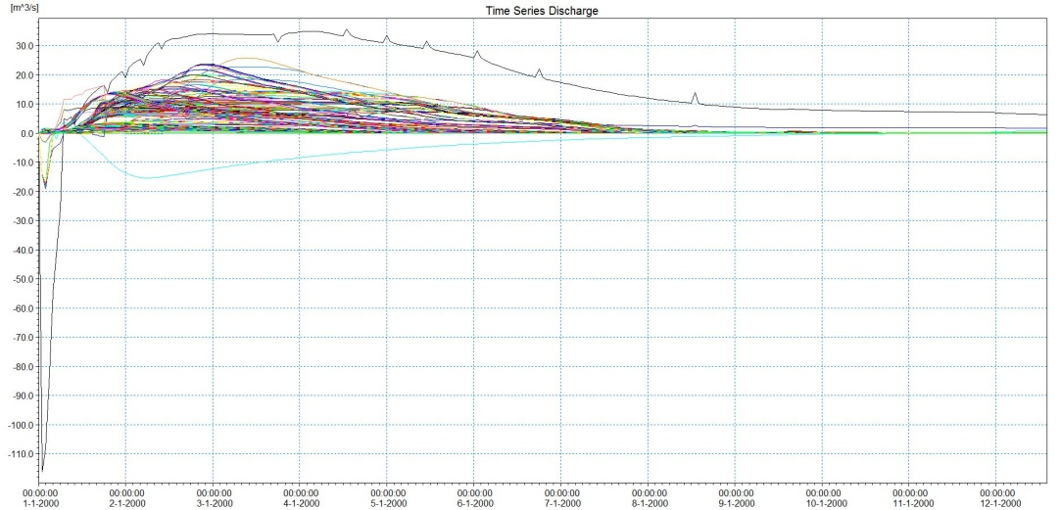

b)

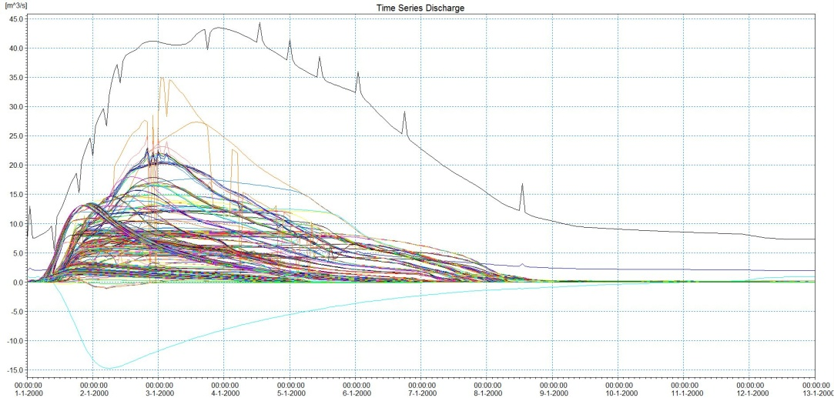

c)

**Fig. 14.** Discharge hydrographs for the Budkowiczanka River model calculation points;   
a) *Distributed* option, b) *High/Low flow zones* option, c) *Uniform* option

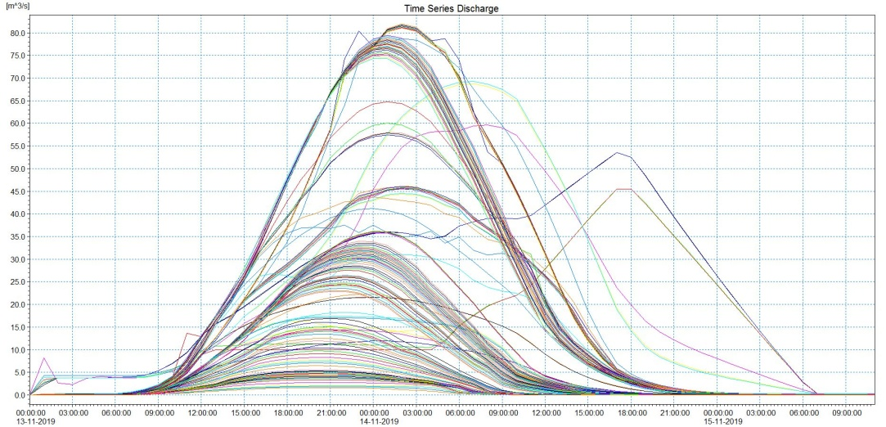

a)

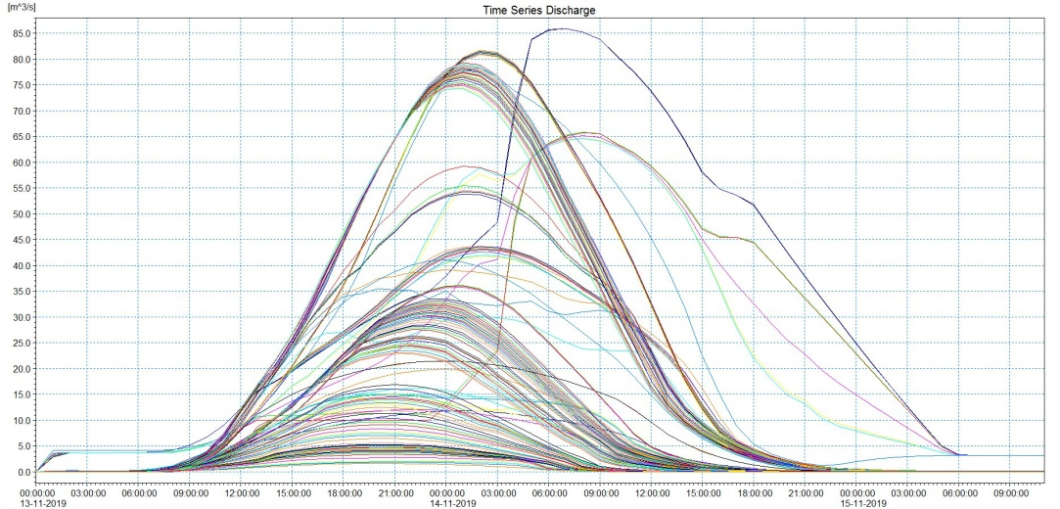

b)

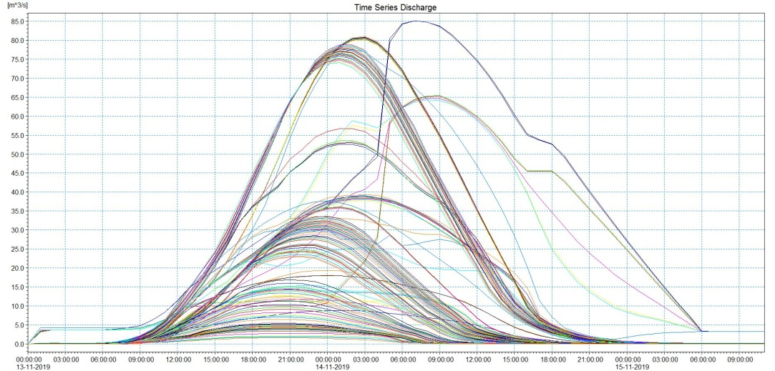

c)

**Fig. 15.** Discharge hydrographs for the Drama River model calculation points;   
a) *Distributed* option, b) *High/Low flow zones* option, c) *Uniform* option

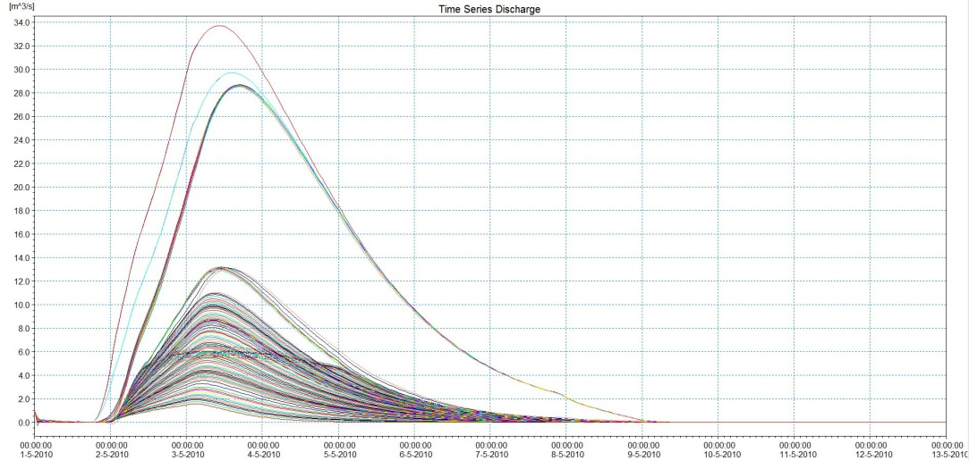

a)

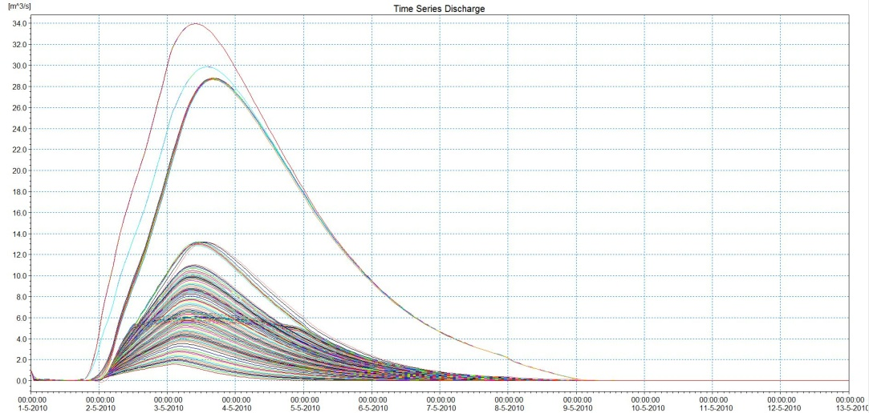

b)

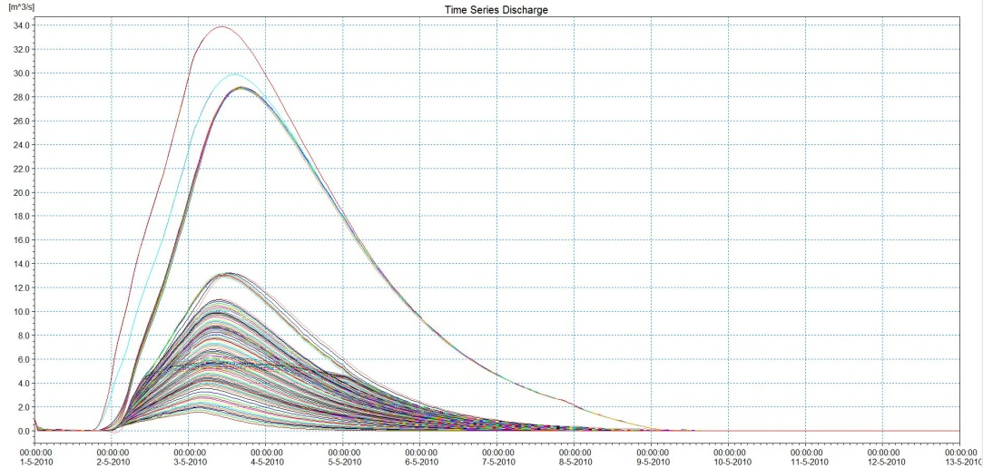

c)

**Fig. 16.** Discharge hydrographs for the Jasienica River model calculation points;   
a) *Distributed* option, b) *High/Low flow zones* option, c) *Uniform* option

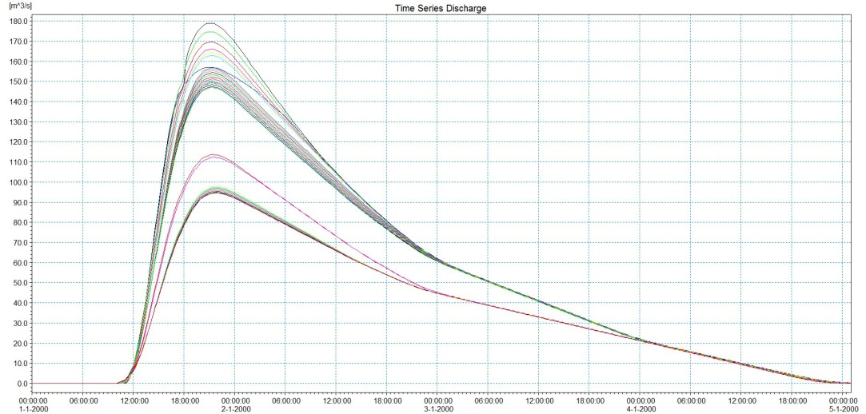

a)

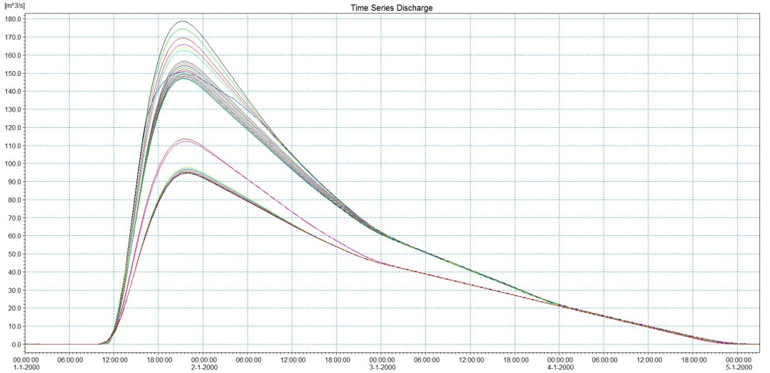

b)

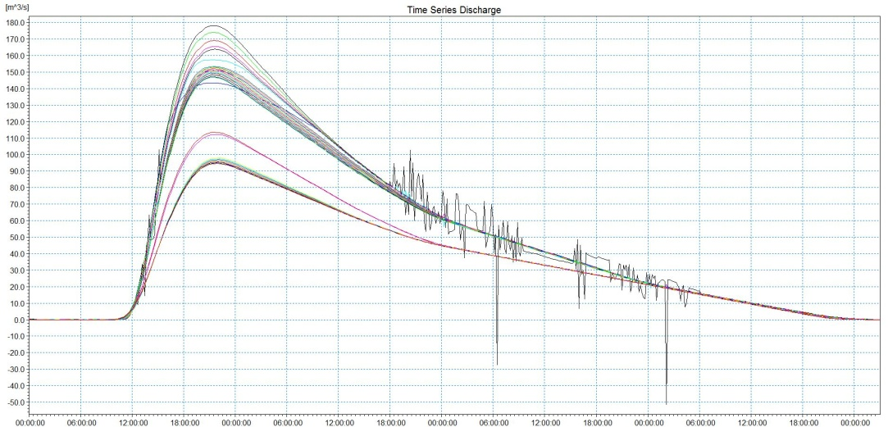

c)

**Fig. 17.** Discharge hydrographs for the Opawica River model calculation points;   
a) *Distributed* option, b) *High/Low flow zones* option, c) *Uniform* option

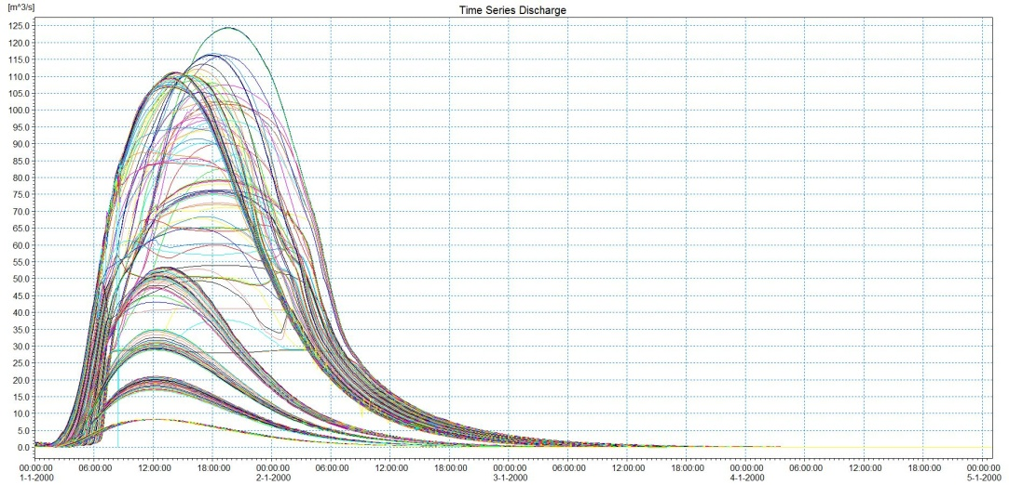

a)

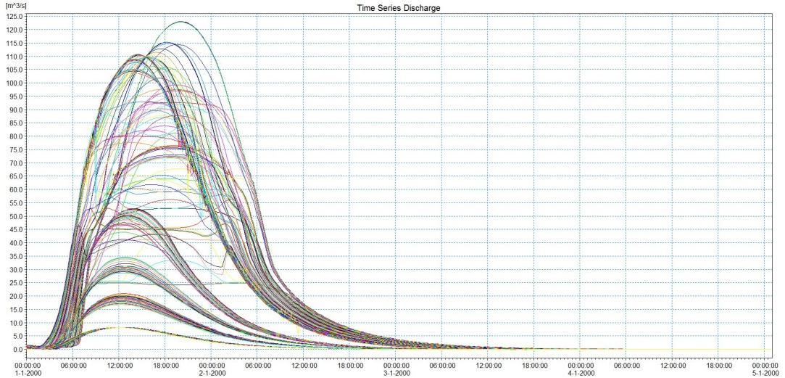

b)

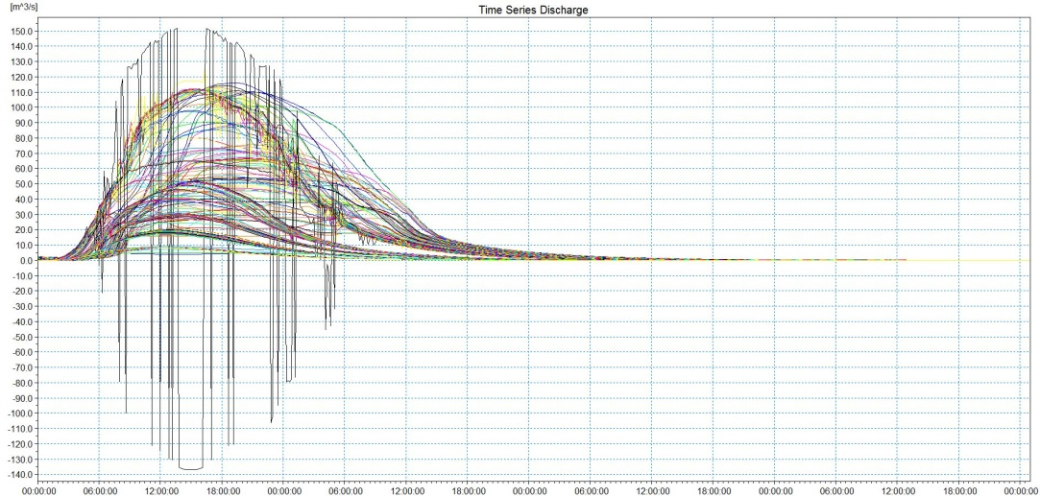

c)

**Fig. 18.** Discharge hydrographs for the Piotrówka River model calculation points;   
a) *Distributed* option, b) *High/Low flow zones* option, c) *Uniform* option

**5. Discussion and Summary**

Flow resistance in river channels is a topical and extremely important issue, especially in the context of flood hazard zone modelling. From the point of view of the model calculations, the key issue is how to determine the magnitude of the roughness coefficient as a characteristic feature of the substrate, as well as one that determines the flow velocity, the water level and the stability of the model.

The choice of the method for representing roughness coefficients should depend on the specific characteristics of the flood plains and the variability of land use types, while it is also important to bear in mind that roughness coefficients account not only for flow resistance but also for the geometric representation of the watercourse and the valley. In the case of varying land use in the cross-section, a variable roughness coefficient value is recommended, as confirmed by the results of this work.

This paper presents the results of model calculations for selected rivers of the Upper Odra Water Region using three methods of defining the transversal variation of roughness coefficients in valley cross-sections: *Distributed*, *High/Low flow zone* and *Uniform*. The highest discharge values were observed in those models where the initial roughness coefficients were assigned to individual measurement points in the cross-sections based on the isolated land cover forms. This is because this method represents most accurately the actual roughness in the channel and on the floodplains, resulting in outcomes closest to the observed ones. However, models developed using the *Distributed* option were not always computationally stable. Oscillations were frequently observed in selected cross-sections. In the *High/Low flow zone* method, the initial roughness coefficients were averaged using a weighted average and assigned to the flow zones corresponding to the right and left flood plains and the main riverbed. In this method, the distribution of discharges along the rivers was very similar to that in the *Distributed* method, although flow rate values were generally lower (by 0.55 m3/s on average). Models in which roughness was defined in terms of a single flow resistance value assigned to the entire section were the least stable, in terms of computational quality, of all the options tested. Discharges had the lowest values along the watercourses. Large fluctuations in discharges were also observed. At the same time, in the models developed with the *Uniform* option, the simulation results showed the highest water level.

Typically, the roughness coefficients in the riverbed are lower than those of the coefficients adopted for floodplain terraces, which are generally vegetated. Therefore, averaging these values over the entire length of the cross-section results in an erroneous overestimation of roughness in the channel and its underestimation on the floodplain terraces. For this reason, models that have averaged roughness coefficients show lower discharges and higher water levels. It directly affects the extent of the flood hazard zones. This is extremely important, especially for models developed for rivers flowing through highly urbanised areas and subject to strong anthropogenic impacts. Under such conditions, any change in the value of roughness coefficients increasing to the extent of flood zones can have serious consequences. Averaging the roughness coefficient across a cross-section, lowering its value in relatively high roughness areas will result in a higher flow, lower water levels and therefore a smaller floodplain extent than expected. This is a situation that generates potentially high hazards due to the underestimation of risk. The opposite situation, associated with an increase in the roughness coefficient, as a result of its averaging, in areas with relatively low values outside the channel, will result in an overestimation of risk in the form of a larger extent of the flood zone, but this in itself is less dangerous.

It is worth noting that the described differences in discharges and water levels are greater, the more complex the model design and the more complex the flow conditions are. In simple models with little variation in land use, flow rates and water levels are similar regardless of the option used to define roughness coefficients.

In the case of the models developed with the Distributed as well as High/Low Flow Zones and Uniform options, flow oscillations are observed in some rivers (Fig. 12, 13, 14). This is mainly the case in rivers with complex flow conditions, where the flood wave is split due to the creation of flood plains with connecting channels in the river section. Oscillations also occur at calculation points below bridges, which narrow the flow to high waters into the lumen of the structure, implying a decrease in flow velocity. Once the 'obstacle' is bypassed, there is a sharp increase in discharge. These phenomena affect the appearance of 'peaks' in the flow hydrographs. The fact is that with the Uniform option, the oscillations are greater, which is further influenced by the large change in the averaged roughness coefficient between successive cross-sections.

Roughness is very often used as a calibration parameter in computational models. The way it is defined has an impact on the quality of model calculations. Each time the roughness in a channel with a given geometrical configuration increases, the resistance to flow increases, resulting in higher water levels and slower flow. On the other hand, in a channel with a certain roughness, slope, and cross-sectional geometry, this resistance depends on the discharge. When the rough elements are entirely underwater, they decrease with increasing discharge. These factors must be considered when designing hydro structures and taking any measures to reduce flood risk.

Summing up the results presented in this study may provide helpful material for those performing work with similar tools, particularly to support decisions on choosing methods for simplifying or detailing roughness information.

References

Aberle, J. (2020). The roughness of waterways. *Magazyn Polskiej Akademii Nauk*, *2*(62), 46-50. (in Polish) https://doi.org/10.24425/academiaPAS.2020.134859

Aberle, J. Smart, G.M. (2003). The influence of roughness structure on flow resistance on steep slopes. *Journal of Hydraulic Research*, *41*(3), 259-269. https://doi.org/[10.1080/00221680309499971](http://dx.doi.org/10.1080/00221680309499971)

Act of 20 July 2017 – Water law (Dz.U. z 2022 r. poz. 2625). (in Polish)  
Available online: <https://isap.sejm.gov.pl/isap.nsf/DocDetails.xsp?id=WDU20220002625>

Arcement, G.J., Schneider, V.R. (1989). *Guide for Selecting Manning's Roughness Coefficients for Natural Channels and Flood Plains*. United States Geological Survey Water-Supply Paper 2339. <https://doi.org/10.3133/wsp2339>

Bezzola, G., Müller, A., Minor, H. (2004). *Shallow open channel flow with large roughness*. Int. Conf. Hydraulic Engineering: Research and Practice. Roorkee, India, pp. 264-276.

Carling, P.A., Kelsey, A., Glaister, M. (1992). Effect of bed roughness, particle shape, and orientation on initial motion criteria. In: *Dynamics of gravel-bed rivers;* Billi, P., Hey, R.D., Thorne, C.R., Tacconi, P, Eds.; John Wiley and Sons, Ltd., New York, USA, pp. 23-39, ISBN 10: 047192976X

Chow, V.T. (1959). *Open-Channel Hydraulics*. McGraw-Hill, New York, USA, pp. 1-680, ISBN 9780070859067

Cowan, W.L. (1956). Estimating hydraulic roughness coefficients. *Agrcicultural Engineering*, *37*(7), 473-475.

Dawson, H., Fisher, K.R. (2003). *Roughness Review & Roughness Advisor*. UK Defra/Environment Agency Flood and Coastal Defence R&D Programme, Report on Project W5A-057.   
Available online: http://www.riverconveyance.net/documents/Conveyance Manual.pdf

French, R.H. (1986). *Open-Channel Hydraulics*. Mc Graw-Hill Book Company, International Editions, pp. 1-705,   
ISBN 0-07-022134-0.

Goździk, M. (2006). Resistance to water movement in the coastal ecotone. Infrastruktura i ekologia terenów wiejskich. *Komisja Technicznej Infrastruktury Wsi*, *4*(2), 17-27. (in Polish)

Hey, R.D. (1988). Bar Form Resistance in Gravel-Bed Rivers. *Journal of Hydraulic Engineering – ASCE*, *114*(12), 1498-1508. [https://doi.org/10.1061/(ASCE)0733-9429(1988)114:12(149](https://doi.org/10.1061/(ASCE)0733-9429(1988)114:12(1498))8)

Hobot, A. Ed. (2010). Project entitled: *Detailed requirements, constraints and priorities for the implementation of the river basin management plan in Poland. Stage I, Upper Oder River Water Region*. Kraków, MGGP Inżynieria, Architektura, Geoinformacja. (in Polish)

Horn, R., Richards, K. (2007). Flow-Vegetation Interactions in Restored Floodplain Environments. In *Hydroecology and Ecohydrology: Past, Present and Future,* Wood, P. J., Hannah, D. M., Sadler, J. P., Eds.; John Wiley and Sons, Ltd.: West Sussex, England, pp. 269-294, ISBN: 978-0-470-01017-4

*Hydraulic models of watercourses of the Upper Oder River water region – unpublished materials*. Departament Ochrony Przed Powodzią i Suszą, Państwowe Gospodarstwo Wodne Wody Polskie, Krajowy Zarząd Gospodarki Wodnej, Warszawa, Polska, 2021. (in Polish)

Knight, D.W., Shiono, K., Pirt, J. (1989). Prediction of depth mean velocity and discharge in natural rivers with overbank flow. In: Falconer, R.A., Goodwin, P., Matthew, R.G.S. Eds.; *Proceedings of International Conference on Hydraulic and Environmental Modelling of Coastal, Estuarine and River Waters*, Gower Technical, University of Bradford, pp. 419-428.

Knighton, D. (1998). *Fluvial forms and processes. A new perspective,* 2nd ed.; Routledge, Taylor & Francis Group, London, U.K., ISBN 978-0-340-66313-4

Kondracki, J. (2009). *Regional Geography of Poland*, 3rd ed.; Wydawnictwo Naukowe PWN S.A., Warszawa, Polska, (in Polish) ISBN 978-83-01-16022-7

Kubrak, J., Nachlik, E. (2003). *Hydraulic basis for calculating the capacity of river channels*, Wydawnictwo SGGW, Warszawa, Polska, pp. 1-317, (in Polish) ISBN 8372443858

Methodology for developing Flood Hazard Maps and Flood Risk Maps in the 2nd planning cycle. In: *Report on the review and update of the Flood Hazard Maps and Flood Risk Maps*. Instytut Meteorologii i Gospodarki Wodnej – Państwowy Instytut Badawczy, ARCADIS sp. z o.o. w Warszawie, Warszawa, Polska, 2020. (in Polish)

*MIKE 11 A modeling system for Rivers and Channels*. User Guide. DHI Water and Environment 2017.

Morvan, H., Knight, D., Wright, N., Tang, X., Crossley, A. (2008). The concept of roughness in fluvial hydraulics and its formulation in 1D, 2D and 3D numerical simulation models. *Journal of Hydraulic Research*, *46*(2), 191-208. <https://doi.org/10.1080/00221686.2008.9521855>

Parker, G., Peterson, A.W. (1980). Bar resistance of gravel-bed streams. *Journal of the Hydraulics Division – ASCE*, *106*(10), 1559-1573.

Phillips, J.V., Tadayon, S. (2007). *Selection of Manning's Roughness Coefficient for Natural and Constructed Vegetated and Non Vegetated Channels, and Vegetation Maintenance Plan Guidelines for Vegetated Channels in Central Arizona*. Scientic Investigations Report 2006-5108. U.S. Geological Survey, Reston, Virginia. <https://doi.org/10.3133/sir20065108>

Popescu, I. (2012). *Hydroinformatics Module 4:* Numerical Methods I, Lecture 3 and 4:PDE, Hyperbolic PDE, Stability, Accuracy.

Simmons D.B., Richardson E.V. (1963).Friction factors in open channels: Progress report of the task force on friction factors in open channels of the Committee on Hydromechanics of the Hydraulics Division. *Journal of the Hydraulics Division, Proc. American Society of Civil Engineers* (ASCE), *89*, HY2, Paper 3464, New York, 97-143.

Słowik-Opoka, E., Brożek, M. (2015). Study on the influence of roughness coefficient changes on the magnitude of the design flow. *Landform Analysis*, *30*, 49-56, (in Polish) https://doi.org/[10.12657/landfana.030.005](https://doi.org/10.12657/landfana.030.005)

Smart, G.M., Duncan, M.J., Walsh, J.M. (2002). Relatively rough flow re­sistance equations. *Journal of Hydraulic Engineering – ASCE*, *128*(6), 568-578. https://doi.org/[10.1061/(ASCE)0733-9429(2002)128:6(568)](http://dx.doi.org/10.1061/(ASCE)0733-9429(2002)128:6(568))

Streeter, V., Wylie, E. (1979). *Fluid Mechanics*. 7th ed.; Mc Graw-Hill, New York, USA, ISBN 10: [0070622329](https://www.abebooks.com/9780070622326/Fluid-Mechanics-7th-edition-Streeter-0070622329/plp)

Strupczewski, W. (1998). Dependence of roughness coefficient on river channel shape. *Przegląd Geofizyczny*, *Polskie Towarzystwa Geofizyczne, Komitet Geofizyki PAN*, *43*(3-4), 147-163. (in Polish)

Szczepański, A., Różkowski, A. (2007). Mine waters in areas of intensive mining exploitation. In: *Regional hydrogeology of Poland, Volume II, Mineral, medicinal and thermal and mine waters*, 1sr ed.; Paczyński, B.; Sadurski, A.; Państwowy Instytut Geologiczny, Warszawa, Polska, pp. 146-180, ISBN 978-83-7538-169-6

Vidal, J.P., Moisan, S., Faure, J.B., Dartus, D. (2007). River model calibration, from guidelines to operational support tools. *Environmental Modelling and Software*, *22*(11), 1628-1640. https://doi.org/10.1016/j.envsoft.2006.12.003

Wallis, S.G., Knight, D.W. (1984). Calibration studies concerning a one-dimensional numerical tidal model with particular reference to resistance coefficients. *Estuarine, Coastal and Shelf Science*, *19*, 541-562. <https://doi.org/10.1016/0272-7714(84)90015-5>

Yen, B.C. (1991). *Channel flow resistance: centennial of Manning's formula*. Water Resources Publications: Colorado, USA, ISBN 13: 978-1-887201-80-3

Yen, B.C. (2002). Open channel flow resistance. *Journal of Hydraulic Engineering*, *128*(1), 20-39. <https://doi.org/10.1061/(ASCE)0733-9429(2002)128:1(20)>

Żelazo, J. (1992). *Studies of velocity and flow resistance in natural lowland river channels*, Seria Monografie Naukowe, SGGW, Warszawa, Polska, pp. 1-148. (in Polish)