|  |  |  |  |
| --- | --- | --- | --- |
|  |  | | |
| **Rocznik Ochrona Środowiska** | | |
| Volume 26 | Year 2024 ISSN 2720-7501 | pp. 251-263 |
|  | https://doi.org/10.54740/ros.2024.025 open access | | |
|  | Received: May 2024 Accepted: June 2024 Published: July 2024 | | |

Optimizing Energy Efficiency and Environmental Sustainability in Gas Distribution Station: A Comprehensive Analysis and Technological Solutions

Violeta Misevičiūtė1*, Artur Rogoža2, Rapolas Tučkus3

1Department of Building Energetics, Faculty of Environmental Engineering,   
Vilnius Gediminas Technical University, Lithuania   
<https://orcid.org/0000-0001-6348-3888>

2Department of Building Energetics, Faculty of Environmental Engineering,   
Vilnius Gediminas Technical University, Lithuania   
<https://orcid.org/0000-0001-6964-5534>

3Dujų technikos centras, JSC, Gas Technical Center, JSC, Vilnius, Lithuania

*corresponding author’s e-mail: violeta.miseviciute@vilniustech.lt

**Abstract:** It is important to address the world‘s energy crisis, increasing energy demand and changing climate by finding ways to recover unused energy and minimise primary and secondary energy use and emissions. The natural gas sector, which consists of the transmission network and gas distribution stations, is an important part of the global and Lithuanian energy sector. However, due to the operating principle of gas pressure regulators, the energy potential of high-pressure gas is not efficiently utilized in gas distribution stations. As a result, natural gas boilers are used for gas preheating, and gas distribution stations cause additional environmental pollution. This study aims to find ways to optimise the efficiency of gas distribution stations and reduce their negative environmental impact by identifying areas where energy is wasted and proposing alternative technological solutions: turbine expander (as an alternative for gas pressure regulator), ground heat pumps, solar collectors and photovoltaic solar cells (as gas preheating alternatives). The best alternative technological solution for the gas distribution station is evaluated based on energy efficiency, economic viability, and environmental impact (3E criteria).

**Keywords:** energy efficiency, sustainability, gas distribution station, technological solutions, gas pressure regulator, ground heat pump, natural gas, solar collectors, photovoltaics, turbine expander, life cycle assessment, 3E criteria

1. Introduction

Global energy crisis after the COVID-19 pandemic in 2021, increasing energy demand and changing climate require finding ways to recover wasted energy, reduce primary and secondary energy consumption and cut emissions. Using energy more efficiently and thus reducing consumption can reduce energy consumption, protect the environment, reduce climate change, improve the quality of life, and reduce the EU's dependence on external oil and gas suppliers. To achieve these benefits, energy efficiency must be improved throughout the energy chain, from production to final consumption, and surplus energy must be used from inefficient sources to produce electricity and other useful energy products. In December 2018, the revised Energy Efficiency Directive (EU) 2018/2002 entered into force, replacing some of the specific provisions of the previous Directive and introducing some new elements. In particular, it sets an EU energy efficiency target of at least 32.5% by 2030 (European Commission, 2018). Another important objective as part of the European Green Deal is to achieve climate neutrality by 2050 (Council of the EU and the European Council, 2024). There is potential for decarbonization of the energy sector (Papadis & Tsatsaronis 2020), but this requires investment to drive the shift from intensive CO2 technologies to sustainable technologies.

In Europe, improving energy efficiency is very important in response to rising energy prices, emerging concerns about energy security and the urgency of tackling climate change. Several institutional reforms have been implemented to promote energy efficiency, including the European Energy Efficiency Directive (The European Parliament and the Council 2012) and various national and private initiatives (Amber Grid 2023, Seimas of the Republic of Lithuania 2020, 2018).

Although global efforts are being made to move away from polluting energy sources as soon as possible (Brauers 2022), natural gas accounts for a large share of the energy balance in Europe and Lithuania (Eurostat 2024). Lithuania's demand for natural gas is expected to remain constant at 21.2 TWh/year until 2029, suggesting that the natural gas sector and its infrastructure will be an important part of Lithuania's energy sector (Amber Grid 2023). The Amber Grid (2024) transmission network operator, operating a 2288 km long network of high-pressure gas pipelines in Lithuania, supports and contributes to the promotion of the development of green energy in Lithuania as it seeks to meet the country's objectives to reduce its impact on climate change and contribute to the transition to becoming a green energy country. Therefore, in its grid development plan, the company lists more efficient operation of the transmission system as one of its objectives, as well as the reduction of emissions and greenhouse gases (Amber Grid 2023). The natural gas sector, composed of transmission networks and gas distribution stations (GDSs), is an important component of Lithuania's energy sector. However, there are opportunities to enhance energy recovery at GDS, particularly regarding the reduction of gas pressure by gas pressure regulators (GPR). Additionally, there is potential to better utilize the energy potential of high-pressure gas and address the environmental impact of preheating natural gas using gas boilers.

In addition, several studies have been carried out to investigate the potential of energy recovery in the GDS depressurization process with turbine expanders (TE) (Khanmohammadi et al. 2014, Jedlikowski et al. 2020, Bielka & Kuczyński 2022). Applications are utilised in GDSs across various countries, and their impact on isoenthalpic GPR is under thorough examination. These studies emphasise that the TE equipped GDS pressure relief units are very sensitive and not applicable to GDS with seasonal features. It has been found the temperature drop in TE systems was higher three times compared to GPR (Poživil 2004).

Both conventional, such as GPR and alternative technologies, such as TE require preheating gas to protect against the formation of hydrate crystals and maintain efficient equipment operations. In most GDSs, the gas is heated by gas-fired boilers before it enters the pressure relief units, reducing the gas temperature to 3°C to counteract the Joule-Thomson effect.

Some studies have examined alternative methods to conventional gas sources (Farzaneh-Gord et al. 2014, Ghezelbash et al. 2015, Arabkoohsar et al. 2015, Arabkoohsar et al. 2016). Ghezelbash et al. (2015) reviewed the ground heat pump (GHP) as an alternative to the GDS, as electricity is supplied from the grid / TE. Researchers (Farzaneh-Gord et al. 2014, Arabkoohsar et al. 2015) suggested using solar collectors with storage tanks and TE for energy recovery to reduce gas usage for preheating. Another study assessed the energy-economic potential and environmental impact of photovoltaic power plants (PV) and compressed air energy storage, as well as concentrated solar power plant (SCS) for GDS gas preheating (Arabkoohsar et al. 2016).

According to the results, (Arabkoohsar et al. 2015, Danieli et al. 2020, Farzaneh-Gord et al. 2014, Ghezelbash et al. 2015, Kostowski 2010, Osiadacz et al. 2018, Poživil 2004, Prieskienis et al. 2015, Rahman 2010, Taheri-Seresht et al. 2010, Ipieca, 2023) of the studies only one or at most two technologies were considered, without comparison and consideration Lithuania's GDS, only solutions addressing one, two of the three E (3E) criteria (energy, economy, ecology ) were examined. The study analyses GDS gas preheating and pressure reduction techniques based on 3E criteria. In this study, solutions for gas preheating and depressurisation of a GDS are investigated and evaluated employing a multi-criteria analysis.

Using multi-criteria analysis to evaluate the proposed technological solutions for optimizing energy efficiency and environmental sustainability at GDS is a strategic approach. This method allows for a comprehensive assessment that considers not only the energy aspects but also the economic and environmental dimensions of the solutions. This holistic evaluation will provide a well-rounded understanding of the potential impact of the proposed solutions and facilitate informed decision-making.

2. The Subject of the Study

The Lithuanian gas transmission system has [68 GDS](https://ambergrid.lt/en/for-clients/transmission-system/gas-transmission-system-of-lithuania/645), the main function of which is to reduce the gas pressure to the level needed by distribution system users (Amber Grid, 2024). Many of those stations are relatively new (or reconstructed) and, therefore, have a similar technological structure. This study compiled the design *(actual)* data for the new GDS and conducted calculations:

* average gas flow, n.m3/h: 10-5000 *(107-918)*,
* gas temperature at the inlet to / outlet of the GDS, °C: 2-10 *(5-11) /* 3-7 *(3)*,
* gas pressure at the inlet to / outlet of the GDS, bar: 20-55 *(39-41) /* 3-16 *(3)*.

The study revealed that gas filtration points experience minimal gas pressure loss across the site (pressure drops less than 0.5 bar). The impact of measuring units on energy fluctuations (Natural Gas Solutions North America 2022a) is relatively low (less than 17.3 mbar for turbine and less than 4.97 mbar for rotating meters (Natural Gas Solutions North America 2022b)). Similarly, the addition of odorant (Ministry of Economy of Lithuania of the Republic 2014) has an insignificant impact on gas mass and energy. Therefore, the research focuses solely on gas preheating and pressure control systems. The research uses the GDS scheme with proposed and analysed alternatives depicted in Fig. 1.

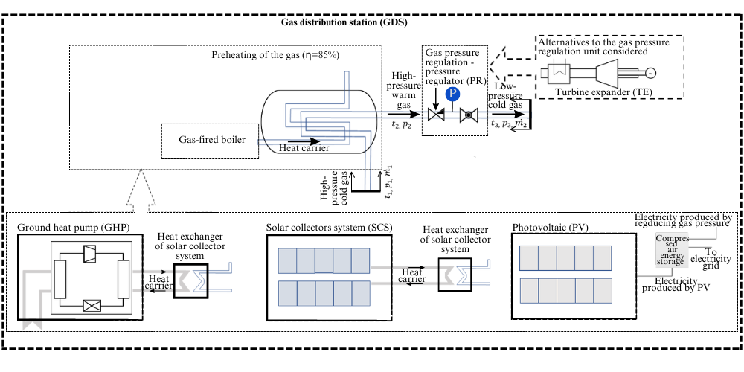**Fig. 1.** GDS scheme with alternatives prepared based on a master thesis (Tučkus 2023)

Alternative gas preheating sources (SCS, PV, and GHP) are considered, and a gas pressure control device (TE) is analysed as an alternative for GPR is considered. Separate alternatives and their combinations were analysed and evaluated (Fig. 2).

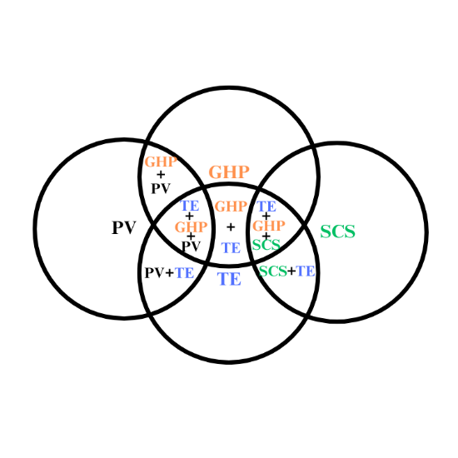

**Fig. 2.** Combinations of alternative devices

To assess the sustainability of the ten alternatives shown in Figure 2 (at the intersections of two or three circles, within circles), a multi-criteria analysis of the proposed solutions was carried out, considering energy, economic and environmental aspects. The study's methodology includes determining the heat demand for gas preheating and a multi-criteria assessment.

3. Methodology for Multi-criteria Assessment of Alternatives

Multi-criteria analysis is applied to evaluate the alternatives proposed to optimise the energy and sustainability of GDS considering energy (MWh/(n.m3 of gas)), environmental (E/(n.m3 of gas), and economic (NPV)/(n.m3 of gas) indicators. After identifying and evaluating the above-mentioned criterion, the applicability and sustainability of the GDS can be evaluated, and the most appropriate solutions can be selected. Each criterion is given an equal weight of 0.3, and the weighting of the criteria is calculated using formula (1), taking into account the different levels of importance for energy, environmental, and economic factors (with the energy and environmental criteria being the most important at the lowest level, and the economic criterion the most important at the highest level).

3E $=0.3∙\left(\frac{€\left(NPV\right)}{{n.m}^{3} of gas}\right)-0.3∙\left(\frac{MWh}{{n.m}^{3} of gas}\right)-0.3∙\left(\frac{E}{{n.m}^{3} of gas}\right)$ (1)

where:

€(NPV)/(n.m3 of gas) – the relative economic criterion,

MWh/(n.m3 of gas) – the relative energy criterion,

E/(n.m3 of gas) – the relative ecological criterion.

The technological solution that has the highest 3E value is considered to be the optimal.

3.1. Energy criterion calculation methodology

After implementing the suggested alternatives at the analysed GDS, the energy criterion evaluates electricity and gas consumption. Energy consumption (kWh/n.m3 gas) for gas preheating in the GDS is used as a measure for this criterion. In some cases, the system under investigation can transition from an energy consumption facility to an energy production facility, resulting in a negative functional value. The process for calculating the energy criterion involves a series of steps outlined in Fig. 3.

**Fig. 3.** The procedure of energy criterion evaluation

Based on the data collected (B, p1, p2, etc.), the energy demand (G) to preheat the gas in GDS is calculated (2):

$G=\frac{B·((p_{1}-p_{2})· μ +(t_{out} – t_{min}))· c_{p}·ρ·k}{3.6}$*,*W (2)

where:

B – the gas flow rate, n.m3/h,

p1, p2 – the upstream (1) and downstream (2) gas pressure, bar,

μ – the Joule-Thomson coefficient for GPR (0.6°C/bar),

tout, tmin – the gas temperature at the outlet (out) and the minimum (min) gas temperature at the inlet of the GDS, °C,

cp – the specific heat of the gas (2.25 kJ/kg**·**K),

ρ – the density of the gas (0.73 kg/m3),

k – the heater fouling assessment factor (1.05).

If TE replaces the GPR, the energy quantity has to be recalculated according to formula (3) (Danieli et al. 2020).

$E_{el,exp}={\dot{m}}_{step}·∆h_{is, step}·η_{is, step}·∆t_{ step}·η_{el}, kWh$ (3)

where:

Eel,exp – the electricity generated by TE, kWh,

${\dot{m}}_{step}$– the mass flow rate of the gas, kg/s,

$∆h_{is, step}$– the isentropic enthalpy difference between the upstream and downstream TE, kJ/kg,

$η_{is, step}$– TE isentropic efficiency,

ηel – generator efficiency (0.9),

∆tstep – TE operating time, in hours.

Since TE compression processes reduce the gas temperature by transforming thermal energy into motion energy, whereas GPRs cause isoenthalpic processes that do not produce such large temperature changes, TE compression processes reduce the gas temperature much more than GPRs. As a consequence, the expanding gas is cooler than with GPR, supplementary heating is required to maintain the outlet temperature below 3°C. Therefore, for the calculation of TE, the heat required to heat the gas is recalculated by applying formula (2), where the Joule-Thomson coefficient instead of the usual GPR of 0.6°C/bar, 1.5°C/bar is used (Prieskienis et al. 2015).

The effectiveness of single-stage radial type TE (with an efficiency of 0.85) depends on the expansion ratio (rdp) that is estimated to be almost constant (from 13.0 to 13.7 (Fig. 4)) and the flow of gas. Based on the dependence described in the study (Danieli et al. 2020) the efficiency of the TE due to flow changes at a maximum of 0.85 at 500 n.m3/h and 0.51 to 0.85. Fig. 4 shows the monthly heating demand needed to heat GDS gas without alternative solutions and the efficiency of TE compared to flow, pressure ratio rDP.

**Fig. 4.** Monthly gas flows, heat demand for gas preheating of GDS and TE efficiency versus flow, pressure ratio rDP (Misevičiūtė et al. 2023)

EnergyPro software (EMD International 2017) was applied to model gas heating alternatives (GHP, PV, SCS), considering annual solar radiation intensity, outdoor air temperatures, ground temperatures, and calculation according to the system‘s available technical data produced heat, and electricity consumption. The analyses showed that the heat demand for heating with natural gas from the GDS under TE technology is 106.34 MWh/year and only 37.01 MWh/year if the heat produced outside of TE technology. Therefore, TE significantly increases the heat demand for natural gas supplied via GDS, and these estimated demands are used to calculate the energy criteria. The inputs and characteristics of all the alternatives analysed in the study are shown in Table 1.

The heat demand for preheating GDS gas is equal to 106.34 MWh/year for the alternatives TE, TE + GHP, TE + PV, TE + GHP + PV, TE + SCS, TE + GHP + SCS and 37.01 MWh/year for the rest (GHP, PV, GHP+PV, SCS).

**Table 1.** Description, data and schemes of gas preheating alternatives modelled with EnergyPro to evaluate energy criterion of the proposed alternatives (Tučkus & Rogoža 2023)

|  |  |
| --- | --- |
| Description of the proposed alternative | Input data and (or) scheme of alternative in EnergyPro software |
| **The electricity**[1] **generated by the turbine expander (TE)** is primarily used to heat the gas using electric heaters[2]. |  |
| **A ground heat pump (GHP) covers the entire heat demand needed for natural gas preheating, and** electricity is supplied from the electrical grid. | GHP[3] has a power of 70 kW, COP = 4.09, annual changes and decline in soil temperature are introduced due to GHP operation (−4°C). With the GHP, a storage tank of 1 m3 is installed, the bottom temperature of which is 40°C and the top temperature is 45°C. The temperature of the heat carrier is 45°C/40°C. |
| **TE+GHP** (GHP uses the electricity produced by the TE). | Input data[4] |
| The electricity generated by **photovoltaic solar cells (PV**[5]**)** is primarily used to heat gas using electric heaters1. | The power plant, which is 5.7 kW and consists of 16 units of 355 W modules with a size of 1x2 m and a tilt angle of 35°, can be installed on GDS‘s roof. |
| **TE+PV (**the electricity generated by TE and PV is primarily used to heat gas using electric heaters1). | Input data [6] |
| **GHP+PV** (GHP uses electricity produced by PV). | Input data4 |
| **TE+GHP+PV (**GHP usesthe electricity generated  by TE and PV). | Input data [7] |
| The heat produced by the **solar collector system (SCS5)** is used to heat natural gas. An electric heater1 is used to heat the gas, and electricity is supplied from the electrical grid (in the event of a heat shortage). | 32 m2 flat-plate SCS can be installed on the roof (Vitosol, 2022). A larger volume storage tank of 3 m3 has also been calculated, with a temperature of 40°C at the bottom of the tank and 55°C at the top. |
| **TE+SCS (**electricity and heat produced by TE and SCS are used to heat natural gas). | Input data [8] |
| **TE+GHP+SCS** (SCS and GHP heat the natural gas, GHP uses the electricity produced by the TE). | Input data [9] |

The assumption in the calculations is that all energy produced and consumed locally is given preference. If there is a electricity shortage, it is assumed that it will be fed into the storage network; alternatively, it will be drawn from the grid. The energy criterion evaluated (kWh/m3 of gas) for each alternative is applied for multi-criterion analysis.

3.2. Environmental criterion calculation methodology

For this assessment, the combination of the GDS and each of the offered energy and emission reduction solutions (the installation of TE, the change of the gas preheating system from gas-fired boilers to GHP, SCS or PV plant with electric heater, and the combinations of these options (Fig. 2)) was assessed in terms of non-renewable primary energy consumed during the production, use and disposal phases, and in terms of CO2 (global warming), SO2 (acidification of water), PO4 P-lim (eutrophication of water), CFC-11 (depletion of ozone) emissions. The step-by-step process for calculating the eco-evaluation criterion is shown in Fig. 5.

**Fig. 5.** Steps for calculating the ecological assessment criterion

Alternatives are first evaluated according to the inventory of materials, which categorises the system analysed into elements, then by materials and quantities, and finally by impact categories. Ecoinvent v3.7 databases and SimaPro software were used to analyse materials for the European market. Only emissions from materials used to manufacture elements and systems were assessed in the manufacturing stage. At the end of the operational phase, the replacement of the elements will not be evaluated, as all the proposed alternatives have a lifetime of 25 years. At this stage, only the environmental impacts of the proposed energy consumption system (gas/electricity consumption based on energy assessment) are assessed. The end-of-life phase assesses the emissions from recycling, combustion or disposal of material at the end of its useful life. The environmental impact of transport from all components of European production sites to Lithuanian research centres and waste disposal sites is also evaluated. The calculation of environmental performance, in which the impact of all proposed systems on all life cycle impacts is calculated, is aggregated by emission type, converted into an impersonal value, and weighted for each indicator (Fig. 6). ECO (ecological criterion) is evaluated by dividing the dimensionless functional unit by the annual gas flow of the GDS and evaluates the environmental impact of the proposed system.

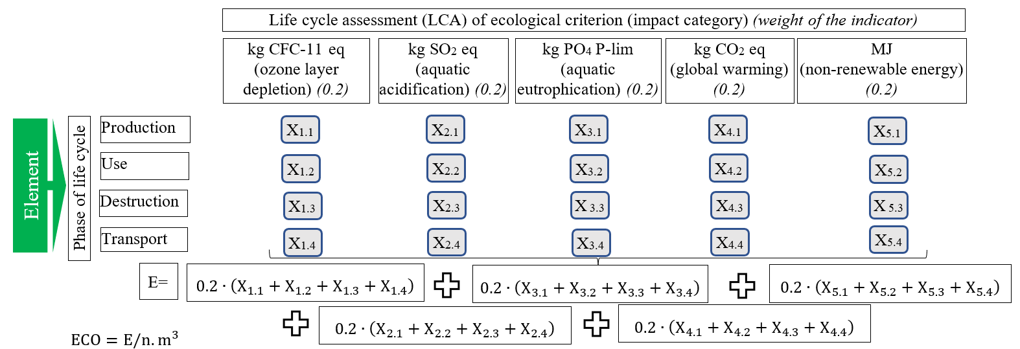

**Fig. 6.** Methodology for the evaluation of ecological criterion

The ecological criterion (E/n.m3 of gas) results calculated for each proposed technological solution are used for multi-criteria analysis.

3.3. Economic criterion calculation methodology

For this criterion, all the proposed alternative indicators were calculated based on a single indicator, the net present value (NPV) (formula (4)). This evaluation is beneficial because it indicates whether the measures provide sufficient savings and whether the project will be profitable over the lifetime of the project, taking into account its depreciation. The steps involved in calculating the economic evaluation criteria are shown in Fig. 7.

**Fig. 7.** Steps for calculating the economic evaluation criterion

${NPV}_{t}=-I_{0}+\sum_{i=1}^{n}{\frac{P-C-I}{{\left(1+d\right)}^{t}}}$ (4)

where:

NPVt – the net present value after a given time (t), €,

I0 – the initial investment, €,

CFt – the cash flow per year, €,

d – the discount rate (0.0019),

t – the elapsed time, in years,

P – the annual income or economic benefit, €,

C – the annual cost, €,

I – the investment, €.

The initial investment (I0) and annual costs (C) for each proposed alternative are calculated before calculating the NPV. This calculation includes the estimated annual maintenance costs of the system. The prices for electricity and gas adopted are presented in Table 2.

**Table 2.** Prices for gas and electricity

|  |  |
| --- | --- |
| Type of energy | Price |
| Gas | 1.91 €/m3 (Ignitis Group 2023a) |
| Electricity | 0.28 €/kWh (Ignitis Group 2023b) |
| The storage of electricity in the electrical grid | 0.045 €/kWh (ESO 2023) |

The NPV of each proposed alternative is evaluated and then divided by the total gas flow over 25 years (lifetime) to obtain the economic criterion (€(NPV)/n.m3) that evaluates the profitability of the proposed investment over its lifetime.

4. Results and Validation

First, the proposed alternatives are compared by category (energy, environment and economy). The results of each assessment of the criterion are shown in Fig. 8.

**Fig. 8.** Theresults of the evaluation of the energy, economic and ecological criterion

The technological solutions analysed here exclude (Fig. 8) the use of gas for preheating. If the system fails to generate enough electricity, the electricity grid meets the shortfall. The blue positive bar indicates that this is the demand for preheating the gas and the amount of electricity that remains after an electric heater heats the gas is returned to the grid. The proposed measures will reduce the energy consumption of GDS to heat a unit of gas, with PV and SCS reducing energy consumption by 27% and 18%, respectively. GHP will reduce energy consumption by 83%, with the highest energy savings achieved by installing GHP additionally. The TE systems are estimated to be systems that no longer use energy but supply it. The combinations of TE + GHP + PV (2.41 Wh of electricity/n.m3 of gas) and TE + GHP + SCS (2.31 Wh of electricity/n.m3 of gas) deliver the highest energy savings.

It is imperative to evaluate technological solutions based on ecological criteria, which include primary energy consumption and the amount of CO2, SO2, PO4 Plim, and CFC-11 emissions released during its lifecycle. The proposed solution must have the lowest value to be considered environmentally friendly.

According to the research, it has been found that several alternatives such as GHP, PV, GHP+PV, and SCS may have a significantly greater negative environmental impact over their lifetime as compared to the no alternatives. However, using TE alone can help reduce the environmental impacts by about 78%. On the other hand, the proposed measures, such as GHP and PV, can be considered positive due to the green energy produced by their use, which can be exported off-site, and the values of the environmental criterion being negative. The combination of three alternatives, namely TE+GHP+PV and TE+GHP+SCS, has the highest positive environmental impact with -0.163 E/n.m3 of gas and -0.174 E/n.m3 of gas, respectively.

The proposed alternatives are evaluated based on economic criteria expressed in €(NPV)/n.m3 of gas to determine the most economically viable alternative. This indicator shows the economic attractiveness of each alternative. The higher the value of this indicator, the more economically viable the proposed alternative. Upon analysing the results (Fig. 8), it can be observed that only the PV and SCS alternatives would not generate a positive return on investment during their lifetime, as they have a negative value of €(NPV)/n.m3 of gas. However, the TE and GHP alternatives are the most economically attractive. TE+GHP and TE+GHP+SCS have a value of 0.016 €(NPV)/n.m3 of gas, whereas TE+GHP+PV has a value of 0.017 €(NPV)/n.m3 of gas.

The most favourable alternatives are those that have the highest economic criterion and the lowest energy and environmental criterion, which are represented by the best 3E criteria (shown in red values in Fig. 8). To evaluate and compare the proposed alternatives, a multi-criteria analysis is carried out in which each evaluation criterion (energy, ecology, economic) is multiplied by a weighting factor of 0.3. The results of this analysis are presented in Fig. 9.

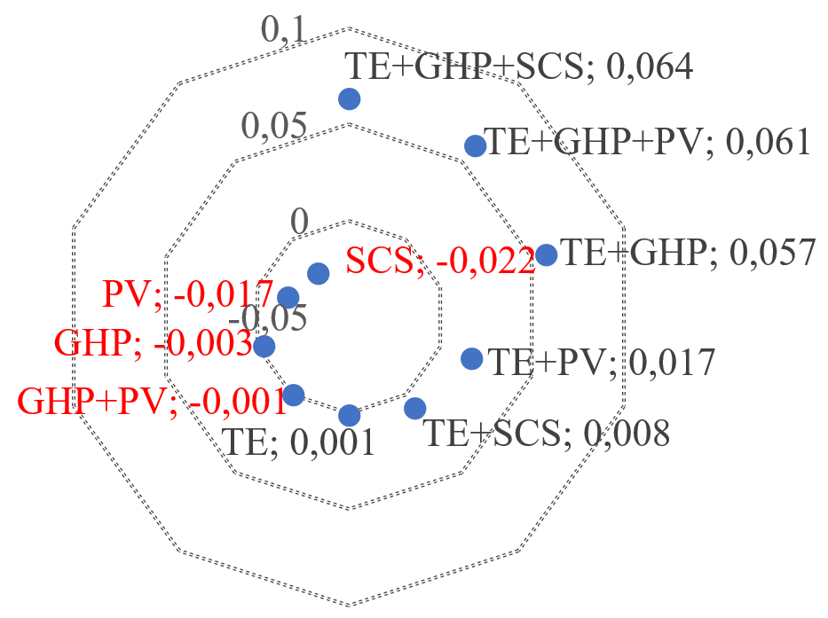

**Fig. 9.** Results of 3E criteria analysis

Taken together, these results suggest that the SCS, PV, GHP and GHP + PV alternatives are not suitable for optimising the energy efficiency and sustainability of the GDS as they have a negative impact (highlighted in red (Fig. 9)). This is due to the excessive demand for electricity from the grid, insufficient generation and high costs in the operation phase. However, introducing an additional generating unit (TE) changes the evaluation of the alternatives: 0.001 is only generated by TE, the TE+PV generates 0.017, and TE+SCS generates 0.008. The results show that the best alternatives when TE and GHP are used together are TE+GHP+SCS (0.064), TE+GHP+PV (0.061) and TE+GHP (0.057).

The findings imply that the SCS, PV, GHP, and GHP + PV alternatives are not appropriate for improving the energy efficiency and sustainability of the GDS, as they have a negative impact, marked in red (Fig. 9). This is due to the high demand for electricity from the grid, inadequate generation, and exorbitant operating costs. However, the scenario changes when introducing an additional generating unit (TE). TE generates only 0.001, TE+PV generates 0.017, and TE+SCS generates 0.008. The results indicate that the best alternatives when TE and GHP are utilized together are TE+GHP+SCS (0.064), TE+GHP+PV (0.061), and TE+GHP (0.057).

4.1. Determining the validity of the study results

To ensure that the study results are reliable and can be used to draw further conclusions, it is important to establish the credibility of the study's results. Since similar studies have not been carried out on different measures proposed by the GDS and assessed against at least three criteria, the results of the criteria for evaluation for several proposed alternatives can be compared (Table 3).

**Table 3.** Validity of the results

|  |  |  |  |
| --- | --- | --- | --- |
| Comparative result | Result of research | Results of studies  conducted by other authors | Explanation |
| GDS payback time for  installing TE | Actual payback time obtained  8.77 years. | The real payback time  is about 2 years  (Taheri-Seresht et al. 2010). | In the current study, the gas flow was uneven, leading to variations  in TE efficiency and payback. |
| The real payback time is about 4 years (Ebrahimi Saryazdi et al. 2021). |

**Table 3.** cont.

|  |  |  |  |
| --- | --- | --- | --- |
| Comparative result | Result of research | Results of studies  conducted by other authors | Explanation |
| GDS energy consumption for preheating after TE  installation | Energy consumption has been  reduced  by a factor of 4. | Energy consumption has fallen by more than 65% (Farzaneh-Gord et al. 2016). | In this study, it was decided to abandon gas heating altogether in favour of TE (Farzaneh-Gord et al. 2016) resulting in a significant reduction in energy consumption. |
| GDS CO2 emissions  related to GHP installation | CO2 emissions have been reduced by more than 2.5 times  over its use phase. | CO2 emissions have been reduced by up to 79%  (Farzaneh-Gord et al. 2016). | Research methodologies vary. In the current study, CO2 emissions over the 25-year lifetime of the LCA were only one component of the LCA. |
| Payback time for installing a GHP GDS | Actual payback time obtained  13.21 years. | The real payback time is about 2 years (Farzaneh-Gord et al. 2016). | Differences in modelling, system size, and climate conditions. |
| Payback time for the installation of TE and GHP in GDS | Actual payback time obtained  3.5 years. | The real payback time is about 6 years  (Ghezelbash et al. 2015). | Differences in modelling, system size, and climate conditions. |
| GDS payback time for SCS installation | Actual payback time obtained  -13.9 years  (no payback). | The real payback time is about 5.5 years (Farzaneh-Gord et al. 2014). | Differences in modelling, system size and climate conditions.  According to a study by Italian  researchers, solar energy solutions are recommended only for GDSs located in southern latitudes and in areas with sufficient radiation even in winter (Cascio et al. 2018). |
| The real payback time is about 11.5 years  (Arabkoohsar et al. 2015). |
| GDS payback time for SCS and TE installation | Actual payback time obtained  13.1 years. | The actual payback time is about 3.5 years  (Arabkoohsar et al. 2015). | Similarly, to the installation of SCS only, the installation of solar radiation systems is not acceptable in the Lithuanian climate. In comparison, the payback period for a TE-only installation is shorter, around 8.77 years. |

Comparing the results obtained in this study, most of the comparisons show similar results. It can be seen that the energy reduction obtained in this study (around 400%) by installing a TE is higher than that obtained in another researcher's research (65%). Similarly, the reduction in CO2 obtained by installing a GHP is greater (2.5 times in this study and 79% in another author's research). Differences in methodologies can explain these differences since this study assumed a complete abandonment of the use of gas for gas-fired district heating. The differences also influenced the differences in results in the technological sizes of the sites studied since the GDSs studied in Lithuania have very different flow rates (in summer, the lowest flow rate is 107 n.m3/h, and in winter, the highest flow rate is 918 n.m3/h). This is due to the different climatic conditions of the compared sites, resulting in higher gas consumption in winter in Lithuania and higher (GHP, TE) or even negative (SCS) payback times. This is because the climatic conditions in Lithuania (e.g. soil temperature and solar radiation used in the study) are less suitable for the installation of alternative measures such as GHP, SCS, and PV and lead to a lower efficiency compared to the locations studied by other authors (Iran, Italy).

5. Conclusions

1. The literature analysis has confirmed that the topic of natural GDS is relevant and has important practical implications for more sustainable development of the natural gas sector.
2. The calculations show that the GDS pressure relief unit has insufficient energy production potential. This energy can be used to produce energy for TE; however, this increases the heat demand of preheating gas by a factor of three.
3. In Lithuania, PV and SCS installations save only small amounts of GDS energy, and these proposed alternative systems would not be beneficial in multi-criteria combinations when deployed separately.
4. The economic criteria for the gas preheating alternatives (PV, SCS) are also negative, while the economic criteria for the other alternatives are positive. TE+GHP+PV and TE+GHP+SCS produce most electricity, emitting 1 n.m3 of gas, less CO2, SO2, PO4 P-lim and CFC-11,4.
5. The most cost-effective are the alternatives that cover both (TE and GHP): TE + GHP, TE + GHP + SCS, TE + GHP + PV, while the alternatives combined from the three elements have a NPV of between 0.016 and 0.017 €(NPV)/n.m3 of gas, respectively.
6. If all criteria are considered individually and based on multiple criteria, the best alternatives include GHP and TE: TE+GHP, TE+GHP+PV, and TE+GHP+SCS. This is because GHP is an efficient and environmentally friendly heating method if the source of electricity is also environmentally friendly. With the installation of TE, the green energy produced would be fully sufficient to operate the GHP, and the surplus would be fed into the general electricity network.
7. The results were compared with other research to assess the results' reliability. The magnitude of the energy reduction obtained with the installation of TE is higher (about 400% reduction) compared to the other study (65% reduction). The CO2 reduction obtained with a GHP is also higher (2.5 times the reduction in this study and 79% in the other author's research). Differences in methodology and differences in the size and climatic conditions of the study sites can explain these differences.

References

Amber Grid. (2024). *Gas transmission system of Lithuania*. https://ambergrid.lt/en/for-clients/transmission-system/gas-transmission-system-of-lithuania/645

Amber Grid Strategy 2030 – Green Start (2023).

Arabkoohsar, A., Farzaneh-Gord, M., Deymi-dashtebayaz, M., Machado, L. (2015). A new design for natural gas pressure reduction points by employing a turbo expander and a solar heating set. *Renewable Energy*, *81*, 239-250. https://doi.org/10.1016/j.renene.2015.03.043

Arabkoohsar, A., Machado, L., Koury, R.N.N. (2016). Operation analysis of a photovoltaic plant integrated with a compressed air energy storage system and a city gate station. *Energy*, *98*, 78-91.   
https://doi.org/10.1016/j.energy.2016.01.023

Bielka, P., Kuczyński, S. (2022). Energy Recovery from Natural Gas Pressure Reduction Stations with the Use of Turboexpanders: Static and Dynamic Simulations. *Energies*, *15*(23). https://doi.org/10.3390/en15238890

Brauers, H. (2022). Natural gas as a barrier to sustainability transitions? A systematic mapping of the risks and challenges. Energy Research & Social Science, 89, 102538. https://doi.org/https://doi.org/10.1016/j.erss.2022.102538

Cascio, E. Lo, Ma, Z., Schenone, C. (2018). Performance assessment of a novel natural gas pressure reduction station equipped with parabolic trough solar collectors. *Renewable Energy*, *128*, 177-187. https://doi.org/https://doi.org/10.1016/j.renene.2018.05.058

Council of the EU and the European Council. (2024). *The European Green Deal*. Delivering the European Green Deal. https://www.consilium.europa.eu/en/policies/green-deal/

Danieli, P., Carraro, G., Lazzaretto, A. (2020). Thermodynamic and Economic Feasibility of Energy Recovery from Pressure Reduction Stations in Natural Gas Distribution Networks. *Energies*, *13*(17), 1-19. https://doi.org/https://doi.org/10.3390/en13174453

Directive 2012/27/EU Of the Europeam Parliament and of the Council of 25 October 2012 on Energy Efficiency, Amending Directives 2009/125/EC and 2010/30/EU and Repealing Directives 2004/8/EC and 2006/32/EC, 1 (2012).

Ebrahimi Saryazdi, S.M., Rezaei, F., Saboohi, Y. (2021). Optimal detailed design and performance assessment of natural gas pressure reduction stations system equipped with variable inlet guide vane radial turbo-expander for energy recovery. *Journal of Natural Gas Science and Engineering*, *96*, 104222. https://doi.org/https://doi.org/10.1016/j.jngse.2021.104222

EMD International. (2017). *energyPRO – Software for modelling and analysis of complex energy projects*.

Energy Efficiency Improvement Law of the Republic of Lithuania, Pub. L. No. XII–2702 (2020).

ESO. (2023). *Settlement methods for generating consumers – Tariff plans, prices, settlemen*.

European Commission. (2018). Directive 2018/2002/EC of the European Parliament and of the Council of 11 December 2018 – amending Directive 2012/27/EU on energy efficiency. *Official Journal of the European Union*, 2018   
(November), 210-230.   
https://eur-lex.europa.eu/legal-content/EN/TXT/?uri=uriserv%3AOJ.L_.2018.328.01.0210.01.ENG

Eurostat. (2024). *Simplified energy balances*. https://doi.org/10.2908/NRG_BAL_S

Farzaneh-Gord, M., Arabkoohsar, A., Dasht-bayaz, M.D., Machado, L. (2014). Energy and exergy analysis of natural gas pressure reduction points equipped with solar heat and controllable heaters. *Renewable Energy*, *72*, 258-270. https://doi.org/10.1016/j.renene.2014.07.019

Farzaneh-Gord, M., Ghezelbash, R., Sadi, M., Moghadam, A.J. (2016). Integration of vertical ground-coupled heat pump into a conventional natural gas pressure drop station: Energy, economic and CO2 emission assessment. *Energy*, *112*, 998-1014. https://doi.org/10.1016/j.energy.2016.06.100

Ghezelbash, R., Farzaneh-Gord, M., Behi, H., Sadi, M. (2015). Performance assessment of a natural gas expansion plant integrated with a vertical ground-coupled heat pump. *Energy*, *93*, 2503-2517.   
https://doi.org/10.1016/j.energy.2015.10.101

Ignitis Group. (2023a). *Natural gas plans and prices*.

Ignitis Group. (2023b). *Public supplier’s electricity plans*.

Ipieca. (2023). *Gas turboexpanders*.

Jedlikowski, A., Englart, S., Cepiński, W., Badura, M., Sayegh, M.A. (2020). Reducing energy consumption for electrical gas preheating processes. *Thermal Science and Engineering Progress*, *19*(May), 100600. https://doi.org/10.1016/j.tsep.2020.100600

Khanmohammadi, S., Ahmadi, P., Mirzaei, D. (2014). *Thermodynamic modeling and optimization of a novel integrated system to recover energy from a gas pressure reduction station*. 13th International Conference on Clean Energy, June 8-12, 2014.

Kostowski, W. (2010). The possibility of energy generation. *Strojarstvo*, *52*(4), 429-440.

Misevičiūtė, V., Tučkus, R., Rogoža, A. (2023). Multi-Criteria Evaluation of Technological Solutions to Improve Gas Distribution Station Efficiency. *Journal of New Technologies in Environmental Science*, *7*(4), 109-120. https://doi.org/10.53412/jntes-2023-4-1

National Energy Independence Strategy (2018).

Natural Gas Solutions North America. (2022a). *Gas Measurement C&I Gas Meters Fluxi 2000/TZ*.

Natural Gas Solutions North America. (2022b). *Gas Measurement Commercial & Industrial Rotary Meter Delta*.

Order on the Rules for the Operation of Trunk Gas Pipelines (2014).

Osiadacz, A.J., Chaczykowski, M., Kwestarz, M., Isoli, N. (2018). The concept of zero-energy city gate station for natural gas industry. *Gaz, Woda i Technika Sanitarna*, *1*(4), 4-8. (in Polish) https://doi.org/10.15199/17.2018.4.1

Papadis, E., Tsatsaronis, G. (2020). Challenges in the decarbonization of the energy sector. *Energy*, *205*, 118025. https://doi.org/10.1016/j.energy.2020.118025

Poživil, J. (2004). Use of Expansion Turbines in Natural Gas Pressure Reduction Stations. *Acta Montanistica Slovaca*, *9*(3), 258-260.

Prieskienis, Š., Barauskas, A., Bružas, M., Jasinskas, N. (2015). *An assessment of the energy efficiency potential of gas infrastructure, in particular with regard to transmission, distribution, load management, and interconnection, as well as connection to generation facilities, including access for very small power producers*. Retrieved from https://enmin.lrv.lt/uploads/enmin/documents/files/Veikla/Veiklos sritys/energijos-naudojimo-efektyvumas/EVE-priemoniu-diegimas-Ekotermija-2015.pdf.

Rahman, M.M. (2010). Power Generation from Pressure Reduction in the Natural Gas Supply Chain in Bangladesh. *Journal of Mechanical Engineering*, *ME 41*(2), 89-95.

Taheri-Seresht, R., Jalalabadi, H. K., Rashidian, B. (2010). *Retrofit of Tehran City Gate Station (C.G.S.No.2) by Using Turboexpander*. Proceedings of the ASME 2010 Power Conference. ASME 2010 Power Conference. Chicago, Illinois, USA. July 13-15, 207-212. https://doi.org/https://doi.org/10.1115/POWER2010-27087

Tučkus, R., Rogoža, A. (2023). Research of methods for improving energy efficiency and emissions reduction in distribution station of natural gas transmission network. *Mokslas – Lietuvos Ateitis*, *15*, 1-9. (in Lithuanian). https://doi.org/10.3846/mla.2023.19409

Vitosol. (2022). *Vitosol System Design Guide*.

1. The energy produced by TE is calculated according to formula (3)
2. 98.5% effectiveness
3. Heat source for the GHP consists of 15 vertical boreholes, 120 m deep (heat emission from the ground is 60 W/m if the COP = 4, it can be assumed that ¾ of the heat will come from the boreholes in the open air).
4. The same as for the GHP
5. Installed on GDS building roof of area 50 m2
6. The same as for the TE and PV
7. The same as for TE, GHP and PV
8. The same as for TE and SCS
9. The same as for TE, GHP, and SCS