 | Rocznik Ochrona Środowiska
 | Volume 26 | Year 2024 ISSN 2720-7501 | pp. 226-235
 | https://doi.org/10.54740/ros.2024.023 open access
 | Received: April 2024 Accepted: June 2024 Published: June 2024
Study on the Temporal and Spatial Variation of PM_{2.5} Health Burden
in Henan Province from 2014 to 2021
Jun Yan1*, Ting Wang2, Xinying Wang3, Xu Zhang4
1School of Geographic Sciences, Xinyang Normal University, Xinyang 464000, China
https://orcid.org/0000-0001-7407-1934
2School of Geographic Sciences, Xinyang Normal University, Xinyang 464000, China
https://orcid.org/0009-0000-9690-9515
3School of Geographic Sciences, Xinyang Normal University, Xinyang 464000, China
https://orcid.org/0009-0003-8066-1262
4School of Geographic Sciences, Xinyang Normal University, Xinyang 464000, China
https://orcid.org/0009-0000-5618-5129
*corresponding author's e-mail: pgworker@xynu.edu.cn
Abstract: The research focuses on the temporal and spatial variation of PM_{2.5} health burden of Henan Province from 2014 to 2021. The Global Exposure Mortality Model was used to estimate the health burden attributed to PM_{2.5}. The results are as follows: The concentration of PM_{2.5} showed a significant downward trend, with a spatial distribution pattern of higher in the north and the east but lower in the south and the west. The exposed population showed a decreasing trend. The overall frequency of PM_{2.5} concentration decrease was 0.13 μg·m⁻³/a. The number of PM_{2.5}
– attributable mortality decreased from 86,297 in 2014 to 82,667 in 2021. Ischemic heart disease had the highest number of attributable mortality, with an average of 55,072 deaths per year. Chronic obstructive pulmonary disease and lung cancer had relatively high numbers, while respiratory tract infections were lower, with an average of 4,034 deaths per year.
Keywords: PM_{2.5}, GEMM model,·attributable mortality,·Henan Province
1. Introduction
With the rapid development of industrialisation and urbanisation since China's reform and opening up, air pollution has become a major environmental problem and is the fourth health risk factor for leading diseases and deaths worldwide, especially PM_{2.5} (Murray et al. 2020). The World Health Organization (WHO) updated the Global Air Quality Guidelines (2021) and tightened the PM_{2.5} guideline value from 10 μg·m⁻³ to 5 μg·m⁻³ (World Health Organization 2021). According to the Global Burden of Disease (GBD) study in 2019 (Fuller et al. 2022), PM_{2.5} pollution caused about 4.14 million premature deaths worldwide, with more than a quarter of them occurring in China, which is significantly higher than in other countries. Henan Province has consistently had high levels of environmental air quality index and is highly sensitive to smog pollution (Chen, et al. 2019, Liu et al. 2022). PM_{2.5,} or particles smaller than 2.5 microns in diameter, are considered the most harmful to human health. Numerous studies at home and abroad have shown that exposure to PM_{2.5} environment increases the risk of specific diseases such as ischemic heart disease, stroke, chronic obstructive pulmonary disease, lower respiratory tract infections, and lung cancer (Cohen et al. 2017, Wang et al. 2022). Even with low exposure levels, PM_{2.5} can harm health (Brunekreef et al. 2021). Therefore, PM_{2.5} pollution seriously threatens the ecological environment and public health (Jia et al. 2023, Xu et al. 2023, Xue et al. 2020), and research on health burden assessments is necessary.
In recent years, many scholars at home and abroad have conducted related studies on the PM_{2.5} concentration changes, population exposure risks, and health burden caused by PM_{2.5}. Regarding population exposure risks, the assessment methods based on population distribution are more accurate than using atmospheric pollutant concentrations as an indicator of air pollution exposure risk. The PM_{2.5} exposure risk was assessed in Beijing and found a high consistency between the spatial distribution of population exposure risk and population density (Zhang et al. 2018). The Pearl River Delta region was studied and found no significant spatial matching relationship between population density and PM_{2.5} concentration (Cai et al. 2021). The population exposure risk in the Guanzhong Region is still increasing (Liu et al. 2023). Regarding health burden, domestic and foreign scholars have mostly used epidemiological methods to evaluate the long-term health effects of PM_{2.5} pollution based on exposure-response relationship models (Chuai et al. 2022). The overall health burden of PM_{2.5} has been assessed in China and found a decreasing trend in the number of deaths, with significant spatial differences (Xiao et al. 2022). Health burden assessments have also been conducted in typical regions, such as the Beijing-Tianjin-Hebei region (Chen et al. 2020), the Pearl River Delta (Cai et al. 2021), the Yangtze River Delta (Wei et al. 2023), the Yangtze River Economic Belt (Li et al. 2023), and the Fen-Wei Plain (Hao et al. 2023). There is also extensive research at the provincial scale, such as Beijing (Du & Wang 2021), Shanghai (Zhou et al. 2023), and Gansu (Liao et al. 2023). Different regions have significant differences in PM_{2.5} air pollution characteristics and attributable mortality.
With a large population, Henan Province has actively implemented air pollution control policies. However, the spatial and temporal evolution characteristics of population exposure risks and health burdens under the changing PM_{2.5} concentrations in recent years are still unclear and need further exploration. Therefore, this study uses the data of annual average PM_{2.5} concentration, population and baseline mortality in Henan Province from 2014 to 2021 and applies the exposure risk assessment model and optimised Global Exposure Mortality Model (GEMM) system to evaluate the population exposure risks and health burdens in Henan Province. The aim is to provide scientific references for formulating fine-grained air pollution prevention and control policies in Henan Province.
2. Materials and Methods
2.1. Study area
Henan Province is located in the central and eastern part of China, in the middle and lower reaches of the Yellow River. It covers a total area of 167,000 square kilometres, accounting for 1.73% of the total area of China. It borders Shandong and Anhui to the east, Shaanxi to the west, Hebei and Shanxi to the north, and Hubei to the south. It is located between the Beijing-Tianjin-Hebei and Yangtze River Delta economic development circles (Liao & Chen 2022). Henan Province's terrain presents a pattern of higher elevation in the west and lower in the east, with diverse landforms, including mountains, hills, plains, and basins. The eastern and central parts of the province are Huangzhong alluvial plains, and the southwest is the Nanyang Basin, accounting for over 60% of the total area of Henan Province. It spans the Haihe River, Yellow River, Huaihe River, and Yangtze River basins and has a transitional climate from the North Subtropical Zone to the Warm Temperate Zone, with a continental monsoon climate. Henan is located at the junction of the coastal open areas and the central and western regions, representing the middle zone where China's economy gradually advances from east to west. Additionally, Henan Province is a major agricultural and mineral resource province, as well as being populous and a major province for agriculture and grain processing, a comprehensive transportation hub, and a centre for population flow, logistics and information flow.
2.2. Data sources
The data used in this study includes the annual average concentration of PM_{2.5}, population distribution, age structure and baseline mortality rates for various age groups in Henan Province from 2014 to 2021. The PM_{2.5} annual average concentration data is derived from the China High-resolution Air Pollution (CHAP) dataset (https://zenodo.org/record/6398971), with units in µg·m⁻³ and a spatial resolution of 1 km × 1 km. PM_{2.5} data is one of the primary indicators in this dataset. This data is based on a spatio-temporal extreme random tree model and utilises model data to fill in the spatial gaps of the satellite MODIS MAIAC AOD product. It is produced by integrating ground-based observations, atmospheric reanalysis, and emission inventories to generate seamless ground-level PM_{2.5} data for the entire country. Population distribution data is sourced from the Statistical Yearbook of Henan Province. In contrast, the age structure data and baseline mortality rates for various age groups are obtained from the Chinese Cause of Death Surveillance Data Set (China Center for Disease Control and Prevention Chronic Non-communicable Disease Control and Prevention Center). The data for the central region is selected and applied to Henan Province.
2.3. Research methods
2.3.1. PM_{2.5} Exposure Risk Assessment Model
To quantify the spatiotemporal differences in population exposure to PM_{2.5} pollution and explore the actual PM_{2.5} exposure risk for the population of Henan Province, this study considers the spatial relationship between population density and PM_{2.5} concentration. It utilises the PM_{2.5} population-weighted annual average concentration to characterise population PM_{2.5} exposure, also known as population-weighted exposure level, which is an important indicator reflecting the level of PM_{2.5} exposure in the region (Lu et al. 2020). By comparing the difference between the PM_{2.5} population-weighted annual average concentration and the PM_{2.5} arithmetic annual average concentration, the PM_{2.5} exposure risk for the population of Henan Province is assessed. If the PM_{2.5} population-weighted annual average concentration is greater than the PM_{2.5} arithmetic annual average concentration, it indicates that areas with higher population density have higher PM_{2.5} concentration, demonstrating a clear spatial matching relationship between population density and PM_{2.5} concentration. Conversely, if the PM_{2.5} population-weighted annual average concentration is lower than the PM_{2.5} arithmetic annual average concentration, it indicates that areas with higher population density have lower PM_{2.5} concentration, without a clear spatial matching relationship between population density and PM_{2.5} concentration.
Related calculation formulae:
(1)
(2)
Where $C_{Pop}$ represents the PM_{2.5} population-weighted annual average concentration, $C_{mean}$ represents the PM_{2.5} arithmetic annual average concentration, i represents the i-th pixel of the image grid, n represents the number of pixels in the image grid, $C_{i}$ and $P_{i}$ represent the PM_{2.5} concentration and the i-th pixel population count respectively (Gui et al. 2019).
2.3.2. Health burden assessment model
For the long-term health effects of PM_{2.5} pollution, the corresponding exposure-response relationship model has undergone a developmental process from simple linear model-logarithmic linear model-integrated exposure-response model (IER)-Global Exposure Mortality Model (GEMM). Previous studies have shown that when assessing the health risks attributed to PM_{2.5} pollution exposure, the GEMM model outperforms the IER model (Burnett et al. 2018). Based on this, the latest optimised Global Exposure Mortality Model (GEMM) is used in this study to assess the health burden of long-term exposure to PM_{2.5} pollution in Henan Province. The GEMM model considers premature deaths from 5 specific diseases: ischemic heart disease (IHD), stroke, chronic obstructive pulmonary disease (COPD), lung cancer (LC), and lower respiratory infections (LRI). In line with the actual situation, this study takes the 1 km × 1 km spatial grid unit as the accounting unit and, using this assessment model considers the premature deaths from the 4 specified diseases – ischemic heart disease, chronic obstructive pulmonary disease, lung cancer, and lower respiratory infections, due to PM_{2.5} exposure in Henan Province.
Related calculation formulae:
(3)
(4)
Where i, j, and k represent the grid unit, age group (25~29, 30~34, 35~39, 40~44, 45~49, 50~54, 55~59, 60~64, 65~69, 70~74, 75~79, and ≥80 years old), and the 4 specific diseases. $M_{i,j,k}$ represents the number of premature deaths from a specific disease k in age group j in the i-th grid unit due to PM_{2.5} exposure; ${Pop}_{i}$ represents the population exposed in the i-th grid unit; ${PS}_{j}$ represents the proportion of the population exposed in age group j;$B_{j,k}$ represents the baseline mortality rate of disease k in age group j; ${RR}_{i,j,k}$ represents the relative risk; $C_{i}$ is the PM_{2.5} concentration value (μg·m⁻³) of the i-th grid unit; $C_{0}$ represents the theoretical minimum risk concentration (2.4μg·m⁻³) (Geng et al. 2021); θ, α, μ, and ν are the fitting parameters of the PM_{2.5} exposure-response function, with detailed parameter values for diseases and age groups (Burnett et al. 2018).
3. Results and Analysis
3.1. Analysis of PM_{2.5} annual average concentration
The spatiotemporal variation of PM_{2.5} annual average concentration in Henan Province from 2014 to 2021 is shown in Figure 1. There was a significant overall decreasing trend in PM_{2.5} concentration, with a spatial distribution pattern of higher in the north and lower in the south, higher in the east and lower in the west. The lowest PM_{2.5} mass concentration values in Henan Province were all greater than China's second-level national ambient air quality standard (35 μg∙m⁻³) until 2018. The lowest PM_{2.5} mass concentration values had begun to meet China's second-level national ambient air quality standard from 2018. Analysing the spatial distribution of PM_{2.5} average concentration in Henan Province over the past 8 years, it could be observed that the overall high-concentration areas are mainly concentrated in Anyang, Puyang and Hebi, with Anyang city having the highest average concentration, while the low-concentration areas were mainly concentrated in Sanmenxia, Luoyang and Nanyang, with Sanmenxia city having the lowest concentration. Notably, the lowest average values of PM_{2.5} mass concentration over several years were greater than China's second-level national ambient air quality standard, indicating that the air pollution caused by PM_{2.5} in Henan Province had improved to some extent but was still not optimistic.

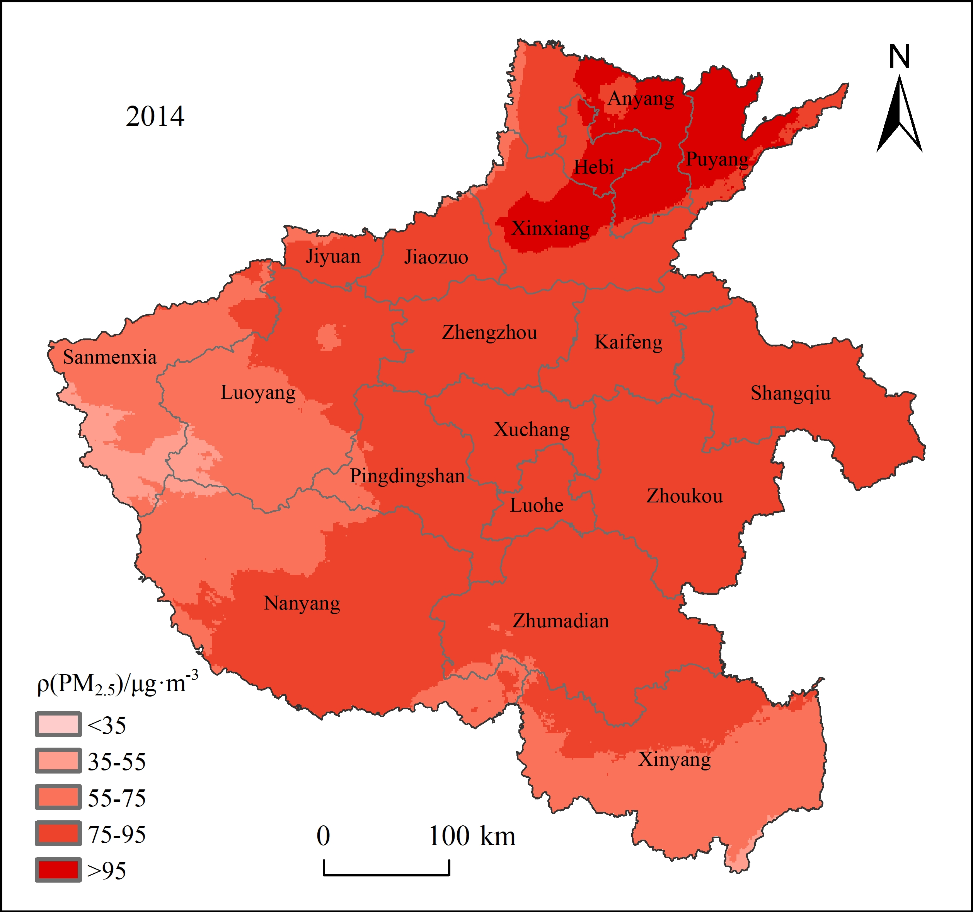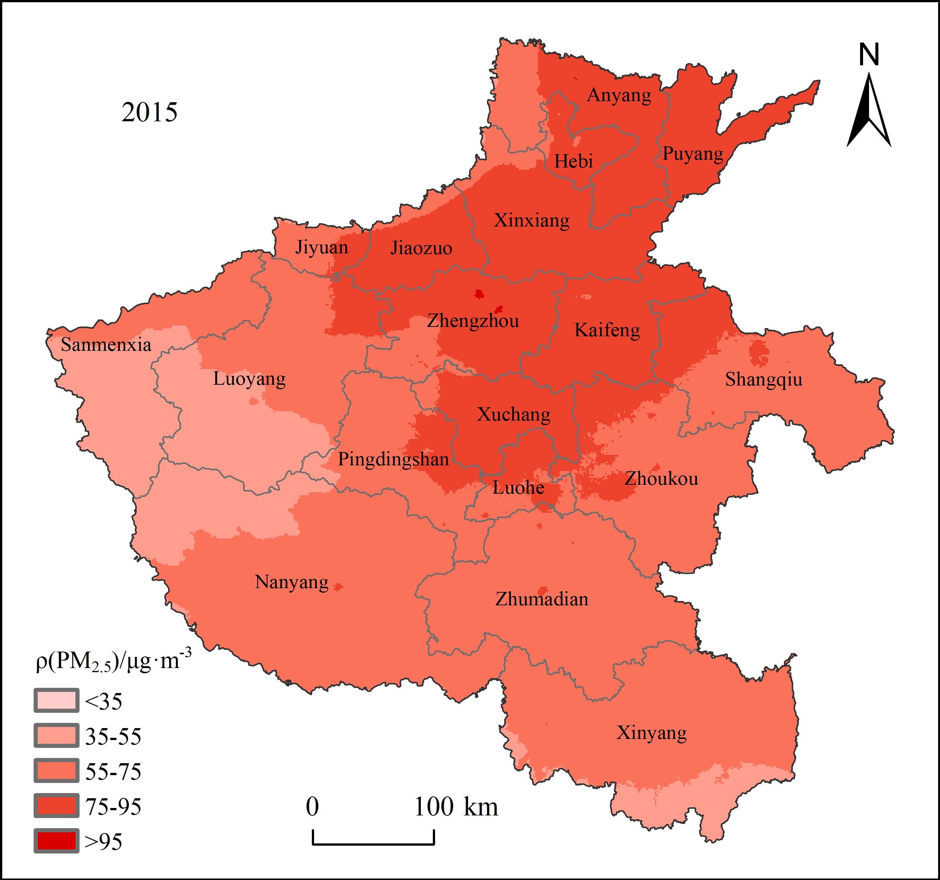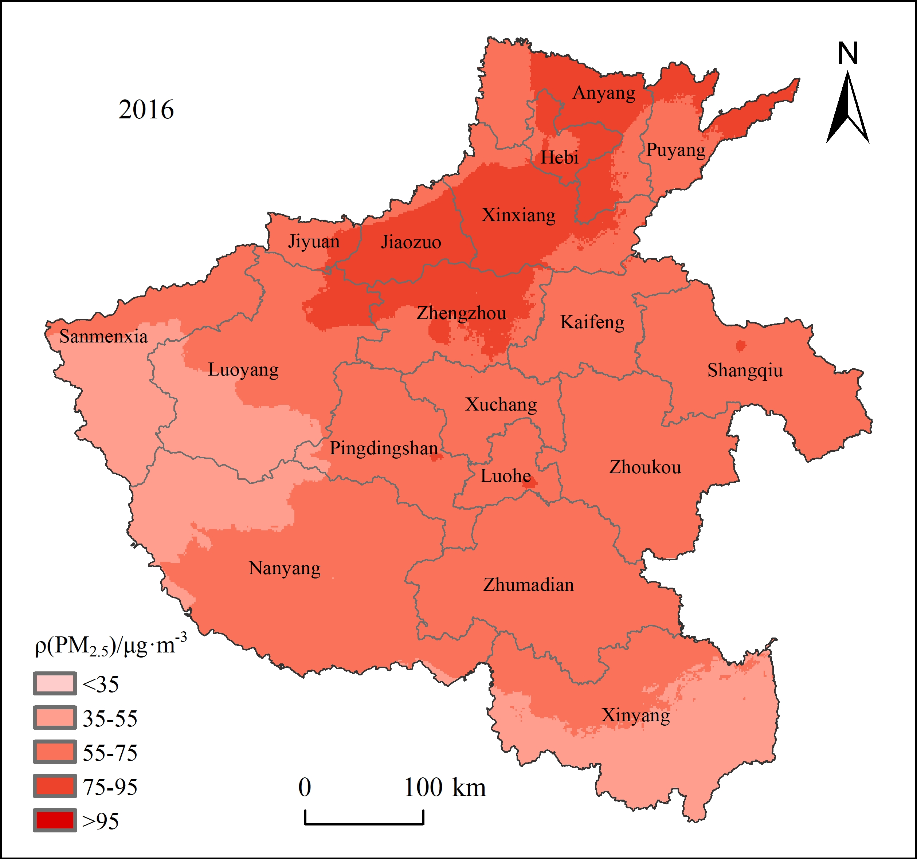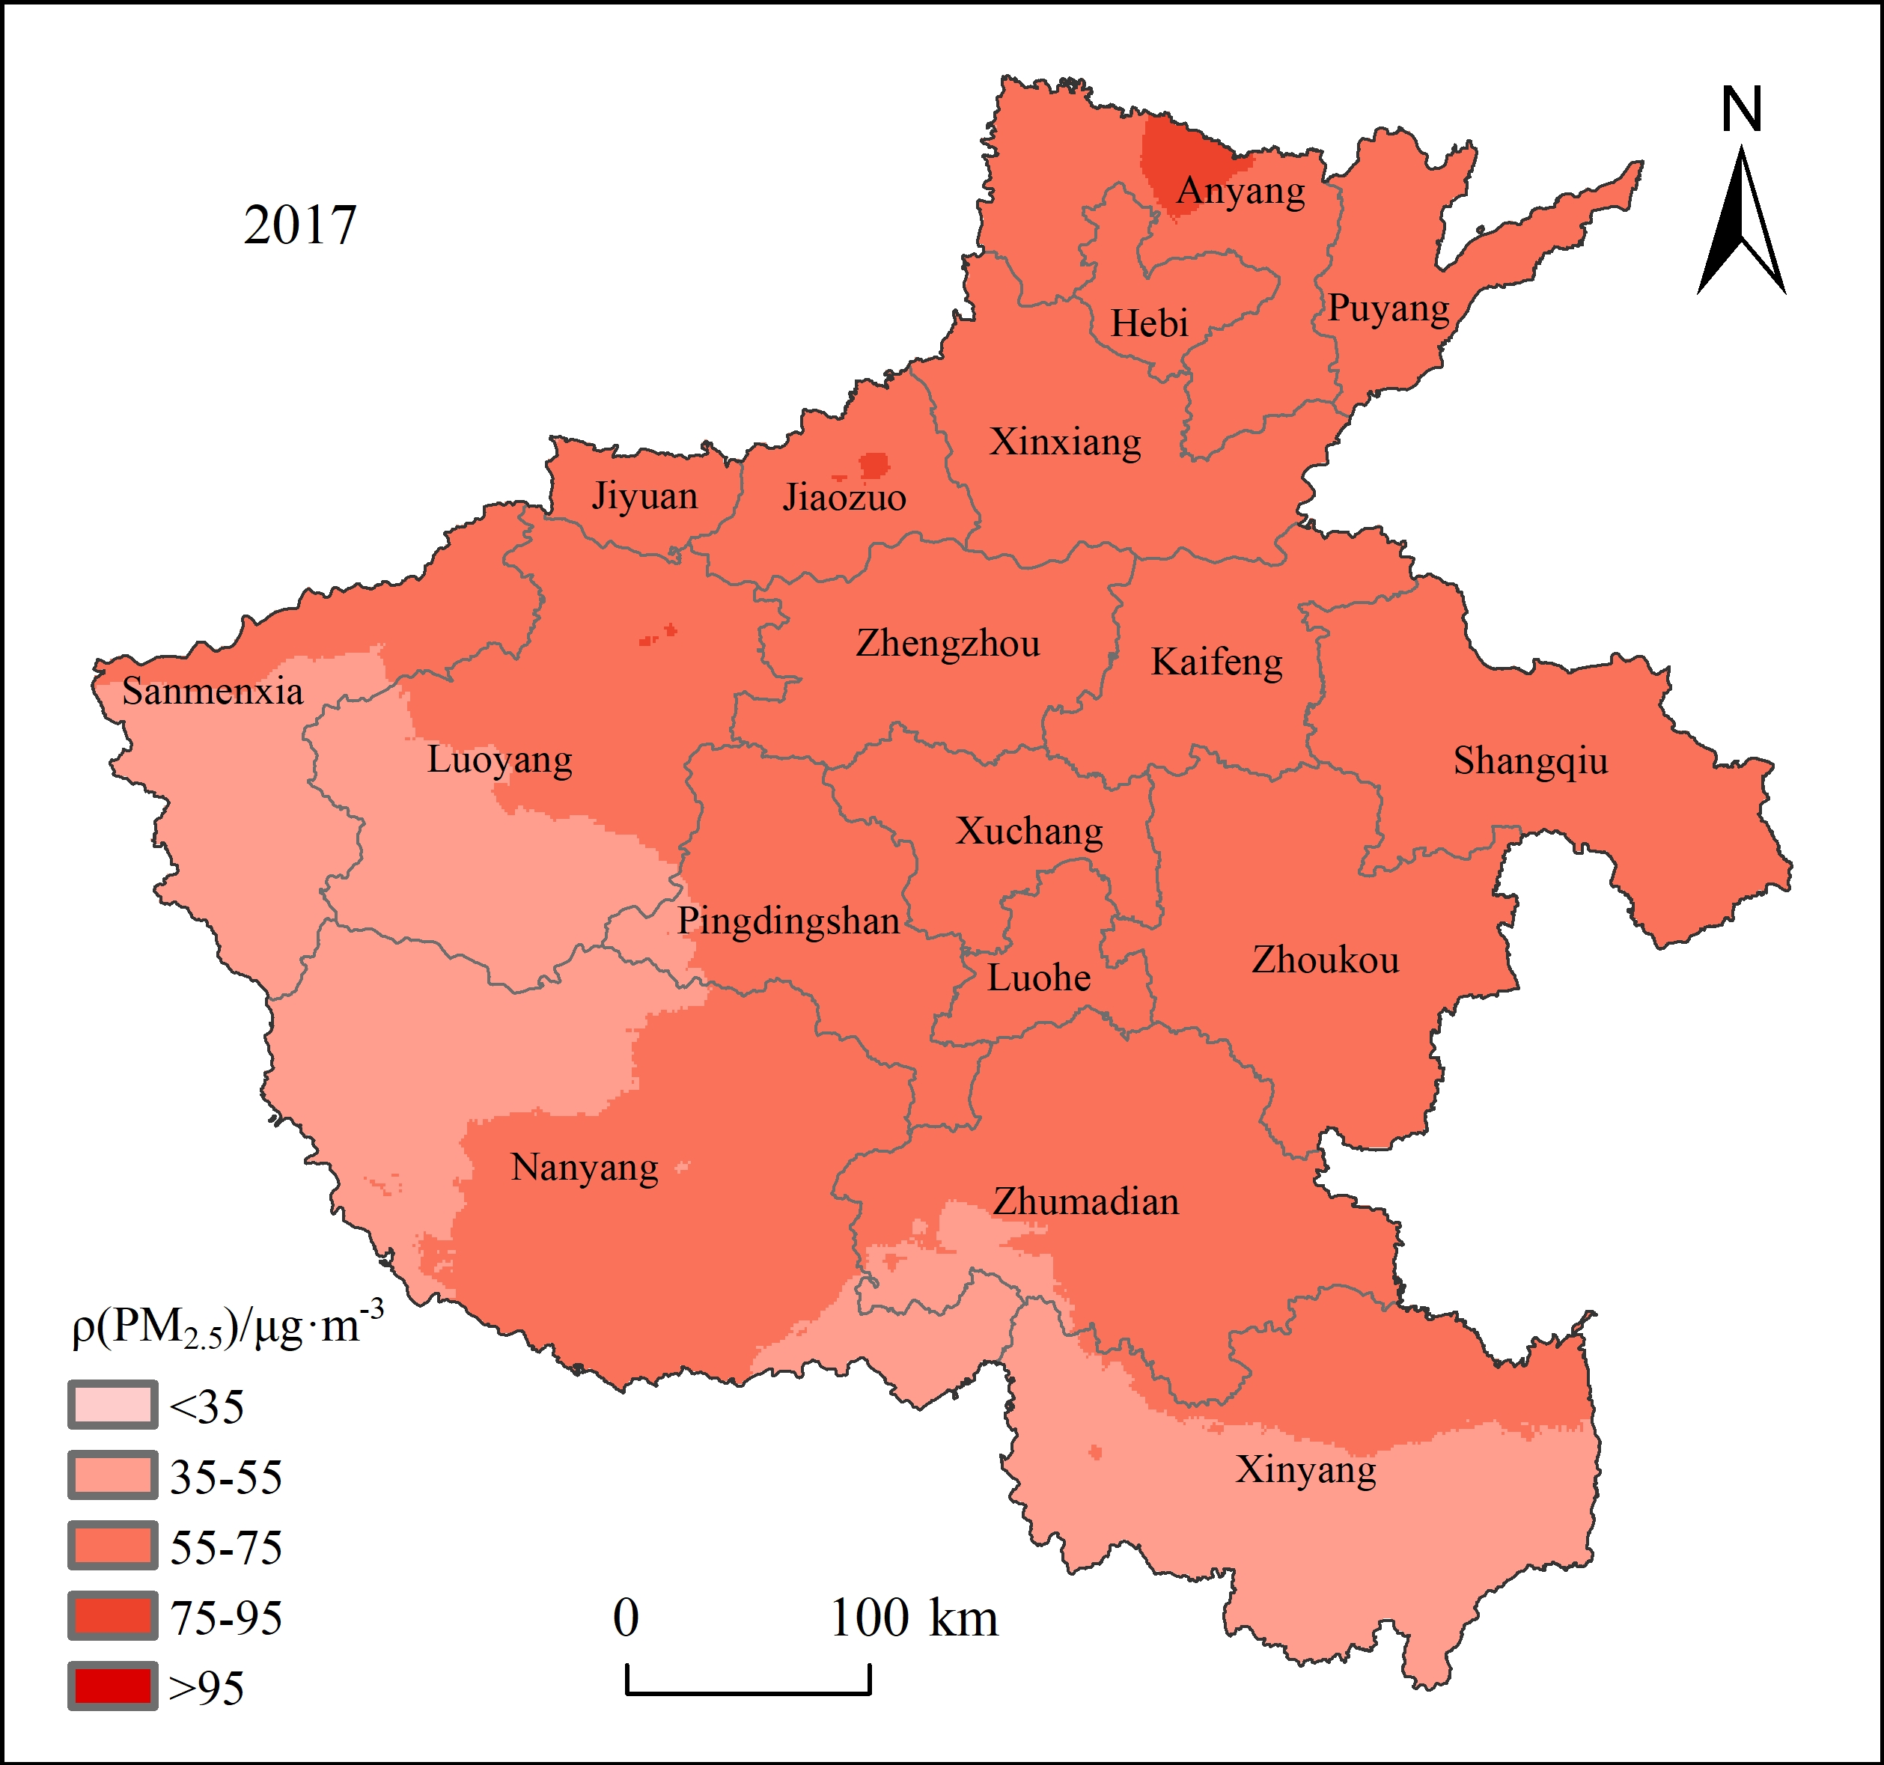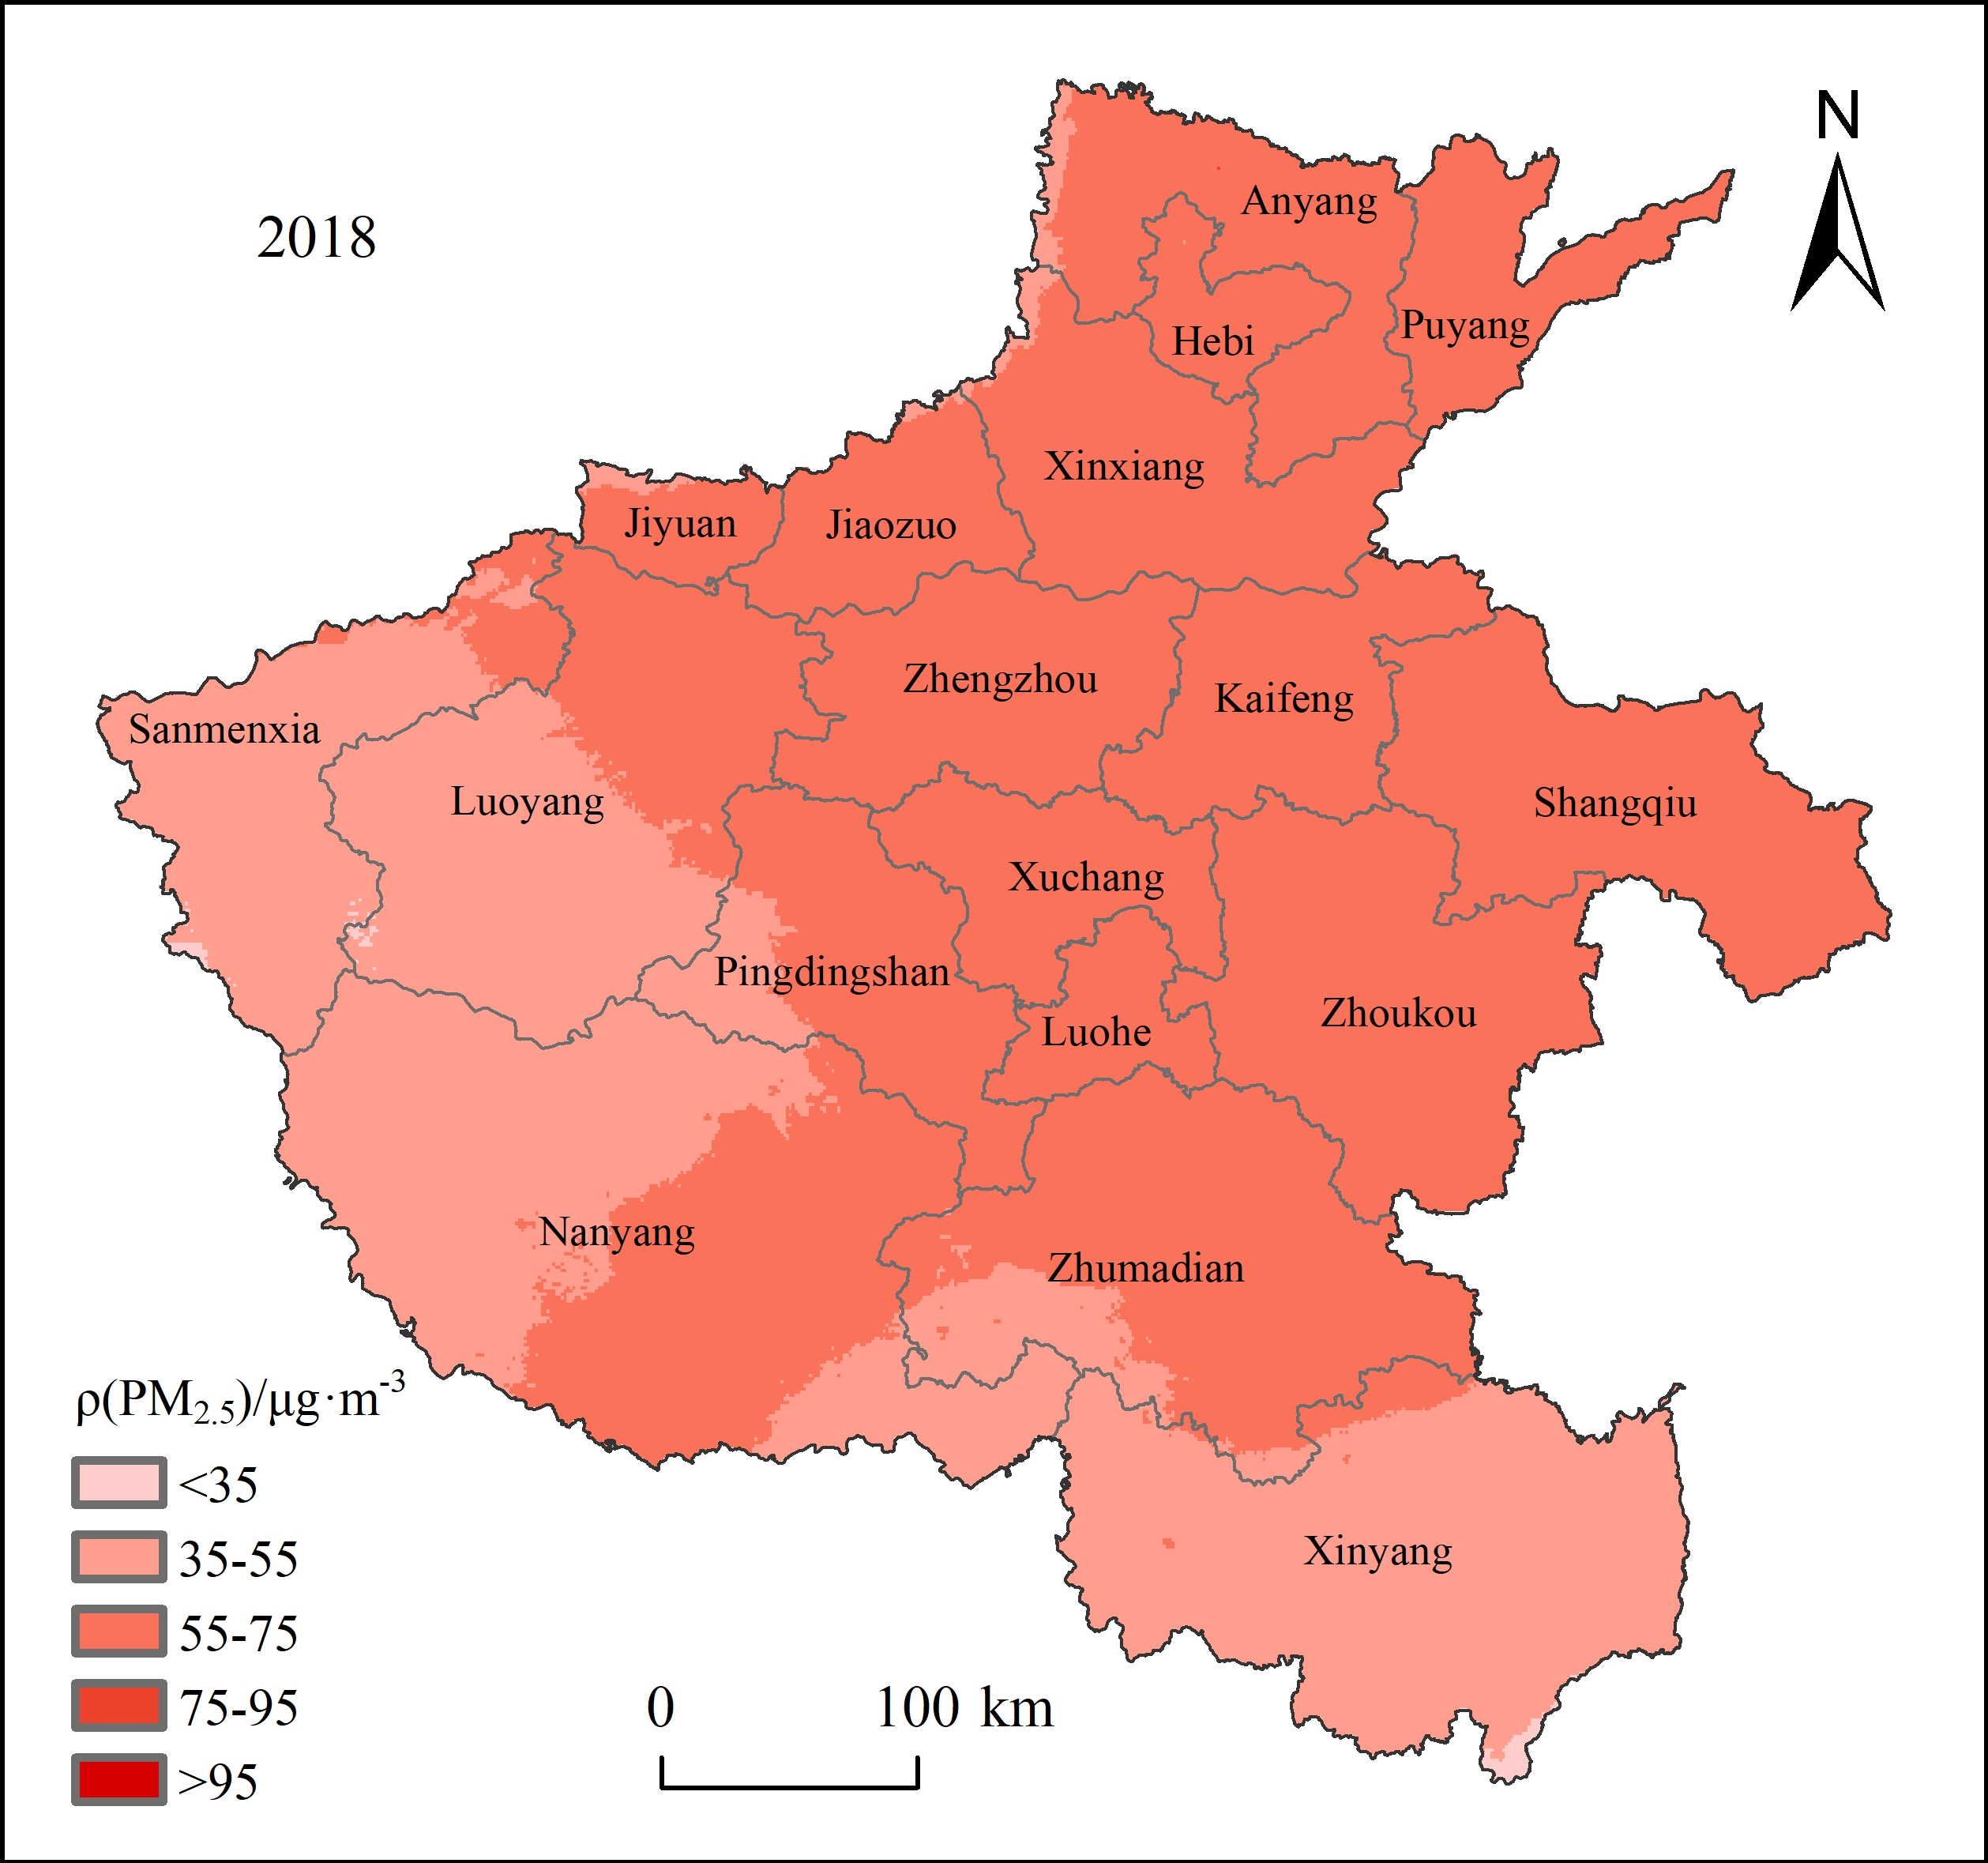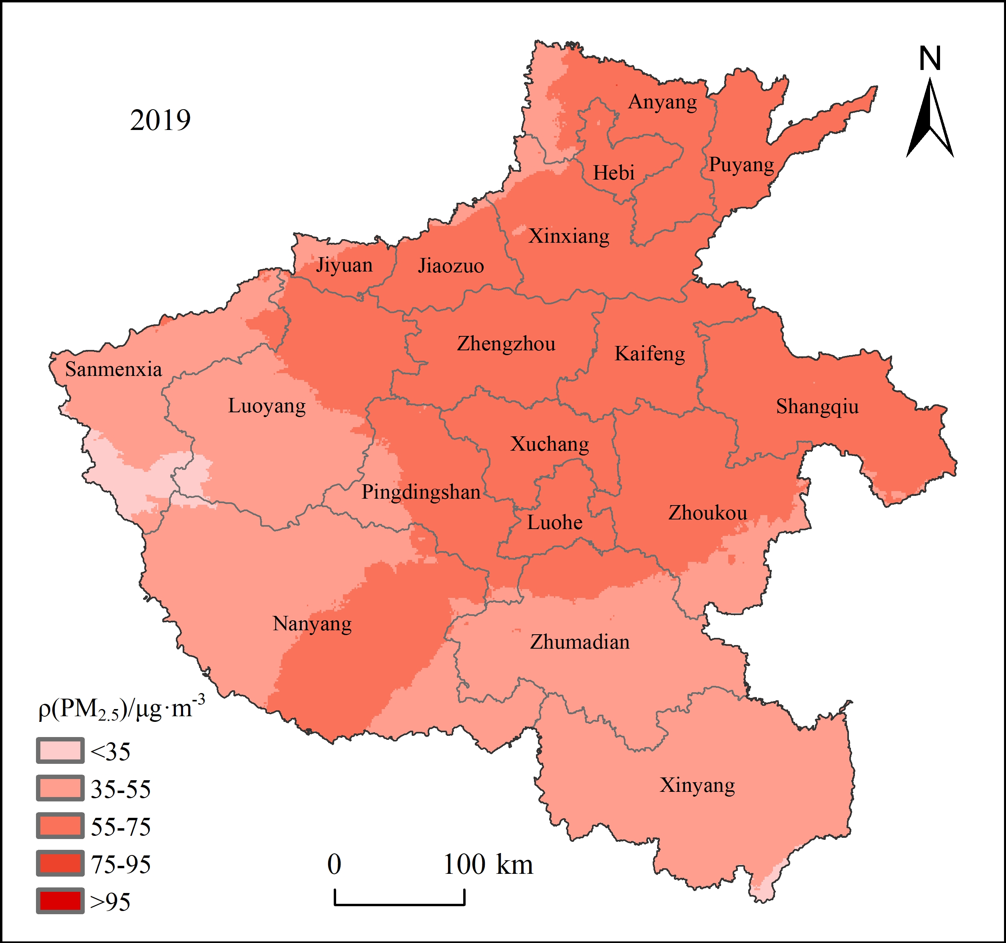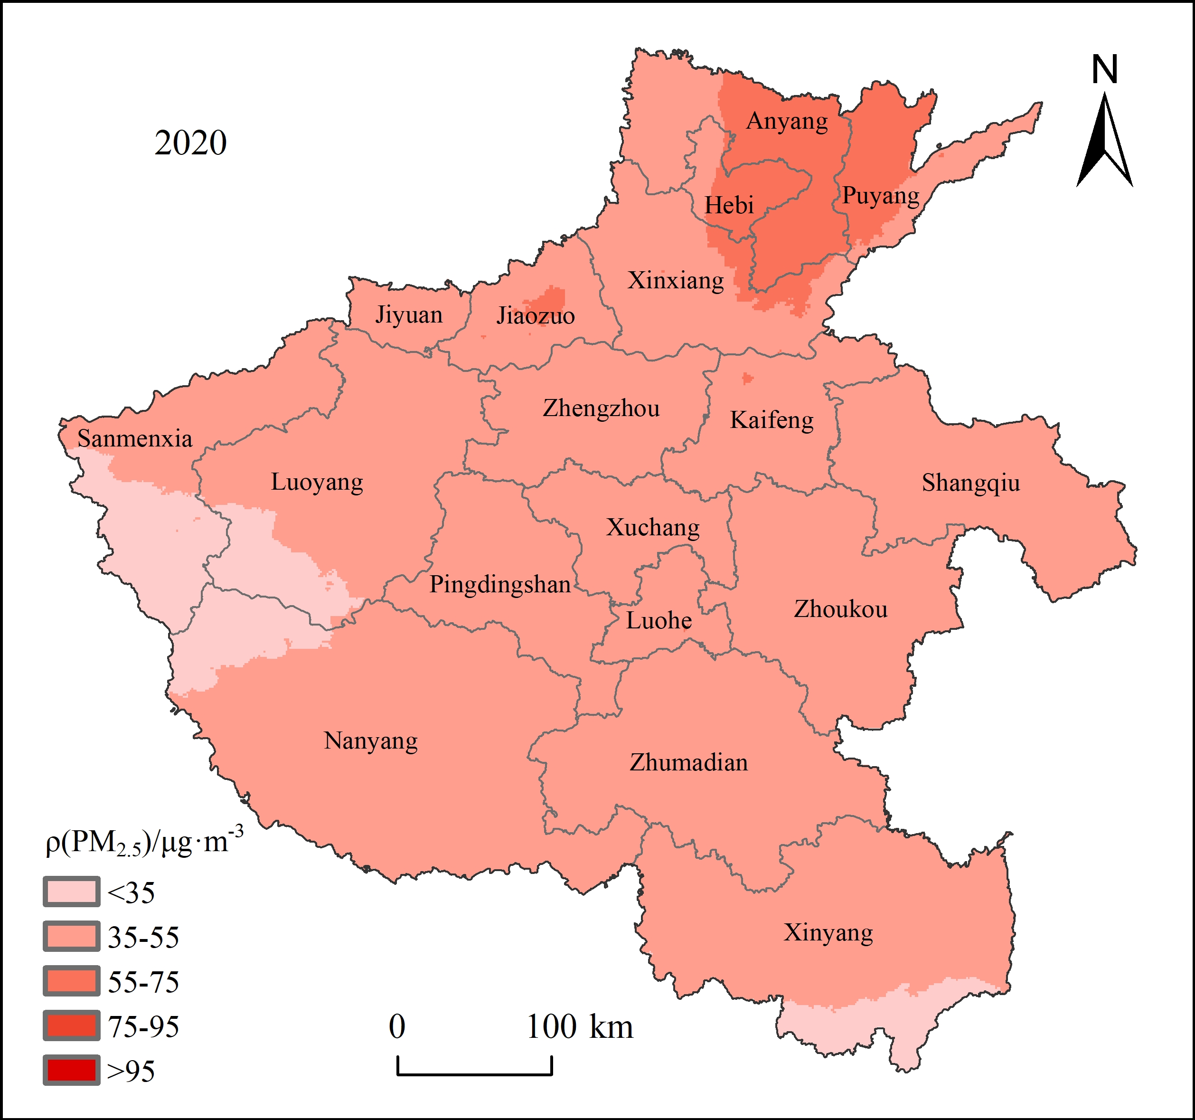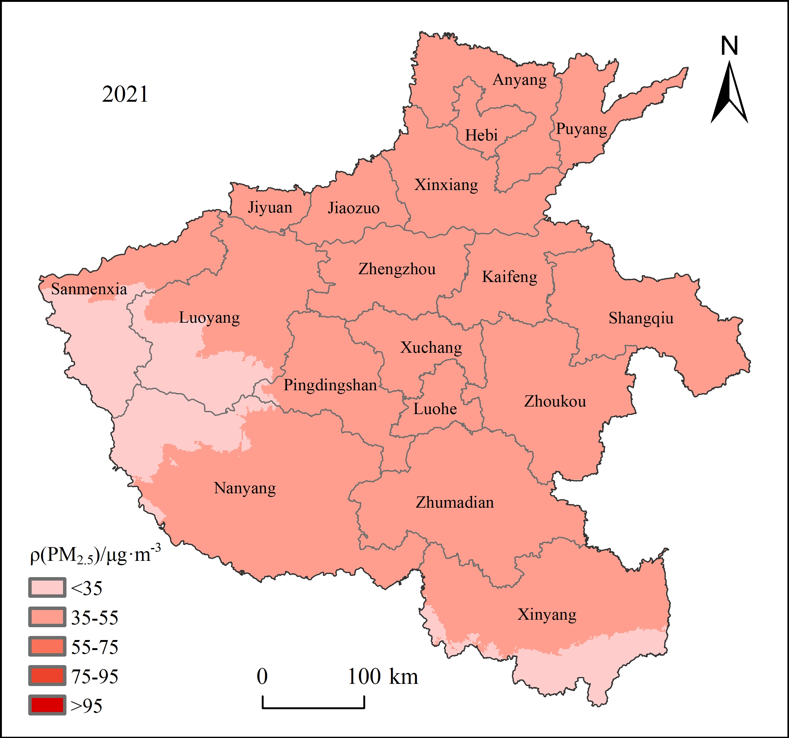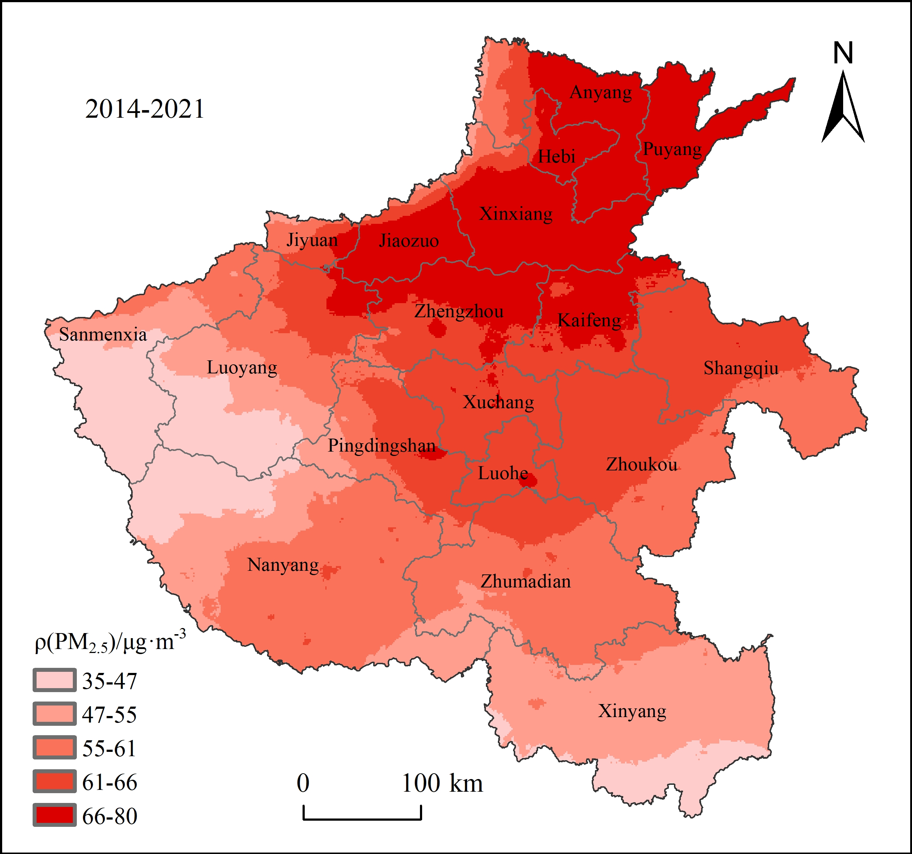
Fig. 1. The spatial distribution of PM_{2.5} concentration in Henan Province from 2014 to 2021

Utilising the ArcGIS spatial analysis platform, the PM_{2.5} concentration raster data and population density raster data for Henan Province were overlaid to obtain the population scale within the range of PM_{2.5} concentration ≥ 35 μg∙m⁻³, representing the exposed population of each prefecture-level city. The spatial distribution of the exposed population in Henan Province can be seen in Figure 2.

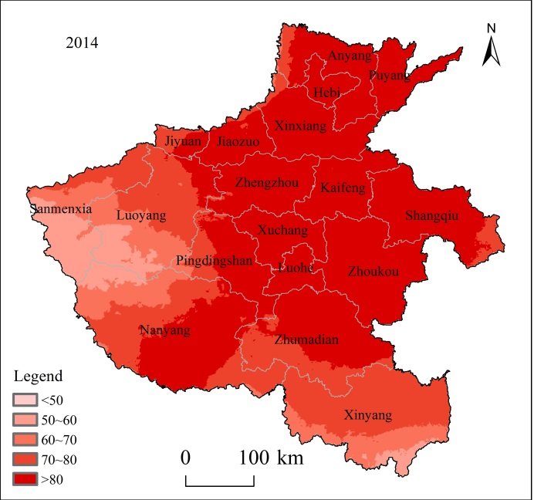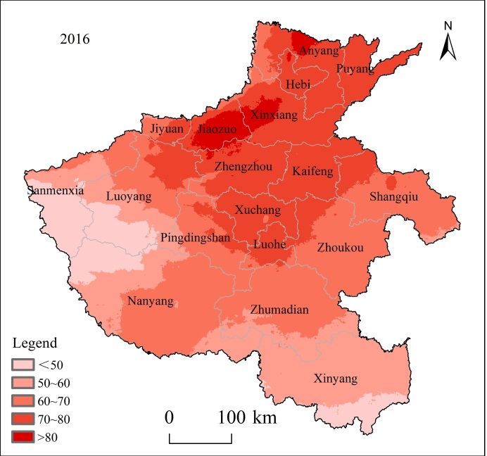

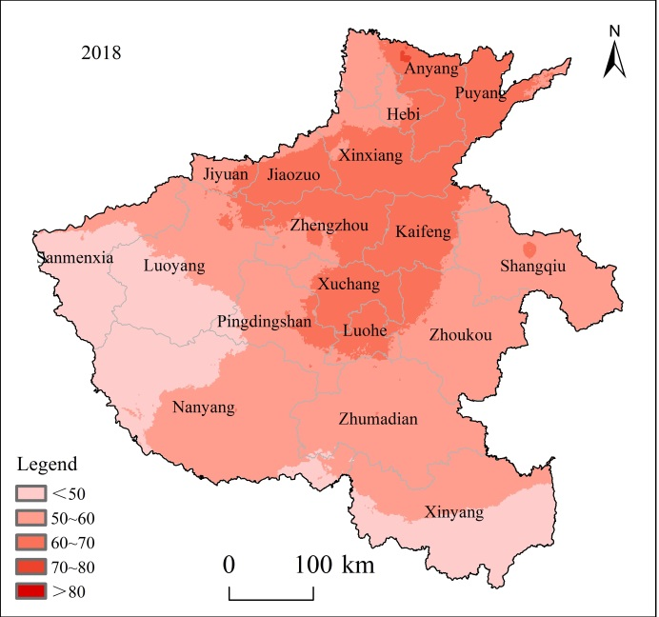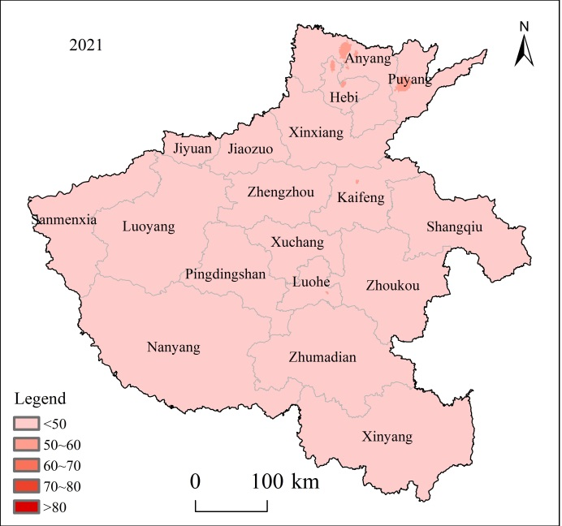
Fig. 2. Spatial Distribution of Exposed Population in Henan Province from 2014 to 2021

The exposed population showed a decreasing trend in Henan Province from 2014 to 2021, gradually shrinking towards the northern regions. In 2014, approximately 58.68% of the provincial area had an exposed population of over 800,000, while areas with less than 500,000 population accounted for less than
0.01% of the total provincial area. The areas with an exposed population of over 800,000 had reduced to 0 in 2021, and areas with less than 500,000 population accounted for 97.88% of the total provincial area, indicating an effective improvement in environmental pollution control in Henan Province.
3.2. Exposure risk assessment
To quantify the temporal and spatial differences in PM_{2.5} pollution in Henan Province and explore the actual PM_{2.5} exposure risk for the population, the difference between the arithmetic annual average concentration of PM_{2.5} and the population-weighted annual average concentration was calculated (Table 1) to assess the spatial relationship between population density and PM_{2.5} concentration.

Table 1. PM_{2.5} Arithmetic Annual Average Concentration and Population-Weighted Annual Average Concentration in Henan Province from 2014 to 2021(μg∙m⁻³)
Year | 2014 | 2015 | 2016 | 2017 | 2018 | 2019 | 2020 | 2021
Population weighted average annual concentration of PM_{2.5} | 81.63 | 70.30 | 65.72 | 61.33 | 56.61 | 54.45 | 48.09 | 42.77
Arithmetic annual average  PM_{2.5} concentration | 80.27 | 68.40 | 64.21 | 60.21 | 55.66 | 53.51 | 47.12 | 42.05

The population-weighted annual average concentration and the arithmetic annual average concentration of PM_{2.5} showed a significant decreasing trend in Henan Province from 2014 to 2021. The population-weighted annual average concentration exhibited a larger variation amplitude of 5.02 μg·m⁻³/year, while the arithmetic annual average concentration had a frequency of 4.89 μg·m⁻³/year; both passed the 0.01 significance level test. The analysis of the difference between the two is shown in Figure 3.

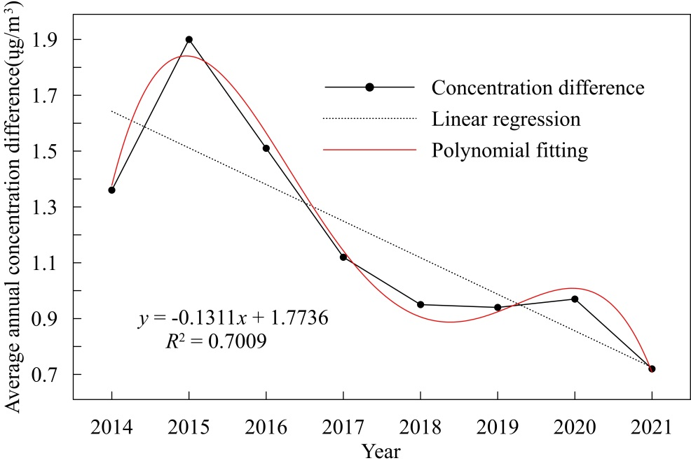
Fig. 3. Difference between PM_{2.5} Arithmetic Annual Average Concentration and PM_{2.5} Population – Weighted Annual Average Concentration in Henan Province from 2014 to 2021

The population-weighted annual average concentration of PM_{2.5} in Henan Province from 2014 to 2021 consistently exceeded the arithmetic annual average concentration. This indicated a clear spatial matching relationship between population density and PM_{2.5} concentration within the region, where areas with higher population density exhibited higher PM_{2.5} concentrations and vice versa. A polynomial fitting of the difference between the two annual average concentrations showed fluctuating trends of increase, decrease, increase, and decrease, but a linear fit revealed an overall significant decreasing trend with a frequency of 0.13 μg·m⁻³/year, passing the 0.01 significance level test. In general, there was a high spatial matching between population density and PM_{2.5} concentration in Henan Province, with areas of higher population density having higher PM_{2.5} concentrations, leading to a greater exposure risk to PM_{2.5} for the population. However, this spatial matching relationship gradually weakened, and the population's exposure risk gradually decreased.
3.3. Health burden assessment
3.3.1. Disease characteristics analysis
Using the GEMM model, the estimated health burden attributed to PM_{2.5} pollution in Henan Province from 2014 to 2021 is shown in Figure 4.
Fig. 4. PM_{2.5}-Attributed Deaths in Henan Province from 2014 to 2021

The number of PM_{2.5}-attributable mortality in Henan Province decreased from 86,297 in 2014 to 82,667 in 2021. Overall, there was a fluctuating downward trend during the study period, with the highest number of PM_{2.5}-attributable mortality occurring in 2019, followed by 2017, with 94,217 and 93,475 deaths, respectively. The lowest number of PM_{2.5}-attributable mortality occurred in 2021, followed by 2015, with 85,416 deaths in 2015. The overall trend showed a decreasing trend of 173 deaths per year, the regression equation passed the significance level test.
Regarding PM_{2.5}-attributable mortality from specific diseases, ischemic heart disease had the highest number of attributable mortality during the period, averaging 55,072 deaths per year, and the proportion of attributable mortality continued to increase at a frequency of 1,147 deaths per year. The diseases with relatively high attributed death numbers after ischemic heart disease were chronic obstructive pulmonary disease (COPD) and lung cancer, while the attributable mortality from lower respiratory infections were the least, averaging 4,034 deaths per year. The attributable mortality for COPD, lung cancer, and lower respiratory infections all showed a decreasing trend, with reduction frequencies of 1,032, 125, and 162 deaths per year, respectively. Among the four diseases studied, the change rates of PM_{2.5}-attributable mortality for ischemic heart disease and COPD passed the 0.05 and 0.01 significance level tests, respectively, while the change rates for lung cancer and lower respiratory infections did not pass the significance level test.
3.3.2. Regional characteristics analysis
Analysis of the spatial distribution of PM_{2.5}-attributable mortality in Henan Province from 2014 to 2021 (Figure 5) revealed significant spatial differences in the number of PM_{2.5}-attributable mortality. The spatial distribution of PM_{2.5}-attributable mortality differed significantly from the spatial distribution of PM_{2.5} concentration studied earlier, showing the opposite trend of higher in the south, lower in the north, higher in the east, and lower in the west. The area with the highest number of attributable mortality was Nanyang, while the lowest was Hekou. This distinct characteristic might be related not only to spatial differences in population quantity but also to potential mismatches in the spatial distribution of medical resources. In July 2023, the General Office of the People's Government of Henan Province issued the Three-Year Action Plan for the Construction of Medical Service System in Henan Province (2023-2025), aiming to optimise the allocation of medical resources according to practical needs, and accelerated the establishment of a high-quality and efficient medical service system to meet further the growing demand for medical services from the people. In the future, effective control of environmental pollution-attributable mortality will be achieved through environmental protection and improvements in medical resources.

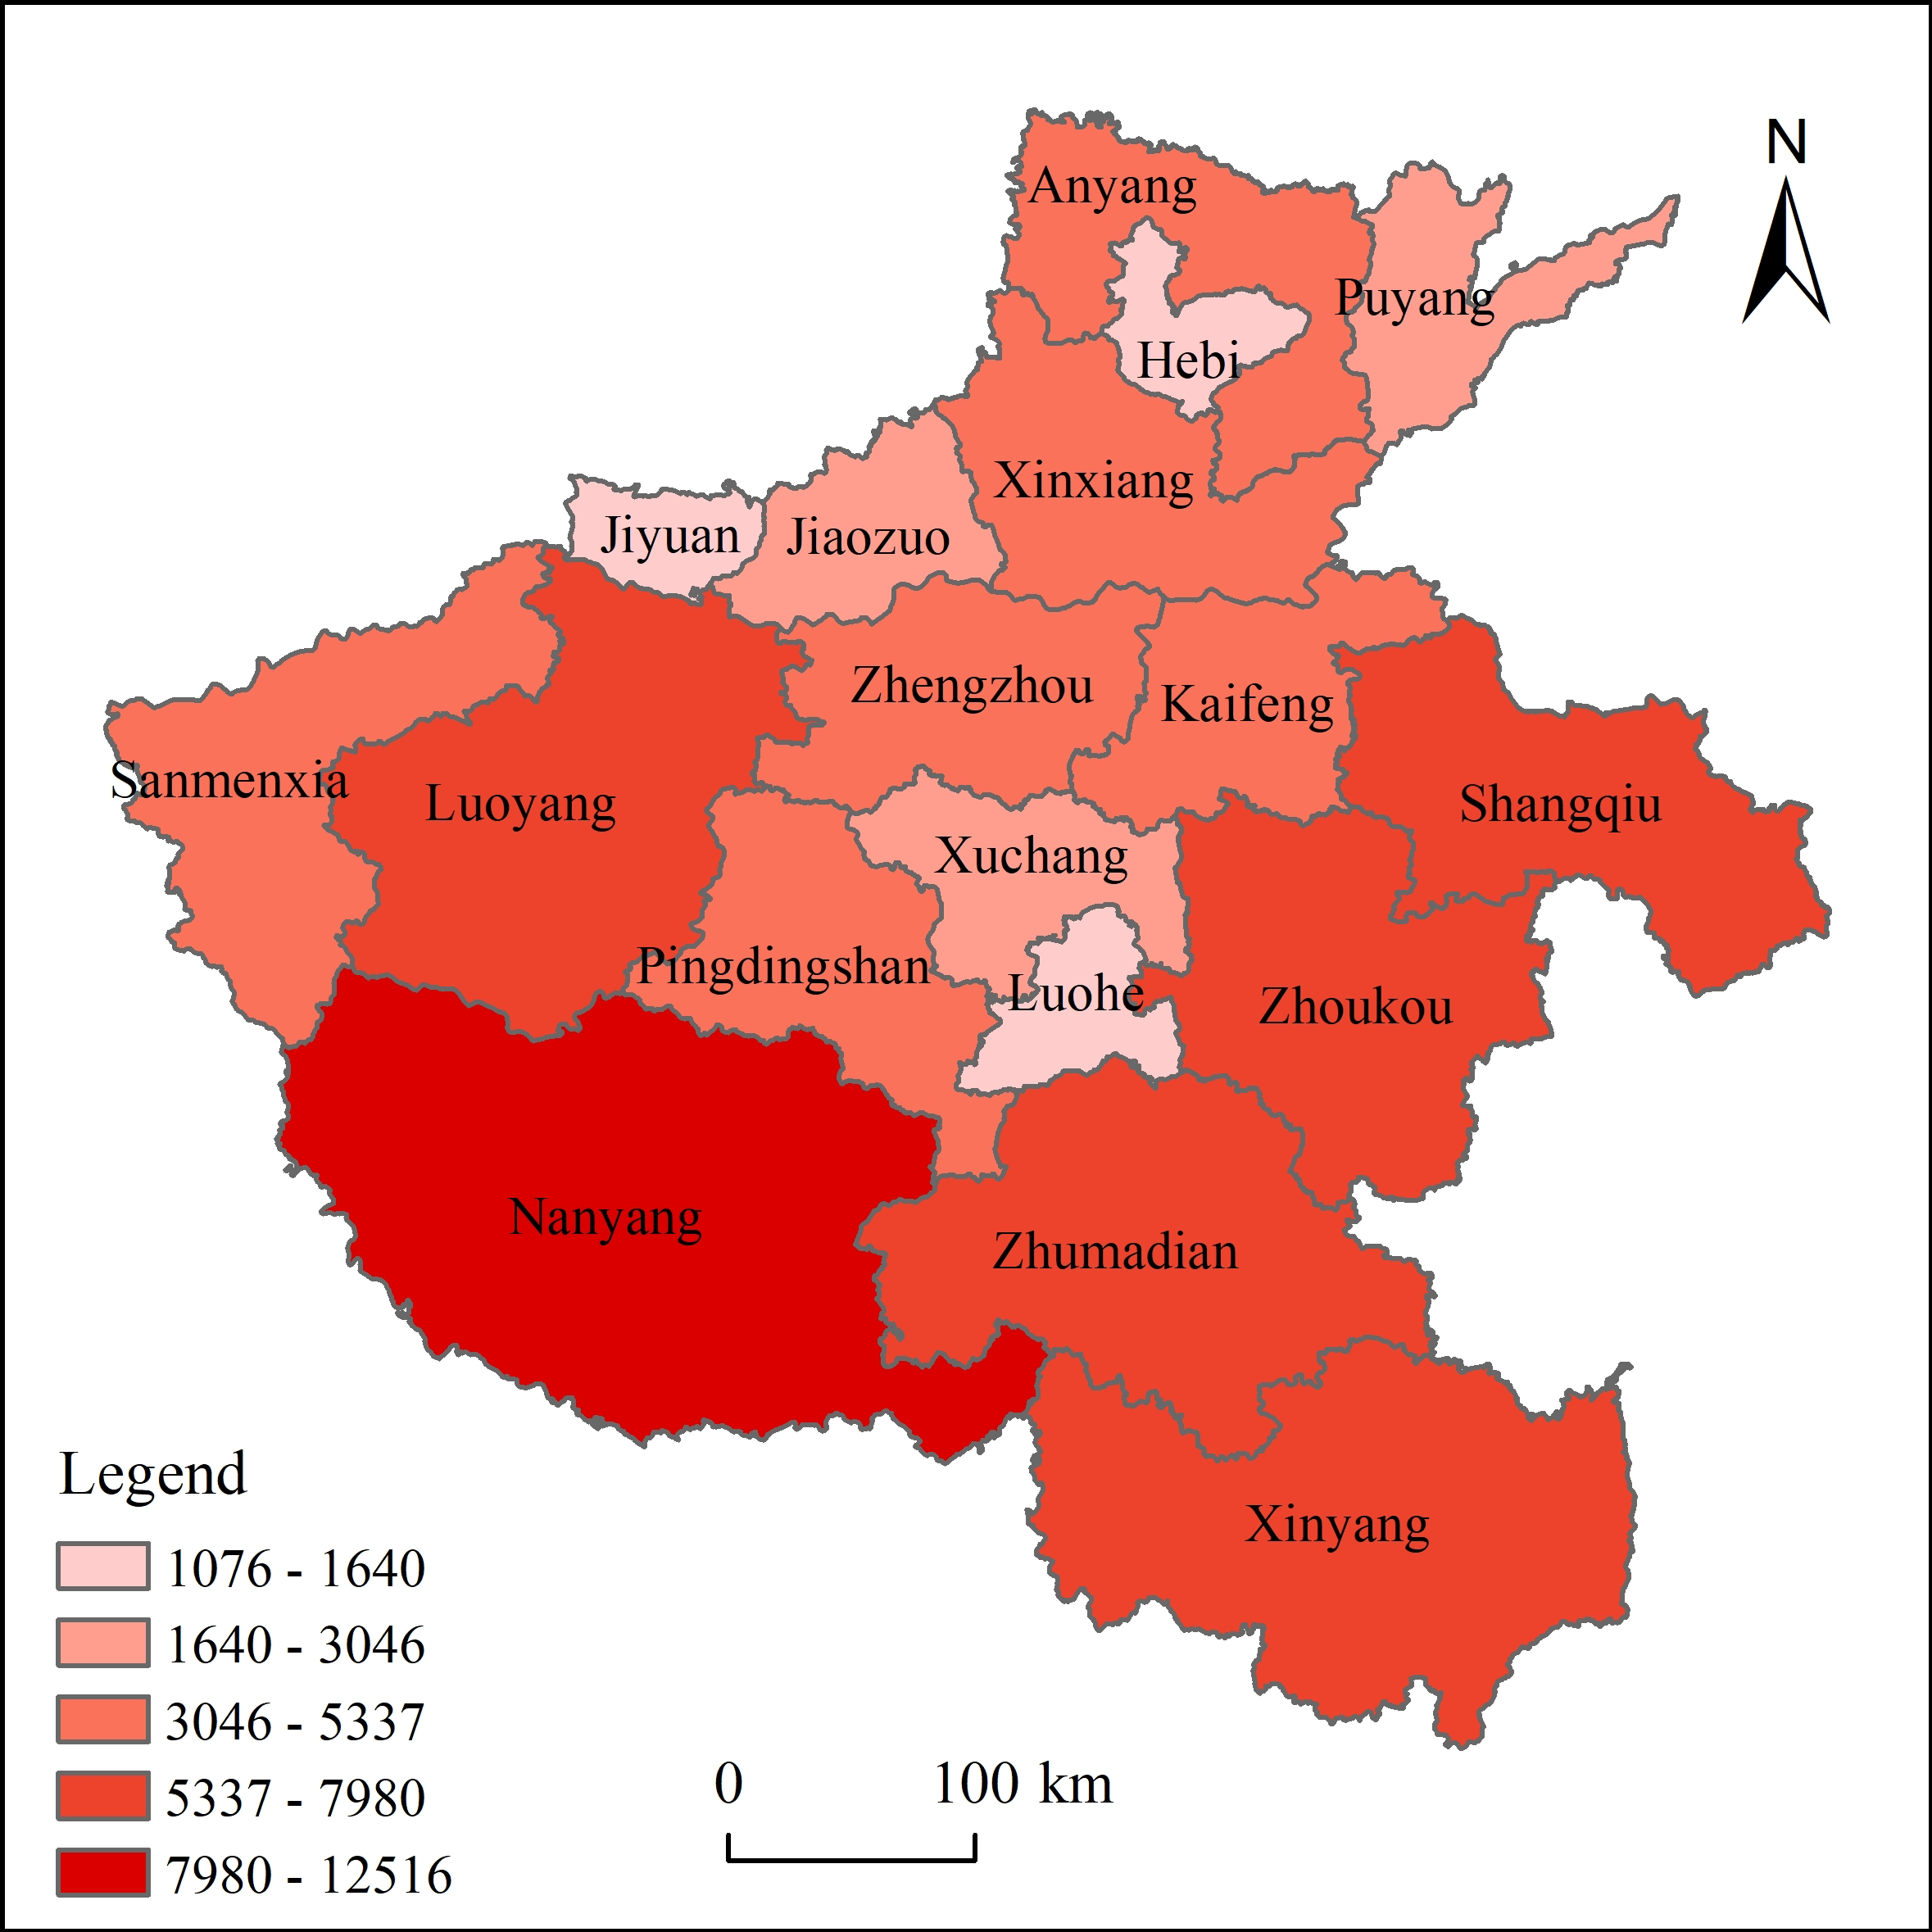
Fig. 5. Spatial distribution of PM_{2.5}-attributed deaths in Henan Province from 2014 to 2021
4. Conclusions and Discussion
This study utilised the data of annual average PM_{2.5} concentration, population distribution, and baseline mortality rate in Henan Province from 2014 to 2021, and applied the latest Global Exposure Mortality Model (GEMM) to estimate the health burden attributed to PM_{2.5} in Henan Province. The findings are as follows:
(1) The PM_{2.5} concentration in Henan Province showed a significant decreasing trend from 2014 to 2021. Spatially, it exhibited a distribution pattern of higher in the north and lower in the south, higher in the east and lower in the west. The population exposed to high PM_{2.5} levels gradually decreased towards the northern region. The proportion of areas with over 800,000 people exposed to PM_{2.5} decreased from approximately 58.68% in 2014 to 0 in 2021, while the proportion of areas with less than 500,000 people exposed to PM_{2.5} increased from 0 in 2014 to 97.88% in 2021.
(2) The population-weighted annual average PM_{2.5} concentration in Henan Province between 2014 and 2021 was consistently higher than the arithmetic average concentration. The spatial distribution of population density closely matched with PM_{2.5} concentration, although this spatial relationship gradually weakened over time. The population exposure risk to PM_{2.5} gradually decreased.
(3) PM_{2.5}-attributable mortality showed a fluctuating downward trend in Henan Province from 2014 to 2021. The year with the highest number of attributable mortality was 2019, followed by 2017. The years with the fewest attributable mortality was 2021, followed by 2015. Ischemic heart disease had the highest number of attributable mortality during the study period, with an average annual death toll of 55,072, showing an increasing trend at a rate of 1,147 people per year. Chronic obstructive pulmonary disease (COPD) and lung cancer had relatively higher proportions of attributable mortality, while lower respiratory tract infections had the fewest attributable mortality, with an average annual death toll of 4,034, gradually decreasing at rates of 1,032, 125, and 162 people per year, respectively. Moreover, there were significant spatial differences in PM_{2.5}-attributable mortality, with more deaths in the south and fewer in the north. The difference in distribution between the East and West was less pronounced. The city with the highest number of attributable mortality was Nanyang, while the city with the fewest was Hebi.
This study analysed PM_{2.5} concentration changes, population exposure risk, and health burden in Henan Province from a macro perspective. Further research could explore the spatiotemporal variations in PM_{2.5} concentration and population distribution in Henan Province in more detail. For example, the seasonal variations in PM_{2.5} concentration and the sensitivity analysis of PM_{2.5}-attributable mortality to different age groups could be investigated. Additionally, using baseline mortality rate data from the central region of China to represent the entire study area may introduce some bias, which could be improved in future research.

This work was supported by the National Natural Science Foundation of China (NSFC) (Grant No. 42371255) and the Natural Science Foundation of Henan Province of China (Grant No. 182300410114).
References
Brunekreef, B., Strak, M., Chen, J., Andersen, Z.J., Atkinson, R., Bauwelinck, M., … Hoek, G. (2021). Mortality and Morbidity Effects of Long-Term Exposure to Low-Level PM_{2.5}, BC, NO₂, and O₃: An Analysis of European Cohorts in the ELAPSE Project. Boston: Health Effects Institute, 5-129. https://pubmed.ncbi.nlm.nih.gov/36106702/
Burnett, R., Chen, H., Szyszkowicz, M., Fann, N., Hubbell, B., Pope, C.A., … Spadaro, J.V. (2018). Global estimates of mortality associated with longterm exposure to outdoor fine particulate matter. Proceedings of the National Academy of Sciences of the United States of America, 115(38), 9592-9597. https://doi.org/10.1073/pnas.1803222115
Cai, Q.N., Che, Y.Z., Sun, L.Y., Tian, J.X., Fang, D.L., Chen, B., Luo, M. (2021). PM2.5 concentration prediction and its health effect in the Pearl River Delta of China. Acta Ecologica Sinica, 41(22), 8977-8990.
Chen, B., Yan, J.W., Luo, Y.N. (2019). Will Haze Promote Public Willingness for Green Investment – Empirical Research Based on SEM. China Population. Resources and Environment, 29(3). https://doi.org/10.12062/cpre.20180923
Chen, S., Liu, Y.Y., Li, S.M., Shi, X.D., Lv, H., Wang, J. (2020). Research on Health Risks and Economic Losses of PM_{2.5} Pollution in Typical Cities of Beijing Tianjin Hebei. Journal of Safety and Environment, 20(3), 1146-1153. https://doi.org/10.13637/j.issn.1009-6094.2019.0615
China Center for Disease Control and Prevention Chronic Non communicable Disease Control and Prevention Center. (n.d.). National Health Commission Statistical Information Center. China Cause of Death Monitoring Dataset (2013-2020). Beijing: China Science and Technology Press.
Chuai, X.M., Han, Y.J., Zhou, H.X., Fan, C. (2022). Evaluation study on health damage caused by PM2.5 in Henan Province from 2015 to 2018. Journal of Henan Polytechnic University (Natural Science), 41(2), 67-76.
Cohen, A.J., Brauer, M., Burnett, R., Anderson, H.R., Frostad, J., Estep, K., … Forouzanfar, M.H. (2017). Estimates and 25-year trends of the global burden of disease attributable to ambient air pollution: an analysis of data from the Global Burden of Diseases Study 2015. The Lancet, 389(10082), 1907-1918.
https://doi.org/10.1016/S0140-6736(17)30505-6
Du, P., Wang, J.Z. (2021). Health Benefit Assessment of PM2.5 Pollution Control in Beijing. Environmental Science, 42(3), 1255-1267. https://doi.org/10.13227/j.hjkx.202005225
Fuller, R., Landrigan, P.J., Balakrishnan, K., Bathan, G., Bose-O'Reilly, S., Brauer, M., … Yan, C. (2022). Pollution and health: a progress update. The Lancet Planetary Health, 6, e535-e547. Elsevier B.V. https://doi.org/10.1016/S2542-5196(22)00090-0
Geng, G.N., Zhang, Y.X., Zhang, Q., Xue, T., Zhao, H.Y., Tong, D., … Davis, S.J. (2021). Drivers of PM2.5 air pollution deaths in China 2002-2017. Nature Geoscience, 14(9), 645-650. https://doi.org/10.1038/s41561-021-00792-3
Gui, K., Che, H., Zheng, Wang, Y.Q., Wang, H., Hang, L., Zhao, H. K., … Zhang, X. ye. (2019). Satellite-derived PM_{2.5} concentration trends over Eastern China from 1998 to 2016: Relationships to emissions and meteorological parameters. Environmental Pollution, 247, 1125-1133. https://doi.org/10.1016/j.envpol.2019.01.056
Hao, Y.P., Song, X.W., Zhu, X.D., Wang, J.W., Cheng, P., Bi, X. (2023). Health Benefit and Scenario Forecast of PM_{2.5} and O₃ in Fenwei Plain. Research of Environmental Sciences, 1-16.
https://doi.org/10.13198/j.issn.1001-6929.2023.12.04
Jia, W.L., Li, L., Lei, Y.L., Wu, S.M. (2023). Synergistic effect of CO₂ and PM_{2.5} emissions from coal consumption and the impacts on health effects. Journal of Environmental Management, 325. https://doi.org/10.1016/j.jenvman.2022.116535
Li, F., Guo, J.Y., Qu, Z.G., Yan, J.J., Kong, S.J., Zhou, Y.Y., Ou, C.H. (2023). Temporal and Spatial Evolution of PM_{2.5} in the Yangtze River Economic Belt and Evaluation of Health Economic Benefits. Safety, Health and Environment, 23(11), 48-59. https://doi.org/10.3969/j.issn.1672-7932.2023.11.009
Liao, L.X., Chen, J. (2022). Study on the Spatiotemporal Characteristics and Influencing Factors of Population Exposure to Particulate Matter (PM_{2.5}) in Henan Province. Journal of Fujian Normal University (Natural Science Edition), 38(1), 59-68. https://doi.org/10.12046/j.issn.1000-5277.2022.01.008
Liao, Q., Li, Y., Tao, Y. (2023). Spatiotemporal Trends and Driving Factors of PM_{2.5} – related Health Burden in Gansu Province, China from 2013 to 2020. Environmental Science. https://doi.org/10.13227/j.hjkx.202308073
Liu, L.Y., Zhang, J. (2023). Spatial-temporal Evolution of PM_{2.5} Population Exposure Risk in Urban Agglomerations in Guanzhong Plain. Envioonmental Science and Management, 48(6),49-54.
Liu, X.Y., Zhang, Y.D., Yan, J.H., Zhang, X.M., Zhao, C.M. (2022). Assessing the Influence of Anthropogenic Emissionsons on Fine Particulate Matter and Ozone in Xinyang. Journal of Xinyang Normal University, 36(2), 190-195. https://doi.org/10.3969/j.issn.1003-0975.2023.02.004
Lu, X.C., Chen, Y., Huang, Y.Q., Chen, D.H., Shen, J., Lin, C.Q., … Lau, A.K.H. (2020). Exposure and mortality apportionment of PM_{2.5} between 2006 and 2015 over the Pearl River Delta region in southern China. Atmospheric Environment, 231. https://doi.org/10.1016/j.atmosenv.2020.117512
Murray, C.J.L., Aravkin, A.Y., Zheng, P., Abbafati, C., Abbas, K.M., Abbasi-Kangevari, M., … Lim, S.S. (2020). Global burden of 87 risk factors in 204 countries and territories, 1990-2019: a systematic analysis for the Global Burden of Disease Study 2019. The Lancet, 396(10258), 1223-1249.
https://doi.org/10.1016/S0140-6736(20)30752-2
Wang, Z.G., Hu, B.F., Zhang, C., Atkinson, P.M., Wang, Z.F., Xu, K., … Shi, Z. (2022). How the Air Clean Plan and carbon mitigation measures co-benefited China in PM_{2.5} reduction and health from 2014 to 2020. Environment International, 169. https://doi.org/10.1016/j.envint.2022.107510
Wei, T., Li, Z.L., Chen, Y., Zhao, X.G., Wang, D.L., Hou, Y.X., Liu, F. (2023). Assessment of the health benefits of declining PM_{2.5} levels in the Yangtze River Delta. China Environmental Science, 43(6), 3211-3219. https://doi.org/10.19674/j.cnki.issn1000-6923.20230223.001
World Health Organization (WHO). (2021). WHO global air quality guidelines: Particulate matter (PM_{2.5} and PM₁₀), ozone, nitrogen dioxide, sulfur dioxide and carbon monoxide. https://www.who.int/publications/i/item/9789240034228
Xiao, Q.Y., Geng, G.N., Xue, T., Liu, S.G., Cai, C.L., He, K. Bin, Zhang, Q. (2022). Tracking PM_{2.5} and O₃ Pollution and the Related Health Burden in China 2013-2020. Environmental Science and Technology, 56(11), 6922-6932. https://doi.org/10.1021/acs.est.1c04548
Xu, F.J., Huang, Q.X., Yue, H.B., Feng, X.Y., Xu, H.R., He, C.Y., … Bryan, B.A. (2023). The challenge of population aging for mitigating deaths from PM_{2.5} air pollution in China. Nature Communications, 14(1). https://doi.org/10.1038/s41467-023-40908-4
Xue, T., Liu, J., Zhang, Q., Geng, G.N. (2020). Rapid improvement of PM_{2.5} pollution in China from 2013 to 2017 and its health benefits. Science China Press, 50(4), 441-452. https://doi.org/10.1360/sste-2019-0245
Zhang, X.Y., Hu, H.B. (2018). Risk Assessment of Exposure to PM_{2.5} in Beijing Using Multi-Source Data. Acta Scientiarum Naturalium Universitatis Pekinensis, 54(5), 1103-1113.
https://doi.org/10.13209/j.0479-8023.2018.031
Zhou, L., Niu, Y., Chen, R.J., Kan, H.D. (2023). Assessment of PM2.5-related mortality burden and health economic loss in Shanghai. China Environmental Science, 43(7).
https://doi.org/10.19674/j.cnki.issn1000-6923.20230314.001

