 | Rocznik Ochrona Środowiska
 | Volume 26 | Year 2024 ISSN 2720-7501 | pp. 217-225
 | https://doi.org/10.54740/ros.2024.022 open access
 | Received: January 2024 Accepted: February 2024 Published: June 2024
Understanding Dynamics of Land Cover Changes Using GIS Technique in a River Catchment with High Altitude Differences – an Analysis from Kosovo
Valbon Bytyqi¹*, Tropikë Agaj²
¹Department of Geography, FMNS, University of Pristina, Kosovo
https://orcid.org/0000-0002-8625-1470
²University of Life Sciences, Poznan, Poland
https://orcid.org/0000-0001-8154-7013
*corresponding author's e-mail: valbon.bytyqi@uni-pr.edu
Abstract: This article analyses Land Cover Changes in the Lumbardhi of Prizreni (LP) River catchment in southern Kosovo. As a landlocked country, Kosovo has highly diverse landform features. LP River catchment is located in Sharri's transboundary high mountain range and the southern part of Dukagjini Plain. In the last two decades, the landscape has experienced a transformation in land cover changes, especially in the increasing of artificial surfaces in the plains. Using GIS techniques, data were calculated for the selected years, and their dynamics were visualised for the last two decades. The analysis shows a decrease in agricultural land and complex cultivation patterns (-806 ha), an increase in artificial surface, especially discontinuous urban fabric (+354 ha), and small changes in forest and seminatural areas, which are primarily included in "Sharri" National Park.
Keywords: Lumbardhi of Prizreni, Land Cover/Land Use (LULC), agricultural land, discontinuous urban fabric, "Sharri" National Park
1. Introduction
In recent decades, anthropogenic impact on the natural landscape has increased rapidly (Schneider 2012, Winkler et al. 2021), even in protected areas (Getzner & Švajda 2015). Land cover features indicate the relationship between human activities, landscape transformation, and nature in general (Gaitanis et al. 2015). As a small country, Kosovo has diverse natural features, with high-altitude mountains surrounding tectonic plains in the middle. Rapid urbanisation has had its impact with the increasing population number and migration towards the plains. Many studies state that the urban population is increasing rapidly worldwide (Cleland 2013), and extensive landscape fragmentation results from scattered natural vegetation (Ramalho et al. 2014).
Human activities as a driving force have played a role in pressing issues in the landscape (Wolf et al. 2023), where environmental sustainability has become an issue of the modern age. Earth's terrestrial surface and its transformation refers to Land Use/Land Cover Changes (LULC). Rapid urbanisation, agricultural land reduction, deforestation, and other changes are related to heat islands and urban climate or water resource imbalance (Xu et al. 2023). Rapid urbanisation has led to cover and water balance changes (Schlesinger & Jasechko 2014), biodiversity loss (Newbold et al. 2015), and soil alteration and degradation (Smith et al. 2015). Some changes have local or regional impacts, and in the Earth system, they are related.
The second part of the XX and the XXI century are marked by intensive land use (Lambin et al. 2001, Matson et al. 1997), where alteration, fragmentation, and loss of natural areas happened (Falcucci et al. 2009). After the agricultural revolution, land use was the oldest anthropogenic environmental activity (Cegielska et al. 2018). However, later, with the appearance of industrialisation, the scale of changes was massive and developed rapidly (Nuissl et al. 2021), and some studies have paved the way to Anthropocene (Ellis 2021).
Environmental changes have become a global issue, and academic attention has increased. In Europe, humans have changed the landscape for millennia, where most transformations were done towards agricultural land resulting in landscape changes in human-Earth's system interaction. Every region has its spatial pattern of land use and land changes (Kuemmerle et al. 2016). Estimations of the global population have predicted that at the end of 2050, the urban population will increase to 70%, and Kosovo will be affected too. In contrast, an increase in the urban population will pressure agricultural land and natural habitats.
The Balkan Peninsula, especially the Western Balkans, where Kosovo belongs, is distinguished by diverse geographies and unique habitats (Hyka et al. 2022), with the remaining wild areas, like the Sharr Mountains, serving as biodiversity hot-spots (Miho et al. 2023), very abundant with freshwaters like LP is, where, with the declaration of its areas as national park, natural values have been preserved.

Kosovo has experienced land cover transformation in the last two decades, mostly shifting agricultural land, forests and seminatural areas towards artificial surfaces. Plains have served as agricultural land, but lately, intensive urbanisation has decreased the area of agricultural land and increased the area of artificial surfaces. According to landscape metrics, land cover is experiencing not only a formal transformation in cover type but also changes in number of patches and their size. LP, as one of the catchments of Drini i Bardhë (White Drin), is located mostly in the Sharr Mountains, and its highest altitude belongs to the national park, protected since 1986, but human imprints are obvious. The lowest altitude of the catchment belongs to Dukagjini Plain, where rapid urbanisation has been developed in the last 20 years, shifting artificial surfaces towards agricultural land and transforming the landscape into a discontinuous urban fabric. It is important to mention nature preservation through "Sharri" National Park, where landscape transformation shows minimal changes.
In this context, the study reveals relationships between human activities in a part of Kosovo with diverse physiographical features, the presence of a national park, and a part with rapid urbanisation, where landscape transformation has been done on a diverse scale in the last two decades.
2. Materials and Methods
Land cover change data from the Copernicus Land Monitoring Service (CLMS) were downloaded and analysed in the ArcMap 10.8 environment. Raster and vector data (shapefiles) containing information about land cover, their distribution and other metric information were extracted for the LP River catchment and later analysed, interpreted, and finally, thematic maps were prepared. The GIS technique is useful for comparing and finding differences for selected years (2000, 2006 and 2018). Land cover data, including physiographical factors like altitude, slope, aspect, and human driving forces like urbanisation, were intersected, and the main conclusions were found. Population statistics from the official census for selected settlements were used to compare the temporal and spatial changes in population numbers and changes in artificial surfaces in response to land cover classes.

Table 1. Datasets used for Land Cover changes analysis in LP catchment
Data/maps | Resolution/scale | Source of dataset
DEM (altitude, slope, aspect) | 10 m | Kosovo Cadastral Agency
Topographic maps | 1:50,000 | Kosovo Cadastral Agency
Land cover 1990 | 1:25,000 | Former Yugoslavia topographic maps
Land Use/Land Cover (LULC) 2000, 2006, 2018 | 100 m | Copernicus Land Monitoring Service
Population statistics | – | Statistical Agency of Kosovo
3. Results and Discussion
Study areas represent nearly 2.4% of Kosovo's territory. It is located between Kosovo and Northern Macedonia in the high-altitude mountain range of the Sharr Mountains, a transboundary mountain in the western part of the Balkan Peninsula. LP is one of the main tributaries of the White Drini River (alb.: Drini i Bardhë). The west part of the catchment lies in Dukagjini Plain, more precisely in the south of it. Being in two different geological-tectonic units, diverse geological, morphological, and biogeographic features are created throughout the river's catchment. Diverse morphography is represented by high altitude differences in the catchment's area. The lowest point in the catchment lies at the mouth of LP River, in the confluence with White Drini, while the upper part of the catchment, where the international border between Kosovo and Northern Macedonia lies, is above 2,500 m. The highest peaks are the surface water divide between the Adriatic and Aegean Seas. Water sources from high altitudes have created streams and rivers flowing towards Dukagjini Plain. In contrast, the northern part consists mainly of limestones with very low drainage density. Main tributaries have played an essential founding role for most settlements in the catchment.
The average altitude of the catchment is 1,135 m, and it is the second-highest river catchment in Kosovo. 29 settlements are located within the catchment, with an average density of 11.2 for every 100 km². In 1948, there were about 35 thousand inhabitants. In 2011, it increased to about 107 thousand, corresponding to an increase of about 3.1 times. The average population density is 412 inhabitants/km², and it is one of the most densely populated catchments in Kosovo. The average settlement size in 2011 was 3,694 inhabitants (Statistical Agency of Kosovo, 2013). Changes in settlement size have indicated land use and cover changes. However, these changes were not correspondingly equal to each settlement, where those inside Sharr Mts. have experienced a decrease in population. In contrast, those in the plains, where the main regional centre – Prizren, is located, have experienced a high population increase, mostly towards the agricultural land of Dukagjini Plain.
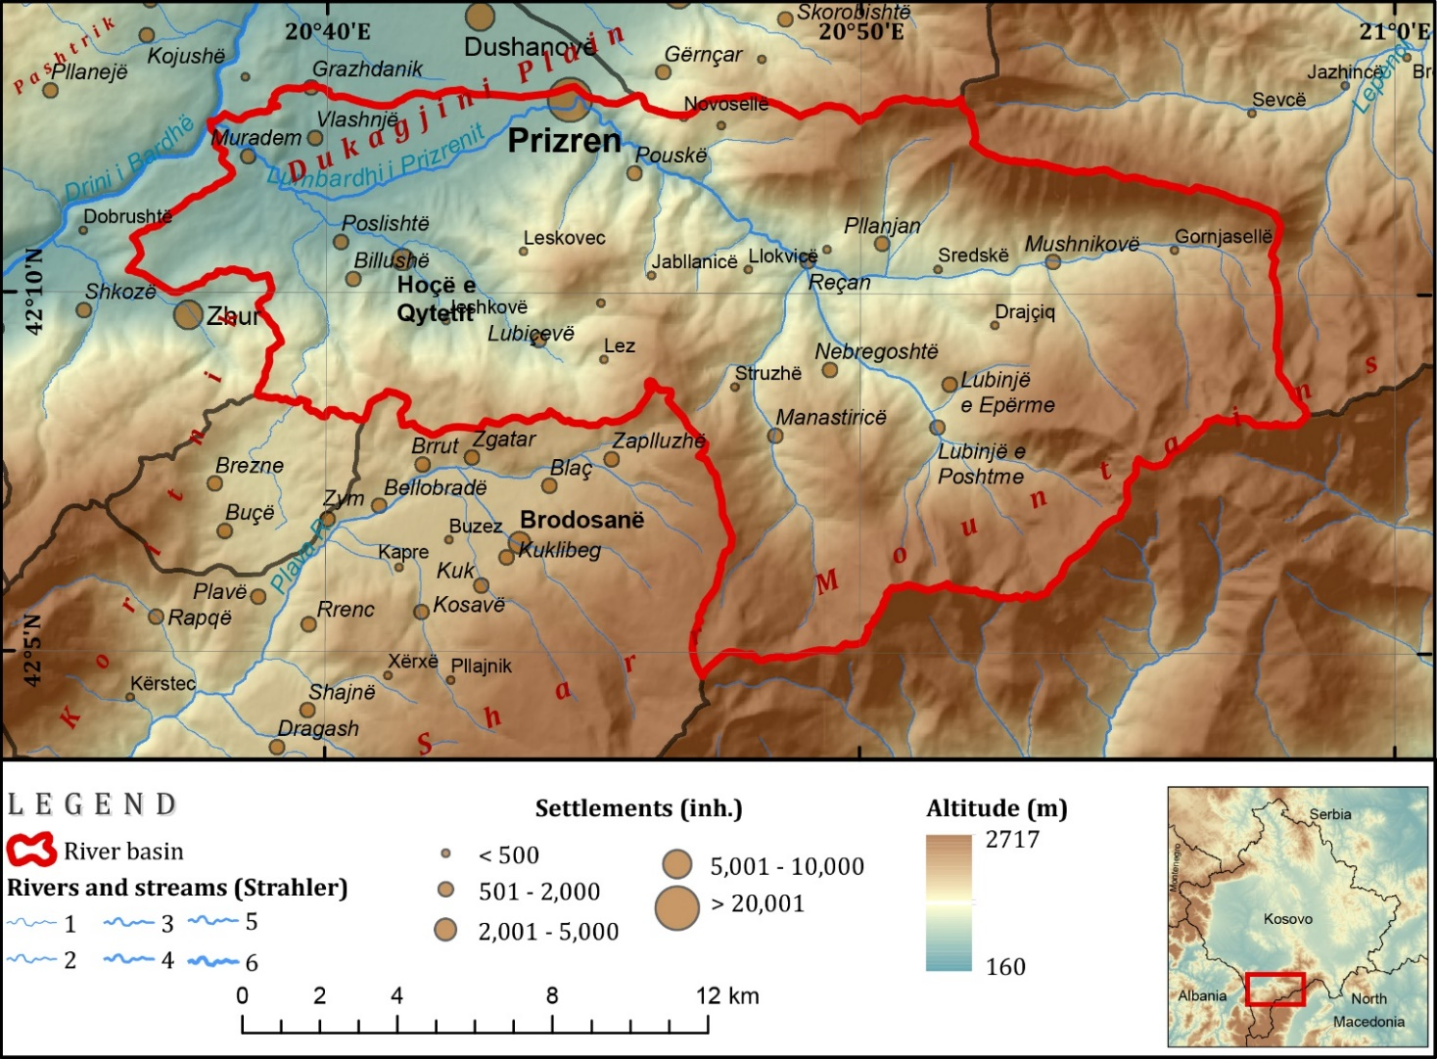
Fig. 1. Location and physical map of the catchment (source: authors)

Distinguished from its diverse geological, geomorphological, hydrographical, and biogeographical features, Sharr Mountains, where the study area is located, have been declared a National Park since 1986 with an area of 39,000 ha and later extended to 56,469 ha (Law on National Park "Sharri" Nr. 2011/04-L-087), whereas 9,595.5 ha are located inside the catchment.
In general terms, the LP River catchment has been the subject of several studies about the Sharr Mountains, including geological settings (Pruthi 2011, Elezaj & Kodra 2007), surface waters and climate (Pllana 2011, Pllana 2015), water regime (Labus 1979), nature conservation (Veselaj & Mustafa 2015), which included specific studies. While most of the river catchment is included in one municipality (Prizren), several local studies have been done. Settlement types, demographic changes, and other transformations in the last decades have been part of a general study of settlements in Kosovo, where physical features, demographics, and other functions have been included (Lexicon of Settlements of Kosovo, 2020).
Land Cover is associated with natural and societal factors operating at temporal and spatial levels, where each factor has influenced its features and dynamics. According to physiographic features, land use/land cover (LULC) patterns are developed, but human influence in changing directions can be seen. As landscape characteristics, land use/land cover express anthropogenic impacts on the Earth's surface (Quintero-Gallego 2018). Landforms and altitude have played a significant role in influencing climate, water resources, and biogeographical features. Valleys, even if they are deep at the bottom, are located in most of the settlements of the catchment. Only the western part of the catchment lies in Dukagjini Plain, with flat and gentle slopes used for agricultural production in the past. Land use classes are related to altitude and climatic features. Different altitude zones have distinguished different climatic features where broad-leaved, coniferous, and mixed forests are found. However, above them, due to vertical zonation, natural grassland covers about 20% of the catchment's total area. Agriculture has a positive relationship with low altitudes, where plains and gentle slopes are found. In contrast, an increase in altitude changes the climate and steepness of slopes, making agriculture nearly impossible. However, the land use/land cover (LULC) patterns at high altitudes show the absence of anthropogenic activity (Ye et al. 2017) and conservation of ecological stability (White et al. 2021). As in many countries worldwide, slope gradients and elevation influence land cover changes (Birhanu et al. 2019).
The main driving force in landscape transformation is human activity. However, having distinguished natural features, the Sharr Mountains' upper part is declared by law as a national park, aiming for landscape conservation and reducing human impact. Unlike mountainous areas, plain ones have experienced the most changes during the last two decades, transforming natural landscapes into artificial ones. During the last two decades, economic activities have changed, mostly by abandoning agriculture and migrating towards main cities or regional centres in service activities. Over the years, the expansion of artificial infrastructure has settled down, with a significant impact on the natural environment, primarily by fragmenting it (Grigoraș et al. 2019). Over the years, an increase in population numbers and migration has contributed to an increase in built-up areas, which were made towards agricultural lands.
3.1. Land cover change analysis
The dynamics of LULC changes are assessed by analysing the downloaded data with 100 m spatial resolution from the Copernicus Land Monitoring Service. Later, the data were intersected and interpreted according to spatial and temporal changes. During the last two decades (2000-2018), nearly all categories of CORINE Land Cover have experienced changes in their destination. However, more affected were natural areas (agricultural land and forest and seminatural areas), which experienced a decrease, and artificial surfaces, which experienced an increase. Most changes were detected in the plains, where discontinuous urban fabric was extended towards agricultural areas. These uneven shifts were a norm in the last two decades in Kosovo and the LP catchment, where the second biggest city at the country level is located (Prizren).

Table 2. Land Cover classes and their changes during selected years
CLC code | CLC group | CLC description | 2000 |  | 2006 |  | 2018 |  | Changes  2000-2018  (ha)
 |  |  | Area (ha) | % | Area (ha) | % | Area (ha) | %
112 | Artificial  surfaces | Discontinuous urban fabric | 465.34 | 1.79 | 729.53 | 2.80 | 820.04 | 3.15 | 354.71
121 |  | Industrial or commercial units | 20.52 | 0.08 | 20.52 | 0.08 | 94.45 | 0.36 | 73.93
122 |  | Road and rail networks  and associated land | – | – | – | – | 64.34 | 0.25 | 64.34
131 |  | Mineral extraction sites | – | – | – | – | 22.46 | 0.09 | 22.46
141 |  | Green urban areas | 44.66 | 0.17 | 39.48 | 0.15 | 39.11 | 0.15 | -5.56
211 | Agricultural  areas | Non-irrigated arable land | – | – | – | – | 481.59 | 1.85 | 481.59
231 |  | Pastures | 96.05 | 0.37 | 95.97 | 0.37 | – | – | -96.05
242 |  | Complex cultivation patterns | 2,237.03 | 8.59 | 2,155.73 | 8.28 | 1,430.80 | 5.49 | -806.23
243 |  | Land principally occupied by agriculture, with significant  areas of natural vegetation | 3,400.91 | 13.06 | 3,264.94 | 12.54 | 3,470.24 | 13.32 | 69.33
311 | Forest and  seminatural areas | Broad-leaved forest | 7,771.16 | 29.84 | 7,678.28 | 29.48 | 7,915.62 | 30.39 | 144.46
312 |  | Coniferous forest | 558.79 | 2.15 | 511.46 | 1.96 | 502.65 | 1.93 | -56.13
313 |  | Mixed forest | 141.71 | 0.54 | 119.62 | 0.46 | 99.42 | 0.38 | -42.29
321 |  | Natural grasslands | 4,864.06 | 18.68 | 5,151.48 | 19.78 | 5,071.22 | 19.47 | 207.16
322 |  | Moors and heathland | 569.36 | 2.19 | 680.10 | 2.61 | 680.81 | 2.61 | 111.45
324 |  | Transitional woodland-shrub | 5,637.75 | 21.65 | 5,411.87 | 20.78 | 5,213.59 | 20.02 | -424.17
333 |  | Sparsely vegetated areas | 138.89 | 0.53 | 138.89 | 0.53 | 138.88 | 0.53 | -0.01
334 |  | Burnt areas | 98.98 | 0.38 | 47.34 | 0.18 | – | – | -98.98
511 | Watercourses |  | 0.18 | 0.00 | 0.18 | 0.00 | 0.18 | 0.00 | 0.00
Total: |  |  | 26,045.39 | 100.00 | 26,045.39 | 100.00 | 26,045.39 | 100.00
Source: Copernicus Land Monitoring Service

During the last two decades of land cover changes, most of the transformation happened to artificial surfaces, which experienced a 196.1% increase, while agricultural land decreased by 6.12%. Other Corine Land Cover classes like forest and seminatural areas had a steady flow with just -0.8% changes for the analysed period. Significant changes in artificial surfaces are made due to the increase in built-up areas as discontinuous urban fabric, mostly in flat areas of Dukagjini Plain, where the city of Prizren and its suburbs are located.

All types of artificial areas (class codes 112-141) increased in 2018 compared to the first year of records (2000). Moreover, the increase was made with the discontinuous urban fabric, where in the year 2000, there was 465 ha, while in 2018, there was an increase of 76%, expressed in absolute values from 465 ha to 820 ha, making the biggest transformation of plain areas, and covering 4% to catchment's total area. When looking at spatial changes between the years 2000 and 2006, the increase in discontinuous urban fabric was made from land principally occupied by agriculture with significant areas of natural vegetation (243) with 162 ha, complex cultivation pattern (242) 55 ha, transitional woodland and shrub with 36.5 ha, and from green urban areas and grassland. Such an increase in artificial surfaces is linked with an increase in the population numbers, primarily by migration after the war in Kosovo (1999), where settlements like Prizren with its suburbs and near regional roads (towards Lubizhdë, Dushanovë, Petrovë, etc.) had an increase in population number. Most of the settlement extensions were made towards agricultural land. Between 2006 and 2018, another increase of discontinuous urban fabric was heading to 820 ha in the total area of the catchment. The rapid extension of urbanisation with artificial surface increases was made by constructing new roads and other infrastructure, including commercial units (64.3 ha). Studies made in other countries (Iváncsics et al. 2021) reveal nearly the same process, where agricultural land has lost its compactness and is fragmented, as revealed in our study. Extension of discontinuous fabric is not the only concern about landscape transformation. However, the decrease in green urban areas negatively contributes to urban ecology and the appearance of urban heat islands (Aram et al. 2019, Knight et al. 2021).

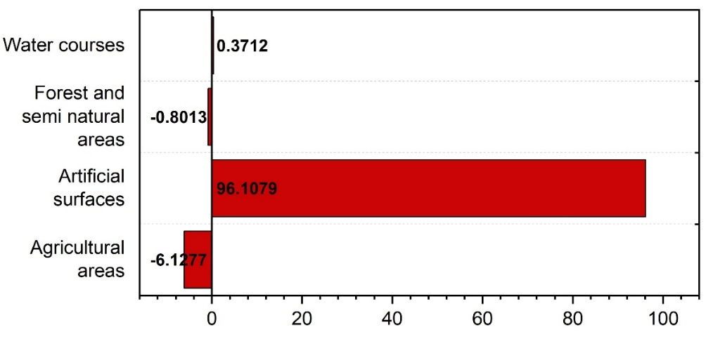
Fig. 2. Changes in % of CORINE Land Cover classes between 2000 and 2018

Industrial and commercial, as a specific category of artificial surfaces, had an increase from 20.5 ha (2000) to 94.5 ha (2018), which shows a high increase and is related to the extension of commercial units near main roads, especially regional roads connecting the city of Prizren with other regional centres. The annual rate of built-up area extension between 2000-2018 was 9.8%, when compared to Kosovo Plain (the most industrialised and densely populated area in Kosovo), where it was 4.87%, shows a high rate of changes and landscape transformation. The main driving forces of landscape transformation are rapid urbanisation in the plains and the absence of zoning maps for construction and its type.
Because of physiographic conditions, agricultural land in the catchment is only one-fifth of the area (20.6%). They are located in the western part, mainly in Dukagjini Plain. Based on analysis, while artificial surfaces experienced an increase, agricultural land areas have decreased in all categories except non-irrigated arable land. In 2000, the total size of agricultural land areas was 5,516 ha. It decreased to 5,382 ha in 2018 when their direction was toward discontinuous urban fabric, roads and other infrastructure, and non-irrigated arable land. Over the years, due to the extension of the urban fabric, agricultural land changed to non-irrigated arable land, mainly near the city of Prizren and other settlements, where land was fragmented over the years and transformed into a discontinuous urban fabric. Complex cultivation patterns are associated with the near-settlement areas (suburbs), and their primary destination was cultivation land for agricultural goods. Their areas decreased by 806 ha and are associated with built-up areas extension, which is currently an extension of current settlements, with very high housing density, meaning abandoning agriculture as the main economic sector in the past, towards new possibilities in service activities. In the last century, the agricultural land fund at the national level has decreased, and it is mostly due to rapid urbanisation. For Kosovo and the population in Prizren and the suburbs, agricultural land was a critical resource in securing fresh foods and goods for the urban population. However, the current trend shows a decrease in agricultural land.
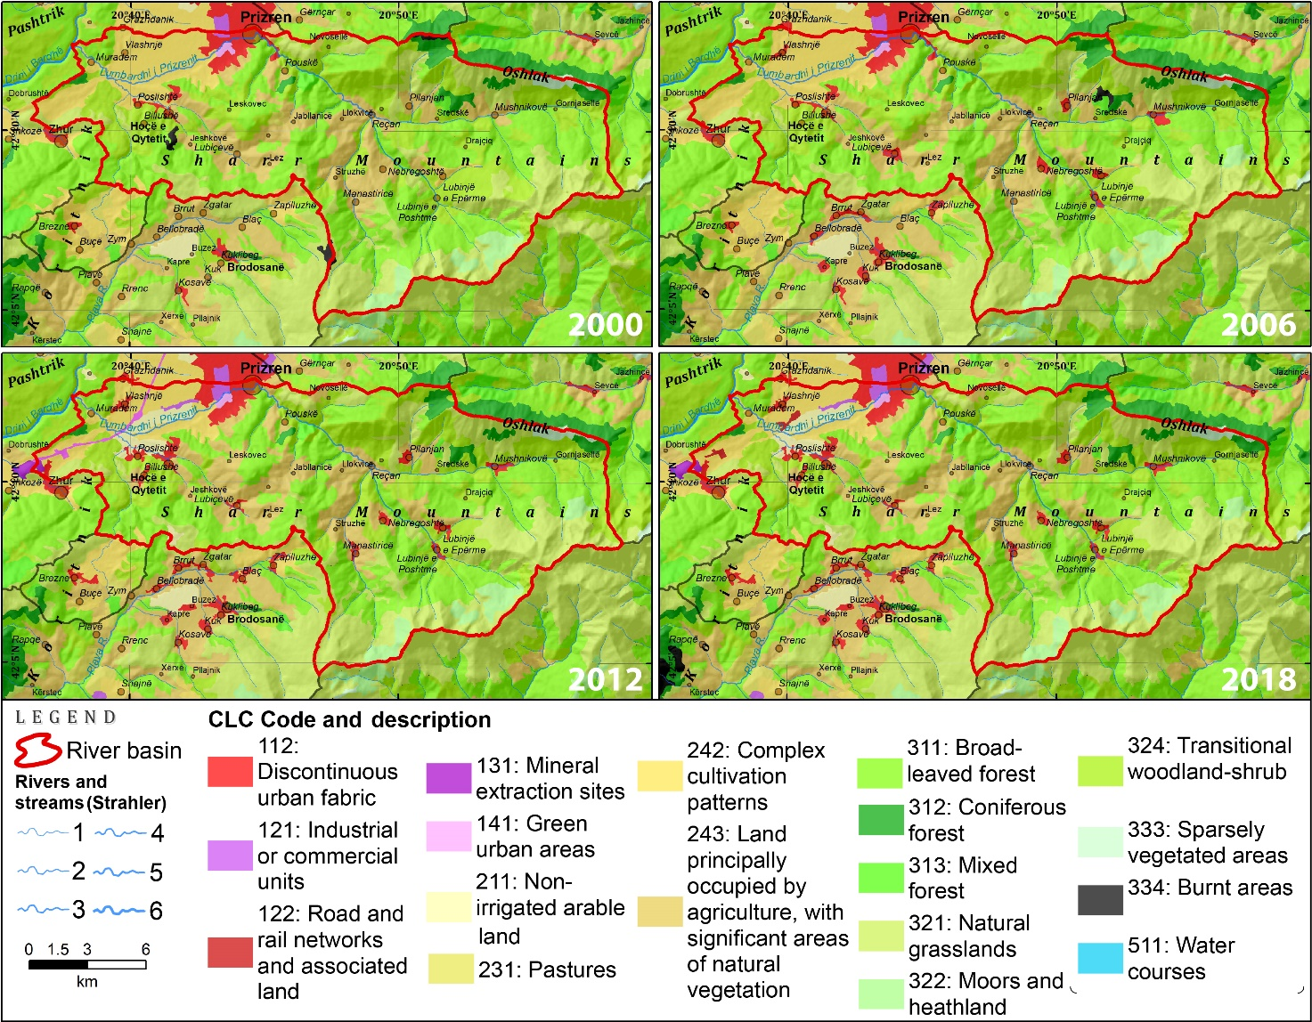
Fig. 3. Land cover changes in the years 2000, 2006, 2012 and 2018

Forests and seminatural areas have experienced small changes in size (-0.8%), from 19,780 ha in 2000 to 19,622 ha in 2018. Physiographic features of the catchment with high altitude and mountainous climate conditions have influenced the distribution of forest and seminatural areas, which cover about 75.3% of the catchment's area. Coniferous forest covered about 502 ha (1.9%) in 2018 and are distributed in the northern slopes of the catchment, more precisely in the southern and western slopes of Oshlak (2,212 m) mountain with an east-west stretch, where the southern slope of it belongs to LP catchment. Broad-leaved forest covers about 30.4% of the total area in 2018. Their distribution is mainly in the northern part of Sharr Mts., stretching from the western part of the catchment at low altitude until the eastern and southern part of the catchment until 1,900 m, where most of them are included in National Park "Sharri" for their pristine landscapes, which includes not only the national park but also strict nature reserves and natural monuments (Law on National Park "Sharri" 2012). The highest biogeographical zone in the LP River catchment contains natural grassland (5,071 ha) and moors and heathlands (680.8 ha), which covered 22.1% of the total catchment areas in 2018, including high biodiversity values. The second most distributed forest and seminatural areas in the catchment are transitional woodland shrubs, which covered 5,213 ha or 20% of the total area in 2018 but experienced a loss of 424 ha compared to the year 2000, being the first rank in forest and seminatural areas, with high-losses. They have been transformed into a discontinuous urban fabric with 36.5 ha in the year 2006, but also in another natural class, into a broad-leaved forest (273 ha) in 2018. Some areas were also transformed into significant areas of natural vegetation. Between 2000 and 2006, 47 ha of coniferous areas were burnt, but later mostly transformed into mixed forest and grassland, where natural succession occurred, which could be a contemporary process of climatic changes.
The analysis made with data from CORINE Land Cover for different years shows changes in areas and patches, even though they were very small. Changes in the number of patches show the fragmentation of the natural landscape and disturbing ecological stability. LP has diverse physiographical features where the population is not distributed equally, where its impact would be equal.
Size metrics and patch density are landscape transformation elements that allow an understanding of ecological processes and their directions (Frazier & Kedron 2017). Landscape metrics allow assessment and conservation priority for the future (Midha & Mathur 2010). Based on metrics calculated by ArcMap 10.8, LP catchment has changed. Still, it could be concluded that mountainous areas have preserved their ecological stability with minor transformation, impacted by high altitude, climate conditions, and small human footprints. Otherwise, plain areas have undergone a series of processes where landscape changes are evident. Patches are indications of landscape compaction or fragmentation. Over the years, some land cover classes have undergone fragmentation by creating a number of patches or reducing them. In 2000, the discontinuous urban fabric had 4 patches; in 2018, it increased to 14 patches. Other artificial surface classes were created: road and rail networks and associated land (2 patches) and mineral extraction sites (1 patch) due to the Albania-Kosovo highway's construction. Changes in patches and their size also have forest and seminatural areas. Thus, the broad-leaved forest had a size increase from 7,772 ha (2000) to 7,917 ha (2018), whereas, from 16 patches with a mean size of 485 ha, it increased to 565 ha. Other categories that experienced changes were moors and heathland, which increased from 569.47 ha to 680.94 ha or from 7 patches (mean size 81 ha) to 4 patches (mean size 170 ha).

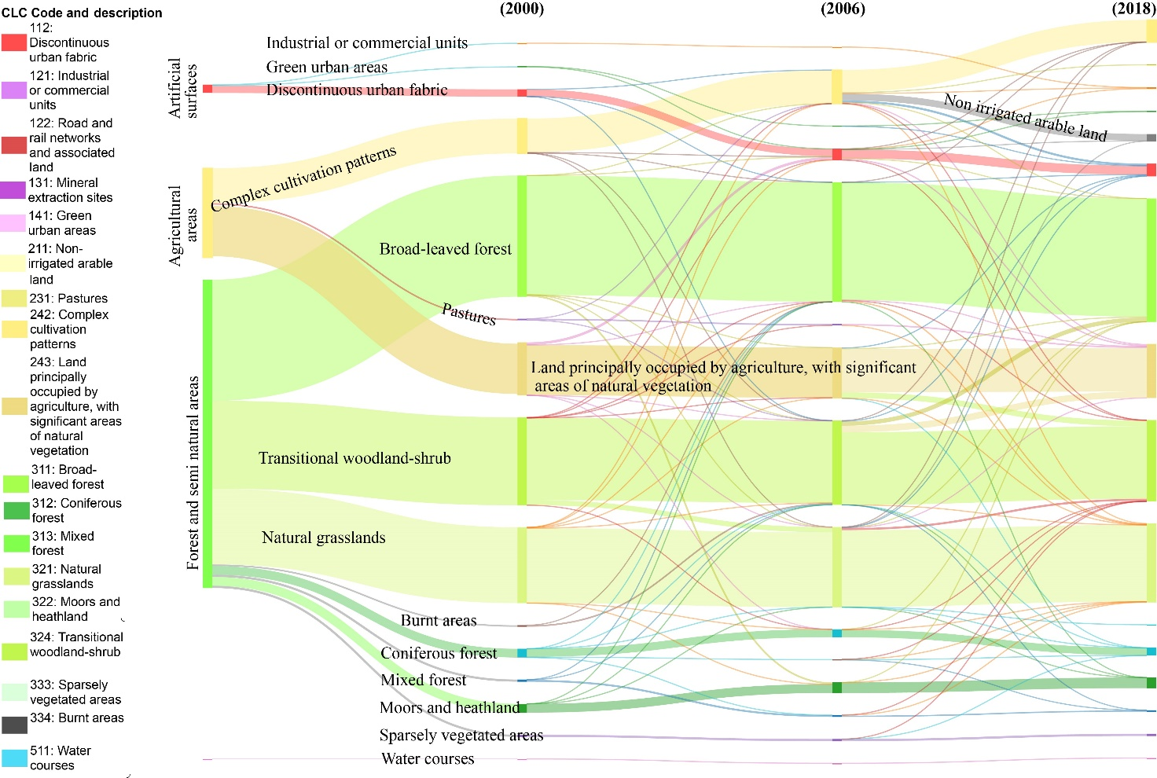
Fig. 4. Visualisation of landscape features and their flow transformation between 2000-2018

The 21st century is well known for the intense urbanisation process, which has altered natural habitats and fragmented landscapes, mainly with increased artificial surfaces and road infrastructure. Urbanisation processes had a very intense shift toward agricultural land in the plains, initiated by population migration from hilly mountainous areas. Landscape changes, both in abandoned former artificial areas and the new ones, have accelerated soil erosion (Borrelli et al. 2017), where soil loss and regional food security have been challenged. Kosovo is a small country in the Western Balkans with a diverse topography and a high percentage of hilly-mountainous areas, with the actual rate of urbanisation in plain areas jeopardising the environment with a decrease in agricultural land.

4. Conclusions
Since the beginning of satellite observations over the Earth's surface, it has been made possible to track changes in the natural environment and human impact, and the CORINE Land Cover from Copernicus Land Monitoring Service has made it possible to determine, analyse, and track changes over the years. Kosovo is experiencing intense land cover changes over the plains, where intensive population migration has happened in the last two decades, followed by rapid urbanisation and infrastructure construction. Spatiotemporal changes from CORINE Land Cover data for the last two decades show changes, mainly in plain areas where agricultural lands are found. LP River catchment is an example from Kosovo, where settlements are found in high altitudes (1.110 m), settled in river valleys and smooth mountain ridges. Nevertheless, hilly-mountainous settlements have experienced population migration towards the city of Prizren and other settlements located near regional roads, experiencing an increase in industrial or commercial units, road and rail networks and associated land. Located in terrain with high altitude differences, with some peaks above 2,000 m, forest and seminatural areas cover 75.3% of the catchment's areas, which had small changes during the 18 years of data analysis. Areas on flat landforms were covered with agricultural land and served for agricultural production for the urban population. However, in 2018, agricultural land decreased by 351 ha, or a yearly rate of 19.5 ha, mostly shifting towards artificial surfaces.
Based on landform features, Kosovo has a small agricultural land fund, and the tendency is for intense urbanisation of the land. Recently, with 0.25 ha of agricultural land per capita at the national level, Kosovo lies under the European level, where a country can secure agricultural goods for its inhabitants. Land cover changes show human impact on landscape transformation, fragmentation, and ecological instability in the plains, which can endanger sustainable development and bring society towards unstable food security.
To control the increase of artificial surface towards agricultural land, zoning construction should be implemented, stabilising the agricultural land fund and allowing sustainable development by saving the ecological stability of the catchment.
References
Aram, F., Higueras García, E., Solgi, E., Mansournia, S. (2019). Urban green space cooling effect in cities. Heliyon, 5(4), e01339. https://doi.org/10.1016/j.heliyon.2019.e01339
Birhanu, L., Hailu, B.T., Bekele, T., Demissew, S. (2019). Land use/land cover change along elevation and slope gradient in highlands of Ethiopia. Remote Sensing Applications: Society and Environment, 16, 100260. https://doi.org/10.1016/j.rsase.2019.100260
Cegielska, K., Noszczyk, T., Kukulska, A., Szylar, M., Hernik, J., Dixon-Gough, R., … Filepné Kovács, K. (2018). Land use and land cover changes in post-socialist countries: Some observations from Hungary and Poland. Land Use Policy, 78, 1-18. https://doi.org/10.1016/j.landusepol.2018.06.017
Cleland, J. (2013). World Population Growth; Past, Present and Future. Environmental and Resource Economics, 55(4), 543-554. https://doi.org/10.1007/s10640-013-9675-6
Elezaj, Z., Kodra, A. (2008). Geology of Kosovo. Prishtina: UP. (in Albanian)
Ellis, E.C. (2021). Land Use and Ecological Change: A 12,000-Year History. Annual Review of Environment and Resources, 46(1), 1-33. https://doi.org/10.1146/annurev-environ-012220-010822
Falcucci, A., Ciucci, P., Maiorano, L., Gentile, L., Boitani, L. (2009). Assessing habitat quality for conservation using an integrated occurrence-mortality model. Journal of Applied Ecology, 46(3), 600-609.
https://doi.org/10.1111/j.1365-2664.2009.01634.x
Frazier, A.E., Kedron, P. (2017). Landscape Metrics: Past Progress and Future Directions. Current Landscape Ecology Reports, 2(3), 63-72. https://doi.org/10.1007/s40823-017-0026-0
Gaitanis, A., Kalogeropoulos, K., Detsis, V., Chalkias, C. (2015). Monitoring 60 Years of Land Cover Change in the Marathon Area, Greece. Land, 4(2), 337-354. https://doi.org/10.3390/land4020337
Getzner, M., Švajda, J. (2015). Preferences of tourists with regard to changes of the landscape of the Tatra National Park in Slovakia. Land Use Policy, 48, 107-119. https://doi.org/10.1016/j.landusepol.2015.05.018
Hyka, I., Hysa, A., Dervishi, S., Solomun, M.K., Kuriqi, A., Vishwakarma, D.K., Sestras, P. (2022). Spatiotemporal Dynamics of Landscape Transformation in Western Balkans' Metropolitan Areas. Land, 11(11), 1892. https://doi.org/10.3390/land11111892
Iváncsics, V., Filepné Kovács, K. (2021). Analyses of new artificial surfaces in the catchment area of 12 Hungarian middle-sized towns between 1990 and 2018. Land Use Policy, 109, 105644. https://doi.org/10.1016/j.landusepol.2021.105644
Knight, T., Price, S., Bowler, D., Hookway, A., King, S., Konno, K., Richter, R.L. (2021). How effective is "greening" of urban areas in reducing human exposure to ground-level ozone concentrations, UV exposure and the "urban heat island effect"? An updated systematic review. Environmental Evidence, 10(1), 1-38. https://doi.org/10.1186/s13750-021-00226-y

Kuemmerle, T., Levers, C., Erb, K., Estel, S., Jepsen, M.R., Müller, D., … Reenberg, A. (2016). Hot-spots of land use change in Europe. Environmental Research Letters, 11(6), 064020. https://doi.org/10.1088/1748-9326/11/6/064020
Labus, D. (1979). Water regime of Drini i Bardhë River. Kërkime Gjeografike, 1. (in Serbian)
Lambin, E.F., Geist, H.J., Lepers, E. (2003). Dynamics of Land-Use and Land-Cover change in tropical regions. Annual Review of Environment and Resources, 28(1), 205-241. https://doi.org/10.1146/annurev.energy.28.050302.105459
Law on National Park "Sharri", (2012).
Masný, M., Balážovičová, L., Šoltés, M. (2023). Land cover changes over the past 30 years in the Demänovka river catchment. Geografický Časopis, 75(3), 235-252. https://doi.org/10.31577/geogrcas.2023.75.3.12
Matson, P.A., Parton, W.J., Power, A.G., Swift, M.J. (1997). Agricultural Intensification and Ecosystem Properties.
Science, 277(5325), 504-509. https://doi.org/10.1126/science.277.5325.504
Midha, N., Mathur, P.K. (2010). Assessment of forest fragmentation in the conservation priority Dudhwa landscape, India using FRAGSTATS computed class level metrics. Journal of the Indian Society of Remote Sensing, 38(3), 487-500. https://doi.org/10.1007/s12524-010-0034-6
Miho, A., Marka, J., Krasniqi, Z. (2023). Importance of EU Integration for Biodiversity and Nature Conservation in Transboundary Protected Areas (TPAs) in the Western Balkan. Hydrobiology, 2(1), 235-243. https://doi.org/10.3390/hydrobiology2010015
Newbold, T., Hudson, L.N., Hill, S.L.L., Contu, S., Lysenko, I., Senior, R.A., … Ingram, D.J. (2015). Global effects of land use on local terrestrial biodiversity. Nature, 520(7545), 45-50. https://doi.org/10.1038/nature14324
Nuissl, H., Siedentop, S. (2020). Urbanisation and Land Use Change. Human-Environment Interactions, 8, 75-99. https://doi.org/10.1007/978-3-030-50841-8_5
Pllana, R. (2013a). Natural heritage values of Kosovo. In R. Ismajli & M. Kraja (Eds.), Kosovo: A monographic survey (pp. 78-82). Prishtina, Kosovo: Kosovo Academy of Sciences and Arts. (in Albanian)
Pllana, R. (2013b). The climate of Kosovo. In R. Ismajli & M. Kraja (Eds.), Kosovo: A monographic survey (pp. 50-56). Prishtina, Kosovo: Kosovo Academy of Sciences and Arts. (in Albanian)
Pllana, R. (2013c). Water of Kosovo. In R. Ismajli & M. Kraja (Eds.), Kosovo: A monographic survey (pp. 40-49). Prishtina, Kosovo: Kosovo Academy of Sciences and Arts. (in Albanian)
Pruthi, V. (2013). Geological features of Kosovo. In R. Ismajli & M. Kraja (Eds.), Kosovo: A monographic survey
(pp. 28-34). Prishtina: Kosovo Academy of Sciences and Arts. (in Albanian)
Quintero-Gallego, M.E., Quintero-Angel, M., Vila-Ortega, J.J. (2018). Exploring land use/land cover change and drivers in Andean mountains in Colombia: A case in rural Quindío. Science of the Total Environment, 634, 1288-1299. https://doi.org/10.1016/j.scitotenv.2018.03.359
Ramalho, C.E., Laliberté, E., Poot, P., Hobbs, R.J. (2014). Complex effects of fragmentation on remnant woodland plant communities of a rapidly urbanising biodiversity hot-spot. Ecology, 95(9), 2466-2478. https://doi.org/10.1890/13-1239.1
Schlesinger, W.H., Jasechko, S. (2014). Transpiration in the global water cycle. Agricultural and Forest Meteorology, 189-190, 115-117. https://doi.org/10.1016/j.agrformet.2014.01.011
Schneider, A. (2012). Monitoring land cover change in urban and peri-urban areas using dense time stacks of Landsat satellite data and a data mining approach. Remote Sensing of Environment, 124, 689-704. https://doi.org/10.1016/j.rse.2012.06.006
Smith, P., House, J.I., Bustamante, M., Sobocká, J., Harper, R., Pan, G., … Meersmans, J. (2015). Global change pressures on soils from land use and management. Global Change Biology, 22(3), 1008-1028. https://doi.org/10.1111/gcb.13068
Statistical Agency of Kosovo. (2013). Census, Households and Housing in Kosovo 2011: The Final Results: Key Data (pp. 1-77). Prishtina.
Veselaj, Z., Mustafa, B. (2015). Overview of Nature Protection Progress in Kosovo. Landscape Online, 45, 1-10. https://doi.org/10.3097/lo.201545
White, H.J., Gaul, W., León‐Sánchez, L., Sadykova, D., Emmerson, M.C., Caplat, P., Yearsley, J.M. (2021). Ecosystem stability at the landscape scale is primarily associated with climatic history. Functional Ecology, 36(3), 622-634. https://doi.org/10.1111/1365-2435.13957
Winkler, K., Fuchs, R., Rounsevell, M., Herold, M. (2021). Global land use changes are four times greater than previously estimated. Nature Communications, 12(1), 2501. https://doi.org/10.1038/s41467-021-22702-2
Wolf, I.D., Sobhani, P., Esmaeilzadeh, H. (2023). Assessing Changes in Land Use/Land Cover and Ecological Risk to Conserve Protected Areas in Urban-Rural Contexts. Land, 12(1), 231. https://doi.org/10.3390/land12010231
Xu, J., Meng, M., Liu, Y., Zhang, Z., Zhuo, H., Qiu, G., … Zheng, R. (2023). Assessing 30-Year Land Use and Land Cover Change and the Driving Forces in Qianjiang, China, Using Multitemporal Remote Sensing Images. Water, 15(18), 3322-3322. https://doi.org/10.3390/w15183322
Yu, H., Zhang, F., Kung, H., Johnson, V.C., Bane, C.S., Wang, J., … Zhang, Y. (2017). Analysis of land cover and landscape change patterns in Ebinur Lake Wetland National Nature Reserve, China, from 1972 to 2013. Wetlands Ecology and Management, 25(5), 619-637. https://doi.org/10.1007/s11273-017-9541-3

