 | Rocznik Ochrona Środowiska
 | Volume 26 | Year 2024 ISSN 2720-7501 | pp. 201-216
 | https://doi.org/10.54740/ros.2024.021 open access
 | Received: April 2024 Accepted: May 2024 Published: June 2024
A Brief Overview of Antibiotic Contamination Sources
in Wastewater and Elimination Approaches
Zeba Ali Mumtaj¹, Abdul Rahman Khan², Jamal Akhtar Ansari³, Abdullah Asiri⁴, Saimah Khan^{5*}
¹Department of Chemistry, Integral University, India
https://orcid.org/0009-0009-8634-6945
²Department of Chemistry, Integral University, India
³Department of Chemistry, Integral University, India
https://orcid.org/0000-0002-1467-6226
⁴Department of Civil Engineering, King Khalid University, Abha, Saudi Arabia
https://orcid.org/0009-0000-8592-4314
⁵Department of Chemistry, Integral University, India
https://orcid.org/0000-0002-6483-4325
*corresponding author's e-mail: saimah2606@gmail.com
Abstract: Antibiotic contamination of natural resources and the receiving environment is of great concern. This brief discussion consists of the sources regarding antibiotic contamination and the analysis of several viable methods of removing antibiotic substances. The sources include domestic discharges, agricultural runoff, and pharmaceutical manufacturing effluents. Antibiotics are classified as emerging contaminants attributed to their persistence in the environment. Antibiotics and their metabolites enter the environment through human and animal urine and faeces. Persistent pollutants are introduced to aquatic ecosystems as they pass the wastewater treatment process. The overuse of antibiotics has led to the emergence of bacteria and genes resistant to antibiotics in the environment. This study provides a descriptive overview of antibiotic sources in the environment, their harmful effects, analytical techniques for its detection in wastewater, related challenges in monitoring antibiotic contamination in water, and recently used techniques for its removal from wastewater and problems associated with current strategies. The study also underscores the importance of understanding the sources and learning how to successfully apply methods to minimise the effects of antibiotic contamination in wastewater.
Graphical Abstract
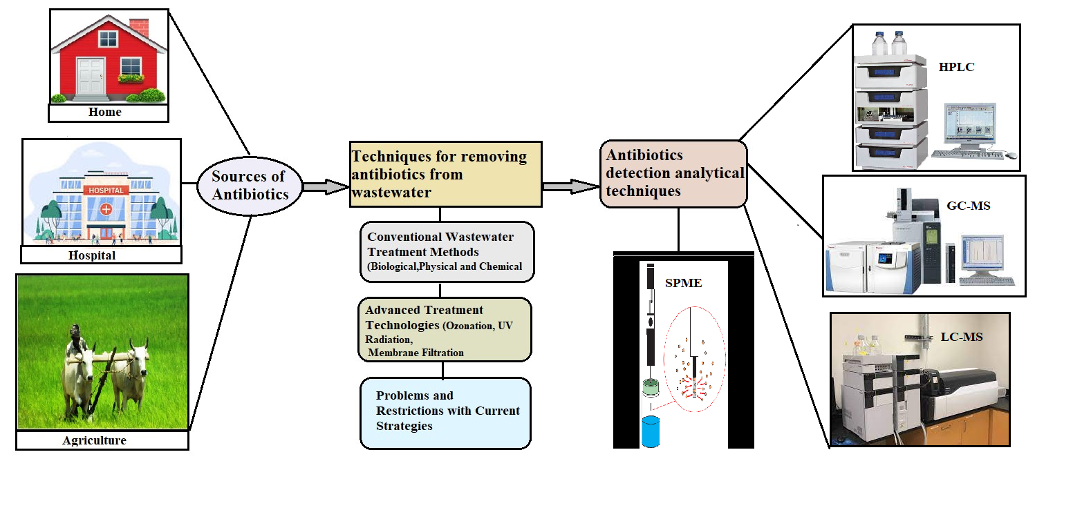

Keywords: Antibiotics, Bioremediation, wastewater, Sustainable, Effluent
1. Introduction
Water is a finite yet renewable resource that is necessary for both the sustainability of the environment and human life. Chemical contamination of surface waters, primarily from emissions from agriculture and industry, is a major concern in some developing countries (Rehman et al. 2015). Most developing countries use water and pathogen management to address public health protection needs (Zhu et al. 2013). Antibiotics are considered the most important medications for treating and preventing infections in hospitals. These antibiotics end up in water bodies due to improper disposal practices (Chen et al. 2018). Prolonged exposure to sub-inhibitory concentrations of antibiotics can lead to bacterial resistance against multiple antibiotics, resulting in multidrug-resistant bacteria that disrupt the bio-geo-chemical cycle in addition to causing resistance (Chen et al. 2014, Aghdam et al. 2016). In addition to hospital waste, one of the largest "hotspots" for antibiotics is thought to be municipal wastewater (Segura et al. 2009, Alsubih et al. 2022). The main ways that antibiotics and antibiotic-resistant bacteria enter aquatic ecosystems are through human and animal faeces and carcasses. These bacteria can pass their genes to waterborne pathogenic microbes, leading to resistance (Sapkota et al. 2007, Qiao et al. 2018). Antibiotic resistance thus has the potential to become a major problem in modern medicine because it can lead to disastrous epidemics (Wu et al. 2016). Ensuring sufficient processing of these substances before their release into the environment is crucial, as failure may result in severe pollution and disruption of the natural equilibrium. However, getting rid of antibiotics from wastewater is a difficult task (Lyu et al. 2020). Chemical precipitation, ion exchange, biosorption, reverse osmosis, nanofiltration, etc., are the most often utilised conventional techniques for eliminating these antibiotics (Gadipelly et al. 2014, Shafi et al. 2024). The characteristics of each process, combined with environmental factors, water quality conditions, biological and chemical oxygen demand, and other factors, all affect the efficiency of antibiotic elimination (Larsson 2014). Despite this, antibiotics are not entirely removed in wastewater treatment plants because they can still be found in surface water, groundwater, municipal and hospital sewage, stagnant wastewater ponds, and surface water (Kümmerer 2009, Justino et al. 2016). Currently, membrane technology is considered a promising way to get rid of antibiotics from wastewater (Lyu et al. 2020). Either directly or indirectly, an effective treatment or conservation strategy would have a favourable effect and be crucial in providing notable advantages in terms of economic development (Li et al. 2008). To help prevent the emergence of antibiotic-resistant genes and bacteria that give rise to new diseases, as well as to help combat their detrimental effects on humans and the environment, this review outlines various sources of antibiotics and the various strategies for their removal.
2. Sources of Contaminated Antibiotics
Wastewater contaminated with antibiotics is a major environmental problem affecting public health. Soil, water resources, and sewage include antibiotic-based pollution (Ebrahimi et al. 2020). Its presence must be immediately addressed since it harms ecosystems and human health. It also leads to bacterial resistance, which renders therapy for infections useless. These antibiotic-resistant bacteria can potentially infect people and other animals by contaminating water or food. Once inside the host, they can alter the gut microbiota and cause various illnesses (Kumar et al. 2020, Sun et al. 2020). The largest and most varied populations of micro- and macroorganisms are found in municipal wastewater, which promote the creation of organisms resistant to drugs. Antibiotic-resistant traits are unsurprising in these organisms, including commensals, pathogens, environmental bacteria, protozoa, or fungi (Kumar & Pal 2018, Teixeira et al. 2020). The three main sources of antibiotic contamination covered in this paper are runoff from agriculture, hospital and pharmaceutical industry effluents, and domestic wastewater. It is essential to comprehend the sources of antibiotic pollution to create mitigation strategies that work.
- Effluent from homes.
- Effluents from hospitals and the pharmaceutical industry.
- Runoff from agriculture.
2.1. Effluent from homes
The main source of antibiotic contamination is domestic wastewater, which comes from homes and other residential areas. The excretion of antibiotics by humans and improper disposal of unused medications and personal care products are the main causes of these substances found in household sewage. Research has demonstrated that various antibiotics can be found in household wastewater, indicating the common usage and disposal of pharmaceuticals in daily life. (Ternes et al. 2004). Determination of pharmaceuticals in biosolids by pressurised liquid extraction and liquid chromatography-mass spectrometry.
2.2. Effluents from hospitals and the pharmaceutical industry
Hospital and pharmaceutical manufacturing plant effluents mostly cause antibiotic contamination. Antibiotics are discharged into wastewater from healthcare facilities by patients' excretion and discarding leftover medication. Moreover, large amounts of antibiotics are produced during the pharmaceutical manufacturing process and are dumped into wastewater, which presents a serious environmental risk (Larsson et al. 2007, Khan et al. 2023). Hospitals' contribution to the pharmaceutical consignment in wastewater is difficult to assess because most people use medications and contraceptives. Numerous programs are currently being performed to evaluate and shelter hospitals, investigating their possible role as reservoirs for medications and other materials that can give rise to germs resistant to multiple medicines (Escher et al. 2011, Mumtaj et al. 2024).
2.3. Runoff from agriculture
Agricultural practices cause antibiotic contamination in water bodies, specifically using antibiotics in crop production and veterinary medicine. This leads to runoff into water bodies. Antibiotics given to animals or crops have the potential to seep into the soil and surface water, after that they may end up in agricultural runoff. The potential for the emergence of antibiotic-resistant bacteria in the environment makes this source concerning (Kim et al. 2012). Therefore, various sources, such as veterinary waste, human waste streams, livestock husbandry waste, stored animal faces, etc., are introducing antibiotics into the environment. These resources can potentially release antibiotics into surface and groundwater, often initiated by moderate to heavy precipitation. According to Samrot et al. (2023), this has consequently emerged as the primary source of environmental antibiotic contamination. Table 1 indicates the sources of antibiotics in wastewater.

Table 1. Sources of contaminated antibiotics
Source | Description | Reference
Domestic Wastewater | Disposal of unused or metabolised antibiotics by households | Jones et al. 2021
Hospital Effluents  and disposal of Expired Medications | Discharge of pharmaceuticals and antibiotics from medical facilities. Also, inappropriate disposal leads to leaching of antibiotics into the environment | Smith 2020  Wu et al. 2022
Pharmaceutical Industry Effluents | Release of antibiotics during manufacturing processes | Brown et al. 2020
Agricultural Runoff | Runoff from fields with antibiotic-laden fertilisers and manure | Gupta et al. 2019
Aquaculture Effluents and Aquatic Discharge from Sewage Treatment Plants | The misuse of antibiotics for fisheries and aquaculture; particularly used in fish and shrimp cultures. Also, Effluents from wastewater treatment plants containing residual antibiotics | Wang et al. 2022  Li et al. 2018
Veterinary Waste | Disposal of unused or excreted antibiotics from animal healthcare | Zhang et al. 2021
Landfill Leachate  and Urban Storm water Runoff | Dispersal of antibiotics from waste pharmaceuticals to landfill repositories. Also, transport of antibiotics from impervious surfaces to water bodies | Tanaka et al. 2023  Chen et al. 2023
3. Routes Via Which Antibiotics Enter Wastewater
There are several ways that antibiotics get into wastewater, and knowing these paths is crucial to solving the problem of antibiotic pollution in aquatic environments. These are a few important routes:
- Pharmaceutical Manufacturing Discharges: During the production processes in pharmaceutical manufacturing plants, antibiotics are introduced into wastewater. These facilities' discharges greatly increase the antibiotic burden on the environment (Larsson et al. 2007).
- Healthcare Facility Effluents: When patients excrete or throw away unused or expired medication, hospitals and other healthcare facilities release antibiotics into the wastewater. Antibiotics can be found in wastewater from major sources, including healthcare facility wastewater (Rodriguez-Mozaz et al. 2015).
- Household Disposal: When people dispose of unused medications by washing them down the sink or flushing them down the toilet, antibiotics end up in wastewater. Household wastewater contains antibiotics due to improper disposal practices (Ternes et al. 2004).
- Agricultural Runoff: Particularly in areas with intensive farming practices, antibiotics used in agriculture, either as veterinary medications or for crop protection, can find their way into wastewater through runoff from fields and animal facilities (Kim et al. 2012).

4. Antibiotic Contamination's Effect on the Environment
The issue of antibiotic contamination in the environment has gained significant attention and significant ramifications. The present study explores the complex ramifications of antibiotic pollution, with particular attention to its effects on aquatic ecosystems, the emergence of antibiotic-resistant bacteria, and ecology.
- Repercussions on the environment.
- Bacteria that become resistant to antibiotics.
- Impacts on aquatic environments.
4.1. Repercussions on the environment
Contamination with antibiotics has serious ecological repercussions that impact different ecosystem components. Antibiotic exposure can disturb soil microbial communities, resulting in imbalances in the cycling of nutrients and overall ecosystem functioning. Research has indicated that the presence of antibiotic residues in the surroundings can change the variety and makeup of soil microorganisms, affecting important ecological functions. (Cycoń et al. 2019). Figure 1 indicates repercussions on the environment.

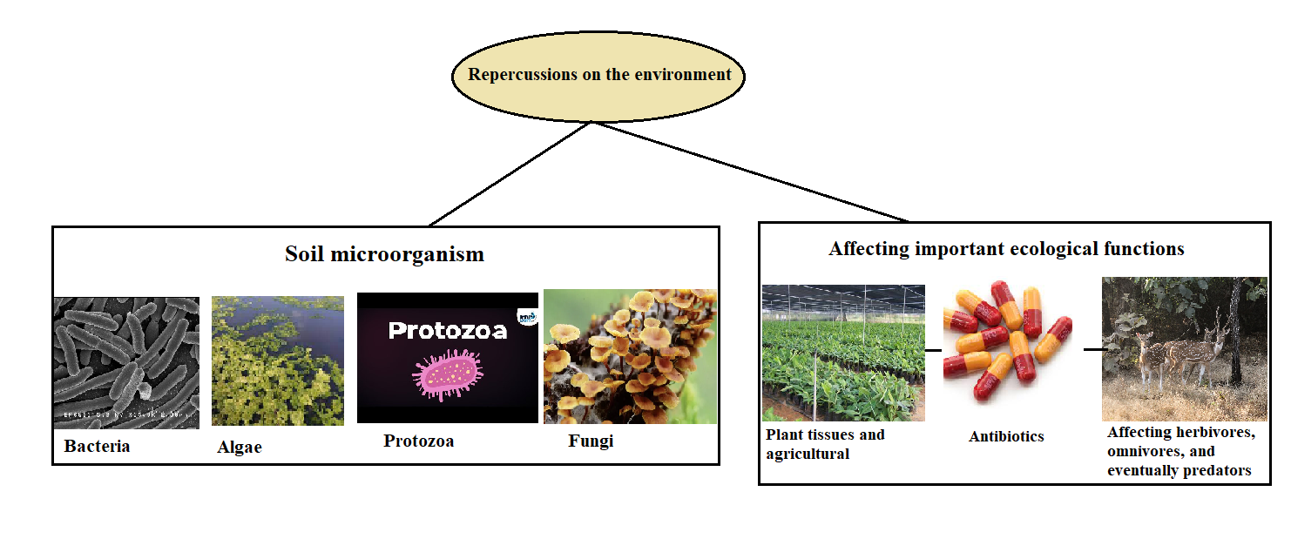
Fig. 1. Repercussions on the environment affecting important ecological functions and soil microorganisms

Moreover, introducing antibiotics into plant tissues and agricultural produce may have a domino effect on higher trophic levels, affecting herbivores, omnivores, and eventually predators. This disturbance of ecological interactions could jeopardise the stability and resilience of entire ecosystems.
4.2. Bacteria that develop antibiotic resistance
The emergence and spread of antibiotic-resistant bacteria is one of the most important and concerning effects of antibiotic contamination. Sub-lethal antibiotic concentrations in the environment exert selective pressure, which is fertile ground for the emergence of resistance mechanisms. The effectiveness of antibiotic treatments is diminished by this phenomenon, which has grave implications for human and animal health. Figure 2 indicates bacterial antibiotic resistance implications for human and animal health.
Numerous studies have found antibiotic-resistant genes in environmental samples, underscoring the significance of environmental antibiotic contamination in the spread of resistance. The risk of incurable infections is further increased by transferring resistance genes between environmental bacteria and pathogens (Martinez 2009).
4.3. Impacts on aquatic environments
Antibiotic contamination poses a serious threat to aquatic ecosystems, especially those that are found in surface water bodies. Antibiotics are introduced into rivers, lakes, and oceans through wastewater discharge from pharmaceutical plants, hospitals, and urban areas (Alsubih et al. 2022). Aquatic organisms may be exposed to antibiotics for an extended period due to their persistence in these environments. Figure 3 indicates the consequences of antibiotics on the aquatic environment.

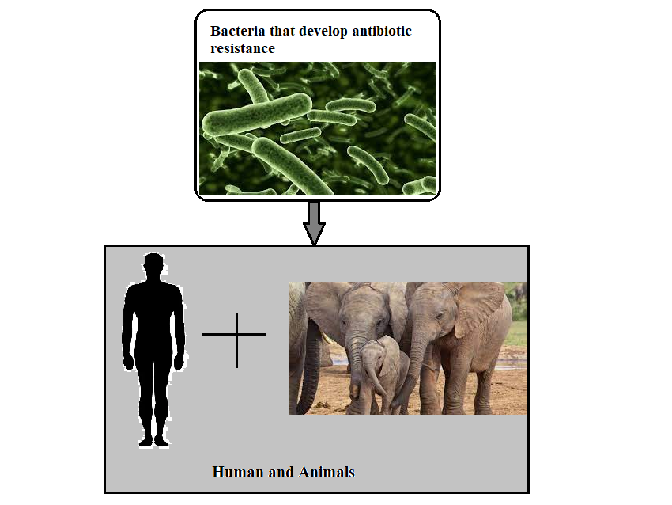
Fig. 2. Bacterial antibiotic resistance implications for the health of both human and animal

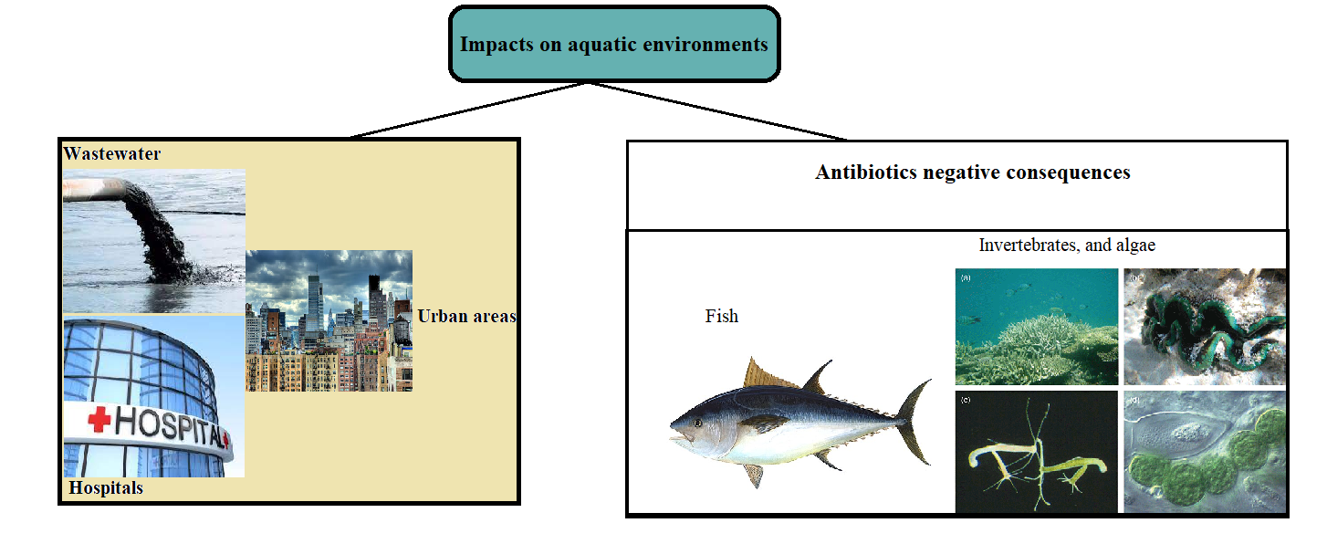
Fig. 3. Antibiotics negative impacts on aquatic environments

Research has indicated that antibiotic exposure can negatively affect fish, invertebrates, and algae. These effects can include altered behaviour, stunted growth, and interference with reproductive processes. In addition, the use of antibiotics in aquatic environments fosters the growth of bacteria resistant to the drugs, establishing a source of resistance genes that human pathogens can inherit. (Gao & Sui 2020). Wastewater treatment plants are hotspots for the evolution of antibiotic resistance because of the diverse spectrum of bacteria, antibiotics, metals, and other toxins that interact with the surrounding bacteria (Cacace et al. 2019, Sharmaa & Sharmab 2020).

5. Antibiotic Monitoring and Detection in Wastewater
Due to the growing concern over antibiotic contamination in wastewater, strong monitoring and detection techniques are required to determine the scope of this environmental problem. This paper addresses the difficulties in tracking antibiotic contamination and summarises the analytical techniques used to find antibiotics in wastewater. Figure 4 indicates the antibiotics detection analytical techniques in wastewater.

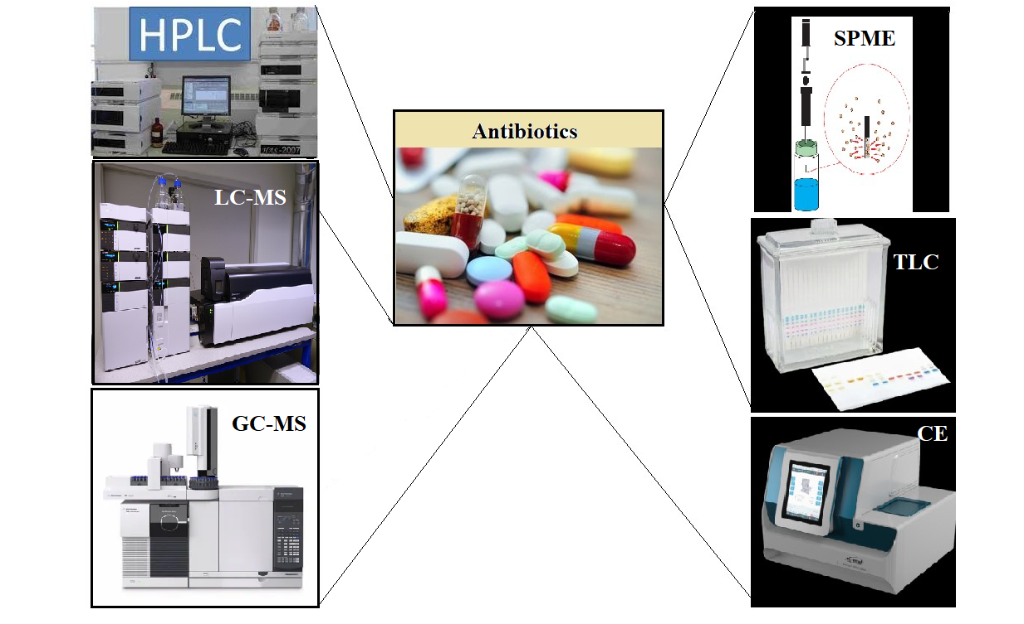
Fig. 4. Antibiotic detection analytical techniques

Antibiotic detection analytical techniques: In recent years, several rapid, precise, and focused analytical techniques for figuring out how many antibiotics are in complicated biological conditions have been used in routine lab situations. These methods are necessary to produce repeatable outcomes that can be applied in clinical studies to raise the efficacy of antibiotic therapy. Because antibiotics can have a wide range of chemical characteristics and concentrations, many analytical techniques have been developed to identify and measure these compounds in wastewater. The range of antibiotics being studied, sensitivity, and specificity all influence the method of choice. In addition to these techniques, HPLC, GC-MS, LC-MS, SPME, TLC, and CE are also available. To monitor antibiotic residues in food products, considerable efforts have been made to develop reliable analytical methods using a combination of techniques, such as tandem mass spectrometry (LC-MS/MS) and high-performance liquid chromatography (HPLC) coupled with mass spectrometry (MS). Food products may include antibiotic residues, which are frequently hard to find because they are linked to matrices that obstruct the examination of the residues (Farouk et al. 2015). In novel analytical techniques, capillary electrophoresis (CE) is utilised. CE and HPLC are widely applicable techniques frequently used to track antibiotic concentrations. However, successful drug extraction from the biological matrix and sensible parameter selection for chromatographic separation and detection is vital for procuring reliable consequences with monitored medicines.
5.1. High-Performance Liquid Chromatography (HPLC)
Since HPLC has a high sensitivity and specificity, it is a commonly used technique for analysing antibiotics. It makes it possible to identify and measure specific antibiotics in intricate wastewater matrices. When mass spectrometry (MS) and HPLC are combined, detection capabilities are improved, and multiple antibiotic residues can be identified simultaneously (Gros et al. 2013). After the antibiotic was extracted liquid-liquid (dichloromethane), the components were examined using HPLC equipped with a fluorescence detector (HPLC-FL). The analysis employed a 150 cm long HPLC column with an internal diameter of 4.6 mm and a particle size of 5 µm.

5.2. Liquid chromatography- Mass spectroscopy (LC-MS)
LC-MS is an important analytical method for determining the structure and chemical characteristics of various molecules and for identifying, separating, and quantifying known and new chemicals. Absorption processes remove antibiotics and pharmaceutical compounds, whereas biodegradation removes pharmaceutical compounds and antibiotics (Munjanja 2017, Ajala et al. 2023).
5.3. GC-MS (Gas- chromatography- Mass spectroscopy)
Although GC is best suited for analysing non-polar and volatile substances, it can also be used to analyse pharmaceuticals at low concentrations by adding a derivatisation step. This is a crucial step for which there have been numerous optimisation attempts because analyte losses may occur and impact the method's accuracy (Fatta-Kassinos et al. 2011). Gas chromatography (GC) is another method used to determine the presence of antibiotics in biological fluids in addition to thin-layer chromatography. However, the GC method is rarely employed because medications and their metabolites must be converted into thermostable derivatives (Ahuja 1976).
5.4. Solid-phase microextraction (SPME)
A solid phase extraction (SPE) method is used to compare the performance of the SPME method. A novel and sensitive solvent-free sample preparation technique is solid phase microextraction (SPME). Using the solid phase microextraction (SPME) technique, wastewater containing antibiotics and pharmaceutical compounds can be simultaneously collected (McClure & Wong 2007).
5.5. TLC (Thin liquid chromatography)
This technique can be used to find the chemicals that thin-layer chromatography (TLC) separated: chemical (substances' coloured reactions when separated and exposed to visualising reagents), biological (using bio detectors), physical (substance's unique fluorescence in UV light) (Pyka 2014). The UV radiation at wavelengths between 190 and 400 nm was used to identify the antibiotics. The method's accuracy, represented as a recovery percentage, ranged from 95.08% to 100.6%. According to Jain et al. (2007), the method satisfies the validation acceptance requirements and could help determine the concentration of minocycline in human plasma.
5.6. Capillary electrophoresis (CE)
Common methods for performing capillary electrophoresis include optical methods (fluorescence and absorption). Capillary electrophoresis is a commonly used technique for biomolecule analysis, biopharmaceutical characterisation, and impurity profiling of medications with stereo-chemical centres in their structures. However, capillary electrophoresis is a more cost-effective option for creating less complex and costly analytical methods (Kappes & Hauser 1999). Furthermore, capillary electrophoresis has also been developed throughout the last ten years. These advanced techniques won't completely replace the conventional plate counting techniques that rely on cultures and microscopes, but neither will their development nor application continue.
5.7. Enzyme-Linked Immunosorbent Assay (ELISA)
ELISA offers a quick and affordable way to check for antibiotics in wastewater. This immunological method targets antibiotics based on the specificity of antibodies. Even though ELISA is less precise than chromatographic techniques, it is still useful for making initial determinations about the presence of antibiotics in big sample sets (Hashemi et al. 2017).
5.8. Polymerase Chain Reaction (PCR)
One of the most significant, if not the most significant, advances in the biological and chemical sciences was the discovery of Polymerase Chain Reaction (PCR). In developing other molecular techniques, PCR is still the most popular technique in clinical and experimental laboratories. It can detect two different target sequences in the tested DNA or the PCR-positive control DNA in a single tube. Real-time PCR (RT-PCR) is a variation of the PCR method that can be performed in specialised equipment with appropriately prepared starters and allows for the measurement of the sample's fluorescence during the reaction, which is proportionate to the product produced. Antibiotic resistance genes linked to antibiotic presence are primarily found using molecular techniques like PCR. These techniques shed light on the genetic potential for antibiotic resistance in wastewater-associated microbial communities (Jahan et al. 2014).

6. Challenges in Monitoring Antibiotic Contamination
Antibiotic residue measurements in the environment give important information about the potential harm these substances could do to ecosystem function, animal health, and human health. Antibiotic exposure and ecological risk analysis require predictive approaches due to the high expense of national and regional monitoring programmers. It has been demonstrated that integrating exposure data with geographic information systems, geology and hydraulic databases, and monitoring programmers is a potent, affordable substitute for determining and ranking the environmental dangers connected to antibiotics. At-risk soils and water bodies for antibiotics and other biologically active emerging contaminants have been identified on a landscape scale using these modelling strategies (de la Torre et al. 2012, Iatrou et al. 2014, Wajsman & Ruden 2006, Schowanek & Webb 2002, Wajsman & Ruden 2006, Williams et al. 2009). Several models have been put forth to make it easier to anticipate the risks and environmental toxicity of pollutant mixtures (Aga et al. 2016). Even with improvements in analytical methods, several obstacles still make accurate assessments more difficult to monitor antibiotic contamination in wastewater.
6.1. Matrix Interference
Matrix interference is one of the major problems encountered when sampling antibiotics from wastewater. Wastewater is a source of a wide range of carbon-containing compounds, including natural organic matter, heavy metals and other interferences that can mask or suppress the signal in the analysis of antibiotics. Sample preparation methods and cleanup procedures are adequate to selectively extract the antibiotics from other matrix interferences to overcome this challenge. Mass spectrometry (MS) techniques used in LC-MS include solid-phase extraction (SPE) and liquid-liquid extraction (LLE) methods that help reduce the matrix effects and enhance the accuracy and reliability of the measurements. This can cause difficulties in identifying the target analytes by modern methodologies and a potential underestimation of the driving concentrations of antibiotics in wastewater samples due to poorly prepared samples (Carvalho et al. 2014).
6.2. Multi-Class and Multi-Residue Analysis
Another challenge is the fact that there is a need to develop methods that can analyse various classes of compounds at once, and also in trace levels amount. In general, wastewater can present a broad spectrum of antibiotics of various classes: beta-lactams, tetracyclines, sulfonamides, and fluoroquinolones. Therefore, analytical methods are needed to determine the mentioned antibiotics in a single run. However, this is technically not easy to realise since the chemical and physical properties of different classes of antibiotics are very different from each other. This has, however, been made difficult by the existence of multiple antibiotics, which have been made easier by the development of LC-MS/MS. Nevertheless, the precise tuning of these methods for optimal sensitivity and specificity as applicable to several classes of antibiotics continues to be very challenging.
6.3. Low Concentrations and Detection Limits
Accordingly, antibiotics are usually present in the wastewater at a trace concentration, necessitating their analysis and determination. Because of the low concentrations detected, there is a need to use sophisticated analytical methods that can detect the elements at very low levels. Therefore, it is necessary to develop methods capable of detecting antibiotic residues at a very low level to determine the extent of their occurrence and possible impact on the environment. Among the common analytical methods, HPLC coupled with MS has been widely used due to its high sensitivity and usefulness when analysing antibiotic trace levels. Since antibiotic contamination at trace levels impacts ecology and human health, proper detection is critical. It also helps in strategies for monitoring and controlling the above contaminants in the environment (Petrović et al. 2005).
6.4. Emerging Contaminants
It can be difficult to maintain current monitoring techniques due to the ongoing development of new antibiotics and the appearance of transformation products. For thorough monitoring, the capacity to modify techniques in order to identify new compounds is crucial. Adding micro-pollutants to an ecosystem is ongoing and is typically influenced by factors like manufacturing, population density, and other factors. In general, human influences have the potential to accelerate the pace at which organic pollutants disperse. Using synthetic organic compounds in personal care and health-related items has resulted in an unprecedentedly harmful concentration of these compounds in the environment (Liu & Wong 2013a).

7. Techniques for Removing Antibiotics from Wastewater
Traditional techniques for treating wastewater include (a) biological, physical and chemical, and (b) advanced treatment technologies; UV radiation, membrane filtration, and ozonation, and (c)Difficulties and restrictions with the methods used now
Effective removal strategies during wastewater treatment are necessary due to the serious threat that antibiotic contamination in wastewater poses to the environment and public health. The strengths, drawbacks, and difficulties of the conventional and cutting-edge treatment techniques used to remove antibiotics from wastewater are covered in detail in this report. Full sulfuric acid antibiotic extraction is impossible with conventional activated sludge treatment processes. However, the pace of microbial metabolism may slow down due to exposure to antibiotic-contaminated wastewater, which could impair the efficacy of the biological treatment of the sewage. Employing technologies such as ozonation to pre-treat antibiotic effluent is a good strategy to minimise the biological unit's disposal challenges.
7.1. Conventional Wastewater Treatment Methods
Antibiotics can be found in wastewater in both source and washbasin forms. Antibiotics in wastewater and the incapacity of conventional wastewater treatment plants (WWTPs) to handle them have become more prevalent in recent years. Various technologies have been proposed to degrade these pollutants to attain safe levels for environmental protection, given their persistence (Christofilopoulos et al. 2019). These biological methods, like secondary wastewater treatment and artificial wetlands, are examples of biological disinfection techniques. Chemical processes include advanced oxidation technology, chlorination, ozonation, and ultraviolet (UV) irradiation.
7.1.1. Biological Treatment
Removing antibiotics from wastewater largely depends on biological treatment techniques, such as activated sludge processes and biological nutrient removal. Microorganisms can more easily remove antibiotics from activated sludge systems because they can metabolise or adsorb them. However, depending on the particular antibiotic compound and the degree of adaptability of the microbial community, the effectiveness of biological treatment can differ (Xia et al. 2023). Pharmaceuticals cannot be completely removed during conventional activated sludge treatment (CAS). Numerous substitute approaches, such as membrane biological reactors (MBRs), membrane filtration technologies, and advanced oxidation processes, have been proposed to eradicate pharmaceuticals (Radjenović et al. 2009).
7.1.2. Physical and Chemical Treatment
Antibiotics are eliminated by precipitation or adsorption using physical and chemical treatment techniques like sedimentation, flocculation, and coagulation. Furthermore, hydrogen peroxide or chlorine chemical oxidation processes can break down some antibiotic compounds. However, the antibiotics' unique characteristics and the wastewater's makeup affect these techniques' effectiveness (De Cazes et al. 2014).
7.2. Advanced Treatment Technologies
7.2.1. Ozonation
Ozonation is a sophisticated oxidation technique that uses ozone to break down antibiotics. Antibiotics' chemical structures are broken down, and their concentration decreases when ozone interacts. Ozonation can effectively eliminate many antibiotics, which is especially helpful for substances resistant to biological therapy (Alsager et al. 2018). Under perfect conditions, including exposure durations and ozone dosage, the ozonation process directly targets the bacterial cellular wall while also averting possible bacterial regeneration (Michael-Kordatou et al. 2018, Mecha & Chollom 2020). On the other hand, the rate of reaction is relatively low in other organic molecules, including inactivated aromatic (Chen & Wang 2019).
7.2.2. Fenton
When combined with additional techniques, Fenton oxidation produces superior removal outcomes, and 100% all antibiotics removal except clarithromycin with 91%. However, the best efficiencies are reached by applying photo-Fenton in an antibiotic solution since it achieves better outcomes in less time, turning this into more efficiency inside a wastewater due to the potential of treating a high flow rate in a short time (Zúñiga et al. 2022).

7.2.3. Ultrasound
Acoustic cavitation is used in ultrasound implementation to degrade pollutants. This phenomenon occurs when acoustic waves are delivered into a liquid body and cause micro-bubbles to emerge that are filled with steam or gas. One benefit of this technology is that it may be used under ambient temperature and pressure settings and does not require oxidising agents. On the other hand, the energy expenditures associated with creating waves with this method are relatively significant (Zúñiga et al. 2022).
7.2.4. Electrochemical
Utilising electrodes and electrolytes to facilitate the electrochemical process, which generates radicals capable of oxidising contaminants and creating CO₂ and H₂O, is what makes electrochemical processes possible. Since 1978, this approach has been extensively studied; this documentation has grown exponentially in the past five years, resulting in 266 papers overall (Zúñiga et al. 2022).
7.2.5. Absorption with activated carbon
During this process, the soluble material is placed on a solid media (activated carbon). In this manner, antibiotics are absorbed by activated carbon without producing harmful byproducts (Prados 2010). This is made feasible by claiming and physically or chemically activating the carbon, which changes its porosity and makes it possible for pollutants to be extracted by adsorption the process in which the carbon binds to other molecules – and makes this possible (Zúñiga et al. 2022).
7.2.6. Membrane Filtration
By physically removing antibiotics from wastewater, membrane filtration techniques such as ultrafiltration and nanofiltration can effectively eradicate antibiotics. Membrane filtration is especially effective at getting rid of bigger particles and microbes, which lowers the concentrations of antibiotics (Wang & Wang 2016). Membrane bioreactors with an additional value, microorganisms, or a combination of aerobic and anaerobic processes are used to demonstrate the removal of antibiotics. Conventional methods such as filtration, flocculation, sedimentation, and so on are used by pharmaceutical companies and wastewater treatment facilities, however they are ineffective in getting rid of antibiotics (Nqombolo et al. 2018).
7.2.7. UV Irradiation
Because UV irradiation causes photolysis and produces reactive oxygen species, which break down antibiotic molecules, it is a promising method for antibiotic degradation (Rahman et al. 2020). Antibiotics resistant to biological processes respond well to UV treatment, which can be incorporated into already-existing wastewater treatment facilities. (Hübner et al. 2022, Ahmad 2021). Table 2 shows the treatment techniques of antibiotic removal in wastewater with their removal efficiency.

Table 2. Techniques for Removing Antibiotics from Wastewater
Treatment Method | Description | Removal  efficiency (%) | Reference
Biological Treatment  - Activated Sludge Process  - Trickling Filter | Utilises microorganisms  to break down pollutants | 10-80% | Smith 2020,  Al-Wasify et al. 2023
 | Microbial flocs digest organic matter | 50-80% | Chen & Wang 2019,  Al-Wasify et al. 2023
 | Wastewater trickles  over microbial film | 45% | Wang et al. 2021,  Al-Wasify et al. 2023
Physical and Chemical Treatment  - Coagulation-Flocculation  - Sedimentation | Involves physical processes  and chemical reactions | 50-70% | Brown et al. 2018,  Al-Wasify et al. 2023
 | Chemicals induce particle  aggregation | 50-100% | Jones et al. 2023,  Al-Wasify et al. 2023
 | Gravity separation of particles from water | up to 45% | Gupta et al. 2019,  Al-Wasify et al. 2023

Table 2. cont.
Treatment Method | Description | Removal  efficiency (%) | Reference
Advanced Treatment  Technologies  - UV Radiation  - Membrane Filtration  - Ozonation | Employ sophisticated processes for enhanced removal | 10-100% | Zhang et al. 2023,  Al-Wasify et al. 2023
 | Inactivates microorganisms through UV light | 50-70% | Li et al. 2018,  Al-Wasify et al. 2023
 | Uses semi-permeable  membranes to filter impurities | 15-55% | Tanaka et al. 2019,  Al-Wasify et al. 2023
 | Oxidises pollutants with ozone | 70-90% | Wu et al. 2022,  Al-Wasify et al. 2023
7.3. Problems and Restrictions with Current Strategies
Despite the success of these therapeutic approaches, problems and restrictions still exist. Certain antibiotics might not break down, which would leave them incompletely removed. Furthermore, it is concerning that during treatment, antibiotics can change into potentially more hazardous metabolites. Furthermore, there are financial obstacles to the widespread adoption of advanced treatment technologies because of their high energy requirements and operating costs.
The selection and optimisation of treatment strategies are further complicated by the emergence of new antibiotics and the variability in wastewater composition. In addition, questions concerning the long-term effectiveness of these methods are raised by the possible emergence of antibiotic-resistant bacteria in treated effluents. Antibiotic removal from wastewater necessitates a multimodal strategy that combines traditional and cutting-edge treatment techniques. Although biological treatment is still the mainstay, newer technologies such as membrane filtration, UV irradiation, and ozonation present promising paths for improved removal. Long-term solutions must consider the difficulties and constraints posed by these approaches To reduce the negative effects of antibiotic contamination in wastewater on the environment.
8. Emerging Challenges in Antibiotic Contamination
8.1. Antibiotic-Resistant Microbes
Recent studies have established that antibiotics in wastewater have a strategic role in developing antibiotic-resistant organisms. Once these antibiotics are released into the environment, they alter the environment in a way that favours the growth of resistant strains of microbes. This is especially true in wastewater systems where different microbial communities are subjected to low concentrations of antibiotics that enhance the likelihood of exchanging resistance genes among bacteria. The proliferation of antibiotic resistance, including resistance genes in the environment, is a dynamic process triggered by various factors such as concentration, type of antibiotics or the microbial community and environmental factors. This increasing level is dangerous for public health since the bacteria may reach a stage where they cannot be eradicated by presently used antibiotics. Knowledge regarding the factors that lead to the development of antibiotic resistance and its spread is significant in creating strategies to prevent it. This ranges from enhancing wastewater treatment to lowering the amounts of antibiotics and regulating the level of antibiotics that go into the environment (Pruden et al. 2013).
8.2. Transformation Products
Another emerging issue is the conversion of antibiotics during wastewater treatment, which has made it difficult to predict the fate of these substances. Concerning the effectiveness of the antibiotics, it is important to note that antibiotics can transmute chemically or biologically during treatment processes; this results in the formation of metabolites or transformation products. These byproducts may often be more hazardous to toxicity and more persistent in the environment than the parent substances. General information regarding these transformation products must also be ascertained to determine the behavioural implications on ecosystems and human health. Despite improvements achieved by the known wastewater treatment methods for reducing bacterial resistance of parent antibiotics, residual concentrations of these compounds are still noteworthy. They can settle in water bodies and become dangerous to aquatic life; sometimes, they may even get into the human life system. However, some of the transformation products may still possess antibiotic activity, adding to the resistance problem. Thus, it is imperative to know the mechanisms by which antibiotics are transformed in wastewater treatment processes, as well as the characteristics of the resulting transformation products, to develop effective and efficient strategies to counteract the effects of antibiotics, which may include the promotion of new methodologies on antibiotic elimination in wastewater treatment processes and actions that may prevent the further emission of antibiotics to water utilities (Michael et al. 2013).
9. Future Directions and Recommendations
Antibiotic contamination in wastewater is a dynamic environmental challenge with evolving complexities. This report discusses emerging challenges, identifies areas for future research, and proposes policy recommendations and best practices to guide efforts towards sustainable solutions. Chemical therapeutic agents, often known as pharmaceutical products, are used to treat infectious diseases in humans, plants, and animals. However, a sizable portion of antibiotics produced each year are utilised globally for purposes other than therapy (Chattopadhyay 2021). Most of it is used not for therapy connected to infections but as growth promoters (Oliver et al. 2011). It has been shown that electrochemical sensing techniques developed using nanomaterial technologies operate better, detecting antibiotics more quickly, accurately, and sensitively. Antibiotics are frequently used in medical treatments, which release them into the environment through farm waste. The environment still contains antibiotics (Ezzariai et al. 2018). The process of extracting and/or detoxifying pollutants using live organisms is known as bioremediation. Although antibiotics have been in the environment for a long time, negative effects have recently been noted. Their individual and combined health consequences are unknown, even though their acute and long-term effects on flora, wildlife, and humans have been documented in countless articles. It is necessary to have a deeper comprehension of the environmental fate, impact, and potential dangers associated with these antibiotics. Therefore, more research should be done to determine how well environmental medications biodegrade and how to stop the spread of illnesses that are resistant to antibiotics. Antibiotic research should, therefore, be ongoing, persistent, and consistent. More affordable technology is required for faster implementation and more economical outcomes. Pharmacological exposure to the environment may have dangers related to eco-toxicological consequences and disruption of the ecosystem process. Considering the risks to public health, environmental antibiotics must be eliminated. Although adopting an antibiotic prohibition is a defensive tactic, it is not the best course of action because it may harm public health (Phillips et al. 2004). Legislation should, therefore, be established with the adverse effects of an antibiotic ban in mind.
10. Conclusion
This paper discusses the complex phenomenon of antibiotic presence in wastewater by presenting the sources, processes, consequences, and potential remedies for this problem. These revelations show the ubiquity and complexity of antibiotic pollution and its origins in residential homes, hospitals, pharmaceutical factories, and farms. The paper gives detailed insight into the transportation of antibiotics within the wastewater systems, the direct discharge, the different processes in the treatment system, and the major barriers to eradicating the pollutants.
The study shows the concern for the environment and human health caused by the misuse of antibiotics, which lead to the creation of antibiotic-resistant bacteria and toxic effects on aquatic life. Some treatments have been effective, though limited to biological and physical-chemical treatment. Some advanced treatment methods like membrane filtration, UV irradiation, and ozonation also exist. However, these strategies continue to be threatened with the following challenges, implying a need for more studies on the researched strategies and very flexible measures. Therefore, eradicating antibiotics in polluted wastewater could be best addressed by applying novel treatment processes, strict legal provisions, and robust monitoring mechanisms. Future research and interdisciplinary cooperation are critical to address antibiotic pollution's environmental and health consequences and to design new solutions to tackle the problem.

Declaration
All the authors of the manuscript have no conflict of interest to declare. This manuscript has Integral University Manuscript Communication Number: IU/R&D/2024-MCN0002333.

Acknowledgement
The authors extend their appreciation to the Deanship of Scientific Research at King Khalid University for funding this work through a large group Research Project under grant number GRP2/165/44. The authors duly acknowledged the Integral University, India, for the technical support and guidance.

References
Aga, D.S., Lenczewski, M., Snow, D., Muurinen, J., Sallach, J.B., Wallace, J.S. (2016). Challenges in the measurement of antibiotics and in evaluating their impacts in agroecosystems: a critical review. Journal of environmental quality, 45(2), 407-419.
Aghdam, E.M., Hejazi, M. S., Barzegar, A. (2016). Riboswitches: From living biosensors to novel targets of antibiotics. Gene, 592(2), 244-259.
Ahmad, N., Anae, J., Khan, M.Z., Sabir, S., Yang, X.J., Thakur, V.K., ... Coulon, F. (2021). Visible light-conducting polymer nanocomposites as efficient photocatalysts for the treatment of organic pollutants in wastewater. Journal of Environmental Management, 295, 113362.
Ahuja, S. (1976). Derivatisation in gas chromatography. Journal of Pharmaceutical Sciences, 65(2), 163-182.
Ajala, O.A., Akinnawo, S.O., Bamisaye, A., Adedipe, D.T., Adesina, M.O., Okon-Akan, O.A., ... Bello, O.S. (2023). Adsorptive removal of antibiotic pollutants from wastewater using biomass/biochar-based adsorbents. RSC advances, 13(7), 4678-4712.
Alsager, O.A., Alnajrani, M.N., Abuelizz, H.A., Aldaghmani, I.A. (2018). Removal of antibiotics from water and waste milk by ozonation: kinetics, byproducts, and antimicrobial activity. Ecotoxicology and environmental safety, 158, 114-122.
Alsubih, M., El Morabet, R., Khan, R. A., Khan, N. A., Khan, A. R., Khan, S., ... Yousefi, M. (2022). Performance evaluation of constructed wetland for removal of pharmaceutical compounds from hospital wastewater: Seasonal perspective. Arabian Journal of Chemistry, 15(12), 104344.
Alsubih, M., El Morabet, R., Khan, R.A., Khan, N.A., Khan, A.R., Khan, S., ... Singh, L. (2022). Field performance investigation for constructed wetland clubbed with tubesettler for hospital wastewater treatment. Journal of Water Process Engineering, 49, 103147.
Al-Wasify, R.S., Alruwaili, M.M., Aljohani, F.S., Hamed, S.R., Ragab, S. (2023). The Efficiency of Wastewater Treatment Plants for the Removal of Antibiotics.
Anjum, M., Al-Makishah, N.H., Barakat, M.A. (2016). Wastewater sludge stabilisation using pre-treatment methods. Process Safety and Environmental Protection, 102, 615-632.
Brown, A.K., Wong, C.S. (2018). Distribution and fate of pharmaceuticals and their metabolite conjugates in a municipal wastewater treatment plant. Water research, 144, 774-783.
Brown, P.C., Borowska, E., Peschke, R., Schwartz, T., Horn, H. (2020). Decay of elevated antibiotic resistance genes in natural river sediments after sedimentation of wastewater particles. Science of The Total Environment, 705, 135861.
Cacace, D., Fatta-Kassinos, D., Manaia, C.M., Cytryn, E., Kreuzinger, N., Rizzo, L., ... Berendonk, T.U. (2019). Antibiotic resistance genes in treated wastewater and in the receiving water bodies: A pan-European survey of urban settings. Water research, 162, 320-330.
Carvalho, I.T., et al. (2014). Antibiotics in the aquatic environments: A review of the European scenario. Environment International, 69, 78-97.
Chattopadhyay, I. (2021). Antibiotic-resistant bacteria and antibiotic resistance genes profile in wastewater treatment plants by using genomic approaches. In Wastewater treatment reactors (pp. 567-582). Elsevier.
Chen, C., Dubin, R., Kim, M.C. (2014). Emerging trends and new developments in regenerative medicine: a scientometric update (2000-2014). Expert opinion on biological therapy, 14(9), 1295-1317.
Chen, H., Jing, L., Teng, Y., Wang, J. (2018). Multimedia fate modeling and risk assessment of antibiotics in a water-scarce megacity. Journal of hazardous materials, 348, 75-83.
Chen, H., Wang, J. (2019). Catalytic ozonation of sulfamethoxazole over Fe₃O₄/Co₃O₄ composites. Chemosphere, 234, 14-24.
Chen, X., Davitt‐Liu, I., Erickson, A.J., Feng, X. (2023). Integrating the spatial configurations of green and gray infrastructure in urban stormwater networks. Water Resources Research, 59(12), e2023WR034796.
Christofilopoulos, S., Kaliakatsos, A., Triantafyllou, K., Gounaki, I., Venieri, D., Kalogerakis, N. (2019). Evaluation of a constructed wetland for wastewater treatment: Addressing emerging organic contaminants and antibiotic resistant bacteria. New biotechnology, 52, 94-103.
Cycoń, M., Mrozik, A., Piotrowska-Seget, Z. (2019). Antibiotics in the soil environment – degradation and their impact on microbial activity and diversity. Frontiers in microbiology, 10, 338.
De Cazes, M., Abejón, R., Belleville, M.P., Sanchez-Marcano, J. (2014). Membrane bioprocesses for pharmaceutical micropollutant removal from waters. Membranes, 4(4), 692-729.
De la Torre, A., Iglesias, I., Carballo, M., Ramírez, P., Muñoz, M.J. (2012). An approach for mapping the vulnerability of European Union soils to antibiotic contamination. Science of the Total Environment, 414, 672-679.
Ebrahimi, S.M., Dehghanzadeh Reyhani, R., Asghari-JafarAbadi, M., Fathifar, Z. (2020). Diversity of antibiotics in hospital and municipal wastewaters and receiving water bodies and removal efficiency by treatment processes: a systematic review protocol. Environmental Evidence, 9, 1-9.
Escher, B.I., Baumgartner, R., Koller, M., Treyer, K., Lienert, J., McArdell, C.S. (2011). Environmental toxicology and risk assessment of pharmaceuticals from hospital wastewater. Water research, 45(1), 75-92.
Ezzariai, A., Hafidi, M., Khadra, A., Aemig, Q., El Fels, L., Barret, M., ... Pinelli, E. (2018). Human and veterinary antibiotics during composting of sludge or manure: Global perspectives on persistence, degradation, and resistance genes. Journal of hazardous materials, 359, 465-481.
Farouk, F., Azzazy, H.M., Niessen, W.M. (2015). Challenges in the determination of aminoglycoside antibiotics, a review. Analytica Chimica Acta, 890, 21-43.
Fatta-Kassinos, D., Meric, S., Nikolaou, A. (2011). Pharmaceutical residues in environmental waters and wastewater: current state of knowledge and future research. Analytical and bioanalytical chemistry, 399, 251-275.
Gadipelly, C., Pérez-González, A., Yadav, G.D., Ortiz, I., Ibáñez, R., Rathod, V.K., Marathe, K.V. (2014). Pharmaceutical industry wastewater: review of the technologies for water treatment and reuse. Industrial & Engineering Chemistry Research, 53(29), 11571-11592.
Gao, R., Sui, M. (2020). Antibiotic resistance fate in the full-scale drinking water and municipal wastewater treatment procedures: A.
Gros, M., Rodríguez-Mozaz, S., Barceló, D. (2012). Fast and comprehensive multi-residue analysis of a broad range of human and veterinary pharmaceuticals and some of their metabolites in surface and treated waters by ultra-high-performance liquid chromatography coupled to quadrupole-linear ion trap tandem mass spectrometry. Journal of Chromatography A, 1248, 104-121.
Gupta, A., Mumtaz, S., Li, C.H., Hussain, I., Rotello, V.M. (2019). Combatting antibiotic-resistant bacteria using nanomaterials. Chemical Society Reviews, 48(2), 415-427.
Hashemi, B., Zohrabi, P., Raza, N., Kim, K. H. (2017). Metal-organic frameworks as advanced sorbents for the extraction and determination of pollutants from environmental, biological, and food media. TrAC Trends in Analytical Chemistry, 97, 65-82.
Hübner, U., Wurzbacher, C., Helbling, D.E., Drewes, J.E. (2022). Engineering of managed aquifer recharge systems to optimize biotransformation of trace organic chemicals. Current Opinion in Environmental Science & Health, 27, 100343.
Iatrou, E.I., Stasinakis, A.S., Thomaidis, N.S. (2014). Consumption-based approach for predicting environmental risk in Greece due to the presence of antimicrobials in domestic wastewater. Environmental Science and Pollution Research, 21, 12941-12950.
Jahan, K., Hoque, S., Ahmed, T. (2014). Activated sludge and other aerobic suspended culture processes. Water Environment Research, 86(10), 1026-1069.
Jain, G.K., Jain, N., Iqbal, Z., Talegaonkar, S., Ahmad, F.J., Khar, R.K. (2007). Development and validation of an HPTLC method for determination of minocycline in human plasma. Acta Chromatographica, 19, 197.
Jones, D.L., Rhymes, J.M., Wade, M.J., Kevill, J.L., Malham, S.K., Grimsley, J.M., ... Weightman, A.J. (2023). Suitability of aircraft wastewater for pathogen detection and public health surveillance. Science of The Total Environment, 856, 159162.
Jones, E.R., Van Vliet, M.T., Qadir, M., Bierkens, M.F. (2021). Country-level and gridded estimates of wastewater production, collection, treatment and reuse. Earth System Science Data, 13(2), 237-254.
Justino, C.I., Duarte, K.R., Freitas, A.C., Panteleitchouk, T.S., Duarte, A.C., Rocha-Santos, T.A. (2016). Contaminants in aquaculture: Overview of analytical techniques for their determination. TrAC Trends in Analytical Chemistry, 80, 293-310.
Kappes, T., Hauser, P.C. (1999). Electrochemical detection methods in capillary electrophoresis and applications to inorganic species. Journal of Chromatography A, 834(1-2), 89-101.
Khan, R.A., Khan, N.A., El Morabet, R., Alsubih, M., Khan, A.R., Khan, S., ... Khoo, K.S. (2023). Comparison of constructed wetland performance coupled with aeration and tubesettler for pharmaceutical compound removal from hospital wastewater. Environmental Research, 216, 114437.
Kim, K.R., Owens, G., Kwon, S.I., So, K.H., Lee, D.B., Ok, Y.S. (2011). Occurrence and environmental fate of veterinary antibiotics in the terrestrial environment. Water, Air, & Soil Pollution, 214, 163-174.
Kumar, A., Pal, D. (2018). Antibiotic resistance and wastewater: Correlation, impact and critical human health challenges. Journal of environmental chemical engineering, 6(1), 52-58.
Kumar, S.B., Arnipalli, S.R., Ziouzenkova, O. (2020). Antibiotics in food chain: The consequences for antibiotic resistance. Antibiotics, 9(10), 688.
Kümmerer, K. (2009). Antibiotics in the aquatic environment – a review – part I. Chemosphere, 75(4), 417-434.
Larsson, D.J. (2014). Pollution from drug manufacturing: review and perspectives. Philosophical Transactions of the Royal Society B: Biological Sciences, 369(1656), 20130571.
Larsson, D.J., de Pedro, C., Paxeus, N. (2007). Effluent from drug manufactures contains extremely high levels of pharmaceuticals. Journal of hazardous materials, 148(3), 751-755.
Li, D., Yang, M., Hu, J., Zhang, Y., Chang, H., Jin, F. (2008). Determination of penicillin G and its degradation products in a penicillin production wastewater treatment plant and the receiving river. Water Research, 42(1-2), 307-317.
Li, L., Guo, C., Fan, S., Lv, J., Zhang, Y., Xu, Y., Xu, J. (2018). Dynamic transport of antibiotics and antibiotic resistance genes under different treatment processes in a typical pharmaceutical wastewater treatment plant. Environmental Science and Pollution Research, 25, 30191-30198.
Liu, J.L., Wong, M. H. (2013). Pharmaceuticals and personal care products (PPCPs): a review on environmental contamination in China. Environment international, 59, 208-224.
Lyu, J., Yang, L., Zhang, L., Ye, B., Wang, L. (2020). Antibiotics in soil and water in China – a systematic review and source analysis. Environmental Pollution, 266, 115147.
Mahara, G., Wu, Z., Ge, Q., Li, Z., Zhang, J. (2021). Assessment on the impact on human health, environment, water and soil by disposing household expired drugs: A cross-sectional study in China. Risk Management and Healthcare Policy, 1711-1721.
Martinez, J.L. (2009). Environmental pollution by antibiotics and by antibiotic resistance determinants. Environmental pollution, 157(11), 2893-2902.
McClure, E.L., Wong, C.S. (2007). Solid phase microextraction of macrolide, trimethoprim, and sulfonamide antibiotics in wastewaters. Journal of Chromatography A, 1169(1-2), 53-62.
Mecha, A.C., Chollom, M.N. (2020). Photocatalytic ozonation of wastewater: a review. Environmental Chemistry Letters, 18, 1491-1507.
Michael, I., Rizzo, L., McArdell, C.S., Manaia, C.M., Merlin, C., Schwartz, T., ... Fatta-Kassinos, D.J.W.R. (2013). Urban wastewater treatment plants as hotspots for the release of antibiotics in the environment: a review. Water research, 47(3), 957-995.
Michael-Kordatou, I., Karaolia, P., Fatta-Kassinos, D. (2018). The role of operating parameters and oxidative damage mechanisms of advanced chemical oxidation processes in the combat against antibiotic-resistant bacteria and resistance genes present in urban wastewater. Water research, 129, 208-230.
Mumtaj, Z.A., Khan, A.R., Alsubih, M., Aleya, L., Khan, R. A., Khan, S. (2024). Removal of pharmaceutical contaminants from hospital wastewater using constructed wetlands: a review. Environmental Science and Pollution Research, 1-15. https://doi.org/10.1007/s11356-024-32022-9
Munjanja, B.K. (2017). Liquid Chromatography Mass Spectrometry (LC-MS). Multiresidue Methods for the Analysis of Pesticide Residues in Food, 197-234.
Nqombolo, A., Mpupa, A., Moutloali, R.M., Nomngongo, P.N. (2018). Wastewater treatment using membrane technology. Wastewater and water quality, 29, 30-40.
Oliver, S.P., Murinda, S.E., Jayarao, B.M. (2011). Impact of antibiotic use in adult dairy cows on antimicrobial resistance of veterinary and human pathogens: a comprehensive review. Foodborne pathogens and disease, 8(3), 337-355.
Petrović, M., et al. (2005). Analysis and removal of emerging contaminants in wastewater and drinking water. TrAC Trends in Analytical Chemistry, 24(10), 685-706.
Phillips, I., Casewell, M., Cox, T., De Groot, B., Friis, C., Jones, R., ... Waddell, J. (2004). Does the use of antibiotics in food animals pose a risk to human health? A critical review of published data. Journal of antimicrobial chemotherapy, 53(1), 28-52.
Prados Joya, G. (2010). Tratamiento de aguas para la eliminación de antibióticos-nitroimidazoles-mediante adsorción sobre carbón activado y tecnologías avanzadas de oxidación.
Pruden, A., Larsson, D.J., Amézquita, A., Collignon, P., Brandt, K.K., Graham, D.W., ... Zhu, Y.G. (2013). Management options for reducing the release of antibiotics and antibiotic resistance genes to the environment. Environmental health perspectives, 121(8), 878-885.
Pyka, A. (2014). Detection progress of selected drugs in TLC. BioMed research international, 2014.
Qiao, M., Ying, G.G., Singer, A.C., Zhu, Y.G. (2018). Review of antibiotic resistance in China and its environment. Environment international, 110, 160-172.
Radjenović, J., Petrović, M., Barceló, D. (2009). Fate and distribution of pharmaceuticals in wastewater and sewage sludge of the conventional activated sludge (CAS) and advanced membrane bioreactor (MBR) treatment. Water research, 43(3), 831-841.
Rahman, Q.I., Ali, A., Ahmad, N., Lohani, M.B., Mehta, S.K., Muddassir, M. (2020). Synthesis and characterisation of CuO rods for enhanced visible light driven dye degradation. Journal of Nanoscience and Nanotechnology, 20(12), 7716-7723.
Rehman, M.S.U., Rashid, N., Ashfaq, M., Saif, A., Ahmad, N., Han, J.I. (2015). Global risk of pharmaceutical contamination from highly populated developing countries. Chemosphere, 138, 1045-1055.
Rodriguez-Mozaz, S., Chamorro, S., Marti, E., Huerta, B., Gros, M., Sànchez-Melsió, A., ... Balcázar, J.L. (2015). Occurrence of antibiotics and antibiotic resistance genes in hospital and urban wastewaters and their impact on the receiving river. Water research, 69, 234-242.
Samrot, A.V., Wilson, S., Sanjay Preeth, R.S., Prakash, P., Sathiyasree, M., Saigeetha, S., ... Rajesh, V.V. (2023). Sources of Antibiotic Contamination in Wastewater and Approaches to Their Removal – An Overview. Sustainability, 15(16), 12639.
Sapkota, A.R., Lefferts, L.Y., McKenzie, S., Walker, P. (2007). What do we feed to food-production animals? A review of animal feed ingredients and their potential impacts on human health. Environmental health perspectives, 115(5), 663-670.
Schowanek, D., Webb, S. (2002). Exposure simulation for pharmaceuticals in European surface waters with GREAT-ER. Toxicology Letters, 131(1-2), 39-50.
Segura, P.A., François, M., Gagnon, C., Sauvé, S. (2009). Review of the occurrence of anti-infectives in contaminated wastewaters and natural and drinking waters. Environmental health perspectives, 117(5), 675-684.
Shafi, A., Ahmad, N., Imtiaz, S., Jabeen, S., Bhat, A.H., Sabir, S. (2024). Photocatalytic Wastewater Remediation using Nanoparticles. Application of Nanotechnology for Resource Recovery from Wastewater, 36.
Sharmaa, N., Sharmab, S.K. (2020). Wastewater Treatment Plants as emerging source of antibiotic resistance. Green Chemistry and Water Remediation: Research and Applications, 239.
Singh, N.K., Gupta, G., Upadhyay, A.K., Rai, U.N. (2019). Biological wastewater treatment for prevention of river water pollution and reuse: perspectives and challenges. Water conservation, recycling and reuse: issues and challenges, 81-93.
Smith, M.B. (2020). March's advanced organic chemistry: reactions, mechanisms, and structure. 8th Edition. ISBN: 978-1-119-37179-3
Sun, S., Yao, H., Fu, W., Xue, S., Zhang, W. (2020). Enhanced degradation of antibiotics by photo-fenton reactive membrane filtration. Journal of hazardous materials, 386, 121955.
Tanaka, H., Hayashi, W., Iimura, M., Taniguchi, Y., Soga, E., Matsuo, N., ... Nagano, N. (2019). Wastewater as a probable environmental reservoir of extended-spectrum-β-lactamase genes: detection of chimeric β-lactamases CTX-M-64 and CTX-M-123. Applied and Environmental Microbiology, 85(22), e01740-19.
Tanaka, Y. (2023). The international law of the sea. Cambridge University Press.
Teixeira, P., Costa, S., Brown, B., Silva, S., Rodrigues, R., Valerio, E. (2020). Quantitative PCR detection of enteric viruses in wastewater and environmental water sources by the Lisbon municipality: A case study. Water, 12(2), 544.
Ternes, T.A., Herrmann, N., Bonerz, M., Knacker, T., Siegrist, H., Joss, A. (2004). A rapid method to measure the solid–water distribution coefficient (Kd) for pharmaceuticals and musk fragrances in sewage sludge. Water research, 38(19), 4075-4084.
Thompson, M., et al. (2011). Analysis of antibiotics in water and wastewater using liquid chromatography – mass spectrometry. TrAC Trends in Analytical Chemistry, 30(5), 772-783.
Wajsman, D., Rudén, C. (2006). Identification and evaluation of computer models for predicting environmental concentrations of pharmaceuticals and veterinary products in the Nordic environment. Journal of Exposure Science & Environmental Epidemiology, 16(1), 85-97.
Wang, J., Sun, Y., Xia, K., Deines, A., Cooper, R., Pallansch, K., Wang, Z.W. (2022). Pivotal role of municipal wastewater resource recovery facilities in urban agriculture: A review. Water Environment Research, 94(6), e10743.
Wang, J., Wang, S. (2016). Removal of pharmaceuticals and personal care products (PPCPs) from wastewater: a review. Journal of environmental management, 182, 620-640.
Wang, K., Zhuang, T., Su, Z., Chi, M., Wang, H. (2021). Antibiotic residues in wastewaters from sewage treatment plants and pharmaceutical industries: Occurrence, removal and environmental impacts. Science of the Total Environment, 788, 147811.
Williams, R.J., Keller, V.D., Johnson, A.C., Young, A.R., Holmes, M.G., Wells, C., ... Benstead, R. (2009). A national risk assessment for intersex in fish arising from steroid estrogens. Environmental Toxicology and Chemistry: An International Journal, 28(1), 220-230.
Wu, D., Sui, Q., Mei, X., Yu, X., Gu, Y., Zhao, W. (2022). Non-antibiotics matter: Evidence from a one-year investigation of livestock wastewater from six farms in East China. Science of The Total Environment, 846, 157418.
Wu, M., Que, C., Tang, L., Xu, H., Xiang, J., Wang, J., ... Xu, G. (2016). Distribution, fate, and risk assessment of antibiotics in five wastewater treatment plants in Shanghai, China. Environmental Science and Pollution Research, 23, 18055-18063.
Xia, M., Niu, Q., Qu, X., Zhang, C., Qu, X., Li, H., Yang, C. (2023). Simultaneous adsorption and biodegradation of oxytetracycline in wastewater by Mycolicibacterium sp. immobilised on magnetic biochar. Environmental Pollution, 339, 122728.
Zhang, A., He, J., Shen, Y., Xu, X., Liu, Y., Li, Y., Makinia, J. (2021). Enhanced degradation of glucocorticoids, a potential COVID-19 remedy, by co-fermentation of waste activated sludge and animal manure: The role of manure type and degradation mechanism. Environmental Research, 201, 111488.
Zhang, K., Zhao, Z., Luo, H., Chen, W., An, X., Mo, Y., Chen, J. (2023). Enhanced the treatment of antibiotic wastewater and antibiotic resistance genes control by Fe0-catalyzed microalgal MFCs in continuous flow mode. Journal of Water Process Engineering, 53, 103701.
Zhu, Y. G., Johnson, T. A., Su, J. Q., Qiao, M., Guo, G. X., Stedtfeld, R. D., ... Tiedje, J. M. (2013). Diverse and abundant antibiotic resistance genes in Chinese swine farms. Proceedings of the National Academy of Sciences, 110(9), 3435-3440.
Zúñiga, M.C.Z., Pérez, M.A.P., Berrio, J.A.Á., Gómez, N.I.M. (2022). Technologies in Wastewater Treatment Plants for the Removal of Antibiotics, Resistant Bacteria and Antibiotic Resistance Genes: a Review of the Current Literature. Ingeniería y universidad, 26, 4.

