 | Rocznik Ochrona Środowiska
 | Volume 26 | Year 2024 ISSN 2720-7501 | pp. 187-200
 | https://doi.org/10.54740/ros.2024.020 open access
 | Received: May 2024 Accepted: May 2024 Published: June 2024
The Power of Recycled Furniture in Preparing for and Recovering
from Natural Disasters: Earthquakes
Ehab Abu-Hannoud^{1*}, Jehad Alameri², Haifa’a Bani Ismail³
¹Applied Arts Department, Faculty of Fine Arts, An-Najah National University, Nablus, Palestine https://orcid.org/0000-0001-6951-4358
²School of Arts and Design, University of Jordan, Amman, Jordan
https://orcid.org/0000-0001-5082-5332
³School of Arts and Design, University of Jordan, Amman, Jordan
https://orcid.org/0000-0002-9394-3037
*corresponding author's e-mail: ehab.abuhannoud@najah.edu
Abstract: This research explores strategies for effectively preparing for and mitigating the impact of seismic natural disasters on individuals and their health. The study underscores the potential for sustainable furniture solutions to play a pivotal role, emphasising the critical need for proactive disaster risk reduction. Drawing on descriptive analysis of case studies from events such as the Tokyo and Paris Olympics, the research employs an analytical framework to examine the application of recycled cardboard furniture in addressing the needs of disaster-prone regions. The study advocates for locally sourced solutions to enhance preparedness, response, and recovery efforts by optimising the utilisation of sustainable furniture, particularly in developing countries like Palestine. The findings suggest that leveraging locally recycled cardboard furniture can offer a scalable, cost-effective approach to furnishing disaster-affected areas, facilitating ease of transportation, storage, and assembly without requiring specialised skills.
Keywords: sustainable furniture, eco-friendly furniture, recycled furniture, natural disaster relief,
earthquake preparedness and response
1. Introduction
Earthquakes manifest as intricate phenomena, characterised by sudden and violent movements of the earth's crust, resulting from the release of substantial energy from within the planet. This energy stems from fractures in the surface layers of the earth, often exposing underlying layers, particularly in fault-prone areas. These faults entail vertical or horizontal displacements of the earth's rocks due to constant contraction and pressure. Earthquakes vary in intensity, ranging from mild tremors causing minimal damage to violent quakes resulting in surface fractures. The closer an earthquake occurs to the earth's surface, the greater its destructive potential, especially concerning its proximity to populated areas, leading to injuries, loss of life, and widespread destruction of property, buildings, roads, and infrastructure (Lye 1992). This underscores the pressing need for swift replacement of furniture destroyed in affected facilities or temporary shelters established post-earthquake, the absence of which significantly impacts individuals' health and quality of life. Additionally, essential pieces of furniture vital for field hospitals, such as medical beds and storage units for medicines and surgical instruments, are urgently required by the state in large quantities and within a short timeframe, either at the disaster site or designated locations allocated by the state for this purpose.
2. Literature Review
2.1. Natural Disasters: Earthquakes
An earthquake is a sudden and rapid ground shaking caused by movement within the earth's crust or volcanic or magmatic activity. Earthquakes strike without warning at any time, leading to fatalities, injuries, property damage, displacement, and disruption of vital infrastructure. Most earthquake-related fatalities occur because of building collapses or secondary hazards such as fires, tsunamis, floods, landslides, and the release of chemicals or toxic substances (See 2010).
2.1.1. Earthquakes in Palestine
The Rift Valley in Palestine is an extension of the broader regional Rift Valley, which stretches from the Gulf of Aden in the Red Sea to the Gulf of Aqaba. It continues through Wadi Araba, the Dead Sea, and along the Jordan River and Lake Tiberias before reaching Antioch in Turkey. The ongoing movement within the Arabian plate causes it to diverge from the African plate in a northeastern direction and to collide with the Anatolian plate. Simultaneously, it moves horizontally and vertically along the subduction trench that separates it from the Palestine-Sinai plate, a branch of the African plate. Due to the specific fault types in the Dead Sea and Jordan Valley areas, Palestine is gradually moving away from Jordan through a transcurrent movement towards the south at a rate of 5-7 mm per year. In general, seismic activity is influenced by countries' geographical location and earthquake history. In Palestine, earthquakes originate from various seismic centres and ground faults. These are the primary causes of earthquakes in the region, each with its recurring periodicity (see Table 1). The most recent earthquake in Palestine occurred in February 2023 near the city of Nablus, registering a magnitude of 4.8 on the Richter scale. Historical records show that Palestine and its neighbouring areas have experienced numerous devastating earthquakes over the ages (Aldabbagh 2018), notably:
- The city of Jericho saw its fortified wall collapse 17 times between 3000 BC and 2300 BC.
- Pella (Tabaqat Fahel), located on the eastern bank near the Jordan River, was razed in 746 AD.
- Over a millennium ago, Jerash was devastated by an earthquake.

There are documented records of earthquakes impacting numerous cities and regions in Palestine, with notable events occurring in the following years (Table 1).

Table 1. Dates of the most notable earthquakes occurring in Palestine between the years 1068 and 1995
(El-Kela & Arraf 2021)
1837 | 1834 | 1759 | 1666 | 1656 | 1546 | 1402 | 1339 | 1212 | 1202 | 1068
1995 | 1954 | 1927 | 1923 | 1903 | 1900 | 1896 | 1873 | 1872 | 1859 | 1854

Among the most seismically active areas in Palestine, which frequently experience devastating earthquakes, are:
- The region north of Tiberias and the Finger of Galilee, where significant earthquakes occur approximately every 800 years.
- The (Al-Fara'a - Al-Karmel) fault, which was active between 200 and 300 years ago. The last devastating earthquake in that region was in 1759, resulting in extensive damage across the country and triggering a tsunami along the northern Palestinian coast. This led to severe damage to the cities of Safed, Nablus, and Tiberias, as well as the almost complete destruction of 19 Palestinian and Lebanese villages, resulting in thousands of casualties.
- The Dead Sea region is another seismic hotspot where earthquakes occur approximately every hundred years. The most recent earthquake took place in 1927, registering a magnitude of 6.3 on the Richter scale.

One of the most significant earthquakes to strike Palestine, resulting in a considerable loss of life over the past two centuries, was the earthquake of January 1, 1837, with its epicentre near the city of Safed. Its impact spread throughout the entire region, claiming the lives of over five thousand individuals and causing widespread destruction in several villages in the Tiberias area. The most affected cities and towns included Tiberias, Safed, Acre, Haifa, Jaffa, Jerusalem, Nablus, Jericho, Nazareth, Gaza, the Dead Sea region, the Jordan Valley, and the Umm al-Rashrash region (Gulf of Aqaba). It is noteworthy that most Palestinian cities have been impacted by earthquakes documented over the past millennium. However, not all cities experienced the same level of impact from each earthquake, as the intensity of the effects depends on various factors, notably the city's proximity to the earthquake's epicentre and the strength of the tremors. For instance, earthquakes originating from the Jericho and Dead Sea regions tend to have a more severe impact on areas such as Jericho, the Jordan Valley, and the region stretching from Nablus to Jerusalem compared to other regions (Abu Deyya 1986).
2.1.2. Potential Earthquakes in the Future
All seismic studies conducted in the region show that Palestine and its neighbouring countries may face future earthquakes with a maximum magnitude reaching 6.5-7.0 on the Richter scale. While earthquakes of this magnitude are relatively strong, buildings and infrastructure can endure such tremors if constructed in compliance with earthquake-resistant building codes or even meet the minimum requirements for earthquake resilience in standard buildings. Therefore, the main concern lies not in the anticipated magnitude of earthquakes but in the vulnerability of buildings and infrastructure. This vulnerability stems from their seismic susceptibility and institutions' lack of readiness and preparedness to handle expected earthquakes in the post-disaster period (SASPARM, 2013).

2.1.3. Effects of Earthquakes
Natural disasters significantly affect a country's economy, often destroying infrastructure and the loss of personal property at the individual level. The challenges related to furniture arising from earthquakes include:
- Destruction of personal property leads to a shortage of furniture.
- Displacement from homes, necessitating furniture suitable for alternative accommodation with different requirements.
- Transportation of large quantities of furniture to temporary shelters or field hospitals established post-earthquake.
- Requirement for skilled labour to install furniture in temporary shelters or field hospitals.
- Limited storage space for emergency furniture in municipalities, shelter centres, and Civil Defense Authority facilities.
- High costs associated with acquiring standard furniture.
- Inability to recycle standard furniture post-disaster.
2.1.4. Strategy for Addressing the Aftermath of Natural Disasters
Adequate planning and preparedness are necessary To lessen the negative effects that seismic disasters may have on civilisation. This level of readiness is attained by persistent investigation, unceasing observation, and precise evaluation of the calamity before, during, and following its incidence. Only through knowledge development, efficient governance, and potential harm minimisation tactics can such measures be achieved. One crucial measure before earthquakes is enacting specific building regulations, such as constructing earthquake-resistant structures and ensuring their compliance. Moreover, keeping emergency supplies on hand, improving the ability to set up field hospitals and shelters, and preparing volunteers and rescue and civil defence teams, along with the active participation of citizens, experts, and legislators, all constitute preventive measures that help minimise casualties and hasten the process of recovering from seismic disasters (Agha 1995).
2.1.5. Strategies to Mitigate the Risks of Potential Seismic Disasters
Complying with safe city requirements is essential, meaning that municipalities and other pertinent local institutions must pledge to follow specific rules and guidelines approved by relevant international organisations, like the United Nations International Strategy for Disaster Reduction (UNISDR). In addition, Dweikat suggests that citizens follow a set of procedures in case of a seismic emergency. The most important is maintaining self-control and ensuring family preparedness by devising an emergency plan. This plan should include securing entrances and exits, identifying safe locations, and assembling a medical kit to endure the critical first 72 hours following the earthquake (Al-Dabbeek 2009). It is crucial to comprehend the possible hazards of disasters, reduce these risks, and respond efficiently to minimise short- and long-term losses, such as casualties, destruction of property, infrastructure, economic activity, and the environment. It is important to understand that the degree of risk associated with damages and losses from natural or man-made threats is not solely determined by the strength of the hazard itself, such as an earthquake, but can also be strongly impacted by how prepared a society is for disaster relief (Al Dabbeek 2014).
Therefore, the study concluded that cardboard furniture can significantly enhance society's preparedness to respond to seismic disasters, a topic that will be further explored in subsequent sections of this research.
2.2. Cardboard Industry
2.2.1. History of the Origin of Cardboard
Paper has been used for thousands of years; in the seventeenth century, the Chinese were the first to use cardboard. Sir Malcolm Thornhill's invention of the first cardboard box for commerce in 1817 allowed the English to profit from this discovery. In 1856, both Edward C. Healy and Edward E. Allen began folding cardboard for use as lining in men's hats (Kurlansky 2017)). The first large-scale commercial production in paperboard factories occurred in New York in 1871 and London in 1883. Corrugated paperboard was used as a cushion for fragile glassware in transit by the 1870s. As a result, stronger, reinforced corrugated cardboard was created. In 1890, American Robert Geer engineered the first highly efficient cardboard box. His design allowed for flat storage and easy folding for use. Later improvements replaced labour-intensive, space-consuming, and heavy wooden crates with cardboard boxes. Since then, cardboard boxes have gained widespread recognition for their recyclability, affordability, lightweight design, and durability. By 1914, cardboard cartons had become the preferred choice for sea shipping, replacing expensive wooden crates (Hunter 2011).

2.2.2. Raw Material for Cardboard Manufacturing
The process of making paper uses many resources, including energy, water, chemicals, and natural resources. The conventional method of producing paper and cardboard involves using organic pulp extracted from trees, which has significant financial and environmental expenses. However, cardboard offers a durable, sturdy, and lightweight alternative. Cardboard, which consists of three layers of brown kraft paper, owes its strength to a process developed in 1884 by Swedish chemist Carl F. Dahl, known as the kraft process. This process involves decomposing wood chips into sturdy paper resistant to tearing, bursting, or misalignment. Pine trees that grow quickly are the main source of raw material for corrugated cardboard. Major packaging corporations often own extensive land holdings, where trees are harvested and replaced cyclically. After harvesting, the trees undergo processing at pulp mills, typically owned by these packaging companies, where they are converted into kraft paper using the sulphate process, named for the chemicals used in wood chip breakdown. Once pulped and treated, the fibres are sent to paper machines for shaping, pressing, drying, and rolling into large rolls (Bulnwar et al. 2023). Few additional raw materials are required to produce finished boxes at corrugation plants. Cornstarch glue bonds the corrugated medium to the linerboards (Gok & Akpinar 2020). Large quantities of this glue are transported and kept in silos as a dry powder until needed. It is mixed with water and other additives when necessary and applied to the corrugated medium during production. Other raw materials, such as paraffin wax or vegetable oil, can be used to give the containers resistance to grease and moisture, making them suitable for food products (Abu Anwar et al. 1999).
2.2.3. Cardboard Recycling and its Environmental Impact
The increase in supply, transportation, packing, and consumption patterns has resulted in a similar rise in the use of cardboard. This increase is directly linked to increased demand for forest trees, which leads to environmental imbalance and atmospheric oxygen depletion. To counteract this, global efforts are underway to recycle paper waste or used paper, aiming to decrease the reliance on tree-based paper production. This approach reduces tree felling and mitigates the burning of paper waste, which emits carbon dioxide, contributing to environmental pollution. Toxic chemicals found in inks and dyes are frequently found in printed paper. The process of burning paper creates toxic vapours that increase the risk to the environment. Furthermore, the combustion residue, comprised of carbonaceous particles suspended in the air, poses respiratory risks to humans and animals alike. Consequently, cardboard production and paper recycling initiatives emerge as essential endeavours with both economic and environmental importance. The raw materials for this industry are abundantly available, sourced from public waste, printing presses, and landfill sites housing discarded paper. Therefore, society's imperative to recycle paper and harness its output across various sectors underlines the economic and environmental significance of cardboard recycling (Li et al. 2023).
Recycling keeps commodities like cardboard and paper in constant use, extending their lifespan. This closed-loop system is best illustrated by cardboard, which is collected after use, sorted, and then shipped to paper mills where it is recycled into new cardboard and paper products. This cycle repeats indefinitely, with corrugated packaging typically comprising 89% recycled content on average. Across Europe, corrugated packaging is extensively collected and recycled, obviating the need to return it to its original manufacturing facility. Paper stands as one of Europe's most extensively recycled materials. In 2022, its recycling rate shot up to 81.5%, surpassing rates for iron 75.7% and plastic 37.6%. Leveraging recycled paper as a primary resource optimises resource utilisation and curtails environmental footprint. Moreover, recycling packaging materials safeguards precious resources by averting incineration and landfilling, thereby preserving environmental integrity and preventing pollution or depletion of natural resources (EPRC, 2022).
2.2.4. Recycled Cardboard and Furniture
It is evident that protecting the environment and responsibly using its natural resources are among society's top issues for construction, industry, etc. Obtaining as little contaminated material as possible during production and use processes is important. Since this will be the same issue, the energy consumption that must be employed in both its creation and use must be regulated. One of the main ways to reuse materials that you might not have another opportunity to use as a product is through recycling. Today, there are many ideas dedicated to recycling. However, furniture has been connected with wood for life and it is difficult to change the mentality that recycled objects or materials can serve these uses well. Cardboard was once considered a delicate, non-durable material that could only be used to package other materials. However, its use has increased over time, and it is now a viable substitute for wood in furniture and a possible building material. For instance, IKEA's cardboard furniture is a revolution that will dispel many people's doubts about its usefulness. The company sells cardboard as furniture on a large scale worldwide, as it has undoubtedly become possible to design all types of manufactured furniture using recycled cardboard because it has proven its success as an acceptably resistant material in the modern era. Here at IKEA, innovation has played an essential role in developing ideas and manufacturing new products, enabling it to lead the global market (Abd Elazeem 2022).
2.2.5. History of Cardboard Furniture Design
With the release of architect Frank Gehry's Easy Edges furniture series (1969-1972), well-known for his creative use of unconventional materials, cardboard furniture began to rise in popularity in terms of design. Previously, cardboard was mainly considered a low-weight substitute for conventional furniture materials like wood, but it wasn't as strong as plastics. Gehry's Easy Edges series revolutionised this perception, elevating cardboard from a humble material to a strong and durable option for furniture construction. The iconic Wiggle Side Chair, a standout piece from the series, epitomises this transformation. Despite its seemingly simplistic appearance, the chair's sculptural design showcases the craftsmanship of a master architect, offering not only remarkable comfort but also unmatched durability and stability.
Since then, designers have capitalised on cardboard's inherent properties (including strength, stability, ease of shaping, and lightweight nature) to create structures that can bear weight without additional bonding materials like adhesives. Moreover, advancements in cardboard production have addressed its drawbacks, making it waterproof and fireproof, enhancing its durability and appeal. Although cardboard furniture may not last as long as its wooden or aluminium counterparts, it is still a cost-effective option even after applying several physicochemical treatments. Although it may require more frequent replacement, the overall cost of cardboard furniture is significantly lower. Furthermore, its production and disposal have minimal environmental impact, making it a sustainable choice. Therefore, cardboard furniture emerges as a much cheaper alternative when considering all factors, including affordability and eco-friendliness.
2.2.6. Cardboard Furniture and the Environment
Furniture from cardboard boasts significantly lower environmental impacts throughout its lifecycle than more durable materials (Kiandokht 2023). This can be attributed to the following factors:
- Much of the cardboard used in furniture production is sourced from recycled fibers, reducing waste.
- Cardboard can undergo multiple recycling cycles without compromising its physical properties, such as durability and resilience to varying climatic conditions.
- Recycling cardboard conserves energy that would be utilised to manufacture alternative materials.
- Given its primary component of natural cellulose, cardboard readily biodegrades within approximately one year, minimising environmental persistence.
- Cardboard furniture can be efficiently packed flat, reducing energy consumption during transportation.

Ultimately, the growing popularity of cardboard furniture is not solely attributable to its economic advantages and affordability but also to its lower environmental footprint than traditional raw materials like wood and iron.
3. Research Significance
Pre-disaster preparedness measures undertaken by nations hold significantly greater importance than post-disaster response efforts. This encompasses the level of awareness, the formulation and enforcement of laws and regulations, and their implementation before the occurrence of a disaster. Nations that proactively prepare for disasters typically exhibit more effective post-disaster response plans. Dr. Jalal Al Dabbeek emphasised that the peril posed by earthquakes in Palestine stems not from the magnitude of the seismic activity but from society's unpreparedness for such events (Al-Dabbeek 2009). Al Dabbeek's studies in Palestine have revealed a high vulnerability of buildings to earthquakes, including governmental and non-governmental structures, primarily due to inadequate seismic resistance design. While some progress has been made in recent years, it has not been commensurate with the effort invested. Establishing clear disaster mitigation plans can significantly bolster preparedness for and recovery from natural disasters, enhancing the capacity to confront them effectively (UNISDR, 2015).

4. Research Objectives
The research encompasses several key objectives, notably:
- Enhancing preparedness levels for natural disasters in low- and middle-income developing nations.
- Facilitating effective response and post-disaster recovery mechanisms.
- Reinforcing societal resilience to accelerate recovery following seismic events.
- Strengthening national health systems' capacity to confront disasters and manage their aftermath, particularly within the crucial initial 72-hour window following an earthquake.
- Protecting resources and promoting energy conservation while increasing awareness of the significance of sustainable furniture and its societal benefits.
5. Research Problems
Palestinian society faces various challenges concerning interdependencies following earthquakes, necessitating effective interventions. The research will specifically address the following critical issues:
- The difficulty of sourcing the necessary volumes of emergency furniture, which could amount to several thousand units, before their transportation to the affected areas, particularly within the crucial first 72 hours following the disaster (Alsurakji 2021).
- Difficulty in packing, storing, and transporting furniture intended for natural emergencies undermines the level of preparedness for such events (Sweet 2018).
- The difficulty of ensuring an adequate supply of trained, skilled workforce in suitable numbers and locations to facilitate the installation of emergency furniture, whether in designated shelter centres or field hospitals.
- The economic expenses and substantial environmental impact associated with the furniture required for serving shelter centres and the challenges of recycling it afterwards are particularly pronounced in many developing countries.
- The challenge of distributing sanitary and secure furniture to field hospitals, particularly in the aftermath of earthquakes (Sawalmeh 2024).

As a result, the inflexibility of existing household furniture in addressing post-seismic disaster phases, its significant environmental impact, and the high production costs collectively constitute the primary issues with the currently available furniture in Palestinian homes.
6. Research Hypotheses
This research was established by formulating specific hypotheses believed to effectively address the study's problem. These hypotheses are structured around the following four principles:
- Providing affordable, locally produced furniture following natural disasters, characterised by ease of production and storage, is believed to facilitate the rapid acquisition of substantial quantities of specialised furniture for shelters and field hospitals, thereby enhancing preparedness for such events in developing countries.
- It is assumed that the ability to manufacture sustainable furniture featuring a lightweight design, easy transportability, and the capability for swift disassembly and assembly without needing adhesives or specialised tools will strengthen immediate support for earthquake-affected areas.
- It is hypothesised that the potential to manufacture furniture crafted from recycled cardboard, capable of being transported, disassembled, and assembled without the requirement for trained or skilled labour or specialised tools, will empower all members of society to participate in the relief effort. This, in turn, is expected to expedite the recovery and rehabilitation process.
- Identifying a secure, health-conscious, and environmentally sustainable alternative, especially for shelter centres and hospitals, will bolster the capacity of the healthcare sector to address the aftermath of the disaster within the crucial initial 72-hour period following the impact.
7. Research Methodology
The research adopted a descriptive approach, examining case studies of cardboard furniture recycled from previous events such as the Tokyo and Paris Olympics. Subsequently, an analytical approach was employed to analyse how this furniture meets the requirements of such large-scale sporting events, which share similarities with the needs of earthquake-prone communities, including Palestine. These needs entail the provision of sustainable furniture to large populations within a short timeframe and at an affordable cost, necessitating easy transportation and storage. Finally, the study bridged these identified needs with the research objectives.
8. Research Limitations
The research is subject to the following limitations:
- This study exclusively focused on seismic disasters as a type of natural disaster.
- The geographical scope was limited to Palestine, serving as an illustrative example of a developing nation.
- Recycled cardboard was selected as the sustainable and environmentally friendly material studied within the furniture industry.
9. Research Parameters
The following considerations are essential for designing and manufacturing furniture following natural disasters, particularly earthquakes. The furniture aimed at bridging the gap post-earthquake occurrence should possess the following characteristics:
- Production: The furniture intended for post-natural disaster scenarios, as studied, should be crafted using local expertise and labour, utilising readily available recycled materials abundant in the local market. Additionally, it should be manufactured in large quantities and within a short timeframe.
- Cost: Furniture for natural disasters should be economically viable, ensuring significantly lower costs compared to conventional furniture made from materials like iron or wood.
- Transportation: The furniture in focus should be lightweight and compact for easy packaging and transportation. Unlike conventional furniture, it should not require specialised equipment or trucks for transport. Various modes of transportation can be utilised for this purpose.
- Storage: The furniture should occupy minimal space when stored, allowing large quantities to be lodged in small areas compared to regular furniture.
- Installation and Assembly: The furniture should not require skilled or pre-trained labour for disassembly or assembly, and it should be easily put together using bare hands without the need for adhesives or special tools.
- Raw Materials: The furniture under study should be crafted from locally sourced, eco-friendly, recycled materials that can be further recycled or repurposed once the crisis subsides.
- Ease of Disposal or Decomposition: The furniture should be designed for easy disposal or decomposition, ensuring minimal environmental pollution and swift degradation within a short timeframe.
- Safe and Healthy: The furniture should be readily combustible and destructible during epidemics and infectious disease outbreaks to mitigate the spread of disease-causing organisms.
- Durability: The bed should support a person weighing at least 140 kilograms.
- Sustainability: It should be capable of disassembly, installation, and reuse as required.
10. Reviews of Successful Case Studies Featuring Designs of Recycled Cardboard Furniture
10.1. Global Cases: Tokyo and Paris Olympics
Airweave designers developed a recycled cardboard furniture design especially for athletes' accommodations during the 2020 Tokyo Olympics (Fig. 1). The company produced a lightweight bed that can be folded and conveniently transported while boasting a claimed weight capacity of 140 kilograms (Foroudi 2023).
Evidence of the bed's durability and quality lies in its ability to endure the weight of nine athletes from the Israeli basketball team. They tested the bed made of recycled cardboard by repeatedly jumping on it until it was eventually destroyed. Later, they apologised for their actions (Orris 2021). The key lies in the design process and the durability achieved through the folding of the cardboard itself, incorporating corrugated shapes (Fig. 6). The company manufactured 18,000 beds for the Olympic Village and an additional 8,000 beds for the Paralympic Village. All beds used during the Summer Olympics in Tokyo were constructed out of cardboard, and following the competition, they were donated to global organisations. This made it easier to fold, transport, and store them before being sent to different international organisations worldwide. The company is also the primary supplier of a total of 16,000 beds for the Paris Olympics (Paris 2024), to be hosted in the Olympic and Paralympic Village, following their proven success and durability during the Tokyo 2020 Summer Olympics (Berkeley 2023) (Reuters, 2023). The standard beds measured 90 cm in width and 200 cm in length. However, Mr. Motokuni Takaoka, the company's founder and CEO, mentioned that the beds could be extended to 220 cm to accommodate taller athletes.

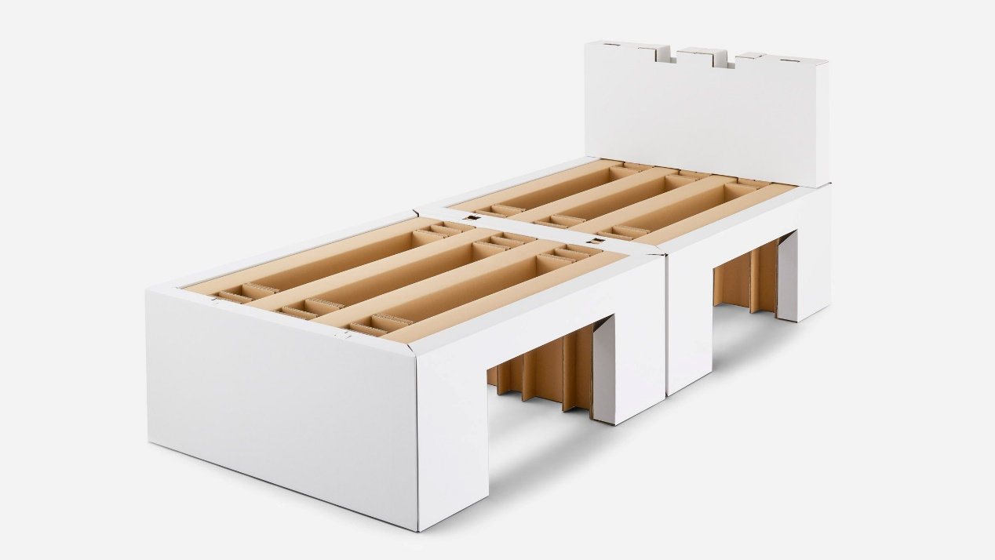
Fig. 1. Airweave creates cardboard beds and modular mattresses for Tokyo 2020 Olympics (Finney 2021)

Modern computer programs have considerably advanced this process, enabling designers to manipulate these folds and craft sturdy, visually appealing structures (Dovramadjiev et al. 2014). Perhaps most unexpectedly, cardboard can offer a competitive edge over seemingly sturdier structural materials in earthquake-prone regions. This realisation prompted world-renowned architect Shigeru Ban to incorporate cardboard (as a form of paper) more extensively into his work, stating: "The first time I used paper was for an interior, but I realised it was strong enough to be used as a structural element to hold up the building. Wood and paper can stand up to earthquakes where concrete can be destroyed. In other words, I discovered that the strength of the materials is unrelated to the strength of the building" (Corkill 2013).
Based on the above, the main features of the Airweave beds utilised in both the Tokyo and Paris Olympics can be summarised as follows:
- durability,
- lightweight,
- easy disassembly and installation,
- convenient transportation and storage,
- environmentally friendly,
- sustainable,
- reusability for other events and activities,
- scalable production capabilities,
- economically viable.

These characteristics and features meet the requirements for furniture required during a natural disaster, particularly in the immediate aftermath. The study suggests that leveraging these characteristics could help meet societal needs in preparing for and mitigating the consequences of seismic disasters on individuals and communities.
10.2. Local Case: Practical Application of Cardboard Furniture (Bed)
Within the study's parameters, a plan was developed for a bed made of recycled cardboard that would be useful for people impacted by seismic disasters, particularly for usage in shelter centres. Recycled cardboard was selected due to its environmental friendliness, cost-effectiveness, widespread availability in the local market, and the presence of requisite expertise and machinery for production.
In the initial phase, manual sketches were drafted, meticulously considering human body dimensions, durability, ease of assembly, disassembly, and installation sans specialised equipment, tools, or adhesives.
In the second phase, these manual sketches were digitally transformed into detailed engineering plans using AutoCAD, showcasing various perspectives of the piece along with precise scales and dimensions (Fig. 2).

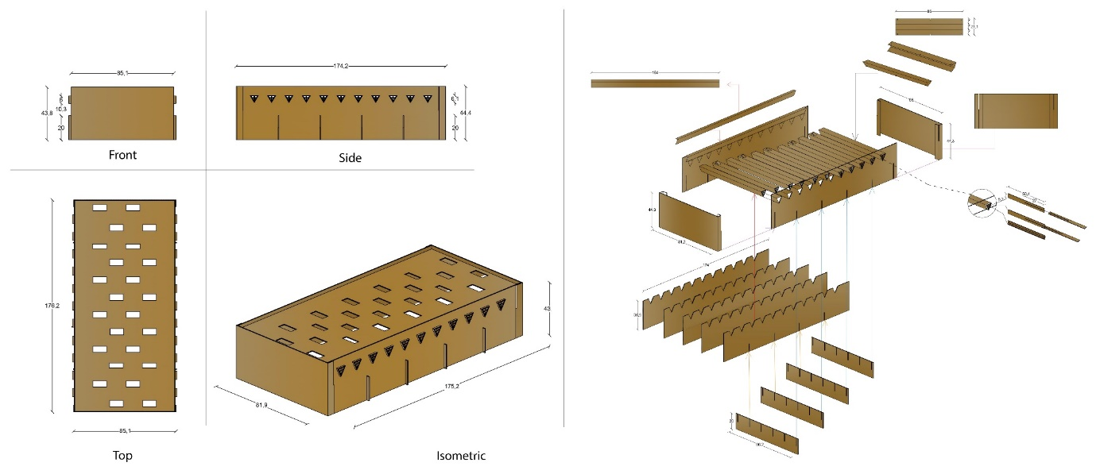
Fig. 2. Detailed plan for local furniture constructed from recycled cardboard using the dovetail assembly method (Nasasreh et al.)

The third phase involved converting the two-dimensional drawings into three-dimensional renderings using the 3Ds Max program to scrutinise the piece's shape from different angles post-assembly (Fig. 3).

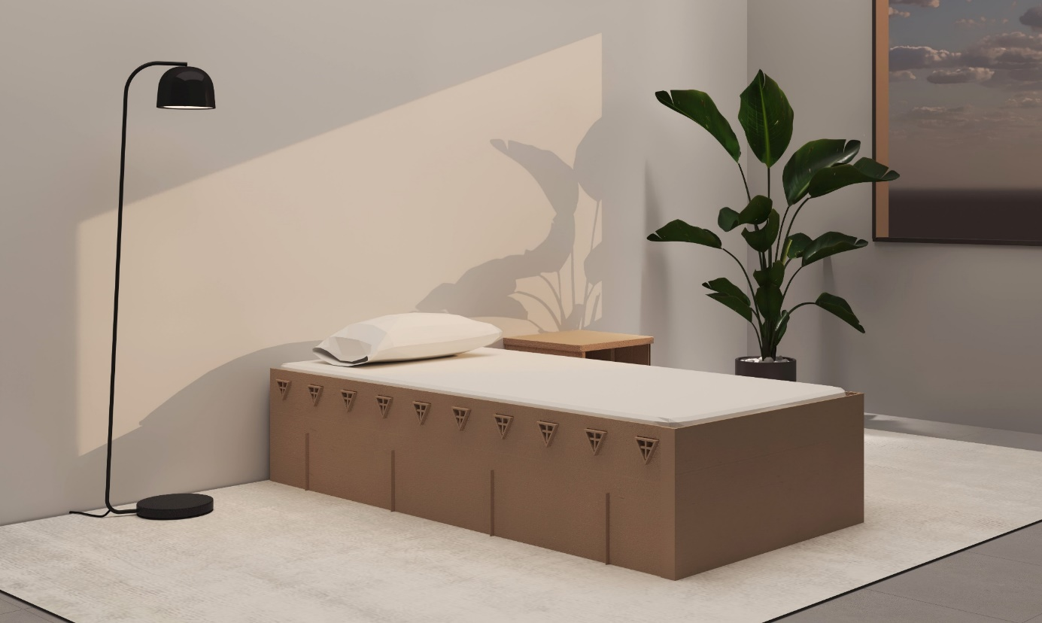
Fig. 3. A 3D model of the selected design for local production, created to facilitate comprehensive examination from various perspectives (Nasasreh et al.)

In the fourth phase, several scaled study models (1:10) were crafted (Fig. 4) to assess the stability of the piece and identify necessary design modifications before proceeding to the first prototype (Fig. 5). The availability of various raw materials in the market facilitated the distribution of materials for the proposed initial model, allowing flexibility in material type, thickness, and weight, thereby reducing costs, loads, and facilitating subsequent cutting and assembly.

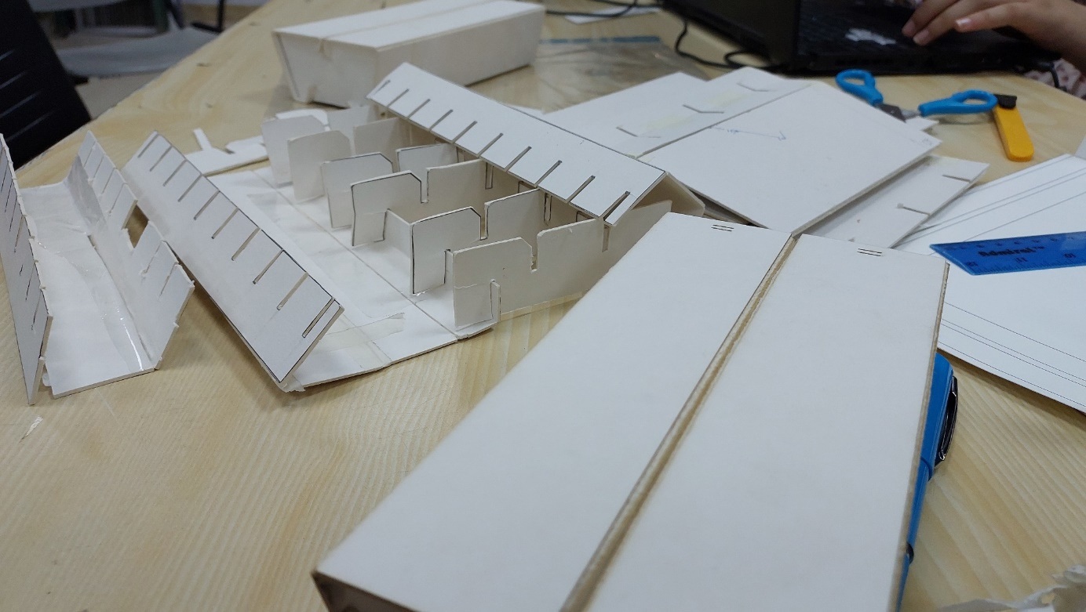
Fig. 4. An image depicting multiple prototype designs for a cardboard bed, scaled at 10:1 (Nasasreh et al.)

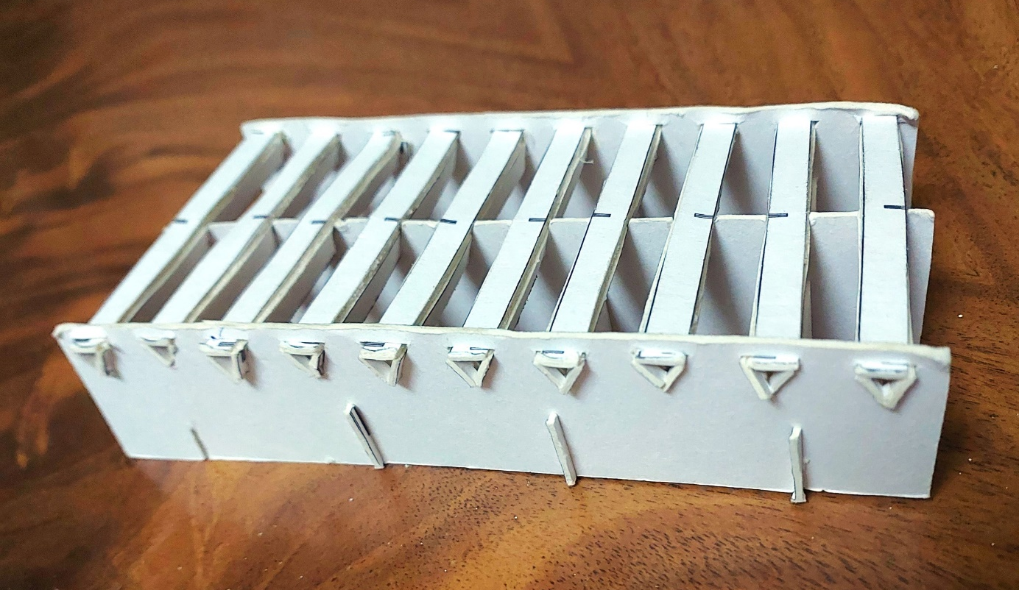
Fig. 5. The initial model (Study Model) selected for the study, scaled at 10:1, was crafted from paper (Nasasreh et al.)

The fifth phase involved visits to local cardboard factories in Nablus to assess available cardboard types, their advantages, disadvantages, pricing, and measurements, facilitating the production of an economical and sustainable bed design while minimising waste (Fig. 6).

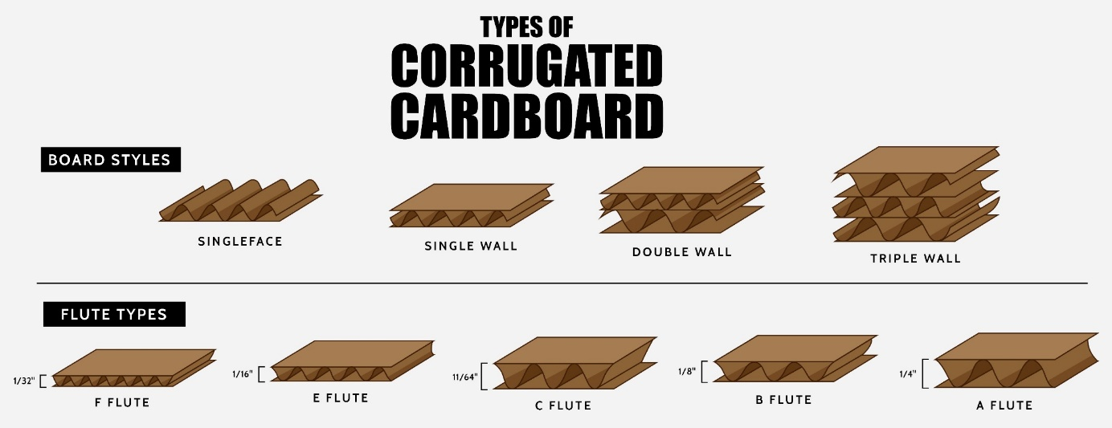
Fig. 6. An image displaying various types of corrugated cardboard accessible in the local market, used for crafting the bed in the local case (Lukáš Fictum 2020)

The bed's primary load-bearing components utilised double-walled B flute cardboard with a thickness ranging from 6-7.6 mm while cladding and non-load-bearing areas utilised double-walled B flute cardboard with a 3.6-4.1 mm thickness. Paperweights ranged between 480-1450 g/m².
In the subsequent phase, an experimental 1:1 scale model was crafted (Fig. 7) using the cardboard selected from previous stages to evaluate the bed's strength and material utilisation. Computer Numerical Control (CNC) technology facilitated cutting known for its cost-effectiveness and efficiency in prototype production. Notably, the material cost for a single bed was calculated at $10.99, consuming less than 5 sheets of cardboard measuring 210 cm by 100 cm.

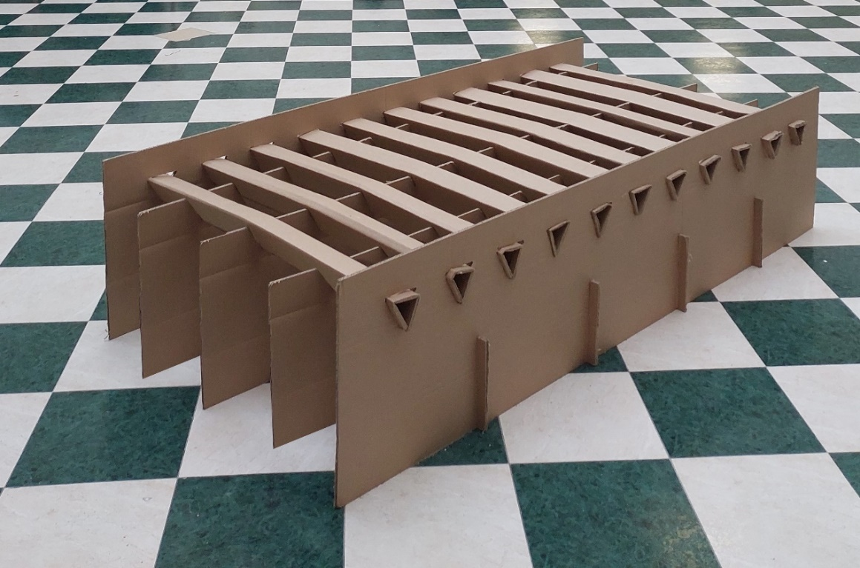
Fig. 7. The initial prototype of a locally crafted cardboard bed, built to a 1:1 scale with dimensions of 90 by 200 cm (Nasasreh et al.)

While the production time per bed with this technique averaged 50 minutes, costing $27.47, the total production cost for one bed amounted to $38.46. It is estimated that costs will significantly decrease with mass production and shearing presses. The cost of shearing a bed of this size ranges from $275-412, with anticipated production costs dropping to less than $11.50 per bed when employing shearing press technology for a production run of 1000 beds.
Following the cutting process, the bed components were assembled using a dovetail method that ensured a simple construction process by eliminating the need for additional tools, metal connections, screws, nails, or adhesives. With its lightweight construction, the bed weighed only a few kilograms and was easily portable with one hand. This comprehensive approach yielded an economical, lightweight, and easily transportable piece, ideal for post-disaster scenarios.
10.3. Advantages and Disadvantages of Cardboard Furniture
10.3.1. Advantages:
- Cost-effective and economical compared to wooden or metal furniture.
- Highly sustainable with a low environmental footprint, preserving natural resources (Turrini 2017).
- Energy-efficient at every stage of production, from recycled raw materials to shipping and installation (Renata & Knoskova 2021).
- Easy to install, assemble, and dismantle without specialised tools or equipment.
- Lightweight.
- Flexible and easily shaped, allowing for innovative and unique designs.
- Durability is ensured by the strength of cardboard paper against tearing and shocks (Gok & Akpinar 2020).
- Requires minimal specialised labour for installation, enabling broad societal participation when necessary.
10.3.2. Disadvantages:
- Limited durability compared to wood and aluminium, necessitating frequent replacement.
- However, the possibility of being susceptible to weather factors can be mitigated with special treatments.
- Highly flammable unless treated for fire resistance.

The local case study reveals the feasibility of producing furniture from Palestinian recycled cardboard, contingent upon:
- Local availability of raw materials.
- Access to expertise for design.
- Essential equipment and technology for manufacturing.
- There are factories and workshops staffed by skilled workers.

In addition, a practical economic study demonstrated the cost-effectiveness of cardboard beds compared to alternatives such as iron or wood in the local market. The initial product displayed promising endurance, indicating potential for further development and increased efficiency to achieve a 100% local product.
11. Outputs
The practical use of cardboard in sporting events such as the Tokyo and Paris Olympics provided strong proof of its potential, particularly due to its large-scale application over a significant duration, covering the entirety of the sporting events. This emphasised recycled cardboard's crucial role in filling gaps, particularly in developing countries like Palestine, in pre-disaster preparation and post-disaster mitigation to relieve negative societal impacts. Due to considerations like cost-effectiveness and the availability of local manufacturing knowledge, the study's recommendation for applicability in Palestine, given its status as a developing country with limited economic resources, bears significance for many other developing nations. Developed countries can benefit from cardboard applications for similar reasons, offering potential solutions to support economic recovery processes following seismic disasters.
12. Recommendations
Based on the results, several recommendations emerge as essential for effective disaster risk management and preparedness:
- Prioritise disaster risk anticipation, planning, and mitigation efforts to protect communities and reinforce their resilience against potential hazards.
- Implement a comprehensive approach to mitigate earthquake risks, necessitating cooperative participation from various societal sectors, such as national authorities, local government, businesses, civil society, NGOs, and academia.
- Integrate the proposed natural disaster furniture in Palestine's national disaster management plan, ensuring provisions for storage and distribution as part of broader risk management strategies.
- View investment in disaster risk reduction as critical, recognising it as a fundamental component of local development rather than an additional expense competing with other priorities in environments with limited resources.
- Encourage the establishment of small to medium-sized initiatives and workshops in all governorates to produce disaster-ready furniture, providing training and resources for rapid mobilisation in response to post-earthquake needs. At the same time, large cardboard factories should be mandated to contribute.
- Motivate designers and researchers to investigate the possibilities of recycled cardboard in the regional furniture sector, acknowledging its financial feasibility and eco-friendliness, which can benefit various societal groups in both peaceful and natural disaster situations.
13. Results
Overlooking disaster risk reduction poses inherent dangers, such as dire environmental and economic consequences and declining confidence among locals and investors. The recommendations above represent a national investment in disaster risk reduction aimed at enhancing the resilience of individuals and communities across economic, social, and health domains. These cost-effective measures significantly contribute to saving lives and mitigating losses. The research underlines the potential of recycled cardboard as a practical material for post-disaster furniture production, offering cost-effective solutions that enhance recovery and rehabilitation efforts. Recycled cardboard is a compelling option in evolving societal mindset toward sustainable practices in terms of storage, transportation, installation, distribution, and environmental sustainability.
14. Conclusion
Sustainable materials are vital in mitigating the impact of natural disasters. Cardboard and recycled paper, in particular, can considerably reduce the adverse effects of seismic risks on health and living conditions, especially in developing countries with fragile economies, such as Palestine. For countries at risk of seismic activity, cardboard and corrugated paper furniture offer an economical and adaptable alternative. The availability of low-cost raw materials, local manufacturing expertise, ease of installation, transportation, and safe storage will contribute effectively and directly to providing quick and practical solutions. Additionally, it will encourage developed countries to participate in preventive and remedial measures, addressing the consequences of seismic disasters while maintaining a low carbon footprint, thereby positively impacting global warming and climate change.
References
Abd Elazeem, A.E. (2022). Efficient Use of Cardboard as an Environmentally Friendly Replacement Material to Achieve a Sustainable Interior Design and Furniture Applying for a Furniture Design Course (1). Journal of Architectural, Arts and Humanities Sciences. https://doi.org/10.21608/mjaf.2022.165784.2866
Abu Anwar, A., Aljafry, M.S., Albasosy, M.M., Roshdy, A. (1999). Industrial Engineering Foundations. Jeddah: King AbdulAziz University.
Abu Deyya, A. (1986). Building Defects. Amman: National Press.
Agha, S.J. (1995). Earthquakes: their reality and effects. Kuwait: National Council for Culture, Art & Letters Kuwait.
Al Dabbeek, J. (2014). Seismicity of the Dead Sea and Jordan Valley Region and Mitigating Earthquake Risks. Conference: Jordan Valley (pp. 55-). Nabulus: An-Najah National University. Retrieved from http://sasparm.najah.edu/en/Uploads/file/FP7-%20Research%20data%20resource%20status%20report-Vesrsion1-finallD2_1.pdf
Aldabbagh, M.M. (2018). Palestine, Our Homeland. Institute for Palestine Studies.
Al-Dabbeek, J. (2009). Earthquake Risk Reduction. Nablus: An-Najah National University.
Alsurakji, S. (2021). The Most Common Problems, Difficulties and Challenges that face the furniture industry in Palestine today. (E. Abu-Hannoud, Interviewer)
Berkeley, G. (2023). Cardboard beds to be used at Paris 2024 after going viral at Tokyo 2020. Retrieved from inside the games: https://www.insidethegames.biz/articles/1138948/cardboard-beds-to-be-used-paris-2024
Bulnwar, H., Lakhal, E., Mayyal, J.S. (2023). Pulp Production by Recycling Used Paper. Ain Temouchent: University of Ain Temouchent.
Corkill, E. (2013). Shigeru Ban: 'People's architect' combines permanence and paper. Retrieved from The Japan Times: https://www.japantimes.co.jp/life/2013/04/07/people/peoples-architect-shigeru-ban-combines-permanence-and-paper/
Dovramadjiev, T., Bratanov, P., Cankova, K., Jecheva, G. (2014). Creating and Researching Sustainable Design of Corrugated. Varna: Technical University of Varna.
El-Kela, R.J., Arraf, S.N. (2021). The Historical Earthquakes in the Dead Sea Rift Region. Journals Geographic, 1(33), 119-174.
EPRC. (2022). Monitoring Report 2022. Brussels: European Paper Recycling Council.
Finney, A. (2021). Airweave creates cardboard beds and modular mattresses for Tokyo 2020 Olympics. Retrieved from dezeen: https://www.dezeen.com/2021/07/11/cardboard-beds-modular-mattresses-airweave-tokyo-2020-olympics/
Foroudi, L. (2023). Athletes will sleep well without AC in Paris, says IOC president. Retrieved from Reuters: https://www.reuters.com/world/europe/athletes-will-sleep-well-without-ac-paris-says-ioc-president-2023-07-25/
Gok, B., Akpinar, D. (2020). Investigation of Strength and Migration of Corrugated Cardboard Boxes. Hittite Journal of Science and Engineering, 7(3), 163-168. https://doi.org/10.17350/hjse19030000185
Hunter, D. (2011). Papermaking: The History and Technique of an Ancient Craft. Dover Publications: New York.
Kiandokht, M. (2023). Eco-Conscious Furniture Design: Exploring Cardboard Layering in Eco-Friendly Chair Design. Greensboro: The University of North Carolina.
Kurlansky, M. (2017). Paper: Paging Through History. New Work: W. W. Norton & Company.
Li, Y., Xiong, X., Qu, M. (2023). Research on the Whole Life Cycle of a Furniture Design and Development System Based on Sustainable Design Theory. Sustainability, 15(18), 2-22. https://doi.org/10.3390/su151813928
Lukáš Fictum, M.Š. (2020). Furniture structural joints made of cardboard and/or plywood. International Society of Wood Science and Technology.
Lye, K. (1992). Earthquakes. London: Franklin Watts.
Nasasreh, R., Raed, M., Haboub, N., Alanas, E., Shakhshir, J., Hussein, S., Rezeq, F. (n.d.). Furniture Design: Ergonomic Furniture. An Najah National University, Nablus.
Orris, E. (2021). Team Israel's baseball team apologises for 'mischievous' Tokyo bed prank. New York Post.
Renata, S., Knoskova, L. (2021). Sustainable Design in the Furniture Industry. 21st International Joint Conference Central and Eastern Europe in the Changing Business Environment : Proceedings. Bratislava: University of Economics in Bratislava, Faculty of Commerce, Department of Commodity Science and Product Quality. https://doi.org/10.18267/pr.2021.krn.4816.20
Reuters. (2023). Paris 2024 unveils 'very strong' cardboard beds. Retrieved from Reuters: https://news.yahoo.com/paris-2024-unveils-very-strong-201855461.html?
SASPARM. (2013). The Role if SASPARM Project in Building the Resilience of the Palestinian Community to Disasters. Nablus: An-Najah National University.
Sawalmeh, A.A. (2024). Medical Preparedness and Response to Earthquake Disasters. (E. Abu-Hannoud, Interviewer)
See, T.J. (2010). The Cause of Earthquakes, Mountain Formation and Kindred Phenomena Connected with the Physics of the Earth (1907). Whitefish: Kessinger Publishing.
Sweet, T.M. (2018). Furniture Design For Disaster: A Case Study for Psychologically Resilient Objects. Journal of Interior Design, 43(11-25), 20. http://dx.doi.org/10.1111/joid.12110
Turrini, D. (2017). Democratic Cardboard. Materials and design for a sustainable society. The Design Journal, 20,
S1682-S1691. https://doi.org/10.1080/14606925.2017.1352691
UNISDR. (2015). Sendai Framework for Disaster Risk Reduction 2015-2030. United Nations.

