 | Rocznik Ochrona Środowiska
 | Volume 26 | Year 2024 ISSN 2720-7501 | pp. 137-145
 | https://doi.org/10.54740/ros.2024.014 open access
 | Received: December 2023 Accepted: March 2024 Published: April 2024
River Erosion Impact on Transport Infrastructure
in "Gilort River Nature2000 site", Romania
Alexandru-Andrei Giurea^{*1}, Laura Comănescu², Cosmin Păunescu³,
Alexandru Nedelea⁴, Laurențiu Ilie⁵
¹Geomorphology-Pedology-Geomatics Department, Faculty of Geography,
University of Bucharest, Romania
https://orcid.org/0000-0002-6267-2967
²Geomorphology-Pedology-Geomatics Department, Faculty of Geography,
University of Bucharest, Romania
https://orcid.org/0000-0001-9767-1190
³Geomorphology-Pedology-Geomatics Department, Faculty of Geography,
University of Bucharest, Romania
https://orcid.org/0000-0001-9769-8756
⁴Geomorphology-Pedology-Geomatics Department, Faculty of Geography,
University of Bucharest, Romania
https://orcid.org/0000-0002-6373-818X
⁵Geomorphology-Pedology-Geomatics Department, Faculty of Geography,
University of Bucharest, Romania
https://orcid.org/0000-0002-0998-0020
* corresponding author's e-mail: andrei.giurea@drd.unibuc.ro
Abstract: River erosion is a complex process due to multiple factors, such as climate changes, discharge quantity, the type of transported sediments, and variations in the hydrological regime. This paper aims to analyse river erosion's impact on transport elements' stability (especially on bridges). To do so, a Geomorphic Change Detection analysis was used, which involves calculating the altitude differences between two successive digital models, as a basis for calculating surfaces and volumes of sediments displaced through the erosion process. This analysis was doubled by a series of cross-sections in the proximity of bridges to observe the current river bed configuration and identify the active processes. The variation of these processes is directly dependent on human interventions undertaken to reduce the erosion process and to protect the infrastructure elements. The bridges located in the studied area are in different stages of damage by lateral and depth erosion processes, depending on their intensity and the human interventions made to protect these bridges. The least affected are the bridges where complex measures have been taken (construction of bed sills) or the dynamic processes have a low intensity.
Keywords: river erosion, Geomorphic Change Detection, transport, infrastructure, Gilort, Romania
1. Introduction
River morphological dynamics are natural occurrences for fluvial rivers (Camporeale et al. 2005, Kleinhans 2010) resulting from processes involving discharge flow, debris and sediment transport, channel migration, and floodplain erosion and accretion (Abbe & Montgomery 2003, Latrubesse et al. 2005, Gurnell et al. 2012). The main causes of river bank erosion, accretion, and channel course changes are related to climate change, discharge quantity and type of sediment, and variations of the hydrologic regime (Schumm 1969).
Fluvial geomorphology has witnessed a time-scale and space-scale research transition, with increasing emphasis on the dynamics of small site-specific rivers with specific characteristics. This shift can be regarded as part of a trend towards understanding and explaining local events rather than describing how rivers change long-term, which raises important questions regarding the relevance of such short-time-scale and small-space-scale research to understand longer-term aspects of landform behaviour (Lane 1998).
Traditionally, the study of fluvial geomorphology has been conducted by observation based in the field or laboratories. Many of the important advances in the discipline are based on these approaches. However, some questions cannot be answered this way for several reasons: there is a temporal scale discontinuity between observation and the scale of change, especially for long-term river evolution. Rivers evolve over centuries or millennia, while direct observation is limited to years or decades. This limitation can be overcome partially by using historical data, maps and aerial photographs (Coulthard 2012).

The subject of riverbed changes has been studied both nationally and internationally, with different perspectives and approaches. At the national level, we mention Rădoane et al., 2010, who analysed the level of the riverbed following the river flow, and Zaharia et al., 2011, with a study aimed at the influence of the runoff regime on sediment transport, depending on the variability of the watershed. Also, Dobre (2009, 2016) highlights the impact of the relief dynamics (including the riverbed) in developing transport infrastructure in Prahova Valley, Romania. On an international scale, there are numerous approaches to the changes in riverbeds: the analysis of the dynamics of the riverbeds using aerial images from different periods (Winterbottom 2000, Gurnel 1997, Zawiejska & Wyżga 2010, Ziliani & Surian 2012), the analysis of the changes occurring in the riverbed following anthropic intervention (Surian & Rinaldi 2003, Rinaldi 2003, Liébault & Piégay 2002, Surian & Cisotto 2007, Wyżga 2008), but also the impact of changes in the bed configuration on anthropic elements (Swanson et al. 2011). In 2021, Păunescu proposed a decision-making analysis for transport development based on GIS tools, considering both natural and anthropic factors.
The purpose of the current study is to observe the impact of the riverbed and floodplain erosion process on the transport infrastructure elements' stability and resistance, using a statistical modelling analysis of dynamic processes based on successive series of satellite images and digital elevation models. This analysis can be used as a monitoring tool for the evolution of dynamic processes in close connection with the anthropic elements in river proximity, regardless of their type. It can be used at regular time intervals or after important hydrological events, such as flash floods, by making local digital models.
1.1. Study area
The study area is located in southwestern Romania (Fig. 1), in the Gorj Subcarpathians unit. The length of the Gilort River in this area, measured on the thalweg, is approximately 27 km.
The altitude range is between 227 and 503 m above sea level. Lower altitudes characterise depression areas and valley corridors, while higher altitudes characterise hill areas, with the Gorj Subcarpathians being a highly fragmented relief unit. The slope of the terrain varies between 0° (quasi-horizontal surfaces, located mainly in river floodplain, respectively on interfluves) and 45° (specific to the slopes). Geological composition is exclusively made of sedimentary rocks with different characteristics. There are sands, gravels and loessoid deposits (alluvial deposits), as well as marls, clays, gypsum, salt and quartz conglomerates (Ielenicz et al. 2003). Based on field measurements, the sediment grain size in the river bed varies from 0.1 mm (mud) to 500 mm (small boulders), with a high percentage (over 50%) of coarse and very coarse gravel (size between 16 and 64 mm). From a pedological point of view, there are two distinct groups of soils: specific floodplain soils (alluvial and alluvial prototypes) and soils specific to the topography and geographical position (especially brown argillaceous soils, brown eu-mesobasic soils and rendzina).

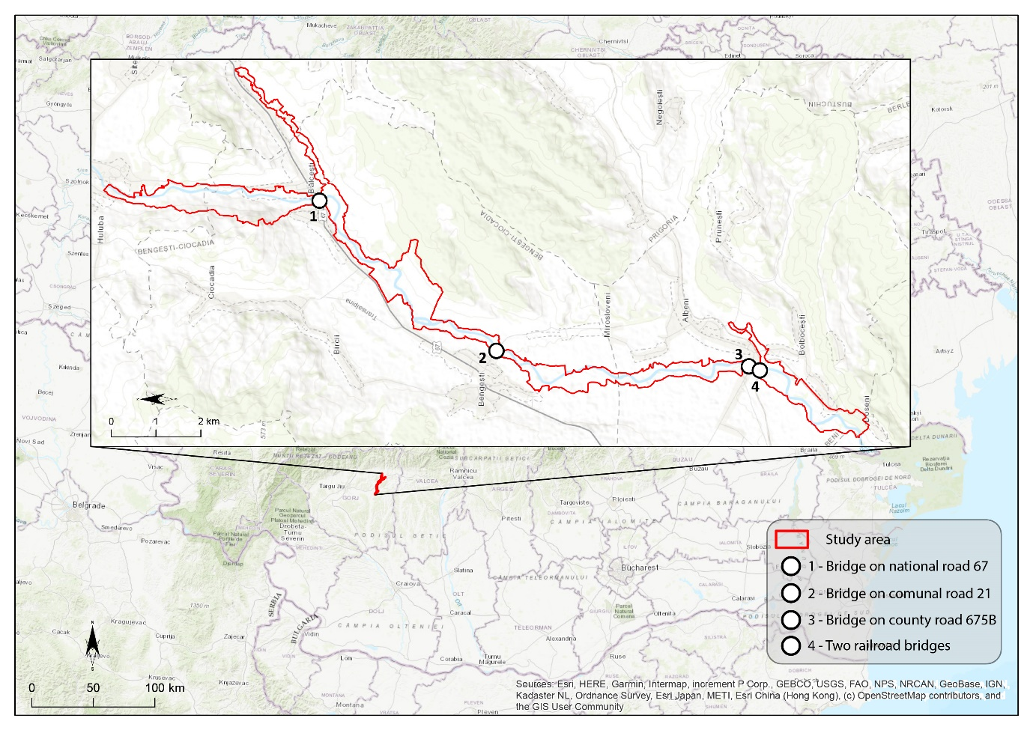
Fig. 1. Study area

The process of gleisation on these soils is null or very small (Soil Map of Romania, 1973). The average annual flow of the Gilort River in the study area is about 10 m³/s. The average flood water flows in the area are about 100 m³/s and occur more frequently in spring (March-May) and late fall and early winter (October-December), according to the data available at The National Institute of Hydrology and Water Management.
Recent history of the study area has seen several floods with different socio-economic implications: Year 2007 – maximum recorded flow rate of 158 m³/s, year 2013 – maximum recorded rate of 145.4 m³/s, year 2014 – maximum recorded rate of 174 m³/s, year 2016 – maximum recorded rate of 118 m³/s, data recorded at the Târgu Cărbunesti Station (downstream of the study area).
Transport infrastructure elements with the greatest vulnerability to the river erosion processes are the bridges on which the rivers are crossed. Thus, five such bridges were identified in the study area: the bridge on National Road 67 (DN67) in Bălcești town, the bridge on Communal Road 21 (DC21) in Bengești town, the bridge on County Road 675B (DJ675B) in Albeni town and two railway bridges located south of the Albeni town (Fig. 1).
A series of anthropic interventions have been identified in the Gilort River bed, which aim to increase the stability of the infrastructure elements by reducing the impact of the riverbed and floodplain erosion process. In this regard, we mention a bed sill to reduce the flow speed and potential energy of the river at the bridge on DN67 in Bălcești town and an embankment to protect the river bank by reducing lateral erosion on the bridge on DC21 in Bengești town.
2. Methodology
The main process highlighted when discussing the impact of river erosion on transport infrastructure components is erosion. This study aims to identify the sectors with potential negative implications on the transport infrastructure by identifying the evolution of the lateral and depth erosion processes in the 2015-2019 time frame.
A Geomorphic Change Detection (GCD) analysis was used to identify the processes in the river bed. This type of analysis involves the calculation of the altitudinal differences between two successive digital models (DEM of Difference – DoD), and, further, based on the results, the calculation of the areas, volumes and percentages of the analysed surface that have undergone lowering (erosion) or rising (accumulation) processes of the topographic surface. As for the digital models, a Digital Terrain Model (DTM) from 2015 and a Digital Surface Model (DSM) from 2019 were used, both datasets having a spatial resolution of 1 m. In the GCD run, a calculation threshold of 0.01 m was set for the highest possible accuracy of the results. There is a difference in structure between the two types of digital models used. DTM represents the land surface, ignoring irregularities such as buildings or vegetation, but DSM includes those irregularities. Thus, the present study cannot give a correct picture of the accumulation processes in the riverbed and floodplain, and they are not the purpose of this paper.
In order to analyse the processes that take place in the proximity of the vulnerable elements of the transport infrastructure (especially bridges), a series of cross-sections were made downstream of these elements to highlight as precisely as possible any lateral or depth active erosion processes.
The historical migration zone of the river (HMZ) was identified to establish the topographic boundary at which run the GCD. This represents the lateral limits to which the river has drifted in recent history. The identification of the HMZ was carried out using successive series of satellite data obtained from different sources: national and international databases (Landsat, Sentinel, Planet Explorer) for the period 1965-2019. The banks were mapped, and a polygon was created to reflect the maximum limits of river migration.
3. Results and Discussions
The total area for which the GCD was run is 3.67 km². As mentioned in the methodology, two digital models with different characteristics are being used; only the areas that recorded negative differences (lowering of the topographic surface) will be discussed. Their surface is 0.82 km², the volume of materials displaced by erosion was calculated at 887,976.57 m², and the average depth at which the topographic surface lowered was 1.08 m. The accuracy of the data, according to the GCD run, is 99.08%.
The magnitude and implications of the lateral and depth erosion process differ for the identified structures, depending on the consolidation and conservation actions undertaken (existing or absent).
The northernmost bridge identified is the bridge on DN67 over the Gilort River in Bălcești town (Fig. 2).
This is a rehabilitated bridge for which a bed sill-type structure was built to reduce the flow speed and implicitly, the river potential energy, which reduces the erosion process at the bridge piers. As a consequence of this type of construction, according to the GCD, the topographic surface lowered less than – 0.4 m in the time interval, compared to the areas 300 m upstream of the bridge, where the surfaces lowered by up to -1.5 m in the same period. Also, from the cross-section made immediately downstream of the bridge (Fig. 3) one can observe the asymmetric banks with a levelling of the riverbed, after which the basic elements of the bed (e.g. thalweg) can no longer be distinguished. Such an intervention (the construction of the bed sills downstream to the bridges) is the most common and with the most optimal results in terms of preserving the infrastructure elements, but it must be designed and thought to integrate into the river ecosystem so as not to create a barrier to upstream migration of fish species.

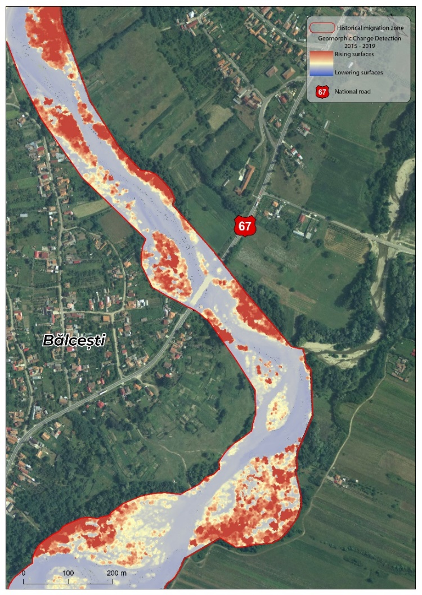
Fig. 2. GCD results at National Road 67

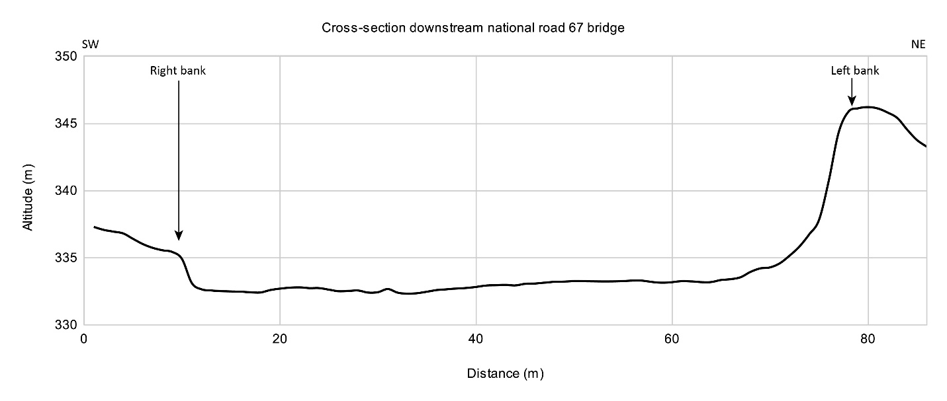
Fig. 3. Cross-section downstream of National Road 67 bridge
The second bridge is the bridge on DC21 in Bengesti town (Fig. 4). This bridge was built after 2014 when a flash flood destroyed the old bridge. This bridge has no riverbed protective structures, so it can be exposed to erosion processes at the bridge piers.
The GCD run shows that the river is divided into two arms, with a median island under the bridge. Topographic surface lowering values of up to 1 m on the eastern channel were calculated between 2015 and 2019. Also, upstream of the bridge, a sector with strong lateral erosion is identified on the left (eastern) bank, with calculated values of lowering of 3.5 m; downstream, a sector with pronounced depth erosion is identified, with calculated values of lowering of up to 3.0 m. These two sectors can contribute to the destabilisation of the bridge, by advancing lateral erosion and affecting the bridge's connection to the main road, respectively by changing the longitudinal profile of the river and advancing in depth erosion upstream.

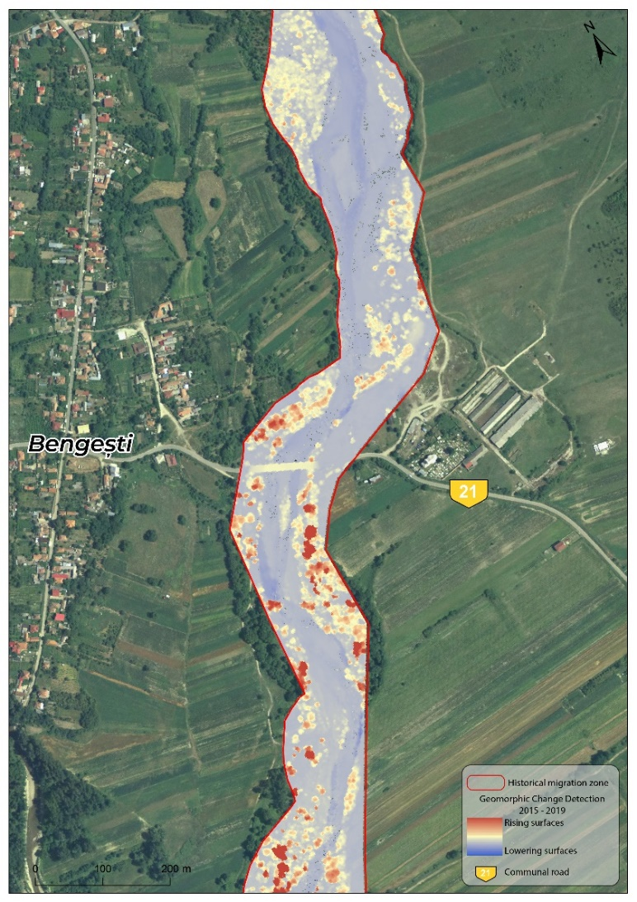
Fig. 4. GCD results at Communal Road 21 bridge

Analysing the cross-section (Fig. 5), it can be seen that in the proximity of the bridge, there are no immediate processes affecting its resistance structure, and on the left bank, there is a protective enbankment to ensure its stability in case of lateral erosion.

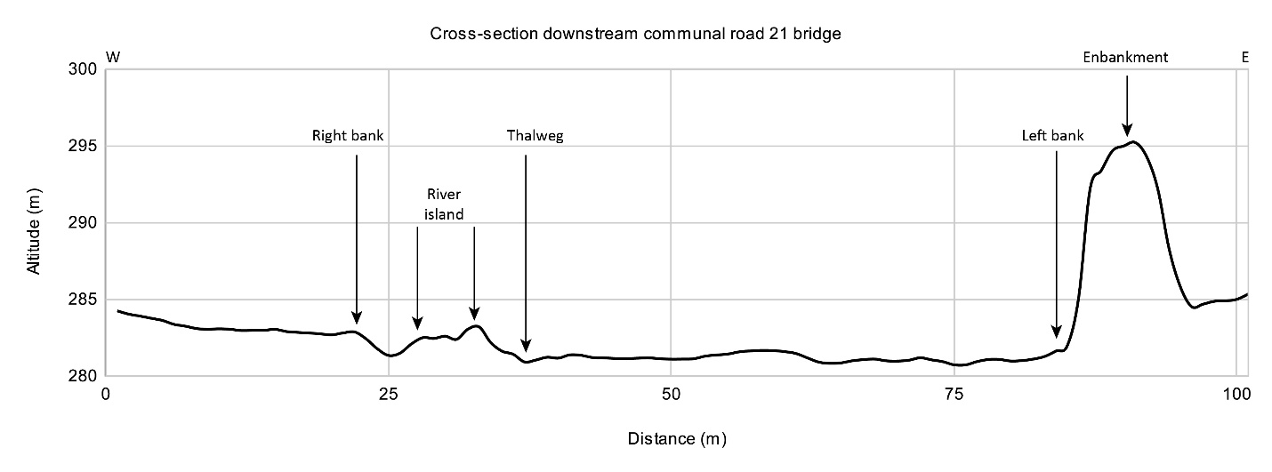
Fig. 5. Cross-section downstream of Communal Road 21 bridge

In Albeni town, one bridge for the road infrastructure and two for the railway infrastructure were identified (Fig. 6).

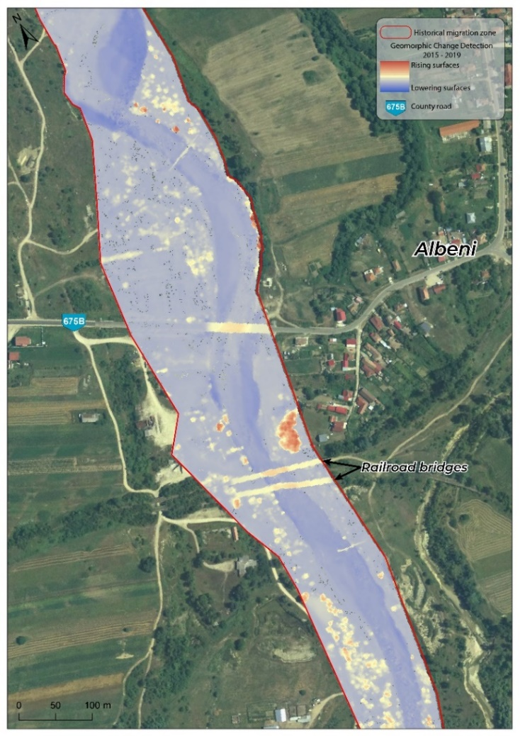
Fig. 6. GCD results at Albeni town bridges

The road bridge is both over the Gilort River and over a left tributary of it (Câlnic), and the GCD results record a lowering of the topographic surface by up to -2.20 m on the right bank of the Gilort and by up to 1 m on the left bank of Câlnic. Also, downstream of the bridge, a sector with pronounced depth erosion is identified, with calculated values of lowering up to 4 m in the Gilort River bed and a sector with depth erosion with calculated lowering values of up to 3 m in the Câlnic River bed. These sectors can destabilise the longitudinal profile of the river, leading to a natural process of balancing the profile by accentuating in-depth erosion upstream.
Analysing the cross-section, an area with a visible erosion tendency can be observed on the right bank of the Gilort (Fig. 7). Also, no protective structure or intervention to regulate the course and flow speed is observed for this bridge.

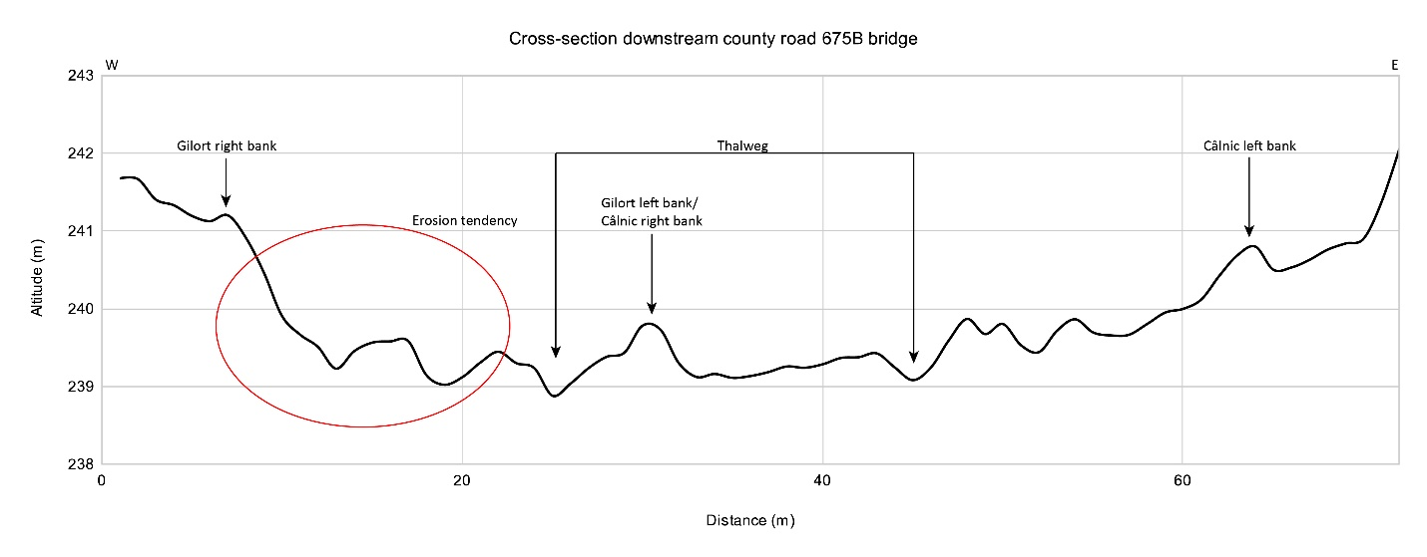
Fig. 7. Cross-section downstream of County Road 675B bridge

The two railway bridges located south of Albeni town (Fig. 6) belong to the same railway main (CF220 Cărbunești – Albeni – Călugăreasca), currently non-interoperable (according to National Railway Company data from 2020). Due to in-depth and lateral erosion, it became impossible to use, its structure and resistance being endangered by the lowering of the river's base level below the level of the bridge piers (Fig. 8). For the studied time interval, a lowering of the topographic surface by approximately 3 m was calculated, so erosion processes are still active in this area. The accentuated erosion tendency can also be observed in the cross-section, especially on the right bank of the Gilort (Fig. 9).
The second railway bridge is built at a distance of 15 m upstream from the first one. Thus, the same accentuated trends of lateral erosion on the right bank are identified. The GCD analysis calculated a surface lowering of approximately 3 m, and the cross-section is similar to the one downstream (Fig. 10).

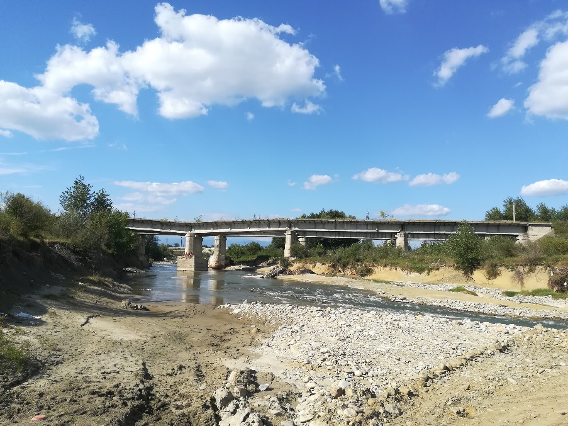
Fig. 8. Railway bridge, Albeni. Photo taken in 2019

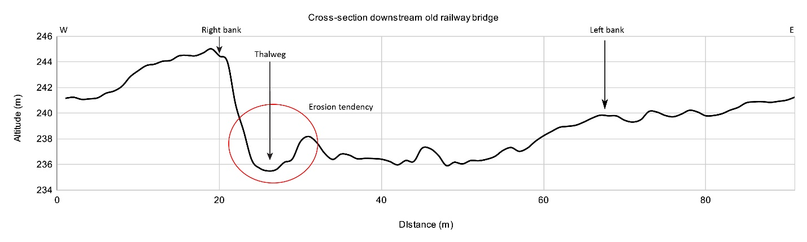
Fig. 9. Cross-section downstream the first railway bridge

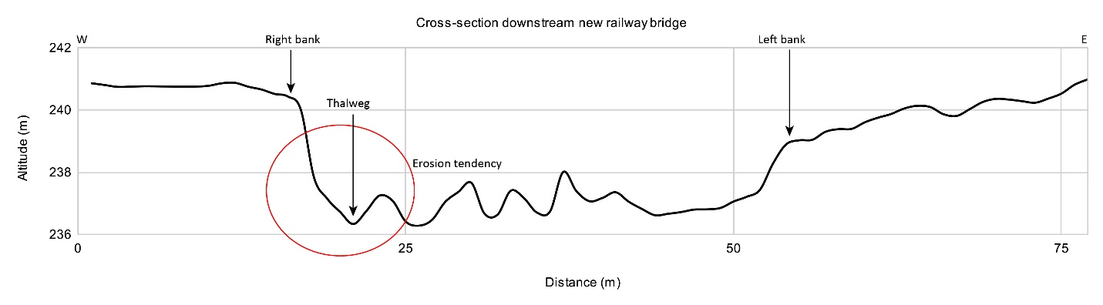
Fig. 10. Cross-section downstream the second railway bridge
4. Conclusions
The elements of the transport infrastructure with the greatest vulnerability to the riverbed erosion processes are bridges. Their construction must consider the evolution trends of the river bed in those sections where it is necessary to cross it. The operational life of some infrastructure elements, such as bridges, is approximately 50 years from the date they were put into use, so the dynamics of riverbed processes must be considered for the entire period. Among the bed processes, lateral and in-depth erosion have the highest impact on the transport infrastructure.
There are several interventions, either at the level of the riverbed or at the level of the banks, through which the erosion processes can be diminished. In the studied area, a series of anthropic interventions were identified to reduce the impact of erosion on the stability of bridges: the construction of bed sills to reduce the flow speed (this intervention must be doubled by constant actions to remove the sediments deposited at the bridge piers, to avoid the risk of damming the river), as well as structures to strengthen the banks against lateral erosion (enbankments).
In the studied area (with a total surface of 3.67 km²), 0.82 km of surfaces recorded a lowering of the topographic surface through erosion processes (lateral or in-depth), with an average depth of lowering of -1.08 m.
The bridges identified in the study area are in different stages of damage due to lateral and in-depth erosion processes, depending on the intensity of the processes and the interventions carried out to protect these bridges.
The study's limitations are related to the difference in structure between the two types of digital models used. Also, the lack of a digital model for an intermediate year could have created a clearer picture of the evolution of dynamic processes (if it is a linear evolution or these processes are related to a hydrological event recorded in the analysed period).
References
Abbe, T.B., Montgomery, D.R. (2003). Patterns and Processes of Wood Debris Accumulation in the Queets River Basin, Washington. Geomorphology, 51(1-3), 81-107. https://doi.org/10.1016/S0169-555X(02)00326-4
Addiscott, T.M., Tuck, G. (2015). Sensitivity Analysis for Regional-Scale Solute Transport Modeling. Book Series: Soil Science Society of America, Inc. 153-62. https://doi.org/10.2136/sssaspecpub48.c8
Camporeale, C., Perona, P., Porporato, A., Ridolfi, L. (2005). On the Long‐term Behavior of Meandering Rivers. Water Resources Research, 41(12). https://doi.org/10.1029/2005WR004109
Coulthard, T.J., Van De Wiel, M.J. (2012). Modelling River History and Evolution. Philosophical Transactions of the Royal Society A: Mathematical, Physical and Engineering Sciences, 370(1966), 2123-42. https://doi.org/10.1098/rsta.2011.0597
Dobre, R.R. (2016). Relația Dinamica Reliefului – Infrastructura de Transport. Bucharest: Editura Etnologică.
Dobre, R.R. (2009). Pretabilitatea Reliefului Pentru Căi de Comunicație Și Transport În Culoarul Prahovei. Bucharest: University of Bucharest.
Gurnell, A.M. (1997). Channel Change on the River Dee Meanders, 1946-1992, from the Analysis of Air Photographs. Regulated Rivers: Research & Management, 13(1), 13-26.
https://doi.org/10.1002/(SICI)1099-1646(199701)13:1<13::AID-RRR420>3.0.CO;2-W
Gurnell, A.M., Walter, Bertoldi, Dov Corenblit. (2012). Changing River Channels: The Roles of Hydrological Processes, Plants and Pioneer Fluvial Landforms in Humid Temperate, Mixed Load, Gravel Bed Rivers. Earth-Science Reviews, 111(1-2), 129-41. https://doi.org/10.1016/j.earscirev.2011.11.005
Ielenicz, M., Pătru, I., Ghincea, M. (2003). Subcarpații României. Bucharest: Editura Universitară.
Kleinhans, M.G. (2010). Sorting out River Channel Patterns. Progress in Physical Geography: Earth and Environment, 34(3), 287-326. https://doi.org/10.1177/0309133310365300
Lane, S.N., Richards, K.S. (1997). Linking River Channel Form and Process: Time, Space and Causality Revisited. Earth Surface Processes and Landforms, 22(3), 249-60.
https://doi.org/10.1002/(SICI)1096-9837(199703)22:3<249::AID-ESP752>3.0.CO;2-7
Latrubesse, E.M., Stevaux, J.C., Sinha, R. (2005). Tropical Rivers. Geomorphology, 70(3-4), 187-206. https://doi.org/10.1016/j.geomorph.2005.02.005
Liébault, F., Piégay, H. (2002). Causes of 20th Century Channel Narrowing in Mountain and Piedmont Rivers of Southeastern France. Earth Surface Processes and Landforms, 27(4), 425-44. https://doi.org/10.1002/esp.328
Paunescu, C., Dobre, R., Comănescu, L., Drăghici, T., Nedelea, A. (2021). GIS as a Support Tool for Sensitivity and Decision-Making Analysis for Transport Infrastructure Development. Rocznik Ochrona Środowiska, 23, 23-41. https://doi.org/10.54740/ros.2021.002
Rădoane, M., Pandi, G., Rădoane, N. (2010). Contemporary Bed Elevation Changes from the Eastern Carpathians. Carpathian Journal of Earth and Environmental Sciences, 5(2), 49-60.
Rinaldi, M. (2003). Recent Channel Adjustments in Alluvial Rivers of Tuscany, Central Italy. Earth Surface Processes and Landforms, 28(6), 587-608. https://doi.org/10.1002/esp.464
Schumm, S.A. (1969). River Metamorphosis. Journal of the Hydraulics Division, 95(1), 255-74. https://doi.org/10.1061/JYCEAJ.0001938
Surian, N., Cisotto, A. (2007). Channel Adjustments, Bedload Transport and Sediment Sources in a Gravel‐bed River, Brenta River, Italy. Earth Surface Processes and Landforms, 32(11), 1641-56. https://doi.org/10.1002/esp.1591
Surian, N., Rinaldi, M. (2003). Morphological Response to River Engineering and Management in Alluvial Channels in Italy. Geomorphology, 50(4), 307-26. https://doi.org/10.1016/S0169-555X(02)00219-2
Swanson, B.J., Meyer, G.A., Coonrod, J.E. (2011). Historical Channel Narrowing along the Rio Grande near Albuquerque, New Mexico in Response to Peak Discharge Reductions and Engineering: Magnitude and Uncertainty of Change from Air Photo Measurements. Earth Surface Processes and Landforms, 36(7), 885-900. https://doi.org/10.1002/esp.2119
Winterbottom, S.J. (2000). Medium and Short-Term Channel Planform Changes on the Rivers Tay and Tummel, Scotland. Geomorphology, 34(3-4), 195-208. https://doi.org/10.1016/S0169-555X(00)00007-6
Wyżga, B. (2007). 20 A Review on Channel Incision in the Polish Carpathian Rivers during the 20th Century. In: Book series: Developments in Earth Surface Processes, 11, 525-53. https://doi.org/10.1016/S0928-2025(07)11142-1
Zaharia, L., Grecu, F., Ioana-Toroimac, G., Neculau, G. (2011). Sediment Transport and River Channel Dynamics in Romania – Variability and Control Factors. Sediment Transport in Aquatic Environments, 293-316.
Zawiejska, J., Wyżga, B. (2010). Twentieth-Century Channel Change on the Dunajec River, Southern Poland: Patterns, Causes and Controls. Geomorphology, 117(3-4), 234-46. https://doi.org/10.1016/j.geomorph.2009.01.014
Ziliani, L., Surian, N. (2012). Evolutionary Trajectory of Channel Morphology and Controlling Factors in a Large Gravel-Bed River. Geomorphology, 173-174, 104-17. https://doi.org/10.1016/j.geomorph.2012.06.001
* * *, Pedological Map of Romania, Sc. 1:200.000, ICPA, București, 1978

