 | Rocznik Ochrona Środowiska
 | Volume 26 | Year 2024 ISSN 2720-7501 | pp. 56-64
 | https://doi.org/10.54740/ros.2024.006 open access
 | Received: January 2024 Accepted: February 2024 Published: February 2024
CFD Simulation of Heat Transfer Through a Window Frame
Borys Basok ^{1*}, Volodymyr Novikov², Аnatoliy Pavlenko³, Borys Davydenko⁴,
Hanna Koshlak⁵, Svitlana Goncharuk⁶, Oksana Lysenko⁷
¹Institute of Engineering Thermophysics of the National Academy of Sciences of Ukraine, Ukraine
https://orcid.org/0000-0002-8935-4248
²Institute of Engineering Thermophysics of the National Academy of Sciences of Ukraine, Ukraine
https://orcid.org/0000-0003-1062-7336
³Kielce University of Technology, Poland
https://orcid.org/0000-0002-8103-2578
⁴Institute of Engineering Thermophysics of the National Academy of Sciences of Ukraine, Ukraine
⁵Kielce University of Technology, Poland
https://orcid.org/0000-0001-8940-5925
⁶Institute of Engineering Thermophysics of the National Academy of Sciences of Ukraine, Ukraine
https://orcid.org/0000-0002-5609-7337
⁷Institute of Engineering Thermophysics of the National Academy of Sciences of Ukraine, Ukraine
*corresponding author’s e-mail: basok@ittf.kiev.ua
Abstract: The use of various coatings with a low level of radiation on the glass elements of window structures, filling the interglacial space in double-glazed windows with inert gases instead of air, increasing the number of cameras in double-glazed windows, other constructive measures aimed at improving the thermal insulation properties of double-glazed windows, led to a significant increase in the thermal resistance of the fenestration system. However, little has changed in the design and construction of window frames and edge areas adjacent to building facades, leaving these elements responsible for heat transfer through modern windows. In this article, with the help of three-dimensional CFD modeling, the thermal insulation properties of window frames are investigated in the most complete setting, taking into account the effect on heat transfer through the profile of the window frame of the adjacent walls of the building facade on one side and the double-glazed unit on the other. Finding out the thermal insulation parameters of the window frame will help to make appropriate changes in its design.
Keywords: profile, window frame, double-glazed unit, heat transfer, thermal resistance, CFD modeling, experiment
1. Introduction
Recently, the development of energy-efficient design of window structures has accelerated rapidly. Due to the use of coatings with a low level of radiation, gas fillers with low thermal conductivity in the interglacial space of double-glazed windows, the use of two- and three-chamber double-glazed windows led to a significant improvement in the thermal insulation properties of the fenestration system. However, the energy efficiency of the window structure as a whole, with a rather high heat transfer resistance in the central part of the glass unit, can be significantly impaired (up to 60) (Byars & Arasteh 1992), when ordinary wooden frames with ordinary metal spacers are used as frames for such glass units. Therefore, some authors (Zajas & Heiselberg 2011) believe that window frames are the "weakest link", and even though they cover a relatively small part of the enclosure area, they are still responsible for a significant amount of heat loss.
It is possible to reduce heat loss through the window frame, keeping in mind the mechanisms of heat transfer from the room to the environment through the profile from which the frames are made. By the way, the mentioned mechanisms are the same as during heat transfer through the central part of the double-glazed unit:
- thermal conductivity through solid frame materials,
- convection and radiation through air cavities that are present in modern PVC profiles (Figure 1).

The action of each of these heat transfer mechanisms can be limited in a certain way. For example, it is possible to reduce thermal conductivity in the walls of the profile structure by embedding a layer of insulation in the walls of the profile (Zajas & Heiselberg 2011). To reduce the effect of radiation in the air cavities of the profile, its walls are covered with films with low emissivity, as is done on the glass surfaces in the central part of the double-glazed unit. The convection component in the air cavities of the profiles is reduced by dividing the cavity into smaller volumes with additional partitions.

In order to assess the thermal insulation properties of modern window profiles, both fairly simple approximate methods (ISO 2003. ISO 15099:2003(E)) and calculations of the thermal properties of frames in transparent structures using CFD modeling are traditionally used (Byars & Arasteh 1992, Zajas & Heiselberg 2011, ISO 2003. ISO 15099:2003(E), Basok et al. 2023a, Basok et al. 2023b). Thus, in (ISO 2003. ISO 15099:2003(E)) the air cavities of the profiles are considered as if they contain an opaque solid with effective thermal conductivity, and then, to determine the heat transfer parameters, the corresponding heat conductivity equation is solved. CFD modeling of horizontal window frames with complex internal air cavities was carried out in (Gustavsen et al. 2007a, Gustavsen et al. 2007b). The simulation results showed that traditional software packages that model only thermal conductivity and use equivalent coefficients of thermal conductivity defined in ISO 15099 (ISO 2003. ISO 15099:2003(E)) for modeling radiation and natural convection in air cavities give results that are almost indistinguishable from CFD model data. That is, the idea of using equivalent values of thermophysical characteristics to calculate heat transfer through window frames, proposed in the international standard (ISO 2003. ISO 15099:2003(E)), is effective and can be used in practice.
There are works (Clarke 2011, Lechowska & Schnotale 2015, Berardi et al. 2020, Lechowska et al. 2017, Baldinelli et al. 2020, ISO 10077-2, 2017), which theoretically, experimentally and in practical operation investigate the effects and methods of increasing the thermal resistance of the window profile. Thus, in (Lechowska & Schnotale 2015), the use of an additional insert is recommended in the area of the glass-profile junction. In (Berardi et al. 2020), the results of a comprehensive study of the thermal characteristics of window profiles with the filling of their cavities with airgel granules, an effective thermal insulation material, are presented. Other options for modernizing the constructive execution of window profiles, namely, filling the cavities with polyurethane foam and applying a low-emission coating on the surface of the profile, are recommended and studied in (Lechowska et al. 2017). To improve the design of window profiles, in (Baldinelli et al. 2020), CFD modeling was performed and relevant experiments were conducted on the influence of all components of the profile design, due to which it was established that the greatest influence on thermal conductivity (and, accordingly, on thermal resistance) is determined by the processes in the air chambers of the structure. The results of (Baldinelli et al. 2020) supplement the materials of the standard (ISO 10077-2, 2017).
2. Setting tasks
However, the complex geometric structure of the profiles, the heterogeneity of the component PVC profiles (Fig. 1) and sometimes a very large ratio between the thickness of the profile walls (0.003 m) and its possible dimensions (1.06×0.642 m) do not allow the full use of CFD modeling of window frames. Therefore, most of the known studies in which CFD modeling of the thermal state of profiles is used, for example (Byars & Arasteh 1992, Zajas & Heiselberg 2011, ISO 2003. ISO 15099:2003(E)), by using their simplified geometry. This approach involves combining small volumes of air cavities into larger rectangular structures within the overall dimensions of the profiles. At the same time, the horizontal and vertical parts of the frame (Zajas & Heiselberg 2011, ISO 2003. ISO 15099:2003(E), Basok et al. 2023a) are considered separately, without taking into account the central parts of the glass unit and the wall structures of the facades of the buildings adjacent to them. On the surfaces of the profiles in contact with the air of the room and the environment, boundary conditions of the third kind are used with standard heat transfer coefficients of 7...8 W/ m²∙K and 23...29 W/m²∙K, respectively.

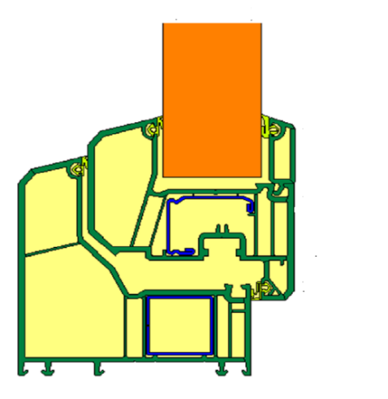
Fig. 1. Cross section of polyvinyl chloride (PVC) window frame (Gustavsen A. et al. 2007a)
This paper presents the results of 3D CFD modeling of heat transfer through a window structure built into the window opening of the building facade. The geometric model of the window structure includes a window opening with jambs, a window block, mounting seams, window sills, a part of the facade walls where the window opening is located, as well as parts of the air volumes in the environment and inside the room (Fig. 2). The window unit includes two-chamber glazing and a three-chamber PVC frame profile with a steel insert. Polyurethane mounting foam is used as a seal between the window unit and the hole in the wall.

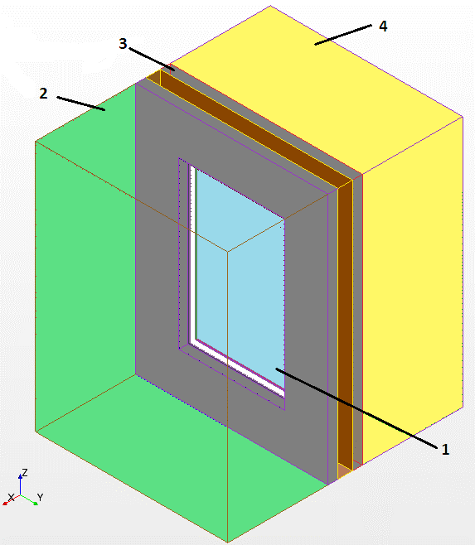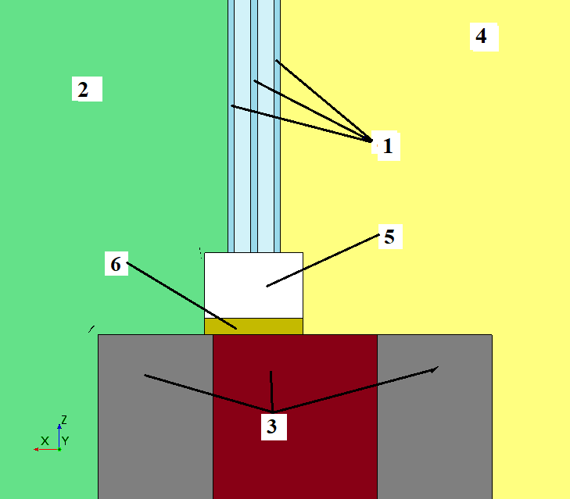
- b)
Fig. 2. Geometrical model of a two-chamber double-glazed unit built into a wall panel: a – three-dimensional model; b – flat cross-section; 1 – two-chamber double-glazed unit 4M1-10-4M1-10-4M1 with dimensions 1.06×0.642 m;
2 – external environment with T air, out = -10℃; 3 – wall "sandwich" panel; 4 – the premises of the room with T air, in = 20℃; 5 – three-chamber profile 0.04×0.06 m; 6 – a layer of mounting foam with a thickness of 0.01 m

Momentum and energy transfer processes in the window construction system are considered in a three-dimensional formulation and described by a system of differential equations consisting of the continuity equation, momentum transfer equations, energy equation (for gaseous medium) and heat conduction equation for solid elements. Conjugation conditions that take into account the convection-radiation heat exchange on these surfaces are realized on the interfaces "solid body – air" and "solid body – solid body", including on the outer surfaces of the window frame. Known empirical dependencies are used to draw up conjugation conditions (ISO 2003. ISO 15099:2003(E)).
3. Result
CFD modeling. From the numerical solution of the specified system of equations, the temperature fields of all model elements, including the three-chamber profile of the double-glazed window frame, are determined (Fig. 3).
The lines along which the graphs of temperatures and heat flux were built are located in the middle of the profile surfaces that are in contact with the air of the room and the external environment.
Based on the ISO 15099 recommendation for modeling and calculating the thermophysical properties of profiles from which window frames are made, the model of the three-chamber profile was built as a solid body with dimensions of 0.04×0.06 m in cross section with dimensions of 1.06×0.642 m with specific thermophysical characteristics. The density, thermal conductivity and heat capacity of the profile model were calculated as weighted average values:
. (1)
In this case, the values of x_{1,2,3} correspond to the values of density, or heat capacity, or thermal conductivity of the components that make up the profile: air – 1, plastic (PVC) – 2, metal tape – 3, and w_{1,2,3} are weighting factors the same components. Weight factors are the actual weight of the profile components.

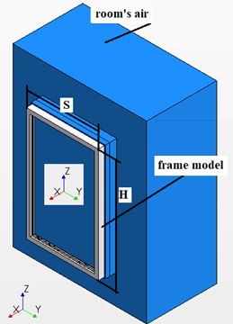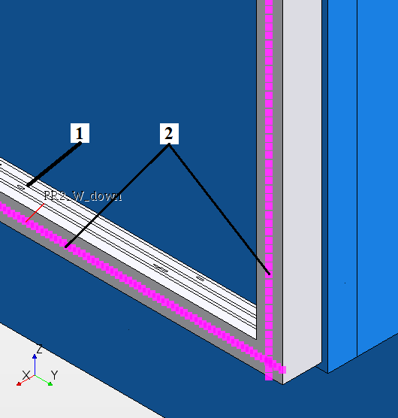
Fig. 3. Part of the three-dimensional model Figure 2: 1 – three-chamber profile model; 2 – the lines along which graphs of temperatures and heat flux were constructed

As a result of numerous experiments, the fields of temperatures and heat flux of the window frame were established, taking into account the influence of the double-glazed unit and the adjacent walls of the building facade. The most important indicator that determines the thermal insulation characteristics of any structural element is the heat transfer resistance R:
, (2)
where T_{in} is the temperature of the profile surface from the room side; T_{out} – profile surface temperature from the environment; qout is the heat flux density on the surface of the profile from the environment.

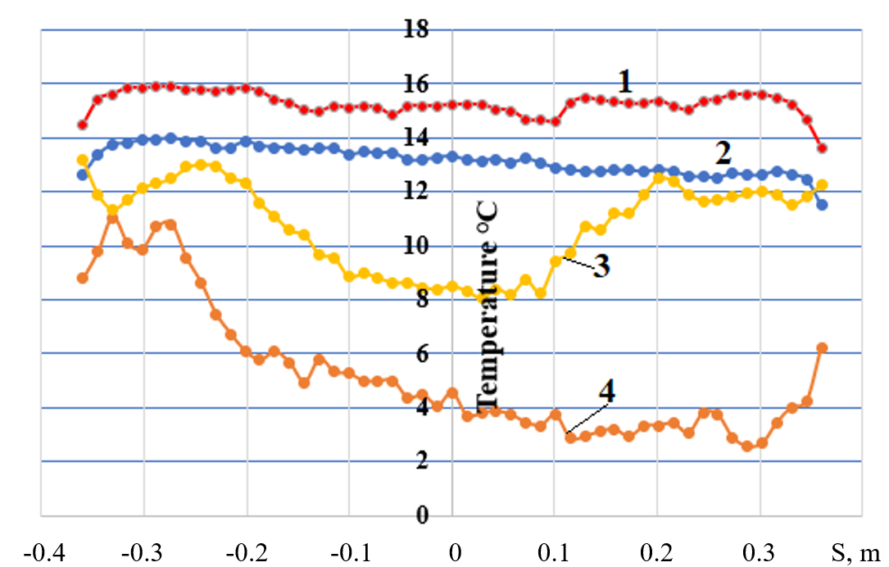

Fig. 4. Temperature distribution on horizontal parts of the frame: 1 – temperature value on the upper part of the frame from the side of the room; 2 – temperature value on the lower part of the frame from the side of the room;
3 – temperature value on the upper part of the frame from the environment; 4 – temperature value on the lower part of the frame from the environment

The results of the 3D CFD simulation under consideration allow you to determine all the necessary data for evaluating the heat transfer resistance (1) of the double-glazed frame. Thus, Figures 4 and 5 show temperature distributions on the horizontal and vertical surfaces of the window frame profile, both from the room side and from the environment side. As expected, the temperature distribution on the outer surface of the frame is lower than on the inner surface.
Also, the temperature on the upper horizontal parts of the profile (Fig. 4), is higher than at the bottom. You should pay attention to the negative values of the distance of the horizontal and vertical components of the window frame in the previous and subsequent Figures.

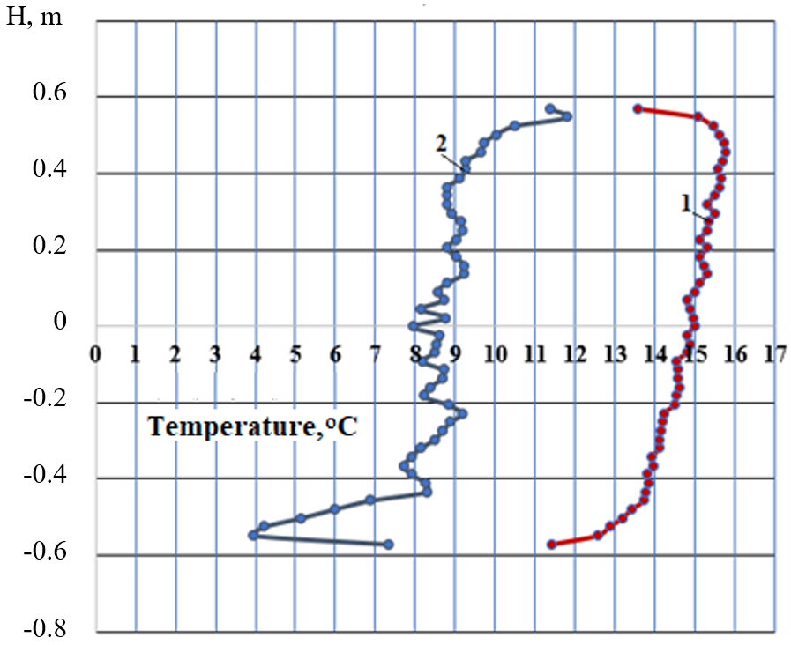
Fig. 5. Temperature distribution on the vertical parts of the frame: 1 – temperature value from the side of the room;
2 – temperature value from the environment

This is due to the fact that the origin of the coordinate system of the model is located in its center, Figure 3.
Figures 6 and 7 show the value of the heat flux density on the frame surfaces, as well as from the side of the room and the environment.

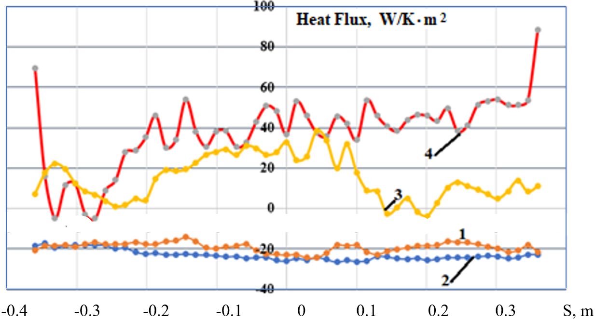
Fig. 6. Distribution of the density of heat flux on the horizontal parts of the profile: 1 – the value of the density of the heat flow on the upper part of the frame from the side of the room; 2 – the value of the heat flow density on the lower part of the frame from the side of the room; 3 – the value of the heat flux density on the upper part of the frame from the environment; 4 – the value of the heat flux density on the lower part of the frame from the environment

Negative values of heat flows from the side of the room in accordance with the balance conditions of the calculation scheme of the simulation means that the heat flux comes from a certain area of the model. In this case – from the indoor. Fluctuations in the values of the functions in the given figures are related to the instability of the boundary layers of the air in the ascending and descending flows, generated by natural convection due to the temperature difference in the room and the environment.
The distribution of temperatures on the internal and external surfaces of the frame (Fig. 4, 5) and the distribution of heat flux on the external surfaces of the frame (Fig. 6, 7) it make possible to determine the local values of heat transfer resistance (1) of the horizontal and vertical components of the frame (Fig. 8, 9).
In Figures 8, 9, the vertical and horizontal straight lines correspond to the average heat transfer resistance of the profile components: 0.29 m²∙К/W for the horizontal part of the profile and 0.32 m²∙К/W for the vertical component.
In addition to the heat transfer resistance value, its inverse value – the so-called U-factor – is used for the thermal insulation characteristics of the structural element. In our case, the U-factor of the components of the window frame is 3.1 and 3.4 (W/m²∙K), respectively, for the vertical and horizontal components.

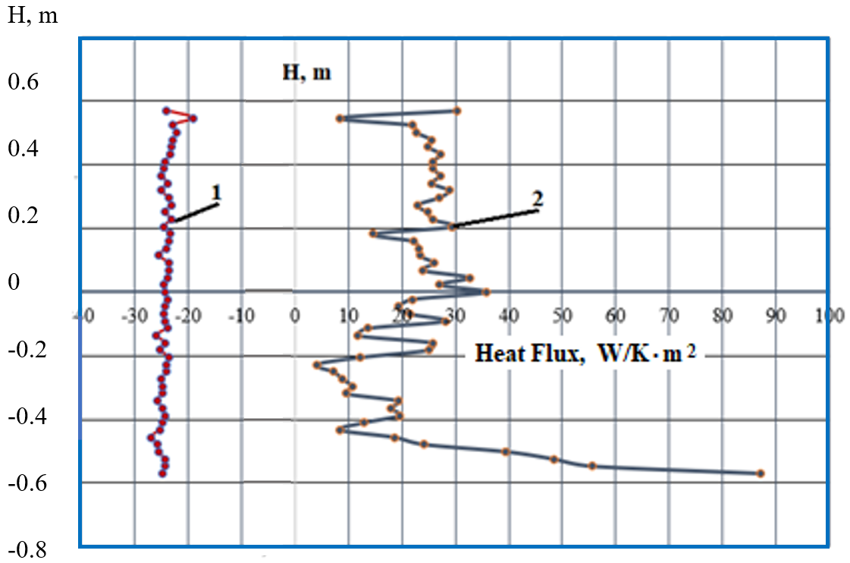
Fig. 7. Distribution of the density of heat flux on the vertical parts of the profile: 1 – the value of the density of the heat flux from the side of the room; 2 – value of heat flux density from the environment

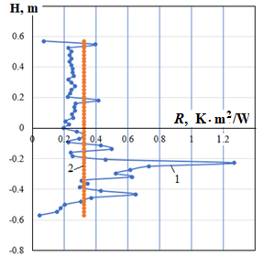
Fig. 8. Value of heat transfer resistance to the vertical part of the double-glazed frame: 1 – local value of thermal resistance; 2 – average value of thermal resistance

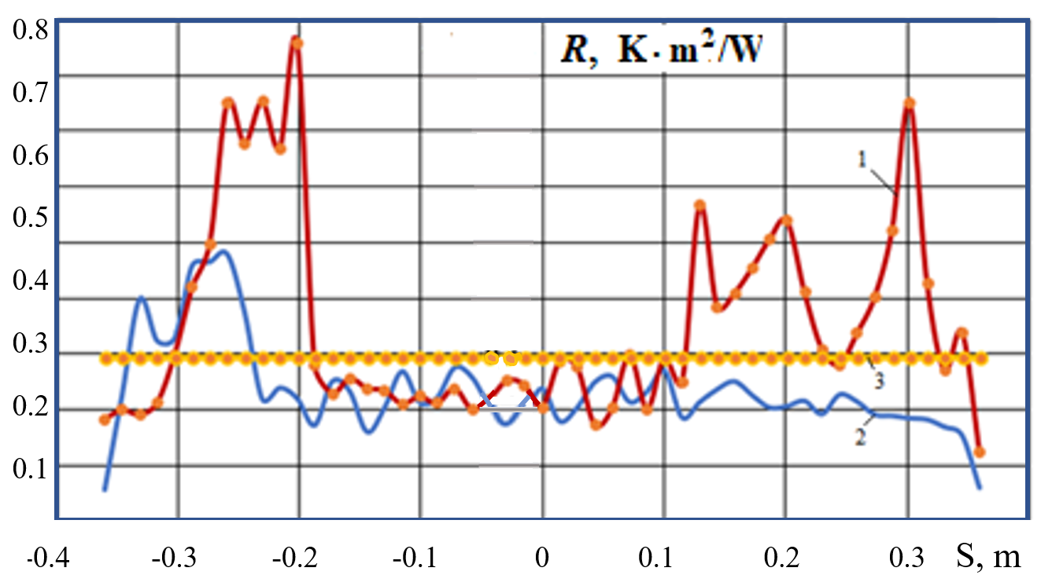
Fig. 9. The value of the heat transfer resistance on the horizontal parts of the double-glazed frame: 1 – thermal resistance on the upper part of the frame; 2 – thermal resistance on the lower part of the frame; 3 – average value of thermal resistance

Those values closely correlate with the data given in (Byars & Arasteh 1992, Zajas & Heiselberg 2011). The graphs of the corresponding functions given in the figures correspond to the values of temperatures and heat flows along the straight lines that pass through the centers of the surfaces of the vertical and horizontal components of the profile.
4. Experiment
In Figure 10 presents experimental data of temperature distribution, and Figure 11 – data for heat flows for a part of a window with a three-chamber profile similar in design to Figure 1 and a similar arrangement in the window frame according to Figure 2, for 5 days of continuous measurement or 120 hours. Measurements by all sensors (8 – temperature and 8 – heat flow) were carried out once every 10 minutes, or 144 per day. Sensors No. 15-18 (diagram of the window part in Fig. 10) are installed in the middle of the parts of the window profile of the stationary (deaf, non-opening) part of the window with the single-glazed unit formula 6M1-12-i6M1 (both horizontally – No. 17, 18 and vertically – No. 15, 16) inside the building, and sensors No. 19-22 are geometrically oppositely installed on the outer surface of the window profiles, that is, from the side of the environment. The sensors are installed on the window of the strictly north orientation of the building, and therefore there is no influence of direct solar radiation. The data are given for the window of an administrative building in Kyiv in the real climate of operation for the beginning of the heated season, the beginning of November, the central heating is not turned on at the proper capacity, the building gradually cools down (upper line in Fig. 10).

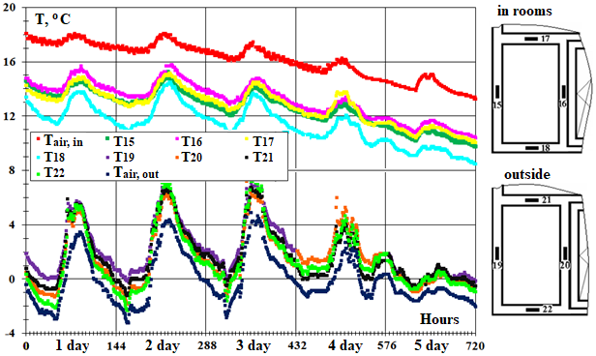
Fig. 10. Temperature dynamics in the central places of the surfaces of the three-chamber profile of the window in real operation. Each point of experimental data corresponds to an instantaneous measurement once every 10 minutes (144 points per day). The right of the place of installation and numbering of measuring sensors of temperature and specific heat flow

Fluctuations in heat flow data are caused by the stochastic dynamics of the speed of air movement both indoors and, especially, outside the building. With a drop in the average daily temperature of the environment, the heat flow also decreases on average from 30 to 20 W/m²∙K in 5 days.

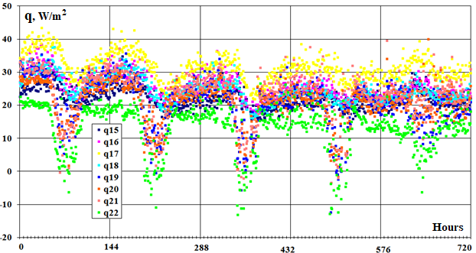
Fig. 11. Temporal dynamics of specific heat fluxes through the surfaces of the three-chamber profile. The locations of the sensors correspond to the positions in Fig. 10, the color of the experimental point is similar to Fig. 10

The reversal of the direction of the heat flow during the day (green dots in the region of negative values, Fig. 11) is due to the daytime maximum of diffuse solar radiation, the increase in the temperature of the environment in the middle of the day (Fig. 10, lower part), as well as the fact that the bottom of the window is a heated device that affects the measurement data. For calculations, only quasi-stationary experimental data were selected at night, when there is no insolation and there are no personnel in the room. As a result of processing the obtained experimental data, the average value of the total heat transfer resistance (taking into account the coefficients of heat transfer from the room to the profile and from the profile to the environment) of the window profiles was determined, which was Rexp = 0.62 m²∙K/W. In the passport for the profile, the manufacturer indicated a similar passport value of R. = 0.62 m²∙K/W, which was measured in the construction climatic chamber. The thermal resistance of the actual window profile was R. = 0.45 m²∙K/W, which is slightly more than obtained from independent modeling. At the same time, we note that in theoretical calculations, the range of values of the thermal resistance of the window profile corresponds to a rather wide interval (Fig. 8, 9) from 0.2 to 0.9 m²∙K/W.
5. Conclusions
There are several circumstances regarding window frames and profiles. Firstly, these structures are a mandatory element of windows – the weakest link of building facades from the point of view of heat loss to the environment. Window profiles account for 10 to 30% of the heat loss of the entire translucent structure (Research and Development Opportunities Report for Windows, 2020), while even frames with the highest thermal characteristics lag behind highly insulated glass units. However, secondly, the positive aspect of window profiles includes the fact that the life cycle is almost 2 times longer than the life of PVC double-glazed windows, reaching 30-40 years. Thirdly, marketing studies show (PVC-window-profiles-market) that the market for the use of PVC window profiles will steadily grow from US$550 (2021) to US$764 million in 2030. Therefore, window profiles have significant prospects in the industry of building construction materials, accordingly, they need scientific and technical support during design, production and operation. Preference should definitely be given to the study of multi-chamber profiles – 6, 7-chamber or more, vacuum or filled with effective heat-insulating materials, for example, transparent granules or plates of nanostructured airgel.

The article was written with the assistance of the National Research Foundation of Ukraine
within the framework of project No. 208/0172 “Aerodynamics, heat exchange and innovations
for increasing the energy efficiency of window structures and their use for the reconstruction
of war-damaged buildings in Ukraine”.
References
Baldinelli, G., Lechowska, A., Bianchi, F., Schnotale, J. (2020). Sensitivity Analysis of Window Frame Components Effect on Thermal Transmittance. Energies, 13(11), 2957. https://doi.org/10.3390/en13112957

Basok, B.I., Davydenko, B.V., Pavlenko, A.M., Kuzhel, L.М., Novikov, V.H., Goncharuk, S.M., Ilienko, B.K., Nikitin, Ye.Ye., Veremiichuk, H.М. (2023a). Reduced heat loss through window structures. Energy Technologies & Resource Saving, 76(3), 43-57. https://doi.org/10.33070/etars.3.2023
Basok, B.I., Pavlenko A.M., Nedbailo O., Bozhko I., Moroz M. (2023b). A Two-dimensional Numerical Model of Heat Exchange in the Soil Massif During the Operation of a Shallow Horizontal Soil Heat Exchanger. Rocznik Ochrona Środowiska, 25, 274-281. https://doi.org/10.54740/ros.2023.029
Berardi, U., Kisilewicz, T., Kim, S., Lechowska, A., Paulos, J., Schnotale, J. (2020). Experimental and numerical investigation of the thermal transmittance of PVC window frames with silica aerogel. Journal of Building Engineering, 32, 101665, https://doi.org/10.1016/j.jobe.2020.101665
Byars, N., Arasteh, D. (1992). Design options for low-conductivity window frames. Solar Energy Materials and Solar Cells, 25(1-2), 143-148.
Clarke, A. (2001). Energy Simulation in Building Design. 2nd Edition, Butterworth-Heinemann Linacre House, Jordan Hill, Oxford OX2 8DP 225 Wildwood Avenue, Woburn, MA 01801-2041 A division of Reed Educational and Professional Publishing Ltd 2001, 362 p.
Gustavsen, A., Jelle, B.P., Arasteh, D., Kohler, C. (2008). State-of-the-Art Highly Insulating Window Frames – Research and Market Review. https://doi.org/10.2172/941673
Gustavsen, A., Kohler, C., Dalehaug, A., Arasteh, D. (2007). Two-Dimensional Computational Fluid Dynamics and Conduction Simulations of Heat Transfer in Horizontal Window Frames with Internal Cavities. LBNL Report NumberLBNL-1132E Conference Paper ASHRAE Winter Meeting 01/2007, Dallas, TX.
ISO 10077-2. Thermal Performance of Windows, Doors and Shutters – Calculation of Thermal Transmittance – Part 2: Numerical Method for Frames; International Organization for Standardization: Geneva, 2017.
ISO 2003. ISO 15099:2003(E) – Thermal performance of windows, doors and shading devices – Detailed calculations. Geneva, Switzerland: International Organization for Standardization.
Lechowska, A., Schnotal, J., Baldinelli, G. (2017). Window frame thermal transmittance improvements without frame geometry variations: An experimentally validated CFD analysis. Energy Build., 145, 188-199. https://doi.org/10.1016/j.enbuild.2017.04.002
Lechowska, A., Schnotale, J. (2015). The window edge-of-glass region temperature profile improvement by inserting a small additional glass pane-a CFD study and measurements. Journal of Building Engineering, 4, 41-51. https://doi.org/10.1016/j.jobe.2015.08.002
PVC-window-profiles-market. https://straitsresearch.com/report/pvc-window-profiles-market/request-sample
Research and Development Opportunities Report for Windows. 2020. 74 р. Retrieved from: https://www.energy.gov/eere/buildings/articles/research-and-development-opportunities-report-windows
Zajas, J., Heiselberg, P. (2011). Analysis of energy saving potential and optimization of thermally broken fiberglass window frames. Proceedings of Building Simulation 2011: 12th Conference of International Building Performance Simulation Association, Sydney, 14-16 November 2011.

