 | Rocznik Ochrona Środowiska
 | Volume 26 | Year 2024 ISSN 2720-7501 | pp. 49-55
 | https://doi.org/10.54740/ros.2024.005 open access
 | Received: January 2024 Accepted: February 2024 Published: February 2024
Heat Transfer Through a Three-chamber Glass Unit
Borys Basok^{1*}, Borys Davydenko², Аnatoliy Pavlenko³,
Svitlana Goncharuk⁴, Hanna Koshlak⁵, Oksana Lysenko⁶
¹Institute of Engineering Thermophysics of National Academy of Sciences of Ukraine, Ukraine
https://orcid.org/0000-0002-8935-4248
²Institute of Engineering Thermophysics of National Academy of Sciences of Ukraine, Ukraine
³Kielce University of Technology, Poland
https://orcid.org/0000-0002-8103-2578
⁴Institute of Engineering Thermophysics of National Academy of Sciences of Ukraine, Ukraine
https://orcid.org/0000-0002-5609-7337
⁵Kielce University of Technology, Poland
https://orcid.org/0000-0001-8940-5925
⁶Institute of Engineering Thermophysics of National Academy of Sciences of Ukraine, Ukraine
*corresponding author's e-mail: basok@ittf.kiev.ua
Abstract: A well-known way to increase the thermal insulation properties of windows in buildings is to increase the number of glasses in a window or, what is the same, to increase the number of glass chambers in a glass unit. This method, in combination with low-emissivity coatings on the inner surfaces of glass, can provide a significant increase in the heat transfer resistance of window structures. The use of such windows in construction can significantly reduce heat loss from the premises in the winter, which leads to a reduction in energy costs for heating and increases the energy efficiency of the building. In this work, the characteristics of heat transfer through a three-chamber glass unit are studied using numerical modeling and experimental study. Options for the absence and presence of low-emissivity coatings on glass are considered. Changes in air velocity and temperature in the chambers are studied. Heat transfer resistance for three-chamber windows are calculated depending on the number of low-emissivity coatings on the glass.
Keywords: heat transfer, mathematical modelling, windows, window thermal resistance, thermal transmittance
1. Introduction
Well-known methods of increasing the heat transfer resistance of windows are the use of low-emissivity coatings on the inner surfaces of glass, replacement of the air medium in the layers between the glass surfaces with inert gases that have a lower thermal conductivity than air. To increase the thermal insulation characteristics of window structures, vacuum glazing (Dongfang et al. 2012, Manz et al. 2006) and filling the gap between the glasses with aerogel (Cook 2018, Dong et al. 2020) are also used. Often, reducing heat loss through a window is achieved by increasing the number of chambers in glass unit. In (Arıcı et al. 2015) it is shown that by increasing the number of glasses, which act as protection against radiation and slow down air flows in the space between the glasses, reducing heat flows by convection, it is possible to significantly reduce heat loss through windows. In (Arıcı et al. 2015, Zhang et al. 2016) also notes that equivalent energy saving of double pane window coated with low emissivity material can be achieved with multiple pane windows even with ordinary window glass. About 50% or 67% of energy savings can be made if the double pane window is replaced by triple or quadruple pane windows, respectively.
The thermal insulation benefits of triple-glazed windows using low-e coatings over double-glazed windows that also use low-e coatings are presented on the base of experimental studies in (Ranaa et al. 2018).
When using a double-chamber glass unit with a width of 32 mm instead of a single-chamber glass unit with the same width, the heat transfer resistance of the window structure increases by 1.7 times, even without using a low-emission coating and without replacing the air in the double-glazed chambers with inert gases (Basok et al. 2016). Replacing a two-chamber window with a three-chamber one can significantly increase heat transfer resistance, that is, increasing the number of chambers in a double-glazed unit increases its heat transfer resistance.
2. Problem Statement
The purpose of this study is to determine the heat transfer characteristics of three-chamber windows and their advantages in comparison with two-chamber windows from the point of view of improving thermal insulation properties of windows.
For this, numerical and experimental studies of heat transfer through three-chamber windows are carried out. Windows has the following dimensions: height H = 0.57 m; width L = 0.43 m; thickness 0.046 m. A three-chamber glass unit consists of four glasses with a thickness of δ_{gl} = 4 mm and three air layers with a thickness of δ_{a} = 10 mm. The problem of heat transfer is solved for cases of absence and presence of low-emission coatings on the inner surfaces of windows. For this purpose, four variants of three-chamber windows are considered: glass surfaces do not have low-emission coatings (1); a low-emission coating is applied to one of the inner surfaces of the inner chamber of the glass unit (2); low-emission coatings are applied to one of the inner surfaces of the inner chamber of the glass unit and to one of the surfaces of the middle chamber of the three-chamber glass unit (3), that is, there are 2 low-emissive coatings in the window; low-emissivity coatings are applied to one of the inner surfaces of the inner chamber, to one of the surfaces of the middle chamber and to one of the surfaces of the outer chamber of the three-chamber window (4), i.e., in the glass unit there are 3 low-emissive coatings.
The problem of hydrodynamics and heat transfer is described by a system of equations that includes continuity equations, momentum equations, and energy equations for a gas medium. The flow of a gaseous medium is considered to be laminar. Heat transfer in glass is described by the heat conduction equation. Conditions of the fourth kind are set on the glass surfaces of the window chamber, which take into account the radiation heat transfer between adjacent glass surfaces. Emission coefficients of surfaces without low-emission coating is ε = 0.89, and with low-emission coating – ε = 0.2. Thermal conductivity of glass is λ_{gl} = 0.74 W/(m·K). The chambers of three-chamber glass unit are filled with air. On the outer surfaces of the window boundary conditions of the third kind are set. The temperature of the outside air is equal to t_{out} = -10.0°С, and the temperature inside the room is t_{in} = +20.0°С. The coefficient of heat transfer on the outer surface of the glass unit is α_{out} = 23 W/(m²K), and on the inner surface α_{in} = 23 W/(m²K). The formulation and method of numerical solution of such a problem are considered in more detail in (Basok et al. 2016, Basok et al. 2023a, Basok et al. 2023b, Basok et al. 2022).
3. Numerical Simulation Results
The results of calculating the velocity and the temperature fields in the three- chamber glass units for the case of windows without coatings and windows with three coatings are shown in Figure 1.
As follows from the calculation results, in all three chambers of the glass unit there is a rising and falling free convection flow of air (Fig. 2). For window without coatings (Figure 2, curve 1), in the outer chamber the velocity of the up-and-down flow is maximum, and in the inner chamber it is minimum. When applying a low-emission coating to the glass surface only in the inner chamber of the glass unit (Figure 2, curve 2), the maximum velocity of the up-and-down air flow is observed in the inner chamber of the glass unit. This is explained by the maximum temperature difference between the two surfaces of the inner chamber of a three-chamber window in the presence of a low-emissivity coating only in this chamber.

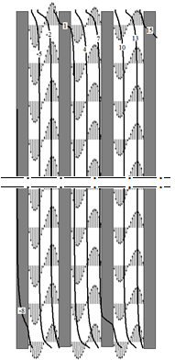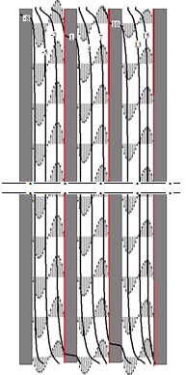
а) b)
Fig. 1. Temperature field (°С) and directions of velocity of the gas medium in the vertical section of three-chamber double-glazed windows: a) without coatings, b) with three coatings
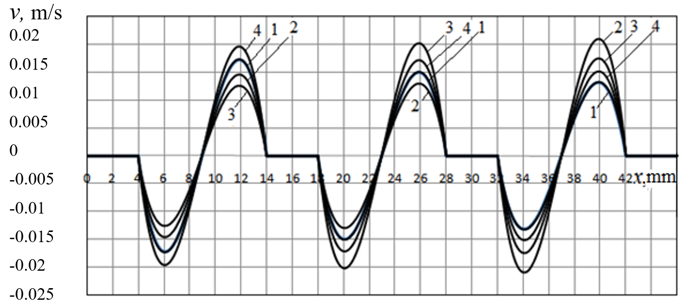
Fig. 2. Comparison of vertical velocity distributions in air layers along the thickness of a three-chamber glass unit: 1) without coatings, 2) one coating, 3) two coatings, 4) three coatings

When a low-emission coating is applied to one surface of glass in the inner chamber of the glass unit and one surface of glass in the middle chamber of the three camber glass unit (Figure 2, curve 3), the maximum velocity of the air flow is observed in the middle chamber. Thus, air velocities are higher in chambers with a low-emission coating. In the case of the presence of a low-emission coating in three chambers (Figure 2, curve 4), the nature of the velocity distribution in the chambers becomes similar to the case of the absence of any coating (option 1). That is, in the outer chamber, as in the first case, the velocity of the rising and falling flow is maximum, and in the inner one – minimum. But comparing the values of the maximum velocities in the chambers, it can be seen that in the case of applying low-emission coatings in all three chambers, the absolute values of the velocities in the chambers will be slightly higher than in the case of the absence of any coatings.
Temperature distributions across the thickness of three-chamber glass units without coating and with coatings in their average horizontal sections for four options for applying a low-emission coating are shown in Figure 3.
Due to the low velocity of the free convection flow in the layers between the glass of a three-chamber glass unit, convection, in comparison with heat conduction and radiation, has an insignificant effect on heat transfer. Therefore, the temperature distribution over the thickness of the gas layers is close to linear, as is the case when heat transfer is carried out mainly by heat conduction.
Comparing the temperature characteristics of three chamber glass units and the temperature differences between the surfaces of different chambers, it can be seen that in the absence of any coating on the glass surfaces, the temperature on the outer surface of the three chamber glass unit is equal to t_{out} = -8.0°С, and on the inner surface t_{in} = 14.7°С.

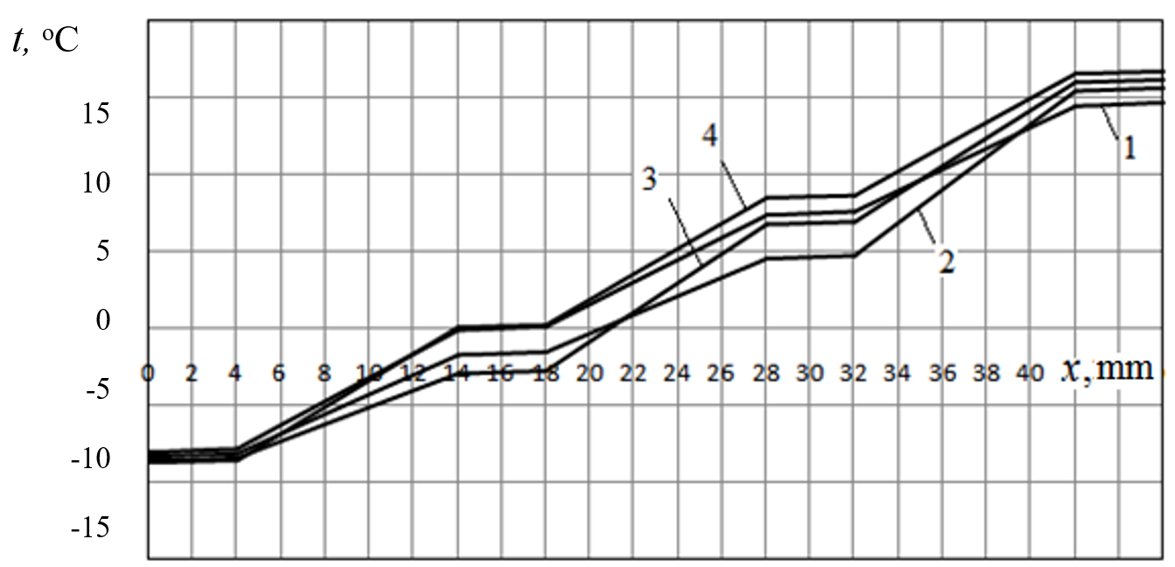
Fig. 3. Comparison of temperature distributions across the thickness of a three-chamber double-glazed unit: 1) without coatings, 2) one coating, 3) two coatings, 4) three coatings

The temperature differences in the chambers of window are equal to: in the inner chamber of the glass unit Δt_{in} = 6.86°С; in the middle chamber Δt_{mid} = 7.26°С, and in the outer chamber Δt_{out} = 7.71°С. It can be seen from these data that in this case the highest temperature difference is observed in the outer chamber (curve 1 in Figure 3). This explains the result that the velocity of air flow in this chamber in the absence of coatings is the highest.
In the presence of one low-emission coating, the highest temperature difference is observed in the inner chamber (curve 2 in Figure 3). With the presence of low-emission coatings on one of the surfaces of the inner chamber and the middle chamber (2 coatings), the temperature of the outer surface of the three chamber glass unit becomes slightly lower than in the case of coating only in the inner chamber, and the temperature of the inner surface is almost 0.6°C higher than in the case of application coating only in the inner chamber. The highest temperature difference is in this case observed in the middle chamber (curve 3 in Figure 3), and the lowest temperature difference is in the outer chamber.
With the presence of low-emission coatings on one of the surfaces of all three chambers (3 coatings), the temperature of the outer surface of the three chamber glass unit becomes the lowest than in the three previous versions, and the temperature of the inner surface is the highest than in the previous versions. The highest temperature difference is observed again in the outer chamber, as well as in the case where there were no coatings at all. But it is now higher by 0.9°C than in the case of no coatings (curve 4 in Figure 3).
As follows from the above results, the presence of a low-emissivity coating contributes to an increase in the temperature difference in the chamber in which this coating is present, and also increases the overall temperature difference between the inner and outer surfaces of the entire glass unit. The heat transfer resistance in each chamber of the three chamber glass unit increases in proportion to the increase in the temperature difference in this chamber.
It should be noted that according to the results of determining the velocity of free convection movement of air in the chambers, with increasing temperature differences in the chamber, the maximum air velocity also increases (Fig. 2). This increases the contribution of convection to the amount of heat flux through the chamber and contributes to the reduction of heat transfer resistance. But due to a more significant decrease in the radiation heat flux due to the presence of a low-emission coating, the total heat flux decreases, and the heat transfer resistance in the chamber, as well as in the entire glass unit, increases.
Therefore, when the number of coatings increases, the temperature on the outer surface of the three chamber glass unit decreases, the temperature on the inner surface increases, and the temperature difference between the inner and outer surfaces increases. This indicates an increase in the overall heat transfer resistance of the three chamber glass unit with an increase in the number of chambers with glass that has a low-emission coating.
Figure 4 shows a comparison of the distributions of heat flux densities on the surfaces of the three camber glass unit for various cases for applying a low-emission coating.

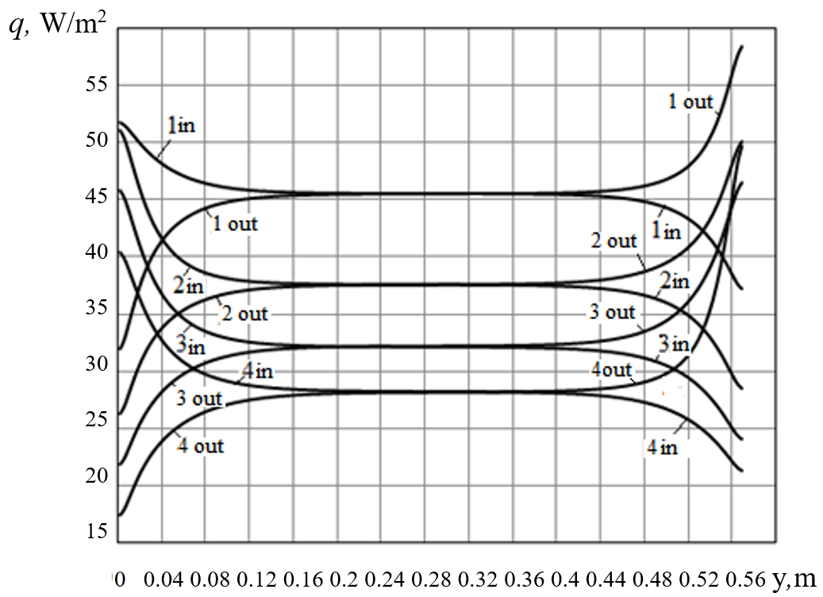
Fig. 4. Comparison of heat flux density distributions on the outer (out) and inner (in) surfaces of a three-chamber glass unit: 1) without coatings, 2) one coating, 3) two coatings, 4) three coatings

It can be seen from this figure that the heat flux densities on the inner and outer surface of the three chamber glass unit without coatings practically coincide in middle parts of these surfaces. As can be seen from this figure, each additional application of a low-emission coating contributes to the reduction of heat flux densities.
A comparison of the total heat fluxes on the surfaces of a three-chamber glass units for different numbers of low-emission coatings is presented in Figure 5. From this figure, it can be seen that with an increase in the number of low-emission coatings, the heat fluxes on the surfaces of the three-chamber glass unit decrease. This figure also shows that one coating in the inner chamber reduces the heat flux by 1.2 times. Two coatings reduce heat flux by 1.4 times, and three coatings reduce this indicator by almost 1.6 times.

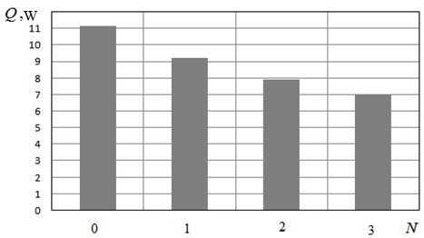
Fig. 5. Dependence of the integral heat flux transferred through a three-chamber glass unit on the number of low-emission coatings

According to the results of calculation studies, the value of the total heat transfer resistance of the three-chamber glass unit R is also determined, depending on the number of low-emission coatings (Fig. 6a). According to these data, the heat transfer resistance of the glass unit itself is also calculated according to the formula . The results of the calculation are shown in Figure 6b.

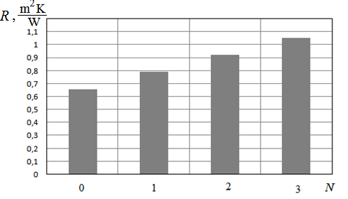
a)

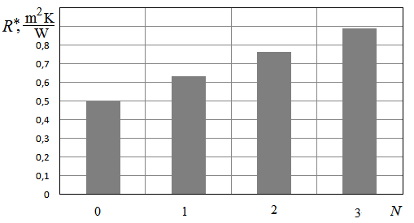
b)
Fig. 6. Dependence of the heat transfer resistance of a three-chamber glass unit on the number of low-emission coatings: a) total resistance, b) own resistance

From the given results, it follows that the presence of a third chamber in the glass unit increases its heat transfer resistance in comparison with the case of double-chamber glass unit. One chamber of glass unit without coating provides a heat transfer resistance of R*_{1.0} ≈ 0.167 m²K/W, and one chamber with one coating provides R*_{1.1} ≈ 0.297 m²K/W. The total resistance of a glass unit having n chambers without coatings and m chambers with one coating can be calculated approximately by the formula (1).
(1)
At the same time, the total resistance of the glass unit is calculated according to the formula (2).
(2)
The results of the experimental determination of the temperature on the outer and inner surfaces of the three-chamber glass unit and the corresponding graphs of the heat flux density are presented in Figures 7, 8. Each parameter was measured every 10 minutes throughout the day in real climatic conditions for 9 days. The amplitude of heat flux fluctuations on the outer surface of the glass unit (from the environment) is greater than on the inner surface of the glass (inside the room), which is caused by significant fluctuations in the out wind velocity.

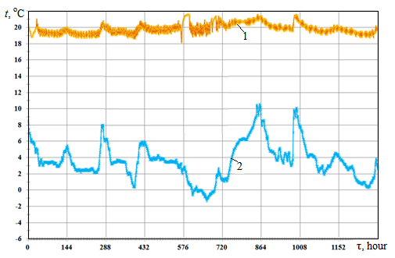
Fig. 7. Temperature distribution on the inner (1) and outer (2) surfaces of three-chamber glass unit

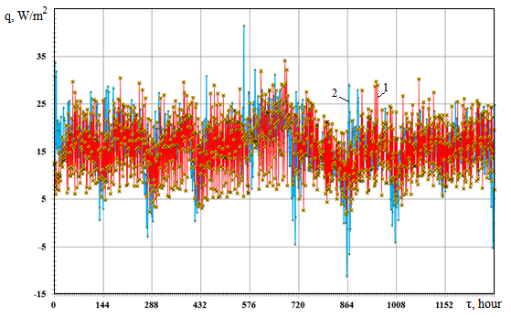
Fig. 8. Distribution of heat flux densities on the inner (1) and outer (2) surfaces of the three-chamber glass unit

From the obtained data, the average temperature values of the inner and outer surface of the three-chamber glass unit were: t_{in} = 19.1°С and t_{out} = 2.5°С at steady state. The average value of the heat flux density on the inner surface of such a window structure: q_{in} = 17.3 W/m². The experimental value of the heat transfer resistance of a three-chamber double-glazed unit with four low-emission coatings was: R = 1,121 m² K/W. The experimentally obtained value of the heat transfer resistance of a three-chamber glass unit with low-emission coatings is quite close to the value of heat transfer resistance found from the results of numerical modeling (Figure 6a).
4. Conclusion
From the results of calculation and experimental studies it follows that with an increase in the number of chambers in the glass unit from two to three, the heat transfer resistance of the window increases accordingly. The heat transfer resistance of a three-chamber glass unit increases if there is a low-emissivity coating on the glass surfaces in chamber. One coating in the inner chamber of a three-chamber glass unit increases its heat transfer resistance by 1.2 times. Two coatings (one in the inner chamber and one in the middle chamber) increases heat transfer resistance by 1.4 times compared to a three-chamber glass unit without coating. Three coatings (one in each chamber) increases heat transfer resistance by 1.6 times.

The article was written with the assistance of the National Research Foundation of Ukraine
within the framework of project No. 208/0172 “Aerodynamics, heat exchange and innovations
for increasing the energy efficiency of window structures and their use for the reconstruction
of war-damaged buildings in Ukraine”.
References
Arıcı, M., Karabay, H., Kan, M. (2015). Flow and heat transfer in double, triple and quadruple pane windows. Energy and Buildings, 86, 394-402. https://doi.org/10.1016/j.enbuild.2014.10.043
Basok, B.I., Davydenko, B. V., Isaev, S.A., Goncharuk, S.M., Kuzhel, L.N. (2016). Numerical modeling of heat transfer through a triple-pane window. Journal of Engineering Physics and Thermophysics, 89(5), 1277-1283. https://doi.org/10.1007/s10891-016-1492-7
Basok, B.I., Davydenko, B.V., Novikov, V.H., Pavlenko, A.M., Novitska, M., Sadko, K., Goncharuk, S. (2022). Evaluation of Heat Transfer Rates through Transparent Dividing Structures. Energies, 15(13), 4910. https://doi.org/10.3390/en15134910
Basok, B.I., Davydenko, B.V., Pavlenko, A.M., Kuzhel, L.М., Novikov, V.H., Goncharuk, S.M., Ilienko, B.K., Nikitin, Ye,Ye, Veremiichuk, H.М. (2023a). Reduced heat loss through window structures. Energy Technologies & Resource Saving, 76(3), 43-57. https://doi.org/10.33070/etars.3.2023
Basok, B.I., Pavlenko, A.M., Nedbailo, O., Bozhko I., Moroz M. (2023b). A Two-dimensional Numerical Model of Heat Exchange in the Soil Massif During the Operation of a Shallow Horizontal Soil Heat Exchanger. Rocznik Ochrona Środowiska, 25, 274-281. https://doi.org/10.54740/ros.2023.029
Cook, Kian. (2018). Implementing Aerogels into Windows to Reduce Heat Transfer and Decrease Emissions. Honors Theses. 1636. Retrieved from: https://digitalworks.union.edu/theses/1636
Dong, Li, Chengjun, Zhang, Qing, Li, Changyu, Liu, Müslüm, Arıcı, Yangyang, Wu. (2020). Thermal performance evaluation of glass window combining silica aerogels and phase change materials for cold climate of China. Applied Thermal Engineering, 165(25), 114547. https://doi.org/10.1016/j.applthermaleng.2019
Dongfang, Hu, Yichen, Li, Chang, Liu, Yanbing, Li. (2018). Analysis for the heat transfer of fully tempered vacuum glazing based on the thermal resistance model and finite element model. Advances in Mechanical Engineering, 10(9), 1-11:168781401879598. https://doi.org/10.1177/1687814018795985
Manz, H., Brunner, S., Wullschleger, L. (2006). Triple vacuum glazing: Heat transfer and basic mechanical design constraints. Solar Energy, 80(12), 1632-1642. https://doi.org/10.1016/j.solener.2005.11.003
Ranaa, A., Alama, M. S., Charlesa, K., Pereraa, P., Hewagea, K., Sadiq, R. (2018). Thermal performance of double and triple glazed windows: Experimental results from lab and in-situ measurements. 1st International Conference on New Horizons in Green Civil Engineering (NHICE-01), Victoria, BC, Canada, April 25-27, 2018. Retrieved from: https://www.researchgate.net/publication/326316386
Zhang, T., Tan, Y., Yang, H., Zhang, X. (2016). The application of air layers in building envelopes: A review. Applied Energy, 165(1), 707-734. https://doi.org/10.1016/j.apenergy.2015.12.108

