 | Rocznik Ochrona Środowiska
 | Volume 26 | Year 2024 ISSN 2720-7501 | pp. 18-29
 | https://doi.org/10.54740/ros.2024.002 open access
 | Received: December 2023 Accepted: January 2024 Published: January 2024
Multi-domain, Autonomous Measurement Buoy as an Element of the Water Quality Monitoring and Early Warning System in Rivers and Water Reservoirs
Andrzej Błażejewski^{1*}, Sebastian Pecolt², Maciej Grunt³, Gwidon Wieczorek⁴, Tomasz Królikowski⁵
¹Faculty of Mechanical Engineering, Koszalin University of Technology, Poland
https://orcid.org/0000-0002-5683-4069
²Faculty of Mechanical Engineering, Koszalin University of Technology, Poland
https://orcid.org/0000-0003-1664-695X
³Hilo Solutions Sp. z o.o., Szczecinek, Poland
https://orcid.org/0000-0001-6327-3557
⁴Enviwise Sp. z o.o., Szczecinek, Poland
⁵Faculty of Mechanical Engineering, Koszalin University of Technology, Poland
https://orcid.org/0000-0003-0247-6478
*corresponding author's e-mail: andrzej.blazejewski@tu.koszalin.pl
Abstract: This article presents a novel, innovative, open multi-domain platform for early warning against adverse events in reservoirs and watercourses, which can measure temperature, pH, redox, conductivity, turbidity, chlorophyll and phycocyanin. These parameters are key indicators of cyanobacteria bloom. This platform allows remote and distributed monitoring of important locations on lakes and rivers. The station's design enables the use of both wired sensors directly connected to the station and wireless data collection from locally dispersed measurement points that communicate with the station-buoy. The data aggregation system is open, and the technological solution of the station is universal, which means it can use different sensors for chemical and biological parameters that are required by, for example, the Water Framework Directive, from the market and industry standards. The platform also has built-in machine learning and data analysis mechanisms that can optimise the number of stations needed to achieve the desired level of data acquisition. The sensor dispersion and station autonomy ensure the flexibility and scalability of the measurements.
Keywords: water bodies, water chemical and ecological status, blooming of cyanobacteria, measurement platform
1. Introduction
The idea of measuring buoys in the form of a multi-domain early warning platform that can monitor the water condition in different aspects is presented in this article. They can collect and, at the same time, analyse water quality data determined by temperature, salinity, acidity or alkalinity value, dissolved oxygen, turbidity, and other parameters important in a specific case. Such a buoy can also detect and warn of abnormal or hazardous situations, such as oil spills, harmful algal blooms, or marine pollution. The buoy is designed to be robust, reliable, and easy to deploy and maintain. It can communicate with the administrator and other chosen users through wireless or satellite networks and provide real-time information and reports on the water condition. Water purity monitoring is the process of measuring and analysing water's physical, chemical and biological characteristics to ensure its quality and safety for various uses. Water purity monitoring can be done at different stages of the water cycle, such as source water, treatment plants, distribution systems and end users. Water purity monitoring can help detect and prevent water pollution, protect public health, comply with regulations and standards, and optimise water resources management (Xiaojun et al. 2022, Dipshika et al. 2019, Ula et al. 2022). A device for water purity monitoring in the form of a measuring buoy that collects data on water quality in different water bodies, such as lakes and rivers (Washburn et al. 2001, Wilson 2009), has installed sensors that measure various factors relating to water quality, such as temperature, pH, oxygen content, turbidity and other water quality indicators (Ribas et al. 2018, Zhao et al. 2015). The data from the buoy helps to track changes in water quality and find possible sources of pollution or environmental issues that can harm the water life and the nearby people (Chamier-Gliszczyński et al. 2016).
Discharging harmful substances into the water, such as chemicals, plastics, sewage, oil, and metals, can affect the water quality and damage the habitats and health of water life (Ng et al. 2012). Pollution can also cause eutrophication, which is the excessive growth of algae that depletes the oxygen in the water and creates dead zones where no life can survive (Agade et al. 2022, Mantas et al. 2013).

Measuring buoys are useful tools for understanding and managing water resources (Colen et al. 2019), and they provide, together with other modern technologies, important information to scientists, policymakers, and others who care about protecting, preserving, and managing our water resources (Mantas et al. 2013).
There is ongoing research and development in this field, and some of the recent advances and improvements are real-time monitoring. It allows for quick reactions to environmental changes and fast detection of pollution sources or other risks. GIS (Geographic Information Systems) is a technology that can be used to combine data from measuring buoys with other environmental data, such as land use and water flow. GIS can help to visualise, analyse, and interpret the spatial patterns and relationships of the data.
Measuring buoys can collect and transmit various data on water quality using multi-parameter sensors and wireless technologies (Šaliga et al. 2015). The data can be sent wirelessly to a central monitoring station using satellite, cellular, or other methods, enabling remote access and analysis. It is especially useful for large water bodies where manual data collection (Pecolt et al. 2023) may be difficult or dangerous. However, the accuracy of the sensors may be affected by fouling, drift, or calibration issues, which need to be addressed to ensure the reliability of the data. The data can also help identify patterns and correlations that can inform management decisions based on the location of threats (Rodero et al. 2022, Sim et al. 2020).
One of the main challenges in water quality monitoring is data management. Measuring buoys can produce large volumes of data that require specialised software tools to store and analyse. Some examples of these tools are Aquarius, HydroServer, and WaterML (Khattar et al. 2020). These tools can help researchers and other applicants track trends, observe changes in water quality over time, and make evidence-based decisions about resource management. Data quality, integration, and management are important factors that affect the usefulness of the data collected by measuring buoys. Measuring buoys work best when used in partnership with local communities or other stakeholders. Building trust, sharing data, and developing management strategies with these groups can be difficult but are essential for the long-term success of any water quality monitoring program. Data management is also enhanced by machine learning and artificial intelligence (Iafolla et al. 2022, Jörges et al. 2021). These algorithms can analyse data from measuring buoys to find trends, anomalies, and other patterns that may be hard to detect using traditional statistical methods, improving the accuracy of water quality predictions and informing decision-making (Jin et al. 2021).
To assess the performance of water monitoring buoys, one must consider the technical difficulties that may affect their functionality (Beckman et al. 2022). For example, these buoys usually and mostly rely on solar panels or other renewable energy sources to power the sensors and communication systems (Stachiw 1980), reducing maintenance or battery replacement. However, monitoring buoys require regular servicing to ensure operational efficiency and accuracy (Delwiche et al. 2017), which can be especially challenging in remote, hard-to-reach and risky locations (Tulloh et al. 2019). Another factor that should be considered is the costs (Knight et al. 2020, Lancaster et al. 2021). Although monitoring buoys have become more affordable in recent years, they may still be costly, especially for small organisations or community groups, potentially limiting the accessibility of this technology for those who need it most (Medina et al. 2022). As shown by the above discussion, devices such as monitoring buoys are essential to address the challenges posed by smart technologies and systems in today's world, including smart cities (Chamier-Gliszczyński 2021) and smart transport (Wang et al. 2023, Grunt et al. 2022) However, some technological limitations exist; for instance, monitoring buoys may not be able to detect certain pollutants, such as microplastics, and may not work well in very shallow or rapidly flowing water.
This innovative solution builds on the state of the art by offering a comprehensive system with extra features and improved prediction modules. It uses Apache Kafka data broker for real-time monitoring, which enables fast and efficient data collection, processing, and presentation. It also integrates GIS for spatial data visualisation and Copernicus Sentinel for geospatial data access. Copernicus Sentinel is a space mission that consists of a constellation of satellites that carry different instruments for Earth observation. The solution adopts a microservices architecture, a way of designing software systems as a collection of independent and loosely coupled services. Each service has its functionality, data, and communication protocols and can be deployed and updated independently. It is a modern and scalable approach for developing multipurpose and modular systems with high data processing and energy efficiency. The solution provides a user interface based on React.js, which makes it interactive, responsive, and appealing. React.js is widely adopted for building modern web applications due to its efficiency, flexibility, and ability to create interactive and dynamic user interfaces. It is combined with other technologies, such as state management libraries and build tools. It ensures a user-friendly experience even for non-technical users.

2. Functional Buoy Concept
The project's objective is an innovative, open multi-domain platform for early warning of adverse events in water bodies (lakes) and streams, which, in the first implementation, will enable the measurement of temperature, pH, redox, conductivity, turbidity, chlorophyll, phycocyanin – these parameters have been determined as key in the pre-project work, which correlates with the occurrence of cyanobacterial bloom. Cyanobacterial bloom is a rapid increase in the cyanobacteria population (also known as blue-green algae) in aquatic ecosystems, which can produce toxins and affect water quality. Cyanobacterial bloom's effects can harm people, animals and the environment. Some of the dangerous effects are (Lapointe et al. 2018):
- Rashes, allergies, gastrointestinal problems, and occasionally death for people working or recreating on the water via direct skin contact, inhalation, or inadvertent ingestion of water.
- Ingestion of cyanotoxins by consuming fish or shellfish from contaminated water.
- Inhibition of other phytoplankton and suppression of zooplankton grazing, leading to reduced growth and reproductive rates and changes in community structure and composition.
- Oxygen depletion upon bloom senescence can cause fish kills and hypoxic zones.
- Release of harmful gases that can affect the climate.

The early warning platform for cyanobacterial blooms will enable remote and distributed monitoring of key stakeholders. places on lakes and rivers. The openness of the data aggregation system and the universality of the technological solution in the form of a measuring station will enable the acquisition of chemical and biological parameters expected by users, resulting from, among others, the Water Framework Directive, using measurement sensors available on the market and recognised in the industry. The planned construction of the station assumes the possibility of using both wired sensors connected directly to the measuring station and data acquisition from locally dispersed measuring points communicating wirelessly with the measuring station buoy. Thanks to built-in machine learning and data analysis mechanisms, the platform will use the minimum number of measurement stations to achieve the assumed level of data acquisition. The dispersion of sensors and the autonomy of measurement stations will ensure the measurements' flexibility and scalability. The measurement platform will consist of the following basic modules-subsystems:
2.1. Measuring station
A measuring station (Fig. 1) is developed and adapted to the specific needs of users. The sensor combinations enable a wide range of measurements corresponding to the assumed sensor requirements. To meet specific requirements for monitoring the aquatic environment, particularly detecting potential cyanobacterial blooms. It uses several sensors capable of measuring key parameters such as temperature, conductivity, pH, and dissolved oxygen levels. These parameters are necessary to assess the state of the aquatic environment and the potential risk of cyanobacterial blooms. Thanks to energy autonomy, the measuring station can operate independently for long periods, which is crucial for the continuity of data collection. Modern power technologies, such as long-lasting batteries and solar panels, ensure the station's energy autonomy. It allows stations to be placed in remote locations and guarantees long-term, independent operation in the field. All station components are contained in a solid, weather-resistant housing, allowing it to function in various environmental conditions. Additionally, the station has a data transmission system that enables wireless communication with the central monitoring system. As a result, the monitoring station is a comprehensive tool for examining the condition of the aquatic environment and detecting potential threats related to cyanobacterial blooms. Its autonomy, reliability and ability to monitor key parameters of the aquatic environment make it a key element of the early warning system against cyanobacterial blooms.
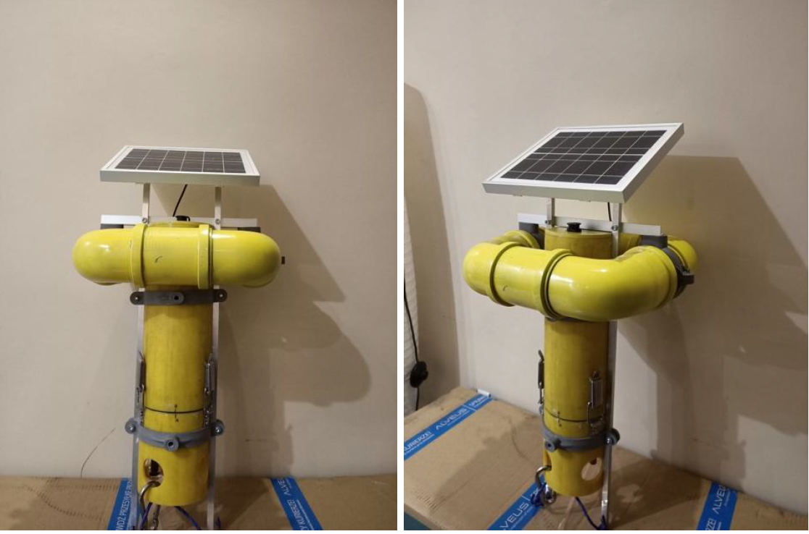
Fig. 1. Prototype of the measurement probe in the variant for preliminary tests
2.2. Communication module
Wireless communication module for efficient communication that ensures a stable and reliable connection between individual system elements. One of the key technological challenges encountered during the project was the construction of the wireless communication module. The aim was to create a dedicated module enabling communication between the monitoring station and the central database. The wireless communication module used in the monitoring station uses GSM technology for data transmission. This technology was chosen due to its widespread use, which guarantees coverage in most locations, which is crucial for the effective operation of the early warning system. The module has been designed to minimise energy consumption and thus ensure long-term, independent operation of the station. This achievement resulted from the use of advanced energy management techniques, which optimised the data transmission process so that it was as little burdensome as possible for the station's power system. Additionally, the module enables two-way communication, allowing for remote management of the station's operating parameters and software updates. This functionality makes system management much easier and allows for quick responses to potential problems. After analysing the available technologies and their adaptation to the specific nature of the project, the decision was made to implement communication using long-range Bluetooth Low Energy (BLE) technology, also known as Long Range Bluetooth. Long Range Bluetooth was selected for its ability to provide reliable, energy-efficient communication over long distances, essential for distributed sensors in the field. This technology allows for seamless base station connection with many sensors despite large distances or terrain obstacles. The use of this technology enabled the creation of more complex sensor configurations, which increased the monitoring capabilities and improved the accuracy of the cyanobacteria bloom detection system. Additionally, BLE technology is characterised by low energy consumption, which is crucial for autonomous applications such as this project. Long-term operation of sensors on a single power source is possible thanks to intelligent energy management mechanisms and effective use of the communication bandwidth. Communication between the station and the sensors takes place using an encrypted protocol, which ensures the security of transmitted data and protects the system against potential attacks. The wireless communication module has been designed as a plug-and-play module to ensure ease of integration with the system, enabling easy system expansion with additional sensors. The GSM NBIoT network allows for fast and effective data transmission, and the Bluetooth module's long range enables wireless data acquisition from distributed sensors.

2.3. Central application
Central Application Services have also been developed, which include, among others, a chlorophyll and phycocyanin level prediction module, a classifier warning against cyanobacterial blooms, and the possibility of integration with the Copernicus Sentinel space mission website and an external weather monitoring station. It has also the function of typing the location of measurement points. The central application created as part of the project is the most important element of the entire system. It is the central point where all data from individual measurement stations flows, and it is then responsible for their processing, analysis, and presentation in a form accessible to users. This system is based on a microservices architecture, allowing for independent management of individual application parts and their scaling. The Apache Kafka data broker manages all of this, which handles communication between the individual services and ensures real-time data processing (Fig. 2). This approach allows to collect, process and present data quickly and efficiently. Finally, the data is presented to users through a React.js-based user interface. This technology allowed us to create an interactive, responsive, aesthetically attractive interface that is easy to use even for people without advanced technical knowledge (Fig. 3-5). Using these advanced technologies allowed us to create a system that is efficient and reliable, easy to use and accessible to users. Thanks to this, the central application is a key system element that enables effective data management and early detection of cyanobacterial blooms.

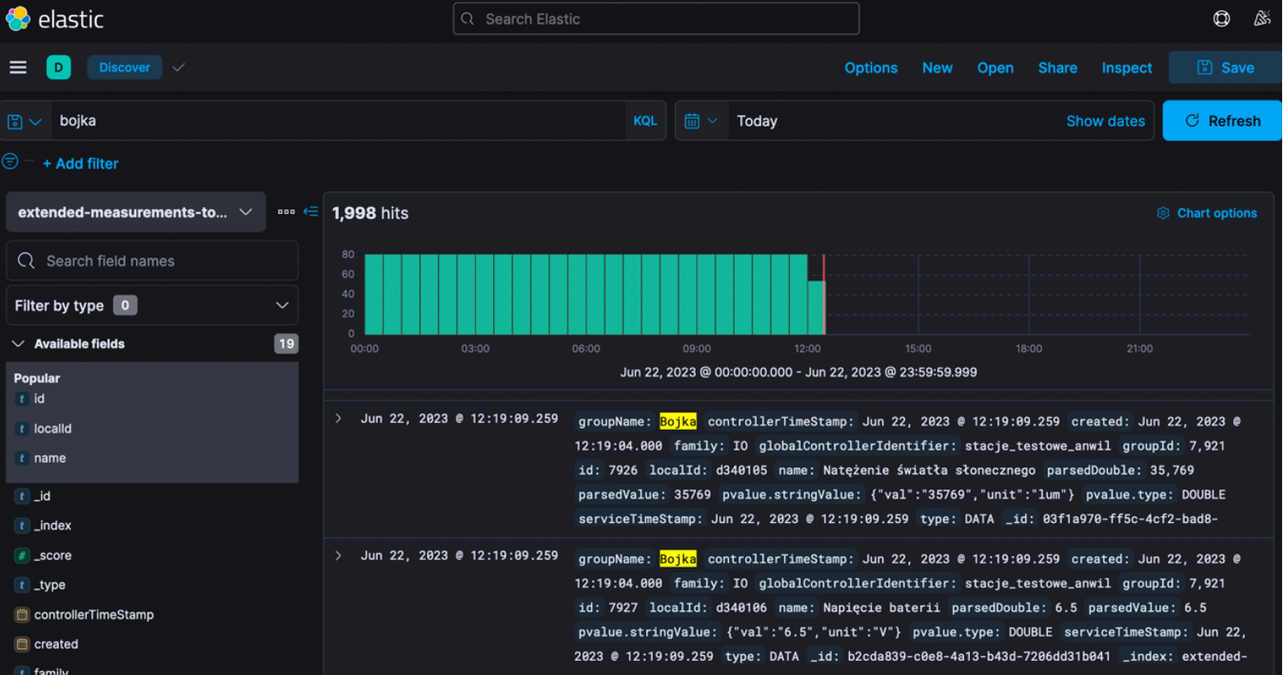
Fig. 2. Backend view of the Kafka data broker presenting test measurements from the measurement probe

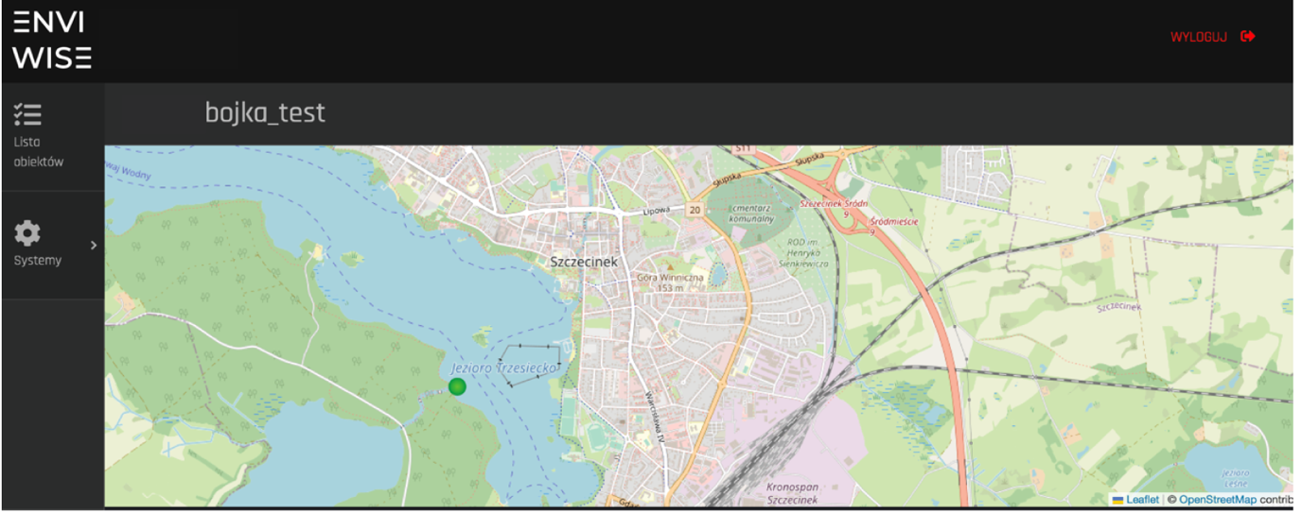
Fig. 3. Main screen of the central application with a map and the location of the measuring station
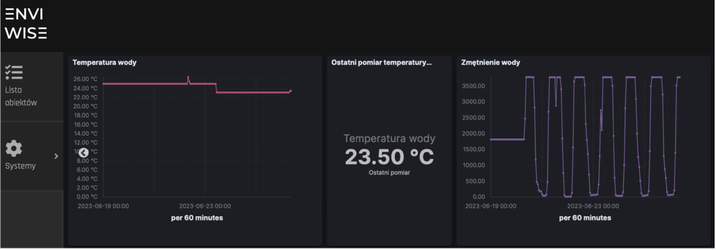
Fig. 4. Test charts of the central application dashboard – data from the temperature and water turbidity sensor
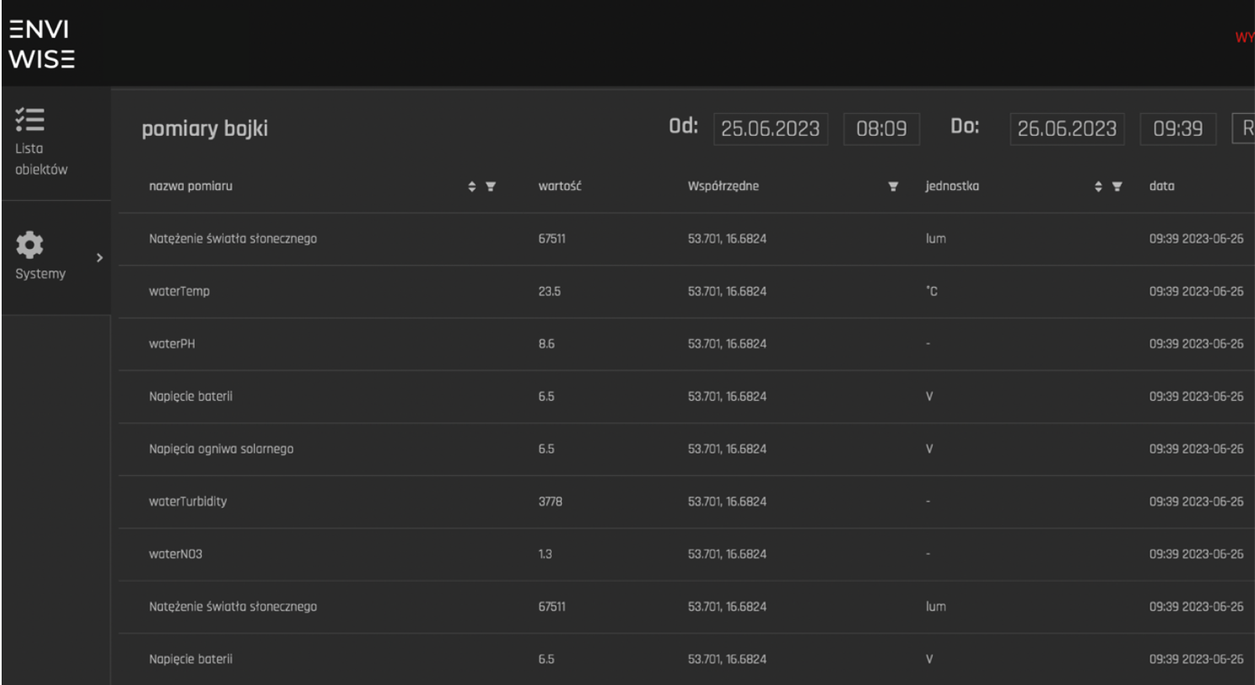
Fig. 5. Table of probe measurements in the central application recorded at a given location (Fig. 3), date and time
This project also aims to develop a central application that can collect, process, display, and export measurement data from various monitoring stations. The application should also be able to access and use data from the Sentinel satellite mission, which provides high-resolution images of the Earth's surface and atmosphere. The application should allow users to select and analyse different parameters from the available sensors, such as temperature, humidity, air quality, etc. The application should also be able to map these parameters onto a graphical interface that shows the spatial distribution and temporal variation of the data. Furthermore, the application should be able to integrate the sensor data with the satellite data and provide a comprehensive view of the environmental conditions in the monitored areas (Fig. 6).
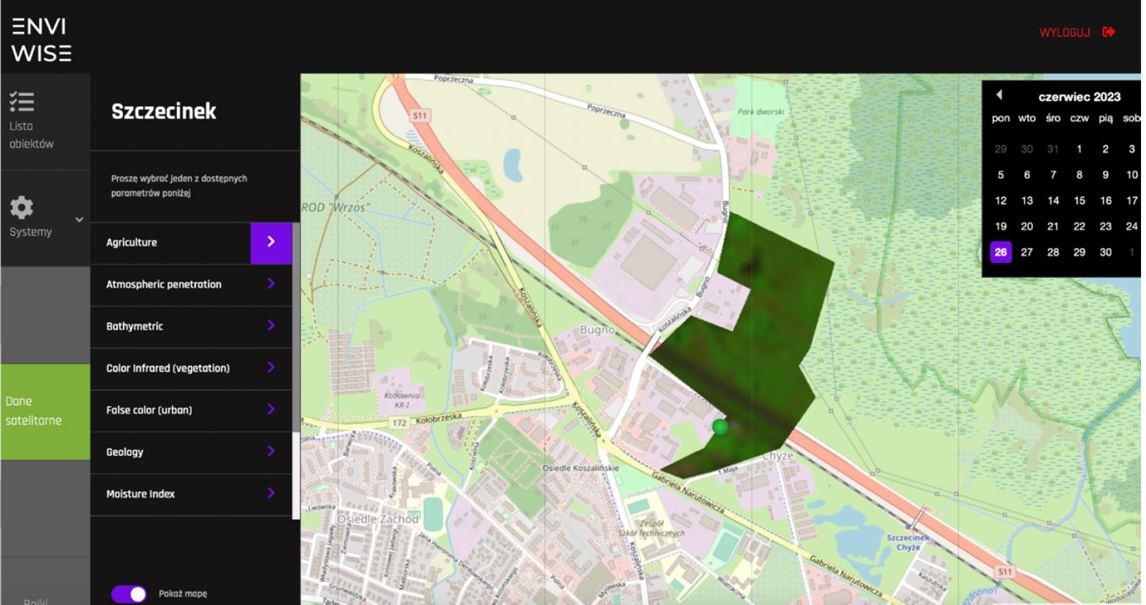
Fig. 6. Measurement system's data integration with satellite data service
2.4. Classifiers and predictive algorithm
The development work also included the creation of classifiers and predictive algorithms that can process and interpret data from monitoring station sensors. The classifiers were built using advanced machine learning techniques, in particular, supervised learning algorithms such as Support Vector Machines (SVM) and neural networks were used. Using these methods allowed the creation of models that can recognise various types of cyanobacterial blooms based on data from sensors, considering various environmental variables. Predictive algorithms, in turn, were built based on machine learning techniques, particularly linear regression, logistic regression and models based on decision trees. These techniques allowed the creation of models that can predict chlorophyll and phycocyanin levels, which is crucial for early warning of cyanobacterial blooms. To maximise their accuracy and efficiency, these models were tested and optimised using cross-validation and hyperparameter optimisation techniques. These advanced techniques allowed the creation of a system that can monitor and predict the appearance of cyanobacterial blooms. Thanks to this, the system can warn users in advance, increasing the effectiveness of preventive actions. It is worth noting that the development of these classifiers and predictive algorithms is the result of intensive research work and constitutes a significant contribution to environmental monitoring.
3. Verifications in the Real Environment
The probe, built for field tests, enables remote monitoring of physicochemical parameters of surface waters. The device is a semi-submersible, anchored buoy, where the above-water element is a float with an antenna responsible for GSM communication and a system of small photovoltaic panels ensuring the autonomous power supply of the device. The buoy is an electronic, microprocessor-based measuring device, the most important element of which is a programmable microcontroller equipped with several peripherals, including an analog-to-digital converter of appropriate resolution, which receives signals of appropriate size from operational amplifiers, constituting specific galvanometric systems. This solution makes it possible to measure all parameters (physical, chemical, biological) that can be converted into electrical quantities using appropriate probes. The proposed device is equipped with probes enabling the measurement of the following parameters:
pH – Water pH is measured using a dedicated probe – a combined glass electrode. The parameter is calibrated based on the curve formula acc. measurements made in standards with known pH values (4,7,9).
Oxidation-reduction potential – The measurement is carried out using a dedicated probe – a combined metal electrode consisting of a platinum indicator half-cell with a potential depending on the oxidation-reduction balance in the solution and a silver chloride reference half-cell with constant potential. The parameter is calibrated based on a measurement made in a standard with a known mV value (220 mV).
Electrical conductivity – A generator that produces alternating voltage is used, which is applied to metal electrodes. Depending on the electrolyte concentration – the conductivity increases as the ion content increases, the resistance decreases and the current flow increases. The higher the conductivity, the higher the conductivity reading indicates a higher charge of substances dissolved in the water. The technical solution allows alternatively to measure the value of the so-called TDS, meaning the total amount of dissolved salts. Similarly, to conductivity it is a unit that defines the degree of water pollution. Conductivity measurement is also performed to estimate the total dissolved salts (TDS) content.
Temperature – Temperature measurement is carried out by a dedicated semiconductor, digital integrated circuit DS18b20 placed in a metal, stainless steel thimble, ensuring its full waterproofness.
Turbidity (transparency) – Transparency measurement is carried out by emitting a pulse of infrared light with a wavelength of approximately 800-900 nm towards a detector sensitive to radiation in the infrared wavelength range. The suspension in the emission field absorbs the radiation, reducing the amount of light reaching the detector. The more suspension there is the proportionally smaller amount of light received, indicating a higher turbidity level.
Chlorophyll and phycocyanin content – The measurement is carried out using a specially constructed probe composed of an LED emission diode with a specific wavelength (400-470 nm for chlorophyll, 580-590 phycocyanin) and detectors with a high-pass gel filter with appropriate values of 620-650-720 nm. Light-emitting diodes, having the properties of photodiodes with high monochromaticity (sensitivity to a selected light spectrum), were used as detectors. The solution uses the fluorescent properties of chlorophyll and phycocyanin, which, under the influence of the emission of light of a specific wavelength – UV, blue (chlorophyll) and yellow-orange (phycocyanin), emit light of lower energy – red. The amount of red light the detector receives is proportional to the amount of chlorophyll/phycocyanin in the water.
The device in the chosen location (Fig. 7 and Fig. 3) automatically measures the parameters mentioned above at every programmable time interval, the values of which are then sent to an external Internet server.

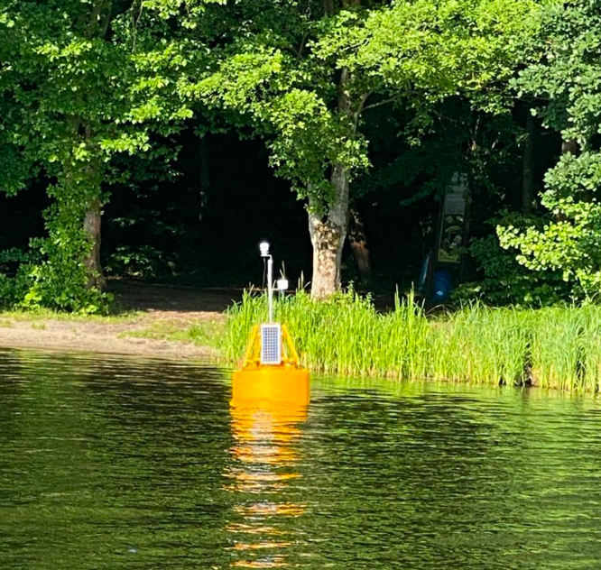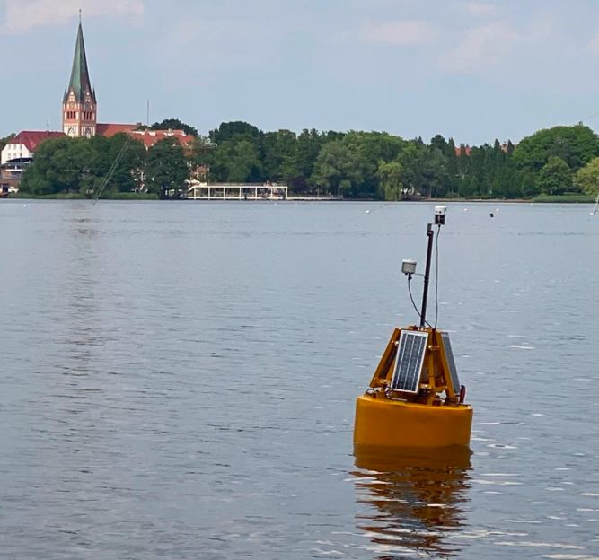
Fig. 7. Development version of the probe in a steel housing in the form of a full buoy during test measurements
4. Results
The results of the parameters collected by the buoy from June 23 to October 18 are presented in Fig. 8. Data are collected every ten minutes and sent wirelessly to the database.

- b)
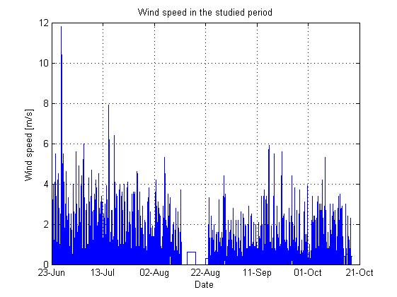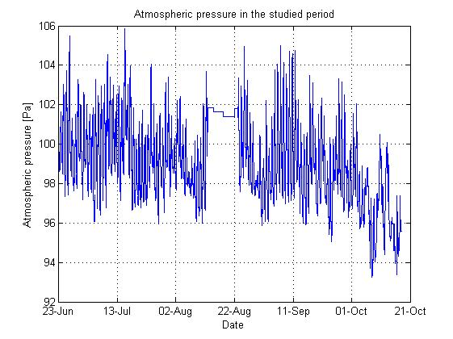
c) d)
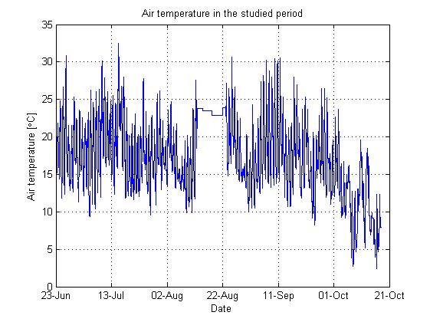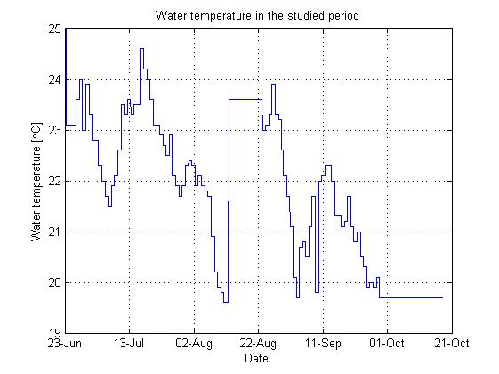

e) f)
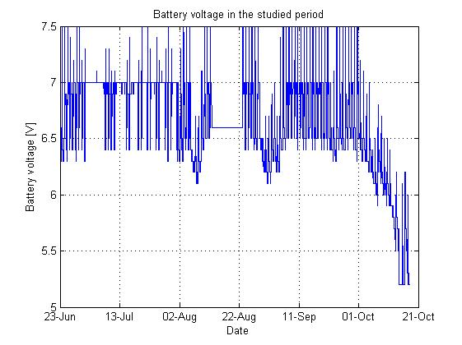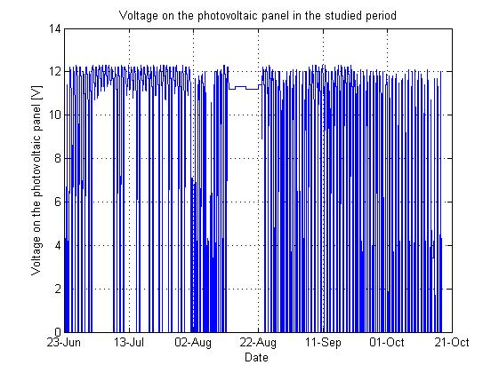
Fig. 8. Collected data by the buoy in the period from June 23 to October 18

g) h)
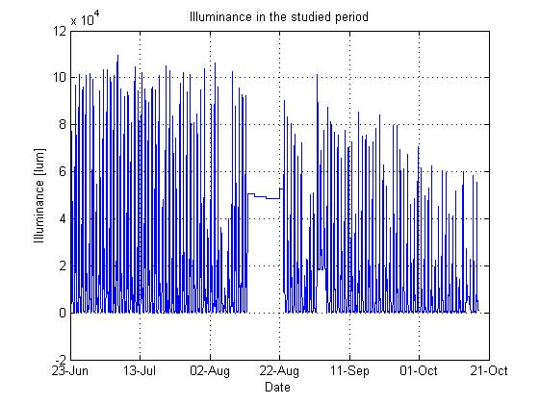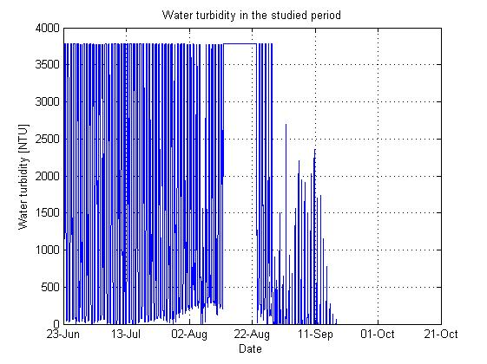
i) j)
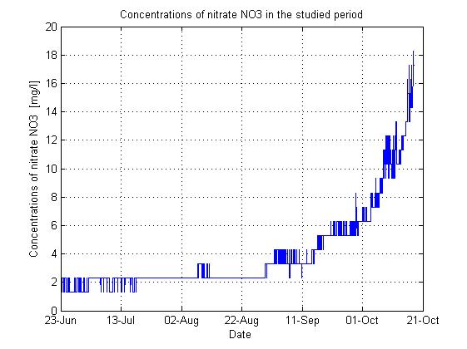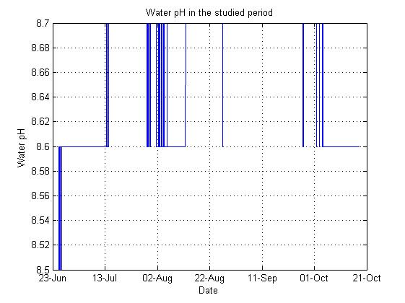
Fig. 8. cont.
5. Summary
Analysing the above charts (Fig. 8 a-j), we notice a gap in data collection from August 12 to 23. The lack of measurements during this period was due to service work on the measuring buoy, which involved pulling it out of the water and checking the correct operation of individual sensors and systems. The current prototype measuring buoy offers measurements of basic meteorological parameters such as wind speed (Fig. 8a), atmospheric pressure (Fig. 8b), air temperature (Fig. 8c) and water temperature (Fig. 8d). Due to the battery power supply of the measurement buoy and the recharging of the batteries by photovoltaic panels, the voltage on the batteries (Fig. 8e) and the voltage on the photovoltaic panels (Fig. 8f) are also measured. Other very important data collected concerns illuminance (Fig. 8g), water turbidity (Fig. 8h), concentrations of nitrate NO₃ (Fig. 8i) and pH water (Fig. 8j). Analysing the collected data concentrations of nitrate NO₃ (Fig. 8i), increasing values can be noticed after September 11. Exceeding values above 5 mg/l suggest a high concentration of pollutants and usually concern areas of intensive agricultural production or areas with intensive use of fertilisers where high NO₃ concentrations may be experienced, which may lead to water quality problems. Such a high concentration of nitrates NO₃ in the water was probably caused by greater rainfall at the beginning of September and the washing out of artificial fertilisers from the fields near the measurement point. Analysing Fig. 8h, one can observe a gradual decrease in the NTU parameter towards the end of August. This is likely due to the lack of necessary sensor cleaning, leading to the gradual accumulation of pollutants and, consequently, its erroneous operation, which is evident towards the end of the monitoring period.
As observed from the measurements taken by the monitoring buoy, the recorded parameters can be utilised to assess the current state of the water and identify adverse phenomena, such as cyanobacterial blooms.
Bloom of cyanobacteria, also known as blue-green algae, is a complex phenomenon associated with various water parameters. This article discusses key factors contributing to this occurrence. The growth of cyanobacteria is often linked to warm waters, highlighting the importance of monitoring temperature in the context of potential cyanobacterial development. Cyanobacteria rely on photosynthesis, making access to light a crucial factor. However, excessive sunlight can favour cyanobacterial growth. An excess of nitrates and phosphates promotes the development of cyanobacteria. Therefore, controlling fertilisation and nutrient substances is essential in preventing excessive growth. Constant sources of nutrients from water inflows can create conditions conducive to cyanobacterial development. The absence of predators and competitors can allow cyanobacteria to dominate over other organisms. Stagnant waters promote cyanobacterial growth, emphasising the need to monitor and control water flow. Chemical pollutants, such as certain fertilisers and sewage, can supply nutrients to cyanobacteria. The complex interactions of these factors influence cyanobacterial development. Effective monitoring of water quality and control of environmental conditions is crucial to maintaining a healthy aquatic ecosystem and preventing excessive cyanobacterial growth.
In addition to monitoring water parameters and predicting potential threats, the prototype of the monitoring buoy also provides the capability to monitor its technical condition. It includes monitoring voltage levels on batteries and photovoltaic cells, enabling the anticipation and planning of maintenance periods and the replacement of damaged components. This functionality is evident in the case of the water turbidity sensor.
References
Agade, P., Bean, E.Z., Dean, R.N., Blersch, D., Vasconscelos, J., Knappenberger, T., Brantley, E. (2022). GatorByte: A Water-Quality Mapping Buoy for Locating Watershed Pollution Sources. Proceedings of IEEE Sensors, Dallas, TX, USA, 2022-October. 1-4. https://doi.org/10.1109/SENSORS52175.2022.9967172
Beckman, J.N., Long, J.W. (2022). Quantifying errors in wind and wave measurements from a compact, low-cost wave buoy. Frontiers in Marine Science, 9. https://doi.org/10.3389/fmars.2022.966855
Chamier-Gliszczyński, N.J. (2011). Sustainable operation of a transport system in cities. W (Red.), Key Engineering Materials. 175-178. https://doi.org/10.4028/www.scientific.net/KEM.486.175
Chamier-Gliszczyński, N.J., Bohdal, T. (2016). Urban Mobility Assessment Indicators in the Perspective of the Environment Protection. Annual Set The Environment Protection, 18, 670-681.
Colen, M.E., Houard, H., Imenkamp, C., van Velthoven, G., Pajula, S., Malheiro, B., Ribeiro, C., Justo, J., Silva, M.F., Ferreira, P., Guedes, P. (2019). Water Intellibuoy – An EPS@ISEP 2018 Project. In Advances in Intelligent Systems and Computing, 917, 439-449. https://doi.org/10.1007/978-3-030-11935-5_42
Delwiche, K., Hemond, H.F. (2017). An enhanced bubble size sensor for long-term ebullition studies. Limnology and Oceanography: Methods, 15(10). https://doi.org/10.1002/lom3.10201
Dipshika, M., Kannan, P., Arun, S. (2019). A Survey on Smart Water Monitoring and Control Using Internet of Things. IJSDR1911011 International Journal of Scientific Development and Research, 4(11).
Głowiński, S., Sobieraj, M., Błażejewski, A., Pecolt, S.Z. (2023). Design of a Low-Cost Measurement Module for the Acquisition of Analogue Voltage Signals. Electronics (Switzerland), 12. https://doi.org/10.3390/electronics12030610
Grunt, M., Błażejewski, A., Pecolt, S. Z., Królikowski, T.P. (2022). BelBuk System—Smart Logistics for Sustainable City Development in Terms of the Deficit of a Chemical Fertilizers. Energies, 15(13). https://doi.org/10.3390/en15134591
Iafolla, L., Fiorenza, E., Chiappini, M., Carmisciano, C., Iafolla, V.A. (2022). Sea Wave Data Reconstruction Using Micro-Seismic Measurements and Machine Learning Methods. Frontiers in Marine Science, 9. https://doi.org/10.3389/fmars.2022.798167
Jin, J.Y., Dae Do, J., Park, J.S., Park, J.S., Lee, B., Hong, S.D., Moon, S.J., Hwang, K.C., Chang, Y.S. (2021). Intelligent Buoy System (INBUS): Automatic Lifting Observation System for Macrotidal Coastal Waters. Frontiers in Marine Science, 8. https://doi.org/10.3389/fmars.2021.668673
Jörges, C., Berkenbrink, C., Stumpe, B. (2021). Prediction and reconstruction of ocean wave heights based on bathymetric data using LSTM neural networks. Ocean Engineering, 232. https://doi.org/10.1016/j.oceaneng.2021.109046
Khattar, R., Ames, D. (2020). A Web Services Based Water Data Sharing Approach using Open Geospatial Consortium Standards Technology Methods. Open Water Journal, 6(1), 2.
Knight, P.J., Bird, C.O., Sinclair, A., Plater, A.J. (2020). A low-cost GNSS buoy platform for measuring coastal sea levels. Ocean Engineering, 203. https://doi.org/10.1016/j.oceaneng.2020.107198
Lancaster, O., Cossu, R., Boulay, S., Hunter, S., Baldock, T.E. (2021). Comparative wave measurements at a wave energy site with a recently developed low-cost wave buoy (Spotter), adcp, and pressure loggers. Journal of Atmospheric and Oceanic Technology, 38(5). https://doi.org/10.1175/JTECH-D-20-0168.1
Lapointe, B.E., Burkholder, J.M., Van Alstyne, K.L. (2018) Harmful Macroalgal Blooms in a Changing World: Causes, Impacts, and Management, S.E. Shumway, J.M. Burkholder, S.L. Morton (Eds.), Harmful Algal Blooms: a Compendium Desk Reference, John Wiley & Sons, Ltd., Hoboken, New Jersey, 515-542.
Mantas, V.M., Pereira, A.J.S.C., Neto, J., Patrício, J., Marques, J.C. (2013). Monitoring estuarine water quality using satellite imagery. The Mondego river estuary (Portugal) as a case study. Ocean and Coastal Management, 72. https://doi.org/10.1016/j.ocecoaman.2011.06.013
Medina, J.D., Arias, A., Triana, J.M., Giraldo, L.F., SeguraQuijano, F., Gonzalez-Mancera, A., Zambrano, A.F., Quimbayo, J., Castillo, E. (2022). Open-source low-cost design of a buoy for remote water quality monitoring in fish farming. PLoS ONE, 17. https://doi.org/10.1371/journal.pone.0270202
Ng, C.L., Senft-Grupp, S., Hemond, H.F. (2012). A multi-platform optical sensor for in situ sensing of water chemistry. Limnology and Oceanography: Methods, 10. https://doi.org/10.4319/lom.2012.10.978
Pecolt, S.Z., Błażejewski, A., Sobieraj, M., Głowiński, S. (2023). Design of a Low-Cost Measurement Module for the Acquisition of Analogue Voltage Signals. Electronics (Switzerland), 12(3), 610. https://doi.org/10.3390/electronics12030610
Ribas-Ribas, M., Kilcher, L.F., Wurl, O. (2018). Sniffle: A step forward to measure in situ CO₂ fluxes with the floating chamber technique. Elementa: Science of the Anthropocene, 6, 14. https://doi.org/10.1525/elementa.275
Rodero, C., Bardaji, R., Olmedo, E., Piera, J. (2022). Operational monitoring of water quality with a Do-It-Yourself modular instrument. Frontiers in Marine Science, 9. https://doi.org/10.3389/fmars.2022.1004159
Sim, B.R., Kim, H.C., Kim, C.S., Kim, J.H., Park, K.W., Lim, W.A., Lee, W.C. (2020). Seasonal distributions of phytoplankton and environmental factors generate algal blooms in the taehwa river, south korea. Water (Switzerland), 12(12). https://doi.org/10.3390/w12123329
Šaliga, J., Žiga, M., Galajda, P., Drutarovský, M., Kocur, D., Maceková, L. (2015). Wireless sensor network for river water quality monitoring. XXI IMEKO World Congress "Measurement in Research and Industry".
Stachiw, J.D. (1980). Performance of photovoltaic cells in undersea environment. Journal of Manufacturing Science and Engineering, Transactions of the ASME, 102(1). https://doi.org/10.1115/1.3183829
Tulloh, R., Sodikin, I., Khasanah, R. (2019). Usulan Perawatan Buoy Tsunami Dengan Menggunakan Metode Risk Based Maintenance. Jurnal REKAVASI, 7(1).
Ula, M., Tjut Adek, R., Bustami, B., Mulaesyi, S., Bayu Juhri, M. (2022). A Monitoring System for Aquaponics Based on Internet of Things. Proceedings of Malikussaleh International Conference on Multidisciplinary Studies (MICoMS), 3, https://doi.org/10.29103/micoms.v3i.49
Wang, Y., Li, Y., Lu, C. (2023). Evaluating the Effects of Logistics Center Location: An Analytical Framework for Sustainable Urban Logistics. Sustainability, 15, 3091. https://doi.org/10.3390/su15043091
Washburn, L., Johnson, C., Gotschalk, C.C., Thor Egland, E. (2001). A gas-capture buoy for measuring bubbling gas flux in oceans and lakes. Journal of Atmospheric and Oceanic Technology, 18(8), 1411-1420, https://doi.org/10.1175/1520-0426(2001)018<1411:AGCBFM>2.0.CO;2
Wilson, D. (2009). The Chesapeake Bay Interpretive Buoy System: Recent expansion and advances. MTS/IEEE Biloxi – Marine Technology for Our Future: Global and Local Challenges, OCEANS 2009. 1-5, https://doi.org/10.23919/oceans.2009.5422353
Xiaojun Z., Xiaomeng J., Yuxin L. (2022). Water-induced luminescence improvement in a lanthanide β-diketone complex for monitoring water purity, Chinese Chemical Letters, 33(4). 2117-2120, https://doi.org/10.1016/j.cclet.2021.08.080
Zhao, J., Zhang, H., Chen, Z., Wang, Z., Zhang, Y., Shang, X. (2015). On-the-fly measurements of large-drop water level and high flow velocity in the closure gap. Flow Measurement and Instrumentation, 45. https://doi.org/10.1016/j.flowmeasinst.2015.06.012

