 | Rocznik Ochrona Środowiska
 | Volume 25 | Year 2023 ISSN 2720-7501 | pp. 357-366
 | https://doi.org/10.54740/ros.2023.036 open access
 | Received: December 2023 Accepted: December 2023 Published: December 2023
Changes in the Natural Surroundings are a Determinant of the Implementation
of the Environmental Management System
Marcin Olkiewicz
Faculty of Economic Sciences, Koszalin University of Technology, Poland
https://orcid.org/0000-0001-6181-6829
corresponding author's e-mail: marcin.olkiewicz@tu.koszalin.pl
Abstract: The economic, technical, technological, social and economic development of the world, carried out at an increasingly faster pace, aims to increase the quality and standards of life. Attempting to meet market stakeholders' changing expectations and requirements significantly affects the overexploitation of natural resources and the degradation of the natural environment, often leading to irreversible consequences. The publication aims to analyse selected changes in the natural surroundings that influence the implementation decisions of the environmental management system. Research conducted over the last 10 years shows that the pro-environmental activities undertaken bring results not only in the number of management systems implemented but also in the number of ecological farms created, reduction of air pollution and reduction in the extraction of natural resources (coal).
Keywords: natural surroundings, renewable resources, environmental management system
1. Introduction
Identification of the surroundings, including natural ones, is not uniform. In management and quality sciences, the environment is perceived as conditions and mutual dependencies of various elements, organisations, spheres, phenomena, processes, etc. (Griffin 1997, Wach 2010, Marek & Białasiewicz 208). The source of such complexity is its features, including, among others (Matejun & Nowicki 2013):
- structure – the presence of specific elements, spheres, trends, phenomena, processes, thanks to which we determine the level, distance and direction of interactions occurring between the environment,
- complexity – expresses the number, degree of complexity and diversity of elements occurring in the environment, shows the interconnections and relations between elements, dimensions and planes of the environment,
- variability – determines the speed and dynamics of changes taking place,
- uncertainty – results from variability and instability related to difficulties in predicting the future shape and potential of the environment,
- potential – the ability to create opportunities for survival, development and systematic growth,
- multi-aspect – the impact of components on individual elements, organisations, phenomena, etc.,
- space – size, scale of occurrence of specific elements.

Despite the great importance of individual features in defining the environment, in the literature on the subject, the attention is most often focused on identifying and assessing the organisation's environment through the prism of decisions made (Małkowska-Borowczyk 2011). Mainly the economic, political-legal, socio-cultural and technological aspects resulting from the division of micro and macro-environment (Goszczyński 2018, Pizło & Mazurkiewicz-Pizło 2008, Trojanowski 2014, Gierszewska & Romanowska 2009) are discussed, and the importance of the natural surroundings is not noticed. Therefore, the environment is often understood, on the one hand, as a system regulated by market entities and, on the other hand, as a phenomenon functioning, developing and degrading due to stakeholders' changing expectations and needs (Pathak 2011).
The natural surroundings, also known as the environmental environment, are mainly examined through the prism of (England 2006) the use of resources and values of the natural (natural) environment. This is justified (Goyal 2006) because the interpretation of identified phenomena and trends determines decision-making by economic entities, society and governments regarding the implementation of innovations, the development of individual industries (e.g. tourism) as well as their reduction (e.g. mining), pro-environmental activities (e.g. launching financial support for renewable energy sources), quality management systems and implementing a policy of building pro-environmental awareness (Siekierski & Śliwa 2015, Olkiewicz 2015, Michalak et al. 2023). Most activities are the result of, among others, globalisation, environmental degradation, raw material and energy crisis, and limited resources. Also, the decreasing availability of investment areas forces entrepreneurs to make more and more thoughtful decisions regarding the selection of company locations, as well as the technologies and materials used, as well as solutions for the use of new closed-loop technologies or those using renewable energy (Woo 2023, Gajdzik et al. 2023).
The consumption of non-renewable resources results in an irreversible depletion of the raw material base available to us. Renewable resources, however, create the opportunity for their continuous exploitation as long as we do not abandon the principle of deriving permanent income from the resource (Śleszyński 2016). Therefore, environmental restrictions are treated as market barriers (environmental barriers), thanks to which the activities and development of economic entities aim at rational management of natural resources and protection of environmental well-being (Balicka 2015). Market stakeholders undertake various pro-environmental activities as part of responsible management, including implementing systems, e.g. ISO 14001, EMAS, CSR, 5S or 7S, as well as several activities and educational programs, thus forcing or encouraging people to save water or electricity. Also, the effect of such an adopted policy and strategy is the installation of appropriate devices that control material expenditure so that there is no waste, no environmental pollution or those based on renewable resources (e.g. photovoltaics, heat pumps or wind turbines) (Cichosz & Wierzbicki 2016, Oliver & Peters 2020, Pacana & Siwiec 2022). Such targeted activities of economic entities, on the so-called environmental economics, aimed at minimising costs as part of pro-environmental activities, are increasingly positively assessed and create greater competitiveness. Taking advantage of market opportunities and strengths through implemented environmental innovations sometimes becomes the main determinant of the entity's existence, especially where the ecological attractiveness of the sector is high and the degree of environmental degradation is low (Puciato & Żmigrodzki 2009, Michalak et al. 2023).
When analysing the natural environment, the following factors are distinguished: the condition and availability of natural resources, climate, topography, and changes in the natural environment caused by organised activities, which have an impact or can be used by market stakeholders.
Considering the strong environmental policy implemented in the EU, where environmental values are the most important determinant of the success of many economic entities, instruments for managing the natural surroundings become important (Rudewicz 2016). Striving to achieve various parameters (indicators) established, e.g. by the European Union, in the area of renewable energy or environmental protection, allows individual countries or economic entities to determine the permissible limits of the use of the natural environment (Puciato & Żmigrodzki 2009, Tomaszewski & Sekściński 2020).
2. Materials and Methods
Rapid environmental change is influencing the decision-making process of individual governments, businesses and society. The need to be flexible and understand the responsibility to care for the environment can bring benefits in the future. The publication aims to analyse selected changes in the natural surroundings that influence the implementation decisions of the environmental management system. To achieve the goal, a research hypothesis was put forward: the use of an appropriate pro-quality policy will positively impact the development of indicators (parameters) determining the assessment of the impact on the natural environment. It is particularly important from the point of view of the assessment of natural capital, which is considered here primarily as biodiversity, land use, air pollution – dust, railway noise, ecological farms, inventions and patents. Therefore, the scope of empirical research included selected factors related to concern for the natural environment. The study used secondary data from the Central Statistical Office, including 10 years. Additionally, the study analyses domestic and foreign literature on the subject, indicating the lack of literature strictly related to the natural environment.
3. Results and Discussion
Various changes visible in everyday life, including climatic, economic, social, technical and technological, significantly affect the natural environment (Bönke et al. 2023, Mentes 2023, Moghimi et al. 2023). Their influence is visible, among others, in nature (forest, water, soil resources, etc.), in the way the organisation operates and develops (investment strategy), as well as in the expectations and needs of society (consumption of goods and services). All market stakeholders need to increase their pro-environmental awareness and take actions to protect and restore the natural environment. The actions taken should also aim to, among others, maintain or restore the natural environment, improve society's quality of life, develop organisations, sustainable development, and agglomeration consistent with maintaining environmental safety. (Olkiewicz et al. 2023, Siwiec & Pacana 2021). All this affects how we perceive environmental changes (positive and negative), the main factor of which is biodiversity.
Biodiversity should be considered in the context of, among others, legally protected areas with significant environmental value and bird numbers. In 2019, protected areas covered 10.1 million hectares or 32.3% of the country's territory. The scale of biological diversity of the land is shown in Fig. 1. It is worth noting that the largest percentage (in this structure) were protected landscape areas (69.5%), as well as landscape parks (25.8%). There were 2,633 m² of statutorily protected areas per 1 Pole. In 2019, the percentage of birds in the agricultural landscape was one of the lowest in history, 23% lower than in 2000 (the base year). Changes in the percentage of forest birds show the opposite tendency – it increased by 27% compared to the base year and is one of the highest since 2000.

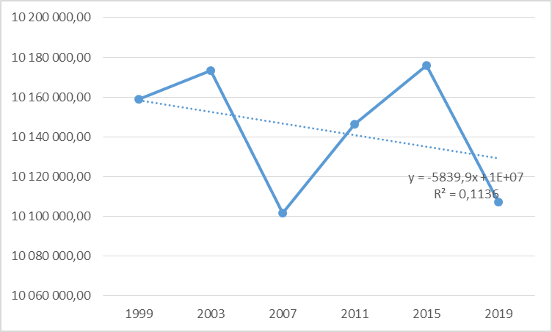
Fig. 1. Area of protected areas [ha]

Protected areas provide a sense of natural "security". However, this security may be undermined by changes in land use. The scale of changes is presented in the identification of land use (Fig. 2). In the years 2002-2019, there was an increase in built-up and inhabited areas by 14%, forests and areas covered with trees and shrubs by 7%, and areas under water by 2.8%. It was achieved by reducing remaining and agricultural land – by 26.8% and 3.5%, respectively. In 2019, 4.9 thousand ha of forest and agricultural areas were excluded for non-forest and non-agricultural purposes. It is an increase of 8.1% compared to the previous year and 68.5% compared to the base year 2000. Of this, 52.9% was allocated to housing estates and 16.7% to industrial areas.

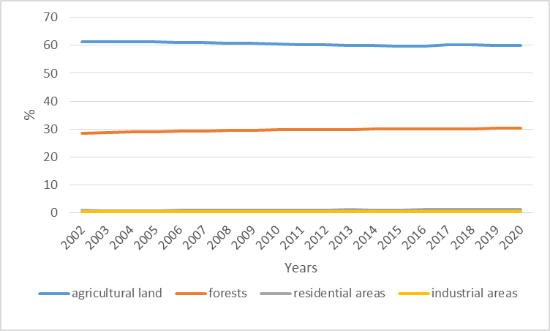
Fig. 2. Use of the country's area in %

It should be noted that the trend in using the country's area (in %) of agricultural land, after a downward trend until 2014, remains almost constant, while forests have a stable growth trend. In turn, industrial and local areas remain stable, with an increasing trend in housing.
Maintaining the phenomena (Fig. 2) at a certain level should also be reflected in the air pollution (dust) index (Fig. 3). It is currently a problem in the assessment of air quality in Poland because suspended dust standards are exceeded, especially in winter in some areas of the country, affecting the total index. In 2018, PM₁₀ dust emissions amounted to 242.8 thousand tons and remained at the same level as the previous year, 8.2% lower than the one checked in 2000. PM₁₀ is dust no larger than 10 micrometres and is determined because of its significant negative impact on human health. PM_{2.5} dust is atmospheric aerosol with a diameter not exceeding 2.5 micrometres and acc. According to the World Health Organization, it is the most harmful dust to humans. The PM_{2.5} index is 136.7 thousand tons of emissions, which decreased by 0.8% compared to the previous year and 8.8% compared to 2000. In 2018, there was 6.3 kg of PM₁₀ dust per capita, including 3.6 kg of PM_{2.5} dust – and this measurement is lower than in 2000.

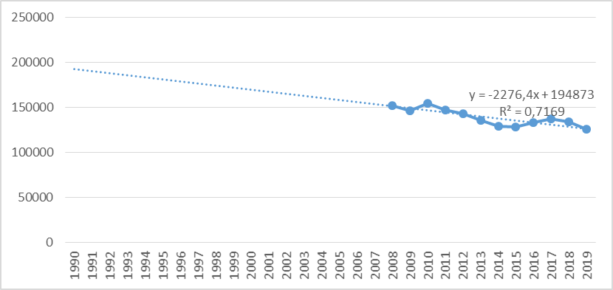
Fig. 3. Emission of PM_{2.5} air pollution in tons

Another factor influencing feelings and changes in the natural environment is noise. The sounds produced and heard constitute a nuisance for society in everyday life (social activity), work, and the natural environment for animals. The most frequently identified noises are traffic, i.e., car, railway, tram, and industrial noises. The analysis of the data shows (Fig. 4) that there is a decreasing trend identifying the noise intensity above 55 dB was perceived by 231.4 thousand citizens in agglomerations with more than 100,000 inhabitants. It took place during a time of social activity. However, at night, noises louder than 50 dB were perceived by 143.7 thousand people citizens living in cities. In 2012, this figure was 4% and 3.1% of all citizens exposed to noise.

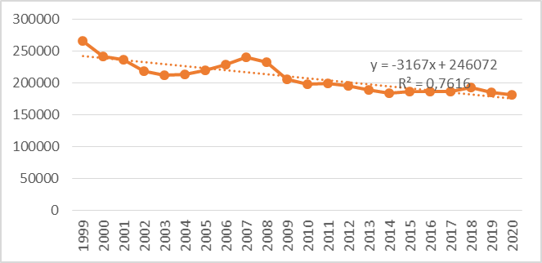

Fig. 4. People exposed to noise above 55 dB [thousands]

Agricultural farms are important in maintaining terrain diversity, affecting the natural environment and game. Growing expectations regarding food safety, especially individual elements of the food chain, and the growing public awareness of healthy nutrition and food have resulted in the emergence of ecological farms. The growing demand for healthy food seemed to be a good educational symptom, but the supply does not always meet the demand. In this case, this happened because, since 2014, there has been a downward trend in the area of organic farms, which lasted for 4 years and resulted in a slowdown in the next growth trend (Fig. 5).

Fig. 5. Area of certified organic farms in hectares

Perhaps it resulted from decreasing demand or increasing prices of agricultural real estate. The analysis of recent years indicated that in 2019, there were 18.6 thousand Ecological farms (Figure 6). At that time, the crops of these farms covered 507.6 ha of agricultural fields, constituting 3.5% of all agricultural lands in Poland. Compared to the previous year, their volume decreased by 3%, while the overall rate of agricultural land used increased by 4.7%. The average size of such farms is 27.2 ha, the largest since 2000. Data from the Agency for Restructuring and Modernization of Agriculture indicate that in 2019, organic farms received PLN 333.3 million in subsidies. It means that the amount of subsidies was 14.6% higher than a year earlier and approximately 9.5 times higher than in 2005, when the Rural Development Program began to operate, which resulted in the emergence of development opportunities and a stable but slow growth trend number of organic agricultural entities.

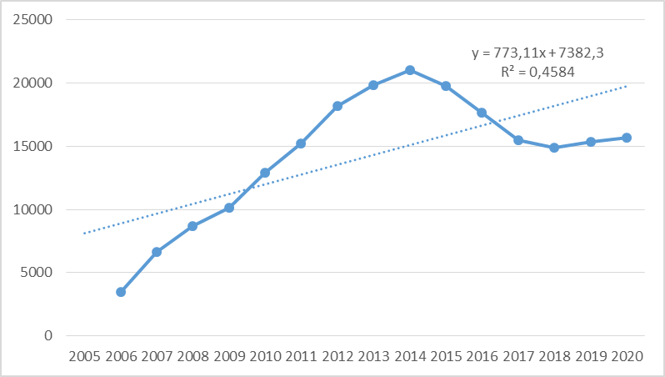
Fig. 6. Certified organic farms (General Inspectorate of Trade Quality of Agricultural and Food Products)

The factors that accelerated the pace of implementation of pro-environmental changes were inventions and patents in this area (Fig. 7). As many as 43 applications in the field of innovation in the area of environmental protection were submitted in 2017 (Organization for Economic Co-operation and Development Poles). In the period from 2000, most inventions, as many as 73, were registered in 2015. In 2017, 7.6% of the total number of inventions were reported, 2.4 percentage points less than the previous year and 2.7 percentage points more than in the base year 2000. In 2019, the European Patent Office registered 39 Polish environmental protection patents, the most successful since 2000. "Environmental" patents accounted for 10.7% of all Polish patents. It increased 0.6 percentage points compared to the previous year and 1.1 percentage points more compared to the base year 2000. The registered set of 158 inventions related to environmental protection registered in the Patent Office of the Republic of Poland constitutes 4% of all reported inventions, which constitutes a decrease compared to the previous year by 25.1% and a decrease compared to the base year 2000 by 31.3%. The largest number of these inventions was recorded in 2012 and constituted 264 applications, i.e. 5.7% of all applications. In 2019, the Patent Office of the Republic of Poland issued 161 environmental protection patents, constituting 5.3% of all patents filed in this area. It was the highest since 2000. Compared to the previous year, it was 11% more and 69.5% more than in the base year 2000 (GUS 2019).
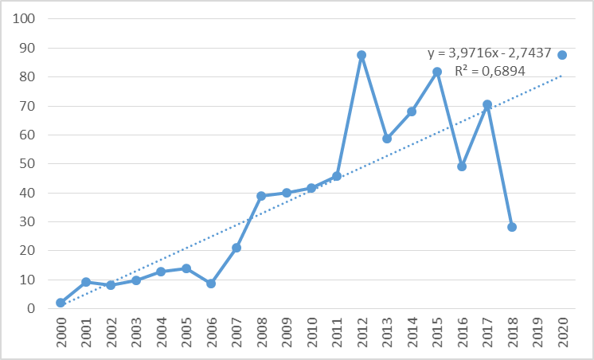
Fig. 7. Number of applications in the area of environmental protection submitted to the European Patent Office

In the social economy, and in particular, the entities competing in it, build their competitiveness not only through the appropriate quality of products/services, the use of modern technologies, and having qualified employees but, among others, on the possession (acquisition) or skilful use of renewable and economically cheap resources (with high quality) production factors (Dmuchowski 2019, Pacana & Siwiec 2021). It is important because natural resources are running out, and needs are growing (Fig. 8).
In the years 1990-2019, changes in the extraction of natural resources are visible. For example, in 2019, the annual extraction of hard coal decreased from 151.3 million tons to 64.1 million tons (a reduction of 57.7%) and brown coal by 21.9%, which resulted in an increase in natural gas extraction by 44%. Minimising coal mining resulted in the search for new solutions and an increase in energy acquisition, which was already noticeable in 2018, when there was an increase in the use of renewable energy sources (RES), i.e. wind energy (12.2%), biogas (3.2%), hydropower (1.9%), or solar energy (0.9%) (Seroka 2022). Data analysis indicates that the trend is growing, mainly thanks to financial support from aid funds (EU) as well as EU directives and energy compensation (Adams et al. 2019, Cichosz & Wierzbicki 2016, Villar et al. 2023, PE 2018). It should be noted, however, that the hierarchy of energy demand in 2018 was quite surprising, as the transport sector took first place (32.4%), then households (27.7%), industry (23%), services (11.3%), agriculture (5.6%). Comparing these data to 2000, the largest decline was in industry – 8.7 percentage points – and the largest increase was in transport – 15.4 percentage points. It means that the industry has made a significant technical and technological transformation in obtaining the necessary raw material for production: energy.
Therefore, it becomes important to monitor the material consumption rate (DMC – Domestic Material Consumption), which is an important element in assessing the condition of the natural surroundings. It is an indicator that measures the volume of materials used in the country's economy, which means that it identifies the annual volume of raw materials obtained in the country along with imported raw materials (Fig. 8). In 2019, Poland consumed 702 million tons of raw materials, i.e. 4.4% less than in 2018, but 30.2% more than in the base year of 2000. Such a high national consumption volume indicates that one Polish citizen consumes as many as 18,5 tons of raw materials.

Fig. 8. The volume of domestic consumption of materials (raw materials) in million tons

The presented phenomena and their distributions indicate that the quality of the natural environment, particularly its potential, may largely depend on, among others, implemented state policy, investment opportunities and society itself. Growing ecological awareness, also related to waste segregation, recycling, etc., causes enterprises to undertake several pro-ecological activities, also as part of responsible management. For example, in 2019, 1.3 thousand public procurements in the broadly understood area of environmental protection which represented an increase of 0.9% of all orders this year. Compared to 2018, the number of these orders increased by 2%, and compared to 2016 by 120.2%. It means that awareness and actions taken bring the desired result. Notably, the value of ecological orders (excluding VAT) is PLN 5.9 billion, which is 3% of all orders (Central Statistical Office 2020). However, it should be remembered that public procurement applies only to some market entities. Private enterprises also carry out implementation activities in the field of optimisation of production processes, minimisation of defective and non-compliant products, use of recycled raw materials, application of closed loop, etc. It means they operate under the adopted strategy based on customer requirements and expectations while caring for the natural environment. Pro-environmental activities have become necessary (Pacana & Ulewicz 2017, Olkiewicz et al. 2019) and, simultaneously, one of the main directions of strategic activities providing a competitive advantage for enterprises. Strong pressure from market stakeholders to implement modern, pro-ecological solutions (Hu & Wang 2021, Kong et al. 2020, Chang et al. 2020) means that the implementation of the concept of Environmental Corporate Social Responsibility – ECSR (Wyszomirski & Olkiewicz 2020, Xu et al. 2019, Ponomarenko et al. 2016), Eco-Management and Audit Scheme (EMAS) (Džubáková 2019), or the implementation of the ISO 14001 standard will not only allow for obtaining positive ecological effects, but will also enable the digitisation of strategic processes (Rela et al. 2020, Wei et al. 2019, Pacana & Ulewicz 2020). Regardless of organisations' actions, they strive to improve the natural environment.
An effective environmental management system allows the organisation to achieve measurable results of implemented changes in line with the high expectations of market stakeholders in the areas of environmental protection following applicable law and EU conditions (Nemati et al. 2019, Maletic et al. 2015). They allow us to improve the economic situation of factors in the natural environment that enable the proper functioning of society and entrepreneurship. This means that the benefits resulting from the implementation of the ISO 14001 standard allow the company to compete on international markets, apply for external aid funds (of a given sector) and build an appropriate image through social media and public relations tools (Wu et al. 2020, Pacana et al. 2017). The awareness and involvement of employees in maintaining the environmental system and monitoring the correct operation of the organisation, which is focused, among other things, on improving processes in the area of environmental protection, shows the values that guide the organisation and build opportunities for many generations (He & Shen 2019). Building an appropriate image is always reflected in the number of clients, contractors and development potential of the organisation. Figure 9 shows the growth of entities undergoing certification following the ISO 14001 standard in Poland.

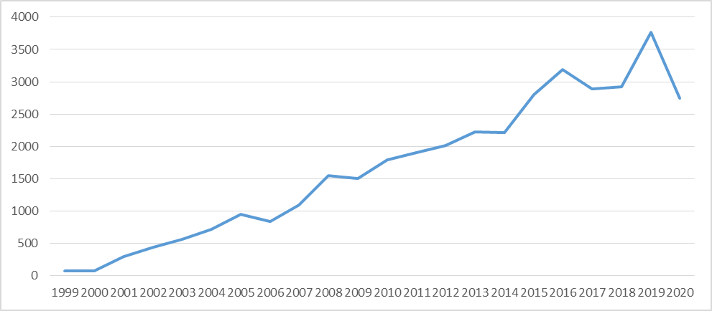
Number of entities certified to the ISO 14001 standard
Fig. 9. Shows that despite the amendment of the standard, the changing natural environment, the growing requirements and expectations of stakeholders (Brodnicka & Jakubiec 2016), and economic changes in the country and around the world, the growing trend continued until 2020 (Treacy et al. 2019, when the COVID-19 pandemic appeared
4. Conclusions
Due to changes in the natural environment, there is a need to take pro-environmental actions based on standardisation, guaranteeing a sense of security and supervision over the implemented changes. Implementing an environmental system according to the ISO 14001 standard will increase employees' and contractors' organisational potential and awareness. It will also positively impact shaping relationships with other market stakeholders. The data presented, e.g., identifying the low use of renewable energy sources, indicate that there is a problem with social acceptance and investment opportunities in Poland. Nevertheless, despite the growing awareness of environmental degradation and the willingness to take care and introduce changes to minimise the effects, the domestic consumption rate of raw materials is growing. It means that despite the growing awareness, implemented pro-environmental activities, and focus on ecological food and energy production, the pace of change achieved is too slow and not entirely effective. Such conclusions only partially confirm the research hypothesis because the effects take too long to achieve.
References
Adams, R., Jenkins, J., Peck, D., White, D. (2019). Renewable Energy Finance: Powering the Future. UK, London: Palgrave Macmillan.
Balicka, A. (2015). Controlling ekologiczny w przedsiębiorstwie, Wrocław: Publishing House of the Wrocław University of Economics.
Bönke, T., Dany-Knedlik, G., Roeger, W. (2023). Meeting climate targets can only spur on economic growth with the right combination of measures. DIW Wkly. Rep., 13, 236-242.
Brodnicka, E., Jakubiec, M. (2016). Globalne trendy w certyfikacji systemu zarządzania środowiskowego. Przedsiębiorstwo We współczesnej Gospodarce – Teoria i Praktyka, 2, 95-106. (in Polish)
Chang, T.W., Yeh, Y.L., Li, H.X. (2020). How to shape an organisation's sustainable green management performance: the mediation effect of environmental corporate social responsibility. Sustainability, 12(21), 9198, 1-19.
Cichosz, M., Wierzbicki, M. (2016). Innowacyjne modele biznesowe w sektorze energetyki odnawialnej – Analiza przypadków z Polski. Probl. Zarz., 14, 105-116. (in Polish)
Dmuchowski, R. (2019). Uwarunkowania konkurencyjności przedsiębiorstw. Galician economic journal, 58(3), 65-67.
Džubáková, M. (2019). Adoption of voluntary environmental tools in Slovak Republic – focused on ISO 14001 and EMAS. International Journal of Learning and Change, 11(3), 222-236.
England, R.W. (2006). Measurement of the natural capital stock: conceptual foundations and preliminary empirics, [in:] Lawn Ph. (red.), Sustainable Development Indicators in Ecological Economics. Cheltenham: Edward Elgar, 209-220.
Gajdzik, B., Wolniak, R, Nagaj, R., Grebski, W., Romanyshyn, T. (2023). Barriers to renewable energy source (RES) installations as determinants of energy consumption in EU countries. Energies, 16(21), 7364, 1-32. http://doi.org/10.3390/en16217364.
Gierszewska, G., Romanowska, M. (2009). Analiza strategiczna przedsiębiorstwa. Warszawa: PWE, 26-36. (in Polish)
Goszczyński, T. (2018). The impact of microenvironmental and macroenvironmental factors on the innovation processes taking place in the enterprises. Quality Production Improvement, 18, 43-44.
Goyal, A. (2006). Business Enviromment. New Delhi: V.K. Enterprises.
Griffin, R.W. (1997). Podstawy zarządzania organizacjami, Otoczenie organizacji i menedżerów. Warszawa: PWN, 74. (in Polish)
He, W., Shen, R. (2019). ISO 14001 Certification and Corporate Technological Innovation: Evidence from Chinese Firms. Journal of Business Ethics, 158(1), 97-117.
Hu, S., Wang, X. (2021). The origin of proactive environmental corporate social responsibility (ECSR) of large irms: Institutional embeddedness-driven, family involvement-promoted, or resource-dependent? Sustainability, 13(3), 1197, 1-23.
Kong, X., Pan, Y., Sun, H., Taghizadeh-Hesary, F. (2020). Can Environmental Corporate Social Responsibility Reduce Firms' Idiosyncratic Risk? Evidence From China. Frontiers in Environmental Science, 8, 608115.
Maletic, M., Podpečan, M., Maletic, D. (2015). ISO 14001 in a corporate sustainability context: a multiple case study approach, Management of Environmental Quality, 26(6), 872-890.
Małkowska-Borowczyk, M. (2011). Otoczenie jako źródło problemów i presji na wybory strategiczne przedsiębiorstw [w:] E. Urbanowska-Sojkin (red.), Podstawy wyborów strategicznych w przedsiębiorstwach. Warszawa: PWE,
121-123. (in Polish)
Marek, S., Białasiewicz M. (red.). (2008). Podstawy nauki o organizacji. Przedsiębiorstwo jako organizacja gospodarcza. Warszawa: PWE, 17-18. (in Polish)
Matejun M., Nowicki M. (2013). Organizacja w otoczeniu – od analizy otoczenia do dynamicznej lokalizacji, [w:] Adamik A. (red.), Nauka o organizacji. Ujęcie dynamiczne. Warszawa: Oficyna a Wolters Kluwer Business, 152-221. (in Polish)
Mentes, M. (2023). Sustainable development economy and the development of green economy in the European Union. Energy Sustain. Soc., 13, 32.
Michalak, A., Wolniak, R. (2023). The innovativeness of the country and the renewables and non-renewables in the energy mix on the example of European Union. Journal of Open Innovation: Technology, Market, and Complexity, 9(2), 100061, 1-16. https://doi.org/10.1016/j.joitmc.2023.100061
Moghimi, F.H., Fälth, H.E., Reichenberg, L., Siddiqui, A.S. (2023). Climate Policy and Strategic Operations in a Hydro-Thermal Power System. Energy J., 44, 67-93.
Nemati, Mehdi and Zheng, Yuqing and Hu, Wuyang, ISO-14001 Standard and Firms' Environmental Performance:
Evidence from the U.S. Transportation Equipment Manufacturers (July 27, 2016). Prepared for Presentation at the Agricultural & Applied Economics Association and Western Agricultural Economics Association Annual Meeting, Boston, Massachusetts, July 31-August 2 2016, Available at SSRN: https://ssrn.com/abstract=2932347 or http://dx.doi.org/10.2139/ssrn.2932347
Oliver, G.J.; Peters, J.A.H.W. (2020). Trends in Global CO₂ and Total Greenhouse Gas. Emissions: 2019 Report. The Netherlands: PBL Netherlands Environmental Assessment Agency.
Olkiewicz, M. (2015). Knowledge management as a determinant of innovation in enterprises. In Proceedings of the 9th International Management Conference Management and Innovation for Competitive Advantage. Bucharest, Romania, 399-409.
Olkiewicz, M., Dyczkowska, J.A., Olkiewicz, A.M. (2023). Financial Aspects of Energy Investments in the Era of Shaping Stable Energy Development in Poland: A Case Study. Energies, 16, 7814. https://doi.org/10.3390/en16237814
Olkiewicz, M., Wolniak, R., Skotnicka-Zasadzień, B. (2019). Implementation of ISO 14001 standard in the European union countries. Rocznik Ochrona Srodowiska, 21(2), 868-880.
Pacana, A., Lew, G., Kulpa, W. (2017). Rating the quality of implementation of environmental management systems. Journal of Business & Retail Management Research (JBRMR), 11(2), 165-169.
Pacana, A., Siwiec, D. (2021). Universal Model to Support the Quality Improvement of Industrial Products. Materials, 14(24), 7872, https://doi.org/10.3390/ma14247872
Pacana, A., Siwiec, D. (2022). Model to Predict Quality of Photovoltaic Panels Considering Customers' Expectations. Energies, 15(3), 1101, https://doi.org/10.3390/en15031101
Pacana, A., Ulewicz, R. (2017). Researches of determinants motivating to implementation of the environmental management system. Polish Journal of Management Studies, 16(1), 165-174.
Pacana, A., Ulewicz, R. (2020). Analysis of causes and effects of implementation of the quality management system complaint with ISO 9001. Pol. J. Manag. Stud., 21, 283-296.
Parlament Europejski (2018). Redukcja Emisji Gazów Cieplarnianych: Cele I Działania Unii Europejskiej. Available online: https://www.europarl.europa.eu/pdfs/news/expert/2018/3/story/20180305STO99003/20180305STO99 003_pl.pdf (accessed on 13 August 2023)
Pathak, H. (2011). Organisational Change. Noida: Dorling Kindersley.
Pizło, W., Mazurkiewicz-Pizło, A. (2008). Koncepcja otoczenia organizacji z uwzględnieniem wybranych aspektów międzynarodowych. Zeszyty Naukowe SGGW w Warszawie. Ekonomika i Organizacja Gospodarki Żywnościowej, 71, 27-28. (in Polish)
Ponomarenko, T.V., Wolniak, R., Marinina, O.A. (2016). Corporate Social responsibility in coal industry (Practices of Russian and European companies). Journal of Mining Institute, 222, 882-891.
Puciato, D., Żmigrodzki, M. (2009). Zmiany w makrootoczeniu a funkcjonowanie współczesnych przedsiębiorstw hotelarskich. Zeszyty Naukowe Małopolskiej Wyższej Szkoły Ekonomicznej w Tarnowie, 14(3), 86-93. (in Polish)
Rela, I.Z., Awang, A.H., Ramli, Z., Md-Sum, S., Meisanti, M. (2020). Effects of environmental corporate social responsibility on environmental well-being perception and the mediation role of community resilience. Corporate Social Responsibility and Environmental Management, 27(5), 2176-2187.
Rudewicz, J. (2016). Zmiany kierunków użytkowania gruntów ze szczególnym uwzględnieniem terenów przemysłowych w wielkich miastach Polski i ich otoczeniu w latach 2005 i 2009-2014. Prace Komisji Geografii Przemysłu Polskiego Towarzystwa Geograficznego, 30(2), 122-141. (in Polish)
Seroka, A. (2022). Odnawialne źródła energii jako element zarządzania bezpieczeństwem energetycznym państwa. Zeszyty Naukowe Politechniki Częstochowskiej. Zarządzanie, 46, 88-100. https://doi.org/10.17512/znpcz.2022.2.07
Siekierski, J., Śliwa R. (2015). Otoczenie instytucjonalne a procesy innowacyjne w polskiej gospodarce w latach 2004-2020 (w świetle dokumentów strategicznych i operacyjnych). Zeszyty Naukowe Małopolskiej Wyższej Szkoły Ekonomicznej w Tarnowie, 26(1), 139-150. (in Polish)
Siwiec, D., Pacana, A. (2021). Model of Choice Photovoltaic Panels Considering Customers' Expectation, Energies, 14(18), 5977, https://doi.org/10.3390/en14185977
Śleszyński, J. (2016). Economics and irreversible changes in the environment. Research Papers of Wrocław University of Economics. Ekonomia środowiska i polityka ekologiczna, 453, 143-144. https://doi.org/10.15611/pn.2016.453.11
Tomaszewski, K., Sekściński, A. (2020). Odnawialne źródła energii w Polsce – perspektywa lokalna i regionalna. Rynek Energii, 149(4), 10-19. (in Polish)
Treacy, R., Humphreys, P., McIvor, R., Lo, C. (2019). ISO14001 certification and operating performance: A practice-based view. International Journal of Production Economics, 208, 319-328.
Trojanowski, T. (2014). Sustainable socio-cultural and natural environment of an enterprise. Zeszyty Naukowe Wyższej Szkoły Humanitas. Zarządzanie, 2, 373-379. (in Polish)
Villar, E.M., Barroso, C., del Carmen, M. (2023). The need to review the role of tax incentives for self-consumption in the context of support schemes for pv solar energy. Crónica Tribut., 187, 139-168.
Wach, K. (2010). Analiza otoczenia przedsiębiorstwa w szkołach i koncepcjach zarządzania. Zeszyty Naukowe Uniwersytetu Ekonomicznego w Krakowie, 812, 134-135. (in Polish)
Wei, Z., Song, X., Makhdoom, Z.H., Xie, P. (2019). Paradox strategic cognition and ECSR in China: a three-tripod perspective. Asia Pacific Business Review, 25(3), 392-412.
Woo, T.H. (2023). Climate change analysis in energy-mix with non-carbon emission energy incorporated with pandemic society. Environ. Dev. Sustain., 25, 11723-11733.
Wu, W., An, S., Wu, C.H., Tsai, S.B., Yang, K. (2020). An empirical study on green environmental system certification affects financing cost of high energy consumption enterprises-taking metallurgical enterprises as an example. Journal of Cleaner Production, 244, 118848.
Wyszomirski, A., Olkiewicz, M. (2020). Environmental corporate social responsibility as a tool for creating the future of environmental protection. Rocznik Ochrona Srodowiska, 22(2), 1145-1161.
Xu, J., Wei, J., Lu, L. (2019). Strategic stakeholder management, environmental corporate social responsibility engagement, and financial performance of stigmatised firms derived from Chinese special environmental policy. Business Strategy and the Envionment, 28(6), 1027-1044.

