 | Rocznik Ochrona Środowiska
 | Volume 25 | Year 2023 ISSN 2720-7501 | pp. 329-341
 | https://doi.org/10.54740/ros.2023.034 open access
 | Received: November 2023 Accepted: December 2023 Published: December 2023
Rationalisation of the Functioning of Vehicle Recycling
Pawel Zajac^{*1}, Stanisław Ejdys^{*2}, Piotr Balicki³
¹Wroclaw University of Science and Technology, Poland
https://orcid.org/0000-0003-3103-832X
²Ignacy Moscicki’s University of Applied Sciences in Ciechanów, Poland
https://orcid.org/0000-0003-4312-7880
³Ignacy Moscicki’s University of Applied Sciences in Ciechanów, Poland
https://orcid.org/0000-0001-7874-8797
*corresponding author's e-mail: pawel.zajac@pwr.edu.pl, stanislaw.ejdys@pansim.edu.pl
Abstract: Includes the identification and analysis of the vehicle recycling system using the example of buses in consideration of economic and business issues in Poland, specialising in the collection of cars/buses, their dismantling, segregation of materials and secondary use (recycling), given the regulatory changes proposed by the EU. The operations listed are interrelated. Reusing materials identical to their original purpose (including reuse of steel for car bodies) and assemblies from end-of-life vehicles (after possible reconditioning) can be applied as spare parts for repairs, subject to the observance of certain rules and the law. Life extension activities contribute to reducing the amount of waste sent to landfills. The paper presents a case for dismantling a bus.
Keywords: recycling, waste, environmental protection, management
1. Introduction
In the implementation of vehicle recycling (Li et al. 2021, Li et al. 2021a, Li et al. 2019, Liu et al. 2020, Meng et al. 2022), especially of trucks and buses, it is necessary to build economic systems on a national scale or individual EU international communities that ensure safe collection of end-of-life cars/buses, dismantling, reuse, recovery (Chamier-Gliszczyński 2011) selection and transport of materials to processing plants, characterised by:
- Tightness – ensuring that every end-of-life vehicle/bus (except for antique vehicles with museum or collector value) goes to the recycling network and preventing environmental contamination during uncontrolled dismantling by spilling oil into the ground or dumping tires into the forest, among others. (Osiński & Żach 2019),
- Recycling level – as high as possible, or at least required by the EU Directive (Chamier-Gliszczyński 2011a),
- Profitability – all business entities participating in the system must conduct economically viable operations.
The problems of recycling end-of-life vehicles are complex (Lenort et al. 2021), and the situation was further complicated by the legal status, which did not include trucks, buses and motorcycles. The changes introduced by the EU could lay the groundwork for big, needed changes, especially in the context of putting EV vehicles into service (https://ec.europa.eu/commission/presscorner/detail/en/IP_23_3819). A diagram of the logistical management of end-of-life vehicles is shown in Fig. 1.
In place of Directive 2000/53/EC, currently in effect at the time of writing, there are plans to modify bus recycling in the EU through a regulation with annexes that will apply directly in each country of the European Union. This significant change requires an amendment to the Polish Act of January 20, 2005 on Recycling of End-of-Life Vehicles (Merkisz-Guranowska 2007, 2008).

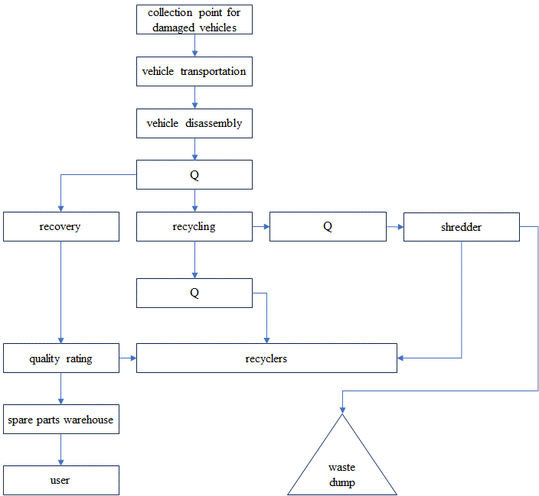
Fig. 1. Diagram of process logistics, where Q stands for pre-classification, based on (Merkisz-Guranowska 2007)
2. Bus Recycling System in Poland
Bus recycling activities in Poland have not been regulated by the provisions of the Act of January 20, 2005 on Recycling of End-of-Life Vehicles, which has been in force since March 14, 2005. This is due to the provision that end-of-life vehicles are vehicles in the M1 and N1 (passenger/truck) categories. In the Regulation of the Minister of Infrastructure dated 24.10.2005, the bus belongs to the M3 category (a vehicle weighing more than 5 tons, with more than 8 seats). The Waste Act of April 27, 2001 (Journal of Laws 2001 No. 62, item 628) defines the category of waste presented in Appendix 1 to the Act mentioned above. The appendix in question does not take into account / does not classify waste, which could be buses. Thus, an end-of-life bus is not waste under the Waste Act of April 27, 2001. Therefore, it should be considered that there is a lack of regulation (Osiński & Żach 2015).
The dismantling station is obliged to accept any end-of-life vehicle with identifying features, collect a fee from the vehicle's owner if it is incomplete or contains other waste not originating from that vehicle. The dismantling station can accept vehicles of other categories than M1/N1, such as buses. Recycling of such vehicles is not included in the Recycling Act. An entity that dismantles vehicles that do not belong to the M1 and N1 categories shall comply with environmental regulations, considering the Waste Act.
The registration certificate, license plates, and vehicle card are invalidated when the vehicle is taken to the dismantling facility. The facility issues a certificate of dismantling to the owner and the registration authority. Detailed requirements for dismantling stations are outlined in the Minister of Economy and Labor Regulation on minimum requirements for dismantling stations and how to dismantle end-of-life vehicles (Journal of Laws 2001 No. 62 item 628). The processes carried out at the dismantling station are shown in Fig. 2.
The first stage involves preparing and taking the vehicle to the dismantling station. The next step is to drain off any fluids, such as brake fluid, windshield washer fluid, engine oil and air conditioning fluid. Once the vehicle is dry, the next step is to remove hazardous substances such as an acid battery. The dismantling station is an essential link during the recycling process. The operator of the dismantling station is obliged to fulfil the obligations imposed by the Road Traffic Act (Bylina 2020), the Environmental Protection Act (Bojanowicz 2015) and the Waste Act (Journal of Laws 2001 No. 62 item 628). Accordingly, the station should ensure that all vehicles are effectively received to be scrapped following applicable environmental requirements and issue a certificate of scrapping to the owner. In addition, a station that accepts a car for recycling must have a permit for such activity, which the governor issues. Dismantling stations that accept vehicles for recycling must also keep records of the cars they accept, the waste generated, and its records, following current regulations. Below is a diagram of the recycling process (Chamier-Gliszczyński 2010). The most important step in the recycling process is to dismantle the vehicle environmentally soundly (Chamier-Gliszczyński 2011b). The end-of-life vehicle dismantling station operator also collects and transports waste, recovers products and materials and transfers generated waste for further processing. The technology for dismantling end-of-life cars should be designed to make the venture profitable. The profitability of the venture is influenced by many factors, such as obtaining the vehicles for dismantling and its cost, ensuring continuity of supply, the cost of dismantling: labour, energy, fixed assets, environmental fees and waste disposal fees, the depth of dismantling, revenue from the sale of replacement parts and materials for further processing, and the cost of transporting metal and non-metal scrap (Transportation. Results of Operations 2016). To avoid environmental hazards, each stage of the dismantling process should follow BAT requirements, that is, using all appropriate pollution prevention measures. The technology of car dismantling should also take into account the logistics of the entire recycling process, the purpose of which is to minimise the time and cost of waste collection (Izdebski & Jacyna 2018), (Jacyna et al. 2018), storage and transportation of materials and their sale (Bujak & Zajac 2012).

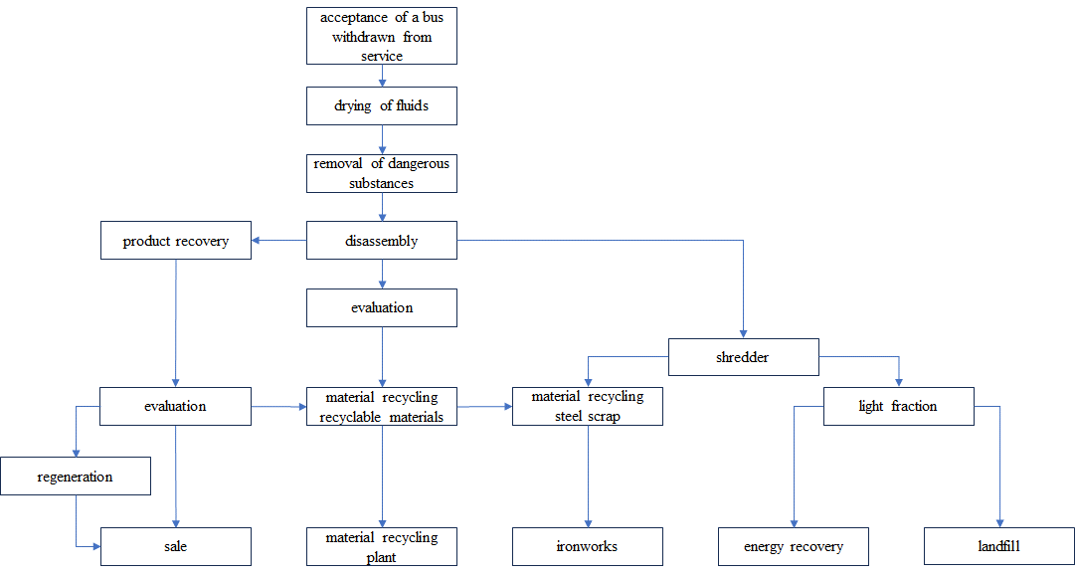
Fig. 2. General diagram of the end-of-life bus recycling process, based on (Tomczyk 2012)

Due to its processing capacity, the vehicle dismantling and scrap shredding station qualifies as an IPPC (Integrated Pollution Prevention and Control Directive) plant, representing a potentially significant environmental impact. There is a possibility of adverse events, including those that may lead to harm (Listwan 2009).
Waste generation and management are the main environmental aspects of operating an end-of-life car dismantling station. The dismantling station generates waste from cars delivered for recycling (Chamier-Gliszczynski & Krzyzynski 2005, Czwajda et al. 2019).
When vehicles are dismantled, hazardous waste is generated, which may threaten the environment. This is linked to groundwater and soil contamination due to fluid leaks from recycled vehicles (Gabryelewicz et al. 2021). Appropriate technical and technological solutions are used to reduce these risks to ensure an integrated pollution control and prevention approach. One legal instrument to achieve this is an integrated permit. Considering the obligation imposed on the plant to comply with BAT requirements (European Commission Implementing Decision 2019/2010/EU of 2019), which establishes conclusions on the best available techniques for waste incineration following Directive 2010/75/EU of the European Parliament and the Council. There are 4 years from the date of the decision to achieve compliance – so the requirements should be met by November 12, 2023) related to the conducted operations; the dismantling station should be designed and operated under applicable environmental regulations. Moreover, reusing components and materials used in vehicles is significant regarding economical, natural resources (Lenort et al. 2019) and energy management while reducing waste streams placed irretrievably in landfills. The operators should be guided by the principle of working to benefit the environment by maximising recovery and recycling of hazardous waste, including scrap metal from the bus, and not contributing to any environmental damage.
3. Bus Dismantling Process
The dismantling process is carried out in cells (dismantling cells) or on belts. The division of dismantling technologies carried out in this way implies the level of automation and the level of manual work required (Sąsiadek et al. 2018). With cell-based dismantling, the vehicle is dismantled in one place, with the participation of station personnel Fig. 3. However, before it goes to the lift (before the cell), it is necessary to drain the vehicle, i.e. remove dangerous fluids, including the battery removal. The station has a highly specialised lift (Journal of Laws 143, item 1206, 2005), which allows workers to dismantle not only above or inside the vehicle but also, very importantly, under it (under classic conditions, the presence of a worker in the work zone under the vehicle is not allowed by health and safety regulations). Components that cannot be dismantled on the lift, such as the engine, are recovered at other stations.

- 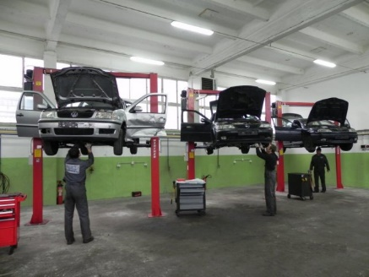 B. 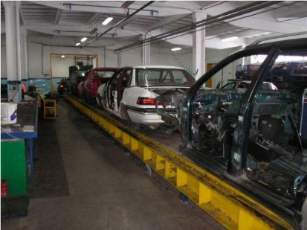
Fig. 3. A – lift used in cell-based dismantling; B – dismantling of components in the dismantling line

Cell-based dismantling is used primarily in small dismantling stations that handle a small number of vehicles. This is the most popular dismantling method used in Poland.
On the other hand, belt-based dismantling takes place on a special belt line that is automated and resembles an assembly line. The dismantling process takes place at several stations, starting with removing fluids at the beginning of the line, then dismantling subsequent components of end-of-life vehicles, and finally, transferring the rest for shredding if the station is equipped with a special mill. Belt-based dismantling is carried out smoothly; up to 40 vehicles can be dismantled in a working day. Some bus manufacturing companies choose to build a dismantling line to obtain parts for reuse in bus construction – which is sometimes referred to as "industrial cannibalism" (Kosobudzki et al. 2018), the application of which is defined by Regulation of the Minister of Infrastructure of September 28, 2005 on reuse, where it is specified that reuse is not allowed for: airbags with pyrotechnic activators, electronic control units and sensors, brake pads, brake shoes, brake system hoses and seals, exhaust system mufflers, steering and suspension joints, seats integrated with seat belts or airbags, steering lock systems, immobilisers including electrical control transponders, anti-theft and alarm devices, electrical and electronic components of driving safety systems (especially ABS and ASR), fuel lines, disposable filters and filter cartridges – i.e. those that are directly responsible for safety (Jamroziak et al. 2019).
These lines are tailored to specific makes, models, and companies – they are not characterised by versatility but by sourcing specific parts (Listwa et al. 2009). The dismantling of an example Volvo bus is listed below by process steps:
- Removal of the battery.
- Removal of the windshield, headlights, and exterior mirrors.
- Removal of the seats.
- Removal of the steering wheel, gauge clusters and dashboard. Removal of the fan and air-conditioning, audio-visual, tachograph, and other electronic components.
- Removal of radiators, fans, ducts/pipes and side panels.
- Removal of speaker lamps and air supply nozzles, etc.
- Removal of nets and shelf flaps.
- Removal of the door mechanism, air conditioning fan, air tank and electrical wiring.
- Removal of doors and roof flaps.
- Removal of ceiling lining.
- Removal of all wall and ceiling insulation.
- Removal of any equipment located on the roof, such as an air-conditioning unit.
- Removal of the roof using a crane or gantry.
- Removal of bumpers, all flaps and roof framing.
- Removal of the front and rear of the vehicle.
- Removal of the floor mat.
- Removal of the floor plates.
- Removal of the sides of the body.
- Removal of the fuel tank and other components, such as the pump, muffler, hoses, etc.
- Removal of the wheels and their components.

The process steps are shown in Fig. 4-12 below, based on (Information material 2018).

- 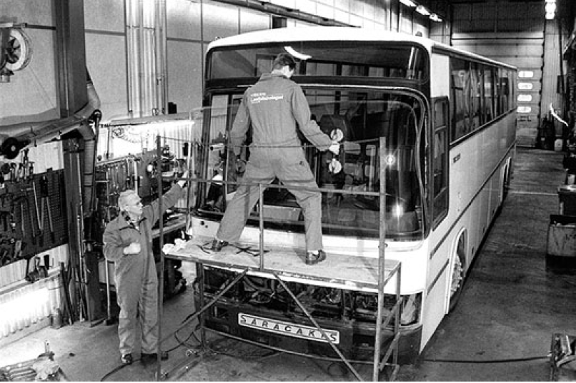B. 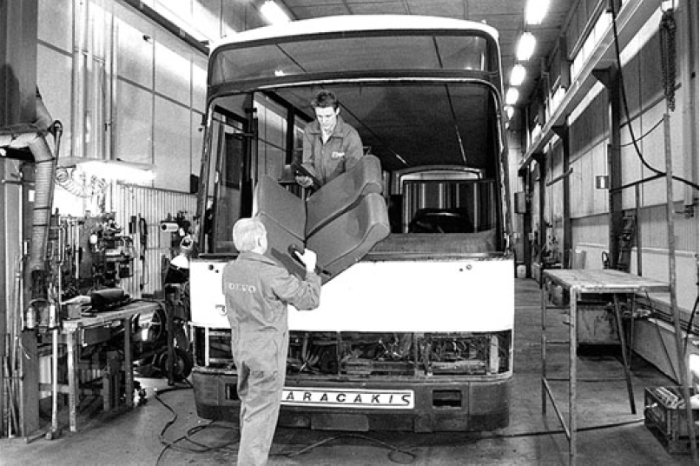
Fig. 4. A – Windshield removal; B – Seats removal

- 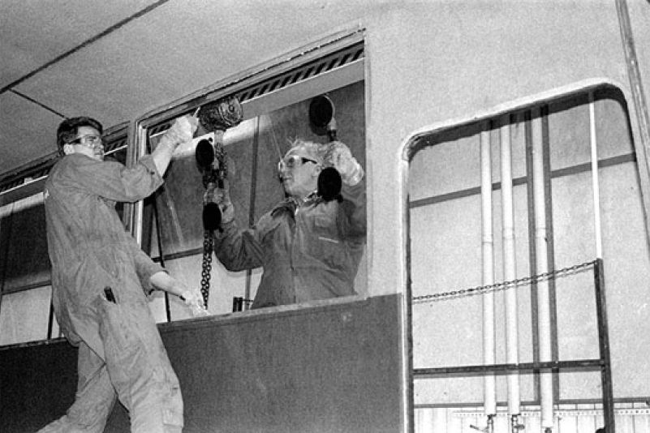B. 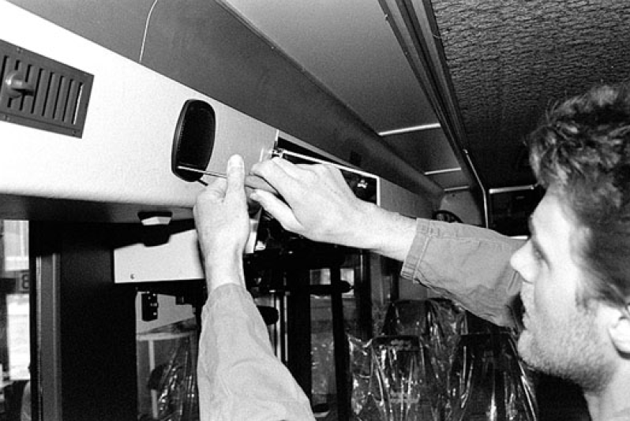
Fig. 5. A – Side windows removal; B – Removal of speaker lamps and air supply nozzles

- 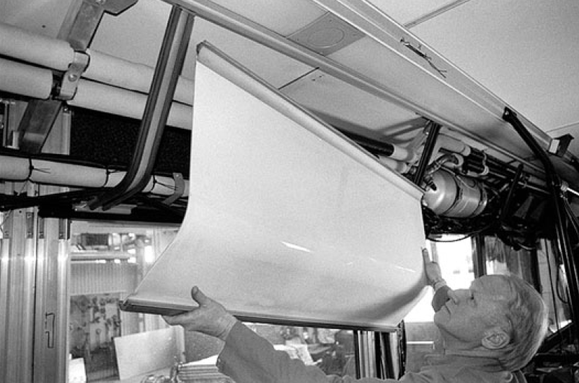B. 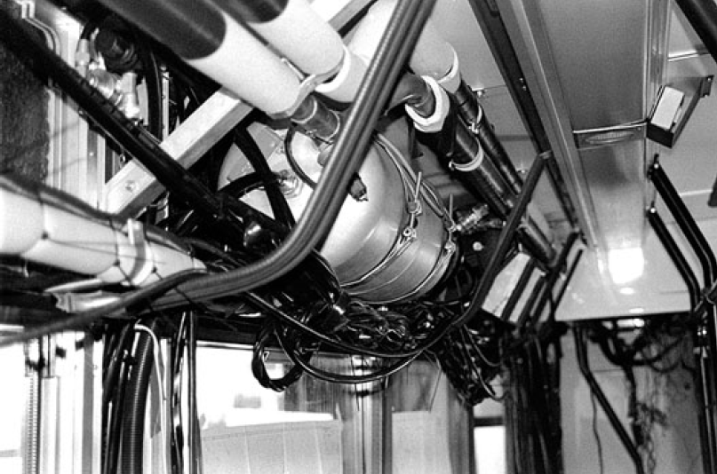
Fig. 6. A – Removal of shelf nets and flaps; B – Removal of door mechanism, air conditioning fan, air tank and electrical wires

- 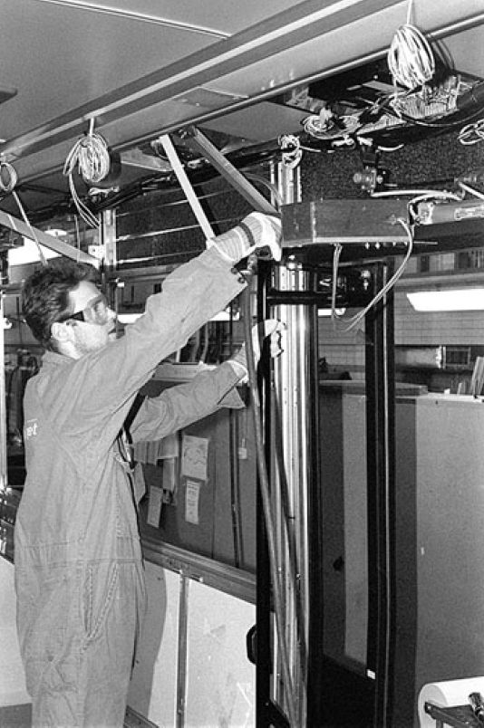B. 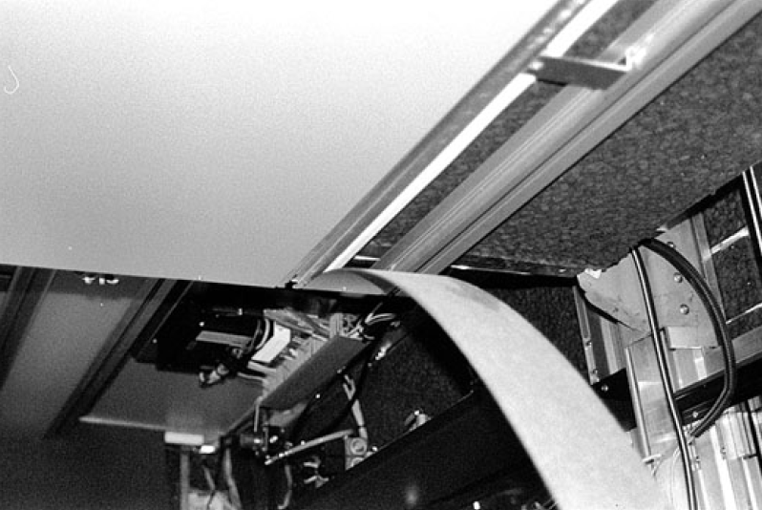
Fig. 7. Removal of doors and roof flaps; B – Removal of ceiling lining.

- 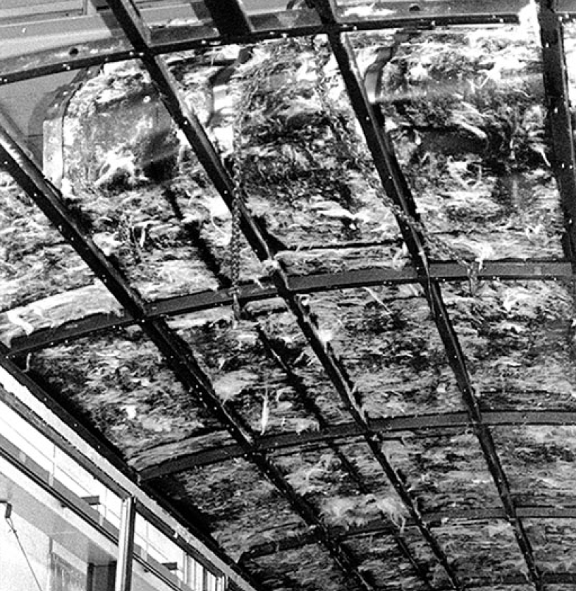 B. 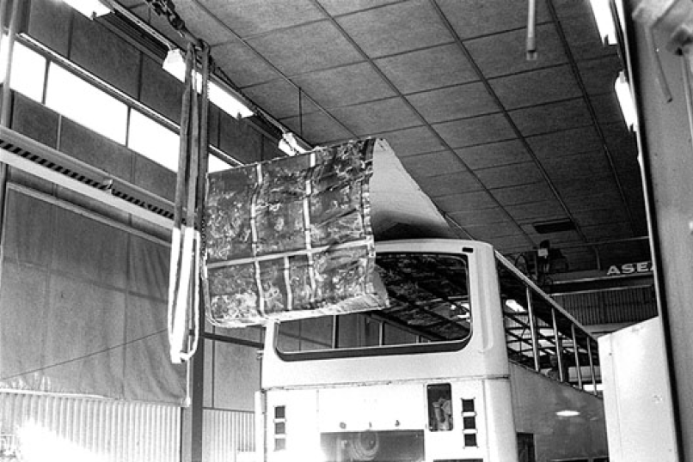
Fig. 8. A – Removal of the entire wall and ceiling insulation; B – Removal of the roof using a crane or gantry

- 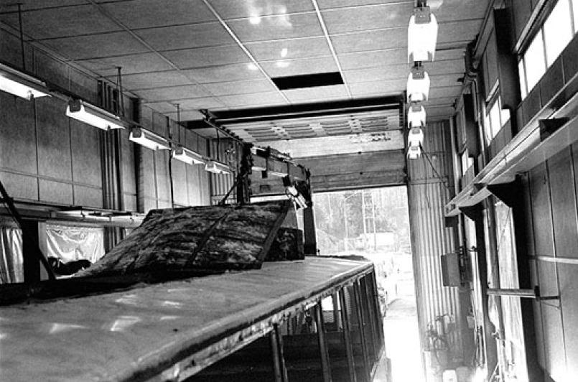B. 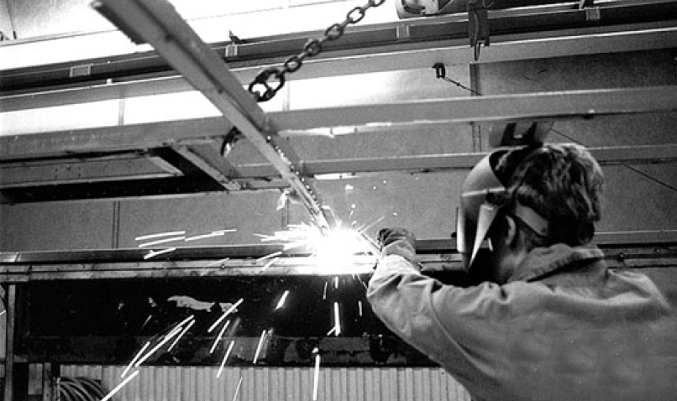
Fig. 9. A – Removal of the roof using a crane or overhead crane; B – Removal of bumpers, all flaps and roof framing

- 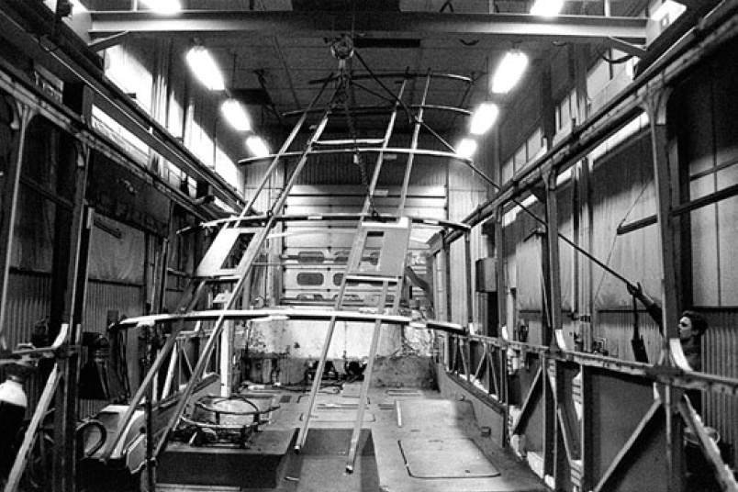B. 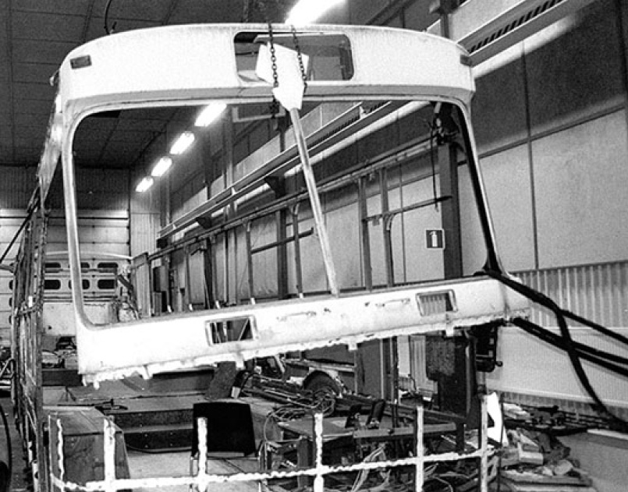
Fig. 10. Removal of the roof; B – Removal of the front by cutting

- 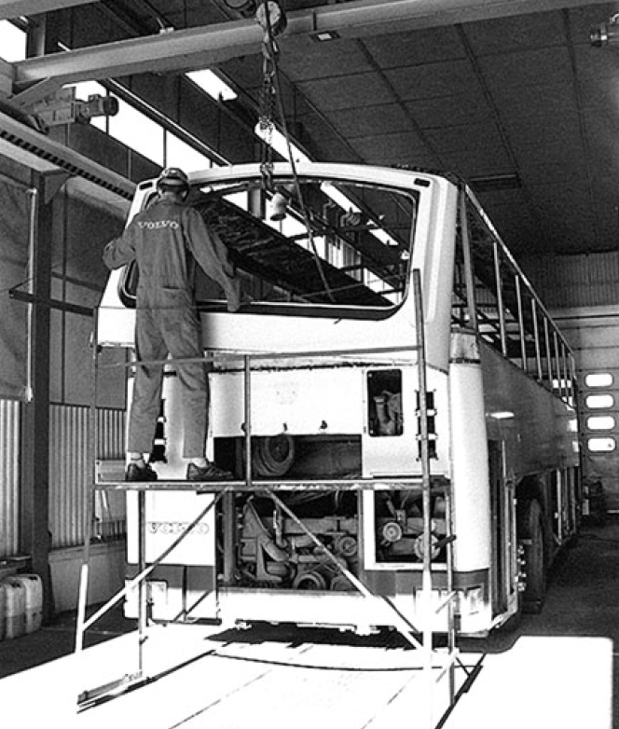B. 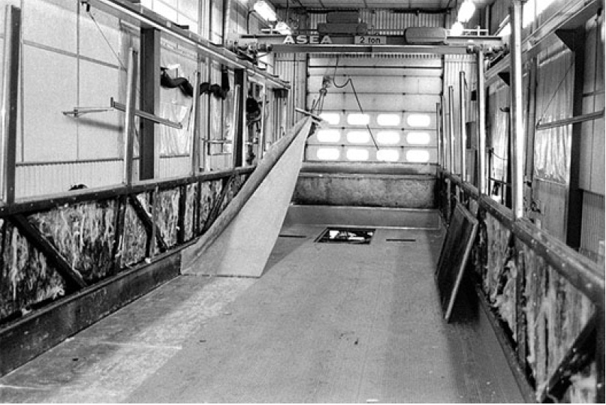
Fig. 11. A – Removal of the rear of the bus; B – Removal of the floor mat

- 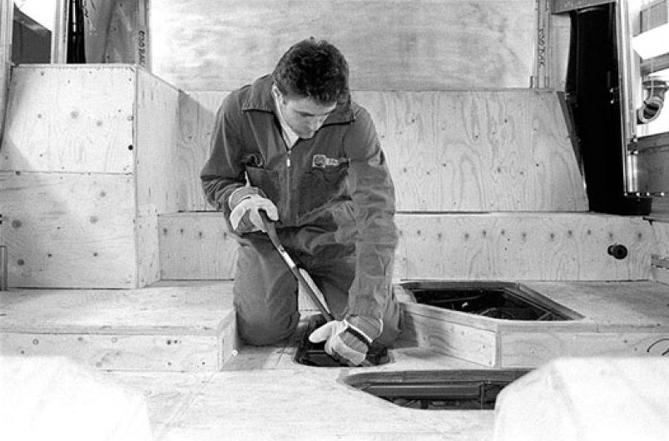B. 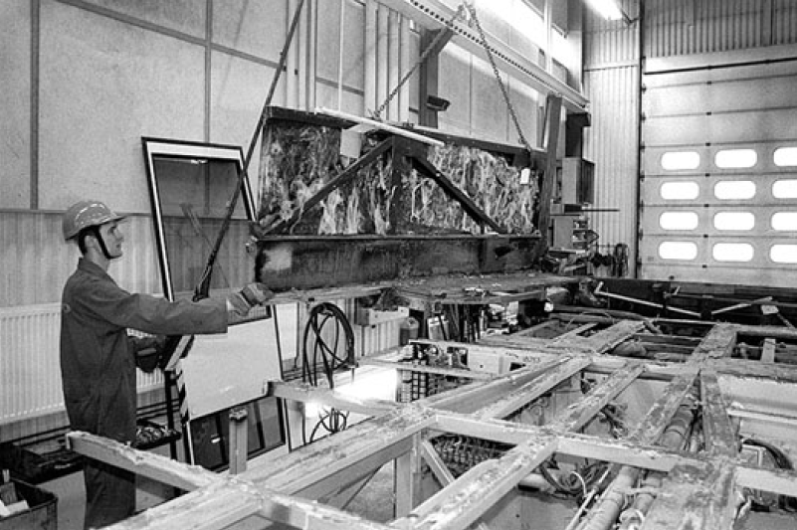
Fig. 12. A – Removal of floor slabs; B – Removal of the body sides
4. Management of Dismantled Assemblies and Materials
A survey of recycling stations (Bylina 2020, Tomczyk 2012) found that the stations would like to sell dismantled components for re-installation in new or refurbished vehicles. Such a process requires the development of, firstly, legal solutions and, secondly, providing for the dismantling stations of business solutions for the resale of parts inspected as safe and fit for re-implementation. This calls for developing methodologies for conducting assessments according to a specific standard and is useful in repeat applications.
Another novel solution is to see the bus as a source of raw materials of good quality. Recovered raw materials could go to the commodities exchange. In this regard, there is a lack of legal solutions and cooperation between dismantling stations and universities and institutes ready to transfer the required new technologies.
Technological barriers were overcome in the following areas:
- Tires and other rubber components – in the EU, about 2.6 million Mg of waste tires must be managed annually. The number is increasing by about 500,000 Mg every 5 years, of which more than 130 thousand tons are in Poland, where 120-155 thousand Mg of tires annually have been retired for nearly 10 years. Large quantities of waste tires are because waste tires are also created during the car's life (they are replaced). Worldwide stocks of waste car tires are estimated at 29 million Mg, with an annual increase of at least 7.5 million Mg. Of the number mentioned, only 23% of tires are used (export to other countries, incineration for energy purposes, mechanical grinding for road construction and others). The remaining 77% of waste car tires are not disposed of in any way due to the lack of cost-effective disposal methods. Accurately determining the amount of waste rubber and derivatives from end-of-life vehicles is very difficult due to the lack of records in this regard. Extending their useful life through retreading and increasing their durability (according to statistics, about 40% of truck tires are currently retreaded; passenger car tires are retreaded in small numbers). Retreading allows for continued safe operation and reuse of 75% of the tire material. The cost of replacing the tread is roughly 40% of the material, energy and labour inputs relative to the cost of producing a new tire. The key – given the cost criterion – are the parameters of regranulate – and, above all, the grain diameter: fines – up to 1 mm, granulate – 0-10 mm, pulp – 0-40 mm, chips – 10-40 mm, shred – the largest product of grinding – 40-300 mm. Depending on this, they may be qualified for use as fillers in building construction elements. Due to its very good insulating properties, both acoustic and thermal, as well as water resistance, rubber with such fragmentation parameters can be used in constructing tunnels, underground passages, roads or bridges. Other applications include rubber granulate and pulp. Due to its small size, it is excellent for manufacturing playground surfaces, playing fields, isolation mats used, for example, in noise barriers. In horticulture, such raw material is often used as synthetic peat. The finest fraction of shredded rubber (fines) is used as an additive to rubber compounds from which new products are made. Examples of such products include industrial tires, floor coverings, doormats, mats, car mats and many others (Woźniak et al. 2018). An increasingly popular method of managing rubber fines is to add it to asphalt in road construction and, more recently, to the substrate of playgrounds.
- Engine and drive units – e.g., gearboxes and main transmissions- are, in case of good condition, dismantled in their entirety and used as spare parts for reuse. If they are in poorer condition, they are dismantled at a dismantling station for steel and other ferrous alloys and non-ferrous metals. Among non-ferrous metals in automobiles, aluminium alloy parts account for the largest percentage. It is a metal that is characterised by high strength and low specific weight – and for this reason, there is an increase in its use in the production of new cars. These are mainly suspension components, such as suspension arms, the braking system, such as brake calipers and cylinders, the cooling system, such as radiators, engine parts, such as heads, and engine and powertrain blocks, such as transmission housings, etc. In several applications, aluminium is replaced by magnesium alloys that allow for weight savings, such as transmission housing, steering wheel rim or dashboard bar. Magnesium has the advantage of low energy consumption during secondary processing (about 5% compared to consumption during manufacture from natural resources). As with aluminium, there are problems with contamination, requiring the sorting of scrap metal in terms of contamination. Smaller amounts of other metals, including copper, zinc, nickel, and cobalt, are also used in the construction of buses as components of integrated circuit boards of wires, electrical equipment, etc.
- In percentage terms, lead-acid batteries are the most popular type of bus power source of all those in use today. Waste bus batteries are one of the most dangerous wastes generated by vehicle operation. Approximately 350 million batteries are produced annually worldwide. Global consumption of lead in their production oscillates around 3.5 million Mg. This accounts for 70% of global lead production. Annually, 2.3 million batteries are sold in Poland. Only a little over a million are recycled. All components of a used battery are suitable for reuse. The situation was improved by introducing a deposit fee on purchasing a new battery if the old battery is not donated. There are two facilities in Poland that process battery scrap: ZGH Orzeł Biały in Bytom and Baterpol in Świętochłowice, whose capacity is much greater than the weight of batteries sold in Poland during the year. Annually, ZGH Orzeł Biały can process 120000 Mg of waste batteries, while Baterpol can process 80,000 Mg. The technological process of separating batteries (Engitex System) is based on aqueous separation into components: metallic lead, lead paste, polypropylene, electrolyte and iron waste. The technology offers the possibility to process the entire amount of scrap generated in the country and manage almost entirely lead (up to 99%), polypropylene, electrolyte and organic materials (up to 95%). Also, the sulfur contained in the sludgy components can be fully recovered.
- Electrical and electronic devices – number of electrical and electronic devices used in bus construction is increasing. These are difficult-to-reuse items composed of many materials. For example, printed circuit boards (PCBs) are made from laminates produced from epoxy resins, containing about 10 layers of glass cloth covered with copper foil. Current PCB recycling and disposal technologies can be divided into two main groups: thermal technologies, such as pyrolysis, hydrometallurgy and metallurgy, and non-thermal technologies, such as dismantling, shredding, separation and chemical treatment. Products resulting from non-thermal technologies usually require further chemical processing. The main problems associated with the recycling and disposing printed circuit boards are mainly due to their complex structure and varied material composition. They concern such issues as the difficulty of determining the exact material structure and the orientation of current recycling technologies towards the recovery of mainly metals, which account for only 28% of the mass of printed circuit boards (more than 70% of scrap PCBs are not recycled), the diversity of designs and the lack of standards that make it difficult to automate PCB dismantling and segregation processes. Rare metals such as tantalum, for example, are present on the boards in small quantities and at low concentrations, affecting the efficiency of recovery processes and the harmfulness to the environment of all known recycling technologies.
5. Technological Challenges in Recycling of Buses
Bus construction is constantly evolving – this is due to the natural tendency to design better and better products. One of the development directions is the use of material engineering achievements – the use of plastics and composites is of particular interest (Kurzawa et al. 2020). The many advantages of this type of material, especially the high specific strength (strength-to-weight ratio), make building buses with less weight possible, directly contributing to reducing fuel consumption and the amount of toxic exhaust fumes emitted into the atmosphere. For this reason, the use of plastics in car construction (Zając et al. 2022) continues to expand. Trends in the use of structural materials in bus construction are shown in Table 1.

Table 1. Trends in the use of structural materials in bus construction, inspiration (Chłopek 2002)
Production | 1980-1990 | 1991-2004 | 2005-2015
Steel, iron  Non-ferrous metals  Plastics  Rubber  Glass  Fluids  Other  Decommissioned | 72%  4,5%  7,5%  5,5%  3,5%  5%  2%  1995-2005 | 62%  5%  17%  6%  3%  5,5%  1,5%  2006-2019 | 40%  5,5%  38%  6,5%  2,5%  6%  1,5%  2020-2039

Based on the data in Table 1, it can be concluded that buses with a much higher proportion of plastics will be sent for dismantling. Recycling this material will, therefore, become a kind of challenge in the coming years. The solution to these problems will be fostered by introducing new plastics with greater recyclability. It is also expected that the increased reliability of buses currently in production will significantly reduce the need for reusable assemblies and spare parts. Therefore, the reduction in reuse will have to be offset by an increase in material recycling. Changes in car design are also driven by the need to be better prepared for recycling.
In the process of designing a bus, they can include adaptation to dismantling – by avoiding elements joined from different materials, such as steel and plastic ornaments, the introduction of connections that are easier to dismantle (snaps instead of bolted connections), and the development of detailed and graphically clear dismantling instructions for each vehicle. This includes a material known under the trade name Cellasto, i.e., cellular polyurethane elastomer for damping and energy-absorbing elements and damping and sound-insulating inserts. Waste and worn-out Cellasto parts can be repeatedly processed by methods inherent to thermoplastics (e.g., injection and extrusion) without losing their physical and chemical properties. Intensive work is also underway to develop and implement new materials from the thermosetting plastics group. Until recently, it was not possible to reuse cross-linked material.

Newer generation buses equipped with passive safety systems are increasingly arriving at dismantling stations. The problem is ensuring safety when removing pyrotechnically actuated devices: airbags and seatbelts. Airbags and pyrotechnic pretensioners should be deactivated without being removed from the vehicle (Chłopek 2002).
6. Bus Recycling in Poland
Efficient and environmentally compliant processing of 600-800 thousand vehicles per year requires adequate infrastructure. The first link in the recycling system is dismantling stations that prepare vehicles for further processing. To rationalise the operation of recycling facilities, the location of stations in Poland should take into account:
- the peculiarity of regions in terms of ensuring an adequate number of end-of-life vehicles for processing, i.e. the number and age structure of registered vehicles,
- the existing recycling infrastructure in terms of minimising processing costs, i.e. the number and type of recycling facilities located in a given region (Polskie Autobusy 2/2018, 10/2018).

In Poland, with an area of 312,685 km², there should be a minimum of 62 stations (or collection points), assuming that they can be located anywhere where a dismantling station serves 5,000 km² (Ekorecykler 2021). Since the stations cannot, in practice, be located arbitrarily, the minimum number of points to cover the national territory is 80-100. There are currently more than 700 dismantling stations licensed to recycle cars in Poland, which means that the number is sufficient regarding network availability and processing capacity (Disposal Center Data 2021).
The experience of EU countries, especially Germany, shows that small and medium-sized stations, dismantling a few hundred to a few thousand vehicles a year, perform better than very large stations. Small and medium-sized enterprises generally combine dismantling activities with other services, i.e. vehicle mechanics, trade in spare parts or end-of-life cars, and purchase of recyclable materials. By diversifying their operations, they can more easily "survive periods of low vehicle supply," which is important, especially in Poland (http://www.recykling.pl/recykling/).
If all vehicles currently being decommissioned were transferred to licensed stations, there would be about 1,100 vehicles per station. On the other hand, assuming the country should decommission 700,000 vehicles yearly (2010 figures), there will be about 1,500 vehicles per station.
Therefore, it is not advisable to increase the number of dismantling stations in the country unless they were to be established in regions with a shortage of them, such as the Łódź province.
The weak point in the current network of stations is the geographic distribution. The density is particularly high around some cities, e.g., Kraków or Katowice. It ensures a convenient reception of end-of-life vehicles. Still, in some regions (provinces: Podlaskie, Świętokrzyskie, Warmińsko-Mazurskie), the network is very underdeveloped, resulting in no possibility of handing over a scrapped vehicle for dismantling within an area of several tens of kilometres. The solution to this problem should be establishing existing dismantling stations of vehicle collection points (Zając et al. 2023).
Due to transportation costs and a lack of technical infrastructure, only 25% of scrapped vehicles are sent to steel mills via shredding lines Fig. 13. The network of shredders operating in Poland has a capacity of 520,000 tons per year. Still, only 30% of the raw material processed comes from vehicles. If such a proportion of weight to other waste continues and the average weight of vehicles returned for shredding is around 700 kg, the current network of shredders can process a maximum of 220,000 end-of-life vehicles. The existing network needs to be expanded with shredders with a total capacity of about 200,000 Mg of vehicle-only raw material to scrap 500,000 vehicles. Therefore, expanding the network with a minimum of two large shredders or four smaller ones is urgently necessary. In the first stage, industrial mills would have to be put into operation, covering the metropolitan area of Łódź, Szczecin, the Lublin region and the northeastern region. In principle, a second shredder should be set up near Warsaw, as the mill currently operating there has a capacity of only 50,000 tons per year, which is far too little for the region's needs (Directive 75/442/EEC).
The optimal location of shredders in terms of their ability to provide an adequate number of end-of-life vehicles and transportation costs would be as follows (Bojanowicz 2015):
- Existing shredders: Poznań, Grudziądz, Wrocław, Częstochowa, Pruszków.
- Phase I of the expansion: Łódź (region of Łódź and partly Warsaw), Szczecin (region of Western Pomerania), Ostrołęka (northeastern Poland), Tarnobrzeg (southeastern Poland).
- Phase II: Kraków (Lesser Poland), Lubin (western part of Lower Silesia), Gdańsk (Pomerania), Opole and Mińsk Mazowiecki (eastern part of the Warsaw region).
Due to the large investment in setting up shredding plants, an alternative solution to the problem may be to set up compaction (body flattening) points, reducing transportation costs to existing facilities (Zając et al. 2020). These centres (about 20-30 stations), which would serve several points and accept end-of-life and dismantling vehicles, would provide opportunities for better raw material procurement for mills currently in operation. However, in the long term, due to the limited capacity of existing shredders, expanding their network will still be necessary. When transporting vehicles without prior flattening, its profitability is assumed up to a distance of 100-120 km. With this solution, the country should ultimately have at least 11-12 shredders (Zając & Poznański 2021).

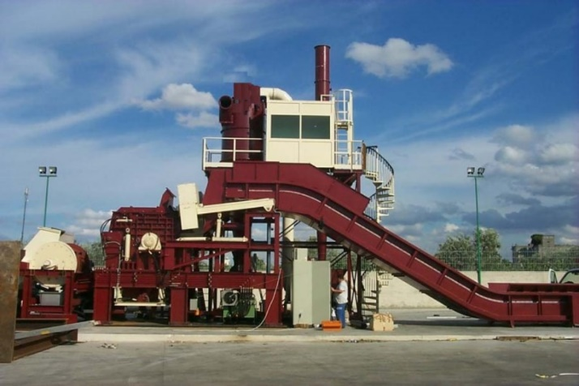
Fig. 13. Shredder – overview
7. Conclusions
- The revision of EU bus recycling regulations will support resolving bus recycling problems. Technological advances, particularly the popularisation of drive systems powered by green fuels such as gas, hydrogen, and batteries, will generate new technical and technological problems not addressed in the new EU regulations.
- Vehicles can be treated as potential sources of raw materials or spare parts – but in this area, there is a need for cooperation between recycling facilities and universities to develop and transfer new, much-needed knowledge to raise the level of vehicle recycling and for the development of laboratories and methods to operationally assess characteristics such as suitability or durability of machine components for reuse.
- Recycled parts should be marked with the appropriate information vector, unambiguously indicating the "reuse" status and GS1-13 – coded.
References
Bojanowicz, J. (2015). Kolejna strzępiarka w Polsce. Recykling samochodów, (7). (in Polish)
Bujak, A., Zając, P. (2012). Can the increasing of energy consumption of information interchange be a factor that reduces the total energy consumption of a logistic warehouse system? In Telematics in the Transport Environment: 12th International Conference on Transport Systems Telematics, TST 2012, Katowice-Ustroń, Poland, October 10-13, 2012. Selected Papers 12 (pp. 199-210). Springer Berlin Heidelberg.
Bylina, R. (2020). Recykling we współczesnym przemyśle samochodowym. Szczecin University of Technology (unpublished). (in Polish)
Chamier-Gliszczynski, N., Krzyzynski, T. (2005). On modelling three-stage system of receipt and automotive recycling. REWAS'04, Global Symposium on Recycling, Waste Treatment and Clean Technology 2005, 2813-2814, Madrid, Spain, 26-29 September 2004, Conference Paper, ISBN: 8495520060.
Chamier-Gliszczyński, N. (2010). Optimal Design for the Environment of the Means Transportation: A Case Study of Reuse and Recycling Materials. Sold State Phenomena, 165, 244-249. https://doi.org/10.4028/www.scientific.net/SSP.165.244.
Chamier-Gliszczyński, N. (2011). Reuse, Recovery and Recycling System of End-of Life Vehicles. Key Engineering Materials, 450, 425-428. https://doi.org/10.4028/www.scientific.net/KEM.450.425.
Chamier-Gliszczyński, N. (2011a). Environmental aspects of maintenance of transport means, end-of life stage of transport means. Eksploatacja i Niezawodnosc – Maintenance and Reliability, 50(2), 59-71. http://ein.org.pl/podstrony/wydania/50/pdf/07.pdf
Chamier-Gliszczyński, N. (2011b). Recycling Aspect of End-of Life Vehicles. Recovery of Components and Materials from ELVs. Key Engineering Materials, 450, 421-424. https://doi.org/10.4028/www.scientific.net/KEM.450.421.
Czwajda, L., Kosacka-Olejnik, M., Kudelska, I., Kostrzewski, M., Sethanan, K., Pitakaso, R. (2019). Application of prediction markets phenomenon as decision support instrument in vehicle recycling sector. LogForum, 15(2), 265-278. https://doi.org/10.17270/J.LOG.2019.329
Chłopek, Z. (2002). Ochrona środowiska naturalnego. Wydawnictwa Komunikacji i Łączności. (in Polish)
Centrum utylizacji Opon, Organizacja Odzysku S.A. (2021). www.utylizacjaopon.pl
Dyrektywa 75/442/EEC z dnia 15.07.1975 w sprawie odpadów, OJ nr 194. (in Polish)
Ekorecykler, 2/2021
http://www.recykling.pl/recykling/index.php/technologia/27
Gabryelewicz, I., Lenort, R., Wędrychowicz, M., Krupa, P., Woźniak, W. (2021). Environmental Loads Resulting from Manufacturing Technology. Rocznik Ochrona Srodowiska, 23, 613-628. https://doi.org/10.54740/ros.2021.043
Izdebski, M., Jacyna, M. (2018). The Organization of Municipal Waste Collection: the Decision Model. Rocznik Ochrona Srodowiska, 20, 919-933.
Jacyna, M., Wasiak, M., Lewczuk, K., Chamier-Gliszczyński, N., Dąbrowski, T. (2018). Decision Problems in Developing Proecological Transport System. Rocznik Ochrona Srodowiska, 20(2), 1007-1025.
Jamroziak, K., Kwaśniowski, S., Kosobudzki, M., Zajac, P. (2019). Analysis of heat exchange in the powertrain of a road vehicle with a retarder. Eksploatacja i Niezawodność, 21(4), 577-584.
Kosobudzki, M., Jamroziak, K., Bocian, M., Kotowski, P., Zając, P. (2018). The analysis of structure of the repaired freight wagon. In AIP Conference Proceedings, 2029(11). AIP Publishing.
Kurzawa, A., Roik, T., Gavrysh, O., Vitsiuk, I., Bocian, M., Pyka, D., Jamroziak, K. (2020). Friction mechanism features of the nickel-based composite antifriction materials at high temperatures. Coatings, 10(5), 454.
Kusacki, A.O., Ayvaz, B., Cin, E., Aydin, N. (2019). Optimisation of reverse logistics network of End of Life Vehicles under fuzzy supply: A case study for Istanbul Metropolitan Area. Journal of Cleaner Production, 215, 1036-1051. https://doi.org/10.1016/j.jclepro.2019.01.090
Lenort, R., Baran, J., Wysokiński, M., Gołasa, P., Bieńkowska-Gołasa, W., Golonko, M., Chamier-Gliszczyński, N. (2019). Economic and environmental efficiency of the chemical industry in Europe in 2010-2016. Rocznik Ochrona Srodowiska, 21(2), 1398-1404.
Lenort, R., Staš, D., Wicher, P., Straka, M. (2021). State of the Art in the End-of-Lie Vehicle Recycling. Rocznik Ochrona Srodowiska, 23, 902-913, https://doi.org/10.54740/ros.2021.062.
Li, C.J., Yang, W.X., Liu, X.D., Wang, Y.M., Feng, S.H., He, Y.A. (2021). Research on vehicle recycling based on ELV Directive. IOP Conference Series: Earth and Environmental Science, 687(1), 012196. https://doi.org/10.1088/1755-1315/687/1/012196
Li, H., Wang, Y., Fan, F., Yu, H., Chu, J. (2021a). Sustainable Plant Layout Design for End of Life Vehicle Recycling and Disassembly Industry Based on SLP Method, A Typical Case in China. IEEE Access. https://doi.org/10.1109/ACCESS.2021.3086402.
Li, J., Barwood, M., Rahimifard, S. (2019). A multi-criteria assessment of robotic disassembly to support recycling and recovery. Resources Conservation and Recycling, 140, 158-165. https://doi.org/10.1016/j.resconrec.2018.09.019
Listwan, A., Baic, I., Łuksa, A. (2009). Podstawy gospodarki odpadami niebezpiecznymi. Publishing House of Radom University of Technology. (in Polish)
Liu, M., Chen, X., Zhang, M., Lv, X., Wang, H., Chen, Z., Huand, X., Zhang, X., Zhang, S. (2020). End-of-life passenger vehicles recycling decision system in China based on dynamic material flow analysis and life cycle assessment. Waste Management, 117, 81-92. https://doi.org/10.1016/j.wasman.2020.08.002
VOLVO Polska (2018). Information materials.
Merkisz-Guranowska A. (2007). Recykling samochodów w Polsce, Poznań-Radom. (in Polish)
Merkisz-Guranowska A. (2008). Aspekty rozwoju recyklingu w Polsce, Wyd. ILIM. (in Polish)
Osiński, J., Żach, P. (2015). Rozwój systemu recyklingu pojazdów wycofanych z eksploatacji w Polsce. Materiały konferencyjne XV Kongresu Eksploatacji Urządzeń Technicznych, Stare Jabłonki 2015. (in Polish)
Osiński, J., Żach, P. (2019). Wybrane zagadnienia recyklingu samochodów. Wydawnictwa Komunikacji i Łączności.
(in Polish)
Polskie Autobusy, 03/2018. (in Polish)
Polskie Autobusy, 10/2018. (in Polish)
Rozporządzenie Ministra Gospodarki i Pracy z 28.07.2005 w sprawie minimalnych wymagań dla stacji demontażu oraz sposobu demontażu pojazdów wycofanych z eksploatacji, Dziennik Ustaw nr 143, poz. 1206, 2005. (in Polish)
Sąsiadek M., Kielec R., Woźniak W., Niedziela M. (2018). Planning and Management of the Mechanical Assembly Sequences, W: Proceedings of the 31st International Business Information Management Association Conference – IBIMA, ISBN: 9780999855102, Milan, Italy, 4712-4719.
Tomczyk K. (2012). Logistyka recyklingu autobusów wycofanych z eksploatacji. Wroclaw University of Science and Technology. (unpublished). (in Polish)
Transport. Wyniki działalności w 2016 roku, GUS 2016. (in Polish)
Ustawa z dnia 27 kwietnia 2001 r. o odpadach, Dz. U. 2001 nr 62 poz. 628. (in Polish)
Woźniak W., Walkowiak J., Sąsiadek M., Stryjski R. (2018). Organisation of the Research Process into an Innovative, Anti-Clogging Assembly for Heavy Vehicles in the Interests of Increased Road Safety, W: Proceedings of the 32nd International Business Information Management Association Conference – IBIMA, ISBN: 9780999855119, Seville, Spain, 4772-4784.
Zając, M., Rozic, T., Bajor, I. (2023). Model for Evaluating the Effectiveness of Cargo Operation Strategy in an Inland Container Terminal. Applied Sciences, 13(12), 7127.
Zając, P., Poznański, J. (2021). Management Model Improving Environmental Protection. Rocznik Ochrona Środowiska, 23. https://doi.org/10.54740/ros.2021.026
Zając, P., Ejdys, S., Dzik, R. (2022). Recycling of Polyethylene Terephthalate (PET) Bottles in the Logistics Supply Chain–Overview. Rocznik Ochrona Środowiska, 24. https://doi.org/10.54740/ros.2022.031
Zając, P., Staš, D., Lenort, R. (2020). Noise Charge in Rail Transport-EU Regulations Versus Operation of Logistics Systems. Rocznik Ochrona Środowiska, 22, 226-241.

