 | Rocznik Ochrona Środowiska
 | Volume 25 | Year 2023 ISSN 2720-7501 | pp. 289-300
 | https://doi.org/10.54740/ros.2023.031 open access
 | Received: November 2023 Accepted: November 2023 Published: December 2023
Heat Transfer Characteristics of a Combination of Two Double-chamber Windows
Borys Basok¹, Borys Davydenko², Аnatoliy Pavlenko^{3*}, Volodymyr Novikov⁴, Svitlana Goncharuk⁵
¹Institute of Engineering Thermophysics, National Academy of Sciences of Ukraine, Ukraine
https://orcid.org/0000-0002-8935-4248
²Institute of Engineering Thermophysics, National Academy of Sciences of Ukraine, Ukraine
³Kielce University of Technology, Poland
https://orcid.org/0000-0002-8103-2578
⁴Institute of Engineering Thermophysics, National Academy of Sciences of Ukraine, Ukraine
⁵Institute of Engineering Thermophysics, National Academy of Sciences of Ukraine, Ukraine
https://orcid.org/0000-0002-5609-7337
*corresponding author's e-mail: apavlenko@tu.kielce.pl
Abstract: Low-emissivity coatings on glass surfaces, inert gas instead of air between glasses, and double-glazed windows are usually used to reduce heat loss from a room through windows. This effect can also be achieved by installing two double-chamber windows in one window opening at a certain distance from each other. This work uses numerical modelling to study the characteristics of heat transfer through a system of two two-chamber windows. The distributions of temperature and airflow velocity due to natural convection in the chambers of double-chamber windows and the space between the windows are analyzed. The distributions of temperatures and heat fluxes over the surfaces of windows are determined depending on the distance between the windows. The dependences on the distance between the windows of radiation, convective, and total heat flow through a system of two double-chamber windows are studied. It is shown that two double-chamber windows located at a certain distance from each other make it possible to increase the heat transfer resistance compared to one two-chamber window without a low-emission coating by 2.6...2.8 times. As the distance between windows increases, a given system's overall heat transfer resistance increases. However, this increase becomes insignificant if this distance is greater than 80 mm.
Keywords: heat loss, double-chamber windows, numerical modelling, heat transfer resistance
1. Introduction
Typically, window structures have lower heat transfer resistance than walls, for which heat-insulating coatings are used to increase this resistance. Well-known methods of increasing the heat transfer resistance of windows are using low-emission coatings on the internal surfaces of glass, replacing the air medium in the area between glass surfaces with inert gases that have lower thermal conductivity than air, increasing the number of chambers in windows, etc.
Studies of the influence of these methods on increasing the heat transfer resistance of windows and reducing heat losses through windows were carried out using experimental and computational methods. In (Bangre et al. 2023, Forughian & Aiini 2017), it is shown that increasing the number of glasses in a window helps to increase the energy efficiency of buildings. In (Banihashemi et al. 2015) it is noted that additional glazing is beneficial both in the cold and hot periods of the year. It reduces heating loads in the winter months and reduces energy costs for air conditioning in the summer.
Using the numerical simulation method, the patterns of heat transfer through a two-chamber window, the chambers of which are filled with air or argon, were studied (Basok et al. 2016a). The influence of the middle glass in a window on the increase in the heat transfer resistance of a two-chamber window compared to a single-chamber window has been clarified. It is shown that this method reduces both convective and radiative heat fluxes from the room to the environment through the window. The heat transfer resistance of a two-chamber window was determined depending on the thickness of the gas layer, the temperature on the outer surface of the window and the gas filler of the glass unit chambers. The possibilities of reducing radiant heat loss through double-glazed windows by increasing the number of glasses and using glass with low-emissivity coatings are also analyzed (Maiorov 2020).

In (Basok et al. 2023), the characteristics of heat transfer through window structures are considered, and the level of heat loss through double-glazed windows is assessed. The results were obtained by numerical modelling and experimental methods. The results of modelling radiation-convective heat transfer in the chambers of a double-chamber window with ordinary glass show that about 60% of the heat is transferred by radiation. Therefore, an effective measure to reduce heat loss through windows is to reduce the radiation component of the total heat flux by applying a low-emission coating to the internal surfaces of the glass unit. It makes it possible to reduce the overall heat flux and heat loss to the environment by 20-34%, depending on the number of glass surfaces with such a coating.
The results of a numerical study of the effect of low-emissivity coatings on heat transfer intensity through double-chamber windows are also presented in (Basok et al. 2016b). The results of calculating the heat transfer characteristics through double-chamber windows with low-emissivity coating are compared with similar calculation results obtained for windows with ordinary glass. From the results obtained it follows that the presence of a low-emission coating leads to a significant increase in the heat transfer resistance of the window. Thus, replacing one of the glass units with low-emissivity glass can significantly reduce heat loss through the window.
The results of numerical studies of airflow characteristics due to natural convection and heat transfer in the gap between the glasses of a single-chamber window are presented in (Basok et al. 2022). It is shown that under certain conditions, the cyclic airflow mode in ascending and descending air flows loses stability and turns into a vortex mode. Loss of stability occurs depending on the gap width between the window panes, the transverse temperature gradient, the inclination angle and the window's height. The study made it possible to determine the critical values of the Rayleigh number at which the airflow regime in the gap between the window panes changes. The values of the heat transfer resistance of the window were determined depending on the width of the gap between the glasses, the angle of inclination and the transverse temperature gradient.
An analysis of the results of numerical studies of heat transfer processes through the glazed surfaces of building facades was carried out in (Sadko & Piotrowski 2022, Pavlenko & Sadko 2023). Numerical models and methods for determining the value of heat transfer coefficients through windows are considered. The values of heat fluxes, temperature distribution over glazed surfaces, and the accuracy of traditional approaches to determining heat loss through window structures were assessed.
In (Arici et al. 2015), the results of a numerical study of heat transfer in windows with double, triple and quadruple glazing are presented. Calculations are carried out for different values of the gap width between the glasses and different outside temperatures. It has been shown that heat loss through windows can be significantly reduced by increasing the number of glasses, which reduces radiative heat fluxes and slows down the gas flow in the window chambers, thereby reducing convection heat fluxes. It is indicated that about 50% or 67% of thermal energy can be saved by replacing a two-pane window with a three- or four-pane window, respectively. The advantage of multi-pane windows is especially noticeable in cold regions.
Thus, replacing a double-chamber window with a three-chamber one can significantly increase heat transfer resistance; that is, increasing the number of chambers in a window unit increases its heat transfer resistance. However, the manufacture and installation of windows with a large number of chambers are associated with certain difficulties. Therefore, in practice, three-chamber windows are used less frequently than double-chamber windows, and windows with more than three chambers are rarely produced. It is also possible to solve the problem of increasing the heat transfer resistance of windows by combining two double-chamber glass units, which are sequentially installed in the window frame. Numerical studies of this process are carried out to determine heat transfer characteristics and resistance through two double-chamber glass units in such a structure.
2. Statement of the Numerical Simulation Problem
Numerical studies of heat transfer through two double-chamber windows, the distance between which is equal to Δ, are carried out by finite-difference solving of a system of equations for the dynamics of the air medium in the chambers of a double-chamber window and in the space between the double-chamber windows, as well as heat transfer equations in a gaseous medium and glass. The system of equations for air medium is as follows:
– continuity equation:
; (1)

– momentum equations:
(2)
(3)
– energy equation for gas:
(4)
– gas state equation:
(5)
where:
τ – time,
x, y – horizontal and vertical coordinates,
u, v – horizontal and vertical gas velocities,
p – pressure,
T – absolute temperature,
g – gravity acceleration,
µ_{a} – dynamic viscosity coefficient,
λ_{a} – thermal conductivity,
ρ_{a} – density,
C_{p,a} – heat capacity at constant pressure,
R_{a} – gas constant for air.

The heat transfer equation for glass is
(6)
where:
λ_{g}, ρ_{g}, C_{p,g} – thermal conductivity, density and heat capacity for glass, respectively.

Airflow due to natural convection is considered laminar. Temperature values are set on the outer surface of the outer glass unit T = T_{out} and on the inner surface of the inner glass unit T = T_{in} (conditions of the first kind). On all other vertical glass surfaces, boundary conditions of the fourth kind are specified, considering radiation-convection heat transfer on these surfaces. For the outer chamber of the outer glass unit, these conditions are as follows:
– for the left (cold) glass surface:
– for the right (warm) glass surface:
where:
q_{r} – radiation heat flux,
δ_{g} – glass thickness,
δ_{a} – air layer thickness (distance between glasses). For other inner surfaces of chambers, the boundary conditions of fourth kind are the same. At the top and bottom surfaces of windows, thermal insulation conditions are set:
y = 0; y = H:= 0.
3. Numerical Simulation Results
As a result of the numerical solution of the system of equations with these boundary conditions, the air velocity fields in the windows' chambers, the space between the windows, and the temperature fields in the gaseous medium and glass are determined. The influence of the distance between double-chamber windows on the heat transfer characteristics of this system is investigated. Heat transfer through a double window system is considered using the example of two double-chamber windows without low-emissivity coating. Each double-chamber window has dimensions: height H = 0.72 m, width L = 0.94 m and thickness 0.032 m. A double-chamber window consists of three glasses with a thickness of δ_{g} = 4 mm and two air layers δ_{a} = 10 mm. The emissivity of all surfaces is ε = 0.89. The temperature on the outer surface of the outer glass unit is
t_{out} = -5.0°С, and the temperature of the inner surface of the inner glass unit is t_{in} = +15.0°С. The heat transfer problem is solved for different distances between double-chamber windows. The problem is solved in a two-dimensional formulation in a vertical section of the window structure, perpendicular to the glass surfaces and passing through the middle of the glass unit. The velocity and temperature fields inside the double-glazed windows and in the space between the double-chamber windows for three values of the distance between them are presented in Fig 1. As can be seen from the figures, an up and down flow of air occurs in the gap between the double-chamber windows. It is caused by natural convection. The air rises near the outer surface of the inner glass unit, which has a higher temperature than the inner surface of the outer glass unit. The air flow goes down at the inner surface of the outer glass unit, which has a lower temperature.
A characteristic feature of heat transfer in these conditions is that the isotherms in the vertical sections of the internal and external double-chamber windows are almost parallel in the middle part. Deviation from parallelism of isotherms is observed only in the upper and lower parts of the glass unit, where the flow of the gaseous medium turns, and the flow direction changes from upward to downward.

a) b) c)
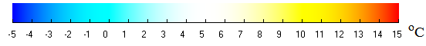
Fig. 1. Temperature field (°С) and directions of gas flow velocity in the vertical section of a double-chamber window system: a) – Δ = 32 mm; b) – Δ = 80 mm; c) – Δ = 120 mm

If in the chambers of double-chamber windows, the isotherms are almost vertical and almost parallel to each other, then in the space between the windows, the isotherms in certain areas turn out to be both vertical (closer to the glass) and horizontal (in the middle part). It indicates a rather complex nature of the temperature field in the gap between the double-chamber windows.
The distribution of vertical velocity in a gaseous medium along the thickness of the chambers of the outer double-chamber window in their middle horizontal sections is shown in Figure 2a. These results are obtained for Δ = 32 mm. As seen from this figure, there is a rising and falling free convection airflow in both chambers of the internal double-chamber window. For an external glass unit, if the distance between the glass units is Δ = 32 mm, the maximum vertical velocity in the outer chamber is 9.8 mm/s, and the inner chamber of the external glass unit is 9.3 mm/s. For distances between double-chamber windows of 80 mm and 120 mm, the similar indicators for the inner and outer chambers of an external double-chamber window will be almost the same. That is, the distance between the windows has virtually no effect on the velocity of the gaseous medium in the chambers of the outer double-chamber window.

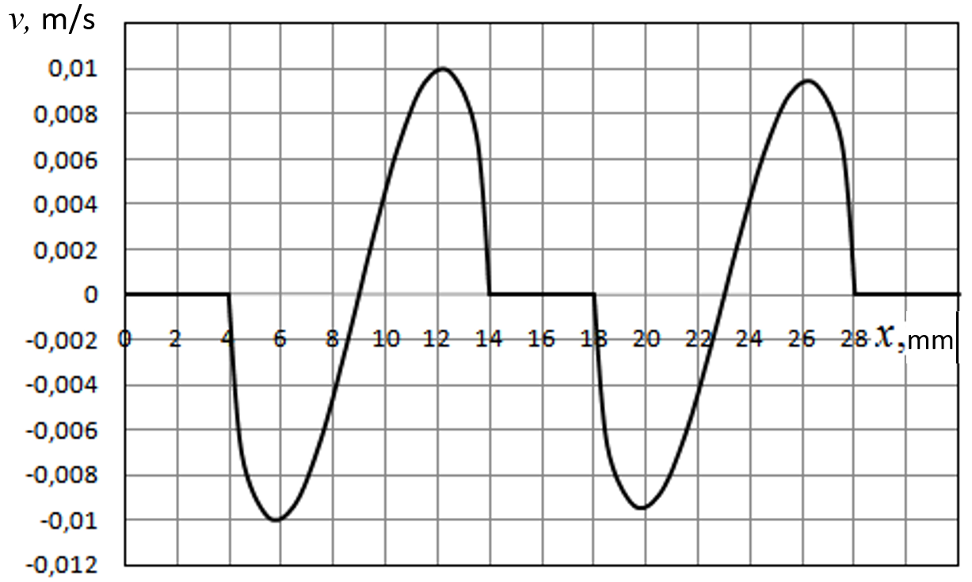
a)
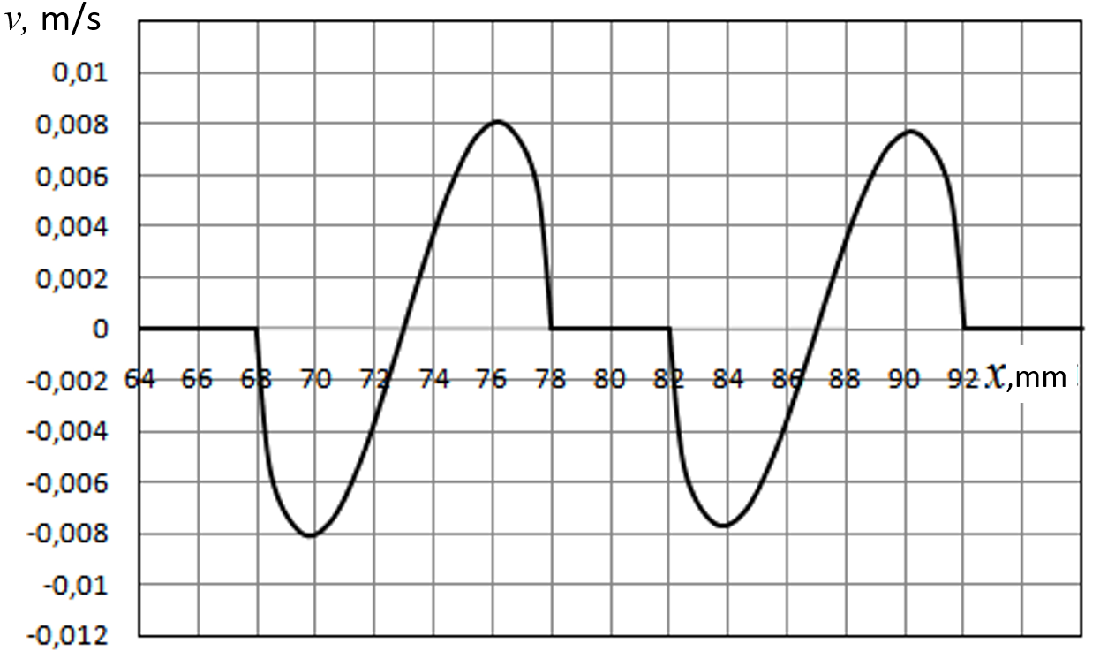
b
Fig. 2. Distribution of vertical velocity along the thickness of an external double-chamber window (a) and inner double-chamber window (2) for Δ = 32 mm

For the internal double-chamber window, the graphs of the vertical velocity distribution in the gas medium by the thickness of the chambers in their average horizontal sections are shown in Figure 2b. The nature of the flow in the chambers of the internal double-chamber window is the same (up and down flow) as in the chambers of the external double-chamber window. For a distance between glass units of 32 mm, the maximum velocity in the outer chamber is 7.9 mm/s, and in the inner chamber of the inner glass unit, respectively, 7.6 mm/s. The maximum velocities in the inner and outer chambers of the inner glass unit at distances between 80 mm and 120 mm glass units have almost the same values.
As for the vertical velocities of the airflow in the gap between two double-chamber windows, the nature of its distribution depends on the distance between them, and the absolute values of these velocities depend little on the width of the gap (Fig. 3).

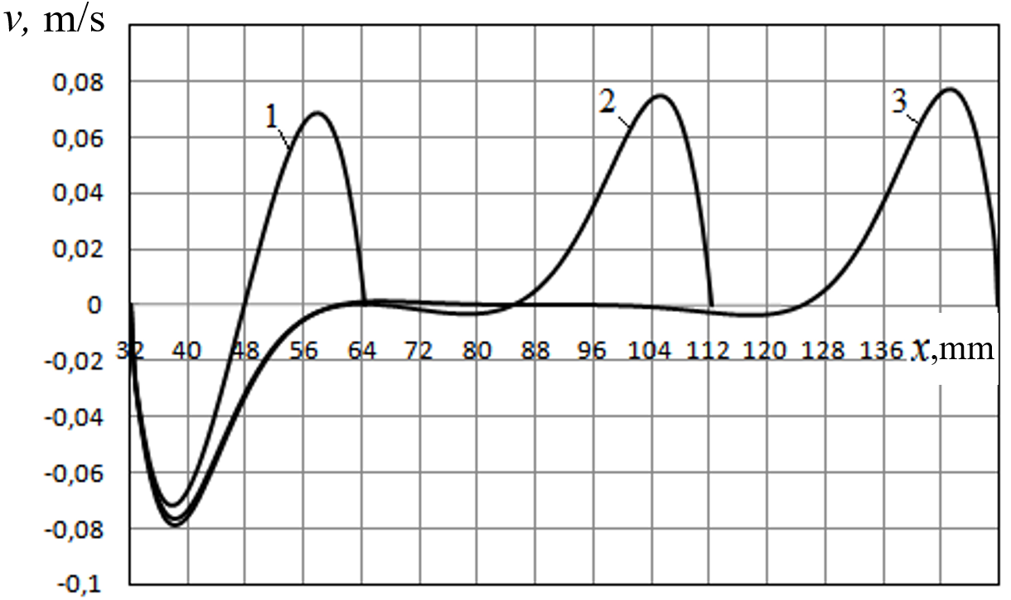
Fig. 3. Distribution of vertical velocity in the gap between two double-chamber windows: 1 – Δ = 32 mm,
2 – Δ = 80 mm, 3 – Δ = 120 mm

With a distance between glass units of 32 mm, the maximum velocity in the gap (rising flow) is 68.5 mm/s, and the minimum velocity (falling flow) is -71.6 mm/s respectively. With distance values of 80 mm, themaximum velocity is 75.0 mm/s, and the minimum is -76.0 mm/s. With distance values of 120 mm, the maximum velocity is 77.4 mm/s, and the minimum is -78.6 mm/s.That is, at distances greater than 80 mm, this distance between the windows practically does not affect the maximum and minimum values of the vertical velocity. At distances of 80 mm and 120 mm, there is a sufficiently large gap between the glass units, where the velocity is practically zero. Only in the areas of the gap, which are closer to the glass surfaces, is a rising or falling flow.
It can be noted that the maximum velocities in the gap are an order of magnitude higher than in the window chambers, comparing the velocity distributions in the gap between the windows with the velocities in the window chambers. It is explained by the fact that in the chambers of double-chamber windows, the forces of friction of the flow against the glass surface, which inhibit the flow, are much higher than in the large space between the windows. The movement of air in the chambers of double-chamber windows, which occurs at too low a velocity, practically does not contribute to the heat transfer through the chambers of double-chamber windows. That is, heat transfer in the chambers occurs mainly by heat conduction through the air layer and radiation between the glass surfaces in the chambers.
The insignificant influence of convection on heat transfer in the chambers of the outer double-chamber window can be seen in Figure 4a. This figure shows the temperature distributions along the thickness of the outer two-chamber window when the distance between the double-chamber windows is Δ = 32 mm. It can be seen from this figure that the temperature distributions over the thickness of the gas layers are close to linear, as is the case when heat transfer is carried out mainly by heat conduction. The temperature distributions along the glass thickness are also linear. The temperature change along the glass thickness is insignificant. The temperature distributions along the thickness of the outer two-chamber windows for distances between them Δ = 80 mm and Δ = 120 mm are the same.
The temperature distribution over the thickness of the internal double-chamber window for the distance between the double-chamber windows Δ = 32 mm is presented in Figure 4b. As can be seen from the figure, the temperature distribution over the thickness of the internal double-chamber window is similar in shape to the temperature distribution over the thickness of the external double-chamber window. These distributions are close to linear, as is the case when heat transfer is carried out mainly by heat conduction, and convection has little effect on this heat transfer. The temperature distributions along the thickness of the internal two-chamber windows for distances between them Δ = 80 mm and Δ = 120 mm are the same.
The temperature distributions in the gaps between the glass units appear more complex. These distributions for different values of the distance between the glass units are presented in Fig. 5. As can be seen from the figure, the temperature increases monotonically for a distance of 32 mm (curve 1). However, the largest temperature gradients are observed near the surfaces of the windows. In the middle of the gap, the temperature gradient becomes slightly smaller. At larger distances (greater than 80 mm), the highest temperature gradients are also observed near the glass surfaces. In the middle part of the interval, the temperature is more uniform. There is even a slight decrease in temperature along the gap in its middle part. It is a consequence of the complex nature of the flow in the gap between the windows. The consequence is also the complex form of the isotherms in the gap (Fig. 1).

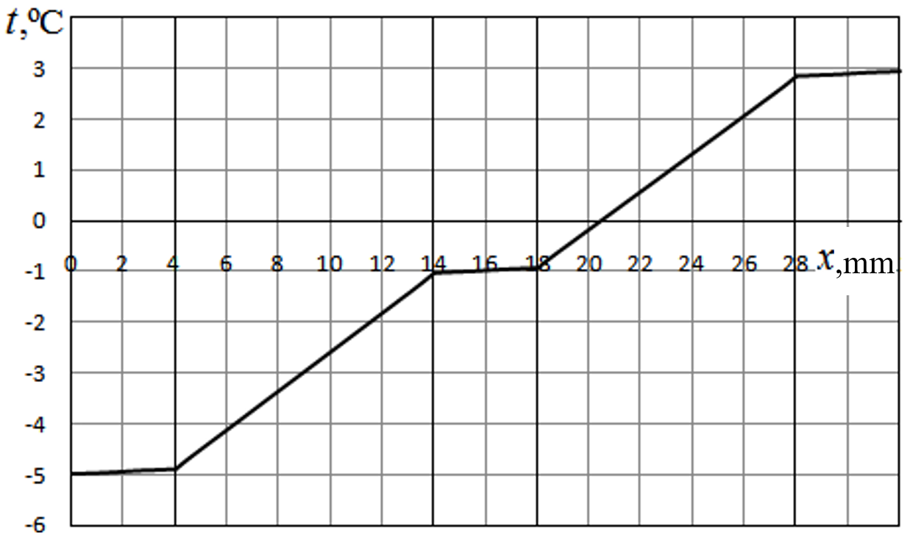
a)
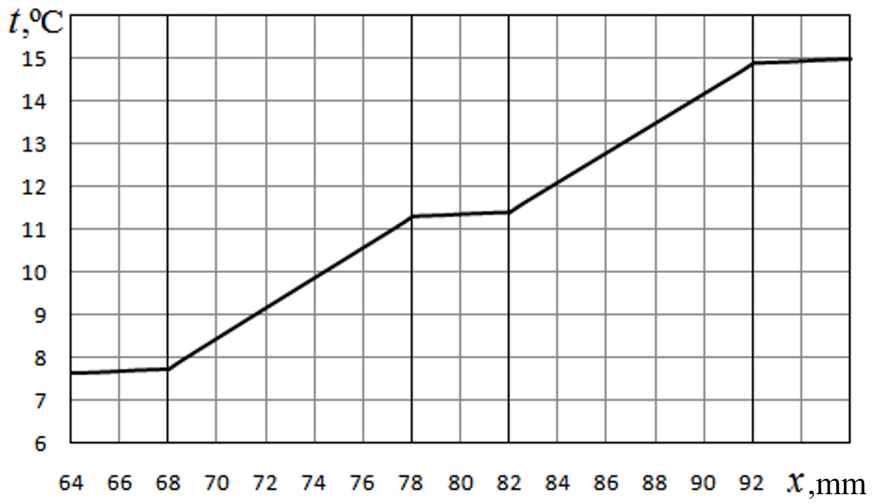
b)
Fig. 4. Distribution of temperature along the thickness of an external (a) and inner (b) double-chamber windows at for Δ = 32 mm

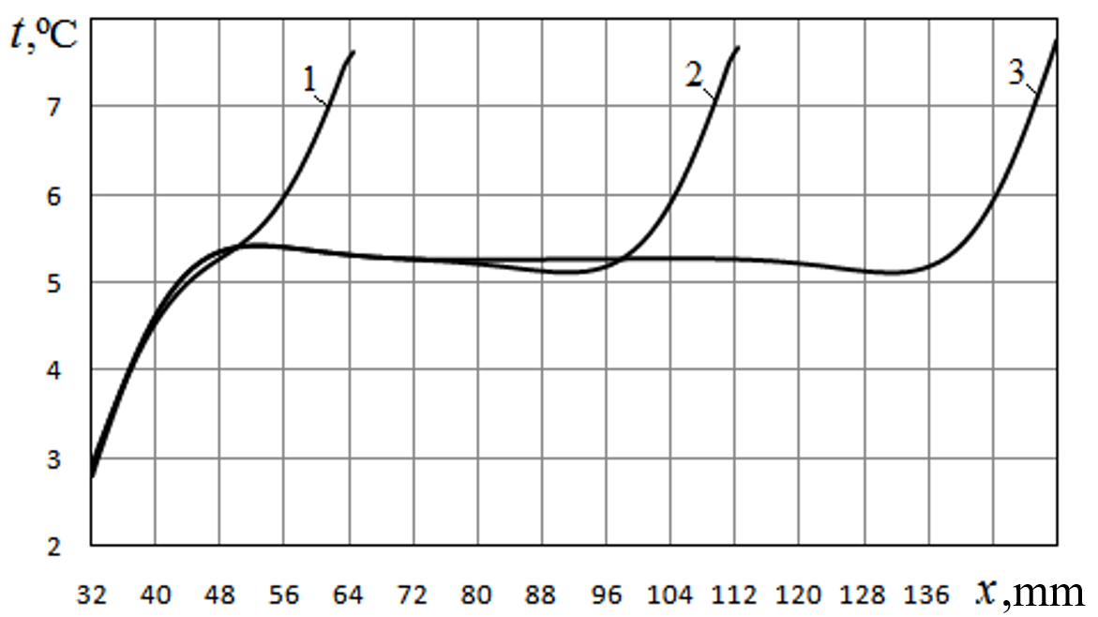
Fig. 5. Distribution of temperature in the gap between two double-chamber windows: 1 – Δ = 32 mm, 2 – Δ = 80 mm; 3 – Δ = 120 mm

From the given data, it is clear that when the distance between the double-chamber windows is more than 32 mm, between the sections of the downward and upward flow, in the gap between the double-chamber windows, there is a section in which there is almost no airflow, and the temperature is distributed almost evenly. That is, almost no heat transfer occurs in this area.
The distributions of temperatures over the surfaces of double-chamber windows standing parallel to each other are presented in Figure 6. These results were obtained for distances between the double-chamber windows Δ = 32 mm and Δ = 120 mm. Curves 1 and 4 in this figure refer to the outer surface of the outer glass unit and the inner surface of the inner glass unit. For these surfaces, temperatures are considered constant and specified by boundary conditions. Curves 2 refer to the temperature of the inner surface of the outer double-chamber window, and curves 3 refer to the outer surface of the inner double-chamber window.
From a comparison of the curves in these figures, it is clear that the nature of the temperature distribution and its values are almost independent of the distance between the double-chamber windows. Their analysis shows that the temperature on both surfaces facing each other increases from bottom to top by approximately 4.8...4.9°C. The difference between the temperatures on the opposite surfaces of two double-chamber windows is almost constant and amounts to 4.4…4.7°C.

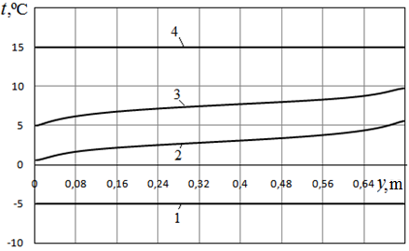
a)
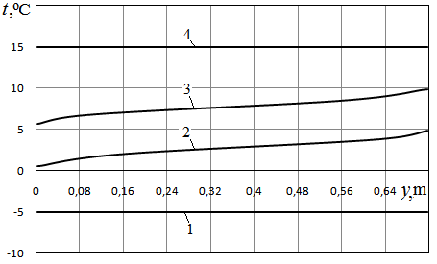
b)
Fig. 6. Temperature distributions on the outer (1) and inner (2) surfaces of the outer glass unit and on the outer (3) and inner (4) surfaces of the inner glass unit: a) – Δ = 32 mm, b) – Δ = 120 mm

The distributions of heat flux over the four surfaces of two double-chamber windows at different distances between them Δ = 32 mm and Δ = 120 mm are shown in Figure 7. As can be seen from comparing these results, the nature of the heat flux distribution over surfaces and the values of these heat flux themselves do not depend significantly on the distance between the double-chamber windows.

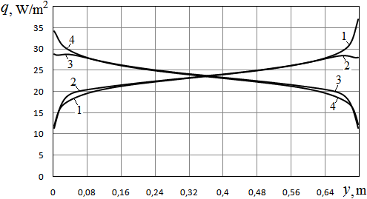
a)
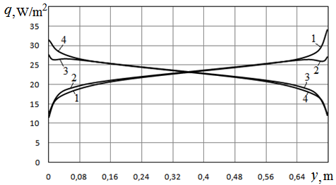
b)
Fig. 7. Distributions of heat flux on the outer (1) and inner (2) surfaces of the outer glass unit and on the inner (3) and outer (4) surfaces of the inner glass unit a) – Δ = 32 mm, b) – Δ = 120 mm
In the case of the system of two double-chamber windows on the surfaces of the outer glass unit, the heat flux is minimal in the lower part of the glass unit. Its value increases from bottom to top and reaches a maximum in the upper part of the glass unit. On the surfaces of the internal glass unit, the nature of the change in heat flux is the opposite. Its value is maximum in the lower part of the internal glass unit. With height, the heat flux decreases and reaches a minimum in the upper part of the surface.
The dependences of the radiation and convective-conductive heat fluxes on the distance between the double-chamber windows in each chamber of the external and internal windows and in the space between them are shown in Figure 8. Figure 8a shows that the highest radiation heat flux occurs in the inner chamber of the internal double-chamber window. The minimum radiation heat flux is in the outer chamber of the external double-chamber window. The greatest radiation heat flux occurs in the gap between the windows. The power of radiation fluxes decreases with increasing distance between windows.

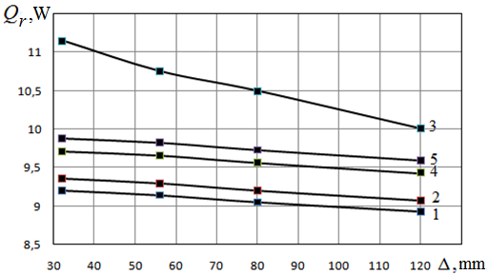
a)
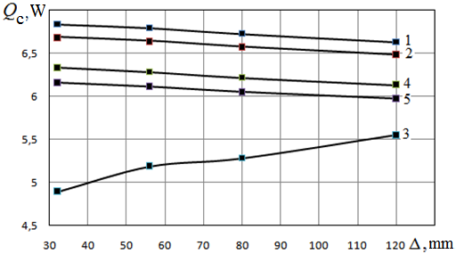
b)
Fig. 8. Dependences of the radiation (a) and convective-conductive (b) heat fluxes in the chambers of the system of two double-chamber windows on the distance between the double-chamber windows

The smallest convective heat flux occurs in the inner chamber of the glass unit (Figure 8b). The maximum convective heat flux is in the outer chamber of the outer double-chamber window. The smallest convective heat flux occurs in the gap between the windows. At the same time, the power of convective fluxes in the chambers of double-chamber windows decreases with increasing distance between the windows. The exception is the dependence of the convective heat flux in the gap between the windows, where its value increases with increasing distance between the windows.
Consequently, in the gap between the windows, as the distance between the windows increases, the radiation heat flux decreases, and the convective heat flux increases. However, the total heat flux decreases very slightly with increasing distance between the windows (Figure 9a). When the distance increases from 32 to 120 mm, the total heat flux decreases by only 3.02%.
As for the relationship between radiation and total heat fluxes in the spaces between double-chamber windows, the share of radiation heat flux with increasing distance from 32 mm to 120 mm decreases from 69.5 to 64.3% (Figure 9b). Accordingly, the share of conductive-convective flux increases.

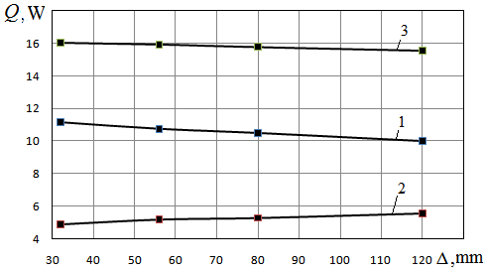
a)
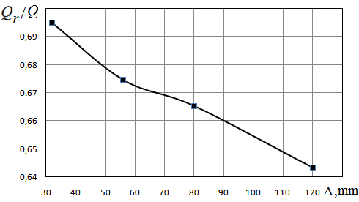
b)
Fig. 9. Dependence of the heat flux components in the gap between the glass units on the distance between them:
1 – radiation heat flux Q_{r}, 2 – conductive-convection heat flux Q_{c}, 3 – total heat flux Q = Q_{r} + Q_{c}

The value of heat transfer resistance is used to assess the thermal insulation efficiency of double-chamber windows and a system of two double-chamber windows. Calculations show that for almost all distances between double-chamber windows, the heat transfer resistance of an external double-chamber window is
where:
– the average temperature of the inner surfaces of the outer glass unit.

Also, for almost all distances, the heat transfer resistance of the internal double-chamber window is
where:
– the average temperature of the outer surface of the inner glass unit.

As for the gap between the glass units, the heat transfer resistance for it
increases from 0.192 to 0.218 m²K/W when the distance between the windows increases from 32 mm to 120 mm (Figure 10 a). As a result, as this distance increases, the total heat transfer resistance
also increases from 0.843 to 0.87 m²K/W (Figure 10 b). This value characterizes the heat transfer resistance of the entire system of two glass units and the gap between them.

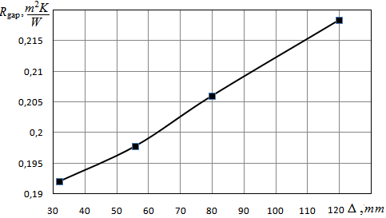
a)
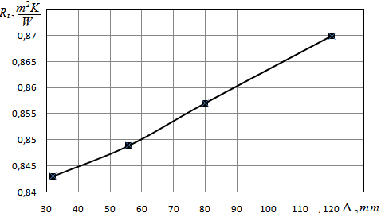
b)
Fig. 10. Dependence of heat transfer resistance of the gap (a) and total heat transfer resistance (b) on the width of the gap between the windows
4. Conclusions
Based on the results of these numerical studies, the following conclusions can be drawn:
– a system of two two-chamber windows located at a certain distance from each other allows, when this distance is increased from 32 mm to 120 mm, an increase in the heat transfer resistance relative to one two-chamber window without coatings from 0.31 m²K/W up to 0.87 m²K/W, i.e. 2.63...2.8 times;
– the heat transfer resistance of the system of two two-chamber windows without coatings increases with the increase of the distance between them. But this increase is insignificant. When the distance increases from 32 mm to 120 mm, the total heat flow decreases by 3.0%, and the heat transfer resistance increases by 3.1% accordingly;
– the heat transfer resistance of the gap between two glass units when it increases from 32 mm to 120 mm increases from 0.192 m²K/W to 0.2185 m²K/W;
– the heat transfer resistance of a system of two double-chamber windows can be calculated as the sum of the heat transfer resistances of two single double-chamber windows and the gap between them.

The article was written with the Ukrainian support of the National Research Foundation
within the framework of project No. 2022.01/0172
"Aerodynamics, heat transfer and innovations to improve the energy efficiency of window structures
and their use for the restoration of war-damaged buildings in Ukraine."
References
Arici, M., Karabay, H., Kan, M. (2015). Flow and heat transfer in double, triple and quadruple pane windows. Energy and Buildings, 86, 394. https://doi.org/10.1016/j.enbuild.2014.10.043
Bangre, A., Surwade, R., Kamal, M. (2023). Prospects of Double Glazed Windows in Buildings: Energy Conservation and Environmental Sustainability. American Journal of Civil Engineering and Architecture, 11(3), 64-69. https://doi.org/10.12691/ajcea-11-3-1
Banihashemi, S., Golizadeh, H., Hosseini, M.R., Shakouri, M. (2015). Climatic, parametric and non-parametric analysis of energy performance of double-glazed windows in different climates. International Journal of Sustainable Built Environment, 4(2), 307-322. https://doi.org/10.1016/j.ijsbe.2015.09.002
Basok, B.I., Davydenko, B.V., Isaev, S.A., Goncharuk, S.M., Kuzhel’, L.N. (2016a). Numerical modeling of heat transfer through a triple-pane window. Journal of engineering physics and thermophysics, 89, 1277-1283. https://doi.org/10.1007/s10891-016-1492-7
Basok, B., Davydenko, B., Zhelykh, V., Goncharuk, S., Kuzhel’, L.N. (2016b). Influence of low-emissivity coating on heat transfer through the double-glazing windows. Fizyka Budowli w Teorii i Praktyce, 8(4), 5-8.
Basok, B.I., Davydenko, B.V., Pavlenko, A.M., Kuzhel’, L.М, Novikov, V.H, Goncharuk, S.M, Ilienko, B.K, Nikitin, Ye. Ye., Veremiichuk, H.М. (2023). Reduced heat loss through window structures. Energy Technologies & Resource Saving, 76(3), 43-57. https://doi.org/10.33070/etars.3.2023.04
Basok, B., Davydenko, B., Novikov, V., Pavlenko, A.M., Novitska, M., Sadko, K., Goncharuk, S. (2022). Evaluation of heat transfer rates through transparent dividing structures. Energies, 15(13), 4910. https://doi.org/10.3390/en15134910
Forughian, S., Taheri, Shahr, Aiini, M. (2017). Comparative Study of Single-glazed and Double-glazed Windows in Terms of Energy Efficiency and Economic Expenses. Journal of History Culture and Art Research, 6(3), 879-893. http://dx.doi.org/10.7596/taksad.v6i3.884
Maiorov, V.A. (2020). Heat transfer through a double-glazed window by radiation. IOP Conf. Series: Materials Science and Engineering, 939, 012048. https://doi.org/10.1088/1757-899X/939/1/012048
Pavlenko, A.M. & Sadko, K. (2023). Evaluation of numerical methods for predicting the energy performance of windows. Energies, 16(3), 1425. https://doi.org/10.3390/en16031425
Sadko, K., Piotrowski, J.Z. (2022). Numerical investigations of the thermal properties of window systems: a review. Structure and Environment, 14(4), 126-141. https://doi.org/10.30540/sae-2022-015

