 | Rocznik Ochrona Środowiska
 | Volume 25 | Year 2023 ISSN 2720-7501 | pp. 282-288
 | https://doi.org/10.54740/ros.2023.030 open access
 | Received: November 2023 Accepted: November 2023 Published: December 2023
Risk Management Model in ISO-standards as the Implementation of Environmental Safety for Housing Construction
Elena Smirnova^{1*}, Arkadij Larionov², Alexander Shkarovskiy³
¹Saint Petersburg State University of Architecture and Civil Engineering, Russia
https://orcid.org/0000-0002-9860-9230
²National Research University – Moscow State University of Civil Engineering, Russia
https://orcid.org/0000-0001-9706-5131
³Koszalin University of Technology, Poland
Saint Petersburg State University of Architecture and Civil Engineering, Russia
https://orcid.org/0000-0002-2381-6534
*corresponding author’s e-mail: esmirnovae@yandex.ru
Abstract: The authors analyse the standardisation of risk management as an effective tool for the safety of design solutions in residential construction. The analysed regulatory documentation answers the question of achieving an acceptable level of risk. Within the framework of improving environmental management, the use of specific penalties looks quite natural. However, the primary purpose of ISO 14001 is to form a responsible attitude toward the environment and natural resources as the most crucial assets of economic activity. The article raises the issue that domestic standards cannot thoroughly guide risk analysts due to their lack of development and inconsistency with ISO 31000:2018 and ISO 14001:2016. It is necessary to develop a unique approach to risk assessment, de facto describing the interaction of different scenarios, which will ensure an increase in the environmental and economic effects in the field of housing safety.
Keywords: ecological risk, environmental management, environmental safety, housing construction, risk assessment, risk management model, safety standards
1. Introduction
Standardisation of the risk management process plays an important role in minimising risks to improve the efficiency of economic activities. Timely risk identification contributes to the protection of sectoral management strategies from critical risk values both from the standpoint of the interests of enterprises associated with the construction industry and the state (Sayigh 2014, Crispin 2018).
It is believed that under the concept of risk as the negative impact of uncertainty on goals, we mean risk as the probability of an event occurring, which, if it occurs, can cause damage to the organisation (Gallop et al. 2016). In this regard, the desire to provide a standard procedure and a standard criterion for defining and measuring the quality of risk analysis, as well as to facilitate decision-making on risk management, has led to the definition of the necessary processes and procedures (context discovery, stakeholder participation, risk identification and assessment, decision making and risk management) to introduce the international standard ISO 31000:2018 “Risk Management. Guidelines” (https://www.iso.org/en/standard/43170.html; accessed on 10.11.2023) (2018) and ISO 14001:2016 “Environmental Management Systems” (2016) (https://base.garant.ru/77322728; accessed on 10.11.2023).
A number of scientists note the advantages of these standards, which were revised and published in a new edition (Rausand & Haugen 2020, de Melo & de Medeiros 2020). In industrialised countries, the entire life cycle of an organisation, any decision-making activity at different levels, is regulated by these standards. Experts note that in Russia, a risk-based approach, as a rule, is not implemented by various government agencies, but remains a matter of private initiative only. Although there are examples of good practice represented by the Federal Property Management Agency, the Ministry of Economic Development and some other government departments, the requirements, for example, GOST RISO 31000:2019, quite often contradict the international regulatory framework in the field of risk management. Thus, in the latest version of GOST RISO 31000:2019, the principle of the inseparability of risk management from the decision-making process was excluded, as well as the provision on uncertainty, the exclusive subject of risk management; the definition of residual risk was omitted, requiring appropriate measures to reduce its probability (Link & Naveh 2016).
When comparing the main environmental document, i.e. the Federal Law of January 10, 2002 N 7-FZ “On Environmental Protection” (2002) (https://base.garant.ru/77322728; accessed on 25.11.2023), and the standard ISO 14001:2016 "Environmental Management Systems" related to environmental problems in companies with low and high risks, it becomes obvious that ordinary operational environmental measures cannot lead to a reduction in production costs and the entry of companies to the international level of cost and resource savings (Dhir & Dhir 2020). Only intermediate values are effective, so employers must plan and improve the achieved indicators to improve the state of natural and technical systems. The standard implies that, by its definition, environmental management can only be based on the principles of waste-free production (reduction of waste and unlimited consumption of resources) and the constant implementation of more stringent environmental standards to reduce companies' negative impact on the environment. It does not have an end result in the process of ensuring environmental safety. Based on continuous improvement, ISO 14001 certifies that organizations have a strategic approach (forward-looking in providing firms with competitive advantages, balanced asset values, and reduced liability insurance costs) to address environmental issues. Thus, enterprises of different energy efficiency and environmental safety conditions can use ISO 14001 to improve the state of the environment (Smirnova & Vavilova 2022, Gadzhiev et al. 2021).
The relevance of the research topic is to show the benefits of ISO 31000:2018 and ISO 14001:2016 standards, together with ISO Guide 73:2009 (2009) (https://www.iso.org/obp/ui/#iso:std:iso:guide:73:ed-1:v1:en; accessed on 10.11.2023), which contains the key terms of riskology. These compare favourably with the COSO model “Enterprise Risk Management” (2017) (https://www.coso.org/documents/2017-coso-erm-integrating-with-strategy-and-performance-executive-summary.pdf; accessed on 10.11.2023).
The advantages of the above standards over other models are represented by IEC 31010:2019 “Risk assessment techniques” (2019) (https://www.iso.org/standard/72140.html; accessed on 10.11.2023), which supplements ISO 31000 with detailed information on risk assessment and a description of the advantages and disadvantages of different methods when comparing risk management options and capabilities. The importance of ISO Guide 73:2009 for implementing ISO standards should be noted. It aims to promote mutual and consistent understanding and a harmonized approach to describing risk management activities. It also aims to introduce a common risk management terminology across standard risk management processes and frameworks.
Considering the foregoing, the authors are faced with analysing the level of environmental impact of the work of enterprises in the construction industry, as well as Russian state standards on safety aspects for their compliance with ISO 31000:2018 and ISO 14001:2016, whether they can be used to assess any risk.
2. Materials and Methods
In their methodology, the authors followed the concept of “risk” presented in ISO 31000:2018 and ISO 14001:2016. It should be noted that the term “safety” means “the absence of unacceptable risk”. The degree of potential harm to people's health, their property or the environment depends on how the key concept of “risk” is defined. Identifying a potential hazard source is also important for subsequent risk minimisation and assessment of the remaining risk after the protective measures are taken, which is very significant for decreasing possible environmental and economic damage (Kulentsan & Marchuk 2022).
The research methodology is also based on the concept of risk in the COSO-2017 “Enterprise Risk Management standard”. This document does not define "risk" and is grounded on the idea of risk developed by PricewaterhouseCoopers. According to it, “risk” is understood as a negative aspect of an uncertain event (a set of factors), the arrival of which for the company may result in damage and/or benefit. The subsequent risk identification provides information about its thresholds (the organisation will take the risk if it is below the impact level; if it is higher, it will be unacceptable).
Agreeing with ISO 31000:2018, a “risk” is an uncertainty that affects goals negatively and/or positively. ISO 31000:2018 defines risk management processes as procedures, practices, and actions aimed at communicating, consulting, and determining the current situation in the organisation's external and internal environment. Obviously, there is if not the complete identity of the wordings of Pricewaterhouse-Coopers and ISO 31000:2018, then their semantic proximity. At the same time, the developers of ISO 31000:2018 believe that “risk” can be terminologically characterised as sources of hazards, potential events, and consequences, as well as the likelihood of events and/or consequences. Risk analysis includes detailed consideration of uncertainties, sources of risk, consequences, likelihood, events, scenarios, controls and their effectiveness.
The research methodology is also based on the fact that risk understanding by ISO 41001:2016 serves as the basis for substantiating the principles of environmental safety of economic activity and creating a universal model for (1) identifying and (2) assessing risks, (3) planning and (4) implementing planned risk prevention measures. The subject analysis involves the following question: how the concept of risk, uncertainty, and risk management, presented in the international standards ISO 31000:2018 and ISO 41001:2016, correlate with the aspects and safety requirements formulated in specific Russian GOSTs (state standards) on risk management.

3. Results
A large accumulation of buildings and structures, infrastructure, and industrial facilities in a small area has a negative impact on the environment, which causes a severe increase in the carbon footprint and other dangerous pollution, which often negatively affects facilities under construction and reconstruction. Enterprises-“poisoners”, not interested in environmental activities, do not ensure the safety of enter-prises-“recipients”, which cause the greatest damage from the pollution of ecosystems. Chemical, petrochemical, metallurgy, pulp and paper industries, energy and other technologies and urban life support systems are the main polluters, and health care, utilities, agriculture, fisheries and forestry suffer from their activities. Due to the high costs of treating patients, recultivating landscapes and agricultural land, restoring the productivity of livestock and fish farms, and repairing buildings and facilities for various purposes, the implementation of full-fledged environmental activities is questionable not only for “poisoning” enterprises but also for business entities-“recipients”.
The key criterion for assessing the balance of the work of an enterprise, about economic and environmental safety, is the level of environmental effect, calculated by the formula:
, (1)
where NVP is an indicator of net present value; B_{t} is the income received from the sale of products; E_{t} is the environmental effect, on the basis of the environmental costs and benefits of economic activity; C_{t} is the sum of production costs; r is the discount factor; t is a period.
The enterprise benefits are due to the availability of processing operations the aggregate of waste disposal, tax and credit incentives, and other premiums having to comply with environmental reputation. The costs are formed due to payment for exceeding the norms of consumption of natural resources, environmental pollution and waste disposal, fines for violating the law, additional taxation, etc. The use of natural resources is carried out by the owners of enterprises on a paid basis (Figure 1).
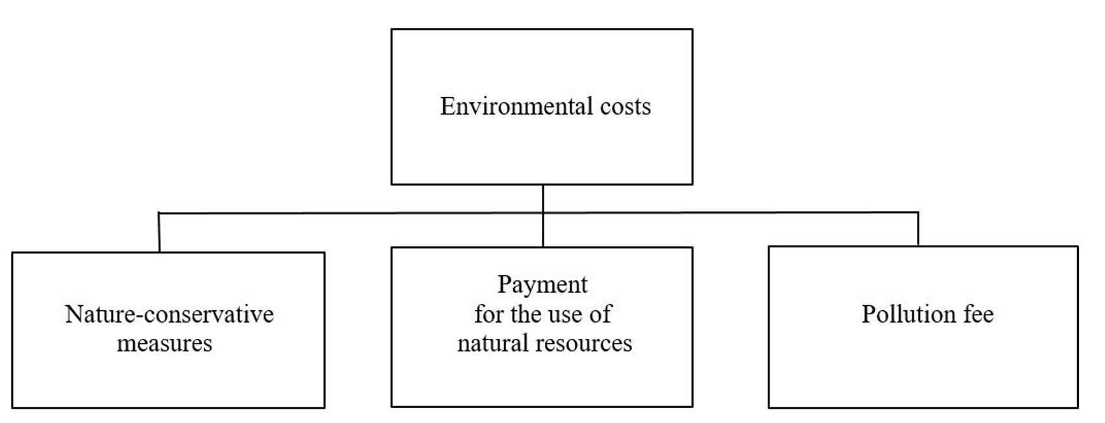
Fig. 1. Environmental costs of the construction industry

In sustainable building projects, the emphasis is on managing desired indoor conditions, lifespan, and adaptability, together with controlling environmental stress during building operation (Figure 2).
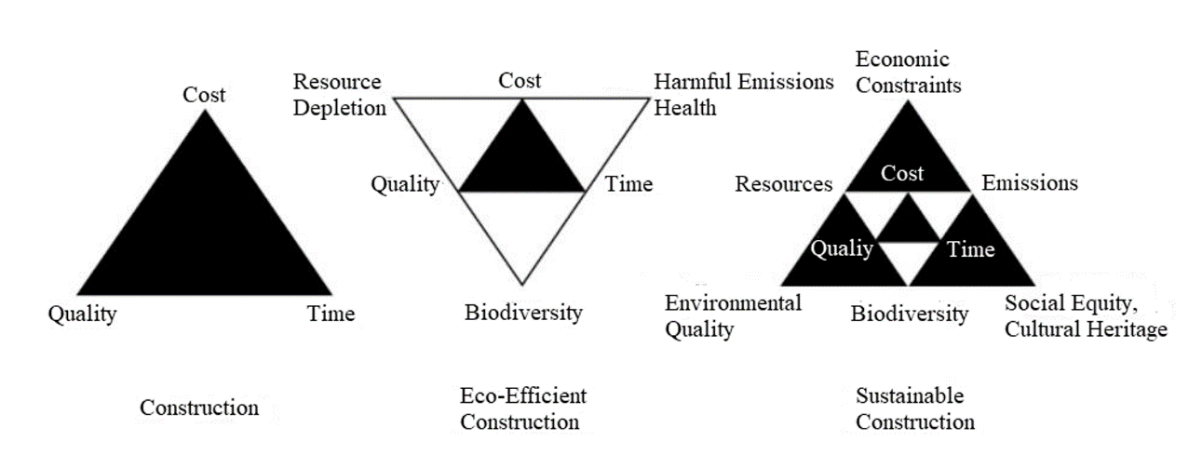
Fig. 2. Environmental costs of the different construction projects
Consider the specifics of the Russian Federation's environmental safety regulatory framework. There is no unified code on ecology in Russian legislation. Federal laws, codes for certain areas of the environment, and by-laws and legal acts of the constituent entities of the Russian Federation represent it. Among the main laws related to environmental safety regulation in construction, the Federal Law “On Environmental Protection” (as last amended on March 26, 2022) dated 01.10.2002 N 7-FZ with numerous amendments should be mentioned.
The specifics of the law in terms of environmental safety are as follows. Federal Law N7 regulates the leadership of the employer and not his responsibility. As part of improving environmental management, using certain fines and penalties looks quite natural. However, the main goal of the ISO 14001 standard is not to indicate the need for managers to have leadership qualities as the main factor in ensuring environmental safety but to form a responsible attitude towards the environment and natural resources as the most important asset of human economic activity.
Federal Law N7 places great emphasis on design limits to increase the natural environment's protection level. The system of regulation of maximum permissible concentrations (MPC) is discussed. This aspect can be considered positive since many enterprises, factories, and other structures that have a negative impact on the environment will be forced to comply with a predetermined level of safety. However, such strict supervision of the maximum allowable rationing makes it impossible to improve environmental safety because most enterprises focus on compliance rather than improving their production processes. Because of this, the attitude towards environmental safety in the Russian Federation is more administrative, emphasising supervisory activities, while a real increase in the level of environmentally friendly construction and operation of industrial facilities remains outside the scope of the activities of safety and control bodies.
The problem of risk management in domestic standards: The former Russian GOST R ISO 31000:2010 and the current GOST RISO 31000:2019, developed on the basis of ISO 31000, are evaluated as useful documents. In them, the concept of risk is defined following ISO 31000 and clarifies the management of any risk as the impact of uncertainty on goals. The formula describes the risk:
Risk = Probability × Severity, (2)
where Probability is the likelihood of the fault occurring, and Severity is the impact on construction safety, product quality (or other hazards).
These standards provide management of risk events and an opportunity to significantly increase organisations' chances to complete projects and the economic effect successfully. They also indicate that GOST RISO 31000:2019 can be applied to any activity, including the decision-making process at all levels of management. On the other hand, the document is advisory in nature and not binding at all. All this does not allow making informed decisions on the functioning of environmentally safe natural and manufactured complexes.
Consider the domestic GOST R 51898:2002 (“Safety Aspects. Rules for Inclusion in Standards”) (2018) (https://docs.cntd.ru/document/1200030314; accessed on 10.11.2023), which provides guidelines for the inclusion of safety aspects in various codes, standards and guidelines (for example, GOST R 22.0.01-2016 “Safety in Emergency Situations” (2016) (https://docs.cntd.ru/document/1200136692?ysclid=l9vovx664g999742542; accessed on 09.11.2023) and etc.)).
In this document, terms such as “safety”, “risk”, “danger”, and “event causing damage” are used. Rational decision-making requires a clear and quantifiable way of expressing risk so that it can be properly analysed along with all other costs and benefits in the decision-making process. This suggests that risk as a background value is always present in economic activity, and, therefore, it remains only to choose between risks (Smirnova et al. 2022a, Larionov et al. 2021).
In this GOST, “risk” refers to a combination of the likelihood of damage and its severity (i.e. physical damage or other harm to the environment or human health). Accordingly, safety refers to any acceptable risk of an event leading to harm. Figure 3 shows the risk minimization process according to GOST R 51898:2002.
Attention is drawn to the main drawback of this GOST. In the block diagram, the concept of “uncertainty” is not mentioned at all, although the concept of risk itself represents both uncertainty and possible loss or damage. From this analysis, it would seem that the following formula for determining risk follows:
R = U + C, (3)
where U means uncertainty, and C is the damage.

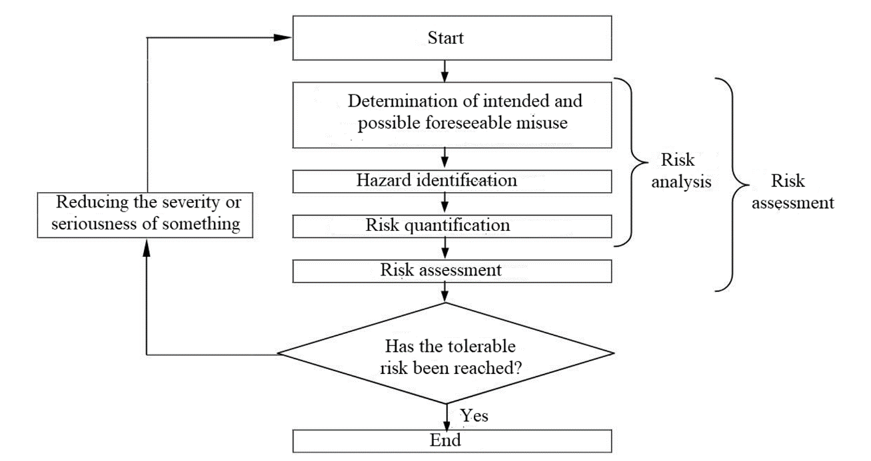
Fig. 3. Risk minimization process, according to GOST R 51898:2002

However, as already mentioned, the standard does not say anything about uncertainty. According to this GOST, the risk formula is:
R = P × C, (4)
where P is the probability, and C is the damage.
Indeed, in a number of departmental standards, the risk is proposed to be calculated as the product of the probability of an accident at the facility and the losses incurred by the environment directly as a result of a man-made incident; damage is interpreted as a monetary form of causing a negative technogenic impact and its consequences on a specific ecosystem (e.g. “Interim methodological guidelines for assessing the environmental risk of oil depots and gas stations” (http://snipov.net/c_4654_snip_59538.htm; accessed on 09.11.2023) etc.)).
As already mentioned, the background value of risk is inherent in the entire natural and technical system, since the “risk-free” state is also determined relative to risk, i.e. danger and damage are inherent in any relation to the natural environment, potentially present to an indefinite degree. Therefore, a number of authors compare the quantitative characteristics of risk with uncertainty (Jones 2019).
Uncertainty refers to many possible outcomes without saying anything about their likelihood. On the other hand, risk refers to a situation with a finite number of outcomes, the values of the probability frequency of which are known. Risks can be insured. Uncertainty is not insurable. Nevertheless, rapid technological progress is associated precisely with uncertainty. Let's say, according to the law of large numbers, a random variable receives the values of the average mathematical expectation and serves to estimate the probability of large deviations. With a large number of random variables, it is reliably known that their arithmetic mean as a random variable differs infinitely little from the non-random normal value (indicating the value of its average mathematical expectation). In other words, a set of random factors gives a result that is almost independent of chance. Here, the well-known approximation of the calculations of probable quantities to a constant occurs (Nezhnikova et al. 2021).
But a problem arises: if there is no randomness factor, random parameters, or random chain of events in a risky decision, then what is about alternativeness and stochasticity? If the criteria for a risky decision are based on the achievement of the set task, are consistent with regulatory acts, follow modern scientific and technical requirements, and are aimed at combating the risk of losses and risky consequences, then this kind of desire not to lose will turn the risk into directives descended from above. There will be an actual devaluation of the risk. In the latter case, there can be no question of efficiency and competitiveness in economic activity. On the contrary, in a situation of risk, the correlation between probable losses and the significance of the final result and gain comes to the fore (Pojasek 2019, Smirnova 2020).
Analyzing numerous definitions of risk, the following key definitions can be called the main features of a risk situation. In it:
1) there must be alternative solutions since we do not have exact knowledge of the consequences of anthropogenic interference in nature and there is no exact correspondence between what was conceived and implemented due to error proneness (here it should be noted that the risk manager is dealing with a choice: a) more reliable and acceptable, but less success, or b) expected with less certainty and doubt, but greater gain; it is obvious that greater success as a kind of provocation to achieve an impossible goal indicates an unwillingness to completely eliminate uncertainty from practice);
2) when calculating the risk based on data processing, there is an interest in the future great benefit, the success of which is unlikely and extremely uncertain, and, on the contrary, in the case of a small but guaranteed success, the individual does not have the incentive to make risky decisions.
3) the stochastic nature of the event or action is realized, which determines one of the possible outcomes of the implementation of the decision;
4) after the decision is made, the development of a risky situation should lead to losses or additional advantages and benefits (Bas 2019).

Risk cannot be understood outside the two-dimensional combination of (1) events and (2) the consequences of those events, and their associated (3) uncertainties, which is consistent with the meaning of ISO 31000:2018. However, this aspect of risk assessment is absent from the GOST R 51898:2002 standard.
The concept of acceptable risk: The concept of acceptable risk is one of the most difficult areas of risk management. On the one hand, it does not have a detailed description in ISO 31000:2018. On the other hand, it is contextually clear in the Russian GOST what risks have to be considered acceptable. It should be determined after a comparative risk assessment. This can be explained by the fact that GOST does not so much require a risk management specialist to consider risk management as part of an overall management and strategic planning system, but rather to correctly identify and propose responses to individual risks. When essential management decisions are being made, the human factor becomes crucial. The personal preferences of risk managers (some are risk-averse, others not) should be levelled by introducing modern simulation tools based on cloud-based digital platforms. Qualitative and quantitative methods in the field of risk-based planning are guided not by fixed basic parameters but by their distribution and lists of the most critical risks, which affects the choice of methods for their management, as well as the assessment of key decisions made. On the contrary, a unified risk management regulation and a unified assessment scale (a unified methodology) of risk processes should be replaced by various approaches to decision-making and implementation of the organisation's activities, i.e. different evaluation criteria, methodologies, analysis tools, and risk classifiers. They must be used within the framework of making various decisions or carrying out the activities of the organization. After identifying and evaluating key risk situations based on the company's income and expense distribution model, measures can be developed to level them to include in the flowchart of the action algorithm for the future period. If the level of initial risks is unacceptable, their analysis will require revising the company's strategy and targets (Smirnova 2021).
The following disadvantages are inherent in the GOST R 51898:2002 standard. The formula “risk is a combination of probability and consequences” is misleading regarding assessing risk in a single scenario of events. Within the framework of a probabilistic-mathematical model, the significance of risk, and, consequently, damage, can be determined on the basis of probability theory (with the characteristics of random damage: mathematical expectation as the average damage and variance as an indicator of the spread of values). In addition, risk analysis systematizes the existing knowledge and uncertainties (!) regarding the phenomena, systems and activities that are being studied (Smirnova et al. 2022b).
In other words, since decisions are made within the framework of insufficient information, on the basis of random parameters and the process of the development of the situation, the inevitability of an alternative course of action, it is important to identify the probability of an event, the intensity of its impact on the ecosystem, and the possibility of detection/control. Obviously, the probabilistic-mathematical model is determined by the algorithm with which it was created. Mathematical modelling helps you meet your requirements, avoid unexpected errors, and optimize system performance. Let us turn to the environmental risk assessment developed in GOST R 14.09:2005, “Environmental management. Guidelines for risk assessment in the field of environmental management” (2005) (https://docs.cntd.ru/document/1200077552; accessed on 01.12.2021), then it requires the development of a scenario approach (Jones 2019). The risk is defined here by reference to GOST R 51898:2002, i.e., “probability multiplied by consequences”.
Although the emphasis in the standard is on the interactivity of the risk minimization process in order to emphasize the focus on the effectiveness of risk management (allocating the necessary resources, appointing responsible persons, empowering them with the required powers), nevertheless, the limited methodology for understanding risk terminology will not allow enterprises (in particular, in the housing fund) to fully realize the communicative essence of this standard. The reason for the flaw is that uncertainty refers to both the event and the consequences of its occurrence (which is recorded in ISO 31000:2018, but not mentioned in GOST R 14.09:2005).
5. Conclusions
Thus, we can conclude that the study confirmed the initial hypothesis about the advantage of the international standard ISO 31000:2018 and the lack of development of a number of Russian state safety standards (GOST R 51898:2002 and GOST R 14.09:2005). The usual operational environmental measures prescribed in Russian standards cannot lead to a reduction in production costs and the entry of companies to the international level of cost and resource savings.
According to ISO 14001, only intermediate values are effective, achieving which employers must plan and improve the achieved indicators in order to improve the state of natural and technical systems. Russian standards, through a system of limiting indicators, cannot regulate enterprises with different energy efficiency and environmental safety conditions in order to achieve a sustainable state of the environment.
References
Bas, E. (2019). Basics of Probability and Stochastic Processes. Cham: Springer.
Crispin, G. (2020). The essence of risk identification in project risk management: An overview. International Journal of Science and Research, 9(2), 1553-1557. https://doi.org/10.21275/SR20215023033
de Melo, F.J.C., de Medeiros, D.D. (2020). Applying interpretive structural modelling to analyse the fundamental concepts of the management excellence model guided by the risk-based thinking of ISO 9001: 2015. Human and Ecological Risk Assessment: An International Journal, 27(3), 742-772. https://doi.org/10.1080/10807039.2020.1752144
Dhir, S., Dhir, S. (2020). Modelling of strategic thinking enablers: A modified total interpretive structural modelling (TISM) and MICMAC approach. International Journal of System Assurance Engineering and Management, 11(1), 175-188. https://doi.org/10.1007/s13198-019-00937-z
Gadzhiyev, N.G., Konovalenko, S.A., Trofimov, M.N., Gadzhiyev, A.N. (2021). Rol' i znacheniye ekologicheskoy bezopasnosti v sisteme obespecheniya ekonomicheskoy bezopasnosti gosudarstva [The role and importance of environmental safety in the system of ensuring the economic security of the state]. Yug Rossii: Ekologiya, Razvitiye, 16(3), 200-214. https://doi.org/10.18470/1992-1098-2021-3-200-214
Gallop, D., Willy, C., Bischoff, J. (2016). How to catch a black swan: Measuring the benefits of the premortem technique for risk identification. Journal of Enterprise Transformation, 6(2), 87-106. https://doi.org/10.1080/19488289.2016.1240118
Jones, A. (2019). Risk, Opportunity, Uncertainty and Other Random Models Working (Ser: Guides to Estimating & Forecasting, vol. V). Abingdon, Oxon: Routledge.
Kulentsan, A.L., Marchuk, N.A. (2022). Analysis of the impact of pollutants on humans and the environment. Izvestiya Vysshikh Uchebnykh Zavedeniy. Khimiya i Khimicheskaya Tekhnologiya, 65(1), 116-121. https://doi.org/10.6060/ivkkt.20226501.6531
Larionov, A., Nezhnikova, E., Smirnova, E. (2021). Risk assessment models to improve environmental safety in the field of the economy and organization of construction: A case study of Russia. Sustainability, 13(24), 13539. https://doi.org/10.3390/su132413539
Link, S., Naveh, E. (2016). Standardization and discretion does the environmental standard ISO 14001 lead to performance benefits? IEEE Transactions on Engineering Management, 53(4), 508-519. https://doi.org/10.1109/TEM.2006.883704
Nezhnikova, E., Larionov, A., Smirnova, E. (2021). Ecological risk assessment to substantiate the efficiency of the economy and the organization of construction. Human and Ecological Risk Assessment: An International Journal, 27(8), 2069-2079. https://doi.org/10.1080/10807039.2021.1949262
Pojasek, R.B. (2019). How New Risk Management Helps Leaders Master Uncertainty. New York: Business Expert Press.
Rausand, M., Haugen, S. (2020). Risk Assessment: Theory, Methods, and Applications. London: Wiley.
Sayigh, A. (2014). Sustainability, Energy and Architecture: Case Studies in Realizing Green Buildings. Oxford: Academic Press.
Smirnova, E. (2020). The use of the Monte Carlo method for predicting environmental risk in construction zones. Journal of Physics: Conf. Ser., 1614(1), 012083. https://doi.org/10.1088/1742-6596/1614/1/012083
Smirnova, E. (2021). Monte Carlo simulation of environmental risks of technogenic impact. In: E. Rybnov, P. Akimov, M. Khalvashi, E. Vardanyan (Eds.), Contemporary Problems of Architecture and Construction (pp. 355-360). London: CRC Press.
Smirnova, E., Larionova, Y., Mukhammedov, A. (2022b). Risk modeling in the national safety standards for the housing stock of Russia. AIP Conference Proceeding, 2657(1), 020032. https://doi.org/10.1063/5.0106719
Smirnova, E., Mamedov, S., Shkarovskiy, A. (2022a). Improving the environmental safety risk assessment in construction using statistical analysis methods. Rocznik Ochrona Środowiska, 24, 110-128. https://doi.org/10.54740/ros.2022.009
Smirnova, O.P., Vavilova, M.A. (2022). Osobennosti vnedreniya sistemy ekologicheskogo menedzhmenta v promyshlennosti [Features of the implementation of the environmental management system in the industry]. Yestestvenno-Gumanitarnyye Issledovaniya, 39(1), 303-308. https://doi.org/10.24412/2309-4788-2022-1-39-303-308

