 | Rocznik Ochrona Środowiska
 | Volume 25 | Year 2023 ISSN 2720-7501 | pp. 222-227
 | https://doi.org/10.54740/ros.2023.022 open access
 | Received: May 2023 Accepted: September 2023 Published: October 2023
Effects of Contamination with Gasoline and Diesel Oil
on Shear Strength of Coarse Grained Soil
Bartłomiej Brzeziński^{1*}, Andrzej Olchawa²
¹University of Applied Sciences in Elbląg, Poland
https://orcid.org/0000-0002-0268-0551
²University of Applied Sciences in Elbląg, Poland
https://orcid.org/0000-0002-6211-4375
*corresponding author's e-mail: b.brzezinski@ans-elblag.pl
Abstract: The paper presents research results into the influence of motor fuels on the shear strength of coarse-grained soil. The soil was classified following the unified soil classification system PN-EN ISO 14668-1 as saGr. The soil samples were artificially contaminated with three percentage ratios of motor fuels 5, 7.5 and 10% in relation to the dry mass of the soil skeleton. The test results have shown that motor fuel contamination significantly impacts the tested soil's mechanical properties. Increasing the content of impurities causes a significant decrease in shear strength parameters. For soil contaminated with 5%, 7.5% and 10% of motor fuel, i.e. gasoline or diesel, the angle of internal friction decreased by 8%, 15% and 20%, respectively. Along with the impurities increase, the soil's ultimate bearing capacity, calculated following EC-7, showed a dramatic decrease. The decrease was 40%, 57% and 66% respectively.
Keywords: motor fuels, coarse-grained soil, shear strength, direct shear tests
1. Introduction
Soil contamination is a significant problem in geotechnical engineering practice. Contaminants occurring in the ground are mostly chemical substances resulting from human activity such as plant protection products, post-production waste, landfills waste, and petroleum substances. Not only do contaminants change the biological, chemical, or physical properties of the soil, but they also affect the geotechnical properties, which can have serious consequences for the bearing capacity of the foundations (Puri 2000, Korzeniowska-Rejmer 2001, Czado et al. 2010).
Contaminants occur in the ground as point or dispersed contaminants, i.e., linear and areal, with the largest range of negative impacts. Their movement and extent in the groundwater and the soil itself depend on the chemical composition of the contaminant and its density, the granulometric composition of the soil, the type of soil, its permeability, and the ability to absorb foreign bodies. (Fine et al. 1997, Nudelman et al. 2002, Karkush & Kareem 2017).
Due to the range and commonness of occurrence, contamination with petroleum substances is one of the most dangerous for the environment and soil, and they belong to typical organic types of pollution. Spills of crude oil and petroleum products such as gasoline, diesel and mineral oils are mainly related to the fuel industry. This type of contamination is most often the result of leakages from storage tanks, broken transport pipes, random accidents, emergency aircraft fuel dumps and various operational conditions connected with human activities (Surygała 2000, Rahman et al. 2010, Khosravi et al. 2013, Abousnina et al. 2015). Petroleum substances in the ground completely fill the spaces between the grains, around which a "shell" is formed (Rulkens & Bruning 1995). This phenomenon may affect the ultimate bearing capacity of the soil.
This paper aims to assess how soil contamination with diesel and gasoline in the amount of 5, 7.5 and 10% in relation to the dry mass of the soil skeleton influences the strength parameters of sandy gravel (saGr).
2. Materials and Methods
2.1. Soil
The soil was taken from the Borowiec gravel pit near Gdańsk. The soil granulometric composition was tested according to PN-EN ISO14688-1:2018-05P. The soil was classified following the PN-EN ISO 14688-1:2006 standard. It was found that the soil was sandy gravel – saGr. The results of the granulometric analysis are shown in Table 1.
Table 1. Grain-size content of the soil as percentage
Si | Sa | Gr
d < 0.063 | 0.063 < d < 2 | 2 < d < 63
0.5% | 37.05% | 62.5%
2.2. Contaminants
Two commercial motor fuels were used for experimental research. These were 95-octane gasoline and diesel fuel. Both fuels were produced in the LOTOS refinery in Gdańsk. The density of motor fuels measured in the soil mechanics laboratory is presented below:
– Diesel oil, 0.846 ∙ 10³ kg/m³,
– Gasoline, 0.797 ∙ 10³ kg/m³.
2.3. Samples preparation
Soil samples with water content close to natural (12%) were prepared. The soil was contaminated in laboratory conditions in the ratio of the mass of petroleum substance to the mass of the skeleton, which was 5%, 7.5% and 10%. The soil was mixed manually with fuels to obtain a homogeneous mass and then left for 10 days in tightly closed hermetic containers to enable the redistribution of contaminants in the soil. This procedure was also aimed at equalizing the humidity and homogenization of the four-phase system, i.e. soil-water-pollutant-air. The samples were prepared in the same way to compare the influence of contamination on the shear strength parameters of the soils. After that, a series of laboratory tests were carried out on both "clean" and artificially contaminated soil samples to measure the influence of contamination on the physical and mechanical properties of the soil samples.
2.4. Direct shear tests
Direct shear tests were carried out on "clean" and contaminated samples according to the Polish Standard PN-88/B-04481. The tests were performed in a square, shear box of 6 cm long. The shear deformation rate equals 1mm/min at normal loads of 25, 50, 75, 100, 125 and 150 kPa. Tests were performed in conditions preventing the fuel drainage from the samples. The criterion of maximum shear strength is defined as the maximum value of the shear stress τ_{max} that occurred during the shear of a given sample. According to p.7.2.2.5 PN-88/B-04481 strength at relative deformation of the specimen ε < 10% were calculated according to the formula:
(1)
where:
τ_{f} – shear strength [kPa],
a – the side length of the sample at ε = 0% [cm],
r – the length of the displacement of the frame in relation to the box when the force is reached Qmax [cm],
Q_{max} – maximum force shearing the sample at relative deformation less than 10% [kN].

The assumed range of normal stress in the ground degraded by fuels corresponds to loads from low objects, such as low-storage warehouses, repair workshops, car washes, etc. However, the increase in normal stress does not significantly change the determined soil strength parameters (Gan et al. 1988).
3. Results
The shear strength of sandy gravel decreases with increasing motor fuels, as shown in Fig. 1 and in Fig. 2. As shown in Fig. 3 and Fig. 4, the angle of internal friction of sandy gravel decreases with increasing motor fuels, whereas an increase in cohesion is observed. These results align with those reported by other researchers (Shin et al. 1999, Czado et al. 2011, Saberian & Khabiri 2016, Sarmadi et al. 2019, Ostovar et al. 2020, Elazzabi 2020).
Figures 1 and 2 show straight-line regression of the relationship τ_{f} = (tg φ) ∙ σ_{n} + c and their coefficients of determination. Figure 3 shows the approximated simple relationships φ = A ∙ (x) + c, where x is a contamination percentage.
The internal friction angle of the soil contaminated with 5%, 7.5% and 10% diesel is respectively 0.92, 0.85 and 0.81 of the value of "clean" soil. Similarly, the values for the soil contaminated with motor gasoline are 0.91, 0.86 and 0.85, respectively.
It can be assumed that the sand particles were covered with motor fuels. The reduction in the internal angle occurred because the fuels acted as a lubricant that allowed interparticle sliding after the friction between the particles was reduced.
Internal friction angle values for the same percentage content of both fuels are comparable. The percentage of fuels in the soil can be a predictor for calculating the angle of internal friction. The approximated function is linear. The calculated equation estimators fit the function to the data by at least 98%.
The cohesion value comes up along with the increase in contamination (Saberian & Khabiri 2016, Sarmadi et al. 2019, Elazzabi 2020). The cohesion value is higher for the same impurities when gasoline is the contaminant. The fuel percentage can also be used for soil cohesion calculations (see Fig. 4). Figure 4 shows c = A ∙ (x)² + B ∙ (x) + c, where x is denoted as the percentage of contamination. The approximated function fits the data in nearly 100%.
The curve reaches a maximum at 10% of contamination. The maximum cohesion value is 0.648 kPa and 0.860 kPa for diesel and petrol, respectively. Both values are less than 1.00 kPa. The increase in consistency can be attributed to the viscosity of fuels. It can be seen from this that cohesion has no significant impact on the shear strength of the contaminated non-cohesive soil.
These properties of contaminated soils indicate that the reduction in shear strength is mainly due to the reduction in the internal friction angle.
The ultimate bearing capacity of the soils, i.e. "clean" and contaminated, was calculated according to EC 7 (PN-EN 1997-1:2008). Fig. 5 shows the relative ultimate bearing capacity limit resistance of contaminated soils in relation to "clean" soil. The calculations indicate that along with the increasing content of propulsion fuels, the limit resistance of the ground decreases dramatically. The relative ultimate bearing capacity decreases with the increase of the contamination. The decrease can be calculated according to the equation:
(2)
where:
Rd_{ct} – ultimate bearing capacity of contaminated soil,
Rd_{cl} – ultimate bearing capacity of "clean" soil,
x – as above.

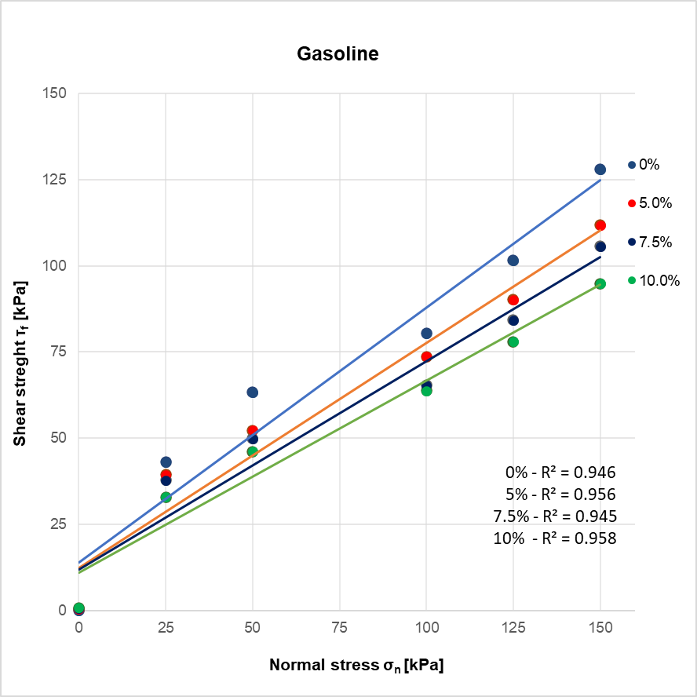
Fig. 1. Shear strength of the soil with varying percentages of gasoline contamination

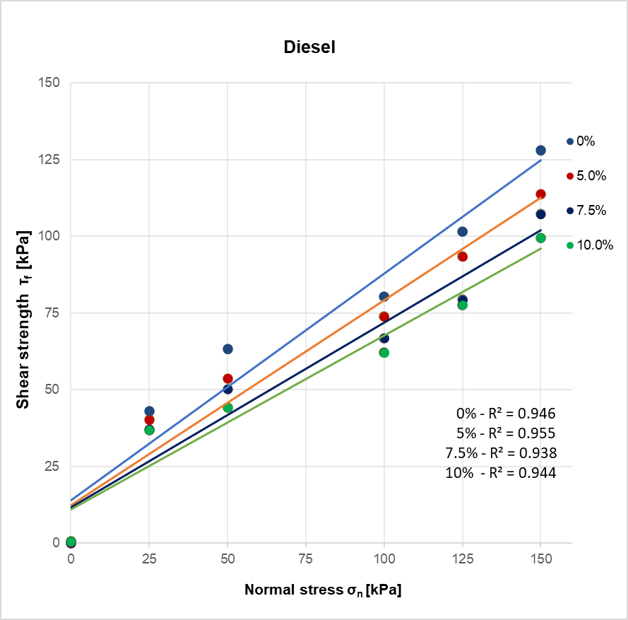
Fig. 2. Shear strength of the soil with varying percentages of diesel oil contamination

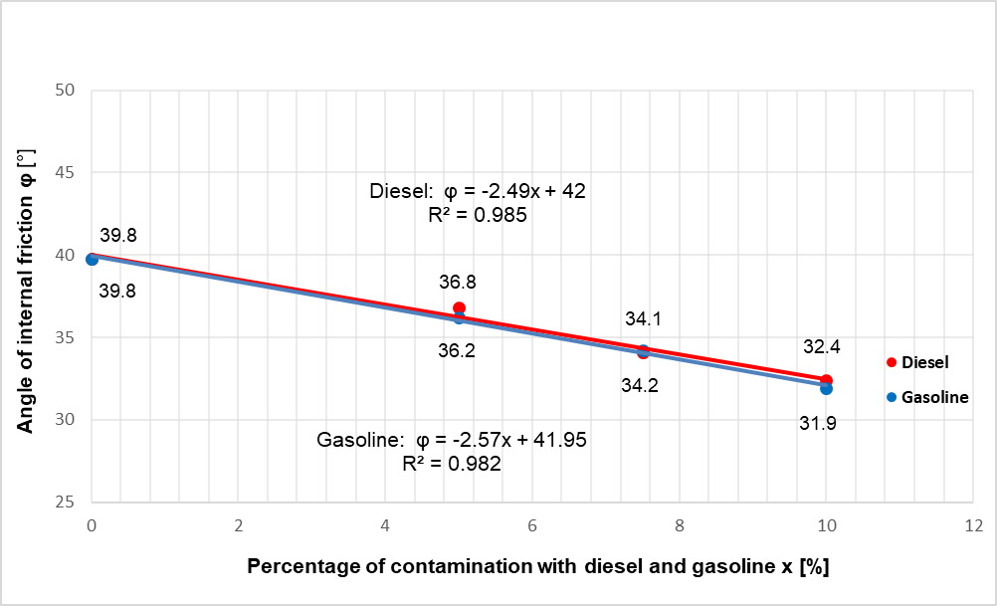
Fig. 3. The angle of internal friction vs. percentage of contamination

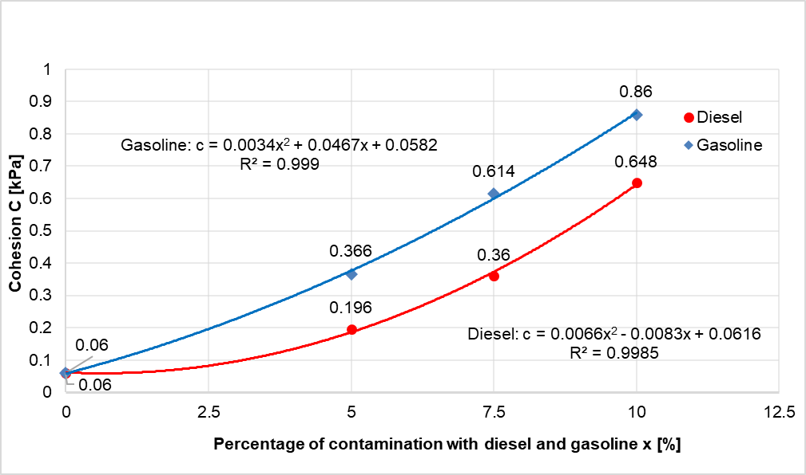
Fig. 4. The cohesion vs. percentage of contamination

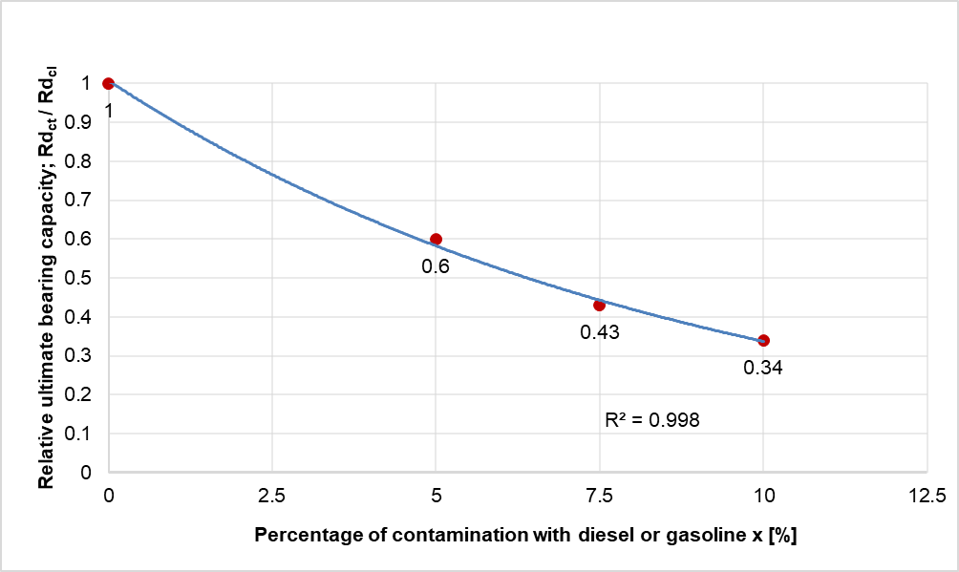
Fig. 5. Relative ultimate bearing capacity of soil contaminated with fuels
4. Conclusions

This paper has presented laboratory test results to study motor fuel's effect on the strength parameters of sandy gravel.

The following conclusions can be drawn from this study:
1. An increased content of the propulsion fuels in the soil decreases its shear strength. This property is observed for the 25-150 kPa normal stress range.
2. Increasing the propulsion fuel content in the soil decreases the internal friction angle. For the same content of diesel oil or gasoline, the values of internal friction angles are comparable.
3. An increased content of the propulsion fuels in the soil increases the cohesion. For the same content of contaminants in the soil, the cohesion value is higher in the case of gasoline.
4. Contamination of the ground with propulsion fuels dramatically reduces the ultimate bearing capacity of the ground, along with increasing fuel content.
5. The influence of fuel density on the shear strengths of contaminated soil was not observed.
References
Abousnina, R.M., Manalo, A., Shiau, J., Lokuge, W. (2015). Effects of light crude oil contamination on the physical and mechanical properties of fine sand. Soil and Sediment Contamination: An International Journal, 24(8), 833-845. https://doi/abs/10.1080/15320383.2015.1058338
Czado, B., Korzeniowska-Rejmer, E., Pietras, J.S. (2010). Analiza zmian nośności podłoża budowlanego w wyniku jego zanieczyszczenia substancjami ropopochodnymi na przykładzie gruntów piaszczystych. Górnictwo i Geoinżynieria, Rok 34, Zeszyt 2. (in Polish)
Czado, B., Korzeniowska-Rejmer, E., Pietras, J.S. (2011). Wpływ zanieczyszczeń olejowych na wytrzymałość na ścinanie i nośność gruntów piaszczystych. Czasopismo Techniczne. Środowisko, Tom 2-Ś, R. 108, Z. 6, 79-88. (in Polish)
Elazzabi, A.A. (2020). Effect of crude oil pollution on some properties of disturbed sandy soil. Third Conference for Engineering Sciences and Technology.
Fine, P., Graber, E.R., Yaron, B. (1997). Soil interactions with petroleum hydrocarbons: Abiotic processes. Soil Technology, 10, 133-153.
Gan, J.K.M., Fredlund, D.G., Rahardjo, H. (1988). Determination of the shear strength parameters of an unsaturated soil using the direct shear test. Canadian Geotechnical Journal, 25(3), 500-510.
Karkush, MO., Abdul, Kareem, Z. (2017). Investigation the impacts of fuel oil on the geotechnical properties of cohesive soil. Journal of Engineering, 21(4), 127-137.
Khosravi, E., Ghasemzadeh, H., Sabour, M.R., Yazdani, H. (2013). Geotechnical properties of gas oil-contaminated kaolinite. Engineering Geology, 166, 11-16. https://doi:10.1016/j.enggeo.2013.08.004.
Korzeniowska-Rejmer, E. (2001). Wpływ zanieczyszczeń ropopochodnych na charakterystykę geotechniczną gruntów, stanowiących podłoże budowlane. Inżynieria Morska i Geotechnika, 2, 83-87 (in Polish)
Nudelman, N.S., Rio, I.S., Katusich, O. (2002). Fate of the oil residuals in Patagonian soils effects of the environmental exposure time. J. Environ. Assessment Remediation, 3, 1-8.
Ostovar, M., Ghiassi, R., Javad, M., Shariatmadari, N. (2020). Effects of Crude Oil on Geotechnical Specification of Sandy Soils. Soil and Sediment Contamination (formerly Journal of Soil Contamination), 30(4), 1-16.
PN-88/B-04481 Grunty budowlane. Badania próbek gruntu. (in Polish)
PN-EN ISO 14688-1:2006 Badania geotechniczne. Oznaczanie i klasyfikowanie gruntów. Część 1: Oznaczanie i opis. (in Polish)
PN-EN 1997-1:2008 Eurokod 7 Projektowanie geotechniczne. Część 1. Zasady ogólne. (in Polish)
PN-EN ISO14688-1:2018-05P Rozpoznanie i badania geotechniczne. Oznaczanie i klasyfikowanie gruntów. Część 1: Oznaczanie i opis. (in Polish)
Puri, V.K. (2000). Geotechnical aspects of oil-contaminated sands. Soil Sediment Cotam. 9(4), 359-374.
Rahman, Z.A., Hamzah, U., Taha, M.R., Ithnain, N.S., Ahmad, N. (2010). Influence of oil contamination on geotechnical properties of basaltic residual soil. American Journal of Applied Sciences, 7(7), 954-61. https://doi:10.3844/ajassp.2010.954.961
Rulkens, W.H., Bruning, H. (1995). Clean-up possibilities of contaminated soil by extraction and wet classification: effect of particle size, pollutant properties and physical state of the pollutants. W.J van den Brink, R. Bosman, F. Arendt (eds.), Contaminate soil, 95, 761-773.
Saberian, M., Khabiri, M.M. (2016). Effect of oil pollution on function of sandy soils in protected deserts and investigation of their improvement guidelines (case study: Kalmand area, Iran). Environmental Geochemistry and Health volume, 40, 243-254. https://doi:10.1007/s10653-016-9897-y
Sarmadi, M.S., Zohrevand, P., Rezaee, M. (2019). Effect of kerosene contamination on the physical and mechanical properties of sandy soil. Innovative Infrastructure Solutions, 4(1). https://doi:10.1007/ s41062-019-0196-1
Shin, E.C., Lee, J.B., Das, B.M. (1999). Bearing capacity of a model scale footing on crude oil-contaminated sand. Journal of Geotechnical and Geological Engineering, 17(2), 123-32. https://doi:10.1023/A:1016078420298
Surygała, J. (2000). Zanieczyszczenia naftowe w gruncie. Wrocław. Oficyna Wydawnicza Politechniki Wrocławskiej. (in Polish)

