 | Rocznik Ochrona Środowiska
 | Volume 25 | Year 2023 ISSN 2720-7501 | pp. 208-214
 | https://doi.org/10.54740/ros.2023.020 open access
 | Received: August 2023 Accepted: September 2023 Published: October 2023
Thermomodernization – Rescue for the Building
Magdalena Orłowska
Koszalin University of Technology, Poland
https://orcid.org/0000-0002-2072-1791
corresponding author's e-mail: magdalena.orlowska@tu.koszalin.pl
Abstract: The article discusses issues related to modifying existing buildings to improve their condition in terms of lower energy consumption and reducing heat loss. The study takes the form of a review. Current systems and data are described according to relevant standards. The issue of the energy efficiency of the building is explored. A list of the most common ways of thermal modernization has been presented. Financial support programs were discussed. The merits and drawbacks of the solutions are delineated.
Keywords: energy saving, characteristic, thermal modernization
1. Introduction
The concept of thermal modernization is understood as a series of activities aimed at improving the condition of the building in terms of heat exchange and reducing heat loss. The concept of modernization is also associated with replacing the heat source with a more ecological one. In addition, an obligation has been introduced in Poland to demonstrate the energy characteristics of the building, which results from European law. It is a document that is a set of information and energy indicators of a building or its part in terms of energy consumption for heating, ventilation, cooling, domestic hot water preparation, and even in non-residential buildings regarding lighting. The total demand for energy needed to use the buildings as intended is determined (Journal of Laws 2021, Journal of Laws 2023).
Primary energy (EP)
The demand for non-renewable primary energy (EP) – for heating, cooling, ventilation or lighting, hot water production, and operation of electrical devices – may not exceed 70 kWh/m².
This indicator has decreased due to the requirements of the environment, and it was still much higher in previous years. The required conditions regarding EP must be met To obtain a building permit. The focus should be on the latest green technologies that support renewable sources while limiting non-renewable resources.
Final energy demand (EK)
This indicator ensures the required temperature and ventilation in the building. It is necessary to choose the right source of heat, preferably environmentally friendly, and proper air circulation – in the sense of ventilation, e.g. in the recovery of part of used heat, i.e. recuperation, recirculation, to guarantee appropriate parameters. Remember that with tight doors and windows, ventilation must also remove carbon dioxide and water vapour.
Usable energy demand (EU)
An essential parameter which determines how much energy is needed per 1 m² of the building. This indicator should be considered already at the design stage. The location of the building in relation to the cardinal directions should be taken into account to get the most out of the sun, the climatic zone, the type of insulation of windows and doors, the construction of walls and roofs and so on.
Heat sources have changed over the years. The difference in global primary energy consumption between 1800 and 2022 is colossal. You can see various possibilities appearing over the years – Fig. 1.
The graph is based on the "substitution method". This method considers the inefficiency of fossil fuel production by converting non-fossil energy into the required energy inputs. The assumption is that they have the same conversion losses as fossil fuels.
In her scientific work, the author also deals with research aimed at solutions that reduce energy consumption (Orłowska 2017, Orłowska 2019).
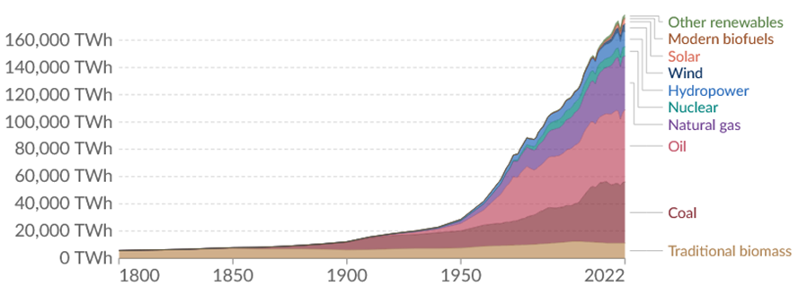
Fig. 1. Global primary energy consumption according to various sources in the years 1800-2022 (https://ourworldindata.org/grapher/global-energy-substitution)
2. Research and Prognosis
Currently, the most popular thermo-modernization treatments consist of replacing the existing insulation of the building's walls or adding a new thermal insulation layer to the walls. Insulation materials must have appropriate values of the thermal conductivity coefficient λ [W/m∙K] and meet several requirements (e.g. appropriate structure, binder, low ability to absorb moisture, insensitivity to rapid temperature changes, etc.), described in the relevant standards. The thickness of the material depends on its type and the construction of the building partition. In 2021, the values of heat transfer coefficients U for partitions changed. For roofs and flat roofs, maximum U = 0.15 W/m²∙K, external walls U = 0.2 W/m²∙K, and floors U = 0.3 W/m²∙K. The reciprocal of the heat transfer coefficient is the thermal resistance R, which is the ratio of the wall thickness
– d to the thermal conductivity coefficient – λ. When calculating the thermal resistance, the thermal resistance RSI and RSE should be taken into account on the internal and external sides of the partition, respectively Figure 2.

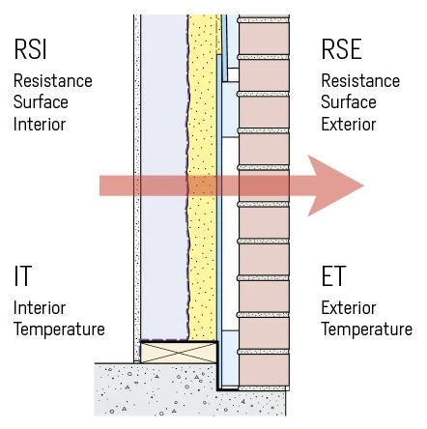
Fig. 2. Thermal resistance in a cross section wall (https://stacbond.com/us/thermal-resistance-material-vs-heating/)

Approximately 20-25% of heat escapes from the house through walls that are not insulated, up to 30% through the roof, 10-15% through the floor, 10-20% through non-tight windows and doors, and the rest is losses through chimneys and ventilation about 30-40%,. Where the climate is colder, and buildings need to be heated, heat losses through ventilation are greater than in temperate climates. The building structure has a significant impact on heat loss. Heat conduction takes place in solids – in the case of a wall – the materials from which the wall is built. Heat transfer on the outside and inside of the wall and conduction in the materials from which the wall is made is called heat transfer U W/m²∙K. That is why materials are so important. We can reduce losses by using appropriate thermal insulation.
Figure 3 shows exemplary heat losses given in percentage. According to this source, the largest losses occur in the case of chimney-ventilation 30-40% and the smallest through the floor 3-6%.

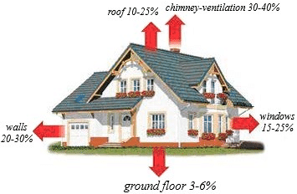
Fig. 3. Percentage of approximate heat loss in the house (https://www.researchgate.net/figure/Heat-loss-in-the-building-12_fig1_331304641)

Graphite polystyrene is the most popular material for thermal insulating external walls or floors. If the walls are damp due to the low vapour permeability of expanded polystyrene, a special variety is used, the so-called expanded EPS. Damp walls covered with polystyrene are difficult to dry. Unfortunately, polystyrene is not a material that dampens sound. It is also not resistant to solvents, solvent-based paints or adhesives. A variant with higher mechanical strength, better insulation, and low water absorption is XPS extruded polystyrene, the so-called styrodur.
Another thermal insulating material is mineral wool, which is more plastic, flexible, sound-absorbing, and non-combustible.
The dry and wet methods of fixing thermal insulation are ways of finishing the walls of buildings. In the dry one, a grate is used, into which boards, e.g. made of mineral wool, are placed. Polystyrene or a mineral wool board is attached to the adhesive in the light, wet method, followed by a reinforcing layer and plaster mortar. In the wet method, a large selection of plasters and satisfactory thermal parameters may be an advantage, and the disadvantages are the price, sensitivity to mechanical damage and weather dependence of the installation. In a dry one, cleanliness during installation is certainly an advantage, but it is not always possible to match the cladding to the appearance of the building. For sloping usable attics and roofs, the insulation thickness is at least 20 cm, so two layers of wool are laid.
The heat transfer coefficient for ordinary windows, façade windows and balcony doors should be U = 0.9 W/m²∙K according to the technical requirements in 2022; for skylight and roof windows, U = 1.1 W/m²∙K,. It is best to replace all the windows in the building, even those that do not open. Currently, windows and doors should provide the best possible insulation and thus the smallest heat escape to the outside, which is also associated with savings on heating. Windows that meet the latest requirements are marked with the U_{w} symbol, which means that both the glass and the frame meet the insulation criteria. The window can be equipped with a ventilator with a filter. There are frame colours to choose from, in the offer of sales companies, you can even order two-colour windows, with a different colour inside and outside the apartment.
The windows can be triple-glazed (more soundproof) and double-glazed, with the so-called warm frames, filled with gas, with a different number of chambers – e.g. with additional filling, e.g. polystyrene, which also insulates.
Modern doors should guarantee the smallest possible heat escape to the outside, so they should be thermally insulating and tight. According to the latest regulations, the heat transfer coefficient U for external doors is a maximum of 1.3 W/m²∙K. Doors are a house decoration. They fit aesthetically into the type of facade. You can choose from doors with fittings, glazing, cassette doors, sound insulation doors, etc. First, they should ensure safety (anti-burglary with an increased security class) and be characterized by high-quality components, high durability and strength. Currently, you can buy doors with additional equipment, such as an electronic lock with a keypad, card reader, LED backlight of the handle, and special hidden or roller hinges. They can have different door frames, rebates or not, a different way of movement, a different number of leaves, etc. Let's remember that interior toilet and bathroom doors have a characteristic cutout on the bottom, guaranteeing free air circulation. By cutting this type of door from the bottom, we disturb this free flow, which undoubtedly affects the correct air circulation.
Some works related to thermal modernization require notification, others require building permits, while others can be carried out without additional formalities. You can apply for a thermo modernization relief.
The purchase of window or door joinery can be supported thanks to the following programs: "Clean Air", "Stop Smog", and "Warm Apartment".
"Clean Air" 2018-2030. Several requirements must be met, e.g. appropriate income per year, ownership or co-ownership of a house as a single-family building or a residential unit separated in a building with a land and mortgage register. Funding can be obtained at the level of the so-called. Basic up to 66 thousand pln, increased to PLN 99 thousand pln or the highest up to 135 thousand pln (1 Euro – 4.5 pln, 1 USD – 4.2 pln for a day 6.9.2023). Financing requirements increase with each level. Activities under this program concern "comprehensive thermal modernization" or replacing old heat sources with modern, more environmentally friendly ones. There are many forms and options for funding. All the details and requirements are described on the Polish government website https://czystepowietrze.gov.pl/czyste-powietrze/#do-pobrania.
The "Stop Smog" 2019-2028 program applies to those areas of communes where anti-smog resolutions are in force (Niepołomice, Pszczyna, Rybnik, Skawina, Sosnowiec, Sucha Beskidzka and Tuchów have so far signed agreements in the recruitment). These are low-emission projects that are safer for the environment. You can get up to 70% of the investment costs. The remaining 30% is the municipality's contribution. In this way, the inhabitants of such communes can receive 100% of the subsidy, and the investment cost cannot exceed 53,000 pln in one building. If the building has two apartments, it cannot exceed 53,000 pln for one apartment. Accordingly, the percentage values of the lowest old-age pension determine the subsidy amount. If a single person, for example, wants to replace the stove with a more ecological one and applies for the program, he must prove that the monthly income per person does not exceed 175% of the amount of the lowest pension. If the family consists of many people, the monthly income per person cannot exceed 125% of the amount of the lowest old-age pension.
"Warm apartment" program 2022-2026. It applies to communes, owners or persons with limited property rights to premises in a multi-family residential building. This program aims to improve air quality and energy efficiency in multi-family residential buildings. Air quality will improve, for example, by replacing heat sources with more efficient ones with lower CO₂ emissions into the atmosphere or by connecting them to an effective heat source that supplies the building with heat. Communes that are the most polluted can receive funding according to three levels. Basic up to 17,500 pln of co-financing, increased to 26,900 pln and the highest up to 39,900 pln. Other municipalities have slightly lower subsidy amounts. The Polish government website provides details https://czystepowietrze.gov.pl/cieple-mieszkanie/.
Figure 4 refers to the building – above 20 years old, inhabited by three people, and the area of the house is 180 m².
According to the Polish Smog Alarm, just insulating the house and replacing the heat source is an investment that pays off after 1 to 7 years. The audit was carried out on 8 selected houses.
It is not possible to precisely determine the costs of thermal modernization. Material prices are changing and have recently increased. The cost is influenced by, for example, the purpose of the building, location, technical condition, age, area, shape of the building, scope of work included in the thermal modernization project, techniques and time used to carry out the process, and materials used. Citing the source https://rynekpierwotny.pl/wiadomosci-mieszkaniowe/ile-kosztuje-termomodernizacja-budynku-ceny/12267/, the exemplary cost of insulating walls with polystyrene with material and labour per 1 m² is 240-315 pln, the cost of insulating with mineral wool is 300-400 pln per 1 m², the cost of preparing an energy audit is approx is about 1000-3000 pln.

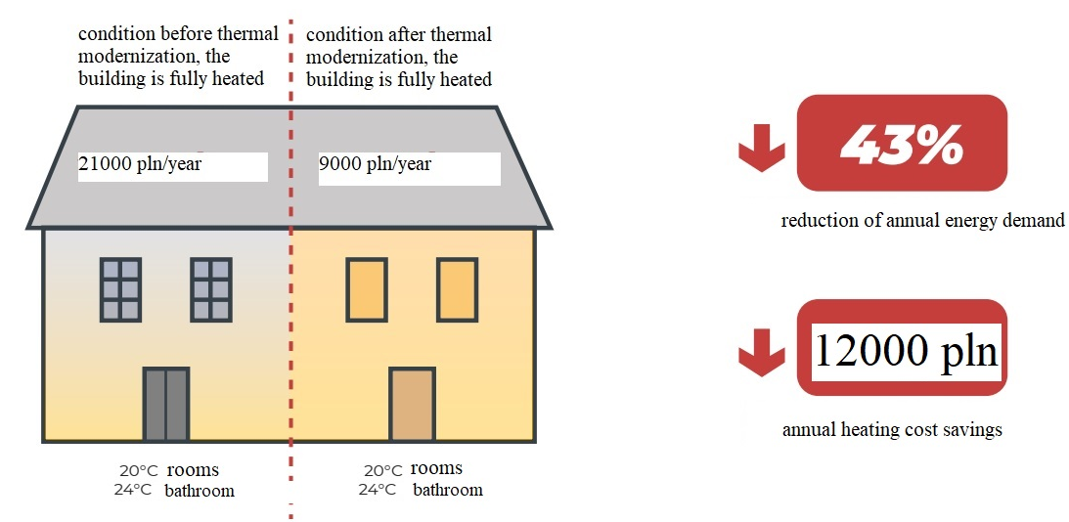
Fig. 4. Annual energy demand and annual heating costs at home after thermo-modernization recommendations with replacement of the heat source (https://globenergia.pl/termomodernizacja-zwraca-sie-nawet-w-rok/ – based on Polish Smog Alert)

Energetic efficiency. It is best to choose a source that will give us savings and, at the same time, will be ecological, with the least possible harm to the environment and the atmosphere. The selection of heat sources is huge these days. It is necessary to analyze the costs of investment or modernization, consider all the advantages and disadvantages, and adjust the system to the existing conditions. An incorrectly selected source, e.g. oversized, will not ensure effective, rational energy use. It is best to perform an energy audit and check the system's operating parameters for a specific building. Ground source heat pumps achieve the highest efficiency. The temperature in the ground has a stable value and is not dependent on the surface temperature. However, heat pumps are the most expensive. They need electricity to drive. Due to investment costs, they are not the most popular. Heat pumps can be combined with a photovoltaic system. That is a great solution, but expensive.
Indicative calorific values of various fuels are presented in Table 1.
According to Table 1, not all fuels mentioned in the text refer to the content of Table 1; however, plant materials are interesting in comparison to the value of black coal.

Table 1. Calorific values of some fuels (https://www.researchgate.net/figure/Average-calorific-value-for-selected-energy-raw-materials_tbl1_326625427)
Type of plant materials | Calorific value of the dry state, MJ/kg
Pelet – beech wood | 18.6
Pelet – pine wood | 17.7
Wheat straw | 16.8
Rye straw | 17.1
Maize straw | 17.5
Rape straw | 17.3
Meadow hay | 16.6
Oat grains | 18.4
Black coal | 14.7-29.3

A pellet stove is now a reasonable solution. The calorific value of pellets of 18.5 MJ/kg is satisfactory, and the humidity is low, positively affecting the process combustion. It leaves a low carbon footprint, and CO₂ emissions when burning it are symbolic. It is considered an ecological fuel, as it is made of wood chips and wood cuttings. Biomass in Poland is a fuel in the development phase. Waste wood, briquettes, pellets, and straw are used in boiler houses and combined heat and power plants. Poland is a country that enjoys some of the highest bioenergy opportunities in Europe (Igliński et al. 2022). Pellet boilers have high energy efficiency. Another advantage is cleanliness in the boiler room, with no ash as when burning hard coal. Due to ecology, these two solutions – heat pumps and a pellet boiler have positive opinions. Gas heating can also be considered, but gas prices have recently increased, and gas, like coal, is a non-renewable fuel. Natural gas belongs to organic fuels. This fuel is the main natural gaseous fuel. Gaseous synthesis fuels are mostly from coal gasification processes, biomass and crude oil processing waste (Chmielniak 2018). The gas boiler is characterized by clean and simple operation and has small dimensions. It can be installed in bathrooms, kitchens or other rooms (Guzik 2015). A popular source of heat is also an eco-pea coal boiler. This fuel has a high calorific value, calorific value of 24-26 MJ/kg , but it is also made of coal. It comes in a purer variety, thanks to lower sulfur and ash content. It is characterized by low sinterability and non-combustible substances' content, hence the name's prefix eco,.
Figure 5 shows the products of combustion. Unfortunately, combustion products that are dangerous to the atmosphere, the environment and humans are formed during the combustion process.

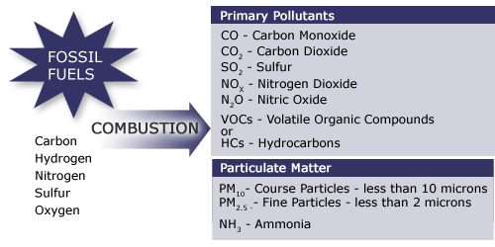
Fig. 5. Products of combustion (https://www.e-education.psu.edu/egee102/node/1951)
3. Conclusions
The significance of energy is continuously escalating and will persist in doing so. The progression of civilization remains unabated, with individuals heavily reliant on energy. Energy offers a specific level of comfort and standard of living, thereby shaping the core of society, economic sectors, and national security (Kucharska 2021).
Following thermal modernization, a prominent health aspect should be underscored, stemming from the improved thermal comfort conditions within the building. Proper humidity, temperature, and consequent air circulation deter the proliferation of fungi and mould culprits responsible for numerous perilous human ailments. Another compelling argument supporting thermal modernization initiatives is heightened energy efficiency, thereby yielding financial benefits for us, the users, in the form of reduced bills.
Thermal modernization campaigns have positive effects on the environment as well. They encompass contemporary, eco-friendly heat sources, like heat pumps or photovoltaic panels, and ventilation systems featuring recuperation. After thermal modernization, the building gains aesthetic value and its value increases. The building will be quieter due to replacing windows and doors, appropriate insulation of the walls, and changes in the roof surface. The benefits of the thermo-modernization process are long-term.
Bearing these points in mind, it is imperative to enhance our living conditions in buildings where we allocate a substantial portion of our time, whether at home or work.
References
Chmielniak, T. (2018). Technologie energetyczne, PWN, Warszawa, 21, 22. (in Polish)
Guzik, J. (2015). Instalacje centralnego ogrzewania, KaBe, Krosno, 33. (in Polish)
Igliński, B., Kiełkowska, U., Pietrzak, M.B., Skrzatek, M. (2022), Energia odnawialna w województwie pomorskim, Scientific Publishing House of the Nicolaus Copernicus University in Toruń. (in Polish)
Journal of Laws (2021). Dziennik Ustaw Rzeczypospolitej Polskiej 2021 poz. 497, Obwieszczenie Marszałka Sejmu Rzeczypospolitej Polskiej z dnia 23 lutego 2021 r. w sprawie ogłoszenia jednolitego tekstu ustawy o charakterystyce energetycznej budynków. (in Polish)
Journal of Laws (2023). Dziennik Ustaw Rzeczypospolitej Polskiej z dnia 13 kwietnia 2023 r. poz. 697, Rozporządzenie Ministra Rozwoju i Technologii z dnia 28 marca 2023 r. zmieniające rozporządzenie w sprawie metodologii wyznaczania charakterystyki energetycznej budynku lub części budynku oraz świadectw charakterystyki energetycznej). (in Polish)
Kucharska, A. (2021), Transformacja energetyczna. Wyzwania dla Polski wobec doświadczeń krajów Europy Zachodniej. PWN, Warszawa. (in Polish)
Orłowska, M. (2017), Numerical analysis of the heat exchanger energy efficiency depending on location from the floor. E3S Web of Conferences, 17, Article Nr 00068.
Orłowska, M. (2019), Laboratory stand for flow and energetic experimental research vertical heaters with free convection and the possibility of intensification. Contemporary Issues of Heat and Mass Transfer. Vol. 1, 417-428, Publishing House of the Koszalin University of Technology, Koszalin.

https://budujemydom.pl/stan-surowy/termoizolacja/a/7433-ocieplenie-scian-zewnetrznych
https://czystepowietrze.gov.pl/cieple-mieszkanie/
https://czystepowietrze.gov.pl/czyste-powietrze/#do-pobrania.
https://czystepowietrze.gov.pl/lifting-domu-dzieki-nowym-oknom-i-drzwiom/
https://dobry-ekogroszek.pl/charakterystyka-ekogroszku/
https://domel.pl/termomodernizacja/czyste-powietrze?gclid=EAIaIQobChMIjs3Thv6cgAMV1OyyCh1d5g6xEAAYASAAEgINsvD_BwE
https://globenergia.pl/termomodernizacja-zwraca-sie-nawet-w-rok/
https://grzejemnieto.pl/najbardziej-efektywne-zrodla-ciepla-porownanie/
https://jakbudowac.pl/warunki-techniczne-2022-co-to-jest-aktualne-przepisy
https://metalfachtg.com.pl/ekogroszek-jaka-kalorycznosc-wybrac/
https://ourworldindata.org/grapher/global-energy-substitution
https://polskialarmsmogowy.pl/2023/06/jak-szybko-zwraca-sie-inwestycja-w-ocieplenie-domu-wyniki-audytu-polskiego-alarmu-smogowego/
https://rynekpierwotny.pl/wiadomosci-mieszkaniowe/ile-kosztuje-termomodernizacja-budynku-ceny/12267/
https://stacbond.com/us/thermal-resistance-material-vs-heating/)
https://www.e-education.psu.edu/egee102/node/1951
https://www.foveotech.pl/strefa-wykonawcy/porady-techniczne/metoda-lekka-mokra-a-lekka-sucha-metody-docieplen-scian
https://www.gov.pl/web/arimr/stop-smog-20---nowe-lepsze-zasady-od-31-marca2
https://www.instalacjebudowlane.pl/5159-23-40-biomasa--wlasciwosci-wartosc-opalowa.html
https://www.researchgate.net/figure/Average-calorific-value-for-selected-energy-raw-materials_tbl1_326625427
https://www.researchgate.net/figure/Heat-loss-in-the-building-12_fig1_331304641
https://www.termofol.pl/informacje-ogolne/ep-ek-i-eu-co-oznaczaja-te-pojecia/

https://www.termofol.pl/informacje-ogolne/ep-ek-i-eu-co-oznaczaja-te-pojecia/
https://corab.pl/aktualnosci/standard-energetyczny-wt-2021-jakie-ma-wymagania
https://budujemydom.pl/stan-surowy/termoizolacja/a/7433-ocieplenie-scian-zewnetrznych
https://www.researchgate.net/figure/Heat-loss-in-the-building-12_fig1_331304641
https://www.researchgate.net/figure/Heat-loss-in-the-building-12_fig1_331304641
https://www.foveotech.pl/strefa-wykonawcy/porady-techniczne/metoda-lekka-mokra-a-lekka-sucha-metody-docieplen-scian
https://budujemydom.pl/stansurowy/termoizolacja/a/7433-ocieplenie-scian-zewnetrznych
https://jakbudowac.pl/warunki-techniczne-2022-co-to-jest-aktualne-przepisy
https://czystepowietrze.gov.pl/lifting-domu-dzieki-nowym-oknom-i-drzwiom/
https://domel.pl/termomodernizacja/czyste-powietrze?gclid=EAIaIQobChMIjs3Thv6cgAMV1OyyCh1d5g6xEAAYASAAEgINsvD_BwE
https://www.gov.pl/web/arimr/stop-smog-20---nowe-lepsze-zasady-od-31-marca2
https://polskialarmsmogowy.pl/2023/06/jak-szybko-zwraca-sie-inwestycja-w-ocieplenie-domu-wyniki-audytu-polskiego-alarmu-smogowego/
https://www.instalacjebudowlane.pl/5159-23-40-biomasa--wlasciwosci-wartosc-opalowa.html
https://metalfachtg.com.pl/ekogroszek-jaka-kalorycznosc-wybrac/
https://grzejemnieto.pl/najbardziej-efektywne-zrodla-ciepla-porownanie/
https://dobry-ekogroszek.pl/charakterystyka-ekogroszku/

