 | Rocznik Ochrona Środowiska
 | Volume 25 | Year 2023 ISSN 2720-7501 | pp. 174-187
 | https://doi.org/10.54740/ros.2023.017 open access
 | Received: June 2023 Accepted: August 2023 Published: September 2023
Hydro-ecological State of Ukrainian Water Bodies Under the Influence of Military Actions
Valentyna Stelmakh^{1*}, Mykhailo Melniichuk², Oleh Melnyk³, Ivan Tokarchuk⁴
¹Faculty of Geography, Lesya Ukrainka Volyn National University, Lutsk, Ukraine
https://orcid.org/0000-0002-7106-4242
²Faculty of Geography, Lesya Ukrainka Volyn National University, Lutsk, Ukraine
https://orcid.org/0000-0002-7258-2869
³Faculty of Geography, Lesya Ukrainka Volyn National University, Lutsk, Ukraine
https://orcid.org/0000-0002-1584-2943
⁴Faculty of Geography, Lesya Ukrainka Volyn National University, Lutsk, Ukraine
*corresponding author's e-mail: stelmakh.valia@vnu.edu.ua
Abstract: The article aims to analyse the impact of military operations on the hydro-ecological state of water bodies in Ukraine, analyse potential military risks and assess the prospects for recovery in the water sector. The war leads to the destruction of water supply infrastructure and, secondly, to the pollution of natural waters with sewage and ammunition. Thus, Ukraine's hydro-ecological condition of natural watercourses and reservoirs is deteriorating during a full-scale war. First, we analysed the literature and modern scientific publications and studied the current state of the water bodies of Ukraine under martial law. The article analyses the key consequences of military operations on water bodies, including the destruction of water infrastructure and hydraulic structures, contamination by explosives and destroyed military equipment, flooding by mine water, and leaks from tailing ponds. Special attention is paid to the results of water quality monitoring in wartime. The authors systematised and reviewed the key incidents of destruction and damage to hydraulic structures since the beginning of the war. Potential risks to water bodies in the context of Russian aggression are studied. Finally, the author analyses the directions of the post-war reconstruction of Ukraine and proposes a list of practical steps necessary to restore water resources. The author's view on post-war reconstruction measures in water resources is offered. In addition, environmental organisations and local authorities can use the results of this scientific research.
Keywords: hydro-ecological condition, water body, martial law, water quality monitoring, water infrastructure, pollution, flooding
1. Introduction
Russia's full-scale invasion of Ukraine has had devastating consequences. In addition to the war bringing thousands of deaths, mutilated lives, and the destruction of critical and essential infrastructure, it will have other painful consequences that we will feel for decades to come, including environmental ones. The consequences of the environmental crisis are the shelling of nuclear power and chemical plants, land mining, decomposition of bodies, detonation of shells, burning of forests and much more. They imprint on the state of Ukraine's ecosystem and affect the population's life and health (Scorched Land and Polluted Water, 2022).
International law protects water infrastructure, but as experience shows in the course of armed conflicts and wars, water objects (water infrastructure) are often intentionally or unintentionally damaged. Among such cases should be mentioned the operation "Chastise" of 1943 (air strike of the Air Force of Great Britain on dams in Germany), the Bosnian War (1992-1996), two explosions of the Dnipro HPP (in 1941 and 1943) (Khilchevskyi et al. 2023).
After the full-scale invasion of Russia into Ukraine, water resources also suffered the greatest negative impact from military actions on the territory of our state. Water bodies occupy 24.2 thousand km² of our territory, which is 4.0% of the country's total area (Hrebin et al. 2014). Almost 63 thousand rivers flow across Ukraine. In addition, 1,054 reservoirs have been built, and more than 50,793 ponds have been created (Hrebin & Khilchevsky 2021). Therefore, the war leads to the destruction of water supply infrastructure and, secondly, to the pollution of natural waters with sewage and ammunition. The consequences of the armed aggression and their impact on water bodies can be fully assessed only after the complete de-occupation of all occupied regions and after the demining of the territory of Ukraine. At the same time, it can already be stated that the hydro-ecological state of natural watercourses and reservoirs in Ukraine is deteriorating during the full-scale war, and its study and research are one of the most pressing issues of our time.

2. Literature Review
Several publications are devoted to the issue of the impact of armed conflicts on water resources and water infrastructure in the scientific literature. In particular, Schillinger J., Özerol G., Güven-Griemert S., and Heldeweg M. (Schillinger et al. 2020) conduct a systematic review of the literature that considers the impact of armed conflicts on water resources. The authors analysed and classified the role of water resources in armed conflicts.
The study of the impact of military operations on the state of water resources in Ukraine in armed conflict zones has been insufficiently researched. They are mostly concerned on the socio-humanitarian aspects of ensuring access to water. Still, the danger of pollution of all environmental components associated with military actions' direct or indirect impact is obvious (The Artery of the East of Ukraine, 2021).
Scientists actively began to study the impact of military actions on the ecological state of Ukraine since the beginning of the occupation of our territory in 2014. As a rule, the studies covered the East of Ukraine, where active hostilities occurred. A.I. Danylchenko examines the environmental threats of military operations in Donbas in his scientific works (Danylchenko 2018). In particular, the research concerns the issue of weakening control over the mine water level, problems of air and soil pollution by explosive materials and emissions from their detonation.
A significant part of the works are devoted to man-made and ecological threats in the zone of military operations in the East of Ukraine because this region is characterised by a high density of potentially dangerous objects. These questions are revealed in the scientific works of O.D. Malka (Malko 2019), S.P. Ivanіuty (Ivaniuta 2017), N.V. Tymoshenko (Tymoshenko 2017).
In the scientific researches of N.O. Lisova (Lisova 2017), attention is focused on the problems associated with water coming to the surface from non-functioning submerged coal mines, from the malfunctioning of wastewater treatment facilities, and, as a result, the scale of contamination of water and land resources. Special attention is paid to studying the degree of anthropogenic and technogenic influence on landscape complexes in the East of our country.
The studies of some scientists for example, Klymenko M.O., Klymenko O.M., Petruk A.M. (Klymenko et al. 2013) are devoted to hydro-ecological monitoring of water ecosystems from the standpoint of current European trends. At the same time, it is worth noting that since the beginning of the full-scale invasion of Russia on the territory of Ukraine, scientists have not carried out a comprehensive analysis of the impact of military actions on the hydro-ecological state of water bodies.
After Russia's full-scale invasion of Ukraine began, scientists from other countries also actively joined the research of the outlined topic. Pereira P, Bašić F, Bogunovic I, Barcelo D. (Pereira et al. 2022) study the impact of the Russian-Ukrainian war on the environment, including analysing the consequences of the destruction of water infrastructure and the ingress of pollutants and essential substances into water bodies.
Shumilova O., Tockner K., Sukhodolov A., Khilchevskyi V., Meester L.D., Stepanenko S., Trokhymenko G., Hernández-Agüero J.A. & Gleick P. (Shumilova et al. 2023) analysed the multifaceted impacts of the military actions on freshwater resources and water infrastructure during the first three months of the conflict.
3. Methodology
The study's theoretical basis was formed based on the works of domestic and foreign scientists, primarily those who were engaged in the study of inland waters and water resources of Ukraine, ecological consequences of active military operations technogenic and ecological threats of war.
We used the following methods to conduct objective and thorough research:
- General scientific: literary (literature review), descriptive, mathematical and statistical (processing of water quality monitoring data); systematic and cause-and-effect relationships (systematisation of information, establishing a chronology of key incidents);
- specific scientific: cartographic (working with maps and creating own cartographic materials), observational, aerospace (analysis of space images to study incidents of flooding of territories), spatial analysis (study of the territorial characteristics of the impact of war on the hydro-ecological state of water bodies), forecasting (proposals for a post-war recovery plan) and others;
- methods of empirical and theoretical generalisation of information and technical methods of processing the received information.

The statistical information base of the study consists of materials from scientific publications on the topic of the study, materials from the State Water Resources Agency of Ukraine, results of laboratory analysis of the chemical composition of water samples, data from Ukrainian and international media, data from The Conflict and Environment Observatory (Ukraine conflict environmental briefing: Water, 2022).
4. Case Studies
Ukraine belongs to the countries with insufficient supply of water resources. Our state ranks 17th in terms of water supply among European countries (Ekodia – Center for Environmental Initiatives, 2022). On the territory of Ukraine, water bodies (rivers, lakes, ponds, reservoirs, etc.) occupy 24.2 thousand km², which is 4.0% of the country's total area. The territory of our state is characterised by a not very dense hydrographic network, on average – 0.34 km/km². There are also no vast water bodies, and groundwater reserves are also insufficient. Marshes, which acted as a natural water regulator, were largely drained. Thus, the natural water resources of Ukraine are mainly formed by river runoff (local and transit), water reserves of natural and artificial reservoirs, as well as the thickness of underground aquifers.
All watercourses on the territory of Ukraine belong to the basin of the three seas: the Black, Azov and Baltic seas. Most river basins (98% of the state's territory) belong to the Black and Azov seas. A small share, 2% of the country's area, belongs to the Baltic basin. The distribution of the river network of Ukraine into the main watersheds is shown in Fig. 1 (Stelmakh & Melniichuk 2022).

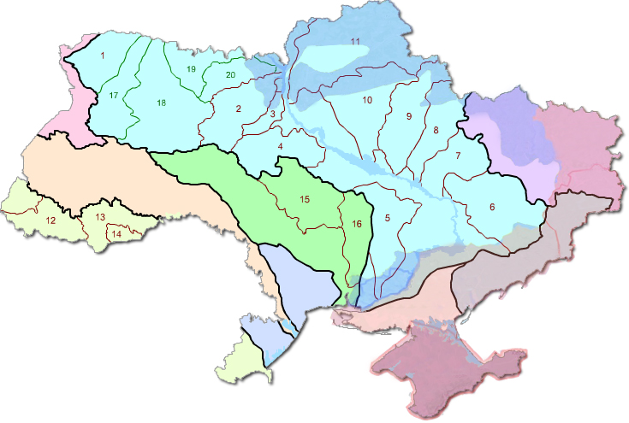
Legend  River basin of the 1st order  River basin of the 2nd order  The river basin of the 3rd order | - temporarily occupied territories  - de-occupied territories

Dnieper river basin  1. Prypiat river basin  2. Teteriv river basin  3. Irpin river basin  4. Ros river basin  5. Inhulets river basin  6. Samara river basin  7. Orіl river basin  8. Vorskla river basin  9. Psel river basin | 10. Sula river basin  11. Desna river basin  17. Styr river basin  18. Horyn river basin  19. Ubort river basin  20. Uzh river basin  Southern Buh river basin  15. Syniukha river basin  16. Inhul river basin | Danube river basin  12. Tysa river basin  13. Prut river basin  14. Seret river basin  Dniester river basin  Vistula (Western Buh) river basin  Don (Siverskyi Donets) river basin  Black Sea coast river basin  Azov Sea coast river basin  Crimean river basin
Fig. 1. Distribution of permanent watercourses by basins of large rivers in the conditions of occupation of part of the territory of Ukraine*
*improved by the authors using (Rivers of Ukraine, dateless)
The total number of all-natural watercourses on the territory of Ukraine is 63,119 (Palamarchuk & Zakorchevna 2001). The total length of the rivers of Ukraine is 206.4 km. Small rivers, with a catchment area of less than 2,000 km², make up 99.87% of the total number of rivers. Their number is 63,029 (Yatsyk 1991).
There are eight large rivers with a more than 50,000 km² catchment area in Ukraine. These include Dnipro, Dniester, Danube, Desna, Siversky Donets, Southern Bug and Tisza. Medium rivers include watercourses with a catchment area of 2,000 to 50,000 km², of which there are about 82 in Ukraine (Khilchevskyi 2021).
The density of the river network is determined by the influence of numerous natural factors, including climatic features, orography, the nature of the geological and tectonic structure and soil cover, features of the vegetation cover, etc.
The density of the river network is higher in the north (0.5 km/km²) and quite low in the south (up to 0.1 km/km²). The Carpathian Mountains and the Crimean Mountains are characterised by the highest density of the hydrographic network, over 1 km/km² and up to 0.6-0.7 km/km², respectively (Khilchevskyi et al. 2008). The average density of the river network in the basins of the main rivers of Ukraine is respectively (km/km²): Danube (within Ukraine) – 1.12, Dniester – 0.24, Vistula (within Ukraine) – 0.58, Southern Buh – 0.35, Dnieper – 0.30, Siverskyi Donets – 0.22 (Klymenko 2010).
Ukraine is characterised by a large number of lakes (about 20,000), but the vast majority of them belong to small bodies of water located mainly within river valleys. 99.54% of lakes are characterised by an area of less than 0.5 km². About 70 shallow water bodies have an area of 1-10 km². There are 21 large lakes with an area of 10 to 100 km², and there is only one very large lake (over 100 km²) – Yalpug (Khilchevskyi 2021). The spatial distribution of lakes in the territory of Ukraine is characterised by unevenness. The largest number of lakes is in the floodplain of the lower reaches of the Danube, the Poliska lowland, the Carpathian Mountains, the Black Sea and the Azov region. The vast majority of lakes are freshwater; only a few dozen lakes located in the south of Ukraine are salty and, as a rule, have an estuarine origin. The indicator of lake density for the territory of Ukraine is 0.15%, and if reservoirs are also taken into account, it reaches 2.15%. In terms of administrative units, this indicator is the highest in Odesa (1.43%) and Volyn (0.69%) regions, and if reservoirs are taken into account, then in Odesa (3.96%) and Chernivtsi (2.2%) regions (Klymenko 2010).
1,054 water reservoirs, as well as more than 50793 ponds, have been created and are functioning on the territory of Ukraine (Hrebin & Khilchevsky 2021). The total area of the reservoirs (under a normal support water level) is 9,362 km², excluding the Dnieper and Dniester reservoirs – 2,332 km². The total volume of water is 55.13 km³, of which 26.7 km³ is a useful volume (Hrebin & Khilchevsky 2021). In general, all reservoirs and ponds on our state's territory occupy about 12,000 km² (Stelmakh & Melniichuk 2022). Therefore, water reserves exceeding the Dnipro's average annual flow in full-water years are conserved in reservoirs and ponds.
An uneven spatial distribution of artificial water bodies is inherent in the country's territory. Most of them are concentrated within the forest-steppe and steppe zone. The largest number of ponds is located in Vinnytsia (10.5%), Dnipropetrovsk (6.5%), Kyiv (6.3%) and Lviv (6.3%) regions, and the smallest number of them are located in Luhansk (0.7%) and Zakarpattia (1.3%) regions (Khilchevsky 2021).
On the territory of Ukraine, groundwater forms several artesian basins. 90% of all drinking water in our country is concentrated in them. Groundwater lies in the following artesian basins: Volhynian-Podolian, Dnieper-Donets, Black Sea Basin. The indicator of the total reserve of groundwater is 20 km³ per year. Freshwaters mainly lie at a depth of 300-400 m in the north of Ukraine and at a depth of 100-150 m in the south (Stelmakh & Melniichuk 2022).
The totality of all surface, groundwater, and sea waters forms the water resources of Ukraine. Mostly, surface waters (particularly rivers) mainly provide fresh water for residential and communal use, agriculture and industry. Spatial differences are observed regarding the availability of fresh water in the regions of Ukraine. Thus, the western and northern regions are the most well-off, among which Kyiv and Zakarpattia lead. The lowest indicator is characteristic of the Autonomous Republic of Crimea, Donetsk, Luhansk, Kharkiv, Odesa and Mykolaiv regions (Fig. 2). Consequently, a significant number of settlements in the south are characterised by a lack of water.
Due to the presence of military actions on the territory of Ukraine, the entire environment and the sphere of nature protection, including surface and groundwater, have suffered a significant negative impact. Ukraine's Ministry of Environmental Protection and Natural Resources recorded more than 334 environmental crimes, most likely committed by Russia. After the liberation of the right-bank Kherson region and the regional centre, the total area of the de-occupied territories was 41,200 km². Of these, 14,000 km² are parts of the Chernihiv and Sumy regions, 12,000 km² are the north and East of the Kharkiv region, 6,800 km² are the north of the Kyiv region, 8,200 km² are parts of Mykolaiv region and the right-bank Kherson region (Gnenny & Reshchuk 2022).
108,600 km² of Ukraine remains under occupation. Of these, 44,000 km² are Crimea and D/LPR. 45,500 km² are the southern parts of Donetsk and Zaporizhzhia and the left-bank Kherson regions. 17,200 km² – the north of Luhansk and part of the Kharkiv regions (Gnenny & Reshchuk 2022).
Thus, in the specified territories, military actions significantly impacted the state of the Ukrainian water resources: surface and groundwater. Undoubtedly, water bodies on the de-occupied Ukrainian lands were less affected than those that remain under occupation and over which it is impossible to control and monitor the quality of their water. Water bodies on the front line will experience the greatest negative impact.
In addition, an armed conflict on the state's territory also affected the water supply system. That is, as a result of the aggression, there are problems with water supply to consumers and damage to the relevant infrastructure. That, in turn, leads to incidents of pollution of water bodies and, therefore, to the deterioration of their water quality. The pollution of internal waters is also caused by the direct conduct of hostilities, which is caused by the strategic value of water and water infrastructure. On the other hand, when there are active battles, the facilities of many industries that depend on the availability of water resources are destroyed, or the activity or cessation of activity which can affect the quality of water (Ukraine conflict environmental briefing: Water, 2022).

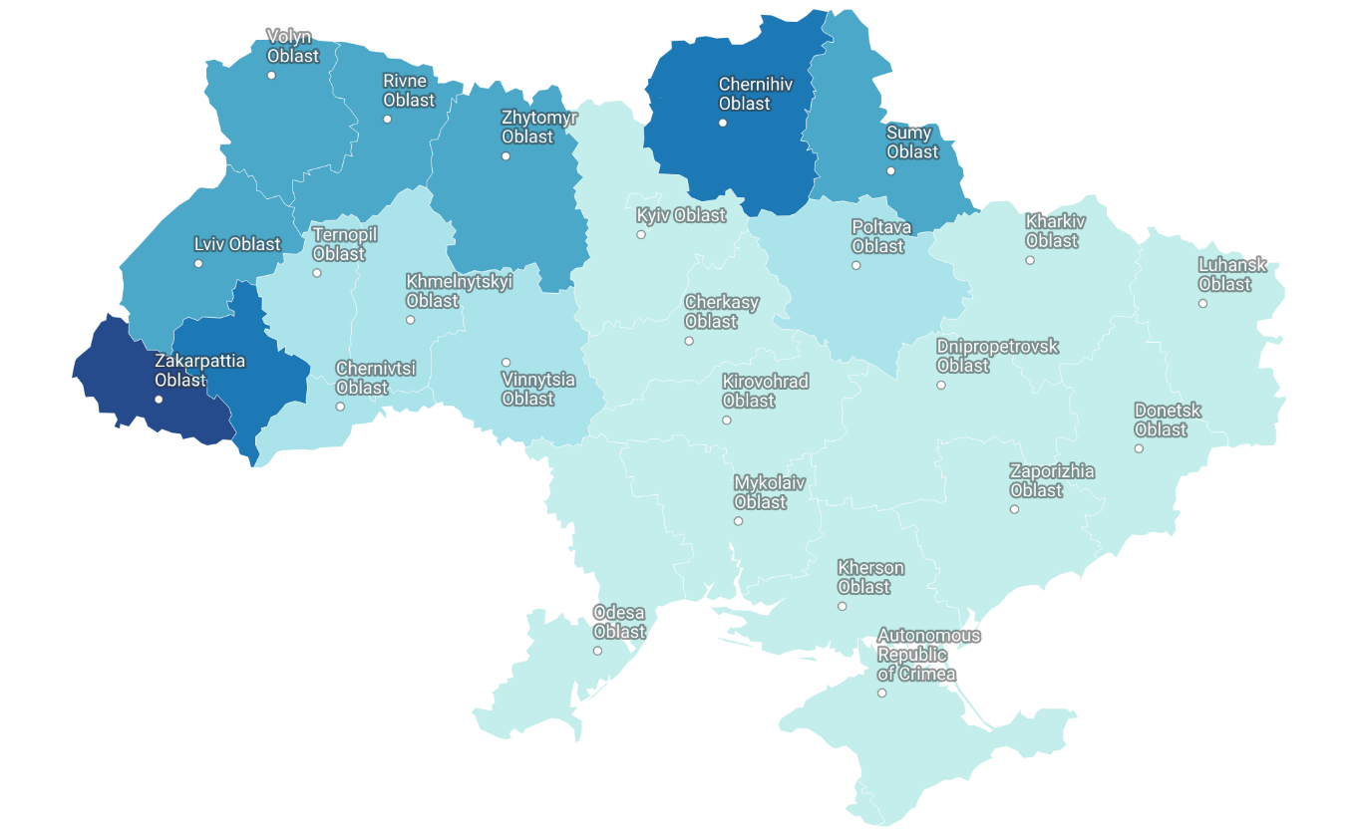
Fig. 2. Coefficient of Ukraine's provision of water resources, thousand m³/year per person in terms of administrative regions (as of 2020)*
*created by authors based on data (Ekodia – Center for Environmental Initiatives, 2022)

During the war, more than 500 water infrastructure facilities were destroyed, and the volume of water lost due to damage and destruction of dams and other hydrotechnical structures was 742.2 million m³. In any industrial region, military action poses a significant environmental hazard. Intentional or even inadvertent damage to production facilities, infrastructure, or storage sites for industrial waste can become a source of environmental disaster (Ukraine conflict environmental briefing: Water, 2022).
During the period from 2014 to the beginning of the full-scale invasion of Russia on the territory of Ukraine in the Donbass, at least 577 cases of disruption of the work of industrial enterprises related to hostilities were recorded, of which 477 cases (78%) occurred during the period of the most active hostilities in 2014-2016 years (Ukraine conflict environmental briefing: Water, 2022). Among them were the most ecologically dangerous, in particular: Yasynivskyi, Avdiivskyi, and Yenakiivskyi coke plants, Yenakiivskyi, Alchevskyi, and Donetsk metallurgical plants, Toretsky ferroalloy plant, "Styrol", Luhansk, Vuglegirsk, and Myronivsk TPPs (Fig. 3).
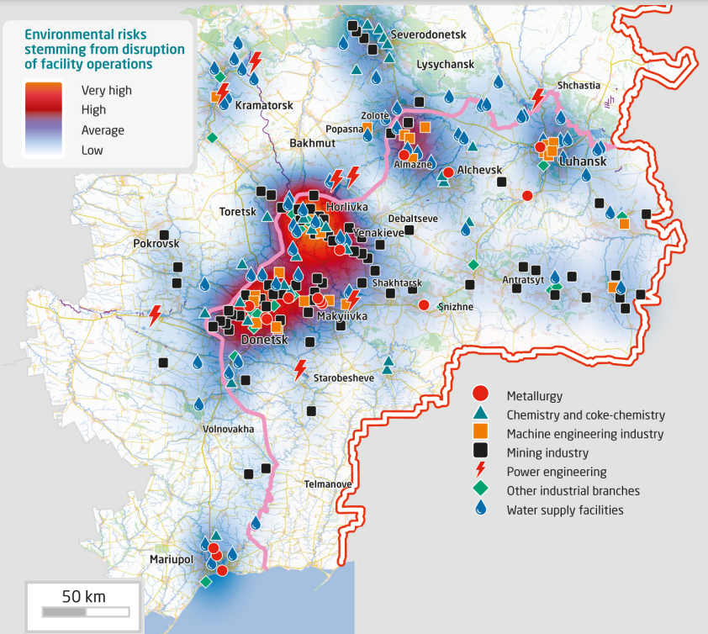
Fig. 3. Potential environmental risks in case of disruption of industrial enterprises in Donbas (Ukraine conflict environmental briefing: Water, 2022)

The level of such threats is several times lower after a full-scale invasion since the hostilities are taking place in the east and south of our country, which have always been industrially developed. The nuclear power plants (Chernobyl and Zaporizhzhya) became one of the most controversial and potentially dangerous facilities.
Due to active hostilities on the territory of Ukraine and due to constant Russian attacks on critical infrastructure, water facilities suffer, in particular:
- The water supply and drainage system is violated, which is a direct threat to the pollution of rivers, which are the main source of water for people and enterprises;
- In the war zone, restoring the water supply system is very difficult. That happens after a rather long period, so the condition of drinking water deteriorates significantly;
- The ingress of ammunition, explosive substances, and military equipment into water bodies and the territory of river basins causes pollution associated with metal oxidation;
- Pollution of water bodies also occurs due to the destruction of sludge storage facilities, tailings storage facilities, and landfills, which threatens water pollution and emergencies in the regions;
- The flooding of mines in the territory not controlled by Ukraine and the stopping of drainage works by the occupiers carries the threat of landslides, the release of groundwater to the surface, and the contamination of drinking water sources;
- Large-scale spills of oil products and other harmful substances significantly worsen the condition of both water and soil.

Such actions by Russia and Belarus grossly violate the UNECE International Convention "On the Protection and Use of International Watercourses and International Lakes". After all, before the start of the war, all activities related to using transboundary watercourses were regulated and carried out based on bilateral agreements concluded between Ukraine, Russia and Belarus, which have now lost their validity.
Thus, the risks arising from damage to infrastructure, communications, industrial enterprises, etc., which are potentially environmentally dangerous, are highly significant since the lack of access to these objects makes it impossible to eliminate the negative consequences of incidents. Therefore, the scale of such impacts every day is increasing.
During the period of military operations in Donbas since 2014, and especially after the full-scale invasion of Russia, numerous damage to hydraulic structures were recorded, particularly pipelines and sewer pipes, water towers, pumping stations, etc. One of the clear examples of this is the territory of Popasnaya near Bilogorivka, which the enemy repeatedly targeted. As a result, the filter station, lifting station and electrical equipment were damaged.
At least four dams and reservoirs were directly destroyed. The Oskil reservoir on the Siverskyi Donets River near Izyum was destroyed on March 31, 2022. The reservoir, the eighth in Ukraine in terms of size, was emptied, causing the water level in the lower reaches to rise (Ukraine conflict environmental briefing: Water, 2022).
The destruction of hydrotechnical structures not only impedes water supply but also creates direct threats to the hydro-ecological state of water bodies.
One of the problems that lead to direct water pollution and deterioration of the hydro-ecological condition of rivers is damage to sewage treatment facilities. Such cases were recorded in Chernihiv, Mariupol, Mykolaiv, Skadovsk, Sloviansk and Vasylivka. The water treatment facilities of the Severodonetskvodokanal, Lysychanskvodokanal, Rubizhne Vodokanal, and Popasna Vodokanal utilities were damaged. Because of this, untreated wastewater from Severodonetsk, Lysychansk, Rubizhny, Popasnaya and part of Zaporizhzhia pollutes water resources.
For example, on March 14, 2022, water from several districts of the city of Zaporizhzhia entered the Dnieper without treatment due to a Russian weapon hitting wastewater treatment facilities in the village of Verkhnya Krynytsia, Zaporizhzhia region.
In addition, the destruction of wastewater treatment facilities will increase the surface runoff of polluting material into water bodies throughout Ukraine.
Moreover, water infrastructure has often been the focus of attention for its strategic or military use. Among the most striking examples is the Kakhovskaya HPP, which the invaders captured at the beginning of the full-scale invasion. That is because the confluence of the North Crimean Canal with the Dnieper is located here. Since the channel has always been the main source of water supply to the Crimean Peninsula and was blocked by the Ukrainian side after the illegal annexation of the autonomous republic by Russia in 2014, the capture of the hydroelectric power station was of strategic importance for the occupiers (Ukraine conflict environmental briefing: Water, 2022).
On February 26, 2022, the dam between the Irpin River and the Kyiv Reservoir was damaged. As a result of the incident, a large volume of flood waters was concentrated in the valley of the Irpin River, which led to the flooding of such settlements as Demydiv and Kozarovychi.
The Irpin River has been significantly regulated and has undergone hydro-technical construction since the 1950s. It will be necessary to pump water to a height of more than three meters into the Kyiv Reservoir to overcome the consequences of the dam collapse. Since there is such a large height difference between the Irpin River and the Kyiv Reservoir, this led to the rapid flooding of the territory in the river valley after the dam's destruction (Fig. 4).
Undoubtedly, pollutants from abandoned and destroyed military equipment and ammunition also enter the flood waters. In addition, a significant area of agricultural land will be flooded, the water level will decrease, and the soil will be contaminated with heavy metals and PAHs. Any soluble fertilisers and pesticides can now also be dissolved in water.
After the de-occupation of the region and demining of the territory, a bridge over the Irpin River was rebuilt. In addition, the restored pumping station is already working at full capacity. In July 2023, the restoration of the damaged lock of the destroyed dam across the Irpin River in Demydovo was started.
The wetlands along the Irpin are noted for their biodiversity and a protected area as part of the Emerald Network. In this regard, creating a landscape reserve of local importance, "Hero Irpin River", has already begun.

a) b)
Fig. 4. The condition of the floodplain of the Irpin River during the invasion of the Russian Federation in Ukraine in 2022: a) before the detonation of the dam at the confluence of the Irpin River in Kyiv Reservoir on the Dnieper
– the floodplain is not flooded; b) after undermining this dam – the floodplain is flooded

The strategic destruction of bridges leads to an increase in the level of pollution and disrupts the flow of rivers. The Antoniv highway bridge is one of the largest bridges destroyed due to Russian aggression. At least 50 more bridges were destroyed.
One of the potential threats is also the actions of the occupation authorities in the territories not controlled by Ukraine. In particular, an ecological problem appeared in the temporarily occupied Mariupol, due to the thoughtless actions of the occupation authorities and the dismantling of the artificial hydrotechnical structure, the Kalchyk River. After all, due to the destruction, the flow speed in the river slowed down, and the water acquired an unusual colour. In addition, a characteristic unpleasant smell spread.
Thus, considering the impact of military actions on residential, industrial and economic facilities, it is worth noting that all surface runoff on the territory of Ukraine has undergone significant pollution. The key incidents of destruction and damage to hydraulic structures are shown in Table 1.

Table 1. Key incidents of destruction and damage to hydrotechnical structures in 2022-2023*
Date | Objects | Consequences of military action
26.02.22 | Kyiv Reservoir and HPP | Ukrainian air defence forces shot down a rocket of Russian troops directed towards the dam of the Kyiv Reservoir and HPP in the north of Kyiv. Dam failure would cause flooding and inundation of large areas.
27.02.22 | North Crimean Canal | The temporary dam, the bridge and the main barrier structure No. 1 of the North Crimean Canal were destroyed. As a result of the partial depressurisation of the hydraulic structure by the occupiers, illegal water withdrawal is carried out from the Kakhov reservoir.
05.03.22 | Wastewater treatment facilities  in Donbas | As a result of hostilities by the troops of the Russian Federation,  the infrastructure facilities of the water management complex were damaged, in particular, the wastewater treatment facilities "Severodonetskvodokanal", "Lysychanskvodokanal", "Rubizhne Vodokanal", "Popasna Vodokanal". Thus, the wastewater treatment process was stopped, and raw sewage got into water bodies.
10.03.22 | Kakhov reservoir | Information was received from Energoatom about the seizure by the troops of the aggressor of the Zaporizhzhya NPP and the mining of the coast of the Kakhov reservoir, which is located on the border with the nuclear power plant.

Table 1. cont.
Date | Objects | Consequences of military action
11.03.22 | Wastewater treatment facilities "Mariupol Production Department of Water Supply and Sewerage" | Due to an extremely large number of rocket attacks and the siege  the water supply and drainage systems of Mariupol were damaged, making it impossible for the "Mariupol Production Department of Water Supply and Sewerage" to function normally.  As a result of the incident, untreated wastewater entered the waters of the Sea of Azov.
14.03.22 | Facilities for wastewater treatment of the Vasylivsk  operational workshop | As a result of shelling by the troops of the Russian Federation in the village of Verkhnya Krynytsia of the Zaporizhzhia region suffered destruction of the premises and arrangement of sewage pumping station No. 1. Sewage without treatment freely entered the Dnipro River.
 | Pumping station "Chernigivvodo-kanal" | The water treatment plant, which provides water intake, purification and supply of water in the territory of the entire Chernihiv region, was damaged due to military aggression. That caused contamination of water resources of the region with dangerous substances.
26.03.22 | Lviv Oil Base | Due to the shelling of the oil depot in Lviv, a significant amount of oil products got into the Western Buh River. That led to the pollution not only of water bodies of Ukraine but also created threats to the geoecological state of transboundary water bodies.
22.05.22 | Samara River | As a result of enemy rocket fire in the Pavlograd district of the Dnipropetrovsk region, one of the rockets fell into the Samara River.
27.06.22 | Tank with ammonia (near the villages  of Velika and Mala Oleksandrivka,  Kherson region) | In the temporarily occupied territories near the settlements of Velika and Mala Oleksandrivka, an ammonia tank was damaged as a result of hostilities. As a result of the leakage, pollutants entered the soil and seeped into the groundwater.
05.07.22 | Water tower (Dubove village, Khmelnytskyi region) | There was a missile attack on the territory of the Khmelnytskyi region. The water tower, whose operation ensures water supply for the entire territorial community, was under the crosshairs.
24.07.22 | Karlivsk filter station | As a result of the hostilities, power was cut off at the Karlivka filter station in the Donetsk region. Due to this, untreated water entered  water bodies.
13.08.22 | Karlivsk filter station | Repeated power outages at the Karlivska station and continuous shelling make repair work impossible.
15.08.22 | Lakes  of Severodonetsk | The city's military-civilian administration reported that the lakes in the temporarily captured Severodonetsk are rapidly drying up. It is noted that lakes Chiste and Parkove, which served as a place for townspeople to relax, have already shrunk many times.
14.09.22 | Karachuniv reservoir | The Russian military launched a missile attack on Kryvyi Rih and damaged the hydraulic facilities of the Karachuniv Reservoir. Due to the attack, the water level in various sections of the Ingulets River rose to almost 2 meters. 112 houses were flooded. People were evacuated, in particular from Gdansk and Motronivka. Аlmost 5,000 people are without water in the Sofiyiv community. The water in the river was characterised by a high degree of colour, in particular, it acquired a red and brown colour. Among the possible causes of this colour is the presence of iron and hematite minerals in the soils.
21.09.22 | Pecheneg reservoir | With shelling, Russian troops damaged the upper lock of the Pecheneg reservoir in the Kharkiv region. There remains a threat of the destruction of the dam of the Pecheneg hydroelectric junction, which could lead to catastrophic flooding of the territories downstream.
Table 1. cont.
Date | Objects | Consequences of military action
24.09.22 | Southern Buh | Russian missiles fell into the waters of the Southern Buh River.
27.09.22 | Mykolaiv city  water supply | As a result of enemy shelling, the water main in Mykolaiv was damaged. Due to the loss of a large volume of water, there is no water supply in the central part of the city, and other areas are supplied with reduced pressure.
5-6.10.22 | Karliv reservoir | The Russians shelled the dam of the Karliv reservoir in the Donetsk region. On October 6, during the chaotic retreat, Russian troops blew up the dam, which caused the settlement of Raihorodok to flood.
9-11.11.22 | Вridges of the Kherson region | In the temporarily occupied part of the Kherson region, the Daryiv bridge across the Ingulets River the Tyagin and Novovasyliv bridges, were blown up.
12.11.22 | Dam in Nova Kakhovka | The Russian occupiers blew up the dam in Nova Kakhovka to complicate the offensive of the Armed Forces.
28.11.22. | Pumping station  of MKP Mykolaivvodokanal | Mykolaiv was once again left without drinking water after Russian terrorists damaged the pumping station of the Mykolaivvodokanal MCP located in the Kherson region.
12.12.22 | Bridge over the Molochna River | In the evening, information was received about undermining the road bridge over the Molochna River in Melitopol.
30.04.23 | Water supply  of Konstantinovka | The Russians shelled Kramatorsk and Kostiantynivka with rockets  at night. In Konstantinovka, 10 houses and an infrastructure facility were damaged. There is a partial lack of water supply in the city.
06.06.23 | Kakhovskaya HPP | Around 2:50 in the morning, the Kakhovka hydroelectric power  station was destroyed. The Kakhovskaya HPP dam was most likely mined and blown up, which led to its destruction.
22.06.23 | Water pipeline  of Kherson  and Antonivka | In the morning, Russian troops struck the residential quarters of Kherson and Antonivka. Residential buildings were on fire, water pipes, gas pipes and critical infrastructure were damaged.
*compiled by authors based on data (Ministry of Environmental Protection and Natural Resources of Ukraine, dateless), (Ukraine conflict environmental briefing: Water, 2022).

On June 6, 2023, Russian aggressors blew up the Kakhovskaya HPP dam (Nova Kakhovka), committing the largest act of ecocide during the period of the full-scale invasion of Ukraine. The territories of 48 settlements were flooded in the Kherson region, and 23 in Mykolaiv region. The population was evacuated (Fig. 5).
At least 150 tons of lubricant reached the Dnipro River. The estimated damage to water resources is approximately UAH 2 billion. It does not consider the damage to the nature reserve fund, soils, biodiversity, forests and other natural resources. The amount will only increase (Khilchevskyi et al. 2023).
The undermining of the Kakhovsky Reservoir dam called into question the possibility of supplying Dnieper water to Crimea. The North Crimea channel, through which it reaches the peninsula occupied in 2014, originates a few hundred meters near the destroyed dam (Khilchevskyi et al. 2023).
A significant problem is also the pollution of rivers, reservoirs and reservoirs of Ukraine with mines and explosive objects, the coastal waters of the Azov and Black Seas, hydrotechnical structures and seaports. The total area of water areas of Ukraine potentially contaminated with explosive objects is about 16 thousand square kilometres. Getting equipment into rivers and lakes is also dangerous because metal oxidation can lead to water pollution.
Fires from explosions of shells and rockets lead to the destruction of ecosystems of Ukrainian reservoirs and watercourses. After all, it is extremely dangerous for combustion products to enter the water from fires resulting from hostilities, detonation of shells, destruction of military equipment, etc. Taht is explained by the fact that there is an emission of complex polycyclic compounds, most of which are carcinogens and poison (What Russia does with Ukrainian rivers during the war, 2022).
Other pollution hotspots are linked to the conduct of conflict, such as contested river crossings where large volumes of damaged vehicles are present.

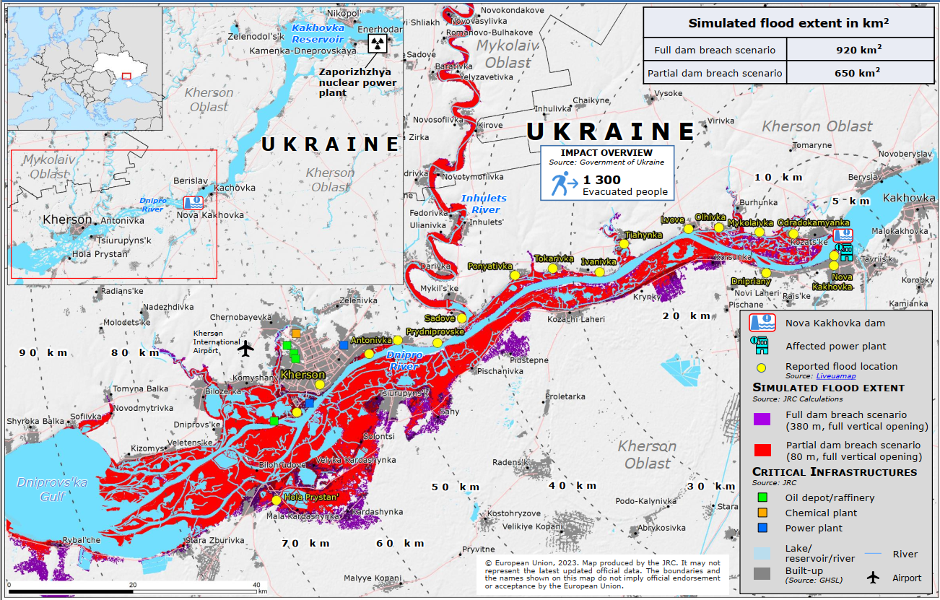
Fig. 5. The flooding zone of the territory below the blown-up dam of the Kakhovsky reservoir in the lower reaches of the Dnipro (Ukraine. Nova Kakhovka Dam breach, 2023)

Pollution from destroying buildings, industry, and military equipment can enter floodwaters through surface runoff. Damaged military vehicles and equipment emit harmful pollutants, including heavy metals, motor oil and fuel, persistent organic pollutants such as polycyclic aromatic hydrocarbons (PAHs) and polychlorinated biphenyls (PCBs), and explosives that have varying degrees of toxicity and environmental sustainability.
Among the most significant processes that potentially worsen the hydro-ecological state of water bodies is the flooding of coal mines that are located in the territory not under the control of the government of Ukraine and have hydraulic connections with adjacent mines located in river basins in the controlled territory (The Artery of the East of Ukraine, 2021).
Mines flooded by the occupiers in Donbas can cause an ecological disaster. Even before the full-scale invasion of the Russian Federation, the mines in the occupied territories were almost 100% inactive. But even if coal mining is no longer carried out, water must be pumped out of the tunnels, and the invaders did not do this.
The arrival of additional volumes of water from flooded to operating mines can cause an emergency shutdown of the latter's drainage systems and, on a larger scale, lead to their complete flooding.
At least 39 mines of Donbas are flooded or are already completely flooded and are not subject to further operation due to the termination of energy supply, destruction of infrastructure, the dismantling of pumping equipment, etc. Some of them contain dangerous substances.
Within the territories adjacent to the flooded minefields, there is a risk of developing zones of inundation of built-up areas and agricultural lands, as well as changes in the chemical composition of underground and surface water towards deterioration. Mines used to store hazardous waste, such as Oleksandr Zahid, which is already more than two-thirds flooded, pose a particular danger to water bodies. The most difficult situation has developed within the boundaries of the Toretsk-Yenakiiv mining and industrial agglomeration (Donetsk region) and the Almazno-Mariv coal-mining district.
One of the objects of increased danger for water bodies is tailings – complex water management engineering structures, accumulators of multi-tonnage liquid waste from various industries with long-term functionality, which are not only under the influence of the natural environment but also many socio-political and economic factors (The Artery of the East of Ukraine, 2021). According to available official information, only in the Luhansk and Donetsk regions, there are 200 tailings storage facilities, which contain up to 939 million tons of industrial waste.
During the period of martial law, in the process of monitoring the quality of surface water, the State Water Resources Agency of Ukraine (State Agency of Water Resources of Ukraine, 2022) and the State Environmental Inspection (State Environmental Inspection of Ukraine, 2022) recorded cases of pollution and, accordingly, exceeding certain indicators from the norms.
In April 2022, the State Ecological Inspectorate (State Environmental Inspection of Ukraine, 2022) published the results of a study of surface water samples in the Ikva River in the Rivne region, which was polluted upstream due to the damage of a tank with mineral fertilisers in the north of the Ternopil region by fragments of a Russian missile. According to the results of the detailed analysis, water samples at two sampling points showed deviations from the norms: ammonium – 163 times near the village of Bereg; nitrites – 7 times near the village of Sapanovchyk; nitrates – 49.7 times near the village of Sapanovchyk; total iron – 7.4 times near the village of Bereg; biological oxygen consumption – 1.9 times near the village of Sapanovchyk (State Environmental Inspection of Ukraine, 2022).
In June and July 2022, in the Siversky Dоnetsk basin, where drinking water for the entire Donetsk region is taken, experts recorded mercury pollution, excess nitrogen and nitrite indicators, as well as traces of petroleum products, which had never been recorded there before (State Agency of Water Resources of Ukraine, 2022). In particular, in July, an 8.4-fold excess of mercury concentration was found at the mouth of the Sukhy Torets River (0.59 μg/dm³ against the permissible 0.07 μg/dm³) (State Agency of Water Resources of Ukraine, 2022). In June 2022, in drinking water intake near Sloviansk, ammonium nitrogen and nitrites were found in water samples 2.4 and 2.8 times higher than the average long-term values (State Agency of Water Resources of Ukraine, 2022). These are signs of inefficient operation of treatment facilities.
Oil products were also detected in the water at a concentration of 0.028 mg/dm³ (State Agency of Water Resources of Ukraine, 2022). In previous years, they were not found at all in the areas of surface drinking water intakes of Siversky Dinets. Thus, in the sub-basin of the Siverskyi Donets River, the exceedance of environmental quality standards for such dangerous substances as pesticides, polyaromatic hydrocarbons, volatile organic compounds and heavy metals was recorded. These are probably the consequences of the battles along the main river of the Ukrainian East.
Priority practical steps necessary for post-war recovery in the field of water resources include:
- Restoration of all critical infrastructure of the water management complex, which has an impact on water resources;
- The attraction of international investors for the reconstruction of the water management complex and cooperation with international companies specialising in the field of water resources;
- Restoration of water quality monitoring throughout the territory of Ukraine;
- Systematic biochemical analysis of water samples from water bodies in all occupied and de-occupied regions of the country;
- Compliance with all requirements of the EU Water Framework Directive, transition to European standards;
- Creation of volunteer organisations for cleaning up garbage (domestic and military) and cleaning both the waters themselves and the coastal area;
- Stabilisation of the ecological balance of water bodies and restoration of their biodiversity.
5. Conclusion
As a result of the ongoing armed conflict in Ukraine, the entire system of natural resources, including surface and underground waters, has been affected. During the war, more than 500 water infrastructure facilities were destroyed, and the volume of water lost due to damage and destruction of dams and other hydrotechnical structures is 742.2 million m³. Since 2014, at least 577 cases of disruption of the work of industrial enterprises related to hostilities have been recorded in Donbas.
Potential pollutants in flooded communities include wastewater from household toilets, fuel and lubricants from gas stations, building materials from construction sites, paint from metalworking, and heavy metals from electrical infrastructure. One of the problems that leads to direct water pollution and deterioration of the hydro-ecological condition of rivers is damage to wastewater treatment facilities (Chernihiv, Mariupol, Mykolaiv, Skadovsk, Sloviansk, Vasylivka, Rubizhne, Popasna, Severodonetsk, Lysychansk). There are many cases when water infrastructure was used for military or strategic purposes (for example, the capture of Kakhovskaya HPP). The strategic destruction of bridges leads to an increase in pollution and disrupts river flow (for example, the Antoniv highway bridge).
Pollution of rivers (16 thousand km²) by mines and explosive objects is also a significant problem. It is extremely dangerous for combustion products to enter the water from fires resulting from hostilities, detonation of shells, destruction of military equipment, etc. Damaged military vehicles and equipment emit harmful pollutants, including heavy metals, motor oil and fuel, persistent organic pollutants such as polycyclic aromatic hydrocarbons (PAHs) and polychlorinated biphenyls (PCBs), and explosives that have varying degrees of toxicity and environmental sustainability. At least 39 mines of Donbas are flooded or are already completely flooded and are not subject to further operation due to the termination of energy supply, destruction of infrastructure, the dismantling of pumping equipment, etc. Some of them contain dangerous substances.
The ways of recovery are proposed: restoration of the critical infrastructure of the water sector, the attraction of investors, systematic biochemical analysis of water, cleaning up war debris with the help of volunteers, and attracting reparations to the water sector.
References
The Artery of the East of Ukraine. Summary of the analysis of the problems of the Siverskyi Donets and the program of measures to solve them. Kyiv, 2021. 102 с. (in Ukrainian).
Scorched land and polluted water: catastrophic environmental consequences of Russia's war against Ukraine. (2022, June 30). Retrieved from https://www.radiosvoboda.org/a/ekolohichna-katastrofa-cherez-viynu-rosiyi/31921705.html (in Ukrainian) (2022, December, 05)
Palamarchuk, M.M., Zakorchevna N.B. (2001). Water Fund of Ukraine. Nika-Tsentr. (in Ukrainian).
Danylchenko, А. (2018). Environmental threats of military operations in Donbas. Environmental consequences of military actions: materials of a scientific and practical conference (April 17-18, 2018, Kyiv), 88-91. National Pedagogical Dragomanov University (in Ukrainian).
State Environmental Inspection of Ukraine. Retrieved from https://www.dei.gov.ua/ (in Ukrainian). (2022, December, 15).
State Agency of Water Resources of Ukraine. Retrieved from https://www.davr.gov.ua/news/vsesvitnij-den-monitoringu-yakosti-vodi--2022 (in Ukrainian) (2022, December, 18).
Ekodia – Center for Environmental Initiatives. Retrieved from https://ecoaction.org.ua/ (in Ukrainian) (2022, November, 19).
Ivaniuta, S.P. (2017). Environmental and man-made threats in the military conflict zone in Eastern Ukraine. Strategic Panorama, (1), 53-60 (in Ukrainian).
Khilchevskyi, V., Zabokrytska, M., Stelmakh, V. (2023). Hydroecological aspects of water supply and sanitation. DIA (in Ukrainian).
Klymenko, V.G. (2010). Hydrology of Ukraine. V.N. Karazin Kharkiv National University. (in Ukrainian).
Hrebin, V.V., Khilchevskyi, V.K., Stashuk, V.A., Chunarov, O.V., Yaroshevych, O.Ie. (2014). Water Fund of Ukraine: Artificial reservoirs – reservoirs and ponds. Interpres. (in Ukrainian).
Klymenko, М.О., Klymenko, О.M., Petruk, A.M. (2013). Hydro-ecological monitoring of water ecosystems in view of modern European trends in environmental protection activities. Bulletin of Poltava State Agrarian Academy, (3), 22-27 (in Ukrainian).
Lisova, N.O. (2017). The influence of military actions in Ukraine on the ecological state of the territory. The Scientific Issues of Ternopil Volodymyr Hnatiuk National Pedagogical University. Series: Geography, (2), 165-173 (in Ukrainian).
Malko, O.D. (2019). Man-made threats in the zone of military operations in the East of Ukraine. Problems of technological and environmental safety: Education, science, practice (2019, November 21-22, Kharkiv), 43-45. National University of Civil Defense of Ukraine (in Ukrainian).
Ministry of Environmental Protection and Natural Resources of Ukraine. Retrieved from https://mepr.gov.ua/ (in Ukrainian) (2022, December, 17).
Five years of hostilities in the East of Ukraine: Ecological aspects in infographics. (2020, February, 3). Organisation for Security and Cooperation in Europe | OSCE. Retrieved from https://www.osce.org/uk/project-coordinator-in-ukraine/445369 (in Ukrainian) (2022, December, 10).
Rivers of Ukraine. Retrieved from https://river.land.kiev.ua (in Ukrainian) (2022, October, 27).
Shumilova, O., Tockner, K., Sukhodolov, A., Khilchevskyi, V., Meester, L.D., Stepanenko, S., Trokhymenko, G., Hernández-Agüero, J.A., Gleick, P. (2023). Impact of the Russia-Ukraine armed conflict on water resources and water infrastructure. Nature Sustainability, (6), 578-586 (in English).
Schillinger, J., Özerol, G., Güven-Griemert, S., Heldeweg, M. (2020). Water in war: understanding the impacts of armed conflict on water resources and their management. WIREs Water, (7), e1480 (in English).
Stelmakh, V.Y., Melniichuk, M.M. (2022). Hydrography of Ukraine: Lecture notes. Lutsk. Private Entrepreneur Ivanyuk V.P. (in Ukrainian).
Tymoshenko, N.V. (2017). Environmental consequences of hostilities in the area of the anti-terrorist operation. Rule of law: history, modernity and prospects of formation in Ukraine (2017, January 27, Dnipro), 123-125. Dnipropetrovsk State University of Internal Affairs. (in Ukrainian).
Gnenny, К., Reshchuk, К. (2022). Ukraine liberated 40% of the territories occupied after February 24. Forbes.ua | Business, billionaires, news, finance, investments, companies. Retrieved from https://forbes.ua/war-in-ukraine/ukraina-zvilnila-40-okupovanikh-pislya-24-lyutogo-teritoriy-kontrnastup-zsu-v-tsifrakh-14112022-9743 (in Ukrainian) (2022, December, 16).
What Russia does with Ukrainian rivers during the war: 6 million people do not have water because of the war. (2022, 30 вересня). Open Dnister. Retrieved from https://dnister.in.ua/articles/239825/scho-rosiya-robit-z-ukrainskimi-richkami-pid-chas-vijni-6-miljoniv-lyudej-cherez-vijnu-ne-mayut-vodi (in Ukrainian) (2022, November, 28).
Ukraine conflict environmental briefing: Water. (September, 2022). CEOBS. Retrieved from https://ceobs.org/ukraine-conflict-environmental-briefing-water/ (in English) (2022, December, 13).
Ukraine. Nova Kakhovka Dam breach – DG ECHO Daily Map (2023, June, 06). ReliefWeb. Retrieved from https://reliefweb.int/map/ukraine/ukraine-nova-kakhovka-dam-breach-dg-echo-daily-map-06062023 (in English) (2023, June, 10).
Pereira, P., Bašić, F., Bogunovic, I., Barcelo, D. (2022). Russian-Ukrainian war impacts the total environment. Sci Total Environ., 837, 155865. https://doi.org/10.1016/j.scitotenv.2022.155865. Epub 2022 May 13. PMID: 35569661. (in English).
Khilchevskyi, V.K. (2021). Modern characteristics of surface water bodies of Ukraine: watercourses and reservoirs. Hydrology, hydrochemistry and hydroecology, 1(59), 17-27. https://doi.org/10.17721/2306-5680.2021.1.2.
Hrebin, V.V., Khilchevsky, V.K. (2016). Retrospective analysis of studies of the river network of Ukraine and the application of the river typology of the EU Water Framework Directive at the current stage. Hydrology, hydrochemistry and hydroecology, (2), 32-47.
Hrebin, V.V., Khilchevsky, V.K. (2021). Large and small reservoirs of Ukraine: regional and basin features of distribution. Hydrology, hydrochemistry and hydroecology, 2(60), 6-17. https://doi.org/10.17721/2306-5680.2021.2.1.
Yatsyk А.V. (Ed.). (1991). Small rivers of Ukraine. Urozhai. (in Ukrainian).
Khilchevskyi, V.K., Obodovskyi, O.H., Hrebin, V.V. (2008). General hydrology. VPTs «Kyivskyi universytet» (in Ukrainian).

