 | Rocznik Ochrona Środowiska
 | Volume 25 | Year 2023 ISSN 2720-7501 | pp. 159-173
 | https://doi.org/10.54740/ros.2023.016 open access
 | Received: June 2023 Accepted: August 2023 Published: August 2023
Analysis of Rheological Properties of Cement Composites Based on Waste Materials
Mateusz Zakrzewski¹, Jacek Domski²
¹Faculty of Civil Engineering, Environmental and Geodetic Sciences, Koszalin University of Technology, Poland
https://orcid.org/0000-0002-0419-5058
²Faculty of Civil Engineering, Environmental and Geodetic Sciences, Koszalin University of Technology, Poland
https://orcid.org/0000-0002-5112-1035
*corresponding author's e-mail: mateusz.zakrzewski@tu.koszalin.pl, jacek.domski@tu.koszalin.pl
Abstract: This report presents the results and analysis of long-term properties of fiber-reinforced cement composite based on waste aggregate. The long-term tests were carried out on the stand proposed by the authors for simultaneously testing three beams with dimensions of 100x200x2900 mm. A total of 8 mixtures of cement composites with aggregate from ceramic waste and waste sand were tested. Three beams were made for each mixture. One without dispersed reinforcement and two with 0.5% and 1.0% fiber reinforcement ratios. As dispersed reinforcement, steel cord and hooked steel fibers were used. The beams were subjected to a four-point bending test. The research was carried out for 1000 days. An optical system was used as an innovative solution in long-term research. Based on the measurements, the creep coefficient in the mid-span of the beams was determined, and the crackings of the beams were analysed. The results obtained using manual measuring devices and the optical system were compared. A good convergence of measurement methods was observed. During the analysis of the results, the coefficients modifying the method for calculating the crack width included in Eurocode 2 were determined.
Keywords: cement composites, creep, steel cord, fiber-reinforcement concrete, long-term study, concrete beams,
waste aggregate, waste fibers, crack
1. Introduction
We should prioritise protecting the environment first. Hence, we should have an impact on the sensible utilisation of mineral deposits. Use them as little as feasible. This idea ought to be applied to construction as well. There are numerous publications where the researchers advocate using waste materials instead of conventional building materials (Contreras-Marín et al. 2021, Hosseini 2020, Kim & Choi 2012, Kong et al. 2022, Pappu et al. 2007, Şahan Arel 2016, Seitl et al. 2019, Shafigh et al. 2014). The production of cement composites based on waste materials offers many possibilities for the utilisation of various types of materials. Scientists are developing materials in which natural aggregate is replaced with waste (Awoyera et al. 2018, Babafemi et al. 2022, Saikia & de Brito 2014) or waste is used as concrete additives (Singh Shekhawat & Aggarwal 2007, Zhu et al. 2016) or dispersed reinforcement (Al-Tikrite & Hadi 2017, Borhan et al. 2020, Khaloo et al. 2015). From the point of view of using cement composites based on waste materials in structural elements, a significant issue is the behaviour under load over time. In order to maintain the serviceability limit states, it is necessary to precisely predict the deflection and crackings of element made of cement composites. For this reason, it is also necessary to determine the shrinkage and creep of these materials. All these features are not yet sufficiently tested to be able to design optimised structures. Knowledge of these features will allow for a more accurate prediction of the behaviour of the structure over time. Considering current trends, the share of building materials using recycled waste will increase. The use of substitutes for coarse aggregate is important for the Authors' region. There are large deposits of natural aggregates in north-western Poland. They are mostly fine sands. Coarse aggregate is obtained in the process of hydroclassification (Głodkowska et al. 2013, Laskowska-Bury 2009). As a result of this process, significant amounts of sand are generated, which are currently difficult to manage. The best example of this is Pomorska Góra Piasku. It is an artificial hill made of waste sand, about 600 m long and about 200 m wide. At its highest point, it reaches a height of 66 m. The hill was created as a result of many years of aggregate extraction. According to estimates, 8 million tons of sand are in the heap.
Scientists less frequently perform research on the rheological properties of cement composites due to the long period of research. Most often, tests are performed for a period of less than one year (Alrshoudi et al. 2020, Domingo et al. 2010, Nakov 2017) or a period between 400-1000 days (Gayarre et al. 2019, Seara-Paz et al. 2016, Zakrzewski et al. 2023). Less frequently, studies are conducted longer (Tan & Saha 2005). The basic test of rheological properties is the determination of creep in the state of axial compression and contraction. These tests are carried out in simple devices in which cylindrical or cuboidal samples are located, and the measurement is usually carried out using manual devices. In publications on the long-term properties of concretes and cement composites, there are many interesting proposals to study these properties based on elements on a natural scale. Selected studies are presented in Table 1, where test parameters are compared. The common feature of the presented studies is that the four-point bending scheme was used. In the mentioned tests, the loading method with concrete elements using their mass is dominant. Peng et al. used an unusual loading method (Peng et al. 2021). The load was carried out by bolting two beams with steel bolts at both ends. In these tests, traditional top and bottom reinforcement was used in all cases except Miàs (Miàs et al. 2013) and Chen (Chen et al. 2020). What distinguishes the research presented in this article is using only tensile reinforcement to better observe the impact of waste aggregate creep on the beams' compression zone. In the research proposed by the authors, a system with a lever was used. The advantage of this solution is that the deflection of the beams does not reduce the load and does not require large-sized elements. Tests on elements similar in shape and dimensions to real constructions give the best results necessary to evaluate the calculation methods and determine the materials' rheological properties.

Table 1. Parameters of long-term tests of concrete beams on a natural scale
Authors | Beams dimensions [mm] | Force spacing | Span | Total number of tested beams (only long-term) | Number of beams  in one testing stand | Longitudinal reinforcement | Strirrups | Aggregate | Test duration
(Hong & Park 2016) | 200x300x2700 | 200 | 2400 | 3 | 1 | Comp. 3D13  Tens. 3D10 | 10 mm | Natural | 550 days
(Chen et al. 2020) | 150x300x3000 | 1300 | 2700 | 8 | 1 | Comp. no bars  in mid span.  Tens. Different | 10 mm (only in shear-span) |  | Average  245 days
(Vasanelli et al. 2014) | 250x250x3000 | 900 | 2800 | 10 | 5 | Comp. 3D14 Tens. 2D14 | 8 mm |  | 17 monts  1 stand, second still cont.
(Miàs et al. 2013) | 140x190x2450 | 800 | 2250 | 20 | 1 | Only Tens.  GFRP bars  2#D12 or 2D16  or Steel bars 2D10 | 8 mm  (only in shear-span) |  | 250-700 days
(Tan & Saha 2005) | 200x300x3300 | 450 | 1800 | 10 | 1 | Comp. 2D6 Tens. 2D10 | 6 mm |  | 10 years
(Peng et al. 2021) | 120x200x1400 | 400 | 1200 | no data | 2 | Comp. 2D8 Tens. 2D12 | 8 mm | Waste ad natural | 80 months
(Cao et al. 2020) | 200x300x3300 | 1000 | 3000 | 16 | 6 | Comp. 4D14  Tens. 2D12 | 6 mm |  | 744
(Tošić et al. 2018) | 160x200x3500 | 1060 | 3200 | 6 | 1 | Comp. 2D10  Tens. 2D6 | 6 mm |  | 450 days

The purpose of the research in this article was to test the author's stand for long-term research and the use of an optical system in research. In addition, selected long-term parameters of cement composites based on waste materials were determined. Three types of waste aggregate were used instead of natural mineral aggregate. As a substitute, waste from producing porcelain and ceramic hollow bricks and waste sand were used. In the materials proposed by the authors, natural aggregate was 100% replaced with waste. In addition, dispersed reinforcement was used using hooked steel fibers 50/0.8 and steel cord obtained during the disposal of used tires. The cracking and deformation of the beams were analysed. Basic research was also performed. Compressive strength and modulus of elasticity on cylindrical samples were determined.

2. Materials and specimens
The assumption of the research was to replace 100% of mineral aggregate with waste aggregate. All mixes were prepared under the guidelines of the standard (EN 1766:2017) regarding the aggregate for reference concrete. Maintaining the same composition of aggregates allows for a better determination of the characteristics of individual aggregates based on waste. Mixtures made based on waste sand and waste from the production of ceramic products were tested. Wastes from a porcelain factory (WC – white ceramics) and a ceramic hollow brick factory were used (RC – red ceramics). In the first stage of the research, only factory wastes were used. The waste received from the producers was subjected to mechanical processing to obtain appropriate aggregate fractions (Figure 1). A jaw crusher, a ball mill and a disk mill were used for this purpose. Due to the large amount of work needed to obtain the 0.125-0.25 fraction, it was decided that these fractions would be replaced with waste sand (S) in the second stage.

a) b)
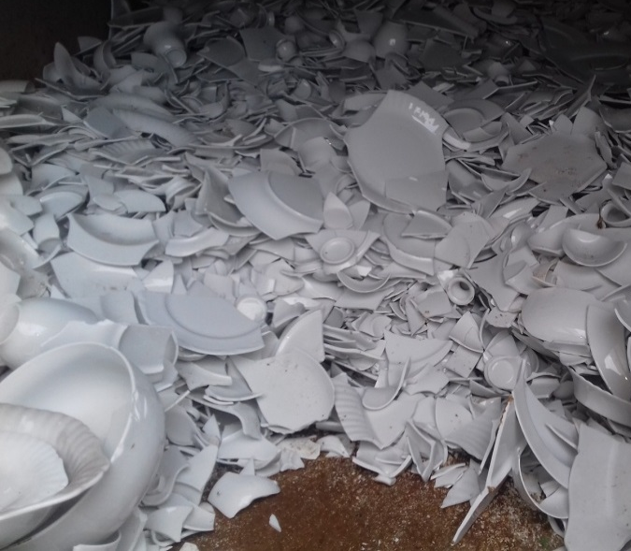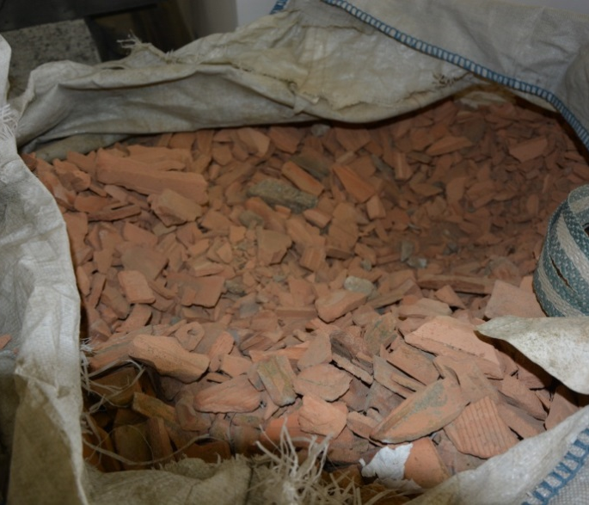
Fig. 1. a) Waste from a) porcelain factory b) pre-crushed waste from ceramic hollow bricks

Before preparing the mixes, several parameters of the used waste aggregate were tested. Void, loose bulk density and water absorption were specified under standards (EN 1097-3:2000; EN 1097-6:2022; PN-B-06714-06:1976). The results obtained are presented in Table 2.

Table 2. Parameters of used waste aggregates
Type of aggregate | Voids | Apparent density | Loose bulk density | Water absorption
 | [%] | g/cm³ | kg/dm³ | [%]
Red ceramic | 47.20 | 2.52 | 1.100 | 25.92
White ceramic | 35.46 | 2.42 | 1.412 | 14.35
Waste sand | 38.00 | 2.59 | 1.634 | 18.54

Fibers were added to the mixtures in amount of 0.5% and 1.0% of volume. Hooked steel fibers 50/0.8 and waste fibers were used (Figure 2). The waste fibers come from end-of-life car tires recycling factory. Steel cord is a mixture of fibers of various dimensions and strength parameters. The properties of steel cord have been determined and described by the authors in previous articles (Domski et al. 2017, Pająk et al. 2021). The composition of the mixtures is shown in Table 3.
Fig. 2. Fibers used in the research: Steel cord and Steel fibers 50/0.8

Table 3. Compositions of the tested mixtures
Stage | Cement type |  |  | Cement amount |  |  | w/c |  | Superplasticizer
 | CEM I 42.5 R |  |  | 400 kg/m³ |  |  | 0.45 |  | Silka ViscoCrete 5  – 1% of cement weight
 | Symbol | Beam number | Aggregate  0.125-2.00 |  | Aggregate  2.00-8.00 | Fiber-reinforcement |  | Fiber-reinforcement  ratio |  | Addition
I | RCf0 | B3 | Red ceramic waste |  | Red ceramic waste | Steel fibers 50/1.0 |  | 0.0% |  | none
 | RCf05 | B2 |  |  |  |  |  | 0.5%
 | RCf10 | B1 |  |  |  |  |  | 1.0%
 | RCc0 | B3 | Red ceramic waste |  | Red ceramic waste | Steel cord |  | 0.0%
 | RCc05 | B2 |  |  |  |  |  | 0.5%
 | RCc10 | B1 |  |  |  |  |  | 1.0%
 | WCf0 | B3 | White  ceramic waste |  | White  ceramic waste | Steel fibers 50/1.0 |  | 0.0% |  | Silica fume – 8%  of cement weight
 | WCf05 | B2 |  |  |  |  |  | 0.5%
 | WCf10 | B1 |  |  |  |  |  | 1.0%
 | WCc0 | B3 | White  ceramic waste |  | White  ceramic waste | Steel cord |  | 0.0%
 | WCc05 | B2 |  |  |  |  |  | 0.5%
 | WCc10 | B1 |  |  |  |  |  | 1.0%
II | Sc0 | B3 | Waste Sand |  | Natural Corase | Steel cord |  | 0.0% |  | none
 | Sc05 | B2 |  |  |  |  |  | 0.5%
 | Sc10 | B1 |  |  |  |  |  | 1.0%
 | RCSc0 | B3 | Waste Sand |  | Red ceramic waste | Steel cord |  | 0.0%
 | RCSc05 | B2 |  |  |  |  |  | 0.5%
 | RCSc10 | B1 |  |  |  |  |  | 1.0%
 | WCSf0 | B3 | Waste Sand |  | White  ceramic waste | Steel fibers 50/1.0 |  | 0.0% |  | Silica fume – 8%  of cement weight
 | WCSf05 | B2 |  |  |  |  |  | 0.5%
 | WCSf10 | B1 |  |  |  |  |  | 1.0%
 | WCSc0 | B3 | Waste Sand |  | White  ceramic waste | Steel cord |  | 0.0%
 | WCSc05 | B2 |  |  |  |  |  | 0.5%
 | WCSc10 | B1 |  |  |  |  |  | 1.0%

The mixtures parameters were tested on cylindrical samples with dimensions of 150x300 mm. On 6 such specimens, the compressive strength was determined. The elasticity modulus of concrete was determined on 3 specimens. These features were tested at the age of 28 days. The samples were unmoulded the day after concreting and then kept underwater until the day of testing.
Long-term parameters of mixtures were determined on beams a with dimensions 100x200x2900 mm. Longitudinal reinforcement was located only in the tension zone of beams. Two reinforcing rods with dia. 10 mm were made of steel RB 500 (Figure 3). Such a reinforcement arrangement was used to better determine the effect of creep on cracking and deformation of the cross-section. No stirrups were used in the beams. The beams were unmoulded after three days and then were regularly watered until research started. Subsequent beams made of the same material but with different amounts of dispersed reinforcement were concreted at intervals of 7 days. The beams were placed in the test stand at 28 days.
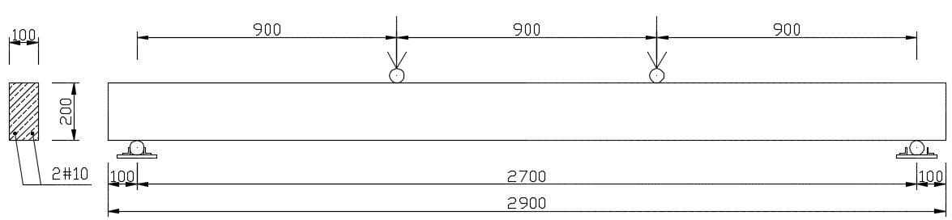
Fig. 3. Geometry and static scheme of tested beams, details of conventional reinforcement
3. Research methodology
The research was divided into two stages. In the first stage, mixes were made in which only aggregate produced from ceramic wastes were used. In the second stage, mixes were made in which fine fractions were replaced with waste sand. Obtaining a fraction in the range of 0.125-2.0 mm from ceramic waste requires several mechanical processing. Therefore, replacing these fractions with waste sand makes the mixtures more affordable from an economic point of view.
3.1. Stand for long-term study
The article's authors created the research stand (Figure 4 and Figure 5). The assumption was to test three beams at one stand. The stand mustn't take up much space in studies lasting several years. The load on the stand is carried out by a lever consisting of two steel rods with a full round cross-section 50 mm in diameter. At the end of the lever, cast iron discs with a total weight of 110 kg were mounted. The article describes all the stand's details (Zakrzewski & Domski 2023). Three beams with different fiber-reinforcement ratios were placed on top of each other. Centre beam was inverted. All beams were subjected to a four-point bending test. Forces spacing was 0.9 m.

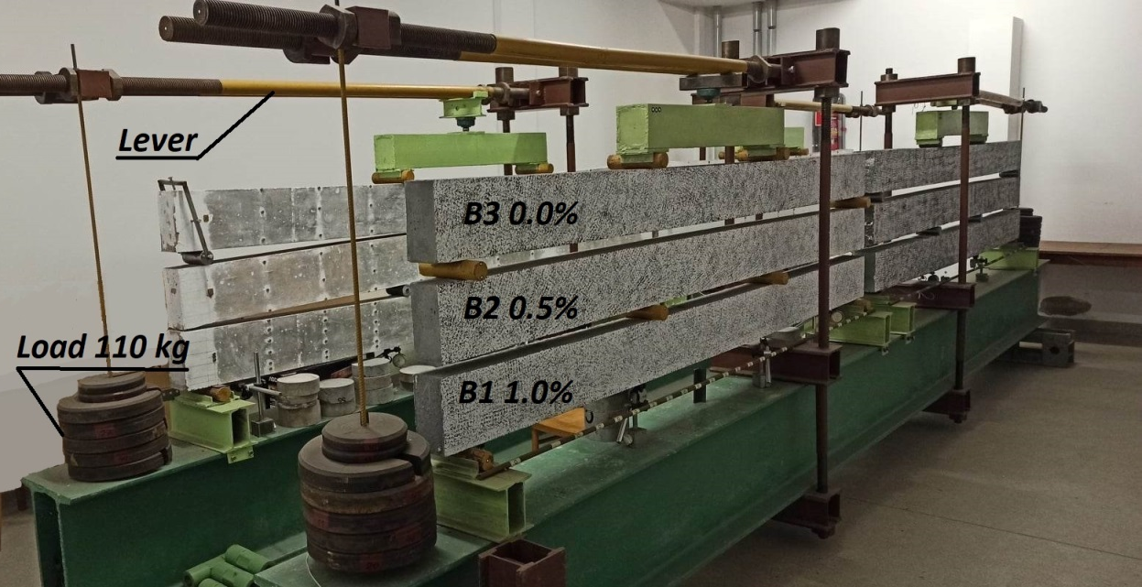
Fig. 4. Stands for testing rheological properties of cement composites based on waste aggregate. Stage I, mixtures RCf, RCc, WCf, WCc

a) b)
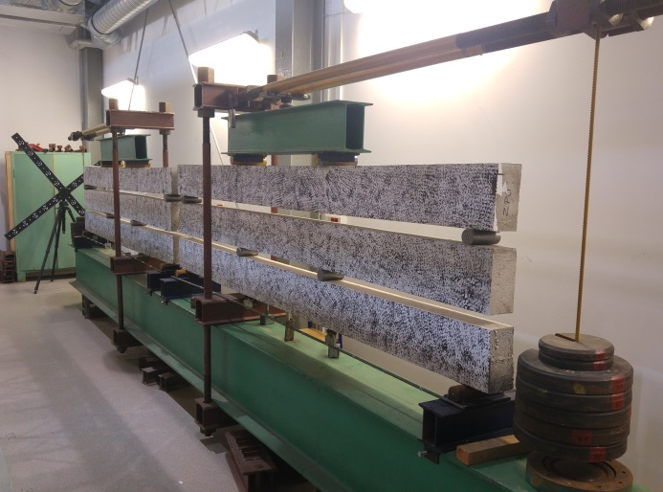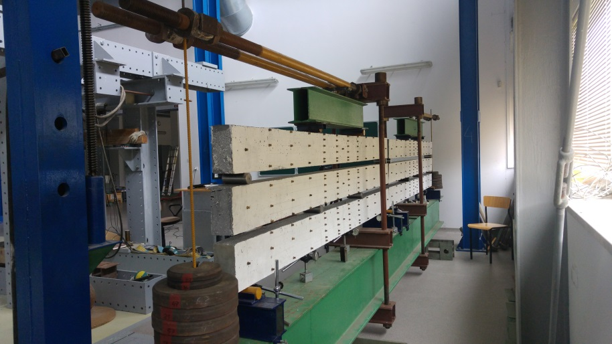
Fig. 5. Stands for testing rheological properties of cement composites based on waste aggregate. Stage II, mixtures:
a) Sc, RCSc, b) WCSf, WCSc

The load was selected so that the beams cracked during the gradual loading of the beams. The beams were placed from the bottom in the order B1, B2, and B3 because each successive beam is more heavily loaded. The beams were loaded gradually to determine their short-term properties. The load was increased according to the Table 4. The time between the successive loading phases resulted from the concreting technology (7 days) and measurements using the optical system and manual devices (1 hour).

Table 4. Load phases and values
Type of load | Phase |  | Load |  | Interval to the next phase
Short term | I |  | B1 (own weight) |  | 7 days
 | II |  | B1+B2 |  | 7 days
 | III |  | B1+B2+B3 |  | 1 hour
 | IV |  | B1+B2+B3+Lever |  | 1 hour
 | V |  | B1+B2+B3+Lever+28 kg |  | 1 hour
 | VI |  | B1+B2+B3+Lever+56 kg |  | 1 hour
 | VII |  | B1+B2+B3+Lever+82 kg |  | 1 hour
 | VIII |  | B1+B2+B3+Lever+110 kg |  | 1 hour
Long term | IX |  | B1+B2+B3+Lever+110 kg |  | 1000 days
Beam number |  | Load (two forces) [kN] |  | Bending moment
B1 |  | 6.58 |  | 5.92
B2 |  | 5.82 |  | 5.24
B3 |  | 5.80 |  | 5.22

Each beam had to be properly prepared before being placed in the stand. The pores on the surface have been patched. One surface of the beam was painted with white paint, and then a special pattern of black paint was applied (Figure 8a). This surface was measured using an optical system. On the second surface, cracks were measured with a microscope with a 36-fold magnification and resolution of 0.02 mm, deformation was measured with a manual extensometer with an accuracy of 0.001 mm, and measurement base 250 mm (Figure 6) and cracks spacing was measured using calliper with an accuracy of 0.05 mm. For deformation measurements, brass benchmarks were mounted on the surface. After installing the third beam at the stand, the implementation of subsequent phases began. The time interval between the successive phases was about 1 hour. After loading the beams to the selected level, short-term measurements were completed. Measurements were then taken at intervals to determine the increase in deformations over time.

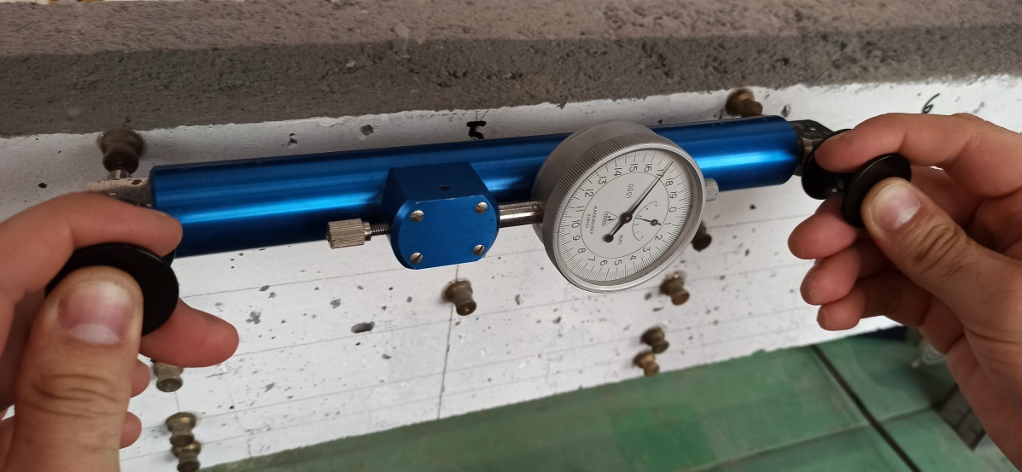
Fig. 6. Measurement of displacements of points on the beam using an extensometer
3.2. Air condition
Temperature and air humidity were measured with a recorder every hour. The average temperature was 21.6°C (standard deviation of 1.15°C). The average air humidity was 40.7% (standard deviation of 13.90%). A detailed graph of temperature and air humidity changes is presented in (Zakrzewski & Domski 2023).
3.3. Optical measurements
As an innovation in the study of long-term properties of cement composites, the article's authors used an optical system in their long-term studies. The GOM Aramis 4M 3D optical analysis system was used to measure the propagation of cracks and deformations over time. The operation of the ARAMIS measurement system is based on the Digital Image Correlation technique. The 3D surface model is created based on images taken from two cameras (Figure 8b). The parameters and settings of the optical system are presented in Table 5. In this article, the analysis was limited to the area covered by the middle part of all three beams at the position with a width of 1100 mm (Figure 8a). The system was used to analyse one side surface of each beam (Figure 9). The optical system was moved between stations and used between measurements for other tests. Before each measurement, the system was calibrated. Measurements with the optical system were made from three positions. The system was set up so that areas 1 and 3 share a common area with area 2, as shown in Figure 7.

Table 5. Optical system parameters
Lens focal length | 20 mm
Cameras spacing | 645 mm
Distance from the tested elements | 1540 mm
Camera angle | 21°
Calibration standard | Calibration cross CC20/1400

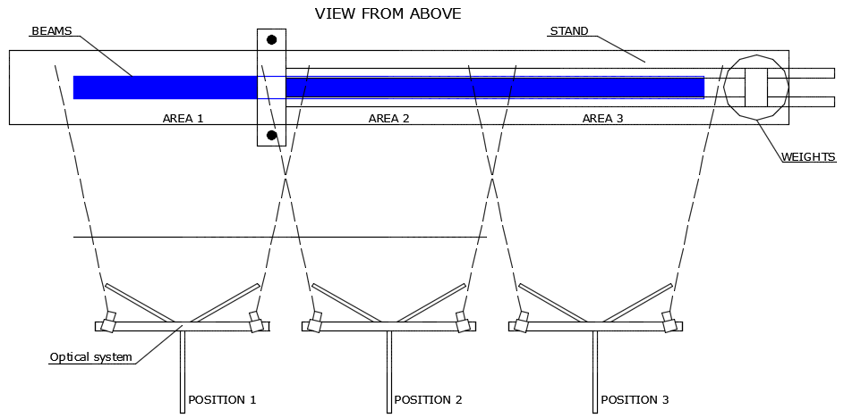
Fig. 7. Positions of the optical system relative to the station and measurement areas
A steel element was welded under the beams on which round markers were applied to refer measurements on the beams to fixed points.

a) b)
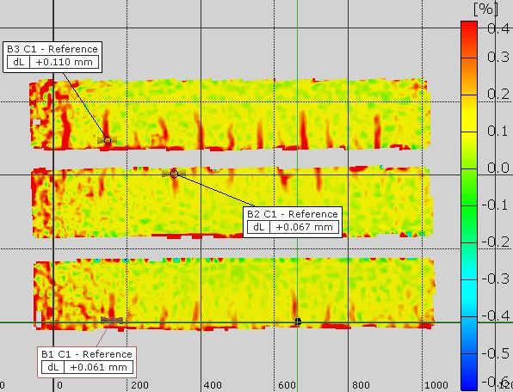
Fig. 8. a) Area where cracks were analysed. Position 2 of an optical system. b) Mathematical model of beams in area 2

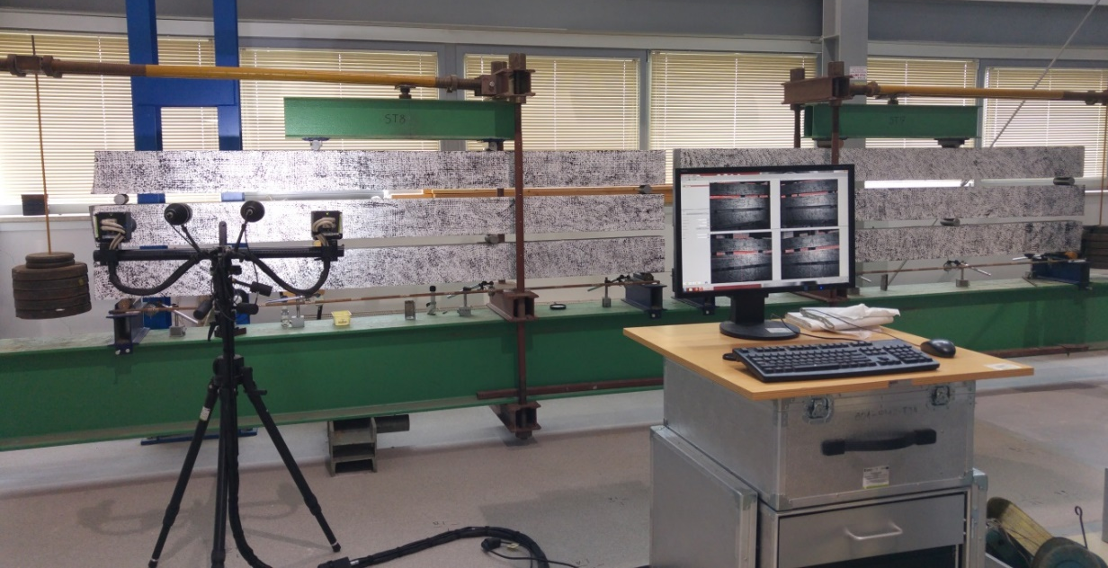
Fig. 9. Measurement using optical measurement. Position 1. Mixture WCSc

3.4. The accuracy of the optical systems
The accuracy of the optical system depends on many factors, such as lens quality, the size of the measurement area, the quality of the pattern on the surface, and the positioning of the cameras relative to the object (Krawczyk et al. 2017). Another important factor affecting the quality of measurements is lighting changes. All measurements with the optical system were made with the same lighting as possible. Only artificial lighting was in the basement, where the stands of the first stage were set up. The stands of the second stage were placed in the hall, where the windows were covered during the measurements (Figure 9). The same set of lights was used each time the measurements were made. Before starting the measurements, an efficiency test of the optical system was performed. 150 photos of unloaded beams were taken. Three measurement bases were selected, corresponding to the subsequent measurements: 12 mm (crack width measurement), 250 mm (deformation determination) and 1100 mm (length of the entire beam in the photos). Measurement deviations are shown in Figure 10.

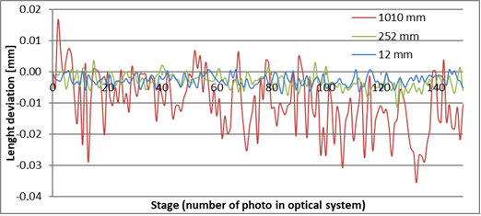
Fig. 10. Optical system measurement deviations

The results of deviations were subjected to a simple analysis, the results of which are presented in Table 6 below.

Table 6. Optical system deviations
Length [mm] | Average [mm] | Standard  deviation [mm] | Maximum [mm] | Minimum [mm] | Peak-to-peak amplitude [mm]
1100 | 0.0102 | 0.0093 | 0.0165 | -0.0356 | 0.0521
250 | -0.0031 | 0.0024 | 0.0036 | -0.0114 | 0.0150
12 | -0.0027 | 0.0018 | 0.0025 | -0.0069 | 0.0094

Based on the obtained results, it can be concluded that the deviations in the case of the measurements are at a satisfactory level. Assuming the total maximum deviation of 0.0094 mm as the measurement accuracy for measuring the crack width, it should be stated that the accuracy of the optical system is higher than that of the microscope used. The accuracy of measuring deformations of the optical system is definitely lower than that of the extensometer. Nevertheless, for the conducted research, this accuracy is sufficient. In order to reduce the influence of deviations on the measured value, it was assumed that 10 photos would be taken for each measurement, and the average value would be taken as the measured value.
4. Results
This chapter presents the test results obtained using the measurement methods described earlier.
4.1. Cracks
Table 7 presents the results of crack measurement using a manual microscope and an optical system. Values of crack width, average crack spacing, and number of cracks are presented. The width of the cracks was measured at the level of the longitudinal reinforcement.

Table 7. Cracks width and spacing
Stage | Mixture | Beam number | Average  Crack spacing [mm] |  | Max. crack opening [mm] |  |  |  | Number of cracks
 |  |  | Manual | Optical system | Manual |  | Optical system |  | Manual | Optical system
 |  |  |  |  | Instantaneous | After 1000 Days | Instantaneous | After 1000 Days
I | RCf0 | B3 | 46.6 | 49.34 | 0.09 | 0.12 | 0.094 | 0.112 | 19 | 18
 | RCf05 | B2 | 47.7 | 48.32 | 0.09 | 0.12 | 0.097 | 0.118 | 19 | 19
 | RCf10 | B1 | 48.8 | 49.68 | 0.10 | 0.10 | 0.073 | 0.103 | 19 | 19
 | RCc0 | B3 | 44.3 | 48.75 | 0.08 | 0.10 | 0.108 | 0.129 | 22 | 21
 | RCc05 | B2 | 58.1 | 56.09 | 0.09 | 0.10 | 0.081 | 0.090 | 15 | 15
 | RCc10 | B1 | 49.6 | 47.21 | 0.10 | 0.12 | 0.049 | 0.084 | 21 | 21
 | WCf0 | B3 | 66.5 | 64.86 | 0.02 | 0.08 | 0.011 | 0.057 | 14 | 14
 | WCf05 | B2 | 71.2 | 69.61 | 0.02 | 0.08 | 0.043 | 0.100 | 13 | 13
 | WCf10 | B1 | 69.8 | 65.21 | 0.03 | 0.08 | 0.055 | 0.083 | 14 | 14
 | WCc0 | B3 | 63.3 | 66.92 | 0.02 | 0.06 | 0.051 | 0.051 | 14 | 14
 | WCc05 | B2 | 77.8 | 82.64 | 0.04 | 0.08 | 0.084 | 0.084 | 11 | 11
 | WCc10 | B1 | 61.1 | 74.75 | 0.07 | 0.10 | 0.108 | 0.108 | 14 | 13
II | RCSc0 | B3 | 67.7 | 63.93 | 0.09 | 0.12 | 0.078 | 0.122 | 13 | 13
 | RCSc05 | B2 | 52.3 | 51.82 | 0.06 | 0.12 | 0.081 | 0.115 | 19 | 19
 | RCSc10 | B1 | 46.4 | 49.50 | 0.07 | 0.14 | 0.110 | 0.138 | 13 | 13
 | WCSf0 | B3 | 76.9 | 71.36 | 0.08 | 0.10 | 0,038 | 0.110 | 12 | 12
 | WCSf05 | B2 | 66.1 | 69.58 | 0.05 | 0.08 | 0,027 | 0.067 | 15 | 14
 | WCSf10 | B1 | 57.6 | 67.18 | 0.03 | 0.04 | 0,041 | 0.059 | 14 | 13
 | WCSc0 | B3 | 90.3 | 89.15 | 0.03 | 0.06 | 0.071 | 0.083 | 11 | 11
 | WCSc05 | B2 | 71.8 | 70.38 | 0.04 | 0.08 | 0.07 | 0.067 | 11 | 11
 | WCSc10 | B1 | 64.8 | 67.18 | 0.04 | 0.08 | 0.082 | 0.079 | 14 | 14
 | Sc0 | B3 | 93.8 | 90.61 | 0.09 | 0.12 | 0.096 | 0.111 | 10 | 10
 | Sc05 | B2 | 72.9 | 71.63 | 0.09 | 0.14 | 0.092 | 0.126 | 14 | 13
 | Sc10 | B1 | 64.1 | 58.62 | 0.05 | 0.08 | 0.047 | 0.063 | 14 | 14

4.2. Deformation in the mid-span
The beam mid-span creep coefficient was determined based on deformations of the compressed edge of the elements using the following formula:
$ϕ_{r}=\frac{ε_{cc}}{ε_{ce}},$ (1)
where:
$ε_{cc}$– strain measured under the load at 1000 days,
$ε_{ce}$ – strain measured after loading.

The results of beam surface deformations and the creep coefficient determined in the middle span are presented in Table 8. The coefficient was determined based on measurements made with an extensometer and an optical system. The coefficient values were compared with those determined in the guidelines of the EC2 (EN 1992-1-1) standard.

Table 8. Compression deformation and creep coefficient
Stage | Mixture | Beam  number | Instantaneous deformation [‰] |  | Deformation  after 1000 days [‰] |  | ϕ exp |  | ϕ EC2
 |  |  | Optical system | Manual | Optical system | Manual | Manual | Optical system
I | RCf0 | B3 | -1.308 | -1.244 | -2.045 | -1.932 | 1.56 | 1.56 | 2.85
 | RCf05 | B2 | -1.348 | -1.388 | -1.896 | -1.604 | 1.16 | 1.41 | 2.78
 | RCf10 | B1 | -1.309 | -1.236 | -1.804 | -1.932 | 1.56 | 1.38 | 2.69
 | RCc0 | B3 | -0.547 | -0.588 | -1.905 | -2.04 | 3.45 | 3.48 | 2.21
 | RCc05 | B2 | -0.534 | -0.564 | -1.847 | -1.872 | 3.32 | 3.46 | 2.14
 | RCc10 | B1 | -0.692 | -0.756 | -1.783 | -1.676 | 2.22 | 2.58 | 2.10
 | WCf0 | B3 | -0.242 | -0.168 | -0.625 | -0.748 | 2.79 | 2.58 | 1.92
 | WCf05 | B2 | -0.375 | -0.300 | -0.912 | -0.808 | 2.69 | 2.43 | 1.85
 | WCf10 | B1 | -0.477 | -0.708 | -1.098 | -0.876 | 1.23 | 2.30 | 1.69
 | WCc0 | B3 | -0.185 | -0.212 | -0.477 | -0.644 | 3.02 | 2.58 | 1.71
 | WCc05 | B2 | -0.218 | -0.280 | -0.642 | -0.78 | 2.79 | 2.94 | 1.56
 | WCc10 | B1 | -0.275 | -0.288 | -0.601 | -0.628 | 2.19 | 2.19 | 1.48
II | RCSc0 | B3 | -0.459 | -0.444 | -1.231 | -1.472 | 3.30 | 2.68 | 2.54
 | RCSc05 | B2 | -0.440 | -0.408 | -1.193 | -1.128 | 2.75 | 2.71 | 2.20
 | RCSc10 | B1 | -0.671 | -0.732 | -1.276 | -1.028 | 1.41 | 1.90 | 2.15
 | WCSf0 | B3 | -0.201 | -0.192 | -0.444 | -0.548 | 2.85 | 2.21 | 1.73
 | WCSf05 | B2 | -0.197 | -0.200 | -0.598 | -0.62 | 3.10 | 3.04 | 1.59
 | WCSf10 | B1 | -0.292 | -0.288 | -0.545 | -0.592 | 2.06 | 1.87 | 1.56
 | WCSc0 | B3 | -0.173 | -0.148 | -0.618 | -0.536 | 3.59 | 3.57 | 2.01
 | WCSc05 | B2 | -0.186 | -0.196 | -0.523 | -0.224 | 2.31 | 2.81 | 1.86
 | WCSc10 | B1 | -0.197 | -0.236 | -0.603 | -0.536 | 2.29 | 3.06 | 1.77
 | Sc0 | B3 | -0.288 | -0.244 | -0.739 | -0.668 | 2.74 | 2.57 | 2.34
 | Sc05 | B2 | -0.432 | -0.764 | -0.859 | -0.736 | 1.59 | 1.99 | 1.70
 | Sc10 | B1 | -0.459 | -0.480 | -0.908 | -0.796 | 1.66 | 1.98 | 1.59

5. Modification of the calculation method for determining maximum crack width
Using the tested cement composites in real structures requires some corrections in the crack width calculation methods. Various calculation methods for determining the crack width have been analysed by the authors in the article (Zakrzewski & Domski 2023). As shown in this article, good results for WC composites were obtained using the method included in EC2 (EN 1992-1-1). It is also the main norm in the region of the authors. However, the results obtained with this method were not sufficiently accurate. Therefore, it was decided to modify this method. It was decided to use a coefficient that corrects the value depending only on the aggregate used.
In the final formula of the calculation procedure, the crack width:
$w_{k}=ε∙s_{r,max},$ (2)
it is necessary to apply the coefficient correcting the value of the crack width:
$w_{k}=a_{c}∙ε∙s_{r,max}.$ (3)
To determine the coefficient, a study of 4 stands was planned as part of stage I in accordance with Table 3. The tested composites were divided into two groups. The first group consists of cement composites based on red ceramics (RCf, RCc), and the second group consists of composites based on white ceramics (WCf, WCc). In order to confirm that the coefficients are appropriate, stage II of the research was carried out in which, following point 3, changes in the composition were made. Nevertheless, ceramic waste constituted the majority of aggregate. The composite based on waste sand and gravel of natural origin was omitted from the analysis due to insufficient results.
In the analysis, the maximum crack width for each beam was assumed as the greater value obtained from the measurements using the methods described earlier. It was assumed that both used methods adequately determine the actual width of cracks, and the differences between them may result from the fact that different surfaces of the beams are measured. Based on the analysis of average deviations from the calculated value, the following coefficient values were determined:
- The coefficient for cement composites with red ceramics aggregate:
$a_{rc}=1.686$ (4)
- The coefficient for cement composites with white ceramics aggregate:
$a_{wc}=1.191$ (5)
The results of the calculations after applying the coefficients $a_{rc}$ and $a_{wc}$ are presented in Table 9.

Table 9. Calculation values of the crack width obtained after applying the coefficients – stage I
Mixture | Beam number | Tests | EC2 | Δ [%] | Mod EC2 | Δ [%] | Average Δ [%]
RCf0 | B3 | 0.120 | 0.063 | -90.48 | 0.109 | 11.49 | 9.48
RCf05 | B2 | 0.120 | 0.063 | -90.48 | 0.109 | 11.49
RCf10 | B1 | 0.103 | 0.073 | -41.10 | 0.126 | -19.49
RCc0 | B3 | 0.100 | 0.064 | -56.25 | 0.111 | -7.90
RCc05 | B2 | 0.100 | 0.062 | -61.29 | 0.107 | -4.53
RCc10 | B1 | 0.129 | 0.075 | -72.00 | 0.130 | 1.98
WCf0 | B3 | 0.080 | 0.070 | -14.29 | 0.081 | -4.21 | 14.71
WCf05 | B2 | 0.100 | 0.069 | -44.93 | 0.080 | 17.82
WCf10 | B1 | 0.083 | 0.079 | -5.06 | 0.092 | -13.36
WCc0 | B3 | 0.060 | 0.068 | 11.76 | 0.079 | -34.98
WCc05 | B2 | 0.084 | 0.067 | -25.37 | 0.078 | 5.00
WCc10 | B1 | 0.108 | 0.079 | -36.71 | 0.092 | 12.88

Results obtained in stage II are presented in Table 10.

Table 10. Calculation values of the crack width obtained after applying the coefficients – stage II
Mixture | Beam number | Tests | EC2 | Δ [%] | Mod EC2 | Δ [%] | Average Δ [%]
RCSc0 | B3 | 0.140 | 0.067 | -108.96 | 0.113 | 19.31 | 12.38
RCSc05 | B2 | 0.120 | 0.066 | -81.82 | 0.111 | 7.27
RCSc10 | B1 | 0.122 | 0.08 | -52.50 | 0.135 | 10.56
WCSf0 | B3 | 0.110 | 0.069 | -59.42 | 0.082 | 25.29 | 19.70
WCSf05 | B2 | 0.080 | 0.068 | -17.65 | 0.081 | 1.24
WCSf10 | B1 | 0.059 | 0.081 | 27.16 | 0.096 | 63.51
WCSc0 | B3 | 0.083 | 0.071 | -16.90 | 0.085 | 1.88
WCSc05 | B2 | 0.080 | 0.070 | -14.29 | 0.083 | 4.21
WCSc10 | B1 | 0.080 | 0.082 | 2.44 | 0.098 | 22.08

The presented coefficients significantly improve the results of the crack width obtained by the calculation method.
6. Discussion
Stand
The differences between the loads on the beams are relatively small. The load on beams 2 and 3 is almost identical, and the difference between the load on beams B1 and B3 is 11% of the load on beam B1. The steel elements' cross-sections are sufficient to transfer the load to the beams without excessive deformations. The distance between the beams allows many years of testing despite the lack of reinforcement in the compression zone and using a composite with relatively low strength parameters (mixtures RCf and RCc). Based on the analyses carried out in this article and those presented in the article (Zakrzewski & Domski 2023), it should be concluded that the proposed stand can be effectively used to determine the characteristics of concrete and cement composites beams subjected to long-term load.
Cracks
The crack widths obtained in the tests are relatively small. The maximum values reach about 0.14 mm, which is less than half of the value allowed by the EC2 (EN 1992-1-1) standard for reinforced concrete structures. The results obtained with optical and manual measurement methods are similar. The average difference for the measurements made after the instantaneous part of the tests was 0.024 mm, and for the measurements made after 1000 days, the average difference was 0.012 mm. The maximum differences are 0.051 and 0.036 mm, respectively. It should be emphasised that both measurement methods were used on two different surfaces of the beams. For some mixtures, the smaller number of cracks defined by the optical system is because the smallest cracks and the smallest scratches are difficult to unambiguously determine in the optical system. No unequivocal influence of adding fibers on the number and spacing of cracks was observed. All beams have identical reinforcement in the tension zone, and the load does not cause cracks with a large opening width. Hence, the effect of the fibers may be poorly visible.
Deformation in the mid-span
As in the case of cracks, it is important that the two measurement methods were carried out on different surfaces of the beams. Differences may result, among others, from the shape of the beams. The recorded differences between the measurements are relatively small, and the creep coefficients determined based on the measurements are close to each other. On average, they differ by 15.04%. Considering the above, it should be stated that the optical system can effectively measure beams' deformation under long-term load. The presented values deviate from those determined under (EN 1992-1-1, n.d.). Nevertheless, the standard method applies to an ideal situation where the test specimens are subjected to axial compression. The specified values refer to the shortening of the compression zone due to a long-term load.
Modification of calculating method
Using the coefficient in the EC2 crack width calculation procedure significantly improves the results. The average deviation of the calculated value from the actual value determined for RC mixtures is reduced to 10.45%, and for WC mixtures is reduced to 17.21%. The tests carried out in the second stage confirmed that the coefficient can also be used for mixtures in which the content of aggregates based on ceramic waste is above 50%.
7. Conclusions
The results obtained during the research and the analyses carried out led to the following conclusions:
- The stand proposed by the authors can be successfully used to study the long-term properties of cement composites and concretes. The differences in the load between the individual beams are relatively small; hence, comparing the tested mixtures' properties is justified.
- The optical system significantly facilitates the measurement of the crack width and their location. The measurement accuracy is greater than that of a microscope. The advantage of the optical system is the possibility of reverse analysis. Once the optical system has picked up a crack, you can, knowing its location, analyse previous images to pinpoint exactly when the crack appeared. The system's accuracy is sufficient to determine the deformations of the beam surfaces.
- The analysed cement composites with aggregate from waste materials have basic strength parameters corresponding to concretes made of natural aggregates.
- The use of correction factors will allow for a more accurate prediction of the width of the cracks in structures and thus will enable the design of more optimised structures. Correction factors can be used with the content of waste aggregate above 50%.

Beam studies should be continued to determine their behaviour over a longer period. It is also planned to introduce modifications to the stand to increase the possibilities of using the optical system.
References
Alrshoudi, F., Mohammadhosseini, H., Tahir, M.M., Alyousef, R., Alghamdi, H., Alharbi, Y., Alsaif, A. (2020). Drying shrinkage and creep properties of prepacked aggregate concrete reinforced with waste polypropylene fibers. Journal of Building Engineering, 32, 101522. https://doi.org/10.1016/j.jobe.2020.101522
Al-Tikrite, A., Hadi, M.N.S. (2017). Mechanical properties of reactive powder concrete containing industrial and waste steel fibres at different ratios under compression. Construction and Building Materials, 154, 1024-1034. https://doi.org/10.1016/j.conbuildmat.2017.08.024
Awoyera, P.O., Ndambuki, J.M., Akinmusuru, J.O., Omole, D.O. (2018). Characterisation of ceramic waste aggregate concrete. HBRC Journal, 14(3), 282-287. https://doi.org/10.1016/j.hbrcj.2016.11.003
Babafemi, A.J., Sirba, N., Paul, S.C., Miah, M.J. (2022). Mechanical and Durability Assessment of Recycled Waste Plastic (Resin8 &amp; PET) Eco-Aggregate Concrete. Sustainability, 14(9), 5725. https://doi.org/10.3390/su14095725
Borhan, T.M., Abo Dhaheer, M.S., Mahdi, Z.A. (2020). Characteristics of Sustainable Self-compacting Concrete Reinforced by Fibres from Waste Materials. Arabian Journal for Science and Engineering, 45(5), 4359-4367. https://doi.org/10.1007/s13369-020-04460-3
Cao, W., Liu, Y., Qiao, Q., Feng, Y., Peng, S. (2020). Time-Dependent Behavior of Full-Scale Recycled Aggregate Concrete Beams under Long-Term Loading. Materials, 13(21), 4862. https://doi.org/10.3390/ma13214862
Chen, P., Zhou, X., Zheng, W., Wang, Y., Bao, B. (2020). Influence of high sustained loads and longitudinal reinforcement on long-term deformation of reinforced concrete beams. Journal of Building Engineering, 30, 101241. https://doi.org/10.1016/j.jobe.2020.101241
Contreras-Marín, E., Anguita-García, M., Alonso-Guzmán, E.M., Jaramillo-Morilla, A., Mascort-Albea, E.J., Romero-Hernández, R., Soriano-Cuesta, C. (2021). Use of Granulated Rubber Tyre Waste as Lightweight Backfill Material for Retaining Walls. Applied Sciences, 11(13), 6159. https://doi.org/10.3390/app11136159
Domingo, A., Lázaro, C., Gayarre, F.L., Serrano, M.A., López-Colina, C. (2010). Long term deformations by creep and shrinkage in recycled aggregate concrete. Materials and Structures, 43(8), 1147-1160. https://doi.org/10.1617/s11527-009-9573-0
Domski, J., Katzer, J., Zakrzewski, M., Ponikiewski, T. (2017). Comparison of the mechanical characteristics of engineered and waste steel fiber used as reinforcement for concrete. Journal of Cleaner Production, 158, 18-28. https://doi.org/10.1016/j.jclepro.2017.04.165
EN 1097-3:2000. (2000). Tests for mechanical and physical properties of aggregates – Part 3: Determination of loose bulk density and voids.
EN 1097-6:2022. (n.d.). Tests for mechanical and physical properties of aggregates – Part 6: Determination of particle density and water absorption.
EN 1766:2017. (n.d.). Products and systems for the protection and repair of concrete structures. Test methods. Reference concretes for testing.
EN 1992-1-1. (n.d.). Eurocode 2: Design of concrete structures – Part 1-1 : General rules and rules for buildings.
Gayarre, F.L., González, J.S., Pérez, C.L.-C., Serrano López, M.A., Ros, P.S., Martínez-Barrera, G. (2019). Shrinkage and creep in structural concrete with recycled brick aggregates. Construction and Building Materials, 228, 116750. https://doi.org/10.1016/j.conbuildmat.2019.116750
Głodkowska, W., Laskowska-Bury, J., Kobaka, J. (2013). Wpływ włókien stalowych na kształtowanie właściwości kompozytu drobnokruszywowego. Materiały Budowlane, 9, 28-30 (in Polish)
Hong, S., Park, S.-K. (2016). Long-term behavior of fiber-reinforced-polymer-plated concrete beams under sustained loading: Analytical and experimental study. Composite Structures, 152, 140-157. https://doi.org/10.1016/j.compstruct.2016.05.031
Hosseini, S.A. (2020). Application of various types of recycled waste materials in concrete constructions. Advances in Concrete Construction, 9(5), 479-489.
Khaloo, A.R., Esrafili, A., Kalani, M., Mobini, M.H. (2015). Use of polymer fibres recovered from waste car timing belts in high performance concrete. Construction and Building Materials, 80, 31-37. https://doi.org/10.1016/j.conbuildmat.2015.01.011
Kim, Y.J., Choi, Y.W. (2012). Utilisation of waste concrete powder as a substitution material for cement. Construction and Building Materials, 30, 500-504. https://doi.org/10.1016/j.conbuildmat.2011.11.042
Kong, J., Cong, G., Ni, S., Sun, J., Guo, C., Chen, M., Quan, H. (2022). Recycling of waste oyster shell and recycled aggregate in the porous ecological concrete used for artificial reefs. Construction and Building Materials, 323, 126447. https://doi.org/10.1016/j.conbuildmat.2022.126447
Krawczyk, Ł., Gołdyn, M., Urban, T. (2017). O niedokładnościach systemów cyfrowej korelacji obrazu. Journal of Civil Engineering, Environment and Architecture, XXXIV(64), 259-270. (in Polish). https://doi.org/10.7862/rb.2017.120
Laskowska-Bury, J. (2009). Selected physico-mechanical properties fiber reinforced composite produced on waste aggregate. (in Polish)
Miàs, C., Torres, L., Turon, A., Sharaky, I.A. (2013). Effect of material properties on long-term deflections of GFRP reinforced concrete beams. Construction and Building Materials, 41, 99-108. https://doi.org/10.1016/j.conbuildmat.2012.11.055
Nakov, D. (2017). Experimental and Analytical Analysis of Creep of Steel Fibre Reinforced Concrete. Periodica Polytechnica Civil Engineering. https://doi.org/10.3311/PPci.11184
Pająk, M., Krystek, M., Zakrzewski, M., Domski, J. (2021). Laboratory Investigation and Numerical Modelling of Concrete Reinforced with Recycled Steel Fibers. Materials, 14(8), 1828. https://doi.org/10.3390/ma14081828
Pappu, A., Saxena, M., Asolekar, S.R. (2007). Solid wastes generation in India and their recycling potential in building materials. Building and Environment, 42(6), 2311-2320. https://doi.org/10.1016/j.buildenv.2006.04.015
Peng, L., Zhao, Y., Zhang, H. (2021). Flexural behavior and durability properties of recycled aggregate concrete (RAC) beams subjected to long-term loading and chloride attacks. Construction and Building Materials, 277, 122277. https://doi.org/10.1016/j.conbuildmat.2021.122277
PN-B-06714-06:1976. (n.d.). Mineral aggregates - Research - Determination of apparent density in a measuring cylinder. (in Polish)
Şahan Arel, H. (2016). Recyclability of waste marble in concrete production. Journal of Cleaner Production, 131,
179-188. https://doi.org/10.1016/j.jclepro.2016.05.052
Saikia, N., de Brito, J. (2014). Mechanical properties and abrasion behaviour of concrete containing shredded PET bottle waste as a partial substitution of natural aggregate. Construction and Building Materials, 52, 236-244. https://doi.org/10.1016/j.conbuildmat.2013.11.049
Seara-Paz, S., González-Fonteboa, B., Martínez-Abella, F., González-Taboada, I. (2016). Time-dependent behaviour of structural concrete made with recycled coarse aggregates. Creep and shrinkage. Construction and Building Materials, 122, 95-109. https://doi.org/10.1016/j.conbuildmat.2016.06.050
Seitl, S., Miarka, P., Šimonová, H., Frantík, P., Keršner, Z., Domski, J., Katzer, J. (2019). Change of Fatigue and Mechanical Fracture Properties of a Cement Composite due to Partial Replacement of Aggregate by Red Ceramic Waste. Periodica Polytechnica Civil Engineering, 63(1), 152-159. https://doi.org/10.3311/PPci.12450
Shafigh, P., Mahmud, H. Bin, Jumaat, M.Z. Bin, Ahmmad, R., Bahri, S. (2014). Structural lightweight aggregate concrete using two types of waste from the palm oil industry as aggregate. Journal of Cleaner Production, 80, 187-196. https://doi.org/10.1016/j.jclepro.2014.05.051
Singh Shekhawat, B., Aggarwal, V. (2007). Utilisation of Waste Glass Powder in Concrete-A Literature Review. International Journal of Innovative Research in Science, Engineering and Technology (An ISO (Vol. 3297). Retrieved from www.ijirset.com
Tan, K.H., Saha, M.K. (2005). Ten-Year Study on Steel Fiber-Reinforced Concrete Beams Under Sustained Loads. ACI Structural Journal, 102.
Tošić, N., Marinković, S., Pecić, N., Ignjatović, I., Dragaš, J. (2018). Long-term behaviour of reinforced beams made with natural or recycled aggregate concrete and high-volume fly ash concrete. Construction and Building Materials, 176, 344-358. https://doi.org/10.1016/j.conbuildmat.2018.05.002
Vasanelli, E., Micelli, F., Aiello, M.A., Plizzari, G. (2014). Crack width prediction of FRC beams in short and long term bending condition. Materials and Structures, 47(1-2), 39-54. https://doi.org/10.1617/s11527-013-0043-3
Zakrzewski, M., Domski, J. (2023). Cracking Behavior and Deflections in Recycled-Aggregate Beams Reinforced with Waste Fibers Subjected to Long-Term Constant Loading. Materials, 16(10), 3622. https://doi.org/10.3390/ma16103622
Zakrzewski, M., Sanok, A., Domski, J. (2023). Rheological Properties of Concrete Based on Waste Materials. International Scientific Conference – Environmental Challenges in Civil Engineering II. ECCE 2022. Lecture Notes in Civil Engineering, vol 322. Springer, Cham. (175-184). https://doi.org/10.1007/978-3-031-26879-3_14
Zhu, P., Mao, X., Qu, W., Li, Z., Ma, Z.J. (2016). Investigation of using recycled powder from waste of clay bricks and cement solids in reactive powder concrete. Construction and Building Materials, 113, 246-254. https://doi.org/10.1016/j.conbuildmat.2016.03.040

