 | Rocznik Ochrona Środowiska
 | Volume 25 | Year 2023 ISSN 2720-7501 | pp. 148-158
 | https://doi.org/10.54740/ros.2023.015 open access
 | Received: July 2023 Accepted: August 2023 Published: August 2023
Prospects for the Use of Renewable Energy Sources while Increasing the Energy Efficiency Level of Office Buildings to the Level of nZEB
Valeriі Deshko¹, Inna Bilous^{2*}, Nadiya Buyak³, Olena Naumchuk⁴
¹National Technical University of Ukraine "Igor Sikorsky Kyiv Polytechnic Institute", Educational and Research Institute of Nuclear and Heat Power Engineering, Ukraine,
Institute of Engineering Thermophysics of NAS of Ukraine
https://orcid.org/0000-0002-8218-3933
²National Technical University of Ukraine "Igor Sikorsky Kyiv Polytechnic Institute", Educational and Research Institute of Nuclear and Heat Power Engineering, Ukraine,
Institute of General Energy of NAS of Ukraine
https://orcid.org/0000-0002-6640-103X
³National Technical University of Ukraine "Igor Sikorsky Kyiv Polytechnic Institute", Educational and Research Institute of Nuclear and Heat Power Engineering, Ukraine
https://orcid.org/0000-0003-0597-6945
⁴National Technical University of Ukraine "Igor Sikorsky Kyiv Polytechnic Institute", Educational and Research Institute of Nuclear and Heat Power Engineering, Ukraine,
https://orcid.org/0000-0002-7059-8867
*corresponding author's e-mail: biloys_inna@ukr.net
Abstract: According to the Energy Performance of Buildings Directive (EPBD), all new buildings must be constructed using technologies that will ensure almost zero energy consumption by the building through renewable energy sources and an energy-efficient thermal envelope. To assess the possibilities of reconstructing an existing building following the requirements of the EPBD in Ukraine, we have presented possible ways to modernise an office in Kyiv using renewable energy sources (biomass, heat pump) at different levels of thermal protection. Based on dynamic modelling results in the DesignBuilder software environment, the technical, environmental and economic aspects of building modernisation using near-Zero Energy Buildings (nZEB) technologies have been investigated. In particular, the authors have analysed the possibilities of using different modes of heat pump operation to provide heat to a building of different levels of thermal protection in the GeoTSOL software environment. The results obtained can be used to assess the benefits of improving the energy efficiency of a building using different types of renewable energy sources.
Keywords: energy efficiency, heat supply, energy source, thermal protection, energy demand
1. Introduction
According to the ІЕА, the construction sector is responsible for a significant share of global energy consumption (Buildings – Topics – IEA). In order to reduce energy consumption and increase consumer motivation for energy saving and energy efficiency, the Energy Performance of Buildings Directive (Directive 2010/31/EU of the European Parliament and of the Council of 19 May 2010 – Energy Performance of Buildings Directive – EPBD) sets minimum requirements for the energy efficiency of buildings, aimed at increasing the share of energy-efficient buildings and promoting the use of renewable energy sources to meet the required energy demand. The main principles governing the construction of buildings under the EPBD include:
- Energy efficiency of buildings. Energy efficiency standards require a reduction in energy consumption and greenhouse gas emissions. It is achieved through building structure insulation, highly efficient heating, ventilation and air conditioning systems, and energy-efficient materials and technologies.
- Use of renewable energy sources. The EPBD promotes using renewable energy sources such as solar, wind or geothermal. It may include the installation of solar panels, heat pumps or other systems to generate electricity or heat.
- Monitoring and certification. The EPBD requires the monitoring of energy consumption in buildings and the implementation of energy efficiency certification systems that allow for the assessment and comparison of the energy efficiency of buildings.
- Regulatory requirements. The EPBD includes regulatory requirements that must be implemented at the national level. These requirements may relate to minimum energy efficiency standards for new buildings, mandatory retrofitting of existing buildings, and information and education for building owners.
Recovery of the construction sector in Ukraine is an important task for economic development and improving living conditions. Following the difficult economic and social changes that have taken place in the country in recent years, the construction industry has received support and incentives for development and modernisation. In particular, the Ukrainian government actively supports measures to improve energy efficiency in construction. Such measures include promoting the use of energy-efficient materials and technologies, integrating renewable energy sources, and introducing energy-efficient standards in building codes, including integrating European norms into the construction sector. For example, in line with the latest requirements for energy efficiency in buildings, the government has decided to develop zero-energy technologies.
There are several reasons for promoting nZEB technologies, which aim to increase energy efficiency, ensure environmental sustainability, reduce energy costs and improve the quality of life. The use of nZEB technologies contributes to a significant reduction in energy consumption in buildings, which helps reduce the country's energy dependence and the cost of heating, cooling and general operation of buildings. At the same time, nZEB technologies help to reduce greenhouse gas emissions and other harmful substances into the environment, which contributes to the conservation of natural resources and reduces the negative impact of the construction industry on the climate and the environment. The social benefit of nZEB's buildings is that they provide comfortable living and working conditions. Using energy-efficient insulation materials, ventilation systems, and indoor climate control technologies ensures a stable temperature, reduces noise and improves indoor air quality. The introduction of nZEB technologies stimulates the development of innovative solutions in the construction industry, including using renewable energy sources, modern energy management systems and construction automation.
According to the International Energy Agency, 26.9% of total global emissions are associated with the operation of buildings, and the construction sector generates 13% of global emissions during the construction phase. In total, the construction sector accounted for 39.9% of global emissions in 2021. nZEB technologies are an integral part of achieving climate-neutral construction, and the scaling up of nZEB contributes to the development of a low-carbon construction sector from a global perspective.
The paper aims to assess the ways of modernising the building, particularly the use of renewable energy sources for the heat supply of the building while increasing its energy efficiency, and to analyse the technical, economic and environmental benefits of modernisation.
The following tasks have been set to achieve this goal:
1) Creation of a building model in DesignBuilder with different levels of thermal protection (I – non-insulated building, existing level of thermal protection, II – level of thermal protection that meets the requirements of Ukraine, III – level of thermal protection that meets the requirements of Sweden);
2) Estimation of the building heating demand at different levels of thermal protection according to the results of dynamic modelling in DesignBuilder;
3) Assessment of the possibilities of using biomass and a heat pump for the heat supply of a building with different levels of thermal protection;
4) Dynamic modelling of heat generation by a heat pump at different levels of thermal protection of a building in the GeoTSOL environment (GeoT*SOL | Calculation and simulation software for heat pump systems. Valentin Software);
5) Assessment of the carbon footprint when using different energy sources for the heat supply of the building at different levels of thermal protection;
6) Estimation of integrated costs for heating a building using fossil fuel and renewable energy at different levels of thermal protection for the heat supply of the building.
2. Materials and Results of the Study
Source data. The object of study is a public building (office) in Kyiv. The thermal envelope of the building is represented by non-insulated external envelope structures and insufficiently efficient translucent structures. According to the results of the analysis of the technical passport for the building, the outer walls are expanded clay concrete slabs, the translucent structures are metallic double-glazed windows and glass blocks (installed in the 1970s in the places of stairwells and an assembly hall that was dismantled), the roof is made of reinforced concrete slabs with a layer of roofing material. The ceiling over the unheated basement is made of reinforced concrete slabs. In other words, the overall condition of the building envelope can be characterised as inefficient, with significant heat loss through the building envelope and non-compliance with the indoor climate parameters. The main energy source for heat supply is a boiler located in the boiler room, which is in relative proximity to the office. The boiler is fired by natural gas, and the heating system has no weather-dependent control.
Several options for possible heat supply of the research object have been considered to improve the energy efficiency of the building, which can be divided into several stages:
1) Improving the thermal protection of the building to the level of a high-energy envelope – on the example of compliance of building envelopes with the requirements of Ukraine and the requirements of Sweden (Shkarovskiy et al. 2021, Deshko et al. 2022);
2) Use of biomass energy for heat supply of the building (Deshko et al. 2023);
3) Use of a heat pump for the heat supply of the building (Deshko et al. 2023).

The energy demand for heating, determined according to the results of dynamic modelling of the building in DesignBuilder with the existing technical and physical parameters of the building envelope and the stable operation of the heating system (without weather-dependent control), is 411.6 MWh.
Model description. The technical and economic analysis of the modernisation of the building under consideration to the nZEB level is carried out for three variants of thermal protection of the building (non-insulated – I, insulated according to the requirements of Ukraine – II, insulated according to the requirements of Sweden – III) using the results of dynamic modelling in DesignBuilder. In particular, the building model created in DesignBuilder corresponds to the geometric parameters of the existing building (according to the general plan of the building, all geometric dimensions of the premises and the building as a whole are maintained), climatic data of Kyiv, technical and physical parameters of the building envelope (Figure 1).

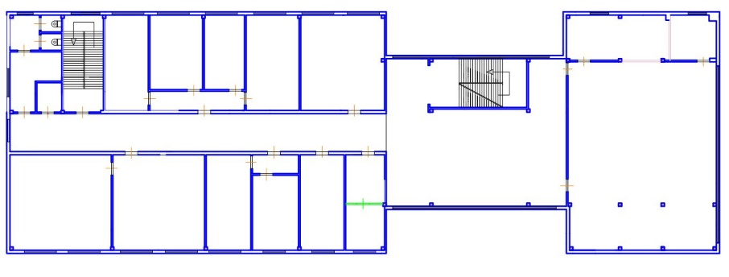
Fig. 1. Floor plan of the building

Improvement of thermal protection to Levels II and III is achieved by insulating the building envelope and changing the thermal resistance for each building envelope in DesignBuilder by tracking modelling results. The thermal resistance of the building envelope for Levels I, II, and III, as well as the heat supply requirements for the building, are shown in Table 1.

Table 1. Technical and physical parameters of building envelope and energy characteristics at different levels of thermal protection
Level of thermal  protection  of the building | Thermal resistance of the building envelope, R, m²·°C/W |  |  |  |  |  |  |  | Energy consumption for heating, MWh | Heat consumption, kWh/year/m³
 | Outer walls | Overlaps over driveways  and unheated basements | Translucent  structures |  |  | External doors |  | Roof
 |  |  | Metal-plastic | Glass blocks | Metal-plastic |  | Metal
І | 1.36 | 0.37 | 0.60 | 0.40 | 0.60 |  | 0.30 | 0.40 | 411.6 | 66.0
ІІ | 4.40 | 4.30 | 0.83 |  |  | 0.60 |  | 5.86 | 107.4 | 17.2
ІІІ | 5.84 | 6.70 | 1.00 |  |  | 1.05 | 0.84 | 9.50 | 84.1 | 13.5

The modelling results are used to assess the possibility of covering the required heat supply with renewable energy sources, such as biomass and a heat pump.
Analysis of the research findings. In accordance with the EPBD Directive, the possibilities of using biomass and a heat pump have been analysed to meet the required energy demand for heating from renewable sources of the research object.
The prospects of biomass use were made following the assessment of the theoretical potential of using different types of biomass in the energy sector. Thus, according to the Bioenergy Association of Ukraine, the theoretical potential of using different types of biomass is distributed as follows: 43% of the balance of the potential is accounted for by agricultural residues, energy crops account for 36%, 12% of the balance is attributed to woody biomass, 5%, 3% and 1% are distributed among biogas, bioethanol and biodiesel, respectively. Since the share of biomass from agricultural residues is the largest, further analysis of building modernisation when replacing the energy source with one that runs on biomass is carried out for fuels that are agricultural residues. Following the physical and technical characteristics of the fuel, the location of the facility to the areas of the highest crop yields considered (Deshko et al. 2023), and the centres of fuel pellet production capacity, the most attractive from an economic and technical point of view is biomass from sunflower husk.
In terms of geographical location and cost of operation, an air-to-water heat pump is another optimal way to modernise a building to the level of one that uses a renewable source for heat supply. For Levels I, II, and III of thermal protection of the building, the assessment of the required heating demand by a heat pump was carried out in the GeoTSOL software environment. The result of the dynamic modelling of the heat supply of a building with different levels of thermal protection is the amount of heat generation by the heat pump and the amount of electricity required for such generation. Taking into account the possibilities of modelling the operation of the heat pump in different modes of operation (monovalent, single-energy and bivalent), a technical and economic justification for the use of a heat pump for a building at different levels of its thermal protection, according to the energy demand for heating, obtained as a result of dynamic modelling in DesignBuilder, was made as follows:
- Partially bivalent: Parallel operation of a heat pump and a natural gas boiler for the Level I thermal protection;
- Partially single-energy: Parallel operation of the heat pump and heating element for the Level II thermal protection;
- Partially single-energy: parallel heat pump and heating element operation for the Level III thermal protection.

Following the heat supply of the building of different levels of thermal protection, the main system elements were selected from the manufacturers proposed by the program: for Level I – a heat pump, a storage tank and a natural gas boiler, for Levels II and III – a heat pump and a heating element with a capacity of 20 kW and 5 kW, respectively. The technical parameters of the selected system elements in different operating modes and the system connection scheme are shown in Table 2.
The results of dynamic modelling of the energy demand for heating (using DesignBuilder) and heat generation by a heat pump for thermal protection of a building of Levels I, II and III by a heat pump (using GeoTSOL) during the heating season in the consideration of the heating demand of an existing building are shown in Figure 2.
Taking into account the dynamic modelling data in GeoTSOL and the amount of heating demand at different levels of thermal protection of the building obtained as a result of modelling in DesignBuilder (Table 1), the heat pump covers a significant share of the required energy for heating an uninsulated building (43.3%) and can provide the necessary heat for a building insulated to the requirements of Ukraine and Sweden. At the same time, the GeoTSOL software makes it possible to estimate the amount of electricity required for the heat pump, which is one of the key factors in calculating the integrated costs of heating a building. In particular, the energy consumption of a system with a heat pump at the level of thermal protection of a building that meets the requirements of Ukraine and Sweden is 40.51 MWh and 28.92 MWh during the heating season, respectively.
The environmental impact and integrated cost of building heating costs were analysed for three levels of thermal protection in use to assess the effectiveness of improving the thermal envelope of the building and replacing the energy source:
- natural gas boiler (from now on referred to as 1),
- boiler on sunflower husk pellets (2),
- heat pump (3).

The use of renewable energy sources for building heating, improving the thermal protection of the building and, accordingly, minimising fuel consumption are the so-called technological steps towards the realisation of buildings with nZEB. Meeting the heating demand from renewable energy sources and creating a highly energy-efficient building envelope helps to reduce the overall carbon dioxide emissions and brings the building closer to carbon neutrality, and scaling up the above technologies will reduce the global carbon footprint of the construction sector (Smirnova et al. 2022). To assess the prospects for reducing emissions when using nZEB technologies in construction, we calculated the CO₂ emissions of each way of modernising the building (the object of study) considered in this paper. In particular, carbon dioxide emissions from the combustion of natural gas (1) were estimated using the international Carbon Footprint Calculator for Individuals and Households, and sunflower husk pellets (2) were estimated using the methodology described in (Ecological-economic calculations of pollutant emissions). CO₂ emissions generated by electricity generation to power the heat pump (3) are calculated according to the case study presented in (Calculation of CO₂ emission reductions), considering the required amount of fuel for electricity generation by a thermal power plant in Ukraine. The amount of carbon dioxide emissions for each way of modernising the building is shown in Figure 3.

Table 2. Connection diagram and technical specifications of the equipment of the system with a heat pump in different operating modes
Operating mode | System connection diagram | Type of equipment | Manufacturer/model | Equipment specifications
 |  |  |  | Pnom., kW | Boiler efficiency, % | Heat pump's COP | Storage tank volume, L
bivalent partially parallel | 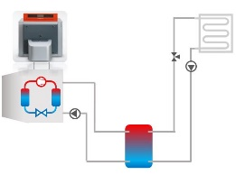 | Boiler  running on natural gas | Viessmann Werke GmbH & Co KG/ Vitoradial 300-T | 407.0 | 97 | – | –
 |  | Storage tank (buffer tank) | Viessmann Werke GmbH & Co KG/ Vitocell 100 – W | – | – | – | 120
 |  | Air-to-water heat pump | Waterkotte GmbH/ EcoTouch Air Kaskade 5120.5 | 107.2 | – | 5.0 | –
single-energy  partially parallel | 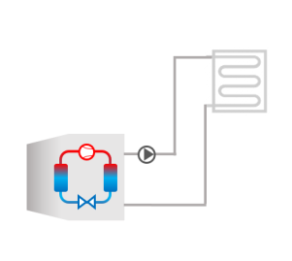
 |  | Heating  element | Drazice/ tpk 210-12 | 6 | – | – | –

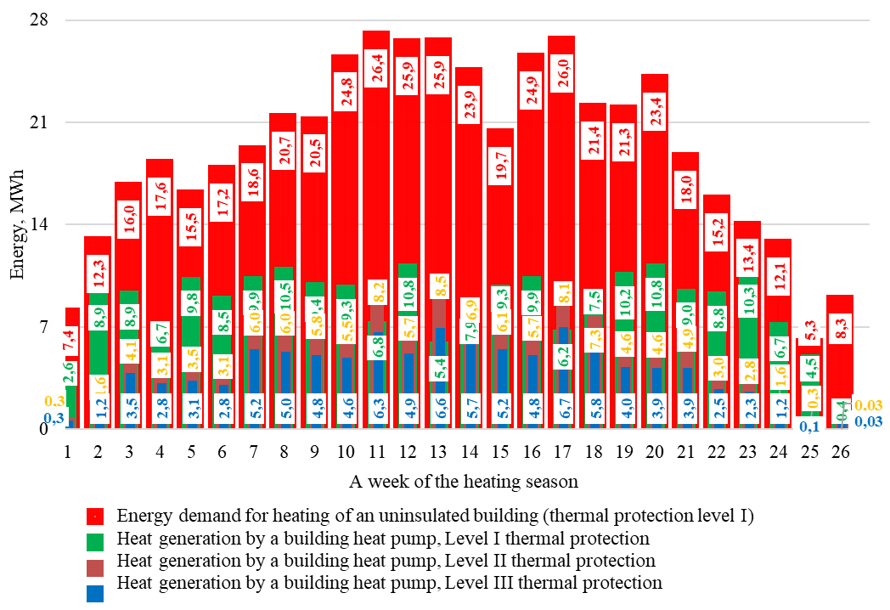
Fig. 2. Energy demand of a building for heating and heat generation by a heat pump for thermal protection of a building of Levels I, II and III by a heat pump during the heating season

Fig. 3. Volume of carbon dioxide emissions for the building modernisation options under consideration

According to the data presented in Figure 3, it is evident that carbon dioxide emissions at each level of thermal protection of a building (I, II, III) are approximately of the same order. Still, the use of sunflower husk for heat supply is the most environmentally attractive. It is explained, in particular, by the type of fuel used by thermal power plants in Ukraine to generate energy. Most thermal power plants in Ukraine are coal-fired, and in Kyiv, in particular, lignite is used to generate energy at thermal power plants, the level of emissions during combustion of which is relatively high.
The integrated costs of heating the building have been estimated taking into account the fuel consumption during the heating period, the efficiency of the selected boilers and heat pump (according to the passport data of the equipment manufacturer), the cost of the fuel storage facility (pellets), the boiler itself, and the required flue gas cleaning system. The calculations of the integrated cost were made according to the tariffs for natural gas and sunflower husk pellets in force in Ukraine in 2022; in the first approximation, the impact of the discount rate and the increase in energy prices are not considered (E = 0%, l₁₋₃ = 0%). The change in the integral cost of heating costs over time was calculated using Formula 1:
$B= \sum_{t=0}^{n}{\frac{B_{t}^{oper}}{{(1+Е)}^{t}}+}\sum_{t=0}^{n}{B_{t}^{energy}∙\frac{\left(1+l∙t\right)}{{\left(1+Е\right)}^{t}}+I_{ep}+I_{thp}+I_{hd}}$ (1)
where:
$B_{t}^{energy}$ – annual cost of energy consumption (EUR),
$B_{t}^{oper}$ – other costs (EUR),
$I_{ep}$ – investment expenditure for the purchase of heat-generating equipment (EUR),
$I_{thp}$ – expenditures aimed at improving the thermal protection of the building (EUR),
$I_{hd}$ – expenditures for the purchase of heating devices (EUR),
l – coefficient that takes into account the increase in energy prices,
n – the time for which the integrated discounted costs are determined (years),
E – discount rate.

The results of the calculated parameters of the formula for integrated heating costs are shown in Table 3.
To assess the cost-effectiveness of a building's modernisation, you can use, among other things, the method of economic calculation of heating systems established by the EN 15459-1:2017 standard. The standard defines the alignment of the energy needs of a building and the energy efficiency of its heating systems.
In particular, the reference materials provide data on the service life of energy system components (boiler
– 20 years, heat pump – 15 to 20 years) and maintenance costs (boiler – 1.5%, heat pump – 3%, electric heater – 1%). It means that at the end of the service life/lifecycle of the systems considered in this paper, its further operation is inefficient, and the system itself needs to be replaced. The change in integrated building heating costs for the modernisation options under consideration, estimated over 20 years according to EN 15459-1:2017, is shown in Figure 4.

Table 3. Components of integral heating costs for different levels of thermal protection of a building when using various energy sources for the heat supply of a building
Thermal protection  of building  – Source of energy | Expenditures
 | Fuel energy, thousand kWh | Investment expenditure  (EUR thousand) |  | Annual expenditure  (EUR thousand)
 |  | Improvement of building thermal protection Іthp | Equipment purchased, Iep* | Energy  consumed, Ben | Other costs, Вoper**
І – 1 | 451.98 | – | – | 59.94 | 1.13
І – 2 | 447.45 | – | 22.39 | 58.34 | 0.21
І – 1, 3 | 319.99 | – | 78.64 | 40.86 | 0.29
ІІ – 1 | 121.91 | 97.97 | 14.29 | 16.17 | 0.21
ІІ – 2 | 117.99 |  | 18.51 | 18.58 | 0.15
ІІ – 3 | 41.15 |  | 55.63 | 4.56 | 1.64
ІІI – 1 | 77.11 | 149.19 | 6.67 | 10.23 | 0.10
ІІІ – 2 | 92.44 |  | 15.93 | 11.98 | 0.11
ІІІ – 3 | 28.51 |  | 54.55 | 3.16 | 1.63
* Taking into account the cost of purchasing a solid fuel (pellet) boiler, flue gas cleaning system and fuel storage bunker (sunflower husk pellets) for Energy Source 2, the cost of purchasing a storage tank, heat pump, gas boiler and heating element for Energy Source 3
** Taking into account the annual maintenance costs of heat-generating equipment

Fig. 4. Changes in integrated heating costs for different ways of modernising a building

The result of the analysis of the slope of the lines characterising the integral costs indicates that the most cost-effective energy efficiency measures for building modernisation in the long term are measures aimed at using a heat pump for heat supply with an improved level of thermal protection of the building envelope (II – 3, III – 3). Therefore, Figure 4 demonstrates the economic efficiency of improving the thermal protection of a building and using a heat pump for heat supply when implementing energy efficiency measures, provided that the parameters characterising the discount rate and energy price growth are neglected. The data on the payback periods of energy efficiency measures, which are the points of intersection of the integrated costs in Figure 4, is presented in numerical values in Table 4.
According to the payback periods obtained (Table 4) for modernisation measures, which are the result of the intersection of the integrated costs of heating a building during their implementation (Figure 4), the efficiency of using renewable energy sources for heat supply can be assessed by comparing the dynamics of costs of a building of the same thermal protection level (Levels I, II, III) using natural gas as an energy carrier (1) with those using renewable sources (2, 3 or parallel operation 1, 3). At the same time, the economic effect of using a heat pump for heat supply is somewhat more attractive compared to using a boiler that runs on sunflower husk pellets. This effect is achieved due to a significant difference in the cost of energy consumption.

Table 4. Payback period for implementing energy efficiency measures in a building
Building thermal protection  – Energy source | І – 1 | І – 2 | І – 1, 3 | ІІ – 1 | ІІ – 2 | ІІ – 3 | ІІІ – 1 | ІІІ – 2 | ІІІ – 3
І – 1 | – | 9 | 3.3 | 2.5 | 2.8 | 2.8 | 3.1 | 3.4 | 3.6
І – 2 | 9.0 | – | 3.2 | 2.2 | 2.4 | 2.5 | 2.8 | 3.1 | 3.3
І – 1, 3 | 3.3 | 3.2 | – | 1.4 | 1.7 | 2.2 | 2.5 | 3.0 | 3.5
ІІ – 1 | 2.8 | 2.4 | 1.7 | – | – | 4.1 | 7.2 | 12.5 | 8.0
ІІ – 2 | 2.8 | 2.4 | 1.7 | – | – | 2.9 | 4.7 | 7.4 | 6.3
ІІ – 3 | 2.8 | 2.5 | 2.2 | 4.1 | 2.9 | – | – | – | –
ІІІ – 1 | 3.1 | 2.8 | 2.5 | 7.2 | 4.7 | – | – | – | 8.8
ІІІ – 2 | 3.4 | 3.1 | 3.0 | 12.5 | 7.4 | – | – | – | 5.3
ІІІ – 3 | 3.6 | 3.3 | 3.5 | 8.0 | 6.3 | – | 8.8 | 5.3 | –

The impact of the parameters characterising the increase in energy prices and the discount rate will be assessed by analysing tariffs for natural gas, electricity, and sunflower husk pellets in the pre-war period. Studies of the natural gas and sunflower husk pellet markets show that tariff increases (for non-household consumers) are interdependent and vary between 3% and 2%, respectively. According to statistics, the price increase for electricity used by the heat pump for heat generation was chosen at 3%. The discount rate for estimating the discounted integrated heating costs was chosen at the level of the discount rate used by EU member states in calculating the optimal costs of energy system modelling – 5% (Hermelink, et al. 2015). The change in the discounted integrated costs of heating a building for 20 years for the modernisation options under consideration is shown in Figure 5.

Fig. 5. Changes in discounted integrated heating costs for different ways of modernising the building

Considering the economic parameters (E, l1-3) to estimate the integrated heating costs of the building, modernisation did not significantly affect the nature of the lines of change in integrated costs over 20 years for all thermal protection levels and energy sources under consideration. Due to the insignificant difference in energy tariff growth rates, the payback periods for modernisation measures increased slightly. Still, they remained at an attractive level from an economic point of view. The payback periods for each of the considered ways of modernising the building, considering the increase in energy prices and the discount rate justified above, are shown in Table 5.

Table 5. The payback period for implementing energy efficiency measures in the building, taking into account the increase in energy prices and discount rate
Building thermal protection  – Energy source | І – 1 | І – 2 | І – 1, 3 | ІІ – 1 | ІІ – 2 | ІІ – 3 | ІІІ – 1 | ІІІ – 2 | ІІІ – 3
І – 1 | – | 5.8 | 4.2 | 2.6 | 2.8 | 2.9 | 3.3 | 3.5 | 3.7
І – 2 | 5.8 | – | 3.6 | 2.3 | 2.4 | 2.7 | 2.9 | 3.3 | 3.6
І – 1, 3 | 4.2 | 3.6 | – | 1.4 | 1.7 | 2.3 | 2.6 | 3.1 | 3.6
ІІ – 1 | 2.6 | 2.3 | 1.4 | – | – | 4.3 | 7.8 | 12.7 | 8.6
ІІ – 2 | 2.8 | 2.4 | 1.7 | – | – | 3.2 | 5.4 | 8.4 | 7.1
ІІ – 3 | 2.9 | 2.7 | 2.3 | 4.3 | 3.2 | – | – | – | –
ІІІ – 1 | 3.3 | 2.9 | 2.6 | 7.8 | 5.4 | – | – | – | 9.2
ІІІ – 2 | 3.5 | 3.3 | 3.1 | 12.7 | 8.4 | – | – | – | 5.8
ІІІ – 3 | 3.7 | 3.6 | 3.6 | 8.6 | 7.1 | – | 9.2 | 5.8 | –

Analysing the data from Table 5, we can conclude that the economic attractiveness of improving the thermal protection of the building and using renewable energy sources will increase with a 3% increase in tariffs for natural gas and electricity and a 2% increase in sunflower husk pellets. The impact of a more significant increase in tariffs on the feasibility of modernising a building by improving its thermal protection and using renewable energy sources for heat supply will be assessed at a fixed rate of tariff growth:
L₁ – 20%, L₂ – 12.5%, L₃ – 18%. The discount rate will be chosen at the level of the reduced rate E = 10%, which was considered by the Energy Department of the European Commission when modelling scenarios for achieving the energy efficiency target by 2030 (Battle of the Discount Rates). The points of intersection of the lines of integral heating costs, considering the above parameters, are shown in Table 6.

Table 6. The payback period for implementing energy efficiency measures in a building, taking into account a significant increase in energy prices and discount rates
Building thermal protection  – Energy source | І – 1 | І – 2 | І – 1, 3 | ІІ – 1 | ІІ – 2 | ІІ – 3 | ІІІ – 1 | ІІІ – 2 | ІІІ – 3
І – 1 | – | 2.5 | 3.3 | 2.3 | 2.4 | 2.5 | 2.7 | 2.9 | 3.2
І – 2 | 2.5 | – | 4.6 | 2.1 | 2.2 | 2.5 | 2.8 | 3.0 | 3.4
І – 1, 3 | 3.3 | 4.6 | – | 1.3 | 1.5 | 1.9 | 2.4 | 2.6 | 3.0
ІІ – 1 | 2.3 | 2.1 | 1.3 | – | 7.0 | 3.3 | 6.1 | 7.2 | 6.2
ІІ – 2 | 2.4 | 2.2 | 1.5 | 7.0 | – | 2.9 | 6.1 | 7.2 | 6.2
ІІ – 3 | 2.5 | 2.5 | 1.9 | 3.3 | 2.9 | – | – | – | –
ІІІ – 1 | 2.7 | 2.8 | 2.4 | 6.1 | 6.1 | – | – | 1.3 | 6.3
ІІІ – 2 | 2.9 | 3.0 | 2.6 | 7.2 | 7.2 | – | 1.3 | – | 5.2
ІІІ – 3 | 3.2 | 3.4 | 3.0 | 6.2 | 6.2 | – | 6.3 | 5.2 | –

The results of calculations of the integrated costs of heating a building for implementing the energy efficiency measures considered in this paper indicate a high economic feasibility of their implementation even under conditions of a significant increase in energy tariffs. Thus, if tariffs increase to the level described above L₁ – 3 and the discount rate E = 10%, the economic efficiency of the building operation when replacing the energy source at the existing level of thermal protection (I – 2, I – 1, 3), compared to the I – 1 system, is confirmed by the payback periods of the systems of 2.5 and 3.3 years, respectively. At the same time, the high economic feasibility of implementing measures aimed at using renewable energy sources with an improved building envelope is confirmed by the payback periods of systems II – 2, II – 3 and III – 2, I
II – 3 compared to I – 1.
3. Conclusions
The paper presents the results of the dynamic modelling of a building in DesignBuilser at different levels of thermal protection of the building:
- the existing level of thermal protection provided by an uninsulated building,
- thermal protection improved to Ukrainian requirements, energy-efficient building envelope,
- thermal protection improved to Swedish requirements, highly energy-efficient building envelope.

The possibilities of using renewable energy sources and modernisation's economic, technical and environmental impact were assessed by comparing the advantages of biomass and a heat pump over natural gas. According to the assessment, the most attractive measure from an environmental and economic point of view is replacing natural gas with biomass represented by sunflower husk pellets, with an improved level of thermal protection to the level of an energy-efficient and highly energy-efficient building envelope. At the same time, the long-term heating costs for a building using biomass as an energy source at different levels of thermal protection are the lowest under different scenarios of energy tariff growth and discount rates.
Further research will focus on estimating the cooling demand for a building in the summer at different thermal protection levels using different energy sources.
References
Battle of the Discount Rates. Friends of the Earth Europe. Retrieved from: http://www.foeeurope.org/sites/default/files/energy_savings/2015/battle-discount-rates.pdf.
Buildings – Topics – IEA. IEA. Retrieved from: https://www.iea.org/topics/buildings
Calculation of CO₂ emission reductions – Unisolar. Unisolar. Retrieved from: https://unisolar.com.ua/en/blog-en/prorahunok-zmenshennya-vikidiv-co2/.
Carbon Footprint Calculator. Retrieved from: https://www.carbonfootprint.com/calculator.aspx.
Deshko, V., Bilous, I., Buyak, N., Naumchuk, O. (2023). Analysis of directions to increase the energy efficiency of office buildings in Ukraine to the nZEB level. Energy and automation, I, 150-164. (in Ukrainian). http://dx.doi.org/10.31548/energiya1(65).2023.150
Deshko, V., Buyak, N., Bilous, I., Naumchuk, O. (2022). Economic assessment of increasing thermal protection of municipal buildings to modern European requirements. Power Eng.: Econ., Tech., Ecol., 2, 7-18. (in Ukrainian). https://doi.org/10.20535/1813-5420.2.2022.261277
Deshko, V., Naumchuk, O. (2023). Evaluation of the efficiency of the options for the modernisation of the heat supply and thermal protection of the office building. Collection of Scientific Works of the Ukrainian State University of Railway Transport, 2, 12-26. (in Ukrainian). Retrieved from: https://kart.edu.ua/wp-content/uploads/2023/07/tht_zbirn_204.pdf
Directive 2010/31/EU of the European Parliament and of the Council of 19 May 2010 – Energy Performance of Buildings Directive – EPBD//EN L 153/13-35, 19.05.2010
Ecological-economic calculations of pollutant emissions. Institute of Doctoral and Postgraduate Studies – Vinnitsa National Technical University. Retrieved from: http://inmad.vntu.edu.ua/portal/static/16C6EA96-BCB1-4B60-948B-DD62552C9925.pdf.
GeoT*SOL – The Calculation and simulation software for heat pump systems. Valentin Software | Planungs- und Simulationssoftware für erneuerbare Energien. Retrieved from: https://valentin-software.com/en/products/geotsol/
Hermelink, А.Н., de Jage, D. (2015). Evaluating our future – The crucial role of discount rates in European Commission energy system modelling. The Europe an Council for an Energy Efﬁcient Economy (eceee) & Ecofys. Retrieved from: https://doi.org/10.13140/RG.2.2.20152.65285
Shkarovskiy, A., Mamedov, S. (2021). Improving the Efficiency of Non-Stationary Climate Control in Buildings with a Non-Constant Stay of People by Using Porous Materials. Materials, 14(9). 2307. https://doi.org/10.3390/ma14092307
Smirnova, E., Mamedov, Sh., Shkarovskiy, A. (2022). Improving the Environmental Safety Risk Assessment in Construction Using Statistical Analysis Methods. Rocznik Ochrona Środowiska, 24, 110-128 https://doi.org/10.54740/ros.2022.009

