 | Rocznik Ochrona Środowiska
 | Volume 25 | Year 2023 ISSN 2720-7501 | pp. 77-85
 | https://doi.org/10.54740/ros.2023.009 open access
 | Received: May 2023 Accepted: May 2023 Published: June 2023
Impact of Heating System Local Control on Energy Consumption in Apartment Buildings
Valeriі Deshko¹, Inna Bilous^{2*}, Oleksandra Maksymenko³
¹National Technical University of Ukraine "Igor Sikorsky Kyiv Polytechnic Institute", Educational and Research Institute of Nuclear and Heat Power Engineering, Ukraine,
Institute of Engineering Thermophysics of NAS of Ukraine
https://orcid.org/0000-0002-8218-3933
²National Technical University of Ukraine "Igor Sikorsky Kyiv Polytechnic Institute", Educational and Research Institute of Nuclear and Heat Power Engineering, Ukraine,
Institute of General Energy of NAS of Ukraine
https://orcid.org/0000-0002-6640-103X
³National Technical University of Ukraine "Igor Sikorsky Kyiv Polytechnic Institute", Educational and Research Institute of Nuclear and Heat Power Engineering, Ukraine
https://orcid.org/0000-0003-4099-2772
*corresponding author's e-mail: biloys_inna@ukr.net
Abstract: Improving the energy efficiency of residential buildings is ensured by improving the thermal protection characteristics and the wider introduction of control tools. In order to take into account the influence of individualisation of operating conditions, the study of the regulation of heating distribution of a single-pipe system with bypassed heating devices of a 5-storey typical for Ukraine mass building of the 80s after thermos-modernisation for conditions in Kyiv and Warsaw (Poland) was carried out. On the basis of the simulation model created in the Mathcad software environment for design/rated and average climatic conditions, the influence of internal heat flows into adjacent rooms on the distribution of energy consumption, changes in internal air temperature under the influence of local changes in the heating device flow coefficients were studied. The developed approaches, and the results obtained on the influence of local regulation of devices of vertical single-pipe heating systems can be used to clarify the distribution of energy consumption for heating between individual zones of apartment buildings.
Keywords: energy saving, internal temperature, energy control and consumption for heating, residential buildings, modelling
1. Introduction
Energy efficiency is one of the most important issues of our time. According to official statistics for 2019-2022, more than 40% of all final energy consumption is in the building sector. In countries with continental climates, heating costs account for more than 85% of all energy consumption in buildings. Therefore, in the building sector of European countries, there is an active energy efficiency policy, which aims at almost zero energy consumption (according to the EU Directive 2010/3/EU On the energy efficiency of buildings).
In Ukraine, the reform of the regulatory framework in the field of energy efficiency began to actively develop with the introduction of the Law of Ukraine On Energy Efficiency of Buildings (Law of Ukraine On Energy Efficiency of Buildings) and its harmonisation with the European one is increasingly taking place (DSTU B V.2.2−39:2016, DSTU ISO 50002:2016, DSTU B A.2.2−12:2015, DSTU B EN ISO 13790:2011).
Currently, when addressing the issue of increasing the energy efficiency of the existing residential and public buildings, energy-saving measures for the improvement of thermal properties of the building envelope and improving the performance of engineering systems with the introduction of energy-efficient heating modes are being actively implemented, since the vast majority of buildings have been erected during mass construction, which is characterised by the low level of thermal protection properties of enclosures and limited regulation of heating systems both in Ukraine and to some extent in other countries (Nedbailo et al. 2023, Eutukhova et al. 2020). Accordingly, each building must be considered comprehensively, considering the consumption of thermal energy, building enclosures, engineering systems and equipment (Directive 2012/27/EU).
Furthermore, modern research on the energy efficiency of buildings is based on the concept of a building as an energy system, which includes a person as an active element (Deshko et al. 2019). Occupant behavior is now widely recognised as a major contributing factor to uncertainty of building performance (Yan et al. 2016). An overview and analysis of various stages of researching the influence of occupant behavior on the energy characteristics of buildings using building performance simulation was carried out. But the features of multi-occupant spaces, especially when modeling heating, require additional attention.
Numerous scientific studies point to the significant influence of the behavioral characteristics and needs of users of public buildings (Agee et al. 2021, Redko et al. 2021) and especially the influence of users primarily of residential buildings, which significantly affect the determination of energy consumption for heating, is actively studied. The analysis of human-centered approach to smart buildings carried out in (Agee et al. 2021) emphasises energy analysis, but does not focus on the engineering aspects of distribution of energy consumption. In the article (Park et al. 2019), a review of occupant-centric control research examples, focusing on field-implementation case studies in actual buildings under realistic use conditions, was carried out. The review (Azar et al. 2020) critically analysed existing studies applying computer-based modelling and simulation to guide occupant-centric building design. Future research directions are to promote an occupant-in-the-loop approach to the building design process. The empirical study (Zhao et al. 2017) aimed at identifying the relationship between building technology and resident behaviour and their joint effects on energy consumption in residential buildings. Data analysis was performed using energy simulation and multivariate regression techniques. In the review (Happle et al. 2018), emphasis is placed on different occupant behaviour modelling approaches impacts on the urban scale for various building energy modelling. The study (Ahn & Park 2016) shows that energy consumption is more correlated to the control action of occupants than occupants' presence, while the latter has randomness. Occupants' energy behavior research review (Zou et al. 2016) shows the dominance of quantitative methods, and the framework of qualitative, quantitative and mixed methods was discussed. Considering the importance of human-building interactions, the paper (Balvedi et al. 2018) reviews and analyses methods for monitoring, modelling occupant behaviour, and applying them in residential building performance simulations. When building energy modeling and the cost-benefit analysis is performed, the uncertainty in occupant behavior and possible energy-intensive wrong behaviors are examined (Ascione et al. 2020).
It should be noted that the tasks set by different researchers at the level of modern European standards and for the operating conditions of buildings of mass construction in Ukraine are essentially different. So, the study (Nord et al. 2018) evaluated the change in the energy performance of a ZEB located in Norway, and the effect of the occupant behaviour is becoming even bigger when it comes to highly energy-efficient buildings. Occupant behavior might change the annual energy balance reliability by 20%. But in Ukraine, for example, researchers pay attention to the influence of temperature schedules compliance, individual heating regulation, and complex and "shred" insulation on the temperature conditions of separate premises (Deshko et al. 2019, Deshko et al. 2018). Or the effect on the heating level of heat flows through internal enclosures (Deshko et al. 2020) is considered. Results of numerical study of design and operating parameters of the heat supply network concern reduced temperature graph and optimal flow-rate of circuit water of a district heating system in Ukraine (Redko et al. 2021). The change in CO₂ concentration and air exchange in the premises of educational institutions (Deshko et al. 2020), and the influence of air exchange modes on energy use for heating in residential buildings (Deshko et al. 2021) is studied. At the same time, it is concluded that when developing energy strategy problems for Ukraine at the national level, social aspects and issues of energy consumption management are not given enough attention (Basok et al. 2017).
According to (DSTU−N B V.3.2−3:2014), reducing energy consumption for heating buildings in Ukraine can be achieved in different ways. Nowadays, the multi-storey residential buildings in Ukraine implement thermal modernisation through modern thermal insulation materials and technologies with mandatory heating system modernisation.
Although the vast majority of residential buildings, offices and other premises in Ukraine are connected to district heating (DH) and provide a significant share of heat energy demand in different countries, in recent years, the share of DH in Ukraine has been significantly decreasing. Comparing the indicators of comfort, reliability and energy characteristics of DH and individual heat supply (IHS) of residential buildings, it should be noted that the installation of individual heating systems in Ukraine has several significant advantages and is gaining significant scale (Basok et al. 2017).
The experience of such countries as Denmark, Germany, Finland, Sweden and the Netherlands shows the development of DH and the need for the building's first-class equipment of the individual heat point (IHP) with an automatic control system. Many district heating systems in Poland must also be modernised to meet the requirements of the European Directive EED 2018/2002 (Fedorczak-Cisak et al. 2017).
It should be noted that the regulation of heating systems is possible only if the comfort conditions, a sufficient level of thermal protection, and the interest of residents in the individual implementation of energy-efficient heating modes are ensured (Shkarovskiy et al. 2021). The dispersion of the effects of individual regulation in space and time complicates their analysis and requires additional research.
Since the main guideline in the implementation of a set of energy-saving measures is to reduce energy consumption while maintaining the normative internal air temperature in the premises, it is important to investigate not only the consequences of heating regulation in the apartment under study but also the neighbouring premises, since the difference in temperature conditions causes such an effect as heat flows through the internal enclosures. Heat flows cause additional heat losses and reduce the energy efficiency of the regulation in the apartment and the building as a whole. Changing the temperature conditions by adjusting the heating system by individual occupants in a single apartment can significantly impact the heat losses through the internal building enclosures and the comfort conditions in neighbouring apartments.
Taking into account the operational features that arise under the influence of the socio-characteristics of the occupants of the building, the purpose of the work is to analyse the distribution of heat energy consumption for heating typical buildings in Ukraine after thermo-modernization (Kyiv) and in Poland (Warsaw), taking into account local apartment regulation, as well as to study the impact of heat flows between adjacent zones (apartments).
According to the set goal, the following tasks should be performed:
- creation and adjustment of a mathematical model of a residential building, the peculiarity of which is the thermal interaction of individual rooms and heating device hydraulic interaction in the riser of a single-pipe system;
- determination of heat consumption and temperatures of individual premises under the influence of individual heating control;
- analysis of heat flows between neighbouring apartments under the condition of implementation of a set of energy-saving measures to improve the thermophysical characteristics of the building enclosures and local regulation of the heating system.
2. Material and Research Results
Initial data. According to the work's purpose, the study's object is a typical five-apartment building without complex architectural, planning or design solutions that meets the modern requirements of thermal protection properties of enclosures in Ukraine and Poland. Climatic conditions are typical for Kyiv. Heat energy metering is carried out for the building as a whole. The heating system is single-pipe, with upper water input, connecting heating devices (radiators type MC−140) with a bypass section and the possibility of local regulation using a valve. The temperature schedule of the building heating system for design conditions is "95/70". The project provides a heating device flow coefficient α = 0.5. The power of heating devices for cast iron radiators is selected to ensure an internal temperature of 18°C in the premises under the design conditions of the heating system's external temperature and temperature schedule. For existing buildings without thermal modernisation, the indoor air temperature in the premises corresponds to the conditions for which the heating system was configured when the building was designed.
The characteristics of heating devices were determined from the design calculation for an internal temperature of 18°C, outside air t_{out} = -22°C (DSTU−N B V.1−27:2010) and the absence of internal and external heat supply at heating device flow coefficient on all floors α = 0.5, the temperature at the inlet/outlet of the riser of the heating system 95/70°C.
In addition to the thermophysical properties of the enclosures, the following parameters were set: outdoor temperature, the temperature at the inlet to the heating system of the building riser, according to the temperature schedule 95/70:
(1)
where:
– the temperature in the supply pipeline, °С
(2)
– coefficient of reduction of heat consumption for heating and ventilation depending on the outside air temperature,
– internal temperature, °С
– outside temperature, °С
– heating design outdoor air temperature, °С.

Thermal characteristics of external building enclosures according to the standards in Ukraine (DBN V,.2.6−31:2016) and Poland (Fedorczak-Cisak et al. 2017) are given in Table 1.
Table 1. General characteristics of fencing structures
Type of fencing  structure | Square | The value of the heat transfer coefficient of the fencing structure
 |  | Ukraine | Poland
 | A, m²
Exterior wall | 12.6 | 0.30 | 0.20
Internal wall | 35 | 1.86 | 1.86
Internal floor/ceilings | 18 | 0.74 | 0.74
Window | 1.8 | 1.33 | 0.83
Roof | 18 | 0.20 | 0.15
Floor on the ground | 18 | 0.22 | 0.22

For simulation purposes, a model of a block of five identical heated premises located on different floors. The power of the heating devices was selected from the calculation with the design conditions using a flow coefficient α = 0.5. The value of the design power of the radiators is shown in Fig. 1 for apartments with the heat-shielding properties of the fences meeting the requirements of Ukraine (on the left) and the requirements of Poland (on the right). The geometrical dimensions of a representative room are given in Fig. 2.

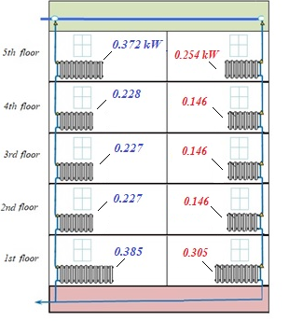 | Fig. 1. Model of a representative building
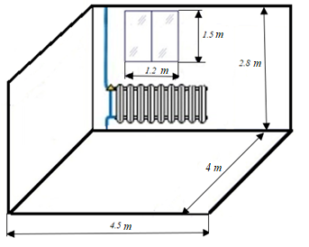 | Fig. 2. Model of a representative room
Model description. A simulation model was created in the Mathcad software environment, which considers the riser of a single-pipe system with bypassed heating devices which passes through the same living premises of a five-storey building. Based on the equations of heat flow balances for premises and heating devices for steady-state conditions, a system of 47 equations is solved. For the first and fifth floors, the floor and the roof are considered external horizontal enclosures, respectively.
The equation of heat balance of the premises takes into account: heat flow from heaters and from water in the heater, taking into account the heating device flow coefficient α, heat losses through external (taking into account transmission and ventilation) and internal enclosures, ceiling, and floor.
The system of equations for the internal (fourth) floor is presented below. This is a system of heat balance equations: heat transfer from the heater to the air in the room (3), heat flow from the water to the heater connected to the riser of the single-pipe heating system (4), and from the room to the outside (6). The overall balance (5) also takes into account heat transfer through the internal walls (7), floor (8) and ceiling (9). Inter floor balances for the water ducts in the heating system (10) are also added to the overall system. It was assumed that there are no additional internal heat gains in the room, losses with natural ventilation are added to the heat transfer through the external enclosures.
(3)
(4)
(5)
(6)
(7)
(8)
(9)
(10)
where:
– nominal heat flow of the heating device at ∆t = 70°C, kW/m²;
$t=\frac{t_{\sup_{4}{}}+t_{ret}}{2}$ – average temperature of the heating device, °C;
– the temperature of the heat carrier at the inlet to the heating device, °C;
– the temperature of the heat carrier at the outlet to the heating device, °C;
– internal air temperature in the room, °C;
– internal air temperature in the adjacent rooms, °C, is taken from the calculation without local regulation;
– internal air temperature in the 3rd floor room, °C;
– internal air temperature in the 4th floor room, °C;
m – the heat carrier flow through the riser, kg/s;
α – heating device flow coefficient;
c – specific heat of the heat carrier (water), kJ/kg·°С;
– heat losses through external enclosures, through side walls to adjacent premises, through floor and ceiling, kW, respectively;
– additional heat input, kW;
t_{out} – outdoor air temperature, °C;
h – the heat transfer coefficient of the enclosures is determined according to the characteristics of the enclosing structures shown in Table 1.

The developed model makes it possible to determine the temperature of the heat carrier at the inlet and outlet of the heater, the heat flow from the radiator, heat losses through the external enclosures, heat flows through the internal enclosures of the premises and the air temperature in the premises of different floors with heating devices connected to certain riser of a vertical single-pipe system.
Analysis of the study results. In this work, simulations were performed for design conditions of Kyiv at outdoor temperature t_{out} = -22°C (DSTU−N B V.1−27:2010) and a series of simulations for average conditions for the heating season t_{out} = -0.1°C. The effect of local heating system regulation on the 4th floor by means of different heating device flow coefficients of valves on the heaters at different external conditions and corresponding water supply temperatures in the riser pipe is investigated. Solar thermal inputs were not considered to isolate the influence of each studied component and the possibility of comparing them under design and average external conditions.
Figure 3 shows the results of adjusting the heating device on the 4th floor of the building with the characteristics of the thermal resistance of the fences in Ukraine and Poland for the average temperature of the heating season -0.1°С. At the same time, local regulation is not performed in adjacent premises. Data on changes in the amount of heat flow and internal temperature in the room at different values of the heating device flow coefficient are given. Data on the heat flow from the heating device and heat losses through external enclosures (Q_{out}) are presented. The given Q_{out} data correspond to the sum of heat inputs from heating and due to flows through the enclosure from adjacent rooms, as well as the heat flow from the heating device without local regulation, which ensures the appropriate value of the air temperature in the room.
The obtained data give an idea of the maximum possible differences in the level of heating and air temperature under quasi-stationary conditions of heating regulation in a separate room with the given characteristics of the resistance of the fences.

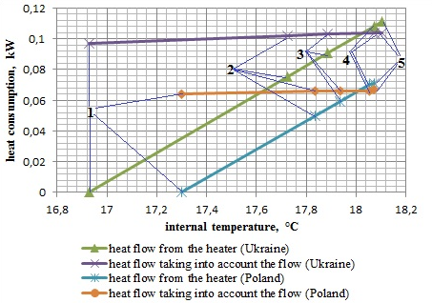
Fig. 3. Heat flow from the heater and heat losses due to external enclosures (Q_{out}) of the 4th floor and the room temperature at different heating device flow coefficients α (1 – 0; 2 – 0.05; 3 – 0.1; 4 – 0.5; 5 – 1.0)

In this situation, at t_{out} = -22°C the influence of internal overflows is much greater than at an average temperature of the heating season of -0.1°C.
Regulation of heating devices in the direction of decreasing heat flow can significantly reduce heat losses, while the internal air temperature in the premises can be maintained to a large extent through flows through the external enclosures, and the temperature reduction during regulation depends on the level of thermal protection. Increasing the heating device flow coefficient to α = 1.0 does not lead to a significant increase in the heating device's thermal power and the room's temperature.
With greater heat transfer resistance according to Polish standards compared to Ukrainian standards, the range of heating level changes decreases, and the temperature level in the room increases.

Fig. 4 shows the distribution of air temperatures and the level of heating for rooms located on five floors, the heating devices of which are connected to the vertical riser of the water heating system with the upper supply of the coolant. The calculation results are presented for options when there are no heat flows between floors and through internal walls and when these flows are present. The water supply temperature corresponds to the outside air temperature of -0.1°C.
The higher level of heating on the first and fifth floors is determined by the choice of heating devices to compensate for additional heat losses through the roof and floor. An increase in the thermal resistance of the fences leads to a decrease in the heating level by approximately 30%.
For the option when there are no heat flows between floors and through internal walls, and when there is no heating reduction on the 4th floor when water is supplied to the riser with a temperature that corresponds to the heating schedule at an external temperature of -0.1°C, we have an increase in the air temperature in the rooms to the level of 19°C with some increase on the lower floors. Adjusting the heating on the 4th floor to α = 0.1 leads to a decrease in heating by 11% and air temperature in the room by more than 2°C, as well as a slight increase on the lower floors.
In the presence of overflows, the temperature level in the premises is equalised. Adjusting the heating to α = 0.1 leads to a reduction of heating on the 4th floor by more than 15% and the air temperature in the room by less than 0.2°C. The decrease in heating regulation's effect on the room's air temperature is explained by the effect of heat flows from neighbouring rooms.
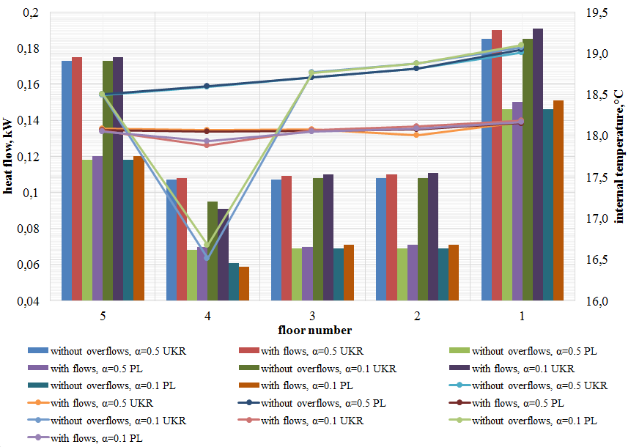
Fig. 4. Distribution of air temperatures and heating level on five floors

Figure 5 shows the amount of heat flows through the external enclosures of the room on the 4th floor under different conditions: external temperature -22 and -0.1°С under the condition of heating device flow coefficient α = 0.1. The difference between inflows and losses of heat through external enclosures corresponds to internal heat input from heating. The ratio between inflows and heat losses is in the range of 12-18% and decreases with an increase in the temperature of the outside air and the heat transfer resistance of the external walls. The largest component of heat inflows takes place through the internal walls. It decreases when the resistance of the external walls increases.

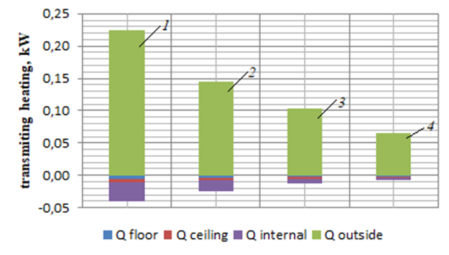
Fig. 5. Transmitting heating due to enclosing structures at different outside temperatures; 1, 3 – for the building according to Ukrainian standards, at t_{out} = 22°C and t_{out} = -0.1°C respectively; 2, 4 – the same for the building according to Polish standards
3. Conclusions
In the paper, a simulation model of a 5-storey typical building of mass construction of the 80s of the 20th century after thermal modernisation for conditions in Kyiv and Warsaw (Poland) with a single-pipe heating system with bypassed heating devices was created in the Mathcad software environment.
The influence of local regulation of a single-pipe heating system bypassed heating devices was studied based on a simulation model for estimated/calculated and average Kyiv climatic conditions.
Internal heat flows to adjacent premises, changes in the internal air temperature under the influence of flow coefficient changes in the heating device of the 4th floor and the floor temperature distribution in the premises at an outside air temperature of -22 and -0.1°С are investigated. The obtained data give an idea of the maximum possible differences in the level of heating and air temperature under quasi-stationary conditions of heating regulation in a separate room for the given characteristics of the fences' thermal resistance. Thus, with a local change in the heating device flow coefficient in one room from 0.5 to 0.1, the heating level can decrease by 13% and the temperature in the room by 0.14°С. In the absence of heat flows through the internal enclosures, the temperature in the room would decrease by more than 2°С. When the heating is turned off, the air temperature in the room can decrease by 1.1°C due to the influence of heat flows from adjacent rooms with a constant temperature.
The developed approaches and the results obtained on the influence of local regulation of devices of vertical single-pipe heating systems can be used to clarify the distribution of energy consumption for heating between individual zones of apartment buildings. Further, it is planned to conduct experimental studies of heat transfer processes in heated rooms following real operating conditions. Further research considers the inertia of fences and devices of heating systems when determining the possibilities of local heating regulation in multi-apartment buildings of mass construction.
References
Ahn, K.U., Park, C.S. (2016). Correlation between occupant and energy consumption. Energy and Building, 116,
420-433. https://doi.org/10.1016/j.enbuild.2016.01.010
Agee, P., Gao, X., Paige, F., McCoy, A., Kleiner, B. (2020). A human-centred approach to smart housing. Build. Res. Inf., 49(1). 84-99. https://doi.org/10.1080/09613218.2020.1808946
Ascione, F. et al. (2020). The role of the occupant behavior in affecting the feasibility of energy refurbishment of residential buildings: Typical effective retrofits compromised by typical wrong habits. Energy and Buildings, 223. https://doi.org/10.1016/j.enbuild.2020.110217
Azar, E., O'Brien, W., Carlucci, S., Hong, T., Sonta, A., Kim, J., Andargie, M.S., Abuimara, T., El Asmar, M., Jain, R.K., Ouf, M.M., Tahmasebi, F., Zhou, J. (2020). Simulation-aided occupant-centric building design: A critical review of tools, methods, and applications. Energy and Buildings, 224, 110292. https://doi.org/10.1016/j.enbuild.2020.110292
Basok, В.I., Nedbaylo, O.M. (2017). Prospects for the Development of Heat Supply of the Population of Ukraine. KNUBA Energy-Efficiency in Civil Engineering and Architecture, 31-37.
Bruna, Faitão, B., Ghisi, E., Lamberts, R. (2018). A review of occupant behavior in residential buildings. Energy and Building, 174, 495-505. https://doi.org/10.1016/j.enbuild.2018.06.049
Directive (EU) 2018/2002 of the European Parliament and of the Council of 11 December 2018 amending Directive 2012/27/EU on energy efficiency
Deshko, V., Buyak, N., Voloshchuk, V. (2019). Reference state for the evaluation of energy efficiency of the system "heat source-human-building envelope". ECOS 2019 − Proceedings of the 32nd International Conference on Efficiency, Cost, Optimization, Simulation and Environmental Impact of Energy Systems. 2287-2300.
Deshko, V., Bilous, I., Maksymenko, O. (2018). Analysis of Domestic Individual Thermosanation of Different Structures of Multi-Apartment Residential Buildings. Power Eng.: Econ., Tech., Ecol., 4, 7-13. (in Ukrainian).
Deshko, V., Bilous, I., Maksymenko, O. (2019). Мodern problems of the heating system of multi-apartment buildings. Technical sciences and technologies, 1, 267-277. (in Ukrainian).
Deshko, V., Bilous, I., Shovkaliuk, M., Hureyev, M. (2020). Evaluation of differentiated impact of apartment building occupants' behavior on energy consumption. IEEE 7th International Conference on Energy Smart Systems, ESS 2020 − Proceedings, 2020, 196-200, 9160046.
Deshko, V., Bilous, I., Sukhodub, I., Yatsenko, O. (2021). Evaluation of energy use for heating in residential building under the influence of air exchange modes. Journal of Building Engineering, 42, 103020. https://doi.org/10.1016/j.jobe.2021.103020
Deshko, V., Bilous, I., Vynogradov-Saltykov, V., Shovkaliuk, M., Hetmanchuk, H. (2020). Іntegrated approaches to determination of CO₂ concentration and air rate exchange in educational institution. Rocznik Ochrona Środowiska, 22(1), 82-104.
Directive 2010/31/EU of the European Parliament and of the Council of 19 May 2010 – Energy Performance of Buildings Directive – EPBD//EN L 153/13−35, 19.05.2010
Directive 2012/27/EU of the European Parliament and of the Council of 25.10.2012 on the energy performance of buildings. Official Journal of the European Communities. 2012. L315. 8-18.
DSTU B EN ISO 13790:2011 Enerhetychna efektyvnist budivel. Rozrakhunok enerhospozhyvannia na opalennia ta okholodzhennia. [Energy efficiency of buildings. Calculation of energy consumption for heating and cooling]. Kyiv, 2013. 150. (in Ukrainian).
DSTU ISO 50002:2016 Enerhetychni audyty. Vymohy shchodo yikh provedennia. [Energy Audits Requirements With Guidance For Use]. Kyiv, 2016. 25. (in Ukrainian).
DSTU B A.2.2−12:2015 Enerhetychna efektyvnist budivel. Metod rozrakhunku enerhospozhyvannia pry opalenni, okholodzhenni, ventyliatsii ta HVP. [Energy efficiency of buildings. Method of calculating energy consumption for heating, cooling, ventilation and DHW]. Kyiv, 2015. 145. (in Ukrainian).
DSTU B V.2.2−39:2016 Metody ta etapy provedennia enerhetychnoho audytu. [Methods And Phase Of Conducting Energy Audits Of Buildings]. Kyiv, 2016. р. 50. (in Ukrainian).
DSTU−N B V.1−27:2010. Budivelna Klimatologiya [Building Climatology]. Кyiv, 2011. 127. (in Ukrainian).
DSTU−N B V.3.2−3:2014 Nastanova z vikonannya termomodernizatsii zhitlovyh budynkiv [Guidelines for the Implementation of Thermomodernisation of Residential Buildings]. Кyiv, 2014. 71. (in Ukrainian).
DBN V,.2.6−31:2016. Teplova izolyatsiya budivel [Thermal Insulation of Buildings] Кyiv, 2016. 33. (in Ukrainian).
Eutukhova, T., Kovalko, O., Novoseltsev O., Woodroof E. (2020). Energy Services: A Proposed Framework to Improve Results. Energy Engineering, 117(3), 99-110, https://doi.org/10.32604/EE.2020.010864
Fedorczak-Cisak, M., Knap, K., Kowalska-Koczwara, A., Pachla, F., Pekarchuk, O. (2019). Energy and Cost Analysis of Adapting an Existing Building to 2017 Technical Requirements and Requirements for NZEB. IOP Conference Series: Materials Science and Engineering. 471(11). https://doi.org/10.1088/1757-899X/471/11/112094
Happle, G., Fonseca, J.A., Schlueter, A. (2018). A review on occupant behavior in urban building energy models. Energy and Buildings, 174, 276-292. https://doi.org/10.1016/j.enbuild.2018.06.030
LAW OF UKRAINE On Energy Efficiency of Buildings. https://zakon.rada.gov.ua/laws/show/2118−19?lang=en#Text
Nord, N., Tereshchenko, T., Qvistgaard, L.H., Tryggestad, I.S. (2018). Influence of occupant behavior and operation on performance of a residential Zero Emission Building in Norway. Energy and Buildings, 159, 75-88. https://doi.org/10.1016/j.enbuild.2017.10.083
Nedbailo, O., Basok, B., Bozhko, I., Novitska, M. (2023). Energy Saving through Automation of the Lightweight Floor Heating System. Civil Engineering and Architecture, 11(2), 930-938. https://doi.org/10.13189/cea.2023.110229
Park, J.Y., Ouf, M.M., Gunay, B., Peng, Y., O'Brien, W., Kjærgaard, M.B., Nagy, Z. (2019). A critical review of field implementations of occupant-centric building controls. Building and Environment, 165, 106351. https://doi.org/10.1016/j.buildenv.2019.106351
Redko, I., Ujma, A., Redko, A., Pavlovskiy, S., Redko, O., Burda, Y. (2021). Energy efficiency of buildings in the cities of Ukraine under the conditions of sustainable development of centralised heat supply systems. Energy and Buildings, 247, 110947. https://doi.org/10.1016/j.enbuild.2021.110947
Shkarovskiy, A., Mamedov, S. (2021). Improving the Efficiency of Non-Stationary Climate Control in Buildings with a Non-Constant Stay of People by Using Porous Materials. Materials, 14(9), 2307. https://10.3390/ma14092307
Yan, D., O'Brien, W., Hong, T., Feng, X., Burak Gunay, H., Tahmasebi, F., Ardeshir, M. (2016). Occupant behavior modeling for building performance simulation: Current state and future challenges. Energy and Buildings, 116, 694-702. https://doi.org/10.1016/j.enbuild.2015.11.052
Zhao, D., McCoy, A.P., J. Du, J., Agee, P., Lu, Y. (2017). Interaction effects of building technology and resident behavior on energy consumption in residential buildings. Energy and Buildings, 134, 223-233. https://doi.org/10.1016/j.enbuild.2016.10.049
Zou, P.X.W., Xu, X., Sanjayan, J., Wang, J. (2016). A mixed methods design for building occupant energy behavior research, Energy and Building, 166, 239-249, https://doi.org/10.1016/j.enbuild.2018.01.068

