 | Rocznik Ochrona Środowiska
 | Volume 24 | Year 2022 ISSN 2720-7501 | pp. 472-480
 | https://doi.org/10.54740/ros.2022.033 open access
 | Received: 21 November 2022 Accepted: 12 December 2022 Published: 14 December 2022
Saving Energy – a Smart, Ecological and Necessary Trend
Magdalena Orłowska
Koszalin University of Technology, Poland
https://orcid.org/0000-0002-2072-1791
corresponding author’s e-mail: magdalena.orlowska@tu.koszalin.pl
Abstract: The article discusses selected ways of saving energy. It is a review material on the problems of humanity and industry in terms of energy consumption of machines, and devices as well as principles and actions aimed at improving and protecting the environment and the Earth – as our planet. Energy efficiency, which should go hand in hand with energy saving, was also mentioned. A prognosis for the coming years and new ways of labelling devices were presented. In addition, the issue of greenhouse gases and their emissions into the atmosphere was also raised.
Keywords: energy saving, energy, protect, environment
1. Introduction
The current situation in the country and the world indicates changes in the energy sector, both in global and individual and social terms. Rising prices of energy carriers force us to reflect on the resources provided by the state and the world. Can you save energy, and how? Each of us asks this question. How can the daily routine reduce household electricity, gas and water consumption? How do operate devices economically and ecologically?
The article is a review material about problems related to the energy consumption of devices and machines, the prevalence of their use and the problems humanity faces in a world full of machines, devices, and tools powered by energy. Research on the energy efficiency of devices has been conducted worldwide for many years and is a constantly developing topic. The study concerns many issues in the field of energy management in industry and countries’ households. A brief review of the literature shows the areas of selected research.
The author dealt with Innovation in Start-Up Business Model in Energy-Saving Solutions for Sustainable Development (Wit et al. 2021). The latest techniques (MCDM: TOPSIS, AHP, DEA) in urban energy were used. The best and the worst city in terms of energy in the researched area were indicated (Wit et al. 2021).
Based on a meta-frontier slacks-based measure model, measurements of total-factor energy environment efficiency, energy-saving and carbon emission-reduction potential in China’s food industry were presented in work by Xie and Li. The method considers the heterogeneity of production between regions by addressing unwanted production (CO₂ emissions). The energy efficiency of the environment is examined for voivodeship, their borders (GTFEEE) and meta-borders (MTFEEE). Differences between the two groups are captured. As a result, management efficiency and energy saving are improved. Although not all areas of China have the same potential, it is evident that there are gaps in technology. The paper presents energy-saving and emission-reduction recommendations (Xie and Li 2021).
Regulation of energy savings as a basis of the efficiency of communal housing was dealt with at work (Kachala et al. 2021). The article concerns the housing sector. Energy-saving technologies take up the challenges of energy efficiency. Foreign experience in the topic mentioned above was analyzed. Measures were proposed to reduce Ukraine’s energy consumption. The need to launch programs that serve to improve energy effects was indicated.
The author of this article also deals with research on intensification, specifically heat exchange in the area of free convection. Works are focused on experimental and numerical studies for plate heat exchangers. The experiment shows how efficiency can be increased without energy expenditure (Orłowska 2017, Orłowska 2019, Orłowska 2019).
2. Research and Prognosis for the Future
The growing population and dynamic social and economic development are associated with increased energy demand and human interference in the natural environment (Igliński et al. 2022). Therefore, high environmental pollution prompts us to think and, most importantly, to take appropriate steps and act to improve the situation.
Often these are choices that limit luxury and comfort. Still, it is essential to consider the concept of energy intensity in a global, environmental aspect. Then our small contribution to improving the surrounding world has a significant, positive meaning.
Household electricity prices in European are shown in the data chart Fig. 1. Out of 32 countries in the ranking, Poland ranks thirteenth. The average price is referred to 1 kWh in July 2022 and includes taxes.
Oil and gas prices are also rising. Climate is getting warmer (Commission of the European Communities 2006). The total energy demand for individual devices and their activities is shown in Fig. 2. It is visible that the energy demand for the same devices decreases in subsequent years. It is an optimistic situation for the environment and humanity.

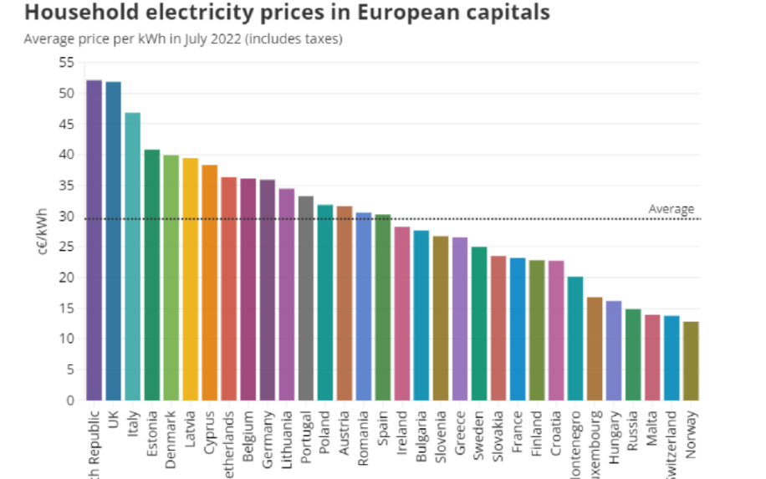
Fig. 1. Household electricity prices in European,
source: https://www.praguemorning.cz/czechs-have-most-expensive-electricity-in-europe-despite-exporting-huge-amounts-of-power-abroad/

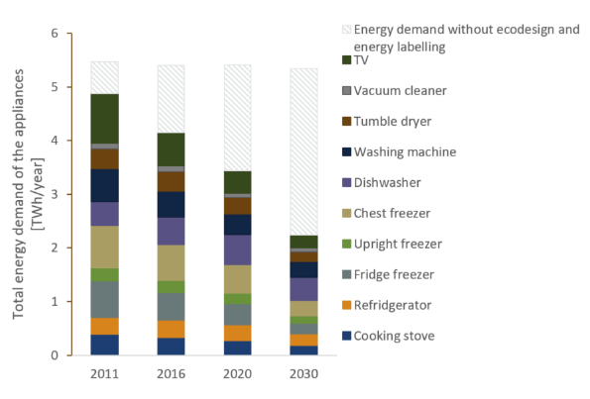
Fig. 2. Total Energy demand of appliances in 2011-2030, source: https://www.nve.no/news-and-reports-from-nve/ecodesign-and-energy-labelling-directives-cause-3-twh-energy-savings-in-norwegian-household-appliances-in-2030/

Reduction of power consumption.
It is best to turn off the power devices that are on standby. Many new devices have power-saving modes, the so-called eco.
We should remember to turn off the lights after leaving the rooms or corridors and use energy-saving light bulbs.
When arranging interiors, we should use furniture settings towards daylight to use it as much as possible. In addition, we should buy devices with the lowest energy consumption and check energy labels. We should modernize buildings as far as possible (replacing windows, doors, radiators, and boilers with more ecological ones). We also should use renewable energy sources (sun, water, wind, biomass, etc.)
Many devices have an intelligent mode, allowing you to combine device features and interact. You can use voice commands to control devices, e.g. turn on your favourite song or turn off the light. Thanks to such connections, you can also remotely turn off and on devices or influence security. For example, during our absence at home or business, we can monitor its condition by remotely controlling the cameras.
Energy labels have been changed after more than 20 years. Since March 2021, they have been more readable and transparent for consumers. The old pluses have disappeared, and the energy consumption designation is presented in letters and colours, with the colour scale remaining the same. The speakers from the top shelf, i.e. A and B, consume the least amount of electricity. These classes are intended for products still in the development phase. Labels are thought out for the long term, so newer and more energy-saving devices will be created with a reserve and thinking about the coming years. With selected equipment groups, there may not be those from classes A and B. In addition, as you can see in the photos of the labels in Fig. 3, there is also a QR code. Its task is to redirect the customer to the product page, where he can read additional information about the device model. Labels for different product groups, e.g. washing machines, refrigerators, dishwashers, dryers or TV sets, slightly differ in appearance and information (Fig. 3). The label of a TV or monitor has, for example, the size of the screen in inches or cm, or whether there is an on/off switch on the TV. The dishwasher or washing machine label contains data on the device’s capacity and water consumption level. The label also shows the annual energy consumption and the noise level expressed in decibels. They have also been enriched with appropriate pictograms. Manufacturers must register devices in the European Product Registry for Energy Labeling (EPREL). Labeling is regulated by relevant regulations in the European Union countries (https://spidersweb.pl/ 2022/02/czy-warto-doplacac-do-klasy energetycznej.html, https://www.conrad.pl/ artykuly/news/nowe-etykiety-energetyczne).
Newly produced equipment must be economical, ecological, energy-saving and innovative. It is the trend. All these features mean that the “life cycle” of such devices is much shorter than those used in the past. Repairing them is no longer profitable, so they are thrown away and replaced with new ones (https://www.agdmaniak.pl/76286/etykiety-energetyczne-2021/).
Fig. 3 presents sample labels for washing machine, washer, dryer, fridge and freezer, dishwasher, TV, and light sources.

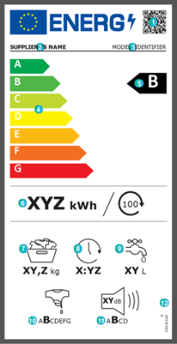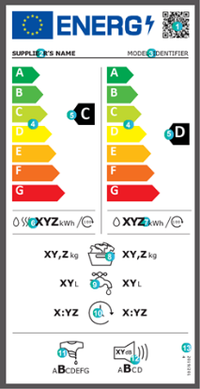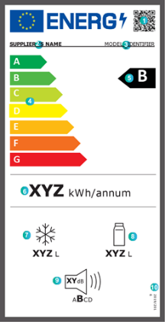
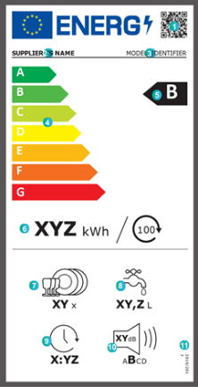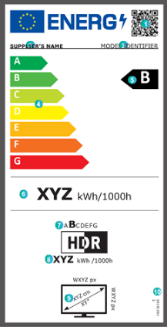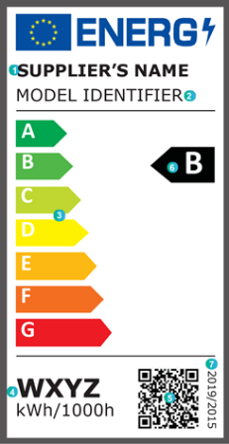
Fig. 3. Sample energy labels for various devices, source: https://www.nve.no/news-and-reports-from-nve/ecodesign-and-energy-labelling-directives-cause-3-twh-energy-savings-in-norwegian-household-appliances-in-2030/https://etykietaenergetyczna.pl/#szczegoly-etykiet

In terms of lighting savings, we have a choice of energy-saving bulbs while ensuring excellent quality of light. We can choose the lighting colour: cool, warm, or neutral. The colour temperature of the light is responsible for the colour type Kelvin. The colour does not affect the energy efficiency but rather the room’s climate. In a nutshell, it can be stated that in warehouses, factories, and shopping centres, lighting is usually cold. In relaxation zones, resting places, e.g. bedrooms, should be warm and neutral in other rooms – including kitchens. All luminaires, light bulbs and lamps must be CE marked following EU directives and requirements. When discussing electronic matters, it should be mentioned that used electronic waste should be disposed of after use, due to its specificity (e.g. toxicity), to specially designated places.
The energy system is related to the atmosphere, hydrosphere and lithosphere. Impacts are associated with energy and nuclear fuels. It should be borne in mind that many gaseous pollutants produced during the combustion of fuels pollute the atmosphere. These are often toxic products. The best-known compounds are CO₂, CO, SO₂, NO, and NO₂-NO_{x}. The distribution of emissions of selected greenhouse gases in individual years 1990-2020 is shown in Fig. 4. The trend is downward, which bodes very well for the future.

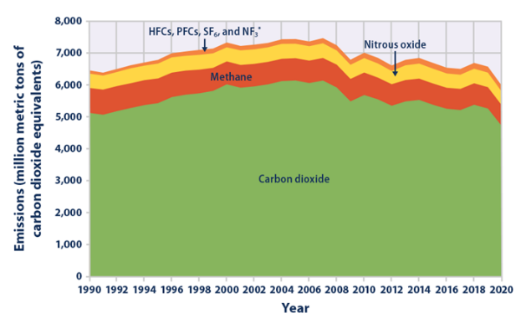
Fig. 4. Greenhouse gas emissions in 1990-2020, source: https://www.epa.gov/climate-indicators/climate-change-indicators-us-greenhouse-gas-emissions

Greenhouse gas emissions in individual sectors are shown in Fig. 5. The chart for 2019 shows that as much as 77.01% of these gases are extracted during energy generation processes, approximately 10.55% from agriculture, approx. 9.1% from industry and use products and about 3.32% from waste management.

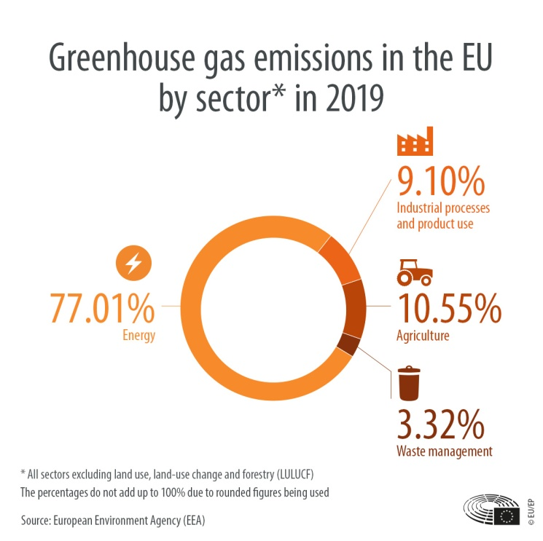
Fig. 5. Greenhouse gas emissions in 2019 in various sectors, source: https://www.europarl.europa.eu/news/en/headlines/society/20180301STO98928/greenhouse-gas-emissions-by-country-and-sector-infographic

Let’s not forget that the products are harmful gases, wastewater, and dust in generating electricity. The European Parliament and the Council issued appropriate combustion directives, indicating the best available techniques (BAT) for large energy facilities. Standards must correct emission limit values. It is reassuring that as awareness increases and new energy-saving technologies are developed, the extreme values are lower (Chmielniak 2018).
3. Conclusion
The energy efficiency of devices with lower and lower energy consumption (more devices are in the production phase) is the key to success in environmental protection.
Energy saving cannot be confused with energy efficiency. Energy saving allows you to reduce energy consumption, e.g. by eliminating excessive consumption. Energy efficiency, on the other hand, also reduces energy while ensuring high efficiency. Advances in these types of solutions are a milestone for the industry. It can produce the same quantity and quality of products using modern technologies as with older, more energy-intensive systems and is more environmentally friendly. Lower demand for energy resources results in greater independence in terms of imports. In the European Strategy for Sustainable, Competitive and Secure Energy Green Paper, we can see two pillars: energy security and environmental security. Awareness and information on energy efficiency should be disseminated among the public. The scope is broad. It concerns transport, industry, construction, and renewable energy sources (Kucharska 2021, Commission of the European Communities 2006).
Developing research, discovery, and innovative methods lead to several reasonable solutions that should serve our planet for the next generations. They will allow you to enjoy cleaner air, better people’s health and let the Earth take a deep breath.
References
Chmielniak, T. (2018). Technologie energetyczne. PWN, Warszawa, pp. 70, 71. (in Polish).
Igliński, B., Kiełkowska, U., Pietrzak, M.B., Skrzatek, M. (2022). Energia odnawialna w województwie pomorskim, Wydawnictwo Naukowe Uniwersytetu Mikołaja Kopernika, Toruń (in Polish).
Kachala, T., Hornyk, V., Pidvalna, O., Boguslavka, S., Chechetova, N., Balakhonova, O. (2021). Regulation of energy savings as a basis of efficiency of communal housing. Ad Alta – Journal of Interdisciplinary Research, 11(1), Special Issue 17, 42-46.
Kucharska, A. (2021). Transformacja energetyczna Wyzwania dla Polski wobec doświadczeń krajów Europy Zachodniej, PWN, Warszawa, pp. 100. (in Polish).
Commission of the European Communities (2006), Zielona Księga, Europejska strategia na rzecz zrównoważonej, konkurencyjnej i bezpiecznej energii, Bruksela
Orłowska, M., Szkarowski, A., Mamedov, S. (2019). Numerical Analysis of Influence of the Angel of Inclination of the Screen on the Intensity of Heat Exchange from a Flat Heat Exchanger in a Partially Limited Space. Rocznik Ochrona Środowiska, 21(1), 728-737.
Orłowska, M. (2019). Laboratory stand for flow and energetic experimental research vertical heaters with free convection and the possibility of intensification. Contemporary Issues of Heat and Mass Transfer, 1, 417-428, Publishing House of the Koszalin University of Technology, Koszalin.
Orłowska, M. (2017). Numerical analysis of the heat exchanger energy efficiency depending on location from the floor, E3S Web of Conferences, 17, Article Nr 00068.
Wit, B., Dresler, P., Surm-Syta, A. (2021). Innovation in Start-Up Business Model in Energy-Saving Solutions for Sustainable Development. Energies, 14(12), 3583, DOI: 10.3390/en14123583
Xie, X., Li, K., (2022). Measuring total-factor energy environment efficiency, energy-saving and carbon emission-reduction potential in China’s food industryAQ1: Based on a meta-frontier slacks-based measure model. Food and Energy security, 11(1), DOI: 10.1002/fes3.324
https://www.praguemorning.cz/czechs-have-most-expensive-electricity-in-europe-despite-exporting-huge-amounts-of-power-abroad/
https://www.europarl.europa.eu/news/en/headlines/society/20180301STO98928/greenhouse-gas-emissions-by-country-and-sector-infographic
https://www.epa.gov/climate-indicators/climate-change-indicators-us-greenhouse-gas-emissions
https://www.smd-led.pl/blog/barwa-swiatla-jak-ja-dobrac-i-czym-sie-kierowac/
https://www.nve.no/news-and-reports-from-nve/ecodesign-and-energy-labelling-directives-cause-3-twh-energy-savings-in-norwegian-household-appliances-in-2030/
https://etykietaenergetyczna.pl/#szczegoly-etykiet
https://www.agdmaniak.pl/76286/etykiety-energetyczne-2021/
https://spidersweb.pl/2022/02/czy-warto-doplacac-do-klasy-energetycznej.html,https://www.conrad.pl/artykuly/news/nowe-etykiety-energetyczne
https://www.nve.no/news-and-reports-from-nve/ecodesign-and-energy-labelling-directives-cause-3-twh-energy-savings-in-norwegian-household-appliances-in-2030/

