 | Rocznik Ochrona Środowiska
 | Volume 24 | Year 2022 ISSN 2720-7501 | pp. 383-392
 | https://doi.org/10.54740/ros.2022.027 open access
 | Received: 04 November 2022 Accepted: 28 November 2022 Published: 30 November 2022
SEVESO III Directive – Information on Establishments
with a High or Increased Risk of a Major Industrial Accident
Izabela Gabryelewicz
Department of Metallurgy and Materials Engineering,
Institute of Materials and Biomedical Engineering,
Faculty of Mechanical Engineering, University of Zielona Góra, Poland
https://orcid.org/0000-0002-0691-4108
Maciej Wędrychowicz
Department of Metallurgy and Materials Engineering,
Institute of Materials and Biomedical Engineering,
Faculty of Mechanical Engineering, University of Zielona Góra, Poland
https://orcid.org/0000-0002-6203-229X
Waldemar Woźniak*
Department of Production and Transport Engineering,
Institute of Materials and Biomedical Engineering,
Faculty of Mechanical Engineering, University of Zielona Góra, Poland
https://orcid.org/0000-0002-4703-6823
Petr Besta
Department of Industrial Systems Management,
Faculty of Materials Science and Technology,
VŠB – Technical University of Ostrava, Czech Republic
https://orcid.org/0000-0001-6309-708X
*corresponding author’s email: w.wozniak@iizp.uz.zgora.pl
Abstract: The article presents the history of the development, and the reasons for the creation of the SEVESO Directive, with particular emphasis on the latest Directive 2012/18 / EU of the European Parliament and the Council. The SEVESO III directive imposes detailed requirements on the plant operators regarding their control against major accident hazards related to dangerous substances. Individual countries of the European Union apply various requirements (following SEVESO III or more rigorous ones) for industrial plants. In Poland, the requirements of the SEVESO III Directive have been implemented in the Environmental Protection Act, and its executive acts. The SEVESO III Directive requires that the citizens of a given country have access to information about high and increased-risk establishments. In Poland, this requirement is met through the website www.mapy.geoportal.gov.pl. People can find information on establishments posing a risk of a serious industrial accident. The article presents how to use the portal and what information can be obtained there.
Keywords: SEVESO Directive, industrial accident, accident risk
1. Introduction
Industrial activity is associated with the risk of accidents leading to environmental contamination, which threatens human health and life. Such threats occur, among other things, in the chemical industry (Lenort et al. 2019). Therefore, the European Union has developed the SEVESO Directives, which indicate methods of counteracting and managing risks in dangerous establishments or those with an increased risk of an industrial accident. It is mainly related to the sustainable development of enterprises (Marczewska & Kostrzewski 2020), their pro-ecological approach (Marczewska et al. 2020), where an important activity is also the process of recovery (Chamier-Gliszczyński 2011), recycling (Chamier-Gliszczyński 2011a) of materials and products (Chamier-Gliszczyński 2010, Chamier-Gliszczyński 2011b). The name SEVESO is associated with an Italian town where in 1976, an explosion occurred in a pesticides and herbicides chemical plant. The explosion resulted in the emission of large amounts of toxic and carcinogenic substances into the atmosphere. Besides the environmental contamination, about 2,000 people were injured.
2. SEVESO Directives
In 1982, Directive 82/501/EEC of 24 June 1982 was developed. Known as the SEVESO I Directive, it regulated the management of plants that used hazardous substances (Table 1). In 1996, the SEVESO II Directive (Council Directive 96/82/EC of 9 December 1996) was created. It was designed to prevent major accidents involving hazardous substances by applying control measures and, in the event of an accident, eliminate its negative effects on humans and the environment. This Directive was based on new concepts and introduced a new safety management system to protect against dangerous accidents and a system for effectively controlling hazards. Directive 2012/18/EU, known as the SEVESO III Directive, was adopted on 4 July 2012. Its main goal is to increase the level of protection against accidents in the sector that manages hazardous substances. In addition, the new Directive introduces changes to the classification of hazardous substances, which are consistent with the currently applicable Globally Harmonized System of Classification and Labelling of Chemicals (GHS) in the European Union. SEVESO III changes the classification of mixtures and chemicals, extends the list of substances by an additional 14 entries, and supplements the “petroleum products” with “heavy fuel oil”. The list of substances determining an establishment as hazardous, along with their threshold values, was included in the Regulation of the Minister of Economy of 10 October 2013 (Journal of Laws of 2013, item 1479).

The SEVESO III Directive classifies industrial plants into two categories, depending on the level of industrial accidents risk:
- lower-tier establishments (Polish: ZZR), and
- upper-tier establishments (Polish: ZDR).

Table 1. History of the development of the SEVESO Directives
Directive | Regulation scope
SEVESO I  Directive 82/501 / EEC  of 24 June 1982 | Regulation of the management of an establishment that uses hazardous substances.
SEVESO II  Directive 96/82 / EC  of 9 December 1996  Directive 2003/105 / EC  of 16 December 2003 | Preventing major accidents involving hazardous substances by applying control measures.  Elimination of the accident’s negative effects both for humans and the natural environment.
SEVESO III – 2012  Directive 2012/18 / EU  of 4 July 2012 | Change in the classification method of mixtures and chemical substances, in line with the new Globally Harmonised System (GHS).  Expanding the list of hazardous substances.  Change in threshold values for hazardous substances.  Notification of the plant to the competent authority of the State Fire Service.

The lower-tier establishments (ZZR) have to report their activities to the competent organ of the Polish Fire Service and must create and implement a major accident prevention policy. The upper-tier establishment (ZDR), in addition to the above documents, is required to prepare a risk report and emergency plans, which are also submitted to appropriate institutions (Table 2).

Table 2. Basic requirements of SEVESO III (Council Directive 96/82 / EC)
The upper-tier establishment (ZDR):  • major accident prevention policy,  • safety management system,  • safety report,  • emergency plans,  • extended-information obligations. | The lower-tier establishment (ZZR):  • major accident prevention policy,  • safety management system.

According to Art. 14 sec. 1 of Directive 2012/18/EU of 4 July 2012 (SEVESO III Directive), EU countries are obliged to provide information to the public, including:
- the full name or business name of the operator and the full address of the establishment concerned,
- a simple explanation of the operation or actions taken in the establishment,
- common names or generic names or hazard classification for relevant hazardous substances on site that may cause a major accident, stating in an uncomplicated form their essential hazardous characteristics,
- general information on how to alert the public if necessary; adequate information on appropriate behaviour in the event of a major accident or indicating where that information can be found electronically,
- details on how to obtain further relevant information.

Concerning upper-tier establishments, in addition to the information provided previously, they need to provide, among other things:
- general information on the nature of the major-accident hazards, including their potential effects on human health and the environment, and summary details of the main types of major-accident scenarios and the control measures to be applied to them,
- where applicable, an indication of whether the establishment is close to the territory of another Member State with the potential for a major accident with transboundary effects under the UNECE Convention on the Transboundary Effects of Industrial Accidents.
3. Sources of Information about Establishments with a high or Increased Risk of a Serious Industrial Accident in Poland
The SEVESO III Directive, in its provisions, also imposes an information obligation on EU Member States and the establishments operating in these countries. In practice, each Member State has to provide involved recipients with information on the correct procedure to be followed in the event of an accident that has led to contamination. This provision contributes to broadening the knowledge of European Union citizens about the dangers of contamination and the proper conduct in such cases. The introduced change also affects companies’ operations, as it extends the scope of their information policy.
In Poland, the easiest way to obtain information about establishments with a high or increased risk of serious industrial accidents is to visit www.mapy.geoportal.gov.pl. By selecting (in the menu on the right) the field “Główny Inspektorat Ochrony Środowiska” (“Chief Inspectorate of Environmental Protection”) and the field “Zakłady stwarzające zagrożenie wystąpienia poważnej awarii przemysłowej” (“Establishments posing the risk of a serious industrial accident”), we will obtain a map with the location of such industrial plants in Poland (Figure 1).

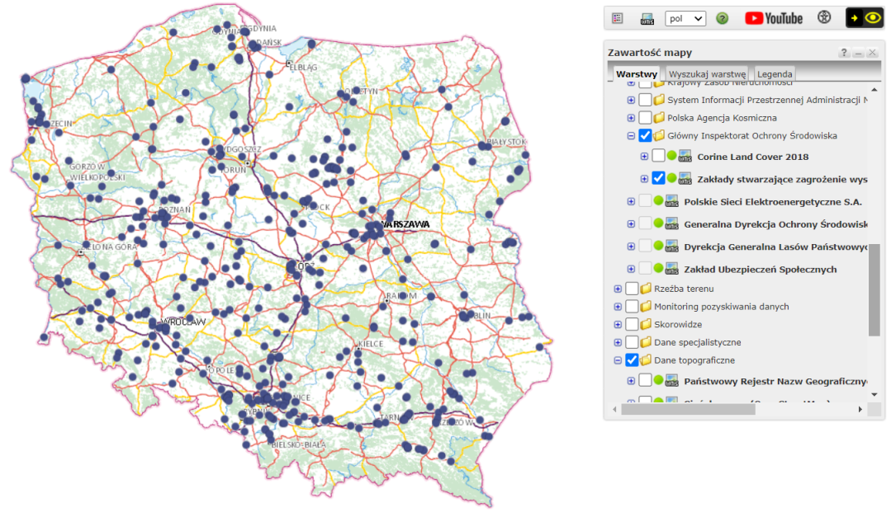
Fig. 1. Production establishments posing the risk of a serious industrial accident in 2022 (www.mapy.geoportal.gov.pl.)

The map presenting establishments with a high or increased risk of a serious industrial accident in Poland may be zoomed in to display details concerning those companies (Figure 2).

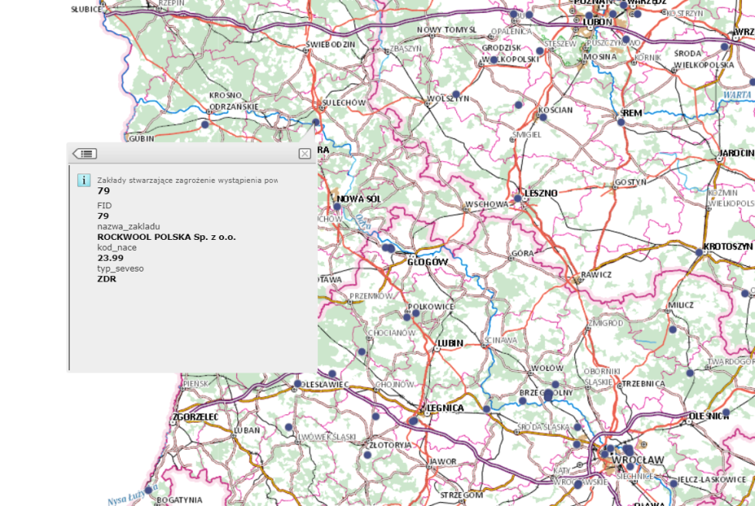
Fig. 2. A map with data of an establishment that may cause an industrial accident (www.mapy.geoportal.gov.pl.)
From the drop-down menu (Fig. 2), we can find that the company ROCKWOOL POLSKA Sp. z o.o. belongs to the group of upper-tier establishments (ZDR). Then the NACE code is shown. NACE (Nomenclature statistique des Activités économiques) is the European Statistical Classification of Economic Activities. NACE groups organizations according to their business activities. By entering the website www.nacev2.com/pl, one can search for the meaning of the code assigned to a given plant (Fig. 3). In the presented case, the code 23.99 means – Manufacture of products from other non-metallic mineral raw materials, not elsewhere classified.

Fig. 3. Website to search for the meaning of the NACE code (www.mapy.geoportal.gov.pl.)

This information must be permanently available to the community, including electronically, and should be kept up to date. Thanks to these provisions, in Poland, information about the ZDR and ZZR establishments is also publicly available, and companies included in this category must disclose this data to the public. We can thus find out what dangerous substances are on the establishment’s premises. We are given a description of the characteristics of the hazardous substances that determine the establishment as high-risk. That description considers the substances’ names or categories and the risks they cause. Table 3 lists such substances that are present on the Rockwool site.

Table 3. Excerpt from the list of substances found at ROCKWOOL with a description of their characteristics (www.mapy.geoportal.gov.pl.)
Substance’s name | Hazard statement code | Hazard class
Formalin  solution:  37-49% | H301 | Toxic if swallowed. Acute toxicity. Category 3
 | H311 | Toxic in contact with skin, Acute toxicity. Category 3
 | H317 | Causes severe skin burns and eye damage, Skin corrosion, Category 1B
 | H330 | Fatal if inhaled, Acute toxicity, Category 2.

Table 3. cont.
Substance’s name | Hazard statement code | Hazard class
Formalin  solution:  37-49% | H335 | May cause respiratory irritation, Specific target organ toxicity, single exposure; Category 2.
 | H341 | Suspected of causing genetic defects. Germ cell mutagenicity, Category 2.
 | H350 | May cause cancer, Carcinogenicity, Category 1B.
Phenol | H301 | Toxic if inhaled, Acute toxicity, Category 3.
 | H311 | Toxic in contact with skin, Acute toxicity. Category 3
 | H314 | Causes severe skin burns and eye damage, Skin corrosion, Category 1B
 | H331 | Toxic if inhaled, Acute toxicity, Category 3.
 | H341 | Suspected of causing genetic defects. Germ cell mutagenicity, Category 2.
 | H373 | May cause damage to organs through prolonged or repeated exposure. Specific target organ toxicity, repeated exposure, Category 2.
 | H411 | Toxic to aquatic life with long-lasting effects, Hazardous to the aquatic environment, chronic toxicity, Category 2.
4. Summary
In Poland, the number of plants with a high and increased risk of a serious industrial accident is growing year by year (Fig. 4). There can be two reasons for this:
- development of the industry, which is classified as potentially threatening to human health and life in case of an industrial accident,
- more rigorous regulations imposed on the operators of industrial plants (stricter standards, increased number of hazardous substances, etc.).

Fig. 4. Number of plants with a high and increased risk of a serious industrial accident in Poland in 2002-2021 (www.mapy.geoportal.gov.pl.)

Thanks to the activities of the European Union, information on industrial plants that pose a potential risk in the event of a major accident is open and public. Disclosure of this information is important for many entities operating (functioning) in the closer and the more distant environment of the enterprise. Thanks to the information, the company’s environment can prepare to take appropriate response measures in the event of a major accident. An interesting concept would be to enrich enterprises with their digital twins to ensure continuous observation of the closer and further environment of enterprises in terms of potential failures in the considered scope (Kosacka-Olejnik et al. 2021, Kostrzewski et al. 2020). This information is essential not only for enterprises operating in the specific environment (e.g. schools, hospitals, other establishments) but also for individual citizens who want to run their businesses (e.g. making decisions to run an agritourism farm) or to decide on the location for their future home.

The work was supported by the specific university research of the Ministry of Education, Youth and Sports of the Czech Republic No. SP2022/27.

References
Chamier-Gliszczyński, N. (2010). Optimal Design for the Environment of the Means Transportation: A Case Study of Reuse and Recycling Materials. Sold State Phenomena, 165, 244-249. DOI: 10.4028/www.scientific.net/SSP.165.244
Chamier-Gliszczyński, N. (2011). Reuse, Recovery and Recycling System of End-of Life Vehicles. Key Engineering Materials, 450, 425-428. DOI: 10.4028/www.scientific.net/KEM.450.425
Chamier-Gliszczyński, N. (2011a). Recycling Aspect of End-of Life Vehicles. Recovery of Components and Materials from ELVs. Key Engineering Materials, 450, 421-424. DOI: 10.4028/www.scientific.net/KEM.450.421
Chamier-Gliszczyński, N. (2011b). Environmental aspects of maintenance of transport means, end-of life stage of transport means. Eksploatacja i Niezawodnosc - Maintenance and Reliability, 50(2), 59-71. http://ein.org.pl/podstrony/wydania/50/pdf/07.pdf
Dyrektywa Parlamentu Europejskiego i Rady 2003/105/WE zmieniającej dyrektywę Rady 96/82/WE: Preambuła oraz postanowienia dyrektywy. (in Polish).
Dyrektywa Parlamentu Europejskiego i Rady 2012/18/UE w sprawie kontroli zagrożeń poważnymi awariami związanymi z substancjami niebezpiecznymi, zmieniająca, a następnie uchylająca dyrektywę Rady 96/82/WE (Directive 2012/18/EU of the European Parliament and of the Council on the control of major-accident hazards involving dangerous substances, amending and subsequently repealing Council Directive 96/82/EC) (in Polish).
Dyrektywa Rady 96/82/WE dotycząca zarządzania zagrożeniami poważnymi awariami z udziałem substancji niebezpiecznych. Tekst jednolity Dyrektywy Seveso II. (in Polish).
Główny Urząd Geodezji i Kartografii. Geoportal Infrastruktury Informacji Przestrzennej, https://mapy.geoportal.gov.pl/imap/Imgp_2.html?gpmap=gp0 (in Polish).
Informacja o środkach bezpieczeństwa i sposobach postępowania w przypadku wystąpienia awarii przemysłowej w Rockwool Polska Sp. z o. o., (in Polish).
https://www.bip.sulechow.pl/res/serwisy/pliki/20212378?version=1.0 (19.08.2022).
Inspekcja Ochrony Środowiska, Główny Inspektorat Ochrony Środowiska, giso.gov.pl/pl/poważne-awarie (20.08.2022) (in Polish).
Kosacka-Olejnik, M., Kostrzewski, M., Marczewska, M., Mrówczyńska, B., Pawlewski, P. (2021). How Digital Twin Concept Supports Internal Transport Systems? Literature Review. Energies, 14, 4919. DOI: 10.3390/en14164919
Kostrzewski, M., Marczewska, M., Chamier-Gliszczynski, N. Woźniak, W. (2020). Digital Twins as Innovation in The Era of Industry 4.0. Proceedings of the 36th International Business Information Management Association (IBIMA), ISBN: 978-0-9998551-5-7, 4-5 November 2020, Granada, Spain. 9641-9653.
Lenort, R., Baran, J., Wysokiński, M., Gołasa, P., Bieńkowska-Gołasa, W., Golonko, M., Chamier-Gliszczyński, N. (2019). Economic and environmental efficiency of the chemical industry in Europe in 2010-2016. Rocznik Ochrona Środowiska, 21(2), 1398-1404.
Marczewska, M., Kostrzewski, M. (2020). Sustainable Business Models: A Bibliometric Performance Analysis. Energies, 13(22), 6062. DOI: 10.3390/en13226062
Marczewska, M., Jaskanis, A., Kostrzewski, M. (2020). Knowledge, Competences and Competitive Advantage of the Green-Technology Companies in Poland. Sustainability, 12, 8826. DOI: 10.3390/su12218826
Raport o występowaniu zdarzeń o znamionach poważnej awarii w 2013 r., Główny Inspektorat Ochrony Środowiska, Warszawa, 04.2014 (in Polish).
Rejestr zdarzeń o znamionach poważnej awarii i poważnych awarii w 2013 roku, https://www.gios.gov.pl/pl/powazne-awarie (20.08.2022) (in Polish).
Rozporządzenie Ministra Rozwoju z dnia 23 lutego 2016 r. w sprawie raportu o bezpieczeństwie zakładu o dużym ryzyku (Dz. U. z 2016 r., poz. 287) (in Polish).
Rozporządzenie Ministra Rozwoju z dnia 29 stycznia 2016 r. w sprawie rodzajów i ilości znajdujących się w Zakładzie substancji niebezpiecznych, decydujących o zaliczeniu Zakładu do zakładu o zwiększonym lub dużym ryzyku wystąpienia poważnej awarii przemysłowej (Dz. U. z 2016 r., poz. 138) (in Polish).
Rozporządzenie Ministra Spraw Wewnętrznych i Administracji z dnia 8 czerwca 2016 r. w sprawie wymagań, jakim powinny odpowiadać plany operacyjno-ratownicze (Dz. U. z 2016 r., poz. 821) (in Polish).
Rozporządzenie Ministra Spraw Wewnętrznych i Administracji z dnia 2 grudnia 2015 r. w sprawie szczegółowego zakresu informacji wymaganych do podania do publicznej wiadomości przez właściwe organy Państwowej Straży Pożarnej (Dz.U. z 2015 poz. 2145) (in Polish).
Ustawa z dnia 27 kwietnia 2001 r. Prawo ochrony środowiska (Dz.U. z 2017 r., poz. 519)
Wykaz zakładów stwarzających zagrożenie występowaniem poważnej awarii przemysłowej wg stanu na 31.12.2017 (in Polish).
Wykaz zakładów stwarzających zagrożenie występowaniem poważnej awarii przemysłowej wg stanu na 31.12.2018 (in Polish).
Wykaz zakładów stwarzających zagrożenie występowaniem poważnej awarii przemysłowej wg stanu na 31.12.2019 (in Polish).
Wykaz zakładów stwarzających zagrożenie występowaniem poważnej awarii przemysłowej wg stanu na 31.12.2020 (in Polish).
Wykaz zakładów stwarzających zagrożenie występowaniem poważnej awarii przemysłowej wg stanu na 31.12.2021 (in Polish).

